**FUNDAMENTALS OF DATABASES – WEEK 3 – ACTIVITY 3**

Supply/perform what is asking in the following statements. Attach or put a screenshot for each number to support your answers.

1. Assuming that you are creating a database table design, provide at least 10 attributes that corresponds to the information of the following:
   1. Student (E.g. Stud_ID, Stud_No)
   2. Employee (E.g. Emp_ID, Emp_No)
2. For each table name field or attributes, think and give the preferred data types for each and lengths (no. of expected number of characters).

Example:

Student Table

Attributes Datatype Length

Stud_ID int 5

Stud_FName text 25

Answer:

1. a. Student (e.g. Stud ID, Stud No.)

b. Employee (e.g. Employee ID, Employee Gender)

c. Products (e.g. Product Type, Product Kind)

d. Smartphone (e.g. Smartphone Brand, Smartphone Processor)

e. Food (e.g. Food ID, Food No.)

f. Shirt (e.g. Shirt ID, Shirt No.)

g. Shoe (e.g. Shoe ID, Shoe No.)

h. Eyeglasses (e.g. Eyeglass ID, Eyeglass No.)

i. Electric Fan (e.g. E-Fan ID, E-Fan No.)

j. Hat (e.g. Hat ID, Hat No.)

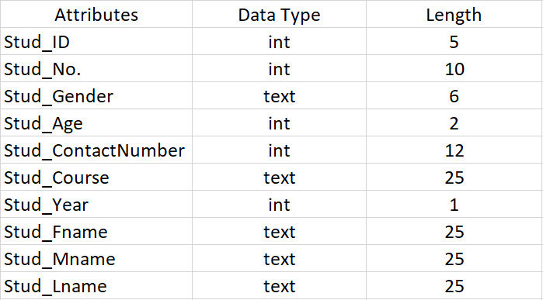  
2.

a.  
b.  
c.  
d.  
e.  
f.  
g.  
h.  
i.  
j.

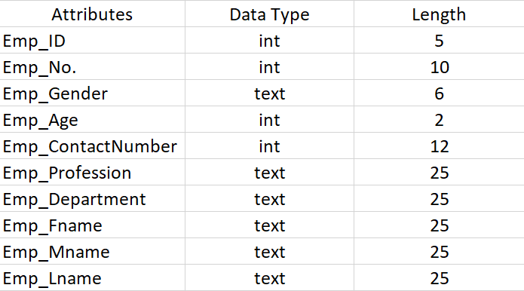

a.  
b.  
c.  
d.  
e.  
f.  
g.  
h.  
i.  
j.