Objective 1: palyginti clsfr:

* Affine tranformacija (vaizdas iš viršaus) 🡪 IsVisible
* IsVisible

Insights:

* Kai kur nusisukusi kamera (tada Affine nieko gero)
* Palyginimas:
  + [Affine🡪IsVisible] geriau nei tik [IsVisible]
  + Rankomis išvalyti vaizdai geriau nei [Affine🡪IsVisible]
  + Laike atitaikytos projekcijos - geriausia

Affine tranf:

New Point Positions:

[ 10., 0.],  
[255., 0.],  
[255., 220.],  
[ 0., 230.]

Original: Transformed:

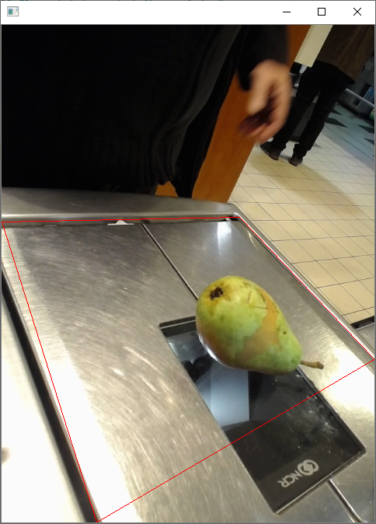 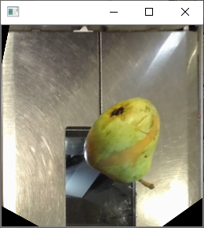

Originalas ir post-affine:

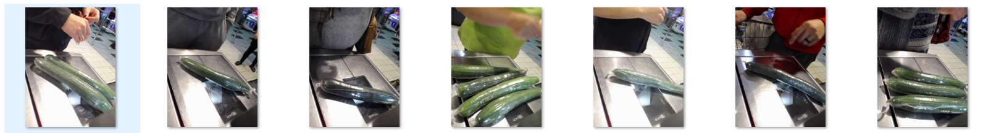

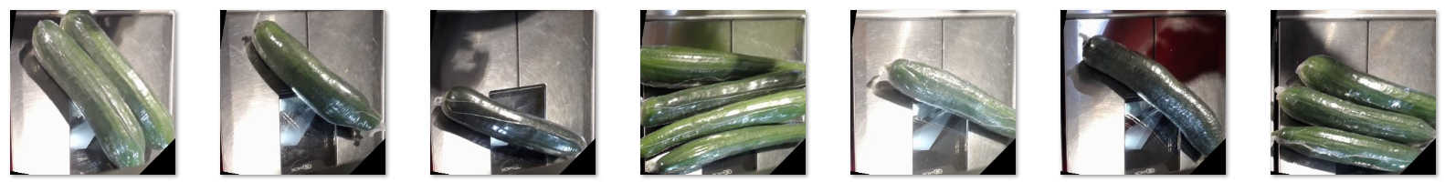

Kai kur nusisukusi kamera:

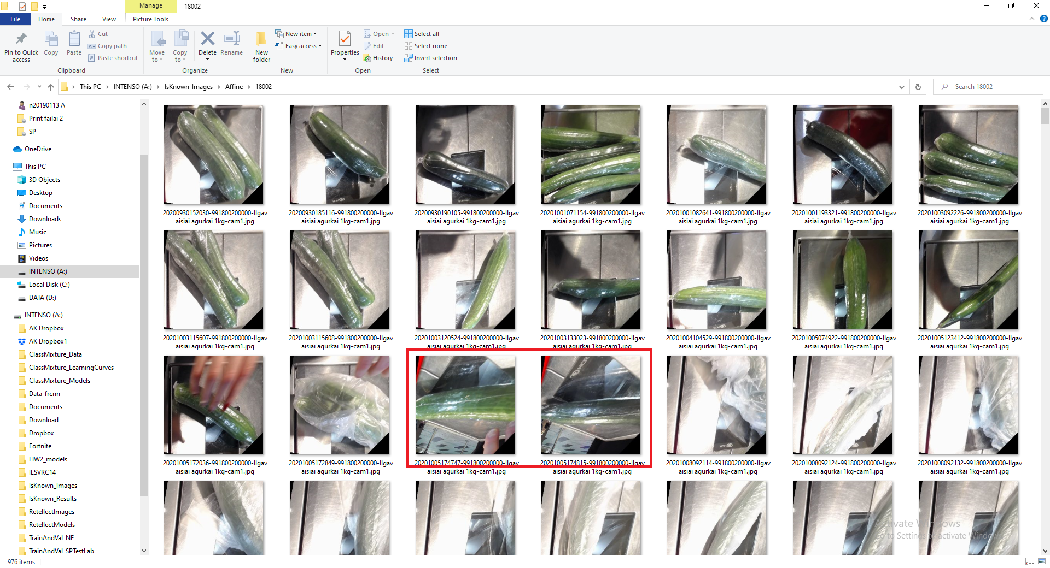

Skirtumai laike:

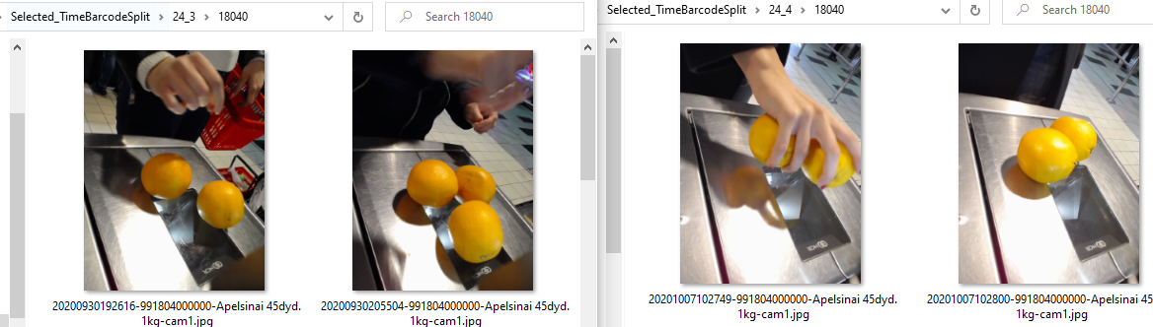

Rezultatai:

|  |  |  |  |  |  |  |  |  |
| --- | --- | --- | --- | --- | --- | --- | --- | --- |
|  |  |  | | | **Affine (1 projekcija per kasą)** | | **Affine, (laike atitaikytos projekcijos)** | |
|  |  | Test acc | | | Test acc | | Test acc | |
| Category level | # classes | Rankomis valyti | Visible=  [2,3,4,m] | Visible=  [2,3,4,m,ma] | Visible=  [2,3,4,m] | Visible=  [2,3,4,m,ma] | Visible=  [2,3,4,m] | Visible=  [2,3,4,m,ma] |
| Ind-0 (Individual) | 221 | 37,7% | 32,4% | 32,3% | **37,5%** |  | **38.6%** | **42.4%** |
| Ind-1 | 119 | 34,6% | 32,1% | 33,7% | **39.6%** | **28.7%** |  |  |
| Ind-2 | 27 | 41,2% | 37,0% | 36,0% | **39.3%** |  |  | **35.9%** |
| Ind-3 | 5 | 84% | 84,2% | 72,2% | **75.8%** |  | **85.7%** |  |
| Ind-4 | 2 | 91% | 85,2% | 83,0% |  |  |  |  |