What’s done:

* Trained klasifikatorius Empty/Not
  + 150 empty images (by hand), augmented
  + 1000 random samples from full DS (not empty)
  + test acc 92.3%
* (refreshed data, 1.5x)

Insights:

* Empty/Not Empty klsf
  + Visi tušti eliminuojami
  + Gana daug ne tuščių eliminuojama

Next steps:

Rezultatai:

|  |  |  |  |  |  |
| --- | --- | --- | --- | --- | --- |
| **Hier** | **Is Visible only** | | **Is NotEmpty => Is Visible** | | **Is Not empty** |
|  | V14  Visible=  [2,3,4,m] | V62  Visible=  [2,3,4,m,ma] | V14  Visible=  [2,3,4,m] | V62  Visible=  [2,3,4,m,ma] |  |
| Ind-0 | 32.8%  model_isvisible_v14_Ind-0_20210212.h5  ~~37.7%~~ | 33.7%  model_isvisible_v62_Ind-0_20210213.h5  ~~36.9%~~ | 29.0%  model_isvisible_v14_Ind-0_20210210.h5 | 27.3%  model_isvisible_v62_Ind-0_20210211.h5 | 23.1%  model_20210209_Ind-0.h5 |
| Ind-1 | ~~37.7%~~ | ~~36.2%~~ |  |  |  |
| Ind-2 | ~~31.2%~~ | ~~44.1%~~ |  |  |  |
| Ind-3 | ~~92.5%~~ | ~~71.8%~~ |  |  |  |
| Ind-4 | ~~88.4%~~ | ~~86.6%~~ |  |  |  |

Empty set

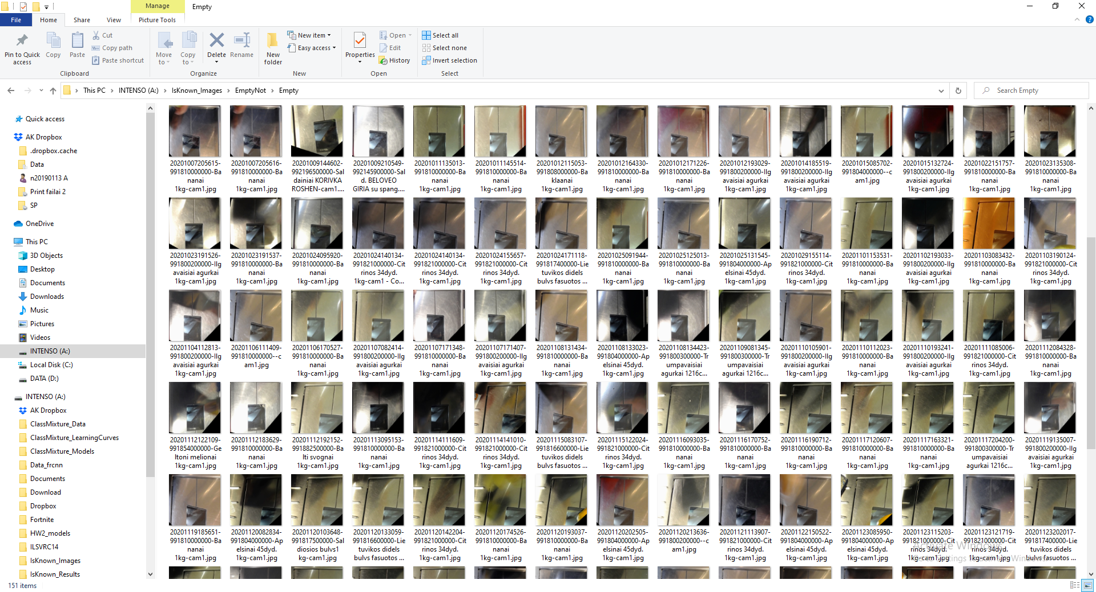

Rezultatai

|  |  |
| --- | --- |
| Empty | Not empty |
|  |  |

