What‘s done:

* Overfit klasifikatorius
* 2 klasių tuštumo klasifikatorius:
  + Problema: Nekonverguojantis train acc
  + Sprendimas: BatchNorm momemtum sumažinimas 0,99->0,95

|  |  |  |
| --- | --- | --- |
| Train Data  \  Set | Balanced  Empty samples: 1000, Not empty: 1000 | NotEmpty undersampled  Empty samples: 1000, Not empty: 3 |
| Train |  |  |
| Val |  | Range 0.99-1: |
|  | 98.8% (val), 98% (test) |  |
| Loss |  |  |
| Acc |  |  |
|  | model_emptyNot_20210222_Balanced.h5 | model_emptyNot_20210222_NotEmptyUndersampled.h5 |

Problema: train_accuracy @fit() << train_accuracy @Eval, @predict

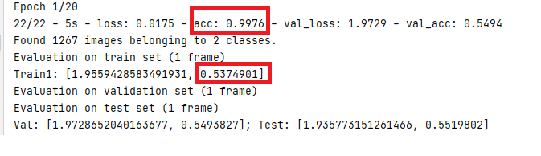

Sprendimas:

* BN (momentum=0.95) (vietoje default 0.99)
* LR = 1e-4 (vietoje default 1e-3)

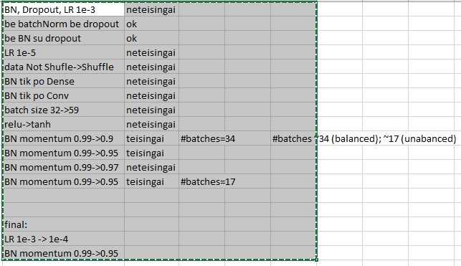

Tusti vaizdai (2-class clsf)

