What’s done:

* Afininė augmentacija
  + Taikyta balansuojant
  + Netaikyta dinamiškai (t.y. kiekvienoje epochoje)
* Autoencoder: pirmas bandymas

Insights:

* Affine augmentacija neaišku ar padėjo

Next steps:

* Autoenc:
  + Train autoencoder
    - 2-5 conv (?)
    - Kaip vertinti ar geras? Vizualiai? Mse?
  + Transfer weights: Encoder + new Dense
  + Train Dense only

Affine aug:

* 10, 20, 30 px distortion

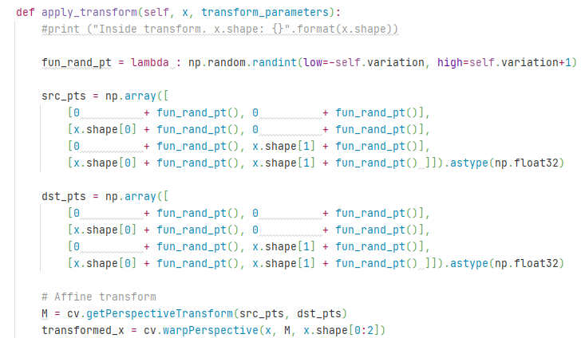

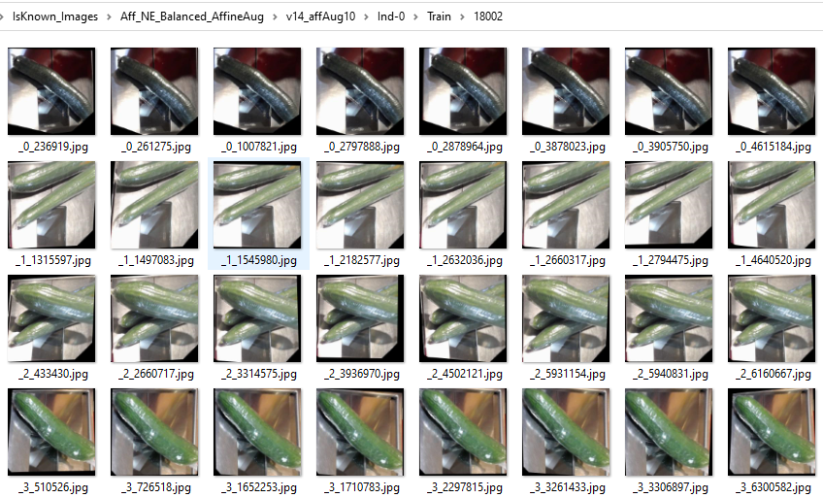

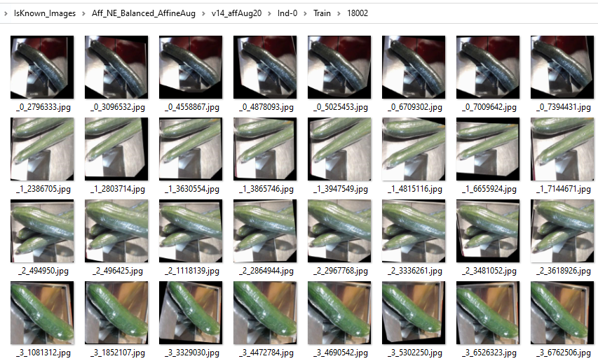

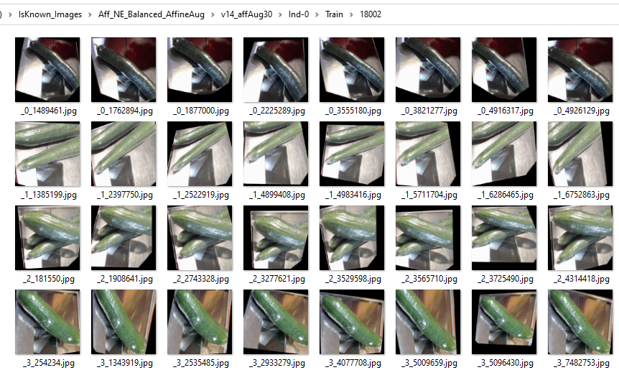

Rezultatai:

(nauji)

|  |  |  |  |  |  |
| --- | --- | --- | --- | --- | --- |
|  | **Hier** | **Is NotEmpty 99% BN**  **=> Is Visible** | | **Is NotEmpty 95% BN**  **=> Is Visible** | |
|  |  | V14  Visible=  [2,3,4,m] | V62  Visible=  [2,3,4,m,ma] | V14  Visible=  [2,3,4,m] | V62  Visible=  [2,3,4,m,ma] |
| Test acc | Ind-0 | 29.0%  model_isvisible_v14_Ind-0_20210210.h5 | 27.3%  model_isvisible_v62_Ind-0_20210211.h5 | 27.4%  model_isvisible_v14_Ind-0_20210223.h5 | 32.4%  model_isvisible_v62_Ind-0_20210224.h5 |
| Val acc | 18.6% | 16.0% | 18.9% | 17.8% |

Affine Aug

|  |  |  |  |  |  |  |  |  |
| --- | --- | --- | --- | --- | --- | --- | --- | --- |
|  | Default aug (rot,shift,h_flip)  (Is NotEmpty 95% BN => Is Visible) | | 10pt Affine aug | | 20pt Affine aug | | 30pt Affine aug | |
|  | V14  Visible=  [2,3,4,m] | V62  Visible=  [2,3,4,m,ma] | V14  Visible=  [2,3,4,m] | V62  Visible=  [2,3,4,m,ma] | V14  Visible=  [2,3,4,m] | V62  Visible=  [2,3,4,m,ma] | V14  Visible=  [2,3,4,m] | V62  Visible=  [2,3,4,m,ma] |
| Test acc | 27.4%  model_isvisible_v14_Ind-0_20210223.h5 | 32.4%  model_isvisible_v62_Ind-0_20210224.h5 | 32.8%  model_isvisible_v14_Ind-0_20210225.h5 | 29.6%  model_isvisible_v62_Ind-0_20210226.h5 | 32.8%  model_isvisible_v14_Ind-0_20210227.h5 | 32.4%  model_isvisible_v62_Ind-0_20210227.h5 | 31.1%  model_isvisible_v14_Ind-0_20210228.h5 | 35.8%  model_isvisible_v62_Ind-0_20210301.h5 |
| Val acc | 18.9% | 17.8% | 20.1% | 19.5% | 17.8% | 17.5% | 17.8% | 17.7% |

