Is Visible:

|  |  |  |  |  |  |  |  |  |
| --- | --- | --- | --- | --- | --- | --- | --- | --- |
|  | Exper.  ID | Acc | 10pt Affine aug  + Baseline | | 20pt Affine aug  + Baseline | | 30pt Affine aug  + Baseline | |
|  |  |  | V14  Visible=  [2,3,4,m] | V62  Visible=  [2,3,4,m,ma] | V14  Visible=  [2,3,4,m] | V62  Visible=  [2,3,4,m,ma] | V14  Visible=  [2,3,4,m] | V62  Visible=  [2,3,4,m,ma] |
| 1070  Py 3.7.7  TF 1.15.0  TF.Keras 2.4.0 | 0 | Test | 37.9%  model_isvisible_v14_Ind-0_20210304.h5 | 31.8%  model_isvisible_v62_Ind-0_20210305.h5 | 31.5%  model_isvisible_v14_Ind-0_20210307.h5 | 34.9%  model_isvisible_v62_Ind-0_20210307.h5 | 31.4%  model_isvisible_v14_Ind-0_20210308.h5 | 33.3%  model_isvisible_v62_Ind-0_20210309.h5 |
| Val | 21,4% | 21,4% | 21.7% | 20.4% | 20.2% | 19.7% |
| 1080  Py 3.8.3  TF 2.4.1  Keras 2.2.4-tf | 1 | Test |  |  | 0.737736 | 0.734918 |  |  |
| Val |  |  | 0.478626 | 0.454551 |  |  |
| 2 | Test |  |  | 0.761052 | 0.753033 |  |  |
| Val |  |  | 0.478038 | 0.463637 |  |  |
| 3 | Test |  |  | 0.775415 | 0.729101 |  |  |
| Val |  |  | 0.473312 | 0.466403 |  |  |
| 4 | Test |  |  | … | 0.757188 |  |  |
| Val |  |  | … | 0.469742 |  |  |
|  |  |  |  | … | … |  |  |
|  | 5 |  |  |  | … | … |  |  |
|  |  |  |  |  | … | … |  |  |
|  | 6 |  |  |  | … | … |  |  |
|  |  |  |  |  | … | … |  |  |
|  | 7 |  |  |  | … | … |  |  |
|  |  |  |  |  | … | … |  |  |
|  | 8 |  |  |  | … | … |  |  |
|  |  |  |  |  | … | … |  |  |
|  | 9 |  |  |  | … | … |  |  |
|  |  |  |  |  | … | … |  |  |
|  | 10 |  |  |  | … | … |  |  |
|  |  |  |  |  | … | … |  |  |

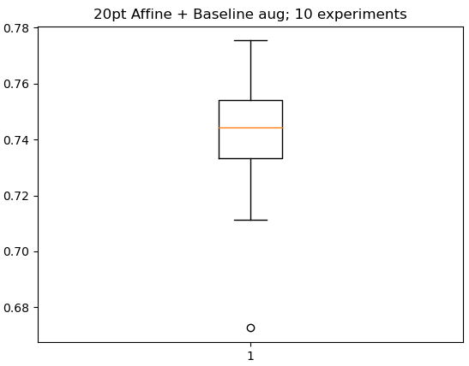

Dataset: aff 20

Is Visible + Tustumo (overfit):

Is Visible + Tustumo (siamese):

Is Visible + Tustumo (2 class clsf):

|  |  |  |  |  |  |  |  |
| --- | --- | --- | --- | --- | --- | --- | --- |
|  |  | Emptyness:  Balanced | | Emptyness:  Overfit | | Emptyness:  Siamese | |
| Exper.  ID | Acc | 20pt Affine aug  + Baseline aug | | | | | |
|  |  | 1080  GPU 0 | 1080  GPU 1 | Amz  Small 2 | Amz  Small 1 | Amz  Small 3 | Amz  Small 4 |
|  |  | V14  Visible=  [2,3,4,m] | V62  Visible=  [2,3,4,m,ma] | V14  Visible=  [2,3,4,m] | V62  Visible=  [2,3,4,m,ma] | V14  Visible=  [2,3,4,m] | V62  Visible=  [2,3,4,m,ma] |
| 1 | Test | 0.694662 | 0.700964 | 0.653069 | 0.6441199 | 0.686525 | 0.701707 |
| Val | 0.464367 | 0.4436796 | 0.421454 | 0.4239886 | 0.452531 | 0.450034 |
| 2 | Test |  |  |  |  |  |  |
| Val |  |  |  |  |  |  |
| 3 | Test |  |  |  |  |  |  |
| Val |  |  |  |  |  |  |
| 4 | Test |  |  |  |  |  |  |
| Val |  |  |  |  |  |  |
| 5 | Test |  |  |  |  |  |  |
| Val |  |  |  |  |  |  |
|  |  | 6 | 6 | 6 | 5 | 5 | 5 |
|  |  | Amz  Small 9 | Amz  Small 10 | Amz  Small 6 | Amz  Small 5 | Amz  Small 7 | Amz  Small 8 |
| 6 | Test |  |  |  |  |  |  |
| Val |  |  |  |  |  |  |
| 7 | Test |  |  |  |  |  |  |
| Val |  |  |  |  |  |  |
| 8 | Test |  |  |  |  |  |  |
| Val |  |  |  |  |  |  |
| 9 | Test |  |  |  |  |  |  |
| Val |  |  |  |  |  |  |
| 10 | Test |  |  |  |  |  |  |
| Val |  |  |  |  |  |  |
|  |  | 4 | 4 | 5 | 5 | 5 | 5 |
|  |  | **10** | **10** | **11** | **10** | **10** | **10** |

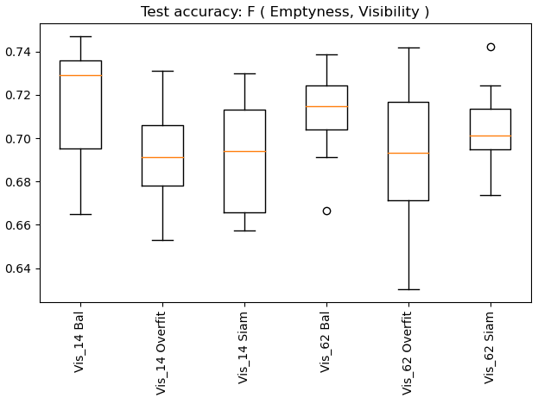

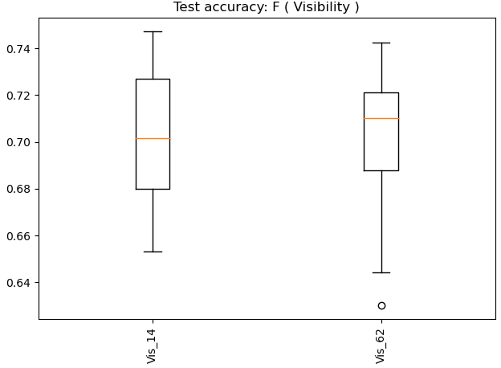

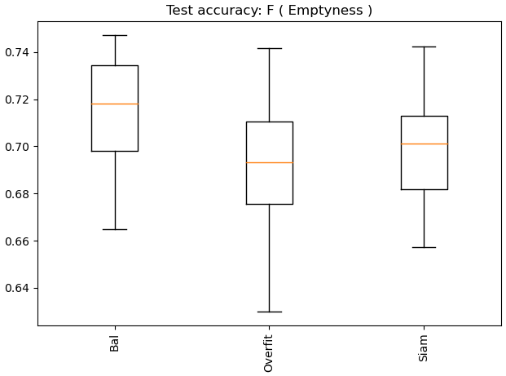LIKS

Dataset: aff 20+Keras vs. 10+20+30+Keras; Balanced

|  |  |  |  |  |  |
| --- | --- | --- | --- | --- | --- |
|  |  | Emptyness:  Balanced | | | |
| Exper.  ID | Acc | 20pt Affine aug | | 10+20+30pt Affine aug | |
|  |  |  |  | Amz  P2 large 1 | Amz  P2 large 2 |
|  |  | V14  Visible=  [2,3,4,m] | V62  Visible=  [2,3,4,m,ma] | V14  Visible=  [2,3,4,m] | V62  Visible=  [2,3,4,m,ma] |
| 1 | Test | Look up | | 0.739455 | 0.6858377 |
| Val |  |  |
| 2 | Test |  |  |
| Val |  |  |

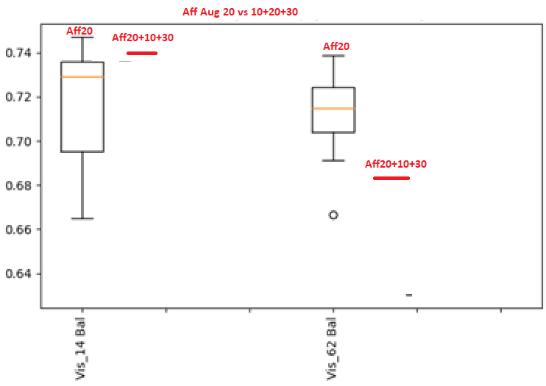LIKS