# Augmentacija:

Keras,**10**,20,**30px** vs. Keras,20px affine

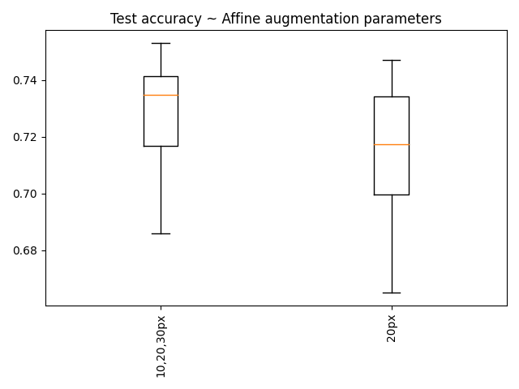

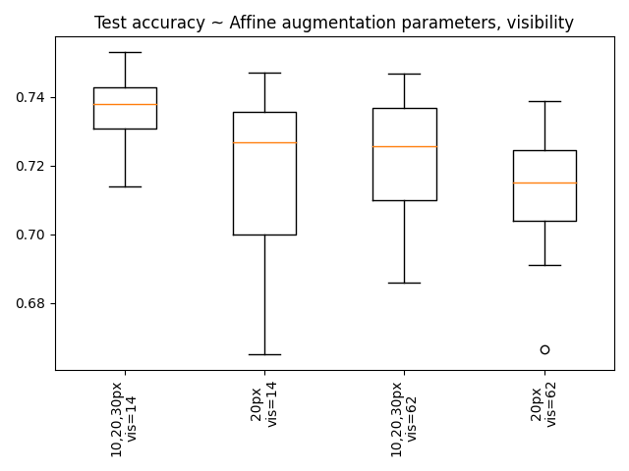

|  |  |
| --- | --- |
|  | V62  V14 |

# Autoenc

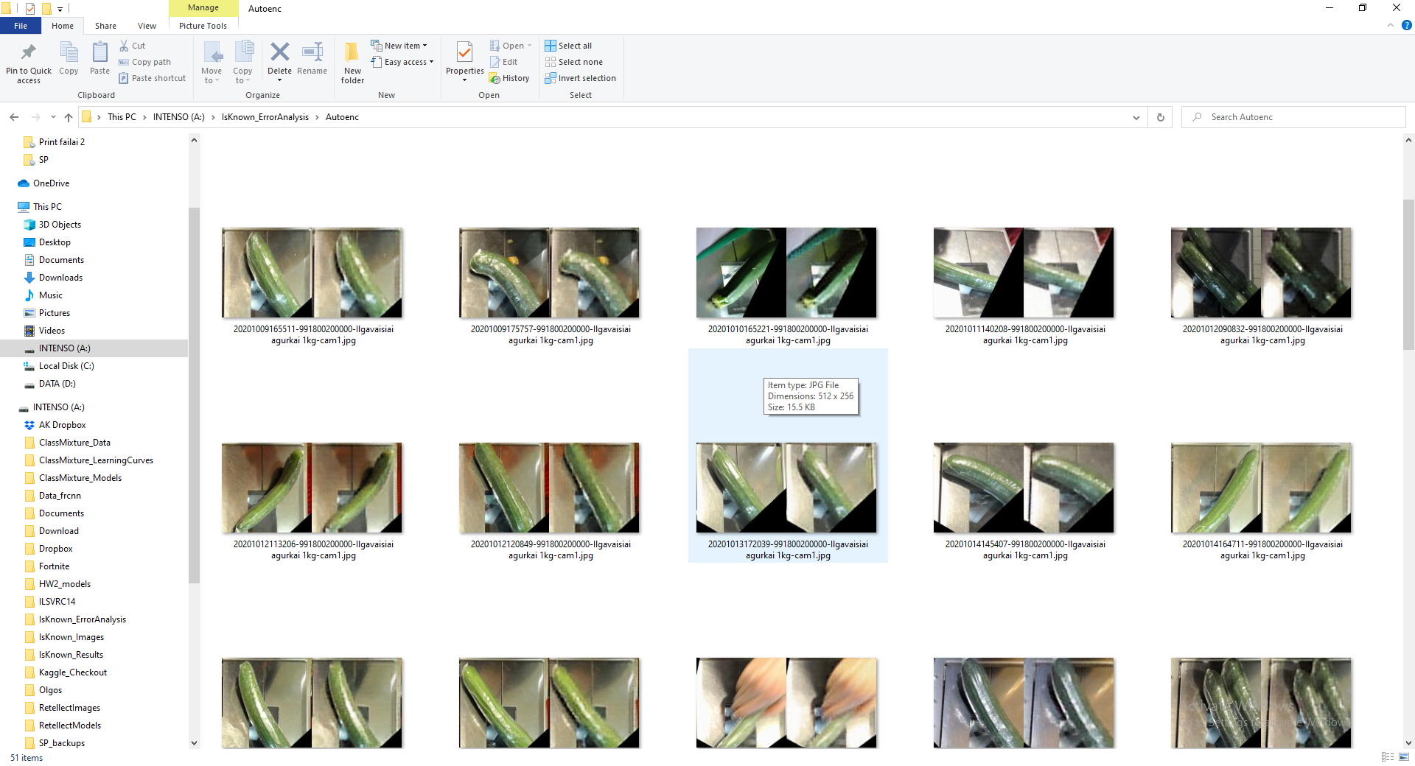

# Autoenc-based clsf

