What:

* SOM clusteriai. Teisingo dydžio gardelės
* Hierarchija 5 lygiai (ind.prod 194 klasės; 109; 26; 5; 2)
* Palyginti klasikinis clsf vs. SOM-based clsf
* Suprasti, kas „sukrenta“ kartu

Insights:

* Train “purity” (~Accuracy) –geras
* Test “purity” (!=Accuracy) – neblogas; prastesnis už klasikinio CNN+Dense accuracy

|  |  |  |  |  |
| --- | --- | --- | --- | --- |
|  |  | Classic arch  (7conv+dense) | SOM clsf based on pre-last activations | |
| Hierarchy | Num classes | Test accuracy Purity (Train/Test) | | SOM grid size |
| 0 (individual products) | 194 | 0.800-0.832 | 0.930 / 0.607 | 14x14 (192) |
| 1 | 109 | 0.837 | ? | 11x11 |
| 2 | 26 | 0.829 | 0.958 / 0.731 | 6x6 (33) |
| 3 | 5 | 0.975 | 0.996 / 0.970 | 3x3 (8) |
| 4 | 2 | 0.971 | 0.952 / 0.891 | 2x2 (3) |

Ind.products

A:\IsKnown_Results\Graph

Train:

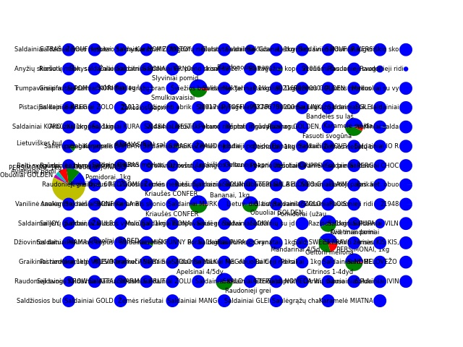

Kriauses+kriauses; didelis apskr – obuoliai, persimonai, pomidorai

Test:

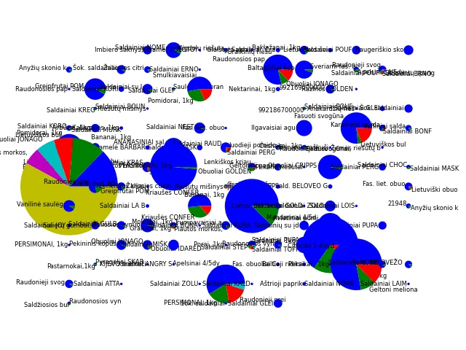

Hier2 (26 classes)

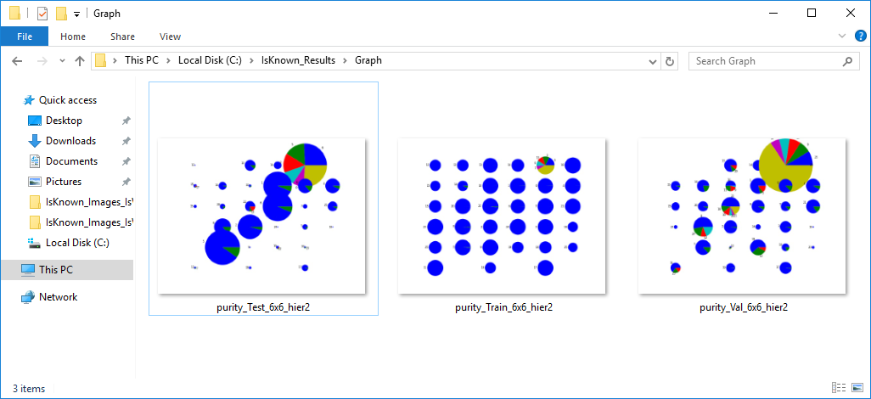

Hier 3 (5 classes)

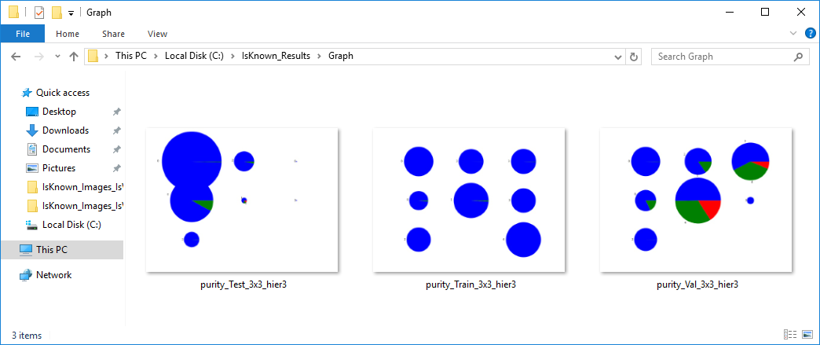

Hier4 (2 classes)

