Policy-Aware Probabilistic Forecasting of Singapore COE Premiums Using Temporal Fusion Transformers on a Cloud-Native Platform
Andrei Loh Jun Jie  DSA2111 Group 7  National University of Singapore  Singapore  e1526256@nus.edu.sg | Bernardino Realino Aryo Lintang  DSA2111 Group 7  National University of Singapore  Singapore  e1122404@nus.edu.sg | Leow Yu Xuan Chloe  DSA2111 Group 7  National University of Singapore  Singapore  e1528726@nus.edu.sg
Sarah Lim Ying Tong  DSA2111 Group 7  National University of Singapore  Singapore  e1156850@nus.edu.sg | Tan Guan Ming Terence  DSA2111 Group 7  National University of Singapore  Singapore  e1398756@nus.edu.sg | Lionel Yee Jen Mok  DSA2111 Group 7  National University of Singapore  Singapore  e1398354@nus.edu.sg

Abstract—In Singapore every new vehicle needs a Certificate of Entitlement (COE), bought at a twice-monthly auction whose supply is fixed by a government quota. With premiums above S$100,000, the timing of a purchase is a major financial decision, yet public tools mostly chart past prices or publish single-number predictions without stated uncertainty or tested accuracy. Policy changes, such as the 2022 electric-vehicle reclassification and the 2025 quota injection, also break the patterns that purely historical models rely on. We present COE Compass, a cloud-native system that produces probabilistic, policy-aware forecasts for all five COE categories and turns them into decision support. Box-Tiao intervention analysis first estimates the level shift of eight policy events. The estimates and the announced quotas then enter a Temporal Fusion Transformer (TFT), written from scratch in PyTorch, as known-future inputs; its quantile head is anchored to a calibrated random walk and cannot produce crossing quantiles. The published forecast averages the quantiles of the TFT and a Box-Tiao ARIMAX model and feeds a market outlook, a bid planner, supply what-if scenarios and a bounded AI analyst; the system deliberately does not tell users to buy or to wait. The system runs as four Docker containers on Kubernetes with scheduled retraining. In a rolling-origin backtest over the last 72 bidding exercises (2,010 forecasts, one to six exercises ahead) the hybrid achieved the lowest pooled pinball loss of eight methods (S$1,928), the lowest mean absolute error (S$5,549; MAPE 6.81%), 59.6% directional accuracy and 87.9% coverage for its nominal 80% interval. Its margin over a random walk is 0.45% and is not statistically significant under a Diebold-Mariano test (p = 0.74): COE premiums are close to a random walk over one quota quarter. A scrambled-data test confirms that no forecast uses information from after its origin. The value of the system therefore lies in calibrated ranges, a published backtest and decision support, not in point accuracy, which existing tools do not disclose.
Keywords—certificate of entitlement, probabilistic forecasting, Temporal Fusion Transformer, intervention analysis, quantile regression, Docker, Kubernetes

I. Introduction
Singapore controls its vehicle population through the Vehicle Quota System (VQS), introduced in May 1990 [1], [2]. Anyone registering a new vehicle must first obtain a Certificate of Entitlement (COE), which gives the right to own and use the vehicle for ten years. COEs are sold in bidding exercises held twice a month in five categories: small cars (Cat A), large cars (Cat B), goods vehicles and buses (Cat C), motorcycles (Cat D) and an open category (Cat E). In each exercise every successful bidder pays the same clearing price, the quota premium. In the second exercise of September 2026 the premium was S$131,890 for Cat A and S$133,000 for Cat B, a six-figure commitment made before the car is registered.
Fig. 1 plots the premium of all five categories from January 2010 to September 2026, the 396 bidding exercises used in this study. Three features stand out. First, the series move in long swings and not around a stable mean: Cat A rose from S$18,502 in January 2010 to S$92,100 in January 2013, fell to S$23,568 in December 2018 and reached S$133,009 in September 2026. Second, large moves can be abrupt: Cat B peaked at S$150,001 in October 2023 and cleared at S$85,010 five exercises later. Third, the markers P1 to P8 are policy interventions, among them car-loan curbs, changes to category rules and a 20,000-COE injection. Supply is set by a quota that follows the deregistration of ten-year-old vehicles [3], so it cannot respond to demand in the short term, and a change in rules or quota can move prices sharply.
A buyer who must decide whether to commit now or wait a few months therefore faces a forecasting problem under uncertainty, and the tools available to the public do not treat it as one. Motoring portals chart past results and publish commentary. COE SG posts a next-round point prediction that it describes as “a simple model + a bit of guessing” [4]. Quota.sg forecasts the quarterly quota and issues buy, wait or caution signals with a stated accuracy of ±5–8%, but with no interval around a forecast and no published backtest [5]. The academic literature on the VQS concentrates on auction design, efficiency and equity [1], [6]–[8]; the few forecasting studies fit structural or autoregressive models and judge them by in-sample fit [9], [10]. None gives a multi-step probability distribution, uses what is already known about the future (announced quota, policy start dates), or shows on unseen data that it beats the simplest benchmark, “the next premium equals the last one”.
We formulate the task as follows. For a category and a forecast origin t, given the premium history, covariates observed up to t and covariates known for the next H = 6 exercises (one quota quarter), estimate the quantiles of the premium at t + 1, …, t + H at seven levels from 5% to 95%. The quantiles must then answer three practical questions: whether waiting is likely to save a meaningful amount, how high a reserve price must be to win with a given probability, and how the answer changes if the next quota is larger or smaller.
Our approach combines two traditions. Box-Tiao intervention analysis [11] estimates, for each category, the level shift attributable to each policy event while an ARIMA process absorbs ordinary dynamics. A Temporal Fusion Transformer (TFT) [12] then receives those estimates, the policy indicators and the announced quota as known-future inputs, next to past premiums, bidding pressure and macroeconomic indicators. Because each category has only 396 observations, we assume from the start that a deep model may not beat simple ones [13], [14]: the network is built so that before training it is exactly a calibrated random walk, and its forecast is averaged with an econometric model. Every claim is then tested against seven baselines on three held-out years. The main contributions are:
- A hybrid, policy-aware probabilistic forecaster. Box-Tiao estimates of eight policy events and announced quotas enter a from-scratch TFT whose monotone quantile head is anchored to a random walk; its quantiles are averaged with those of a Box-Tiao ARIMAX model.
- A benchmark-first evaluation without leakage. A three-year rolling-origin backtest compares eight methods with a proper scoring rule, interval coverage and Diebold-Mariano tests, and reports openly that COE premiums are close to a random walk.
- A reproducible cloud-native decision-support platform. Four containers run on Docker Compose or Kubernetes with self-healing, autoscaling and scheduled retraining, and turn forecasts into a market outlook, bid probabilities, supply scenarios, policy explanations and a tool-bounded AI analyst, covered by 193 automated tests.
Section II reviews related work, Section III describes the system, Section IV reports the experiments and Section V concludes.
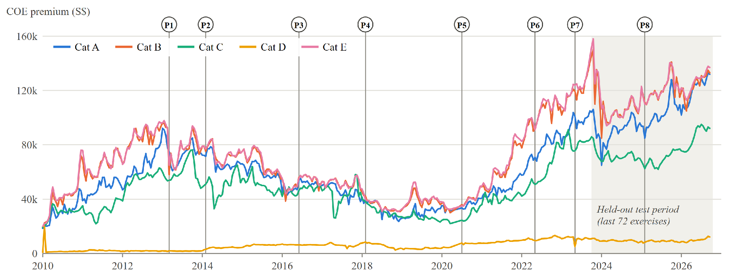
Fig. 1. COE premiums of the five categories, January 2010 to September 2026 (396 bidding exercises). P1 to P8 mark the policy interventions of Table II; the shaded region is the held-out test period.

II. Related Work

A. The Vehicle Quota System and COE Price Studies
Early work on the VQS asked whether an auctioned quota is an efficient and fair way to ration cars. Koh and Lee [1] reviewed the first years of the scheme, its bidding strategies and the case for transferable certificates; Phang et al. [2] documented the issues it raised and the policy process behind its revisions. Koh [6] later showed that a per-vehicle premium favours distributors of expensive cars, for whom it is a smaller share of the price, and Tan [7] assessed how the rationing rules shaped outcomes. These studies evaluate policy, not predictive accuracy.
A second group treats the premium as a time series. Hon and Yong [9] fitted a structural time-series model and reported a stable seasonal pattern. Meng et al. [10] combined a survey of bidders with an autoregressive model with exogenous variables and reported a close fit to observed premiums. Chu found that the number of categories and the change from sealed to open bidding affected price efficiency [8], and that deregistrations fall when premiums are high, so that a quota tied to deregistrations amplifies boom-and-bust cycles [3]; his proposal to smooth supply by borrowing from future quota is close in spirit to the cut-and-fill adjustment of 2023 (P7 in Fig. 1). Huang et al. [15] used the quota as an instrument for the premium when measuring its effect on house prices, which supports treating quota as an exogenous, known driver. For forecasting, the common limitations are that models are judged by in-sample fit or coefficient significance, give a single expected value, and treat policy changes as outside the model.

B. Forecasting Methods
ARIMA models [16] remain the reference for short univariate series, and intervention analysis [11] extends them with step, pulse or temporary inputs for known events. Recurrent networks such as the LSTM [17] and DeepAR [18] learn non-linear dynamics from many related series, and attention [19] lets a model weigh distant time steps directly. The TFT [12] combines these ideas for multi-horizon forecasting: it separates static, observed and known-future inputs, selects variables with gating networks and outputs quantiles, and it reported lower quantile losses than DeepAR and other benchmarks on electricity, traffic, retail and volatility data.
Evidence from forecasting competitions argues for caution. In the M4 competition [13] pure machine-learning entries were less accurate than statistical benchmarks, while combinations and hybrids performed best. Zeng et al. [14] showed that a one-layer linear model outperforms several transformer forecasters on standard long-horizon benchmarks. Hybridisation is a long-standing response: Zhang [20] combined ARIMA with a neural network fitted to its residuals; averaging the quantiles of several forecasters gives sharper distributions than averaging their probabilities [21]; and deep ensembles of independently initialised networks give better-calibrated uncertainty [22]. Gradient-boosted trees [23] are a strong tabular baseline.

C. Evaluating Probabilistic Forecasts
Quantile forecasts are scored with the pinball loss [24], a proper scoring rule [25] that rewards both calibration and sharpness. Point accuracy is usually reported as the mean absolute error (MAE) and as percentage errors (MAPE, sMAPE), whose weaknesses are discussed in [26]. Because observations are ordered in time, accuracy must be measured out of sample with rolling forecast origins [27], and differences between two methods should be tested, for example with the Diebold-Mariano (DM) test [28] and a variance estimate that is robust to the autocorrelation of overlapping multi-step errors [29]. We adopt all of these in Section IV.

D. Existing Tools and Deployment Practice
Among public tools, Quota.sg models the quarterly quota from deregistration records and issues timing signals [5]; COE SG publishes next-round point predictions [4]; and an open-source project fits one SARIMA model per category for one-round-ahead forecasts, reporting a MAPE of 1.86–4.63% over 24 rounds, better than a naive forecast in three of five categories [30]. None publishes prediction intervals. On the engineering side, containers [31] and orchestration with Kubernetes [32] make a service portable and self-healing, and Sculley et al. [33] warn that most of the cost of a machine-learning system lies in data dependencies, configuration and serving, not in model code. This motivates our separation of batch training from online serving.

E. Gaps Addressed
Three gaps follow from this review: (i) there is no multi-horizon probabilistic forecast of COE premiums; (ii) policy events and announced quotas are not used as model inputs; and (iii) accuracy claims are not tested out of sample against a naive benchmark with statistical tests. Section III addresses (i) and (ii), and Section IV addresses (iii).
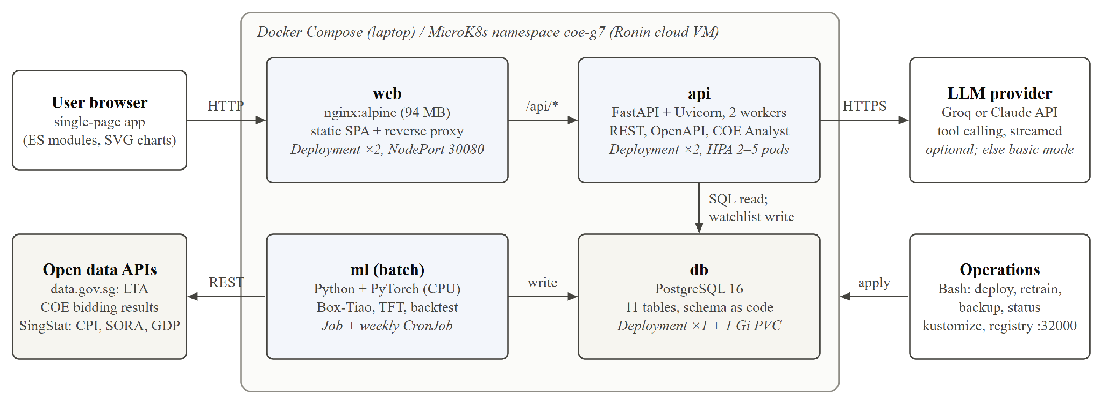
Fig. 2. Deployment architecture. The same four containers run under Docker Compose on a laptop and as the Kubernetes objects shown in italics in a MicroK8s namespace on the Ronin cloud VM.

III. Proposed System Design

A. Overview and Architecture
COE Compass consists of four services (Fig. 2). A batch ml job ingests data, evaluates and trains the models and writes forecasts to PostgreSQL. A stateless api service reads those pre-computed results and applies the decision rules. A web service serves a single-page application and proxies API calls. The db service stores raw data, model runs and user watchlists.
Reading Fig. 2 from left to right, the browser talks only to nginx, which serves static files and forwards requests under /api/ to FastAPI. FastAPI reads from the database and writes only watchlist rows. The ml job is the only writer of data and forecasts and the only component that calls the open-data APIs. A language-model provider, used by the analyst (Ask Compass), is optional. Two design choices follow from this layout. First, training is batch and serving is online, so the API image needs no PyTorch (318 MB against 1.87 GB for the ml image), answers from pre-computed tables and can be replicated freely. Second, the schema is one idempotent SQL file applied by both ml and api at start-up, so containers can start in any order.
The batch job follows the nine stages of Fig. 3. Stages 1 to 5 prepare the data, stage 6 is the backtest of Section IV, and stages 7 to 9 train the production models, forecast and store the run. The following subsections describe them in order.
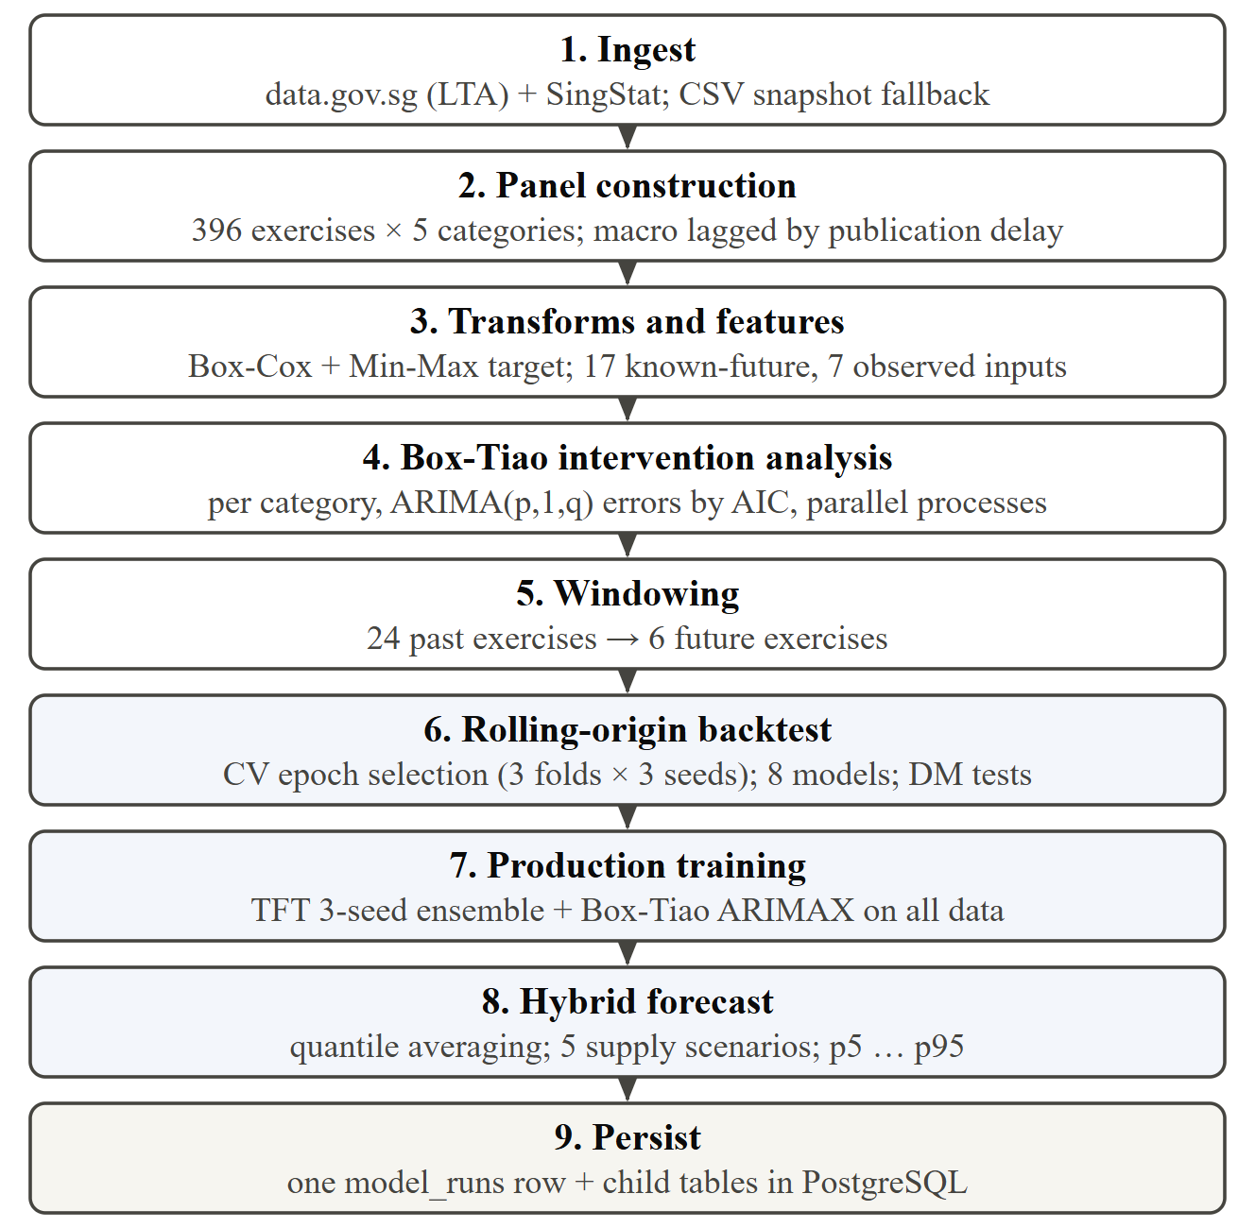
Fig. 3. Stages of the batch pipeline. Shaded stages fit models; the last stage stores every output of the run under one run identifier.

B. Data and Features
Bidding results come from the LTA dataset on data.gov.sg [34]: 1,980 rows covering 396 exercises from January 2010 to September 2026 in five categories, each with quota, bids received, successful bids and premium. The consumer price index, the 3-month compounded SORA and real GDP come from SingStat [35]. Each macroeconomic series is lagged by its publication delay (two months for CPI, which is released around the 23rd of the following month and therefore after both of that month’s exercises; one month for SORA; two months after the quarter for GDP), so that a forecast never uses a figure that was not yet public. A CSV snapshot of all raw data is stored in the image; if a download fails, the pipeline falls back to it.
Table I lists the 24 model inputs by TFT input type. Known-future inputs are those whose values are available over the forecast horizon: the quota for the rest of the current quota quarter is announced, the calendar is deterministic and policy start dates are public. The ten-year quota gap encodes the expiry cycle, because vehicles registered ten years earlier are the main source of current deregistrations and therefore of quota. Observed inputs include bidding pressure, measured as the log ratio of bids received to quota. The target is transformed per category with a Box-Cox transform [36] to stabilise its variance and is then scaled to the range 0 to 1. Transform parameters, feature scalers and intervention estimates are fitted on training rows only.
TABLE I
Model Inputs by TFT Input Type
Type | Variables | No.
Static | COE category (learned embedding) | 1
Known future | Log quota; quarter-on-quarter quota change; quota ten years earlier against now, with an availability flag; month of year (sine, cosine); first or second exercise of the month; position in the quota quarter; Box-Tiao policy effect; eight policy indicators | 17
Observed past | Scaled premium and its first difference; log bids per COE; share of quota allocated; CPI inflation; 3-month SORA; real GDP growth | 7
Known-future inputs feed both the encoder and the decoder; observed inputs feed the encoder only.

C. Box-Tiao Intervention Analysis
For each category we fit a regression with ARIMA errors to the Box-Cox premium y_{t}:
$y_{t} = \sum_{k}{}ω_{k}I_{k}(t) + N_{t}$ (1)
where I_{k}(t) is the indicator of event k (a step from its first bidding month, or a temporary level for the release of unallocated quota in 2020 and 2021), ω_{k} is its level shift and N_{t} follows an ARIMA(p, 1, q) process with p, q ≤ 2 chosen by AIC. An event is included only when at least 12 exercises precede it and 6 follow it in the fitting data. The five categories are fitted in parallel worker processes. Each ω_{k} is converted into a percentage effect relative to the mean level of the 12 exercises before the event (Table II), and the sum of ω_{k}I_{k}(t) becomes the policy effect input of the TFT. Indicators of events that cannot yet be estimated are set to zero, so that the network never receives an input whose weights were not trained.
Table II shows that the estimates are imprecise. With a differenced error process, a permanent step is identified mainly by the change at a single exercise, so most confidence intervals include zero. Of the 26 event-category effects only two are significant at the 5% level: the 2013 loan curbs on Cat E (−32.3%, interval −37.9% to −26.3%) and the release of unallocated quota in 2020 and 2021 on Cat D (+32.9%, interval 26.8% to 39.2%). For Cat A the point estimates have plausible signs, for example −10.8% for the loan curbs and −7.8% for the 2025 injection, but none is significant. The application therefore presents these numbers as estimated associations with their intervals and p-values, not as proven causal effects.
TABLE II
Policy Interventions and Box-Tiao Estimates for Cat A
ID | Event (first bidding month) | Cat. | Effect on Cat A, %  (95% interval) | p
P1 | MAS car-loan curbs (Mar 2013) | A, B, E | −10.8 (−23.3, 3.3) | 0.13
P2 | Cat A 97 kW power cap (Feb 2014) | A, B | −2.6 (−37.4, 46.7) | 0.90
P3 | MAS eases car loans (Jun 2016) | A, B, E | +16.7 (−32.0, 90.7) | 0.56
P4 | Zero vehicle growth (Feb 2018) | A, B, D, E | +4.6 (−24.8, 42.9) | 0.78
P5 | Post-lockdown quota release (Jul 2020 to Jun 2021) | A–E | +5.9 (−27.8, 51.6) | 0.76
P6 | EV reclassification to 110 kW (May 2022) | A, B | +3.9 (−29.7, 49.6) | 0.84
P7 | Quota cut-and-fill smoothing (May 2023) | A, B | −1.5 (−26.4, 30.0) | 0.92
P8 | 20,000-COE injection (Feb 2025) | A–E | −7.8 (−27.6, 16.3) | 0.50
Estimated on all data by the production run. Cat. lists the categories to which each indicator is applied.

D. Temporal Fusion Transformer
Fig. 4 shows the network, implemented from scratch in about 260 lines of PyTorch so that every block can be inspected and the image stays small. The category embedding passes through four gated residual networks (GRNs), which produce context vectors for variable selection (c_{s}), for the initial LSTM state (c_{h}, c_{c}) and for static enrichment (c_{e}). A variable selection network embeds each scalar input, processes it with its own GRN and combines the results with softmax weights, which also serve as a measure of variable importance. An LSTM encoder reads 24 past exercises and a decoder reads the six future steps; a gated skip connection, static enrichment and interpretable multi-head attention with a causal mask follow. The model has 88,120 parameters (hidden size 16, four attention heads, dropout 0.3).
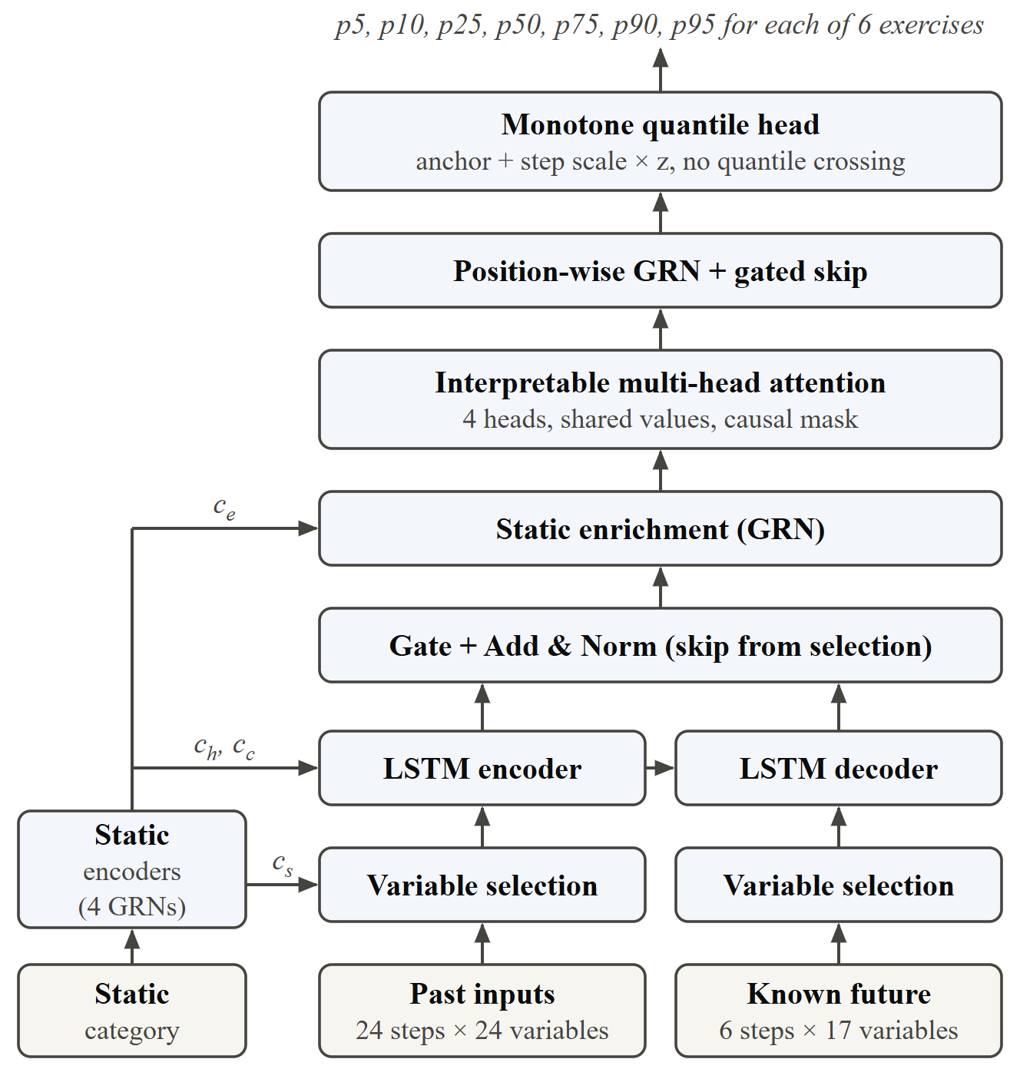
Fig. 4. The Temporal Fusion Transformer as implemented. Subscripts s, e, h and c denote the static context vectors for variable selection, enrichment and the initial LSTM hidden and cell states.
We depart from [12] in three ways, each motivated by the data. (i) Anchoring: the head predicts the change from the last observed premium, not its level. (ii) Random-walk scaling: the change is expressed in units of the typical h-step move s_{h}, estimated from the inter-decile range of training changes, and the output bias is initialised at standard normal quantiles. The forecast quantile at level τ and step h is
$ŷ_{t+h}(τ) = y_{t} + s_{h}z_{h}(τ)$ (2)
so an untrained network is exactly a random walk with intervals of the right width, and training only has to improve on the strongest simple baseline. (iii) Monotone head: z_{h}(τ) is built as a median plus or minus cumulative softplus increments, which guarantees p10 ≤ p50 ≤ p90 without post-processing. The network minimises the pinball loss
$ρ_{τ}(y, q) = max\{τ(y − q), (τ − 1)(y − q)\}$ (3)
averaged over seven quantile levels, six steps and all windows, with AdamW (learning rate 10⁻³, weight decay 10⁻⁴, batch size 64, gradient clipping at 1.0). Three seeds are trained in parallel and their quantiles averaged [22].

E. Hybrid Forecast and Decision Layer
The published forecast is the equal-weight average of the TFT quantiles and those of a Box-Tiao ARIMAX model (BT), taken in S$ after the transforms are inverted:
$q_{h}^{hyb}(τ) = \frac{1}{2}\left(q_{h}^{TFT}(τ) + q_{h}^{BT}(τ)\right)$ (4)
The weights are fixed in advance, so nothing is tuned on the test period, and an average of monotone quantile functions is itself monotone [21].
Four functions turn the quantiles into decision support. Market outlook: the probability that the premium six exercises ahead is below today’s, read from the forecast distribution, sets the outlook: “Downward pressure” at 65% or more, “Slight downward pressure” from 55%, the same two labels for a higher premium, and “No clear direction” otherwise. It is shown with its evidence: the chance of a drop of 8% or more (the saving the proposal treats as meaningful), the width of the 80% range, and the demand and quota drivers. The system does not issue buy or wait calls (Section IV-E). Bid planner: all winners pay the clearing premium, so a reserve price b wins whenever the premium does not exceed it:
$P(win | b) = P(y_{t+1} ≤ b) = F_{t+1}(b)$ (5)
where F_{t+1} is the forecast distribution, obtained by linear interpolation between the seven quantiles. Supply scenarios: the quota of the next, not yet announced, quota quarter is multiplied by 0.8, 0.9, 1.1 or 1.2 and the forecast is recomputed. Watchlist: anonymous target premiums are stored and scored again after every run.
The Ask Compass analyst is a side panel that answers questions about the numbers on screen. It is deliberately bounded: the browser sends only identifiers (page, category, scenario); the server rebuilds every figure from the database; calculations such as bid odds are done by server-side tools and not by the language model; actions are restricted to a whitelist; and any change to the watchlist requires confirmation by the user. Without an API key, or when the provider fails, a deterministic rule-based mode answers the same core questions.

F. Implementation and Deployment
In the pipeline of Fig. 3, independent work (one ARIMA search per category, one network per seed and fold) is distributed over worker processes started with the spawn method, which avoids the deadlocks that forked children can inherit from PyTorch thread pools. Table III summarises the containers. The API is written with FastAPI and exposes 19 documented routes; the front end is a dependency-free single-page application that draws its charts in SVG.
TABLE III
Containers and Kubernetes Objects
Service | Image and stack | Kubernetes objects
web | nginx:alpine; static SPA and reverse proxy (94 MB) | Deployment ×2; NodePort Service 30080; probes
api | Python 3.12, FastAPI, Uvicorn with 2 workers, SQLAlchemy (318 MB) | Deployment ×2 with rolling updates; Service; HPA 2–5 pods at 70% CPU; probes
db | postgres:16-alpine; 11 tables | Deployment ×1; 1 Gi PersistentVolumeClaim; Secret
ml | Python 3.12, PyTorch 2.5 (CPU), statsmodels, scikit-learn (1.87 GB) | Job for the first full run; CronJob every Wednesday 17:30 SGT
HPA: HorizontalPodAutoscaler. Images are built once and pushed to the MicroK8s registry at localhost:32000.
On Kubernetes, web and api run as two-replica Deployments behind Services with readiness and liveness probes, and the API is updated by rolling replacement with no unavailable pod. A HorizontalPodAutoscaler scales the API between two and five pods, PostgreSQL uses a persistent volume claim, a Job trains the first model, and a CronJob retrains every Wednesday evening after bidding closes. Bash scripts build the images, push them to the registry, create the database secret and apply the manifests with kustomize; others back up the database and trigger retraining.
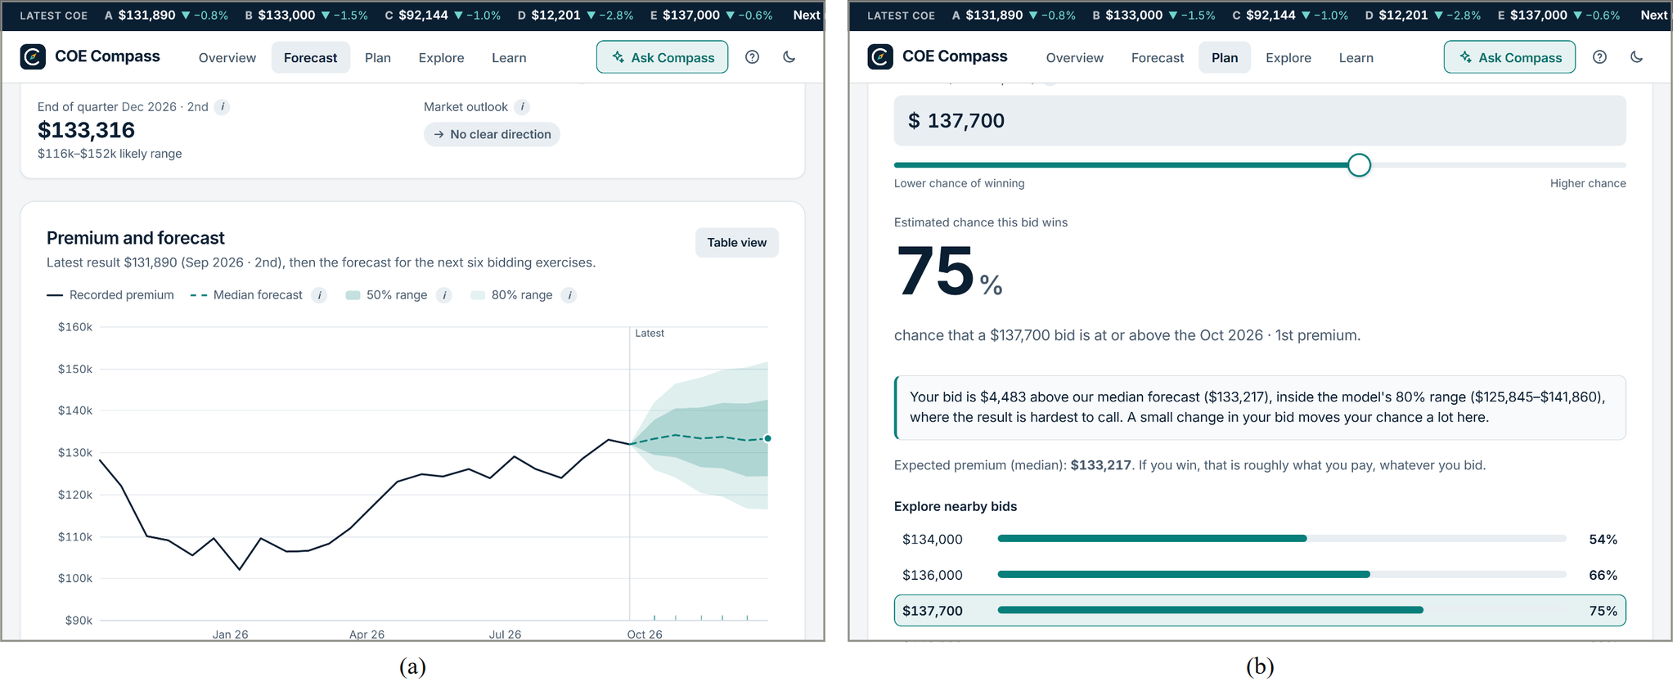
Fig. 5. The working prototype. (a) Forecast page: end-of-quarter median with its likely range, the market outlook, and the six-exercise fan chart with 50% and 80% ranges. (b) Bid planner: probability that a reserve price clears the next exercise.
Fig. 5(a) shows the forecast page for Cat A after the second exercise of September 2026: a median forecast of S$133,316 for the second exercise of December with a likely range of S$116k to S$152k, the market outlook “No clear direction”, and the fan chart from the latest premium of S$131,890 with shaded 50% and 80% ranges that widen with the horizon. Fig. 5(b) shows the bid planner: a reserve price of S$137,700 has a 75% chance of clearing the first exercise of October, and the page explains where the bid sits in the forecast range and gives the chance at nearby bids.

G. Verification
Correctness is checked at four levels: 20 unit tests of the feature pipeline and the networks (for example, that quantiles never cross, that attention is causal, that the Box-Tiao routine recovers a known level shift and that macroeconomic inputs respect their release dates), 73 API tests against a live database, 21 front-end unit tests and 79 browser end-to-end tests with Playwright. All 193 pass on the final build. Leakage is prevented structurally: one function fits every data-dependent quantity on a given panel and another applies it, so the backtest cannot use test rows by accident. It is also tested directly (Section IV-A).

IV. Experiment Evaluations and Performance Comparisons

A. Experimental Setup
All results come from pipeline run 39, with data up to the second exercise of September 2026. The last 72 exercises (October 2023 to September 2026) are held out; this period contains the collapse from the October 2023 peak, the 2025 quota injection and the rise of 2026 (Fig. 1). Nothing from it is used for scaling, Box-Tiao estimation, training or the choice of epochs. One exception concerns design rather than data: the TFT’s hyper-parameters (hidden size, dropout, learning rate) were picked in an earlier sweep that scored candidates on this same period, so the TFT’s scores may be slightly optimistic; the sweep script now scores on the three preceding years instead. A forecast is issued from each of 67 origins for one to six exercises ahead in five categories, which gives 2,010 forecast-outcome pairs per model. At each origin a model sees only data up to that origin, and future quota follows the production rule: the announced quota for the rest of the quarter, then no change.
Leakage checks. The protocol is also tested directly. Every premium, bid count and quota after a cut-off in the middle of the test period (the first exercise of April 2025), and every macroeconomic value from that month on, is multiplied by random noise between 0.3 and 3, and the backtest of the six base models is run again in a reduced configuration (three epochs, one seed, every sixth origin). All 1,260 forecasts issued up to the cut-off are bit-identical to those of the original run, while all 900 issued after it change, so the test would detect a model that used later data. A final code review against official release calendars found one timing error that such a test cannot see: CPI for a month is released around the 23rd of the following month, after both of that month’s exercises, but had been lagged by one month instead of two. With the corrected lag the full backtest moves the pooled pinball loss of the hybrid by S$0.03, of the TFT by S$0.07 and of gradient boosting by S$10 (0.5%), and no DM verdict changes (hybrid against the random walk: p = 0.74), so the results below, from run 39, stand.
The hybrid is compared with seven alternatives that receive the same information: a random walk with empirical intervals; ARIMA; ARIMAX with Box-Tiao indicators, which stands for the econometric approach of [9], [10]; gradient boosting with a quantile loss [23]; a sequence-to-sequence LSTM [17]; the TFT alone; and the TFT without any policy input, as an ablation. The metrics are those of Section II-C: pinball loss over p10, p50 and p90 in S$ (the primary metric), MAE and MAPE of the median, coverage of the 80% interval, directional accuracy (scored only when the median moves by more than 0.5%), and a DM test on the per-origin pinball loss expressed as a percentage of the premium, with a Newey-West variance of five lags.
The number of training epochs is chosen by cross-validation on three one-year folds that precede the test period (Fig. 6). The validation loss of the TFT is lowest after three epochs and rises steadily afterwards; without policy inputs the minimum is at two epochs, and for the much smaller LSTM (5,579 parameters) at seven. With 1,475 training windows the networks start to overfit almost immediately, a first sign that little structure beyond a random walk is available.
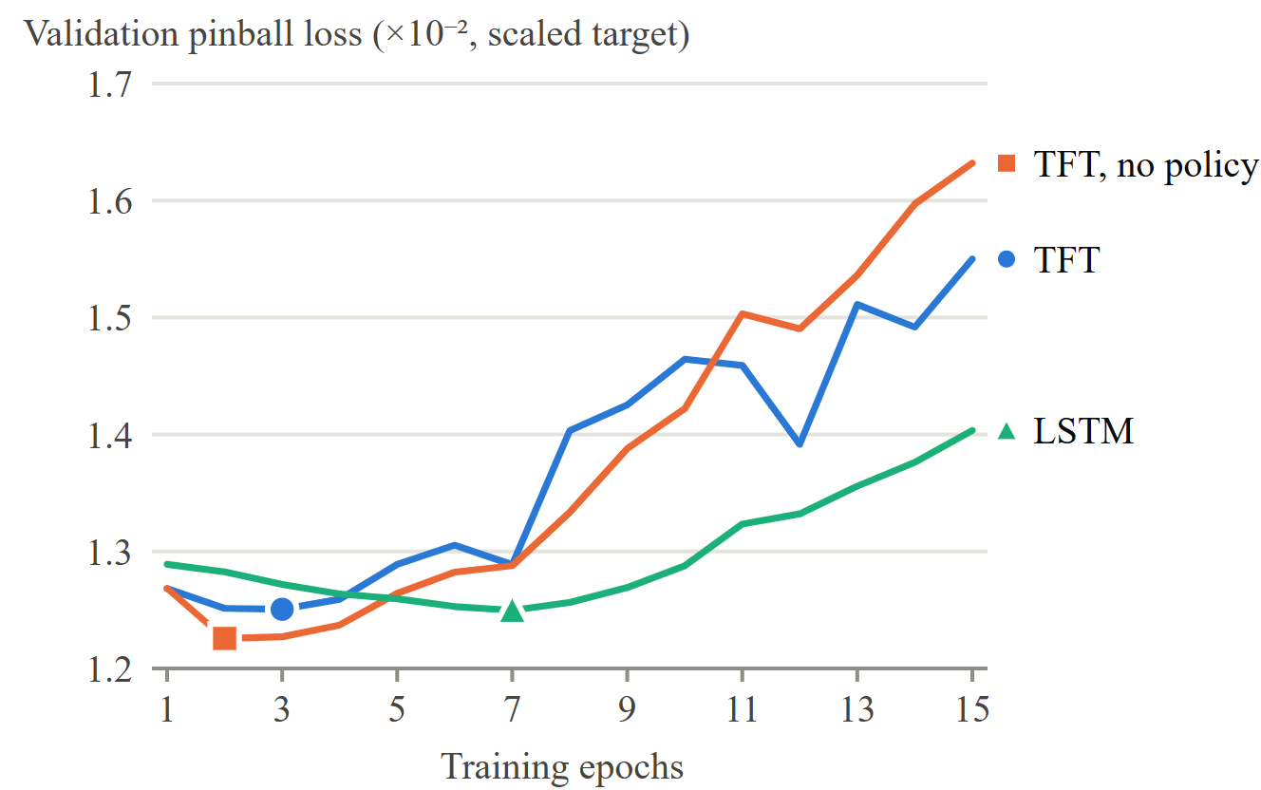
Fig. 6. Validation loss by training epoch, averaged over three rolling folds and three seeds. Large markers show the epoch count selected for each network.

B. Overall Accuracy
Table IV ranks the eight methods by pooled pinball loss. The hybrid is first with S$1,928, followed by the random walk (S$1,937) and ARIMA (S$1,948). It also has the lowest MAE (S$5,549 against S$5,640 for the random walk), the lowest MAPE (6.81%) and the highest directional accuracy (59.6%). Its 80% interval covers 87.9% of outcomes and is therefore somewhat wider than necessary; the ARIMA intervals are wider still (above 91%), whereas gradient boosting covers only 54.7%. The hybrid improves on both of its members, by 3.4% in pinball loss on the TFT and by 1.6% on the ARIMAX model.
TABLE IV
Out-of-Sample Accuracy, All Categories and Horizons (2,010 Forecasts per Model)
Model | Pinball  (S$) | MAE  (S$) | MAPE  (%) | Cov.  (%) | Dir.  (%) | DM p
Hybrid (ours) | 1,928 | 5,549 | 6.81 | 87.9 | 59.6 | –
Random walk | 1,937 | 5,640 | 6.85 | 86.7 | – | 0.74
ARIMA | 1,948 | 5,621 | 6.81 | 91.8 | 56.6 | 0.97
Seq2Seq LSTM | 1,958 | 5,631 | 7.02 | 83.0 | 56.9 | 0.24
ARIMAX + Box-Tiao | 1,959 | 5,665 | 6.84 | 91.4 | 57.0 | 0.89
TFT, no policy inputs | 1,982 | 5,702 | 7.10 | 84.1 | 56.9 | 0.07
TFT, policy inputs | 1,997 | 5,714 | 7.12 | 82.1 | 57.7 | 0.16
Gradient boosting | 2,125 | 6,028 | 7.15 | 54.7 | 54.4 | 0.29
Cov.: share of outcomes inside the 80% interval. Dir.: directional accuracy. DM p: two-sided Diebold-Mariano p-value against the hybrid.
These differences are small. The pinball loss of the hybrid is 0.45% below that of the random walk, and no DM test rejects equal accuracy at the 5% level: p = 0.74 against the random walk and p = 0.07 against the TFT without policy inputs, the closest case. On the percentage loss used by the test, which weights the five categories equally, the hybrid is 0.013 percentage points worse than the random walk. The correct reading is that the hybrid is the best-ranked method on S$ loss but is statistically indistinguishable from a random walk.
TABLE V
Hybrid Versus Each Rival: Pinball, MAE and MAPE Gaps and Diebold-Mariano Verdict
Model | Pinball gap  (S$) | MAE gap  (S$) | MAPE gap  (%) | DM p | Verdict
Hybrid (ours) | - | - | - | – | -
Random walk | -9 | -91 | -0.04 | 0.74 | Tie
ARIMA | -20 | -72 | 0.00 | 0.97 | Tie
Seq2Seq LSTM | -30 | -82 | -0.21 | 0.24 | Tie
ARIMAX + Box-Tiao | -31 | -116 | -0.03 | 0.89 | Tie
TFT, no policy inputs | -54 | -153 | -0.29 | 0.07 | Tie
TFT, policy inputs | -69 | -165 | -0.31 | 0.16 | Tie
Gradient boosting | -197 | -479 | -0.34 | 0.29 | Tie
Gap: hybrid minus rival, so a negative value means the hybrid has the lower error. pp: percentage points. DM p: two-sided Diebold-Mariano p-value against the hybrid on per-origin pinball loss. Verdict: Tie when p ≥ 0.05; a win or loss would need p < 0.05. All values from pipeline run 39, 2,010 forecasts per model.
Table V shows that the hybrid does not beat the random walk significantly, and a random walk with empirical intervals gives similar coverage, so the hybrid’s accuracy does not justify it. What it adds is the ability to respond to quota scenarios and to attach estimated policy effects. Compared with public COE tools, the project’s value lies in publishing its uncertainty and its backtest, which they do not.
On accuracy alone the hybrid is not worth building, because it ties the random walk. Its case rests on what it adds: quota scenarios, estimated policy effects, and a published backtest. We present it as a transparent decision tool, not as a more accurate forecaster.

C. Accuracy by Horizon and Category
Fig. 7 shows where the hybrid gains. One and two exercises ahead it is 1.4% and 1.0% worse than the random walk, and only the LSTM is marginally better (+0.7% at one step). From four exercises ahead the hybrid is better, by 0.7% to 1.9%. The ARIMAX model is poor at short horizons (−5.4% at one step) but positive at five and six exercises, and the TFT alone is below the random walk at every horizon; averaging the two cancels part of their errors.
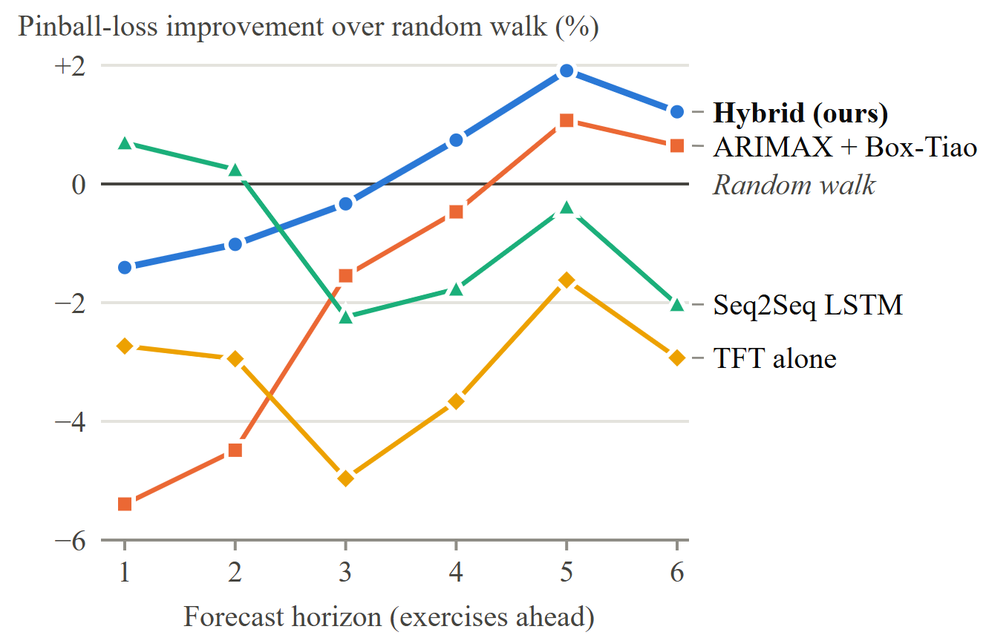
Fig. 7. Improvement in pinball loss over the random walk at each horizon (positive is better). ARIMA and gradient boosting (−22% at one step) are omitted for clarity.
By category (Table VI), the hybrid beats the random walk for Cat B (S$2,908 against S$2,975) and Cat C (S$1,385 against S$1,440) and is slightly worse for Cat A, Cat D and Cat E. No single method wins everywhere: an ARIMA variant is best for Cat A and Cat E, the hybrid for Cat B, the LSTM for Cat C and the random walk itself for Cat D. Coverage also varies, from 76.9% for Cat A to 96.0% for Cat C, so the intervals are slightly too narrow for Cat A and too wide for Cat C.
TABLE VI
Pinball Loss (S$) and Hybrid Coverage by Category
Cat. | Hybrid | Random walk | Best model (pinball) | Hybrid  cov. (%)
Cat A | 2,338 | 2,330 | ARIMAX + Box-Tiao (2,325) | 76.9
Cat B | 2,908 | 2,975 | Hybrid (ours) (2,908) | 86.6
Cat C | 1,385 | 1,440 | Seq2Seq LSTM (1,308) | 96.0
Cat D | 219 | 211 | Random walk (211) | 93.0
Cat E | 2,789 | 2,728 | ARIMA (2,722) | 87.1
402 forecasts per category and model.
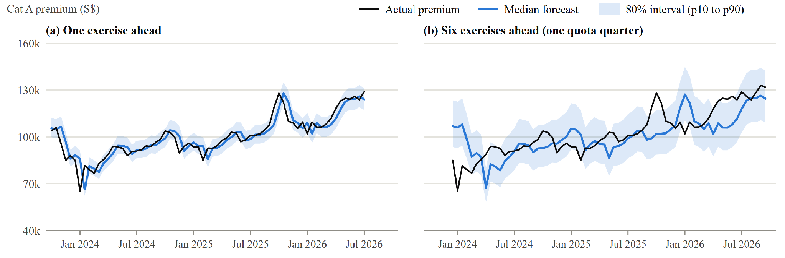
Fig. 8. Out-of-sample hybrid forecasts for Cat A against the realised premium at 67 forecast origins.
Fig. 8 shows what these numbers mean for Cat A. One exercise ahead, the median follows the realised premium with a lag of one step and the 80% band is narrow. Six exercises ahead the band is much wider and contains most outcomes, but the median again lags: it missed the fall from S$106,000 in October 2023 to S$65,010 in January 2024, which lies below the interval, and it followed the rise of late 2025 only after it had happened. Turning points are not predicted; what the model offers is an honest range.

D. Policy Inputs, Interpretability and Predictability
Value of the policy inputs. In run 39 the TFT has a pinball loss of S$1,997 with policy inputs and S$1,982 without them, but cross-validation gave the two versions different training lengths (three and two epochs), so that comparison mixes the policy inputs with training length. Re-run with the same number of epochs for both (two, three or four; three seeds each), the policy inputs lower the TFT’s pinball loss by 0.7%, 1.0% and 0.6%. A DM test finds the gain significant for Cat B and Cat D in all three settings and not for Cat A, C or E; pooled over categories it is significant at two and three epochs (p < 0.001) but not at four (p = 0.12). No TFT variant beats the random walk. For the econometric model, ARIMAX with interventions (S$1,959) is no better than plain ARIMA (S$1,948; DM p = 0.78). Two facts explain this. Seven of the eight events precede the test period, so their effect is already contained in the premium history that every model observes; and the one event inside it, the 2025 injection, cannot be estimated from the fitting data and is switched off by design. In this period, policy awareness gives the neural forecast at most a small, category-specific gain, and its main value is explanation, through the Policy Lab page.
Interpretability. Fig. 9 shows the variable-selection weights of the production TFT. Among past inputs the interest rate (SORA) receives 48.1% of the weight, far more than any other variable. Among known-future inputs the month of the year (23.8%) and the indicator of the 2025 injection (10.0%) lead, followed by the ten-year data flag and the quarterly quota change. Attention over the 24 past exercises is almost flat, with 4.0% to 4.3% on each lag, so no particular lag is singled out. Selection weights describe what the network attends to and not causal influence, and for a model trained for three epochs they should be read as indicative.
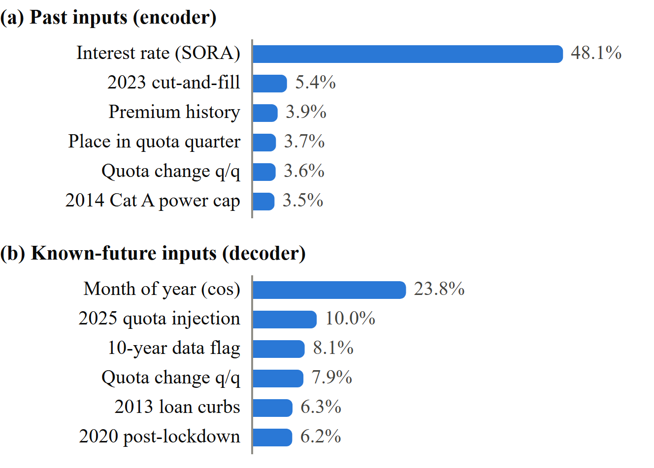
Fig. 9. Variable-selection weights of the production TFT, averaged over recent windows of all categories: the top six of 24 encoder inputs and of 17 decoder inputs.
Predictability. As a model-free check, a linear regression of the h-step log change on momentum, bidding pressure and quota changes, fitted before the test period, has an out-of-sample R² relative to a no-change forecast of 0.020, 0.009 and 0.030 at one, three and six exercises. At most 3% of the variance of premium changes is predictable from public data of this kind, which agrees with the narrow margins of Table IV.

E. Decision Layer and Scenarios
Across the 335 six-step forecasts of the test period the median was never more than 2.2% below the premium at the origin, so the 8% “wait” rule of the proposal was never triggered, although the premium did fall by 8% or more in 54 cases (16.1%). That rule would have presented a near coin flip as a confident “Buy now”, and a forecast of one cost component cannot settle a purchase decision in any case. We therefore replaced it with the market outlook of Section III-E, which states which way the odds lean and shows the evidence instead of a recommendation. In the current forecast all five categories read “No clear direction”, and the chance of a drop of 8% or more is 19% to 28%, of the same order as the 16.1% base rate. Supply scenarios move the forecast in the expected direction, but modestly: a 20% larger quota next quarter lowers the six-step median by 1.0% to 1.6%, and a 20% smaller quota raises it by 0.5% to 1.4%. The hybrid responds half as much as the TFT alone because its ARIMAX member does not use quota.

F. System Performance
Table VII reports measurements on a laptop running the Docker Compose stack. The complete pipeline, including the backtest and 27 cross-validation training jobs, took 344 to 457 s in the last three runs, so weekly retraining is inexpensive. The eight API endpoints that we timed had median latencies of 5.4–11.9 ms and 95th percentiles of at most 21.0 ms over 100 sequential requests each, because every response is read from pre-computed tables.
TABLE VII
Operational Measurements (Docker Compose, Laptop)
Measurement | Value
Full pipeline run, last three runs | 344–457 s
API median latency, 8 endpoints | 5.4–11.9 ms
API 95th-percentile latency | 7.8–21.0 ms
Image size: web / api / ml | 94 MB / 318 MB / 1.87 GB
Parameters: TFT / LSTM | 88,120 / 5,579
Tests passed: ML / API / UI unit / end-to-end | 20 / 73 / 21 / 79
Latency: 100 sequential requests per endpoint through nginx after warm-up.

G. Comparison With Existing Methods
Table VIII compares the system with the public tools reviewed in Section II-D, as observed on 1 October 2026. COE Compass is the only one that publishes prediction intervals and a multi-year backtest against several baselines, and the only one with a bid-level win probability. Quantitatively, our result agrees with the only other published out-of-sample test that we found: the SARIMA project [30] beats a naive forecast by at most 0.2 percentage points of MAPE in three categories and loses in two, and at the same one-step horizon our hybrid has a MAPE of 3.97% against 3.99% for the random walk. Both results indicate that a next-round point forecast of the COE premium can hardly be improved beyond the last premium, a fact that tools publishing a single number do not disclose. The contribution of our system is to state the uncertainty (S$116,388 to S$151,655 for Cat A in the second exercise of December 2026), to test it and to convert it into bid probabilities and a market outlook.
TABLE VIII
Comparison With Public COE Tools
Capability | Quota.sg  [5] | COE SG  [4] | SARIMA  [30] | This work
Forecast target | Quota; timing signal | Premium, next round | Premium, next round | Premium, six exercises
Prediction intervals | No | No | No | p5 to p95
Published backtest | No | No | 24 rounds | 72 exercises
Baselines compared | None | None | Naive | Seven
Policy events modelled | Quota injections | No | No | Eight events
Supply what-if | – | – | – | ±10%, ±20%
Bid win probability | – | – | – | Yes
A dash means that the feature was not offered on the public pages that we reviewed.

H. Usefulness and Market Value
For a private buyer the prototype answers questions that a price chart cannot: how likely a given reserve price is to win, how wide the plausible range is for the next quarter, and whether waiting has a realistic chance of saving money. Repeated buyers have more to gain. Dealers price packages that include a COE, and fleet and leasing operators renew many vehicles every year, so calibrated ranges and scenario budgets have recurring value for them. A commercial version would offer a time-limited pass for private buyers and an API with portfolio upload for dealers and fleets, with the public site serving as evidence of forecast quality. The LTA data are published under the Singapore Open Data Licence, which permits commercial reuse with attribution.

V. Conclusions
We built COE Compass, a cloud-native system that forecasts Singapore COE premiums in five categories six exercises ahead as probability distributions. It combines Box-Tiao intervention analysis, a Temporal Fusion Transformer with a random-walk-anchored monotone quantile head, and quantile averaging with an econometric model. In a three-year rolling-origin backtest the hybrid had the lowest pinball loss (S$1,928), MAE (S$5,549) and MAPE (6.81%) of eight methods and the best directional accuracy (59.6%), with 87.9% coverage of its 80% interval.
The main contributions are the hybrid policy-aware forecaster, an evaluation protocol that excludes leakage, verified by a scrambled-data test, and tests every claim against a naive benchmark, and a reproducible platform of four containers on Kubernetes that turns forecasts into a market outlook, bid probabilities, scenarios and explanations. Unlike existing tools, the system publishes its uncertainty and its own backtest.
The work has clear limitations. The advantage over a random walk is 0.45% and is not statistically significant, and turning points are not anticipated. Policy inputs gave the neural forecast at most a small gain, in Cat B and Cat D, and most Box-Tiao effects have wide confidence intervals. The TFT’s hyper-parameters were chosen on the test period, and the CPI input was lagged one month too little until a late code review, although correcting it changes no result (Section IV-A). The intervals are too wide on average and too narrow for Cat A. Each category has only 396 observations, and no data on deregistrations, vehicle population or dealer order books are used. Operationally, the database is a single replica, the watchlist cannot notify users when the site is closed, and the language-model path of the analyst was tested mainly with scripted clients.
Future work will (i) calibrate the intervals per category with adaptive conformal methods; (ii) add the LTA deregistration and vehicle-population series and the published quota schedule as inputs; (iii) keep a public ledger of forecasts issued before each exercise, so that accuracy is verified prospectively; (iv) evaluate the decision rule by regret in dollars and set its threshold on that basis; and (v) add push notifications, a managed database and a portfolio API for dealers and fleet operators.

Acknowledgment
This project uses COE bidding results published by the Land Transport Authority on data.gov.sg and statistics from the Singapore Department of Statistics, accessed under the Singapore Open Data Licence. It is an independent student project and is not endorsed by any government agency.

References
[1] W. T. H. Koh and D. K. C. Lee, “The vehicle quota system in Singapore: An assessment,” Transp. Res. A, Policy Pract., vol. 28, no. 1, pp. 31–47, Jan. 1994, doi: 10.1016/0965-8564(94)90040-X.
[2] S.-Y. Phang, W.-K. Wong, and N.-C. Chia, “Singapore’s experience with car quotas: Issues and policy processes,” Transp. Policy, vol. 3, no. 4, pp. 145–153, 1996.
[3] S. Chu, “Mitigating supply and price volatilities in Singapore’s vehicle quota system,” Transportation, vol. 41, no. 5, pp. 1119–1134, 2014, doi: 10.1007/s11116-014-9542-5.
[4] COE SG, “Singapore COE prices and predictions.” Accessed: Oct. 1, 2026. [Online]. Available: https://coe.com.sg
[5] Quota.sg, “Know the quota. Time your bid.” Accessed: Oct. 1, 2026. [Online]. Available: https://quota.sg
[6] W. T. H. Koh, “Control of vehicle ownership and market competition: Theory and Singapore’s experience with the vehicle quota system,” Transp. Res. A, Policy Pract., vol. 37, no. 9, pp. 749–770, Nov. 2003, doi: 10.1016/S0965-8564(03)00046-6.
[7] L. H. Tan, “Rationing rules and outcomes: The experience of Singapore’s vehicle quota system,” IMF Staff Pap., vol. 50, no. 3, pp. 436–457, 2003.
[8] S. Chu, “Allocation flexibility and price efficiency within Singapore’s vehicle quota system,” Transp. Res. A, Policy Pract., vol. 46, no. 10, pp. 1541–1550, Dec. 2012, doi: 10.1016/j.tra.2012.07.010.
[9] M. T. Hon and S. K. Yong, “The price of owning a car: An analysis of auction quota premium in Singapore,” Appl. Econ., vol. 36, no. 7, pp. 739–751, 2004, doi: 10.1080/0003684042000222115.
[10] Q. Meng, Z. Lu, and M. I. B. Ohtman, “Determinants of certificate of entitlement premium for cars under vehicle quota system in Singapore,” J. East. Asia Soc. Transp. Stud., vol. 11, pp. 126–140, 2015, doi: 10.11175/easts.11.126.
[11] G. E. P. Box and G. C. Tiao, “Intervention analysis with applications to economic and environmental problems,” J. Amer. Statist. Assoc., vol. 70, no. 349, pp. 70–79, Mar. 1975.
[12] B. Lim, S. Ö. Arık, N. Loeff, and T. Pfister, “Temporal fusion transformers for interpretable multi-horizon time series forecasting,” Int. J. Forecasting, vol. 37, no. 4, pp. 1748–1764, 2021, doi: 10.1016/j.ijforecast.2021.03.012.
[13] S. Makridakis, E. Spiliotis, and V. Assimakopoulos, “The M4 competition: 100,000 time series and 61 forecasting methods,” Int. J. Forecasting, vol. 36, no. 1, pp. 54–74, 2020.
[14] A. Zeng, M. Chen, L. Zhang, and Q. Xu, “Are transformers effective for time series forecasting?” in Proc. AAAI Conf. Artif. Intell., Washington, DC, USA, 2023, vol. 37, no. 9, pp. 11121–11128.
[15] N. Huang, J. Li, and A. Ross, “The impact of the cost of car ownership on the house price gradient in Singapore,” Reg. Sci. Urban Econ., vol. 68, pp. 160–171, Jan. 2018.
[16] G. E. P. Box, G. M. Jenkins, G. C. Reinsel, and G. M. Ljung, Time Series Analysis: Forecasting and Control, 5th ed. Hoboken, NJ, USA: Wiley, 2015.
[17] S. Hochreiter and J. Schmidhuber, “Long short-term memory,” Neural Comput., vol. 9, no. 8, pp. 1735–1780, Nov. 1997.
[18] D. Salinas, V. Flunkert, J. Gasthaus, and T. Januschowski, “DeepAR: Probabilistic forecasting with autoregressive recurrent networks,” Int. J. Forecasting, vol. 36, no. 3, pp. 1181–1191, 2020.
[19] A. Vaswani et al., “Attention is all you need,” in Adv. Neural Inf. Process. Syst., Long Beach, CA, USA, 2017, pp. 5998–6008.
[20] G. P. Zhang, “Time series forecasting using a hybrid ARIMA and neural network model,” Neurocomputing, vol. 50, pp. 159–175, Jan. 2003.
[21] K. C. Lichtendahl, Y. Grushka-Cockayne, and R. L. Winkler, “Is it better to average probabilities or quantiles?” Manage. Sci., vol. 59, no. 7, pp. 1594–1611, Jul. 2013.
[22] B. Lakshminarayanan, A. Pritzel, and C. Blundell, “Simple and scalable predictive uncertainty estimation using deep ensembles,” in Adv. Neural Inf. Process. Syst., Long Beach, CA, USA, 2017, pp. 6402–6413.
[23] J. H. Friedman, “Greedy function approximation: A gradient boosting machine,” Ann. Statist., vol. 29, no. 5, pp. 1189–1232, Oct. 2001.
[24] R. Koenker and G. Bassett, “Regression quantiles,” Econometrica, vol. 46, no. 1, pp. 33–50, Jan. 1978.
[25] T. Gneiting and A. E. Raftery, “Strictly proper scoring rules, prediction, and estimation,” J. Amer. Statist. Assoc., vol. 102, no. 477, pp. 359–378, Mar. 2007.
[26] R. J. Hyndman and A. B. Koehler, “Another look at measures of forecast accuracy,” Int. J. Forecasting, vol. 22, no. 4, pp. 679–688, 2006.
[27] L. J. Tashman, “Out-of-sample tests of forecasting accuracy: An analysis and review,” Int. J. Forecasting, vol. 16, no. 4, pp. 437–450, 2000.
[28] F. X. Diebold and R. S. Mariano, “Comparing predictive accuracy,” J. Bus. Econ. Statist., vol. 13, no. 3, pp. 253–263, Jul. 1995.
[29] W. K. Newey and K. D. West, “A simple, positive semi-definite, heteroskedasticity and autocorrelation consistent covariance matrix,” Econometrica, vol. 55, no. 3, pp. 703–708, May 1987.
[30] A. Lee, “coe-forecasting: SARIMA forecasts of COE prices,” GitHub repository. Accessed: Oct. 1, 2026. [Online]. Available: https://github.com/axellee1994/coe-forecasting
[31] D. Merkel, “Docker: Lightweight Linux containers for consistent development and deployment,” Linux J., vol. 2014, no. 239, Art. no. 2, Mar. 2014.
[32] B. Burns, B. Grant, D. Oppenheimer, E. Brewer, and J. Wilkes, “Borg, Omega, and Kubernetes,” Commun. ACM, vol. 59, no. 5, pp. 50–57, May 2016.
[33] D. Sculley et al., “Hidden technical debt in machine learning systems,” in Adv. Neural Inf. Process. Syst., Montreal, QC, Canada, 2015, pp. 2503–2511.
[34] Land Transport Authority, “COE bidding results / prices,” data.gov.sg. Accessed: Sep. 30, 2026. [Online]. Available: https://data.gov.sg/datasets/d_69b3380ad7e51aff3a7dcc84eba52b8a/view
[35] Singapore Department of Statistics, “SingStat Table Builder: Tables M213751, M700071 and M015661.” Accessed: Sep. 30, 2026. [Online]. Available: https://tablebuilder.singstat.gov.sg
[36] G. E. P. Box and D. R. Cox, “An analysis of transformations,” J. Roy. Statist. Soc. B, Methodol., vol. 26, no. 2, pp. 211–252, 1964.

Individual Workloads and Contributions
The project comprised six workstreams: (1) data ingestion and feature engineering; (2) Box-Tiao intervention analysis and the econometric baselines; (3) the TFT, training and backtesting; (4) the API, the market outlook and the Ask Compass analyst; (5) the web front end and automated tests; and (6) containerisation, Kubernetes deployment and operations scripts. Table IX lists the share of each member.
TABLE IX
Workload and Contributions of Each Member
Member | Workload and contributions
Andrei Loh Jun Jie | Policy-event audit: verified the dates of all eight interventions against LTA and MAS releases, judged the direction and 95% interval of all 26 Box-Tiao effects (Section III-C, Table II), and checked every app page and the analyst for leftover Buy/Wait wording.
Bernardino Realino Aryo Lintang | System lead: built the data pipeline, the Box-Tiao and TFT models, the baselines and backtest, the FastAPI service, web app and AI analyst, the Docker images, Kubernetes manifests and bash scripts; reworked the app into COE Compass; drafted the report and coordinated the evaluation tasks.
Leow Yu Xuan Chloe | Interval calibration: measured how often outcomes fall inside the 80% range, by category and horizon, on run 39 and on her own retrain, showing the ranges are slightly wide overall and too narrow only for Cat A (Section IV-C, Table VI).
Sarah Lim Ying Tong | Fairness checks: wrote the leakage test, which scrambles later data and confirms that earlier forecasts do not change, the bootstrap fairness statistics (skill interval, calibration, error by horizon) and the fairness_checks notebook, and reviewed the backtest for look-ahead (Section IV-A).
Tan Guan Ming Terence | Baseline comparison: compared the hybrid with all seven rivals on pinball loss, MAE and MAPE with Diebold-Mariano verdicts, added Table V and wrote its reading: the hybrid ties the random walk, so its value lies in decision support (Section IV-B).
Lionel Yee Jen Mok | Policy ablation: wrote scripts that rerun the TFT and ARIMA with and without policy inputs at equal training length and test each gap with Diebold-Mariano and Holm corrections, showing a small gain for Cat B and Cat D only (Section IV-D).

Reflections on the Learning Journey
Andrei Loh Jun Jie. [To be written by this member: what was learned during the project, in about 60 to 100 words.]
Bernardino Realino Aryo Lintang. [To be written by this member: what was learned during the project, in about 60 to 100 words.]
Leow Yu Xuan Chloe. [To be written by this member: what was learned during the project, in about 60 to 100 words.]
Sarah Lim Ying Tong. [To be written by this member: what was learned during the project, in about 60 to 100 words.]
Tan Guan Ming Terence. [To be written by this member: what was learned during the project, in about 60 to 100 words.]
Lionel Yee Jen Mok. [To be written by this member: what was learned during the project, in about 60 to 100 words.]

