Bernard John C. Del Rosario

FM 191

**Flow Chart**

A flow diagram, or flow diagram, is a graphical representation of a process or procedure that specifies the sequence of output steps required. A standard flow chart uses a set of simple symbols to represent different functions and shows the sequence and interconnection of lines and arrows functions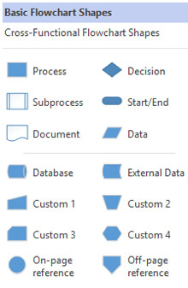. Flow charts can be used to track almost every type of business procedure, from the movement of goods through machinery in a manufacturing activity through the hiring process in a human resources department to the flow of applicant data.

Each flow chart is concerned with one particular process or system. It begins with the input of data or materials into the system and traces all the procedures needed to convert the input into its final output form. Specialized flow chart symbols show the processes that take place, the actions that are performed in each step, and the relationship between various steps. Flow charts may include different levels of detail as needed, from a high-level overview of an entire system to a detailed diagram of one component process within a larger system. In any case, the flow chart shows the overall structure of the process or system, traces the flow of information and work through it, and highlights key processing and decision points.

*Flow charts are an important tool for the improvement of processes. By providing a graphical representation, they help project teams to identify the different elements of a process and understand the interrelationships among the various steps. Flow charts may also be used to gather information and data about a process as an aid to decision making or performance evaluation. For example, the owner of a small advertising agency who hopes to reduce the time involved in creating a print ad might be able to use a flow chart of the process to identify and eliminate unnecessary steps. Though flow charts are relatively old design tools, they remain popular among computer programmers working on systems analysis and design. In recent years, many software programs have been developed to assist business people in creating flow charts*.(Harris, Robert L Information Graphics. Oxford University Press, 2000.)

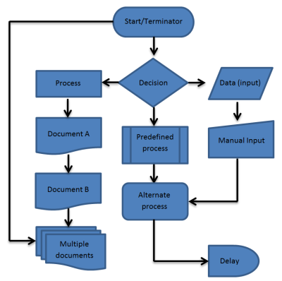

**Pseudocode**

Pseudocode is a detailed and understandable explanation of what a computer program or algorithm needs to do, presented in a natural language rather than a programming language that is formally designed. Pseudocode is sometimes used in the process of developing a program as a comprehensive phase. It allows developers and programmers to articulate the concept in great detail and provides programmers with a comprehensive framework in a particular programming language for the next stage of writing code.

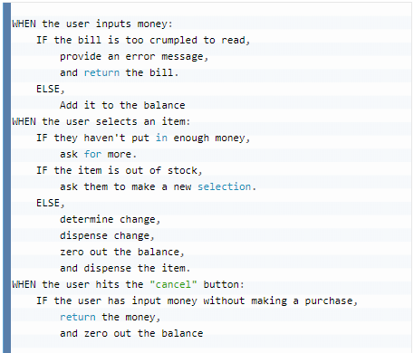

Identifying the central logic of a question is why, even after you've been creating for a long time, working in pseudocode is so useful. Many engineers who are trying to figure out a problem will take out the pen and paper or a dry erase board or pseudocode (aka Whiteboard) the problem first because it's easier to see all the moving parts that way and create a good solution.

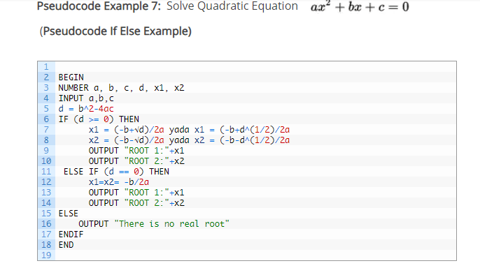

**References**

<http://www.vikingcodeschool.com/software-engineering-basics/what-is-pseudo-coding>

<https://www.inc.com/encyclopedia/flow-charts.html>

<https://www.google.com/search?q=what+is+flow+chart&rlz=1C1GCEA_enPH854PH854&source=lnms&tbm=isch&sa=X&ved=0ahUKEwjgs7W_lJPlAhXDF4gKHTeGB3AQ_AUIEigB&biw=1280&bih=577#imgrc=4JeKllLEYetYLM:>