Bernard Lampe
EECS 442, Fall 2009
Homework #4

The implementation of the Harris corner detector was accomplished using Matlab. Section 1 depicts the corner detections with associated algorithm parameters for both images at 3 different thresholds. Section 2 illustrates the local 2nd moments by plotting the ellipses at each pixel. Both images were illustrated at 4 different window sizes. The commented Matlab code is attached in section 3 below.

Section 1. Harris Corner Performance
The tables below show the performance of the Harris corner detector on each image (I1.png and I3.png). The detections are denoted by the green crosses.

Image 1 (I1.png)  Gaussian Sigma = 1.0  Window Size = 9 x 9 pixels  Threshold > 25% | 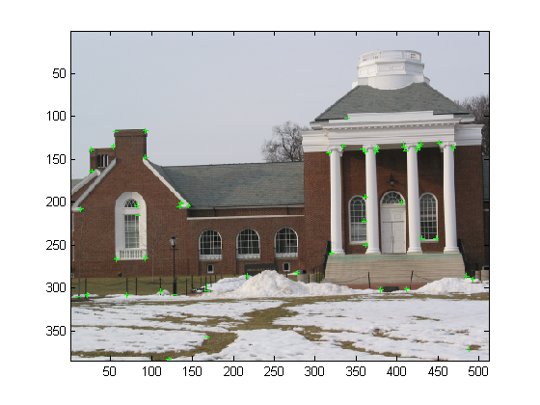
Image 1 (I1.png)  Gaussian Sigma = 1.0  Window Size = 9 x 9 pixels  Threshold > 15% | 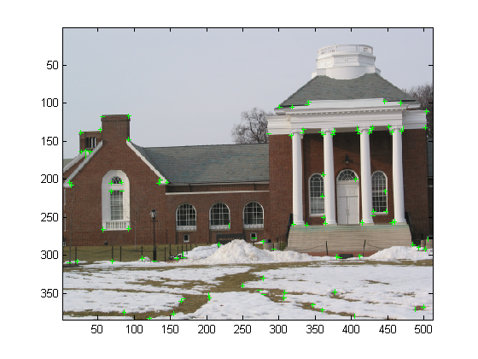
Image 1 (I1.png)  Gaussian Sigma = 1.0  Window Size = 9 x 9 pixels  Threshold > 5% | 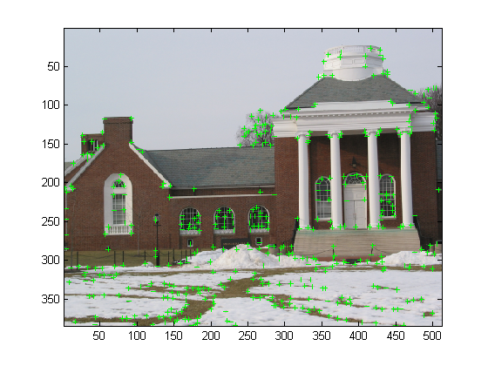
Table 1. Harris Corner Detector Results for Image 1 (I1.png)

Image 2 (I3.png)  Gaussian Sigma = 1.0  Window Size = 9 x 9 pixels  Threshold > 25% | 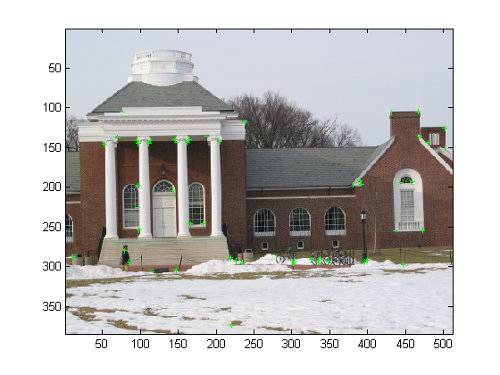
Image 2 (I3.png)  Gaussian Sigma = 1.0  Window Size = 9 x 9 pixels  Threshold > 15% | 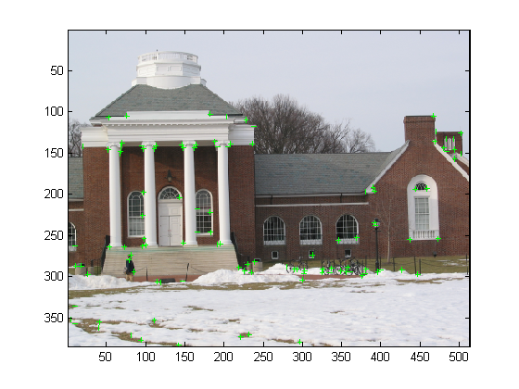
Image 2 (I3.png)  Gaussian Sigma = 1.0  Window Size = 9 x 9 pixels  Threshold > 5% | 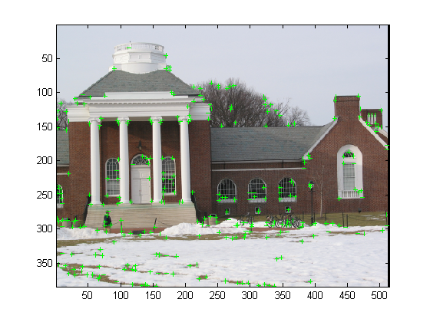
Table 2. Harris Corner Detector Results for Image 2 (I3.png)

Image 1 & 2 Detection Comments
The performance is as expected from the corner detector. I chose a standard deviation of 1.0 for the Gaussian smoothing because these images are fairly devoid of noise and I wanted to preserve the finer detail when extracting corners. If I had made the standard deviations larger, it would have changed the scale of the corners detected. This scale seems to do a good job on the building structures.

The thresholds are the quartiles of the R value distribution. The value of corner strength used by the Harris corner detector (R-values) is not intuitive when choosing a threshold. So I set the threshold as a percentage within the R values. This gave me a threshold that could be tuned from 0.0 to 1.0.

Finally the window size of 9 x 9 pixels was arrived at through empirical exploration. Small window sizes had more false positives because of the small variations in the trees, etc. Also, larger window sizes had more false negatives because some of the smaller corners were missed.

Section 2. 2nd Moment Matrix Illustrations
The tables below depict the 2nd moment matrices on each image. They are ‘zoomed-in’ so that the ellipses are clear. The ellipses were plotted for every other pixel to avoid over cluttering the illustration. Also, low gradient pixels were not plotted to avoid divergent ellipses that are really large due to eigenvalues near zero.
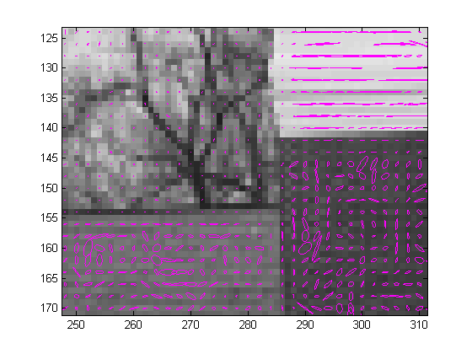  Window Size = 3 x 3 pixels | 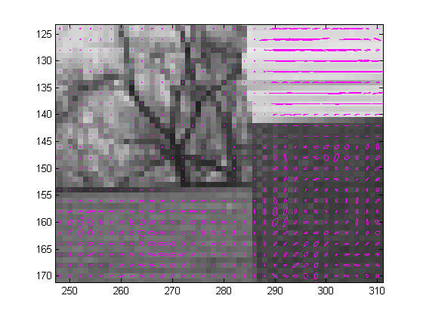  Window Size = 5 x 5 pixels
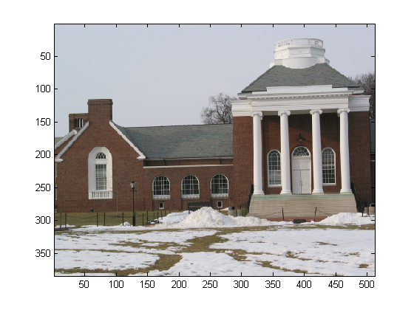  Image 1 (I1.png) with Subset Illustration | 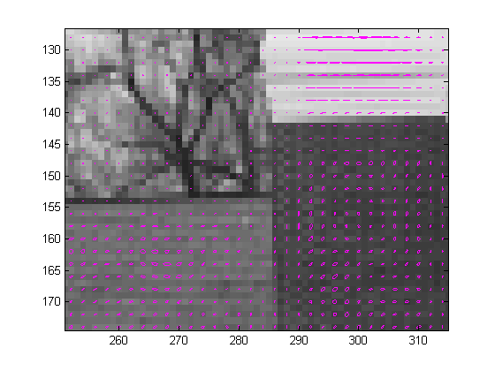  Window Size = 9 x 9 pixels
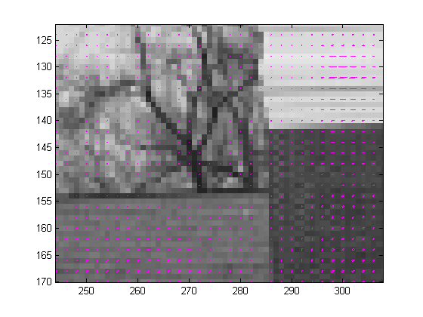
Window Size = 21 x 21 pixels
Table 3. Image 1 (I1.png) and Superimposed Ellipses of 2nd Moments

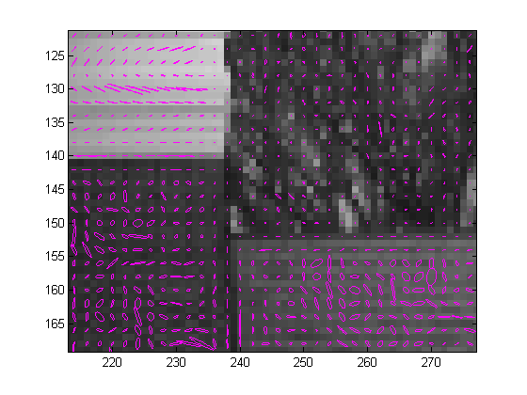  Window Size = 3 x 3 pixels | 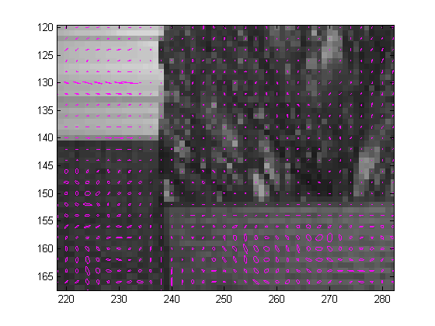  Window Size = 5 x 5 pixels
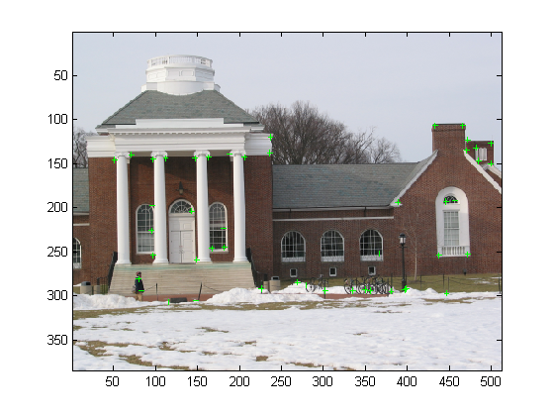  Image 1 (I1.png) with Subset Illustration | 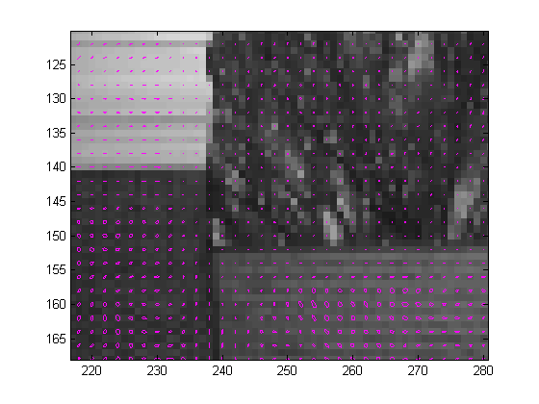  Window Size = 9 x 9 pixels
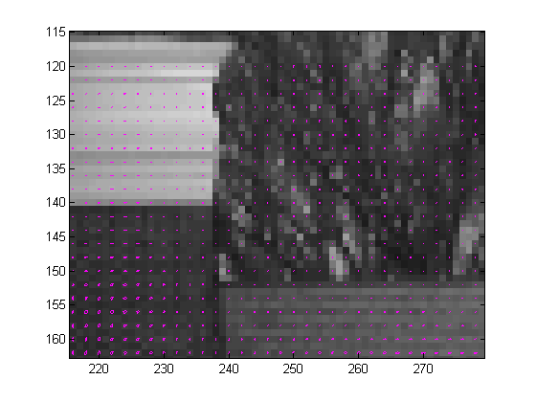
Window Size = 21 x 21 pixels
Table 4. Image 2 (I3.png) and Superimposed Ellipses of 2nd Moments
Image 1 & 2 2nd Moment Matrix Comments
Upon examining the effect of the window size of the second moments it is obvious that as the window size gets bigger the second moments begin to look isotropic. This implies that using a window too large will result in false negatives, because the local behavior of the corner will be overlooked for the global behavior. Also, as the window size becomes really large that second moments will tend to become very symmetric due to lack of detail. Conversely, windows which are too small may result in more false positives due to noise not accounted for during the Gaussian convolution. Optimally the window size would be predicated on the scale of what you are looking for or it would be biased to meet system tolerance levels for false positives and false negatives.

Section 3. Commented Matlab Code
% Bernard Lampe
% Homework #4

% Harris corner detection algorithm
% EECS 442, University of Michigan, Fall 2009
% Algorithm outlined in lecture 16, slide 51

% <arg1> = filename of the image
% <arg2> = std. dev. of the gaussian filter
% <arg3> = window size to compute the 2nd moment matricies
% <arg4> = threshold for corner detection [0,1]

function harris(fname, sigma, winSize, threshold)

% empirical constant per lecture 16, slide 49
k = 0.04;

% check the arguments
if nargin ~= 4
error('Usage: harris( <image filename> <sigma> <window size> <threshold>)');
end

% read in image file
Im = imread(fname);

% convert to grayscale
info = imfinfo(fname);
if strcmp(info.ColorType, 'grayscale')
Im_gray = Im;
else
Im_gray = rgb2gray(Im);
end

% cast to double for computation
Im_d = double(Im_gray);

% construct gaussian filter, use std. dev. passed in and
% make kernel size large enough to hold 3 standard deviations
ksize = 1 + 2 * ceil(2.5 * sigma);
gaus = fspecial('gaussian', ksize, sigma);

% convolve 2D image with gaussian filter
Im_gaus = imfilter(Im_d, gaus, 'symmetric', 'conv');

% compute the magnitude of the derivatives in the x direction
xfilt = [-1 0 1; -1 0 1; -1 0 1];
Im_dx = imfilter(Im_gaus, xfilt, 'replicate', 'conv');

% compute the magnitude of the derivatives in the y direction
yfilt = xfilt';
Im_dy = imfilter(Im_gaus, yfilt, 'replicate', 'conv');

% create squared derivative images (dx^2, dy^2)
Im_dx_2 = Im_dx.^2;
Im_dy_2 = Im_dy.^2;

% create image of cross derviaties
Im_dx_dy = Im_dx .* Im_dy;

% sum the entries about the window in each image using convolution
% use a gaussian window weighting with 3 std. devs. in the window
s = winSize / 5;
win = fspecial('gaussian', winSize, s);
Im_dx_2_sum = imfilter(Im_dx_2, win, 'replicate', 'conv');
Im_dy_2_sum = imfilter(Im_dy_2, win, 'replicate', 'conv');
Im_dx_dy_sum = imfilter(Im_dx_dy, win, 'replicate', 'conv');

% construct second moment matricies
M = zeros([size(Im_gray), 2, 2]);
[height, width] = size(Im_gray);
for h = 1:height
for w = 1:width
M(h, w, 1, 1) = Im_dx_2_sum(h, w);
M(h, w, 2, 2) = Im_dy_2_sum(h, w);
M(h, w, 1, 2) = Im_dx_dy_sum(h, w);
M(h, w, 2, 1) = Im_dx_dy_sum(h, w);
end
end

% compute the corner response values R = det(M(i,j)) - k * (trace(M(i,j))^2
% determinant M = eig(1) * eig(2)
% trace M = eig(1) + eig(2)
R = zeros(size(Im_gray));
for h = 1:height
for w = 1:width
m = reshape(M(h, w, :, :), 2, 2);
e = eig(m);
detM = e(1) * e(2); % compute determinant
traceM = e(1) + e(2); % compute trace
R(h, w) = detM - k * traceM * traceM; % compute corner response
end
end

% threshold R to compute corners
rmin = min(R);
rmax = max(R);
Im_th = zeros(height, width);
for h = 1:height
for w = 1:width
if R(h, w) > (rmax - rmin) * threshold + rmin;
Im_th(h, w) = R(h, w);
end
end
end

% find the image region peaks
Im_th = imregionalmax(Im_th);

% draw ellipses of the 2nd moment matricies on the image
figure;
imagesc(Im_gray);
colormap('gray');
hold on;
for h = 60:90
for w = 100:175
hp = 2 * h;
wp = 2 * w;

% get eigenvectors and values for this matrix
[V, D] = eig(reshape(M(hp, wp, :, :), 2, 2));

% only draw the regions with significant gradient
eps = 1e-5;
if ~(D(1,1) < eps || D(2,2) < eps)
W = V * 1/sqrt(D);
t = linspace(0, 2 * pi, 50);
plot(W(1,1) .* cos(t) + W(1,2) .* sin(t) + wp, ...
W(2,1) .* cos(t) + W(2,2) .* sin(t) + hp, 'm');
end
end
end

% draw a green colored cross at each location of a detection on the
% original image
for h = 1:height
for w = 1:width
if Im_th(h, w) > 0
Im = drawCross(Im, h, w, 3, 3, 0, 255, 0);
end
end
end

% display annotated image
figure;
imagesc(Im);

% draws a cross on the image
% assumes an RGB image

function Im = drawCross(Im, y, x, h, w, r, g, b)

% get image dimensions
[height width] = size(Im);

% draw the vertical line
for i = y - h: y + h
if i > 0 && i <= height
Im(i, x, 1) = r;
Im(i, x, 2) = g;
Im(i, x, 3) = b;
end
end

% draw the vertical line
for i = x - w: x + w
if i > 0 && i <= width
Im(y, i, 1) = r;
Im(y, i, 2) = g;
Im(y, i, 3) = b;
end
end

Source Code Comments
The source code contains a constant k which I set to 0.04 per the lectures slides. This is the empirical constant mentioned in the Harris detector. Also, I choose to use the Gaussian when constructing the second moment matrices. The Gaussian window function gave a better result because it avoided some of the discontinuities that arose in the corner response (R values) when using a square window.

