Bernard Lampe
EECS 442, Computer Vision
Homework #3
22 October 2009

Annotated images with correspondences.
Green cross indicates correct correspondence (inlier set).
Red circle indicates incorrect correspondence (outlier set).

Initially 60 correct image correspondences were chosen. Then 10 incorrect correspondences were generated by permuting the location of 10 correct correspondences in image #2. This resulted in 50 correct correspondences and 10 incorrect correspondences.

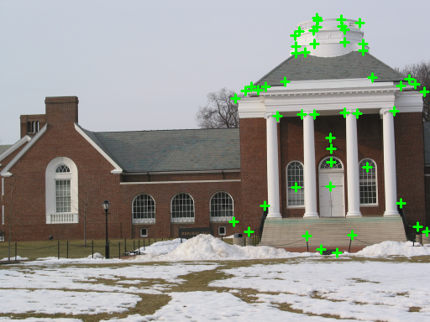  Image #1 (I1.png), correct correspondences. | 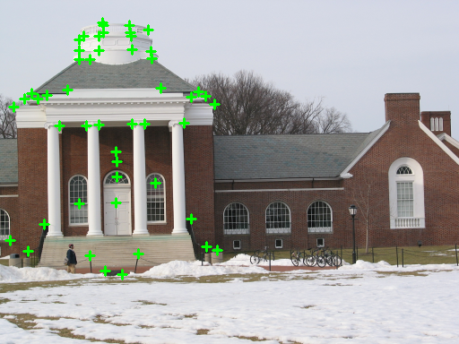  Image #2 (I3.png), correct correspondences.
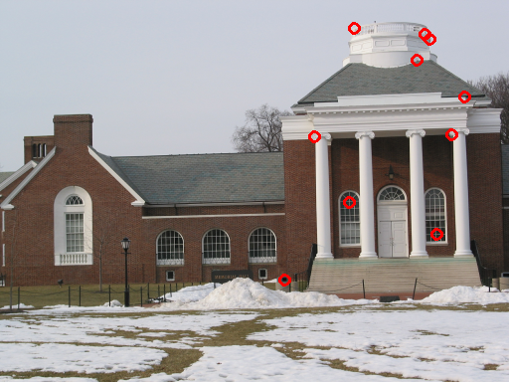  Image #1 (I1.png), incorrect correspondences. | 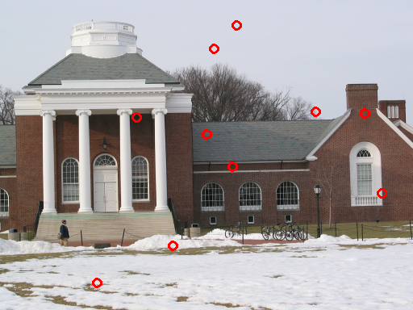  Image #2 (I3.png), incorrect correspondences.

Text output of RANSAC iterations.
------------------------------

Iteration #: 0

Number of Outliers: 20

Fitting Error: 33.3269

***** Found outlier set with minimum cardinality

------------------------------

Iteration #: 1

Number of Outliers: 10

Fitting Error: 20.3246

***** Found outlier set with minimum cardinality

------------------------------

Iteration #: 2

Number of Outliers: 56

Fitting Error: 2.49311e-12

------------------------------

Iteration #: 3

Number of Outliers: 55

Fitting Error: 5.13222

------------------------------

Iteration #: 4

Number of Outliers: 55

Fitting Error: 7.96795

Optimal Homography:

------------------------------

0.58987 -0.005181 -156.34

0.024112 0.57505 -6.7818

9.7246e-05 -8.4059e-06 0.54046

Summary:

------------------------------

Number of Inliers: 50

Number of Outliers: 10

Fitting Error: 20.325

Results Discussion

This project was implemented using C++ and openCV 2.0 API for image/point manipulation, linear algebra and matrix decompositions (SVD). The algorithm implementation was from “Multiple View Geometry in Computer Vision” by Hartley and Zisserman. The Homography function is the Normalized Direct Linear Transform Algorithm on page 109 (algorithm 4.2). The RANSAC portion was adapted from the Homography estimation on page 123 (algorithm 4.6).

I used the simple distance measure as suggested on page 124 where . In addition Hartley and Zisserman suggest randomly choosing samples that are spatially distributed and in a non-degenerate configuration. This functionality was not implemented in this homework. I believe that is why the output of the iterations above is so unstable. The cases with a large number of outliers were a result of a bad homography estimate due to the selection of 4 points of which 3 were on a line or where all 4 points were close together. These cases are frequent with this particular data set because the overlap between the images is small which makes the correspondences spatially dense in the images.

I chose a distance threshold of 12.5 because Harley and Zisserman recommend using a threshold of 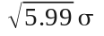. I estimated that the typical error in the process of choosing points by hand was about 4-5 pixels. Pixel inaccuracy is a result of the image resolution and the distance from the object. If you have fewer pixels then choosing an exact point becomes problematic because the objects are not resolved into a single pixel.

C++ code with comments.
This code utilizes openCV 2.0 API.

/* Bernard Lampe
EECS 442, Computer Vision
University of Michigan
Homework #3 */

/* This following code will automatically find
the outliers in the set of image correspondences.
It estimates the Homography using RANSAC.
It utilizes the opencv 2.0.0 API */

/* Usage:
./main
arg 1 = 2D points text file for first image
arg 2 = first image file
arg 3 = 2D points text file for second image
arg 4 = second image file
arg 5 = distance threshold */

#include<exception>
#include<iomanip>
#include<fstream>
#include<limits>
#include<iostream>
#include<vector>

using namespace std;

#include "cv.h"
#include "highgui.h"
#include "Exception.h"
#include "Error.h"
#include "Support.h"
#include "Normalize.h"
#include "Homography.h"
#include "Reject_Outliers.h"

int main(int argc, char **argv)
{
if (argc != 6)
{
cerr << argv[0] << " <ptsFile_img1.txt> <img1>"
<< " <ptsFile_img2.txt> <img2>"
<< " <distThresh>" << endl;
return(1);
}

try
{
// read the corresponding points files
vector<CvPoint3D64f> pts1, pts2;
readPtsFile(argv[1], pts1);
readPtsFile(argv[3], pts2);

// initialize the random number generator
srand(time(NULL));

// set distance threshold
double distThresh = atof(argv[5]);

// compute inlier and outlier sets using RANSAC
vector<int> inlierInds, outlierInds;
Reject_Outliers(pts1, pts2, distThresh, inlierInds, outlierInds);

// read image files
IplImage *img1 = cvLoadImage(argv[2]);
IplImage *img2 = cvLoadImage(argv[4]);
if (!img1 || !img2) throw Exception("could not load image files");

// set colors
CvScalar red = cvScalar(0, 0, 255);
CvScalar green = cvScalar(0, 255, 0);

// annotate images with inlier set
for(unsigned i = 0; i < inlierInds.size(); i++)
{
// draw green cross marks
drawCross(img1, pts1[inlierInds[i]], green, 5, 2);
drawCross(img2, pts2[inlierInds[i]], green, 5, 2);
}

// write annotated images
cvSaveImage("img1_inliers.png", img1);
cvSaveImage("img2_inliers.png", img2);

// free memory
cvReleaseImage(&img1);
cvReleaseImage(&img2);

// read image files
img1 = cvLoadImage(argv[2]);
img2 = cvLoadImage(argv[4]);
if (!img1 || !img2) throw Exception("could not load image files");

// annotate images with outlier set
for(unsigned i = 0; i < outlierInds.size(); i++)
{
drawCircle(img1, pts1[outlierInds[i]], red, 5, 2);
drawCircle(img2, pts2[outlierInds[i]], red, 5, 2);
}

// write annotated images
cvSaveImage("img1_outliers.png", img1);
cvSaveImage("img2_outliers.png", img2);

// free memory
cvReleaseImage(&img1);
cvReleaseImage(&img2);
}
catch(Exception &e)
{
cerr << "Error: " << e.what() << endl;
return(1);
}
catch(...)
{
cerr << "caught unhandled exception" << endl;
return(1);
}

return(0);
}

#ifndef _HOMOGRAPHY_H_
#define _HOMOGRAPHY_H_

/* Compute homography between both set of points.
Point sets passed in are modified. */
void Homography(
vector<CvPoint3D64f> &pts1, // set of image #1 points
vector<CvPoint3D64f> &pts2, // set of image #2 points
CvMat *H) // returned estimated homography
{
// check args
if (pts1.size() != pts2.size()) throw(Exception("vector arrays must have equal dimensions"));
if (pts1.size() < 4) throw(Exception("must specify >= 4 points to compute Homography"));

// normalize points
CvMat *T1, *T2;
T1 = normalizePts(pts1);
T2 = normalizePts(pts2);

// compose constraint matrix
CvMat *A = cvCreateMat(3 * pts1.size(), 9, CV_64FC1);
cvSetZero(A);
for(unsigned i = 0; i < pts1.size(); i++)
{
// [ 0^T -w'*x^T y'*x^T ]
cvmSet(A, 3 * i, 3, -pts2[i].z * pts1[i].x);
cvmSet(A, 3 * i, 4, -pts2[i].z * pts1[i].y);
cvmSet(A, 3 * i, 5, -pts2[i].z * pts1[i].z);
cvmSet(A, 3 * i, 6, pts2[i].y * pts1[i].x);
cvmSet(A, 3 * i, 7, pts2[i].y * pts1[i].y);
cvmSet(A, 3 * i, 8, pts2[i].y * pts1[i].z);

// [ w'*x^T 0^T -x'*x^T ]
cvmSet(A, 3 * i + 1, 0, pts2[i].z * pts1[i].x);
cvmSet(A, 3 * i + 1, 1, pts2[i].z * pts1[i].y);
cvmSet(A, 3 * i + 1, 2, pts2[i].z * pts1[i].z);
cvmSet(A, 3 * i + 1, 6, -pts2[i].x * pts1[i].x);
cvmSet(A, 3 * i + 1, 7, -pts2[i].x * pts1[i].y);
cvmSet(A, 3 * i + 1, 8, -pts2[i].x * pts1[i].z);

// [ -y'*x^T x'*x^T 0^T ]
cvmSet(A, 3 * i + 2, 0, -pts2[i].y * pts1[i].x);
cvmSet(A, 3 * i + 2, 1, -pts2[i].y * pts1[i].y);
cvmSet(A, 3 * i + 2, 2, -pts2[i].y * pts1[i].z);
cvmSet(A, 3 * i + 2, 3, pts2[i].x * pts1[i].x);
cvmSet(A, 3 * i + 2, 4, pts2[i].x * pts1[i].y);
cvmSet(A, 3 * i + 2, 5, pts2[i].x * pts1[i].z);
}

// solve A = U D V^T
CvMat *U = cvCreateMat(3 * pts1.size(), 9, CV_64FC1);
CvMat *D = cvCreateMat(9, 9, CV_64FC1);
CvMat *V = cvCreateMat(9, 9, CV_64FC1);
cvSVD(A, D, U, V, CV_SVD_U_T | CV_SVD_V_T);

// construct Hp as last row of V^T
int j = 0;
CvMat *Hp = cvCreateMat(3, 3, CV_64FC1);
for(int i = 0; i < 3; i++)
{
cvmSet(Hp, i, 0, cvmGet(V, 8, j++));
cvmSet(Hp, i, 1, cvmGet(V, 8, j++));
cvmSet(Hp, i, 2, cvmGet(V, 8, j++));
}

// H = T2^-1 * Hp * T1
CvMat *T2inv = cvCreateMat(3, 3, CV_64FC1);
CvMat *temp = cvCreateMat(3, 3, CV_64FC1);

cvInvert(T2, T2inv);
cvMatMul(T2inv, Hp, temp);
cvMatMul(temp, T1, H);

// free memory
cvReleaseMat(&T1); cvReleaseMat(&T2); cvReleaseMat(&T2inv); cvReleaseMat(&temp);
cvReleaseMat(&A); cvReleaseMat(&U); cvReleaseMat(&D); cvReleaseMat(&V);
cvReleaseMat(&Hp);
}

#endif // _HOMOGRAPHY_H_

#ifndef _REJECT_OUTLIERS_H_
#define _REJECT_OUTLIERS_H_

/* Use RANSAC to find the set of outliers.
Implementation from "Multiple View Geometry in Computer Vision",
Hartley and Zisserman. Algorithm 4.6. */
void Reject_Outliers(
const vector<CvPoint3D64f> &pts1, // image #1 point set
const vector<CvPoint3D64f> &pts2, // image #2 point set
const double &distThresh, // distance threshold
vector<int> &inlierInds, // return set of inlier indicies for point set #1
vector<int> &outlierInds) // return set of outliers indicies for point set #2
{
// check args
if (pts1.size() != pts2.size()) throw(Exception("vector arrays must have equal dimensions"));
if (pts1.size() < 4) throw(Exception("must specify >= 4 points to compute Homography"));

// clear return vectors
inlierInds.clear();
outlierInds.clear();

// get number of correspondences
int numPts = pts1.size();

// initialize high watermark and set optError = inf.
unsigned optNumInliers = 0;
double optError = numeric_limits<double>::max();

// compute number of iterations to ensure sample set
// of only inliers is chosen at probability = 95%
int N = int(ceil(log(1.0 - 0.95) / log(1.0 - pow(0.83, 4.0)))); // assume 50 inliers to 10 outliers

// iterate and find consensus set
for(int i = 0; i < N; i++)
{
// choose a random sample of size 4
vector<CvPoint3D64f> pts1p, pts2p;
for(int j = 0; j < 4; j++)
{
int ind = rand() % numPts;
pts1p.push_back(pts1[ind]);
pts2p.push_back(pts2[ind]);
}

// compute Homography
CvMat *H = cvCreateMat(3, 3, CV_64FC1);
Homography(pts1p, pts2p, H);

// compute two-way error
vector<int> inliers, outliers;
double error = computeError(H, distThresh, pts1, pts2, inliers, outliers);

// print out the stats for this iteration
cout << "------------------------------" << endl;
cout << "Iteration #: " << i << endl;
cout << "Number of Outliers: " << outliers.size() << endl;
cout << "Fitting Error: " << error << endl;

// keep model with largest number of inliers and min error
if (inliers.size() >= optNumInliers && error < optError)
{
// print status
cout << "***** Found outlier set with minimum cardinality" << endl;

// keep the best model
optNumInliers = inliers.size();
optError = error;

// keep track of best out/in liers sets
outlierInds = outliers;
inlierInds = inliers;
}

// release memory
cvReleaseMat(&H);
}

// compute optimal homography from inlier set
CvMat *optH = cvCreateMat(3, 3, CV_64FC1);
vector<CvPoint3D64f> pts1p, pts2p;
for(unsigned i = 0; i < inlierInds.size(); i++)
{
int ind = inlierInds[i];
pts1p.push_back(pts1[ind]);
pts2p.push_back(pts2[ind]);
}
Homography(pts1p, pts2p, optH);

// print out best fit homography
cout << endl << "Optimal Homography:" << endl;
cout << "------------------------------" << endl;
PrintMat(optH);

// print out summary of best fit
cout << "Summary:" << endl;
cout << "------------------------------" << endl;
cout << "Number of Inliers: " << inlierInds.size() << endl;
cout << "Number of Outliers: " << outlierInds.size() << endl;
cout << "Fitting Error: " << optError << endl;

// release memory
cvReleaseMat(&optH);
}

#endif // _REJECT_OUTLIERS_H_

#ifndef _ERROR_H_
#define _ERROR_H_

/* Compute two-way error.
error = sqrt( d(x, H^-1 * x')^2 + d(x', H * x)^2 ) */
double computeError(
const CvMat *H, // estimate homography
const double &t, // distance threshold
const vector<CvPoint3D64f> &pts1, // set of image #1 points
const vector<CvPoint3D64f> &pts2, // set of image #2 points
vector<int> &inlierInds, // set of pts indicies of inliers
vector<int> &outlierInds) // set of pts indicies of outliers
{
// clear returning vectors
inlierInds.clear();
outlierInds.clear();

// compute inverse of H
CvMat *Hinv = cvCreateMat(3, 3, CV_64FC1);
cvInvert(H, Hinv);

// compute two-way error
CvPoint3D64f p;
double e, error = 0;
for(unsigned i = 0; i < pts1.size(); i++)
{
// compute p = H * x
p.x = cvmGet(H, 0, 0) * pts1[i].x + cvmGet(H, 0, 1) * pts1[i].y + cvmGet(H, 0, 2) * pts1[i].z;
p.y = cvmGet(H, 1, 0) * pts1[i].x + cvmGet(H, 1, 1) * pts1[i].y + cvmGet(H, 1, 2) * pts1[i].z;
p.z = cvmGet(H, 2, 0) * pts1[i].x + cvmGet(H, 2, 1) * pts1[i].y + cvmGet(H, 2, 2) * pts1[i].z;

// perspective projection
p.x /= p.z; p.y /= p.z; p.z /= p.z;

// p = p - x'
p.x -= pts2[i].x; p.y -= pts2[i].y; p.z -= pts2[i].z;

// compute ||p - x'||^2
double m1 = p.x * p.x + p.y * p.y + p.z * p.z;

// compute p = H^-1 * x'
p.x = cvmGet(Hinv, 0, 0) * pts2[i].x + cvmGet(Hinv, 0, 1) * pts2[i].y + cvmGet(Hinv, 0, 2) * pts2[i].z;
p.y = cvmGet(Hinv, 1, 0) * pts2[i].x + cvmGet(Hinv, 1, 1) * pts2[i].y + cvmGet(Hinv, 1, 2) * pts2[i].z;
p.z = cvmGet(Hinv, 2, 0) * pts2[i].x + cvmGet(Hinv, 2, 1) * pts2[i].y + cvmGet(Hinv, 2, 2) * pts2[i].z;

// perspective projection
p.x /= p.z; p.y /= p.z; p.z /= p.z;

// p = p - x'
p.x -= pts1[i].x; p.y -= pts1[i].y; p.z -= pts1[i].z;

// compute ||p - x||^2
double m2 = p.x * p.x + p.y * p.y + p.z * p.z;

// error is sqrt of d(x, H^-1 * x')^2 + d(x', H * x)^2
e = sqrt(m1 + m2);

// compute inlier/outlier sets
if (e < t)
{
inlierInds.push_back(i);

// accumulate fitting error
error += m1 + m2;
}
else
{
outlierInds.push_back(i);
}
}

// release memory
cvReleaseMat(&Hinv);

// fitting error = sqrt( sum( |x2 - H*x1|^2 + |x1 - H^-1|^2 ) );
return(sqrt(error));
}

#endif // _ERROR_H_

#ifndef _NORMALIZE_H_
#define _NORMALIZE_H_

/* Normalize points so that origin is points centroid and
the mean distance from the origin is sqrt(2).
Return the similarity transform */
CvMat* normalizePts(
vector<CvPoint3D64f> &pts) // set of points to normalize
{
// get centroid of points
double c_x = 0;
double c_y = 0;
for(unsigned i = 0; i < pts.size(); i++) { c_x += pts[i].x; c_y += pts[i].y; }
c_x /= double(pts.size()); c_y /= double(pts.size());

// translate points so origin is points centroids
for(unsigned i = 0; i < pts.size(); i++) { pts[i].x -= c_x; pts[i].y -= c_y; }

// get the mean distance
double dist = 0;
for(unsigned i = 0; i < pts.size(); i++) { dist += sqrt(pts[i].x * pts[i].x + pts[i].y * pts[i].y); }
dist /= double(pts.size());

// compute scale factor
double scale = sqrt(2.0) / dist;

// scale points
for(unsigned i = 0; i < pts.size(); i++) { pts[i].x *= scale; pts[i].y *= scale; }

// construct similarity transform
CvMat *T = cvCreateMat(3, 3, CV_64FC1);
cvSetIdentity(T);
cvmSet(T, 0, 0, scale);
cvmSet(T, 1, 1, scale);
cvmSet(T, 0, 2, -scale * c_x);
cvmSet(T, 1, 2, -scale * c_y);

return(T);
}

#endif // _NORMALIZE_H_

#ifndef _EXCEPTION_H_
#define _EXCEPTION_H_

/* used to report errors */
class Exception: public exception
{
private:
string mes;

public:
Exception(const char *s): mes(s) { }
virtual ~Exception() throw() { }
virtual const char* what() const throw() { return(mes.c_str()); }
};

#endif //_EXCEPTION_H_

#ifndef _SUPPORT_H_
#define _SUPPORT_H_

/* read the points */
void readPtsFile(const char *fname, vector<CvPoint3D64f> &pts)
{
ifstream is;
int numPts;
double x, y;

// clear return vector
pts.clear();

is.open(fname);
if (!is.good()) throw Exception("could not open pts file");

// first line is number of points
is >> numPts;

// read points in "col row" format and store as (x, y, 1.0)
for(int i = 0; i < numPts; i++) { is >> x >> y; pts.push_back(cvPoint3D64f(x, y, 1.0)); }

is.close();
}

/* print matrix to standard out for analysis */
void PrintMat(CvMat *Fp)
{
for(int i = 0; i < Fp->height; i++)
{
for(int j = 0; j < Fp->width; j++)
{
cout << setw(15) << setprecision(5) << cvmGet(Fp, i, j) << " ";
}
cout << endl;
}

cout << endl;
}

/* draw a cross on the image */
void drawCross(IplImage *img, CvPoint3D64f &p, CvScalar &color, int l, int thick)
{
cvLine(img, cvPoint(p.x - l, p.y), cvPoint(p.x + l, p.y), color, thick);
cvLine(img, cvPoint(p.x, p.y - l), cvPoint(p.x, p.y + l), color, thick);
}

/* draw a circle on the image */
void drawCircle(IplImage *img, CvPoint3D64f &p, CvScalar &color, int d, int thick)
{
cvCircle(img, cvPoint(p.x, p.y), d, color, thick);
}

#endif // _SUPPORT_H_

