<https://statistics.laerd.com/spss-tutorials/dependent-t-test-using-spss-statistics.php>

<https://www.statisticshowto.com/probability-and-statistics/t-test/>

Paired sample t-test, level of significance 0.05

H0: mean of static – mean of dynamic = 0

H1: mean of static – mean of dynamic < 0

P-value < 0.05 reject the null hypothesis

P-value > 0.05 accept the null hypothesis

5000_5000_s_v_d_non_scaled

LR no samp.

|  |  |  |  |  |  |
| --- | --- | --- | --- | --- | --- |
| **Paired Samples Statistics** | | | | | |
|  | | Mean | N | Std. Deviation | Std. Error Mean |
| Pair 1 | static | .7015 | 35 | .02543 | .00430 |
| dynamic | .7166 | 35 | .01992 | .00337 |

|  |  |  |  |  |
| --- | --- | --- | --- | --- |
| **Paired Samples Correlations** | | | | |
|  | | N | Correlation | Sig. |
| Pair 1 | static & dynamic | 35 | .960 | .000 |

|  |  |  |  |  |  |  |  |  |  |  |
| --- | --- | --- | --- | --- | --- | --- | --- | --- | --- | --- |
| **Paired Samples Test** | | | | | | | | | | |
|  | | Paired Differences | | | | | t | df | Sig. (2-tailed) |
| Mean | Std. Deviation | Std. Error Mean | 95% Confidence Interval of the Difference | |
| Lower | Upper |
| Pair 1 | static - dynamic | -.01508 | .00843 | .00142 | -.01797 | -.01218 | -10.587 | 34 | .000 |

|  |  |  |  |  |  |  |
| --- | --- | --- | --- | --- | --- | --- |
| **Paired Samples Effect Sizes** | | | | | | |
|  | | | Standardizera | Point Estimate | 95% Confidence Interval | |
| Lower | Upper |
| Pair 1 | static - dynamic | Cohen's d | .00843 | -1.790 | -2.322 | -1.247 |
| Hedges' correction | .00852 | -1.770 | -2.296 | -1.233 |
| a. The denominator used in estimating the effect sizes.  Cohen's d uses the sample standard deviation of the mean difference.  Hedges' correction uses the sample standard deviation of the mean difference, plus a correction factor. | | | | | | |

5000_5000_s_v_d_non_scaled

LR RU.

|  |  |  |  |  |  |
| --- | --- | --- | --- | --- | --- |
| **Paired Samples Statistics** | | | | | |
|  | | Mean | N | Std. Deviation | Std. Error Mean |
| Pair 1 | static | .7031 | 35 | .02677 | .00452 |
| dynamic | .7185 | 35 | .01805 | .00305 |

|  |  |  |  |  |
| --- | --- | --- | --- | --- |
| **Paired Samples Correlations** | | | | |
|  | | N | Correlation | Sig. |
| Pair 1 | static & dynamic | 35 | .954 | .000 |

|  |  |  |  |  |  |  |  |  |  |
| --- | --- | --- | --- | --- | --- | --- | --- | --- | --- |
| **Paired Samples Test** | | | | | | | | | |
|  | | Paired Differences | | | | | t | df | Sig. (2-tailed) |
| Mean | Std. Deviation | Std. Error Mean | 95% Confidence Interval of the Difference | |
| Lower | Upper |
| Pair 1 | static - dynamic | -.01543 | .01098 | .00186 | -.01920 | -.01166 | -8.317 | 34 | .000 |

|  |  |  |  |  |  |  |
| --- | --- | --- | --- | --- | --- | --- |
| **Paired Samples Effect Sizes** | | | | | | |
|  | | | Standardizera | Point Estimate | 95% Confidence Interval | |
| Lower | Upper |
| Pair 1 | static - dynamic | Cohen's d | .01098 | -1.406 | -1.870 | -.931 |
| Hedges' correction | .01110 | -1.390 | -1.849 | -.921 |
| a. The denominator used in estimating the effect sizes.  Cohen's d uses the sample standard deviation of the mean difference.  Hedges' correction uses the sample standard deviation of the mean difference, plus a correction factor. | | | | | | |

5000_5000_s_v_d_non_scaled

LR SM.

|  |  |  |  |  |  |
| --- | --- | --- | --- | --- | --- |
| **Paired Samples Statistics** | | | | | |
|  | | Mean | N | Std. Deviation | Std. Error Mean |
| Pair 1 | static | .7029 | 35 | .02901 | .00490 |
| dynamic | .7174 | 35 | .02062 | .00348 |

|  |  |  |  |  |
| --- | --- | --- | --- | --- |
| **Paired Samples Correlations** | | | | |
|  | | N | Correlation | Sig. |
| Pair 1 | static & dynamic | 35 | .962 | .000 |

|  |  |  |  |  |  |  |  |  |  |
| --- | --- | --- | --- | --- | --- | --- | --- | --- | --- |
| **Paired Samples Test** | | | | | | | | | |
|  | | Paired Differences | | | | | t | df | Sig. (2-tailed) |
| Mean | Std. Deviation | Std. Error Mean | 95% Confidence Interval of the Difference | |
| Lower | Upper |
| Pair 1 | static - dynamic | -.01456 | .01076 | .00182 | -.01826 | -.01087 | -8.004 | 34 | .000 |

|  |  |  |  |  |  |  |
| --- | --- | --- | --- | --- | --- | --- |
| **Paired Samples Effect Sizes** | | | | | | |
|  | | | Standardizera | Point Estimate | 95% Confidence Interval | |
| Lower | Upper |
| Pair 1 | static - dynamic | Cohen's d | .01076 | -1.353 | -1.808 | -.887 |
| Hedges' correction | .01088 | -1.338 | -1.788 | -.877 |
| a. The denominator used in estimating the effect sizes.  Cohen's d uses the sample standard deviation of the mean difference.  Hedges' correction uses the sample standard deviation of the mean difference, plus a correction factor. | | | | | | |

5000_5000_s_v_d_non_scaled

LR SM.BL 1

|  |  |  |  |  |  |
| --- | --- | --- | --- | --- | --- |
| **Paired Samples Statistics** | | | | | |
|  | | Mean | N | Std. Deviation | Std. Error Mean |
| Pair 1 | static | .7052 | 35 | .02722 | .00460 |
| dynamic | .7183 | 35 | .02006 | .00339 |

|  |  |  |  |  |
| --- | --- | --- | --- | --- |
| **Paired Samples Correlations** | | | | |
|  | | N | Correlation | Sig. |
| Pair 1 | static & dynamic | 35 | .961 | .000 |

|  |  |  |  |  |  |  |  |  |  |
| --- | --- | --- | --- | --- | --- | --- | --- | --- | --- |
| **Paired Samples Test** | | | | | | | | | |
|  | | Paired Differences | | | | | t | df | Sig. (2-tailed) |
| Mean | Std. Deviation | Std. Error Mean | 95% Confidence Interval of the Difference | |
| Lower | Upper |
| Pair 1 | static - dynamic | -.01310 | .00968 | .00164 | -.01642 | -.00977 | -8.003 | 34 | .000 |

|  |  |  |  |  |  |  |
| --- | --- | --- | --- | --- | --- | --- |
| **Paired Samples Effect Sizes** | | | | | | |
|  | | | Standardizera | Point Estimate | 95% Confidence Interval | |
| Lower | Upper |
| Pair 1 | static - dynamic | Cohen's d | .00968 | -1.353 | -1.808 | -.887 |
| Hedges' correction | .00979 | -1.338 | -1.788 | -.877 |
| a. The denominator used in estimating the effect sizes.  Cohen's d uses the sample standard deviation of the mean difference.  Hedges' correction uses the sample standard deviation of the mean difference, plus a correction factor. | | | | | | |

5000_5000_s_v_d_non_scaled

LR SM.BL 2

|  |  |  |  |  |  |
| --- | --- | --- | --- | --- | --- |
| **Paired Samples Statistics** | | | | | |
|  | | Mean | N | Std. Deviation | Std. Error Mean |
| Pair 1 | static | .7064 | 35 | .02654 | .00449 |
| dynamic | .7178 | 35 | .02042 | .00345 |

|  |  |  |  |  |
| --- | --- | --- | --- | --- |
| **Paired Samples Correlations** | | | | |
|  | | N | Correlation | Sig. |
| Pair 1 | static & dynamic | 35 | .966 | .000 |

|  |  |  |  |  |  |  |  |  |  |
| --- | --- | --- | --- | --- | --- | --- | --- | --- | --- |
| **Paired Samples Test** | | | | | | | | | |
|  | | Paired Differences | | | | | t | df | Sig. (2-tailed) |
| Mean | Std. Deviation | Std. Error Mean | 95% Confidence Interval of the Difference | |
| Lower | Upper |
| Pair 1 | static - dynamic | -.01149 | .00861 | .00146 | -.01444 | -.00853 | -7.892 | 34 | .000 |

|  |  |  |  |  |  |  |
| --- | --- | --- | --- | --- | --- | --- |
| **Paired Samples Effect Sizes** | | | | | | |
|  | | | Standardizera | Point Estimate | 95% Confidence Interval | |
| Lower | Upper |
| Pair 1 | static - dynamic | Cohen's d | .00861 | -1.334 | -1.786 | -.871 |
| Hedges' correction | .00871 | -1.319 | -1.767 | -.861 |
| a. The denominator used in estimating the effect sizes.  Cohen's d uses the sample standard deviation of the mean difference.  Hedges' correction uses the sample standard deviation of the mean difference, plus a correction factor. | | | | | | |

5000_5000_s_v_d_non_scaled

LR RO

|  |  |  |  |  |  |
| --- | --- | --- | --- | --- | --- |
| **Paired Samples Statistics** | | | | | |
|  | | Mean | N | Std. Deviation | Std. Error Mean |
| Pair 1 | static | .7061 | 35 | .02652 | .00448 |
| dynamic | .7188 | 35 | .01945 | .00329 |

|  |  |  |  |  |
| --- | --- | --- | --- | --- |
| **Paired Samples Correlations** | | | | |
|  | | N | Correlation | Sig. |
| Pair 1 | static & dynamic | 35 | .960 | .000 |

|  |  |  |  |  |  |  |  |  |  |
| --- | --- | --- | --- | --- | --- | --- | --- | --- | --- |
| **Paired Samples Test** | | | | | | | | | |
|  | | Paired Differences | | | | | t | df | Sig. (2-tailed) |
| Mean | Std. Deviation | Std. Error Mean | 95% Confidence Interval of the Difference | |
| Lower | Upper |
| Pair 1 | static - dynamic | -.01265 | .00957 | .00162 | -.01593 | -.00936 | -7.815 | 34 | .000 |

|  |  |  |  |  |  |  |
| --- | --- | --- | --- | --- | --- | --- |
| **Paired Samples Effect Sizes** | | | | | | |
|  | | | Standardizera | Point Estimate | 95% Confidence Interval | |
| Lower | Upper |
| Pair 1 | static - dynamic | Cohen's d | .00957 | -1.321 | -1.771 | -.860 |
| Hedges' correction | .00968 | -1.306 | -1.752 | -.851 |
| a. The denominator used in estimating the effect sizes.  Cohen's d uses the sample standard deviation of the mean difference.  Hedges' correction uses the sample standard deviation of the mean difference, plus a correction factor. | | | | | | |

5000_5000_s_v_d_non_scaled

RF no samp.

|  |  |  |  |  |  |
| --- | --- | --- | --- | --- | --- |
| **Paired Samples Statistics** | | | | | |
|  | | Mean | N | Std. Deviation | Std. Error Mean |
| Pair 1 | static | .7024 | 35 | .02104 | .00356 |
| dynamic | .7134 | 35 | .01788 | .00302 |

|  |  |  |  |  |
| --- | --- | --- | --- | --- |
| **Paired Samples Correlations** | | | | |
|  | | N | Correlation | Sig. |
| Pair 1 | static & dynamic | 35 | .949 | .000 |

|  |  |  |  |  |  |  |  |  |  |
| --- | --- | --- | --- | --- | --- | --- | --- | --- | --- |
| **Paired Samples Test** | | | | | | | | | |
|  | | Paired Differences | | | | | t | df | Sig. (2-tailed) |
| Mean | Std. Deviation | Std. Error Mean | 95% Confidence Interval of the Difference | |
| Lower | Upper |
| Pair 1 | static - dynamic | -.01095 | .00694 | .00117 | -.01334 | -.00857 | -9.338 | 34 | .000 |

|  |  |  |  |  |  |  |
| --- | --- | --- | --- | --- | --- | --- |
| **Paired Samples Effect Sizes** | | | | | | |
|  | | | Standardizera | Point Estimate | 95% Confidence Interval | |
| Lower | Upper |
| Pair 1 | static - dynamic | Cohen's d | .00694 | -1.578 | -2.072 | -1.074 |
| Hedges' correction | .00702 | -1.561 | -2.049 | -1.062 |
| a. The denominator used in estimating the effect sizes.  Cohen's d uses the sample standard deviation of the mean difference.  Hedges' correction uses the sample standard deviation of the mean difference, plus a correction factor. | | | | | | |

5000_5000_s_v_d_non_scaled

RF RU.

|  |  |  |  |  |  |
| --- | --- | --- | --- | --- | --- |
| **Paired Samples Statistics** | | | | | |
|  | | Mean | N | Std. Deviation | Std. Error Mean |
| Pair 1 | static | .7042 | 35 | .02359 | .00399 |
| dynamic | .7138 | 35 | .01942 | .00328 |

|  |  |  |  |  |
| --- | --- | --- | --- | --- |
| **Paired Samples Correlations** | | | | |
|  | | N | Correlation | Sig. |
| Pair 1 | static & dynamic | 35 | .967 | .000 |

|  |  |  |  |  |  |  |  |  |  |
| --- | --- | --- | --- | --- | --- | --- | --- | --- | --- |
| **Paired Samples Test** | | | | | | | | | |
|  | | Paired Differences | | | | | t | df | Sig. (2-tailed) |
| Mean | Std. Deviation | Std. Error Mean | 95% Confidence Interval of the Difference | |
| Lower | Upper |
| Pair 1 | static - dynamic | -.00964 | .00689 | .00117 | -.01201 | -.00728 | -8.278 | 34 | .000 |

|  |  |  |  |  |  |  |
| --- | --- | --- | --- | --- | --- | --- |
| **Paired Samples Effect Sizes** | | | | | | |
|  | | | Standardizera | Point Estimate | 95% Confidence Interval | |
| Lower | Upper |
| Pair 1 | static - dynamic | Cohen's d | .00689 | -1.399 | -1.862 | -.925 |
| Hedges' correction | .00697 | -1.384 | -1.842 | -.915 |
| a. The denominator used in estimating the effect sizes.  Cohen's d uses the sample standard deviation of the mean difference.  Hedges' correction uses the sample standard deviation of the mean difference, plus a correction factor. | | | | | | |

5000_5000_s_v_d_non_scaled

RF SM

|  |  |  |  |  |  |
| --- | --- | --- | --- | --- | --- |
| **Paired Samples Statistics** | | | | | |
|  | | Mean | N | Std. Deviation | Std. Error Mean |
| Pair 1 | static | .6951 | 35 | .02268 | .00383 |
| dynamic | .7133 | 35 | .02003 | .00339 |

|  |  |  |  |  |
| --- | --- | --- | --- | --- |
| **Paired Samples Correlations** | | | | |
|  | | N | Correlation | Sig. |
| Pair 1 | static & dynamic | 35 | .954 | .000 |

|  |  |  |  |  |  |  |  |  |  |  |
| --- | --- | --- | --- | --- | --- | --- | --- | --- | --- | --- |
| **Paired Samples Test** | | | | | | | | | | |
|  | | Paired Differences | | | | | t | df | Sig. (2-tailed) |
| Mean | Std. Deviation | Std. Error Mean | 95% Confidence Interval of the Difference | |
| Lower | Upper |
| Pair 1 | static - dynamic | -.01816 | .00697 | .00118 | -.02056 | -.01577 | -15.406 | 34 | .000 |

|  |  |  |  |  |  |  |
| --- | --- | --- | --- | --- | --- | --- |
| **Paired Samples Effect Sizes** | | | | | | |
|  | | | Standardizera | Point Estimate | 95% Confidence Interval | |
| Lower | Upper |
| Pair 1 | static - dynamic | Cohen's d | .00697 | -2.604 | -3.299 | -1.900 |
| Hedges' correction | .00705 | -2.575 | -3.262 | -1.879 |
| a. The denominator used in estimating the effect sizes.  Cohen's d uses the sample standard deviation of the mean difference.  Hedges' correction uses the sample standard deviation of the mean difference, plus a correction factor. | | | | | | |

.

5000_5000_s_v_d_non_scaled

RF SM BL 1

|  |  |  |  |  |  |
| --- | --- | --- | --- | --- | --- |
| **Paired Samples Statistics** | | | | | |
|  | | Mean | N | Std. Deviation | Std. Error Mean |
| Pair 1 | static | .6971 | 35 | .02405 | .00406 |
| dynamic | .7111 | 35 | .02047 | .00346 |

|  |  |  |  |  |
| --- | --- | --- | --- | --- |
| **Paired Samples Correlations** | | | | |
|  | | N | Correlation | Sig. |
| Pair 1 | static & dynamic | 35 | .952 | .000 |

|  |  |  |  |  |  |  |  |  |  |
| --- | --- | --- | --- | --- | --- | --- | --- | --- | --- |
| **Paired Samples Test** | | | | | | | | | |
|  | | Paired Differences | | | | | t | df | Sig. (2-tailed) |
| Mean | Std. Deviation | Std. Error Mean | 95% Confidence Interval of the Difference | |
| Lower | Upper |
| Pair 1 | static - dynamic | -.01398 | .00774 | .00131 | -.01664 | -.01132 | -10.684 | 34 | .000 |

|  |  |  |  |  |  |  |
| --- | --- | --- | --- | --- | --- | --- |
| **Paired Samples Effect Sizes** | | | | | | |
|  | | | Standardizera | Point Estimate | 95% Confidence Interval | |
| Lower | Upper |
| Pair 1 | static - dynamic | Cohen's d | .00774 | -1.806 | -2.341 | -1.260 |
| Hedges' correction | .00783 | -1.786 | -2.316 | -1.246 |
| a. The denominator used in estimating the effect sizes.  Cohen's d uses the sample standard deviation of the mean difference.  Hedges' correction uses the sample standard deviation of the mean difference, plus a correction factor. | | | | | | |

5000_5000_s_v_d_non_scaled

RF SM BL 2

|  |  |  |  |  |  |
| --- | --- | --- | --- | --- | --- |
| **Paired Samples Statistics** | | | | | |
|  | | Mean | N | Std. Deviation | Std. Error Mean |
| Pair 1 | static | .6964 | 35 | .02404 | .00406 |
| dynamic | .7109 | 35 | .01958 | .00331 |

|  |  |  |  |  |
| --- | --- | --- | --- | --- |
| **Paired Samples Correlations** | | | | |
|  | | N | Correlation | Sig. |
| Pair 1 | static & dynamic | 35 | .956 | .000 |

|  |  |  |  |  |  |  |  |  |  |
| --- | --- | --- | --- | --- | --- | --- | --- | --- | --- |
| **Paired Samples Test** | | | | | | | | | |
|  | | Paired Differences | | | | | t | df | Sig. (2-tailed) |
| Mean | Std. Deviation | Std. Error Mean | 95% Confidence Interval of the Difference | |
| Lower | Upper |
| Pair 1 | static - dynamic | -.01452 | .00783 | .00132 | -.01721 | -.01183 | -10.967 | 34 | .000 |

|  |  |  |  |  |  |  |
| --- | --- | --- | --- | --- | --- | --- |
| **Paired Samples Effect Sizes** | | | | | | |
|  | | | Standardizera | Point Estimate | 95% Confidence Interval | |
| Lower | Upper |
| Pair 1 | static - dynamic | Cohen's d | .00783 | -1.854 | -2.398 | -1.299 |
| Hedges' correction | .00792 | -1.833 | -2.372 | -1.284 |
| a. The denominator used in estimating the effect sizes.  Cohen's d uses the sample standard deviation of the mean difference.  Hedges' correction uses the sample standard deviation of the mean difference, plus a correction factor. | | | | | | |

5000_5000_s_v_d_non_scaled

RF RO

|  |  |  |  |  |  |
| --- | --- | --- | --- | --- | --- |
| **Paired Samples Statistics** | | | | | |
|  | | Mean | N | Std. Deviation | Std. Error Mean |
| Pair 1 | static | .7042 | 35 | .02301 | .00389 |
| dynamic | .7098 | 35 | .02046 | .00346 |

|  |  |  |  |  |
| --- | --- | --- | --- | --- |
| **Paired Samples Correlations** | | | | |
|  | | N | Correlation | Sig. |
| Pair 1 | static & dynamic | 35 | .976 | .000 |

|  |  |  |  |  |  |  |  |  |  |
| --- | --- | --- | --- | --- | --- | --- | --- | --- | --- |
| **Paired Samples Test** | | | | | | | | | |
|  | | Paired Differences | | | | | t | df | Sig. (2-tailed) |
| Mean | Std. Deviation | Std. Error Mean | 95% Confidence Interval of the Difference | |
| Lower | Upper |
| Pair 1 | static - dynamic | -.00567 | .00541 | .00091 | -.00753 | -.00381 | -6.197 | 34 | .000 |

|  |  |  |  |  |  |  |
| --- | --- | --- | --- | --- | --- | --- |
| **Paired Samples Effect Sizes** | | | | | | |
|  | | | Standardizera | Point Estimate | 95% Confidence Interval | |
| Lower | Upper |
| Pair 1 | static - dynamic | Cohen's d | .00541 | -1.048 | -1.456 | -.629 |
| Hedges' correction | .00547 | -1.036 | -1.440 | -.622 |
| a. The denominator used in estimating the effect sizes.  Cohen's d uses the sample standard deviation of the mean difference.  Hedges' correction uses the sample standard deviation of the mean difference, plus a correction factor. | | | | | | |

5000_5000_s_v_d_non_scaled

XGB no samp.

|  |  |  |  |  |  |
| --- | --- | --- | --- | --- | --- |
| **Paired Samples Statistics** | | | | | |
|  | | Mean | N | Std. Deviation | Std. Error Mean |
| Pair 1 | static | .7062 | 35 | .02030 | .00343 |
| dynamic | .7191 | 35 | .01822 | .00308 |

|  |  |  |  |  |
| --- | --- | --- | --- | --- |
| **Paired Samples Correlations** | | | | |
|  | | N | Correlation | Sig. |
| Pair 1 | static & dynamic | 35 | .930 | .000 |

|  |  |  |  |  |  |  |  |  |  |
| --- | --- | --- | --- | --- | --- | --- | --- | --- | --- |
| **Paired Samples Test** | | | | | | | | | |
|  | | Paired Differences | | | | | t | df | Sig. (2-tailed) |
| Mean | Std. Deviation | Std. Error Mean | 95% Confidence Interval of the Difference | |
| Lower | Upper |
| Pair 1 | static - dynamic | -.01280 | .00750 | .00127 | -.01538 | -.01022 | -10.092 | 34 | .000 |

|  |  |  |  |  |  |  |
| --- | --- | --- | --- | --- | --- | --- |
| **Paired Samples Effect Sizes** | | | | | | |
|  | | | Standardizera | Point Estimate | 95% Confidence Interval | |
| Lower | Upper |
| Pair 1 | static - dynamic | Cohen's d | .00750 | -1.706 | -2.223 | -1.178 |
| Hedges' correction | .00759 | -1.687 | -2.198 | -1.165 |
| a. The denominator used in estimating the effect sizes.  Cohen's d uses the sample standard deviation of the mean difference.  Hedges' correction uses the sample standard deviation of the mean difference, plus a correction factor. | | | | | | |

5000_5000_s_v_d_non_scaled

XGB RU.

|  |  |  |  |  |  |
| --- | --- | --- | --- | --- | --- |
| **Paired Samples Statistics** | | | | | |
|  | | Mean | N | Std. Deviation | Std. Error Mean |
| Pair 1 | static | .7064 | 35 | .02324 | .00393 |
| dynamic | .7172 | 35 | .01792 | .00303 |

|  |  |  |  |  |
| --- | --- | --- | --- | --- |
| **Paired Samples Correlations** | | | | |
|  | | N | Correlation | Sig. |
| Pair 1 | static & dynamic | 35 | .919 | .000 |

|  |  |  |  |  |  |  |  |  |  |
| --- | --- | --- | --- | --- | --- | --- | --- | --- | --- |
| **Paired Samples Test** | | | | | | | | | |
|  | | Paired Differences | | | | | t | df | Sig. (2-tailed) |
| Mean | Std. Deviation | Std. Error Mean | 95% Confidence Interval of the Difference | |
| Lower | Upper |
| Pair 1 | static - dynamic | -.01076 | .00977 | .00165 | -.01411 | -.00740 | -6.517 | 34 | .000 |

|  |  |  |  |  |  |  |
| --- | --- | --- | --- | --- | --- | --- |
| **Paired Samples Effect Sizes** | | | | | | |
|  | | | Standardizera | Point Estimate | 95% Confidence Interval | |
| Lower | Upper |
| Pair 1 | static - dynamic | Cohen's d | .00977 | -1.102 | -1.518 | -.675 |
| Hedges' correction | .00987 | -1.089 | -1.501 | -.667 |
| a. The denominator used in estimating the effect sizes.  Cohen's d uses the sample standard deviation of the mean difference.  Hedges' correction uses the sample standard deviation of the mean difference, plus a correction factor. | | | | | | |

5000_5000_s_v_d_non_scaled

XGB SM.

|  |  |  |  |  |  |
| --- | --- | --- | --- | --- | --- |
| **Paired Samples Statistics** | | | | | |
|  | | Mean | N | Std. Deviation | Std. Error Mean |
| Pair 1 | static | .7007 | 35 | .02599 | .00439 |
| dynamic | .7150 | 35 | .02272 | .00384 |

|  |  |  |  |  |
| --- | --- | --- | --- | --- |
| **Paired Samples Correlations** | | | | |
|  | | N | Correlation | Sig. |
| Pair 1 | static & dynamic | 35 | .952 | .000 |

|  |  |  |  |  |  |  |  |  |  |  |
| --- | --- | --- | --- | --- | --- | --- | --- | --- | --- | --- |
| **Paired Samples Test** | | | | | | | | | | |
|  | | Paired Differences | | | | | t | df | Sig. (2-tailed) |
| Mean | Std. Deviation | Std. Error Mean | 95% Confidence Interval of the Difference | |
| Lower | Upper |
| Pair 1 | static - dynamic | -.01427 | .00819 | .00139 | -.01708 | -.01145 | -10.302 | 34 | .000 |

|  |  |  |  |  |  |  |
| --- | --- | --- | --- | --- | --- | --- |
| **Paired Samples Effect Sizes** | | | | | | |
|  | | | Standardizera | Point Estimate | 95% Confidence Interval | |
| Lower | Upper |
| Pair 1 | static - dynamic | Cohen's d | .00819 | -1.741 | -2.265 | -1.207 |
| Hedges' correction | .00829 | -1.722 | -2.240 | -1.194 |
| a. The denominator used in estimating the effect sizes.  Cohen's d uses the sample standard deviation of the mean difference.  Hedges' correction uses the sample standard deviation of the mean difference, plus a correction factor. | | | | | | |

5000_5000_s_v_d_non_scaled

XGB SM.BL 1

|  |  |  |  |  |  |
| --- | --- | --- | --- | --- | --- |
| **Paired Samples Statistics** | | | | | |
|  | | Mean | N | Std. Deviation | Std. Error Mean |
| Pair 1 | static | .7003 | 35 | .02433 | .00411 |
| dynamic | .7158 | 35 | .01744 | .00295 |

|  |  |  |  |  |
| --- | --- | --- | --- | --- |
| **Paired Samples Correlations** | | | | |
|  | | N | Correlation | Sig. |
| Pair 1 | static & dynamic | 35 | .905 | .000 |

|  |  |  |  |  |  |  |  |  |  |
| --- | --- | --- | --- | --- | --- | --- | --- | --- | --- |
| **Paired Samples Test** | | | | | | | | | |
|  | | Paired Differences | | | | | t | df | Sig. (2-tailed) |
| Mean | Std. Deviation | Std. Error Mean | 95% Confidence Interval of the Difference | |
| Lower | Upper |
| Pair 1 | static - dynamic | -.01548 | .01132 | .00191 | -.01937 | -.01159 | -8.089 | 34 | .000 |

|  |  |  |  |  |  |  |
| --- | --- | --- | --- | --- | --- | --- |
| **Paired Samples Effect Sizes** | | | | | | |
|  | | | Standardizera | Point Estimate | 95% Confidence Interval | |
| Lower | Upper |
| Pair 1 | static - dynamic | Cohen's d | .01132 | -1.367 | -1.825 | -.899 |
| Hedges' correction | .01145 | -1.352 | -1.805 | -.889 |
| a. The denominator used in estimating the effect sizes.  Cohen's d uses the sample standard deviation of the mean difference.  Hedges' correction uses the sample standard deviation of the mean difference, plus a correction factor. | | | | | | |

5000_5000_s_v_d_non_scaled

XGB SM.BL 2

|  |  |  |  |  |  |
| --- | --- | --- | --- | --- | --- |
| **Paired Samples Statistics** | | | | | |
|  | | Mean | N | Std. Deviation | Std. Error Mean |
| Pair 1 | static | .7020 | 35 | .02423 | .00410 |
| dynamic | .7159 | 35 | .02152 | .00364 |

|  |  |  |  |  |
| --- | --- | --- | --- | --- |
| **Paired Samples Correlations** | | | | |
|  | | N | Correlation | Sig. |
| Pair 1 | static & dynamic | 35 | .943 | .000 |

|  |  |  |  |  |  |  |  |  |  |
| --- | --- | --- | --- | --- | --- | --- | --- | --- | --- |
| **Paired Samples Test** | | | | | | | | | |
|  | | Paired Differences | | | | | t | df | Sig. (2-tailed) |
| Mean | Std. Deviation | Std. Error Mean | 95% Confidence Interval of the Difference | |
| Lower | Upper |
| Pair 1 | static - dynamic | -.01386 | .00816 | .00138 | -.01666 | -.01106 | -10.055 | 34 | .000 |

|  |  |  |  |  |  |  |
| --- | --- | --- | --- | --- | --- | --- |
| **Paired Samples Effect Sizes** | | | | | | |
|  | | | Standardizera | Point Estimate | 95% Confidence Interval | |
| Lower | Upper |
| Pair 1 | static - dynamic | Cohen's d | .00816 | -1.700 | -2.215 | -1.173 |
| Hedges' correction | .00825 | -1.681 | -2.191 | -1.160 |
| a. The denominator used in estimating the effect sizes.  Cohen's d uses the sample standard deviation of the mean difference.  Hedges' correction uses the sample standard deviation of the mean difference, plus a correction factor. | | | | | | |

5000_5000_s_v_d_non_scaled

XGB RO

|  |  |  |  |  |  |
| --- | --- | --- | --- | --- | --- |
| **Paired Samples Statistics** | | | | | |
|  | | Mean | N | Std. Deviation | Std. Error Mean |
| Pair 1 | static | .7082 | 35 | .02365 | .00400 |
| dynamic | .7186 | 35 | .01747 | .00295 |

|  |  |  |  |  |
| --- | --- | --- | --- | --- |
| **Paired Samples Correlations** | | | | |
|  | | N | Correlation | Sig. |
| Pair 1 | static & dynamic | 35 | .940 | .000 |

|  |  |  |  |  |  |  |  |  |  |
| --- | --- | --- | --- | --- | --- | --- | --- | --- | --- |
| **Paired Samples Test** | | | | | | | | | |
|  | | Paired Differences | | | | | t | df | Sig. (2-tailed) |
| Mean | Std. Deviation | Std. Error Mean | 95% Confidence Interval of the Difference | |
| Lower | Upper |
| Pair 1 | static - dynamic | -.01040 | .00938 | .00159 | -.01362 | -.00718 | -6.559 | 34 | .000 |

|  |  |  |  |  |  |  |
| --- | --- | --- | --- | --- | --- | --- |
| **Paired Samples Effect Sizes** | | | | | | |
|  | | | Standardizera | Point Estimate | 95% Confidence Interval | |
| Lower | Upper |
| Pair 1 | static - dynamic | Cohen's d | .00938 | -1.109 | -1.526 | -.681 |
| Hedges' correction | .00949 | -1.096 | -1.509 | -.673 |
| a. The denominator used in estimating the effect sizes.  Cohen's d uses the sample standard deviation of the mean difference.  Hedges' correction uses the sample standard deviation of the mean difference, plus a correction factor. | | | | | | |

5000_5000_s_v_d_non_scaled

LGBM no samp.

|  |  |  |  |  |  |
| --- | --- | --- | --- | --- | --- |
| **Paired Samples Statistics** | | | | | |
|  | | Mean | N | Std. Deviation | Std. Error Mean |
| Pair 1 | static | .7056 | 35 | .02189 | .00370 |
| dynamic | .7201 | 35 | .01593 | .00269 |

|  |  |  |  |  |
| --- | --- | --- | --- | --- |
| **Paired Samples Correlations** | | | | |
|  | | N | Correlation | Sig. |
| Pair 1 | static & dynamic | 35 | .929 | .000 |

|  |  |  |  |  |  |  |  |  |  |
| --- | --- | --- | --- | --- | --- | --- | --- | --- | --- |
| **Paired Samples Test** | | | | | | | | | |
|  | | Paired Differences | | | | | t | df | Sig. (2-tailed) |
| Mean | Std. Deviation | Std. Error Mean | 95% Confidence Interval of the Difference | |
| Lower | Upper |
| Pair 1 | static - dynamic | -.01455 | .00923 | .00156 | -.01772 | -.01138 | -9.323 | 34 | .000 |

|  |  |  |  |  |  |  |
| --- | --- | --- | --- | --- | --- | --- |
| **Paired Samples Effect Sizes** | | | | | | |
|  | | | Standardizera | Point Estimate | 95% Confidence Interval | |
| Lower | Upper |
| Pair 1 | static - dynamic | Cohen's d | .00923 | -1.576 | -2.069 | -1.072 |
| Hedges' correction | .00933 | -1.558 | -2.047 | -1.060 |
| a. The denominator used in estimating the effect sizes.  Cohen's d uses the sample standard deviation of the mean difference.  Hedges' correction uses the sample standard deviation of the mean difference, plus a correction factor. | | | | | | |

5000_5000_s_v_d_non_scaled

LGBM RU

|  |  |  |  |  |  |
| --- | --- | --- | --- | --- | --- |
| **Paired Samples Statistics** | | | | | |
|  | | Mean | N | Std. Deviation | Std. Error Mean |
| Pair 1 | static | .7043 | 35 | .02154 | .00364 |
| dynamic | .7170 | 35 | .01599 | .00270 |

|  |  |  |  |  |
| --- | --- | --- | --- | --- |
| **Paired Samples Correlations** | | | | |
|  | | N | Correlation | Sig. |
| Pair 1 | static & dynamic | 35 | .887 | .000 |

|  |  |  |  |  |  |  |  |  |  |
| --- | --- | --- | --- | --- | --- | --- | --- | --- | --- |
| **Paired Samples Test** | | | | | | | | | |
|  | | Paired Differences | | | | | t | df | Sig. (2-tailed) |
| Mean | Std. Deviation | Std. Error Mean | 95% Confidence Interval of the Difference | |
| Lower | Upper |
| Pair 1 | static - dynamic | -.01267 | .01041 | .00176 | -.01624 | -.00909 | -7.197 | 34 | .000 |

|  |  |  |  |  |  |  |
| --- | --- | --- | --- | --- | --- | --- |
| **Paired Samples Effect Sizes** | | | | | | |
|  | | | Standardizera | Point Estimate | 95% Confidence Interval | |
| Lower | Upper |
| Pair 1 | static - dynamic | Cohen's d | .01041 | -1.216 | -1.650 | -.772 |
| Hedges' correction | .01053 | -1.203 | -1.632 | -.764 |
| a. The denominator used in estimating the effect sizes.  Cohen's d uses the sample standard deviation of the mean difference.  Hedges' correction uses the sample standard deviation of the mean difference, plus a correction factor. | | | | | | |

5000_5000_s_v_d_non_scaled

LGBM SM

|  |  |  |  |  |  |
| --- | --- | --- | --- | --- | --- |
| **Paired Samples Statistics** | | | | | |
|  | | Mean | N | Std. Deviation | Std. Error Mean |
| Pair 1 | static | .7029 | 35 | .02346 | .00397 |
| dynamic | .7173 | 35 | .01851 | .00313 |

|  |  |  |  |  |
| --- | --- | --- | --- | --- |
| **Paired Samples Correlations** | | | | |
|  | | N | Correlation | Sig. |
| Pair 1 | static & dynamic | 35 | .930 | .000 |

|  |  |  |  |  |  |  |  |  |  |
| --- | --- | --- | --- | --- | --- | --- | --- | --- | --- |
| **Paired Samples Test** | | | | | | | | | |
|  | | Paired Differences | | | | | t | df | Sig. (2-tailed) |
| Mean | Std. Deviation | Std. Error Mean | 95% Confidence Interval of the Difference | |
| Lower | Upper |
| Pair 1 | static - dynamic | -.01432 | .00925 | .00156 | -.01750 | -.01114 | -9.154 | 34 | .000 |

|  |  |  |  |  |  |  |
| --- | --- | --- | --- | --- | --- | --- |
| **Paired Samples Effect Sizes** | | | | | | |
|  | | | Standardizera | Point Estimate | 95% Confidence Interval | |
| Lower | Upper |
| Pair 1 | static - dynamic | Cohen's d | .00925 | -1.547 | -2.036 | -1.048 |
| Hedges' correction | .00936 | -1.530 | -2.013 | -1.037 |
| a. The denominator used in estimating the effect sizes.  Cohen's d uses the sample standard deviation of the mean difference.  Hedges' correction uses the sample standard deviation of the mean difference, plus a correction factor. | | | | | | |

5000_5000_s_v_d_non_scaled

LGBM SM BL 1

|  |  |  |  |  |  |
| --- | --- | --- | --- | --- | --- |
| **Paired Samples Statistics** | | | | | |
|  | | Mean | N | Std. Deviation | Std. Error Mean |
| Pair 1 | static | .7023 | 35 | .02462 | .00416 |
| dynamic | .7170 | 35 | .02095 | .00354 |

|  |  |  |  |  |
| --- | --- | --- | --- | --- |
| **Paired Samples Correlations** | | | | |
|  | | N | Correlation | Sig. |
| Pair 1 | static & dynamic | 35 | .952 | .000 |

|  |  |  |  |  |  |  |  |  |  |
| --- | --- | --- | --- | --- | --- | --- | --- | --- | --- |
| **Paired Samples Test** | | | | | | | | | |
|  | | Paired Differences | | | | | t | df | Sig. (2-tailed) |
| Mean | Std. Deviation | Std. Error Mean | 95% Confidence Interval of the Difference | |
| Lower | Upper |
| Pair 1 | static - dynamic | -.01468 | .00792 | .00134 | -.01740 | -.01196 | -10.961 | 34 | .000 |

|  |  |  |  |  |  |  |
| --- | --- | --- | --- | --- | --- | --- |
| **Paired Samples Effect Sizes** | | | | | | |
|  | | | Standardizera | Point Estimate | 95% Confidence Interval | |
| Lower | Upper |
| Pair 1 | static - dynamic | Cohen's d | .00792 | -1.853 | -2.397 | -1.298 |
| Hedges' correction | .00801 | -1.832 | -2.371 | -1.284 |
| a. The denominator used in estimating the effect sizes.  Cohen's d uses the sample standard deviation of the mean difference.  Hedges' correction uses the sample standard deviation of the mean difference, plus a correction factor. | | | | | | |

5000_5000_s_v_d_non_scaled

LGBM SM BL 2

|  |  |  |  |  |  |
| --- | --- | --- | --- | --- | --- |
| **Paired Samples Statistics** | | | | | |
|  | | Mean | N | Std. Deviation | Std. Error Mean |
| Pair 1 | static | .7041 | 35 | .02543 | .00430 |
| dynamic | .7170 | 35 | .02016 | .00341 |

|  |  |  |  |  |
| --- | --- | --- | --- | --- |
| **Paired Samples Correlations** | | | | |
|  | | N | Correlation | Sig. |
| Pair 1 | static & dynamic | 35 | .938 | .000 |

|  |  |  |  |  |  |  |  |  |  |  |
| --- | --- | --- | --- | --- | --- | --- | --- | --- | --- | --- |
| **Paired Samples Test** | | | | | | | | | | |
|  | | Paired Differences | | | | | t | df | Sig. (2-tailed) | |
| Mean | Std. Deviation | Std. Error Mean | 95% Confidence Interval of the Difference | |
| Lower | Upper |
| Pair 1 | static - dynamic | -.01288 | .00958 | .00162 | -.01617 | -.00959 | -7.959 | 34 | .000 |

|  |  |  |  |  |  |  |
| --- | --- | --- | --- | --- | --- | --- |
| **Paired Samples Effect Sizes** | | | | | | |
|  | | | Standardizera | Point Estimate | 95% Confidence Interval | |
| Lower | Upper |
| Pair 1 | static - dynamic | Cohen's d | .00958 | -1.345 | -1.800 | -.880 |
| Hedges' correction | .00968 | -1.330 | -1.780 | -.871 |
| a. The denominator used in estimating the effect sizes.  Cohen's d uses the sample standard deviation of the mean difference.  Hedges' correction uses the sample standard deviation of the mean difference, plus a correction factor. | | | | | | |

5000_5000_s_v_d_non_scaled

LGBM RO

|  |  |  |  |  |  |
| --- | --- | --- | --- | --- | --- |
| **Paired Samples Statistics** | | | | | |
|  | | Mean | N | Std. Deviation | Std. Error Mean |
| Pair 1 | static | .7064 | 35 | .02260 | .00382 |
| dynamic | .7187 | 35 | .01936 | .00327 |

|  |  |  |  |  |
| --- | --- | --- | --- | --- |
| **Paired Samples Correlations** | | | | |
|  | | N | Correlation | Sig. |
| Pair 1 | static & dynamic | 35 | .942 | .000 |

|  |  |  |  |  |  |  |  |  |  |  |
| --- | --- | --- | --- | --- | --- | --- | --- | --- | --- | --- |
| **Paired Samples Test** | | | | | | | | | | |
|  | | Paired Differences | | | | | t | df | Sig. (2-tailed) |
| Mean | Std. Deviation | Std. Error Mean | 95% Confidence Interval of the Difference | |
| Lower | Upper |
| Pair 1 | static - dynamic | -.01227 | .00781 | .00132 | -.01496 | -.00959 | -9.296 | 34 | .000 |

|  |  |  |  |  |  |  |
| --- | --- | --- | --- | --- | --- | --- |
| **Paired Samples Effect Sizes** | | | | | | |
|  | | | Standardizera | Point Estimate | 95% Confidence Interval | |
| Lower | Upper |
| Pair 1 | static - dynamic | Cohen's d | .00781 | -1.571 | -2.064 | -1.068 |
| Hedges' correction | .00790 | -1.554 | -2.041 | -1.056 |
| a. The denominator used in estimating the effect sizes.  Cohen's d uses the sample standard deviation of the mean difference.  Hedges' correction uses the sample standard deviation of the mean difference, plus a correction factor. | | | | | | |

5000_5000_s_v_d_LR_scaled

LR no samp.

|  |  |  |  |  |  |
| --- | --- | --- | --- | --- | --- |
| **Paired Samples Statistics** | | | | | |
|  | | Mean | N | Std. Deviation | Std. Error Mean |
| Pair 1 | static | .7036 | 35 | .02898 | .00490 |
| dynamic | .7178 | 35 | .02125 | .00359 |

|  |  |  |  |  |
| --- | --- | --- | --- | --- |
| **Paired Samples Correlations** | | | | |
|  | | N | Correlation | Sig. |
| Pair 1 | static & dynamic | 35 | .961 | .000 |

|  |  |  |  |  |  |  |  |  |  |
| --- | --- | --- | --- | --- | --- | --- | --- | --- | --- |
| **Paired Samples Test** | | | | | | | | | |
|  | | Paired Differences | | | | | t | df | Sig. (2-tailed) |
| Mean | Std. Deviation | Std. Error Mean | 95% Confidence Interval of the Difference | |
| Lower | Upper |
| Pair 1 | static - dynamic | -.01426 | .01042 | .00176 | -.01784 | -.01068 | -8.098 | 34 | .000 |

|  |  |  |  |  |  |  |
| --- | --- | --- | --- | --- | --- | --- |
| **Paired Samples Effect Sizes** | | | | | | |
|  | | | Standardizera | Point Estimate | 95% Confidence Interval | |
| Lower | Upper |
| Pair 1 | static - dynamic | Cohen's d | .01042 | -1.369 | -1.827 | -.900 |
| Hedges' correction | .01053 | -1.354 | -1.807 | -.890 |
| a. The denominator used in estimating the effect sizes.  Cohen's d uses the sample standard deviation of the mean difference.  Hedges' correction uses the sample standard deviation of the mean difference, plus a correction factor. | | | | | | |

5000_5000_s_v_d_LR_scaled

LR RU.

|  |  |  |  |  |  |
| --- | --- | --- | --- | --- | --- |
| **Paired Samples Statistics** | | | | | |
|  | | Mean | N | Std. Deviation | Std. Error Mean |
| Pair 1 | static | .7064 | 35 | .02589 | .00438 |
| dynamic | .7187 | 35 | .01802 | .00305 |

|  |  |  |  |  |
| --- | --- | --- | --- | --- |
| **Paired Samples Correlations** | | | | |
|  | | N | Correlation | Sig. |
| Pair 1 | static & dynamic | 35 | .958 | .000 |

|  |  |  |  |  |  |  |  |  |  |  |
| --- | --- | --- | --- | --- | --- | --- | --- | --- | --- | --- |
| **Paired Samples Test** | | | | | | | | | | |
|  | | Paired Differences | | | | | t | df | Sig. (2-tailed) |
| Mean | Std. Deviation | Std. Error Mean | 95% Confidence Interval of the Difference | |
| Lower | Upper |
| Pair 1 | static - dynamic | -.01224 | .01007 | .00170 | -.01570 | -.00878 | -7.189 | 34 | .000 |

|  |  |  |  |  |  |  |
| --- | --- | --- | --- | --- | --- | --- |
| **Paired Samples Effect Sizes** | | | | | | |
|  | | | Standardizera | Point Estimate | 95% Confidence Interval | |
| Lower | Upper |
| Pair 1 | static - dynamic | Cohen's d | .01007 | -1.215 | -1.649 | -.771 |
| Hedges' correction | .01018 | -1.202 | -1.630 | -.763 |
| a. The denominator used in estimating the effect sizes.  Cohen's d uses the sample standard deviation of the mean difference.  Hedges' correction uses the sample standard deviation of the mean difference, plus a correction factor. | | | | | | |

5000_5000_s_v_d_LR_scaled

LR SM

|  |  |  |  |  |  |
| --- | --- | --- | --- | --- | --- |
| **Paired Samples Statistics** | | | | | |
|  | | Mean | N | Std. Deviation | Std. Error Mean |
| Pair 1 | static | .7057 | 35 | .02705 | .00457 |
| dynamic | .7181 | 35 | .02198 | .00372 |

|  |  |  |  |  |
| --- | --- | --- | --- | --- |
| **Paired Samples Correlations** | | | | |
|  | | N | Correlation | Sig. |
| Pair 1 | static & dynamic | 35 | .952 | .000 |

|  |  |  |  |  |  |  |  |  |  |
| --- | --- | --- | --- | --- | --- | --- | --- | --- | --- |
| **Paired Samples Test** | | | | | | | | | |
|  | | Paired Differences | | | | | t | df | Sig. (2-tailed) |
| Mean | Std. Deviation | Std. Error Mean | 95% Confidence Interval of the Difference | |
| Lower | Upper |
| Pair 1 | static - dynamic | -.01245 | .00908 | .00154 | -.01557 | -.00933 | -8.110 | 34 | .000 |

|  |  |  |  |  |  |  |
| --- | --- | --- | --- | --- | --- | --- |
| **Paired Samples Effect Sizes** | | | | | | |
|  | | | Standardizera | Point Estimate | 95% Confidence Interval | |
| Lower | Upper |
| Pair 1 | static - dynamic | Cohen's d | .00908 | -1.371 | -1.829 | -.902 |
| Hedges' correction | .00919 | -1.356 | -1.809 | -.892 |
| a. The denominator used in estimating the effect sizes.  Cohen's d uses the sample standard deviation of the mean difference.  Hedges' correction uses the sample standard deviation of the mean difference, plus a correction factor. | | | | | | |

5000_5000_s_v_d_LR_scaled

LR SM BL 1

|  |  |  |  |  |  |
| --- | --- | --- | --- | --- | --- |
| **Paired Samples Statistics** | | | | | |
|  | | Mean | N | Std. Deviation | Std. Error Mean |
| Pair 1 | static | .7062 | 35 | .02748 | .00465 |
| dynamic | .7171 | 35 | .02361 | .00399 |

|  |  |  |  |  |
| --- | --- | --- | --- | --- |
| **Paired Samples Correlations** | | | | |
|  | | N | Correlation | Sig. |
| Pair 1 | static & dynamic | 35 | .951 | .000 |

|  |  |  |  |  |  |  |  |  |  |
| --- | --- | --- | --- | --- | --- | --- | --- | --- | --- |
| **Paired Samples Test** | | | | | | | | | |
|  | | Paired Differences | | | | | t | df | Sig. (2-tailed) |
| Mean | Std. Deviation | Std. Error Mean | 95% Confidence Interval of the Difference | |
| Lower | Upper |
| Pair 1 | static - dynamic | -.01090 | .00890 | .00150 | -.01396 | -.00785 | -7.251 | 34 | .000 |

|  |  |  |  |  |  |  |
| --- | --- | --- | --- | --- | --- | --- |
| **Paired Samples Effect Sizes** | | | | | | |
|  | | | Standardizera | Point Estimate | 95% Confidence Interval | |
| Lower | Upper |
| Pair 1 | static - dynamic | Cohen's d | .00890 | -1.226 | -1.661 | -.780 |
| Hedges' correction | .00900 | -1.212 | -1.642 | -.771 |
| a. The denominator used in estimating the effect sizes.  Cohen's d uses the sample standard deviation of the mean difference.  Hedges' correction uses the sample standard deviation of the mean difference, plus a correction factor. | | | | | | |

5000_5000_s_v_d_LR_scaled

LR SM BL 2

|  |  |  |  |  |  |
| --- | --- | --- | --- | --- | --- |
| **Paired Samples Statistics** | | | | | |
|  | | Mean | N | Std. Deviation | Std. Error Mean |
| Pair 1 | static | .7060 | 35 | .02738 | .00463 |
| dynamic | .7169 | 35 | .02532 | .00428 |

|  |  |  |  |  |
| --- | --- | --- | --- | --- |
| **Paired Samples Correlations** | | | | |
|  | | N | Correlation | Sig. |
| Pair 1 | static & dynamic | 35 | .953 | .000 |

|  |  |  |  |  |  |  |  |  |  |  |
| --- | --- | --- | --- | --- | --- | --- | --- | --- | --- | --- |
| **Paired Samples Test** | | | | | | | | | | |
|  | | Paired Differences | | | | | t | df | Sig. (2-tailed) | |
| Mean | Std. Deviation | Std. Error Mean | 95% Confidence Interval of the Difference | |
| Lower | Upper |
| Pair 1 | static - dynamic | -.01091 | .00836 | .00141 | -.01378 | -.00804 | -7.722 | 34 | .000 |

|  |  |  |  |  |  |  |
| --- | --- | --- | --- | --- | --- | --- |
| **Paired Samples Effect Sizes** | | | | | | |
|  | | | Standardizera | Point Estimate | 95% Confidence Interval | |
| Lower | Upper |
| Pair 1 | static - dynamic | Cohen's d | .00836 | -1.305 | -1.753 | -.847 |
| Hedges' correction | .00845 | -1.291 | -1.734 | -.838 |
| a. The denominator used in estimating the effect sizes.  Cohen's d uses the sample standard deviation of the mean difference.  Hedges' correction uses the sample standard deviation of the mean difference, plus a correction factor. | | | | | | |

5000_5000_s_v_d_LR_scaled

LR RO

|  |  |  |  |  |  |
| --- | --- | --- | --- | --- | --- |
| **Paired Samples Statistics** | | | | | |
|  | | Mean | N | Std. Deviation | Std. Error Mean |
| Pair 1 | static | .7086 | 35 | .02469 | .00417 |
| dynamic | .7193 | 35 | .01989 | .00336 |

|  |  |  |  |  |
| --- | --- | --- | --- | --- |
| **Paired Samples Correlations** | | | | |
|  | | N | Correlation | Sig. |
| Pair 1 | static & dynamic | 35 | .958 | .000 |

|  |  |  |  |  |  |  |  |  |  |
| --- | --- | --- | --- | --- | --- | --- | --- | --- | --- |
| **Paired Samples Test** | | | | | | | | | |
|  | | Paired Differences | | | | | t | df | Sig. (2-tailed) |
| Mean | Std. Deviation | Std. Error Mean | 95% Confidence Interval of the Difference | |
| Lower | Upper |
| Pair 1 | static - dynamic | -.01074 | .00800 | .00135 | -.01349 | -.00800 | -7.950 | 34 | .000 |

|  |  |  |  |  |  |  |
| --- | --- | --- | --- | --- | --- | --- |
| **Paired Samples Effect Sizes** | | | | | | |
|  | | | Standardizera | Point Estimate | 95% Confidence Interval | |
| Lower | Upper |
| Pair 1 | static - dynamic | Cohen's d | .00800 | -1.344 | -1.798 | -.879 |
| Hedges' correction | .00809 | -1.329 | -1.778 | -.869 |
| a. The denominator used in estimating the effect sizes.  Cohen's d uses the sample standard deviation of the mean difference.  Hedges' correction uses the sample standard deviation of the mean difference, plus a correction factor. | | | | | | |

5000_1000_s_v_d_LR_scaled

LR no samp.

|  |  |  |  |  |  |
| --- | --- | --- | --- | --- | --- |
| **Paired Samples Statistics** | | | | | |
|  | | Mean | N | Std. Deviation | Std. Error Mean |
| Pair 1 | static | .7058 | 170 | .02397 | .00184 |
| dynamic | .7194 | 170 | .01913 | .00147 |

|  |  |  |  |  |
| --- | --- | --- | --- | --- |
| **Paired Samples Correlations** | | | | |
|  | | N | Correlation | Sig. |
| Pair 1 | static & dynamic | 170 | .948 | .000 |

|  |  |  |  |  |  |  |  |  |  |  |
| --- | --- | --- | --- | --- | --- | --- | --- | --- | --- | --- |
| **Paired Samples Test** | | | | | | | | | | |
|  | | Paired Differences | | | | | t | df | Sig. (2-tailed) |
| Mean | Std. Deviation | Std. Error Mean | 95% Confidence Interval of the Difference | |
| Lower | Upper |
| Pair 1 | static - dynamic | -.01366 | .00843 | .00065 | -.01494 | -.01239 | -21.135 | 169 | .000 |

|  |  |  |  |  |  |  |
| --- | --- | --- | --- | --- | --- | --- |
| **Paired Samples Effect Sizes** | | | | | | |
|  | | | Standardizera | Point Estimate | 95% Confidence Interval | |
| Lower | Upper |
| Pair 1 | static - dynamic | Cohen's d | .00843 | -1.621 | -1.849 | -1.391 |
| Hedges' correction | .00845 | -1.617 | -1.845 | -1.388 |
| a. The denominator used in estimating the effect sizes.  Cohen's d uses the sample standard deviation of the mean difference.  Hedges' correction uses the sample standard deviation of the mean difference, plus a correction factor. | | | | | | |

5000_1000_s_v_d_LR_scaled

RF no samp.

|  |  |  |  |  |  |
| --- | --- | --- | --- | --- | --- |
| **Paired Samples Statistics** | | | | | |
|  | | Mean | N | Std. Deviation | Std. Error Mean |
| Pair 1 | static | .7015 | 170 | .01919 | .00147 |
| dynamic | .7145 | 170 | .01678 | .00129 |

|  |  |  |  |  |
| --- | --- | --- | --- | --- |
| **Paired Samples Correlations** | | | | |
|  | | N | Correlation | Sig. |
| Pair 1 | static & dynamic | 170 | .962 | .000 |

|  |  |  |  |  |  |  |  |  |  |
| --- | --- | --- | --- | --- | --- | --- | --- | --- | --- |
| **Paired Samples Test** | | | | | | | | | |
|  | | Paired Differences | | | | | t | df | Sig. (2-tailed) |
| Mean | Std. Deviation | Std. Error Mean | 95% Confidence Interval of the Difference | |
| Lower | Upper |
| Pair 1 | static - dynamic | -.01295 | .00553 | .00042 | -.01379 | -.01211 | -30.543 | 169 | .000 |

|  |  |  |  |  |  |  |
| --- | --- | --- | --- | --- | --- | --- |
| **Paired Samples Effect Sizes** | | | | | | |
|  | | | Standardizera | Point Estimate | 95% Confidence Interval | |
| Lower | Upper |
| Pair 1 | static - dynamic | Cohen's d | .00553 | -2.343 | -2.633 | -2.050 |
| Hedges' correction | .00554 | -2.337 | -2.627 | -2.046 |
| a. The denominator used in estimating the effect sizes.  Cohen's d uses the sample standard deviation of the mean difference.  Hedges' correction uses the sample standard deviation of the mean difference, plus a correction factor. | | | | | | |

5000_5000_s_v_d_scal._LR_RF_mp

LR no samp.

|  |  |  |  |  |  |
| --- | --- | --- | --- | --- | --- |
| **Paired Samples Statistics** | | | | | |
|  | | Mean | N | Std. Deviation | Std. Error Mean |
| Pair 1 | static | .7036 | 35 | .02898 | .00490 |
| dynamic | .7179 | 35 | .02128 | .00360 |

|  |  |  |  |  |
| --- | --- | --- | --- | --- |
| **Paired Samples Correlations** | | | | |
|  | | N | Correlation | Sig. |
| Pair 1 | static & dynamic | 35 | .961 | .000 |

|  |  |  |  |  |  |  |  |  |  |
| --- | --- | --- | --- | --- | --- | --- | --- | --- | --- |
| **Paired Samples Test** | | | | | | | | | |
|  | | Paired Differences | | | | | t | df | Sig. (2-tailed) |
| Mean | Std. Deviation | Std. Error Mean | 95% Confidence Interval of the Difference | |
| Lower | Upper |
| Pair 1 | static - dynamic | -.01435 | .01035 | .00175 | -.01791 | -.01080 | -8.206 | 34 | .000 |

|  |  |  |  |  |  |  |
| --- | --- | --- | --- | --- | --- | --- |
| **Paired Samples Effect Sizes** | | | | | | |
|  | | | Standardizera | Point Estimate | 95% Confidence Interval | |
| Lower | Upper |
| Pair 1 | static - dynamic | Cohen's d | .01035 | -1.387 | -1.848 | -.915 |
| Hedges' correction | .01046 | -1.372 | -1.828 | -.905 |
| a. The denominator used in estimating the effect sizes.  Cohen's d uses the sample standard deviation of the mean difference.  Hedges' correction uses the sample standard deviation of the mean difference, plus a correction factor. | | | | | | |

5000_5000_s_v_d_scal._LR_RF_mp

RF no samp.

|  |  |  |  |  |  |
| --- | --- | --- | --- | --- | --- |
| **Paired Samples Statistics** | | | | | |
|  | | Mean | N | Std. Deviation | Std. Error Mean |
| Pair 1 | static | .7051 | 35 | .02317 | .00392 |
| dynamic | .7175 | 35 | .01598 | .00270 |

|  |  |  |  |  |
| --- | --- | --- | --- | --- |
| **Paired Samples Correlations** | | | | |
|  | | N | Correlation | Sig. |
| Pair 1 | static & dynamic | 35 | .901 | .000 |

|  |  |  |  |  |  |  |  |  |  |  |
| --- | --- | --- | --- | --- | --- | --- | --- | --- | --- | --- |
| **Paired Samples Test** | | | | | | | | | | |
|  | | Paired Differences | | | | | t | df | Sig. (2-tailed) |
| Mean | Std. Deviation | Std. Error Mean | 95% Confidence Interval of the Difference | |
| Lower | Upper |
| Pair 1 | static - dynamic | -.01240 | .01118 | .00189 | -.01624 | -.00856 | -6.559 | 34 | .000 |

|  |  |  |  |  |  |  |
| --- | --- | --- | --- | --- | --- | --- |
| **Paired Samples Effect Sizes** | | | | | | |
|  | | | Standardizera | Point Estimate | 95% Confidence Interval | |
| Lower | Upper |
| Pair 1 | static - dynamic | Cohen's d | .01118 | -1.109 | -1.526 | -.681 |
| Hedges' correction | .01131 | -1.096 | -1.509 | -.673 |
| a. The denominator used in estimating the effect sizes.  Cohen's d uses the sample standard deviation of the mean difference.  Hedges' correction uses the sample standard deviation of the mean difference, plus a correction factor. | | | | | | |

Analyse -> Descriptive Statistics -> Explore -> In plots tick for normality

Although all the null hypotheses were rejected in the previous paired sampled t-test, we perform the Shapiro-Wilk test for normality.

Shapiro-wilk test for normality distribution in the difference between the two samples, level of significance 0.05

H0: difference is normally distributed

H1: difference is not normally distributed

P-value < 0.05 reject the null hypothesis

P-value > 0.05 accept the null hypothesis

5000_5000_s_v_d_non_scaled

LR no samp.

|  |  |  |  |  |  |  |
| --- | --- | --- | --- | --- | --- | --- |
| **Tests of Normality** | | | | | | |
|  | Kolmogorov-Smirnova | | | Shapiro-Wilk | | |
| Statistic | df | Sig. | Statistic | df | Sig. |
| difference | .158 | 35 | .027 | .914 | 35 | .010 |
| a. Lilliefors Significance Correction | | | | | | |

5000_5000_s_v_d_non_scaled

LR RU

|  |  |  |  |  |  |  |
| --- | --- | --- | --- | --- | --- | --- |
| **Tests of Normality** | | | | | | |
|  | Kolmogorov-Smirnova | | | Shapiro-Wilk | | |
| Statistic | df | Sig. | Statistic | df | Sig. |
| difference | .183 | 35 | .004 | .850 | 35 | .000 |
| a. Lilliefors Significance Correction | | | | | | |

5000_5000_s_v_d_non_scaled

LR SM

|  |  |  |  |  |  |  |
| --- | --- | --- | --- | --- | --- | --- |
| **Tests of Normality** | | | | | | |
|  | Kolmogorov-Smirnova | | | Shapiro-Wilk | | |
| Statistic | df | Sig. | Statistic | df | Sig. |
| difference | .232 | 35 | .000 | .834 | 35 | .000 |
| a. Lilliefors Significance Correction | | | | | | |

5000_5000_s_v_d_non_scaled

LR SM BL 1

|  |  |  |  |  |  |  |
| --- | --- | --- | --- | --- | --- | --- |
| **Tests of Normality** | | | | | | |
|  | Kolmogorov-Smirnova | | | Shapiro-Wilk | | |
| Statistic | df | Sig. | Statistic | df | Sig. |
| difference | .186 | 35 | .003 | .851 | 35 | .000 |
| a. Lilliefors Significance Correction | | | | | | |

5000_5000_s_v_d_non_scaled

LR SM BL 2

|  |  |  |  |  |  |  |
| --- | --- | --- | --- | --- | --- | --- |
| **Tests of Normality** | | | | | | |
|  | Kolmogorov-Smirnova | | | Shapiro-Wilk | | |
| Statistic | df | Sig. | Statistic | df | Sig. |
| difference | .180 | 35 | .006 | .881 | 35 | .001 |
| a. Lilliefors Significance Correction | | | | | | |

5000_5000_s_v_d_non_scaled

LR RO

|  |  |  |  |  |  |  |
| --- | --- | --- | --- | --- | --- | --- |
| **Tests of Normality** | | | | | | |
|  | Kolmogorov-Smirnova | | | Shapiro-Wilk | | |
| Statistic | df | Sig. | Statistic | df | Sig. |
| difference | .202 | 35 | .001 | .839 | 35 | .000 |
| a. Lilliefors Significance Correction | | | | | | |

5000_5000_s_v_d_non_scaled

RF no samp.

|  |  |  |  |  |  |  |
| --- | --- | --- | --- | --- | --- | --- |
| **Tests of Normality** | | | | | | |
|  | Kolmogorov-Smirnova | | | Shapiro-Wilk | | |
| Statistic | df | Sig. | Statistic | df | Sig. |
| difference | .133 | 35 | .122 | .871 | 35 | .001 |
| a. Lilliefors Significance Correction | | | | | | |

5000_5000_s_v_d_non_scaled

RF RU

|  |  |  |  |  |  |  |
| --- | --- | --- | --- | --- | --- | --- |
| **Tests of Normality** | | | | | | |
|  | Kolmogorov-Smirnova | | | Shapiro-Wilk | | |
| Statistic | df | Sig. | Statistic | df | Sig. |
| difference | .127 | 35 | .164 | .921 | 35 | .016 |
| a. Lilliefors Significance Correction | | | | | | |

5000_5000_s_v_d_non_scaled

RF SM

|  |  |  |  |  |  |  |
| --- | --- | --- | --- | --- | --- | --- |
| **Tests of Normality** | | | | | | |
|  | Kolmogorov-Smirnova | | | Shapiro-Wilk | | |
| Statistic | df | Sig. | Statistic | df | Sig. |
| difference | .127 | 35 | .166 | .949 | 35 | .105 |
| a. Lilliefors Significance Correction | | | | | | |

5000_5000_s_v_d_non_scaled

RF SM BL 1

|  |  |  |  |  |  |  |
| --- | --- | --- | --- | --- | --- | --- |
| **Tests of Normality** | | | | | | |
|  | Kolmogorov-Smirnova | | | Shapiro-Wilk | | |
| Statistic | df | Sig. | Statistic | df | Sig. |
| difference | .114 | 35 | .200* | .957 | 35 | .181 |
| *. This is a lower bound of the true significance. | | | | | | |
| a. Lilliefors Significance Correction | | | | | | |

5000_5000_s_v_d_non_scaled

RF SM BL 2

|  |  |  |  |  |  |  |
| --- | --- | --- | --- | --- | --- | --- |
| **Tests of Normality** | | | | | | |
|  | Kolmogorov-Smirnova | | | Shapiro-Wilk | | |
| Statistic | df | Sig. | Statistic | df | Sig. |
| difference | .127 | 35 | .166 | .875 | 35 | .001 |
| a. Lilliefors Significance Correction | | | | | | |

5000_5000_s_v_d_non_scaled

RF RO

|  |  |  |  |  |  |  |
| --- | --- | --- | --- | --- | --- | --- |
| **Tests of Normality** | | | | | | |
|  | Kolmogorov-Smirnova | | | Shapiro-Wilk | | |
| Statistic | df | Sig. | Statistic | df | Sig. |
| difference | .203 | 35 | .001 | .875 | 35 | .001 |
| a. Lilliefors Significance Correction | | | | | | |

5000_5000_s_v_d_non_scaled

XGB no samp.

|  |  |  |  |  |  |  |
| --- | --- | --- | --- | --- | --- | --- |
| **Tests of Normality** | | | | | | |
|  | Kolmogorov-Smirnova | | | Shapiro-Wilk | | |
| Statistic | df | Sig. | Statistic | df | Sig. |
| difference | .133 | 35 | .121 | .959 | 35 | .211 |
| a. Lilliefors Significance Correction | | | | | | |

5000_5000_s_v_d_non_scaled

XGB RU

|  |  |  |  |  |  |  |
| --- | --- | --- | --- | --- | --- | --- |
| **Tests of Normality** | | | | | | |
|  | Kolmogorov-Smirnova | | | Shapiro-Wilk | | |
| Statistic | df | Sig. | Statistic | df | Sig. |
| difference | .132 | 35 | .125 | .940 | 35 | .057 |
| a. Lilliefors Significance Correction | | | | | | |

5000_5000_s_v_d_non_scaled

XGB SM

|  |  |  |  |  |  |  |
| --- | --- | --- | --- | --- | --- | --- |
| **Tests of Normality** | | | | | | |
|  | Kolmogorov-Smirnova | | | Shapiro-Wilk | | |
| Statistic | df | Sig. | Statistic | df | Sig. |
| difference | .152 | 35 | .039 | .834 | 35 | .000 |
| a. Lilliefors Significance Correction | | | | | | |

5000_5000_s_v_d_non_scaled

XGB SM BL 1

|  |  |  |  |  |  |  |
| --- | --- | --- | --- | --- | --- | --- |
| **Tests of Normality** | | | | | | |
|  | Kolmogorov-Smirnova | | | Shapiro-Wilk | | |
| Statistic | df | Sig. | Statistic | df | Sig. |
| difference | .150 | 35 | .045 | .888 | 35 | .002 |
| a. Lilliefors Significance Correction | | | | | | |

5000_5000_s_v_d_non_scaled

XGB SM BL 2

|  |  |  |  |  |  |  |
| --- | --- | --- | --- | --- | --- | --- |
| **Tests of Normality** | | | | | | |
|  | Kolmogorov-Smirnova | | | Shapiro-Wilk | | |
| Statistic | df | Sig. | Statistic | df | Sig. |
| difference | .207 | 35 | .001 | .825 | 35 | .000 |
| a. Lilliefors Significance Correction | | | | | | |

5000_5000_s_v_d_non_scaled

XGB RO

|  |  |  |  |  |  |  |
| --- | --- | --- | --- | --- | --- | --- |
| **Tests of Normality** | | | | | | |
|  | Kolmogorov-Smirnova | | | Shapiro-Wilk | | |
| Statistic | df | Sig. | Statistic | df | Sig. |
| difference | .165 | 35 | .017 | .887 | 35 | .002 |
| a. Lilliefors Significance Correction | | | | | | |

5000_5000_s_v_d_non_scaled

LGBM no samp.

|  |  |  |  |  |  |  |
| --- | --- | --- | --- | --- | --- | --- |
| **Tests of Normality** | | | | | | |
|  | Kolmogorov-Smirnova | | | Shapiro-Wilk | | |
| Statistic | df | Sig. | Statistic | df | Sig. |
| difference | .178 | 35 | .007 | .678 | 35 | .000 |
| a. Lilliefors Significance Correction | | | | | | |

5000_5000_s_v_d_non_scaled

LGBM RU

|  |  |  |  |  |  |  |
| --- | --- | --- | --- | --- | --- | --- |
| **Tests of Normality** | | | | | | |
|  | Kolmogorov-Smirnova | | | Shapiro-Wilk | | |
| Statistic | df | Sig. | Statistic | df | Sig. |
| difference | .182 | 35 | .005 | .816 | 35 | .000 |
| a. Lilliefors Significance Correction | | | | | | |

5000_5000_s_v_d_non_scaled

LGBM SM

|  |  |  |  |  |  |  |
| --- | --- | --- | --- | --- | --- | --- |
| **Tests of Normality** | | | | | | |
|  | Kolmogorov-Smirnova | | | Shapiro-Wilk | | |
| Statistic | df | Sig. | Statistic | df | Sig. |
| difference | .160 | 35 | .024 | .841 | 35 | .000 |
| a. Lilliefors Significance Correction | | | | | | |

5000_5000_s_v_d_non_scaled

LGBM SM BL 1

|  |  |  |  |  |  |  |
| --- | --- | --- | --- | --- | --- | --- |
| **Tests of Normality** | | | | | | |
|  | Kolmogorov-Smirnova | | | Shapiro-Wilk | | |
| Statistic | df | Sig. | Statistic | df | Sig. |
| difference | .062 | 35 | .200* | .964 | 35 | .298 |
| *. This is a lower bound of the true significance. | | | | | | |
| a. Lilliefors Significance Correction | | | | | | |

5000_5000_s_v_d_non_scaled

LGBM SM BL 2

|  |  |  |  |  |  |  |
| --- | --- | --- | --- | --- | --- | --- |
| **Tests of Normality** | | | | | | |
|  | Kolmogorov-Smirnova | | | Shapiro-Wilk | | |
| Statistic | df | Sig. | Statistic | df | Sig. |
| difference | .106 | 35 | .200* | .966 | 35 | .348 |
| *. This is a lower bound of the true significance. | | | | | | |
| a. Lilliefors Significance Correction | | | | | | |

5000_5000_s_v_d_non_scaled

LGBM RO

|  |  |  |  |  |  |  |
| --- | --- | --- | --- | --- | --- | --- |
| **Tests of Normality** | | | | | | |
|  | Kolmogorov-Smirnova | | | Shapiro-Wilk | | |
| Statistic | df | Sig. | Statistic | df | Sig. |
| difference | .123 | 35 | .199 | .909 | 35 | .007 |
| a. Lilliefors Significance Correction | | | | | | |

5000_5000_s_v_d_LR_scaled

LR no samp.

|  |  |  |  |  |  |  |
| --- | --- | --- | --- | --- | --- | --- |
| **Tests of Normality** | | | | | | |
|  | Kolmogorov-Smirnova | | | Shapiro-Wilk | | |
| Statistic | df | Sig. | Statistic | df | Sig. |
| difference | .134 | 35 | .115 | .830 | 35 | .000 |
| a. Lilliefors Significance Correction | | | | | | |

5000_5000_s_v_d_LR_scaled

LR RU

|  |  |  |  |  |  |  |
| --- | --- | --- | --- | --- | --- | --- |
| **Tests of Normality** | | | | | | |
|  | Kolmogorov-Smirnova | | | Shapiro-Wilk | | |
| Statistic | df | Sig. | Statistic | df | Sig. |
| difference | .197 | 35 | .001 | .871 | 35 | .001 |
| a. Lilliefors Significance Correction | | | | | | |

5000_5000_s_v_d_LR_scaled

LR SM

|  |  |  |  |  |  |  |
| --- | --- | --- | --- | --- | --- | --- |
| **Tests of Normality** | | | | | | |
|  | Kolmogorov-Smirnova | | | Shapiro-Wilk | | |
| Statistic | df | Sig. | Statistic | df | Sig. |
| difference | .201 | 35 | .001 | .820 | 35 | .000 |
| a. Lilliefors Significance Correction | | | | | | |

5000_5000_s_v_d_LR_scaled

LR SM BL 1

|  |  |  |  |  |  |  |
| --- | --- | --- | --- | --- | --- | --- |
| **Tests of Normality** | | | | | | |
|  | Kolmogorov-Smirnova | | | Shapiro-Wilk | | |
| Statistic | df | Sig. | Statistic | df | Sig. |
| difference | .178 | 35 | .006 | .887 | 35 | .002 |
| a. Lilliefors Significance Correction | | | | | | |

5000_5000_s_v_d_LR_scaled

LR SM BL 2

|  |  |  |  |  |  |  |
| --- | --- | --- | --- | --- | --- | --- |
| **Tests of Normality** | | | | | | |
|  | Kolmogorov-Smirnova | | | Shapiro-Wilk | | |
| Statistic | df | Sig. | Statistic | df | Sig. |
| difference | .197 | 35 | .001 | .847 | 35 | .000 |
| a. Lilliefors Significance Correction | | | | | | |

5000_5000_s_v_d_LR_scaled

LR RO

|  |  |  |  |  |  |  |
| --- | --- | --- | --- | --- | --- | --- |
| **Tests of Normality** | | | | | | |
|  | Kolmogorov-Smirnova | | | Shapiro-Wilk | | |
| Statistic | df | Sig. | Statistic | df | Sig. |
| difference | .160 | 35 | .024 | .915 | 35 | .010 |
| a. Lilliefors Significance Correction | | | | | | |

5000_1000_s_v_d_LR_scaled

LR no samp.

|  |  |  |  |  |  |  |
| --- | --- | --- | --- | --- | --- | --- |
| **Tests of Normality** | | | | | | |
|  | Kolmogorov-Smirnova | | | Shapiro-Wilk | | |
| Statistic | df | Sig. | Statistic | df | Sig. |
| difference | .203 | 35 | .001 | .875 | 35 | .001 |
| a. Lilliefors Significance Correction | | | | | | |

|  |  |  |  |  |  |  |
| --- | --- | --- | --- | --- | --- | --- |
| **Tests of Normality** | | | | | | |
|  | Kolmogorov-Smirnova | | | Shapiro-Wilk | | |
| Statistic | df | Sig. | Statistic | df | Sig. |
| difference | .121 | 170 | .000 | .898 | 170 | .000 |
| a. Lilliefors Significance Correction | | | | | | |

5000_1000_s_v_d_LR_scaled

RF no samp.

|  |  |  |  |  |  |  |
| --- | --- | --- | --- | --- | --- | --- |
| **Tests of Normality** | | | | | | |
|  | Kolmogorov-Smirnova | | | Shapiro-Wilk | | |
| Statistic | df | Sig. | Statistic | df | Sig. |
| difference | .067 | 170 | .064 | .958 | 170 | .000 |
| a. Lilliefors Significance Correction | | | | | | |

5000_5000_s_v_d_scal._LR_RF_mp

LR no samp.

|  |  |  |  |  |  |  |
| --- | --- | --- | --- | --- | --- | --- |
| **Tests of Normality** | | | | | | |
|  | Kolmogorov-Smirnova | | | Shapiro-Wilk | | |
| Statistic | df | Sig. | Statistic | df | Sig. |
| difference | .209 | 35 | .001 | .872 | 35 | .001 |
| a. Lilliefors Significance Correction | | | | | | |

5000_5000_s_v_d_scal._LR_RF_mp

RF no samp.

|  |  |  |  |  |  |  |
| --- | --- | --- | --- | --- | --- | --- |
| **Tests of Normality** | | | | | | |
|  | Kolmogorov-Smirnova | | | Shapiro-Wilk | | |
| Statistic | df | Sig. | Statistic | df | Sig. |
| difference | .232 | 35 | .000 | .670 | 35 | .000 |
| a. Lilliefors Significance Correction | | | | | | |

https://methods.sagepub.com/dataset/howtoguide/wilcoxon-in-him-2014-2016

We conclude that the samples differences are not coming from a normal distribution, thus we must use the non-parametric Wilcoxon signed rank test. Additionally, we must also check that the difference between the two samples is symmetrically distributed.

H0: median of dynamic – median of static = 0

H1: median of dynamic – median of static > 0

p-value < 0.05 reject the null hypothesis

p-value > 0.05 accept the null hypothesis

5000_5000_s_v_d_non_scaled

LR no samp.

|  |  |  |  |  |
| --- | --- | --- | --- | --- |
| **Hypothesis Test Summary** | | | | |
|  | Null Hypothesis | Test | Sig.a,b | Decision |
| 1 | The median of differences between static and dynamic equals 0. | Related-Samples Wilcoxon Signed Rank Test | .000 | Reject the null hypothesis. |
| a. The significance level is .050. | | | | |
| b. Asymptotic significance is displayed. | | | | |

**Related-Samples Wilcoxon Signed Rank Test**

**static, dynamic**

|  |  |
| --- | --- |
| **Related-Samples Wilcoxon Signed Rank Test Summary** | |
| Total N | 35 |
| Test Statistic | 630.000 |
| Standard Error | 61.053 |
| Standardized Test Statistic | 5.159 |
| Asymptotic Sig.(2-sided test) | .000 |

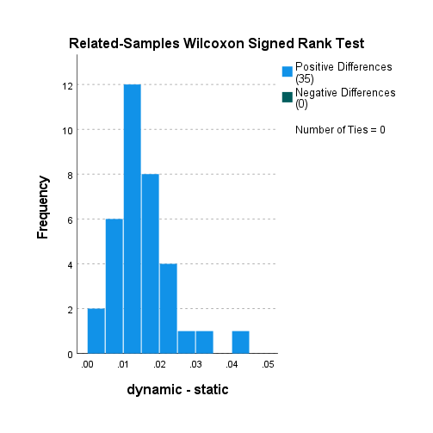

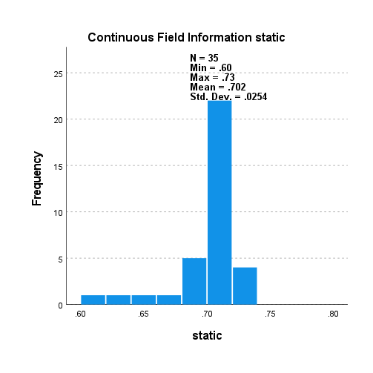

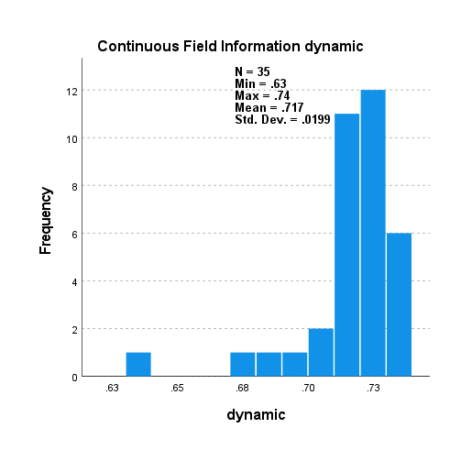

5000_5000_s_v_d_non_scaled

LR RU

|  |  |  |  |  |
| --- | --- | --- | --- | --- |
| **Hypothesis Test Summary** | | | | |
|  | Null Hypothesis | Test | Sig.a,b | Decision |
| 1 | The median of differences between static and dynamic equals 0. | Related-Samples Wilcoxon Signed Rank Test | .000 | Reject the null hypothesis. |
| a. The significance level is .050. | | | | |
| b. Asymptotic significance is displayed. | | | | |

**Related-Samples Wilcoxon Signed Rank Test**

**static, dynamic**

|  |  |
| --- | --- |
| **Related-Samples Wilcoxon Signed Rank Test Summary** | |
| Total N | 35 |
| Test Statistic | 630.000 |
| Standard Error | 61.053 |
| Standardized Test Statistic | 5.159 |
| Asymptotic Sig.(2-sided test) | .000 |

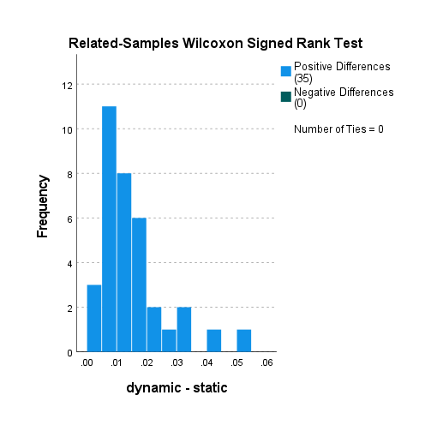

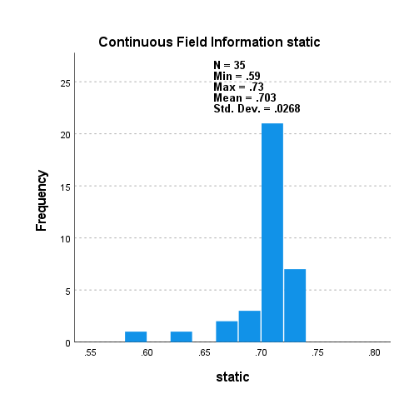

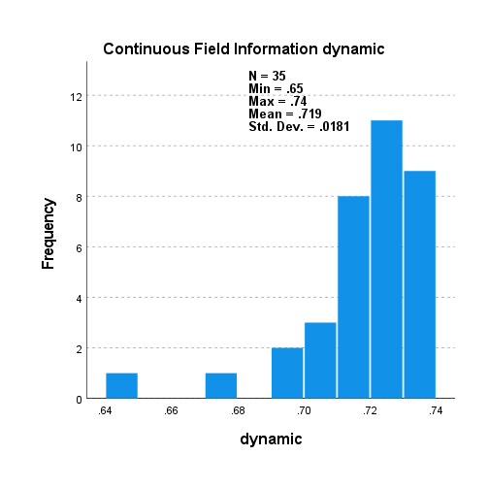

5000_5000_s_v_d_non_scaled

LR SM

|  |  |  |  |  |
| --- | --- | --- | --- | --- |
| **Hypothesis Test Summary** | | | | |
|  | Null Hypothesis | Test | Sig.a,b | Decision |
| 1 | The median of differences between static and dynamic equals 0. | Related-Samples Wilcoxon Signed Rank Test | .000 | Reject the null hypothesis. |
| a. The significance level is .050. | | | | |
| b. Asymptotic significance is displayed. | | | | |

**Related-Samples Wilcoxon Signed Rank Test**

**static, dynamic**

|  |  |
| --- | --- |
| **Related-Samples Wilcoxon Signed Rank Test Summary** | |
| Total N | 35 |
| Test Statistic | 630.000 |
| Standard Error | 61.053 |
| Standardized Test Statistic | 5.159 |
| Asymptotic Sig.(2-sided test) | .000 |

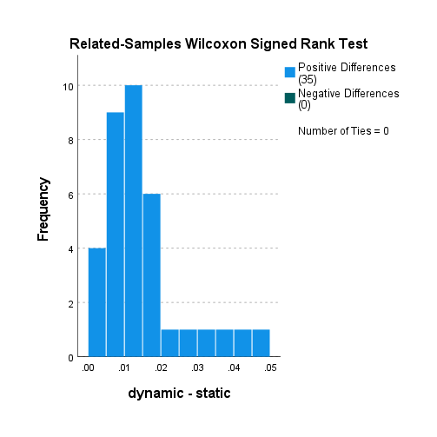

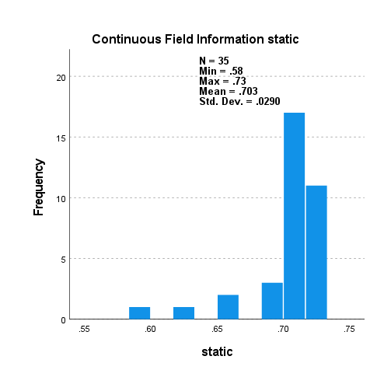

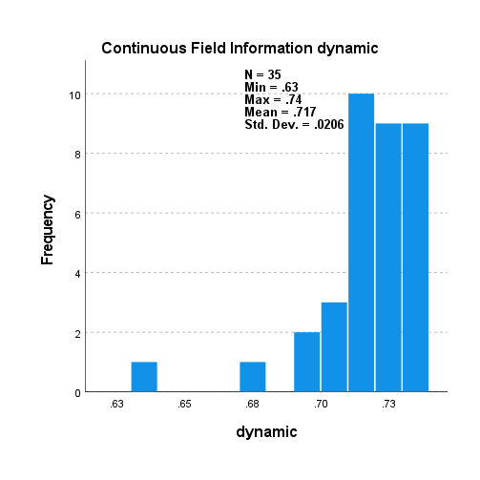

5000_5000_s_v_d_non_scaled

LR SM BL 1

|  |  |  |  |  |
| --- | --- | --- | --- | --- |
| **Hypothesis Test Summary** | | | | |
|  | Null Hypothesis | Test | Sig.a,b | Decision |
| 1 | The median of differences between static and dynamic equals 0. | Related-Samples Wilcoxon Signed Rank Test | .000 | Reject the null hypothesis. |
| a. The significance level is .050. | | | | |
| b. Asymptotic significance is displayed. | | | | |

**Related-Samples Wilcoxon Signed Rank Test**

**static, dynamic**

|  |  |
| --- | --- |
| **Related-Samples Wilcoxon Signed Rank Test Summary** | |
| Total N | 35 |
| Test Statistic | 630.000 |
| Standard Error | 61.053 |
| Standardized Test Statistic | 5.159 |
| Asymptotic Sig.(2-sided test) | .000 |

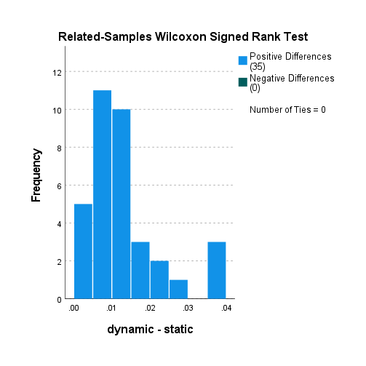

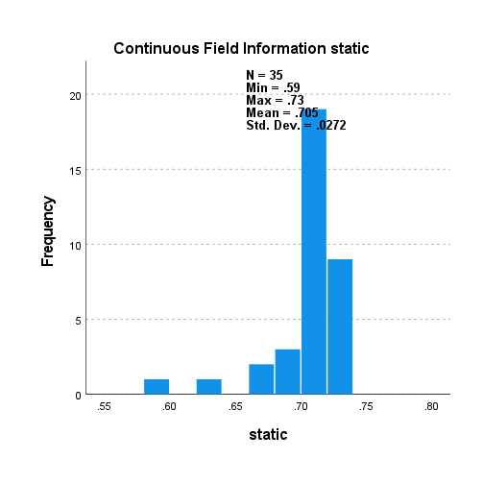

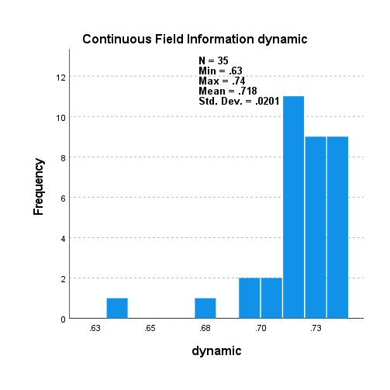

5000_5000_s_v_d_non_scaled

LR SM BL 2

*Nonparametric Tests: Related Samples.

NPTESTS

/RELATED TEST(static dynamic) WILCOXON

/MISSING SCOPE=ANALYSIS USERMISSING=EXCLUDE

/CRITERIA ALPHA=0.05 CILEVEL=95.

**Nonparametric Tests**

|  |  |  |
| --- | --- | --- |
| **Notes** | | |
| Output Created | | 31-AUG-2021 17:54:22 |
| Comments | |  |
| Input | Active Dataset | DataSet0 |
| Filter | <none> |
| Weight | <none> |
| Split File | <none> |
| N of Rows in Working Data File | 35 |
| Syntax | | NPTESTS  /RELATED TEST(static dynamic) WILCOXON  /MISSING SCOPE=ANALYSIS USERMISSING=EXCLUDE  /CRITERIA ALPHA=0.05 CILEVEL=95. |
| Resources | Processor Time | 00:00:00.81 |
| Elapsed Time | 00:00:01.02 |

|  |  |  |  |  |
| --- | --- | --- | --- | --- |
| **Hypothesis Test Summary** | | | | |
|  | Null Hypothesis | Test | Sig.a,b | Decision |
| 1 | The median of differences between static and dynamic equals 0. | Related-Samples Wilcoxon Signed Rank Test | .000 | Reject the null hypothesis. |
| a. The significance level is .050. | | | | |
| b. Asymptotic significance is displayed. | | | | |

**Related-Samples Wilcoxon Signed Rank Test**

**static, dynamic**

|  |  |
| --- | --- |
| **Related-Samples Wilcoxon Signed Rank Test Summary** | |
| Total N | 35 |
| Test Statistic | 630.000 |
| Standard Error | 61.053 |
| Standardized Test Statistic | 5.159 |
| Asymptotic Sig.(2-sided test) | .000 |

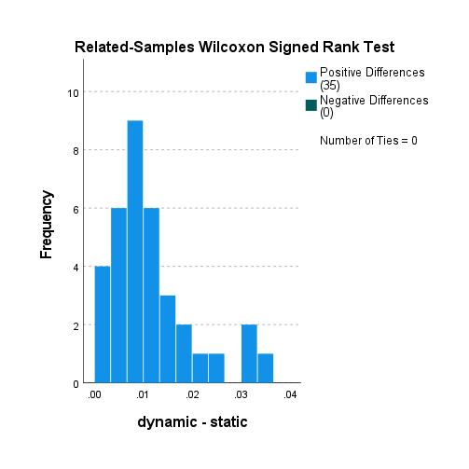

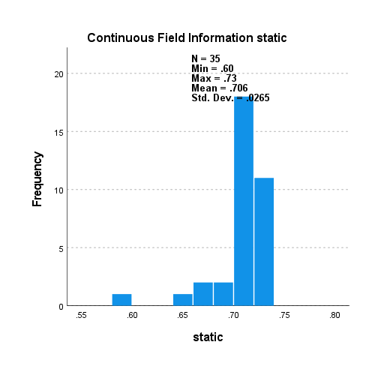

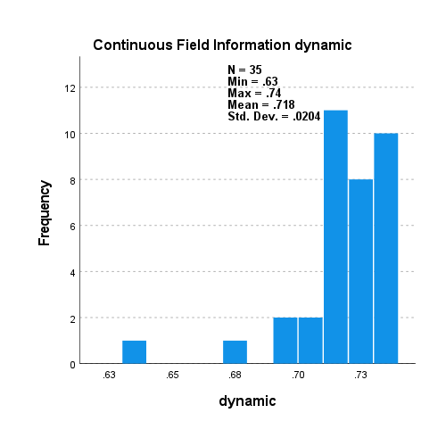

5000_5000_s_v_d_non_scaled

LR RO

*Nonparametric Tests: Related Samples.

NPTESTS

/RELATED TEST(static dynamic) WILCOXON

/MISSING SCOPE=ANALYSIS USERMISSING=EXCLUDE

/CRITERIA ALPHA=0.05 CILEVEL=95.

**Nonparametric Tests**

|  |  |  |
| --- | --- | --- |
| **Notes** | | |
| Output Created | | 31-AUG-2021 17:55:15 |
| Comments | |  |
| Input | Active Dataset | DataSet0 |
| Filter | <none> |
| Weight | <none> |
| Split File | <none> |
| N of Rows in Working Data File | 35 |
| Syntax | | NPTESTS  /RELATED TEST(static dynamic) WILCOXON  /MISSING SCOPE=ANALYSIS USERMISSING=EXCLUDE  /CRITERIA ALPHA=0.05 CILEVEL=95. |
| Resources | Processor Time | 00:00:00.84 |
| Elapsed Time | 00:00:01.06 |

|  |  |  |  |  |
| --- | --- | --- | --- | --- |
| **Hypothesis Test Summary** | | | | |
|  | Null Hypothesis | Test | Sig.a,b | Decision |
| 1 | The median of differences between static and dynamic equals 0. | Related-Samples Wilcoxon Signed Rank Test | .000 | Reject the null hypothesis. |
| a. The significance level is .050. | | | | |
| b. Asymptotic significance is displayed. | | | | |

**Related-Samples Wilcoxon Signed Rank Test**

**static, dynamic**

|  |  |
| --- | --- |
| **Related-Samples Wilcoxon Signed Rank Test Summary** | |
| Total N | 35 |
| Test Statistic | 630.000 |
| Standard Error | 61.053 |
| Standardized Test Statistic | 5.159 |
| Asymptotic Sig.(2-sided test) | .000 |

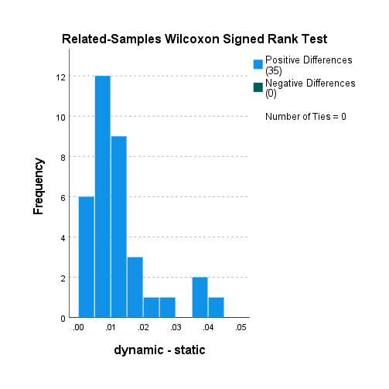

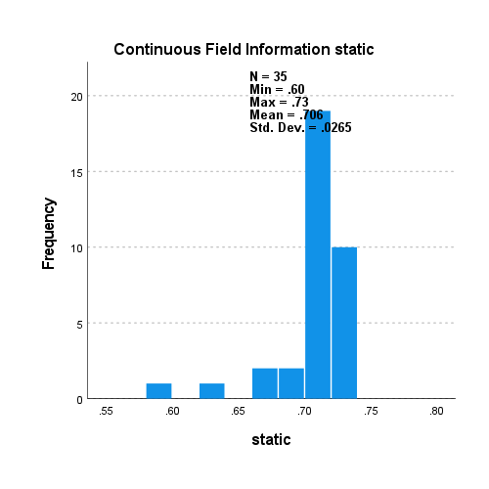

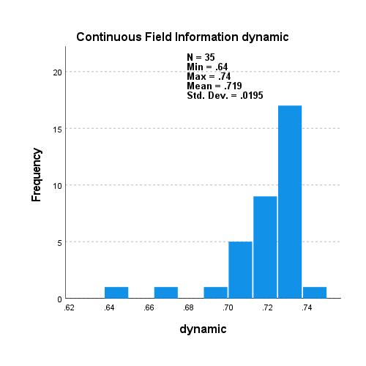

5000_5000_s_v_d_non_scaled

RF no samp.

*Nonparametric Tests: Related Samples.

NPTESTS

/RELATED TEST(static dynamic) WILCOXON

/MISSING SCOPE=ANALYSIS USERMISSING=EXCLUDE

/CRITERIA ALPHA=0.05 CILEVEL=95.

**Nonparametric Tests**

|  |  |  |
| --- | --- | --- |
| **Notes** | | |
| Output Created | | 31-AUG-2021 17:55:50 |
| Comments | |  |
| Input | Active Dataset | DataSet0 |
| Filter | <none> |
| Weight | <none> |
| Split File | <none> |
| N of Rows in Working Data File | 35 |
| Syntax | | NPTESTS  /RELATED TEST(static dynamic) WILCOXON  /MISSING SCOPE=ANALYSIS USERMISSING=EXCLUDE  /CRITERIA ALPHA=0.05 CILEVEL=95. |
| Resources | Processor Time | 00:00:00.78 |
| Elapsed Time | 00:00:00.75 |

|  |  |  |  |  |
| --- | --- | --- | --- | --- |
| **Hypothesis Test Summary** | | | | |
|  | Null Hypothesis | Test | Sig.a,b | Decision |
| 1 | The median of differences between static and dynamic equals 0. | Related-Samples Wilcoxon Signed Rank Test | .000 | Reject the null hypothesis. |
| a. The significance level is .050. | | | | |
| b. Asymptotic significance is displayed. | | | | |

**Related-Samples Wilcoxon Signed Rank Test**

**static, dynamic**

|  |  |
| --- | --- |
| **Related-Samples Wilcoxon Signed Rank Test Summary** | |
| Total N | 35 |
| Test Statistic | 630.000 |
| Standard Error | 61.053 |
| Standardized Test Statistic | 5.159 |
| Asymptotic Sig.(2-sided test) | .000 |

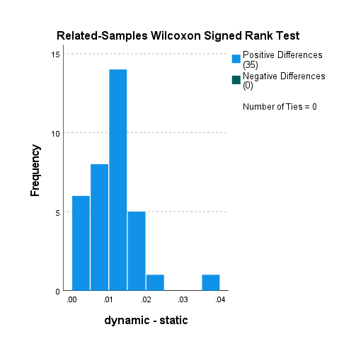

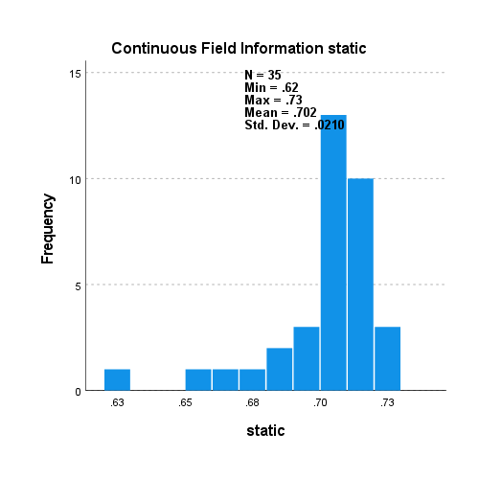

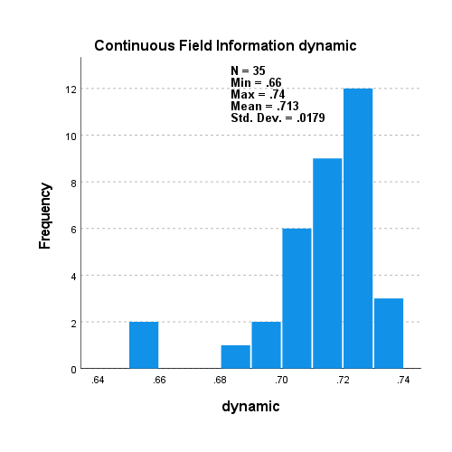

5000_5000_s_v_d_non_scaled

RF RU

*Nonparametric Tests: Related Samples.

NPTESTS

/RELATED TEST(static dynamic) WILCOXON

/MISSING SCOPE=ANALYSIS USERMISSING=EXCLUDE

/CRITERIA ALPHA=0.05 CILEVEL=95.

**Nonparametric Tests**

|  |  |  |
| --- | --- | --- |
| **Notes** | | |
| Output Created | | 31-AUG-2021 17:56:44 |
| Comments | |  |
| Input | Active Dataset | DataSet0 |
| Filter | <none> |
| Weight | <none> |
| Split File | <none> |
| N of Rows in Working Data File | 35 |
| Syntax | | NPTESTS  /RELATED TEST(static dynamic) WILCOXON  /MISSING SCOPE=ANALYSIS USERMISSING=EXCLUDE  /CRITERIA ALPHA=0.05 CILEVEL=95. |
| Resources | Processor Time | 00:00:00.78 |
| Elapsed Time | 00:00:00.79 |

|  |  |  |  |  |
| --- | --- | --- | --- | --- |
| **Hypothesis Test Summary** | | | | |
|  | Null Hypothesis | Test | Sig.a,b | Decision |
| 1 | The median of differences between static and dynamic equals 0. | Related-Samples Wilcoxon Signed Rank Test | .000 | Reject the null hypothesis. |
| a. The significance level is .050. | | | | |
| b. Asymptotic significance is displayed. | | | | |

**Related-Samples Wilcoxon Signed Rank Test**

**static, dynamic**

|  |  |
| --- | --- |
| **Related-Samples Wilcoxon Signed Rank Test Summary** | |
| Total N | 35 |
| Test Statistic | 625.000 |
| Standard Error | 61.053 |
| Standardized Test Statistic | 5.078 |
| Asymptotic Sig.(2-sided test) | .000 |

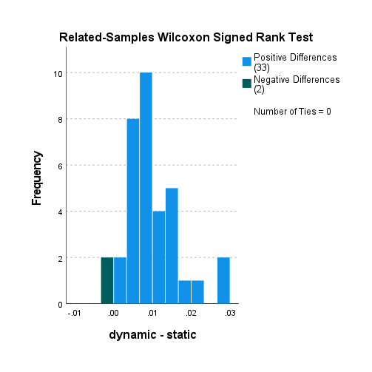

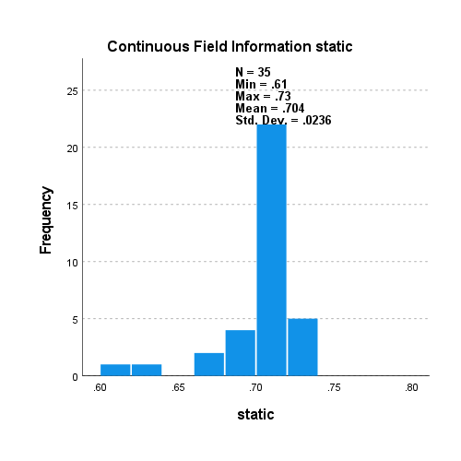

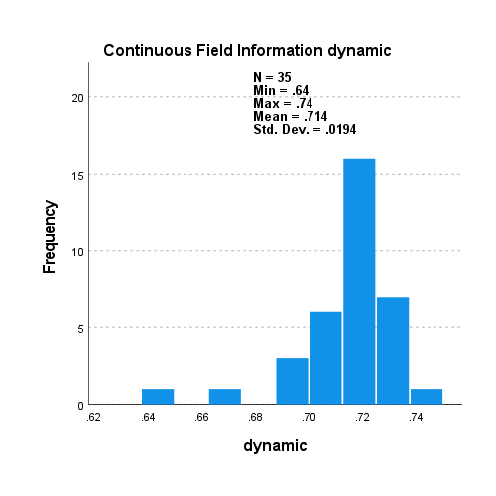

5000_5000_s_v_d_non_scaled

RF SM

*Nonparametric Tests: Related Samples.

NPTESTS

/RELATED TEST(static dynamic) WILCOXON

/MISSING SCOPE=ANALYSIS USERMISSING=EXCLUDE

/CRITERIA ALPHA=0.05 CILEVEL=95.

**Nonparametric Tests**

|  |  |  |
| --- | --- | --- |
| **Notes** | | |
| Output Created | | 31-AUG-2021 17:57:24 |
| Comments | |  |
| Input | Active Dataset | DataSet0 |
| Filter | <none> |
| Weight | <none> |
| Split File | <none> |
| N of Rows in Working Data File | 35 |
| Syntax | | NPTESTS  /RELATED TEST(static dynamic) WILCOXON  /MISSING SCOPE=ANALYSIS USERMISSING=EXCLUDE  /CRITERIA ALPHA=0.05 CILEVEL=95. |
| Resources | Processor Time | 00:00:00.80 |
| Elapsed Time | 00:00:00.81 |

|  |  |  |  |  |
| --- | --- | --- | --- | --- |
| **Hypothesis Test Summary** | | | | |
|  | Null Hypothesis | Test | Sig.a,b | Decision |
| 1 | The median of differences between static and dynamic equals 0. | Related-Samples Wilcoxon Signed Rank Test | .000 | Reject the null hypothesis. |
| a. The significance level is .050. | | | | |
| b. Asymptotic significance is displayed. | | | | |

**Related-Samples Wilcoxon Signed Rank Test**

**static, dynamic**

|  |  |
| --- | --- |
| **Related-Samples Wilcoxon Signed Rank Test Summary** | |
| Total N | 35 |
| Test Statistic | 630.000 |
| Standard Error | 61.053 |
| Standardized Test Statistic | 5.159 |
| Asymptotic Sig.(2-sided test) | .000 |

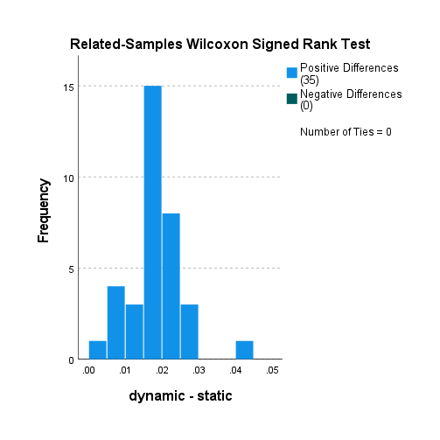

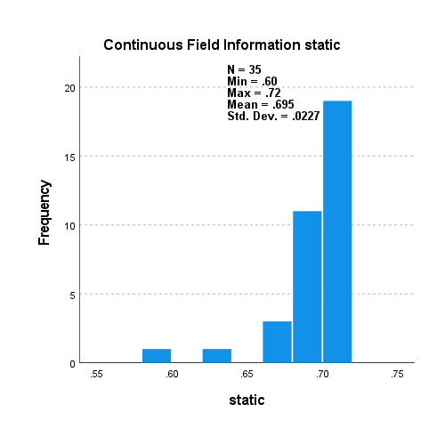

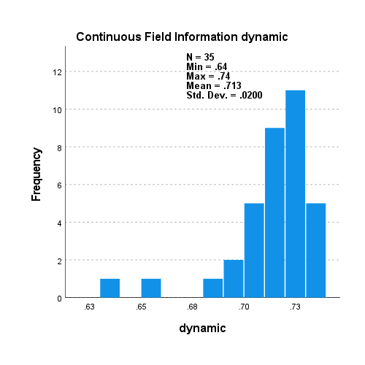

5000_5000_s_v_d_non_scaled

RF SM BL 1

*Nonparametric Tests: Related Samples.

NPTESTS

/RELATED TEST(static dynamic) WILCOXON

/MISSING SCOPE=ANALYSIS USERMISSING=EXCLUDE

/CRITERIA ALPHA=0.05 CILEVEL=95.

**Nonparametric Tests**

|  |  |  |
| --- | --- | --- |
| **Notes** | | |
| Output Created | | 31-AUG-2021 17:57:48 |
| Comments | |  |
| Input | Active Dataset | DataSet0 |
| Filter | <none> |
| Weight | <none> |
| Split File | <none> |
| N of Rows in Working Data File | 35 |
| Syntax | | NPTESTS  /RELATED TEST(static dynamic) WILCOXON  /MISSING SCOPE=ANALYSIS USERMISSING=EXCLUDE  /CRITERIA ALPHA=0.05 CILEVEL=95. |
| Resources | Processor Time | 00:00:00.73 |
| Elapsed Time | 00:00:00.82 |

|  |  |  |  |  |
| --- | --- | --- | --- | --- |
| **Hypothesis Test Summary** | | | | |
|  | Null Hypothesis | Test | Sig.a,b | Decision |
| 1 | The median of differences between static and dynamic equals 0. | Related-Samples Wilcoxon Signed Rank Test | .000 | Reject the null hypothesis. |
| a. The significance level is .050. | | | | |
| b. Asymptotic significance is displayed. | | | | |

**Related-Samples Wilcoxon Signed Rank Test**

**static, dynamic**

|  |  |
| --- | --- |
| **Related-Samples Wilcoxon Signed Rank Test Summary** | |
| Total N | 35 |
| Test Statistic | 630.000 |
| Standard Error | 61.053 |
| Standardized Test Statistic | 5.159 |
| Asymptotic Sig.(2-sided test) | .000 |

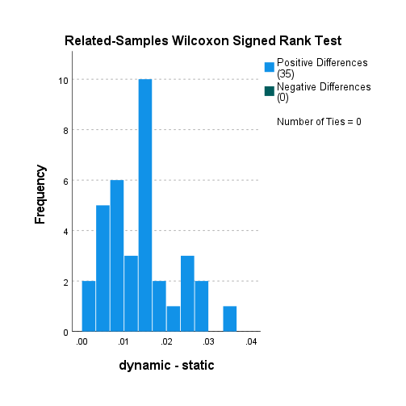

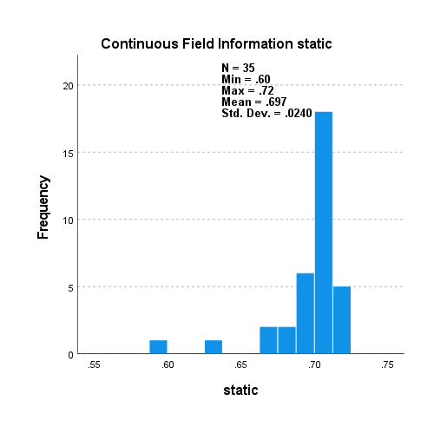

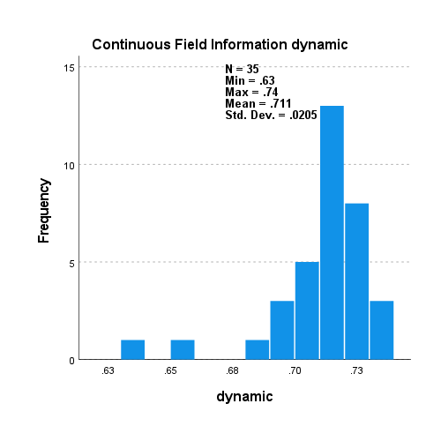

5000_5000_s_v_d_non_scaled

RF SM BL 2

*Nonparametric Tests: Related Samples.

NPTESTS

/RELATED TEST(static dynamic) WILCOXON

/MISSING SCOPE=ANALYSIS USERMISSING=EXCLUDE

/CRITERIA ALPHA=0.05 CILEVEL=95.

**Nonparametric Tests**

|  |  |  |
| --- | --- | --- |
| **Notes** | | |
| Output Created | | 31-AUG-2021 18:06:51 |
| Comments | |  |
| Input | Active Dataset | DataSet0 |
| Filter | <none> |
| Weight | <none> |
| Split File | <none> |
| N of Rows in Working Data File | 35 |
| Syntax | | NPTESTS  /RELATED TEST(static dynamic) WILCOXON  /MISSING SCOPE=ANALYSIS USERMISSING=EXCLUDE  /CRITERIA ALPHA=0.05 CILEVEL=95. |
| Resources | Processor Time | 00:00:00.67 |
| Elapsed Time | 00:00:00.71 |

|  |  |  |  |  |
| --- | --- | --- | --- | --- |
| **Hypothesis Test Summary** | | | | |
|  | Null Hypothesis | Test | Sig.a,b | Decision |
| 1 | The median of differences between static and dynamic equals 0. | Related-Samples Wilcoxon Signed Rank Test | .000 | Reject the null hypothesis. |
| a. The significance level is .050. | | | | |
| b. Asymptotic significance is displayed. | | | | |

**Related-Samples Wilcoxon Signed Rank Test**

**static, dynamic**

|  |  |
| --- | --- |
| **Related-Samples Wilcoxon Signed Rank Test Summary** | |
| Total N | 35 |
| Test Statistic | 630.000 |
| Standard Error | 61.053 |
| Standardized Test Statistic | 5.159 |
| Asymptotic Sig.(2-sided test) | .000 |

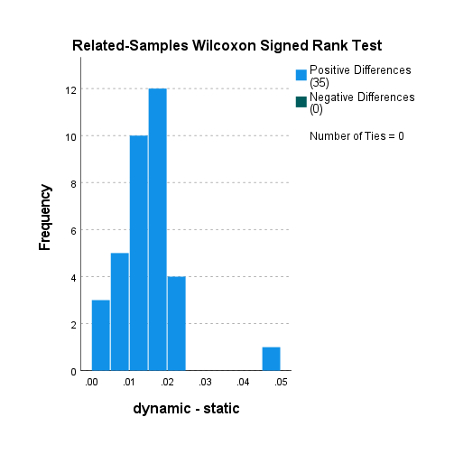

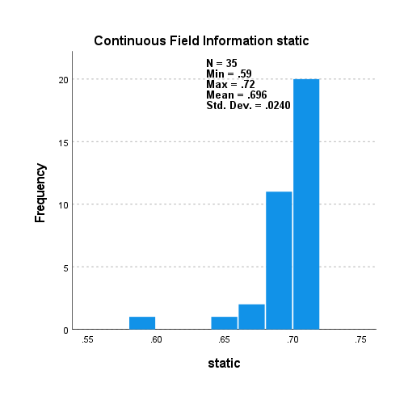

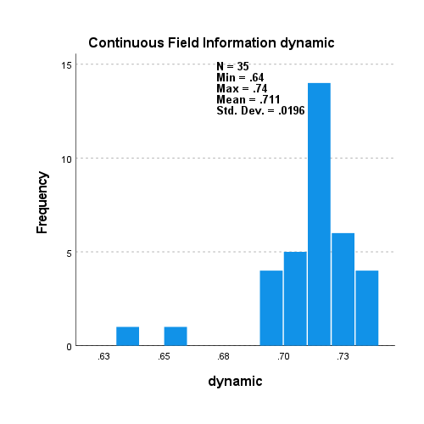

5000_5000_s_v_d_non_scaled

RF RO

*Nonparametric Tests: Related Samples.

NPTESTS

/RELATED TEST(static dynamic) WILCOXON

/MISSING SCOPE=ANALYSIS USERMISSING=EXCLUDE

/CRITERIA ALPHA=0.05 CILEVEL=95.

**Nonparametric Tests**

|  |  |  |
| --- | --- | --- |
| **Notes** | | |
| Output Created | | 31-AUG-2021 18:07:40 |
| Comments | |  |
| Input | Active Dataset | DataSet0 |
| Filter | <none> |
| Weight | <none> |
| Split File | <none> |
| N of Rows in Working Data File | 35 |
| Syntax | | NPTESTS  /RELATED TEST(static dynamic) WILCOXON  /MISSING SCOPE=ANALYSIS USERMISSING=EXCLUDE  /CRITERIA ALPHA=0.05 CILEVEL=95. |
| Resources | Processor Time | 00:00:00.70 |
| Elapsed Time | 00:00:00.80 |

|  |  |  |  |  |
| --- | --- | --- | --- | --- |
| **Hypothesis Test Summary** | | | | |
|  | Null Hypothesis | Test | Sig.a,b | Decision |
| 1 | The median of differences between static and dynamic equals 0. | Related-Samples Wilcoxon Signed Rank Test | .000 | Reject the null hypothesis. |
| a. The significance level is .050. | | | | |
| b. Asymptotic significance is displayed. | | | | |

**Related-Samples Wilcoxon Signed Rank Test**

**static, dynamic**

|  |  |
| --- | --- |
| **Related-Samples Wilcoxon Signed Rank Test Summary** | |
| Total N | 35 |
| Test Statistic | 598.000 |
| Standard Error | 61.053 |
| Standardized Test Statistic | 4.635 |
| Asymptotic Sig.(2-sided test) | .000 |

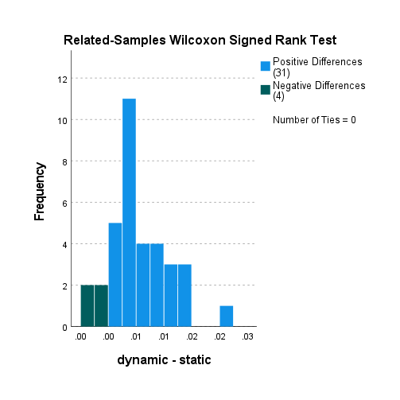

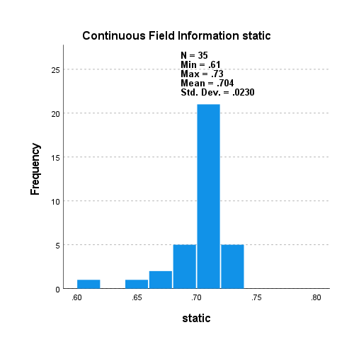

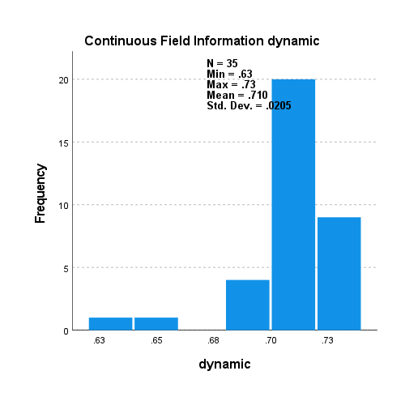

5000_5000_s_v_d_non_scaled

XGB no samp.

*Nonparametric Tests: Related Samples.

NPTESTS

/RELATED TEST(static dynamic) WILCOXON

/MISSING SCOPE=ANALYSIS USERMISSING=EXCLUDE

/CRITERIA ALPHA=0.05 CILEVEL=95.

**Nonparametric Tests**

|  |  |  |
| --- | --- | --- |
| **Notes** | | |
| Output Created | | 31-AUG-2021 18:08:08 |
| Comments | |  |
| Input | Active Dataset | DataSet0 |
| Filter | <none> |
| Weight | <none> |
| Split File | <none> |
| N of Rows in Working Data File | 35 |
| Syntax | | NPTESTS  /RELATED TEST(static dynamic) WILCOXON  /MISSING SCOPE=ANALYSIS USERMISSING=EXCLUDE  /CRITERIA ALPHA=0.05 CILEVEL=95. |
| Resources | Processor Time | 00:00:00.78 |
| Elapsed Time | 00:00:00.95 |

|  |  |  |  |  |
| --- | --- | --- | --- | --- |
| **Hypothesis Test Summary** | | | | |
|  | Null Hypothesis | Test | Sig.a,b | Decision |
| 1 | The median of differences between static and dynamic equals 0. | Related-Samples Wilcoxon Signed Rank Test | .000 | Reject the null hypothesis. |
| a. The significance level is .050. | | | | |
| b. Asymptotic significance is displayed. | | | | |

**Related-Samples Wilcoxon Signed Rank Test**

**static, dynamic**

|  |  |
| --- | --- |
| **Related-Samples Wilcoxon Signed Rank Test Summary** | |
| Total N | 35 |
| Test Statistic | 630.000 |
| Standard Error | 61.053 |
| Standardized Test Statistic | 5.159 |
| Asymptotic Sig.(2-sided test) | .000 |

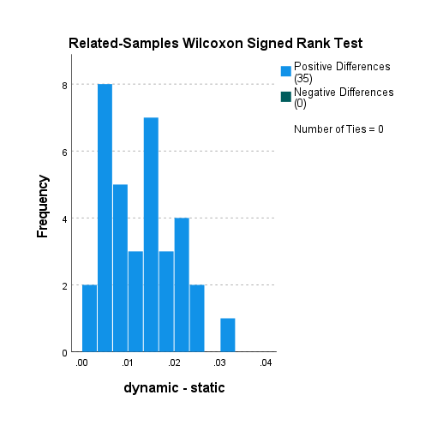

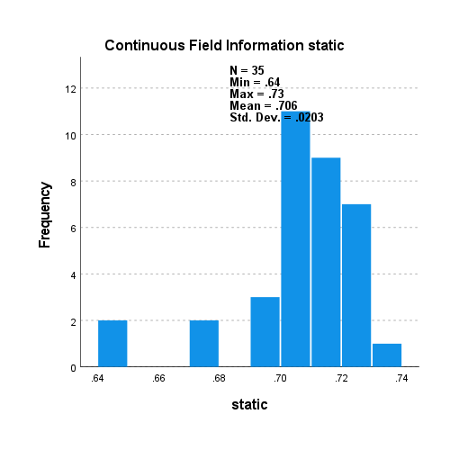

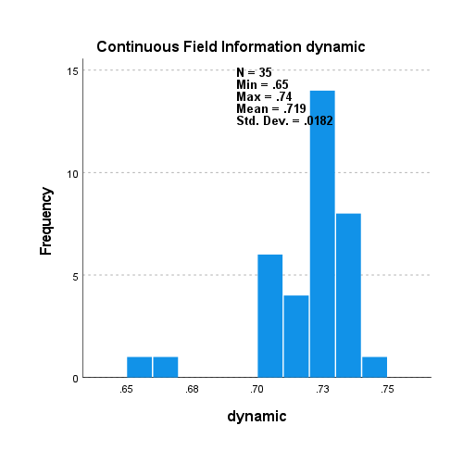

5000_5000_s_v_d_non_scaled

XGB RU

*Nonparametric Tests: Related Samples.

NPTESTS

/RELATED TEST(static dynamic) WILCOXON

/MISSING SCOPE=ANALYSIS USERMISSING=EXCLUDE

/CRITERIA ALPHA=0.05 CILEVEL=95.

**Nonparametric Tests**

|  |  |  |
| --- | --- | --- |
| **Notes** | | |
| Output Created | | 31-AUG-2021 18:08:48 |
| Comments | |  |
| Input | Active Dataset | DataSet0 |
| Filter | <none> |
| Weight | <none> |
| Split File | <none> |
| N of Rows in Working Data File | 35 |
| Syntax | | NPTESTS  /RELATED TEST(static dynamic) WILCOXON  /MISSING SCOPE=ANALYSIS USERMISSING=EXCLUDE  /CRITERIA ALPHA=0.05 CILEVEL=95. |
| Resources | Processor Time | 00:00:00.78 |
| Elapsed Time | 00:00:00.89 |

|  |  |  |  |  |
| --- | --- | --- | --- | --- |
| **Hypothesis Test Summary** | | | | |
|  | Null Hypothesis | Test | Sig.a,b | Decision |
| 1 | The median of differences between static and dynamic equals 0. | Related-Samples Wilcoxon Signed Rank Test | .000 | Reject the null hypothesis. |
| a. The significance level is .050. | | | | |
| b. Asymptotic significance is displayed. | | | | |

**Related-Samples Wilcoxon Signed Rank Test**

**static, dynamic**

|  |  |
| --- | --- |
| **Related-Samples Wilcoxon Signed Rank Test Summary** | |
| Total N | 35 |
| Test Statistic | 615.000 |
| Standard Error | 61.053 |
| Standardized Test Statistic | 4.914 |
| Asymptotic Sig.(2-sided test) | .000 |

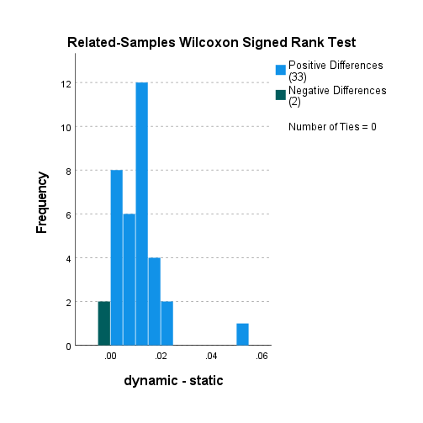

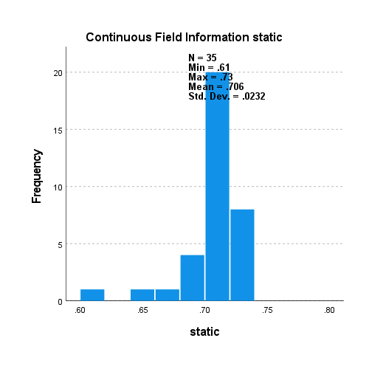

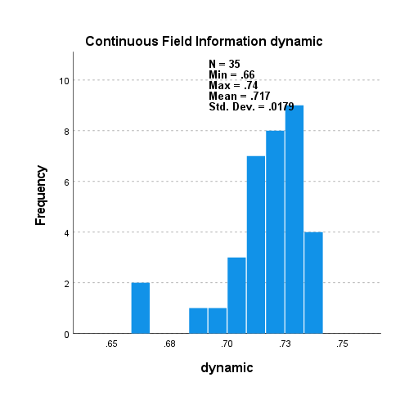

5000_5000_s_v_d_non_scaled

XGB SM

*Nonparametric Tests: Related Samples.

NPTESTS

/RELATED TEST(static dynamic) WILCOXON

/MISSING SCOPE=ANALYSIS USERMISSING=EXCLUDE

/CRITERIA ALPHA=0.05 CILEVEL=95.

**Nonparametric Tests**

|  |  |  |
| --- | --- | --- |
| **Notes** | | |
| Output Created | | 31-AUG-2021 18:09:14 |
| Comments | |  |
| Input | Active Dataset | DataSet0 |
| Filter | <none> |
| Weight | <none> |
| Split File | <none> |
| N of Rows in Working Data File | 35 |
| Syntax | | NPTESTS  /RELATED TEST(static dynamic) WILCOXON  /MISSING SCOPE=ANALYSIS USERMISSING=EXCLUDE  /CRITERIA ALPHA=0.05 CILEVEL=95. |
| Resources | Processor Time | 00:00:00.86 |
| Elapsed Time | 00:00:01.00 |

|  |  |  |  |  |
| --- | --- | --- | --- | --- |
| **Hypothesis Test Summary** | | | | |
|  | Null Hypothesis | Test | Sig.a,b | Decision |
| 1 | The median of differences between static and dynamic equals 0. | Related-Samples Wilcoxon Signed Rank Test | .000 | Reject the null hypothesis. |
| a. The significance level is .050. | | | | |
| b. Asymptotic significance is displayed. | | | | |

**Related-Samples Wilcoxon Signed Rank Test**

**static, dynamic**

|  |  |
| --- | --- |
| **Related-Samples Wilcoxon Signed Rank Test Summary** | |
| Total N | 35 |
| Test Statistic | 630.000 |
| Standard Error | 61.053 |
| Standardized Test Statistic | 5.159 |
| Asymptotic Sig.(2-sided test) | .000 |

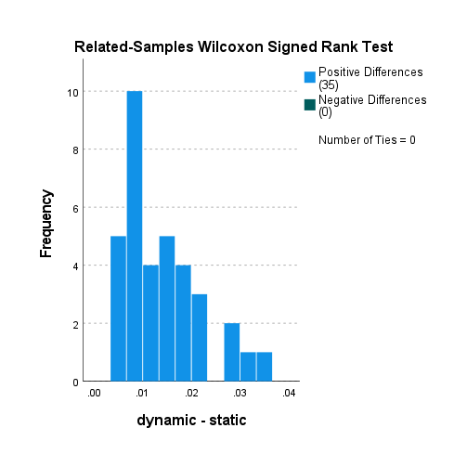

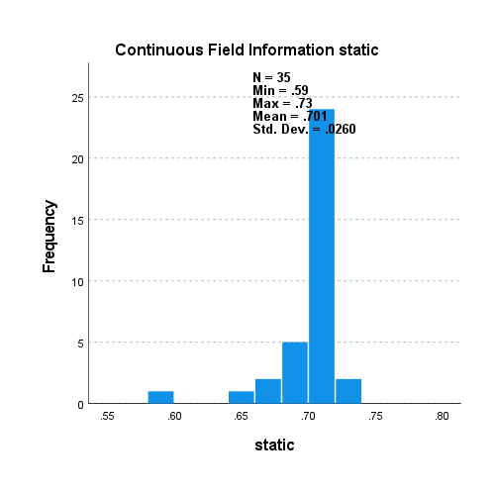

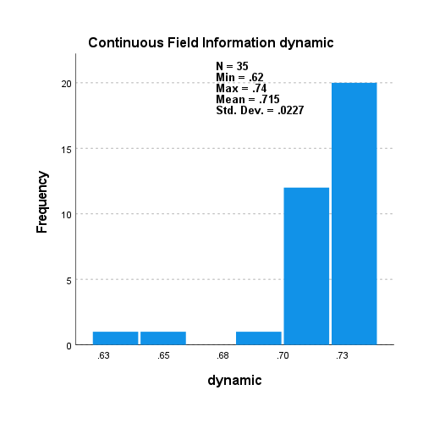

5000_5000_s_v_d_non_scaled

XGB SM BL 1

*Nonparametric Tests: Related Samples.

NPTESTS

/RELATED TEST(static dynamic) WILCOXON

/MISSING SCOPE=ANALYSIS USERMISSING=EXCLUDE

/CRITERIA ALPHA=0.05 CILEVEL=95.

**Nonparametric Tests**

|  |  |  |
| --- | --- | --- |
| **Notes** | | |
| Output Created | | 31-AUG-2021 18:09:43 |
| Comments | |  |
| Input | Active Dataset | DataSet0 |
| Filter | <none> |
| Weight | <none> |
| Split File | <none> |
| N of Rows in Working Data File | 35 |
| Syntax | | NPTESTS  /RELATED TEST(static dynamic) WILCOXON  /MISSING SCOPE=ANALYSIS USERMISSING=EXCLUDE  /CRITERIA ALPHA=0.05 CILEVEL=95. |
| Resources | Processor Time | 00:00:00.72 |
| Elapsed Time | 00:00:00.78 |

|  |  |  |  |  |
| --- | --- | --- | --- | --- |
| **Hypothesis Test Summary** | | | | |
|  | Null Hypothesis | Test | Sig.a,b | Decision |
| 1 | The median of differences between static and dynamic equals 0. | Related-Samples Wilcoxon Signed Rank Test | .000 | Reject the null hypothesis. |
| a. The significance level is .050. | | | | |
| b. Asymptotic significance is displayed. | | | | |

**Related-Samples Wilcoxon Signed Rank Test**

**static, dynamic**

|  |  |
| --- | --- |
| **Related-Samples Wilcoxon Signed Rank Test Summary** | |
| Total N | 35 |
| Test Statistic | 630.000 |
| Standard Error | 61.053 |
| Standardized Test Statistic | 5.159 |
| Asymptotic Sig.(2-sided test) | .000 |

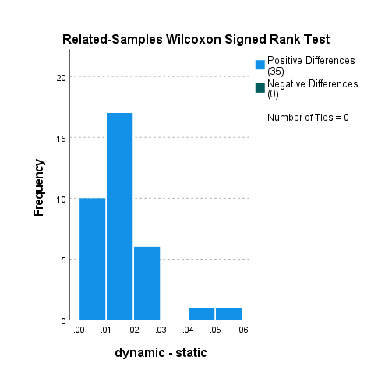

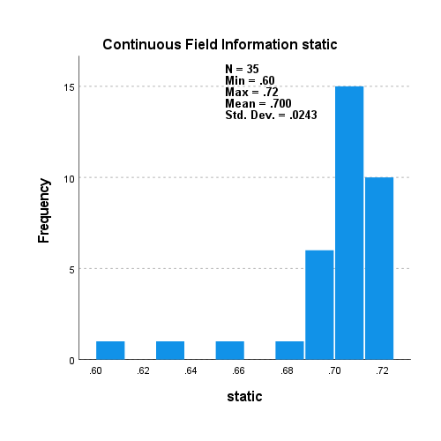

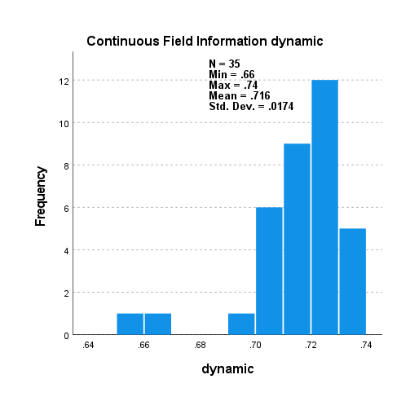

5000_5000_s_v_d_non_scaled

XGB SM BL 2

*Nonparametric Tests: Related Samples.

NPTESTS

/RELATED TEST(static dynamic) WILCOXON

/MISSING SCOPE=ANALYSIS USERMISSING=EXCLUDE

/CRITERIA ALPHA=0.05 CILEVEL=95.

**Nonparametric Tests**

|  |  |  |
| --- | --- | --- |
| **Notes** | | |
| Output Created | | 31-AUG-2021 18:10:33 |
| Comments | |  |
| Input | Active Dataset | DataSet0 |
| Filter | <none> |
| Weight | <none> |
| Split File | <none> |
| N of Rows in Working Data File | 35 |
| Syntax | | NPTESTS  /RELATED TEST(static dynamic) WILCOXON  /MISSING SCOPE=ANALYSIS USERMISSING=EXCLUDE  /CRITERIA ALPHA=0.05 CILEVEL=95. |
| Resources | Processor Time | 00:00:00.77 |
| Elapsed Time | 00:00:00.90 |

|  |  |  |  |  |
| --- | --- | --- | --- | --- |
| **Hypothesis Test Summary** | | | | |
|  | Null Hypothesis | Test | Sig.a,b | Decision |
| 1 | The median of differences between static and dynamic equals 0. | Related-Samples Wilcoxon Signed Rank Test | .000 | Reject the null hypothesis. |
| a. The significance level is .050. | | | | |
| b. Asymptotic significance is displayed. | | | | |

**Related-Samples Wilcoxon Signed Rank Test**

**static, dynamic**

|  |  |
| --- | --- |
| **Related-Samples Wilcoxon Signed Rank Test Summary** | |
| Total N | 35 |
| Test Statistic | 630.000 |
| Standard Error | 61.053 |
| Standardized Test Statistic | 5.159 |
| Asymptotic Sig.(2-sided test) | .000 |

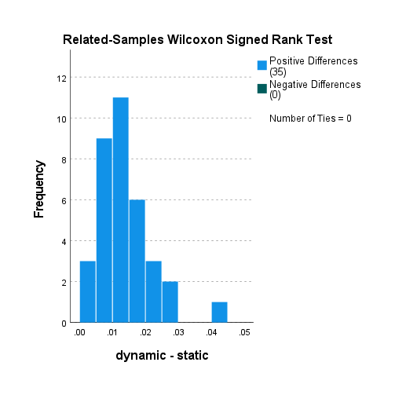

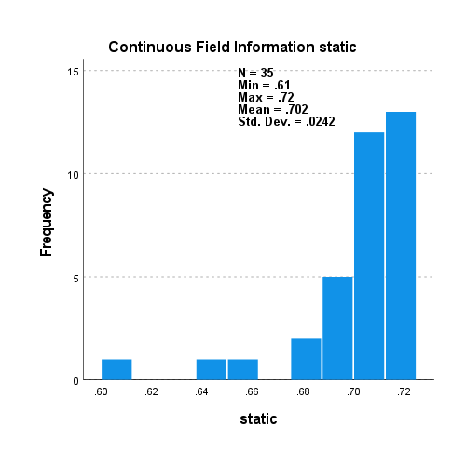

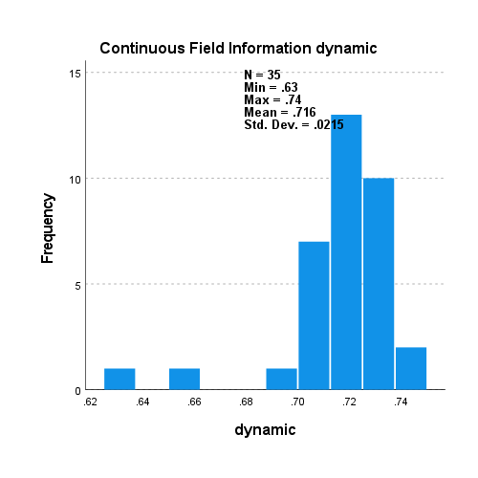

5000_5000_s_v_d_non_scaled

XGB RO

*Nonparametric Tests: Related Samples.

NPTESTS

/RELATED TEST(static dynamic) WILCOXON

/MISSING SCOPE=ANALYSIS USERMISSING=EXCLUDE

/CRITERIA ALPHA=0.05 CILEVEL=95.

**Nonparametric Tests**

|  |  |  |
| --- | --- | --- |
| **Notes** | | |
| Output Created | | 31-AUG-2021 18:11:00 |
| Comments | |  |
| Input | Active Dataset | DataSet0 |
| Filter | <none> |
| Weight | <none> |
| Split File | <none> |
| N of Rows in Working Data File | 35 |
| Syntax | | NPTESTS  /RELATED TEST(static dynamic) WILCOXON  /MISSING SCOPE=ANALYSIS USERMISSING=EXCLUDE  /CRITERIA ALPHA=0.05 CILEVEL=95. |
| Resources | Processor Time | 00:00:00.70 |
| Elapsed Time | 00:00:00.88 |

|  |  |  |  |  |
| --- | --- | --- | --- | --- |
| **Hypothesis Test Summary** | | | | |
|  | Null Hypothesis | Test | Sig.a,b | Decision |
| 1 | The median of differences between static and dynamic equals 0. | Related-Samples Wilcoxon Signed Rank Test | .000 | Reject the null hypothesis. |
| a. The significance level is .050. | | | | |
| b. Asymptotic significance is displayed. | | | | |

**Related-Samples Wilcoxon Signed Rank Test**

**static, dynamic**

|  |  |
| --- | --- |
| **Related-Samples Wilcoxon Signed Rank Test Summary** | |
| Total N | 35 |
| Test Statistic | 628.000 |
| Standard Error | 61.053 |
| Standardized Test Statistic | 5.127 |
| Asymptotic Sig.(2-sided test) | .000 |

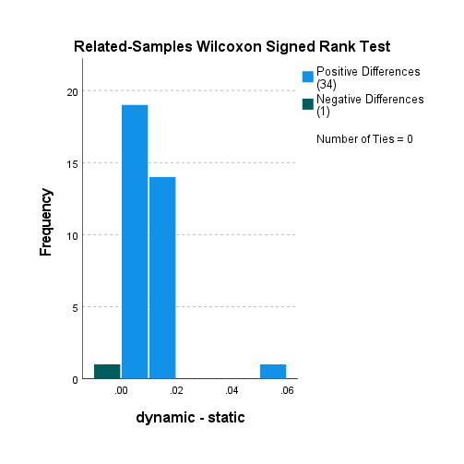

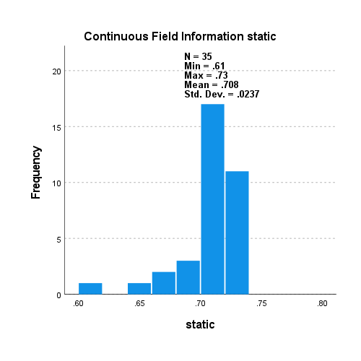

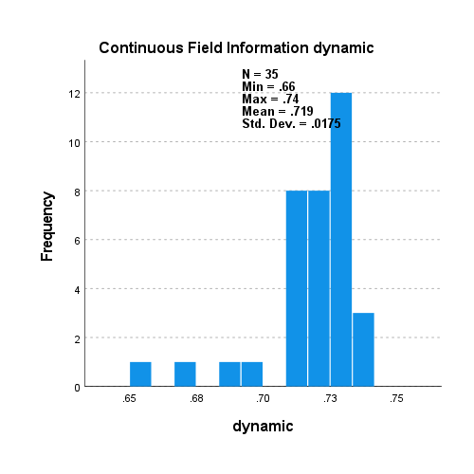

5000_5000_s_v_d_non_scaled

LGBM no samp.

*Nonparametric Tests: Related Samples.

NPTESTS

/RELATED TEST(static dynamic) WILCOXON

/MISSING SCOPE=ANALYSIS USERMISSING=EXCLUDE

/CRITERIA ALPHA=0.05 CILEVEL=95.

**Nonparametric Tests**

|  |  |  |
| --- | --- | --- |
| **Notes** | | |
| Output Created | | 31-AUG-2021 18:11:34 |
| Comments | |  |
| Input | Active Dataset | DataSet0 |
| Filter | <none> |
| Weight | <none> |
| Split File | <none> |
| N of Rows in Working Data File | 35 |
| Syntax | | NPTESTS  /RELATED TEST(static dynamic) WILCOXON  /MISSING SCOPE=ANALYSIS USERMISSING=EXCLUDE  /CRITERIA ALPHA=0.05 CILEVEL=95. |
| Resources | Processor Time | 00:00:00.66 |
| Elapsed Time | 00:00:00.71 |

|  |  |  |  |  |
| --- | --- | --- | --- | --- |
| **Hypothesis Test Summary** | | | | |
|  | Null Hypothesis | Test | Sig.a,b | Decision |
| 1 | The median of differences between static and dynamic equals 0. | Related-Samples Wilcoxon Signed Rank Test | .000 | Reject the null hypothesis. |
| a. The significance level is .050. | | | | |
| b. Asymptotic significance is displayed. | | | | |

**Related-Samples Wilcoxon Signed Rank Test**

**static, dynamic**

|  |  |
| --- | --- |
| **Related-Samples Wilcoxon Signed Rank Test Summary** | |
| Total N | 35 |
| Test Statistic | 630.000 |
| Standard Error | 61.053 |
| Standardized Test Statistic | 5.159 |
| Asymptotic Sig.(2-sided test) | .000 |

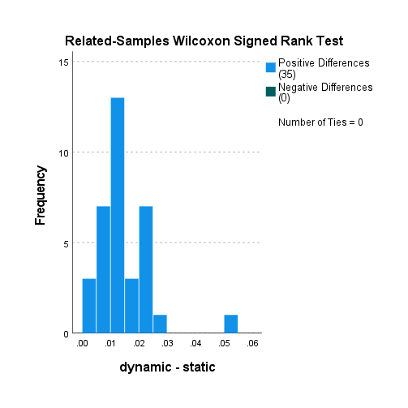

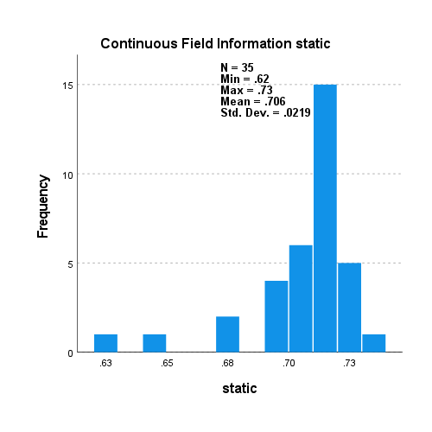

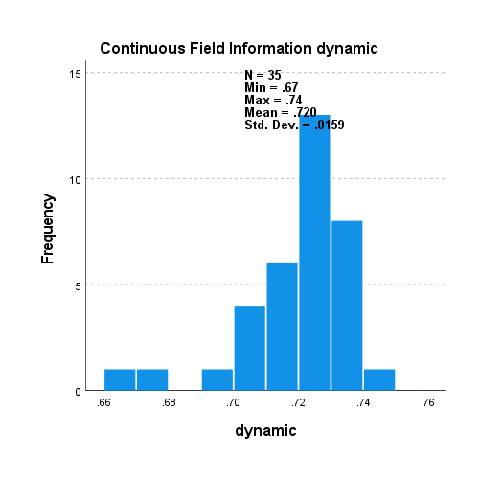

5000_5000_s_v_d_non_scaled

LGBM RU

*Nonparametric Tests: Related Samples.

NPTESTS

/RELATED TEST(static dynamic) WILCOXON

/MISSING SCOPE=ANALYSIS USERMISSING=EXCLUDE

/CRITERIA ALPHA=0.05 CILEVEL=95.

**Nonparametric Tests**

|  |  |  |
| --- | --- | --- |
| **Notes** | | |
| Output Created | | 31-AUG-2021 18:12:04 |
| Comments | |  |
| Input | Active Dataset | DataSet0 |
| Filter | <none> |
| Weight | <none> |
| Split File | <none> |
| N of Rows in Working Data File | 35 |
| Syntax | | NPTESTS  /RELATED TEST(static dynamic) WILCOXON  /MISSING SCOPE=ANALYSIS USERMISSING=EXCLUDE  /CRITERIA ALPHA=0.05 CILEVEL=95. |
| Resources | Processor Time | 00:00:00.67 |
| Elapsed Time | 00:00:00.81 |

|  |  |  |  |  |
| --- | --- | --- | --- | --- |
| **Hypothesis Test Summary** | | | | |
|  | Null Hypothesis | Test | Sig.a,b | Decision |
| 1 | The median of differences between static and dynamic equals 0. | Related-Samples Wilcoxon Signed Rank Test | .000 | Reject the null hypothesis. |
| a. The significance level is .050. | | | | |
| b. Asymptotic significance is displayed. | | | | |

**Related-Samples Wilcoxon Signed Rank Test**

**static, dynamic**

|  |  |
| --- | --- |
| **Related-Samples Wilcoxon Signed Rank Test Summary** | |
| Total N | 35 |
| Test Statistic | 623.000 |
| Standard Error | 61.053 |
| Standardized Test Statistic | 5.045 |
| Asymptotic Sig.(2-sided test) | .000 |

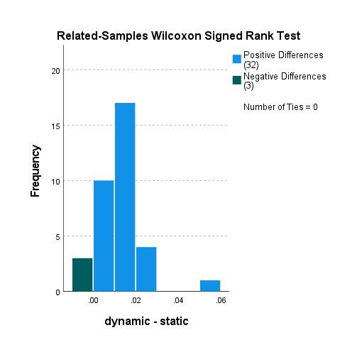

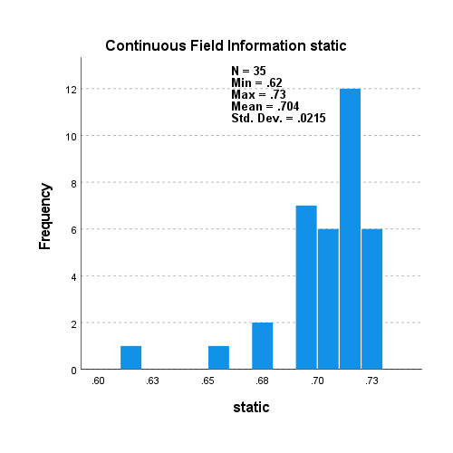

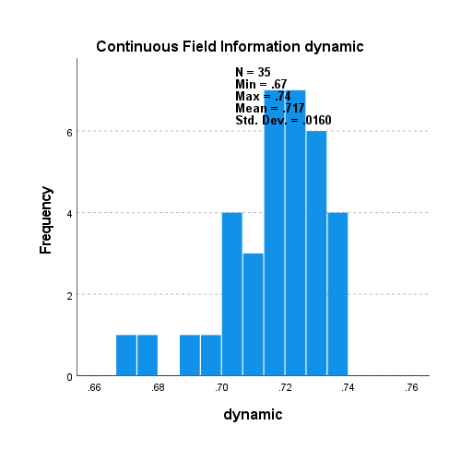

5000_5000_s_v_d_non_scaled

LGBM SM

*Nonparametric Tests: Related Samples.

NPTESTS

/RELATED TEST(static dynamic) WILCOXON

/MISSING SCOPE=ANALYSIS USERMISSING=EXCLUDE

/CRITERIA ALPHA=0.05 CILEVEL=95.

**Nonparametric Tests**

|  |  |  |
| --- | --- | --- |
| **Notes** | | |
| Output Created | | 31-AUG-2021 18:12:26 |
| Comments | |  |
| Input | Active Dataset | DataSet0 |
| Filter | <none> |
| Weight | <none> |
| Split File | <none> |
| N of Rows in Working Data File | 35 |
| Syntax | | NPTESTS  /RELATED TEST(static dynamic) WILCOXON  /MISSING SCOPE=ANALYSIS USERMISSING=EXCLUDE  /CRITERIA ALPHA=0.05 CILEVEL=95. |
| Resources | Processor Time | 00:00:00.84 |
| Elapsed Time | 00:00:00.93 |

|  |  |  |  |  |
| --- | --- | --- | --- | --- |
| **Hypothesis Test Summary** | | | | |
|  | Null Hypothesis | Test | Sig.a,b | Decision |
| 1 | The median of differences between static and dynamic equals 0. | Related-Samples Wilcoxon Signed Rank Test | .000 | Reject the null hypothesis. |
| a. The significance level is .050. | | | | |
| b. Asymptotic significance is displayed. | | | | |

**Related-Samples Wilcoxon Signed Rank Test**

**static, dynamic**

|  |  |
| --- | --- |
| **Related-Samples Wilcoxon Signed Rank Test Summary** | |
| Total N | 35 |
| Test Statistic | 629.000 |
| Standard Error | 61.053 |
| Standardized Test Statistic | 5.143 |
| Asymptotic Sig.(2-sided test) | .000 |

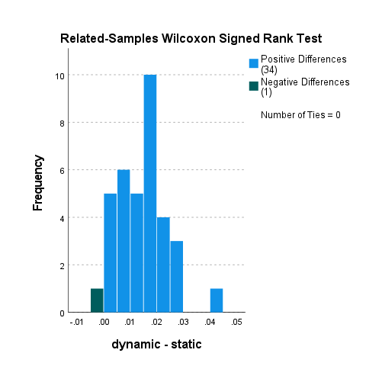

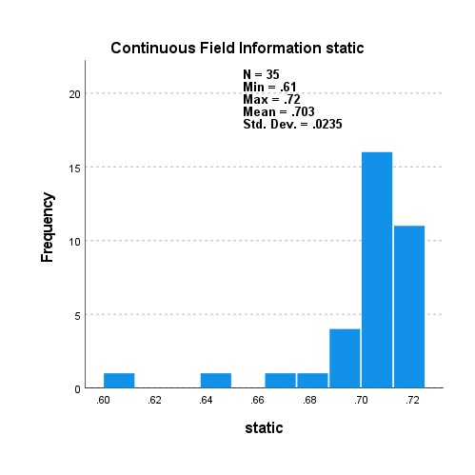

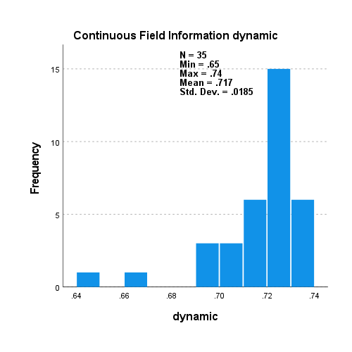

5000_5000_s_v_d_non_scaled

LGBM SM BL 1

*Nonparametric Tests: Related Samples.

NPTESTS

/RELATED TEST(static dynamic) WILCOXON

/MISSING SCOPE=ANALYSIS USERMISSING=EXCLUDE

/CRITERIA ALPHA=0.05 CILEVEL=95.

**Nonparametric Tests**

|  |  |  |
| --- | --- | --- |
| **Notes** | | |
| Output Created | | 31-AUG-2021 18:12:56 |
| Comments | |  |
| Input | Active Dataset | DataSet0 |
| Filter | <none> |
| Weight | <none> |
| Split File | <none> |
| N of Rows in Working Data File | 35 |
| Syntax | | NPTESTS  /RELATED TEST(static dynamic) WILCOXON  /MISSING SCOPE=ANALYSIS USERMISSING=EXCLUDE  /CRITERIA ALPHA=0.05 CILEVEL=95. |
| Resources | Processor Time | 00:00:00.78 |
| Elapsed Time | 00:00:00.79 |

|  |  |  |  |  |
| --- | --- | --- | --- | --- |
| **Hypothesis Test Summary** | | | | |
|  | Null Hypothesis | Test | Sig.a,b | Decision |
| 1 | The median of differences between static and dynamic equals 0. | Related-Samples Wilcoxon Signed Rank Test | .000 | Reject the null hypothesis. |
| a. The significance level is .050. | | | | |
| b. Asymptotic significance is displayed. | | | | |

**Related-Samples Wilcoxon Signed Rank Test**

**static, dynamic**

|  |  |
| --- | --- |
| **Related-Samples Wilcoxon Signed Rank Test Summary** | |
| Total N | 35 |
| Test Statistic | 630.000 |
| Standard Error | 61.053 |
| Standardized Test Statistic | 5.159 |
| Asymptotic Sig.(2-sided test) | .000 |

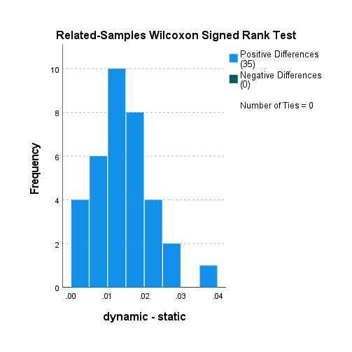

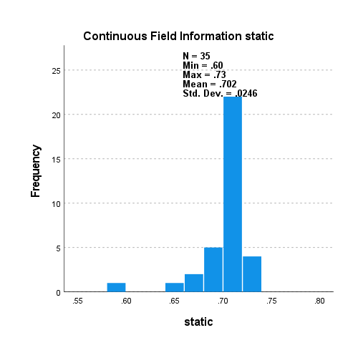

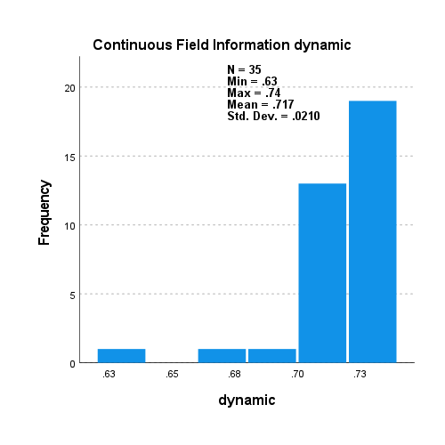

5000_5000_s_v_d_non_scaled

LGBM SM BL 2

*Nonparametric Tests: Related Samples.

NPTESTS

/RELATED TEST(static dynamic) WILCOXON

/MISSING SCOPE=ANALYSIS USERMISSING=EXCLUDE

/CRITERIA ALPHA=0.05 CILEVEL=95.

**Nonparametric Tests**

|  |  |  |
| --- | --- | --- |
| **Notes** | | |
| Output Created | | 31-AUG-2021 18:13:27 |
| Comments | |  |
| Input | Active Dataset | DataSet0 |
| Filter | <none> |
| Weight | <none> |
| Split File | <none> |
| N of Rows in Working Data File | 35 |
| Syntax | | NPTESTS  /RELATED TEST(static dynamic) WILCOXON  /MISSING SCOPE=ANALYSIS USERMISSING=EXCLUDE  /CRITERIA ALPHA=0.05 CILEVEL=95. |
| Resources | Processor Time | 00:00:00.74 |
| Elapsed Time | 00:00:00.76 |

|  |  |  |  |  |
| --- | --- | --- | --- | --- |
| **Hypothesis Test Summary** | | | | |
|  | Null Hypothesis | Test | Sig.a,b | Decision |
| 1 | The median of differences between static and dynamic equals 0. | Related-Samples Wilcoxon Signed Rank Test | .000 | Reject the null hypothesis. |
| a. The significance level is .050. | | | | |
| b. Asymptotic significance is displayed. | | | | |

**Related-Samples Wilcoxon Signed Rank Test**

**static, dynamic**

|  |  |
| --- | --- |
| **Related-Samples Wilcoxon Signed Rank Test Summary** | |
| Total N | 35 |
| Test Statistic | 614.000 |
| Standard Error | 61.053 |
| Standardized Test Statistic | 4.897 |
| Asymptotic Sig.(2-sided test) | .000 |

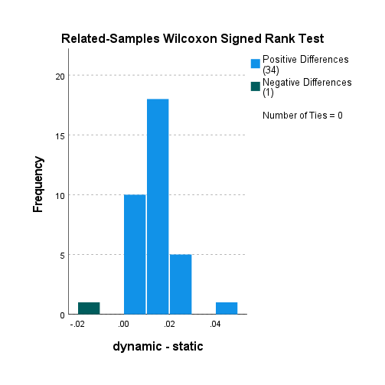

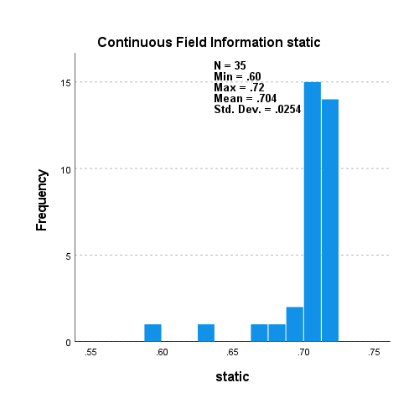

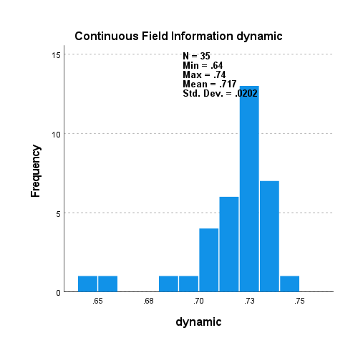

5000_5000_s_v_d_non_scaled

LGBM RO

*Nonparametric Tests: Related Samples.

NPTESTS

/RELATED TEST(static dynamic) WILCOXON

/MISSING SCOPE=ANALYSIS USERMISSING=EXCLUDE

/CRITERIA ALPHA=0.05 CILEVEL=95.

**Nonparametric Tests**

|  |  |  |
| --- | --- | --- |
| **Notes** | | |
| Output Created | | 31-AUG-2021 18:13:58 |
| Comments | |  |
| Input | Active Dataset | DataSet0 |
| Filter | <none> |
| Weight | <none> |
| Split File | <none> |
| N of Rows in Working Data File | 35 |
| Syntax | | NPTESTS  /RELATED TEST(static dynamic) WILCOXON  /MISSING SCOPE=ANALYSIS USERMISSING=EXCLUDE  /CRITERIA ALPHA=0.05 CILEVEL=95. |
| Resources | Processor Time | 00:00:00.74 |
| Elapsed Time | 00:00:00.92 |

|  |  |  |  |  |
| --- | --- | --- | --- | --- |
| **Hypothesis Test Summary** | | | | |
|  | Null Hypothesis | Test | Sig.a,b | Decision |
| 1 | The median of differences between static and dynamic equals 0. | Related-Samples Wilcoxon Signed Rank Test | .000 | Reject the null hypothesis. |
| a. The significance level is .050. | | | | |
| b. Asymptotic significance is displayed. | | | | |

**Related-Samples Wilcoxon Signed Rank Test**

**static, dynamic**

|  |  |
| --- | --- |
| **Related-Samples Wilcoxon Signed Rank Test Summary** | |
| Total N | 35 |
| Test Statistic | 630.000 |
| Standard Error | 61.053 |
| Standardized Test Statistic | 5.159 |
| Asymptotic Sig.(2-sided test) | .000 |

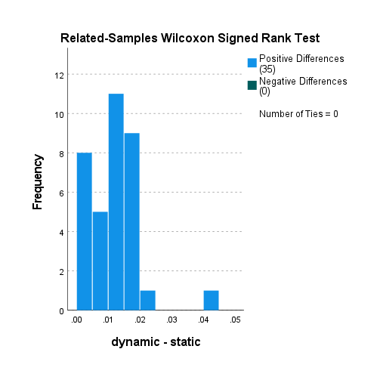

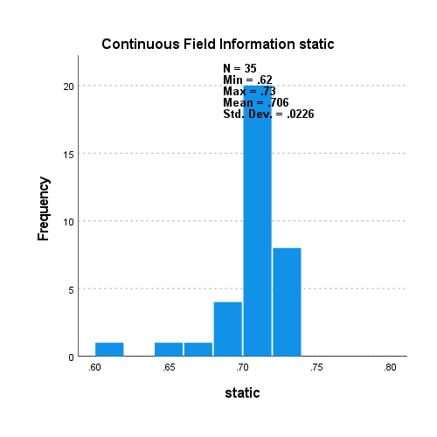

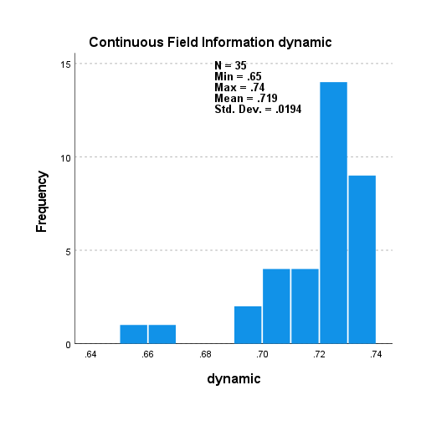

5000_5000_s_v_d_LR_scaled

LR no samp.

*Nonparametric Tests: Related Samples.

NPTESTS

/RELATED TEST(static dynamic) WILCOXON

/MISSING SCOPE=ANALYSIS USERMISSING=EXCLUDE

/CRITERIA ALPHA=0.05 CILEVEL=95.

**Nonparametric Tests**

|  |  |  |
| --- | --- | --- |
| **Notes** | | |
| Output Created | | 31-AUG-2021 18:14:26 |
| Comments | |  |
| Input | Active Dataset | DataSet0 |
| Filter | <none> |
| Weight | <none> |
| Split File | <none> |
| N of Rows in Working Data File | 35 |
| Syntax | | NPTESTS  /RELATED TEST(static dynamic) WILCOXON  /MISSING SCOPE=ANALYSIS USERMISSING=EXCLUDE  /CRITERIA ALPHA=0.05 CILEVEL=95. |
| Resources | Processor Time | 00:00:00.69 |
| Elapsed Time | 00:00:00.89 |

|  |  |  |  |  |
| --- | --- | --- | --- | --- |
| **Hypothesis Test Summary** | | | | |
|  | Null Hypothesis | Test | Sig.a,b | Decision |
| 1 | The median of differences between static and dynamic equals 0. | Related-Samples Wilcoxon Signed Rank Test | .000 | Reject the null hypothesis. |
| a. The significance level is .050. | | | | |
| b. Asymptotic significance is displayed. | | | | |

**Related-Samples Wilcoxon Signed Rank Test**

**static, dynamic**

|  |  |
| --- | --- |
| **Related-Samples Wilcoxon Signed Rank Test Summary** | |
| Total N | 35 |
| Test Statistic | 629.000 |
| Standard Error | 61.053 |
| Standardized Test Statistic | 5.143 |
| Asymptotic Sig.(2-sided test) | .000 |

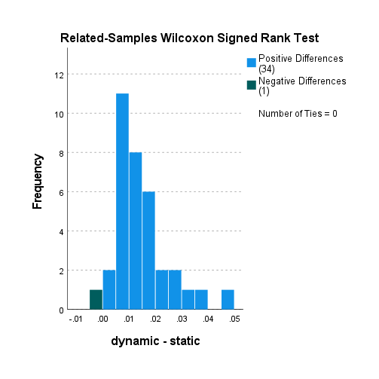

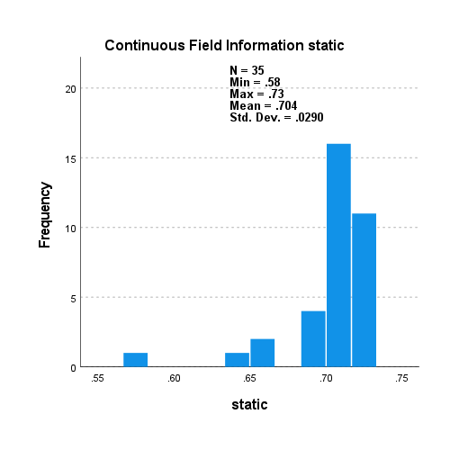

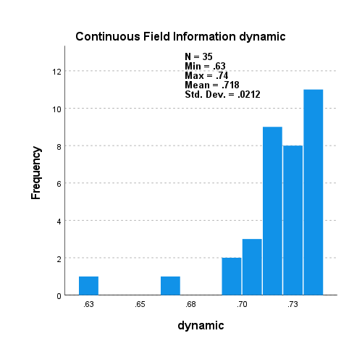

5000_5000_s_v_d_LR_scaled

LR RU

*Nonparametric Tests: Related Samples.

NPTESTS

/RELATED TEST(static dynamic) WILCOXON

/MISSING SCOPE=ANALYSIS USERMISSING=EXCLUDE

/CRITERIA ALPHA=0.05 CILEVEL=95.

**Nonparametric Tests**

|  |  |  |
| --- | --- | --- |
| **Notes** | | |
| Output Created | | 31-AUG-2021 18:14:48 |
| Comments | |  |
| Input | Active Dataset | DataSet0 |
| Filter | <none> |
| Weight | <none> |
| Split File | <none> |
| N of Rows in Working Data File | 35 |
| Syntax | | NPTESTS  /RELATED TEST(static dynamic) WILCOXON  /MISSING SCOPE=ANALYSIS USERMISSING=EXCLUDE  /CRITERIA ALPHA=0.05 CILEVEL=95. |
| Resources | Processor Time | 00:00:00.83 |
| Elapsed Time | 00:00:00.93 |

|  |  |  |  |  |
| --- | --- | --- | --- | --- |
| **Hypothesis Test Summary** | | | | |
|  | Null Hypothesis | Test | Sig.a,b | Decision |
| 1 | The median of differences between static and dynamic equals 0. | Related-Samples Wilcoxon Signed Rank Test | .000 | Reject the null hypothesis. |
| a. The significance level is .050. | | | | |
| b. Asymptotic significance is displayed. | | | | |

**Related-Samples Wilcoxon Signed Rank Test**

**static, dynamic**

|  |  |
| --- | --- |
| **Related-Samples Wilcoxon Signed Rank Test Summary** | |
| Total N | 35 |
| Test Statistic | 627.000 |
| Standard Error | 61.053 |
| Standardized Test Statistic | 5.110 |
| Asymptotic Sig.(2-sided test) | .000 |

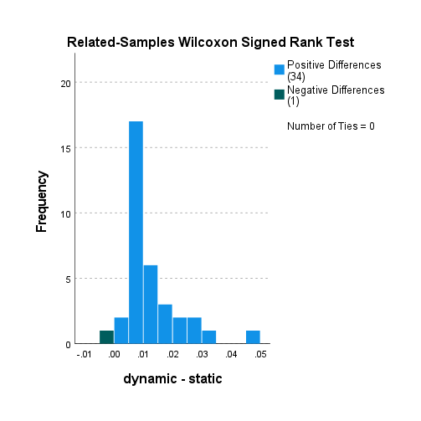

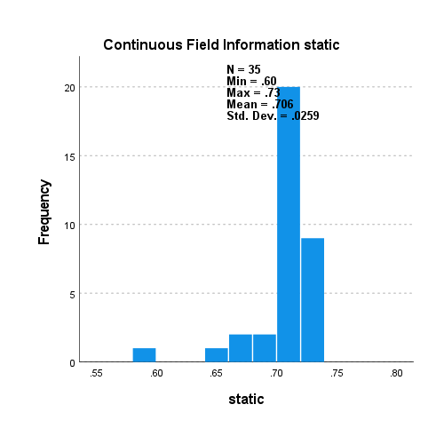

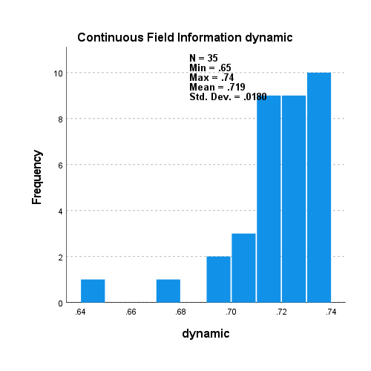

5000_5000_s_v_d_LR_scaled

LR SM

*Nonparametric Tests: Related Samples.

NPTESTS

/RELATED TEST(static dynamic) WILCOXON

/MISSING SCOPE=ANALYSIS USERMISSING=EXCLUDE

/CRITERIA ALPHA=0.05 CILEVEL=95.

**Nonparametric Tests**

|  |  |  |
| --- | --- | --- |
| **Notes** | | |
| Output Created | | 31-AUG-2021 18:15:10 |
| Comments | |  |
| Input | Active Dataset | DataSet0 |
| Filter | <none> |
| Weight | <none> |
| Split File | <none> |
| N of Rows in Working Data File | 35 |
| Syntax | | NPTESTS  /RELATED TEST(static dynamic) WILCOXON  /MISSING SCOPE=ANALYSIS USERMISSING=EXCLUDE  /CRITERIA ALPHA=0.05 CILEVEL=95. |
| Resources | Processor Time | 00:00:00.66 |
| Elapsed Time | 00:00:00.74 |

|  |  |  |  |  |
| --- | --- | --- | --- | --- |
| **Hypothesis Test Summary** | | | | |
|  | Null Hypothesis | Test | Sig.a,b | Decision |
| 1 | The median of differences between static and dynamic equals 0. | Related-Samples Wilcoxon Signed Rank Test | .000 | Reject the null hypothesis. |
| a. The significance level is .050. | | | | |
| b. Asymptotic significance is displayed. | | | | |

**Related-Samples Wilcoxon Signed Rank Test**

**static, dynamic**

|  |  |
| --- | --- |
| **Related-Samples Wilcoxon Signed Rank Test Summary** | |
| Total N | 35 |
| Test Statistic | 629.000 |
| Standard Error | 61.053 |
| Standardized Test Statistic | 5.143 |
| Asymptotic Sig.(2-sided test) | .000 |

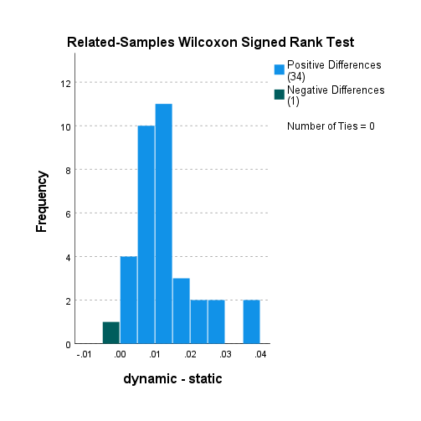

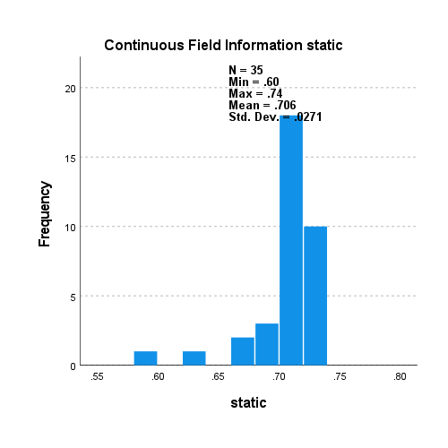

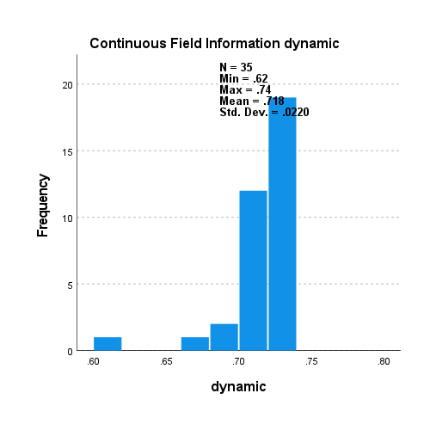

5000_5000_s_v_d_LR_scaled

LR SM BL 1

*Nonparametric Tests: Related Samples.

NPTESTS

/RELATED TEST(static dynamic) WILCOXON

/MISSING SCOPE=ANALYSIS USERMISSING=EXCLUDE

/CRITERIA ALPHA=0.05 CILEVEL=95.

**Nonparametric Tests**

|  |  |  |
| --- | --- | --- |
| **Notes** | | |
| Output Created | | 31-AUG-2021 18:15:35 |
| Comments | |  |
| Input | Active Dataset | DataSet0 |
| Filter | <none> |
| Weight | <none> |
| Split File | <none> |
| N of Rows in Working Data File | 35 |
| Syntax | | NPTESTS  /RELATED TEST(static dynamic) WILCOXON  /MISSING SCOPE=ANALYSIS USERMISSING=EXCLUDE  /CRITERIA ALPHA=0.05 CILEVEL=95. |
| Resources | Processor Time | 00:00:00.73 |
| Elapsed Time | 00:00:00.96 |

|  |  |  |  |  |
| --- | --- | --- | --- | --- |
| **Hypothesis Test Summary** | | | | |
|  | Null Hypothesis | Test | Sig.a,b | Decision |
| 1 | The median of differences between static and dynamic equals 0. | Related-Samples Wilcoxon Signed Rank Test | .000 | Reject the null hypothesis. |
| a. The significance level is .050. | | | | |
| b. Asymptotic significance is displayed. | | | | |

**Related-Samples Wilcoxon Signed Rank Test**

**static, dynamic**

|  |  |
| --- | --- |
| **Related-Samples Wilcoxon Signed Rank Test Summary** | |
| Total N | 35 |
| Test Statistic | 627.000 |
| Standard Error | 61.053 |
| Standardized Test Statistic | 5.110 |
| Asymptotic Sig.(2-sided test) | .000 |

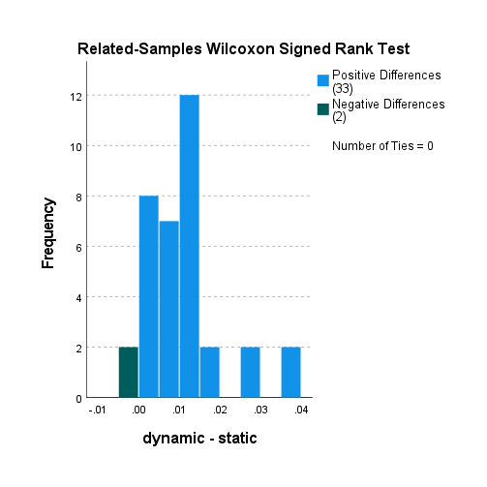

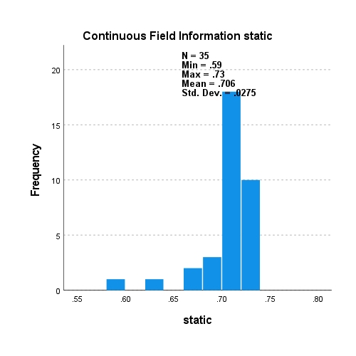

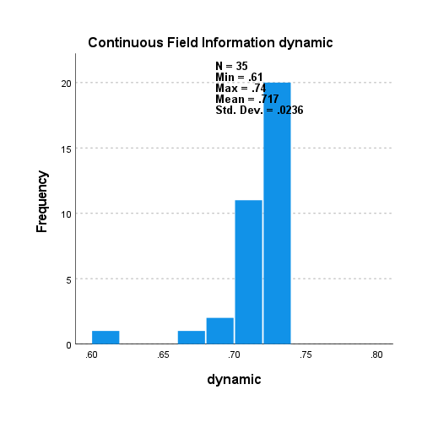

5000_5000_s_v_d_LR_scaled

LR SM BL 2

*Nonparametric Tests: Related Samples.

NPTESTS

/RELATED TEST(static dynamic) WILCOXON

/MISSING SCOPE=ANALYSIS USERMISSING=EXCLUDE

/CRITERIA ALPHA=0.05 CILEVEL=95.

**Nonparametric Tests**

|  |  |  |
| --- | --- | --- |
| **Notes** | | |
| Output Created | | 31-AUG-2021 18:15:59 |
| Comments | |  |
| Input | Active Dataset | DataSet0 |
| Filter | <none> |
| Weight | <none> |
| Split File | <none> |
| N of Rows in Working Data File | 35 |
| Syntax | | NPTESTS  /RELATED TEST(static dynamic) WILCOXON  /MISSING SCOPE=ANALYSIS USERMISSING=EXCLUDE  /CRITERIA ALPHA=0.05 CILEVEL=95. |
| Resources | Processor Time | 00:00:00.77 |
| Elapsed Time | 00:00:00.98 |

|  |  |  |  |  |
| --- | --- | --- | --- | --- |
| **Hypothesis Test Summary** | | | | |
|  | Null Hypothesis | Test | Sig.a,b | Decision |
| 1 | The median of differences between static and dynamic equals 0. | Related-Samples Wilcoxon Signed Rank Test | .000 | Reject the null hypothesis. |
| a. The significance level is .050. | | | | |
| b. Asymptotic significance is displayed. | | | | |

**Related-Samples Wilcoxon Signed Rank Test**

**static, dynamic**

|  |  |
| --- | --- |
| **Related-Samples Wilcoxon Signed Rank Test Summary** | |
| Total N | 35 |
| Test Statistic | 627.000 |
| Standard Error | 61.053 |
| Standardized Test Statistic | 5.110 |
| Asymptotic Sig.(2-sided test) | .000 |

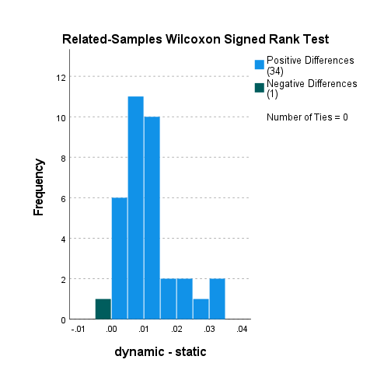

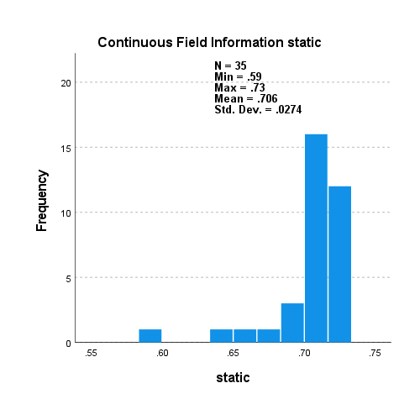

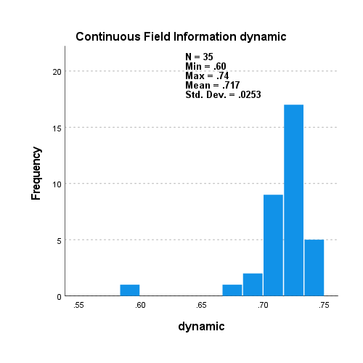

5000_5000_s_v_d_LR_scaled

LR RO

*Nonparametric Tests: Related Samples.

NPTESTS

/RELATED TEST(static dynamic) WILCOXON

/MISSING SCOPE=ANALYSIS USERMISSING=EXCLUDE

/CRITERIA ALPHA=0.05 CILEVEL=95.

**Nonparametric Tests**

|  |  |  |
| --- | --- | --- |
| **Notes** | | |
| Output Created | | 31-AUG-2021 18:16:28 |
| Comments | |  |
| Input | Active Dataset | DataSet0 |
| Filter | <none> |
| Weight | <none> |
| Split File | <none> |
| N of Rows in Working Data File | 35 |
| Syntax | | NPTESTS  /RELATED TEST(static dynamic) WILCOXON  /MISSING SCOPE=ANALYSIS USERMISSING=EXCLUDE  /CRITERIA ALPHA=0.05 CILEVEL=95. |
| Resources | Processor Time | 00:00:00.78 |
| Elapsed Time | 00:00:00.93 |

|  |  |  |  |  |
| --- | --- | --- | --- | --- |
| **Hypothesis Test Summary** | | | | |
|  | Null Hypothesis | Test | Sig.a,b | Decision |
| 1 | The median of differences between static and dynamic equals 0. | Related-Samples Wilcoxon Signed Rank Test | .000 | Reject the null hypothesis. |
| a. The significance level is .050. | | | | |
| b. Asymptotic significance is displayed. | | | | |

**Related-Samples Wilcoxon Signed Rank Test**

**static, dynamic**

|  |  |
| --- | --- |
| **Related-Samples Wilcoxon Signed Rank Test Summary** | |
| Total N | 35 |
| Test Statistic | 630.000 |
| Standard Error | 61.053 |
| Standardized Test Statistic | 5.159 |
| Asymptotic Sig.(2-sided test) | .000 |

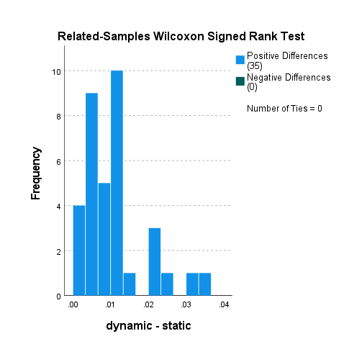

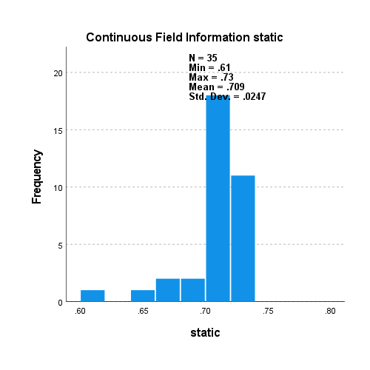

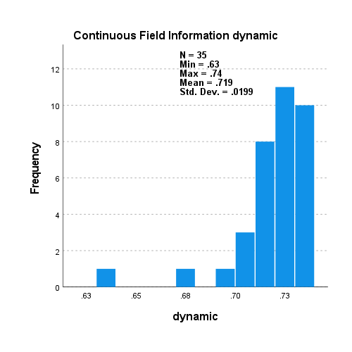

5000_1000_s_v_d_LR_scaled

LR no samp.

*Nonparametric Tests: Related Samples.

NPTESTS

/RELATED TEST(static dynamic) WILCOXON

/MISSING SCOPE=ANALYSIS USERMISSING=EXCLUDE

/CRITERIA ALPHA=0.05 CILEVEL=95.

**Nonparametric Tests**

|  |  |  |
| --- | --- | --- |
| **Notes** | | |
| Output Created | | 31-AUG-2021 18:17:18 |
| Comments | |  |
| Input | Active Dataset | DataSet0 |
| Filter | <none> |
| Weight | <none> |
| Split File | <none> |
| N of Rows in Working Data File | 170 |
| Syntax | | NPTESTS  /RELATED TEST(static dynamic) WILCOXON  /MISSING SCOPE=ANALYSIS USERMISSING=EXCLUDE  /CRITERIA ALPHA=0.05 CILEVEL=95. |
| Resources | Processor Time | 00:00:00.70 |
| Elapsed Time | 00:00:00.78 |

|  |  |  |  |  |
| --- | --- | --- | --- | --- |
| **Hypothesis Test Summary** | | | | |
|  | Null Hypothesis | Test | Sig.a,b | Decision |
| 1 | The median of differences between static and dynamic equals 0. | Related-Samples Wilcoxon Signed Rank Test | .000 | Reject the null hypothesis. |
| a. The significance level is .050. | | | | |
| b. Asymptotic significance is displayed. | | | | |

**Related-Samples Wilcoxon Signed Rank Test**

**static, dynamic**

|  |  |
| --- | --- |
| **Related-Samples Wilcoxon Signed Rank Test Summary** | |
| Total N | 170 |
| Test Statistic | 14534.000 |
| Standard Error | 642.679 |
| Standardized Test Statistic | 11.307 |
| Asymptotic Sig.(2-sided test) | .000 |

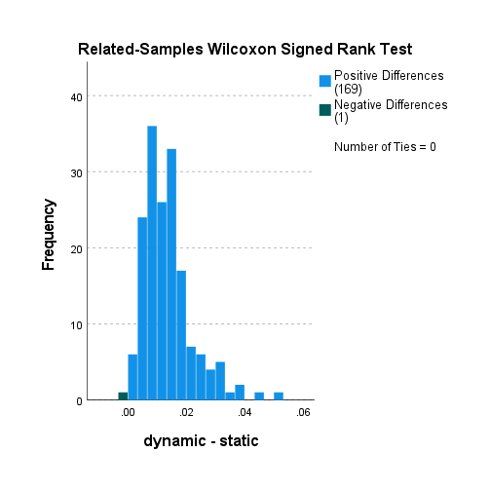

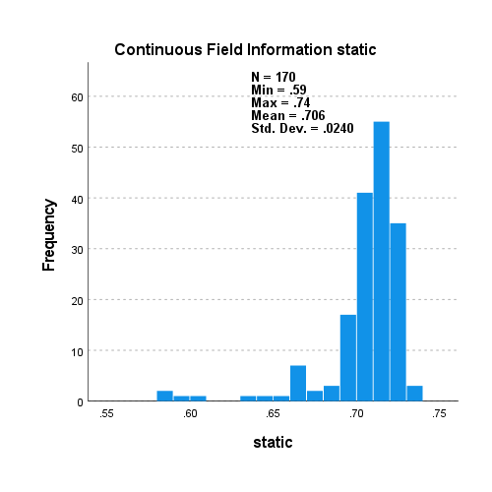

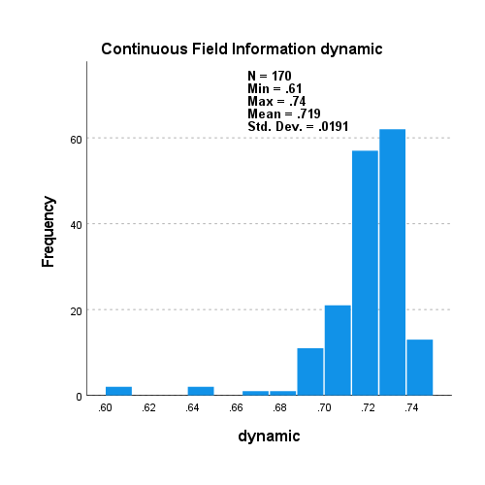

5000_1000_s_v_d_LR_scaled

RF no samp.

*Nonparametric Tests: Related Samples.

NPTESTS

/RELATED TEST(static dynamic) WILCOXON

/MISSING SCOPE=ANALYSIS USERMISSING=EXCLUDE

/CRITERIA ALPHA=0.05 CILEVEL=95.

**Nonparametric Tests**

|  |  |  |
| --- | --- | --- |
| **Notes** | | |
| Output Created | | 31-AUG-2021 18:17:49 |
| Comments | |  |
| Input | Active Dataset | DataSet0 |
| Filter | <none> |
| Weight | <none> |
| Split File | <none> |
| N of Rows in Working Data File | 170 |
| Syntax | | NPTESTS  /RELATED TEST(static dynamic) WILCOXON  /MISSING SCOPE=ANALYSIS USERMISSING=EXCLUDE  /CRITERIA ALPHA=0.05 CILEVEL=95. |
| Resources | Processor Time | 00:00:00.78 |
| Elapsed Time | 00:00:00.95 |

|  |  |  |  |  |
| --- | --- | --- | --- | --- |
| **Hypothesis Test Summary** | | | | |
|  | Null Hypothesis | Test | Sig.a,b | Decision |
| 1 | The median of differences between static and dynamic equals 0. | Related-Samples Wilcoxon Signed Rank Test | .000 | Reject the null hypothesis. |
| a. The significance level is .050. | | | | |
| b. Asymptotic significance is displayed. | | | | |

**Related-Samples Wilcoxon Signed Rank Test**

**static, dynamic**

|  |  |
| --- | --- |
| **Related-Samples Wilcoxon Signed Rank Test Summary** | |
| Total N | 170 |
| Test Statistic | 14535.000 |
| Standard Error | 642.679 |
| Standardized Test Statistic | 11.308 |
| Asymptotic Sig.(2-sided test) | .000 |

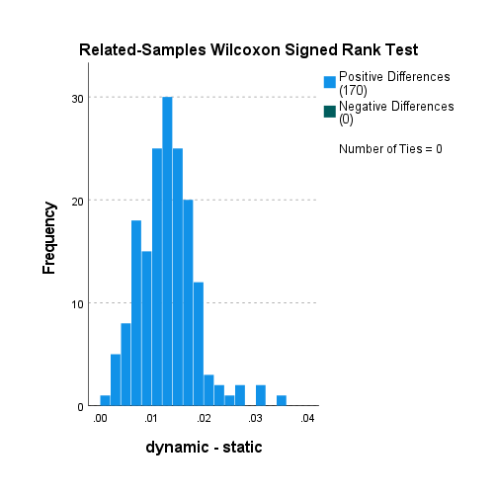

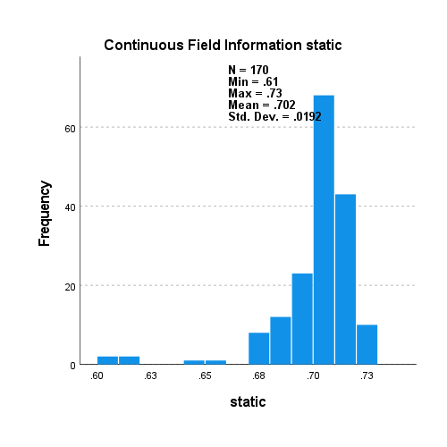

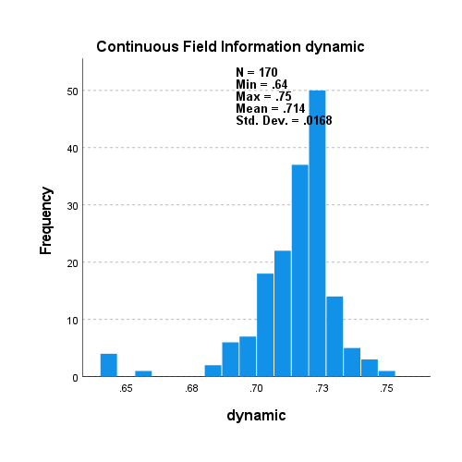

5000_5000_s_v_d_scal._LR_RF_mp

LR no samp.

*Nonparametric Tests: Related Samples.

NPTESTS

/RELATED TEST(static dynamic) WILCOXON

/MISSING SCOPE=ANALYSIS USERMISSING=EXCLUDE

/CRITERIA ALPHA=0.05 CILEVEL=95.

**Nonparametric Tests**

|  |  |  |
| --- | --- | --- |
| **Notes** | | |
| Output Created | | 31-AUG-2021 18:18:17 |
| Comments | |  |
| Input | Active Dataset | DataSet0 |
| Filter | <none> |
| Weight | <none> |
| Split File | <none> |
| N of Rows in Working Data File | 35 |
| Syntax | | NPTESTS  /RELATED TEST(static dynamic) WILCOXON  /MISSING SCOPE=ANALYSIS USERMISSING=EXCLUDE  /CRITERIA ALPHA=0.05 CILEVEL=95. |
| Resources | Processor Time | 00:00:00.73 |
| Elapsed Time | 00:00:00.89 |

|  |  |  |  |  |
| --- | --- | --- | --- | --- |
| **Hypothesis Test Summary** | | | | |
|  | Null Hypothesis | Test | Sig.a,b | Decision |
| 1 | The median of differences between static and dynamic equals 0. | Related-Samples Wilcoxon Signed Rank Test | .000 | Reject the null hypothesis. |
| a. The significance level is .050. | | | | |
| b. Asymptotic significance is displayed. | | | | |

**Related-Samples Wilcoxon Signed Rank Test**

**static, dynamic**

|  |  |
| --- | --- |
| **Related-Samples Wilcoxon Signed Rank Test Summary** | |
| Total N | 35 |
| Test Statistic | 629.000 |
| Standard Error | 61.053 |
| Standardized Test Statistic | 5.143 |
| Asymptotic Sig.(2-sided test) | .000 |

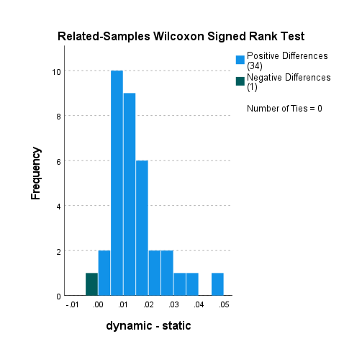



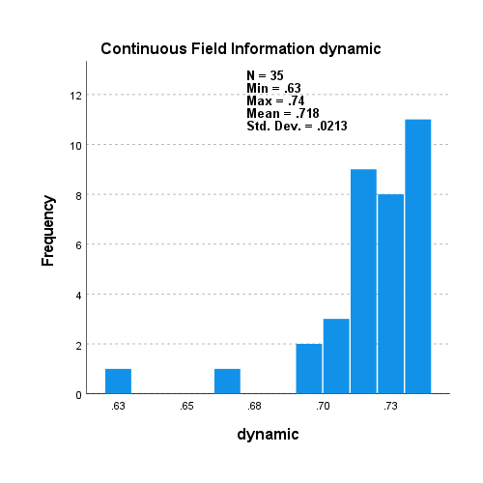

5000_5000_s_v_d_scal._LR_RF_mp

RF no samp.

*Nonparametric Tests: Related Samples.

NPTESTS

/RELATED TEST(static dynamic) WILCOXON

/MISSING SCOPE=ANALYSIS USERMISSING=EXCLUDE

/CRITERIA ALPHA=0.05 CILEVEL=95.

**Nonparametric Tests**

|  |  |  |
| --- | --- | --- |
| **Notes** | | |
| Output Created | | 31-AUG-2021 18:18:38 |
| Comments | |  |
| Input | Active Dataset | DataSet0 |
| Filter | <none> |
| Weight | <none> |
| Split File | <none> |
| N of Rows in Working Data File | 35 |
| Syntax | | NPTESTS  /RELATED TEST(static dynamic) WILCOXON  /MISSING SCOPE=ANALYSIS USERMISSING=EXCLUDE  /CRITERIA ALPHA=0.05 CILEVEL=95. |
| Resources | Processor Time | 00:00:00.86 |
| Elapsed Time | 00:00:00.91 |

|  |  |  |  |  |
| --- | --- | --- | --- | --- |
| **Hypothesis Test Summary** | | | | |
|  | Null Hypothesis | Test | Sig.a,b | Decision |
| 1 | The median of differences between static and dynamic equals 0. | Related-Samples Wilcoxon Signed Rank Test | .000 | Reject the null hypothesis. |
| a. The significance level is .050. | | | | |
| b. Asymptotic significance is displayed. | | | | |

**Related-Samples Wilcoxon Signed Rank Test**

**static, dynamic**

|  |  |
| --- | --- |
| **Related-Samples Wilcoxon Signed Rank Test Summary** | |
| Total N | 35 |
| Test Statistic | 627.000 |
| Standard Error | 61.053 |
| Standardized Test Statistic | 5.110 |
| Asymptotic Sig.(2-sided test) | .000 |

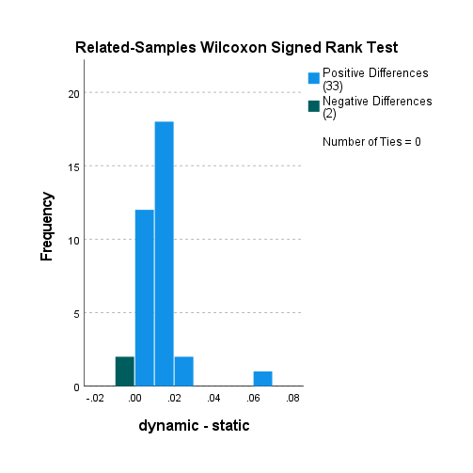

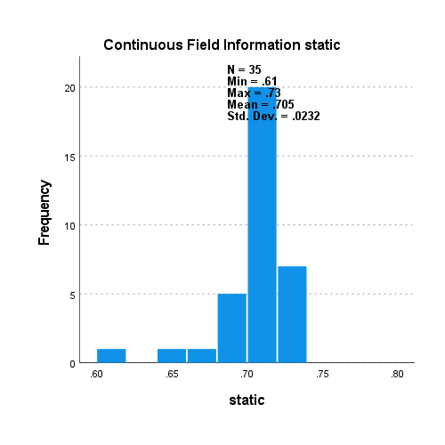

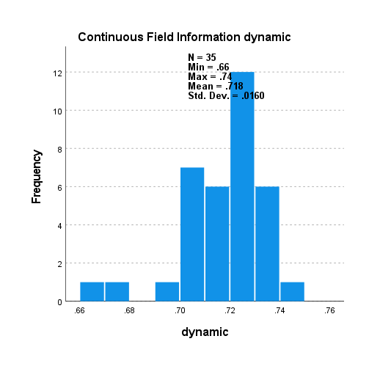

The plots in the Wilcoxon signed ranked test indicated that the difference between the samples is not entirely symmetrical; to confirm this we perform a test for skewness.

5000_5000_s_v_d_non_scaled

LR no samp

|  |  |  |  |  |  |  |  |  |  |
| --- | --- | --- | --- | --- | --- | --- | --- | --- | --- |
| **Descriptive Statistics** | | | | | | | | | |
|  | N | Minimum | Maximum | Mean | Std. Deviation | Skewness | | Kurtosis | |
| Statistic | Statistic | Statistic | Statistic | Statistic | Statistic | Std. Error | Statistic | Std. Error |
| difference | 35 | -.04 | .00 | -.0151 | .00843 | -1.284 | .398 | 2.345 | .778 |
| Valid N (listwise) | 35 |  |  |  |  |  |  |  |  |

5000_5000_s_v_d_non_scaled

LR RU

|  |  |  |  |  |  |  |  |  |  |
| --- | --- | --- | --- | --- | --- | --- | --- | --- | --- |
| **Descriptive Statistics** | | | | | | | | | |
|  | N | Minimum | Maximum | Mean | Std. Deviation | Skewness | | Kurtosis | |
| Statistic | Statistic | Statistic | Statistic | Statistic | Statistic | Std. Error | Statistic | Std. Error |
| difference | 35 | -.05 | .00 | -.0154 | .01098 | -1.647 | .398 | 2.975 | .778 |
| Valid N (listwise) | 35 |  |  |  |  |  |  |  |  |

5000_5000_s_v_d_non_scaled

LR SM

|  |  |  |  |  |  |  |  |  |  |
| --- | --- | --- | --- | --- | --- | --- | --- | --- | --- |
| **Descriptive Statistics** | | | | | | | | | |
|  | N | Minimum | Maximum | Mean | Std. Deviation | Skewness | | Kurtosis | |
| Statistic | Statistic | Statistic | Statistic | Statistic | Statistic | Std. Error | Statistic | Std. Error |
| difference | 35 | -.05 | .00 | -.0146 | .01076 | -1.600 | .398 | 2.393 | .778 |
| Valid N (listwise) | 35 |  |  |  |  |  |  |  |  |

5000_5000_s_v_d_non_scaled

LR SM BL 1

|  |  |  |  |  |  |  |  |  |  |
| --- | --- | --- | --- | --- | --- | --- | --- | --- | --- |
| **Descriptive Statistics** | | | | | | | | | |
|  | N | Minimum | Maximum | Mean | Std. Deviation | Skewness | | Kurtosis | |
| Statistic | Statistic | Statistic | Statistic | Statistic | Statistic | Std. Error | Statistic | Std. Error |
| difference | 35 | -.04 | .00 | -.0131 | .00968 | -1.428 | .398 | 1.683 | .778 |
| Valid N (listwise) | 35 |  |  |  |  |  |  |  |  |

5000_5000_s_v_d_non_scaled

LR SM BL 2

|  |  |  |  |  |  |  |  |  |  |
| --- | --- | --- | --- | --- | --- | --- | --- | --- | --- |
| **Descriptive Statistics** | | | | | | | | | |
|  | N | Minimum | Maximum | Mean | Std. Deviation | Skewness | | Kurtosis | |
| Statistic | Statistic | Statistic | Statistic | Statistic | Statistic | Std. Error | Statistic | Std. Error |
| difference | 35 | -.03 | .00 | -.0115 | .00861 | -1.249 | .398 | 1.247 | .778 |
| Valid N (listwise) | 35 |  |  |  |  |  |  |  |  |

5000_5000_s_v_d_non_scaled

LR RO

|  |  |  |  |  |  |  |  |  |  |
| --- | --- | --- | --- | --- | --- | --- | --- | --- | --- |
| **Descriptive Statistics** | | | | | | | | | |
|  | N | Minimum | Maximum | Mean | Std. Deviation | Skewness | | Kurtosis | |
| Statistic | Statistic | Statistic | Statistic | Statistic | Statistic | Std. Error | Statistic | Std. Error |
| difference | 35 | -.04 | .00 | -.0126 | .00957 | -1.520 | .398 | 1.942 | .778 |
| Valid N (listwise) | 35 |  |  |  |  |  |  |  |  |

5000_5000_s_v_d_non_scaled

RF no samp

|  |  |  |  |  |  |  |  |  |  |
| --- | --- | --- | --- | --- | --- | --- | --- | --- | --- |
| **Descriptive Statistics** | | | | | | | | | |
|  | N | Minimum | Maximum | Mean | Std. Deviation | Skewness | | Kurtosis | |
| Statistic | Statistic | Statistic | Statistic | Statistic | Statistic | Std. Error | Statistic | Std. Error |
| difference | 35 | -.04 | .00 | -.0110 | .00694 | -1.682 | .398 | 6.055 | .778 |
| Valid N (listwise) | 35 |  |  |  |  |  |  |  |  |

5000_5000_s_v_d_non_scaled

RF RU

|  |  |  |  |  |  |  |  |  |  |
| --- | --- | --- | --- | --- | --- | --- | --- | --- | --- |
| **Descriptive Statistics** | | | | | | | | | |
|  | N | Minimum | Maximum | Mean | Std. Deviation | Skewness | | Kurtosis | |
| Statistic | Statistic | Statistic | Statistic | Statistic | Statistic | Std. Error | Statistic | Std. Error |
| difference | 35 | -.03 | .00 | -.0096 | .00689 | -1.081 | .398 | 1.656 | .778 |
| Valid N (listwise) | 35 |  |  |  |  |  |  |  |  |

5000_5000_s_v_d_non_scaled

RF SM

|  |  |  |  |  |  |  |  |  |  |
| --- | --- | --- | --- | --- | --- | --- | --- | --- | --- |
| **Descriptive Statistics** | | | | | | | | | |
|  | N | Minimum | Maximum | Mean | Std. Deviation | Skewness | | Kurtosis | |
| Statistic | Statistic | Statistic | Statistic | Statistic | Statistic | Std. Error | Statistic | Std. Error |
| difference | 35 | -.04 | .00 | -.0182 | .00697 | -.564 | .398 | 2.106 | .778 |
| Valid N (listwise) | 35 |  |  |  |  |  |  |  |  |

5000_5000_s_v_d_non_scaled

RF SM BL 1

|  |  |  |  |  |  |  |  |  |  |
| --- | --- | --- | --- | --- | --- | --- | --- | --- | --- |
| **Descriptive Statistics** | | | | | | | | | |
|  | N | Minimum | Maximum | Mean | Std. Deviation | Skewness | | Kurtosis | |
| Statistic | Statistic | Statistic | Statistic | Statistic | Statistic | Std. Error | Statistic | Std. Error |
| difference | 35 | -.03 | .00 | -.0140 | .00774 | -.627 | .398 | -.101 | .778 |
| Valid N (listwise) | 35 |  |  |  |  |  |  |  |  |

5000_5000_s_v_d_non_scaled

RF SM BL 2

|  |  |  |  |  |  |  |  |  |  |
| --- | --- | --- | --- | --- | --- | --- | --- | --- | --- |
| **Descriptive Statistics** | | | | | | | | | |
|  | N | Minimum | Maximum | Mean | Std. Deviation | Skewness | | Kurtosis | |
| Statistic | Statistic | Statistic | Statistic | Statistic | Statistic | Std. Error | Statistic | Std. Error |
| difference | 35 | -.05 | .00 | -.0145 | .00783 | -1.656 | .398 | 6.461 | .778 |
| Valid N (listwise) | 35 |  |  |  |  |  |  |  |  |

5000_5000_s_v_d_non_scaled

RF RO

|  |  |  |  |  |  |  |  |  |  |
| --- | --- | --- | --- | --- | --- | --- | --- | --- | --- |
| **Descriptive Statistics** | | | | | | | | | |
|  | N | Minimum | Maximum | Mean | Std. Deviation | Skewness | | Kurtosis | |
| Statistic | Statistic | Statistic | Statistic | Statistic | Statistic | Std. Error | Statistic | Std. Error |
| difference | 35 | -.02 | .00 | -.0057 | .00541 | -.679 | .398 | .673 | .778 |
| Valid N (listwise) | 35 |  |  |  |  |  |  |  |  |

5000_5000_s_v_d_non_scaled

XGB no samp

|  |  |  |  |  |  |  |  |  |  |
| --- | --- | --- | --- | --- | --- | --- | --- | --- | --- |
| **Descriptive Statistics** | | | | | | | | | |
|  | N | Minimum | Maximum | Mean | Std. Deviation | Skewness | | Kurtosis | |
| Statistic | Statistic | Statistic | Statistic | Statistic | Statistic | Std. Error | Statistic | Std. Error |
| difference | 35 | -.03 | .00 | -.0128 | .00750 | -.666 | .398 | -.025 | .778 |
| Valid N (listwise) | 35 |  |  |  |  |  |  |  |  |

5000_5000_s_v_d_non_scaled

XGB RU

|  |  |  |  |  |  |  |  |  |  |
| --- | --- | --- | --- | --- | --- | --- | --- | --- | --- |
| **Descriptive Statistics** | | | | | | | | | |
|  | N | Minimum | Maximum | Mean | Std. Deviation | Skewness | | Kurtosis | |
| Statistic | Statistic | Statistic | Statistic | Statistic | Statistic | Std. Error | Statistic | Std. Error |
| difference | 35 | -.05 | .00 | -.0108 | .00977 | -2.041 | .398 | 7.831 | .778 |
| Valid N (listwise) | 35 |  |  |  |  |  |  |  |  |

5000_5000_s_v_d_non_scaled

XGB SM

|  |  |  |  |  |  |  |  |  |  |
| --- | --- | --- | --- | --- | --- | --- | --- | --- | --- |
| **Descriptive Statistics** | | | | | | | | | |
|  | N | Minimum | Maximum | Mean | Std. Deviation | Skewness | | Kurtosis | |
| Statistic | Statistic | Statistic | Statistic | Statistic | Statistic | Std. Error | Statistic | Std. Error |
| difference | 35 | -.03 | .00 | -.0143 | .00819 | -1.046 | .398 | .377 | .778 |
| Valid N (listwise) | 35 |  |  |  |  |  |  |  |  |

5000_5000_s_v_d_non_scaled

XGB SM BL 1

|  |  |  |  |  |  |  |  |  |  |
| --- | --- | --- | --- | --- | --- | --- | --- | --- | --- |
| **Descriptive Statistics** | | | | | | | | | |
|  | N | Minimum | Maximum | Mean | Std. Deviation | Skewness | | Kurtosis | |
| Statistic | Statistic | Statistic | Statistic | Statistic | Statistic | Std. Error | Statistic | Std. Error |
| difference | 35 | -.06 | .00 | -.0155 | .01132 | -1.932 | .398 | 6.135 | .778 |
| Valid N (listwise) | 35 |  |  |  |  |  |  |  |  |

5000_5000_s_v_d_non_scaled

XGB SM BL 2

|  |  |  |  |  |  |  |  |  |  |
| --- | --- | --- | --- | --- | --- | --- | --- | --- | --- |
| **Descriptive Statistics** | | | | | | | | | |
|  | N | Minimum | Maximum | Mean | Std. Deviation | Skewness | | Kurtosis | |
| Statistic | Statistic | Statistic | Statistic | Statistic | Statistic | Std. Error | Statistic | Std. Error |
| difference | 35 | -.04 | .00 | -.0139 | .00816 | -1.509 | .398 | 3.866 | .778 |
| Valid N (listwise) | 35 |  |  |  |  |  |  |  |  |

5000_5000_s_v_d_non_scaled

XGB RO

|  |  |  |  |  |  |  |  |  |  |
| --- | --- | --- | --- | --- | --- | --- | --- | --- | --- |
| **Descriptive Statistics** | | | | | | | | | |
|  | N | Minimum | Maximum | Mean | Std. Deviation | Skewness | | Kurtosis | |
| Statistic | Statistic | Statistic | Statistic | Statistic | Statistic | Std. Error | Statistic | Std. Error |
| difference | 35 | -.06 | .00 | -.0104 | .00938 | -3.471 | .398 | 16.658 | .778 |
| Valid N (listwise) | 35 |  |  |  |  |  |  |  |  |

5000_5000_s_v_d_non_scaled

LGBM no samp

|  |  |  |  |  |  |  |  |  |  |
| --- | --- | --- | --- | --- | --- | --- | --- | --- | --- |
| **Descriptive Statistics** | | | | | | | | | |
|  | N | Minimum | Maximum | Mean | Std. Deviation | Skewness | | Kurtosis | |
| Statistic | Statistic | Statistic | Statistic | Statistic | Statistic | Std. Error | Statistic | Std. Error |
| difference | 35 | -.05 | .00 | -.0145 | .00923 | -2.228 | .398 | 7.922 | .778 |
| Valid N (listwise) | 35 |  |  |  |  |  |  |  |  |

5000_5000_s_v_d_non_scaled

LGBM RU

|  |  |  |  |  |  |  |  |  |  |
| --- | --- | --- | --- | --- | --- | --- | --- | --- | --- |
| **Descriptive Statistics** | | | | | | | | | |
|  | N | Minimum | Maximum | Mean | Std. Deviation | Skewness | | Kurtosis | |
| Statistic | Statistic | Statistic | Statistic | Statistic | Statistic | Std. Error | Statistic | Std. Error |
| difference | 35 | -.06 | .00 | -.0127 | .01041 | -2.020 | .398 | 7.863 | .778 |
| Valid N (listwise) | 35 |  |  |  |  |  |  |  |  |

5000_5000_s_v_d_non_scaled

LGBM SM

|  |  |  |  |  |  |  |  |  |  |
| --- | --- | --- | --- | --- | --- | --- | --- | --- | --- |
| **Descriptive Statistics** | | | | | | | | | |
|  | N | Minimum | Maximum | Mean | Std. Deviation | Skewness | | Kurtosis | |
| Statistic | Statistic | Statistic | Statistic | Statistic | Statistic | Std. Error | Statistic | Std. Error |
| difference | 35 | -.04 | .00 | -.0143 | .00925 | -.555 | .398 | .801 | .778 |
| Valid N (listwise) | 35 |  |  |  |  |  |  |  |  |

5000_5000_s_v_d_non_scaled

LGBM SM BL 1

|  |  |  |  |  |  |  |  |  |  |
| --- | --- | --- | --- | --- | --- | --- | --- | --- | --- |
| **Descriptive Statistics** | | | | | | | | | |
|  | N | Minimum | Maximum | Mean | Std. Deviation | Skewness | | Kurtosis | |
| Statistic | Statistic | Statistic | Statistic | Statistic | Statistic | Std. Error | Statistic | Std. Error |
| difference | 35 | -.04 | .00 | -.0147 | .00792 | -.639 | .398 | .667 | .778 |
| Valid N (listwise) | 35 |  |  |  |  |  |  |  |  |

5000_5000_s_v_d_non_scaled

LGBM SM BL 2

|  |  |  |  |  |  |  |  |  |  |
| --- | --- | --- | --- | --- | --- | --- | --- | --- | --- |
| **Descriptive Statistics** | | | | | | | | | |
|  | N | Minimum | Maximum | Mean | Std. Deviation | Skewness | | Kurtosis | |
| Statistic | Statistic | Statistic | Statistic | Statistic | Statistic | Std. Error | Statistic | Std. Error |
| difference | 35 | -.05 | .01 | -.0129 | .00958 | -.931 | .398 | 4.586 | .778 |
| Valid N (listwise) | 35 |  |  |  |  |  |  |  |  |

5000_5000_s_v_d_non_scaled

LGBM RO

|  |  |  |  |  |  |  |  |  |  |
| --- | --- | --- | --- | --- | --- | --- | --- | --- | --- |
| **Descriptive Statistics** | | | | | | | | | |
|  | N | Minimum | Maximum | Mean | Std. Deviation | Skewness | | Kurtosis | |
| Statistic | Statistic | Statistic | Statistic | Statistic | Statistic | Std. Error | Statistic | Std. Error |
| difference | 35 | -.04 | .00 | -.0123 | .00781 | -2.024 | .398 | 7.534 | .778 |
| Valid N (listwise) | 35 |  |  |  |  |  |  |  |  |

5000_5000_s_v_d_LR_scaled

LR no samp

|  |  |  |  |  |  |  |  |  |  |
| --- | --- | --- | --- | --- | --- | --- | --- | --- | --- |
| **Descriptive Statistics** | | | | | | | | | |
|  | N | Minimum | Maximum | Mean | Std. Deviation | Skewness | | Kurtosis | |
| Statistic | Statistic | Statistic | Statistic | Statistic | Statistic | Std. Error | Statistic | Std. Error |
| difference | 35 | -.05 | .00 | -.0143 | .01042 | -1.533 | .398 | 2.835 | .778 |
| Valid N (listwise) | 35 |  |  |  |  |  |  |  |  |

5000_5000_s_v_d_LR_scaled

LR RU

|  |  |  |  |  |  |  |  |  |  |
| --- | --- | --- | --- | --- | --- | --- | --- | --- | --- |
| **Descriptive Statistics** | | | | | | | | | |
|  | N | Minimum | Maximum | Mean | Std. Deviation | Skewness | | Kurtosis | |
| Statistic | Statistic | Statistic | Statistic | Statistic | Statistic | Std. Error | Statistic | Std. Error |
| difference | 35 | -.05 | .00 | -.0122 | .01007 | -1.903 | .398 | 4.528 | .778 |
| Valid N (listwise) | 35 |  |  |  |  |  |  |  |  |

5000_5000_s_v_d_LR_scaled

LR SM

|  |  |  |  |  |  |  |  |  |  |
| --- | --- | --- | --- | --- | --- | --- | --- | --- | --- |
| **Descriptive Statistics** | | | | | | | | | |
|  | N | Minimum | Maximum | Mean | Std. Deviation | Skewness | | Kurtosis | |
| Statistic | Statistic | Statistic | Statistic | Statistic | Statistic | Std. Error | Statistic | Std. Error |
| difference | 35 | -.04 | .00 | -.0125 | .00908 | -1.372 | .398 | 2.100 | .778 |
| Valid N (listwise) | 35 |  |  |  |  |  |  |  |  |

5000_5000_s_v_d_LR_scaled

LR SM BL 1

|  |  |  |  |  |  |  |  |  |  |
| --- | --- | --- | --- | --- | --- | --- | --- | --- | --- |
| **Descriptive Statistics** | | | | | | | | | |
|  | N | Minimum | Maximum | Mean | Std. Deviation | Skewness | | Kurtosis | |
| Statistic | Statistic | Statistic | Statistic | Statistic | Statistic | Std. Error | Statistic | Std. Error |
| difference | 35 | -.04 | .00 | -.0109 | .00890 | -1.515 | .398 | 2.224 | .778 |
| Valid N (listwise) | 35 |  |  |  |  |  |  |  |  |

5000_5000_s_v_d_LR_scaled

LR SM BL 2

|  |  |  |  |  |  |  |  |  |  |
| --- | --- | --- | --- | --- | --- | --- | --- | --- | --- |
| **Descriptive Statistics** | | | | | | | | | |
|  | N | Minimum | Maximum | Mean | Std. Deviation | Skewness | | Kurtosis | |
| Statistic | Statistic | Statistic | Statistic | Statistic | Statistic | Std. Error | Statistic | Std. Error |
| difference | 35 | -.03 | .00 | -.0109 | .00836 | -1.071 | .398 | .985 | .778 |
| Valid N (listwise) | 35 |  |  |  |  |  |  |  |  |

5000_5000_s_v_d_LR_scaled

LR RO

|  |  |  |  |  |  |  |  |  |  |
| --- | --- | --- | --- | --- | --- | --- | --- | --- | --- |
| **Descriptive Statistics** | | | | | | | | | |
|  | N | Minimum | Maximum | Mean | Std. Deviation | Skewness | | Kurtosis | |
| Statistic | Statistic | Statistic | Statistic | Statistic | Statistic | Std. Error | Statistic | Std. Error |
| difference | 35 | -.03 | .00 | -.0107 | .00800 | -1.331 | .398 | 1.634 | .778 |
| Valid N (listwise) | 35 |  |  |  |  |  |  |  |  |

5000_1000_s_v_d_LR_scaled

LR no samp

|  |  |  |  |  |  |  |  |  |  |
| --- | --- | --- | --- | --- | --- | --- | --- | --- | --- |
| **Descriptive Statistics** | | | | | | | | | |
|  | N | Minimum | Maximum | Mean | Std. Deviation | Skewness | | Kurtosis | |
| Statistic | Statistic | Statistic | Statistic | Statistic | Statistic | Std. Error | Statistic | Std. Error |
| difference | 170 | -.05 | .00 | -.0137 | .00843 | -1.426 | .186 | 2.781 | .370 |
| Valid N (listwise) | 170 |  |  |  |  |  |  |  |  |

5000_1000_s_v_d_LR_scaled

RF no samp

|  |  |  |  |  |  |  |  |  |  |
| --- | --- | --- | --- | --- | --- | --- | --- | --- | --- |
| **Descriptive Statistics** | | | | | | | | | |
|  | N | Minimum | Maximum | Mean | Std. Deviation | Skewness | | Kurtosis | |
| Statistic | Statistic | Statistic | Statistic | Statistic | Statistic | Std. Error | Statistic | Std. Error |
| difference | 170 | -.04 | .00 | -.0129 | .00553 | -.780 | .186 | 2.149 | .370 |
| Valid N (listwise) | 170 |  |  |  |  |  |  |  |  |

5000_5000_s_v_d_scal._LR_RF_mp

LR no samp

|  |  |  |  |  |  |  |  |  |  |
| --- | --- | --- | --- | --- | --- | --- | --- | --- | --- |
| **Descriptive Statistics** | | | | | | | | | |
|  | N | Minimum | Maximum | Mean | Std. Deviation | Skewness | | Kurtosis | |
| Statistic | Statistic | Statistic | Statistic | Statistic | Statistic | Std. Error | Statistic | Std. Error |
| difference | 35 | -.05 | .00 | -.0144 | .01035 | -1.534 | .398 | 2.854 | .778 |
| Valid N (listwise) | 35 |  |  |  |  |  |  |  |  |

5000_5000_s_v_d_scal._LR_RF_mp

RF no samp

|  |  |  |  |  |  |  |  |  |  |
| --- | --- | --- | --- | --- | --- | --- | --- | --- | --- |
| **Descriptive Statistics** | | | | | | | | | |
|  | N | Minimum | Maximum | Mean | Std. Deviation | Skewness | | Kurtosis | |
| Statistic | Statistic | Statistic | Statistic | Statistic | Statistic | Std. Error | Statistic | Std. Error |
| difference | 35 | -.07 | .00 | -.0124 | .01118 | -3.496 | .398 | 16.802 | .778 |
| Valid N (listwise) | 35 |  |  |  |  |  |  |  |  |

https://statistics.laerd.com/spss-tutorials/sign-test-using-spss-statistics.php

The results from the non-parametric Wilcoxon test and the test for skewness also confirm that the difference between the two samples is not symmetrically distributed, thus we conduct a **Paired Sample Sign Test**, which ignores symmetry and normal distribution in the difference between the two samples.

H0: median of dynamic – median of static = 0

H1: median of static – median of dynamic > 0

p-value < 0.05 reject the null hypothesis

p-value > 0.05 accept the null hypothesis

5000_5000_s_v_d_non_scaled

LR no samp

|  |  |  |
| --- | --- | --- |
| **Frequencies** | | |
|  | | N |
| dynamic - static | Negative Differencesa | 0 |
| Positive Differencesb | 35 |
| Tiesc | 0 |
| Total | 35 |
| a. dynamic < static | | |
| b. dynamic > static | | |
| c. dynamic = static | | |

|  |  |
| --- | --- |
| **Test Statisticsa** | |
|  | dynamic - static |
| Z | -5.747 |
| Asymp. Sig. (2-tailed) | .000 |
| a. Sign Test | |

5000_5000_s_v_d_non_scaled

LR RU

|  |  |  |
| --- | --- | --- |
| **Frequencies** | | |
|  | | N |
| dynamic - static | Negative Differencesa | 0 |
| Positive Differencesb | 35 |
| Tiesc | 0 |
| Total | 35 |
| a. dynamic < static | | |
| b. dynamic > static | | |
| c. dynamic = static | | |

|  |  |
| --- | --- |
| **Test Statisticsa** | |
|  | dynamic - static |
| Z | -5.747 |
| Asymp. Sig. (2-tailed) | .000 |
| a. Sign Test | |

5000_5000_s_v_d_non_scaled

LR SM

|  |  |  |
| --- | --- | --- |
| **Frequencies** | | |
|  | | N |
| dynamic - static | Negative Differencesa | 0 |
| Positive Differencesb | 35 |
| Tiesc | 0 |
| Total | 35 |
| a. dynamic < static | | |
| b. dynamic > static | | |
| c. dynamic = static | | |

|  |  |
| --- | --- |
| **Test Statisticsa** | |
|  | dynamic - static |
| Z | -5.747 |
| Asymp. Sig. (2-tailed) | .000 |
| a. Sign Test | |

5000_5000_s_v_d_non_scaled

LR SM BL 1

|  |  |  |
| --- | --- | --- |
| **Frequencies** | | |
|  | | N |
| dynamic - static | Negative Differencesa | 0 |
| Positive Differencesb | 35 |
| Tiesc | 0 |
| Total | 35 |
| a. dynamic < static | | |
| b. dynamic > static | | |
| c. dynamic = static | | |

|  |  |
| --- | --- |
| **Test Statisticsa** | |
|  | dynamic - static |
| Z | -5.747 |
| Asymp. Sig. (2-tailed) | .000 |
| a. Sign Test | |

5000_5000_s_v_d_non_scaled

LR SM BL 2

|  |  |  |
| --- | --- | --- |
| **Frequencies** | | |
|  | | N |
| dynamic - static | Negative Differencesa | 0 |
| Positive Differencesb | 35 |
| Tiesc | 0 |
| Total | 35 |
| a. dynamic < static | | |
| b. dynamic > static | | |
| c. dynamic = static | | |

|  |  |
| --- | --- |
| **Test Statisticsa** | |
|  | dynamic - static |
| Z | -5.747 |
| Asymp. Sig. (2-tailed) | .000 |
| a. Sign Test | |

5000_5000_s_v_d_non_scaled

LR RO

|  |  |  |
| --- | --- | --- |
| **Frequencies** | | |
|  | | N |
| dynamic - static | Negative Differencesa | 0 |
| Positive Differencesb | 35 |
| Tiesc | 0 |
| Total | 35 |
| a. dynamic < static | | |
| b. dynamic > static | | |
| c. dynamic = static | | |

|  |  |
| --- | --- |
| **Test Statisticsa** | |
|  | dynamic - static |
| Z | -5.747 |
| Asymp. Sig. (2-tailed) | .000 |
| a. Sign Test | |

5000_5000_s_v_d_non_scaled

RF no samp

|  |  |  |
| --- | --- | --- |
| **Frequencies** | | |
|  | | N |
| dynamic - static | Negative Differencesa | 0 |
| Positive Differencesb | 35 |
| Tiesc | 0 |
| Total | 35 |
| a. dynamic < static | | |
| b. dynamic > static | | |
| c. dynamic = static | | |

|  |  |
| --- | --- |
| **Test Statisticsa** | |
|  | dynamic - static |
| Z | -5.747 |
| Asymp. Sig. (2-tailed) | .000 |
| a. Sign Test | |

5000_5000_s_v_d_non_scaled

RF RU

|  |  |  |
| --- | --- | --- |
| **Frequencies** | | |
|  | | N |
| dynamic - static | Negative Differencesa | 2 |
| Positive Differencesb | 33 |
| Tiesc | 0 |
| Total | 35 |
| a. dynamic < static | | |
| b. dynamic > static | | |
| c. dynamic = static | | |

|  |  |
| --- | --- |
| **Test Statisticsa** | |
|  | dynamic - static |
| Z | -5.071 |
| Asymp. Sig. (2-tailed) | .000 |
| a. Sign Test | |

5000_5000_s_v_d_non_scaled

RF SM

|  |  |  |
| --- | --- | --- |
| **Frequencies** | | |
|  | | N |
| dynamic - static | Negative Differencesa | 0 |
| Positive Differencesb | 35 |
| Tiesc | 0 |
| Total | 35 |
| a. dynamic < static | | |
| b. dynamic > static | | |
| c. dynamic = static | | |

|  |  |
| --- | --- |
| **Test Statisticsa** | |
|  | dynamic - static |
| Z | -5.747 |
| Asymp. Sig. (2-tailed) | .000 |
| a. Sign Test | |

5000_5000_s_v_d_non_scaled

RF SM BL 1

|  |  |  |
| --- | --- | --- |
| **Frequencies** | | |
|  | | N |
| dynamic - static | Negative Differencesa | 0 |
| Positive Differencesb | 35 |
| Tiesc | 0 |
| Total | 35 |
| a. dynamic < static | | |
| b. dynamic > static | | |
| c. dynamic = static | | |

|  |  |
| --- | --- |
| **Test Statisticsa** | |
|  | dynamic - static |
| Z | -5.747 |
| Asymp. Sig. (2-tailed) | .000 |
| a. Sign Test | |

5000_5000_s_v_d_non_scaled

RF SM BL 2

|  |  |  |
| --- | --- | --- |
| **Frequencies** | | |
|  | | N |
| dynamic - static | Negative Differencesa | 0 |
| Positive Differencesb | 35 |
| Tiesc | 0 |
| Total | 35 |
| a. dynamic < static | | |
| b. dynamic > static | | |
| c. dynamic = static | | |

|  |  |
| --- | --- |
| **Test Statisticsa** | |
|  | dynamic - static |
| Z | -5.747 |
| Asymp. Sig. (2-tailed) | .000 |
| a. Sign Test | |

5000_5000_s_v_d_non_scaled

RF RO

|  |  |  |
| --- | --- | --- |
| **Frequencies** | | |
|  | | N |
| dynamic - static | Negative Differencesa | 4 |
| Positive Differencesb | 31 |
| Tiesc | 0 |
| Total | 35 |
| a. dynamic < static | | |
| b. dynamic > static | | |
| c. dynamic = static | | |

|  |  |
| --- | --- |
| **Test Statisticsa** | |
|  | dynamic - static |
| Z | -4.395 |
| Asymp. Sig. (2-tailed) | .000 |
| a. Sign Test | |

5000_5000_s_v_d_non_scaled

XGB no samp

|  |  |  |
| --- | --- | --- |
| **Frequencies** | | |
|  | | N |
| dynamic - static | Negative Differencesa | 0 |
| Positive Differencesb | 35 |
| Tiesc | 0 |
| Total | 35 |
| a. dynamic < static | | |
| b. dynamic > static | | |
| c. dynamic = static | | |

|  |  |
| --- | --- |
| **Test Statisticsa** | |
|  | dynamic - static |
| Z | -5.747 |
| Asymp. Sig. (2-tailed) | .000 |
| a. Sign Test | |

5000_5000_s_v_d_non_scaled

XGB RU

|  |  |  |
| --- | --- | --- |
| **Frequencies** | | |
|  | | N |
| dynamic - static | Negative Differencesa | 2 |
| Positive Differencesb | 33 |
| Tiesc | 0 |
| Total | 35 |
| a. dynamic < static | | |
| b. dynamic > static | | |
| c. dynamic = static | | |

|  |  |
| --- | --- |
| **Test Statisticsa** | |
|  | dynamic - static |
| Z | -5.071 |
| Asymp. Sig. (2-tailed) | .000 |
| a. Sign Test | |

5000_5000_s_v_d_non_scaled

XGB SM

|  |  |  |
| --- | --- | --- |
| **Frequencies** | | |
|  | | N |
| dynamic - static | Negative Differencesa | 0 |
| Positive Differencesb | 35 |
| Tiesc | 0 |
| Total | 35 |
| a. dynamic < static | | |
| b. dynamic > static | | |
| c. dynamic = static | | |

|  |  |
| --- | --- |
| **Test Statisticsa** | |
|  | dynamic - static |
| Z | -5.747 |
| Asymp. Sig. (2-tailed) | .000 |
| a. Sign Test | |

5000_5000_s_v_d_non_scaled

XGB SM BL 1

|  |  |  |
| --- | --- | --- |
| **Frequencies** | | |
|  | | N |
| dynamic - static | Negative Differencesa | 0 |
| Positive Differencesb | 35 |
| Tiesc | 0 |
| Total | 35 |
| a. dynamic < static | | |
| b. dynamic > static | | |
| c. dynamic = static | | |

|  |  |
| --- | --- |
| **Test Statisticsa** | |
|  | dynamic - static |
| Z | -5.747 |
| Asymp. Sig. (2-tailed) | .000 |
| a. Sign Test | |

5000_5000_s_v_d_non_scaled

XGB SM BL 2

|  |  |  |
| --- | --- | --- |
| **Frequencies** | | |
|  | | N |
| dynamic - static | Negative Differencesa | 0 |
| Positive Differencesb | 35 |
| Tiesc | 0 |
| Total | 35 |
| a. dynamic < static | | |
| b. dynamic > static | | |
| c. dynamic = static | | |

|  |  |
| --- | --- |
| **Test Statisticsa** | |
|  | dynamic - static |
| Z | -5.747 |
| Asymp. Sig. (2-tailed) | .000 |
| a. Sign Test | |

5000_5000_s_v_d_non_scaled

XGB RO

|  |  |  |
| --- | --- | --- |
| **Frequencies** | | |
|  | | N |
| dynamic - static | Negative Differencesa | 1 |
| Positive Differencesb | 34 |
| Tiesc | 0 |
| Total | 35 |
| a. dynamic < static | | |
| b. dynamic > static | | |
| c. dynamic = static | | |

|  |  |
| --- | --- |
| **Test Statisticsa** | |
|  | dynamic - static |
| Z | -5.409 |
| Asymp. Sig. (2-tailed) | .000 |
| a. Sign Test | |

5000_5000_s_v_d_non_scaled

LGBM no samp

|  |  |  |
| --- | --- | --- |
| **Frequencies** | | |
|  | | N |
| dynamic - static | Negative Differencesa | 0 |
| Positive Differencesb | 35 |
| Tiesc | 0 |
| Total | 35 |
| a. dynamic < static | | |
| b. dynamic > static | | |
| c. dynamic = static | | |

|  |  |
| --- | --- |
| **Test Statisticsa** | |
|  | dynamic - static |
| Z | -5.747 |
| Asymp. Sig. (2-tailed) | .000 |
| a. Sign Test | |

5000_5000_s_v_d_non_scaled

LGBM RU

|  |  |  |
| --- | --- | --- |
| **Frequencies** | | |
|  | | N |
| dynamic - static | Negative Differencesa | 3 |
| Positive Differencesb | 32 |
| Tiesc | 0 |
| Total | 35 |
| a. dynamic < static | | |
| b. dynamic > static | | |
| c. dynamic = static | | |

|  |  |
| --- | --- |
| **Test Statisticsa** | |
|  | dynamic - static |
| Z | -4.733 |
| Asymp. Sig. (2-tailed) | .000 |
| a. Sign Test | |

5000_5000_s_v_d_non_scaled

LGBM SM

|  |  |  |
| --- | --- | --- |
| **Frequencies** | | |
|  | | N |
| dynamic - static | Negative Differencesa | 1 |
| Positive Differencesb | 34 |
| Tiesc | 0 |
| Total | 35 |
| a. dynamic < static | | |
| b. dynamic > static | | |
| c. dynamic = static | | |

|  |  |
| --- | --- |
| **Test Statisticsa** | |
|  | dynamic - static |
| Z | -5.409 |
| Asymp. Sig. (2-tailed) | .000 |
| a. Sign Test | |

5000_5000_s_v_d_non_scaled

LGBM SM BL 1

|  |  |  |
| --- | --- | --- |
| **Frequencies** | | |
|  | | N |
| dynamic - static | Negative Differencesa | 0 |
| Positive Differencesb | 35 |
| Tiesc | 0 |
| Total | 35 |
| a. dynamic < static | | |
| b. dynamic > static | | |
| c. dynamic = static | | |

|  |  |
| --- | --- |
| **Test Statisticsa** | |
|  | dynamic - static |
| Z | -5.747 |
| Asymp. Sig. (2-tailed) | .000 |
| a. Sign Test | |

5000_5000_s_v_d_non_scaled

LGBM SM BL 2

|  |  |  |
| --- | --- | --- |
| **Frequencies** | | |
|  | | N |
| dynamic - static | Negative Differencesa | 1 |
| Positive Differencesb | 34 |
| Tiesc | 0 |
| Total | 35 |
| a. dynamic < static | | |
| b. dynamic > static | | |
| c. dynamic = static | | |

|  |  |
| --- | --- |
| **Test Statisticsa** | |
|  | dynamic - static |
| Z | -5.409 |
| Asymp. Sig. (2-tailed) | .000 |
| a. Sign Test | |

5000_5000_s_v_d_non_scaled

LGBM RO

|  |  |  |
| --- | --- | --- |
| **Frequencies** | | |
|  | | N |
| dynamic - static | Negative Differencesa | 0 |
| Positive Differencesb | 35 |
| Tiesc | 0 |
| Total | 35 |
| a. dynamic < static | | |
| b. dynamic > static | | |
| c. dynamic = static | | |

|  |  |
| --- | --- |
| **Test Statisticsa** | |
|  | dynamic - static |
| Z | -5.747 |
| Asymp. Sig. (2-tailed) | .000 |
| a. Sign Test | |

5000_5000_s_v_d_LR_scaled

LR no samp

|  |  |  |
| --- | --- | --- |
| **Frequencies** | | |
|  | | N |
| dynamic - static | Negative Differencesa | 1 |
| Positive Differencesb | 34 |
| Tiesc | 0 |
| Total | 35 |
| a. dynamic < static | | |
| b. dynamic > static | | |
| c. dynamic = static | | |

|  |  |
| --- | --- |
| **Test Statisticsa** | |
|  | dynamic - static |
| Z | -5.409 |
| Asymp. Sig. (2-tailed) | .000 |
| a. Sign Test | |

5000_5000_s_v_d_LR_scaled

LR RU

|  |  |  |
| --- | --- | --- |
| **Frequencies** | | |
|  | | N |
| dynamic - static | Negative Differencesa | 1 |
| Positive Differencesb | 34 |
| Tiesc | 0 |
| Total | 35 |
| a. dynamic < static | | |
| b. dynamic > static | | |
| c. dynamic = static | | |

|  |  |
| --- | --- |
| **Test Statisticsa** | |
|  | dynamic - static |
| Z | -5.409 |
| Asymp. Sig. (2-tailed) | .000 |
| a. Sign Test | |

5000_5000_s_v_d_LR_scaled

LR SM

|  |  |  |
| --- | --- | --- |
| **Frequencies** | | |
|  | | N |
| dynamic - static | Negative Differencesa | 1 |
| Positive Differencesb | 34 |
| Tiesc | 0 |
| Total | 35 |
| a. dynamic < static | | |
| b. dynamic > static | | |
| c. dynamic = static | | |

|  |  |
| --- | --- |
| **Test Statisticsa** | |
|  | dynamic - static |
| Z | -5.409 |
| Asymp. Sig. (2-tailed) | .000 |
| a. Sign Test | |

5000_5000_s_v_d_LR_scaled

LR SM BL 1

|  |  |  |
| --- | --- | --- |
| **Frequencies** | | |
|  | | N |
| dynamic - static | Negative Differencesa | 2 |
| Positive Differencesb | 33 |
| Tiesc | 0 |
| Total | 35 |
| a. dynamic < static | | |
| b. dynamic > static | | |
| c. dynamic = static | | |

|  |  |
| --- | --- |
| **Test Statisticsa** | |
|  | dynamic - static |
| Z | -5.071 |
| Asymp. Sig. (2-tailed) | .000 |
| a. Sign Test | |

5000_5000_s_v_d_LR_scaled

LR SM BL 2

|  |  |  |
| --- | --- | --- |
| **Frequencies** | | |
|  | | N |
| dynamic - static | Negative Differencesa | 1 |
| Positive Differencesb | 34 |
| Tiesc | 0 |
| Total | 35 |
| a. dynamic < static | | |
| b. dynamic > static | | |
| c. dynamic = static | | |

|  |  |
| --- | --- |
| **Test Statisticsa** | |
|  | dynamic - static |
| Z | -5.409 |
| Asymp. Sig. (2-tailed) | .000 |
| a. Sign Test | |

5000_5000_s_v_d_LR_scaled

LR RO

|  |  |  |
| --- | --- | --- |
| **Frequencies** | | |
|  | | N |
| dynamic - static | Negative Differencesa | 0 |
| Positive Differencesb | 35 |
| Tiesc | 0 |
| Total | 35 |
| a. dynamic < static | | |
| b. dynamic > static | | |
| c. dynamic = static | | |

|  |  |
| --- | --- |
| **Test Statisticsa** | |
|  | dynamic - static |
| Z | -5.747 |
| Asymp. Sig. (2-tailed) | .000 |
| a. Sign Test | |

5000_1000_s_v_d_LR_scaled

LR no samp

|  |  |  |
| --- | --- | --- |
| **Frequencies** | | |
|  | | N |
| dynamic - static | Negative Differencesa | 1 |
| Positive Differencesb | 169 |
| Tiesc | 0 |
| Total | 170 |
| a. dynamic < static | | |
| b. dynamic > static | | |
| c. dynamic = static | | |

|  |  |
| --- | --- |
| **Test Statisticsa** | |
|  | dynamic - static |
| Z | -12.808 |
| Asymp. Sig. (2-tailed) | .000 |
| a. Sign Test | |

5000_1000_s_v_d_LR_scaled

RF no samp

|  |  |  |
| --- | --- | --- |
| **Frequencies** | | |
|  | | N |
| dynamic - static | Negative Differencesa | 0 |
| Positive Differencesb | 170 |
| Tiesc | 0 |
| Total | 170 |
| a. dynamic < static | | |
| b. dynamic > static | | |
| c. dynamic = static | | |

|  |  |
| --- | --- |
| **Test Statisticsa** | |
|  | dynamic - static |
| Z | -12.962 |
| Asymp. Sig. (2-tailed) | .000 |
| a. Sign Test | |

5000_5000_s_v_d_scal._LR_RF_mp

LR no samp

|  |  |  |
| --- | --- | --- |
| **Frequencies** | | |
|  | | N |
| dynamic - static | Negative Differencesa | 1 |
| Positive Differencesb | 34 |
| Tiesc | 0 |
| Total | 35 |
| a. dynamic < static | | |
| b. dynamic > static | | |
| c. dynamic = static | | |

|  |  |
| --- | --- |
| **Test Statisticsa** | |
|  | dynamic - static |
| Z | -5.409 |
| Asymp. Sig. (2-tailed) | .000 |
| a. Sign Test | |

5000_5000_s_v_d_scal._LR_RF_mp

RF no samp

|  |  |  |
| --- | --- | --- |
| **Frequencies** | | |
|  | | N |
| dynamic - static | Negative Differencesa | 2 |
| Positive Differencesb | 33 |
| Tiesc | 0 |
| Total | 35 |
| a. dynamic < static | | |
| b. dynamic > static | | |
| c. dynamic = static | | |

|  |  |
| --- | --- |
| **Test Statisticsa** | |
|  | dynamic - static |
| Z | -5.071 |
| Asymp. Sig. (2-tailed) | .000 |
| a. Sign Test | |

Paired sample t-test between best MLP and BEST Result so far (LR scaled more parameters in grid search)

Level of significance 0.05

H0: mean of BEST LR AUC ROC – mean of MLP AUC ROC = 0

H1: mean of BEST LR AUC ROC – mean of MLP AUC ROC < 0

P-value < 0.05 reject the null hypothesis

P-value > 0.05 accept the null hypothesis

5000_5000_s_v_d_scal._LR_RF_mp

|  |  |  |  |  |  |
| --- | --- | --- | --- | --- | --- |
| **Paired Samples Statistics** | | | | | |
|  | | Mean | N | Std. Deviation | Std. Error Mean |
| Pair 1 | BEST_LR_AUC_ROC | .7179 | 35 | .02128 | .00360 |
| MLP_AUC_ROC | .7211 | 35 | .01883 | .00318 |

|  |  |  |  |  |
| --- | --- | --- | --- | --- |
| **Paired Samples Correlations** | | | | |
|  | | N | Correlation | Sig. |
| Pair 1 | BEST_LR_AUC_ROC & MLP_AUC_ROC | 35 | .958 | .000 |

|  |  |  |  |  |  |  |  |  |  |  |
| --- | --- | --- | --- | --- | --- | --- | --- | --- | --- | --- |
| **Paired Samples Test** | | | | | | | | | | |
|  | | Paired Differences | | | | | t | df | Sig. (2-tailed) |
| Mean | Std. Deviation | Std. Error Mean | 95% Confidence Interval of the Difference | |
| Lower | Upper |
| Pair 1 | BEST_LR_AUC_ROC - MLP_AUC_ROC | -.00316 | .00627 | .00106 | -.00531 | -.00101 | -2.981 | 34 | .005 |

|  |  |  |  |  |  |  |
| --- | --- | --- | --- | --- | --- | --- |
| **Paired Samples Effect Sizes** | | | | | | |
|  | | | Standardizera | Point Estimate | 95% Confidence Interval | |
| Lower | Upper |
| Pair 1 | BEST_LR_AUC_ROC - MLP_AUC_ROC | Cohen's d | .00627 | -.504 | -.853 | -.148 |
| Hedges' correction | .00634 | -.498 | -.843 | -.147 |
| a. The denominator used in estimating the effect sizes.  Cohen's d uses the sample standard deviation of the mean difference.  Hedges' correction uses the sample standard deviation of the mean difference, plus a correction factor. | | | | | | |

Analyse -> Descriptive Statistics -> Explore -> In plots tick for normality

Although all the null hypotheses were rejected in the previous paired sampled t-test, we perform the Shapiro-Wilk test for normality.

Shapiro-wilk test for normality distribution in the difference between the two samples, level of significance 0.05

H0: difference is normally distributed

H1: difference is not normally distributed

P-value < 0.05 reject the null hypothesis

P-value > 0.05 accept the null hypothesis

5000_5000_s_v_d_scal._LR_RF_mp

|  |  |  |  |  |  |  |
| --- | --- | --- | --- | --- | --- | --- |
| **Tests of Normality** | | | | | | |
|  | Kolmogorov-Smirnova | | | Shapiro-Wilk | | |
| Statistic | df | Sig. | Statistic | df | Sig. |
| difference | .246 | 35 | .000 | .651 | 35 | .000 |
| a. Lilliefors Significance Correction | | | | | | |

We conclude that the samples differences are not coming from a normal distribution, thus we must use the non-parametric Wilcoxon signed rank test. Additionally, we must also check that the difference between the two samples is symmetrically distributed.

H0: median of BEST MLP AUC ROC – median of BEST LR AUC ROC = 0

H1: median of BEST MLP AUC ROC – median of BEST LR AUC ROC > 0

p-value < 0.05 reject the null hypothesis

p-value > 0.05 accept the null hypothesis

5000_5000_s_v_d_scal._LR_RF_mp

|  |  |  |  |  |
| --- | --- | --- | --- | --- |
| **Hypothesis Test Summary** | | | | |
|  | Null Hypothesis | Test | Sig.a,b | Decision |
| 1 | The median of differences between BEST_LR_AUC_ROC and MLP_AUC_ROC equals 0. | Related-Samples Wilcoxon Signed Rank Test | .000 | Reject the null hypothesis. |
| a. The significance level is .050. | | | | |
| b. Asymptotic significance is displayed. | | | | |

**Related-Samples Wilcoxon Signed Rank Test**

**BEST_LR_AUC_ROC, MLP_AUC_ROC**

|  |  |
| --- | --- |
| **Related-Samples Wilcoxon Signed Rank Test Summary** | |
| Total N | 35 |
| Test Statistic | 539.000 |
| Standard Error | 61.053 |
| Standardized Test Statistic | 3.669 |
| Asymptotic Sig.(2-sided test) | .000 |

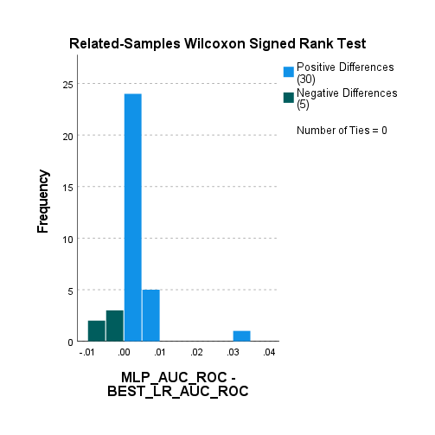

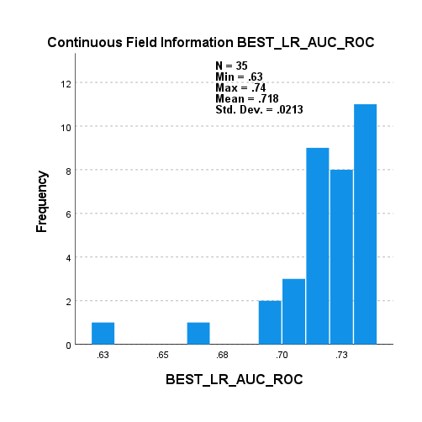

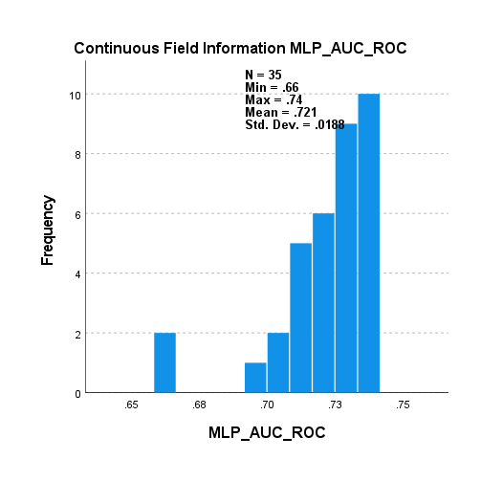

The plots in the Wilcoxon signed ranked test indicated that the difference between the samples is not entirely symmetrical; to confirm this we perform a test for skewness.

5000_5000_s_v_d_scal._LR_RF_mp

|  |  |  |  |  |  |  |  |
| --- | --- | --- | --- | --- | --- | --- | --- |
| **Descriptive Statistics** | | | | | | | |
|  | N | Minimum | Maximum | Mean | Std. Deviation | Skewness | |
| Statistic | Statistic | Statistic | Statistic | Statistic | Statistic | Std. Error |
| difference | 35 | -.03 | .01 | -.0032 | .00627 | -3.225 | .398 |
| Valid N (listwise) | 35 |  |  |  |  |  |  |

The results from the non-parametric Wilcoxon test and the test for skewness also confirm that the difference between the two samples is not symmetrically distributed, thus we conduct a **Paired Sample Sign Test**, which ignores symmetry and normal distribution in the difference between the two samples.

H0: median of BEST MLP AUC ROC – median of BEST LR AUC ROC = 0

H1: median of BEST MLP AUC ROC – median of BEST LR AUC ROC > 0

p-value < 0.05 reject the null hypothesis

p-value > 0.05 accept the null hypothesis

5000_5000_s_v_d_scal._LR_RF_mp

|  |  |  |
| --- | --- | --- |
| **Frequencies** | | |
|  | | N |
| MLP_AUC_ROC - BEST_LR_AUC_ROC | Negative Differencesa | 5 |
| Positive Differencesb | 30 |
| Tiesc | 0 |
| Total | 35 |
| a. MLP_AUC_ROC < BEST_LR_AUC_ROC | | |
| b. MLP_AUC_ROC > BEST_LR_AUC_ROC | | |
| c. MLP_AUC_ROC = BEST_LR_AUC_ROC | | |

|  |  |
| --- | --- |
| **Test Statisticsa** | |
|  | MLP_AUC_ROC - BEST_LR_AUC_ROC |
| Z | -4.057 |
| Asymp. Sig. (2-tailed) | .000 |
| a. Sign Test | |

Paired sample t-test between best MLP and BEST Result so far (LR scaled more parameters in grid search)

Level of significance 0.05

H0: mean of BEST LR AUC ROC – mean of MLP AUC ROC = 0

H1: mean of BEST LR AUC ROC – mean of MLP AUC ROC < 0

P-value < 0.05 reject the null hypothesis

P-value > 0.05 accept the null hypothesis

5000_5000_s_v_d_scal._LR_RF_mp second MLP column

|  |  |  |  |  |  |
| --- | --- | --- | --- | --- | --- |
| **Paired Samples Statistics** | | | | | |
|  | | Mean | N | Std. Deviation | Std. Error Mean |
| Pair 1 | BEST_LR_AUC_ROC | .7179 | 35 | .02128 | .00360 |
| MLP_AUC_ROC | .7207 | 35 | .02124 | .00359 |

|  |  |  |  |  |
| --- | --- | --- | --- | --- |
| **Paired Samples Correlations** | | | | |
|  | | N | Correlation | Sig. |
| Pair 1 | BEST_LR_AUC_ROC & MLP_AUC_ROC | 35 | .986 | .000 |

|  |  |  |  |  |  |  |  |  |  |
| --- | --- | --- | --- | --- | --- | --- | --- | --- | --- |
| **Paired Samples Test** | | | | | | | | | |
|  | | Paired Differences | | | | | t | df | Sig. (2-tailed) |
| Mean | Std. Deviation | Std. Error Mean | 95% Confidence Interval of the Difference | |
| Lower | Upper |
| Pair 1 | BEST_LR_AUC_ROC - MLP_AUC_ROC | -.00279 | .00353 | .00060 | -.00400 | -.00157 | -4.674 | 34 | .000 |

|  |  |  |  |  |  |  |
| --- | --- | --- | --- | --- | --- | --- |
| **Paired Samples Effect Sizes** | | | | | | |
|  | | | Standardizera | Point Estimate | 95% Confidence Interval | |
| Lower | Upper |
| Pair 1 | BEST_LR_AUC_ROC - MLP_AUC_ROC | Cohen's d | .00353 | -.790 | -1.166 | -.405 |
| Hedges' correction | .00357 | -.781 | -1.153 | -.401 |
| a. The denominator used in estimating the effect sizes.  Cohen's d uses the sample standard deviation of the mean difference.  Hedges' correction uses the sample standard deviation of the mean difference, plus a correction factor. | | | | | | |

Analyse -> Descriptive Statistics -> Explore -> In plots tick for normality

Although all the null hypotheses were rejected in the previous paired sampled t-test, we perform the Shapiro-Wilk test for normality.

Shapiro-wilk test for normality distribution in the difference between the two samples, level of significance 0.05

H0: difference is normally distributed

H1: difference is not normally distributed

P-value < 0.05 reject the null hypothesis

P-value > 0.05 accept the null hypothesis

5000_5000_s_v_d_scal._LR_RF_mp second column

|  |  |  |  |  |  |  |
| --- | --- | --- | --- | --- | --- | --- |
| **Tests of Normality** | | | | | | |
|  | Kolmogorov-Smirnova | | | Shapiro-Wilk | | |
| Statistic | df | Sig. | Statistic | df | Sig. |
| difference | .113 | 35 | .200* | .969 | 35 | .428 |
| *. This is a lower bound of the true significance. | | | | | | |
| a. Lilliefors Significance Correction | | | | | | |

We conclude that the samples differences are coming from a normal distribution, however we still use the non-parametric Wilcoxon signed rank test. Additionally, we must also check that the difference between the two samples is symmetrically distributed.

H0: median of BEST MLP AUC ROC – median of BEST LR AUC ROC = 0

H1: median of BEST MLP AUC ROC – median of BEST LR AUC ROC > 0

p-value < 0.05 reject the null hypothesis

p-value > 0.05 accept the null hypothesis

5000_5000_s_v_d_scal._LR_RF_mp second column

|  |  |  |  |  |
| --- | --- | --- | --- | --- |
| **Hypothesis Test Summary** | | | | |
|  | Null Hypothesis | Test | Sig.a,b | Decision |
| 1 | The median of differences between BEST_LR_AUC_ROC and MLP_AUC_ROC equals 0. | Related-Samples Wilcoxon Signed Rank Test | .000 | Reject the null hypothesis. |
| a. The significance level is .050. | | | | |
| b. Asymptotic significance is displayed. | | | | |

**Related-Samples Wilcoxon Signed Rank Test**

**BEST_LR_AUC_ROC, MLP_AUC_ROC**

|  |  |
| --- | --- |
| **Related-Samples Wilcoxon Signed Rank Test Summary** | |
| Total N | 35 |
| Test Statistic | 551.000 |
| Standard Error | 61.053 |
| Standardized Test Statistic | 3.865 |
| Asymptotic Sig.(2-sided test) | .000 |

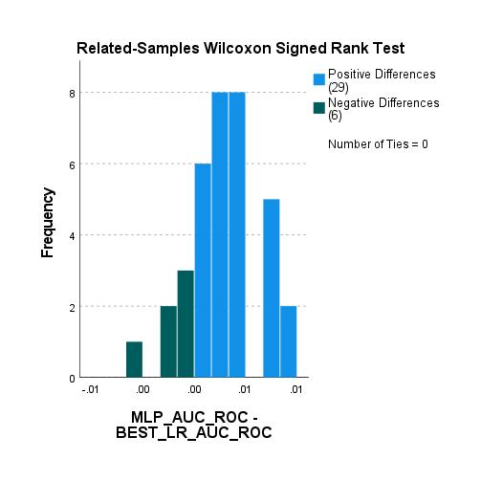

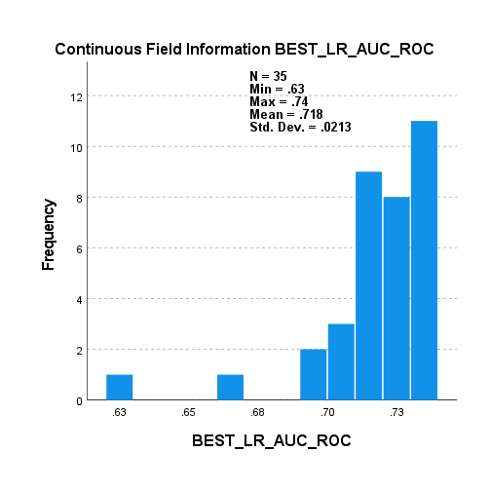

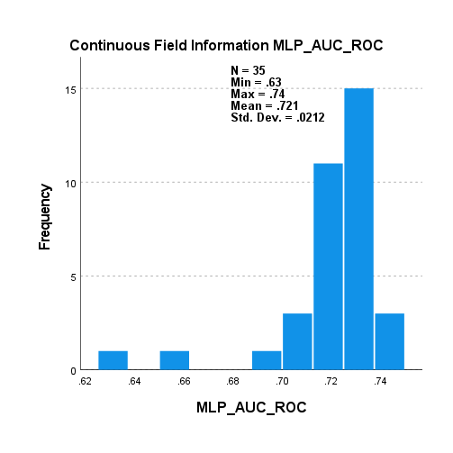

The plots in the Wilcoxon signed ranked test indicated that the difference between the samples is fairly symmetrical; to confirm this we perform a test for skewness.

5000_5000_s_v_d_scal._LR_RF_mp second column

|  |  |  |  |  |  |  |  |
| --- | --- | --- | --- | --- | --- | --- | --- |
| **Descriptive Statistics** | | | | | | | |
|  | N | Minimum | Maximum | Mean | Std. Deviation | Skewness | |
| Statistic | Statistic | Statistic | Statistic | Statistic | Statistic | Std. Error |
| difference | 35 | -.01 | .01 | -.0028 | .00353 | .121 | .398 |
| Valid N (listwise) | 35 |  |  |  |  |  |  |

The results from the non-parametric Wilcoxon test and the test for skewness also confirm that the difference between the two samples is symmetrically distributed; however, we still conduct a **Paired Sample Sign Test**, which ignores symmetry and normal distribution in the difference between the two samples.

H0: median of BEST MLP AUC ROC – median of BEST LR AUC ROC = 0

H1: median of BEST MLP AUC ROC – median of BEST LR AUC ROC > 0

p-value < 0.05 reject the null hypothesis

p-value > 0.05 accept the null hypothesis

5000_5000_s_v_d_scal._LR_RF_mp second column

|  |  |  |
| --- | --- | --- |
| **Frequencies** | | |
|  | | N |
| MLP_AUC_ROC - BEST_LR_AUC_ROC | Negative Differencesa | 6 |
| Positive Differencesb | 29 |
| Tiesc | 0 |
| Total | 35 |
| a. MLP_AUC_ROC < BEST_LR_AUC_ROC | | |
| b. MLP_AUC_ROC > BEST_LR_AUC_ROC | | |
| c. MLP_AUC_ROC = BEST_LR_AUC_ROC | | |

|  |  |
| --- | --- |
| **Test Statisticsa** | |
|  | MLP_AUC_ROC - BEST_LR_AUC_ROC |
| Z | -3.719 |
| Asymp. Sig. (2-tailed) | .000 |
| a. Sign Test | |