TECNOLOGICO DE MONTERREY
School of Engineering and Sciences
Object-Oriented Programming (Java)

LABORATORY — SPRINT 1
Exceptions, Logging & Unit Testing
Order Management System

Course | Object-Oriented Programming (Java)
Professor | Adolfo Arroyo
Term | 6th semester — February–June 2026
Due Date | April 10th
Weight | 25% Exceptions | 30% Implementation + Logging | 45% Testing

⚠️ IMPORTANT
This document is for exclusive use in the Object-Oriented Programming course. Do not distribute without authorization.

TABLE OF CONTENTS

Section 0 — Application Overview

0.1 What is the Order Management System?
The Order Management System is a simplified e-commerce backend built as a Maven project. You will receive a boilerplate that already contains the project structure, models, repository interfaces, services, and test files. The code includes TODO markers that indicate exactly what you must implement.
The system models the creation, modification, and cancellation of customer orders, including inventory checks, product management, and business rule enforcement. There is no database or external server — the repository uses in-memory HashMaps so you can focus entirely on code quality.
The purpose of this sprint is to practice three fundamental pillars of professional Java development:
- Exceptions — designing and using a custom exception hierarchy.
- Logging — providing traceability for operations using SLF4J + Logback.
- Unit Testing — verifying behavior with JUnit 5 and Mockito, achieving ≥ 80% coverage.

0.2 The Three Pillars
Pillar | What will you learn?
Exceptions | Design custom exception hierarchies, throw them at the right time, and handle them appropriately with correct errorCode values.
Logging | Use SLF4J + Logback with the correct levels (DEBUG, INFO, WARN, ERROR) to provide operation traceability in production-quality code.
Unit Testing | Write tests with JUnit 5 and Mockito following the Arrange-Act-Assert (AAA) pattern, achieving ≥ 80% line coverage measured by JaCoCo.

0.3 Technologies Used
Technology | Version | Purpose
Java JDK | 17 | Programming language
Maven | 3.9+ | Dependency management and build tool
JUnit 5 | 5.10.2 | Unit testing framework (Jupiter)
Mockito | 5.11.0 | Mock object library for testing
SLF4J | 2.0.12 | Logging facade (abstraction layer)
Logback | 1.5.3 | SLF4J implementation (console + file output)
JaCoCo | 0.8.11 | Code coverage reporting

0.4 How the Code is Organized
The project follows a layered architecture. Each layer has a specific responsibility:
Exception Layer → Custom exception hierarchy (base + 3 specific exceptions)
Model Layer → Product, OrderItem, Order (core business entities)
Repository Layer → OrderRepository interface + InMemoryOrderRepository
Service Layer → OrderService, InventoryService (business logic — TODO)
Test Layer → 4 test classes covering all layers (TODO)

- You do NOT need a database or external server.
- The repository stores orders and products in in-memory HashMaps.
- The focus is purely on code quality: exception handling, logging, and testing.

0.5 What You Will Deliver
- Complete source code with all TODO markers implemented and pushed to the repository.
- All tests passing (green) — terminal output of mvn test.
- JaCoCo coverage report showing ≥ 80% line coverage.
- Screenshot evidence for each milestone.

Section 1 — Environment Setup

1.1 Prerequisites
Verify all required tools are installed before you begin:

Tool | Min. Version | Verification Command | Notes
Java JDK | 17 | java -version | Liberica, Temurin, or Oracle JDK 17
Maven | 3.9+ | mvn -version | Can use the wrapper ./mvnw
Git | 2.x | git --version | Required to clone the repository
IDE | — | IntelliJ IDEA or VS Code | With Java and Maven extensions

1.2 Clone the Repository
git clone https://github.com/adolfoarroyotec/Java2026/tree/main/Sprint%201
cd order-management
⚠️ IMPORTANT
The Project is also attached in the practice

1.3 Project Structure
order-management/
├── pom.xml ← Maven config (dependencies, plugins)
├── src/
│ ├── main/
│ │ ├── java/com/tecmx/ordermanagement/
│ │ │ ├── exception/
│ │ │ │ ├── OrderManagementException.java ← Base exception (COMPLETE — DO NOT MODIFY)
│ │ │ │ ├── ResourceNotFoundException.java ← TODO: fix inheritance + add field
│ │ │ │ ├── ValidationException.java ← TODO: fix inheritance + add field
│ │ │ │ └── BusinessRuleException.java ← TODO: fix inheritance + add constructor
│ │ │ ├── model/
│ │ │ │ ├── Product.java ← COMPLETE
│ │ │ │ ├── OrderItem.java ← TODO: implement getSubtotal()
│ │ │ │ └── Order.java ← TODO: implement getTotal()
│ │ │ ├── repository/
│ │ │ │ ├── OrderRepository.java ← Interface (DO NOT MODIFY)
│ │ │ │ └── InMemoryOrderRepository.java ← COMPLETE (DO NOT MODIFY)
│ │ │ └── service/
│ │ │ ├── OrderService.java ← TODO: implement all 5 methods
│ │ │ └── InventoryService.java ← TODO: implement all 3 methods
│ │ └── resources/
│ │ └── logback.xml ← Logging configuration
│ └── test/java/com/tecmx/ordermanagement/
│ ├── exception/ExceptionTests.java ← TODO: complete 6 tests
│ ├── model/ModelTests.java ← TODO: complete 6 tests
│ ├── service/OrderServiceTest.java ← TODO: complete ~20 tests
│ └── service/InventoryServiceTest.java← TODO: complete ~12 tests
└── README.md

1.4 Compile and Verify
mvn compile
This should complete with BUILD SUCCESS. If it fails, verify that Java 17 and Maven are installed and that JAVA_HOME points to the correct JDK.

1.5 Run the Tests (failures are expected!)
mvn test
Many tests will fail because the TODO implementations are missing. This is by design. As you complete each phase, more tests will turn green.
📸 [Screenshot]
Terminal showing mvn test output with multiple test failures — this is the expected initial state before implementing anything.
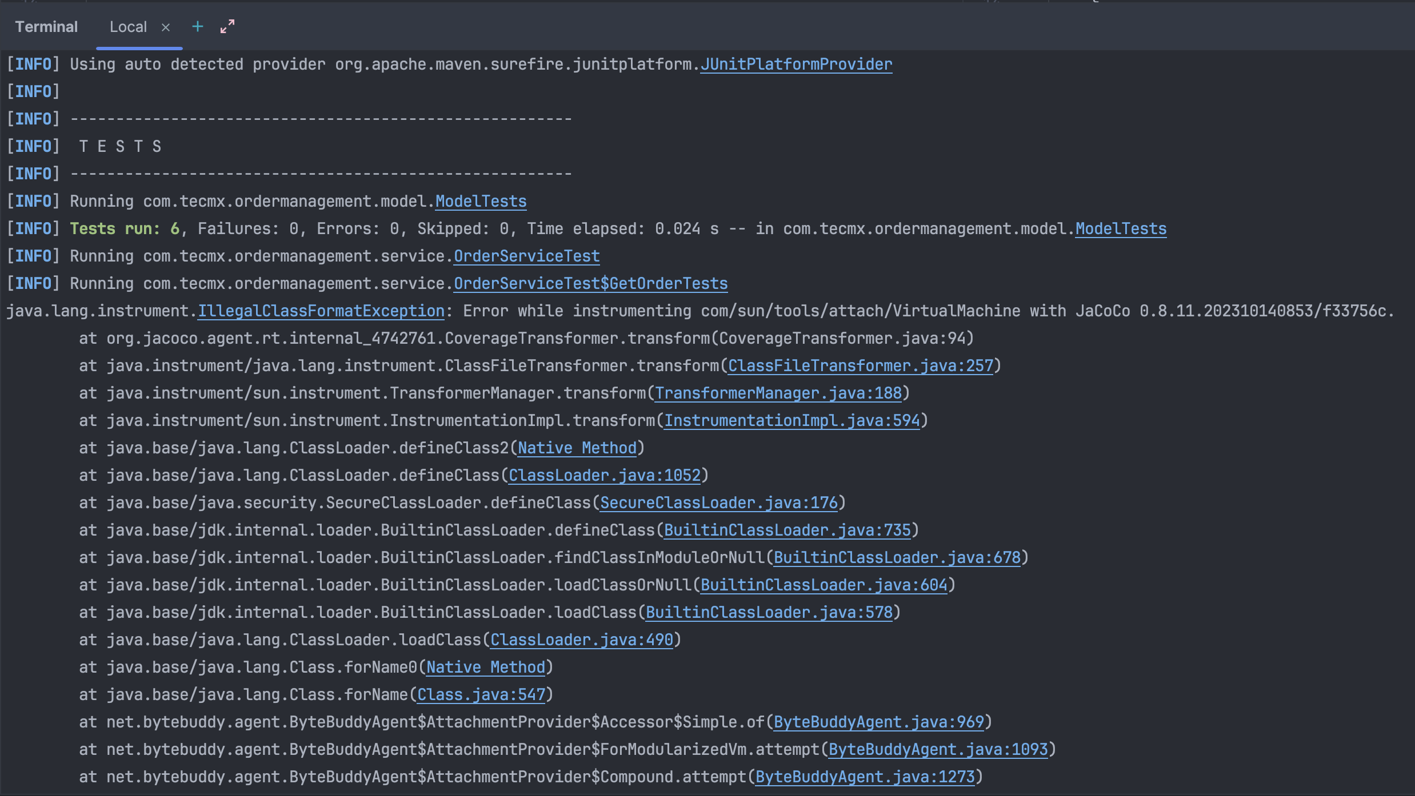

Section 2 — Phase 1: Exceptions (Weight: 25%)

2.1 Understanding the Exception Hierarchy
The project uses a custom exception hierarchy with a common base class. The base class, OrderManagementException, is already complete and extends RuntimeException. It adds an errorCode field for machine-readable error classification.
Your job is to make the three specific exceptions extend OrderManagementException instead of RuntimeException directly:
RuntimeException
└── OrderManagementException (errorCode) ← BASE (DO NOT MODIFY)
├── ResourceNotFoundException (resourceId) ← errorCode: "RESOURCE_NOT_FOUND"
├── ValidationException (fieldName) ← errorCode: "VALIDATION_ERROR"
└── BusinessRuleException ← errorCode: "BUSINESS_RULE_VIOLATION"

2.2 ⚠️ EXERCISE: Fix the Exception Classes
Open each file and apply the changes described below. The TODO markers in the code will guide you.

ResourceNotFoundException.java
- Change extends RuntimeException → extends OrderManagementException.
- Add a private final String resourceId field with a getter: getResourceId().
- In the constructor, replace super(message) with super(message, "RESOURCE_NOT_FOUND") and set this.resourceId.

ValidationException.java
- Change extends RuntimeException → extends OrderManagementException.
- Add a private final String fieldName field with a getter: getFieldName().
- Add a constructor (String message, String fieldName) that calls super(message, "VALIDATION_ERROR") and assigns the field.

BusinessRuleException.java
- Change extends RuntimeException → extends OrderManagementException.
- In the existing constructor, replace super(message) with super(message, "BUSINESS_RULE_VIOLATION").
- Add a second constructor (String message, Throwable cause) that calls super(message, "BUSINESS_RULE_VIOLATION", cause).

💡 TIP
Remember that super(message, errorCode) and super(message, errorCode, cause) call the constructors of OrderManagementException. Open that file to see the exact constructor signatures available.

2.3 Verify Phase 1
mvn test -Dtest=ExceptionTests
All 6 exception tests should now pass.
📸 [Screenshot]
Terminal or IDE showing ExceptionTests — 6 tests, all green.

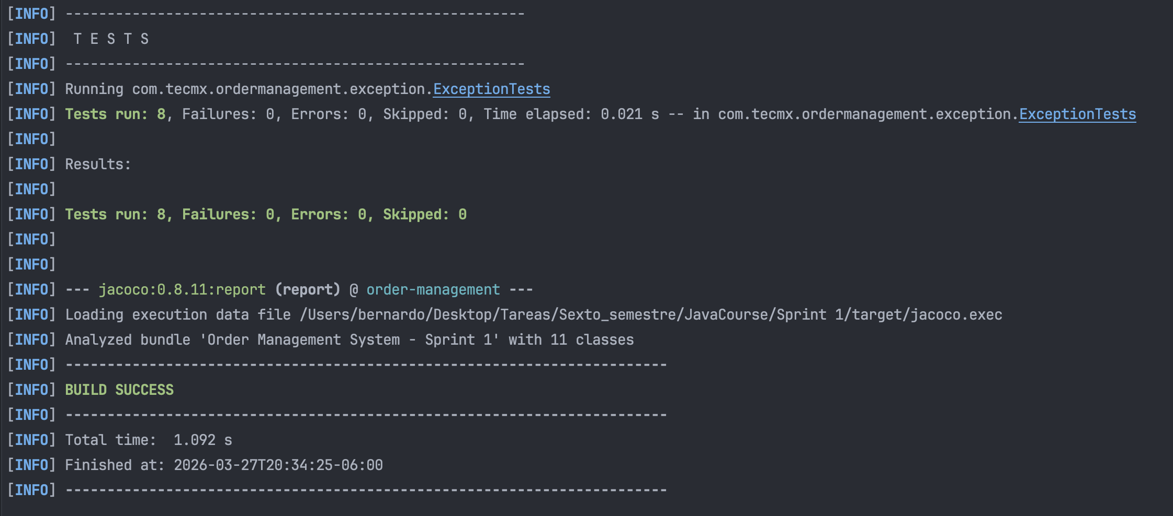

Section 3 — Phase 2: Implementation with Logging (Weight: 30%)

3.1 Understanding SLF4J Logging
SLF4J is a logging facade — your code depends on the SLF4J API, and Logback provides the actual output implementation. Every class that needs logging declares a logger as a class-level constant:
private static final Logger logger = LoggerFactory.getLogger(ClassName.class);

Log levels, from most to least verbose: TRACE < DEBUG < INFO < WARN < ERROR. The project’s logback.xml is configured to show DEBUG and above for the project package, and INFO and above for everything else.

Level | When to use | Example
logger.debug() | Diagnostic info, queries, internal state | logger.debug("Looking up order: {}", orderId)
logger.info() | Successful operations, key business events | logger.info("Order {} created with {} items", id, n)
logger.warn() | Unusual but controlled situations | logger.warn("Order {} cancelled", orderId)
logger.error() | Exceptions and failures | logger.error("Failed to process: {}", e.getMessage())

⚠️ IMPORTANT
Always use placeholders {} instead of string concatenation. Write logger.info("Order: {}", id) — NOT logger.info("Order: " + id). Concatenation defeats the purpose of lazy evaluation and wastes CPU when the log level is disabled.

3.2 ⚠️ EXERCISE: Implement the Model Methods

OrderItem.getSubtotal()
- Calculate and return price * quantity.
- If quantity is ≤ 0, throw a ValidationException with fieldName = "quantity".
- Log the calculation at DEBUG level.

Order.getTotal()
- Sum all item subtotals using the items list.
- If the order has no items, throw a BusinessRuleException.
- Log the result at INFO level including the order ID and total amount.

3.3 ⚠️ EXERCISE: Implement OrderService (5 methods)
Follow the TODO markers in OrderService.java. Each method has detailed comments explaining the validations, exceptions, and log messages required.

Method | Key Validations | Exceptions to Throw
createOrder() | orderId not null/empty, customerId not null/empty | ValidationException
addProductToOrder() | Order exists, product exists, stock sufficient | ResourceNotFoundException, BusinessRuleException
confirmOrder() | Order exists, not already confirmed, not cancelled | ResourceNotFoundException, BusinessRuleException
cancelOrder() | Order exists, not already shipped or delivered | ResourceNotFoundException, BusinessRuleException
getOrder() | Order exists | ResourceNotFoundException

3.4 ⚠️ EXERCISE: Implement InventoryService (3 methods)
Follow the TODO markers in InventoryService.java. Apply the same pattern: validate inputs, throw the appropriate exception, log the outcome.

Method | Key Validations | Exceptions to Throw
registerProduct() | name not null/empty, price > 0, stock ≥ 0 | ValidationException
restockProduct() | Product exists, quantity > 0 | ResourceNotFoundException, ValidationException
checkStock() | Product exists | ResourceNotFoundException

3.5 Verify Phase 2
mvn test
Model tests and several service tests should now be green. Exception tests from Phase 1 should remain passing.
📸 [Screenshot]
Terminal showing more tests passing after Phase 2 implementation — ModelTests and partial service tests green.

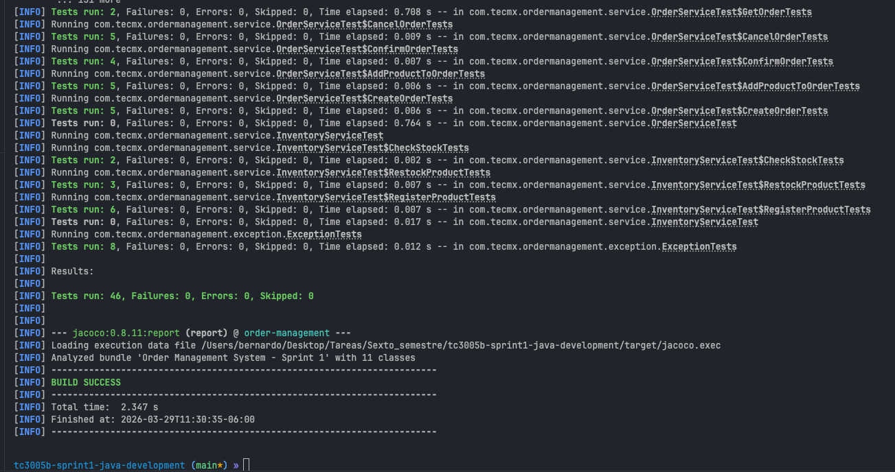

Section 4 — Phase 3: Unit Testing (Weight: 45%)

4.1 Understanding the AAA Pattern
All tests in this project must follow the Arrange-Act-Assert (AAA) pattern. This keeps tests readable and maintainable:
@Test
void shouldDoSomething() {
// Arrange — prepare data and configure mocks
Product product = new Product("P1", "Laptop", 999.99, 10);
when(repository.findProductById("P1")).thenReturn(Optional.of(product));

// Act — execute the method under test
Product result = service.checkStock("P1");

// Assert — verify the outcome
assertEquals("Laptop", result.getName());
verify(repository, times(1)).findProductById("P1");
}

4.2 Understanding Mockito Annotations
Annotation / Method | Purpose
@ExtendWith(MockitoExtension.class) | Enables Mockito processing in a JUnit 5 test class
@Mock | Creates a mock of a dependency class or interface
@InjectMocks | Creates the real object under test and injects @Mock fields into it
when(...).thenReturn(...) | Configures what a mock returns when a specific method is called
assertThrows(Ex.class, () -> {...}) | Verifies that the lambda throws the expected exception
verify(mock, times(1)).method() | Verifies the mock method was called exactly once
verify(mock, never()).method() | Verifies the mock method was never called
any(), anyString() | Argument matchers for flexible stub/verify setup

4.3 ⚠️ EXERCISE: Complete ExceptionTests.java
6 tests to complete. They validate the exception hierarchy you implemented in Phase 1:
- Verify that all 3 specific exceptions are instances of OrderManagementException.
- Verify that each exception sets the correct errorCode.
- Verify that ResourceNotFoundException correctly stores and returns resourceId.
- Verify that ValidationException correctly stores and returns fieldName.
- Verify that BusinessRuleException supports the (message, cause) constructor.

4.4 ⚠️ EXERCISE: Complete ModelTests.java
6 pure unit tests (no mocks needed):
- getSubtotal() returns the correct value for valid inputs.
- getSubtotal() throws ValidationException when quantity ≤ 0.
- getTotal() correctly sums all item subtotals.
- getTotal() throws BusinessRuleException when the order has no items.
- Constructor behavior for Order and OrderItem.

4.5 ⚠️ EXERCISE: Complete OrderServiceTest.java
Approximately 20 tests organized using @Nested classes for readability. Use @Mock OrderRepository and @InjectMocks OrderService.

@Nested Class | Test Scenarios
CreateOrder | Success, null order ID, null customer ID
AddProductToOrder | Success, order not found, product not found, insufficient stock
ConfirmOrder | Success, order not found, already confirmed, already cancelled
CancelOrder | Success, order not found, already shipped
GetOrder | Success, order not found

4.6 ⚠️ EXERCISE: Complete InventoryServiceTest.java
Approximately 12 tests organized using @Nested classes:

@Nested Class | Test Scenarios
RegisterProduct | Success, null/empty name, negative price
RestockProduct | Success, product not found, negative quantity
CheckStock | Success, product not found

4.7 Run All Tests and Generate Coverage
mvn test jacoco:report
Open the HTML coverage report:
# macOS
open target/site/jacoco/index.html

# Windows
start target/site/jacoco/index.html

# Linux
xdg-open target/site/jacoco/index.html
📸 [Screenshot]
JaCoCo HTML report showing ≥ 80% line coverage with green bars across the exception, model, and service packages.
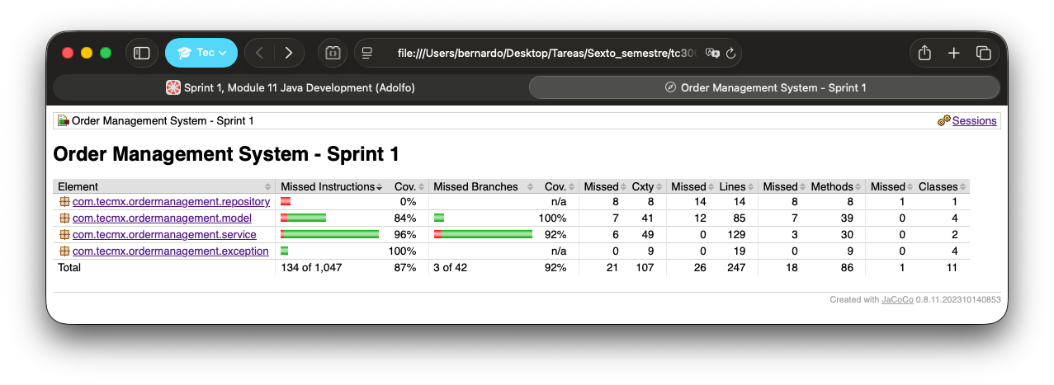
✅ VERIFICATION
Target: ≥ 80% line coverage across the project as reported by JaCoCo. Both success paths AND exception paths must be tested to reach this threshold.

Section 5 — Evaluation Criteria

5.1 Rubric

Please include document and repository / code
Criterion | Excellent (100%) | Satisfactory (75%) | In Progress (50%) | Insufficient (<50%)
Exceptions (25%) | Correct hierarchy, all fields, consistent errorCodes | Correct inheritance but missing fields or inconsistent codes | Only some exceptions inherit correctly | Inheritance not modified
Implementation (30%) | All methods, complete validations, correct logic | Most implemented, some validations missing | Less than half implemented | Only 1–2 methods attempted
Logging (part of 30%) | Correct levels, {} placeholders, descriptive messages | Present but wrong levels or string concatenation used | Logging in some methods only | No logging or System.out.println only
Testing (45%) | All tests, AAA pattern, Mockito correct, coverage ≥ 80% | Most tests, coverage ≥ 60% | Partial tests, coverage ≥ 40% | Few tests, coverage < 40%

5.2 Detailed Checklist

Exceptions
- All 3 exceptions extend OrderManagementException (not RuntimeException directly).
- Each exception sets the correct errorCode string in its super() call.
- ResourceNotFoundException has the resourceId field with getResourceId() getter.
- ValidationException has the fieldName field with getFieldName() getter.
- BusinessRuleException has a second constructor that accepts a Throwable cause.

Logging
- SLF4J is used throughout (no System.out.println in production code).
- Correct log levels are applied: DEBUG for diagnostics, INFO for success events, WARN for unusual situations, ERROR for failures.
- Placeholders {} are used instead of string concatenation in all log statements.
- Log messages include relevant context (IDs, quantities, status values).

Testing
- @ExtendWith(MockitoExtension.class) is present on every service test class.
- @Mock and @InjectMocks are used correctly (no manual instantiation).
- Every test follows the AAA pattern with clear Arrange / Act / Assert sections.
- assertThrows() is used to validate exception scenarios.
- verify() is used to confirm mock interactions in service tests.
- verify(mock, never()) is used where methods should NOT have been called.
- Both success paths and error paths are tested for every method.
- JaCoCo reports ≥ 80% line coverage.

Section 6 — Useful Commands Reference
Command | Purpose
mvn compile | Compile the project
mvn test | Run all tests
mvn test jacoco:report | Run tests and generate coverage report
open target/site/jacoco/index.html | Open coverage report in browser (macOS)
mvn test -Dtest=OrderServiceTest | Run only a specific test class
mvn test -Dtest=OrderServiceTest#shouldCreateOrderSuccessfully | Run a specific test method
mvn test -Dtest=ExceptionTests | Run only the exception tests (Phase 1 verification)
mvn clean test jacoco:report | Clean build + test + coverage (for final submission)

Section 7 — Troubleshooting
Symptom | Probable Cause | Solution
BUILD FAILURE on mvn compile | Java 17 not installed or JAVA_HOME not set | Run java -version. Install JDK 17 and set JAVA_HOME correctly.
NullPointerException on a mock | Missing @ExtendWith(MockitoExtension.class) | Add the annotation at the top of the test class.
when() stub does nothing | Mock not injected properly | Use @Mock + @InjectMocks. Do not instantiate manually with new.
assertThrows passes but shouldn't | Lambda doesn't actually call the method | Ensure the call is INSIDE the lambda: () -> service.method()
JaCoCo report is empty | Tests didn't run before report | Run mvn test jacoco:report (both goals together).
Maven downloads many dependencies | First execution | Normal — only happens once. Internet connection required.
"Cannot resolve symbol" in IDE | IDE hasn't imported the Maven project | Right-click pom.xml → Add as Maven Project (IntelliJ) or Reload.
Coverage below 80% | Missing tests for error/edge cases | Add tests for exception paths, not just success paths.
Tests pass locally but not on CI | System.out or hardcoded paths used | Remove System.out calls; use SLF4J. Avoid absolute paths.

💡 TIP
If after checking this table you still cannot resolve the issue, share the complete stack trace (not just the last error line) when asking for help. The "Caused by:" section at the bottom of the stack trace usually reveals the actual root cause.

Section 8 — Glossary
Term | Definition
Exception Hierarchy | A tree of exception classes where specific exceptions extend a common base, enabling polymorphic catch blocks.
Checked vs Unchecked | Checked exceptions must be caught or declared; unchecked (RuntimeException subclasses) do not require explicit handling.
SLF4J | Simple Logging Facade for Java — a logging abstraction layer. Your code depends on SLF4J; the implementation (Logback) is swappable.
Logback | The SLF4J implementation that handles actual log output to console and/or files. Configured via logback.xml.
Log Level | Severity classification for log messages: TRACE < DEBUG < INFO < WARN < ERROR. Messages below the configured threshold are suppressed.
JUnit 5 | The standard Java unit testing framework (also called Jupiter). Provides @Test, @Nested, @BeforeEach, assertThrows, etc.
Mockito | A library for creating mock objects in unit tests. Allows you to simulate dependency behavior without real implementations.
Mock | A simulated object that replaces a real dependency in tests, returning pre-configured responses and recording calls.
AAA Pattern | Arrange-Act-Assert — the standard three-section structure for unit tests: set up data, execute the method, verify the outcome.
JaCoCo | Java Code Coverage — a Maven plugin that generates HTML/XML reports showing which lines were executed by tests.
Code Coverage | The percentage of code lines (or branches) exercised by the test suite. ≥ 80% is the target for this sprint.
Maven | Build tool that manages dependencies (via pom.xml), compiles source code, runs tests, and generates reports.

Section 9 — Deliverables
Submit the following as evidence of completion:
- Complete source code with all TODO items implemented, committed, and pushed to the repository.
- Screenshot of all tests passing (green) — terminal output of mvn test showing 0 failures.
- Screenshot of the JaCoCo HTML report showing ≥ 80% line coverage with green bars.
- (Optional — bonus) Screenshot of additional tests beyond the TODO markers that you wrote independently.

📸 [Screenshot]
Terminal output of mvn test showing all tests passing with 0 failures and 0 errors.
📸 [Screenshot]
JaCoCo index.html report in a browser showing the overall coverage percentage and package breakdown.

Section 10 — Important Rules
⚠️ IMPORTANT
The following constraints are strictly enforced. Violations will result in point deductions.

☑ RULE
DO NOT modify the OrderRepository interface or the InMemoryOrderRepository class.
☑ RULE
DO NOT modify the OrderManagementException class (it is already complete).
☑ RULE
DO NOT modify the signature of any existing method (name, parameters, return type).
☑ RULE
DO NOT use System.out.println in production code. Use SLF4J loggers only.

✅ VERIFICATION
You MAY add private helper methods if they improve your implementation. You MAY add additional test methods beyond the TODO markers (extra tests earn bonus points).

Section 11 — Reference Resources
Resource | URL
JUnit 5 User Guide | https://junit.org/junit5/docs/current/user-guide/
Mockito Documentation | https://javadoc.io/doc/org.mockito/mockito-core/latest/org/mockito/Mockito.html
SLF4J Manual | https://www.slf4j.org/manual.html
Logback Configuration | https://logback.qos.ch/manual/configuration.html
JaCoCo Maven Plugin | https://www.eclemma.org/jacoco/trunk/doc/maven.html
Mockito @ExtendWith guide | https://www.baeldung.com/mockito-junit-5-extension

Object-Oriented Programming (Java) · Tecnologico de Monterrey · February–June 2026
This document is didactic material for the course. All code templates are the property of Tecnologico de Monterrey.

