Main Menu

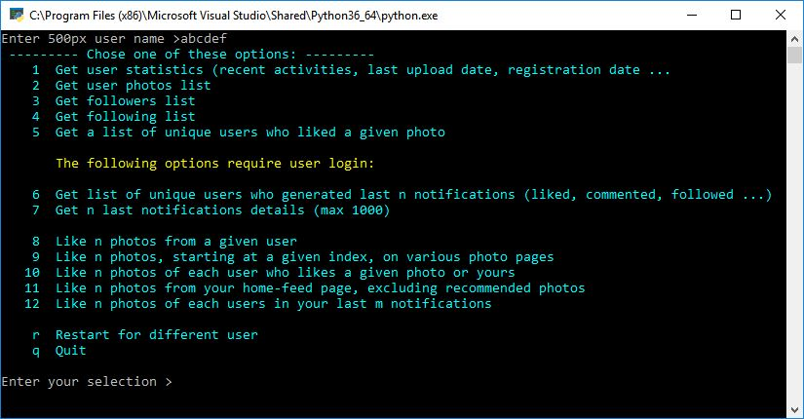

The first 7 options are for data collection, for which you need to provide a 500px username.

Results are saved on disk as CSV files. You will be offered to view the data in the web browser when the process finished.

The next 5 options, from 8 to 12, are the automated processes, for which you need to enter a password for actions.

Option #1 sample output:

Basic statistics of a user

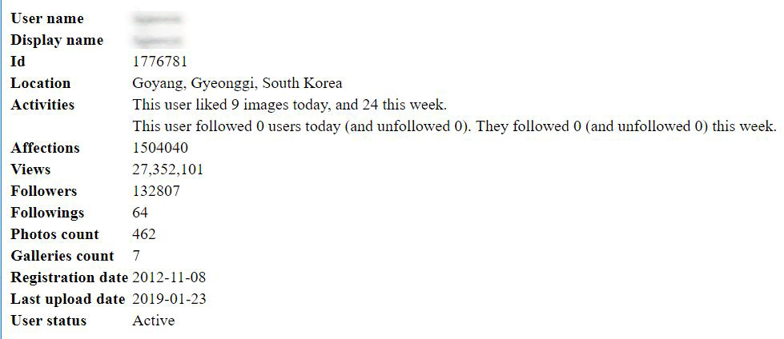

Option #2 sample output:

List of photos of a given user

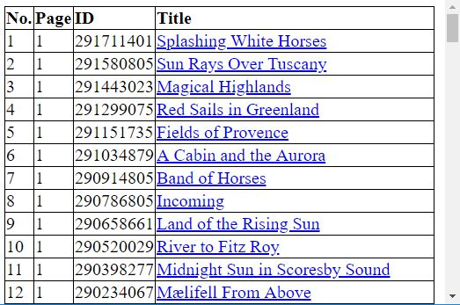

Option #3, #4 sample output:

A list of followers or friends

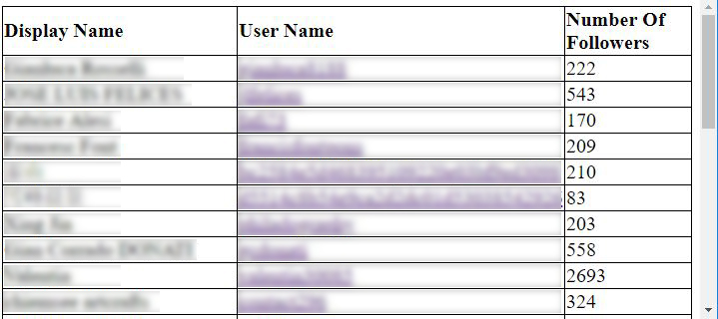

Option #5 sample output:

A list of unique users who liked a given photo

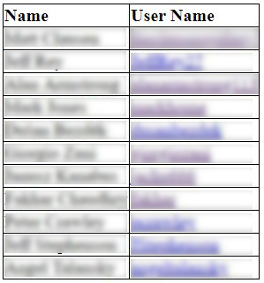

Option#7 sample output:

Details of n last notifications on a user

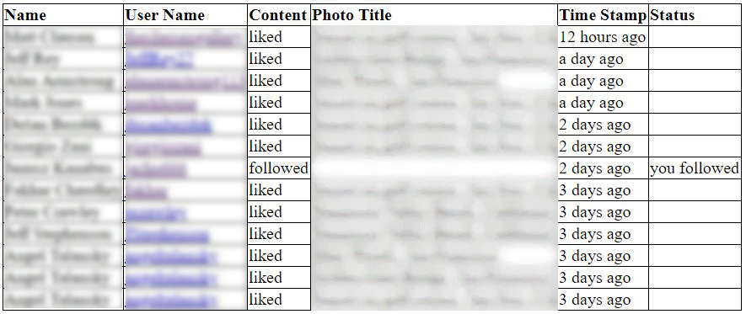

Option #8 sample result:

Auto-like 3 photos of a given user

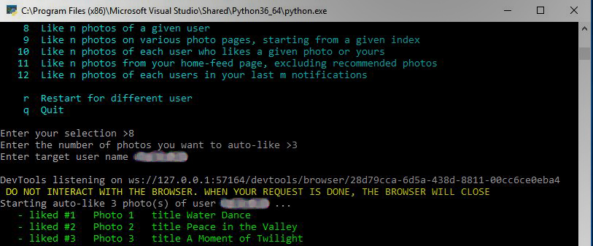

Option #9 sample result:

Like (5) photos, starting at photo (#100) on the page (Popular of Undiscovered photographers)

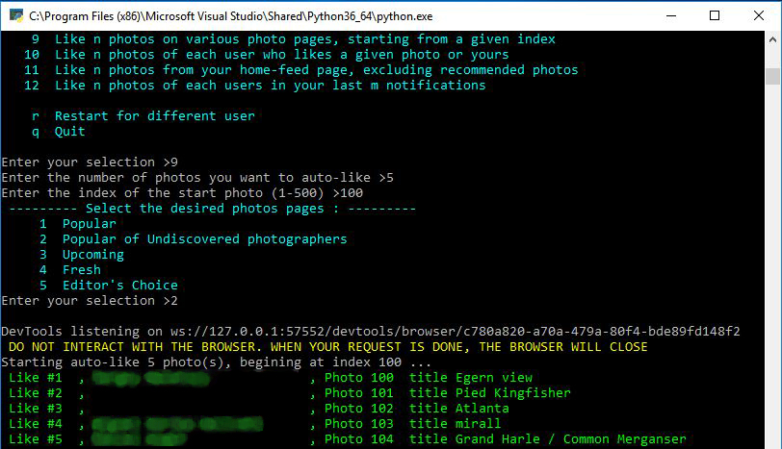

Option #10 sample result:

Auto-like (1) photo of each user who liked a given photo, skipping already-liked photos

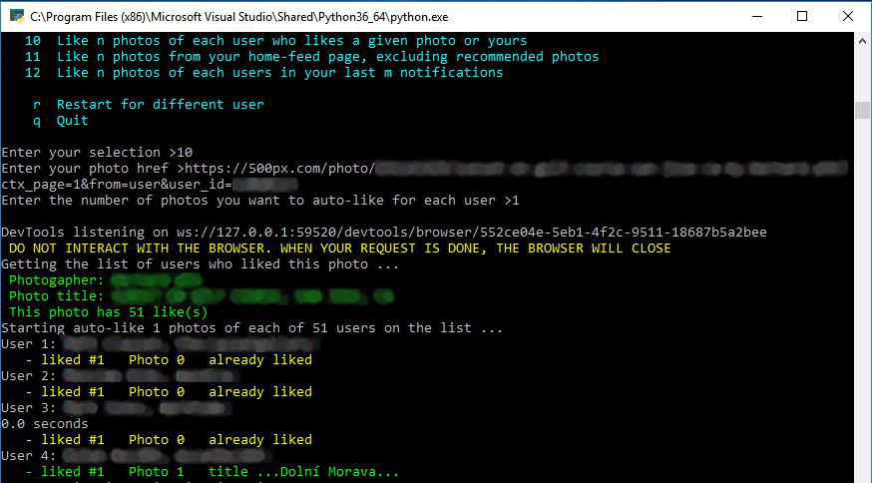

Option #11 sample result:

Auto-like (15) photos from the user’s home feed page, excluding the recommended photos and skipping consecutive photos of the same users

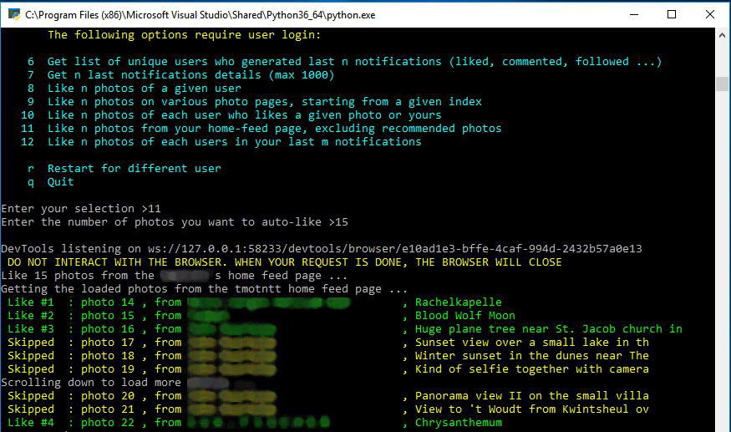

Option #12 sample result:

Auto-like (2) photos of each user in the last (10) notifications

