



Spatial Feature Report

T: +27 12 364 2546 | E: info@novus3.co.za Postnet Suite 471, Private Bag X15,

Menlo Park, 0102**www.novus3.co.za**

engineered solutions

Disclaimer

This document contains data that was obtained from a live CP3 system at the moment the data was requested. The data is updated by users of the CP3 System and unless the system is locked for changes, this data may change on a daily basis. The reader is therefore cautioned not to place inappropriate reliance on the data unless there is certainty on the status of the data in terms of how recently it has been updated, how “clean” the data is (is there a quality control and/or verification process that was followed by the licensee of the CP3 system to ensure that data is checked and verified from time-to-time) and whether the correct baseline was queried. This report therefore provides a “snapshot in time”. Consequently, the document may be less relevant at a different time, or using a different financial baseline to query from.

At all times, all rights, title and interest in and to this material remains vested in the owner of this document and are copyrighted and protected by regulatory provisions. These materials may not be copied, reproduced, modified, published, uploaded, posted to websites or otherwise distributed in any way, without our prior written permission from the Licensee and Licensor (Nvous3 (Pty) Ltd) of the CP3 Software. The owner of this document does not grant any right to reproduce the materials. All our rights in this regard are and remain reserved.

Spatial Query Report: Regions

This document was created *2022-04-10-10_54* from the **City of Johannesburg Metropolitan Municipality** CP3 system by the following user: *'Bernard'.*

The baseline **'2022/2023_MTREF Planning Capture Baseline_20210823'** with description: **' 2021/2022_MTREF Rollover + Planning Baseline_20210307 duplicate + 2022/22 budget planning'** was used. The spatial feature that was selected for the purpose of this report was: **'Regions'**.

This is a spatial feature report for the *City of Johannesburg Metropolitan Municipality.* The data contained in this report was sourced directly from the municipality's live CP3 system. The information in this report therefore reflects the data as it was on the *2022-04-10* when this report was requested. Any subsequent updates to the data contained the CP3 System related to the applicable baseline from which this reports was drawn, would therefore not reflect in this report.   
  
For the *City of Johannesburg Metropolitan Municipality, the following spatial features are available for the purpose of developing* 'Spatial Query Reports' (similar to this report):

* _Deprivation Areas_
* _Informal Settlements_
* _Inner City Node_
* _Pro Poor_
* _Regions_
* _Strategically Targeted Areas_
* _Urban Development Zones_
* _Wards 2020_



We hope you find this useful! Sincerely, *The Novus3 Team.*

# Introduction

The baseline that was queried for this report contains *2465* projects of which a total of *27 (1.1%)* projects do not have any recorded intersection (overlap) with Regions.The following spatial features are available for queries using this API profile:

* _Deprivation Areas_
* _Informal Settlements_
* _Inner City Node_
* _Pro Poor_
* _Regions_
* _Strategically Targeted Areas_
* _Urban Development Zones_
* _Wards 2020_

The probable reasons for the 27 non intersecting projects reported are that:

* these projects simply do not have a location associated with them yet (most frequently the case with 'no-intersect' projects) or;
* the location that was captured for some of these projects, may have been in the wrong place (e.g. outside the boundaries of Joburg - this is very rarely the reason).

It is important to take note of the 1.1% projects that do not intersect with Regions feature when appraising this report.

The 1.1% of non-intersecting projects is a relative low percentage and therefore not much cause of concern for this particular report.

Figure 1: Intersecting vs Non-Intersecting Projects

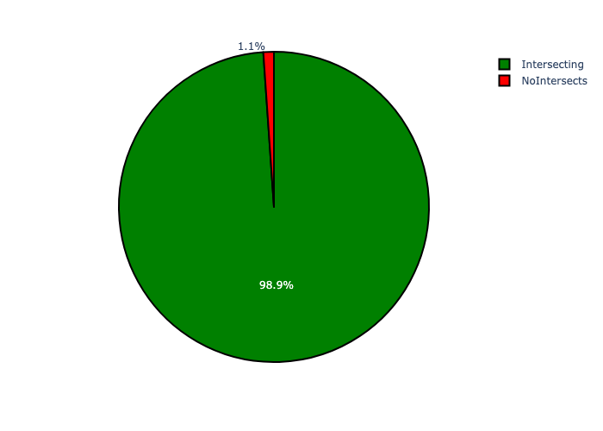

# Regions Analysis

Table 1.1: Regions Analysis - Number of Projects

|  |  |  |  |
| --- | --- | --- | --- |
| Description | Info (1) | Info (2) | Info (3) |
| Number of projects in all Regions - Overview | Total in all Regions: 2438 projects | Average per Regions: 348 projects | 75th percentile of projects across all Regions: 348.0 projects |
| The highest number of projects | Regions: In Region F | Number of projects in Region F: 585 | Percentage of total in Region F: 24.00% |
| The lowest number of projects: | Regions: In Region D | Number of projects in Region D: 260 | Percentage of total in Region D: 10.66% |

Table 1.2: Regions Analysis - Capital Demand (R)

|  |  |  |  |
| --- | --- | --- | --- |
| Description | Info (1) | Info (2) | Info (3) |
| Capital demand in all Regions - Overview | Total capital demand in all Regions: R6,742,492,157 | The average capital demand per Regions: R963,213,165 | The 75th percentile of capital demand for Regions: R1,245,909,542 |
| The highest capital demand | Regions: In Region E | Capital Demand in Region E: R1,337,870,737 | Percentage of total in Region E: 19.84% |
| The lowest capital demand | Regions: In Region B | Capital Demand in Region B: R328,200,268 | Percentage of total in Region B: 4.87% |

Figure 2: The single Region with the highest value (Nr of Projects & Capital Demand) vs the rest

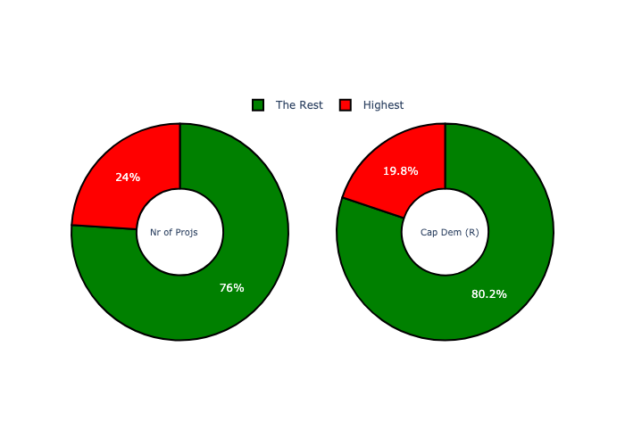

Figure 3: Projects and Capital Demand per Regions

