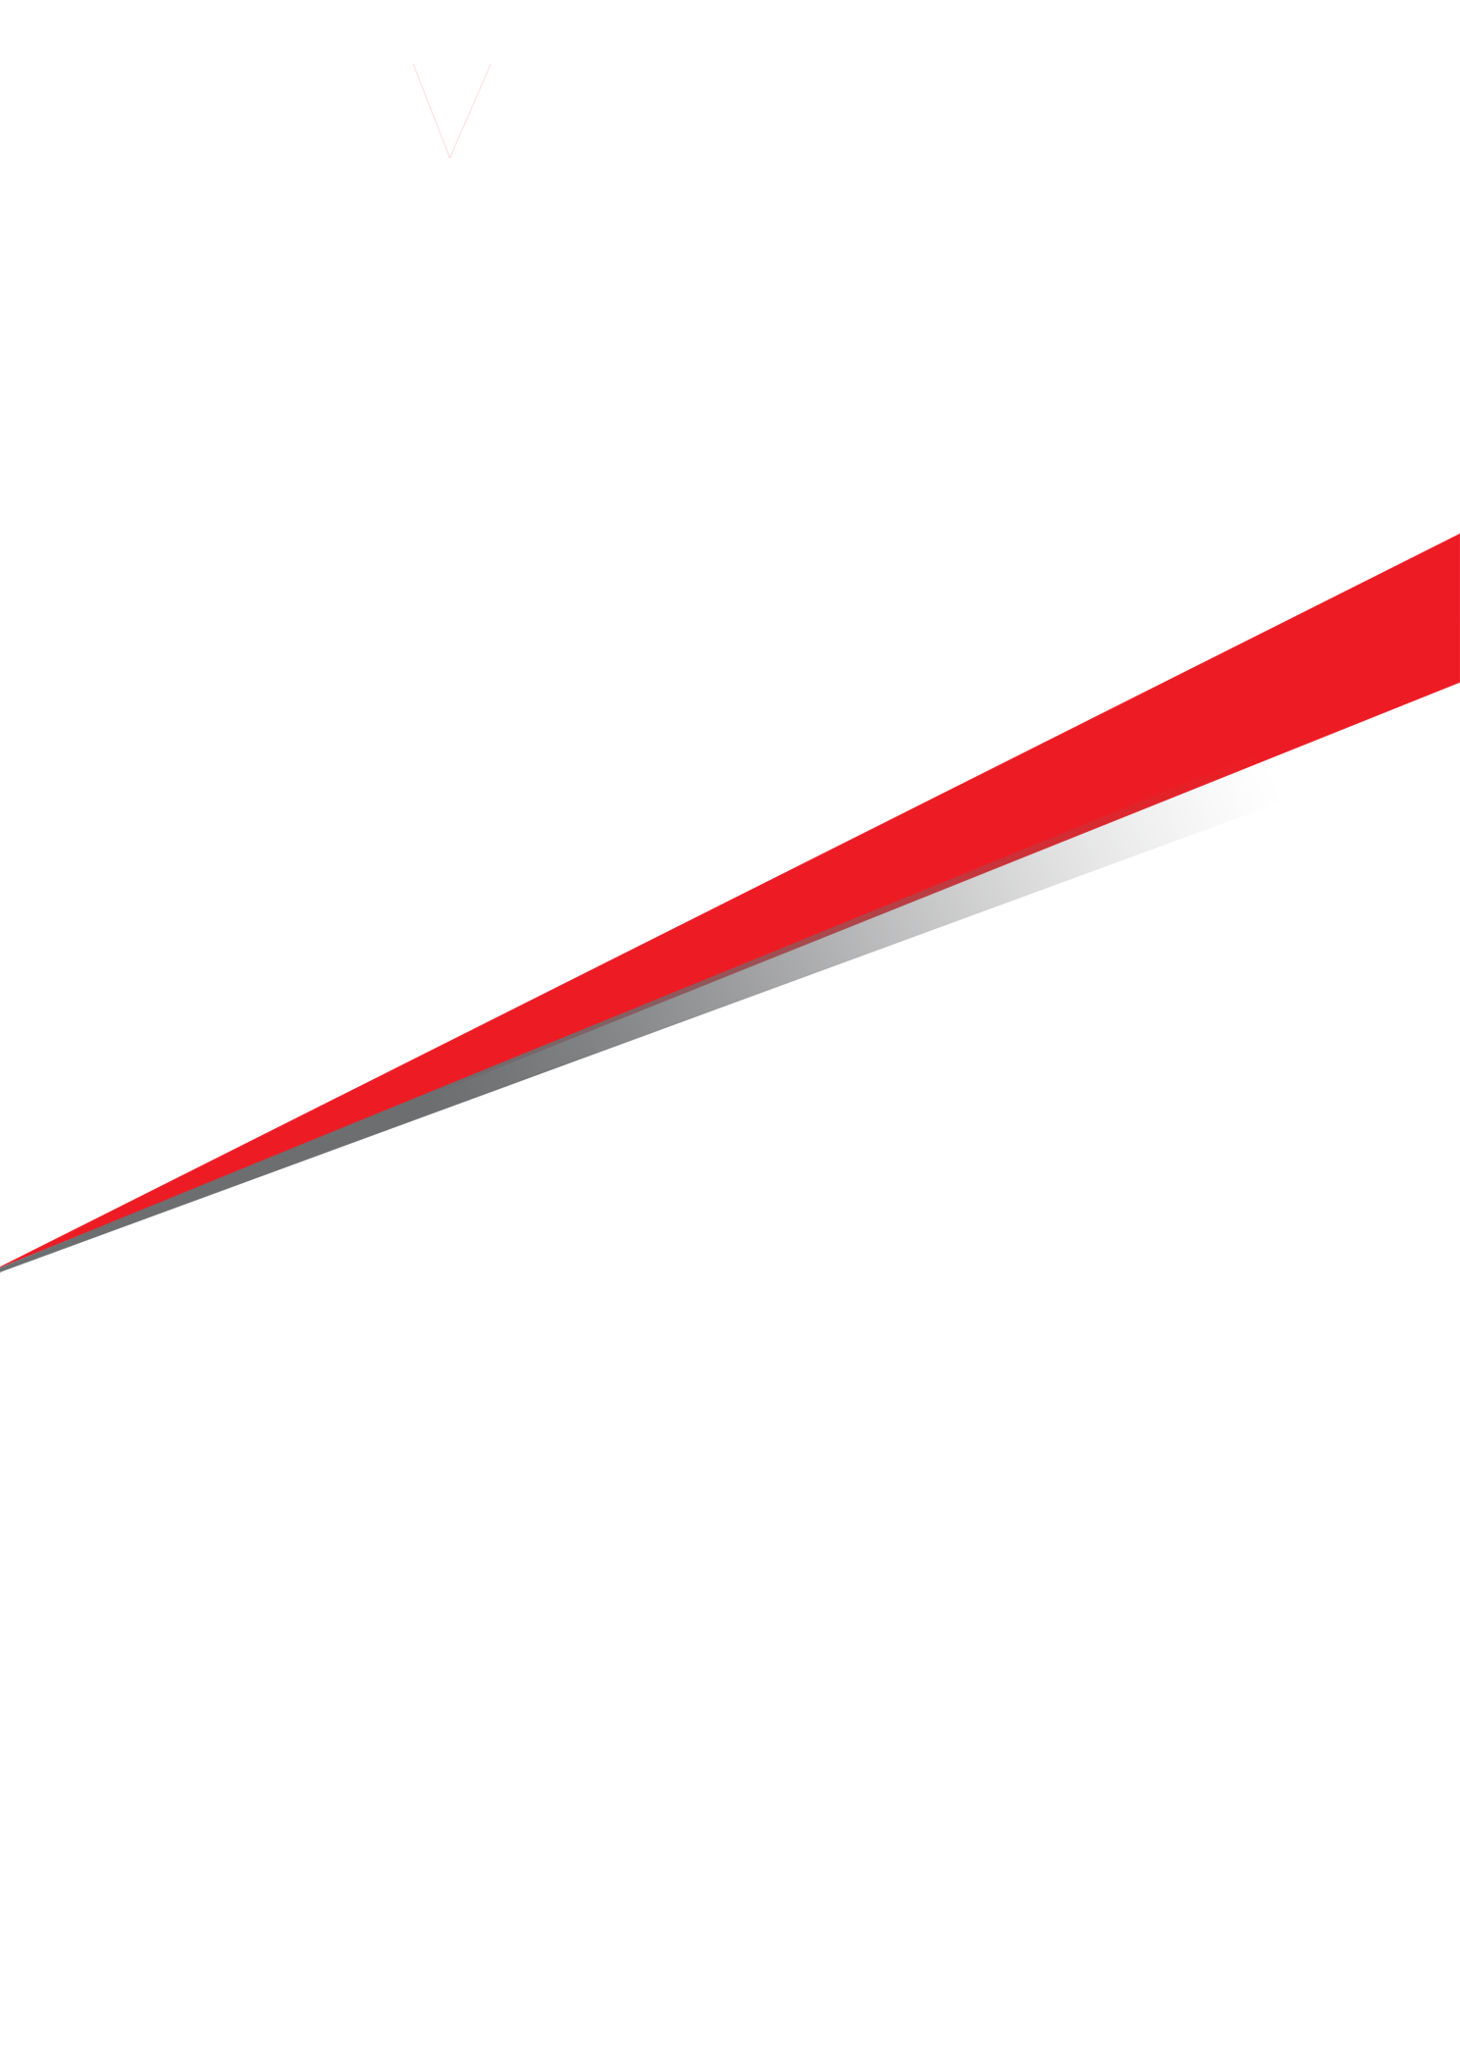

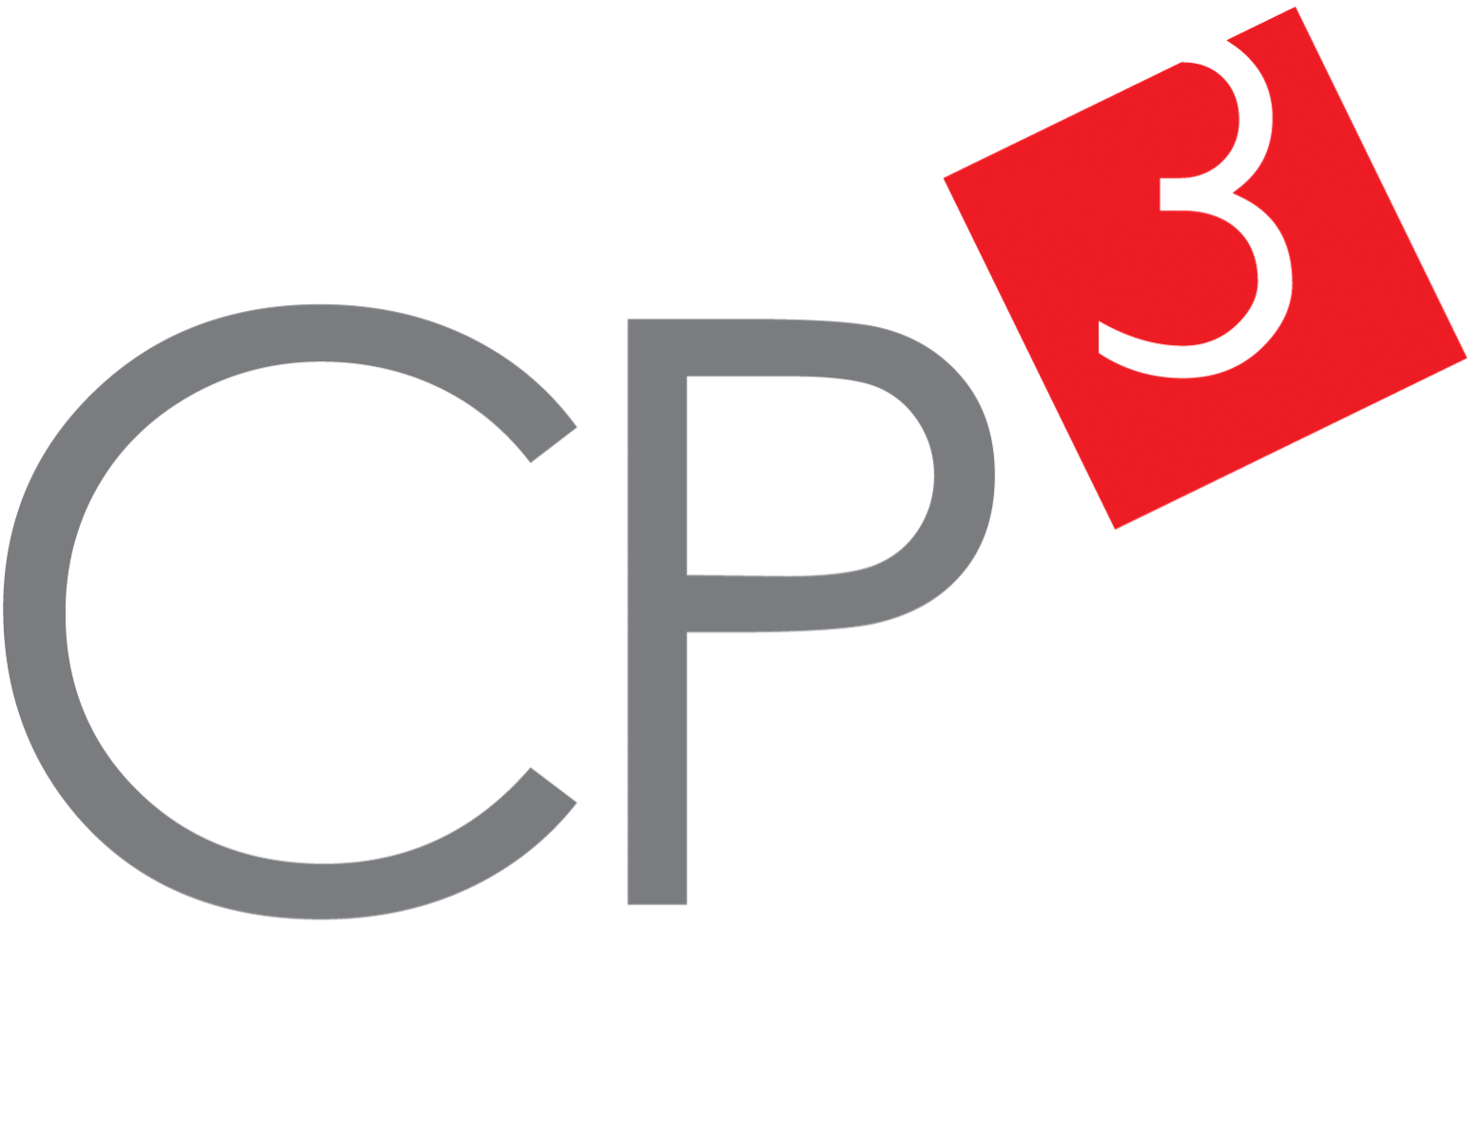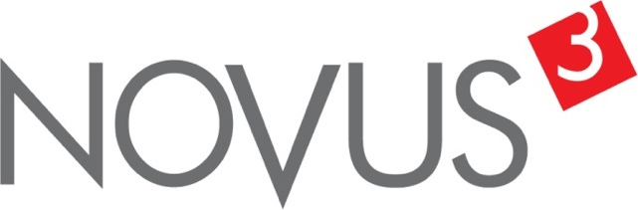

Spatial Feature Report

T: +27 12 364 2546 | E: info@novus3.co.za Postnet Suite 471, Private Bag X15,

Menlo Park, 0102**www.novus3.co.za**

engineered solutions

Disclaimer

This document contains data that was obtained from a live CP3 system at the moment the data was requested. The data is updated by users of the CP3 System and unless the system is locked for changes, this data may change on a daily basis. The reader is therefore cautioned not to place inappropriate reliance on the data unless there is certainty on the status of the data in terms of how recently it has been updated, how “clean” the data is (is there a quality control and/or verification process that was followed by the licensee of the CP3 system to ensure that data is checked and verified from time-to-time) and whether the correct baseline was queried. This report therefore provides a “snapshot in time”. Consequently, the document may be less relevant at a different time, or using a different financial baseline to query from.

At all times, all rights, title and interest in and to this material remains vested in the owner of this document and are copyrighted and protected by regulatory provisions. These materials may not be copied, reproduced, modified, published, uploaded, posted to websites or otherwise distributed in any way, without our prior written permission from the Licensee and Licensor (Nvous3 (Pty) Ltd) of the CP3 Software. The owner of this document does not grant any right to reproduce the materials. All our rights in this regard are and remain reserved.

Spatial Query Report: Wards 2020

This document was created *2022-04-20-10_06* from the **City of Johannesburg Metropolitan Municipality** CP3 system by the following user: *'Bernard'.*

The baseline **'2022/2023_MTREF Planning Capture Baseline_20210823'** with description: **' 2021/2022_MTREF Rollover + Planning Baseline_20210307 duplicate + 2022/22 budget planning'** was used. The spatial feature that was selected for the purpose of this report was: **'Wards 2020'**.

This is a spatial feature report for the *City of Johannesburg Metropolitan Municipality.* The data contained in this report was sourced directly from the municipality's live CP3 system. The information in this report therefore reflects the data as it was on the *2022-04-20* when this report was requested. Any subsequent updates to the data contained the CP3 System related to the applicable baseline from which this reports was drawn, would therefore not reflect in this report.   
  
For the *City of Johannesburg Metropolitan Municipality, the following spatial features are available for the purpose of developing* 'Spatial Query Reports' (similar to this report):

* _Deprivation Areas_
* _Informal Settlements_
* _Inner City Node_
* _Pro Poor_
* _Regions_
* _Strategically Targeted Areas_
* _Urban Development Zones_
* _Wards 2020_



We hope you find this useful! Sincerely, *The Novus3 Team.*

# Introduction

The baseline that was queried for this report contains *3095* projects of which a total of *40 (1.29%)* projects do not have any recorded intersection (overlap) with Wards 2020.The following spatial features are available for queries using this API profile:

* _Deprivation Areas_
* _Informal Settlements_
* _Inner City Node_
* _Pro Poor_
* _Regions_
* _Strategically Targeted Areas_
* _Urban Development Zones_
* _Wards 2020_

The probable reasons for the 40 non intersecting projects reported are that:

* these projects simply do not have a location associated with them yet (most frequently the case with 'no-intersect' projects) or;
* the location that was captured for some of these projects, may have been in the wrong place (e.g. outside the boundaries of Joburg - this is very rarely the reason).

It is important to take note of the 1.29% projects that do not intersect with Wards 2020 feature when appraising this report.

The 1.29% of non-intersecting projects is a relative low percentage and therefore not much cause of concern for this particular report.

Figure 1: Intersecting vs Non-Intersecting Projects

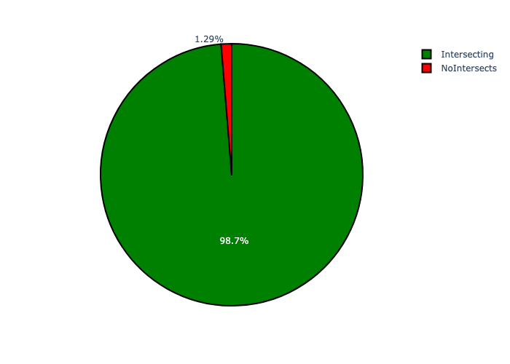

# Wards 2020 Analysis

Table 1.1: Wards 2020 Analysis - Number of Projects

|  |  |  |  |
| --- | --- | --- | --- |
| Description | Info (1) | Info (2) | Info (3) |
| Number of projects in all Wards 2020 - Overview | Total in all Wards 2020: 3055 projects | Average per Wards 2020: 22.6 projects | 75th percentile of projects across all Wards 2020: 28.5 projects |
| The highest number of projects | Wards 2020: In 124 | Number of projects in 124: 118 | Percentage of total in 124: 3.86% |
| The lowest number of projects: | Wards 2020: In 50 | Number of projects in 50: 2 | Percentage of total in 50: 0.07% |
| The 5 Wards 2020 that collectively have with the highest number of projects | Wards 2020: In 84, 117, 57, 60 and 124 | Number of projects in 84, 117, 57, 60 and 124 together: 456 | Percentage of total in 84, 117, 57, 60 and 124 together: 14.93% |

Table 1.2: Wards 2020 Analysis - Capital Demand (R)

|  |  |  |  |
| --- | --- | --- | --- |
| Description | Info (1) | Info (2) | Info (3) |
| Capital demand in all Wards 2020 - Overview | Total capital demand in all Wards 2020: R10,811,044,506 | The average capital demand per Wards 2020: R80,081,811 | The 75th percentile of capital demand for Wards 2020: R115,601,468 |
| The highest capital demand | Wards 2020: In 91 | Capital Demand in 91: R1,149,512,495 | Percentage of total in 91: 10.63% |
| The lowest capital demand | Wards 2020: In 50 | Capital Demand in 50: R0 | Percentage of total in 50: 0.00% |
| The 5 Wards 2020 that collectively have collective the highest capital demand: | Wards 2020: In 131, 124, 60, 96 and 91 | Capital Demand in 131, 124, 60, 96 and 91 together: R2,805,268,881 | Percentage of total in 131, 124, 60, 96 and 91 together: 25.95% |

Figure 2.1: The single Wards 2020 with the highest value (Nr of Projects & Capital Demand) vs the rest

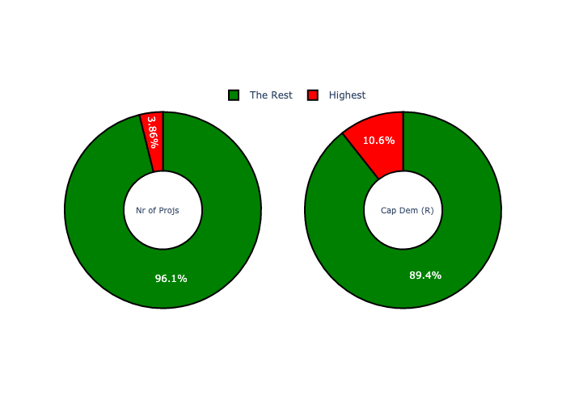

The highest number of projects in a single Wards 2020 is in **124.** *That is 118 projects and this is 3.86% of the total number of projects.*The highest capital demand in a single Wards 2020 is in **91.** *That is R1,149,512,495 and this amounts to 10.63% of the total capital demand.*

Figure 2.2: The 5 Wards 2020 with the highest values (Nr of Projects & Capital Demand) vs the rest

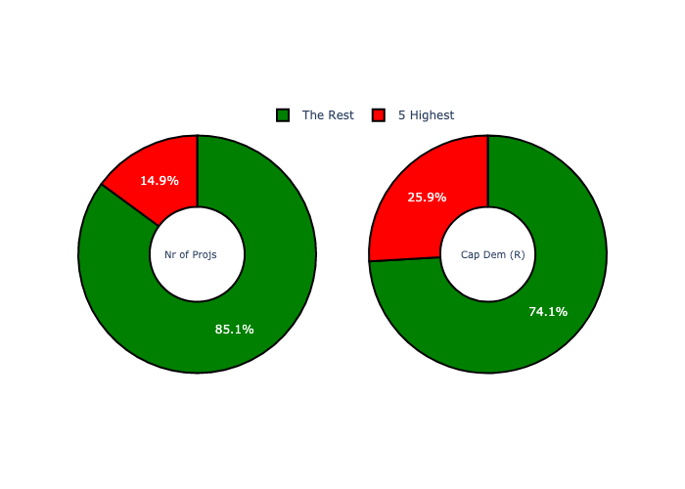

The 5 Wards 2020 that collectively have with the highest number of projects are in **84, 117, 57, 60 and 124.** *That is 456 projects and this is 14.93% of the total number of projects.*The 5 Wards 2020 that collectively have the highest capital demand are in **131, 124, 60, 96 and 91.** *That is 25.95% and this amounts to R2,805,268,881 of the total capital demand.*

Figure 3.1: Projects and Capital Demand per Wards 2020 (1/3)

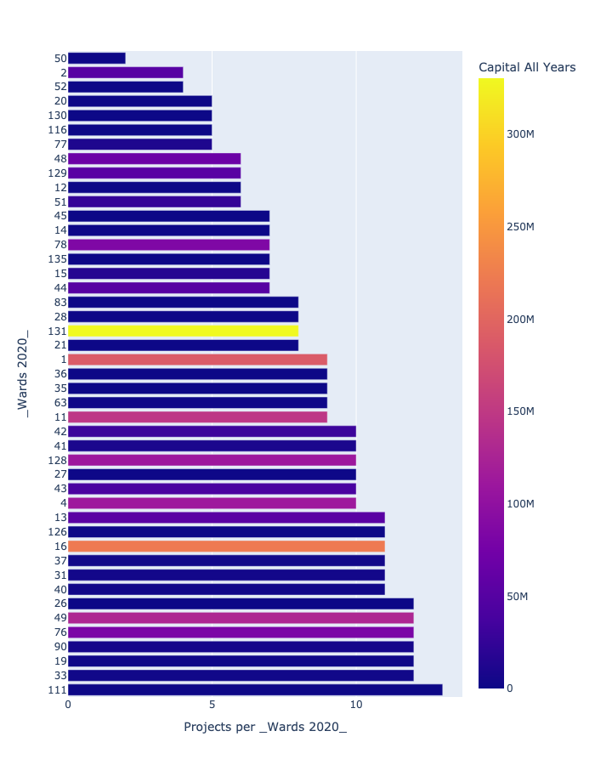

Figure 3.2: Projects and Capital Demand per Wards 2020 (2/3)

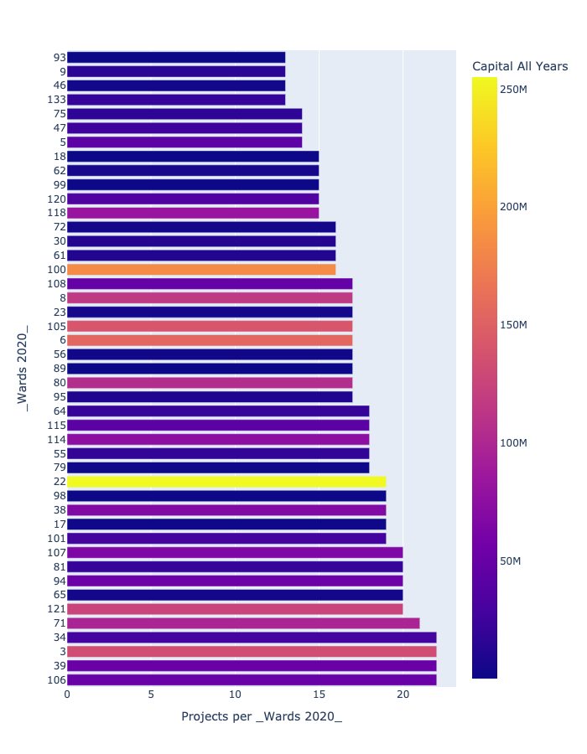

Figure 3.3: Projects and Capital Demand per Wards 2020 (3/3)

