



Spatial Feature Report

T: +27 12 364 2546 | E: info@novus3.co.za Postnet Suite 471, Private Bag X15,

Menlo Park, 0102**www.novus3.co.za**

engineered solutions

Disclaimer

This document contains data that was obtained from a live CP3 system at the moment the data was requested. The data is updated by users of the CP3 System and unless the system is locked for changes, this data may change on a daily basis. The reader is therefore cautioned not to place inappropriate reliance on the data unless there is certainty on the status of the data in terms of how recently it has been updated, how “clean” the data is (is there a quality control and/or verification process that was followed by the licensee of the CP3 system to ensure that data is checked and verified from time-to-time) and whether the correct baseline was queried. This report therefore provides a “snapshot in time”. Consequently, the document may be less relevant at a different time, or using a different financial baseline to query from.

At all times, all rights, title and interest in and to this material remains vested in the owner of this document and are copyrighted and protected by regulatory provisions. These materials may not be copied, reproduced, modified, published, uploaded, posted to websites or otherwise distributed in any way, without our prior written permission from the Licensee and Licensor (Nvous3 (Pty) Ltd) of the CP3 Software. The owner of this document does not grant any right to reproduce the materials. All our rights in this regard are and remain reserved.

Spatial Query Report: Regions

This document was created *2022-04-23-15_15* from the **City of Johannesburg Metropolitan Municipality** CP3 system.

The baseline **'2022/2023_MTREF Planning Capture Baseline_20210823'** with description: **' 2021/2022_MTREF Rollover + Planning Baseline_20210307 duplicate + 2022/22 budget planning'** was used. The spatial feature that was selected for the purpose of this report was: **'Regions'**.

This is a spatial feature report for the *City of Johannesburg Metropolitan Municipality.* The data contained in this report was sourced directly from the municipality's live CP3 system. The information in this report therefore reflects the data as it was on the *2022-04-23* when this report was requested. Any subsequent updates to the data contained the CP3 System related to the applicable baseline from which this reports was drawn, would therefore not reflect in this report.   
  
For the *City of Johannesburg Metropolitan Municipality, the following spatial features are available for the purpose of developing* 'Spatial Query Reports' (similar to this report):

* Deprivation Areas
* Informal Settlements
* Inner City Node
* Pro Poor
* Regions
* Strategically Targeted Areas
* Urban Development Zones
* Wards 2020



We hope you find this useful! Sincerely, *The Novus3 Team.*

# Introduction

The baseline that was queried for this report contains *2465* projects of which a total of *27 (1.1%)* projects do not have any recorded intersection (overlap) with Regions.The following spatial features are available for queries using this API profile:

* Deprivation Areas
* Informal Settlements
* Inner City Node
* Pro Poor
* Regions
* Strategically Targeted Areas
* Urban Development Zones
* Wards 2020

The probable reasons for the 27 non intersecting projects reported are that:

* these projects simply do not have a location associated with them yet (most frequently the case with 'no-intersect' projects) or;
* the location that was captured for some of these projects, may have been in the wrong place (e.g. outside the boundaries of Joburg - this is very rarely the reason).

It is important to take note of the 1.1% projects that do not intersect with Regions feature when appraising this report.

The 1.1% of non-intersecting projects is a relative low percentage and therefore not much cause of concern for this particular report.

Figure 1: Intersecting vs Non-Intersecting Projects

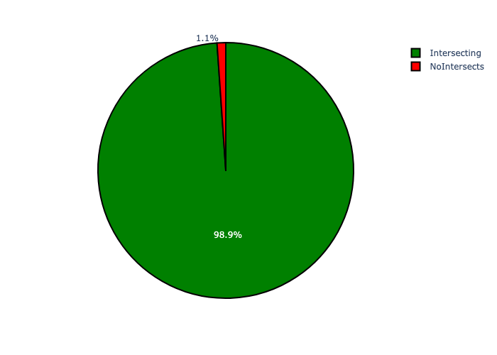

# Total Number of Projects and Total Capital Demand per Region - All Years

Table 1.1 below provides a concise summary of key statistical insights regarding the number of projects that are requesting funding in each of the Regions.

Table 1.1: Regions Analysis - Number of Projects

|  |  |  |  |
| --- | --- | --- | --- |
| Description | Info (1) | Info (2) | Info (3) |
| Number of projects in all Regions - Overview | Total in all Regions: 2438 projects | Average per Regions: 348 projects | 75th percentile of projects across all Regions: 348.0 projects |
| The highest number of projects | Regions: In Region F | Number of projects in Region F: 585 | Percentage of total in Region F: 24.00% |
| The lowest number of projects: | Regions: In Region D | Number of projects in Region D: 260 | Percentage of total in Region D: 10.66% |

Table 1.2 below provides a concise summary of key statistical insights regarding the total capital demand per Region.

Table 1.2: Regions Analysis - Capital Demand (R)

|  |  |  |  |
| --- | --- | --- | --- |
| Description | Info (1) | Info (2) | Info (3) |
| Capital demand in all Regions - Overview | Total capital demand in all Regions: R10,811,043,838 | The average capital demand per Regions: R1,544,434,834 | The 75th percentile of capital demand for Regions: R1,909,509,391 |
| The highest capital demand | Regions: In Region G | Capital Demand in Region G: R2,007,118,178 | Percentage of total in Region G: 18.57% |
| The lowest capital demand | Regions: In Region B | Capital Demand in Region B: R628,374,717 | Percentage of total in Region B: 5.81% |

The number of projects per Region and the capital demand per Region needs to be looked at together for better insight. Figure 2 assists with further graphical insight into some of the numbers that are provided in Tables 1.1 and 1.2.

Figure 2: The single Region with the highest value (Nr of Projects & Capital Demand) vs the rest

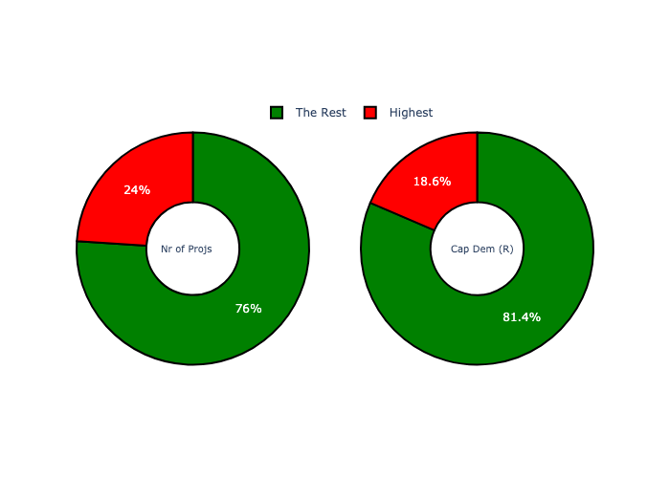

The highest number of projects in a single Region is in **Region F.** *That is 585 projects and this is 24.00% of the total number of projects.*The highest capital demand in a single Region is in **Region G.** *That is R2,007,118,178 and this amounts to 18.57% of the total capital demand.*

The following figures provide a bar graph representation of the number of projects per Region with the colour of the bars representing the level of capital demand in each of these Regions.

Figure 3.1: Projects and Capital Demand per Region (1/1)

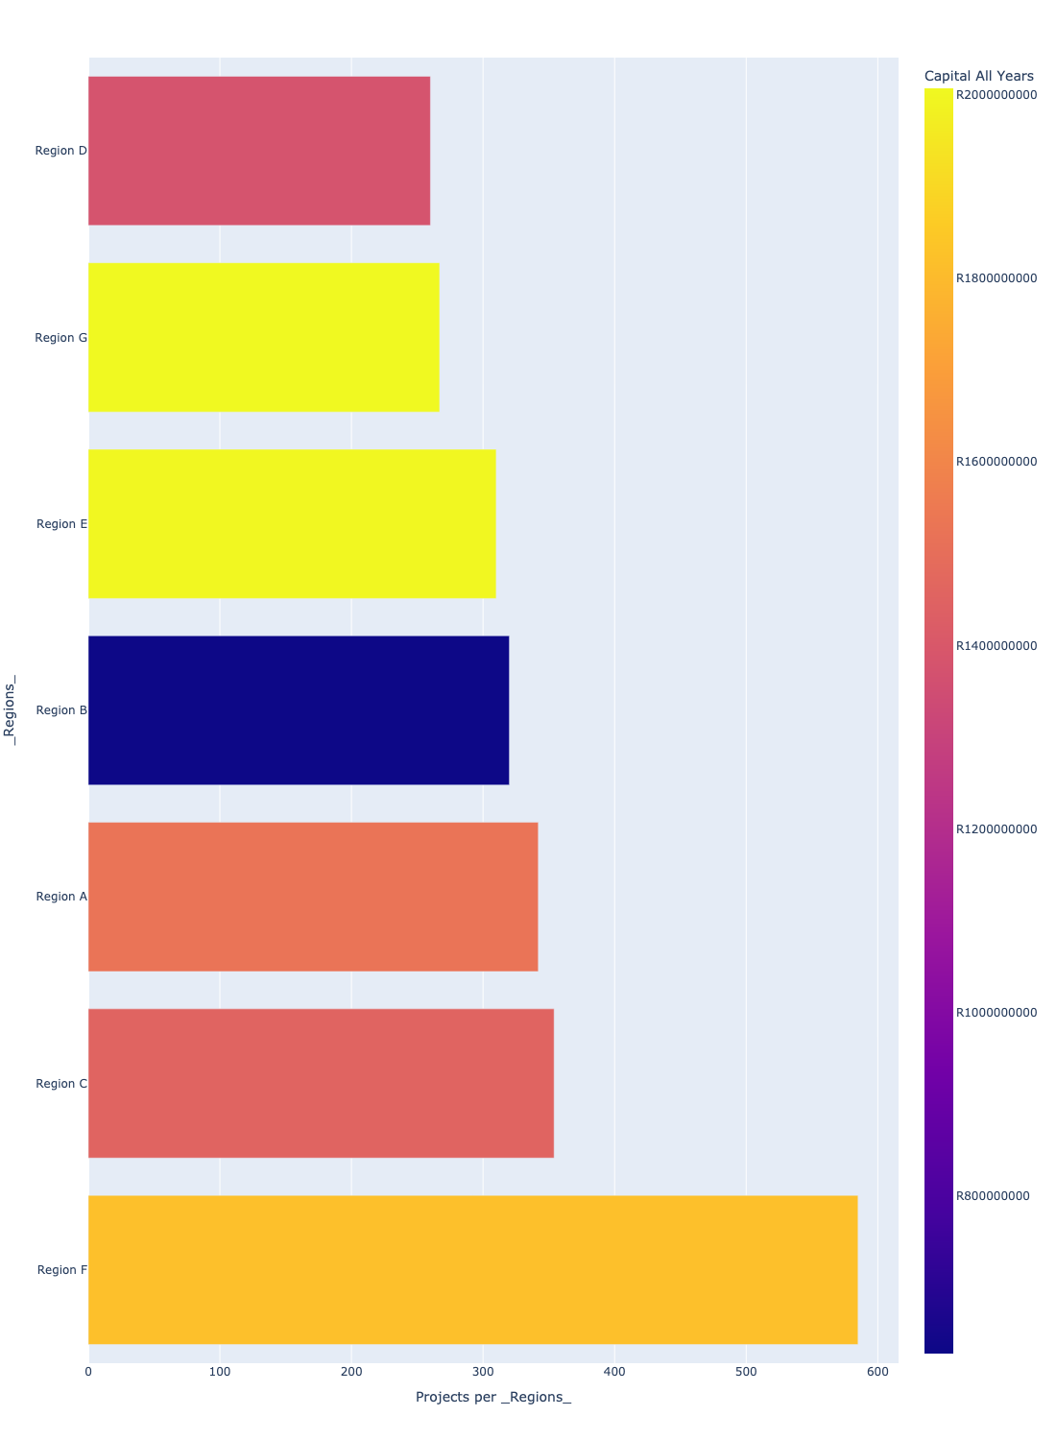

# Total Capital Demand per Region - All Years

The following figures provide a histogram representation of the capital demand per Region. A colour breakdown is provided of each year's sub-total that contribute towards the overall total capital demand of each Region. Note that the capital demand beyond the first three years representing the Medium Term Expenditure Framework (MTREF) - years 2023, 2024 and 2025 - are generally more sparsely and less diligently populated, therefore less reliance should be vested on these outer years when appraising the overall capital demand. The reason for this is usually because of National Treasury's requirement for annual budget submissions spanning only over the MTREF (i.e. the next three years).

Figure 4.1: Capital Demand per Region - All Years (1/1)

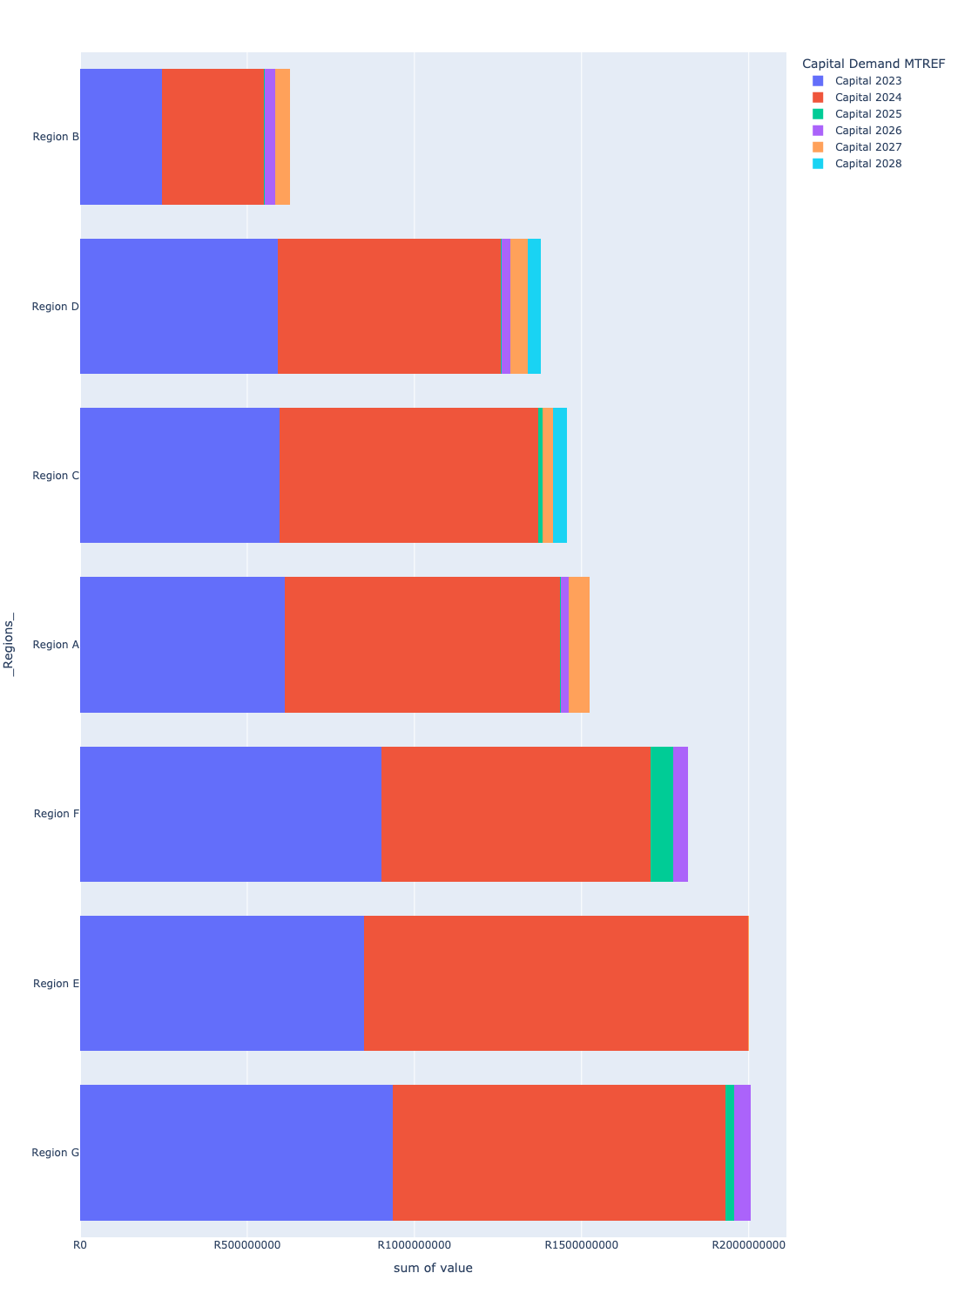

# Total Capital Demand per Region - MTREF only

Table 2 below provides a concise summary of key statistical insights regarding the total MTREF capital demand per Region.

Table 2: Regions Analysis - MTREF Capital Demand (R)

|  |  |  |  |
| --- | --- | --- | --- |
| Description | Info (1) | Info (2) | Info (3) |
| MTREF Capital demand in all Regions - Overview | MTREF capital demand in all Regions: R10,360,543,838 | The average MTREF capital demand per Region: R1,480,077,691 | The 75th percentile of MTREF capital demand for Regions: R1,865,698,755 |
| The highest MTREF capital demand | In Region: Region E | MTREF capital Demand in Region E: R1,998,157,286 | Percentage of total MRTEF capital demand in Region E: 19.29% |
| The lowest MTREF capital demand | In Region: Region B | MTREF capital Demand in Region B: R551,145,584 | Percentage of total MTREF capital demand in Region B: 5.32% |

The following figures provide a histogram representation of the capital demand per Region. A colour breakdown is provided of each year's sub-total that contribute towards the overall MTREF total capital demand of each Region.

Figure 5.1: Capital Demand per Region - MTREF Period (1/1)

