



Spatial Feature Report

T: +27 12 364 2546 | E: info@novus3.co.za Postnet Suite 471, Private Bag X15,

Menlo Park, 0102**www.novus3.co.za**

engineered solutions

Disclaimer

This document contains data that was obtained from a live CP3 system at the moment the data was requested. The data is updated by users of the CP3 System and unless the system is locked for changes, this data may change on a daily basis. The reader is therefore cautioned not to place inappropriate reliance on the data unless there is certainty on the status of the data in terms of how recently it has been updated, how “clean” the data is (is there a quality control and/or verification process that was followed by the licensee of the CP3 system to ensure that data is checked and verified from time-to-time) and whether the correct baseline was queried. This report therefore provides a “snapshot in time”. Consequently, the document may be less relevant at a different time, or using a different financial baseline to query from.

At all times, all rights, title and interest in and to this material remains vested in the owner of this document and are copyrighted and protected by regulatory provisions. These materials may not be copied, reproduced, modified, published, uploaded, posted to websites or otherwise distributed in any way, without our prior written permission from the Licensee and Licensor (Nvous3 (Pty) Ltd) of the CP3 Software. The owner of this document does not grant any right to reproduce the materials. All our rights in this regard are and remain reserved.

Table of Contents

**No table of contents entries found.** (Right-click -> Update Field)

Spatial Query Report

This document was created *2022-04-25-18_58* from the **City of Johannesburg Metropolitan Municipality** CP3 system.

The baseline **'2022/2023_MTREF Planning Capture Baseline_20210823'** with description: **' 2021/2022_MTREF Rollover + Planning Baseline_20210307 duplicate + 2022/22 budget planning'** was used. The spatial feature that was selected for the purpose of this report was: **'Strategically Targeted Areas'**.

This is a spatial feature report for the *City of Johannesburg Metropolitan Municipality.* The data contained in this report was sourced directly from the municipality's live CP3 system. The information in this report therefore reflects the data as it was on the *2022-04-25* when this report was requested. Any subsequent updates to the data contained the CP3 System related to the applicable baseline from which this reports was drawn, would therefore not reflect in this report.   
  
For the *City of Johannesburg Metropolitan Municipality, the following spatial features are available for the purpose of developing* 'Spatial Query Reports' (similar to this report):

* Deprivation Areas
* Informal Settlements
* Inner City Node
* Pro Poor
* Regions
* Strategically Targeted Areas
* Urban Development Zones
* Wards 2020



We hope you find this useful! Sincerely, *The Novus3 Team.*

# Introduction

The baseline that was queried for this report contains *3141* projects of which a total of *1221 (38.9%)* projects do not have any recorded intersection (overlap) with Strategically Targeted Areas.The following spatial features are available for queries using this API profile:

* Deprivation Areas
* Informal Settlements
* Inner City Node
* Pro Poor
* Regions
* Strategically Targeted Areas
* Urban Development Zones
* Wards 2020

The probable reasons for the 1221 non intersecting projects reported are that:

* these projects simply do not have a location associated with them yet (most frequently the case with 'no-intersect' projects) or;
* the location that was captured for some of these projects, may have been in the wrong place (e.g. outside the boundaries of Joburg - this is very rarely the reason).

It is important to take note of the 38.9% projects that do not intersect with Strategically Targeted Areas feature when appraising this report.

Figure 1: Intersecting vs Non-Intersecting Projects

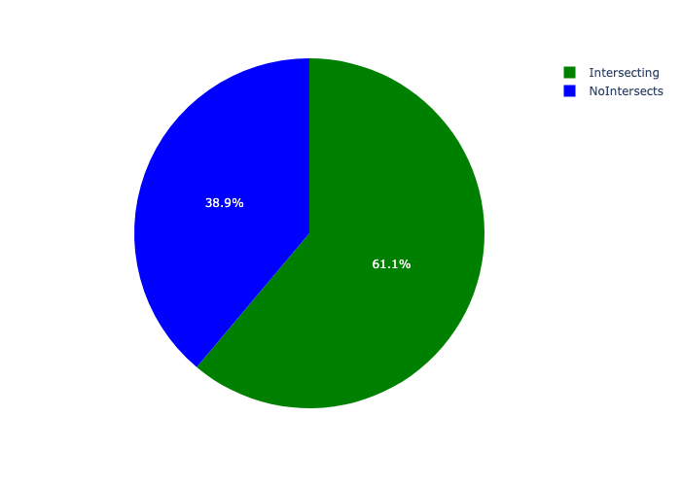

# Total Number of Projects and Total Capital Demand per Strategically Targeted Area - All Years

Table 1.1 below provides a concise summary of key statistical insights regarding the number of projects that are requesting funding in each of the Strategically Targeted Areas.

Table 1.1: Strategically Targeted Areas Analysis - Number of Projects

|  |  |  |  |
| --- | --- | --- | --- |
| Description | Info (1) | Info (2) | Info (3) |
| Number of projects in all Strategically Targeted Areas - Overview | Total in all Strategically Targeted Areas: 1920 projects | Average per Strategically Targeted Areas: 240 projects | 75th percentile of projects across all Strategically Targeted Areas: 313.5 projects |
| The highest number of projects | Strategically Targeted Areas: In Soweto Corridor | Number of projects in Soweto Corridor: 395 | Percentage of total in Soweto Corridor: 20.57% |
| The lowest number of projects: | Strategically Targeted Areas: In Turffontein Strategic Area | Number of projects in Turffontein Strategic Area: 88 | Percentage of total in Turffontein Strategic Area: 4.58% |

Table 1.2 below provides a concise summary of key statistical insights regarding the total capital demand per Strategically Targeted Area.

Table 1.2: Strategically Targeted Areas Analysis - Capital Demand (R)

|  |  |  |  |
| --- | --- | --- | --- |
| Description | Info (1) | Info (2) | Info (3) |
| Capital demand in all Strategically Targeted Areas - Overview | Total capital demand in all Strategically Targeted Areas: R5,987,683,297 | The average capital demand per Strategically Targeted Areas: R748,460,412 | The 75th percentile of capital demand for Strategically Targeted Areas: R947,338,073 |
| The highest capital demand | Strategically Targeted Areas: In Louis-Botha Corridor | Capital Demand in Louis-Botha Corridor: R1,236,975,462 | Percentage of total in Louis-Botha Corridor: 20.66% |
| The lowest capital demand | Strategically Targeted Areas: In Turffontein Strategic Area | Capital Demand in Turffontein Strategic Area: R231,097,067 | Percentage of total in Turffontein Strategic Area: 3.86% |

The number of projects per Strategically Targeted Area and the capital demand per Strategically Targeted Area needs to be looked at together for better insight. Figure 2 assists with further graphical insight into some of the numbers that are provided in Tables 1.1 and 1.2.

Figure 2: The single Strategically Targeted Area with the highest value (Nr of Projects & Capital Demand) vs the rest

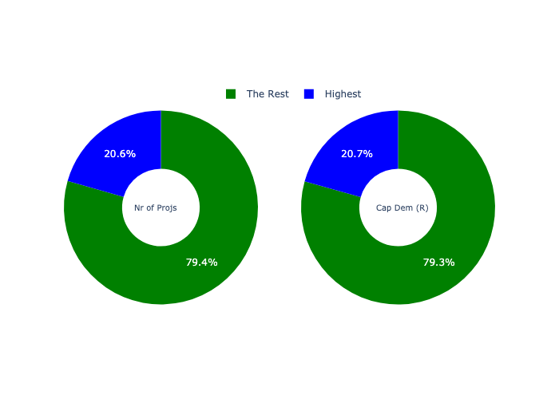

The highest number of projects in a single Strategically Targeted Area is in **Soweto Corridor.** *That is 395 projects and this is 20.57% of the total number of projects.*The highest capital demand in a single Strategically Targeted Area is in **Louis-Botha Corridor.** *That is R1,236,975,462 and this amounts to 20.66% of the total capital demand.*

The following figures provide a bar graph representation of the number of projects per Strategically Targeted Area with the colour of the bars representing the level of capital demand in each of these Strategically Targeted Areas.

Figure 3.1: Projects and Capital Demand per Strategically Targeted Area (1/1)

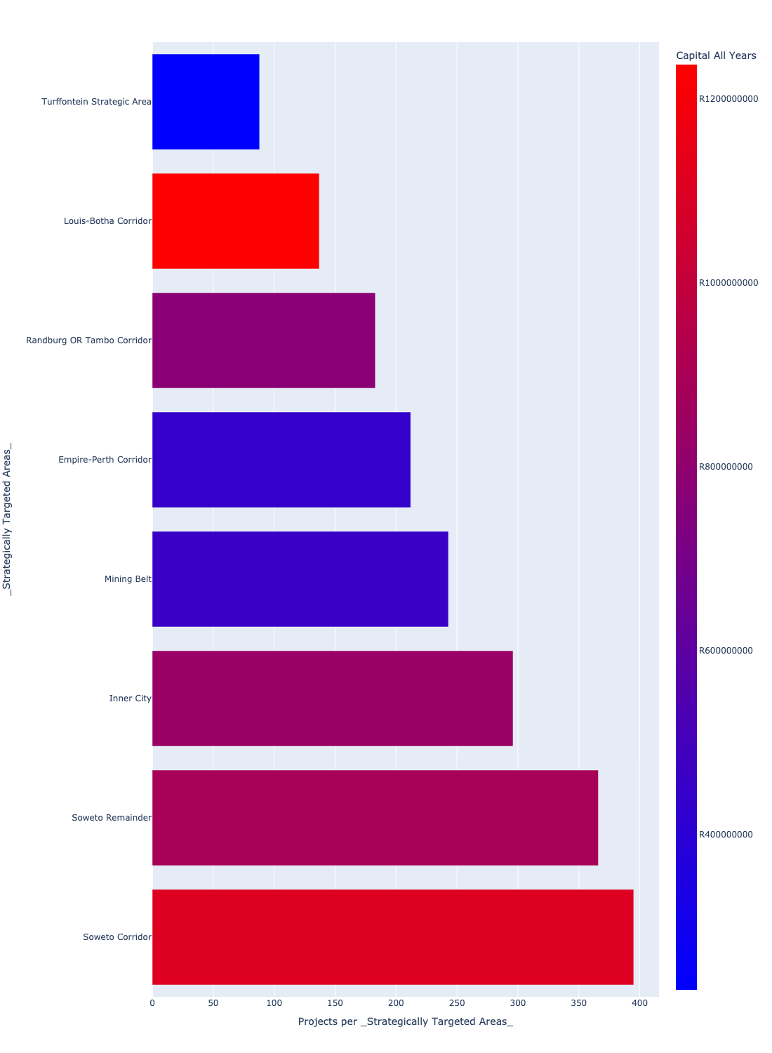

# Total Capital Demand per Strategically Targeted Area - All Years

There are different funding sources from which capital is requested. For the financial baseline that was selected for this report query (2022/2023_MTREF Planning Capture Baseline_20210823), the breakdown of capital demand for City of Johannesburg Metropolitan Municipality per funding source is shown in Figure 4 below.

Figure 4: Capital Demand Per Funding Source

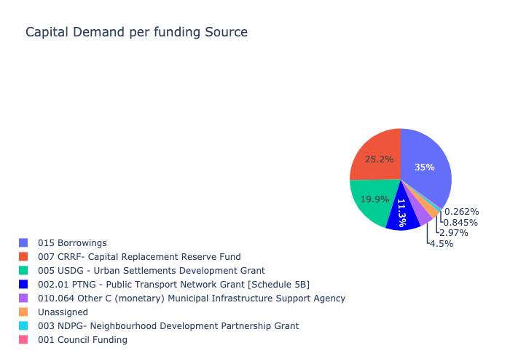

The following figures provide a histogram representation of the capital demand per Strategically Targeted Area. A colour breakdown is provided of each year's sub-total that contribute towards the overall total capital demand of each Strategically Targeted Area. Note that the capital demand beyond the first three years representing the Medium Term Expenditure Framework (MTREF - years 2023, 2024 and 2025) are generally more sparsely and less diligently populated, therefore less reliance should be vested on these outer years when appraising the overall capital demand. The reason for this is usually because of National Treasury's requirement for annual budget submissions spanning only over the MTREF (i.e. the next three years).

Figure 5.1: Capital Demand per Strategically Targeted Area - All Years (1/1)

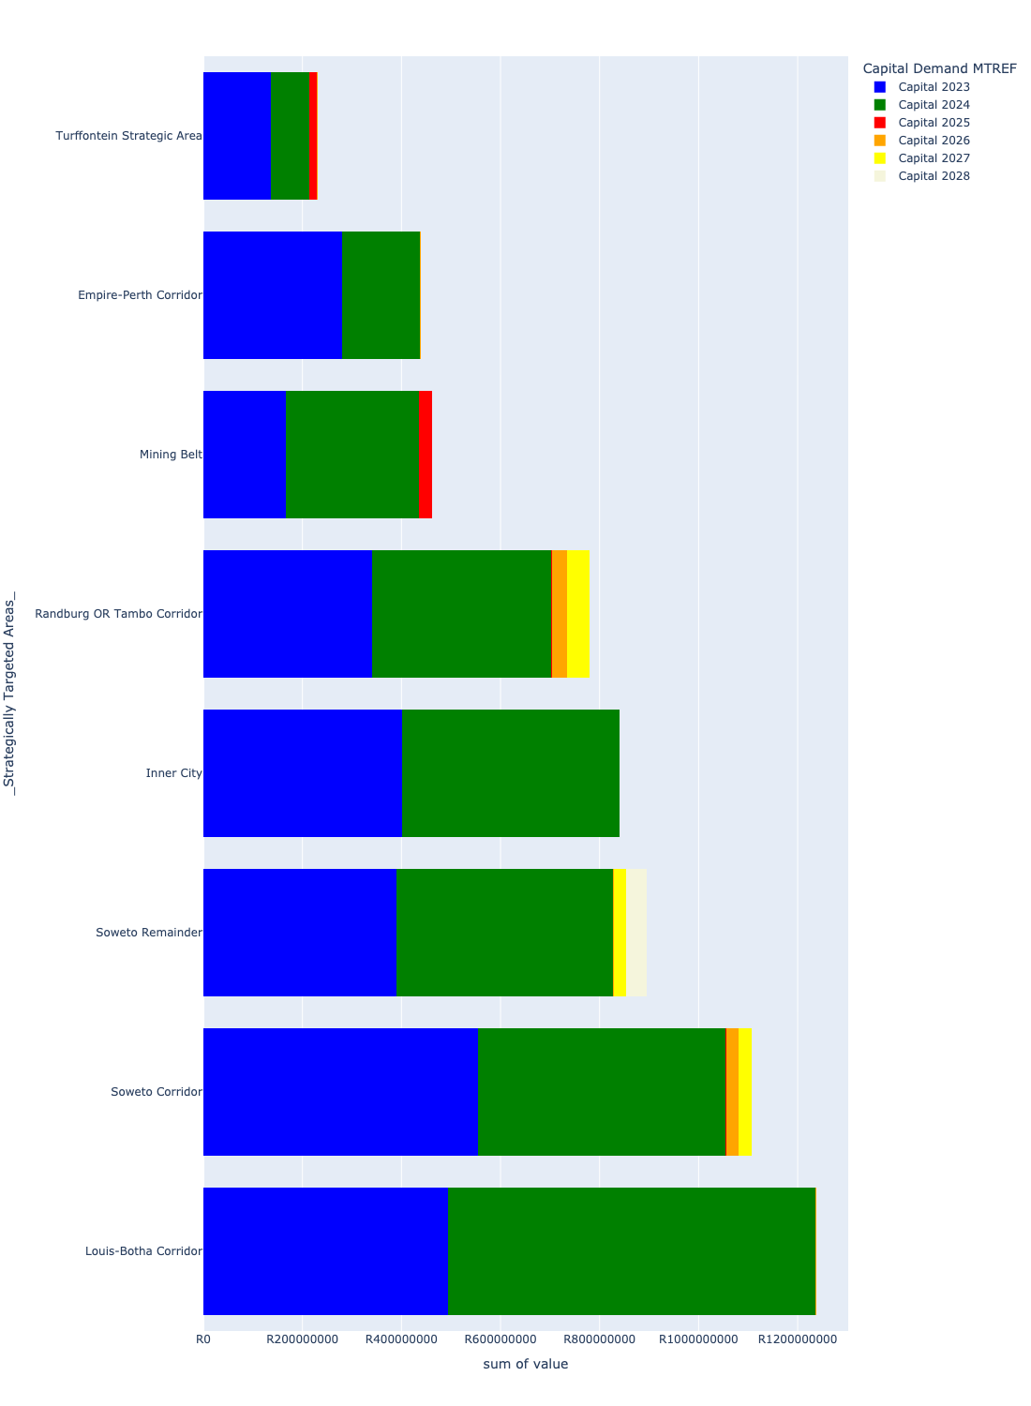

# Total Capital Demand per Strategically Targeted Area - MTREF only

Table 2 below provides a concise summary of key statistical insights regarding the total MTREF capital demand per Strategically Targeted Area.

Table 2: Strategically Targeted Areas Analysis - MTREF Capital Demand (R)

|  |  |  |  |
| --- | --- | --- | --- |
| Description | Info (1) | Info (2) | Info (3) |
| MTREF Capital demand in all Strategically Targeted Areas - Overview | MTREF capital demand in all Strategically Targeted Areas: R5,791,966,818 | The average MTREF capital demand per Strategically Targeted Area: R723,995,852 | The 75th percentile of MTREF capital demand for Strategically Targeted Areas: R893,953,691 |
| The highest MTREF capital demand | In Strategically Targeted Area: Louis-Botha Corridor | MTREF capital Demand in Louis-Botha Corridor: R1,236,772,311 | Percentage of total MRTEF capital demand in Louis-Botha Corridor: 21.35% |
| The lowest MTREF capital demand | In Strategically Targeted Area: Turffontein Strategic Area | MTREF capital Demand in Turffontein Strategic Area: R228,097,066 | Percentage of total MTREF capital demand in Turffontein Strategic Area: 3.94% |

The following figures provide a histogram representation of the capital demand per Strategically Targeted Area. A colour breakdown is provided of each year's sub-total that contribute towards the overall MTREF total capital demand of each Strategically Targeted Area.

Figure 6.1: Capital Demand per Strategically Targeted Area - MTREF Period (1/1)

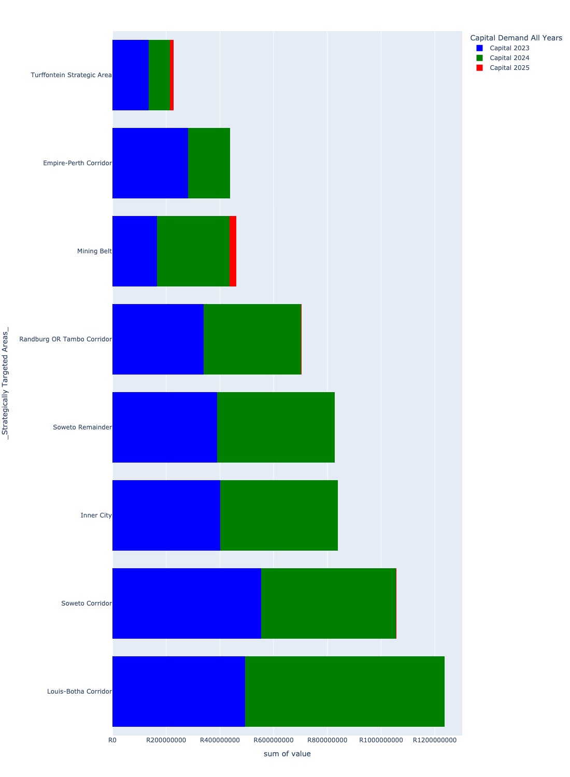

# Summary per Strategically Targeted Area

## Soweto Corridor

Table 3: Soweto Corridor Summary

|  |  |
| --- | --- |
| Item | Description |
| Number of Projects |  |

## Turffontein Strategic Area

Table 4: Turffontein Strategic Area Summary

|  |  |
| --- | --- |
| Item | Description |
| Number of Projects |  |

## Empire-Perth Corridor

Table 5: Empire-Perth Corridor Summary

|  |  |
| --- | --- |
| Item | Description |
| Number of Projects |  |

## Louis-Botha Corridor

Table 6: Louis-Botha Corridor Summary

|  |  |
| --- | --- |
| Item | Description |
| Number of Projects |  |

## Randburg OR Tambo Corridor

Table 7: Randburg OR Tambo Corridor Summary

|  |  |
| --- | --- |
| Item | Description |
| Number of Projects |  |

## Soweto Remainder

Table 8: Soweto Remainder Summary

|  |  |
| --- | --- |
| Item | Description |
| Number of Projects |  |

## Inner City

Table 9: Inner City Summary

|  |  |
| --- | --- |
| Item | Description |
| Number of Projects |  |

## Mining Belt

Table 10: Mining Belt Summary

|  |  |
| --- | --- |
| Item | Description |
| Number of Projects |  |