

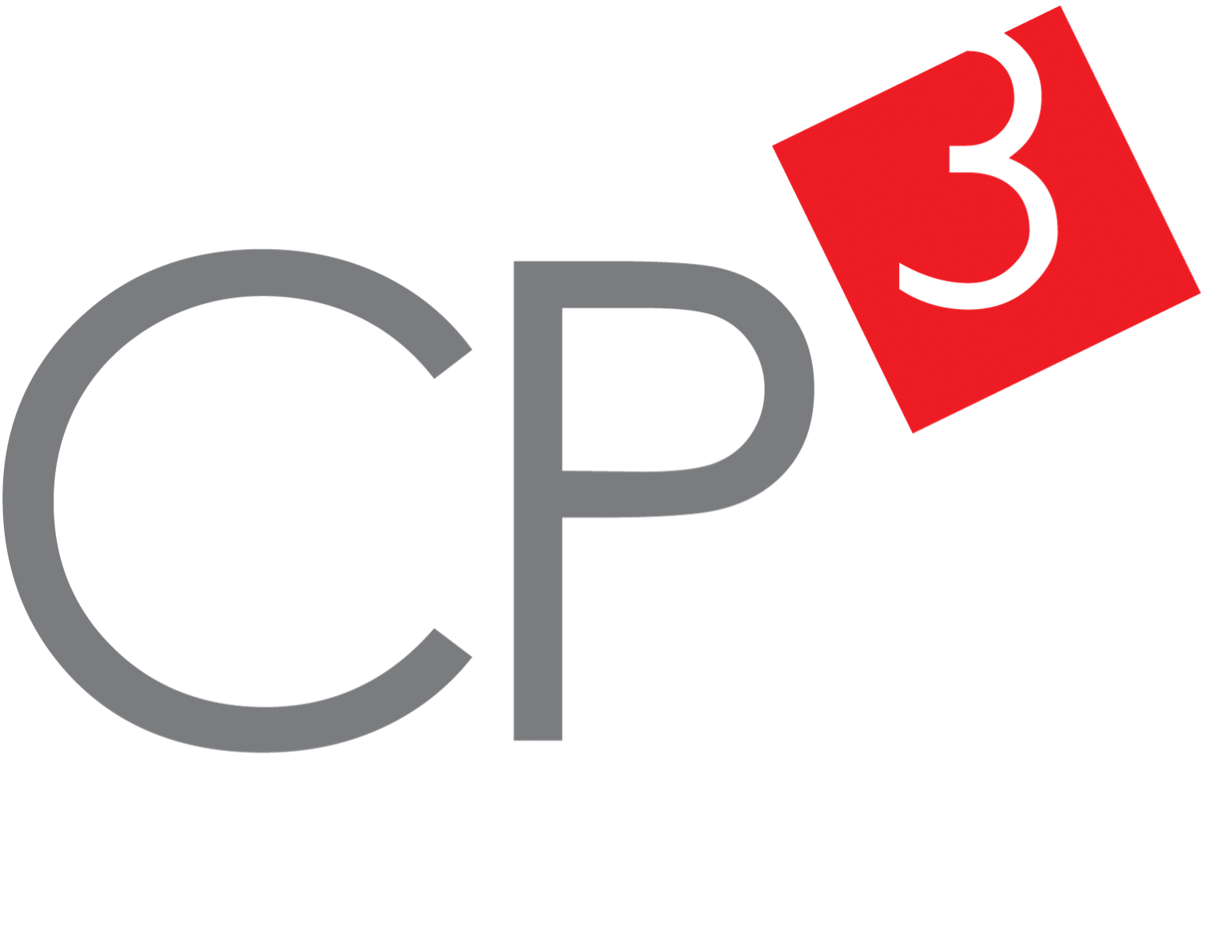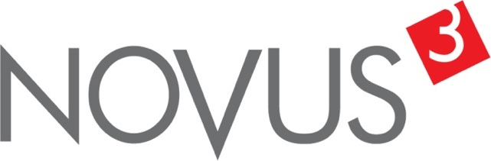

Spatial Feature Report

T: +27 12 364 2546 | E: info@novus3.co.za Postnet Suite 471, Private Bag X15,

Menlo Park, 0102**www.novus3.co.za**

engineered solutions

Disclaimer

This document contains data that was obtained from a live CP3 system at the moment the data was requested. The data is updated by users of the CP3 System and unless the system is locked for changes, this data may change on a daily basis. The reader is therefore cautioned not to place inappropriate reliance on the data unless there is certainty on the status of the data in terms of how recently it has been updated, how “clean” the data is (is there a quality control and/or verification process that was followed by the licensee of the CP3 system to ensure that data is checked and verified from time-to-time) and whether the correct baseline was queried. This report therefore provides a “snapshot in time”. Consequently, the document may be less relevant at a different time, or using a different financial baseline to query from.

At all times, all rights, title and interest in and to this material remains vested in the owner of this document and are copyrighted and protected by regulatory provisions. These materials may not be copied, reproduced, modified, published, uploaded, posted to websites or otherwise distributed in any way, without our prior written permission from the Licensee and Licensor (Nvous3 (Pty) Ltd) of the CP3 Software. The owner of this document does not grant any right to reproduce the materials. All our rights in this regard are and remain reserved.

Table of Contents

**No table of contents entries found.** (Right-click -> Update Field)

Spatial Query Report

This document was created *2022-05-25-12_31* from the **City of Johannesburg Metropolitan Municipality** CP3 system.

The baseline **'2022/2023_MTREF Planning Capture Baseline_20210823'** with description: **' 2021/2022_MTREF Rollover + Planning Baseline_20210307 duplicate + 2022/22 budget planning'** was used. The spatial feature that was selected for the purpose of this report was: **'_Regions_'**.

This is a spatial feature report for the *City of Johannesburg Metropolitan Municipality.* The data contained in this report was sourced directly from the municipality's live CP3 system. The information in this report therefore reflects the data as it was on *2022-05-25* when this report was requested. Any subsequent updates to the data contained the CP3 System related to the applicable baseline from which this reports was drawn, would therefore not reflect in this report.   
  
For the *City of Johannesburg Metropolitan Municipality, the following spatial features are available for the purpose of developing* 'Spatial Query Reports' (similar to this report):

* Deprivation Areas
* Informal Settlements
* Inner City Node
* Pro Poor
* Regions
* Strategically Targeted Areas
* Urban Development Zones
* Wards 2020



We hope you find this useful! Sincerely, *The Novus3 Team.*

# Introduction

The baseline that was queried for this report contains *2466* projects of which a total of *27 (1.09%)* projects do not have any recorded intersection (overlap) with the 'Regions' spatial feature that was selected for this report. The following spatial features are available for queries using this API profile:

* Deprivation Areas
* Informal Settlements
* Inner City Node
* Pro Poor
* Regions
* Strategically Targeted Areas
* Urban Development Zones
* Wards 2020

The probable reasons for the 27 non intersecting projects reported are that:

* these projects simply do not have a location associated with them yet (most frequently the case with 'no-intersect' projects) or;
* the location that was captured for some of these projects, may have been in the wrong place (e.g. outside the boundaries of Joburg - this is very rarely the reason).

It is important to take note of the 1.09% projects that do not intersect with the 'Regions' spatial feature when appraising this report.

The 1.09% of non-intersecting projects is a relative low percentage and therefore not much cause of concern for this particular report.

Figure 1.1: Intersecting vs Non-Intersecting Projects

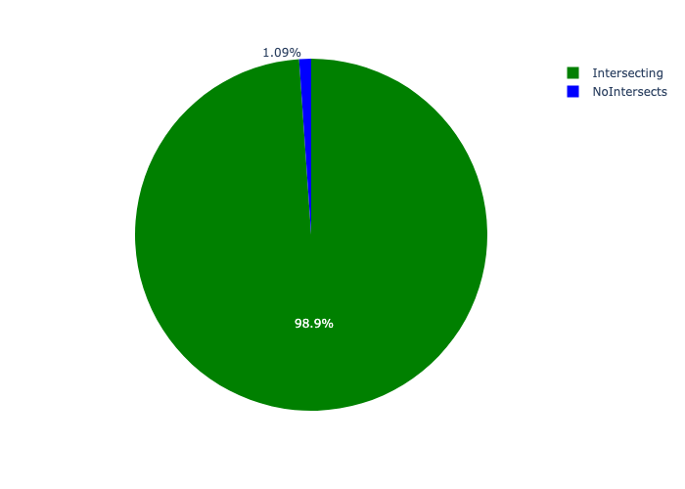

# Total Number of Projects and Total Capital Demand per Region - All Years

Table 2.1 below provides a concise summary of key statistical insights regarding the number of projects that are requesting funding in each of the regions.

Table 2.1: Regions Analysis - Number of Projects

|  |  |  |  |
| --- | --- | --- | --- |
| Description | Info (1) | Info (2) | Info (3) |
| Number of projects in all Regions - Overview | Total in all Regions: 2439 projects | Average per Regions: 348 projects | 75th percentile of projects across all Regions: 348.0 projects |
| The highest number of projects | Regions: In Region F | Number of projects in Region F: 586 | Percentage of total in Region F: 24.03% |
| The lowest number of projects: | Regions: In Region D | Number of projects in Region D: 260 | Percentage of total in Region D: 10.66% |

Table 2.1 below provides a concise summary of key statistical insights regarding the total capital demand per region.

Table 2.1: Regions Analysis - Capital Demand (R)

|  |  |  |  |
| --- | --- | --- | --- |
| Description | Info (1) | Info (2) | Info (3) |
| Capital demand in all Regions - Overview | Total capital demand in all Regions: R11,837,942,219 | The average capital demand per Regions: R1,691,134,603 | The 75th percentile of capital demand for Regions: R1,947,810,891 |
| The highest capital demand | Regions: In Region G | Capital Demand in Region G: R2,317,072,559 | Percentage of total in Region G: 19.57% |
| The lowest capital demand | Regions: In Region B | Capital Demand in Region B: R848,163,717 | Percentage of total in Region B: 7.16% |

The number of projects per region and the capital demand per region needs to be looked at together for better insight. Figures 2.1 and 2.2 assist with further graphical insight into some of the numbers that are provided in Tables 2.1 and 2.2.

Figure 2.1: The single region with the highest value (Nr of Projects & Capital Demand) vs the rest

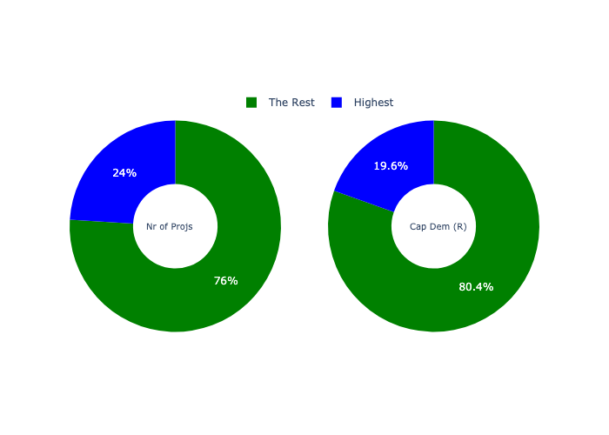

The highest number of projects in a single region is in **Region F.** *That is 586 projects and this is 24.03% of the total number of projects.* The highest capital demand in a single region is in **Region G.** *That is R2,317,072,559 and this amounts to 19.57% of the total capital demand.*

The following figures provide a bar graph representation of the number of projects per region with the colour of the bars representing the level of capital demand in each of these regions.

Figure 2.2: Projects and Capital Demand per Region

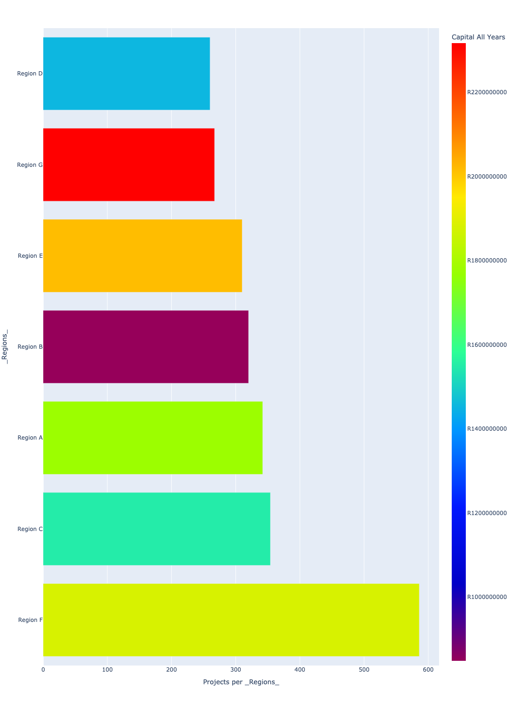

# Total Capital Demand per region - All Years

There are different funding sources from which capital is requested. For the financial baseline that was selected for this report query (2022/2023_MTREF Planning Capture Baseline_20210823), the breakdown of capital demand for City of Johannesburg Metropolitan Municipality per funding source is shown in Figure 3.1 below.

Figure 3.1: Capital Demand Per Funding Source

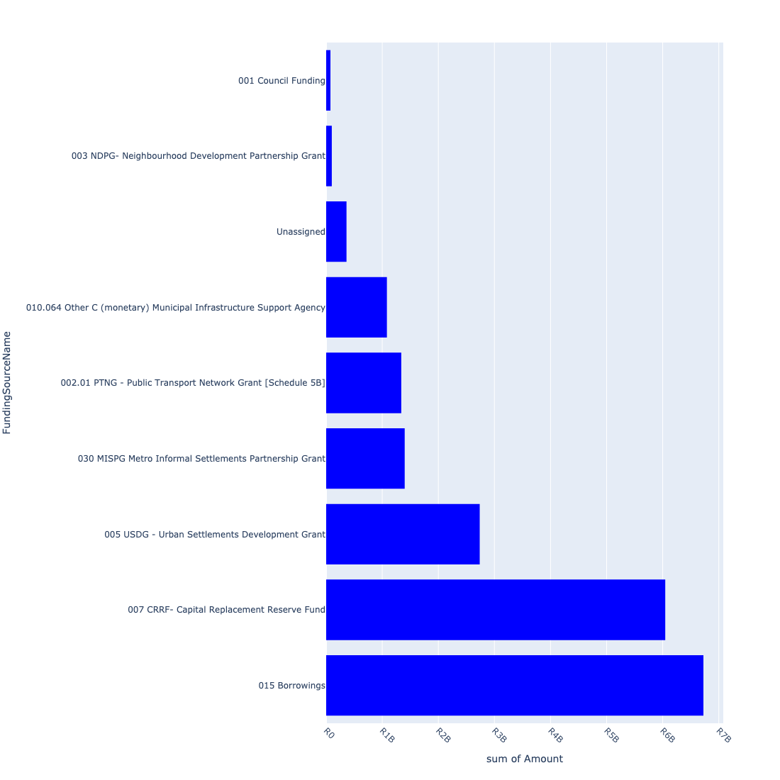

For the financial baseline that was selected for this report query (2022/2023_MTREF Planning Capture Baseline_20210823), the breakdown of capital demand for City of Johannesburg Metropolitan Municipality per department is shown in Figure 3.2 below.

Figure 3.2: Capital Demand Per City of Johannesburg Metropolitan Municipality Department

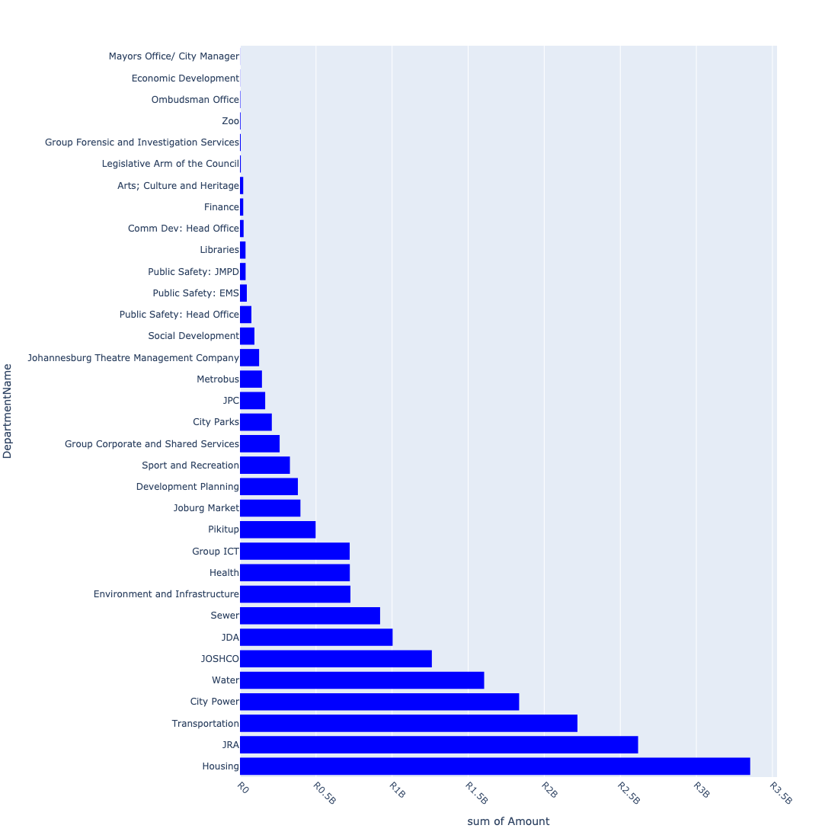

The following figures provide a histogram representation of the capital demand per region. A colour breakdown is provided of each year's sub-total that contribute towards the overall total capital demand of each region. Note that the capital demand beyond the first three years representing the Medium Term Expenditure Framework (MTREF - years 2023, 2024 and 2025) are generally more sparsely and less diligently populated, therefore less reliance should be vested on these outer years when appraising the overall capital demand. The reason for this is usually because of National Treasury's requirement for annual budget submissions spanning only over the MTREF (i.e. the next three years).

Figure 3.3: Capital Demand per Region - All Years

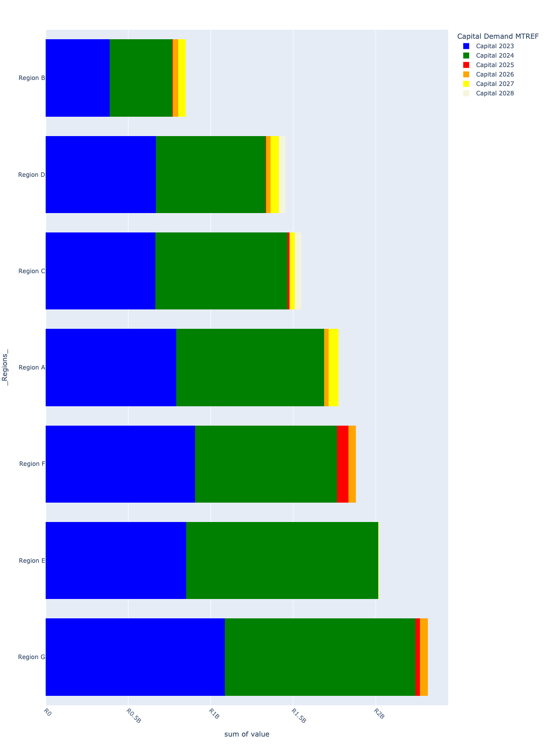

# Total Capital Demand per Region - MTREF only

Table 4.1 below provides a concise summary of key statistical insights regarding the total MTREF capital demand per region.

Table 4.1: Regions Analysis - MTREF Capital Demand (R)

|  |  |  |  |
| --- | --- | --- | --- |
| Description | Info (1) | Info (2) | Info (3) |
| MTREF Capital demand in all Regions - Overview | MTREF capital demand in all Regions: R11,387,442,219 | The average MTREF capital demand per region: R1,626,777,460 | The 75th percentile of MTREF capital demand for Regions: R1,924,867,936 |
| The highest MTREF capital demand | In Region: Region G | MTREF capital Demand in Region G: R2,266,376,305 | Percentage of total MRTEF capital demand in Region G: 19.90% |
| The lowest MTREF capital demand | In Region: Region B | MTREF capital Demand in Region B: R770,934,584 | Percentage of total MTREF capital demand in Region B: 6.77% |

The following figures provide a histogram representation of the capital demand per region. A colour breakdown is provided of each year's sub-total that contribute towards the overall MTREF total capital demand of each region.

Figure 4.1: Capital Demand per Region - MTREF Period

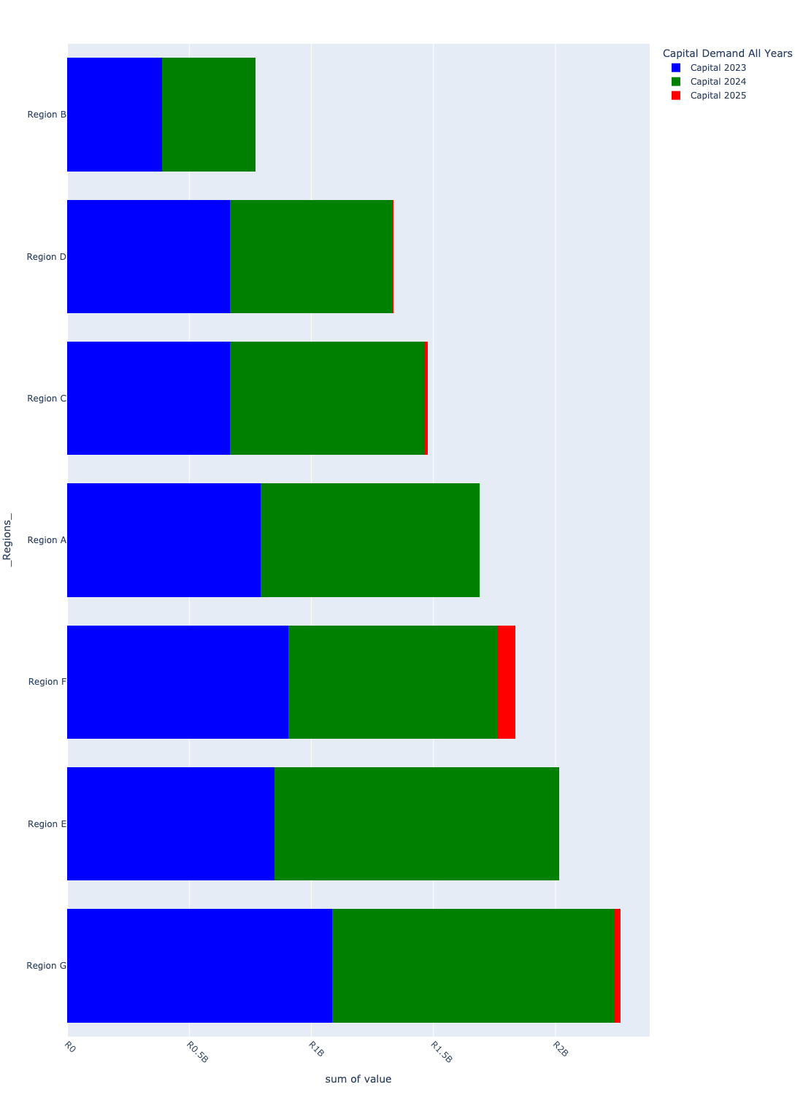

# Summary per Region

## Region A

Figure 5.1: Region A Funding Requests

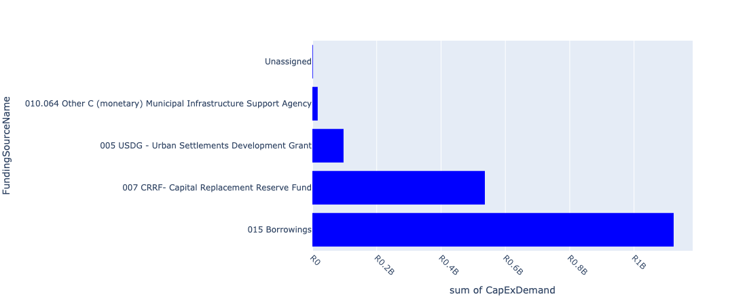

Figure 5.2: Region A Departmental Requests

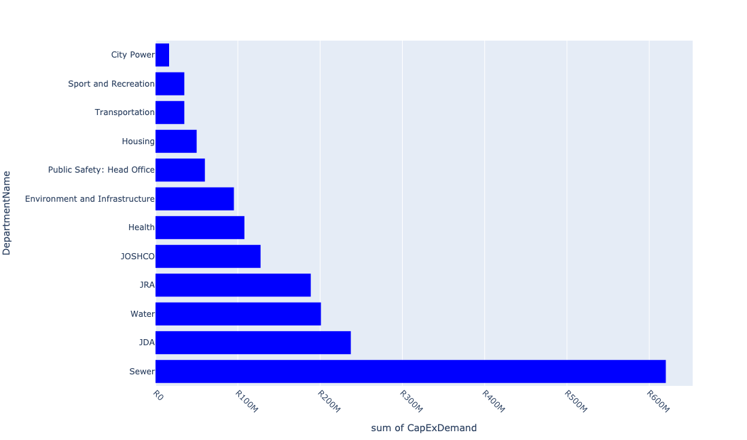

Table 5.1: Summary - Region A

|  |  |
| --- | --- |
| Item | Description |
| Total Capital Demand for Region A - All Years | R1,774,490,214 Rank: 4 (1 = Highest) |
| Total Capital Demand for Region A - MTREF | R1,688,351,743 Rank: 4 (1 = Highest) |
| Financial Years in which capital requirements are listed for Region A | 2023, 2024, 2025, 2026 and 2027 |
| Financial Year with highest capital demand for Region A | 2024 |
| Region A intersecting feature used | Works Location |
| Total number of projects intersecting with Region A | 342 Rank: 3 (1 = Highest) |

Table 5.2: All projects asking for budget in Region A

|  |  |  |  |
| --- | --- | --- | --- |
| Project ID | Project Name | Department | Project Budget |
| 6548 | WWTW: Mechanical Plant | Sewer | R499,819 (0.03%) Budget spread across: 2024 |
| 23557 | 01_22684_Air Conditioners | Health | R10,293 (0.00%) Budget spread across: 2025, 2026 and 2027 |
| 22012 | DSM: Solar PV Systems on Buildings | City Power | R0.00 (0%) No budget request. |
| 2268 | Newmarket: Provision of servitudes and establish of new 2x45MVA 88/11kV S/S New Bulk Infrastructure HOOGLAND EXT.21 C | City Power | R0.00 (0%) No budget request. |
| 23562 | 06_22684_Security Installations | Health | R643,273 (0.04%) Budget spread across: 2025, 2026 and 2027 |
| 23556 | 02_22684_Electricity Upgrade | Health | R1,068,055 (0.06%) Budget spread across: 2025, 2026 and 2027 |
| 2520 | WWTW: Automation Of WWTW Plant | Sewer | R499,774 (0.03%) Budget spread across: 2024 |
| 6663 | Business Desk and Revenue enhancement Unit at Midrand Centre for Corporate Clients | Public Safety: Head Office | R0.00 (0%) No budget request. |
| 21988 | NW: Dam 03 | Water | R1,000,000 (0.06%) Budget spread across: 2024 |
| 2573 | RABIE RIDGE Sport Centre New Contruction | Sport and Recreation | R0.00 (0%) No budget request. |
| 22218 | Deep South / Orange Farm:Diepsloot Reservoir 40ML.Duplicate | Water | R0.00 (0%) No budget request. |
| 22217 | Deep South / Orange Farm:Diepsloot Tower 1.6ML | Water | R0.00 (0%) No budget request. |
| 6494 | Midrand: Erand Tower 2 1.5ML | Water | R0.00 (0%) No budget request. |
| 2879 | MISCL - Pedestrian Bridge in Kaalfontein New Bridges (Pedestrian and Vehicles) KAALFONTEIN EXT.2 A Ward | JRA | R0.00 (0%) No budget request. |
| 21058 | Midrand : CBD Midrand switching station upgrade | City Power | R0.00 (0%) No budget request. |
| 20749 | Halfway Gardens Ext100 Sws: Satellite | City Power | R0.00 (0%) No budget request. |
| 21081 | Midrand : Staugh Voster switching station upgrade | City Power | R0.00 (0%) No budget request. |
| 3105 | New Park Development in Ivory Park New Park IVORY PARK EXT.2 A Ward | City Parks | R0.00 (0%) No budget request. |
| 3531 | Ivory Park Social Housing Project Region A | JOSHCO | R0.00 (0%) No budget request. |
| 3205 | Beaulieu Bird Sanctuary Paving Road entrance and parking area (erosion control). Upgrade dam wall trail (collonial fencing) Renewal Park KYALAMI ESTATE EXT.1 A Regional | City Parks | R0.00 (0%) No budget request. |
| 2967 | BRID 30 - Extension of Riverside and Swazi Inn Roads to K111 (Bridge over Kaalspruit) New Bridges (Pedestrian and Vehicles) IVORY PARK EXT.10 A Ward | JRA | R0.00 (0%) No budget request. |
| 21064 | Midrand : Fire Station switching station supply upgrade | City Power | R0.00 (0%) No budget request. |
| 21313 | VodaWorld | City Power | R0.00 (0%) No budget request. |
| 3019 | RNP057_Allandale Road Extension New Roads: Construction and Upgrades KYALAMI PARK A Ward | JRA | R0.00 (0%) No budget request. |
| 21659 | Diepsloot IWMF | Pikitup | R0.00 (0%) No budget request. |
| 2529 | Diepsloot Nodal Economic Development New Precinct/Nodal Development DIEPSLOOT WES EXT.2 A Ward | Economic Development | R0.00 (0%) No budget request. |
| 22160 | Diepsloot reception Area | Housing | R0.00 (0%) No budget request. |
| 22154 | Tanganani Development | Housing | R0.00 (0%) No budget request. |
| 2827 | Upgrade MV supply to and in Kya Sands. Renewal Medium Voltage Network KYA SAND A Regional | City Power | R0.00 (0%) No budget request. |
| 21075 | Midrand : Proposed switching station in Crescent Wood Country Estate area | City Power | R0.00 (0%) No budget request. |
| 20878 | WILLIAM NICOL Sws: Satellite | City Power | R0.00 (0%) No budget request. |
| 6517 | Midrand: Planned replacement sewermains | Sewer | R10,000,000 (0.56%) Budget spread across: 2023 and 2024 |
| 3451 | Erand Precinct New Park ERAND A.H. A Ward | City Parks | R0.00 (0%) No budget request. |
| 2455 | Midrand Market and Taxi Rank faciity upgrading and Repair of Fire System and Close Circuit Cameras Renewal Taxi Rank ALLANDALE EXT.9 A Ward | JPC | R0.00 (0%) No budget request. |
| 22850 | Rietfontein EE Centre | City Parks | R0.00 (0%) No budget request. |
| 2884 | RNP030_Construction of Alexandra Road between N1 and Van Heerden Road Renewal Roads: Construction and Upgrades HALFWAY GARDENS EXT.126 A Ward | JRA | R0.00 (0%) No budget request. |
| 2647 | Hikensile Clinic Renewal Clinic IVORY PARK EXT.9 A Ward | Health | R1,300,000 (0.07%) Budget spread across: 2024 |
| 20792 | Midrand : Refurbishment of old equipment | City Power | R0.00 (0%) No budget request. |
| 3600 | Roodepoort/ Diepsloot: Kya Sands sewer upgrade KYA SAND EXT.20 C | Sewer | R0.00 (0%) No budget request. |
| 3102 | Diepsloot river -Eco Park development New Park DIEPSLOOT | City Parks | R0.00 (0%) No budget request. |
| 21055 | Midrand : Airport switching station supply cables upgrade | City Power | R0.00 (0%) No budget request. |
| 2996 | CATCH 10 - Implementation of CBP Stormwater Masterplanning: Diepsloot New Stormwater Catchments DIEPSLOOT WES A Ward | JRA | R0.00 (0%) No budget request. |
| 3302 | Replace Hawker Siddeley feederboard and 30 MVA transformers at Grand Central. Renewal Bulk Infrastructure GRAND CENTRAL EXT.19 A Ward | City Power | R0.00 (0%) No budget request. |
| 20855 | Sagewood: Satellite | City Power | R0.00 (0%) No budget request. |
| 23760 | President Park Tower Reservoir 2.25Ml | Water | R20,000,000 (1.13%) Budget spread across: 2023 and 2024 |
| 3145 | Ivory Park Thabo Mbeki New Bulk Infrastructure IVORY PARK EXT.10 A Ward | Housing | R0.00 (0%) No budget request. |
| 23411 | OV: Infrastructure Renewal Plan 2 (2019/20 to 2012/22).Duplicate | Water | R5,000,000 (0.28%) Budget spread across: 2024 |
| 2853 | RNP022_Richards Drive Upgrading Renewal Roads: Construction and Upgrades HALFWAY HOUSE EXT.95 | JRA | R18,652,000 (1.05%) Budget spread across: 2023 and 2024 |
| 6545 | Northern Works: Unit 4: Replacement of Electromechanical | Sewer | R10,000,000 (0.56%) Budget spread across: 2024 |
| 6497 | Roodeport/ Diepsloot: Lion Park Reservoir 15ML | Water | R0.00 (0%) No budget request. |
| 3488 | Northern Works: Sludge turners DIEPSLOOT WES A | Sewer | R0.00 (0%) No budget request. |
| 20823 | Randjespark Ext72: Satellite | City Power | R0.00 (0%) No budget request. |
| 22266 | Ecological infrastructure drainage management and flood mitigation GLEN AUSTIN | Environment and Infrastructure | R0.00 (0%) No budget request. |
| 6305 | Township Reticulation Midrand | City Power | R0.00 (0%) No budget request. |
| 21061 | Midrand : Country View Property switching station supply upgrade | City Power | R0.00 (0%) No budget request. |
| 6405 | Rehabilitation of the Diepsloot Water Management Unit (J-DWMU) | Environment and Infrastructure | R0.00 (0%) No budget request. |
| 2987 | RNP075_Upgrading and Doubling of R101 Renewal Roads: Construction and Upgrades GLEN AUSTIN A.H. A Regional | JRA | R0.00 (0%) No budget request. |
| 2916 | Electrification of K-60 New Electrification COMMERCIA EXT.11 A Regional | City Power | R0.00 (0%) No budget request. |
| 3528 | Ivory Park sewer upgrade Renewal IVORY PARK EXT.2 G | Sewer | R0.00 (0%) No budget request. |
| 3457 | Riverside View ext 28 (Diepsloot ext 12) | Housing | R50,000,000 (2.82%) Budget spread across: 2023 and 2024 |
| 22844 | Diepsloot Mall Gateway Node | Development Planning | R0.00 (0%) No budget request. |
| 22512 | Roodepoort/ Diepsloot: Diepsloot Reservoir 40 Ml | Water | R15,000,000 (0.85%) Budget spread across: 2023 and 2024 |
| 2438 | Allandale Substation: Upgrade 2 X 10 MVA transformers to 40 MVA Renewal Bulk Infrastructure COMMERCIA EXT.11 A Regional | City Power | R0.00 (0%) No budget request. |
| 20783 | Lenasia Ext 4: Satellite | City Power | R0.00 (0%) No budget request. |
| 3465 | Sandton/ Alexandra: Dainfern Reservoir New Reserviors DAINFERN B Regional | Water | R0.00 (0%) No budget request. |
| 22306 | Acquisition and UPGRADING of an existing landfill site in region A (SOWETO) | Environment and Infrastructure | R0.00 (0%) No budget request. |
| 22303 | Development of Conservation Park LION PARK | Environment and Infrastructure | R5,250,000 (0.30%) Budget spread across: 2023 and 2024 |
| 2830 | Northern Works: Replace HOW Screens Renewal Bulk Waste Water DIEPSLOOT WES EXT.2 A Ward | Sewer | R0.00 (0%) No budget request. |
| 24026 | 23775_Management of Grey Water | Water | R0.00 (0%) No budget request. |
| 21072 | Midrand : Noordwyk Ext. 43 switching station upgrade | City Power | R0.00 (0%) No budget request. |
| 20740 | Gallagher Estate: Satellite | City Power | R0.00 (0%) No budget request. |
| 3142 | Ivory Park Ext 8 Hlophe New Bulk Infrastructure IVORY PARK EXT.8 A Ward | Housing | R0.00 (0%) No budget request. |
| 3093 | Electrification of Lindelani Settlement New Electrification RABIE RIDGE A Ward | City Power | R0.00 (0%) No budget request. |
| 3311 | NR: Nodal Regeneration: Diepsloot Region A | Transportation | R0.00 (0%) No budget request. |
| 21828 | Diepsloot Water Upgrade | Water | R0.00 (0%) No budget request. |
| 20717 | Delta-G Sws: Satellite | City Power | R0.00 (0%) No budget request. |
| 23302 | New Midrand depot facility Phase 1 at Rabie Ridge Ext 31 | Pikitup | R0.00 (0%) No budget request. |
| 2521 | Roodepoort/Diepsloot: Lanseria Reservoir New Reservoirs LANSERIA EXT.21 A Ward | Water | R0.00 (0%) No budget request. |
| 22661 | Midrand:Kyalami Water Upgrade.Duplicate | Water | R0.00 (0%) No budget request. |
| 22071 | Northern Works: Unit 3: New PSTs # 2 | Sewer | R0.00 (0%) No budget request. |
| 21948 | Carlswald Water Upgrade | Water | R0.00 (0%) No budget request. |
| 6445 | M9 Rivonia road extention on new alignment from Leukop rd Via MAlinda :Malid | JRA | R0.00 (0%) No budget request. |
| 23259 | Diepsloot new Multi-Purpose | Sport and Recreation | R5,000,000 (0.28%) Budget spread across: 2024 |
| 3540 | Midrand: Planned replacement: Watermains Renewal | Water | R20,000,000 (1.13%) Budget spread across: 2023 and 2024 |
| 3042 | RNP093_Lone Hill Boulevard Upgrading Renewal Roads: Construction and Upgrades BEVERLEY A.H. A Ward | JRA | R0.00 (0%) No budget request. |
| 20709 | Commercia Sws: Satellite | City Power | R0.00 (0%) No budget request. |
| 3646 | RNP043_Road in Commercia New Roads: Construction and Upgrades COMMERCIA A Ward | JRA | R0.00 (0%) No budget request. |
| 2956 | RNP048_K113 - From PWV3 to K56 New Roads: Construction and Upgrades AUSTIN VIEW A.H. E Regional | JRA | R0.00 (0%) No budget request. |
| 3299 | Establish Zonkizizwe primary substation. New Bulk Infrastructure GRAND CENTRAL EXT.1 A Ward | City Power | R0.00 (0%) No budget request. |
| 20803 | Noordwyk Ext7: Satellite | City Power | R0.00 (0%) No budget request. |
| 6345 | High Street Infrastructure Development- IVORY PARK | Economic Development | R0.00 (0%) No budget request. |
| 3961 | Northern Works: Unit 4 liquor treatment | Sewer | R40,500,000 (2.28%) Budget spread across: 2023 and 2024 |
| 2965 | BRID 30 - Third Road; Chartwell Renewal Bridges (Pedestrian and Vehicles) CHARTWELL A.H. A Ward | JRA | R0.00 (0%) No budget request. |
| 6569 | Ivory Park Informal Settlements - New Bulk Infrastructure | Housing | R0.00 (0%) No budget request. |
| 2871 | RNP035_K46 Upgrade to K-Route Standards Renewal Roads: Construction and Upgrades FOURWAYS A Regional | JRA | R0.00 (0%) No budget request. |
| 6377 | Rehabilitation of Kyalami Water Management Unit (WATERFALL) (J-KWMU) | Environment and Infrastructure | R0.00 (0%) No budget request. |
| 3821 | Rabie Ridge Redevelopment New Bulk Infrastructure RABIE RIDGE EXT.1 A Regional | Housing | R0.00 (0%) No budget request. |
| 3034 | MISCL - Pedestrian Bridge in Rabie Ridge (No. 2) New Bridges (Pedestrian and Vehicles) RABIE RIDGE EXT.5 A Ward | JRA | R0.00 (0%) No budget request. |
| 20818 | Q-Data Sws: Line | City Power | R0.00 (0%) No budget request. |
| 3011 | RNP068_Doubling of Dale Road - Between R101 and Modderfontein Road Renewal Roads: Construction and Upgrades GLEN AUSTIN A.H. A Ward | JRA | R0.00 (0%) No budget request. |
| 22267 | Ecological infrastructure drainage management and flood mitigation CARLSWARD | Environment and Infrastructure | R0.00 (0%) No budget request. |
| 21079 | Midrand : Randjespark Ext. 72 switching station upgrade | City Power | R0.00 (0%) No budget request. |
| 20778 | Kyalami Estates: Satellite | City Power | R0.00 (0%) No budget request. |
| 3128 | Wetland rehabilitation Le-Roux Avenue Vorna valley New Park VORNA VALLEY EXT.19 A Regional | City Parks | R0.00 (0%) No budget request. |
| 24021 | 23775_Stormwater Conversion: wards 78, 79, 133 | JRA | R0.00 (0%) No budget request. |
| 6323 | New Substation for Kyasands Informal Settlement | City Power | R0.00 (0%) No budget request. |
| 21073 | Midrand : Noordwyk Ext. 7 switching station upgrade | City Power | R0.00 (0%) No budget request. |
| 22158 | 10 Allandale Rabie Ridge | Housing | R0.00 (0%) No budget request. |
| 2533 | Northern Works: Unit 3 Module 3 refurbish clarifier .Completed | Sewer | R0.00 (0%) No budget request. |
| 3074 | Public Lighting Diepsloot New Public Lighting DIEPSLOOT WEST EXT.1 A Regional | City Power | R0.00 (0%) No budget request. |
| 20692 | Bekker: Satellite | City Power | R0.00 (0%) No budget request. |
| 6440 | M38 Modderfontein rd from R101 TO m18 Andrew Mapheto/M39 Zuurfontein Ave (K117) | JRA | R0.00 (0%) No budget request. |
| 3120 | New Park Development Stand No. 1105 Magnolia Circle Noordwyk New Park NOORDWYK EXT.64 A Regional | City Parks | R0.00 (0%) No budget request. |
| 22066 | WWTW: Northerm Farm - Dam Repair | Sewer | R0.00 (0%) No budget request. |
| 2430 | Upgrade Noodwyk sub station by replacing 2 x 20 MVA transformers (two of the three) with 40 MVA (Eskom). Build new switchroom and install two new feederboards. Renewal Bulk Infrastructure NOORDWYK EXT.19 A | City Power | R0.00 (0%) No budget request. |
| 3449 | Randjiesfontein/Homestead Park New Park RANDJESPARK EXT.132 A City Wide | City Parks | R0.00 (0%) No budget request. |
| 2859 | RNP019_Maxwell Drive Upgrading Renewal Roads: Construction and Upgrades WOODMEAD A Ward | JRA | R0.00 (0%) No budget request. |
| 2453 | Deep South/ Orange Farm: Diepsloot Reservoir 40ML | Water | R0.00 (0%) No budget request. |
| 21780 | Dainfern Sewer Upgrade | Water | R0.00 (0%) No budget request. |
| 3970 | Sandton/ Alexandra: Witkoppen pipe Replacement Renewal WITKOPPEN B | Sewer | R0.00 (0%) No budget request. |
| 23772 | Driefontein Works: Infrastructure renewal plan 2 (2020/21 tp 2022/23).Duplicate | Water | R1,000,000 (0.06%) Budget spread across: 2024 |
| 22072 | Mikateko School Site (Informal Settlement) | Housing | R0.00 (0%) No budget request. |
| 23366 | Tum-Key 1: Region A | JOSHCO | R127,652,000 (7.19%) Budget spread across: 2023 and 2024 |
| 21090 | Randburg : Hawken distributors offload | City Power | R0.00 (0%) No budget request. |
| 6446 | Gravel road :Ebony park and surounding areas :New roads : Construction and construction | JRA | R0.00 (0%) No budget request. |
| 2567 | Midrand: Blue Hills Tower 1.8ML | Water | R0.00 (0%) No budget request. |
| 22029 | Catchment rehabilitation Randjiesfontein | JRA | R0.00 (0%) No budget request. |
| 3300 | Install double circuit 132 kV cable from Whisken street to New Road. New Bulk Infrastructure MIDRIDGE PARK A Regional | City Power | R0.00 (0%) No budget request. |
| 22278 | Greater Ivory Park Urban Development Framework Implementation | Development Planning | R0.00 (0%) No budget request. |
| 22129 | Hlophe (Informal Settlement) | Housing | R0.00 (0%) No budget request. |
| 3151 | Ivory Park Ext 2 KwaGreen New Bulk Infrastructure IVORY PARK EXT.2 A Ward | Housing | R0.00 (0%) No budget request. |
| 6346 | Upgrade Recreational Facility- IVORY PARK | Economic Development | R0.00 (0%) No budget request. |
| 2410 | 23775_03_MISCL - Tarring of Gravel Roads: Diepsloot. New Roads: Construction and Upgrades DIEPSLOOT WEST EXT.3 A Ward | JRA | R50,000,000 (2.82%) Budget spread across: 2023 and 2024 |
| 2799 | Vorna Valley. Upgrade sub station Renewal Bulk Infrastructure VORNA VALLEY EXT.7 A Regional | City Power | R0.00 (0%) No budget request. |
| 23692 | NW: Installation of 4 new belt presses | Sewer | R1,000,000 (0.06%) Budget spread across: 2024 |
| 24024 | 23775_Upgrading Roads in Idube, Milo, Edlelwini - Ward 77 | JRA | R0.00 (0%) No budget request. |
| 21059 | Midrand : Commercia switching station upgrade | City Power | R0.00 (0%) No budget request. |
| 20821 | Randjespark Ext 75: Satellite | City Power | R0.00 (0%) No budget request. |
| 2845 | Transfer load from Noordwyk to New Road New Medium Voltage Network NOORDWYK EXT.2 A Regional | City Power | R0.00 (0%) No budget request. |
| 22149 | Midrand Station Development public environment upgarde | JPC | R0.00 (0%) No budget request. |
| 3532 | Riverside Social Housing Project Region A | JOSHCO | R0.00 (0%) No budget request. |
| 2204 | Establishment of new townships New Network Development ERAND GARDENS EXT.94 A Regional | City Power | R0.00 (0%) No budget request. |
| 2473 | Northern Works: desludge Dam 01 .Completed | Sewer | R0.00 (0%) No budget request. |
| 3231 | Roodepoort/Diepsloot: Lion Park Reservoir 15ml New Water Mains ROODEPOORT C Regional | Water | R0.00 (0%) No budget request. |
| 21717 | Lanseria Reservoir 20Ml | Water | R0.00 (0%) No budget request. |
| 3918 | Roodepoort/ Diepsloot: Diepsloot sewer Pipelines and Bridge | Sewer | R0.00 (0%) No budget request. |
| 3068 | Rabie Ridge Clinic Renewal Clinic RABIE RIDGE A | Health | R105,000,000 (5.92%) Budget spread across: 2024, 2026 and 2027 |
| 3031 | RNP077_George Road Link over the N1 New Roads: Construction and Upgrades ERAND A.H. A Ward | JRA | R0.00 (0%) No budget request. |
| 3964 | Northern Works: Unit 3 electro mech/ cabling bios 1 and 3.Completed | Sewer | R0.00 (0%) No budget request. |
| 2974 | RNP082_Doubling of Lever Road - Midrand Renewal Roads: Construction and Upgrades ERAND A.H. A Ward | JRA | R0.00 (0%) No budget request. |
| 22848 | Greater Glen Austin Urban Development Framework | Development Planning | R0.00 (0%) No budget request. |
| 21076 | Midrand : Proposed switching station in Rietfontein 61-Ir area | City Power | R0.00 (0%) No budget request. |
| 3546 | Midrand: Kaalfontein sewer upgrade KAALFONTEIN EXT.1 A | Sewer | R0.00 (0%) No budget request. |
| 23775 | 23775_00_Ivory Park Urban Renewal Programme | JDA | R207,325,000 (11.68%) Budget spread across: 2023 and 2024 |
| 21262 | New Road Substation (CP_E201) | City Power | R0.00 (0%) No budget request. |
| 23420 | Trans Relocation Area - Zandspruit Extension 84 - 701 units | Housing | R0.00 (0%) No budget request. |
| 21903 | Zandspruit Water Upgrade | Water | R0.00 (0%) No budget request. |
| 21070 | Midrand : Kyalami Estate switching station upgrade | City Power | R0.00 (0%) No budget request. |
| 20695 | Boulders Sws: Satellite | City Power | R0.00 (0%) No budget request. |
| 3140 | Kya Sands / Lion Park New Bulk Infrastructure KYA SAND EXT.20 A Ward | Housing | R0.00 (0%) No budget request. |
| 2719 | Midrand: President park: Reservoir 80Ml and water Upgrade New Reservoirs PRESIDENT PARK A.H. A Regional | Water | R25,000,000 (1.41%) Budget spread across: 2023 and 2024 |
| 3503 | WWTW: Security Upgrade (CCTV and Fence) | Sewer | R1,000,000 (0.06%) Budget spread across: 2024 |
| 3260 | Electrification of Meriting New Electrification KAALFONTEIN EXT.1 A Regional | City Power | R0.00 (0%) No budget request. |
| 2693 | Midrand: Erand Tower 1.5 Ml. | Water | R0.00 (0%) No budget request. |
| 23698 | PTF: Public Transport Stops in Diepsloot | Transportation | R0.00 (0%) No budget request. |
| 3489 | Northern Works: FEL DIEPSLOOT WES A | Sewer | R0.00 (0%) No budget request. |
| 6443 | Harry Galaum upgrade to K route standards, halfway Gardens | JRA | R0.00 (0%) No budget request. |
| 24020 | 23775_Tarring of gravel roads: wards 77, 133, 80 | JRA | R0.00 (0%) No budget request. |
| 3144 | Ivory Park Ext 9( Goniwe) New Bulk Infrastructure IVORY PARK EXT.9 A Ward | Housing | R0.00 (0%) No budget request. |
| 3141 | Carlswald Midrand New Bulk Infrastructure CARLSWALD A.H. A Ward | Housing | R0.00 (0%) No budget request. |
| 3121 | Installation of litter & Sedment trap in Kaalspruit Ivory park New Park IVORY PARK EXT.10 A Regional | City Parks | R0.00 (0%) No budget request. |
| 3107 | Park Upgrade to flagship in Kaalfontein Ext 8 Stand number 3852 Platy Street Renewal Park KAALFONTEIN EXT.8 A Regional | City Parks | R0.00 (0%) No budget request. |
| 3047 | BOPHELONG Renewal Clinic IVORY PARK EXT.9 A Ward | Health | R0.00 (0%) No budget request. |
| 3041 | RNP058_New Link between Maxwell and Kyalami Road New Roads: Construction and Upgrades JUKSKEI VIEW EXT.19 A Ward | JRA | R0.00 (0%) No budget request. |
| 3027 | BRID 30 - Bridge over Kaalspruit to K111 New Bridges (Pedestrian and Vehicles) IVORY PARK EXT.10 A Ward | JRA | R0.00 (0%) No budget request. |
| 3024 | CATCH 240 - Jukskei Catchment - Vorna Valley Stream New Stormwater Catchments VORNA VALLEY EXT.13 A Ward | JRA | R10,000,000 (0.56%) Budget spread across: 2024 |
| 3004 | RNP091_Upgrade to Mobility Road: 29th September Drive and Acacia Street Renewal Roads: Construction and Upgrades EBONY PARK A Ward | JRA | R0.00 (0%) No budget request. |
| 2995 | RNP088_Upgrade to Mobility Road - Akaya / Freedom Road Renewal Roads: Construction and Upgrades IVORY PARK EXT.9 A Ward | JRA | R0.00 (0%) No budget request. |
| 2981 | RNP072_Extension of K56 from William Nicol to Ceder Road New Roads: Construction and Upgrades FOURWAYS EXT.50 A Ward | JRA | R0.00 (0%) No budget request. |
| 2975 | RNP039_K60 - Upgrade/construct to K Route Standards New Roads: Construction and Upgrades JUKSKEI VIEW EXT.38 A Regional | JRA | R0.00 (0%) No budget request. |
| 2912 | Electrification of Kyasands New Electrification KYA SAND EXT.105 A Ward | City Power | R0.00 (0%) No budget request. |
| 2832 | Catchment Rehabilitation (Jukskei) New Ecological Infrastructure JUKSKEI HEIGHTS EXT.1 A Regional | Environment and Infrastructure | R70,000,000 (3.94%) Budget spread across: 2023 and 2024 |
| 2789 | Upgrade the MV and LV networks Renewal Medium Voltage Network KYALAMI ESTATE A | City Power | R0.00 (0%) No budget request. |
| 2706 | 23775_05_CONV - Conversion of Open Drains to Underground/Covered Drains in Ivory Park and surrounding areas. Renewal Stormwater Management Projects IVORY PARK EXT.7 A Ward | Mayors Office/ City Manager | R0 (0.00%) Budget spread across: 2023 and 2024 |
| 2557 | New Informal Trading Stalls for Diepsloot Activity Street New Informal trading Stalls DIEPSLOOT WES A Ward | Economic Development | R0.00 (0%) No budget request. |
| 2454 | Midrand: Erand: Upgrade water infrastructure Renewal Water Mains SUMMERSET EXT.13 A Regional | Water | R0.00 (0%) No budget request. |
| 2451 | Northern Works: Unit 2 Digesters refurbish #2 .Completed | Sewer | R0.00 (0%) No budget request. |
| 2411 | BSC - Leslie Avenue Upgrade; Magaliessig Renewal Developers Contribution MAGALIESSIG EXT.8 A Ward | JRA | R0.00 (0%) No budget request. |
| 2374 | Roodeport/Diepsloot: Diepsloot Pumped Basin: Upgrade Sewer Phase 1 New Sewer Mains BARBEQUE DOWNS A Regional | Sewer | R0.00 (0%) No budget request. |
| 2340 | New Parks development in Ivory Park New Park KAALFONTEIN EXT.7 A Ward | City Parks | R0.00 (0%) No budget request. |
| 2308 | Northern Works: Belt Presses New #4 | Sewer | R56,000,000 (3.16%) Budget spread across: 2023 and 2024 |
| 2305 | Diepsloort Pound New Building Alterations DIEPSLOOT WES A Regional | Public Safety: JMPD | R0.00 (0%) No budget request. |
| 23691 | NW: Infrastructure Renewal Plan 2 | Sewer | R1,000,000 (0.06%) Budget spread across: 2024 |
| 23270 | Nordwyk Sport New Sport Ground | Sport and Recreation | R5,000,000 (0.28%) Budget spread across: 2024 |
| 22889 | Midrand depot | City Parks | R0.00 (0%) No budget request. |
| 22786 | PTF: Upgrading of Sunninghill Public Transport Facilities | Transportation | R0 (0.00%) Budget spread across: 2023 and 2024 |
| 22514 | Midrand: Erand Tower 0.75Ml | Water | R0.00 (0%) No budget request. |
| 22277 | Greater Diepsloot Urban Development Framework Implementation | Development Planning | R0.00 (0%) No budget request. |
| 22251 | Greater Diepsloot Urban Development Framework Interventions | Development Planning | R0.00 (0%) No budget request. |
| 22131 | Bagdad Informal Settlement | Housing | R0.00 (0%) No budget request. |
| 22128 | Formalisation Ivory Park 9 Extensions | Housing | R0.00 (0%) No budget request. |
| 22102 | Diepsloot West Ext. 5, 7 & 9 (Informal Settlement) | Housing | R0.00 (0%) No budget request. |
| 22059 | Mafelandawonye2( Informal settlement) | Housing | R0.00 (0%) No budget request. |
| 22036 | Catchment rehabilitation Zandspruit | JRA | R0.00 (0%) No budget request. |
| 22028 | Catchment rehabilitation Kyalami | JRA | R0.00 (0%) No budget request. |
| 21933 | Midrand: Diepsloot Tower 1.6 ML . | Water | R18,000,000 (1.01%) Budget spread across: 2023 and 2024 |
| 21896 | Ivory Park North Sewer Upgrade | Water | R0.00 (0%) No budget request. |
| 21770 | Halfway House Water Upgrade | Water | R20,000,000 (1.13%) Budget spread across: 2023 and 2024 |
| 21315 | Waterval Substation CP | City Power | R0.00 (0%) No budget request. |
| 4137 | MISCL - Gravel Roads: Zandspruit New Roads: Construction and Upgrades ZANDSPRUIT C Ward | JRA | R20,000,000 (1.13%) Budget spread across: 2024 |
| 3963 | Northern Works: Desludge and line Dam 02 | Sewer | R10,000,000 (0.56%) Budget spread across: 2024 |
| 3937 | Vorna Valley Wetland rehabilitation New Ecological Infrastructure CARLSWALD A.H. A Regional | Environment and Infrastructure | R0.00 (0%) No budget request. |
| 3868 | ICDG Projects | Development Planning | R0.00 (0%) No budget request. |
| 3834 | Construction of linear market (informal trading shelter) in Kopanong - Ivory Park New Informal trading Stalls IVORY PARK EXT.2 A Ward | Economic Development | R0.00 (0%) No budget request. |
| 3648 | RNP055_K60 Paulshof. New Roads: Construction and Upgrades SUNNINGHILL EXT.112 A Ward | JRA | R0.00 (0%) No budget request. |
| 3548 | Midrand: Noordwyk Sewer Upgrade | Sewer | R16,000,000 (0.90%) Budget spread across: 2023 and 2024 |
| 3545 | Midrand: Blue hills sewer upgrade BLUE HILLS A.H. A | Sewer | R0.00 (0%) No budget request. |
| 3542 | Midrand: Grand central water upgrade New Water Mains GRAND CENTRAL EXT.1 A Regional | Water | R0.00 (0%) No budget request. |
| 3533 | Diepsloot Social Housing Project Region A | JOSHCO | R0.00 (0%) No budget request. |
| 3485 | Northern Work: Emergency overflow dam at HOW DIEPSLOOT WES A | Sewer | R0.00 (0%) No budget request. |
| 3462 | Midrand: Halfway house water upgrade | Water | R20,000,000 (1.13%) Budget spread across: 2023 and 2024 |
| 3304 | New Road - Install fourth 45 MVA transfprmer. New Bulk Infrastructure MIDRIDGE PARK A Ward | City Power | R0.00 (0%) No budget request. |
| 23991 | Dainfern Substation upgrade | City Power | R0.00 (0%) No budget request. |
| 23951 | Riverside, Diepsloot New Clinic | Health | R0.00 (0%) No budget request. |
| 21103 | Randburg : Public Lighting in Randburg depot | City Power | R0.00 (0%) No budget request. |
| 21080 | Midrand : Star Point switching station supply upgrade | City Power | R0.00 (0%) No budget request. |
| 21077 | Midrand : Proposed Westfield switching station | City Power | R0.00 (0%) No budget request. |
| 21066 | Midrand : Halfway House Ex 41 switching station upgrade | City Power | R0.00 (0%) No budget request. |
| 21063 | Midrand : Elect6rification at Rabie Ridge | City Power | R0.00 (0%) No budget request. |
| 21060 | Midrand : Country View Ext. 3 switching station supply upgrade | City Power | R0.00 (0%) No budget request. |
| 20820 | Randburg : Waterford Estate 428 switching station switchgear upgrade | City Power | R0.00 (0%) No budget request. |
| 20814 | Precision Street Sws: Satellite | City Power | R0.00 (0%) No budget request. |
| 20771 | James Crescent: Satellite | City Power | R0.00 (0%) No budget request. |
| 20768 | I.B.G: Satellite | City Power | R0.00 (0%) No budget request. |
| 20751 | Halfway House Ext20 Sws: Satellite | City Power | R0.00 (0%) No budget request. |
| 20748 | Halfway Gardens 22 Sws: Satellite | City Power | R0.00 (0%) No budget request. |
| 20728 | Fedsure Erf324/5 Tonnetti: Satellite | City Power | R0.00 (0%) No budget request. |
| 20714 | Country View Property Sws: Satellite | City Power | R0.00 (0%) No budget request. |
| 20702 | CBD: Satellite | City Power | R0.00 (0%) No budget request. |
| 20691 | Beaulieu: Substation | City Power | R0.00 (0%) No budget request. |
| 20688 | Anton Hartman Sws: Satellite | City Power | R0.00 (0%) No budget request. |
| 20571 | Midrand: Minisubs year 2015 projects | City Power | R0.00 (0%) No budget request. |
| 6662 | Construction of a business desk at Midrand (One Stop shop for corporate clients) | Public Safety: Head Office | R60,000,000 (3.38%) Budget spread across: 2023 and 2024 |
| 6556 | Roodepoort/Diepsloot: Zandspruit Water Upgarde | Water | R0.00 (0%) No budget request. |
| 6536 | Midrand: Kyalami Water Upgrade | Water | R10,000,000 (0.56%) Budget spread across: 2023 |
| 6496 | Midrand: Halfway house Reservoir 20ML | Water | R0.00 (0%) No budget request. |
| 6447 | Alexandra rd from Old Pretoria Main Road under M1 to Van Heerden Rd | JRA | R0.00 (0%) No budget request. |
| 6384 | Ivory Park UDF_ Development_Catalytic Node infrastructure projects | JDA | R20,000,000 (1.13%) Budget spread across: 2023 |
| 6373 | Rehabilitation of Ivory Park Water Management Unit (J-IPWMU) | Environment and Infrastructure | R20,000,000 (1.13%) Budget spread across: 2023 and 2024 |
| 6347 | Retail Hub - IVORY PARK | Economic Development | R0.00 (0%) No budget request. |
| 4223 | Kaalfontein MPC New Construction KAALFONTEIN EXT.1 A Regional | Sport and Recreation | R0.00 (0%) No budget request. |
| 4209 | 23775_03_MISCL - Tarring of Gravel Roads: Mayibuye. New Roads: Construction and Upgrades COMMERCIA A Ward | JRA | R30,000,000 (1.69%) Budget spread across: 2024 |
| 4206 | MISCL - Tarring of Gravel Roads: Kaalfontein. New Roads: Construction and Upgrades KAALFONTEIN EXT.2 A Ward | JRA | R60,000,000 (3.38%) Budget spread across: 2023 and 2024 |
| 24028 | 23775_Upgrading of Malatsie Park in Ward 77 | City Parks | R0.00 (0%) No budget request. |
| 3146 | Rabie Ridge Ptn 1075 & 1345 New Bulk Infrastructure RABIE RIDGE A Ward | Housing | R0.00 (0%) No budget request. |
| 3135 | Bird Sanctuary Infrastructure upgrade - City wide JOHANNESBURG F Regional | City Parks | R0.00 (0%) No budget request. |
| 3106 | Park Upgrade in Rabie Ridge Darter Street stand 326 Renewal Park RABIE RIDGE A Ward | City Parks | R0.00 (0%) No budget request. |
| 3049 | MIDRAND WEST Renewal Clinic MIDRIDGE PARK A | Health | R0.00 (0%) No budget request. |
| 3040 | BSC - Paulshof: Wroxham Road Renewal Developers Contribution PAULSHOF EXT.66 A Ward | JRA | R0.00 (0%) No budget request. |
| 3032 | RNP092_K54 / R562 - Upgrade to K Route Standards Renewal Roads: Construction and Upgrades DIEPSLOOT WES A Regional | JRA | R0.00 (0%) No budget request. |
| 3026 | RNP078_Extension of Leslie Road Renewal Roads: Construction and Upgrades JUKSKEI PARK C Ward | JRA | R0.00 (0%) No budget request. |
| 3020 | RNP087_Doubling of Le Roux Drive (Second Phase). Renewal Roads: Construction and Upgrades HALFWAY HOUSE ESTATE A Ward | JRA | R0.00 (0%) No budget request. |
| 3012 | RNP067_K33 - Upgrade/construct to K Route Standards New Roads: Construction and Upgrades FARMALL A.H. A Regional | JRA | R0.00 (0%) No budget request. |
| 3009 | RNP062_Cedar Road Upgrade from Uranium to 6th Road Renewal Roads: Construction and Upgrades BROADACRES A.H. A Ward | JRA | R0.00 (0%) No budget request. |
| 3000 | RNP060_Construction of K56 between K109 (Dale Road) and Walton Road New Roads: Construction and Upgrades ERAND A.H. A Ward | JRA | R0.00 (0%) No budget request. |
| 2983 | RNP051_K73 - Upgrade Renewal Roads: Construction and Upgrades HALFWAY GARDENS EXT.42 A Regional | JRA | R0.00 (0%) No budget request. |
| 2949 | RNP052_Doubling of the K71 from Centurion to K58. Renewal Roads: Construction and Upgrades KYALAMI ESTATE A Regional | JRA | R0.00 (0%) No budget request. |
| 2840 | Diepsloot East River Side Park New Ecological Infrastructure DIEPSLOOT WES A Ward | Environment and Infrastructure | R0.00 (0%) No budget request. |
| 2814 | Upgrade of Kaalfontein Park New Park KAALFONTEIN EXT.12 A | City Parks | R0.00 (0%) No budget request. |
| 2783 | Kya Sands landfill site-improved compliance and alterations | Pikitup | R0.00 (0%) No budget request. |
| 2694 | Midrand: Olivanstfontein: Upgrade sewers New Sewer Mains RANDJESFONTEIN A Regional | Sewer | R0.00 (0%) No budget request. |
| 2657 | Reconstruction of Ngonyama Road Renewal Precinct Redevelopment DIEPSLOOT WES A Regional (NDPG Projects) | Development Planning | R0.00 (0%) No budget request. |
| 2519 | Northern works: Unit 5 mod 2 | Sewer | R210,000,000 (11.83%) Budget spread across: 2023 and 2024 |
| 2499 | Design and Construction (African Market - Diepsloot New Skills Development Center DIEPSLOOT WEST EXT.6 A Ward | Economic Development | R0.00 (0%) No budget request. |
| 2402 | BSC - Intersection Upgrade Whisken/Walton Renewal Roads: Construction and Upgrades CROWTHORNE A.H. A Ward | JRA | R0.00 (0%) No budget request. |
| 2399 | 23775_01_MISCL - Tarring of Gravel Roads: Ivory Park and Surrounding Areas. New Gravel Road IVORY PARK EXT.9 A Ward | Mayors Office/ City Manager | R0 (0.00%) Budget spread across: 2023 and 2024 |
| 2319 | Roodepoort/Diepsloot: Diepsloot Upgrade sewers New Sewer Mains DIEPSLOOT WEST EXT.3 A Regional | Sewer | R0.00 (0%) No budget request. |
| 2316 | Ivory Park new swimming pool EXT.2 A Ward | Sport and Recreation | R0.00 (0%) No budget request. |
| 2259 | Installation of new service connections New Service Connections HALFWAY HOUSE EXT.74 E Regional | City Power | R16,500,000 (0.93%) Budget spread across: 2023 and 2024 |
| 2233 | Kaalfontein New Community Centre KAALFONTEIN EXT.4 A Ward | Sport and Recreation | R25,000,000 (1.41%) Budget spread across: 2023 and 2024 |
| 109 | Midrand: President Park Tower Reservoir 80Ml | Water | R30,000,000 (1.69%) Budget spread across: 2023 and 2024 |
| 23767 | Northern works: Digesters new (incl pre-conditioning)Duplicate | Water | R10,000,000 (0.56%) Budget spread across: 2024 |
| 23690 | NW: Dam 03 | Sewer | R1,000,000 (0.06%) Budget spread across: 2024 |
| 23289 | 2804_08_Soweto/Ivory Park | Transportation | R0.00 (0%) No budget request. |
| 23149 | 6660_04_establishment of a licensing satellite at diepsloot | Public Safety: Head Office | R0.00 (0%) No budget request. |
| 23143 | 2804_11_Emtonjeni Terminal | Transportation | R0.00 (0%) No budget request. |
| 22788 | Upgrading of Midrand Public Transport Facility | Transportation | R0.00 (0%) No budget request. |
| 22674 | PTF: Small Public Transport Facility Design and Construction of Kya Sand Superstop New Nodal Transport Facilites KYA SAND | Transportation | R35,000,000 (1.97%) Budget spread across: 2023 and 2024 |
| 22651 | Midrand: Ivory Park North Water Upgrade | Water | R0.00 (0%) No budget request. |
| 22330 | Establishment of new Protected Area (Compliance with Protected Areas Act) | Environment and Infrastructure | R0.00 (0%) No budget request. |
| 22273 | Greater Ivory Park Urban Development Framework | Development Planning | R0.00 (0%) No budget request. |
| 22130 | Ivory Park Informal Settlement | Housing | R0.00 (0%) No budget request. |
| 22110 | Lindokuhle (Informal Settlement) | Housing | R0.00 (0%) No budget request. |
| 22090 | Clayoven | Housing | R0.00 (0%) No budget request. |
| 22070 | Northern Works: WAS Thickeners | Sewer | R0.00 (0%) No budget request. |
| 22067 | Temba Khoza (Informal Settlement) | Housing | R0.00 (0%) No budget request. |
| 22027 | Catchment rehabilitation Diepsloot | JRA | R0.00 (0%) No budget request. |
| 22024 | Riverside Electrification and Bulk Infrastructure | City Power | R0.00 (0%) No budget request. |
| 22007 | NW: Unit 3:New PSTs #2 | Water | R1,000,000 (0.06%) Budget spread across: 2024 |
| 21855 | Lanseria Water Upgrade | Water | R0.00 (0%) No budget request. |
| 21718 | Zandspruit Reservoir 25Ml | Water | R0.00 (0%) No budget request. |
| 21263 | New Road Substation (CP_E174) | City Power | R0.00 (0%) No budget request. |
| 3988 | Diepsloot Development Renewal Precinct Redevelopment DIEPSLOOT WES A Regional | JDA | R10,000,000 (0.56%) Budget spread across: 2023 |
| 3968 | Midrand Water upgrade Renewal RANDJESFONTEIN A | Sewer | R0.00 (0%) No budget request. |
| 3916 | Roodepoort/Diepsloot: Diepsloot Sewer upgrade New ROODEPOORT C | Sewer | R0.00 (0%) No budget request. |
| 3882 | Midrand: Carlswald Water Infrastructure Upgrade | Water | R0.00 (0%) No budget request. |
| 3601 | Roodepoort/ Diepsloot: Lanseria Outfall Sewer Upgrade | Sewer | R30,000,000 (1.69%) Budget spread across: 2023 and 2024 |
| 3587 | Johannesburg Central: Beverley Sewer Upgrade | Sewer | R0.00 (0%) No budget request. |
| 3584 | Roodepoort/ Diepsloot: Lanseria Water Upgrade | Water | R0.00 (0%) No budget request. |
| 3547 | Midrand: Kaarlspruit Sewer upgrade | Sewer | R0.00 (0%) No budget request. |
| 3544 | Midrand: Planned replacement sewer PRESIDENT PARK A.H. A | Sewer | R20,000,000 (1.13%) Budget spread across: 2023 and 2024 |
| 3498 | Lanseria: LA module 2 | Sewer | R0.00 (0%) No budget request. |
| 3490 | Northern Works: Infrastructure renewal | Sewer | R11,590,000 (0.65%) Budget spread across: 2023 and 2024 |
| 3461 | Midrand: Carlswald Reservoir New Reserviors CARLSWALD A.H. A Regional | Water | R0.00 (0%) No budget request. |
| 3232 | LA: Module 1 | Sewer | R160,000,000 (9.02%) Budget spread across: 2023 and 2024 |
| 3192 | Bambanani Industrial Node Renewal Precinct Redevelopment IVORY PARK EXT.7 A Regional | Development Planning | R0.00 (0%) No budget request. |
| 24019 | 23775_Dlamini Drive Complete Street Upgrade | JDA | R0.00 (0%) No budget request. |
| 21074 | Midrand : Proposed Austin View switching station | City Power | R0.00 (0%) No budget request. |
| 21071 | Midrand : Longmeadow switching station upgrade | City Power | R0.00 (0%) No budget request. |
| 21068 | Midrand : IBG switching station upgrade | City Power | R0.00 (0%) No budget request. |
| 21065 | Midrand : George St. switching station upgrade | City Power | R0.00 (0%) No budget request. |
| 21062 | Midrand : Delta G switching station upgrade | City Power | R0.00 (0%) No budget request. |
| 20862 | Stauch Voster: Satellite | City Power | R0.00 (0%) No budget request. |
| 20859 | Siemens Park: Satellite | City Power | R0.00 (0%) No budget request. |
| 20853 | S.A.D.B /(D.B.S.A): Satellite | City Power | R0.00 (0%) No budget request. |
| 20822 | Randjespark Ext37: Satellite | City Power | R0.00 (0%) No budget request. |
| 20819 | Rabie Ridge: Satellite | City Power | R0.00 (0%) No budget request. |
| 20802 | Noordwyk Ext43: Satellite | City Power | R0.00 (0%) No budget request. |
| 20779 | Kyalami Park: Satellite | City Power | R0.00 (0%) No budget request. |
| 20750 | Halfway House 41 Sws: Satellite | City Power | R0.00 (0%) No budget request. |
| 20730 | Firestation Sws: Satellite | City Power | R0.00 (0%) No budget request. |
| 20719 | EGX53 Erf 53 Orca 14th Rd: Satellite | City Power | R0.00 (0%) No budget request. |
| 20713 | Country View Ext3 Sws: Satellite | City Power | R0.00 (0%) No budget request. |
| 20693 | Bernie Sws: Satellite | City Power | R0.00 (0%) No budget request. |
| 6650 | New Pound Diepsloot | Public Safety: JMPD | R0.00 (0%) No budget request. |
| 6618 | Midrand: Pretoriusrand Reservoir 10ML | Water | R0.00 (0%) No budget request. |
| 6570 | Rabie Ridge Informal Settlements - New Bulk Infrastructure | Housing | R0.00 (0%) No budget request. |
| 6544 | Northern Works: Digesters New(incl Pre-Conditioning) | Sewer | R30,000,000 (1.69%) Budget spread across: 2024 |
| 6535 | Midrand: Vorna Valley Water Upgrade | Water | R5,000,000 (0.28%) Budget spread across: 2023 |
| 6527 | Midrand: Ivory Park North Upgrade Sewer | Sewer | R11,000,000 (0.62%) Budget spread across: 2023 and 2024 |
| 6495 | Midrand: Pretoriousrand Tower 1.2ML | Water | R0.00 (0%) No budget request. |
| 5276 | Rabie Ridge Ptn 1075 & 1345 New Bulk Infrastructure RABIE RIDGE A Ward | Housing | R0.00 (0%) No budget request. |

Please note that the following projects will not be shown in this table:

* Projects with no recorded intersect with Regions (in other words no Works Location was recorded on the system for this project)

Projects that do not have any recorded budget demand on the system at the time that this report was requested, are shown in the table with zero budgets indicated.

## Region B

Figure 5.3: Region B Funding Requests

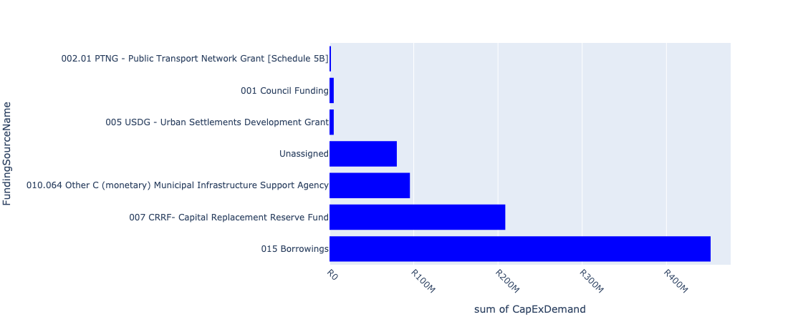

Figure 5.4: Region B Departmental Requests

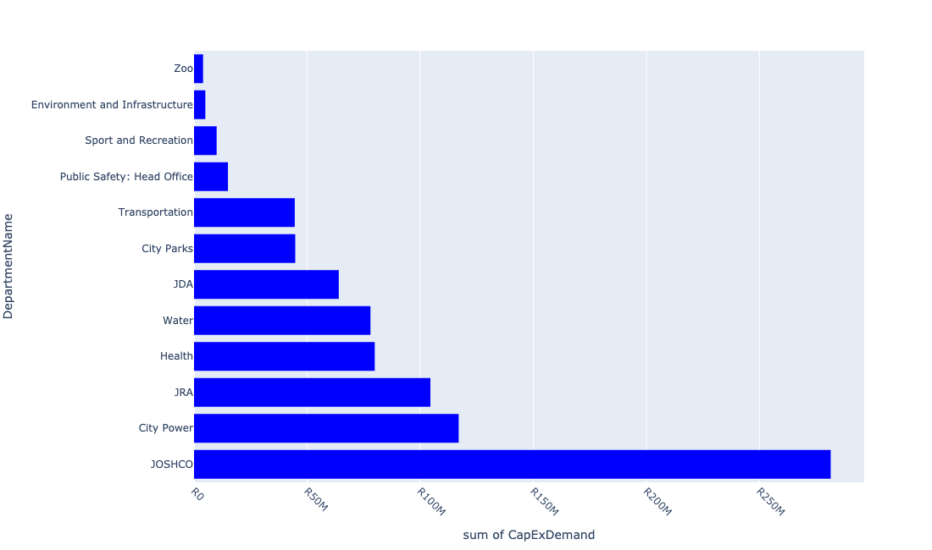

Table 5.2: Summary - Region B

|  |  |
| --- | --- |
| Item | Description |
| Total Capital Demand for Region B - All Years | R848,163,717 Rank: 7 (1 = Highest) |
| Total Capital Demand for Region B - MTREF | R770,934,584 Rank: 7 (1 = Highest) |
| Financial Years in which capital requirements are listed for Region B | 2023, 2024, 2025, 2026 and 2027 |
| Financial Year with highest capital demand for Region B | 2023 |
| Region B intersecting feature used | Works Location |
| Total number of projects intersecting with Region B | 320 Rank: 4 (1 = Highest) |

Table 5.3: All projects asking for budget in Region B

|  |  |  |  |
| --- | --- | --- | --- |
| Project ID | Project Name | Department | Project Budget |
| 23102 | 2804_09_ITS (Fibre Loop and CCTV)- Redundancy Loop | Transportation | R0.00 (0%) No budget request. |
| 23325 | 2804_20 Rea Vaya BRT Phase 1 A and B Station Rehabilitation | Transportation | R0.00 (0%) No budget request. |
| 23557 | 01_22684_Air Conditioners | Health | R189,214 (0.02%) Budget spread across: 2025, 2026 and 2027 |
| 22012 | DSM: Solar PV Systems on Buildings | City Power | R0.00 (0%) No budget request. |
| 2390 | RNP033_Improving the Carrying Capacity of 14th Avenue / Weltevreden / Pendoring from the N1 to Cresta Renewal Roads: Construction and Upgrades CRESTA B Regional | JRA | R0.00 (0%) No budget request. |
| 2885 | RNP010_Jacaranda Road Upgrade Renewal Roads: Construction and Upgrades VANDIA GROVE B Ward | JRA | R0.00 (0%) No budget request. |
| 23562 | 06_22684_Security Installations | Health | R1,462,141 (0.17%) Budget spread across: 2025, 2026 and 2027 |
| 23556 | 02_22684_Electricity Upgrade | Health | R1,743,931 (0.21%) Budget spread across: 2025, 2026 and 2027 |
| 22892 | Florida Park Upgrade | City Parks | R749,864 (0.09%) Budget spread across: 2023 |
| 22534 | Soweto TOD interventions | Development Planning | R0.00 (0%) No budget request. |
| 2946 | MISCL: Pedestrian Bridge in Slovo Park (also Ashanti). New Bridges (Pedestrian and Vehicles) CORONATIONVILLE B Ward | JRA | R0.00 (0%) No budget request. |
| 22531 | Mining belt west development corridor: Eastern Precinct | Development Planning | R0.00 (0%) No budget request. |
| 6411 | Braamfonteinspruit Upper Catchment (Alberts Farm and Botanical Gardens Upper Dams) | Environment and Infrastructure | R5,002,715 (0.59%) Budget spread across: 2023 |
| 23546 | Remainder of Portion 144 of the Farm Langlaagte 244-IQ | JPC | R0.00 (0%) No budget request. |
| 4016 | CORR - Perth Empire Transit Oriented Development (TOD) corridor Traffic Impact Assessment (TIA), Stormwater Masterplan and New Constriction and Upgrading Renewal Corridors of Freedom Intervention WESTBURY B Regional | JDA | R0.00 (0%) No budget request. |
| 23696 | Managed lanes: Dedicated Public Transport Lanes: Ntemi Piliso and Jan Smuts Avenu | Transportation | R4,883,460 (0.58%) Budget spread across: 2023 and 2024 |
| 23301 | 2804_19 Rea Vaya BRT Phase 1 A and 1 B Roadway Rehabilitation Project | Transportation | R1,657,391 (0.20%) Budget spread across: 2023 |
| 3279 | Replace 88 kV cable between Cydna and Rosebank. Renewal Bulk Infrastructure ROSEBANK B Regional | City Power | R0.00 (0%) No budget request. |
| 3447 | PARTITION AND REFURBISHMENT OF RANDURG drivers license testing centre and motor vehicle registration authority | Public Safety: Head Office | R0.00 (0%) No budget request. |
| 2773 | Goudkoppies Landfill site- improved compliance and alterations | Pikitup | R0.00 (0%) No budget request. |
| 6551 | Soweto: Newclare Sewer Upgrade | Sewer | R0.00 (0%) No budget request. |
| 6637 | Johanesburg Central: Greenside Water Upgrade | Water | R0.00 (0%) No budget request. |
| 22083 | Johannesburg Central: Brixton Reservoir 2.26ML | Water | R0.00 (0%) No budget request. |
| 6623 | Johannesburg Central: Newclare Water upgrade | Water | R0.00 (0%) No budget request. |
| 6560 | Roodepoort/Diepsloot: Randparkkrif Water upgrade | Water | R0.00 (0%) No budget request. |
| 2309 | Sandton/Alexandra: Linden Water Upgrade | Water | R0.00 (0%) No budget request. |
| 21763 | Roodepoort/Diepsloot: Crown Gardens Tower 1.1 Ml | Water | R0.00 (0%) No budget request. |
| 22269 | Rehabilitation of river systems in Protected Areas (Little Falls Nature Reserve, KNR Nature Reserve, Melville Koppies Nature Reserve) | Environment and Infrastructure | R0.00 (0%) No budget request. |
| 20918 | Fountainbleau | City Power | R0.00 (0%) No budget request. |
| 2821 | Park Development in Claremont New Park CLAREMONT B | City Parks | R0.00 (0%) No budget request. |
| 2418 | Hilltop Randburg Social Housing Project REgion B | JOSHCO | R0.00 (0%) No budget request. |
| 22555 | Riverlea Social Housing Project | JOSHCO | R0.00 (0%) No budget request. |
| 4195 | CORR - NMT: Link Along 7th Avenue Melville. New Roads: Construction and Upgrades MELVILLE B Ward | JRA | R0.00 (0%) No budget request. |
| 22438 | Integrated Intelligent Operational Centre (IIOC) | Public Safety: Head Office | R15,000,000 (1.77%) Budget spread across: 2023 |
| 22787 | PTF: Upgrading of Randburg Public Transport Facility | Transportation | R0.00 (0%) No budget request. |
| 4218 | Braamfonteinspruit WEST Water Management Unit New Ecological Infrastructure WESTDENE B Regional | Environment and Infrastructure | R0.00 (0%) No budget request. |
| 21018 | Hursthill : Forest Town switching station upgrade | City Power | R0.00 (0%) No budget request. |
| 2781 | Replace 30 MVA transformers with 45 MVA units Renewal Bulk Infrastructure PARKHURST B Regional | City Power | R0.00 (0%) No budget request. |
| 23033 | EE Centres Upgrade | City Parks | R0.00 (0%) No budget request. |
| 4061 | Bosmont Parks Upgrade Renewal Park BOSMONT B Regional | City Parks | R0.00 (0%) No budget request. |
| 6325 | Parktown BRT Land Preparation | JPC | R0.00 (0%) No budget request. |
| 20926 | Hurlingham | City Power | R0.00 (0%) No budget request. |
| 3322 | Conference Centre Renewal Building SAXONWOLD E City Wide | City Parks | R0.00 (0%) No budget request. |
| 20732 | Florida Glen: Substation (CP_E535) | City Power | R0.00 (0%) No budget request. |
| 2927 | Restuarant Renovations Renewal Building Alterations SAXONWOLD E | Zoo | R0.00 (0%) No budget request. |
| 20929 | Industria (CP_E139) | City Power | R0.00 (0%) No budget request. |
| 4115 | Replax PEX cable in bergbron Area Renewal Medium Voltage Network BERGBRON C Regional | City Power | R0.00 (0%) No budget request. |
| 3829 | PENNYVILLE FLATS UPGRADES Renewal Building Alterations PENNYVILLE C Regional | JOSHCO | R0.00 (0%) No budget request. |
| 2243 | Upgrading of Westbury Parks Renewal Park WESTBURY B Regional | City Parks | R0.00 (0%) No budget request. |
| 3855 | Zoo - Digital Radiograph New Plant and Equipment SAXONWOLD E City Wide | Zoo | R0.00 (0%) No budget request. |
| 3216 | Upper Park Drive Entrance Revamp Renewal Building Alterations SAXONWOLD E Regional | Zoo | R0.00 (0%) No budget request. |
| 21831 | Parktown Water Upgrade | Water | R0.00 (0%) No budget request. |
| 2790 | Beyers sub-station phase2 New Bulk Infrastructure FAIRLAND B | City Power | R0.00 (0%) No budget request. |
| 3972 | Johannesburg central: Northcliff pipe replacement Renewal NORTHCLIFF EXT.1 D | Sewer | R0.00 (0%) No budget request. |
| 23305 | Upgrading and engineering services at Waterval Depot | Pikitup | R0.00 (0%) No budget request. |
| 21104 | Randburg : Randburg, Bordeaux, Windsor and Fontainebleau Substations 6.6kV distribution Network conversion | City Power | R0.00 (0%) No budget request. |
| 21098 | Randburg : New Market supply upgrade | City Power | R0.00 (0%) No budget request. |
| 6448 | M10 main rd/Canada Rd and reallignment at Putco depot | JRA | R0.00 (0%) No budget request. |
| 2512 | Berario Renewal Clinic BERARIO B Ward | Health | R0.00 (0%) No budget request. |
| 6451 | Stormwater reticulation System -erosion related projects | JRA | R0.00 (0%) No budget request. |
| 21178 | Bordeaux - Randburg | City Power | R0.00 (0%) No budget request. |
| 21201 | Fontainbleau Substation 88/11kV (CP_E044) | City Power | R0.00 (0%) No budget request. |
| 21084 | Randburg : Bankor switching station upgrade | City Power | R0.00 (0%) No budget request. |
| 20752 | Hammer Street Strydom Park Sws: Satellite | City Power | R0.00 (0%) No budget request. |
| 2824 | Ferndale Randburg Cemetery Renewal Park FERNDALE EXT.4 B | City Parks | R0.00 (0%) No budget request. |
| 3133 | Upgrading of Katjiepiering Street Park in Vrededorp Renewal Park JAN HOFMEYR B Ward | City Parks | R0.00 (0%) No budget request. |
| 20915 | Florida Glen (CP_E154) | City Power | R0.00 (0%) No budget request. |
| 21218 | Industria Substation 88/11 kV | City Power | R0.00 (0%) No budget request. |
| 3325 | Zoo - Animal hospital upgrade Renewal Bulk engineering services SAXONWOLD E City Wide | Zoo | R0.00 (0%) No budget request. |
| 20969 | Randburg | City Power | R0.00 (0%) No budget request. |
| 2329 | Sandton/Alexandra: Delta Basin:Upgrade sewers Renewal Sewer Mains CRAIGHALL B Regional | Sewer | R0.00 (0%) No budget request. |
| 3079 | Wattle Crane Construction Renewal Building Alterations SAXONWOLD E | Zoo | R0.00 (0%) No budget request. |
| 2933 | Zoo Conservation and research farm accommodation -Safari Park Development New Building Alterations SAXONWOLD B City Wide | Zoo | R0.00 (0%) No budget request. |
| 21021 | Hursthill : Proposed switching station at Bosmont area | City Power | R0.00 (0%) No budget request. |
| 2292 | Upgrade of of Frank Brown Park New Park PARKTOWN B Ward | City Parks | R0.00 (0%) No budget request. |
| 2730 | Boma Revamp Renewal Building Alterations SAXONWOLD E Regional | City Parks | R0.00 (0%) No budget request. |
| 5277 | Johannesburg Central: Perth Empire BRT Corridor Sewer Renewal | Sewer | R0.00 (0%) No budget request. |
| 2289 | Extreme enviroments New Building Alterations SAXONWOLD E Ward | Zoo | R0.00 (0%) No budget request. |
| 2930 | Memorial Boulevard road resurfacing Renewal Roads: Rehabilitation SAXONWOLD E Regional | Zoo | R0.00 (0%) No budget request. |
| 20809 | Parkhurst: Substation | City Power | R0.00 (0%) No budget request. |
| 2907 | Network development for townships and service connections New Network Development FERNDALE B Regional | City Power | R0.00 (0%) No budget request. |
| 20766 | Hursthill : Replacement of switchgears | City Power | R0.00 (0%) No budget request. |
| 2813 | Instalional additional 20 MVA 88/11/6.6 kV transformer and expand switchboard. Renewal Bulk Infrastructure WINDSOR B | City Power | R0.00 (0%) No budget request. |
| 21281 | Pennyville Sub | City Power | R0.00 (0%) No budget request. |
| 4144 | Riverlea Shops / Convenience Store New Building Alterations RIVERLEA EXT.1 B Regional | JPC | R0.00 (0%) No budget request. |
| 2260 | New service connections New Service Connections FERNDALE EXT.25 B Regional | City Power | R15,500,000 (1.83%) Budget spread across: 2023 and 2024 |
| 3989 | Westbury Development Renewal Precinct Redevelopment WESTBURY B City Wide | JDA | R0.00 (0%) No budget request. |
| 2415 | CATCH 210 - Klein Jukskei Catchment: Bond Stream Relief System, Ferndale. New Stormwater Catchments FERNDALE B Ward | JRA | R30,000,000 (3.54%) Budget spread across: 2023 and 2024 |
| 6302 | Township Reticulation Hursthill | City Power | R0.00 (0%) No budget request. |
| 3448 | New park development New Park TRIOMF B Ward | City Parks | R0.00 (0%) No budget request. |
| 20760 | Hursthill : Pennyville overhead distribution conversion to underground | City Power | R0.00 (0%) No budget request. |
| 2950 | RNP013_Jan Smuts Dualling Renewal Roads: Construction and Upgrades PARKWOOD B Regional | JRA | R74,500,000 (8.78%) Budget spread across: 2023 and 2024 |
| 4181 | Rosebank Linear Park ReDevelopment New Precinct Redevelopment ROSEBANK B Regional | JPC | R0.00 (0%) No budget request. |
| 2509 | Windsor Renewal Clinic WINDSOR B Ward | Health | R0.00 (0%) No budget request. |
| 3591 | Roodepoort/ Diepsloot: Ferndale Sewer upgrade Renewal Bulk Waste Water FERNDALE C | Sewer | R0.00 (0%) No budget request. |
| 21202 | Fontainbleau Substation 88/11kV (CP_E049) | City Power | R0.00 (0%) No budget request. |
| 2610 | Parkhurst Renewal Clinic PARKHURST B Ward | Health | R0.00 (0%) No budget request. |
| 20824 | Rau Sws: Satellite | City Power | R0.00 (0%) No budget request. |
| 2255 | Randburg CBD Renewal Building Alteration Renewal Building Alterations FERNDALE B Regional | JPC | R0.00 (0%) No budget request. |
| 21179 | Bordeaux Substation 88/6.6kV | City Power | R0.00 (0%) No budget request. |
| 3134 | JHB Botanical Gardens Infrastructure upgrade in Emmarentia Renewal Park EMMARENTIA B City Wide | City Parks | R12,000,000 (1.41%) Budget spread across: 2023 and 2024 |
| 3157 | Conversion and upgrading of the Randburg CBD network. Renewal Medium Voltage Network FERNDALE B Ward | City Power | R0.00 (0%) No budget request. |
| 21087 | Randburg : FNB Ferndale 1997 switching station upgrade | City Power | R0.00 (0%) No budget request. |
| 2865 | RNP029_Dualling of Oxford Road between Riviera and M1 Renewal Roads: Construction and Upgrades FOREST TOWN E Regional | JRA | R0.00 (0%) No budget request. |
| 3967 | Pennyville New Canada Social Housing Project Region B | JOSHCO | R0.00 (0%) No budget request. |
| 3220 | Crocodile enclosure water treatment plant Renewal Building Alterations SAXONWOLD E Regional | Zoo | R0.00 (0%) No budget request. |
| 21279 | Parktown West (San Souci) | City Power | R0.00 (0%) No budget request. |
| 21766 | Randburg Sewer Upgrade | Water | R0.00 (0%) No budget request. |
| 21219 | Industrial - Hurtshill | City Power | R0.00 (0%) No budget request. |
| 2247 | Roodepoort/Diepsloot: Driefontein Basin: Upgrade sewers Renewal Sewer Mains VALERIEDENE B Regional | Sewer | R0.00 (0%) No budget request. |
| 20578 | Randburg: Minisubs year 2015 projects | City Power | R0.00 (0%) No budget request. |
| 2934 | Zoo Food Kitchen coldroom upgrade Renewal Plant and Equipment SAXONWOLD E Regional | Zoo | R0.00 (0%) No budget request. |
| 3715 | Construct 88 kV switchyard adjacent to Pennyville substation. New Bulk Infrastructure PENNYVILLE B Regional | City Power | R0.00 (0%) No budget request. |
| 3028 | BRID 30 - Bridge Upgrade: Parkhurst and Parkview Renewal Bridges (Pedestrian and Vehicles) GREENSIDE B Ward | JRA | R0.00 (0%) No budget request. |
| 2825 | Upgrade of Westpark Cemetery Renewal Park MONTGOMERY PARK EXT.3 B Ward | City Parks | R0.00 (0%) No budget request. |
| 21663 | Bryanston IWMF | Pikitup | R0.00 (0%) No budget request. |
| 3320 | Old Polar Bear Enclosure Renewal Building Alterations SAXONWOLD E City Wide | Zoo | R0.00 (0%) No budget request. |
| 23681 | Bryanston Tower 1.5 Ml | Water | R21,000,000 (2.48%) Budget spread across: 2024 |
| 21024 | Hursthill : Proposed switching station at Newlands area | City Power | R0.00 (0%) No budget request. |
| 2241 | Upgrading of Parks in Claremont Renewal Park CLAREMONT B Regional | City Parks | R0.00 (0%) No budget request. |
| 4090 | Pennyville Precinct Renewal Precinct Redevelopment PENNYVILLE EXT.1 B City Wide | JDA | R23,000,000 (2.71%) Budget spread across: 2023 |
| 2931 | Zoo - Landmark signage New Signage SAXONWOLD E Regional | Zoo | R0.00 (0%) No budget request. |
| 20761 | Hursthill : Refurbishment of Milpark HVC 300 | City Power | R0.00 (0%) No budget request. |
| 21216 | Hurtshill (CP_E067) | City Power | R0.00 (0%) No budget request. |
| 3827 | Bosmont Renewal Clinic BOSMONT B Ward | Health | R0.00 (0%) No budget request. |
| 3329 | Geldenhuis Transnet Hostel Renewal Building Alterations INDUSTRIA EXT.1 F City Wide | JOSHCO | R0.00 (0%) No budget request. |
| 23795 | Braamfischer Parks | City Parks | R0.00 (0%) No budget request. |
| 3163 | Preparation of LC's and MSS for 11kV conversion Bryanston | City Power | R0.00 (0%) No budget request. |
| 6603 | Mellville Koppies | City Parks | R0.00 (0%) No budget request. |
| 3884 | Zoo Infrastructure Renewal Building Alterations SAXONWOLD F Ward | City Parks | R18,000,000 (2.12%) Budget spread across: 2023 and 2024 |
| 2224 | Randburg CBD regeneration Renewal Precinct Redevelopment FERNDALE B Regional | JDA | R1,000,000 (0.12%) Budget spread across: 2023 |
| 2745 | Small carnivore complex upgrade New Building Alterations PARKVIEW E | Zoo | R0.00 (0%) No budget request. |
| 2318 | Roodepoort/Diepsloot: Western Klein Jukskei Basin:Upgrade sewers New Sewer Mains FAIRLAND C Regional | Sewer | R0.00 (0%) No budget request. |
| 2994 | RNP079_Homestead Road Upgrading Renewal Roads: Construction and Upgrades BRYANSTON EXT.5 B Ward | JRA | R0.00 (0%) No budget request. |
| 21786 | Bordeaux Sewer Upgrade | Water | R0.00 (0%) No budget request. |
| 23701 | Complete Street: Greenside (Phase 2) | Transportation | R12,000,000 (1.41%) Budget spread across: 2023 and 2024 |
| 2659 | Design and layout of Riverlea Major Clinic;construction of buildings and carports; furniture and equipment; landscaping; paving and signage. Upgrade Clinic RIVERLEA EXT.1 B | Health | R0.00 (0%) No budget request. |
| 2510 | Sophia Town Clinic New Clinic TRIOMF B Ward | Health | R0.00 (0%) No budget request. |
| 4033 | Westdene Dam park development New Park WESTDENE B Regional | City Parks | R0.00 (0%) No budget request. |
| 3131 | Upgrade of Delta park to world class park in Victory Park Renewal Park VICTORY PARK EXT.4 B Regional | City Parks | R0.00 (0%) No budget request. |
| 4196 | CORR - NMT: Along 4th Street Melville From 7th Avenue To Main Road. New Roads: Construction and Upgrades MELVILLE B Ward | JRA | R0.00 (0%) No budget request. |
| 3649 | RNP059_Rabie Street; Fontainebleau. Renewal Roads: Construction and Upgrades FONTAINEBLEAU B Ward | JRA | R0.00 (0%) No budget request. |
| 2991 | BRID 30 - Bridge Upgrade: Windsor West; Kelland and Ferndale. Renewal Bridges (Pedestrian and Vehicles) KELLAND B Ward | JRA | R0.00 (0%) No budget request. |
| 2722 | City Parks House - IT Equipment New Computer Hardware F Ward | City Parks | R8,000,000 (0.94%) Budget spread across: 2023 and 2024 |
| 20984 | Roosevelt Park Substation 88/11kV | City Power | R0.00 (0%) No budget request. |
| 6672 | Auxiliary Operating/ Control Centre - MARTINDALE | Public Safety: Head Office | R0.00 (0%) No budget request. |
| 6658 | New Outbound Licensing Operation/Call Centre MARTINDALE | Public Safety: Head Office | R0.00 (0%) No budget request. |
| 4064 | Upgrading of existing parks in Brixton Renewal Park BRIXTON B City Wide | City Parks | R0.00 (0%) No budget request. |
| 20589 | Randburg: MV Transformers year 2015 projects | City Power | R0.00 (0%) No budget request. |
| 3217 | Braamfonteinspruit Rehabilitation Renewal Park BRYANSTON EXT.5 E Regional | City Parks | R0.00 (0%) No budget request. |
| 21276 | Parkhurst - Rosebank - Parkview | City Power | R0.00 (0%) No budget request. |
| 21176 | Bond - Randburg | City Power | R0.00 (0%) No budget request. |
| 3323 | Zoo - Bandstand Renewal Building Alterations SAXONWOLD E City Wide | Zoo | R0.00 (0%) No budget request. |
| 3317 | Meesers Aviary Renewal Building Alterations SAXONWOLD E City Wide | City Parks | R0.00 (0%) No budget request. |
| 6666 | Special Garage for 80 Command Post | Public Safety: JMPD | R0.00 (0%) No budget request. |
| 21909 | Auckland Park Water Upgrade | Water | R0.00 (0%) No budget request. |
| 4010 | Perth Empire Corridor (Housing) Renewal Corridors of Freedom Intervention WESTBURY B Regional | Housing | R0.00 (0%) No budget request. |
| 2928 | Zoo - Zoo Shop New Building SAXONWOLD E Regional | Zoo | R0.00 (0%) No budget request. |
| 2338 | Refurbishment of MV infrastructure(Switchgear and transformers) Renewal Medium Voltage Network REUVEN F Regional | City Power | R20,000,000 (2.36%) Budget spread across: 2023 and 2024 |
| 3025 | CATCH 240 - Upgrading of Stormwater: Bond Street & Main Avenue; Ferndale Renewal Stormwater Catchments FERNDALE B Ward | JRA | R0.00 (0%) No budget request. |
| 2550 | Construction of a new seal enclosure New Building Alterations PARKVIEW E | Zoo | R0.00 (0%) No budget request. |
| 20930 | Industria (CP_E232) | City Power | R0.00 (0%) No budget request. |
| 2905 | Fibre optic installations and upgrades Renewal Protection VANDIA GROVE EXT.2 B Regional | City Power | R0.00 (0%) No budget request. |
| 2244 | Development and upgrading of of Riverlea Parks Renewal Park RIVERLEA Ward | City Parks | R0.00 (0%) No budget request. |
| 2195 | Upgrading of Zoo infrastructure Renewal Building Alterations SAXONWOLD E Ward | Zoo | R0.00 (0%) No budget request. |
| 20758 | Hurlingham: Substation | City Power | R0.00 (0%) No budget request. |
| 2401 | CATCH 210 - Bosmont Catchment: Stormwater Drainage: Central Areas New Stormwater Catchments BOSMONT F Ward | JRA | R0.00 (0%) No budget request. |
| 3930 | PTF: Public Transport facilities: Large: Rosebank New Nodal Transport Facilities ROSEBANK B Regional | Transportation | R0.00 (0%) No budget request. |
| 6586 | Eldorado New Park | City Parks | R0.00 (0%) No budget request. |
| 6337 | Composting bins | Pikitup | R0.00 (0%) No budget request. |
| 22238 | Westdene Dam-precinct interventions | Development Planning | R0.00 (0%) No budget request. |
| 3887 | Upgrade Medium voltage networks in Hyde Park Area New Medium Voltage Network HYDE PARK EXT.14 E Regional | City Power | R0.00 (0%) No budget request. |
| 20956 | Parkhurst (CP_E066) | City Power | R0.00 (0%) No budget request. |
| 2364 | Randburg Renewal Clinic BLAIRGOWRIE B Ward | Health | R76,500,000 (9.02%) Budget spread across: 2024, 2025, 2026 and 2027 |
| 2264 | New Service Connections HURST HILL B Regional | City Power | R16,500,000 (1.95%) Budget spread across: 2023 and 2024 |
| 23263 | Bosmont Stadium | Sport and Recreation | R5,000,000 (0.59%) Budget spread across: 2024 |
| 2607 | Amazonia 2nd Phase New Building Alterations SAXONWOLD F Ward | City Parks | R0.00 (0%) No budget request. |
| 2972 | RNP053_Peter Place Road - Upgrading Renewal Roads: Construction and Upgrades HURLINGHAM B Ward | JRA | R0.00 (0%) No budget request. |
| 2938 | Hippo Safari Renewal Building Alterations SAXONWOLD E Ward | Zoo | R0.00 (0%) No budget request. |
| 2935 | New Penguin conservation exhibit New Signage SAXONWOLD E Regional | Zoo | R0.00 (0%) No budget request. |
| 2932 | Condor cliffs New Building SAXONWOLD E Regional | City Parks | R0.00 (0%) No budget request. |
| 2746 | Orangutan Forest New Building Alterations SAXONWOLD E Regional | Zoo | R0.00 (0%) No budget request. |
| 2732 | Painting of Sasol Aviary. Renewal Building Alterations PARKVIEW E | Zoo | R0.00 (0%) No budget request. |
| 2689 | Strengthen Harley Street feeders Renewal Network Development FERNDALE B Ward | City Power | R0.00 (0%) No budget request. |
| 2652 | Wash Bay New Building Alterations EMMARENTIA B Ward | City Parks | R0.00 (0%) No budget request. |
| 2606 | Zoo - Parking Area Development(Zoo & Zoo lake Prencinct) New Bulk engineering services SAXONWOLD E Regional | Zoo | R0.00 (0%) No budget request. |
| 2580 | CATCH 205 - Robinson Canal Catchment Structural Improvement: Robinson Canal Sub 4 Renewal Stormwater Catchments ROBIN ACRES F Ward | JRA | R0.00 (0%) No budget request. |
| 2400 | CATCH 210 - Klein Jukskei Catchment: Gabion Protection in Windsor: Edward Street - Kings Avenue - Queens Rd New Stormwater Catchments WINDSOR B Ward | JRA | R0.00 (0%) No budget request. |
| 2397 | CATCH 205 - Robinson Canal Catchment: Structural Improvement: Robinson Canal Sub 3, Sub 6 and Sub 7 Renewal Stormwater Catchments ROBINDALE F Ward | JRA | R0.00 (0%) No budget request. |
| 2360 | Jerusalem Precinct Mixed Use New Building FAIRLAND B Ward | JOSHCO | R0.00 (0%) No budget request. |
| 2317 | Sandton/ Alexandra : Kensington B Reservoir 22ML | Water | R18,000,000 (2.12%) Budget spread across: 2024 |
| 23379 | Operational Capital_Cleaning In-sourcing | JOSHCO | R0.00 (0%) No budget request. |
| 23367 | Tum-Key 1: Region B | JOSHCO | R129,575,000 (15.28%) Budget spread across: 2023 and 2024 |
| 22901 | Johannesburg Botanical Gardens Admin and Nursery - roof and surface rainwater harvesting | City Parks | R0.00 (0%) No budget request. |
| 22898 | Marks Park Depot | City Parks | R0.00 (0%) No budget request. |
| 22789 | PTF: Upgrading of Rosebank Public Transport Facility | Transportation | R26,000,000 (3.07%) Budget spread across: 2023 and 2024 |
| 22620 | Delta Park | City Parks | R0.00 (0%) No budget request. |
| 22560 | Bosmont Social Housing Project | JOSHCO | R0.00 (0%) No budget request. |
| 22557 | Newclare Social Housing Project | JOSHCO | R0.00 (0%) No budget request. |
| 22291 | Kathrada | Housing | R0.00 (0%) No budget request. |
| 22194 | Langlaagte Pharmacy Depot | Development Planning | R0.00 (0%) No budget request. |
| 22182 | Refurbishment of Canteen and Fitness facillity--Martindale | Public Safety: EMS | R0.00 (0%) No budget request. |
| 22085 | Johannesburg Central: Brixton Tower 2ML | Water | R0.00 (0%) No budget request. |
| 21856 | Linden Water Upgrade | Water | R0.00 (0%) No budget request. |
| 21341 | Delta/Westfield/Kelvin differential protection | City Power | R0.00 (0%) No budget request. |
| 21295 | Roosevelt | City Power | R0.00 (0%) No budget request. |
| 21289 | Randburg Substation 88/11kV | City Power | R0.00 (0%) No budget request. |
| 21278 | Parkhurst Substation 88/11 kV (CP_E107) | City Power | R0.00 (0%) No budget request. |
| 21252 | New Claremont Sub | City Power | R0.00 (0%) No budget request. |
| 4063 | Establishment of new parks in Pennyville New Park PENNYVILLE B Ward | City Parks | R0.00 (0%) No budget request. |
| 4060 | Westbury Parks Upgrade Renewal Park WESTBURY B Regional | City Parks | R0.00 (0%) No budget request. |
| 3900 | Rooseveldt Park:Replace 2 X 45 MVA transformers and replace 11kV switchgear New Bulk Infrastructure LINDEN E Regional | City Power | R0.00 (0%) No budget request. |
| 3871 | Johannesburg Central: Perth - Empire BRT and Rail Corridor Interventions | Water | R0.00 (0%) No budget request. |
| 3857 | Zoo - Purchase of Safe New Operational Capex SAXONWOLD E City Wide | Zoo | R0.00 (0%) No budget request. |
| 3754 | Sophiatown Centenary Project New Park TRIOMF B Ward | City Parks | R0.00 (0%) No budget request. |
| 3596 | Sandton/Alexadra: Hurlingham Sewer Upgrade | Sewer | R0.00 (0%) No budget request. |
| 3588 | Roodepoort/ Diepsloot: Blairgowrie sewer upgrade BLAIRGOWRIE B | Sewer | R0.00 (0%) No budget request. |
| 3568 | Sandton/ Alexandra: Parktown Sewer upgrade PARKTOWN B | Sewer | R0.00 (0%) No budget request. |
| 3450 | Upgrading of the JCPZ Academy Precinct New Building Alterations PARKVIEW B Regional | City Parks | R0.00 (0%) No budget request. |
| 3376 | Big Ben Upgrade Renewal Informal trading Stalls JOHANNESBURG B Region | JPC | R0.00 (0%) No budget request. |
| 3230 | Sandton/ Alexandra: Parktown Water upgrade | Water | R16,000,000 (1.89%) Budget spread across: 2023 and 2024 |
| 3221 | Restaurant Renovation Renewal Building Alterations SAXONWOLD E Regional | Zoo | R0.00 (0%) No budget request. |
| 3193 | Rietfontein Nature Reserve and EE centre upgrade in Bryanston Renewal Park BRYANSTON EXT.5 E Ward | City Parks | R0.00 (0%) No budget request. |
| 21129 | Roodepoort : Boothill switching station upgrade | City Power | R0.00 (0%) No budget request. |
| 21109 | Randburg : Waterfront switching station upgrade | City Power | R0.00 (0%) No budget request. |
| 21089 | Randburg : Hammer switching station upgrade | City Power | R0.00 (0%) No budget request. |
| 21086 | Randburg : CR Swart switching station refurbishment | City Power | R0.00 (0%) No budget request. |
| 21026 | Hursthill : Proposed switching station at Westdene area | City Power | R0.00 (0%) No budget request. |
| 21023 | Hursthill : Proposed switching station at Coronationville area | City Power | R0.00 (0%) No budget request. |
| 21020 | Hursthill : Proposed switching station at Berario area | City Power | R0.00 (0%) No budget request. |
| 21006 | Alexandra : Proposed switching station in Bramley area | City Power | R0.00 (0%) No budget request. |
| 20957 | Parkhurst (CP_E241) | City Power | R0.00 (0%) No budget request. |
| 20934 | Johannesburg Central B | City Power | R0.00 (0%) No budget request. |
| 20914 | Florida Glen (CP_E074) | City Power | R0.00 (0%) No budget request. |
| 20854 | SABC Sws: Satellite | City Power | R0.00 (0%) No budget request. |
| 20788 | Maraisburg Sws: Satellite | City Power | R0.00 (0%) No budget request. |
| 20765 | Hursthill : Replacement of mini substations | City Power | R0.00 (0%) No budget request. |
| 20737 | Forest Town Sws: Satellite | City Power | R0.00 (0%) No budget request. |
| 6639 | Johannesburg Central: Waterval Water Upgrade | Water | R0.00 (0%) No budget request. |
| 6622 | Johannesburg Central: Alberville Water Upgrade | Water | R0.00 (0%) No budget request. |
| 6376 | RIVERLEA SHOPS | JPC | R0.00 (0%) No budget request. |
| 6301 | Township Reticulation Randburg | City Power | R0.00 (0%) No budget request. |
| 3152 | Upgrade the supply to the proposed Selkirk housing development. New Medium Voltage Network FERNDALE B Ward | City Power | R0.00 (0%) No budget request. |
| 3132 | Upgrade of Kingston Frost Park in Brixton Renewal Park BRIXTON B Ward | City Parks | R0.00 (0%) No budget request. |
| 2937 | Conservation Medicine at Animal Hospital New Building Alterations SAXONWOLD E Regional | Zoo | R0.00 (0%) No budget request. |
| 2929 | Zoo - Water Saving project Renewal Internal Water Reticulation SAXONWOLD E Regional | Zoo | R0.00 (0%) No budget request. |
| 2926 | Temple of Ancients Ablution Facillities New Building SAXONWOLD E Regional | Zoo | R0.00 (0%) No budget request. |
| 2880 | RNP025_Upgrade of Republic (3rd Avenue) from Judges Avenue to Barry Hertzog Renewal Roads: Construction and Upgrades LINDEN B Regional | JRA | R0.00 (0%) No budget request. |
| 2866 | RNP020_Mollie Street and Long Street Upgrading Renewal Roads: Construction and Upgrades DELAREY B Regional | JRA | R0.00 (0%) No budget request. |
| 2860 | RNP007_New Link from M1 to Rivonia Road New Roads: Construction and Upgrades MORNINGSIDE EXT.2 E Regional | JRA | R0.00 (0%) No budget request. |
| 2823 | Development of Riverlea Cemetery New Park FRANKLIN ROOSEVELT PARK B Ward | City Parks | R0.00 (0%) No budget request. |
| 2811 | 11 kV Conversion Renewal Medium Voltage Network FERNDALE EXT.3 B | City Power | R0.00 (0%) No budget request. |
| 2737 | Bellavista Clinic; furniture and equipment Renewal Clinic BELLAVISTA ESTATE F Ward | Health | R0.00 (0%) No budget request. |
| 2731 | Zoo - Pygmy hippo filtration. Renewal Building Alterations PARKVIEW E Ward | Zoo | R0.00 (0%) No budget request. |
| 2608 | Staff Facilities New Building Alterations SAXONWOLD E Ward | Zoo | R0.00 (0%) No budget request. |
| 2582 | City Parks House - New Furniture F City Wide | City Parks | R6,000,000 (0.71%) Budget spread across: 2023 and 2024 |
| 2551 | Construction of a new elephant enclosure New Building Alterations PARKVIEW E Ward | Zoo | R0.00 (0%) No budget request. |
| 2539 | Rosebank New Clinic ROSEBANK B Ward | Health | R0.00 (0%) No budget request. |
| 2528 | Corridor of Freedom Economic Development Initiatives New Economic Infrastructure CORONATIONVILLE B City Wide | Economic Development | R0.00 (0%) No budget request. |
| 2502 | CATCH 210 - Klein Jukskei River: Bank Protection - Randpark Golf Course New Stormwater Catchments JUKSKEI PARK E Ward | JRA | R0.00 (0%) No budget request. |
| 2456 | Upgarding of Rosebank Market Facilities & Taxi Rank: provision of additional trading stalls and loading shelter for commuters Renewal Taxi Rank ROSEBANK C Ward | JPC | R0.00 (0%) No budget request. |
| 2396 | CATCH 205 - Robinson Canal Catchment: Structural Improvement: Robinson Canal Sub 10 Renewal Stormwater Catchments ROBINDALE F Ward | JRA | R0.00 (0%) No budget request. |
| 2353 | Randburg Selkirk Social Housing Project Region B | JOSHCO | R131,900,000 (15.55%) Budget spread across: 2023 and 2024 |
| 2342 | Newclare Cemetery - Road Infrastructure New Cemetery INDUSTRIA WEST B Ward | City Parks | R0.00 (0%) No budget request. |
| 2333 | Upgrade Selkirk distributor Renewal Medium Voltage Network BLAIRGOWRIE B Ward | City Power | R0.00 (0%) No budget request. |
| 2196 | Regulatory Compliance Renewal Legislative requirement SAXONWOLD E Regional | Zoo | R0.00 (0%) No budget request. |
| 23261 | Union Stadium | Sport and Recreation | R5,000,000 (0.59%) Budget spread across: 2024 |
| 23086 | 3251_02_Upgrading of weighbridge at Randburg testing Centre | Public Safety: Head Office | R0.00 (0%) No budget request. |
| 22900 | West Park Cemetery | City Parks | R0.00 (0%) No budget request. |
| 22897 | Zoo Lake Training Centre rainwater harvesting | City Parks | R0.00 (0%) No budget request. |
| 22559 | Sandhurst Social Housing Project | JOSHCO | R0.00 (0%) No budget request. |
| 22116 | Melville Activity Street_Neighbourhood Development_ CoF_Upgrade | JDA | R40,000,000 (4.72%) Budget spread across: 2023 and 2024 |
| 21915 | Claremont Water Upgrade | Water | R0.00 (0%) No budget request. |
| 21297 | Rosebank Substation 88/11 kV | City Power | R0.00 (0%) No budget request. |
| 21254 | New Florida North substation | City Power | R0.00 (0%) No budget request. |
| 4134 | Auckland Park Social Housing Project Region B. | JOSHCO | R20,000,000 (2.36%) Budget spread across: 2024 |
| 4131 | Klip Bosmontspruit Water Management New Ecological Infrastructure BOSMONT C Regional | Environment and Infrastructure | R0.00 (0%) No budget request. |
| 4111 | Upgrade MV Network Houghton Estate New Medium Voltage Network Hydepark | City Power | R0.00 (0%) No budget request. |
| 4071 | Hurst Hill Sub-station refurbishment Renewal Bulk Infrastructure HURST HILL B Regional | City Power | R65,000,000 (7.66%) Budget spread across: 2023 and 2024 |
| 4051 | Penny Flats Social Housing Project Upgrade Region B | JOSHCO | R0.00 (0%) No budget request. |
| 4028 | Perth/Empire (JOSHCO) New Corridors of Freedom Intervention WESTBURY B City Wide | JOSHCO | R0.00 (0%) No budget request. |
| 4019 | Perth Empire Corridor (JW: Water) Renewal Corridors of Freedom Intervention | Water | R23,000,000 (2.71%) Budget spread across: 2023 and 2024 |
| 4005 | Perth/Empire (City Parks) Renewal Corridors of Freedom Intervention | City Parks | R0.00 (0%) No budget request. |
| 3936 | Bosmontspruit Rehabilitation Renewal Ecological Infrastructure BOSMONT C Regional | Environment and Infrastructure | R0.00 (0%) No budget request. |
| 3859 | Zoo - Animal Purchases New Operational Capex SAXONWOLD E City Wide | Zoo | R4,000,000 (0.47%) Budget spread across: 2023 and 2024 |
| 3324 | Zoo - Anglo Ablution Block Renewal Building Alterations SAXONWOLD E City Wide | Zoo | R0.00 (0%) No budget request. |
| 3321 | Display Area Renewal Building Alterations SAXONWOLD E City Wide | Zoo | R0.00 (0%) No budget request. |
| 3318 | Provision of subsurface dranage pipes Renewal Building Alterations SAXONWOLD E City Wide | Zoo | R0.00 (0%) No budget request. |
| 3315 | Student Housing New Building SAXONWOLD E City Wide | Zoo | R0.00 (0%) No budget request. |
| 3218 | Chimpanzee Climbing Structure Renewal Building Alterations SAXONWOLD E Regional | Zoo | R0.00 (0%) No budget request. |
| 3215 | Cabybara Enclosure Revamp Renewal Building Alterations SAXONWOLD E Regional | City Parks | R0.00 (0%) No budget request. |
| 21214 | Harley Street Substation 88/11kV | City Power | R0.00 (0%) No budget request. |
| 21200 | Fontainbleau Substation 88/11kV (CP_E105) | City Power | R0.00 (0%) No budget request. |
| 21191 | Delta MTS 275/88kV | City Power | R0.00 (0%) No budget request. |
| 21188 | Clermont Substation | City Power | R0.00 (0%) No budget request. |
| 21180 | Braamfontein - Fort | City Power | R0.00 (0%) No budget request. |
| 21177 | Bond Street Substation 88kV | City Power | R0.00 (0%) No budget request. |
| 21102 | Randburg : Proposed switching station at Randpark area | City Power | R0.00 (0%) No budget request. |
| 21094 | Randburg : Knoppiesdoring switching station supply upgrade | City Power | R0.00 (0%) No budget request. |
| 21088 | Randburg : FNB Ferndale 1999 switching station upgrade | City Power | R0.00 (0%) No budget request. |
| 21028 | Hursthill : Replacement of distributors | City Power | R0.00 (0%) No budget request. |
| 21025 | Hursthill : Proposed switching station at Riverlea area | City Power | R0.00 (0%) No budget request. |
| 21022 | Hursthill : Proposed switching station at Brixton area | City Power | R0.00 (0%) No budget request. |
| 20982 | Roosevelt Park (CP_E112) | City Power | R0.00 (0%) No budget request. |
| 20916 | Florida Glen (CP_E155) | City Power | R0.00 (0%) No budget request. |
| 20879 | Windsor: Satellite | City Power | R0.00 (0%) No budget request. |
| 20856 | Sanlam Centre: Satellite | City Power | R0.00 (0%) No budget request. |
| 20773 | JG Strydom Sws: Satellite | City Power | R0.00 (0%) No budget request. |
| 20762 | Hursthill : Refurbishment of Montgomery P TSS | City Power | R0.00 (0%) No budget request. |
| 20759 | Hursthill : Kathadra overhead distribution conversion to underground | City Power | R0.00 (0%) No budget request. |
| 20739 | Fountainbleau: Substation | City Power | R0.00 (0%) No budget request. |
| 20736 | FontainBleau: Substation | City Power | R0.00 (0%) No budget request. |
| 20733 | Florida Glen: Substation (CP_E536) | City Power | R0.00 (0%) No budget request. |
| 20590 | Randburg: Switchgear year 2015 projects | City Power | R0.00 (0%) No budget request. |
| 8748 | Mining Belt West:Riverlea Regional Sports and Recreation facility | Development Planning | R0.00 (0%) No budget request. |
| 8725 | Mining Belt West: Rehabilitation of headwaters of wetlands south of Riverlea | Development Planning | R0.00 (0%) No budget request. |
| 6673 | Storage Facilities for CCTV - MARTINDALE | Public Safety: Head Office | R0.00 (0%) No budget request. |
| 6621 | Johannesburg Central: Auckland Park Water Upgrade | Water | R0.00 (0%) No budget request. |
| 6306 | Township Reticulation Siemert | City Power | R0.00 (0%) No budget request. |
| 4194 | CORR - NMT: Kingston Frost Park to Melville Koppies Along Cookam and Lothbury Streets. New Roads: Construction and Upgrades AUCKLAND PARK B Ward | JRA | R0.00 (0%) No budget request. |

Please note that the following projects will not be shown in this table:

* Projects with no recorded intersect with Regions (in other words no Works Location was recorded on the system for this project)

Projects that do not have any recorded budget demand on the system at the time that this report was requested, are shown in the table with zero budgets indicated.

## Region C

Figure 5.5: Region C Funding Requests

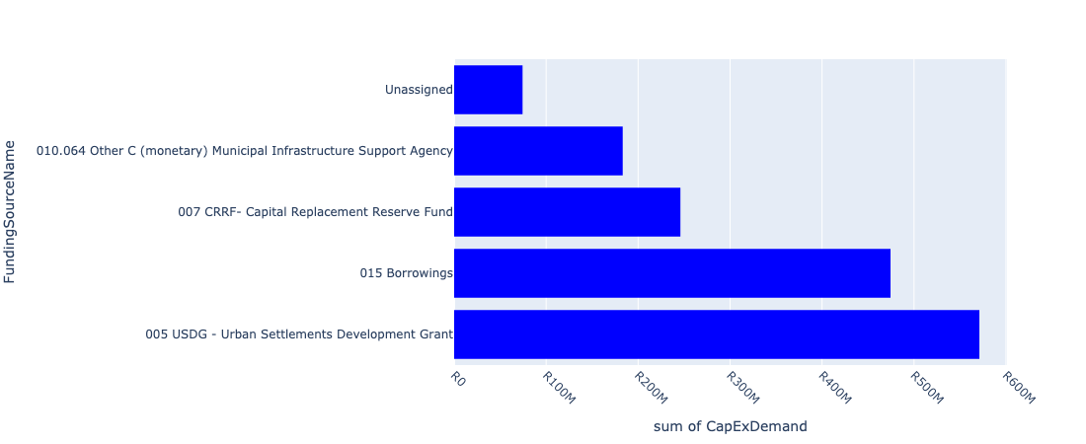

Figure 5.6: Region C Departmental Requests

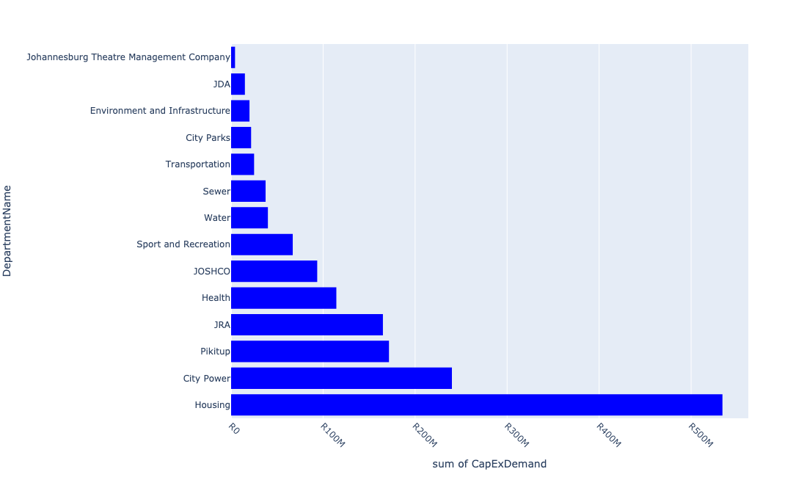

Table 5.3: Summary - Region C

|  |  |
| --- | --- |
| Item | Description |
| Total Capital Demand for Region C - All Years | R1,549,158,493 Rank: 5 (1 = Highest) |
| Total Capital Demand for Region C - MTREF | R1,476,212,124 Rank: 5 (1 = Highest) |
| Financial Years in which capital requirements are listed for Region C | 2023, 2024, 2025, 2026, 2027 and 2028 |
| Financial Year with highest capital demand for Region C | 2024 |
| Region C intersecting feature used | Works Location |
| Total number of projects intersecting with Region C | 354 Rank: 2 (1 = Highest) |

Table 5.4: All projects asking for budget in Region C

|  |  |  |  |
| --- | --- | --- | --- |
| Project ID | Project Name | Department | Project Budget |
| 4259 | Construct of Malibongwe Road | Joburg Market | R0.00 (0%) No budget request. |
| 21760 | Helderkruin Water Upgrade | Water | R0.00 (0%) No budget request. |
| 3638 | Soweto: Bramfisherville Sewer Upgrade | Sewer | R0.00 (0%) No budget request. |
| 3469 | Roodepoort/ Diepsloot: Main Reef 20ML And 2.7ML Tower | Water | R0.00 (0%) No budget request. |
| 3466 | Roodepoort/ diespsloot: Olievenhoutpoort Water Upgrade | Water | R0.00 (0%) No budget request. |
| 2370 | Roodepoort/Diepsloot: Olivedale Water Upgrade | Water | R0.00 (0%) No budget request. |
| 22641 | Lion Park Bulk Water and Sewer Infrastructure Upgrade | Water | R0.00 (0%) No budget request. |
| 22653 | Driefontein works: Sludge Pre-thickening and Pre-conditioning.Duplicate | Water | R0.00 (0%) No budget request. |
| 3695 | Zandspruit new MPC Ward | Sport and Recreation | R15,000,000 (0.97%) Budget spread across: 2024 and 2025 |
| 21344 | Fence anti-climb and anti-cut | City Power | R0.00 (0%) No budget request. |
| 6571 | Bramfischerville Ext 7 & 8 | Housing | R50,000,000 (3.23%) Budget spread across: 2023 and 2024 |
| 6548 | WWTW: Mechanical Plant | Sewer | R500,181 (0.03%) Budget spread across: 2024 |
| 22741 | Erf 1 Arena (Ruimsig Athletic Stadium) | JPC | R0.00 (0%) No budget request. |
| 20772 | Jan Smuts AV Sws: Satellite | City Power | R0.00 (0%) No budget request. |
| 20843 | Ridge: Substation | City Power | R0.00 (0%) No budget request. |
| 23102 | 2804_09_ITS (Fibre Loop and CCTV)- Redundancy Loop | Transportation | R0.00 (0%) No budget request. |
| 22123 | Ebumnandini (Informal Settlements) | Housing | R0.00 (0%) No budget request. |
| 3577 | Roodepoort/ Diepsloot: Cornelius De larey water upgrade New Water Mains ROODEPOORT C Regional | Water | R0.00 (0%) No budget request. |
| 21135 | Roodepoort : Leratong Tranist area Electrification | City Power | R0.00 (0%) No budget request. |
| 2990 | RNP049_New Link Road between Prosperity Rd and CR Swart Road New Roads: Construction and Upgrades PRINCESS A.H. C Ward | JRA | R0.00 (0%) No budget request. |
| 22810 | The project entails the upgrading of existing collector sewers network in Cosmo City Extensions | Sewer | R0.00 (0%) No budget request. |
| 6308 | Upgrade Penny S/S to 3 45MVA trfrs | City Power | R0.00 (0%) No budget request. |
| 20866 | Timber Sws: Satellite | City Power | R0.00 (0%) No budget request. |
| 3136 | Leratong Village Implement Preliminary Design Report for Roads and Related Stormwater infrastructure Renewal Bulk Infrastructure LERATONG VILLAGE C Regional | Housing | R0.00 (0%) No budget request. |
| 3013 | RNP073_Construction and Dualling of Johan Road Renewal Roads: Construction and Upgrades AMBOT A.H. C Ward | JRA | R0.00 (0%) No budget request. |
| 2890 | Davidsonville ward 71 New Bulk Infrastructure DAVIDSONVILLE C Ward | Housing | R0.00 (0%) No budget request. |
| 20981 | Roodetown | City Power | R0.00 (0%) No budget request. |
| 22106 | Itsoseng | Housing | R0.00 (0%) No budget request. |
| 21127 | Roodepoort : Banfield switching station upgrade | City Power | R0.00 (0%) No budget request. |
| 3176 | New parks and upgrades development in Bramfisherville New Park BRAM FISCHERVILLE | City Parks | R0.00 (0%) No budget request. |
| 8732 | Mining Belt West: Roodepoort Reservoir (Install distribution mains) | Development Planning | R0.00 (0%) No budget request. |
| 3468 | Roodepoort/ Diepsloot: Little falls break pressure tanks New Water Mains LITTLE FALLS EXT.1 C Regional | Water | R0.00 (0%) No budget request. |
| 2681 | Fleurhof Phase 2 Social Housing Project Region C | JOSHCO | R0.00 (0%) No budget request. |
| 22206 | Fleurhof Cluster Urban Development Framework | Development Planning | R0.00 (0%) No budget request. |
| 3594 | Roodepoort/ Diepsloot: Hamberg sewer upgrade HAMBERG C | Sewer | R0.00 (0%) No budget request. |
| 2432 | Peter Road. Install third 40 MVA transformer and switchgear New Bulk Infrastructure TRES JOLIE EXT.6 C Regional | City Power | R0.00 (0%) No budget request. |
| 22209 | Matholesville and Braamfischerville Urban Development Framework | Development Planning | R0.00 (0%) No budget request. |
| 4041 | Roodepoort Social Housing Upgrade Region C | JOSHCO | R0.00 (0%) No budget request. |
| 21092 | Randburg : Holding 6 switching station upgrade | City Power | R0.00 (0%) No budget request. |
| 22466 | Securing of Green Infrastructure assets ( Alberts Farm) | Environment and Infrastructure | R0.00 (0%) No budget request. |
| 21284 | Princess | City Power | R0.00 (0%) No budget request. |
| 23325 | 2804_20 Rea Vaya BRT Phase 1 A and B Station Rehabilitation | Transportation | R0.00 (0%) No budget request. |
| 3445 | Rainbow Valley Sub divisions New Bulk Infrastructure ROODEPOORT C Regional | Housing | R0.00 (0%) No budget request. |
| 3196 | Separation at source facilities and equipment | Pikitup | R105,000,000 (6.78%) Budget spread across: 2023 and 2024 |
| 2947 | RNP081_Upgrade and Dualling of Nic Diedericks Blvd (Paul Kruger Rd) Renewal Roads: Construction and Upgrades WILGEHEUWEL C Ward | JRA | R0.00 (0%) No budget request. |
| 20912 | Florida (CP_E073) | City Power | R0.00 (0%) No budget request. |
| 20863 | Strydom Sws: Satellite | City Power | R0.00 (0%) No budget request. |
| 22074 | Lindhaven Plot 6, 9 & 10 | Housing | R0.00 (0%) No budget request. |
| 23697 | PTF: Public Transport Stops in Cosmo City | Transportation | R10,000,000 (0.65%) Budget spread across: 2023 and 2024 |
| 2747 | Replace all overhead service connections in Roodepoort area Renewal Service Connections WITPOORTJIE EXT.7 C Ward | City Power | R0.00 (0%) No budget request. |
| 20700 | Cannary Sws: Satellite | City Power | R0.00 (0%) No budget request. |
| 20849 | Roodepoort : Replacement of supply cables to Boothill switching station | City Power | R0.00 (0%) No budget request. |
| 20949 | Nursery (CP_E245) | City Power | R0.00 (0%) No budget request. |
| 21147 | Roodepoort : Rhinoceros switching station upgrade | City Power | R0.00 (0%) No budget request. |
| 3494 | Driefontein Works: UPS LITTLE FALLS EXT.1 C | Sewer | R0.00 (0%) No budget request. |
| 21198 | Florida | City Power | R0.00 (0%) No budget request. |
| 20846 | Roodepoort : Conversion of Matholesville overhead networt to underground | City Power | R0.00 (0%) No budget request. |
| 8752 | Mining Belt West: Urban Park Development in Fleurhof (Area around Fleurhof Dam) | Development Planning | R0.00 (0%) No budget request. |
| 3156 | Park upgrade Florida Lake | City Parks | R0.00 (0%) No budget request. |
| 3179 | Park development in Doornkop New Park DOORNKOP EXT.3 D Ward | City Parks | R0.00 (0%) No budget request. |
| 20938 | Kloofendal Nature Reserve Infrastructure upgarde | City Parks | R0 (0.00%) Budget spread across: 2023 |
| 22343 | Braamsfischer Park New Park development | City Parks | R0.00 (0%) No budget request. |
| 20961 | Peter Road (CP_E243) | City Power | R0.00 (0%) No budget request. |
| 3580 | Roodepoort/ Diepsloot: RW Weltevreden Water Upgrade | Water | R0.00 (0%) No budget request. |
| 22366 | Tsepisong New Park development | City Parks | R6,000,000 (0.39%) Budget spread across: 2023 and 2024 |
| 2939 | RNP064_Upgrading of President Fouche Drive Renewal Roads: Construction and Upgrades NORTH RIDING ESTATES C Regional | JRA | R0.00 (0%) No budget request. |
| 4215 | PTF:Small Public Transport Facility,Design and Construction of Cosmo City Superstop New Nodal Transport Facilities COSMO CITY A Regional | Transportation | R0.00 (0%) No budget request. |
| 8735 | Mining Belt West: Goudrand Outfall No.1 | Development Planning | R0.00 (0%) No budget request. |
| 2246 | Roodepoort/Diepsloot: Planned Replacement Watermains | Water | R40,000,000 (2.58%) Budget spread across: 2023 and 2024 |
| 3265 | BSC - Upgrading Paul Kruger / Nico Deiedricks in Wilgeheuvel Renewal Roads: Construction and Upgrades WILGEHEUWEL C Ward | JRA | R0.00 (0%) No budget request. |
| 23932 | CosmoCity Resevoir 30 Ml | Water | R0.00 (0%) No budget request. |
| 21270 | Olivedale Substation | City Power | R0.00 (0%) No budget request. |
| 21662 | North Riding IWMF | Pikitup | R0.00 (0%) No budget request. |
| 3022 | CATCH 240 - Klipspruit Catchment: Stormwater Attenuation: Len Rutter Park; Florida Renewal Stormwater Management Projects FLORIDA PARK C Ward | JRA | R0.00 (0%) No budget request. |
| 2979 | RNP063_Dualling of Main Reef Road Renewal Roads: Construction and Upgrades WITPOORTJIE C Regional | JRA | R0.00 (0%) No budget request. |
| 2678 | Roodepoort Phase 2 Social Housing Project Region C | JOSHCO | R0.00 (0%) No budget request. |
| 20729 | Field House Sws: Satellite | City Power | R0.00 (0%) No budget request. |
| 6322 | New Subststaion for Princess Informal Settlement | City Power | R0.00 (0%) No budget request. |
| 20978 | Roodepoort (CP_E182) | City Power | R0.00 (0%) No budget request. |
| 3271 | The construction of new infrastructure in new developments New Medium Voltage Network ROODEPOORT B Regional | City Power | R0.00 (0%) No budget request. |
| 21854 | Cosmo City Water Upgrade | Water | R0.00 (0%) No budget request. |
| 21095 | Randburg : Kya Sands Electrification | City Power | R0.00 (0%) No budget request. |
| 2787 | Upgrade the supply from JG Strydom SWS to reinforce ring. Renewal Bulk Infrastructure | City Power | R0.00 (0%) No budget request. |
| 3497 | Driefontein Works: Infrastructure Renewal Plan | Sewer | R10,000,000 (0.65%) Budget spread across: 2023 |
| 21144 | Roodepoort : Public Lighting in Roodepoort depot | City Power | R0.00 (0%) No budget request. |
| 8738 | Mining Belt West: Florida Upgrade No.2 | Development Planning | R0.00 (0%) No budget request. |
| 20689 | Argyll Sws: Satellite | City Power | R0.00 (0%) No budget request. |
| 8689 | 23775_04_Tarring of Zandspruit Access Road | JRA | R35,000,000 (2.26%) Budget spread across: 2023 and 2024 |
| 2452 | Driefontein Works: Extension New Bulk Waste Water COSMO CITY EXT.2 C Regional | Sewer | R0.00 (0%) No budget request. |
| 21138 | Roodepoort : Panorama switching station upgrade | City Power | R0.00 (0%) No budget request. |
| 8744 | Mining Belt West: Goudrand Outfall No.4 (Construct new outfall) | Development Planning | R0.00 (0%) No budget request. |
| 3162 | Construction of Mausoleum Panarama Cemetery Renewal Park ROODEPOORT C City Wide | City Parks | R0.00 (0%) No budget request. |
| 2595 | Zandspruit New Clinic ZANDSPRUIT EXT.4 C Ward 114 (Acquisition of land, layout and design and construction of buildings etc) | Health | R20,000,000 (1.29%) Budget spread across: 2023 and 2024 |
| 21101 | Randburg : Precision switching station upgrade | City Power | R0.00 (0%) No budget request. |
| 20852 | Ruimsig Sws: Satellite | City Power | R0.00 (0%) No budget request. |
| 3789 | 23776_05_CONV - Conversion of Open Drains to underground storm water system in Bram Fischerville. Renewal Stormwater Management Projects BRAM FISCHERVILLE C Ward | JRA | R50,000,000 (3.23%) Budget spread across: 2023 and 2024 |
| 20746 | Groblersrus Sws: Satellite | City Power | R0.00 (0%) No budget request. |
| 2993 | RNP044_Additional Lanes to Spencer Road Renewal Roads: Construction and Upgrades ROBERTVILLE EXT.1 C Ward | JRA | R0.00 (0%) No budget request. |
| 3597 | Roodepoort/ Diepsloot: Juskei Park Sewer upgrade ROODEPOORT C | Sewer | R0.00 (0%) No budget request. |
| 20958 | Penny | City Power | R0.00 (0%) No budget request. |
| 21293 | Robertville 88/11kV | City Power | R0.00 (0%) No budget request. |
| 3491 | Driefontein Works: Drying bed extension | Sewer | R0.00 (0%) No budget request. |
| 23557 | 01_22684_Air Conditioners | Health | R166,576 (0.01%) Budget spread across: 2025, 2026 and 2027 |
| 20952 | Ontdekkers (CP_E077) | City Power | R0.00 (0%) No budget request. |
| 3274 | New 88/11 kV substation at Fourteenth Ave. New Bulk Infrastructure QUELLERINA C Regional | City Power | R0.00 (0%) No budget request. |
| 20847 | Roodepoort : Conversion of Tshepisong village overhead network to underground | City Power | R0.00 (0%) No budget request. |
| 3057 | SIPHUMLILE Renewal Clinic ROODEPOORT C | Health | R0.00 (0%) No budget request. |
| 21133 | Roodepoort : Kannabos, Elkie Drive, Kiepsol, Heldekruin, Debonair and Vaalbos switching stations upgrade | City Power | R0.00 (0%) No budget request. |
| 3704 | Cosmo City New swimming pool New Community Centre COSMO CITY EXT.3 C Ward | Sport and Recreation | R27,000,000 (1.74%) Budget spread across: 2023 |
| 20987 | Sentraal Roodepoort | City Power | R0.00 (0%) No budget request. |
| 20841 | Rhinoserus Sws: Satellite | City Power | R0.00 (0%) No budget request. |
| 2971 | RNP066_Dualling of Wilge Road between Peter Road and Johan Road Renewal Roads: Construction and Upgrades ALSEF A.H. C Ward | JRA | R0.00 (0%) No budget request. |
| 22891 | Florida Park Rangers | City Parks | R0.00 (0%) No budget request. |
| 2341 | Establish new 88/11 kV substation at Ruimsig A New Bulk Infrastructure RUIMSIG C | City Power | R30,000,000 (1.94%) Budget spread across: 2023 and 2024 |
| 8736 | Mining Belt West: Florida Upgrade No.1 | Development Planning | R0.00 (0%) No budget request. |
| 22012 | DSM: Solar PV Systems on Buildings | City Power | R0.00 (0%) No budget request. |
| 20953 | Ontdekkers (CP_E180) | City Power | R0.00 (0%) No budget request. |
| 2882 | RNP005_Spencer Road New Link New Roads: Construction and Upgrades FLEURHOF C Regional | JRA | R30,000,000 (1.94%) Budget spread across: 2023 and 2024 |
| 22613 | Roodepoort 88kV Oil cables replacements | City Power | R0.00 (0%) No budget request. |
| 8739 | Mining Belt West: Fleurhof Outfall No.1 | Development Planning | R0.00 (0%) No budget request. |
| 3094 | Replace first generation XLPE cable. Renewal Medium Voltage Network GEORGINIA C Regional | City Power | R0.00 (0%) No budget request. |
| 4162 | Roodepoort Town Hall New Community hall ROODEPOORT C Regional | JPC | R0.00 (0%) No budget request. |
| 2908 | Network development for townships and service connections New Network Development ROODEPOORT C Regional | City Power | R0.00 (0%) No budget request. |
| 20861 | Spokeshave Sws: Satellite | City Power | R0.00 (0%) No budget request. |
| 21139 | Roodepoort : President Square switching station upgrade | City Power | R0.00 (0%) No budget request. |
| 8690 | Mining Belt West (Western Precinct):Various new and upgraded north-south and east-west Class 3 road links (+-60km), including Cemetery Road, Durban Deep 1 and Durban Deep 2. | Development Planning | R0.00 (0%) No budget request. |
| 23297 | Construction, upgrading and engineering services of Roodepoort Depot | Pikitup | R0.00 (0%) No budget request. |
| 20741 | Gold Club Sws: Satellite | City Power | R0.00 (0%) No budget request. |
| 20718 | Domkrag Sws: Satellite | City Power | R0.00 (0%) No budget request. |
| 21259 | New Ontdekers 88/11kV | City Power | R0.00 (0%) No budget request. |
| 21196 | Etna south Ring | City Power | R0.00 (0%) No budget request. |
| 20947 | Nursery (CP_E076) | City Power | R0.00 (0%) No budget request. |
| 22121 | Zandspruit Civic Node Development Renewal Precinct Redevelopment Zandspruit REGION C | JDA | R0.00 (0%) No budget request. |
| 3137 | Matholesville Ext 2 School Site New Bulk Infrastructure MATHOLESVILLE EXT.2 C Ward | Housing | R0.00 (0%) No budget request. |
| 3586 | Roodepoort/ Diepsloot: Planned Replacement Sewer mains | Sewer | R25,000,000 (1.61%) Budget spread across: 2023 and 2024 |
| 2261 | New service connections New Service Connections ROODEPOORT EXT.2 C Regional | City Power | R15,500,000 (1.00%) Budget spread across: 2023 and 2024 |
| 21245 | MTN | City Power | R0.00 (0%) No budget request. |
| 3592 | Roodepoort/ diepsloot: Florida Sewer upgrade Renewal Bulk Waste Water FLORIDA EXT C | Sewer | R0.00 (0%) No budget request. |
| 3492 | Driefontein Works: Refurbish WAS and RAS p/s. Completed | Sewer | R0.00 (0%) No budget request. |
| 3440 | Convert Wilro Park substation to 88/11 kV Renewal Bulk Infrastructure WILROPARK EXT.1 C Regional | City Power | R0.00 (0%) No budget request. |
| 8750 | Mining Belt West:Matholesville Regional Sports and Recreation facility | Development Planning | R0.00 (0%) No budget request. |
| 3841 | Promusica Theatre - Building renovations and upgrades Renewal Building Alterations FLORIDA PARK EXT.9 C Regional | Johannesburg Theatre Management Company | R935,050 (0.06%) Budget spread across: 2023 and 2024 |
| 3177 | Upgrading of park in Linhaven Renewal Park LINDHAVEN C Ward | City Parks | R0.00 (0%) No budget request. |
| 21130 | Roodepoort : Canary Ave, Argyll, Paul Kruger Ave and Conradie Str switching stations upgrade | City Power | R0.00 (0%) No budget request. |
| 20798 | New Market: Substation | City Power | R0.00 (0%) No budget request. |
| 20867 | Transport Sws: Satellite | City Power | R0.00 (0%) No budget request. |
| 2891 | Matholesville Proper | Housing | R0.00 (0%) No budget request. |
| 20913 | Florida (CP_E153) | City Power | R0.00 (0%) No budget request. |
| 3578 | Roodepoort/ Diepsloot: Finch Kite Florida water upgrade Renewal Water Mains FLORIDA EXT C Ward | Water | R0.00 (0%) No budget request. |
| 2496 | 23776_02_MISCL - Tarring of Gravel Roads: Bram Fischerville. New Roads: Construction and Upgrades BRAM FISCHERVILLE D Ward | Mayors Office/ City Manager | R0 (0.00%) Budget spread across: 2023 and 2024 |
| 2390 | RNP033_Improving the Carrying Capacity of 14th Avenue / Weltevreden / Pendoring from the N1 to Cresta Renewal Roads: Construction and Upgrades CRESTA B Regional | JRA | R0.00 (0%) No budget request. |
| 21268 | North Riding Substation | City Power | R0.00 (0%) No budget request. |
| 2281 | Promusica Theatre - Upgrading of technical equipment (sound and lighting) Renewal Theatre redevelopment FLORIDA PARK EXT.9 C Regional | Johannesburg Theatre Management Company | R1,192,000 (0.08%) Budget spread across: 2023 and 2024 |
| 3609 | Roodepoort/ Diepsloot: Wilgespruit Sewer Upgrade Renewal Bulk Waste Water ROODEPOORT C | Sewer | R0.00 (0%) No budget request. |
| 6317 | Conversion 6.6/11kV MV Networks Roodepoort Area | City Power | R0.00 (0%) No budget request. |
| 22301 | Development of Baileyspruit Eco Park | Environment and Infrastructure | R20,000,000 (1.29%) Budget spread across: 2023 and 2024 |
| 4256 | RNP_Construction of Main Road from Thulani to Braamfischerville: Construction and Upgrades New Roads: Construction and Upgrades THULANI D Ward | JRA | R0.00 (0%) No budget request. |
| 22155 | Witpoortjie Development | Housing | R0.00 (0%) No budget request. |
| 4156 | PTF Holding Facility: Design and Construction of Roodepoort New Nodal Transport Facilities ROODEPOORT C Regional | Transportation | R0.00 (0%) No budget request. |
| 2828 | Upgrade of Horison View Cemetery Renewal Park HORISON C | City Parks | R0.00 (0%) No budget request. |
| 20787 | Manufacta: Substation | City Power | R0.00 (0%) No budget request. |
| 6606 | Sycamore Park | City Parks | R0.00 (0%) No budget request. |
| 3452 | Princess Plot 59 | Housing | R0.00 (0%) No budget request. |
| 21926 | Witpoortjie Water upgrade | Water | R0.00 (0%) No budget request. |
| 21142 | Roodepoort : Proposed switching station in Poortview area | City Power | R0.00 (0%) No budget request. |
| 21093 | Randburg : Kelland distributor offload and Ferrom distributor split | City Power | R0.00 (0%) No budget request. |
| 22138 | Princess Plot Informal Settlement | Housing | R0.00 (0%) No budget request. |
| 2785 | Replace steel LV distribution poles in various areas in Roodepoort Renewal Low Voltage MARAISBURG C Regional | City Power | R0.00 (0%) No budget request. |
| 23183 | FLEURTHOFF FARM | Social Development | R0.00 (0%) No budget request. |
| 2713 | Roodepoort/Diepsloot: Groblerpark direct feed district: Upgrade water infrastructure New Water Mains ROODEPOORT C Regional | Water | R0.00 (0%) No budget request. |
| 22616 | Westgate precinct | Development Planning | R0.00 (0%) No budget request. |
| 2885 | RNP010_Jacaranda Road Upgrade Renewal Roads: Construction and Upgrades VANDIA GROVE B Ward | JRA | R0.00 (0%) No budget request. |
| 20744 | Granville Sws: Satellite | City Power | R0.00 (0%) No budget request. |
| 20864 | Swanepoel Sws: Satellite | City Power | R0.00 (0%) No budget request. |
| 3054 | REX STREET Renewal Clinic ROODEPOORT C | Health | R72,200,000 (4.66%) Budget spread across: 2025, 2026, 2027 and 2028 |
| 22536 | Noordgesig - Social Precinct Implementation | JDA | R0.00 (0%) No budget request. |
| 3005 | RNP090_Aureole Road Extension Renewal Roads: Construction and Upgrades SONNEDAL A.H. C Ward | JRA | R0.00 (0%) No budget request. |
| 2258 | Construction of a 88kV transmission lines: Lutz / Peter Rd T-point New Transmission Line HONEY PARK EXT.10 C Regional | City Power | R0.00 (0%) No budget request. |
| 2613 | Upgrade of Ruimsig Entomogical education centre reserve New Park RUIMSIG EXT.9 C Ward | City Parks | R0.00 (0%) No budget request. |
| 21199 | Florida North | City Power | R0.00 (0%) No budget request. |
| 20807 | Ontdekkers: Substation | City Power | R0.00 (0%) No budget request. |
| 3495 | Driefontein Works: Compressor LITTLE FALLS EXT.1 C | Sewer | R0.00 (0%) No budget request. |
| 20850 | Roodepoort : Stormill switching station switchgear refurbishment | City Power | R0.00 (0%) No budget request. |
| 21150 | Roodepoort : Ruimsig switching station supply upgrade | City Power | R0.00 (0%) No budget request. |
| 21099 | Randburg : Northgate switching station supply upgrade | City Power | R0.00 (0%) No budget request. |
| 3170 | Zandspruit Phase 2 New Bulk Infrastructure ZANDSPRUIT C Ward | Housing | R0.00 (0%) No budget request. |
| 3150 | Park Development in Cosmo City - COJ special project New Park COSMO CITY C Ward | City Parks | R0.00 (0%) No budget request. |
| 3138 | Randlease Ext 5 New Bulk Infrastructure RAND LEASES EXT.5 C Ward | Housing | R0.00 (0%) No budget request. |
| 3098 | PTF: Small Public Transport Facilities: Tshepisong | Transportation | R0 (0.00%) Budget spread across: 2023 and 2024 |
| 3067 | Helderkruin Clinic Renewal Clinic HELDERKRUIN C | Health | R0.00 (0%) No budget request. |
| 3058 | WELTEVREDENPARK Renewal Clinic WELTEVREDENPARK EXT.58 C Ward | Health | R0.00 (0%) No budget request. |
| 3055 | PRINCESS Renewal Clinic PRINCESS C Ward | Health | R20,000,000 (1.29%) Budget spread across: 2023 and 2024 |
| 3007 | RNP041_Extension of CR Swart Road New Roads: Construction and Upgrades LITTLE FALLS EXT.12 C Ward | JRA | R0.00 (0%) No budget request. |
| 2964 | RNP071_Metropolitan Boulevard (originally PWV 10) New Roads: Construction and Upgrades WILGEHEUWEL C Ward | JRA | R0.00 (0%) No budget request. |
| 2918 | Bulk supply for the electrification of Fleurhof New Electrification FLEURHOF C | City Power | R0.00 (0%) No budget request. |
| 2915 | Electrification of Princess New Electrification PRINCESS C Ward | City Power | R0.00 (0%) No budget request. |
| 2889 | Goudrand Rental Development | Housing | R100,000,000 (6.46%) Budget spread across: 2023 and 2024 |
| 2815 | Replace 20 MVA transformers with 2X40 MVA units Refurbish breakers, CT's VT's Links etc and convert 33kV to 88kV. Renewal Bulk Infrastructure KLOOFENDAL C Regional | City Power | R0.00 (0%) No budget request. |
| 2795 | New 88/11 kV sub station and transmission lines Grobler Park New Bulk Infrastructure GROBLERPARK EXT.6 C Ward | City Power | R0.00 (0%) No budget request. |
| 2792 | Extend 88 kV transmission lines. New Transmission Line RUIMSIG C Ward | City Power | R0.00 (0%) No budget request. |
| 2683 | Fleurhof Mixed Development | Housing | R118,720,000 (7.66%) Budget spread across: 2023 and 2024 |
| 2560 | Construction of Informal trading facilities at the Princess Station Precinct New Linear Markets PRINCESS A.H. C Ward | Economic Development | R0.00 (0%) No budget request. |
| 2534 | Driefontein Works: IRP (DF: Conc Lining).Completed | Sewer | R0.00 (0%) No budget request. |
| 2463 | Roodepoort/Diepsloot: Horison North District: Upgrade water infrastructure Renewal Water Mains ROODEPOORT WEST EXT.1 C Regional | Water | R0.00 (0%) No budget request. |
| 2460 | Roodepoort Informal Trading facility and Taxi Rank upgrading New Linear Markets ROODEPOORT C Ward | JPC | R0.00 (0%) No budget request. |
| 2371 | Roodepoort/Diepsloot: Bushkop Honeydew District Upgrade Water Infrastructure New Water Mains HONEYDEW EXT.5 C Regional | Water | R0.00 (0%) No budget request. |
| 2285 | Replacement of aged and/or faulting MV cables Renewal Medium Voltage Network NORTH RIDING EXT.30 C City Wide | City Power | R32,000,000 (2.07%) Budget spread across: 2023 and 2024 |
| 2274 | Tshepisong Proper | Housing | R40,000,000 (2.58%) Budget spread across: 2023 and 2024 |
| 2268 | Newmarket: Provision of servitudes and establish of new 2x45MVA 88/11kV S/S New Bulk Infrastructure HOOGLAND EXT.21 C | City Power | R0.00 (0%) No budget request. |
| 2257 | Replace Mini subs with no switchgear in Roodepoort Renewal Medium Voltage Network RAND LEASES EXT.5 C Regional | City Power | R0.00 (0%) No budget request. |
| 2205 | The construction of new infrastructure in newly established townships New Network Development FAIRLAND EXT.4 C | City Power | R0.00 (0%) No budget request. |
| 23908 | Braamfischer Ext 12 Roads and stormwater (New line item) | JDA | R0.00 (0%) No budget request. |
| 23702 | Complete Streets: NMT links to public transport facilitiies in Tshepisong | Transportation | R15,000,000 (0.97%) Budget spread across: 2023 and 2024 |
| 23562 | 06_22684_Security Installations | Health | R860,453 (0.06%) Budget spread across: 2025, 2026 and 2027 |
| 23556 | 02_22684_Electricity Upgrade | Health | R1,162,596 (0.08%) Budget spread across: 2025, 2026 and 2027 |
| 22892 | Florida Park Upgrade | City Parks | R750,136 (0.05%) Budget spread across: 2023 |
| 22623 | Golden Harvest Park Upgrade | City Parks | R12,000,000 (0.77%) Budget spread across: 2023 and 2024 |
| 22554 | Florida Social Housing Project | JOSHCO | R0.00 (0%) No budget request. |
| 22534 | Soweto TOD interventions | Development Planning | R0.00 (0%) No budget request. |
| 22208 | Detailed Road Master Plan for Mining Belt West Development Corridor | Development Planning | R0.00 (0%) No budget request. |
| 22159 | Fire investigation Equipment | Public Safety: EMS | R0.00 (0%) No budget request. |
| 22119 | Roodeport CBD regeneration Renewal Precinct Redevelopment REGION C | JDA | R15,000,000 (0.97%) Budget spread across: 2023 |
| 21996 | NW: Infrstructure Renewal Plan | Water | R0.00 (0%) No budget request. |
| 21661 | Doornkop IWMF | Pikitup | R0.00 (0%) No budget request. |
| 21226 | Khaya Sand | City Power | R0.00 (0%) No budget request. |
| 4040 | Roodepoort/Diepsloot: Robertville Tower 2.25ML | Water | R0.00 (0%) No budget request. |
| 3934 | Zandspruit Informal settlements New Ecological Infrastructure ZANDSPRUIT C Regional | Environment and Infrastructure | R0.00 (0%) No budget request. |
| 3794 | Princess Plots Social Housing Project Region C | JOSHCO | R93,605,000 (6.04%) Budget spread across: 2023 and 2024 |
| 3605 | Roodepoort/ Diepsloot: Poortview Sewer upgrade POORTVIEW C | Sewer | R0.00 (0%) No budget request. |
| 3602 | Roodepoort/ Diepsloot: Pampoenspruit Sewer upgrade ROODEPOORT C | Sewer | R0.00 (0%) No budget request. |
| 3599 | Roodepoort/ Diepsloot: Randparkrif Sewer Upgrade RANDPARKRIF EXT.3 C | Sewer | R0.00 (0%) No budget request. |
| 3496 | Driefontein Works: Submersible pumps LITTLE FALLS EXT.1 A | Sewer | R0.00 (0%) No budget request. |
| 3493 | Driefontein works: Sludge Pre-thickening and Pre-conditioning | Sewer | R1,000,000 (0.06%) Budget spread across: 2024 |
| 3456 | COSMO CITY PHASE 2 ( MALIBONGWE RIDGE) | Housing | R146,750,000 (9.47%) Budget spread across: 2023 and 2024 |
| 3439 | Vlei, upgrade the supply from Eskom and build new switching station. Renewal Bulk Infrastructure TSHEPISONG D Regional | City Power | R0.00 (0%) No budget request. |
| 3433 | Fleurhof 88/11 kV substation New Bulk Infrastructure FLEURHOF B Regional | City Power | R0.00 (0%) No budget request. |
| 3310 | COMPL: NMT Facilities: Zandspruit- Northgate Route New Complete Streets ZANDSPRUIT A Regional | Transportation | R0.00 (0%) No budget request. |
| 3270 | CATCH 10 - Implementation of CBP Stormwater Masterplanning: Bram Fishcerville New Stormwater Catchments BRAM FISCHERVILLE C Ward | JRA | R0.00 (0%) No budget request. |
| 3210 | New Bird sanctuary Development Renewal Park HORISON PARK C Regional | City Parks | R0.00 (0%) No budget request. |
| 21152 | Roodepoort : Swanepoel Park, Dave Simpson, William Nicol, Field House, and Jan Smuts switching stations upgrade | City Power | R0.00 (0%) No budget request. |
| 21146 | Roodepoort : Replacement of Strydom Str, Reyger Str, Oranje Str, Groblerus and Koeberg Str. switching stations with 3 x 11kV switching stations | City Power | R0.00 (0%) No budget request. |
| 21143 | Roodepoort : Proposed switching station in Ruimsig area | City Power | R0.00 (0%) No budget request. |
| 21140 | Roodepoort : Princess Estate switching station upgrade | City Power | R0.00 (0%) No budget request. |
| 21132 | Roodepoort : Hull street, Mechanical Workshop and 11th Shaft switching stations upgrade | City Power | R0.00 (0%) No budget request. |
| 21126 | Roodepoort : 7th Str Delarey switching station upgrade | City Power | R0.00 (0%) No budget request. |
| 21100 | Randburg : Olivedale Clinic switching station supply upgrade and DC backup | City Power | R0.00 (0%) No budget request. |
| 21097 | Randburg : New Market 189 supply upgrade | City Power | R0.00 (0%) No budget request. |
| 21000 | Wildropark | City Power | R0.00 (0%) No budget request. |
| 20980 | Roodepoort (CP_E239) | City Power | R0.00 (0%) No budget request. |
| 20977 | Roodepoort (CP_E078) | City Power | R0.00 (0%) No budget request. |
| 20960 | Peter Road (CP_E181) | City Power | R0.00 (0%) No budget request. |
| 20943 | Manufacta | City Power | R0.00 (0%) No budget request. |
| 20920 | Glen Lea (CP_E156) | City Power | R0.00 (0%) No budget request. |
| 20877 | Wildropark: Substation | City Power | R0.00 (0%) No budget request. |
| 20848 | Roodepoort : Refurbishment of mini substations | City Power | R0.00 (0%) No budget request. |
| 20817 | President Sws: Satellite (CP_E557) | City Power | R0.00 (0%) No budget request. |
| 20811 | Peter Road: Substation | City Power | R0.00 (0%) No budget request. |
| 20808 | Panarama Sws: Satellite | City Power | R0.00 (0%) No budget request. |
| 20777 | Koeberg Street Sws: Satellite | City Power | R0.00 (0%) No budget request. |
| 20757 | Hull Street Sws: Satellite | City Power | R0.00 (0%) No budget request. |
| 20754 | Heldekruin Sws: Satellite | City Power | R0.00 (0%) No budget request. |
| 20734 | Florn Sws: Satellite | City Power | R0.00 (0%) No budget request. |
| 20731 | First Ave Sws: Satellite | City Power | R0.00 (0%) No budget request. |
| 20705 | Clear Water Sws: Satellite | City Power | R0.00 (0%) No budget request. |
| 20694 | Boothill Sws: Satellite | City Power | R0.00 (0%) No budget request. |
| 8777 | Mining Belt West Corridor New Capex Mining Belt Interventions | Development Planning | R0.00 (0%) No budget request. |
| 8746 | Mining Belt West: Roodepoort Upgrade No.2 (Upgrade Existing Outfall) | Development Planning | R0.00 (0%) No budget request. |
| 8743 | Mining Belt West: Goudrand Outfall No.3 (Construct New Outfall) | Development Planning | R0.00 (0%) No budget request. |
| 8737 | Mining Belt West: Cresswell Upgrade No.2 | Development Planning | R0.00 (0%) No budget request. |
| 8686 | Mining Belt West Development Corridor (Eastern Precinct):Technical studies on expropriation requirements, to release the necessary land to allow for new roads, road realignments and the widening of road reserves. | Development Planning | R0.00 (0%) No budget request. |
| 6499 | Sandton/ Alexandra: Olievenhoutpoort Reservoir 20Ml | Water | R0.00 (0%) No budget request. |
| 6482 | Bridge Upgrade ( bridges and major Culvers ) | JRA | R0.00 (0%) No budget request. |
| 3092 | Electrification of Princess Plots. New Electrification PRINCESS C Ward | City Power | R0.00 (0%) No budget request. |
| 3089 | Network development for townships and service connections. New Medium Voltage Network ROODEPOORT C Regional | City Power | R0.00 (0%) No budget request. |
| 3086 | Upgrade overloaded distributors and do network extensions. Renewal Medium Voltage Network NORTH RIDING A.H. C Ward | City Power | R0.00 (0%) No budget request. |
| 2989 | BSC - Wilgeheuvel: Peter Road New Developers Contribution WILGEHEUWEL EXT.10 C Regional | JRA | R0.00 (0%) No budget request. |
| 2960 | RNP084_Additional Lanes to Ontdekkers Road Renewal Roads: Construction and Upgrades HELDERKRUIN C Regional | JRA | R0.00 (0%) No budget request. |
| 2946 | MISCL: Pedestrian Bridge in Slovo Park (also Ashanti). New Bridges (Pedestrian and Vehicles) CORONATIONVILLE B Ward | JRA | R0.00 (0%) No budget request. |
| 2940 | RNP069_PWV3 - Upgrading/construction to K Route Standards New Roads: Construction and Upgrades SONNEDAL A.H. C Regional | JRA | R0.00 (0%) No budget request. |
| 2917 | Electrification of Dunusa New Electrification ROODEPOORT C | City Power | R0.00 (0%) No budget request. |
| 2800 | Transfer Noordgesig; Spokeshave and Stormill load to Pennyville Renewal Medium Voltage Network STORMILL EXT.3 C Regional | City Power | R0.00 (0%) No budget request. |
| 2791 | Lutz: Establish new 88/11 kV cabling New Bulk Infrastructure HONEYDEW MANOR EXT.11 C Ward | City Power | R112,500,000 (7.26%) Budget spread across: 2023 and 2024 |
| 2740 | Buyback and sorting facilities including drop-off centres | Pikitup | R66,593,000 (4.30%) Budget spread across: 2023 and 2024 |
| 2734 | Sol Plaatjie Clinic; Medical Equipment and Furniture New Clinic ROODEPOORT WEST C Ward | Health | R0.00 (0%) No budget request. |
| 2565 | Braamfischerville Ext 12&13: C Ward | Housing | R78,575,000 (5.07%) Budget spread across: 2023 and 2024 |
| 2448 | Emergency Work Renewal Medium Voltage Network NORTH RIDING EXT.30 C Regional | City Power | R50,000,000 (3.23%) Budget spread across: 2023 and 2024 |
| 2408 | BSC - Upgrading of Hendrik Potgieter/Van der Kloof intersection Renewal Roads: Construction and Upgrades AMOROSA EXT.3 C Ward | JRA | R0.00 (0%) No budget request. |
| 2293 | New Park Development at Matholesville; Mandelaville and Zandspruit New Park MATHOLESVILLE C Regional | City Parks | R0.00 (0%) No budget request. |
| 2273 | Refurbishment of LV infrastructure Renewal Low Voltage NORTH RIDING EXT.54 C Regional | City Power | R0.00 (0%) No budget request. |
| 2227 | Bambanani Industrial Park New Precinct/Nodal Development ALEXANDRA EXT.4 E Ward | Economic Development | R0.00 (0%) No budget request. |
| 23115 | Partition and Refurbishment of Rooderpoort | Public Safety: Head Office | R0.00 (0%) No budget request. |
| 22665 | Sandton/Alexandra:RW Weltevreden water upgrade.Duplicate | Water | R0.00 (0%) No budget request. |
| 22645 | DF: Infrastructure Renewal Plan 2. | Sewer | R1,000,000 (0.06%) Budget spread across: 2024 |
| 22531 | Mining belt west development corridor: Eastern Precinct | Development Planning | R0.00 (0%) No budget request. |
| 22259 | Golden Harvest Rehabilitation Centre, Randburg | Development Planning | R0.00 (0%) No budget request. |
| 22210 | Matholesville and Braamfischerville Urban Development Framework Interventions Implementation | Development Planning | R0.00 (0%) No budget request. |
| 22207 | Fleurhof Urban Development Framework Interventions Implementation | Development Planning | R0 (0.00%) Budget spread across: 2024 |
| 22144 | Ruimsig Fire Station(New) | Public Safety: EMS | R0.00 (0%) No budget request. |
| 22104 | Fleurhof (Informal Settlement) | Housing | R0.00 (0%) No budget request. |
| 21924 | Main Reef Water Upgrade | Water | R0.00 (0%) No budget request. |
| 21887 | Roodepoort Sewer Upgrade | Water | R0.00 (0%) No budget request. |
| 21678 | CoJ west IWMF | Pikitup | R0.00 (0%) No budget request. |
| 21658 | Marie Louise Material Recovery Facility | Pikitup | R0.00 (0%) No budget request. |
| 21343 | Disaster recovery site Business continuity in case of disaster and is also a national key point act | City Power | R0.00 (0%) No budget request. |
| 21280 | Penny | City Power | R0.00 (0%) No budget request. |
| 21257 | New Market | City Power | R0.00 (0%) No budget request. |
| 21237 | Lutz (CP_E171) | City Power | R0.00 (0%) No budget request. |
| 4108 | Upgrade MV cables to William Nicol 6;6kV SWS Renewal Medium Voltage Network FLORACLIFFE C Regional | City Power | R0.00 (0%) No budget request. |
| 4105 | Network conversions in Roodepoort Area south of Ondekkers Road Renewal Medium Voltage Network FLORIDA EXT C Regional | City Power | R0.00 (0%) No budget request. |
| 3976 | Braamfischer New Clinic BRAM FISCHERVILLE C Regional | Health | R0.00 (0%) No budget request. |
| 3965 | Sonnedale New Bulk Infrastructure ROODEPOORT C Regional | Housing | R0.00 (0%) No budget request. |
| 3865 | Park development Leratong | City Parks | R0.00 (0%) No budget request. |
| 3842 | Promusica Theatre - Information Technology New Computer Hardware & Software FLORIDA PARK EXT.9 C City Wide | Johannesburg Theatre Management Company | R2,148,500 (0.14%) Budget spread across: 2023 and 2024 |
| 3819 | 22776_03_MISCL - Tarring of Gravel Roads: Tshepisong. New Roads: Construction and Upgrades TSHEPISONG C Ward | JRA | R50,000,000 (3.23%) Budget spread across: 2023 and 2024 |
| 3650 | RNP065_Dualling of Peter Road. Renewal Roads: Construction and Upgrades HONEYDEW C Ward | JRA | R0.00 (0%) No budget request. |
| 3647 | RNP046_9th Avenue; Fairland. Renewal Roads: Construction and Upgrades FAIRLAND C Ward | JRA | R0.00 (0%) No budget request. |
| 3610 | Roodepoort/ Diepsloot: Witpoortjie Sewer upgrade Renewal Bulk Waste Water WITPOORTJIE C | Sewer | R0.00 (0%) No budget request. |
| 3607 | Roodepoort/ Diepsloot: Sonnedal sewer upgrade SONNEDAL A.H. C | Sewer | R0.00 (0%) No budget request. |
| 3593 | Roodepoort/ Diepsloot: Edenvale(liondale) sewer upgrade ROODEPOORT C | Sewer | R0.00 (0%) No budget request. |
| 3541 | Roodepoort West Social Housing Project Region C. | JOSHCO | R0.00 (0%) No budget request. |
| 3467 | Roodepoort/ Diepsloot: Robertville Water Upgrade | Water | R0.00 (0%) No budget request. |
| 3458 | Repair damage to substation and convert to 88/11/6.6 kV. Extend 88 kV busbar at Roodetown to supply Roodepoort. Renewal Bulk Infrastructure ROODEPOORT C Regional | City Power | R0.00 (0%) No budget request. |
| 3441 | Development of Roodepoort drivers Testing Station Renewal, Extension & Building Alterations FLORIDA LAKE C Ward | Public Safety: Head Office | R0.00 (0%) No budget request. |
| 3175 | Park development Goudrand | City Parks | R3,000,000 (0.19%) Budget spread across: 2024 |
| 21151 | Roodepoort : Ruimsig switching station upgrade | City Power | R0.00 (0%) No budget request. |
| 21148 | Roodepoort : Ridge Road switching station supply cables from Lutz substation | City Power | R0.00 (0%) No budget request. |
| 21145 | Roodepoort : Replacement of overhead supply to Florin switching station | City Power | R0.00 (0%) No budget request. |
| 21137 | Roodepoort : Maraisburg switching station supply cables upgrade | City Power | R0.00 (0%) No budget request. |
| 21134 | Roodepoort : Kosmos switching station refurbishment | City Power | R0.00 (0%) No budget request. |
| 21131 | Roodepoort : Granville switching station supply cables upgrade | City Power | R0.00 (0%) No budget request. |
| 21128 | Roodepoort : Boothhill switching station supply cables from proposed Lutz substation | City Power | R0.00 (0%) No budget request. |
| 21108 | Randburg : Waterford Estate 428 switching station supply upgrade | City Power | R0.00 (0%) No budget request. |
| 21105 | Randburg : Replacement of Olivenhout switching station overhead distributor | City Power | R0.00 (0%) No budget request. |
| 21085 | Randburg : Bernie switching station upgrade | City Power | R0.00 (0%) No budget request. |
| 20979 | Roodepoort (CP_E210) | City Power | R0.00 (0%) No budget request. |
| 20959 | Penny Street | City Power | R0.00 (0%) No budget request. |
| 20951 | Olivedale | City Power | R0.00 (0%) No budget request. |
| 20948 | Nursery (CP_E158) | City Power | R0.00 (0%) No budget request. |
| 20919 | Glen Lea (CP_E075) | City Power | R0.00 (0%) No budget request. |
| 20876 | Wesgate Sws: Satellite | City Power | R0.00 (0%) No budget request. |
| 20865 | Telko Substation: Satellite | City Power | R0.00 (0%) No budget request. |
| 20845 | Roodepoort : Conversion of Leratong village overhead network to underground | City Power | R0.00 (0%) No budget request. |
| 20825 | Reefhaven Sws: Satellite | City Power | R0.00 (0%) No budget request. |
| 20816 | President Sws: Satellite (CP_E558) | City Power | R0.00 (0%) No budget request. |
| 20805 | NorthGate Shopping Centre: Satellite | City Power | R0.00 (0%) No budget request. |
| 20790 | Mechanical Workshop: Satellite | City Power | R0.00 (0%) No budget request. |
| 20776 | Kiepersol Sws: Satellite | City Power | R0.00 (0%) No budget request. |
| 20753 | Hawken Street Sws: Satellite | City Power | R0.00 (0%) No budget request. |
| 20722 | Elkie Sws: Satellite | City Power | R0.00 (0%) No budget request. |
| 20710 | Conradie Sws: Satellite | City Power | R0.00 (0%) No budget request. |
| 20687 | Alexandra St Sws: Satellite | City Power | R0.00 (0%) No budget request. |
| 8745 | Mining Belt West: Roodepoort Upgrade No.1 (Upgrade Existing Outfall) | Development Planning | R0.00 (0%) No budget request. |
| 8742 | Mining Belt West: Bram Fischer Upgrade No.1 (Upgrade existing outfall) | Development Planning | R0.00 (0%) No budget request. |
| 8722 | Matholesville New MPC Community Centre MATHOLESVILLE C Regional | Sport and Recreation | R25,000,000 (1.61%) Budget spread across: 2023 and 2024 |

Please note that the following projects will not be shown in this table:

* Projects with no recorded intersect with Regions (in other words no Works Location was recorded on the system for this project)

Projects that do not have any recorded budget demand on the system at the time that this report was requested, are shown in the table with zero budgets indicated.

## Region D

Figure 5.7: Region D Funding Requests

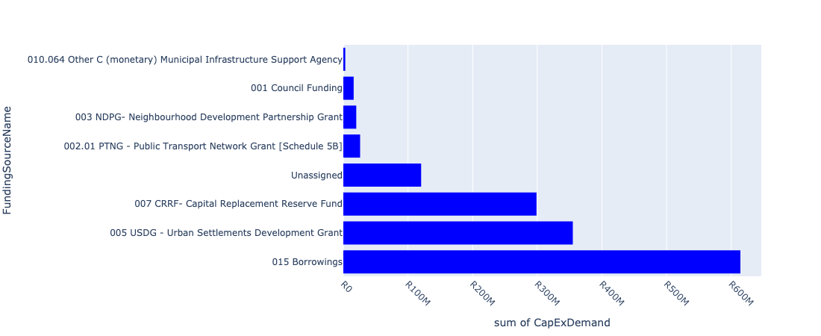

Figure 5.8: Region D Departmental Requests

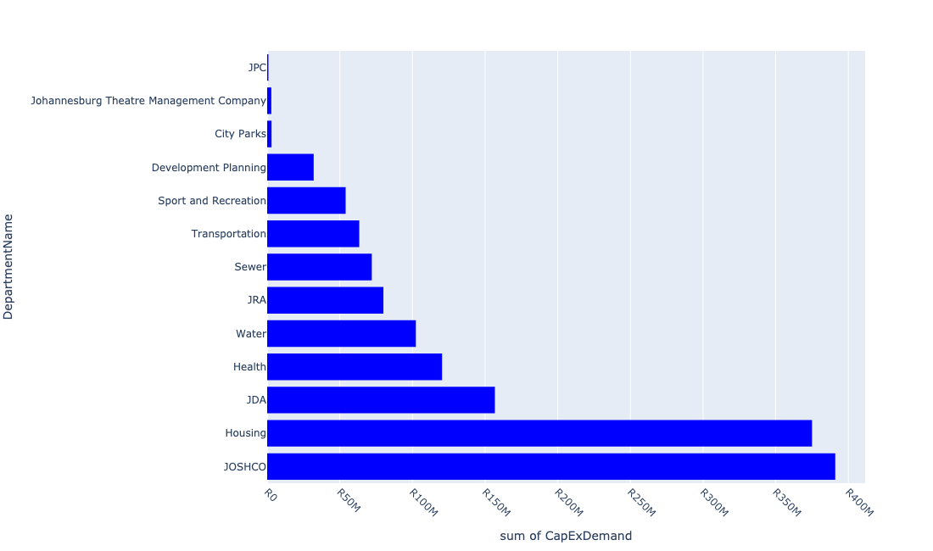

Table 5.4: Summary - Region D

|  |  |
| --- | --- |
| Item | Description |
| Total Capital Demand for Region D - All Years | R1,453,435,455 Rank: 6 (1 = Highest) |
| Total Capital Demand for Region D - MTREF | R1,335,831,592 Rank: 6 (1 = Highest) |
| Financial Years in which capital requirements are listed for Region D | 2023, 2024, 2025, 2026, 2027 and 2028 |
| Financial Year with highest capital demand for Region D | 2023 |
| Region D intersecting feature used | Works Location |
| Total number of projects intersecting with Region D | 260 Rank: 7 (1 = Highest) |

Table 5.5: All projects asking for budget in Region D

|  |  |  |  |
| --- | --- | --- | --- |
| Project ID | Project Name | Department | Project Budget |
| 23102 | 2804_09_ITS (Fibre Loop and CCTV)- Redundancy Loop | Transportation | R0.00 (0%) No budget request. |
| 23325 | 2804_20 Rea Vaya BRT Phase 1 A and B Station Rehabilitation | Transportation | R0.00 (0%) No budget request. |
| 23557 | 01_22684_Air Conditioners | Health | R121,991 (0.01%) Budget spread across: 2025, 2026 and 2027 |
| 22536 | Noordgesig - Social Precinct Implementation | JDA | R0.00 (0%) No budget request. |
| 23908 | Braamfischer Ext 12 Roads and stormwater (New line item) | JDA | R0.00 (0%) No budget request. |
| 23562 | 06_22684_Security Installations | Health | R643,670 (0.04%) Budget spread across: 2025, 2026 and 2027 |
| 23556 | 02_22684_Electricity Upgrade | Health | R903,752 (0.06%) Budget spread across: 2025, 2026 and 2027 |
| 22534 | Soweto TOD interventions | Development Planning | R0.00 (0%) No budget request. |
| 2946 | MISCL: Pedestrian Bridge in Slovo Park (also Ashanti). New Bridges (Pedestrian and Vehicles) CORONATIONVILLE B Ward | JRA | R0.00 (0%) No budget request. |
| 22531 | Mining belt west development corridor: Eastern Precinct | Development Planning | R0.00 (0%) No budget request. |
| 2687 | Soweto masterplan - Baragwanath Hospital Renewal Medium Voltage Network BARAGWANATH F Ward | City Power | R0.00 (0%) No budget request. |
| 3065 | Shanty Clinic Renewal Clinic Region D | Health | R0.00 (0%) No budget request. |
| 22295 | Ennerdale Ext 2 | Housing | R0.00 (0%) No budget request. |
| 23301 | 2804_19 Rea Vaya BRT Phase 1 A and 1 B Roadway Rehabilitation Project | Transportation | R25,969,667 (1.79%) Budget spread across: 2023 |
| 23289 | 2804_08_Soweto/Ivory Park | Transportation | R0.00 (0%) No budget request. |
| 21793 | Protea Glen Sewer Upgrade | Water | R23,618 (0.00%) Budget spread across: 2024 |
| 22479 | Soweto Strategic Area Framework & Implementation | Development Planning | R0.00 (0%) No budget request. |
| 3070 | Nancefield Station Precinct Development New Precinct Redevelopment KLIPSPRUIT D Regional | JDA | R0.00 (0%) No budget request. |
| 2530 | Goudkoppies Works: Balancing tank repairs Renewal Bulk Waste Water RIVASDALE D Regional | Sewer | R1,000,000 (0.07%) Budget spread across: 2024 |
| 6543 | Goudkoppies: New PSTs number 2 | Sewer | R1,000,000 (0.07%) Budget spread across: 2024 |
| 3640 | Soweto: Diepkloof Sewer Upgrade | Sewer | R0.00 (0%) No budget request. |
| 6512 | Deep South/ Orange Farm: Doornkop West Reservoir: Upgrade Water Infrastructure.Completed | Water | R0.00 (0%) No budget request. |
| 6514 | Soweto: Meadowlands Tower 2 2.2ML | Water | R0.00 (0%) No budget request. |
| 6640 | Soweto: Protea Glen Water Upgrade | Water | R0.00 (0%) No budget request. |
| 2953 | MISCL - Pedestrian Bridge in Klipspruit West. New Bridges (Pedestrian and Vehicles) KLIPSPRUIT WEST D Ward | JRA | R0.00 (0%) No budget request. |
| 3188 | Upgrade of Oppenheimer Towers in Central west Jabavu Renewal Park JABAVU CENTRAL WESTERN D Ward | City Parks | R0.00 (0%) No budget request. |
| 21273 | Orlando - Pennyville | City Power | R0.00 (0%) No budget request. |
| 3036 | BRID 20 - Bridge: Elias Motsoaledi Renewal Bridges (Pedestrian and Vehicles) MOFOLO CENTRAL D Ward | JRA | R0.00 (0%) No budget request. |
| 3059 | Naledi clinic New Building NALEDI D | Health | R0.00 (0%) No budget request. |
| 4055 | Jabulani Public Environment Upgrade New Precinct Redevelopment JABULANI D Ward | Development Planning | R0.00 (0%) No budget request. |
| 4247 | CBP-Meadowlands Park New Park MEADOWLANDS D Regional | City Parks | R0.00 (0%) No budget request. |
| 2750 | Mapetla Hostel Renewal Building Alterations TLADI D | Housing | R0.00 (0%) No budget request. |
| 2896 | Freedom park wetland rehabilitattion New Park KLIPSPRUIT WEST EXT.2 D Ward | City Parks | R0.00 (0%) No budget request. |
| 2773 | Goudkoppies Landfill site- improved compliance and alterations | Pikitup | R0.00 (0%) No budget request. |
| 3869 | Soweto BRT and Rail Corridor JOHANNESBURG F | Sewer | R0.00 (0%) No budget request. |
| 2867 | RNP024_Chris Hani Road Interchange New Roads: Construction and Upgrades DIEPKLOOF D Regional | JRA | R0.00 (0%) No budget request. |
| 3182 | Park development in Meadowlands Zone 7 New Park MEADOWLANDS D Ward | City Parks | R0.00 (0%) No budget request. |
| 6477 | Upgrading /widening of Nicholas Rd including pedestrian facilities | JRA | R0.00 (0%) No budget request. |
| 2518 | Goudkoppies Works: Digester Heating and Mixing | Sewer | R0.00 (0%) No budget request. |
| 2913 | Electrification of Slovo Park (Nancefield) New Electrification SLOVOVILLE G Ward | City Power | R0.00 (0%) No budget request. |
| 20989 | Soweto (CP_E237) | City Power | R0.00 (0%) No budget request. |
| 22263 | Jabulani Precinct Upgrades | Development Planning | R20,000,000 (1.38%) Budget spread across: 2023 and 2024 |
| 3623 | Johannesburg Central: Klipspruit sewer upgrade KLIPSPRUIT D | Sewer | R0.00 (0%) No budget request. |
| 24029 | 23776_Kliptown Urban Renewal Programme | JDA | R0.00 (0%) No budget request. |
| 2332 | New 88/11 kV 2 X 45 MVA substation to replace Baragwanath; Soweto and Soweto Local. New Bulk Infrastructure BARAGWANATH D Regional | City Power | R0.00 (0%) No budget request. |
| 22300 | Orlando Social Housing Upgrade | JOSHCO | R0.00 (0%) No budget request. |
| 2675 | Dobsonville Social Housing Project Region D | JOSHCO | R0.00 (0%) No budget request. |
| 6465 | M70 Soweto highway new north facing on and off ramps to/from N1 | JRA | R0.00 (0%) No budget request. |
| 2481 | Soweto: Planned Replacement of the Watermains Renewal Water Mains MAPETLA D Ward | Water | R62,300,000 (4.29%) Budget spread across: 2023 and 2024 |
| 22893 | Klipspruit Depot | City Parks | R0.00 (0%) No budget request. |
| 3116 | New streetlights in Jabulani. New Public Lighting JABULANI D Ward | City Power | R0.00 (0%) No budget request. |
| 22492 | Vilakazi Precinct Interventions | Development Planning | R0.00 (0%) No budget request. |
| 20743 | Goudkoppies Sws: Satellite | City Power | R0.00 (0%) No budget request. |
| 22372 | Park development in George Nkomo Street | City Parks | R0.00 (0%) No budget request. |
| 2306 | Dube Holding Facility New Building Alterations DUBE D Ward | Public Safety: JMPD | R0.00 (0%) No budget request. |
| 23368 | Tum-Key 3: Region D | JOSHCO | R139,395,898 (9.59%) Budget spread across: 2023 and 2024 |
| 20955 | Orlando | City Power | R0.00 (0%) No budget request. |
| 3245 | Goudkoppies work: Automate lime plant; WAS thickener New Bulk Waste Water RIVASDALE F Regional | Sewer | R0.00 (0%) No budget request. |
| 4221 | Klip MIDDLE Soweto Water Management Unit Ecological Infrastructure JABULANI, DOBSONVILLE | Environment and Infrastructure | R0.00 (0%) No budget request. |
| 2893 | Diepkloof Hostel Renewal Bulk Infrastructure DIEPKLOOF EXT.10 D Ward | Housing | R10,000,000 (0.69%) Budget spread across: 2024 |
| 22861 | Dorothy Nyembe EE Centre | City Parks | R0.00 (0%) No budget request. |
| 6474 | Vincent /Mmila/M73 Koma upgrade 2 lanes per direction | JRA | R0.00 (0%) No budget request. |
| 22289 | Naledi Ext 2 | Housing | R0.00 (0%) No budget request. |
| 20992 | Soweto Local Upgrade | City Power | R0.00 (0%) No budget request. |
| 2323 | Lufhereng Social Housing Project Region D | JOSHCO | R83,438,000 (5.74%) Budget spread across: 2023 |
| 2532 | Goudkoppies Works: Replace digester gas pipework Renewal Bulk Waste Water RIVASDALE D Regional | Sewer | R0.00 (0%) No budget request. |
| 2638 | Dobsonville Informal Trading Market Upgrading and construction of Informal Trading Facility New Informal trading Stalls DOBSONVILLE D Ward | JPC | R0.00 (0%) No budget request. |
| 22249 | Noordgesig Clinic | Development Planning | R0.00 (0%) No budget request. |
| 2621 | To formalise the taxi rank and to build stores as the current taxi rank has no shelters and stalls. New Taxi Rank DOORNKOP D Ward | JPC | R0.00 (0%) No budget request. |
| 23136 | 6660_05_establishment of a licensing satellite at Moroka / Jabavu | Public Safety: Head Office | R0.00 (0%) No budget request. |
| 22853 | Dorothy Nyembe EE - E-Learning Center | City Parks | R0.00 (0%) No budget request. |
| 21307 | Soweto Substation 88/22kV | City Power | R0.00 (0%) No budget request. |
| 2864 | RNP018_Protea Boulevard Upgrading Renewal Roads: Construction and Upgrades PROTEA GLEN D Regional | JRA | R0.00 (0%) No budget request. |
| 2366 | Green Village Renewal Clinic DOORNKOP D Ward | Health | R0.00 (0%) No budget request. |
| 22369 | Herby Mdingi and Letsatsi Park New Park Development | City Parks | R0.00 (0%) No budget request. |
| 3242 | Goudkoppies Works: Replace mixers aerators bio no.3 Renewal Bulk Waste Water RIVASDALE F Regional | Sewer | R0.00 (0%) No budget request. |
| 3634 | Soweto: Moroka Sewer Upgrade MOROKA E | Sewer | R0.00 (0%) No budget request. |
| 23700 | Complete Streets: NMT links to Merafe Station (Phase 2) | Transportation | R0.00 (0%) No budget request. |
| 22618 | Soweto TOD interventions | Development Planning | R0.00 (0%) No budget request. |
| 2707 | CATCH 240 - Klipriver Catchment: Upgrading of Stormwater Drainage System in Mogaseview Renewal Stormwater Catchments KLIPSPRUIT D Ward | JRA | R0.00 (0%) No budget request. |
| 3840 | Soweto Theatre - Building Renovations and upgrades JABULANI D | Johannesburg Theatre Management Company | R2,836,100 (0.20%) Budget spread across: 2023 and 2024 |
| 3248 | Goudkoppies Works: Replace screw pumps on bioreactors | Sewer | R0.00 (0%) No budget request. |
| 22724 | Vilakazi Precinct | JPC | R0.00 (0%) No budget request. |
| 2658 | Zola Wetland Upgrade New Precinct Redevelopment ZOLA D Ward | Development Planning | R0.00 (0%) No budget request. |
| 2999 | RNP074_Additional 1 lane per direction - Ndaba Road Renewal Roads: Construction and Upgrades PROTEA NORTH D Ward | JRA | R0.00 (0%) No budget request. |
| 2558 | New Informall trading Stalls MOFOLO NORTH D Construction of additional trading stalls for the Ikwezi informal traders | Economic Development | R0.00 (0%) No budget request. |
| 23148 | 6660_08_establishment of licensing satellite at protea north | Public Safety: Head Office | R0.00 (0%) No budget request. |
| 3180 | Park development in Moletsane New Park MOLETSANE D Ward | City Parks | R0.00 (0%) No budget request. |
| 2919 | Bulk infrastructure for the electrification of Elias Motswaledi New Electrification POWER PARK D Ward | City Power | R0.00 (0%) No budget request. |
| 2441 | Mapetla Park - new ablution facilities New Park MAPETLA D Ward | City Parks | R0.00 (0%) No budget request. |
| 21039 | Lenasia : Lenasia Ext 10 switching station upgrade | City Power | R0.00 (0%) No budget request. |
| 4193 | CORR - NMT: Link From the BRT Station To The Noordgesig Social Cluster. New Roads: Construction and Upgrades NOORDGESIG D Ward | JRA | R0.00 (0%) No budget request. |
| 3529 | Meadowlands Social Hosing Project Region C | JOSHCO | R0.00 (0%) No budget request. |
| 6406 | Rehabilitation of the Klip-Upper Soweto Water Management Unit (K-USWMU) | Environment and Infrastructure | R0.00 (0%) No budget request. |
| 3111 | COMPL: Sidewalk Improvements: Slovoville New Complete Streets SLOVOVILLE Ward | Transportation | R0.00 (0%) No budget request. |
| 22112 | Motsoaledi (Informal Settlement) | Housing | R0.00 (0%) No budget request. |
| 3174 | Doornkop Bambayi Subdivisions New Bulk Infrastructure DOORNKOP C Ward | Housing | R0.00 (0%) No budget request. |
| 6417 | Mayibuye Park | City Parks | R0.00 (0%) No budget request. |
| 2679 | IKWEZI RENTAL HOUSING PROJECT New Housing Development JABULANI D | JOSHCO | R0.00 (0%) No budget request. |
| 3784 | Meadowlands Stadium Renewal Community Centre MEADOWLANDS D Ward | Sport and Recreation | R30,000,000 (2.06%) Budget spread across: 2024 |
| 20884 | Baragwanath (CP_E258) | City Power | R0.00 (0%) No budget request. |
| 21288 | Quattro - Fordsburg | City Power | R0.00 (0%) No budget request. |
| 21282 | PennyVille Switching Station | City Power | R0.00 (0%) No budget request. |
| 6483 | Gravel roads :Devland Construction and upgrades | JRA | R0.00 (0%) No budget request. |
| 2839 | Mshenguville wetland rehabilitation New Ecological Infrastructure MOFOLO NORTH D Ward | Environment and Infrastructure | R0.00 (0%) No budget request. |
| 21308 | Soweto, Soweto/Orlando Local & Baragwanath | City Power | R0.00 (0%) No budget request. |
| 3635 | Soweto: Mogale South sewer upgrade MOROKA E | Sewer | R0.00 (0%) No budget request. |
| 22370 | New Park Development Lefatola Street | City Parks | R0.00 (0%) No budget request. |
| 22086 | Naledi 1 (Tladi) (Informal Settlement) | Housing | R0.00 (0%) No budget request. |
| 3045 | Soweto: Orlando East: Upgrade Sewers New Sewer Mains ORLANDO G Regional | Sewer | R0.00 (0%) No budget request. |
| 6489 | Gravel roads :Naledi .Construction and upgrade | JRA | R0.00 (0%) No budget request. |
| 3002 | RNP061_Dualling of Modjadji Road Renewal Roads: Construction and Upgrades PIMVILLE ZONE 5 D Ward | JRA | R0.00 (0%) No budget request. |
| 2753 | Jabulani Flats Renewal Building Alterations JABULANI D Ward | Housing | R0.00 (0%) No budget request. |
| 4127 | ACH - Upgrading of the June 16 Acre Memorial Renewal Heritage Area Upgrade JABAVU CENTRAL WESTERN D | Arts; Culture and Heritage | R0.00 (0%) No budget request. |
| 23266 | Jabavu Stadium | Sport and Recreation | R8,000,000 (0.55%) Budget spread across: 2024 |
| 23429 | Trans Relocation Area - Lufhereng - 2000 units | Housing | R0.00 (0%) No budget request. |
| 3818 | RESUR - Resurfacing of Soweto Highway. Renewal Roads: Rehabilitation ORLANDO D City Wide | JRA | R35,000,000 (2.41%) Budget spread across: 2023 and 2024 |
| 22533 | Noordgesig - Social Precinct Implementation | Development Planning | R0.00 (0%) No budget request. |
| 2421 | Soweto Empowerment Zone New Economic Infrastructure DIEPKLOOF D Regional | JPC | R0.00 (0%) No budget request. |
| 21677 | North Suburb (Kya Sands) IWMF | Pikitup | R0.00 (0%) No budget request. |
| 3037 | RNP047_Baragwanath / Dippenaar / Orlando Link New Roads: Construction and Upgrades ORLANDO D Ward | JRA | R0.00 (0%) No budget request. |
| 6374 | Bara Taxi rank dead zone revitalisation | JPC | R0.00 (0%) No budget request. |
| 2922 | Electrification of Lufhereng New Electrification LUFHERENG D Ward | City Power | R0.00 (0%) No budget request. |
| 23137 | 6660_03_establishing a licensing satellite office at Dobsonville | Public Safety: Head Office | R0.00 (0%) No budget request. |
| 2682 | Jabulani Social Housing Project Region D | JOSHCO | R0.00 (0%) No budget request. |
| 6486 | Soweto Theatre - Backup Generator | Johannesburg Theatre Management Company | R0.00 (0%) No budget request. |
| 23134 | 6660_06_establishment of a licensing satellite at Orlando East | Public Safety: Head Office | R0.00 (0%) No budget request. |
| 3117 | New streetlights in Nancefield. New Public Lighting KLIPSPRUIT D Ward | City Power | R0.00 (0%) No budget request. |
| 3377 | Bara Upgrade Renewal Informal trading Stalls BARAGWANATH A Ward | JPC | R0.00 (0%) No budget request. |
| 22026 | Jabulani Electrification | City Power | R0.00 (0%) No budget request. |
| 22879 | New Park development Lufhereng | City Parks | R0.00 (0%) No budget request. |
| 20993 | Soweto Local (CP_E240) | City Power | R0.00 (0%) No budget request. |
| 22075 | Bottom Compound | Housing | R0.00 (0%) No budget request. |
| 3091 | Electrification of Elias Motswaledi. New Electrification POWER PARK D Ward | City Power | R0.00 (0%) No budget request. |
| 23712 | Construction of a new MPC in Phiri | Sport and Recreation | R8,000,000 (0.55%) Budget spread across: 2024 |
| 4136 | 22776_04_MISCL - Tarring of Gravel Roads: Slovoville New Roads: Construction and Upgrades SLOVOVILLE D Ward | Mayors Office/ City Manager | R0.00 (0%) No budget request. |
| 3987 | Upgrade of Public Environment at Jabulani Renewal Precinct Redevelopment JABULANI D Regional | Development Planning | R0.00 (0%) No budget request. |
| 2358 | Orlando Ekhaya Social Housing Project Region D | JOSHCO | R0.00 (0%) No budget request. |
| 4179 | Mooki Street Development Infrastructure; Orlando East New Precinct Redevelopment ORLANDO EAST D Regional | JPC | R850,000 (0.06%) Budget spread across: 2024 |
| 22181 | Informal Settlements Region D | Housing | R0.00 (0%) No budget request. |
| 3246 | Goudkoppies Works: Clarifies Automate # 12 & Automation | Sewer | R0.00 (0%) No budget request. |
| 24023 | 23775_Khosa Street- - gravel roads and stormwater | JRA | R0.00 (0%) No budget request. |
| 3118 | Jabulani Station Renewal Nodal Transportation Facilities | JDA | R0.00 (0%) No budget request. |
| 2944 | RNP038_Potchefstroom Road Extension New Roads: Construction and Upgrades DIEPKLOOF EXT D Regional | JRA | R0.00 (0%) No budget request. |
| 2892 | Orlando Womens Hostel Renewal Bulk Infrastructure ORLANDO D Ward | Housing | R0.00 (0%) No budget request. |
| 2861 | RNP031_Upgrading and Widening of Nicholas Road Including Pedestrian Facilitiy Renewal Roads: Construction and Upgrades ORLANDO EAST D Ward | JRA | R0.00 (0%) No budget request. |
| 2855 | RNP014_New Canada Road Widening Renewal Roads: Construction and Upgrades NOORDGESIG B Regional | JRA | R0.00 (0%) No budget request. |
| 2752 | Meadowlands Hostel Renewal Building Alterations MEADOWLANDS D Ward | Housing | R40,000,000 (2.75%) Budget spread across: 2023 and 2024 |
| 2680 | Zola Social Housing Project Region D | JOSHCO | R0.00 (0%) No budget request. |
| 2646 | CBP 2009/10 Upgrade Theatre redevelopment KLIPSPRUIT EXT.4 D Upgrade Theatre | Economic Development | R0.00 (0%) No budget request. |
| 2640 | Phiri Multi Purpose Centre | Sport and Recreation | R8,000,000 (0.55%) Budget spread across: 2024 |
| 2617 | CBP 2009/10 Park 2/2 Renewal Park MEADOWLANDS D Ward | City Parks | R0.00 (0%) No budget request. |
| 2577 | CATCH 10 - Emergency Stormwater Improvement (Multi year). New Stormwater Catchments PROTEA GLEN D Ward | JRA | R45,000,000 (3.10%) Budget spread across: 2023 and 2024 |
| 2566 | Lufhereng Mixed Development (Bulk, Link & Internal Infrastructure Roads, Storm Water Management Systems, Sewer & Water for 24 000 houses) | Housing | R135,000,000 (9.29%) Budget spread across: 2023 and 2024 |
| 2514 | Nokuphila Clinic; Furniture and Medical Equipment - Phase I Upgrade Clinic ZOLA D | Health | R67,200,000 (4.62%) Budget spread across: 2025, 2026, 2027 and 2028 |
| 2503 | Orlando East Station Precinct New Precinct Redevelopment ORLANDO EAST D Ward | JDA | R10,000,000 (0.69%) Budget spread across: 2024 |
| 2457 | Additional trading stalls for informal trading in the new taxi and market facility New Informal trading Stalls DIEPKLOOF D Regional | JPC | R0.00 (0%) No budget request. |
| 2417 | 23776_01_MISCL - Tarring of Gravel Roads: Doornkop/Thulani. New Roads: Construction and Upgrades DOORNKOP D Ward | Mayors Office/ City Manager | R0 (0.00%) Budget spread across: 2023 and 2024 |
| 2288 | Build new 275kV Intake Station to replace Orlando 88kV switch yard. New Bulk Infrastructure RIVASDALE D City Wide | City Power | R0.00 (0%) No budget request. |
| 23794 | Bheki Mlangeni Park | City Parks | R0.00 (0%) No budget request. |
| 23699 | Complete Streets: NMT links to Railway Stations: Phefeni Station | Transportation | R12,399,759 (0.85%) Budget spread across: 2023 and 2024 |
| 23147 | 6660_09_establishment of licensing satellite office at jabulani civic centre | Public Safety: Head Office | R0.00 (0%) No budget request. |
| 22838 | Construction of a World Class Licensing & Testing Centre- Dube | Public Safety: Head Office | R0.00 (0%) No budget request. |
| 22646 | GK: Infrastructure Renewal Plan 2. | Sewer | R10,000,000 (0.69%) Budget spread across: 2024 |
| 22374 | Park development in Orlando West | City Parks | R0.00 (0%) No budget request. |
| 22368 | Nancefield New Park Development | City Parks | R0.00 (0%) No budget request. |
| 22357 | Doornkop Parks New Park developments | City Parks | R0.00 (0%) No budget request. |
| 22354 | Complete Streets: (KFW - German Development Bank): Orlando East to UJ Soweto Route | Transportation | R0.00 (0%) No budget request. |
| 22254 | Jabulani Cultural Precinct | Development Planning | R0.00 (0%) No budget request. |
| 22088 | Naledi 2 & 3 (Informal Settlement) | Housing | R0.00 (0%) No budget request. |
| 22076 | Nomzamo (Informal Settlements) | Housing | R0.00 (0%) No budget request. |
| 22025 | Protea Glen Electrification Project | City Power | R0.00 (0%) No budget request. |
| 21807 | Doornkop water Upgrade | Water | R0.00 (0%) No budget request. |
| 21306 | Soweto Local | City Power | R0.00 (0%) No budget request. |
| 21272 | Orlando - Eldorado | City Power | R0.00 (0%) No budget request. |
| 3940 | COMPL: Sidewalk Improvements: Naledi Station New Nodal Transport Facilities NALEDI D Regional | Transportation | R0.00 (0%) No budget request. |
| 3908 | Slovoville: New Public Lights New Public Lighting SLOVOVILLE D Regional | City Power | R0.00 (0%) No budget request. |
| 3631 | Soweto: Protea Glen Sewer Upgrade | Sewer | R5,000,000 (0.34%) Budget spread across: 2024 |
| 3628 | Soweto: Dube Sewer Upgrade | Sewer | R0.00 (0%) No budget request. |
| 3442 | Sector 2 New Bulk Infrastructure KLIPSPRUIT D Regional | Housing | R0.00 (0%) No budget request. |
| 3244 | Goudkoppies Works: Replace bridge drives PSTs clarifiers Renewal Bulk Waste Water RIVASDALE F Regional | Sewer | R0.00 (0%) No budget request. |
| 3190 | Pimville Koppies Conservation Ecom Tourism Upgrade Renewal Park PIMVILLE ZONE 1 EXT D Regional | City Parks | R0.00 (0%) No budget request. |
| 3187 | Park development in Tladi Renewal Park TLADI D Ward | City Parks | R0.00 (0%) No budget request. |
| 3184 | Elias Motsoaledi Ext1 Township Development (Region D - Ward 24) | Housing | R140,000,000 (9.63%) Budget spread across: 2023 and 2024 |
| 3181 | Park development in Emdeni New Park EMDENI D Ward | City Parks | R0.00 (0%) No budget request. |
| 21043 | Lenasia : Olifantsvlei switching station supply upgrade | City Power | R0.00 (0%) No budget request. |
| 21037 | Lenasia : Lawley Dumpsite Electrification | City Power | R0.00 (0%) No budget request. |
| 20883 | Baragwanath (CP_E194) | City Power | R0.00 (0%) No budget request. |
| 6659 | Construction of a World Class Licensing & Testing Centre - DUBE | Public Safety: Head Office | R0.00 (0%) No budget request. |
| 6642 | RNP016 New link Road from Golden Highway to Soweto New roads :Construction and upgrades Power park Region D | JRA | R0.00 (0%) No budget request. |
| 6565 | Soweto: Zondi Water Upgrade | Water | R0.00 (0%) No budget request. |
| 6553 | Soweto: Diepkloof Water Upgrade | Water | R0.00 (0%) No budget request. |
| 6542 | Goudkoppies: Replace belt presses number 4 | Sewer | R0.00 (0%) No budget request. |
| 6516 | Soweto: Dobsonville Reservoir 15Ml | Water | R25,000,000 (1.72%) Budget spread across: 2023 and 2024 |
| 6513 | Soweto: Meadowlands Reservoir 19.8ML | Water | R0.00 (0%) No budget request. |
| 4200 | New Lift for Disabled : Jabulani Civic Council Chamber New Building Alterations JABULANI B Regional | JPC | R0.00 (0%) No budget request. |
| 4189 | Relocation of Flood Victims in Orlando West New Land Preparation ORLANDO WEST D Regional | JPC | R0.00 (0%) No budget request. |
| 3095 | Electrification of Chris Hani New Electrification DHLAMINI D Ward | City Power | R0.00 (0%) No budget request. |
| 3063 | Klipspruit West Clinic Renewal Clinic KLIPSPRUIT WEST D Ward | Health | R0.00 (0%) No budget request. |
| 3060 | Elias Motsoaledi clinic Renewal Building DUBE EXT.2 D | Health | R51,500,000 (3.54%) Budget spread across: 2024, 2025, 2026 and 2027 |
| 3043 | Bushkoppies Works: Replacement of Aerotion System Renewal Bulk Waste Water DEVLAND G Ward | Sewer | R0.00 (0%) No budget request. |
| 3023 | RNP083_Marthinus Smuts Road Doubling - Diepkloof Renewal Roads: Construction and Upgrades DIEPKLOOF D Ward | JRA | R0.00 (0%) No budget request. |
| 2997 | BRID 20 - Enlarge Culvert Crossing: Marthinus Smuts Renewal Stormwater Catchments DIEPKLOOF D Ward | JRA | R0.00 (0%) No budget request. |
| 2969 | BRID 20 - Bridge Upgrade: Noordgesig and Industria West Renewal Bridges (Pedestrian and Vehicles) NOORDGESIG B Ward | JRA | R0.00 (0%) No budget request. |
| 2877 | RNP016_New Link Road from Golden Highway to Soweto New Roads: Construction and Upgrades POWER PARK D Regional | JRA | R0.00 (0%) No budget request. |
| 2874 | RNP008_On / Off Ramp Soweto Highway New Roads: Construction and Upgrades NOORDGESIG D Regional | JRA | R0.00 (0%) No budget request. |
| 2857 | RNP023.0_Vincent/Mmila/Koma Street Upgrade Renewal Roads: Construction and Upgrades MOFOLO NORTH D Ward | JRA | R0.00 (0%) No budget request. |
| 2751 | Dube Hostel Renewal Building Alterations DUBE EXT.2 D Ward | Housing | R50,000,000 (3.44%) Budget spread across: 2023 and 2024 |
| 2691 | Goudkoppies works: Aerators; mixers; mod3 | Sewer | R0.00 (0%) No budget request. |
| 2574 | Lufhereng Substation. Establish new 88/11 kV sub station. New Bulk Infrastructure LUFHERENG D Ward | City Power | R0.00 (0%) No budget request. |
| 2571 | Deep South/ Orange Farm: Doornkop West/Protea Glen district:Upgrade water infrastructure | Water | R0.00 (0%) No budget request. |
| 2542 | Parks Development and Upgrade in Noordgesig Renewal Park NOORDGESIG D | City Parks | R0.00 (0%) No budget request. |
| 2522 | Orlando Ekhaya Waterfront Development Renewal Park ORLANDO EKHAYA D Regional | JPC | R0.00 (0%) No budget request. |
| 2511 | Protea Glen Clinic; Furniture & Medical Equipment -Phase I New Clinic PROTEA GLEN D Ward | Health | R0 (0.00%) Budget spread across: 2024 |
| 2362 | Eldorado Park ext 2 | Health | R0.00 (0%) No budget request. |
| 2359 | Nancefield Social Housing Project Region D | JOSHCO | R140,000,000 (9.63%) Budget spread across: 2023 and 2024 |
| 23776 | 23776_00_Kliptown and surrounds Turnkey projects | JDA | R146,711,000 (10.09%) Budget spread across: 2023 and 2024 |
| 23707 | Soweto SAF Priority Precinct | Development Planning | R12,000,000 (0.83%) Budget spread across: 2023 and 2024 |
| 23421 | Lufhereng (2000 units) | Housing | R0.00 (0%) No budget request. |
| 23332 | Old Vista Region D | Housing | R0.00 (0%) No budget request. |
| 23298 | Construction, Upgrading and Engineering services at Zondi Depot | Pikitup | R0.00 (0%) No budget request. |
| 23135 | 6660_07_establishment of a licensing satellite at Orlando West | Public Safety: Head Office | R0.00 (0%) No budget request. |
| 23126 | 2197_05_Protea Glen | Water | R0.00 (0%) No budget request. |
| 22622 | Doornkop Park | City Parks | R0.00 (0%) No budget request. |
| 22511 | Soweto: Anthea Nancefield Sewer (Klipspruit River) Phase 1 | Sewer | R0.00 (0%) No budget request. |
| 22376 | Jabulani Social Housing Project Upgrade | JOSHCO | R0.00 (0%) No budget request. |
| 22262 | Upgrading of Lepogo Street, Jabulani | Development Planning | R0.00 (0%) No budget request. |
| 22256 | Station Sports Facility | Development Planning | R0.00 (0%) No budget request. |
| 22253 | Jabulani Amphitheatre | Development Planning | R0.00 (0%) No budget request. |
| 22193 | Noordgesig - Social Precinct Implementation | Development Planning | R0.00 (0%) No budget request. |
| 22124 | Fred Clarke (Informal Settlements) | Housing | R0.00 (0%) No budget request. |
| 21804 | Jabulani Water Upgrade | Water | R0.00 (0%) No budget request. |
| 21463 | Orlando control cable replacement | City Power | R0.00 (0%) No budget request. |
| 24031 | 23776_Title deed roll | JOSHCO | R0.00 (0%) No budget request. |
| 4165 | PTF Small Public Transport Facility Design and Construction of Zola Public Transport Facility New Nodal Transport Facilities ZOLA D Regional | Transportation | R25,000,000 (1.72%) Budget spread across: 2023 and 2024 |
| 4128 | ACH - Upgrading of Kliptown Open Air Museum Renewal Heritage Area Upgrade KLIPSPRUIT WEST D | Arts; Culture and Heritage | R0.00 (0%) No budget request. |
| 3985 | MISCL - Tarring of Gravel Roads: Protea South. New Roads: Construction and Upgrades PROTEA SOUTH EXT.1 G Ward | JRA | R0.00 (0%) No budget request. |
| 3885 | Devland Golden Highway Social Housing Project Region D | JOSHCO | R28,142,000 (1.94%) Budget spread across: 2023 |
| 3653 | Fire Station - Protea Glen New Building New Building Alterations PROTEA GLEN EXT.1 D Regional | Public Safety: EMS | R0.00 (0%) No budget request. |
| 3644 | Soweto: Doornkop sewer replacement DOORNKOP E | Sewer | R0.00 (0%) No budget request. |
| 3627 | Soweto: Planned Replacement Sewermains | Sewer | R20,000,000 (1.38%) Budget spread across: 2023 and 2024 |
| 3484 | Goudkoppies Works: Infrastructure Renewal Plan | Sewer | R35,000,000 (2.41%) Budget spread across: 2023 and 2024 |
| 3455 | JABULANI HOSTEL New Bulk Infrastructure JABULANI D Regional | Housing | R0.00 (0%) No budget request. |
| 3444 | Oldviasta New Bulk Infrastructure ORLANDO D Regional | Housing | R0.00 (0%) No budget request. |
| 3189 | Upgrading of Ndaba Park in Protea Renewal Park PROTEA INDUSTRIAL PARK EXT.9 D Ward | City Parks | R0.00 (0%) No budget request. |
| 3178 | Park development in Protea Glen New Park PROTEA GLEN D Ward | City Parks | R3,000,000 (0.21%) Budget spread across: 2024 |
| 21171 | Baragwanath Substation 20.5/6.6 kV | City Power | R0.00 (0%) No budget request. |
| 21054 | Lenasia : Volta Ext 17 Electrification | City Power | R0.00 (0%) No budget request. |
| 21051 | Lenasia : Slovoville Private Electrification | City Power | R0.00 (0%) No budget request. |
| 20991 | Soweto Yard | City Power | R0.00 (0%) No budget request. |
| 20988 | Soweto (CP_E084) | City Power | R0.00 (0%) No budget request. |
| 6564 | Soweto: Orlando Water Upgrade | Water | R0.00 (0%) No budget request. |
| 6541 | Complete Streets: NMT Facilities: Zola Phase 2 | Transportation | R0.00 (0%) No budget request. |
| 6538 | Soweto: Meadowlands Water Upgrade | Water | R0.00 (0%) No budget request. |
| 6515 | Soweto: Meadowlands Tower 1 1.1Ml | Water | R0.00 (0%) No budget request. |
| 6504 | Soweto: Doornkop West Reservoir 85Ml | Water | R15,000,000 (1.03%) Budget spread across: 2023 and 2024 |
| 6372 | Soweto Strategic Node_Upgrading of Public Environment through co-investment | JDA | R0.00 (0%) No budget request. |
| 4248 | CBP-Park Development in Dobsonville Ext 3 New Park DOBSONVILLE EXT.3 D Ward | City Parks | R0.00 (0%) No budget request. |
| 4205 | 23776_06_CATCH - Implementation of CBP Stormwater Masterplanning: Soweto. New Stormwater Management Projects ORLANDO WEST D Regional | Mayors Office/ City Manager | R0.00 (0%) No budget request. |
| 4174 | Marginalised Area Industrial Support Programme New Economic Infrastructure EMDENI D City Wide | Economic Development | R0.00 (0%) No budget request. |

Please note that the following projects will not be shown in this table:

* Projects with no recorded intersect with Regions (in other words no Works Location was recorded on the system for this project)

Projects that do not have any recorded budget demand on the system at the time that this report was requested, are shown in the table with zero budgets indicated.

## Region E

Figure 5.9: Region E Funding Requests

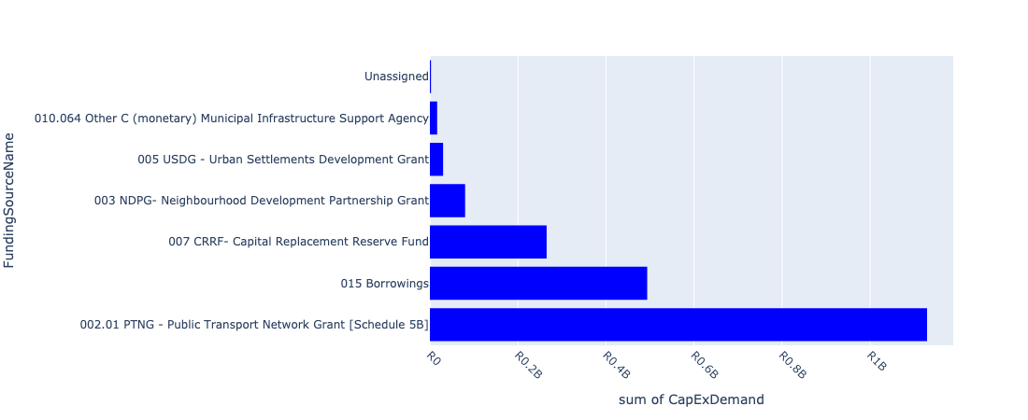

Figure 5.10: Region E Departmental Requests

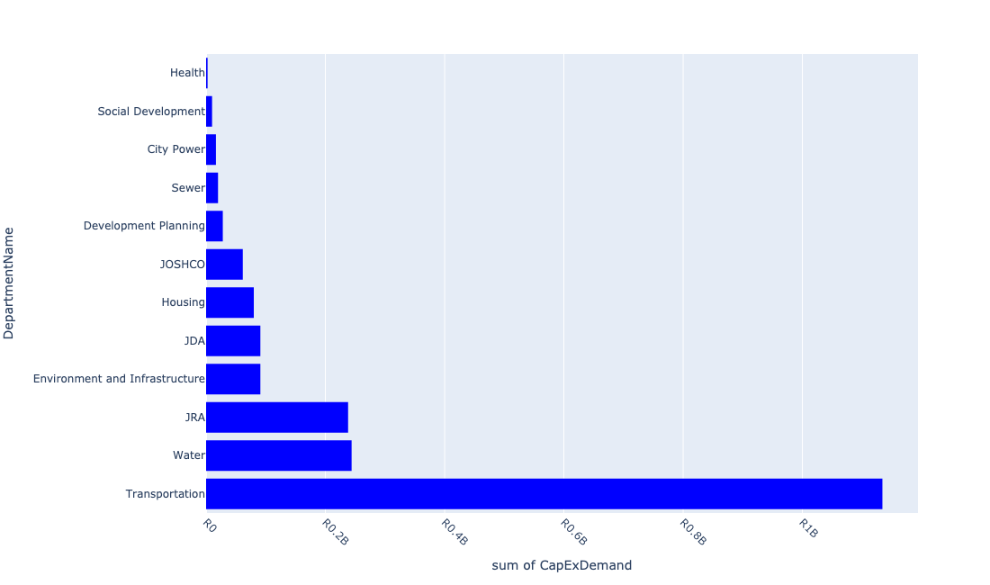

Table 5.5: Summary - Region E

|  |  |
| --- | --- |
| Item | Description |
| Total Capital Demand for Region E - All Years | R2,016,826,986 Rank: 2 (1 = Highest) |
| Total Capital Demand for Region E - MTREF | R2,015,157,286 Rank: 2 (1 = Highest) |
| Financial Years in which capital requirements are listed for Region E | 2023, 2024, 2025, 2026 and 2027 |
| Financial Year with highest capital demand for Region E | 2024 |
| Region E intersecting feature used | Works Location |
| Total number of projects intersecting with Region E | 310 Rank: 5 (1 = Highest) |

Table 5.6: All projects asking for budget in Region E

|  |  |  |  |
| --- | --- | --- | --- |
| Project ID | Project Name | Department | Project Budget |
| 23557 | 01_22684_Air Conditioners | Health | R107,605 (0.01%) Budget spread across: 2025, 2026 and 2027 |
| 22012 | DSM: Solar PV Systems on Buildings | City Power | R0.00 (0%) No budget request. |
| 23562 | 06_22684_Security Installations | Health | R753,651 (0.04%) Budget spread across: 2025, 2026 and 2027 |
| 23556 | 02_22684_Electricity Upgrade | Health | R1,634,930 (0.08%) Budget spread across: 2025, 2026 and 2027 |
| 2946 | MISCL: Pedestrian Bridge in Slovo Park (also Ashanti). New Bridges (Pedestrian and Vehicles) CORONATIONVILLE B Ward | JRA | R0.00 (0%) No budget request. |
| 23142 | 2804_15_Rea Vaya BRT Land Acquisition | Transportation | R0.00 (0%) No budget request. |
| 20898 | Cydna (CP_E141) | City Power | R0.00 (0%) No budget request. |
| 22473 | Yeoville Precinct | Development Planning | R0.00 (0%) No budget request. |
| 20897 | Cydna (CP_E140) | City Power | R0.00 (0%) No budget request. |
| 23710 | Rea Vaya Auto Fare Collection System (AFCS) | Transportation | R74,076,333 (3.67%) Budget spread across: 2023 |
| 23109 | 2804_14_Signage, Demarcation blocks and Corridor Road Markings | Transportation | R16,038,880 (0.80%) Budget spread across: 2023 |
| 3816 | RESUR - Resurfacing of M1 Motorway. Renewal Roads: Rehabilitation MELROSE E City Wide | JRA | R39,138,587 (1.94%) Budget spread across: 2023 and 2024 |
| 20899 | Cydna (CP_E230) | City Power | R0.00 (0%) No budget request. |
| 20896 | Cydna (CP_E072) | City Power | R0.00 (0%) No budget request. |
| 2411 | BSC - Leslie Avenue Upgrade; Magaliessig Renewal Developers Contribution MAGALIESSIG EXT.8 A Ward | JRA | R0.00 (0%) No budget request. |
| 2836 | Far Eastbank New Ecological Infrastructure ALEXANDRA EXT.31 E Ward | Environment and Infrastructure | R80,000,000 (3.97%) Budget spread across: 2023 and 2024 |
| 6383 | Alexandra UDF_Implementaton_of the Alex Land Agreement | JDA | R0.00 (0%) No budget request. |
| 2369 | Sandton/Alexandra: Bryanston Water Upgrade | Water | R5,000,000 (0.25%) Budget spread across: 2024 |
| 21012 | Alexandra : Proposed switching station in Wynberg area | City Power | R0.00 (0%) No budget request. |
| 20680 | Alexandra : Replacement of cable along Andries street | City Power | R0.00 (0%) No budget request. |
| 2704 | Banakekelen Hospice New Clinic ALEXANDRA EXT.38 E Ward | JDA | R1,000,000 (0.05%) Budget spread across: 2023 |
| 22100 | Ghandi Centre (Informal Settlement) | Housing | R0.00 (0%) No budget request. |
| 3508 | Park Upgrade Charltendale Park Orange Grove Renewal Park ORANGE GROVE E Ward | City Parks | R0.00 (0%) No budget request. |
| 23125 | 2197_01_Alexander | Water | R0.00 (0%) No budget request. |
| 20889 | Bryanston | City Power | R0.00 (0%) No budget request. |
| 3554 | Sandton/ Alexandra: Klipfontein water upgrade New Water Mains KLIPFONTEIN VIEW B Regional | Water | R0.00 (0%) No budget request. |
| 20972 | Riviera switching station upgrade | City Power | R0.00 (0%) No budget request. |
| 4015 | CORR - Louis Botha Transit Oriented Development (TOD) corridor Traffic Impact Assessment (TIA), Stormwater Masterplan and New COnstriction and Upgrading Renewal Corridors of Freedom Intervention ORANGE GROVE E Regional | JDA | R0.00 (0%) No budget request. |
| 21190 | Cydna 88/11kV | City Power | R0.00 (0%) No budget request. |
| 23680 | Alexander Water Upgrade (G7) | Water | R50,000,000 (2.48%) Budget spread across: 2023 and 2024 |
| 23797 | Alexandra Hospise | JDA | R0.00 (0%) No budget request. |
| 23417 | Trans Relocation Area - Marlboro & Marlboro Gardens - 2295 units | Housing | R0.00 (0%) No budget request. |
| 22166 | Boikhutsong Development | Housing | R0.00 (0%) No budget request. |
| 22664 | Sandton/Alexandra:Bryanston Water Upgrade.Duplicate | Water | R0.00 (0%) No budget request. |
| 22635 | Sandton/Alexandra: Bruma sewer upgrade | Sewer | R0.00 (0%) No budget request. |
| 21210 | Gresswold 88/11 kV | City Power | R0.00 (0%) No budget request. |
| 22180 | Emergency Housing Region G | Housing | R0.00 (0%) No budget request. |
| 3551 | Sandton/ Alexandra: Alexandra Park water upgrade New Water Mains ALEXANDRA EXT.4 B Regional | Water | R0.00 (0%) No budget request. |
| 2312 | Sandton/Alexandra: Randjeslaagte District:Upgrade water infrastructure Renewal Water Mains BRAMLEY E Regional | Water | R0.00 (0%) No budget request. |
| 4198 | Sandton Taxi Holding Facility; Katherine Street New Precinct Redevelopment SANDOWN E Regional | JPC | R0.00 (0%) No budget request. |
| 22103 | Sandton Permanent Taxi Holding | JPC | R0.00 (0%) No budget request. |
| 3866 | Jukskei Catchment Rehabilitation Renewal Green Infrastructure FAR EAST BANK E Regional | City Parks | R0.00 (0%) No budget request. |
| 21107 | Randburg : Telkor switching station supply upgrade | City Power | R0.00 (0%) No budget request. |
| 22174 | Establishment of Disaster Relief warehouse for storage of incident relief materials | Public Safety: EMS | R0.00 (0%) No budget request. |
| 3557 | Sandton/Alexandra: Sandton water upgrade | Water | R0.00 (0%) No budget request. |
| 3511 | Park Upgrade Umtata Park Renewal Park MARLBORO E Ward | City Parks | R0.00 (0%) No budget request. |
| 21015 | Alexandra : Triangle Electrification | City Power | R0.00 (0%) No budget request. |
| 21009 | Alexandra : Proposed switching station in Hyde Park area | City Power | R0.00 (0%) No budget request. |
| 3039 | RNP042_Upgrading of Benmore Road Renewal Roads: Construction and Upgrades BENMORE GARDENS E Ward | JRA | R0.00 (0%) No budget request. |
| 2352 | Lombardy East Social Housing Project Region E | JOSHCO | R0.00 (0%) No budget request. |
| 3010 | CATCH 210 - Klein Jukskei Catchment: Upgrade to Armorflex Canal; Diamant St; Jukskei Park and Strydom Park Renewal Stormwater Catchments JUKSKEI PARK EXT.1 B Ward | JRA | R0.00 (0%) No budget request. |
| 2252 | Sandton/ Alexandra: Collectors for Modderfontein outfall sewer New Sewer Mains FOUNDERS HILL B Regional | Sewer | R0.00 (0%) No budget request. |
| 3085 | Refurbish TSSs as required by Area Maintanance. Renewal Medium Voltage Network CRYSTAL GARDENS A.H. E Regional | City Power | R0.00 (0%) No budget request. |
| 2398 | CATCH 210 - Klein Jukskei Catchment: (CBP) Stormwater Control: Willows Development - Windsor New Stormwater Catchments JUKSKEI PARK B Ward | JRA | R30,000,000 (1.49%) Budget spread across: 2023 and 2024 |
| 21184 | Bryanston Substation CP | City Power | R0.00 (0%) No budget request. |
| 3279 | Replace 88 kV cable between Cydna and Rosebank. Renewal Bulk Infrastructure ROSEBANK B Regional | City Power | R0.00 (0%) No budget request. |
| 22738 | San Kopano Community Centre | JPC | R0.00 (0%) No budget request. |
| 2924 | Replace link cabinets in the Kew Depot area Renewal Medium Voltage Network KEW EXT.1 E Regional | City Power | R0.00 (0%) No budget request. |
| 2887 | RNP017_Ballyclaire Drive Widening Renewal Roads: Construction and Upgrades RIVER CLUB EXT.2 E Regional | JRA | R0.00 (0%) No budget request. |
| 4250 | CBP-Upgrade of Glenhazel Park Renewal Park GLENHAZEL E Ward | City Parks | R0.00 (0%) No budget request. |
| 22890 | Midrand Waterval Cemetery | City Parks | R0.00 (0%) No budget request. |
| 22644 | Sandton/Alexandra:Linksfield Reservoir 37.5Ml | Water | R0.00 (0%) No budget request. |
| 22558 | Raumarais Park Social Housing Project | JOSHCO | R0.00 (0%) No budget request. |
| 20683 | Alexandra : Replacement of RMUs | City Power | R0.00 (0%) No budget request. |
| 6568 | Turffontein Clinic New Clinic Turffontein F Ward | Health | R0.00 (0%) No budget request. |
| 21224 | Kelvin - Sandringham | City Power | R0.00 (0%) No budget request. |
| 22057 | Sandton/Alexandra: Heartland North Reservoir 47ML | Water | R0.00 (0%) No budget request. |
| 23139 | 3251_03_Upgrading of weighbridge at Sandton testing station | Public Safety: Head Office | R0.00 (0%) No budget request. |
| 6468 | Stormwater Reticulation Systems upgrade | JRA | R0.00 (0%) No budget request. |
| 4058 | Upgrade of Dan Pienaar Park Renewal Park SANDRINGHAM E Regional | City Parks | R0.00 (0%) No budget request. |
| 22257 | Thoko Ngoma Clinic, Alexandra | Development Planning | R0.00 (0%) No budget request. |
| 22375 | New Park development in Alexandra | City Parks | R0.00 (0%) No budget request. |
| 22163 | Frankenwald Development | Housing | R0.00 (0%) No budget request. |
| 4187 | CORR - NMT: Facilitate Pedestrian Crossing and Movement Within and to Paterson Park Precinct. Renewal Roads: Construction and Upgrades VICTORIA EXT.3 E Ward | JRA | R0.00 (0%) No budget request. |
| 3969 | Sandton/ Alexandra: Benmore Gardens; Bramley North Renewal Bulk Waste Water BENMORE GARDENS B | Sewer | R0.00 (0%) No budget request. |
| 23986 | BRT phase 1C Roadways | Transportation | R0.00 (0%) No budget request. |
| 21164 | Siemert : Proposed switching station in Kingswood Road | City Power | R0.00 (0%) No budget request. |
| 4018 | Louis Botha Corridor (JW: Water) Renewal Corridors of Freedom Intervention. | Water | R0 (0.00%) Budget spread across: 2023 |
| 3291 | Suppy AEL Factory from Westfield. New Medium Voltage Network MODDERFONTEIN EXT.2 E Ward | City Power | R0.00 (0%) No budget request. |
| 20697 | Bryanston: Substation | City Power | R0.00 (0%) No budget request. |
| 3932 | Jukskie Alexandra Water Management Unit New Ecological Infrastructure ALEXANDRA EXT.36 E Regional | Environment and Infrastructure | R0.00 (0%) No budget request. |
| 23912 | Alexander Water Bulk Main Renewal(G7) | Water | R0.00 (0%) No budget request. |
| 22226 | Sandton / Alexandra: Linbro Park Tower 3.9ML | Water | R16,000,000 (0.79%) Budget spread across: 2024 |
| 22177 | Ward 76 Flats Refurbishment | Housing | R0.00 (0%) No budget request. |
| 2701 | Thoko Mngoma Clinic Marlboro Renewal Clinic ALEXANDRA EXT.53 E | JDA | R0.00 (0%) No budget request. |
| 22183 | Madala Hostel Redevelopment | Housing | R20,000,000 (0.99%) Budget spread across: 2023 and 2024 |
| 3558 | Sandton/ Alexandra: Planned Replacement Sewermains | Sewer | R20,000,000 (0.99%) Budget spread across: 2023 and 2024 |
| 21225 | Kelvin-Westfield | City Power | R0.00 (0%) No budget request. |
| 2942 | RNP086_Kelvin Drive Extension Renewal Roads: Construction and Upgrades MORNINGSIDE EXT.8 E Ward | JRA | R0.00 (0%) No budget request. |
| 2278 | Establish new townships New Network Development ALEXANDRA EXT.46 E Regional | City Power | R0.00 (0%) No budget request. |
| 21156 | Siemert : George Goch Station Electrification | City Power | R0.00 (0%) No budget request. |
| 3535 | Marlboro Social Housing Project Region E | JOSHCO | R61,537,000 (3.05%) Budget spread across: 2023 and 2024 |
| 21016 | Alexandra : TSS 2 conversion to switching station | City Power | R0.00 (0%) No budget request. |
| 21010 | Alexandra : Proposed switching station in Illovo area | City Power | R0.00 (0%) No budget request. |
| 2819 | Upgrading of Waterval Cemetery Renewal Park KAALFONTEIN EXT.10 A Ward | City Parks | R0.00 (0%) No budget request. |
| 3506 | Park Upgrade Rumarais Park Bramley Renewal Park BRAMLEY VIEW EXT.1 E Ward | City Parks | R0.00 (0%) No budget request. |
| 22244 | Paterson Park -Depot relocation Project | Development Planning | R0.00 (0%) No budget request. |
| 22169 | Facility upgrades and alterations: Disaster Managment Satelite Centre (Sandton Fire Station) Auditorium 70 seater and complete renovation to existing kitchen. | Public Safety: EMS | R0.00 (0%) No budget request. |
| 22098 | Triangle (Informal Settlement) | Housing | R0.00 (0%) No budget request. |
| 22902 | Huddle Park Nursery rainwater harvesting | City Parks | R0.00 (0%) No budget request. |
| 20724 | Elphine Lodge Sws: Satellite | City Power | R0.00 (0%) No budget request. |
| 22261 | Alexandra Automotive Hub | JDA | R0.00 (0%) No budget request. |
| 20684 | Alexandra : Replacement of switchgear | City Power | R0.00 (0%) No budget request. |
| 23340 | Klipfonteinview New Clinic Project | Health | R0.00 (0%) No budget request. |
| 3566 | Sandton/ Alexandra: Alexandra Water Upgrade | Sewer | R0.00 (0%) No budget request. |
| 23140 | 2804_08_Rea Vaya New Bus Rapid Transit Phase 1C | Transportation | R979,113,000 (48.55%) Budget spread across: 2023 and 2024 |
| 21451 | Kelvin Bus zone | City Power | R0.00 (0%) No budget request. |
| 22258 | 4th Street Avenue Clinic, Alexandra (Placeholder) | Development Planning | R0.00 (0%) No budget request. |
| 2788 | Upgrade overhead lines in Athol Renewal Medium Voltage Network ATHOLL E | City Power | R0.00 (0%) No budget request. |
| 2267 | Replace feeder cables and 6.6kV load centres with dual ratio mini's Renewal Medium Voltage Network BRYANSTON EXT.77 E Regional | City Power | R0.00 (0%) No budget request. |
| 3572 | Sandton/ Alexandra: Northern sewer upgrade ALEXANDRA EXT.4 B | Sewer | R0.00 (0%) No budget request. |
| 3306 | Complete Streets: NMT Facilities: Alexandra / Wynberg / Sandton / Linbro Park New Complete Streets ALEXANDRA EXT.4 E Regional | Transportation | R0.00 (0%) No budget request. |
| 2696 | Development of open Space New Precinct Redevelopment ALEXANDRA EXT.53 E | JDA | R0.00 (0%) No budget request. |
| 2524 | River Park (Driefontein) Site Development New Park SANDOWN E Ward | JPC | R0.00 (0%) No budget request. |
| 22662 | Sandton/Alexandra:Parktown Water Upgrade.Duplicate. | Water | R22,000,000 (1.09%) Budget spread across: 2023 and 2024 |
| 21923 | Linbro Water Upgrade | Water | R0.00 (0%) No budget request. |
| 20698 | Brynorth: Substation | City Power | R0.00 (0%) No budget request. |
| 2616 | CBP 09/10 New Skills Development Center ORANGE GROVE E To implement skills development | Economic Development | R0.00 (0%) No budget request. |
| 3294 | Build Sebenza - Greenstone Hill 88 kV OHL. New Bulk Infrastructure GREENSTONE PARK E Regional | City Power | R0.00 (0%) No budget request. |
| 3194 | Outspan Bird Sanctuary Service Connections; Bird Hide; trail development in Morningside Renewal Park MORNINGSIDE EXT.2 E Regional | City Parks | R0.00 (0%) No budget request. |
| 21004 | Alexandra : Proposed switching station for the proposed shopping centre | City Power | R0.00 (0%) No budget request. |
| 2702 | Clinic 4th Avenue Renewal Clinic ALEXANDRA EXT.42 E Ward | JDA | R0.00 (0%) No budget request. |
| 2851 | Pedestrian Bridge Vincent Tshabalala Road New Bulk Infrastructure FAR EAST BANK EXT.9 E | JDA | R0.00 (0%) No budget request. |
| 4056 | Patterson Park Renewal Park ORANGE GROVE E City Wide | City Parks | R0.00 (0%) No budget request. |
| 3108 | COJ Park upgrades- Various Regions and wards | City Parks | R0.00 (0%) No budget request. |
| 3509 | Park Upgrade Bramley Park Bramley Renewal Park BRAMLEY NORTH E Ward | City Parks | R0.00 (0%) No budget request. |
| 23761 | Linbro Park Towner 1.5Ml | Water | R10,000,000 (0.50%) Budget spread across: 2023 |
| 3555 | Sandton/ Alexandra: Sebenza Water upgrade New Water Mains SEBENZA EXT.6 B Regional | Water | R0.00 (0%) No budget request. |
| 2962 | RNP076_London Road Widening - Alexandra Renewal Roads: Construction and Upgrades WYNBERG E Ward | JRA | R0.00 (0%) No budget request. |
| 22510 | Sandton/ Alexandra: Alexandra Water Upgrade | Water | R0.00 (0%) No budget request. |
| 2350 | Kelvin Social Housing Project Region E | JOSHCO | R0.00 (0%) No budget request. |
| 20890 | Brynorth | City Power | R0.00 (0%) No budget request. |
| 22049 | Roosevelt Switching Station | City Power | R0.00 (0%) No budget request. |
| 23984 | Alex Depot Phase 2 | Transportation | R0.00 (0%) No budget request. |
| 21067 | Midrand : Harry Gaulaun switching station upgrade | City Power | R0.00 (0%) No budget request. |
| 2590 | Sandton Pound New Building Alterations MARLBORO GARDENS EXT.1 E Regional | Public Safety: JMPD | R0.00 (0%) No budget request. |
| 20973 | Riviera (CP_E152) | City Power | R0.00 (0%) No budget request. |
| 20681 | Alexandra : Replacement of mini substations | City Power | R0.00 (0%) No budget request. |
| 22255 | Watt Street Precinct, Wynberg | Development Planning | R28,000,000 (1.39%) Budget spread across: 2023 and 2024 |
| 3569 | Sandton/Alexandra: Highlands North sewer upgrade HIGHLANDS NORTH B | Sewer | R0.00 (0%) No budget request. |
| 20715 | Cydna: Substation (CP_E613) | City Power | R0.00 (0%) No budget request. |
| 3758 | Alex Centenary Project Renewal Park ALEXANDRA EXT.7 A Ward | City Parks | R0.00 (0%) No budget request. |
| 2527 | Development of SIPF in Alexandra | Economic Development | R0.00 (0%) No budget request. |
| 21185 | Brynorth Substation 88/6.6kV | City Power | R0.00 (0%) No budget request. |
| 3303 | Establish Chloorkop Primary substation. New Bulk Infrastructure KLIPFONTEIN VIEW E Regional | City Power | R0.00 (0%) No budget request. |
| 6386 | Alexandra Sports and Youth Development _SAFA Safe Hub Facility | JDA | R0.00 (0%) No budget request. |
| 3446 | Renovation and extention of Randburg DLTC Renewal Building Alterations DOUGLASDALE EXT.37 F Regional | Public Safety: Head Office | R0.00 (0%) No budget request. |
| 21007 | Alexandra : Proposed switching station in Bramley Park area | City Power | R0.00 (0%) No budget request. |
| 6400 | Distribution Centres for Alexandra, Orange Farm, Diepsloot | Joburg Market | R0.00 (0%) No budget request. |
| 4030 | Louis Botha - Co - Production zone for social interventions Renewal Corridors of Freedom Intervention ORANGE GROVE E Regional | Social Development | R10,000,000 (0.50%) Budget spread across: 2023 |
| 20901 | Cydna (CP_E259) | City Power | R0.00 (0%) No budget request. |
| 2507 | Sandown Extension 49 Erf 575RE Renewal Building Alterations SANDOWN EXT.49 E | JPC | R0.00 (0%) No budget request. |
| 3148 | Fire Station - Alexandra and 'Be Safe Centre' New Building ALEXANDRA EXT.25 E Regional | Public Safety: EMS | R0.00 (0%) No budget request. |
| 3061 | Petervale Clinic Phase 2 Renewal Building Alterations BRYANSTON EXT.1 E Regional | Health | R0.00 (0%) No budget request. |
| 3035 | RNP037_Upgrading of Grayston Drive Renewal Roads: Construction and Upgrades MORNINGSIDE EXT.35 E Regional | JRA | R0.00 (0%) No budget request. |
| 2958 | RNP045_Upgrade of Inchanga Road Renewal Roads: Construction and Upgrades CRAIGAVON A.H. A Ward | JRA | R0.00 (0%) No budget request. |
| 2955 | RNP085_Bulk stormwater development/Transport hub SANDOWN E Ward | JRA | R49,000,000 (2.43%) Budget spread across: 2023 and 2024 |
| 2878 | RNP015_K33 Extension of Planned Route New Roads: Construction and Upgrades BLOUBOSRAND EXT.2 C Regional | JRA | R0.00 (0%) No budget request. |
| 2875 | RNP006_M1 Motorway Capacity Improvements New Roads: Construction and Upgrades JOHANNESBURG F City Wide | JRA | R0.00 (0%) No budget request. |
| 2858 | RNP026_Upgrade of Douglas Drive from Witkoppen to N1 Renewal Roads: Construction and Upgrades DOUGLASDALE EXT.58 E Regional | JRA | R0.00 (0%) No budget request. |
| 2852 | Refuse Bins New Bulk Infrastructure FAR EAST BANK EXT.9 E | JDA | R0.00 (0%) No budget request. |
| 2846 | Linear Markets New Building Alterations ALEXANDRA EXT.45 E Regional | JDA | R0.00 (0%) No budget request. |
| 2835 | Lombardy East New Ecological Infrastructure ALEXANDRA EXT.45 E Ward | Environment and Infrastructure | R0.00 (0%) No budget request. |
| 2769 | Refurbishment and Upgrading of M2 Hostel Renewal Building Alterations ALEXANDRA EXT.52 E | Housing | R10,000,000 (0.50%) Budget spread across: 2024 |
| 2712 | Sandton/Alexandra: Modderfontein: upgrade sewers New Sewer Mains MODDERFONTEIN EXT.2 E Ward | Sewer | R0.00 (0%) No budget request. |
| 2709 | Sandton/Alexanda: Waterfall City District: Upgrade water infrastructure New Water Mains BUCCLEUCH A Ward | Water | R0.00 (0%) No budget request. |
| 2569 | Sandton/Alexandra : Marlboro Reservior Renewal Basic Water and Sewer Services MARLBORO E Ward | Water | R0.00 (0%) No budget request. |
| 2540 | Normalisation Renewal Medium Voltage Network ALEXANDRA EXT.42 E Regional | City Power | R0.00 (0%) No budget request. |
| 2500 | CATCH 200 - Braamfontein Spruit Catchment: Erosion Protection, East of George Lea Park to Marie Str. New Stormwater Catchments BRAAMFONTEIN WERF EXT.1 E Ward | JRA | R0.00 (0%) No budget request. |
| 2328 | Sandton/Alexandra: Cydna Upgrade sewers New WAVERLEY E | Sewer | R0.00 (0%) No budget request. |
| 2314 | Sandton/Alexandra: Linbro Park Water Upgrade | Water | R48,000,000 (2.38%) Budget spread across: 2023 and 2024 |
| 2311 | Sandton/Alexandra: Illovo District:Upgrade water infrastructure New Water Mains INANDA EXT.2 E Regional | Water | R0.00 (0%) No budget request. |
| 2294 | Jukskei River Environmental Upgrading and Rehabilitation Renewal Bulk Infrastructure ALEXANDRA EXT.1 E | JDA | R0.00 (0%) No budget request. |
| 2265 | Upgrade existing 44kV, 10 MVA transformer to a 88kV, 30 MVA transformer with associated feeder board Renewal Bulk Infrastructure KLIPFONTEIN VIEW EXT.3 E | City Power | R0.00 (0%) No budget request. |
| 2251 | Waterval Cemetery: Sewer Phase 2 New Sewer Mains JUKSKEI VIEW EXT.9 E Ward | Sewer | R0.00 (0%) No budget request. |
| 2245 | Sandton/Alexandra: Planned replacement watermains | Water | R45,000,000 (2.23%) Budget spread across: 2023 and 2024 |
| 2202 | Installation of new service connections New Service Connections ALEXANDRA EXT.63 E Regional | City Power | R16,500,000 (0.82%) Budget spread across: 2023 and 2024 |
| 23419 | Trans Relocation Area - Alexandra Extension 52 - 144 units | Housing | R0.00 (0%) No budget request. |
| 23141 | 2804_01_Rea Vaya BRT Guard Houses and Customer Care Centers | Transportation | R5,000,000 (0.25%) Budget spread across: 2024 |
| 23138 | 2804_10_Alexandra Bus Depot (Phase 1 – Platform) | Transportation | R0.00 (0%) No budget request. |
| 23130 | 2804_02_Alex / Watt Interchange (Station Road Works and Bridges) | Transportation | R0.00 (0%) No budget request. |
| 23047 | 3983_03_RAMS - Inner-city Storm-water Network VCA's Region E | JRA | R0.00 (0%) No budget request. |
| 22637 | Sandton/ Alexandra:Linbro Water Upgrade | Water | R48,000,000 (2.38%) Budget spread across: 2023 and 2024 |
| 22506 | Sandton/ Alexandra: Linbro Water Upgrade | Water | R0.00 (0%) No budget request. |
| 22377 | Wynberg Social Housing Project Region F | JOSHCO | R0.00 (0%) No budget request. |
| 22325 | Special Development Zone (Placeholder) | Development Planning | R0.00 (0%) No budget request. |
| 22234 | Orchards Clinic | Development Planning | R0.00 (0%) No budget request. |
| 22222 | Sandton / Alexandra: Illovo Tower 0.66ML | Water | R0.00 (0%) No budget request. |
| 22179 | Alexandra Showers to toilets project | Housing | R0.00 (0%) No budget request. |
| 22171 | Intergrated Incident Management and Disaster Response equipment including Personel Protective Equipment (PPE) | Public Safety: EMS | R0.00 (0%) No budget request. |
| 22168 | Reashoma | Housing | R0.00 (0%) No budget request. |
| 22165 | Organic Market | Housing | R0.00 (0%) No budget request. |
| 22122 | Marlboro South Light Industrial Business Hub_Skills Development Centre | JDA | R0.00 (0%) No budget request. |
| 22048 | Vasco Switching Station | City Power | R0.00 (0%) No budget request. |
| 21930 | Bryanston Water Upgrade (UR_67) | Water | R0.00 (0%) No budget request. |
| 21916 | Waterval Water Upgrade | Water | R0.00 (0%) No budget request. |
| 21664 | Linbro Park IWMF | Pikitup | R0.00 (0%) No budget request. |
| 4066 | Upgrading of Pioneer Park | JDA | R0.00 (0%) No budget request. |
| 4023 | Sandton/ Alexandra: Louis Botha Corridor (JW: Sewer) Renewal Corridors of Freedom Intervention | Sewer | R0.00 (0%) No budget request. |
| 4020 | Louis Botha - Watt Street Public Transport/NMT Interchange Renewal Corridors of Freedom Intervention ORANGE GROVE E City Wide | Transportation | R0.00 (0%) No budget request. |
| 3991 | Balfour Park Transit Precinct Development (Louis Botha Corridor) Renewal Precinct Redevelopment SAVOY ESTATE E City Wide | JDA | R10,000,000 (0.50%) Budget spread across: 2023 |
| 3854 | Linear Markets New Linear Markets WYNBERG EXT.1 E Ward | Economic Development | R0.00 (0%) No budget request. |
| 3845 | Marlboro Holding Facility Renewal Building Alterations MARLBORO E Regional | Public Safety: JMPD | R0.00 (0%) No budget request. |
| 3651 | RNP089_New Road along Marlboro Drive. New Roads: Construction and Upgrades MARLBORO E Ward | JRA | R0.00 (0%) No budget request. |
| 3576 | Sandton/ Alexandra: Woodmead sewer upgrade WOODMEAD B | Sewer | R0.00 (0%) No budget request. |
| 3565 | Sandton/ Alexadra: Marlboro sewer upgrade MARLBORO B | Sewer | R0.00 (0%) No budget request. |
| 3556 | Sandton/ Alexandra: Morningside water upgrade New Water Mains MORNINGSIDE EXT.2 B Regional | Water | R0.00 (0%) No budget request. |
| 3505 | Park Upgrade Orange Grove Park Renewal Park ORANGE GROVE E Ward | City Parks | R0.00 (0%) No budget request. |
| 3479 | New Park Development Reiger Street New Park BLOUBOSRAND EXT.2 A Ward | City Parks | R0.00 (0%) No budget request. |
| 3459 | Mobile Be-Safe Centers New Clinic ALEXANDRA EXT.11 E City Wide | Public Safety: EMS | R0.00 (0%) No budget request. |
| 3296 | Build 88 kV transmission line from North Rand to Klipfontein View. New Bulk Infrastructure KLIPFONTEIN VIEW E Ward | City Power | R0.00 (0%) No budget request. |
| 3293 | Establish Modderfontein CBD primary substation. New Bulk Infrastructure MODDERFONTEIN EXT.2 E Ward | City Power | R0.00 (0%) No budget request. |
| 3273 | Service connections Modderfontein New Service Connections MODDERFONTEIN A.H. E Regional | City Power | R0.00 (0%) No budget request. |
| 3201 | Upgrade of Far East Bank Park Renewal Park FAR EAST BANK E Ward | City Parks | R0.00 (0%) No budget request. |
| 21215 | Houtkoppen Substation | City Power | R0.00 (0%) No budget request. |
| 21183 | Bryanston 88/44kV | City Power | R0.00 (0%) No budget request. |
| 21106 | Randburg : Sanlam switching station supply upgrade | City Power | R0.00 (0%) No budget request. |
| 21083 | Randburg : Aureole switching station supply upgrade | City Power | R0.00 (0%) No budget request. |
| 21057 | Midrand : Bekker switching station upgrade | City Power | R0.00 (0%) No budget request. |
| 21017 | Alexandra : Wynberg Electrification | City Power | R0.00 (0%) No budget request. |
| 21003 | Alexandra : M1 Madala Hostel Electrification | City Power | R0.00 (0%) No budget request. |
| 20974 | Riviera (CP_E235) | City Power | R0.00 (0%) No budget request. |
| 20954 | Orchards | City Power | R0.00 (0%) No budget request. |
| 20900 | Cydna (CP_E257) | City Power | R0.00 (0%) No budget request. |
| 20874 | Waterval: Satellite | City Power | R0.00 (0%) No budget request. |
| 20851 | Roosevelt Park: Substation | City Power | R0.00 (0%) No budget request. |
| 20791 | Melrose Arch: Satellite | City Power | R0.00 (0%) No budget request. |
| 20745 | Gresswold: Substation | City Power | R0.00 (0%) No budget request. |
| 20682 | Alexandra : Replacement of pole mounted transformers | City Power | R0.00 (0%) No budget request. |
| 20479 | Alexandra: Switchgear year 2015 projects | City Power | R0.00 (0%) No budget request. |
| 20445 | Alexandra: Minisubs year projects | City Power | R0.00 (0%) No budget request. |
| 6439 | Stormwater Reticulation System -erosion related projects paulshop | JRA | R0.00 (0%) No budget request. |
| 6407 | Bryanston Pikitup Site Land Preparation | JPC | R0.00 (0%) No budget request. |
| 6310 | New 88kV OHL from Sebenza to Founders/AEL substations | City Power | R0.00 (0%) No budget request. |
| 4249 | CBP-Multipurpose court:Klipfonteinview New Park KLIPFONTEIN VIEW E Ward | City Parks | R0.00 (0%) No budget request. |
| 4220 | Braamfonteinspruit EAST Water Management Unit New Ecological Infrastructure SANDHURST EXT.4 B Regional | Environment and Infrastructure | R0.00 (0%) No budget request. |
| 24022 | 23775_Upgrade roads Klipfonteinview | JRA | R0.00 (0%) No budget request. |
| 3003 | RNP056_South Road (Bowling to Rivonia) Dualling of Carriageway. Renewal Roads: Construction and Upgrades MORNINGSIDE EXT.89 E Ward | JRA | R0.00 (0%) No budget request. |
| 2980 | RNP050_River Road - Killarney between 4th Avenue and 8th Avenue Renewal Roads: Construction and Upgrades RIVIERA E Ward | JRA | R0.00 (0%) No budget request. |
| 2977 | RNP094_Dualling of Corlett Drive Renewal Roads: Construction and Upgrades KEW E Ward | JRA | R0.00 (0%) No budget request. |
| 2966 | BRID 30 - Bridge Accross Jukskei River; Buccleuch New Bridges (Pedestrian and Vehicles) BUCCLEUCH E Ward | JRA | R0.00 (0%) No budget request. |
| 2854 | RNP021_Outspan Road Upgrading Renewal Roads: Construction and Upgrades LITTLEFILLAN E Ward | JRA | R0.00 (0%) No budget request. |
| 2771 | Helen Josephs Refurbishment and Upgrading of Women's Hostel Renewal Building Alterations ALEXANDRA EXT.52 E Ward | Housing | R50,000,000 (2.48%) Budget spread across: 2023 and 2024 |
| 2697 | Marlboro Industrial Park New Precinct Redevelopment ,Capex ALEXANDRA EXT.47 E Ward | Development Planning | R0.00 (0%) No budget request. |
| 2674 | Marlboro Station Precinct New Operational Capex FAR EAST BANK EXT.7 E Regional | Development Planning | R0.00 (0%) No budget request. |
| 2568 | Santon/ Alexandra: Ekuruleni Modderfontein Outfall Extension New Water Mains MODDERFONTEIN A.H. B Regional | Water | R0.00 (0%) No budget request. |
| 2545 | Reconfigure the 88 kV double busbar at CYDNA sub station. Renewal Bulk Infrastructure ABBOTSFORD E Regional | City Power | R0.00 (0%) No budget request. |
| 2405 | CATCH 200 - Braamfontein Spruit Catchment: Erosion Protection - Sub 07, Morningside Manor to George Lea Park. New Stormwater Catchments MORNINGSIDE EXT.77 E Ward | JRA | R60,000,000 (2.97%) Budget spread across: 2023 and 2024 |
| 2313 | Sandton/Alexandra: Marlboro Water Upgrade | Water | R0.00 (0%) No budget request. |
| 2242 | Upgrading of Huddle Park Nursery Renewal Park ALEXANDRA EXT.4 E Regional | City Parks | R0.00 (0%) No budget request. |
| 23418 | Trans Relocation Area - Madala Sports Field - 1233 units | Housing | R0.00 (0%) No budget request. |
| 23269 | CATCH - Flooding intervention and alleviation in Far East Bank - Alexandra | JRA | R60,000,000 (2.97%) Budget spread across: 2023 and 2024 |
| 23146 | 6660_01_Establishement of a Satellite Office Alexandra | Public Safety: Head Office | R0.00 (0%) No budget request. |
| 23129 | 2804_16_Rea Vaya BRT Phase 1C New Stations | Transportation | R59,927,000 (2.97%) Budget spread across: 2023 |
| 22997 | Orchards Clinic | JDA | R0.00 (0%) No budget request. |
| 22894 | Depot 406 Rainwater Harvesting | City Parks | R0.00 (0%) No budget request. |
| 22811 | Klipfontein View Wellness centre | JDA | R80,000,000 (3.97%) Budget spread across: 2023 and 2024 |
| 22688 | PTF: Public Transport Facility in Sandton | Transportation | R0.00 (0%) No budget request. |
| 22239 | Paterson Park - stormwater &new social facilities, park and road upgradings | Development Planning | R0.00 (0%) No budget request. |
| 22173 | Early Warning Systems: 1) Seismology monitor screens linked with the web based automated rainfall station 2) Community rainfall stations 3) River monitoring systems 4) Advanced weather stations 5) Drones | Public Safety: EMS | R0.00 (0%) No budget request. |
| 22170 | Establishment of new Disaster Management Satelite Centres (Inner City and South) | Public Safety: EMS | R0.00 (0%) No budget request. |
| 22167 | Setjwetla | Housing | R0.00 (0%) No budget request. |
| 22133 | Lombardy East Corridors of Freedom Intervention | Housing | R0.00 (0%) No budget request. |
| 22081 | Sandton/Alexandra: Heartland South Tower 2.3ML | Water | R0.00 (0%) No budget request. |
| 22047 | Mangaan Street | JRA | R0.00 (0%) No budget request. |
| 21291 | Rivera | City Power | R0.00 (0%) No budget request. |
| 21234 | Louis Botha | City Power | R0.00 (0%) No budget request. |
| 4142 | Erf 43-46 Victoria Ext 3(Paterson Park Node) VICTORIA EXT.3 E Regional | JPC | R0.00 (0%) No budget request. |
| 4125 | Upgrade Orchards Substation New Bulk Infrastructure ORCHARDS F Regional | City Power | R0.00 (0%) No budget request. |
| 4094 | Corridors of Freedom / TOD Developments Louis Botha Region E | JOSHCO | R0.00 (0%) No budget request. |
| 4059 | Six New Local Parks located in the Louis Botha Corridor of Freedom New Park | City Parks | R0.00 (0%) No budget request. |
| 4008 | Louis Botha Corridor (Housing) Renewal Corridors of Freedom Intervention ORANGE GROVE E Regional | Housing | R0.00 (0%) No budget request. |
| 4002 | Louis Botha Park upgrades E Regional | City Parks | R0.00 (0%) No budget request. |
| 3939 | Pampoenspruit Catchment rehabilitation (Sundowner Dam Rehabilitation) | Environment and Infrastructure | R11,000,000 (0.55%) Budget spread across: 2023 and 2024 |
| 3833 | Construction of linear market (informal trading shelter) at the Pan Africa Facility in Alexandra New Informal trading Stalls ALEXANDRA EXT.4 E Ward | Economic Development | R0.00 (0%) No budget request. |
| 3570 | Sandton/ Alexandra: Kelvin Sewer upgrade KELVIN B | Sewer | R0.00 (0%) No budget request. |
| 3567 | Sandton/ Alexandra: Founders Hill sewer upgrade FOUNDERS HILL B | Sewer | R0.00 (0%) No budget request. |
| 3553 | Sandton/ Alexandra: Founder Hill Water upgrade New Water Mains FOUNDERS HILL B Regional | Water | R0.00 (0%) No budget request. |
| 3538 | President Park/Midrand Social Housing Project Region A | JOSHCO | R0.00 (0%) No budget request. |
| 3510 | Park Upgrade Field and Study Park in Sandton Renewal Park PARKMORE E Ward | City Parks | R0.00 (0%) No budget request. |
| 3507 | Park Upgrade Waverley Park Bramley Renewal Park BRAMLEY E Ward | City Parks | R0.00 (0%) No budget request. |
| 3504 | Park Upgrade Glenhazel Renewal Park GLENHAZEL EXT.2 E Ward | City Parks | R0.00 (0%) No budget request. |
| 3464 | Sandton/ Alexandra: Woodmead Reservoir 22ML | Water | R0.00 (0%) No budget request. |
| 3447 | PARTITION AND REFURBISHMENT OF RANDURG drivers license testing centre and motor vehicle registration authority | Public Safety: Head Office | R0.00 (0%) No budget request. |
| 3301 | Install fourth 45 MVA transformer at Westfield. New Bulk Infrastructure MODDERFONTEIN EXT.2 E Regional | City Power | R0.00 (0%) No budget request. |
| 3295 | Close 88 kV link between Longlake and Klipfontein View. New Bulk Infrastructure KLIPFONTEIN VIEW E Regional | City Power | R0.00 (0%) No budget request. |
| 3292 | Establish Founders Hill primary substation and transmission line. New Bulk Infrastructure MODDERFONTEIN EXT.2 E Ward | City Power | R0.00 (0%) No budget request. |
| 3278 | Establish Longlake primary sub station New Bulk Infrastructure MODDERFONTEIN A.H. E Regional | City Power | R0.00 (0%) No budget request. |
| 3275 | New 88/11 kV substation at Sandringham New Bulk Infrastructure SANDRINGHAM E Regional | City Power | R0.00 (0%) No budget request. |
| 23999 | Upgrade Alexandra Substation | City Power | R0.00 (0%) No budget request. |
| 23959 | New Marlboro Clinic | Health | R0.00 (0%) No budget request. |
| 21165 | Siemert : Proposed switching station in Noorwood area | City Power | R0.00 (0%) No budget request. |
| 21091 | Randburg : Hawken switching station upgrade | City Power | R0.00 (0%) No budget request. |
| 21011 | Alexandra : Proposed switching station in Lynhurst area | City Power | R0.00 (0%) No budget request. |
| 21008 | Alexandra : Proposed switching station in Bramley View area | City Power | R0.00 (0%) No budget request. |
| 21005 | Alexandra : Proposed switching station in Alexandra area | City Power | R0.00 (0%) No budget request. |
| 21002 | Alexandra : Helen Joseph Women Hostel Development | City Power | R0.00 (0%) No budget request. |
| 20922 | Gresswold | City Power | R0.00 (0%) No budget request. |
| 20882 | Alexandra | City Power | R0.00 (0%) No budget request. |
| 20770 | Isle of Houghton: Satellite | City Power | R0.00 (0%) No budget request. |
| 20716 | Cydna: Substation (CP_E620) | City Power | R0.00 (0%) No budget request. |
| 20679 | Alexandra : Replacement of transformers | City Power | R0.00 (0%) No budget request. |
| 20467 | Alexandra: Pole-Mounted Transformer year 2015 projects | City Power | R0.00 (0%) No budget request. |
| 6478 | EXT OF M60 MARLBORO DR M39 CHLOORKOP RD | JRA | R0.00 (0%) No budget request. |
| 6441 | Stormwater floodiline Projects -Overtopings | JRA | R0.00 (0%) No budget request. |
| 6418 | Bergvallei Land Preparation for housing development in plight of Setjwetla residents | JPC | R0.00 (0%) No budget request. |
| 6381 | CoF_Road, NMT and Highstreet_PEU_Norwood, Grant Ave_Louis Botha Corrdor | JDA | R0.00 (0%) No budget request. |
| 6309 | Marlboro Station Project Land Preparation | JPC | R0.00 (0%) No budget request. |
| 4251 | CBP-Upgrade of Phase 1 Park Renewal Park JUKSKEI PARK EXT.1 E Ward | City Parks | R0.00 (0%) No budget request. |
| 4177 | Shared Industrial Facility New Economic Infrastructure ALEXANDRA EXT.4 E Ward | Economic Development | R0.00 (0%) No budget request. |

Please note that the following projects will not be shown in this table:

* Projects with no recorded intersect with Regions (in other words no Works Location was recorded on the system for this project)

Projects that do not have any recorded budget demand on the system at the time that this report was requested, are shown in the table with zero budgets indicated.

## Region F

Figure 5.11: Region F Funding Requests

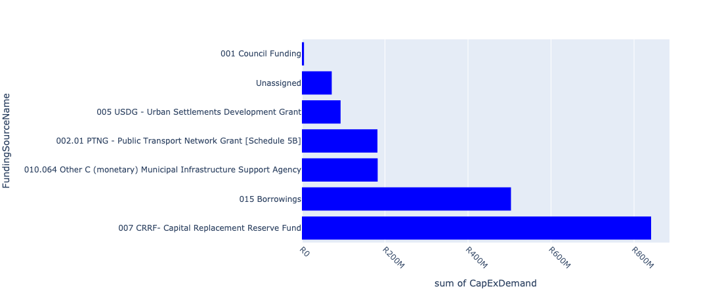

Figure 5.12: Region F Departmental Requests

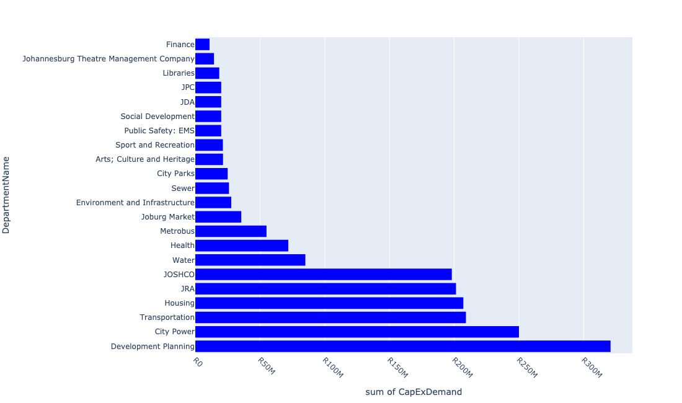

Table 5.6: Summary - Region F

|  |  |
| --- | --- |
| Item | Description |
| Total Capital Demand for Region F - All Years | R1,878,794,797 Rank: 3 (1 = Highest) |
| Total Capital Demand for Region F - MTREF | R1,834,578,585 Rank: 3 (1 = Highest) |
| Financial Years in which capital requirements are listed for Region F | 2023, 2024, 2025, 2026 and 2027 |
| Financial Year with highest capital demand for Region F | 2023 |
| Region F intersecting feature used | Works Location |
| Total number of projects intersecting with Region F | 586 Rank: 1 (1 = Highest) |

Table 5.7: All projects asking for budget in Region F

|  |  |  |  |
| --- | --- | --- | --- |
| Project ID | Project Name | Department | Project Budget |
| 23102 | 2804_09_ITS (Fibre Loop and CCTV)- Redundancy Loop | Transportation | R0.00 (0%) No budget request. |
| 23325 | 2804_20 Rea Vaya BRT Phase 1 A and B Station Rehabilitation | Transportation | R0.00 (0%) No budget request. |
| 23557 | 01_22684_Air Conditioners | Health | R69,349 (0.00%) Budget spread across: 2025, 2026 and 2027 |
| 22012 | DSM: Solar PV Systems on Buildings | City Power | R0.00 (0%) No budget request. |
| 23562 | 06_22684_Security Installations | Health | R474,120 (0.03%) Budget spread across: 2025, 2026 and 2027 |
| 23556 | 02_22684_Electricity Upgrade | Health | R1,264,493 (0.07%) Budget spread across: 2025, 2026 and 2027 |
| 2946 | MISCL: Pedestrian Bridge in Slovo Park (also Ashanti). New Bridges (Pedestrian and Vehicles) CORONATIONVILLE B Ward | JRA | R0.00 (0%) No budget request. |
| 22531 | Mining belt west development corridor: Eastern Precinct | Development Planning | R0.00 (0%) No budget request. |
| 2304 | Dog Kennel Hospital New Building Alterations GLENESK F Ward | Public Safety: JMPD | R0.00 (0%) No budget request. |
| 4032 | Rotunda Park Precinct Turffontein Corridor (JDA) New Precinct Redevelopment TURFFONTEIN F Regional | JDA | R0.00 (0%) No budget request. |
| 3981 | MOB - M2 Motorway at Main Reef Road Intersection. New Roads: Construction and Upgrades CROWN EXT.2 E Regional | JRA | R0.00 (0%) No budget request. |
| 4116 | Upgrading of Heritage Buildings in the Inner City F | Arts; Culture and Heritage | R0.00 (0%) No budget request. |
| 3437 | Public Art restoration programme | Arts; Culture and Heritage | R0.00 (0%) No budget request. |
| 4081 | Brixton MPC (Rec, Sports field and pool) upgrade MAYFAIR WEST B Ward | Sport and Recreation | R0.00 (0%) No budget request. |
| 21740 | Provision for consultants | Water | R0.00 (0%) No budget request. |
| 2476 | Johanesburg Central: Crown Gardens Water Upgrade | Water | R0.00 (0%) No budget request. |
| 2464 | Johannesburg Central: Glenvista Water Upgrade | Water | R0.00 (0%) No budget request. |
| 3472 | Southdale/ Laaglaagte: Crown Gardens Tower 1.1 ML | Water | R0.00 (0%) No budget request. |
| 4021 | Turffontein Corridor (JW: Water) Renewal Corridors of Freedom Intervention | Water | R0.00 (0%) No budget request. |
| 3700 | Shelters for Displaced People Region G | Social Development | R0.00 (0%) No budget request. |
| 23265 | Purchase of Land for Johannesburg Intermodal Transport Interchange (JITI) | Transportation | R0.00 (0%) No budget request. |
| 3723 | Fire Stations - Central Museum Establishment Renewal Building Alterations JOHANNESBURG A Regional | Public Safety: EMS | R0.00 (0%) No budget request. |
| 20703 | Central: Substation | City Power | R0.00 (0%) No budget request. |
| 22363 | Ghandi Square East | Development Planning | R0.00 (0%) No budget request. |
| 22246 | Mining Belt East Corridor New Capex Interventions Implementation | Development Planning | R28,000,000 (1.49%) Budget spread across: 2024 and 2025 |
| 20895 | Cleveland (CP_E228) | City Power | R0.00 (0%) No budget request. |
| 22887 | Springfield Street Trees Depot rainwater harvesting | City Parks | R0.00 (0%) No budget request. |
| 22054 | Mayfair Substation Upgrade | City Power | R0.00 (0%) No budget request. |
| 21204 | Fordsburg-John Ware-Selby | City Power | R0.00 (0%) No budget request. |
| 20872 | Vrededroop Sws: Satellite | City Power | R0.00 (0%) No budget request. |
| 23405 | 8765_01_This involves the purchase of batteries for core nodes ( these batteries are reaching the end of useful life) | Metropolitan Trading Company | R0.00 (0%) No budget request. |
| 21181 | Braamfontein Substation 88/11kV | City Power | R0.00 (0%) No budget request. |
| 2541 | Mulbarton Sub - Install additional 45MVA transformer,refurbishment and bus bar reconfiguration. New Bulk Infrastructure LIEFDE EN VREDE EXT.1 F Ward | City Power | R0.00 (0%) No budget request. |
| 2203 | New service connections New Service Connections BEREA F Regional | City Power | R16,500,000 (0.88%) Budget spread across: 2023 and 2024 |
| 21158 | Siemert : Illman Plastics bulk load supply | City Power | R0.00 (0%) No budget request. |
| 20795 | Mondeo S/S South Gate No3: Satellite | City Power | R0.00 (0%) No budget request. |
| 2303 | Building for stock supplies for dogs New Building Alterations OPHIRTON F Ward | Public Safety: JMPD | R0.00 (0%) No budget request. |
| 22486 | Delivery Programme 2: Subsidized municipal rental rooms | Housing | R0.00 (0%) No budget request. |
| 3159 | Moffat View Ext 6 New Bulk Infrastructure MOFFAT VIEW EXT.6 F Ward | Housing | R0.00 (0%) No budget request. |
| 22292 | 106 Claim Street Inner City Building Conversion Region F | JOSHCO | R0.00 (0%) No budget request. |
| 20935 | John Ware (CP_E256) | City Power | R0.00 (0%) No budget request. |
| 2627 | Department of Economic Development (DED) New Linear Markets JOHANNESBURG F Construction of linear market(informal trading shelter) in De Villiers Street | Economic Development | R0.00 (0%) No budget request. |
| 3362 | Agribusiness Sorting Centre | Joburg Market | R0.00 (0%) No budget request. |
| 2687 | Soweto masterplan - Baragwanath Hospital Renewal Medium Voltage Network BARAGWANATH F Ward | City Power | R0.00 (0%) No budget request. |
| 3614 | Johannnesburg Central: Planned Replacement Sewermains | Sewer | R25,000,000 (1.33%) Budget spread across: 2023 and 2024 |
| 22847 | Yeoville, Hillbrow, Berea Infrastructure Upgrading | Development Planning | R0.00 (0%) No budget request. |
| 22841 | Mobile sub-station | City Power | R42,500,000 (2.26%) Budget spread across: 2023 and 2024 |
| 3863 | Department of Economic Development New Linear Markets JOHANNESBURG F Construction of linear market(informal tradind shelter) in Berea New Linear Markets BEREA F Ward | Economic Development | R0.00 (0%) No budget request. |
| 23683 | Kensington B Tower 0.5 Ml | Water | R10,000,000 (0.53%) Budget spread across: 2024 |
| 20832 | Removal and Replacement of 20.5kV Equipment, Van Beek,Central & Selby SS. Inner City Renewal Medium Voltage Network SELBY F Regional | City Power | R0.00 (0%) No budget request. |
| 2635 | Yeoville Market Upgrading of existing facility Renewal Building Alterations JOHANNESBURG F Regional | JPC | R0.00 (0%) No budget request. |
| 23142 | 2804_15_Rea Vaya BRT Land Acquisition | Transportation | R0.00 (0%) No budget request. |
| 22549 | CCTV Equipment | Joburg Market | R0.00 (0%) No budget request. |
| 3076 | City Parks Economic Development Programme New Economic Infrastructure JOHANNESBURG F City Wide | Economic Development | R0.00 (0%) No budget request. |
| 20763 | Hursthill : Replacement of Auckland park distributor | City Power | R0.00 (0%) No budget request. |
| 3949 | Chelsea Inner City Building Upgrade Region F | JOSHCO | R0.00 (0%) No budget request. |
| 22541 | Smart Market Professional Services | Joburg Market | R0.00 (0%) No budget request. |
| 4092 | 27 Hoek Street New Inner City Building Conversion Region F | JOSHCO | R0.00 (0%) No budget request. |
| 20812 | PPC Jupiter: Substation (CP_E604) | City Power | R0.00 (0%) No budget request. |
| 23133 | 2804_12_Heritage Bridge Landscaping and Public Environment Upgrade Project | Transportation | R0.00 (0%) No budget request. |
| 21118 | Reuven : Proposed switching station in Olifantsvlei -Kibler area | City Power | R0.00 (0%) No budget request. |
| 2624 | Construction of linear market(informal trading shelter) in Wanderers Street New Linear Markets JOHANNESBURG F | Economic Development | R0.00 (0%) No budget request. |
| 22094 | Newtown Public Park Upgrade and service connections | JPC | R0.00 (0%) No budget request. |
| 22615 | Yeoville Precinct | Development Planning | R0.00 (0%) No budget request. |
| 2641 | Department of Economic Development(DED) New Linear Markets JOHANNESBURG F Construction of linear market(informal trading shelter) in Plein Street | Economic Development | R0.00 (0%) No budget request. |
| 21310 | Van Beek 22/6.6 kV | City Power | R0.00 (0%) No budget request. |
| 4072 | Market boundary substation Renewal Bulk Infrastructure TURFFONTEIN F Regional | City Power | R0.00 (0%) No budget request. |
| 3998 | Inner City (City Parks) New Inner City Intervention JOHANNESBURG F Regional | City Parks | R0.00 (0%) No budget request. |
| 3259 | Additional Capex New Building Alterations BRAAMPARK F Regional | Economic Development | R0.00 (0%) No budget request. |
| 2710 | Santon/Alexandra: Bruma ext 1-2 Upgrade sewers New Sewer Mains BRUMA E Ward | Sewer | R0.00 (0%) No budget request. |
| 22535 | Brixton Social Cluster | Development Planning | R0.00 (0%) No budget request. |
| 2555 | Operating Capital: DPUM Renewal Operational Capex BRAAMFONTEIN WERF F City Wide | Development Planning | R6,700,000 (0.36%) Budget spread across: 2023 |
| 20898 | Cydna (CP_E141) | City Power | R0.00 (0%) No budget request. |
| 21304 | Selby 88/11kV | City Power | R0.00 (0%) No budget request. |
| 23958 | 80 Albert Street, Johannesburg Renewal Clinic | Health | R0.00 (0%) No budget request. |
| 22323 | Noord Street | Development Planning | R0.00 (0%) No budget request. |
| 22286 | Construction of new shops | Joburg Market | R0.00 (0%) No budget request. |
| 21290 | Ridge Substation 88/11 kV | City Power | R0.00 (0%) No budget request. |
| 21241 | Moffat 88/11 kV | City Power | R0.00 (0%) No budget request. |
| 2355 | Ellis Park Precinct Social Housing Project Region F | JOSHCO | R0.00 (0%) No budget request. |
| 2269 | Convert PPC cement and Haggie Rand from 20.5kV to 11kV Renewal Bulk Infrastructure HERIOTDALE F Ward | City Power | R0.00 (0%) No budget request. |
| 3537 | Langlaagte Social Housing Project Region B | JOSHCO | R0.00 (0%) No budget request. |
| 2363 | Mayfair Renewal Clinic MAYFAIR F Ward | Health | R0.00 (0%) No budget request. |
| 6348 | Newtown Land Preparation and Packaging | JPC | R0.00 (0%) No budget request. |
| 21490 | Telecommunications last mile connectivity (CP_E995) | City Power | R0.00 (0%) No budget request. |
| 20706 | Cleveland: Substation (CP_E533) | City Power | R0.00 (0%) No budget request. |
| 2263 | New Service Connections REUVEN F Regional | City Power | R13,500,000 (0.72%) Budget spread across: 2023 and 2024 |
| 22280 | Construction of new cooking mamas | Joburg Market | R0.00 (0%) No budget request. |
| 21247 | Mulbarton 88/11 kV (CP_E164) | City Power | R0.00 (0%) No budget request. |
| 2870 | RNP011_8th Street Widening Renewal Roads: Construction and Upgrades VREDEDORP B Regional | JRA | R0.00 (0%) No budget request. |
| 22435 | Visitors Information Centre | Economic Development | R0.00 (0%) No budget request. |
| 20869 | Van Beek : Substation Upgrade | City Power | R0.00 (0%) No budget request. |
| 2561 | Hillbrow/Berea Precinct Development New Precinct/Nodal Development BEREA F Regional | Economic Development | R0.00 (0%) No budget request. |
| 3889 | Upgrade Mulbarton substation Renewal Bulk Infrastructure MULBARTON F Regional | City Power | R0.00 (0%) No budget request. |
| 23145 | 6660_02_Establishement of a Satellite Office at Thuso House | Public Safety: Head Office | R0.00 (0%) No budget request. |
| 4175 | Bertrams Precinct Revitalisation New Precinct/Nodal Development BERTRAMS F Ward | Economic Development | R0.00 (0%) No budget request. |
| 21155 | Siemert : Ellis Park Athletic switching station upgrade | City Power | R0.00 (0%) No budget request. |
| 22790 | Complete Streets: Turfontein | Transportation | R23,000,000 (1.22%) Budget spread across: 2023 |
| 3626 | Johannesburg Central: Alveda Park sewer upgrade ALVEDA EXT.1 D | Sewer | R0.00 (0%) No budget request. |
| 2346 | Horse Building for additional JMPD horses New Building Alterations SPRINGFIELD EXT.4 F | Public Safety: JMPD | R0.00 (0%) No budget request. |
| 3016 | RNP036_New Link Road from N12 (Xavier Street Extension to Columbine) New Roads: Construction and Upgrades MONDEOR F Regional | JRA | R0.00 (0%) No budget request. |
| 20892 | Cleveland (CP_E079) | City Power | R0.00 (0%) No budget request. |
| 23053 | Betrams New Multi Purpose Center | Social Development | R20,000,000 (1.06%) Budget spread across: 2023 |
| 22220 | Crown City Urban Renewal Strategy | Development Planning | R0.00 (0%) No budget request. |
| 2300 | Langlaagte One Stop Shop - Licensing Renewal Building Alterations LANGLAAGTE NORTH F Ward | Public Safety: JMPD | R0.00 (0%) No budget request. |
| 2200 | METRO MALL: MARKET- REPAIRS Renewal Building Alterations JOHANNESBURG-NORTH F Ward | JPC | R0.00 (0%) No budget request. |
| 22097 | Maimai (Informal Settlements) | Housing | R0.00 (0%) No budget request. |
| 3872 | Johannesburg Central: Turffontein Redevelopment Corridor Renewal Watermains | Water | R0.00 (0%) No budget request. |
| 2876 | RNP012_Main Road - Comptonville Renewal Roads: Construction and Upgrades COMPTONVILLE F Ward | JRA | R0.00 (0%) No budget request. |
| 22750 | Newtown UDF implementation | Development Planning | R0.00 (0%) No budget request. |
| 3219 | Kliprivier Nature Reserve Upgrade Renewal KLIPRIVIERSBERG F Regional | City Parks | R0.00 (0%) No budget request. |
| 20886 | Braamfontein (CP_E117) | City Power | R0.00 (0%) No budget request. |
| 20723 | Ellis park athletic_HVC379: Satellite | City Power | R0.00 (0%) No budget request. |
| 6411 | Braamfonteinspruit Upper Catchment (Alberts Farm and Botanical Gardens Upper Dams) | Environment and Infrastructure | R4,997,285 (0.27%) Budget spread across: 2023 |
| 3966 | WWTW Upgrade and refurbish | Sewer | R500,453 (0.03%) Budget spread across: 2024 |
| 2724 | Plant and equipment New Plant and Equipment JOHANNESBURG F Ward | City Parks | R10,000,000 (0.53%) Budget spread across: 2023 and 2024 |
| 4052 | Rachers Inner City Building Upgrade Region F | JOSHCO | R0.00 (0%) No budget request. |
| 3620 | Johanesburg Central: South East Direct sewer upgrade JOHANNESBURG D | Sewer | R0.00 (0%) No budget request. |
| 20932 | Jeppe (CP_E189) | City Power | R0.00 (0%) No budget request. |
| 22260 | Milpark Precinct Implementation | Development Planning | R0.00 (0%) No budget request. |
| 4112 | Upgrade MV Cable network Bez Valley New Medium Voltage Network BEZUIDENHOUT VALLEY F Regional | City Power | R0.00 (0%) No budget request. |
| 4012 | Turffontein Corridor (Housing) Renewal Corridors of Freedom Intervention TURFFONTEIN F Regional | Housing | R0.00 (0%) No budget request. |
| 3471 | Southdale/ Langlaagte: Naturena Reservoir New Reserviors NATURENA D Regional | Water | R0.00 (0%) No budget request. |
| 20975 | Robertsham (CP_E204) | City Power | R0.00 (0%) No budget request. |
| 22552 | The Hill Social Housing Project | JOSHCO | R0.00 (0%) No budget request. |
| 21811 | Yeoville Water Upgrade | Water | R0.00 (0%) No budget request. |
| 21124 | Reuven : Southgate switching station supply upgrade | City Power | R0.00 (0%) No budget request. |
| 2386 | Cross Border Support Hub New Small Business Hub JOHANNESBURG F Ward | Economic Development | R0.00 (0%) No budget request. |
| 22157 | Construction of Mondeor Fire Station | Public Safety: Fire Protection Services | R0.00 (0%) No budget request. |
| 22091 | Mangolongolo (Informal Settlement) | Housing | R0.00 (0%) No budget request. |
| 21238 | Mayfair Substation 88/11kV | City Power | R0.00 (0%) No budget request. |
| 3926 | PTF: Small Public Transport Facilities: Turffontein New Nodal Transport Facilities TURFFONTEIN F Regional | Transportation | R0.00 (0%) No budget request. |
| 4161 | Metro Centre Upgrade : Installation of Fire Rated Panelling (Partitions) | JPC | R0.00 (0%) No budget request. |
| 22469 | Booysens Place Inner City Building Conversion | JOSHCO | R0.00 (0%) No budget request. |
| 2429 | Removal and Replacement of 20.5kV Equipment; Van Beek;Central & Selby SS. Inner City Renewal Medium Voltage Network SELBY F Regional | City Power | R0.00 (0%) No budget request. |
| 2478 | Johannesburg Central:Crosby District: Upgrade water infrastructure New Water Mains CROSBY B Regional | Water | R0.00 (0%) No budget request. |
| 21264 | New Roodetown | City Power | R0.00 (0%) No budget request. |
| 3946 | Citrine Court Building Upgrade Region F | JOSHCO | R0.00 (0%) No budget request. |
| 2695 | Johannnesburg Central: South Eastern: Upgrade Sewers New Sewer Mains JOHANNESBURG F Ward | Sewer | R0.00 (0%) No budget request. |
| 21115 | Reuven : Proposed switching station in Diepkloof area | City Power | R0.00 (0%) No budget request. |
| 3803 | Salisbury House Erf 1052 and 1053 Renewal Heritage JEPPESTOWN F Ward | JPC | R0.00 (0%) No budget request. |
| 6651 | Additional Academy Branch ROSETTENVILLE | Public Safety: JMPD | R0.00 (0%) No budget request. |
| 22638 | Southdale/Langlaagte:Crown Gardens Tower 1.1 Ml | Water | R0.00 (0%) No budget request. |
| 22120 | Wemmer Pan precinct implementation | JDA | R0.00 (0%) No budget request. |
| 2644 | Department of Economic Development New Linear Markets JOHANNESBURG F Construction of linear market(informal tradind shelter) in Joubert Street | Economic Development | R0.00 (0%) No budget request. |
| 4075 | Wemmer Station Upgrade Renewal Bulk Infrastructure WEMMER F Regional | City Power | R0.00 (0%) No budget request. |
| 20995 | Van Beek (CP_E082) | City Power | R0.00 (0%) No budget request. |
| 22040 | CCTV Equipment for investigation purposes on JRA stormwater systems to assist in the daily maintenance or to identify capital interventions | JRA | R0.00 (0%) No budget request. |
| 22675 | Drieziek new MPC (ACH and Sports and Recreation) | Sport and Recreation | R20,000,000 (1.06%) Budget spread across: 2023 and 2024 |
| 6643 | Toilets at the JMPD Academy for new recruits | Public Safety: JMPD | R0.00 (0%) No budget request. |
| 23998 | Ridge Substation substation | City Power | R0.00 (0%) No budget request. |
| 23955 | Fleet Africa Public Transport Facility | Transportation | R0.00 (0%) No budget request. |
| 2801 | Upgrading of the Pioneer Park skills Renewal Community hall ROBERTSHAM F Ward | Social Development | R0.00 (0%) No budget request. |
| 22326 | Large Public Transport Facility: Redevelopment of Jack Mincer and/or, Carr Street, Inner City | Transportation | R0.00 (0%) No budget request. |
| 22283 | Construction of new archive centre | Joburg Market | R0.00 (0%) No budget request. |
| 2856 | RNP034_Upgrading and development of K47 New Roads: Construction and Upgrades ELDORADO PARK EXT.1 G Ward | JRA | R0.00 (0%) No budget request. |
| 22475 | Hillbrow/Berea Catchment Infrastructure | Development Planning | R0.00 (0%) No budget request. |
| 23806 | Test Project | City Parks | R0.00 (0%) No budget request. |
| 20870 | Van Beek : Substation (CP_E616) | City Power | R0.00 (0%) No budget request. |
| 2301 | Building for filing at Academy New Building Alterations OPHIRTON F Ward | Public Safety: JMPD | R0.00 (0%) No budget request. |
| 22198 | New Security Perimeter wall | Joburg Market | R0.00 (0%) No budget request. |
| 2633 | Department of Economic Development(DED) New Linear Markets JOHANNESBURG F Construction of linear market(informal trading shelter) in Von Brandis Street | Economic Development | R0.00 (0%) No budget request. |
| 20893 | Cleveland (CP_E185) | City Power | R0.00 (0%) No budget request. |
| 22553 | Glenanda Social Housing Project | JOSHCO | R0.00 (0%) No budget request. |
| 4176 | City Deep Multi-modal Facility New Small Business Hub CITY DEEP F Ward | Economic Development | R0.00 (0%) No budget request. |
| 2587 | Stormwater Management Renewal Drainage System ROSETTENVILLE EXT.2 F Ward | Public Safety: JMPD | R0.00 (0%) No budget request. |
| 2516 | Pritchard Street Clinic (Inner City) JOHANNESBURG F Ward | Health | R0.00 (0%) No budget request. |
| 4199 | Replacement of lifts in Corporate Buildings : Newtown New Building Alterations NEWTOWN F Regional | JPC | R0.00 (0%) No budget request. |
| 3867 | Fick Street Park Upgrade Renewal Park SOUTH HILLS F Ward | City Parks | R0.00 (0%) No budget request. |
| 21110 | Reuven : Container Depot switching station upgrade | City Power | R0.00 (0%) No budget request. |
| 2796 | Upgrade MV network Renewal Medium Voltage Network HERIOTDALE F | City Power | R0.00 (0%) No budget request. |
| 23025 | Klipriviersberg Nature Reserve roof and surface rainwater harvesting | City Parks | R0.00 (0%) No budget request. |
| 22361 | Fordsburg PEU | Development Planning | R38,500,000 (2.05%) Budget spread across: 2023 and 2024 |
| 2842 | Klipriver/Klipspruit Greening and Rehabilitation Project- Ecoparks development landscaping- Mayoral 2010 Legacy New Park JOHANNESBURG F Regional | Environment and Infrastructure | R0.00 (0%) No budget request. |
| 20964 | PPC Jupiter (CP_E246) | City Power | R0.00 (0%) No budget request. |
| 2639 | Department of Economic Development(DED) New Linear Markets JOHANNESBURG F Construction of linear market(informal trading shelter) in Yeoville/Raleigh Street | Economic Development | R0.00 (0%) No budget request. |
| 8770 | ICDG funded projects: New Programme Johannesburg City Wide | Development Planning | R0.00 (0%) No budget request. |
| 3280 | Extend Mondeor sub station and construct new Mondeor 88 kV switching station. New Bulk Infrastructure MONDEOR F Regional | City Power | R0.00 (0%) No budget request. |
| 20924 | Haggie (CP_E247) | City Power | R0.00 (0%) No budget request. |
| 20887 | Braamfontein (CP_E137) | City Power | R0.00 (0%) No budget request. |
| 22547 | Alternative Energy Systems | Joburg Market | R27,000,000 (1.44%) Budget spread across: 2023 and 2024 |
| 3065 | Shanty Clinic Renewal Clinic Region D | Health | R0.00 (0%) No budget request. |
| 2284 | Revamping of the Informal Trading Stalls within the Inner City Renewal Operational Capex JOHANNESBURG F Ward | JPC | R15,000,000 (0.80%) Budget spread across: 2023 |
| 21657 | Robinson Deep Landfill site acquisition of adajcent land | Pikitup | R0.00 (0%) No budget request. |
| 3017 | RNP002_Rand Show Road: Eastern Extension New Roads: Construction and Upgrades ORMONDE F Regional | JRA | R0.00 (0%) No budget request. |
| 2673 | New Fire Station - Central Fire Station MARSHALLS TOWN F Ward | Public Safety: EMS | R20,000,000 (1.06%) Budget spread across: 2023 |
| 20970 | Ridge (CP_E111) | City Power | R0.00 (0%) No budget request. |
| 20933 | Johannesburg Central A | City Power | R0.00 (0%) No budget request. |
| 6314 | Convert 6.6/11kV networks in Siemert Area | City Power | R0.00 (0%) No budget request. |
| 3621 | Johannesburg Central: South East Upper sewer upgrade JOHANNESBURG D | Sewer | R0.00 (0%) No budget request. |
| 4007 | Turffontein (City Power) Renewal Corridors of Freedom Intervention TURFFONTEIN F Regional | City Power | R0.00 (0%) No budget request. |
| 4107 | Upgrade Prospect Intake Substation Renewal Bulk Infrastructure MOFFAT VIEW F Regional | City Power | R0.00 (0%) No budget request. |
| 21173 | Bellevue - Observatory T (CP_E032) | City Power | R0.00 (0%) No budget request. |
| 22845 | Newtown UDF Implementation | Development Planning | R20,500,000 (1.09%) Budget spread across: 2023 and 2024 |
| 2716 | Johannesburg Central: Bruma Sewer Upgrade | Sewer | R0.00 (0%) No budget request. |
| 2739 | Kibler Park Clinic; Furniture and Equipment Renewal Clinic KIBLER PARK F Ward | Health | R0.00 (0%) No budget request. |
| 2622 | To upgrade the two taxi ranks in order to accommodate the informal taxi rank and the hawkers. Renewal Building Alterations JEPPESTOWN F Ward | JPC | R0.00 (0%) No budget request. |
| 22235 | Wemmer Pan precinct implementation | Development Planning | R0.00 (0%) No budget request. |
| 22470 | 38 Rissik Street (NBS) Inner City Building Conversion | JOSHCO | R73,650,000 (3.92%) Budget spread across: 2023 and 2024 |
| 4113 | Upgrade MV Networks in CBD Renewal Medium Voltage Network JOHANNESBURG F Regional | City Power | R22,500,000 (1.20%) Budget spread across: 2023 and 2024 |
| 4213 | Sports and Recreation Operational Capital JOHANNESBURG F | Sport and Recreation | R1,300,000 (0.07%) Budget spread across: 2023 and 2024 |
| 21116 | Reuven : Proposed switching station in Elandspark area | City Power | R0.00 (0%) No budget request. |
| 22023 | South Hills Electrification | City Power | R0.00 (0%) No budget request. |
| 4047 | La Rosabel Inner City Building Upgrading Region F | JOSHCO | R0.00 (0%) No budget request. |
| 2547 | New farm New Building Alterations WINCHESTER HILLS EXT.1 E Ward | City Parks | R0.00 (0%) No budget request. |
| 23131 | 2804_17_Selby Bus Depot (Phase 2B – Workshops & External Works) | Transportation | R0.00 (0%) No budget request. |
| 6675 | Lipro Mobile Payment Centre House VILLAGE MAIN | Public Safety: JMPD | R0.00 (0%) No budget request. |
| 22490 | Road Traffic Management | Joburg Market | R0.00 (0%) No budget request. |
| 4096 | Mogase View Spruit Eco Park Park JOHANNESBURG F Ward | City Parks | R0.00 (0%) No budget request. |
| 2765 | Demand side management New Load Management REUVEN F | City Power | R0.00 (0%) No budget request. |
| 3357 | Refurbishments/Construction of ablution facilities | Joburg Market | R8,500,000 (0.45%) Budget spread across: 2023 and 2024 |
| 22513 | Lenasia High Level Reservoir 10ML | Water | R0.00 (0%) No budget request. |
| 6303 | Convert and Transfer 6.6kV distributors to 11kV distributors | City Power | R0.00 (0%) No budget request. |
| 4133 | Turffontein Corridor New Social Housing Project Region E | JOSHCO | R0.00 (0%) No budget request. |
| 2461 | Hoek Street - Linear Market Phase 1 and 2 - New Trading Facilities for Informal Traders New Linear Markets FORDSBURG F Ward | Economic Development | R0.00 (0%) No budget request. |
| 23864 | Training_20211005 | Finance | R11,000,000 (0.59%) Budget spread across: 2023 and 2024 |
| 20747 | Haggie : Substation | City Power | R0.00 (0%) No budget request. |
| 20996 | Van Beek (CP_E222) | City Power | R0.00 (0%) No budget request. |
| 6646 | Puppies Training Camp ROSETTENVILLE | Public Safety: JMPD | R0.00 (0%) No budget request. |
| 24044 | New Project | City Parks | R0.00 (0%) No budget request. |
| 3990 | Brixton Transit Precinct Development Renewal Precinct Redevelopment BRIXTON B City Wide | JDA | R0.00 (0%) No budget request. |
| 2553 | Engine and Gear box refurbishment | Metrobus | R30,000,000 (1.60%) Budget spread across: 2023 and 2024 |
| 20512 | HurstHill: Pole-Mounted Transformer year 2015 projects | City Power | R0.00 (0%) No budget request. |
| 2653 | Creating additional space using decking technology by building decks over railway lines | Economic Development | R0.00 (0%) No budget request. |
| 20755 | Highpoint Sws: Satellite | City Power | R0.00 (0%) No budget request. |
| 22378 | Turnkey Developments Social Housing Project | JOSHCO | R0.00 (0%) No budget request. |
| 23953 | Carr Street Public Transport Facility | Transportation | R0.00 (0%) No budget request. |
| 20704 | Church Sws: Satellite | City Power | R0.00 (0%) No budget request. |
| 6380 | Revitalisation of Pageview and Vrededorp | JDA | R10,000,000 (0.53%) Budget spread across: 2023 |
| 3795 | MBV Inner City Building Upgrade Region F | JOSHCO | R0.00 (0%) No budget request. |
| 22364 | Drill Hall Acquisition | Development Planning | R0.00 (0%) No budget request. |
| 22032 | Catchment rehabilitation Mulbarton | JRA | R0.00 (0%) No budget request. |
| 8727 | Mining Belt West: Main Reef Reservoir 2-Install distribution mains | Development Planning | R0.00 (0%) No budget request. |
| 22888 | JCPZ Head office | City Parks | R0.00 (0%) No budget request. |
| 4219 | Natalspruit Water Management Unit New Ecological Infrastructure WEMMER PAN, TURFFONTEIN F Regional | Environment and Infrastructure | R0.00 (0%) No budget request. |
| 22195 | New Turfontein Clinic | Development Planning | R35,000,000 (1.86%) Budget spread across: 2023 |
| 21205 | Fort Substation 88/11 kV (CP_E027) | City Power | R0.00 (0%) No budget request. |
| 20944 | Mayfair (CP_E225) | City Power | R0.00 (0%) No budget request. |
| 21182 | Bree Substation 88/11kV | City Power | R0.00 (0%) No budget request. |
| 20967 | Prospect (CP_E083) | City Power | R0.00 (0%) No budget request. |
| 20844 | Robertsham: Substation upgrade | City Power | R0.00 (0%) No budget request. |
| 22295 | Ennerdale Ext 2 | Housing | R0.00 (0%) No budget request. |
| 3870 | Johannesburg Central: Turfontein Redevelopment Corridor Sewer Renewal | Sewer | R0.00 (0%) No budget request. |
| 22318 | Agent's Carports | Joburg Market | R0.00 (0%) No budget request. |
| 21159 | Siemert : Jeppe substation 6.6kV distribution network conversion | City Power | R0.00 (0%) No budget request. |
| 3014 | MISCL - Inner City Improvement Renewal Roads: Construction and uogrades JOHANNESBURG F Regional | JRA | R0.00 (0%) No budget request. |
| 7685 | Mining Belt West: Tailings Dams/ Slimes Dams Reclamation Interventions (Remove/Rehabilitate Crown Tailing Dams/Mine Dumps/Open cast mine areas in Nasrec and Diepkloof to unlock 500ha of land for development)) | Development Planning | R0.00 (0%) No budget request. |
| 23546 | Remainder of Portion 144 of the Farm Langlaagte 244-IQ | JPC | R0.00 (0%) No budget request. |
| 22358 | Innercity Eastern Gateway | Development Planning | R0.00 (0%) No budget request. |
| 4050 | 195 Commissioner Street Inner City Building Conversion Region F | JOSHCO | R0.00 (0%) No budget request. |
| 21113 | Reuven : Polyoak switching station upgrade | City Power | R0.00 (0%) No budget request. |
| 4110 | Cable upgrade New Doornfontein New Medium Voltage Network NEW DOORNFONTEIN F Regional | City Power | R0.00 (0%) No budget request. |
| 22264 | Development of Conservation Park SOUTH HILL (LION PARK area) | Environment and Infrastructure | R5,250,000 (0.28%) Budget spread across: 2023 and 2024 |
| 3114 | New 88/11 kV substation near Park station. New Bulk Infrastructure NEWTOWN F Regional | City Power | R0.00 (0%) No budget request. |
| 2782 | Cleveland Substation, Reconfigure busbar, replace high risk transformer, add additional 45 MVA transformer andfeeder board. Renewal Bulk Infrastructure HERIOTDALE EXT.10 F Regional | City Power | R0.00 (0%) No budget request. |
| 4016 | CORR - Perth Empire Transit Oriented Development (TOD) corridor Traffic Impact Assessment (TIA), Stormwater Masterplan and New Constriction and Upgrading Renewal Corridors of Freedom Intervention WESTBURY B Regional | JDA | R0.00 (0%) No budget request. |
| 4004 | Inner City Roadmap Economic Development Initiatives Renewal Inner City Intervention JOHANNESBURG F Regional | Economic Development | R0.00 (0%) No budget request. |
| 21316 | Wemmer 88/11 kV | City Power | R0.00 (0%) No budget request. |
| 2736 | Glenanda Clinic New Clinic GLENANDA F Ward | Health | R0.00 (0%) No budget request. |
| 3277 | Install additional 45 MVA transformer at Kaserne New Bulk Infrastructure DROSTE PARK F Regional | City Power | R0.00 (0%) No budget request. |
| 21122 | Reuven : Replacement of Pillar box | City Power | R0.00 (0%) No budget request. |
| 2636 | Department of Economic Development(DED) New Linear Markets JOHANNESBURG F Construction of linear market(informal trading shelter) at Westgate Taxi Rank | Economic Development | R0.00 (0%) No budget request. |
| 2630 | Department of Economic Development (DED) New Linear Markets JOHANNESBURG F Construction of linear market(informal trading shelter) in King George Street | Economic Development | R0.00 (0%) No budget request. |
| 21222 | Kaserne 88/11 kV (CP_E051) | City Power | R0.00 (0%) No budget request. |
| 3615 | Johannesburg Central: City Deep sewer upgrade CITY DEEP D | Sewer | R0.00 (0%) No budget request. |
| 2287 | Establish new 88/11 kV sub station in the Crown/Edgardale area. New Bulk Infrastructure CROWN CITY EXT.26 F Regional | City Power | R0.00 (0%) No budget request. |
| 22550 | Malvern Building Conversion | JOSHCO | R0.00 (0%) No budget request. |
| 3973 | Johannesburg Central: Langlaagte water upgrade Renewal LANGLAAGTE D | Water | R0.00 (0%) No budget request. |
| 20858 | Show Grounds Sws: Satellite | City Power | R0.00 (0%) No budget request. |
| 23941 | Complete Streets in Mulbarton | Transportation | R0.00 (0%) No budget request. |
| 22281 | Inner City Eastern Gateway_TOD and Movement Corridors | JDA | R10,000,000 (0.53%) Budget spread across: 2023 |
| 21285 | Pritchard 88/11 kV substation upgrade | City Power | R0.00 (0%) No budget request. |
| 4044 | Gezina Renewal Building Alterations JOHANNESBURG F Regional | JOSHCO | R0.00 (0%) No budget request. |
| 20764 | Hursthill : Replacement of brick kiosk | City Power | R0.00 (0%) No budget request. |
| 4067 | Upgrade Wemmer Pan Park Facilities Renewal Park WEMMER F Regional | City Parks | R0.00 (0%) No budget request. |
| 3618 | Johannesburg Central: Ormonde sewer upgrade ORMONDE D | Sewer | R0.00 (0%) No budget request. |
| 2954 | CATCH 215 - Bloubos Spruit Catchment: Erosion Protection: Mondeor- Ormonde Dr @ Floreston Renewal Stormwater Catchments ORMONDE EXT.12 F Ward | JRA | R0.00 (0%) No budget request. |
| 2407 | CATCH 240 - Stormwater Network Upgrade: Mayfair. Renewal Stormwater Management Projects MAYFAIR B Ward | JRA | R0.00 (0%) No budget request. |
| 20738 | Fort: Substation | City Power | R0.00 (0%) No budget request. |
| 22544 | New Conferencing Facilities | Joburg Market | R0.00 (0%) No budget request. |
| 22089 | George Goch (Informal Settlements) | Housing | R0.00 (0%) No budget request. |
| 6555 | Roodepoort/Diepsloot: Kensington Water Upgrade | Water | R0.00 (0%) No budget request. |
| 2642 | Department of Economic Development(DED) New Linear Markets JOHANNESBURG F Construction of linear market(informal trading shelter) in Edith Carvell Street | Economic Development | R0.00 (0%) No budget request. |
| 6649 | Hostel ROSETTENVILLE | Public Safety: JMPD | R0.00 (0%) No budget request. |
| 2862 | MISCL - Pedestrian Bridge in Berea New Bridges (Pedestrian and Vehicles) BEREA F Ward | JRA | R0.00 (0%) No budget request. |
| 21305 | Siemert 88/11kV | City Power | R0.00 (0%) No budget request. |
| 20838 | Reuven : Lange switching station switchgear refurbishment | City Power | R0.00 (0%) No budget request. |
| 21162 | Siemert : Proposed switching station at Newtown Junction | City Power | R0.00 (0%) No budget request. |
| 2593 | Ablution Blocks for Academy New Building Alterations OPHIRTON F Ward | Public Safety: JMPD | R0.00 (0%) No budget request. |
| 22659 | Southdale/Langlaagte:Brixton Tower 2ML | Water | R0.00 (0%) No budget request. |
| 4093 | 80 Plein Street Inner City Building Conversion Region F | JOSHCO | R0.00 (0%) No budget request. |
| 2619 | Department of Economic Development (DED) New Linear Markets JOHANNESBURG F Construction of linear market(informal trading shelter) in Delvers Street | Economic Development | R0.00 (0%) No budget request. |
| 22287 | Fraser House Inner City Building Conversion Region F | JOSHCO | R0.00 (0%) No budget request. |
| 3552 | Sandton/ Alexandra: Berea Water upgrade New Water Mains BEREA B Regional | Water | R0.00 (0%) No budget request. |
| 4073 | Produce Market Substation Renewal Bulk Infrastructure CITY DEEP F Regional | City Power | R0.00 (0%) No budget request. |
| 2911 | Convert LPUs to AMR Renewal Service Connections REUVEN F | City Power | R0.00 (0%) No budget request. |
| 21242 | Mondeor 88/11 kV | City Power | R0.00 (0%) No budget request. |
| 2662 | IT Equipment, New Computers and Hardware Computer Hardware | Metrobus | R25,000,000 (1.33%) Budget spread across: 2023 and 2024 |
| 20950 | Observatory | City Power | R0.00 (0%) No budget request. |
| 22473 | Yeoville Precinct | Development Planning | R0.00 (0%) No budget request. |
| 21491 | Telecommunications last mile connectivity (CP_E1017) | City Power | R0.00 (0%) No budget request. |
| 3167 | Glenesk IR Portion 7of Erf 1 (1320 Unit) New Bulk Infrastructure GLENESK F Ward | Housing | R0.00 (0%) No budget request. |
| 3130 | Upgrade of Sir Drummond Chaplin Park Crosby Renewal Park CROSBY B Ward | City Parks | R0.00 (0%) No budget request. |
| 3090 | Network development for townships and service connections. New Medium Voltage Network REUVEN F Regional | City Power | R0.00 (0%) No budget request. |
| 3087 | Network development for townships and service connections. New Medium Voltage Network HURST HILL B Regional | City Power | R0.00 (0%) No budget request. |
| 3064 | Southhills Clinic Renewal Clinic SOUTH HILLS F Ward | Health | R0 (0.00%) Budget spread across: 2024 |
| 3018 | Upgrade Mondeor distributor. Renewal Medium Voltage Network MONDEOR F Ward | City Power | R0.00 (0%) No budget request. |
| 2998 | MOB - Guardrails. Renewal Roads: Construction and Upgrades JOHANNESBURG F Regional | JRA | R40,000,000 (2.13%) Budget spread across: 2023 and 2024 |
| 2952 | RNP070_Widening and Upgrade of Lower Germiston Road Renewal Roads: Construction and Upgrades ROSHERVILLE F Ward | JRA | R0.00 (0%) No budget request. |
| 2895 | Joburg Art Gallery Upgrade JOHANNESBURG F | Arts; Culture and Heritage | R0.00 (0%) No budget request. |
| 2869 | RNP027_Extension of the M2 Highway New Roads: Construction and Upgrades CROWN EXT.3 B Regional | JRA | R0.00 (0%) No budget request. |
| 2838 | Robinson Canal litter trap repair New Ecological Infrastructure SELBY EXT.13 F Ward | Environment and Infrastructure | R0.00 (0%) No budget request. |
| 2826 | Acquisition of strategic open spaces and priorities conservation areas . New Operational Capex JOHANNESBURG F | Environment and Infrastructure | R0.00 (0%) No budget request. |
| 2806 | Joburg Theatre - Building Renovations and upgrades New Building Alterations JOHANNESBURG F Ward | Johannesburg Theatre Management Company | R2,148,500 (0.11%) Budget spread across: 2023 and 2024 |
| 2723 | City Parks House – Building upgrade New Building Alterations JOHANNESBURG F Ward | City Parks | R0.00 (0%) No budget request. |
| 2715 | Johannesburg Central: Kibler Park water district: Upgrade water infrastructure New Water Mains KIBLER PARK D Regional | Water | R0.00 (0%) No budget request. |
| 2692 | WWTW: Ferric dosing x14 New Bulk Waste Water BERTRAMS F City Wide | Sewer | R0.00 (0%) No budget request. |
| 2632 | Upgrading of the Hillbrow Public Transport Facility and taxi rank upgrade JOHANNESBURG F Ward | JPC | R0.00 (0%) No budget request. |
| 2629 | Department of Economic Development (DED) New Linear Markets JOHANNESBURG F Construction of linear market(informal trading shelter) in Eloff Street | Economic Development | R0.00 (0%) No budget request. |
| 2626 | Department of Economic Development (DED) New Linear Markets JOHANNESBURG F Construction of linear market(informal trading shelter) in Twist Street | Economic Development | R0.00 (0%) No budget request. |
| 2623 | Department of Economic Development (DED) New Linear Markets JOHANNESBURG F Construction of linear market(informal trading shelter) in Hancock Street | Economic Development | R0.00 (0%) No budget request. |
| 2520 | WWTW: Automation Of WWTW Plant | Sewer | R500,226 (0.03%) Budget spread across: 2024 |
| 2440 | Francoise Oberholzer Park upgrade (Rossettenville) Renewal Park ROSETTENVILLE EXT F Ward | City Parks | R0.00 (0%) No budget request. |
| 2420 | VANNIN COURT Renewal Building Alterations JOHANNESBURG F | JOSHCO | R0.00 (0%) No budget request. |
| 2391 | CATCH 210 - Bloubos Spruit Catchment: Erosion Protection and Stormwater Attenuation: Klipriviersberg Nature Reserve New Stormwater Catchments BLOUBOSRAND EXT.9 F Ward | JRA | R0.00 (0%) No budget request. |
| 2357 | Selby Staff Hostel Redevelopment Region F | JOSHCO | R0.00 (0%) No budget request. |
| 2354 | Turffontein Social Housing Project Region F | JOSHCO | R0.00 (0%) No budget request. |
| 2351 | City Deep Social Housing Project Region F | JOSHCO | R0.00 (0%) No budget request. |
| 2337 | Refurbishment of LV infrastructure Renewal Low Voltage REUVEN F Regional | City Power | R10,000,000 (0.53%) Budget spread across: 2023 |
| 2320 | Sandton/ Alexandra: Yeoville Water Upgrade | Water | R0.00 (0%) No budget request. |
| 2248 | Johannesburg Central:planned Replacement Watermains | Water | R25,000,000 (1.33%) Budget spread across: 2023 and 2024 |
| 2208 | The construction of new infrastructure in newly established townships New Network Development JOHANNESBURG F Regional | City Power | R0.00 (0%) No budget request. |
| 23762 | Kensington Booster | Water | R20,000,000 (1.06%) Budget spread across: 2023 and 2024 |
| 23711 | Development of South Hills Eco Park | Environment and Infrastructure | R17,500,000 (0.93%) Budget spread across: 2024, 2025 and 2026 |
| 23436 | Furniture and office equipment | Group Forensic and Investigation Services | R0.00 (0%) No budget request. |
| 23413 | Naturena Bulk Water Upgrade | Water | R0.00 (0%) No budget request. |
| 23339 | City Deep/Denver New Clinic | Health | R0.00 (0%) No budget request. |
| 23296 | Upgrading and Engineering Services at Selby Depot | Pikitup | R0.00 (0%) No budget request. |
| 23110 | 3251_01_Upgrading of weighbridge at Langlaagte testing centre | Public Safety: Head Office | R0.00 (0%) No budget request. |
| 23104 | 2804_03_Bus Monitoring and Contract Management | Transportation | R119,855,000 (6.38%) Budget spread across: 2023 |
| 22878 | Catering Insourcing | Johannesburg Theatre Management Company | R0.00 (0%) No budget request. |
| 22849 | Springfield FM depot rainwater harvesting | City Parks | R0.00 (0%) No budget request. |
| 22846 | Drill Hall Heritage Study PEU Implementation | Development Planning | R0.00 (0%) No budget request. |
| 22769 | Boundry Fence Academy | Public Safety: JMPD | R0.00 (0%) No budget request. |
| 22660 | Southdale/Langlaagte:Crown Gardens Reservoir 20ML | Water | R0.00 (0%) No budget request. |
| 22640 | Southdale/Langlaagte:Crosby Tower 1.4ML | Water | R0.00 (0%) No budget request. |
| 22617 | Hillbrow/Berea Catchment infrastructure | Development Planning | R0.00 (0%) No budget request. |
| 22540 | New Housewives Market | Joburg Market | R0.00 (0%) No budget request. |
| 22480 | Facilitation Programme 1: SPRE | Housing | R0.00 (0%) No budget request. |
| 22474 | Westgate Precinct | Development Planning | R0.00 (0%) No budget request. |
| 22420 | NR: Nodal Regeneration: Gandhi Square East Precinct | Transportation | R0.00 (0%) No budget request. |
| 22360 | PROPOSED DETAILED ROAD MASTER PLAN :MINING BELT WEST STRATEGIC AREA FRAMEWORK 2016 | JRA | R0.00 (0%) No budget request. |
| 22334 | Hillbrow Tower Precinct | Development Planning | R0.00 (0%) No budget request. |
| 22331 | Mining Land East | Development Planning | R0.00 (0%) No budget request. |
| 22328 | Rehabilitation of river systems in Protected Areas (Little Falls Nature Reserve, KNR Nature Reserve, Melville Koppies Nature Reserve) | Environment and Infrastructure | R0.00 (0%) No budget request. |
| 22314 | Consignment Control Additional Storage Space | Joburg Market | R0.00 (0%) No budget request. |
| 22297 | Abel Road Inner City Building Conversion Region F | JOSHCO | R0.00 (0%) No budget request. |
| 22294 | 50 Durban Street Inner City Building Conversion Region F | JOSHCO | R0.00 (0%) No budget request. |
| 22268 | Ecological infrastructure for drainage management and biodiversity support MULBARTON | Environment and Infrastructure | R0.00 (0%) No budget request. |
| 22245 | _Brixton Social Cluster | Development Planning | R22,000,000 (1.17%) Budget spread across: 2023 and 2024 |
| 22231 | Johannesburg Central: Crosby Tower 1.4ML | Water | R0.00 (0%) No budget request. |
| 22228 | Southdale/ Langlaagte: Winchester Hills Reservoir 12Ml | Water | R10,000,000 (0.53%) Budget spread across: 2024 |
| 22225 | Crown City Urban Renewal Interventions Implementation | Development Planning | R0 (0.00%) Budget spread across: 2024 |
| 21913 | Crown North Water Upgrade | Water | R0.00 (0%) No budget request. |
| 21773 | Hursthill Water Upgrade | Water | R0.00 (0%) No budget request. |
| 21309 | Trade Route | City Power | R0.00 (0%) No budget request. |
| 21292 | Robertsham 88/11 kV | City Power | R0.00 (0%) No budget request. |
| 21269 | Observatory 88/11 kV | City Power | R0.00 (0%) No budget request. |
| 21223 | Kaserne 88/11 kV (CP_E160) | City Power | R0.00 (0%) No budget request. |
| 4140 | Rissik Street Post Office Restoration Project New Heritage JOHANNESBURG F Regional | JPC | R0.00 (0%) No budget request. |
| 4129 | Museum Africa and Precinct (Three houses, workers museum, Mary Fitzgerald Square) | Arts; Culture and Heritage | R20,000,000 (1.06%) Budget spread across: 2023 and 2024 |
| 4109 | Upgrade MV Networks in Newtown New Medium Voltage Network NEWTOWN F Regional | City Power | R0.00 (0%) No budget request. |
| 4106 | Network conversions in Meredale Area Renewal Medium Voltage Network MEREDALE F Regional | City Power | R0.00 (0%) No budget request. |
| 4089 | Knowledge Precinct: Auckland Park Pedestrian Crossing New Precinct Redevelopment AUCKLAND PARK B City Wide | JDA | R0.00 (0%) No budget request. |
| 4074 | Wemmer 11kV Sub-station Renewal Bulk Infrastructure WEMMER F Regional | City Power | R0.00 (0%) No budget request. |
| 4057 | Yeoville Park Upgrade Renewal Park YEOVILLE F Regional | City Parks | R0.00 (0%) No budget request. |
| 4046 | Casamia Inner City Building Upgrade Region F | JOSHCO | R71,453,000 (3.80%) Budget spread across: 2023 and 2024 |
| 4043 | Sievewright Inner City Building Conversion Region F | JOSHCO | R0.00 (0%) No budget request. |
| 4017 | CORR - Turffontein Corridor of Freedom Traffic Impact Assessment (TIA), Stormwater Masterplan and New Construction and Upgrading Renewal Corridors of Freedom Intervention Renewal Stormwater Management Projects JOHANNESBURG F Regional | JDA | R0.00 (0%) No budget request. |
| 4003 | Inner City (Dev Planning) Renewal Inner City Intervention JOHANNESBURG F Regional | Development Planning | R0.00 (0%) No budget request. |
| 3971 | Bertrams Social Housing Project Region F | JOSHCO | R0.00 (0%) No budget request. |
| 3943 | Neibourhood Development for Bertrams Priority Block New Building Alterations BERTRAMS F Regional | JPC | R0.00 (0%) No budget request. |
| 3880 | EPWP Projects New Building Alterations JOHANNESBURG F City Wide | Economic Development | R0.00 (0%) No budget request. |
| 3828 | AA HOUSE PHASE 2 Inner City Building Upgrade Region F | JOSHCO | R0.00 (0%) No budget request. |
| 3817 | RESUR - Resurfacing of M2 Motorway. Renewal Roads: Rehabilitation JOHANNESBURG F City Wide | JRA | R90,479,689 (4.82%) Budget spread across: 2023 and 2024 |
| 3797 | Nederburg Social Housing Project Region A | JOSHCO | R0.00 (0%) No budget request. |
| 3619 | Soweto: Paarlshoop Sewer Upgrade | Sewer | R0.00 (0%) No budget request. |
| 3616 | Johannesburg Central: Jupiter sewer upgrade JOHANNESBURG D | Sewer | R0.00 (0%) No budget request. |
| 3513 | Park Upgrade J.C. Luckas Turffontein Renewal Park TURFFONTEIN F Ward | City Parks | R0.00 (0%) No budget request. |
| 3473 | Southdale/ Langlaagte: Aeroton Direct Tower1.4ML | Water | R0.00 (0%) No budget request. |
| 3333 | Gazena Hostel Conversion Renewal Building Alterations CITY DEEP F City Wide | JOSHCO | R0.00 (0%) No budget request. |
| 3264 | Underground bins upgrading and new | Pikitup | R0.00 (0%) No budget request. |
| 23954 | Jack Mincer Public Transport Facility | Transportation | R0.00 (0%) No budget request. |
| 21212 | Haggie Rand | City Power | R0.00 (0%) No budget request. |
| 21206 | Fort Substation 88/11 kV (CP_E269) | City Power | R0.00 (0%) No budget request. |
| 21203 | Fordsburg - Brammfonte- Bree | City Power | R0.00 (0%) No budget request. |
| 21186 | Central 88/11 kV | City Power | R0.00 (0%) No budget request. |
| 21172 | Bellevue - Observatory T (CP_E103) | City Power | R0.00 (0%) No budget request. |
| 21166 | Siemert : Proposed switching station in Observatory area | City Power | R0.00 (0%) No budget request. |
| 21163 | Siemert : Proposed switching station in Denver area | City Power | R0.00 (0%) No budget request. |
| 21160 | Siemert : Kinfauns TSS conversion to switching station | City Power | R0.00 (0%) No budget request. |
| 21123 | Reuven : Showground HVC upgrade | City Power | R0.00 (0%) No budget request. |
| 21120 | Reuven : Proposed switching station in Suiderood area | City Power | R0.00 (0%) No budget request. |
| 21112 | Reuven : Mondeor substation 6.6kV distribution network conversion | City Power | R0.00 (0%) No budget request. |
| 21029 | Hursthill : Vrededrop switching station upgrade | City Power | R0.00 (0%) No budget request. |
| 20994 | Van Beek (CP_E192) | City Power | R0.00 (0%) No budget request. |
| 20986 | Selby (CP_E221) | City Power | R0.00 (0%) No budget request. |
| 20966 | Pritchard (CP_E244) | City Power | R0.00 (0%) No budget request. |
| 20963 | PPC Jupiter (CP_E190) | City Power | R0.00 (0%) No budget request. |
| 20937 | John Ware (CP_E071) | City Power | R0.00 (0%) No budget request. |
| 20931 | Jeppe (CP_E219) | City Power | R0.00 (0%) No budget request. |
| 20923 | Haggie (CP_E080) | City Power | R0.00 (0%) No budget request. |
| 20917 | Fort | City Power | R0.00 (0%) No budget request. |
| 20897 | Cydna (CP_E140) | City Power | R0.00 (0%) No budget request. |
| 20894 | Cleveland (CP_E207) | City Power | R0.00 (0%) No budget request. |
| 20891 | Central | City Power | R0.00 (0%) No budget request. |
| 20860 | Soccer City Intake Sws: Satellite | City Power | R0.00 (0%) No budget request. |
| 20857 | Selby: Substation | City Power | R0.00 (0%) No budget request. |
| 20840 | Reuven : Replacement of old equipment | City Power | R0.00 (0%) No budget request. |
| 20794 | Mondeo S/S South Gate No2: Satellite | City Power | R0.00 (0%) No budget request. |
| 20774 | Karserne Sws: Satellite | City Power | R0.00 (0%) No budget request. |
| 20711 | Container Depot Sws: Satellite | City Power | R0.00 (0%) No budget request. |
| 20645 | Siemert: Minisubs year 2015 projects | City Power | R0.00 (0%) No budget request. |
| 8749 | Mining Belt West: Soccer City Precinct Plan | Development Planning | R0.00 (0%) No budget request. |
| 8740 | Mining Belt West: Cresswell Upgrade No.1 | Development Planning | R0.00 (0%) No budget request. |
| 8729 | Mining Belt West: Crown North Reservoir | Development Planning | R0.00 (0%) No budget request. |
| 8726 | Mining Belt West: Main Reef Reservoir 2 Bulk (35 000 kl) | Development Planning | R0.00 (0%) No budget request. |
| 6656 | Purchase Mobile Toilets ROSETTENVILLE | Public Safety: JMPD | R0.00 (0%) No budget request. |
| 6648 | Horses Obtacle Equip Newsance ROSETTENVILLE | Public Safety: JMPD | R0.00 (0%) No budget request. |
| 6645 | Archiving Room at Admin Block Rosettenville | Public Safety: JMPD | R0.00 (0%) No budget request. |
| 6636 | Johannesburg Central: Crown North Water Water Upgrade | Water | R0.00 (0%) No budget request. |
| 6613 | Goudkoppies Works: Clarifier refurbishment #12 and automation | Sewer | R0.00 (0%) No budget request. |
| 6324 | Upgrade Eikenhof Substation | City Power | R0.00 (0%) No budget request. |
| 4212 | ACH Operational Capital JOHANNESBURG F | Arts; Culture and Heritage | R1,400,000 (0.07%) Budget spread across: 2023 and 2024 |
| 3169 | Rem 163/100-Turffontein New Bulk Infrastructure TURFFONTEIN F Ward | Housing | R0.00 (0%) No budget request. |
| 3115 | New 88/11 kV substation near Westgate. New Bulk Infrastructure FERREIRAS DORP F Regional | City Power | R0.00 (0%) No budget request. |
| 3109 | Joburg Theatre - Upgrade of stage machinery Renewal Plant and Equipment JOHANNESBURG F Ward | Johannesburg Theatre Management Company | R12,282,000 (0.65%) Budget spread across: 2023 and 2024 |
| 3069 | Crown Gardens Renewal Clinic CROWN GARDENS F | Health | R0.00 (0%) No budget request. |
| 2903 | Inner City Property Scheme Renewal Building/s JOHANNESBURG F Regional | Economic Development | R0.00 (0%) No budget request. |
| 2894 | J.C Luckas Renewal Park GLENANDA F Ward | City Parks | R0.00 (0%) No budget request. |
| 2883 | RNP028_Extension of Atom Road and the link with Main Reef Road (over rail siding) New Roads: Construction and Upgrades PAARLSHOOP B Regional | JRA | R0.00 (0%) No budget request. |
| 2817 | Replace transformers and install an additional transformer. Extend 11 kV panel. Renewal Bulk Infrastructure BELLE-VUE F Ward | City Power | R0.00 (0%) No budget request. |
| 2780 | Establish new 88/11 kV sub station in Oakdene New Bulk Infrastructure OAKDENE EXT.2 F Ward | City Power | R0.00 (0%) No budget request. |
| 2777 | Operational Capital: Retentions Renewal Building Alterations CITY DEEP EXT.2 F Ward | Joburg Market | R0.00 (0%) No budget request. |
| 2728 | Jukskei River:upgrade of litter trap at Bez valley Renewal Park BEZUIDENHOUT VALLEY F | City Parks | R0.00 (0%) No budget request. |
| 2714 | Johannesburg Central: Aeroton Water Upgrade | Water | R0.00 (0%) No budget request. |
| 2711 | Santon/Alexandra: Bruma Upgrade sewers BRUMA E | Sewer | R0.00 (0%) No budget request. |
| 2677 | Europa House Inner City Ugrade Region F | JOSHCO | R0.00 (0%) No budget request. |
| 2671 | South Hills Housing Mixed Development | Housing | R120,000,000 (6.39%) Budget spread across: 2023 and 2024 |
| 2651 | Upgrade of the public environment for private sector investment. Core Jeppestown; Westgate; Renewal Precinct Redevelopment JOHANNESBURG F Regional | Development Planning | R0.00 (0%) No budget request. |
| 2637 | Upgrading and construction of Informal Trading Facility and Long distance bus depot at Westgate New Linear Markets JOHANNESBURG F Ward | JPC | R0.00 (0%) No budget request. |
| 2634 | Department of Economic Development(DED) New Linear Markets JOHANNESBURG F Construction of linear market(informal trading shelter) in Jeppestown | Economic Development | R0.00 (0%) No budget request. |
| 2631 | Department of Economic Development (DED) New Linear Markets JOHANNESBURG F Construction of linear market(informal trading shelter) in Von Weilligh Street | Economic Development | R0.00 (0%) No budget request. |
| 2628 | Department of Economic Development (DED) New Linear Markets JOHANNESBURG F Construction of linear market(informal trading shelter) in Commercial Street | Economic Development | R0.00 (0%) No budget request. |
| 2625 | Construction of linear market(informal trading shelter) in Noord Street New Linear Markets JOHANNESBURG F | Economic Development | R0.00 (0%) No budget request. |
| 2611 | CATCH 212 - Bezuidenhout Valley Catchment Upgrade: Rehabilitation of existing water course and wetland. | JRA | R30,000,000 (1.60%) Budget spread across: 2023 and 2024 |
| 2605 | Bezuidenhout Valley Clinic, Furniture and Equipment Renewal Clinic BEZUIDENHOUT VALLEY E Ward | Health | R70,000,000 (3.73%) Budget spread across: 2023, 2024, 2025 and 2026 |
| 2591 | Cold Storage for Wemmer Pound New Building Alterations GLENESK F Ward | Public Safety: JMPD | R0.00 (0%) No budget request. |
| 2554 | Operational Capital: Standby Generator upgrade Renewal Building Alterations CITY DEEP EXT.22 F Regional | Joburg Market | R0.00 (0%) No budget request. |
| 2548 | Inner City Upgrading (Transitional/Emergency and Rental Stock) Renewal Rental Flats JOHANNESBURG F Regional | Housing | R87,000,000 (4.63%) Budget spread across: 2023 and 2024 |
| 2525 | Quarts Street - Linear Market (Upgrading of Hilbrow Market into a Linear Market) Renewal Operational Capex JOHANNESBURG F Ward | JPC | R0.00 (0%) No budget request. |
| 2508 | Southern Farms Renewal Building Alterations LEHAE G City Wide | JPC | R0.00 (0%) No budget request. |
| 2465 | Replace open LV conductors with ABC Renewal Low Voltage REUVEN F City Wide | City Power | R10,000,000 (0.53%) Budget spread across: 2023 |
| 2439 | Rotunda Park Upgrade Renewal Park TURFFONTEIN F Ward | City Parks | R0.00 (0%) No budget request. |
| 2428 | Upgrade John Ware sub station Renewal Bulk Infrastructure FORDSBURG F Regional | City Power | R84,953,000 (4.52%) Budget spread across: 2023 and 2024 |
| 2419 | Inner City Buildings Acquisitions | JOSHCO | R16,000,000 (0.85%) Budget spread across: 2023 and 2024 |
| 2356 | Bellavista Estate Building Upgrade Region F | JOSHCO | R0.00 (0%) No budget request. |
| 2345 | Horse Stables and Paddock for the additional JMPD Horses. New Building Alterations SPRINGFIELD EXT.4 F | Public Safety: JMPD | R0.00 (0%) No budget request. |
| 2339 | Replacement of aged and/or faulting MV cables Renewal Medium Voltage Network REUVEN F Regional | City Power | R40,000,000 (2.13%) Budget spread across: 2023 and 2024 |
| 2325 | Rietvlei Zoo Farm Project Renewal Building Alterations LIEFDE EN VREDE EXT.1 F | JPC | R0.00 (0%) No budget request. |
| 2299 | The Wilds Environmental Education Centre Renewal Park HOUGHTON ESTATE F | City Parks | R0.00 (0%) No budget request. |
| 2282 | Park Central Facility Upgrade and Packaging Renewal Building Alterations JOHANNESBURG F Ward | JPC | R5,000,000 (0.27%) Budget spread across: 2023 |
| 2253 | Prepare mini subs and load centres for 11 kV conversion Renewal Township Reticulation JEPPESTOWN SOUTH F Regional | City Power | R10,000,000 (0.53%) Budget spread across: 2023 |
| 2250 | Sandton/Alexandra: Crosby/Hurst Hill: Upgrade supply Renewal Water Mains CROSBY B Regional | Water | R0.00 (0%) No budget request. |
| 2219 | Malvern Clinic New Clinic MALVERN F Ward | Health | R0.00 (0%) No budget request. |
| 2213 | Joburg Library (Centre of Excellence) JOHANNESBURG F | Libraries | R15,000,000 (0.80%) Budget spread across: 2023 and 2024 |
| 2207 | The construction of new infrastructure in newly established townships (new developments - Reuven) New Network Development REUVEN F Regional | City Power | R0.00 (0%) No budget request. |
| 2199 | FARADAY: MARKET- Building of Additional Trading Stalls New Linear Markets JOHANNESBURG F City Wide | JPC | R0.00 (0%) No budget request. |
| 23942 | Public Transport Facility in Murlbarton | Transportation | R0.00 (0%) No budget request. |
| 23710 | Rea Vaya Auto Fare Collection System (AFCS) | Transportation | R25,923,667 (1.38%) Budget spread across: 2023 |
| 23696 | Managed lanes: Dedicated Public Transport Lanes: Ntemi Piliso and Jan Smuts Avenu | Transportation | R4,116,540 (0.22%) Budget spread across: 2023 and 2024 |
| 23435 | Walk in metal detectors | Johannesburg Theatre Management Company | R0.00 (0%) No budget request. |
| 23404 | 22873_01_This will involve the purchase of laptops and desktops and tenant installations | Metropolitan Trading Company | R0.00 (0%) No budget request. |
| 23301 | 2804_19 Rea Vaya BRT Phase 1 A and 1 B Roadway Rehabilitation Project | Transportation | R32,299,943 (1.72%) Budget spread across: 2023 |
| 23132 | 2804_18_Selby Bus Depot (Phase 2C – Administration Building) | Transportation | R0.00 (0%) No budget request. |
| 23109 | 2804_14_Signage, Demarcation blocks and Corridor Road Markings | Transportation | R3,816,119 (0.20%) Budget spread across: 2023 |
| 22854 | The Wilds EE Centre | City Parks | R0.00 (0%) No budget request. |
| 22614 | Durban Street - Central Oil cable replacement | City Power | R0.00 (0%) No budget request. |
| 22551 | Malvern Emergency Housing Project | JOSHCO | R0.00 (0%) No budget request. |
| 22548 | Gen-Farm Relocation | Joburg Market | R0.00 (0%) No budget request. |
| 22542 | New Truck Stop Facility | Joburg Market | R0.00 (0%) No budget request. |
| 22539 | Traffic Management System | Joburg Market | R0.00 (0%) No budget request. |
| 22491 | Mandela Market | Joburg Market | R0.00 (0%) No budget request. |
| 22485 | Delivery Programme 1: TEA | Housing | R0.00 (0%) No budget request. |
| 22468 | Booysens Street Inner City Conversion | JOSHCO | R37,000,000 (1.97%) Budget spread across: 2023 and 2024 |
| 22379 | Rosettenville Social Housing Project | JOSHCO | R0.00 (0%) No budget request. |
| 22365 | Inner City Partnership Fund | Development Planning | R70,000,000 (3.73%) Budget spread across: 2023 and 2024 |
| 22362 | Mayfair PEU | Development Planning | R40,000,000 (2.13%) Budget spread across: 2023 and 2024 |
| 22356 | Park Station to Civic Centre PEU (Park Station Regeneration) | Development Planning | R0.00 (0%) No budget request. |
| 22345 | Innercity Core PEU (Including the Southern Parts) | Development Planning | R60,000,000 (3.19%) Budget spread across: 2023 and 2024 |
| 22333 | Corridor Precinct: Detail Planning and Implementation | Development Planning | R0.00 (0%) No budget request. |
| 22322 | Land Packaging in the Corridors | Development Planning | R0.00 (0%) No budget request. |
| 22313 | Waste re-location and sorting facility | Joburg Market | R0.00 (0%) No budget request. |
| 22310 | Banana Ripening refurbishment | Joburg Market | R0.00 (0%) No budget request. |
| 22299 | City Deep Hostel Upgrade | JOSHCO | R0.00 (0%) No budget request. |
| 22296 | 16 Wolmarans Inner City Building Conversion Region F | JOSHCO | R0.00 (0%) No budget request. |
| 22293 | 133 Albert Street Inner City Building Conversion Region F | JOSHCO | R0.00 (0%) No budget request. |
| 22282 | Smit Street Inner City Building Conversion Region F | JOSHCO | R0.00 (0%) No budget request. |
| 22276 | Refurbishment of existing Agents Carport | Joburg Market | R0.00 (0%) No budget request. |
| 22250 | New Truck Stop Development | Joburg Market | R0.00 (0%) No budget request. |
| 22196 | Rotunda Precinct | Development Planning | R0.00 (0%) No budget request. |
| 22150 | Turfontein office precinct preparation and publuic envoironment upgrade | JPC | R0.00 (0%) No budget request. |
| 22087 | Denver (Informal Settlement) | Housing | R0.00 (0%) No budget request. |
| 22033 | Catchment rehabilitation Glenvista | JRA | R0.00 (0%) No budget request. |
| 21675 | Alternative Waste Treatment Technology (PK_12) | Pikitup | R0.00 (0%) No budget request. |
| 21492 | Telecommunications last mile connectivity (CP_E996) | City Power | R0.00 (0%) No budget request. |
| 21311 | Van Beek 88/22 kV | City Power | R0.00 (0%) No budget request. |
| 21274 | P P Cement | City Power | R0.00 (0%) No budget request. |
| 21220 | Jeppe 20.5/6.6kV | City Power | R0.00 (0%) No budget request. |
| 4145 | Temporary Alternative Accommodation/Emergency Housing New Building Alterations FORDSBURG F Regional | JPC | R0.00 (0%) No budget request. |
| 4068 | Establishment of Parks within the Turffontein Corridor of Freedom (Rotunda Park Upgrade) New Park TURFFONTEIN F Regional | City Parks | R0.00 (0%) No budget request. |
| 4065 | Upgrading of Pieter Roos Park Renewal Park PARKTOWN F City Wide | City Parks | R0.00 (0%) No budget request. |
| 4062 | Brixton Park Upgrade (Empire/Perth Corridor of Freedom) New Park BRIXTON B City Wide | City Parks | R0.00 (0%) No budget request. |
| 4045 | Anthea Building Upgrade Regional F | JOSHCO | R0.00 (0%) No budget request. |
| 4042 | 11 Elloff Street Inner City Building Conversion Regional F | JOSHCO | R0.00 (0%) No budget request. |
| 4039 | Operational Capital: Joburg Theatre - Technical Equipment Renewal Operational Capex JOHANNESBURG F Regional | Joburg Market | R0.00 (0%) No budget request. |
| 4025 | Turffontein Transport Planning and Interventions Renewal Corridors of Freedom Intervention TURFFONTEIN F Regional | Transportation | R0.00 (0%) No budget request. |
| 3999 | Turffontein (City Parks) Renewal Corridors of Freedom Intervention TURFFONTEIN F Regional | City Parks | R0.00 (0%) No budget request. |
| 3942 | Innercity Parks Intervention Development and Upgrading JOHANNESBURG F Regional | City Parks | R15,000,000 (0.80%) Budget spread across: 2023 and 2024 |
| 3862 | Committee rooms and Admin block Building Alterations JOHANNESBURG F City Wide | Legislative Arm of the Council | R0.00 (0%) No budget request. |
| 3816 | RESUR - Resurfacing of M1 Motorway. Renewal Roads: Rehabilitation MELROSE E City Wide | JRA | R40,861,413 (2.17%) Budget spread across: 2023 and 2024 |
| 3770 | Urban Agriculture New Park JOHANNESBURG F Regional | City Parks | R0.00 (0%) No budget request. |
| 3624 | Johannesburg Central: Linmeyer sewer upgrade LINMEYER D | Sewer | R0.00 (0%) No budget request. |
| 3613 | Johannesburg Central: RW Meyers Hill water upgrade New Water Mains JOHANNESBURG D Regional | Water | R0.00 (0%) No budget request. |
| 3470 | Roodepoort/ Diepsloot: Kensington Reservior New Reserviors KENSINGTON C Regional | Water | R0.00 (0%) No budget request. |
| 3378 | Doornfontein Upgrade Renewal Informal trading Stalls DOORNFONTEIN A Ward | JPC | R0.00 (0%) No budget request. |
| 3341 | Renovations and upgrade to the Main Building | Joburg Market | R0.00 (0%) No budget request. |
| 3281 | Observatory Substation. Extend 11 kV switchroom and replace damaged feederboard Renewal Bulk Infrastructure OBSERVATORY E Regional | City Power | R0.00 (0%) No budget request. |
| 3229 | Johannesburg Central: Planned city-wide replacement: Sewer mains Renewal Bulk Waste Water JOHANNESBURG D | Sewer | R0.00 (0%) No budget request. |
| 23956 | Metro Mall Public Transport facility | Transportation | R0.00 (0%) No budget request. |
| 21168 | Siemert : Yeoville substation conversion 11kV | City Power | R0.00 (0%) No budget request. |
| 21154 | Siemert : Central, Selby, and Van Beek substations 6.6kV distribution network conversion to 11kV | City Power | R0.00 (0%) No budget request. |
| 21117 | Reuven : Proposed switching station in Lenaron area | City Power | R0.00 (0%) No budget request. |
| 21114 | Reuven : Produce Market switching station upgrade | City Power | R0.00 (0%) No budget request. |
| 21111 | Reuven : Glen (start point) conversion to switching station | City Power | R0.00 (0%) No budget request. |
| 20999 | Wemmer 88/11 kV | City Power | R0.00 (0%) No budget request. |
| 20985 | Selby (CP_E191) | City Power | R0.00 (0%) No budget request. |
| 20971 | Ridge (CP_E206) | City Power | R0.00 (0%) No budget request. |
| 20968 | Prospect (CP_E161) | City Power | R0.00 (0%) No budget request. |
| 20962 | PPC Jupiter (CP_E081) | City Power | R0.00 (0%) No budget request. |
| 20945 | Mayfair (CP_E233) | City Power | R0.00 (0%) No budget request. |
| 20936 | John Ware (CP_E249) | City Power | R0.00 (0%) No budget request. |
| 20902 | Eikenhof (CP_E195) | City Power | R0.00 (0%) No budget request. |
| 20899 | Cydna (CP_E230) | City Power | R0.00 (0%) No budget request. |
| 20896 | Cydna (CP_E072) | City Power | R0.00 (0%) No budget request. |
| 20888 | Bree | City Power | R0.00 (0%) No budget request. |
| 20885 | Braamfontein (CP_E116) | City Power | R0.00 (0%) No budget request. |
| 20842 | Ridge Road Sws: Satellite | City Power | R0.00 (0%) No budget request. |
| 20839 | Reuven : Market Boundary switching station switchgear refurbishment | City Power | R0.00 (0%) No budget request. |
| 20833 | Rennaisance Park: Satellite | City Power | R0.00 (0%) No budget request. |
| 20813 | PPC Jupiter: Substation (CP_E619) | City Power | R0.00 (0%) No budget request. |
| 20796 | Mondeo S/S South Gate No4: Satellite | City Power | R0.00 (0%) No budget request. |
| 20793 | Mondeo S/S South Gate No1: Satellite | City Power | R0.00 (0%) No budget request. |
| 20707 | Cleveland: Substation (CP_E618) | City Power | R0.00 (0%) No budget request. |
| 20696 | Bree: Substation | City Power | R0.00 (0%) No budget request. |
| 20690 | Bank City Sws: Satellite | City Power | R0.00 (0%) No budget request. |
| 20667 | Siemert: Switchgear year 2015 projects | City Power | R0.00 (0%) No budget request. |
| 20656 | Siemert: MV Transformers year 2015 projects | City Power | R0.00 (0%) No budget request. |
| 20521 | HurstHill: Switchgear year 2015 projects | City Power | R0.00 (0%) No budget request. |
| 20501 | HurstHill: MV Transformers year 2015 projects | City Power | R0.00 (0%) No budget request. |
| 20490 | HurstHill: Minisubs year 2015 projects | City Power | R0.00 (0%) No budget request. |
| 8734 | Mining Belt West:Crown Outfall No.1 | Development Planning | R0.00 (0%) No budget request. |
| 8731 | Mining Belt West: Main Reef Water Tower | Development Planning | R0.00 (0%) No budget request. |
| 6661 | Drive Thru's for Licensing & Traffic Payments - VILLAGE MAIN | Public Safety: Head Office | R0.00 (0%) No budget request. |
| 6647 | Storm Water Ongoing ROSETTENVILLE | Public Safety: JMPD | R0.00 (0%) No budget request. |
| 6644 | Ramp for P.W.D ROSSENTENVILLE | Public Safety: JMPD | R0.00 (0%) No budget request. |
| 6610 | Operating Equipment and Furniture (internally funded) | Johannesburg Theatre Management Company | R0.00 (0%) No budget request. |
| 6607 | Klipview Road Park | City Parks | R0.00 (0%) No budget request. |
| 6498 | Sandton/ Alexandra: Kengsington Booster 4.2Ml | Water | R20,000,000 (1.06%) Budget spread across: 2023 and 2024 |
| 6475 | M38 Main rd , Camptonvile - M68 Colombine Ave to R553 Golden Highway 2 lanes | JRA | R0.00 (0%) No budget request. |
| 6452 | EXT OF Atom rd , industria over paarslhoop rail siding to M5 Du Doit St | JRA | R0.00 (0%) No budget request. |
| 6401 | Weigh Brigde Consignment Station | Joburg Market | R0.00 (0%) No budget request. |
| 6398 | Building of EMS Commercial Academy and Ethics BRIXTON | Public Safety: EMS | R0.00 (0%) No budget request. |
| 6375 | Yeoville Precinct (Monarch Peak) | JPC | R0.00 (0%) No budget request. |
| 6358 | Metromall Taxi Rank Shop Revitalisation and Waste Management Area Redesign | JPC | R0.00 (0%) No budget request. |
| 4214 | Libraries Operational Capital JOHANNESBURG F | Libraries | R3,500,000 (0.19%) Budget spread across: 2023 and 2024 |

Please note that the following projects will not be shown in this table:

* Projects with no recorded intersect with Regions (in other words no Works Location was recorded on the system for this project)

Projects that do not have any recorded budget demand on the system at the time that this report was requested, are shown in the table with zero budgets indicated.

## Region G

Figure 5.13: Region G Funding Requests

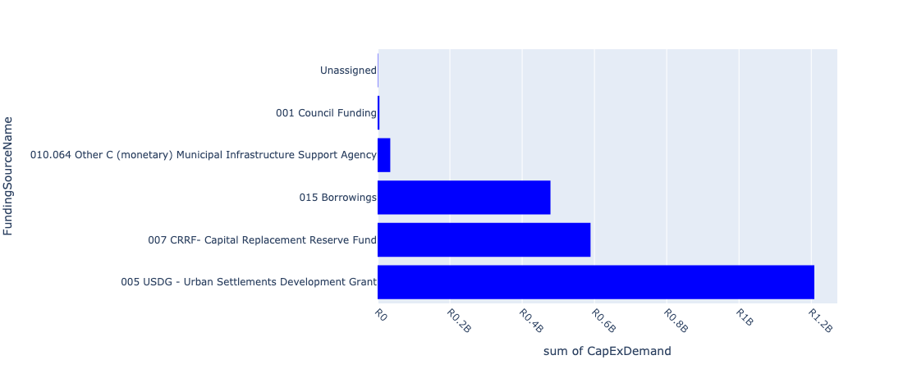

Figure 5.14: Region G Departmental Requests

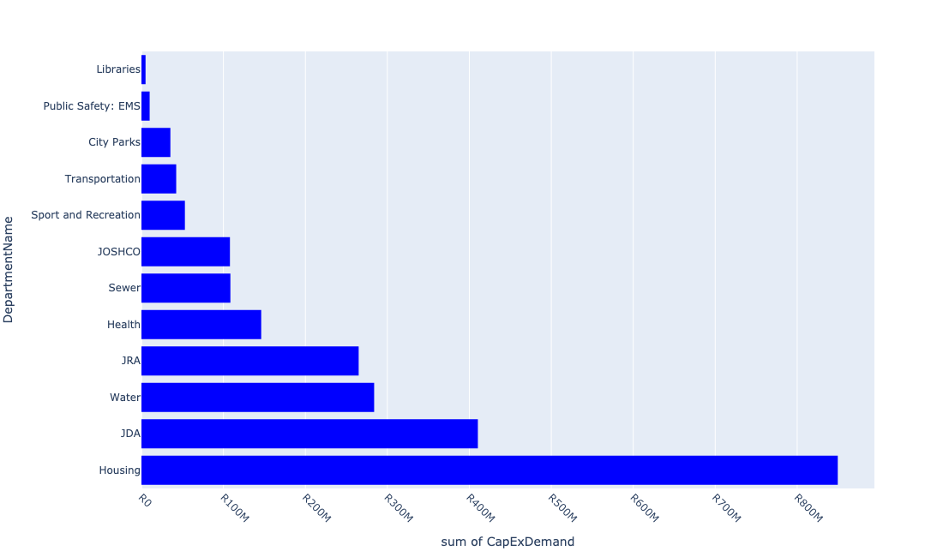

Table 5.7: Summary - Region G

|  |  |
| --- | --- |
| Item | Description |
| Total Capital Demand for Region G - All Years | R2,317,072,559 Rank: 1 (1 = Highest) |
| Total Capital Demand for Region G - MTREF | R2,266,376,305 Rank: 1 (1 = Highest) |
| Financial Years in which capital requirements are listed for Region G | 2023, 2024, 2025, 2026 and 2027 |
| Financial Year with highest capital demand for Region G | 2024 |
| Region G intersecting feature used | Works Location |
| Total number of projects intersecting with Region G | 267 Rank: 6 (1 = Highest) |

Table 5.8: All projects asking for budget in Region G

|  |  |  |  |
| --- | --- | --- | --- |
| Project ID | Project Name | Department | Project Budget |
| 23102 | 2804_09_ITS (Fibre Loop and CCTV)- Redundancy Loop | Transportation | R0.00 (0%) No budget request. |
| 23557 | 01_22684_Air Conditioners | Health | R34,972 (0.00%) Budget spread across: 2025, 2026 and 2027 |
| 22012 | DSM: Solar PV Systems on Buildings | City Power | R0.00 (0%) No budget request. |
| 23562 | 06_22684_Security Installations | Health | R162,692 (0.01%) Budget spread across: 2025, 2026 and 2027 |
| 23556 | 02_22684_Electricity Upgrade | Health | R822,243 (0.04%) Budget spread across: 2025, 2026 and 2027 |
| 3966 | WWTW Upgrade and refurbish | Sewer | R499,547 (0.02%) Budget spread across: 2024 |
| 22295 | Ennerdale Ext 2 | Housing | R0.00 (0%) No budget request. |
| 6324 | Upgrade Eikenhof Substation | City Power | R0.00 (0%) No budget request. |
| 20783 | Lenasia Ext 4: Satellite | City Power | R0.00 (0%) No budget request. |
| 2552 | Kliptown Renewal Precinct Redevelopment (Walter Sisulu Square) KLIPSPRUIT EXT.4 D Ward | JDA | R0.00 (0%) No budget request. |
| 4224 | Orange Farm (Drieziek/Poortjie) MPC New Construction G Regional | Sport and Recreation | R0.00 (0%) No budget request. |
| 3692 | Aqua - Eldorado Park Proper Swimming Pool Renewal Community Centre ELDORADO PARK G Ward | Sport and Recreation | R0.00 (0%) No budget request. |
| 3523 | Orange Farm/ Deep south: Lakeside Sewer Upgrade | Sewer | R0.00 (0%) No budget request. |
| 3526 | Orange Farm/ Deep South: Orange farm Sewer Upgrade | Sewer | R0.00 (0%) No budget request. |
| 2655 | Orange Farm/Deep South:Lenasia South East Basin Upgrade Sewer | Sewer | R0.00 (0%) No budget request. |
| 22212 | Deep South / Orange Farm: Ennerdale Reservoir 50ML | Sewer | R0.00 (0%) No budget request. |
| 22215 | Deep South / Orange Farm: Ennerdale Tower 0.5ML | Water | R0.00 (0%) No budget request. |
| 2375 | Orange farm/ Deep South: Lenasia Water Upgrade | Water | R0.00 (0%) No budget request. |
| 2718 | Orange farm/Deep south: Ennerdale Water Upgrade | Water | R0.00 (0%) No budget request. |
| 3228 | Soweto: Power Park Water Upgrade | Water | R0.00 (0%) No budget request. |
| 6408 | Lehae Training Academy | Public Safety: EMS | R0.00 (0%) No budget request. |
| 22118 | Region G Orange Farm : PEU and Storm water upgrade on Links Road and Civic Node | JDA | R0.00 (0%) No budget request. |
| 21035 | Lenasia : Goudkoppies switching station upgrade | City Power | R0.00 (0%) No budget request. |
| 6402 | Training Academy EMS Fire and USAR Equipment, wall and new props LEHAE EXT 1 City Wide | Public Safety: EMS | R0.00 (0%) No budget request. |
| 4201 | Complete Streets: NMT Facilities Linking Public Transport Facilities: Roodepoort, Lehae, Slovoville, Doornkop, Poortjie, Tshepisong, Orange Farm and Drieziek New Pedestrian Walkways City Wide | Transportation | R0.00 (0%) No budget request. |
| 3520 | Orange Farm/ Deep south: Planned Replacement Sewermains | Sewer | R0.00 (0%) No budget request. |
| 3514 | New Park Development Poortjie New Park POORTJIE G Ward | City Parks | R0.00 (0%) No budget request. |
| 2973 | MISCL - Tarring of Gravel Roads: Lawley. New Roads: Construction and Upgrades LAWLEY EXT.1 | Mayors Office/ City Manager | R0.00 (0%) No budget request. |
| 23975 | Eldorado Park Stadium | Sport and Recreation | R0.00 (0%) No budget request. |
| 3222 | Unaville (Vlakfontein Ext 4) 2402 units New Bulk Infrastructure VLAKFONTEIN G Ward | Housing | R0.00 (0%) No budget request. |
| 20780 | Lenasia : Replacement of old equipment | City Power | R0.00 (0%) No budget request. |
| 23703 | Complete Streets: NMT links to public transport facilitiies in Orange Farm | Transportation | R12,399,758 (0.54%) Budget spread across: 2023 and 2024 |
| 3239 | Bushkoppies works: Kitchen dining area dewatering building New Bulk Waste Water ELDORADO PARK F Regional | Sewer | R0.00 (0%) No budget request. |
| 2575 | Olifantsvlei Cemetery Renewal Cemetery NATURENA EXT.15 D Ward | City Parks | R25,000,000 (1.08%) Budget spread across: 2023 and 2024 |
| 20786 | Lunar_11kV: Substation upgrade | City Power | R0.00 (0%) No budget request. |
| 22515 | Regeneration of Lenasia CBD and Anchorville Industrial Hub – Region G | JDA | R15,000,000 (0.65%) Budget spread across: 2023 |
| 20720 | Eikenhof: Substation | City Power | R0.00 (0%) No budget request. |
| 3480 | Olifantsvlei Works: Sludge turner and FEL KLIPRIVIERSOOG ESTATE G | Sewer | R1,000,000 (0.04%) Budget spread across: 2024 |
| 3208 | Drieziek Ext.5 | Housing | R45,000,000 (1.94%) Budget spread across: 2023 and 2024 |
| 2959 | CATCH 10 - Implementation of CBP Stormwater Masterplanning: Orange Farm New Stormwater Catchments ORANGE FARM G Ward | JRA | R0.00 (0%) No budget request. |
| 2449 | Bushkoppies Works- Digesters purchase New Bulk Waste Water DEVLAND EXT.27 F Regional | Sewer | R0.00 (0%) No budget request. |
| 21041 | Lenasia : Lenasia substation zone 6.6kV distribution network conversion to 11kV | City Power | R0.00 (0%) No budget request. |
| 2604 | Lawley Ext 2 Clinic; Furniture and Equipment - Phase 2 New Clinic LAWLEY EXT.2 G Ward | Health | R0.00 (0%) No budget request. |
| 3978 | Mid-Ennerdale Clinic Renewal Clinic ENNERDALE G Regional | Health | R0.00 (0%) No budget request. |
| 4178 | Techno hubs New Skills Development Center ORANGE FARM G City Wide | Economic Development | R0.00 (0%) No budget request. |
| 4135 | MISCL - Tarring of Gravel Roads: Poortjie. New Roads: Construction and Upgrades POORTJIE G Ward | Mayors Office/ City Manager | R0.00 (0%) No budget request. |
| 20806 | Olifantsflei: Satellite | City Power | R0.00 (0%) No budget request. |
| 3986 | MISCL - Tarring of Gravel Roads: Drieziek. New Roads: Construction and Upgrades DRIEZIEK G Ward | Mayors Office/ City Manager | R0.00 (0%) No budget request. |
| 3534 | Lenasia Social Housing Project Region G | JOSHCO | R0.00 (0%) No budget request. |
| 3202 | Vlakfontein Ext 3 | Housing | R41,500,000 (1.79%) Budget spread across: 2023 and 2024 |
| 2538 | Protea South Clinic Renewal Clinic PROTEA SOUTH EXT.1 G Ward | Health | R49,100,000 (2.12%) Budget spread across: 2023 and 2024 |
| 2206 | The construction of new infrastructure in newly established townships New Network Development LENASIA EXT.8 G Regional | City Power | R0.00 (0%) No budget request. |
| 23763 | Bushkoppies works:Cleaning and lining of emergency Dam | Water | R1,000,000 (0.04%) Budget spread across: 2024 |
| 3225 | Poortjie Dark City | Housing | R0.00 (0%) No budget request. |
| 22126 | Stretford (informal Settlements) | Housing | R0.00 (0%) No budget request. |
| 2847 | Deep South: Lenasia Sewers Upgrade New ENNERDALE G | Sewer | R0.00 (0%) No budget request. |
| 2446 | Olifantsvlei Works: Digester Heating and Mixing | Sewer | R0.00 (0%) No budget request. |
| 4244 | Kliptown Social Housing Project Region D | JOSHCO | R0.00 (0%) No budget request. |
| 21038 | Lenasia : Lawley Station (Roodepoort 302_Iq) electrification | City Power | R0.00 (0%) No budget request. |
| 23686 | BK: Infrastructure Renewal Plan 2 | Sewer | R1,000,000 (0.04%) Budget spread across: 2024 |
| 20543 | Lenasia: MV Transformers year 2015 projects | City Power | R0.00 (0%) No budget request. |
| 2592 | Park development Lehae 1 | City Parks | R0.00 (0%) No budget request. |
| 21032 | Lenasia : Devland switching station upgrade | City Power | R0.00 (0%) No budget request. |
| 3666 | Lehae MPC New Construction LEHAE G | Sport and Recreation | R28,000,000 (1.21%) Budget spread across: 2023 and 2024 |
| 22896 | Lenasia Depot | City Parks | R0.00 (0%) No budget request. |
| 3517 | Orange Farm/ Deep South: Spioenkop water upgrade New Water Mains ORANGE FARM G Regional | Water | R0.00 (0%) No budget request. |
| 2738 | Weillers Farm Clinic; Furniture and Equipment New Clinic KANANA PARK G Ward | Health | R0.00 (0%) No budget request. |
| 3454 | Ennerdale Extension 15(Mountain View) New Bulk Infrastructure ENNERDALE EXT.15 G Regional | Housing | R0.00 (0%) No budget request. |
| 23992 | Lenasia South Substation Upgrade | City Power | R0.00 (0%) No budget request. |
| 3185 | Klipspruit/Kliptown New Bulk Infrastructure (Housing project around the Walter Sisulu Square) KLIPSPRUIT D Ward | Housing | R255,000,000 (11.01%) Budget spread across: 2023 and 2024 |
| 20554 | Lenasia: Pole-Mounted Transformer year 2015 projects | City Power | R0.00 (0%) No budget request. |
| 20909 | Ennerdale (CP_E264) | City Power | R0.00 (0%) No budget request. |
| 21044 | Lenasia : Percy switching station upgrade | City Power | R0.00 (0%) No budget request. |
| 21934 | OV: Upgrade Roads | Water | R0.00 (0%) No budget request. |
| 3342 | Lehae Social Housing Project New Housing Development LEHAE D City Wide | JOSHCO | R0.00 (0%) No budget request. |
| 2850 | Deep South / Orange Farm: Zuurbekom Reservoir New Reserviors | Water | R0.00 (0%) No budget request. |
| 20560 | Lenasia: Switchgear year 2015 projects | City Power | R0.00 (0%) No budget request. |
| 21052 | Lenasia : Thembelihle ( RE/129/301_Iq) Electrification | City Power | R0.00 (0%) No budget request. |
| 20941 | Lotus_11kV | City Power | R0.00 (0%) No budget request. |
| 6546 | Ennerdale Works: Dam cleaning and lining | Sewer | R8,000,000 (0.35%) Budget spread across: 2024 |
| 3890 | Upgrade Nancefield Substation Renewal Bulk Infrastructure NANCEFIELD EXT.1 G Regional | City Power | R0.00 (0%) No budget request. |
| 23764 | Bushkoppies works: Sludge enhancement.Duplicate | Water | R1,000,000 (0.04%) Budget spread across: 2024 |
| 3203 | Finetown Proper -Region G | Housing | R60,000,000 (2.59%) Budget spread across: 2023 and 2024 |
| 21033 | Lenasia : Ennerdale Ext 6 switching station upgrade | City Power | R0.00 (0%) No budget request. |
| 2393 | MISCL - Tarring of Gravel Roads: Orange Farm and Surrounding Areas. New Roads: Construction and Upgrades ORANGE FARM G Ward | JRA | R140,000,000 (6.04%) Budget spread across: 2023 and 2024 |
| 22367 | Driziek New Park Development | City Parks | R0.00 (0%) No budget request. |
| 22315 | Grey water use as an alternative source of water ORANGE FARM ( REGION D, A and G) | Environment and Infrastructure | R0.00 (0%) No budget request. |
| 3088 | Network development for townships and service connections. New Medium Voltage Network LENASIA EXT.1 G Regional | City Power | R0.00 (0%) No budget request. |
| 2447 | Olifantsvlei Works: Belt Presses # 1 | Sewer | R5,000,000 (0.22%) Budget spread across: 2024 |
| 20532 | Lenasia: Minisubs year 2015 projects | City Power | R0.00 (0%) No budget request. |
| 3612 | Johannesburg Central: Naturena Nasrec water upgrade New Water Mains NATURENA D Regional | Water | R0.00 (0%) No budget request. |
| 2733 | Lakeside Ext 1, 3 & 5 | Housing | R51,000,000 (2.20%) Budget spread across: 2023 and 2024 |
| 20784 | Lenasia_6.6kV: Substation | City Power | R0.00 (0%) No budget request. |
| 23037 | Protea Glen New Park Development | City Parks | R0.00 (0%) No budget request. |
| 23334 | Southern Farms Mega Mixed Development | Housing | R30,000,000 (1.29%) Budget spread across: 2023 and 2024 |
| 4253 | CBP-Vlakfontein Park New Park VLAKFONTEIN G Ward | City Parks | R0.00 (0%) No budget request. |
| 2433 | Lunar: Install 1X20MVA 88/11 kV transformer Renewal Bulk Infrastructure FINETOWN G | City Power | R0.00 (0%) No budget request. |
| 3214 | Stretford Cemetery New Park STRETFORD EXT.2 G Regional | City Parks | R0.00 (0%) No budget request. |
| 22115 | Kanana Park Ext 2 | Housing | R40,000,000 (1.73%) Budget spread across: 2023 and 2024 |
| 3286 | Electrification of 281 houses in Meriteng. New Electrification LENASIA G Ward | City Power | R0.00 (0%) No budget request. |
| 3237 | Bushkoppies Works: Sludge Drying Beds New ELDORADO PARK F | Sewer | R0.00 (0%) No budget request. |
| 21047 | Lenasia : Proposed switching station in Lawley area | City Power | R0.00 (0%) No budget request. |
| 20810 | Percy: Satellite | City Power | R0.00 (0%) No budget request. |
| 3549 | New Parks Development in Strettford (Orange Farm) New Park STRETFORD EXT.5 G Ward | City Parks | R0.00 (0%) No budget request. |
| 23274 | Stretford New MPC | Libraries | R5,000,000 (0.22%) Budget spread across: 2024 |
| 2198 | Basic Water Service New Basic Water and Sewer Services | Water | R100,000,000 (4.32%) Budget spread across: 2023 and 2024 |
| 21233 | Lotus Substation 88/11kV | City Power | R0.00 (0%) No budget request. |
| 2816 | Upgrade of Kanana Park Renewal Park KANANA PARK EXT.1 A | City Parks | R0.00 (0%) No budget request. |
| 3243 | Goudkoppies Works: Refurbish bioreactor valves Renewal Bulk Waste Water ELDORADO PARK F Regional | Sewer | R0.00 (0%) No budget request. |
| 21053 | Lenasia : Tsipa Electrification | City Power | R0.00 (0%) No budget request. |
| 23260 | Lenasia cricket stadium | Sport and Recreation | R5,000,000 (0.22%) Budget spread across: 2024 |
| 20910 | Ennerdale (CP_E265) | City Power | R0.00 (0%) No budget request. |
| 8747 | Mining Belt West:Upgrade capacity at Bushkoppies and Olifantsvlei WWTW's | Development Planning | R0.00 (0%) No budget request. |
| 22384 | Landfill site- Ennerdale | Pikitup | R0.00 (0%) No budget request. |
| 2559 | Detail planning of a factory shop; Eldorado Park Node New Building Alterations ELDORADO PARK EXT.4 G Ward | Economic Development | R0.00 (0%) No budget request. |
| 22035 | Catchment rehabilitation Orange Farm | JRA | R0.00 (0%) No budget request. |
| 20904 | Eldorado | City Power | R0.00 (0%) No budget request. |
| 2902 | Olympus Park Development Renewal Park ENNERDALE EXT.1 G | City Parks | R0.00 (0%) No budget request. |
| 2361 | Eldorado Park Ext 9 Renewal Clinic ELDORADO PARK EXT.9 G Ward | Health | R0.00 (0%) No budget request. |
| 20775 | Kaya Centre: Satellite | City Power | R0.00 (0%) No budget request. |
| 20727 | Ennerdale Ext6 Sws: Satellite | City Power | R0.00 (0%) No budget request. |
| 2444 | Olifantsvlei Works: Mod 3 Unit 3 New Bulk Waste Water KLIPRIVIERSOOG ESTATE G Regional | Sewer | R0.00 (0%) No budget request. |
| 3632 | Southdale/ Langlaagte: Lawley High Level Resrvoir 10ML | Sewer | R0.00 (0%) No budget request. |
| 6503 | Bushkoppies Works: Upgrade main Blowers and Pipework | Sewer | R50,000,000 (2.16%) Budget spread across: 2023 and 2024 |
| 3160 | Building of EMS training academy for the City of Johannesburg New Building LEHAE EXT.1 G City Wide | Public Safety: EMS | R10,000,000 (0.43%) Budget spread across: 2023 |
| 21030 | Lenasia : Carina switching station upgrade | City Power | R0.00 (0%) No budget request. |
| 20781 | Lenasia : Replacement of pole-mounted transformers | City Power | R0.00 (0%) No budget request. |
| 24030 | 23705_Orange Farm Urban Renewal Programme | JDA | R0.00 (0%) No budget request. |
| 6409 | Rehabilitation of the Klip Upper Rietspruit Water Management Unit (LENASIA) (K-URWMU) | Environment and Infrastructure | R0.00 (0%) No budget request. |
| 2344 | Lenasia Eco Park Development New Park LENASIA SOUTH | City Parks | R10,300,000 (0.44%) Budget spread across: 2023 and 2024 |
| 3223 | Finetown East/X1 | Housing | R0.00 (0%) No budget request. |
| 22650 | EN: Sludge storage | Sewer | R0.00 (0%) No budget request. |
| 23337 | Construction of sport centre in Vlakfontein | Sport and Recreation | R0.00 (0%) No budget request. |
| 2384 | Upgrade Finetown Park Renewal Park FINETOWN G | City Parks | R0.00 (0%) No budget request. |
| 22424 | Ennerdale Landfill site-improved compliance, alterations and cell development | Pikitup | R0.00 (0%) No budget request. |
| 20907 | Ennerdale (CP_E262) | City Power | R0.00 (0%) No budget request. |
| 3191 | Region G Economic Stimulation New Precinct/Nodal Development POORTJIE G Regional | Economic Development | R0.00 (0%) No budget request. |
| 3240 | Bushkoppies works: HOW module 1 New Basic Water and Sewer Services ELDORADO PARK F Regional | Sewer | R0.00 (0%) No budget request. |
| 3211 | Ennerdale South | Housing | R60,000,000 (2.59%) Budget spread across: 2023 and 2024 |
| 23369 | Tum-Key 4: Region G | JOSHCO | R107,950,411 (4.66%) Budget spread across: 2024 |
| 3234 | Olifantsvlei: RSHF stacker KLIPRIVIERSOOG ESTATE F | Sewer | R0.00 (0%) No budget request. |
| 2450 | Bushkoppies Works: BK Balancing Tank. Completed | Sewer | R0.00 (0%) No budget request. |
| 20701 | Carina Sws: Satellite | City Power | R0.00 (0%) No budget request. |
| 6300 | Township reticulation Lenasia | City Power | R0.00 (0%) No budget request. |
| 3197 | Kanana Park Ext 1 | Housing | R40,000,000 (1.73%) Budget spread across: 2023 and 2024 |
| 21050 | Lenasia : Slovo Park Electrification | City Power | R0.00 (0%) No budget request. |
| 22722 | EN: Upgrading of Southern Treatment Capacity | Sewer | R1,000,000 (0.04%) Budget spread across: 2024 |
| 3075 | Freedom Park New Clinic DEVLAND EXT.30 G Ward | Health | R1,000,000 (0.04%) Budget spread across: 2023 and 2024 |
| 2921 | Electrification of Lehae phase 2 New Electrification LEHAE G Ward | City Power | R0.00 (0%) No budget request. |
| 2881 | RNP004_James Street Extension. New Roads: Construction and Upgrades ENNERDALE G Regional | JRA | R30,000,000 (1.29%) Budget spread across: 2023 and 2024 |
| 2872 | RNP032_K122 / K130 Construction New Roads: Construction and Upgrades DEVLAND D Regional | JRA | R0.00 (0%) No budget request. |
| 2749 | Deep South: Olifantsvlei Basin: Upgrade sewers New Sewer Mains NANCEFIELD F Regional | Sewer | R0.00 (0%) No budget request. |
| 2620 | Kliptown Market & Taxi Rank (Improving Trading Facilities) Renewal Informal trading Stalls PIMVILLE ZONE 9 D Ward | JPC | R0.00 (0%) No budget request. |
| 2609 | Lenasia Clinic; Furniture and Medical Equipment - Phase I Renewal Clinic LENASIA EXT.2 G Ward | Health | R0.00 (0%) No budget request. |
| 2497 | Construction of Stretford informal trading stalls and facilities at Orange Farm New Linear Markets ORANGE FARM EXT.1 G Ward | JPC | R0.00 (0%) No budget request. |
| 2480 | Deep south: Bushkoppies basin: Upgrade Sewer Renewal Sewer Mains DEVLAND EXT.27 F Regional | Sewer | R0.00 (0%) No budget request. |
| 2271 | New public lights New Public Lighting ORANGE FARM EXT.1 G Regional | City Power | R0.00 (0%) No budget request. |
| 2254 | Install 3rd transformer New Bulk Infrastructure LENASIA EXT.13 G Ward | City Power | R0.00 (0%) No budget request. |
| 23931 | OV: Inlet Screw Pumps Replacement. | Sewer | R0.00 (0%) No budget request. |
| 23705 | 23705_00_Orange Farm Urban Renewal Programme | JDA | R395,426,553 (17.07%) Budget spread across: 2023 and 2024 |
| 23688 | BK: Expansion of Bushkoppies WWTW | Sewer | R1,000,000 (0.04%) Budget spread across: 2024 |
| 23685 | OV: Sludge Enhancement | Sewer | R1,000,000 (0.04%) Budget spread across: 2024 |
| 23264 | Ernadale Ext 9 Sport ground | Sport and Recreation | R20,000,000 (0.86%) Budget spread across: 2024 |
| 23127 | OV: Infrastructure Renewal Plan 2. | Sewer | R5,000,000 (0.22%) Budget spread across: 2024 |
| 23124 | 2197_03_Orange Farm | Water | R0.00 (0%) No budget request. |
| 23101 | Region G Orange Farm : PEU and Storm water upgrade on Links Road and Civic Node | JDA | R0.00 (0%) No budget request. |
| 22755 | Stretford Ext 4 Social cluster precinct intervention | Development Planning | R0.00 (0%) No budget request. |
| 22285 | Rehabilitation of the Klip LOWER Reitspruit Water Management Unit (Orange farm) | Environment and Infrastructure | R0.00 (0%) No budget request. |
| 22125 | Informal Settlements Detailed Designs | Housing | R0.00 (0%) No budget request. |
| 22065 | Olifantsvlei: Upgrade Roads | Sewer | R0.00 (0%) No budget request. |
| 21799 | Lawley Water upgrade | Water | R0.00 (0%) No budget request. |
| 21793 | Protea Glen Sewer Upgrade | Water | R876,382 (0.04%) Budget spread across: 2024 |
| 21255 | New Lehae Substation 88/11kV | City Power | R0.00 (0%) No budget request. |
| 21235 | Lunar Substation 88/11kV | City Power | R0.00 (0%) No budget request. |
| 3977 | Lawley Ext. 1 Clinic Renewal Clinic LAWLEY G Regional | Health | R95,000,000 (4.10%) Budget spread across: 2024, 2025 and 2026 |
| 3891 | Upgrade Eldorado Substation Renewal Bulk Infrastructure ELDORADO PARK G Regional | City Power | R0.00 (0%) No budget request. |
| 3888 | Upgrade Nirvana Substation Renewal Bulk Infrastructure LENASIA G Regional | City Power | R0.00 (0%) No budget request. |
| 3788 | CONV - Conversion of Open Drains to underground storm water system/Covered Drains in Orange Farm. Renewal Stormwater Management Projects ORANGE FARM G Ward | JRA | R95,000,000 (4.10%) Budget spread across: 2023 |
| 3539 | Kliptown Golf Course Social Housing Upgrades Region D | JOSHCO | R0.00 (0%) No budget request. |
| 3525 | Orange Farm/ Deep South: Stretford Sewer upgrade Renewal Bulk Waste Water STRETFORD EXT.9 G | Sewer | R0.00 (0%) No budget request. |
| 3522 | Orange Farm/ Deep south: Ennerdale sewer upgrade Renewal Bulk Waste Water ENNERDALE G | Sewer | R0.00 (0%) No budget request. |
| 3519 | Orange Farm/ Deep South: Lenasia South water upgrade Renewal Water Mains LENASIA G Regional | Water | R0.00 (0%) No budget request. |
| 3516 | Orange Farm/ Deep South: Planned Replacement Watermains | Water | R0.00 (0%) No budget request. |
| 3502 | Ennerdale Works: Infrastructure renewal plan | Sewer | R0.00 (0%) No budget request. |
| 3499 | Ennerdale Works: Dewatering Facility | Sewer | R0.00 (0%) No budget request. |
| 3482 | Bushkoppies Works: Infrastructure renewal plan | Sewer | R11,000,000 (0.47%) Budget spread across: 2024 |
| 3453 | Lawley New Bulk Infrastructure LAWLEY EXT.1 G Regional | Housing | R0.00 (0%) No budget request. |
| 3287 | Mountai View infill 20 Houses. New Electrification MOUNTAIN VIEW G Ward | City Power | R0.00 (0%) No budget request. |
| 3236 | Olifantsvlei: Refurbish Unit 2 | Sewer | R9,000,000 (0.39%) Budget spread across: 2024 |
| 3233 | Olifanstvlei: Gasholder repairs #1 Renewal Bulk Waste Water NANCEFIELD F Regional | Sewer | R0.00 (0%) No budget request. |
| 3227 | Eldorado Park Infills(1350) New Bulk Infrastructure ELDORADO PARK G Ward | Housing | R0.00 (0%) No budget request. |
| 3224 | Klipvieroog (1914) New Bulk Infrastructure LEHAE G Ward | Housing | R0.00 (0%) No budget request. |
| 3213 | Upgrade of Lenasia Cemetery Renewal Park LENASIA G Regional | City Parks | R0.00 (0%) No budget request. |
| 3207 | Drieziek Ext.3 | Housing | R55,000,000 (2.37%) Budget spread across: 2023 and 2024 |
| 3204 | Kanana Park Ext 3,4 & 5 | Housing | R40,000,000 (1.73%) Budget spread across: 2023 and 2024 |
| 21195 | Ennerdale Substation 88/11kV (Eskom) | City Power | R0.00 (0%) No budget request. |
| 21046 | Lenasia : Proposed switching station in Klipspruit area | City Power | R0.00 (0%) No budget request. |
| 21040 | Lenasia : Lenasia South Ext 4 switching station upgrade | City Power | R0.00 (0%) No budget request. |
| 20940 | Lenasia_6.6kV | City Power | R0.00 (0%) No budget request. |
| 20911 | Ennerdale (CP_E266) | City Power | R0.00 (0%) No budget request. |
| 20785 | Lotus_11kV: Substation | City Power | R0.00 (0%) No budget request. |
| 20708 | Clover: Satellite | City Power | R0.00 (0%) No budget request. |
| 6605 | Stretford Park Development | City Parks | R0.00 (0%) No budget request. |
| 6410 | Lehae Fire Station | JDA | R0.00 (0%) No budget request. |
| 4252 | CBP-Kanana Park (Majazana) New Park KANANA PARK G Ward | City Parks | R0.00 (0%) No budget request. |
| 4183 | Learning Material for LEHAE Training Academy New Operational Capex | Public Safety: EMS | R0.00 (0%) No budget request. |
| 3103 | PTF: Small Public Transport Facilities: DRIEZIEK EXT.3 | Transportation | R0.00 (0%) No budget request. |
| 3066 | Mountainview Clinic New Clinic FINETOWN G Ward | Health | R0 (0.00%) Budget spread across: 2024 |
| 2986 | RNP080_Upgrading of Wimbledon Road Renewal Roads: Construction and Upgrades LENASIA SOUTH G Ward | JRA | R0.00 (0%) No budget request. |
| 2914 | Electrification of Freedom Charter Square New Electrification LENASIA G Ward | City Power | R0.00 (0%) No budget request. |
| 2834 | Lakeside Wetland Restoration New Ecological Infrastructure ORANGE FARM G Regional | Environment and Infrastructure | R0.00 (0%) No budget request. |
| 2831 | Rehabilitation of lower Klipriver Wetland (Lenasia) New Ecological Infrastructure LENASIA SOUTH EXT.20 G Regional | Environment and Infrastructure | R0.00 (0%) No budget request. |
| 2717 | Deep South: Ennerdale/Lanasia/poortjie: Upgrade sewers New Sewer Mains ENNERDALE G Regional | Sewer | R0.00 (0%) No budget request. |
| 2645 | CBP 2009/10 New Cultural Village NATURENA EXT.17 F To construct one-stop-shop | Economic Development | R0.00 (0%) No budget request. |
| 2614 | Transfer of capacity from Lunar sub station to MOUNTAIN VIEW New Medium Voltage Network ENNERDALE G Ward | City Power | R0.00 (0%) No budget request. |
| 2562 | Develop Region G Eco-Tourism Product New Economic Infrastructure ORANGE FARM G Regional | Economic Development | R0.00 (0%) No budget request. |
| 2459 | construction of additional trading stalls in the market at Lenasia Renewal Informal trading Stalls LENASIA G Ward | JPC | R0.00 (0%) No budget request. |
| 23759 | Orange Farm/Deep South: Lenasia Reservoir 675mm dia Bulk | Water | R90,500,000 (3.91%) Budget spread across: 2023 and 2024 |
| 23687 | BK: Sludge enhancement | Sewer | R1,000,000 (0.04%) Budget spread across: 2024 |
| 23684 | Lenasia Reservoir 675mm dia bulk supply line | Water | R90,500,000 (3.91%) Budget spread across: 2023 and 2024 |
| 23412 | EN: Infrastructure Renewal Plan 2. | Water | R0.00 (0%) No budget request. |
| 22791 | Complete Streets: Deep South | Transportation | R30,000,000 (1.29%) Budget spread across: 2023 and 2024 |
| 22731 | Refurbishment of the Portion of Portion 1 of Erf 1909 Eldorado Park | JPC | R0.00 (0%) No budget request. |
| 22479 | Soweto Strategic Area Framework & Implementation | Development Planning | R0.00 (0%) No budget request. |
| 22342 | Complete Streets: NMT linking to Lenasia Precinct | Transportation | R0.00 (0%) No budget request. |
| 22216 | Deep South / Orange Farm: Lehae Reservoir 15ML | Water | R0.00 (0%) No budget request. |
| 22113 | Kanana Park Proper | Housing | R0.00 (0%) No budget request. |
| 22101 | Slovo (Informal Settlement) | Housing | R0.00 (0%) No budget request. |
| 21769 | Ennerdale water upgrade | Water | R0.00 (0%) No budget request. |
| 21761 | Lenasia Water upgrade | Water | R0.00 (0%) No budget request. |
| 21729 | Ennerdale Tower 0.5ML | Water | R0.00 (0%) No budget request. |
| 21231 | Lenasia Substation 88/6.6kV (Eskom) | City Power | R0.00 (0%) No budget request. |
| 4168 | Small: Public Transport Facility in Zakariya Park Region G | Transportation | R0.00 (0%) No budget request. |
| 3948 | Kliptown Walter Sisulu Square Social Housing Upgrades Region D | JOSHCO | R0.00 (0%) No budget request. |
| 3925 | PTF: Small Public Transport Facilities: Orange Farm Ext 7 (Region G) | Transportation | R0.00 (0%) No budget request. |
| 3716 | Trade Route 88 kV switchyard. New Bulk Infrastructure LENASIA EXT.13 G Regional | City Power | R0.00 (0%) No budget request. |
| 3530 | Transit Area Precincts[Reavaya/Gautrain stations New Building NANCEFIELD A City Wide | JOSHCO | R0.00 (0%) No budget request. |
| 3524 | Orange Farm/ Deep South: Lehae Sewer Upgrade Renewal Bulk Waste Water LEHAE G | Sewer | R0.00 (0%) No budget request. |
| 3521 | Orange Farm/ Deep South: Driezek sewer upgrade Renewal Bulk Waste Water DRIEZIEK G | Sewer | R0.00 (0%) No budget request. |
| 3518 | Orange Farm/ Deep South: Lehae Water upgrade New Water Mains LEHAE G Regional | Water | R0.00 (0%) No budget request. |
| 3481 | Olifantsvlei Works: Infrastructure Renewal Plan | Sewer | R14,000,000 (0.60%) Budget spread across: 2024 |
| 3435 | Lehae 88/11 kV substation New Bulk Infrastructure LEHAE G Regional | City Power | R0.00 (0%) No budget request. |
| 3338 | PTF: Transfer Facility: Lenasia Scholar Transport Interchange | Transportation | R0 (0.00%) Budget spread across: 2023 and 2024 |
| 3261 | Electrification in Poortjie New Electrification POORTJIE G Ward | City Power | R0.00 (0%) No budget request. |
| 3252 | Orange Farm Erf 6446 Renewal Operational Capex ORANGE FARM EXT.1 G Regional | JPC | R0.00 (0%) No budget request. |
| 3238 | Bushkoppies Works: Ablution Block dewatering building New Bulk Waste Water ELDORADO PARK F Regional | Sewer | R0.00 (0%) No budget request. |
| 3235 | Olifastvlei: Cables & switch gear Renewal Bulk Waste Water NANCEFIELD F Regional | Sewer | R0.00 (0%) No budget request. |
| 3226 | Ennerdale Ext 6 (erf 4554 & 4553)Infills - 1358 New Bulk Infrastructure ENNERDALE EXT.6 G Ward | Housing | R0.00 (0%) No budget request. |
| 3186 | Lehae Ext 1 | Housing | R92,000,000 (3.97%) Budget spread across: 2023 and 2024 |
| 21048 | Lenasia : Proposed switching station in Lenasia Ext 6 | City Power | R0.00 (0%) No budget request. |
| 21045 | Lenasia : Proposed switching station in Diepklof area | City Power | R0.00 (0%) No budget request. |
| 21031 | Lenasia : Clover switching station upgrade | City Power | R0.00 (0%) No budget request. |
| 20942 | Lunar_11kV | City Power | R0.00 (0%) No budget request. |
| 20939 | Lenasia South | City Power | R0.00 (0%) No budget request. |
| 20925 | Hopefield | City Power | R0.00 (0%) No budget request. |
| 20908 | Ennerdale (CP_E263) | City Power | R0.00 (0%) No budget request. |
| 20905 | Ennerdale (CP_E208) | City Power | R0.00 (0%) No budget request. |
| 20782 | Lenasia Ext 10: Satellite | City Power | R0.00 (0%) No budget request. |
| 20756 | Hopefield: Substation | City Power | R0.00 (0%) No budget request. |
| 20699 | Bushkoppies Sws: Satellite | City Power | R0.00 (0%) No budget request. |
| 6604 | Driezik Park upgrade | City Parks | R0.00 (0%) No budget request. |
| 6581 | Drieziek Ext.4 | Housing | R40,000,000 (1.73%) Budget spread across: 2023 and 2024 |
| 6547 | Ennerdale Works: Replace module mixers and motors | Sewer | R0.00 (0%) No budget request. |
| 6501 | Bushkoppie: New PSTs number 2 | Sewer | R0.00 (0%) No budget request. |
| 6355 | Walter Sisulu Square of dedication ( Refurbishment) | JPC | R0.00 (0%) No budget request. |
| 4254 | CBP-Dzadza Community Park New Park PROTEA SOUTH EXT.1 G Ward | City Parks | R0.00 (0%) No budget request. |
| 4211 | Upgrade of Tourism offices renewal building alterations New Building Alterations PIMVILLE ZONE 8 D City Wide | Mayors Office/ City Manager | R0.00 (0%) No budget request. |

Please note that the following projects will not be shown in this table:

* Projects with no recorded intersect with Regions (in other words no Works Location was recorded on the system for this project)

Projects that do not have any recorded budget demand on the system at the time that this report was requested, are shown in the table with zero budgets indicated.