

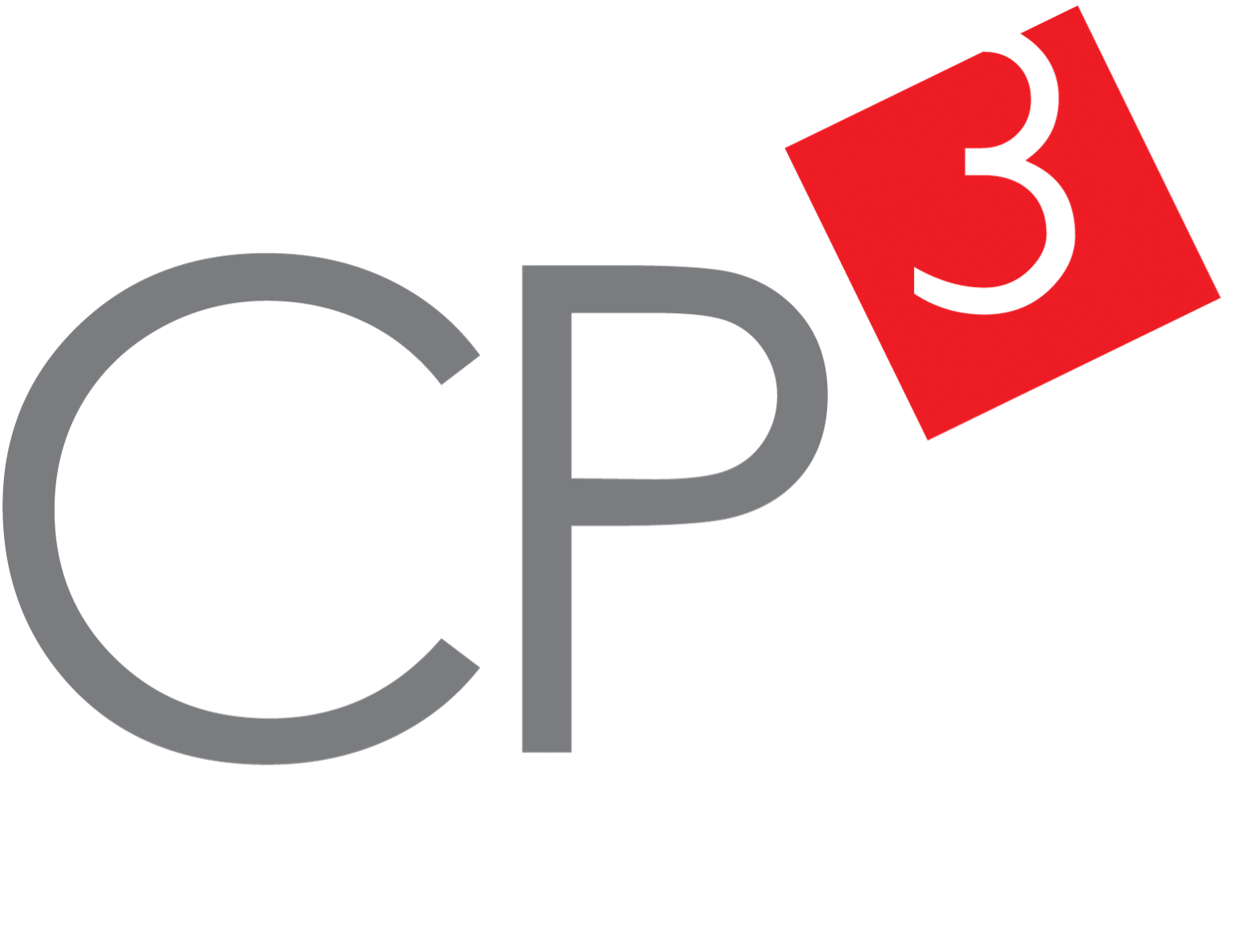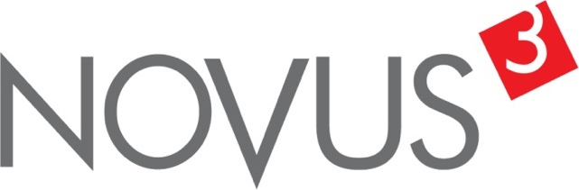

Spatial Feature Report

T: +27 12 364 2546 | E: info@novus3.co.za Postnet Suite 471, Private Bag X15,

Menlo Park, 0102**www.novus3.co.za**

engineered solutions

Disclaimer

This document contains data that was obtained from a live CP3 system at the moment the data was requested. The data is updated by users of the CP3 System and unless the system is locked for changes, this data may change on a daily basis. The reader is therefore cautioned not to place inappropriate reliance on the data unless there is certainty on the status of the data in terms of how recently it has been updated, how “clean” the data is (is there a quality control and/or verification process that was followed by the licensee of the CP3 system to ensure that data is checked and verified from time-to-time) and whether the correct baseline was queried. This report therefore provides a “snapshot in time”. Consequently, the document may be less relevant at a different time, or using a different financial baseline to query from.

At all times, all rights, title and interest in and to this material remains vested in the owner of this document and are copyrighted and protected by regulatory provisions. These materials may not be copied, reproduced, modified, published, uploaded, posted to websites or otherwise distributed in any way, without our prior written permission from the Licensee and Licensor (Nvous3 (Pty) Ltd) of the CP3 Software. The owner of this document does not grant any right to reproduce the materials. All our rights in this regard are and remain reserved.

Table of Contents

**No table of contents entries found.** (Right-click -> Update Field)

Spatial Query Report

This document was created *2022-04-25-22_21* from the **Lekwa Municipality** CP3 system.

The baseline **'2022/2023 Planning Baseline_20211214'** with description: **'New Description'** was used. The spatial feature that was selected for the purpose of this report was: **'Wards 2016'**.

This is a spatial feature report for the *Lekwa Municipality.* The data contained in this report was sourced directly from the municipality's live CP3 system. The information in this report therefore reflects the data as it was on the *2022-04-25* when this report was requested. Any subsequent updates to the data contained the CP3 System related to the applicable baseline from which this reports was drawn, would therefore not reflect in this report.   
  
For the *Lekwa Municipality, the following spatial features are available for the purpose of developing* 'Spatial Query Reports' (similar to this report):

* Functional AreasCombined
* Wards 2016



We hope you find this useful! Sincerely, *The Novus3 Team.*

# Introduction

The baseline that was queried for this report contains *195* projects of which a total of *1 (0.513%)* projects do not have any recorded intersection (overlap) with Wards 2016.The following spatial features are available for queries using this API profile:

* Functional AreasCombined
* Wards 2016

The probable reasons for the 1 non intersecting projects reported are that:

* these projects simply do not have a location associated with them yet (most frequently the case with 'no-intersect' projects) or;
* the location that was captured for some of these projects, may have been in the wrong place (e.g. outside the boundaries of Lekwa - this is very rarely the reason).

It is important to take note of the 0.513% projects that do not intersect with Wards 2016 feature when appraising this report.

The 0.513% of non-intersecting projects is a relative low percentage and therefore not much cause of concern for this particular report.

Figure 1.1: Intersecting vs Non-Intersecting Projects

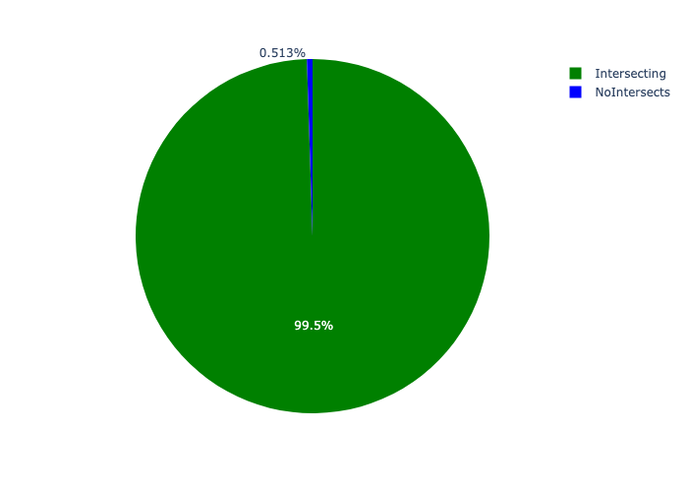

# Total Number of Projects and Total Capital Demand per Wards 2016 - All Years

Table 2.1 below provides a concise summary of key statistical insights regarding the number of projects that are requesting funding in each of the Wards 2016.

Table 2.1: Wards 2016 Analysis - Number of Projects

|  |  |  |  |
| --- | --- | --- | --- |
| Description | Info (1) | Info (2) | Info (3) |
| Number of projects in all Wards 2016 - Overview | Total in all Wards 2016: 194 projects | Average per Wards 2016: 13.9 projects | 75th percentile of projects across all Wards 2016: 13.5 projects |
| The highest number of projects | Wards 2016: In Lekwa LM | Number of projects in Lekwa LM: 87 | Percentage of total in Lekwa LM: 44.85% |
| The lowest number of projects: | Wards 2016: In Ward 12 | Number of projects in Ward 12: 2 | Percentage of total in Ward 12: 1.03% |
| The 5 Wards 2016 that collectively have with the highest number of projects | Wards 2016: In Ward 9, Ward 8, Ward 13, Ward 10 and Lekwa LM | Number of projects in Ward 9, Ward 8, Ward 13, Ward 10 and Lekwa LM together: 146 | Percentage of total in Ward 9, Ward 8, Ward 13, Ward 10 and Lekwa LM together: 75.26% |

Table 2.2 below provides a concise summary of key statistical insights regarding the total capital demand per Wards 2016.

Table 2.2: Wards 2016 Analysis - Capital Demand (R)

|  |  |  |  |
| --- | --- | --- | --- |
| Description | Info (1) | Info (2) | Info (3) |
| Capital demand in all Wards 2016 - Overview | Total capital demand in all Wards 2016: R2,498,336,586 | The average capital demand per Wards 2016: R178,452,613 | The 75th percentile of capital demand for Wards 2016: R138,403,341 |
| The highest capital demand | Wards 2016: In Lekwa LM | Capital Demand in Lekwa LM: R1,249,168,283 | Percentage of total in Lekwa LM: 50.00% |
| The lowest capital demand | Wards 2016: In Ward 12 | Capital Demand in Ward 12: R8,000,000 | Percentage of total in Ward 12: 0.32% |
| The 5 Wards 2016 that collectively have collective the highest capital demand: | Wards 2016: In Ward 9, Ward 14, Ward 11, Ward 8 and Lekwa LM | Capital Demand in Ward 9, Ward 14, Ward 11, Ward 8 and Lekwa LM together: R2,191,290,748 | Percentage of total in Ward 9, Ward 14, Ward 11, Ward 8 and Lekwa LM together: 87.71% |

The number of projects per Wards 2016 and the capital demand per Wards 2016 needs to be looked at together for better insight. Figures 2.1 and 2.1.2 assist with further graphical insight into some of the numbers that are provided in Tables 2.0.1 and 2.0.2.

Figure 2.1: The single Wards 2016 with the highest value (Nr of Projects & Capital Demand) vs the rest

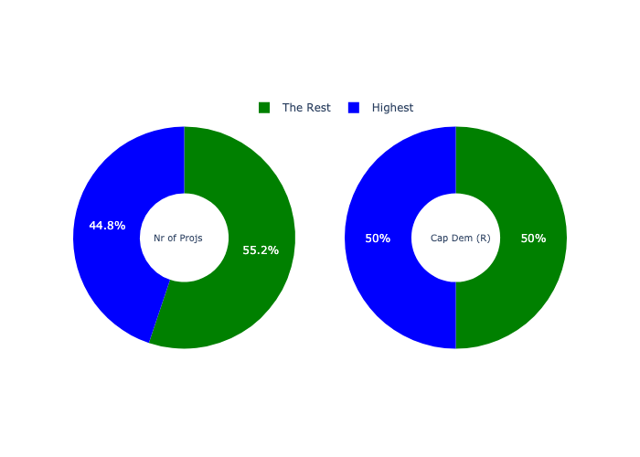

The highest number of projects in a single Wards 2016 is in **Lekwa LM.** *That is 87 projects and this is 44.85% of the total number of projects.*The highest capital demand in a single Wards 2016 is in **Lekwa LM.** *That is R1,249,168,283 and this amounts to 50.00% of the total capital demand.*

Figure 2.2: The 5 Wards 2016 with the highest values (Nr of Projects & Capital Demand) vs the rest

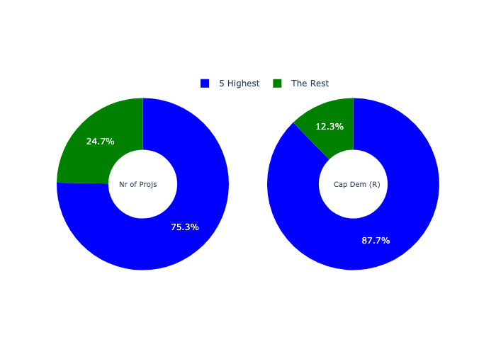

The 5 Wards 2016 that collectively have with the highest number of projects are in **Ward 9, Ward 8, Ward 13, Ward 10 and Lekwa LM.** *That is 146 projects and this is 75.26% of the total number of projects.*The 5 Wards 2016 that collectively have the highest capital demand are in **Ward 9, Ward 14, Ward 11, Ward 8 and Lekwa LM.** *That is 87.71% and this amounts to R2,191,290,748 of the total capital demand.*

The following figures provide a bar graph representation of the number of projects per Wards 2016 with the colour of the bars representing the level of capital demand in each of these Wards 2016.

Figure 2.3: Projects and Capital Demand per Wards 2016

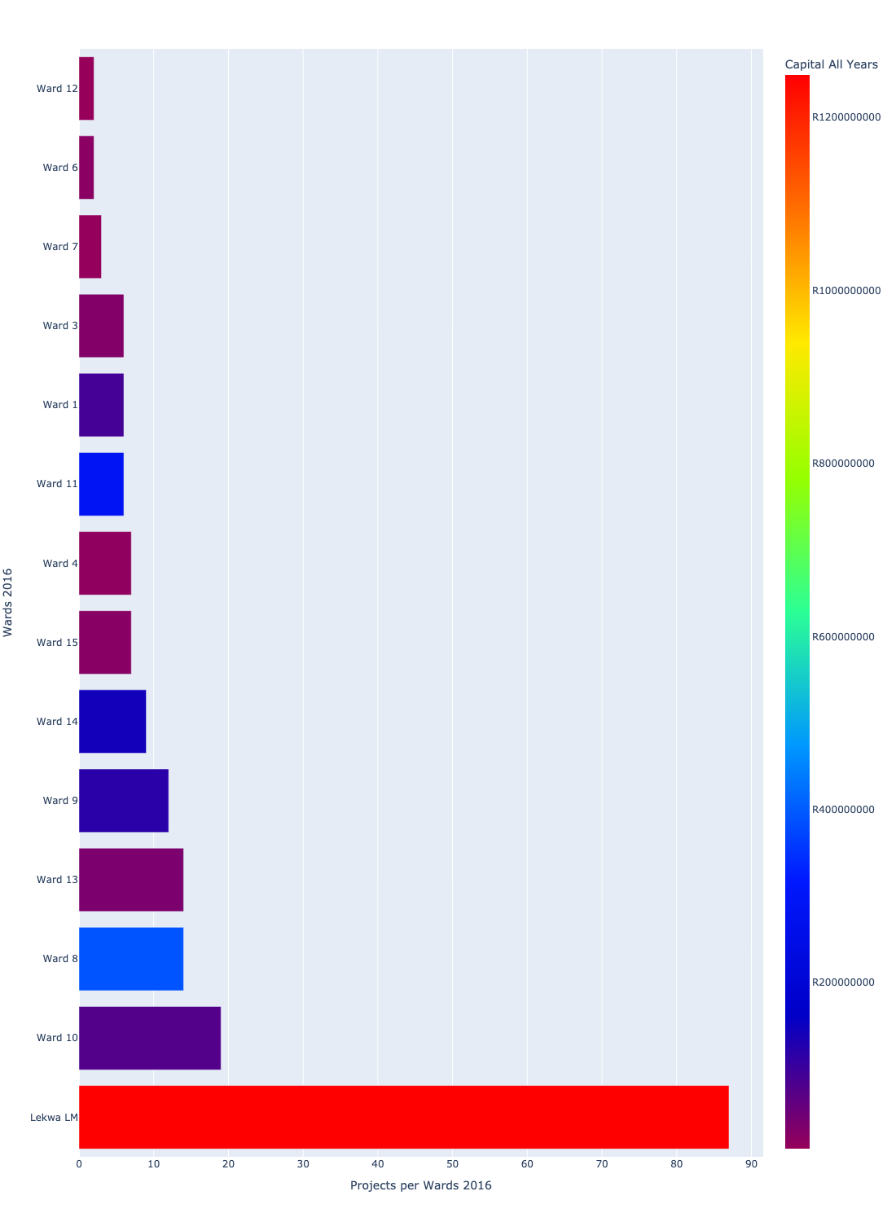

# Total Capital Demand per Wards 2016 - All Years

There are different funding sources from which capital is requested. For the financial baseline that was selected for this report query (2022/2023 Planning Baseline_20211214), the breakdown of capital demand for Lekwa Municipality per funding source is shown in Figure 3.1 below.

Figure 3.1: Capital Demand Per Funding Source

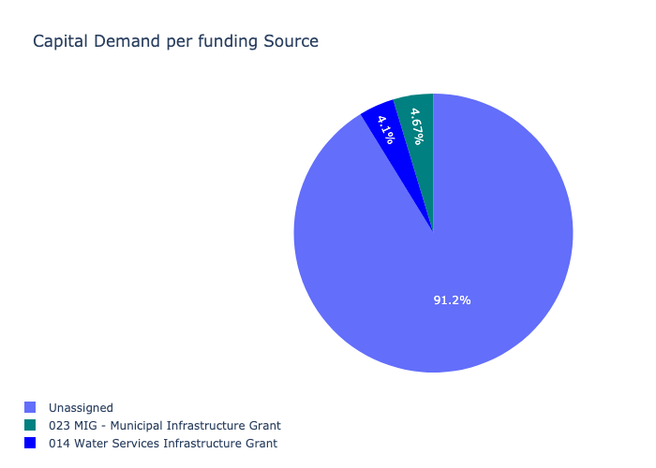

The following figures provide a histogram representation of the capital demand per Wards 2016. A colour breakdown is provided of each year's sub-total that contribute towards the overall total capital demand of each Wards 2016. Note that the capital demand beyond the first three years representing the Medium Term Expenditure Framework (MTREF - years 2023 and 2024) are generally more sparsely and less diligently populated, therefore less reliance should be vested on these outer years when appraising the overall capital demand. The reason for this is usually because of National Treasury's requirement for annual budget submissions spanning only over the MTREF (i.e. the next three years).

Figure 3.2: Capital Demand per Wards 2016 - All Years

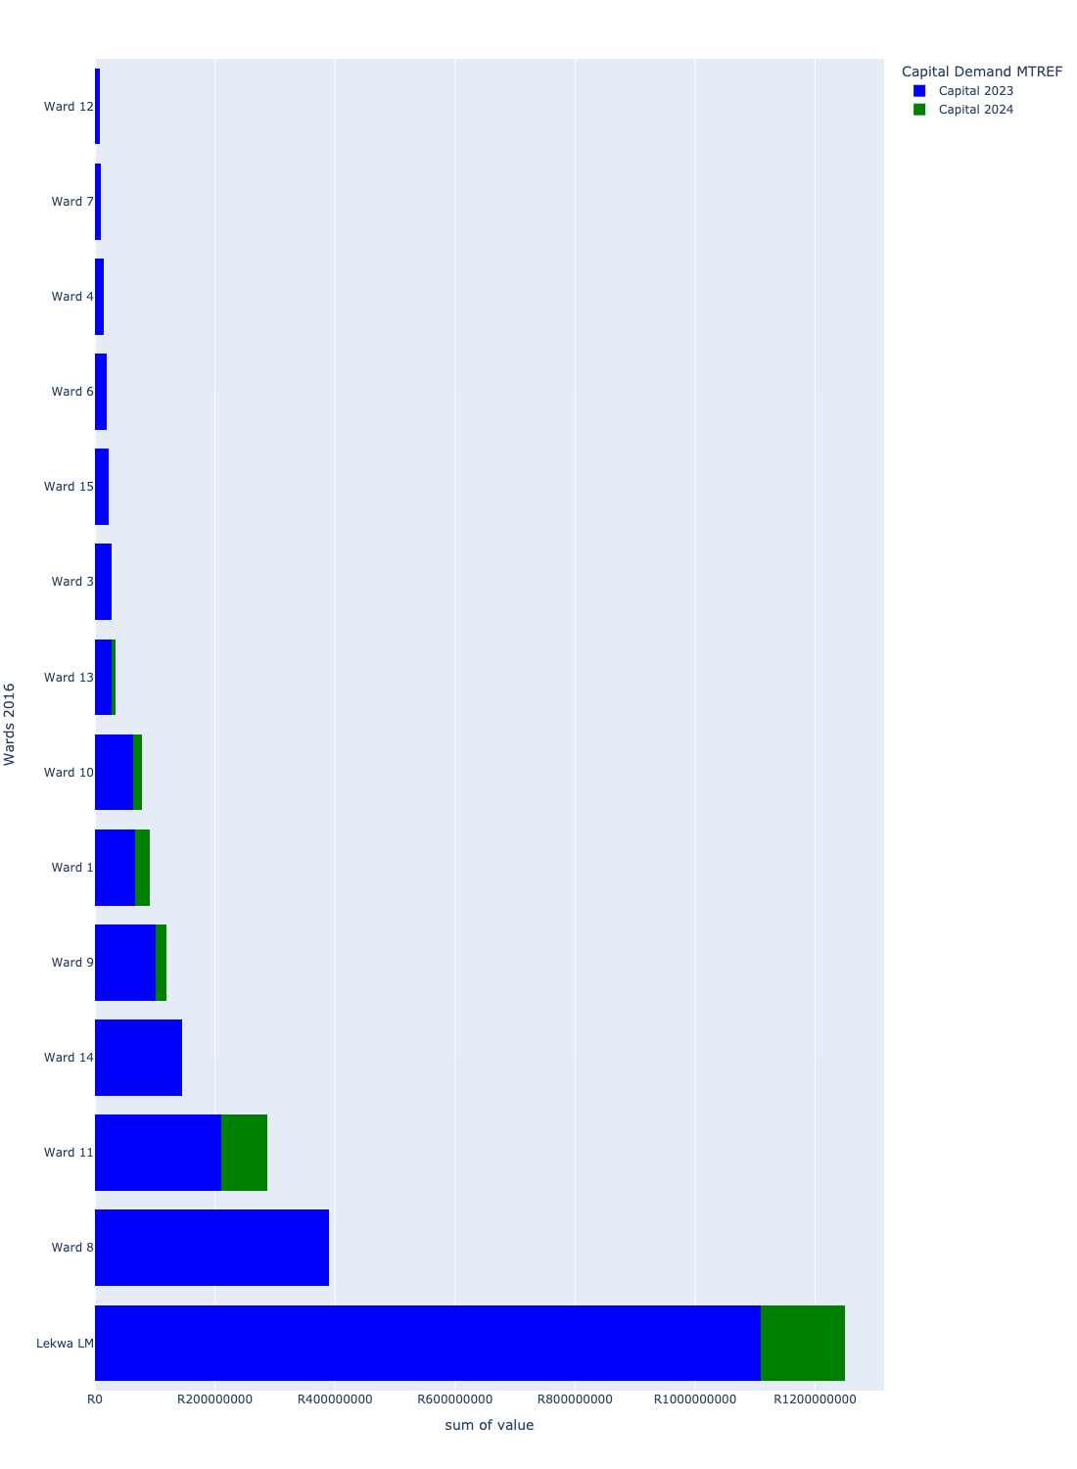

# Total Capital Demand per Wards 2016 - MTREF only

Table 4.1 below provides a concise summary of key statistical insights regarding the total MTREF capital demand per Wards 2016.

Table 4.1: Wards 2016 Analysis - MTREF Capital Demand (R)

|  |  |  |  |
| --- | --- | --- | --- |
| Description | Info (1) | Info (2) | Info (3) |
| MTREF Capital demand in all Wards 2016 - Overview | MTREF capital demand in all Wards 2016: R2,498,336,586 | The average MTREF capital demand per Wards 2016: R178,452,613 | The 75th percentile of MTREF capital demand for Wards 2016: R138,403,341 |
| The highest MTREF capital demand | In Wards 2016: Lekwa LM | MTREF capital Demand in Lekwa LM: R1,249,168,283 | Percentage of total MRTEF capital demand in Lekwa LM: 50.00% |
| The lowest MTREF capital demand | In Wards 2016: Ward 12 | MTREF capital Demand in Ward 12: R8,000,000 | Percentage of total MTREF capital demand in Ward 12: 0.32% |

The following figures provide a histogram representation of the capital demand per Wards 2016. A colour breakdown is provided of each year's sub-total that contribute towards the overall MTREF total capital demand of each Wards 2016.

Figure 4.1: Capital Demand per Wards 2016 - MTREF Period

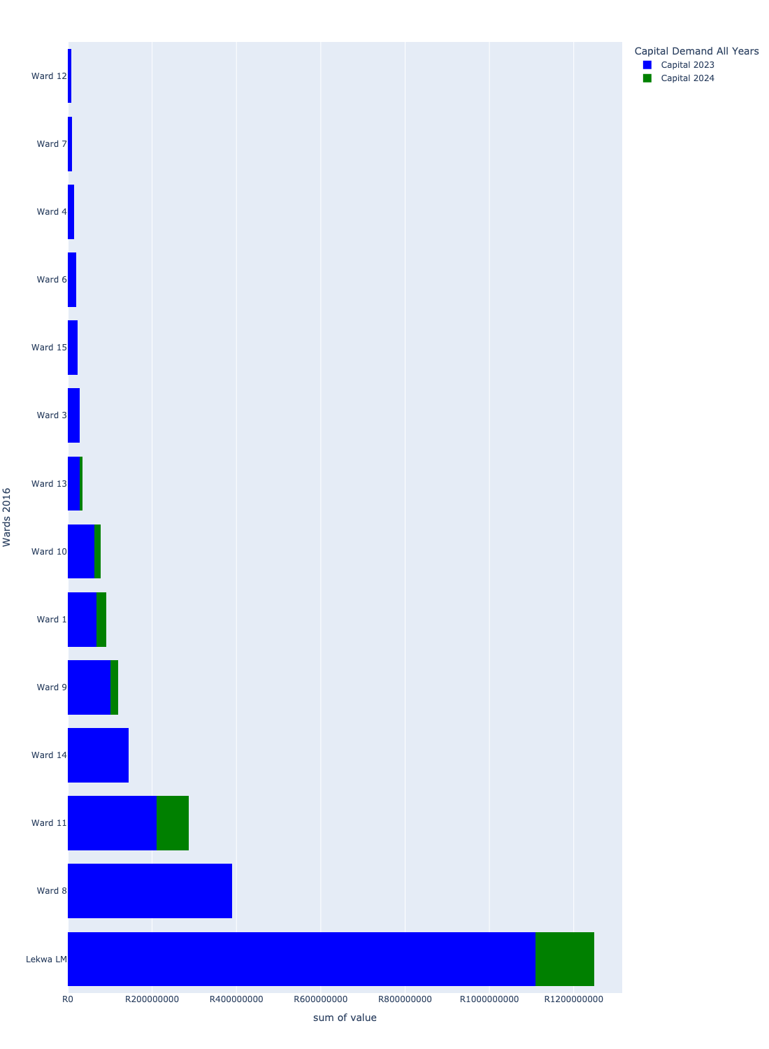

# Summary per Wards 2016

Table 5.1: Summary - Lekwa LM

|  |  |
| --- | --- |
| Item | Description |
| Number of Projects |  |

Table 5.2: Summary - Ward 1

|  |  |
| --- | --- |
| Item | Description |
| Number of Projects |  |

Table 5.3: Summary - Ward 10

|  |  |
| --- | --- |
| Item | Description |
| Number of Projects |  |

Table 5.4: Summary - Ward 11

|  |  |
| --- | --- |
| Item | Description |
| Number of Projects |  |

Table 5.5: Summary - Ward 12

|  |  |
| --- | --- |
| Item | Description |
| Number of Projects |  |

Table 5.6: Summary - Ward 13

|  |  |
| --- | --- |
| Item | Description |
| Number of Projects |  |

Table 5.7: Summary - Ward 14

|  |  |
| --- | --- |
| Item | Description |
| Number of Projects |  |

Table 5.8: Summary - Ward 15

|  |  |
| --- | --- |
| Item | Description |
| Number of Projects |  |

Table 5.9: Summary - Ward 3

|  |  |
| --- | --- |
| Item | Description |
| Number of Projects |  |

Table 5.10: Summary - Ward 4

|  |  |
| --- | --- |
| Item | Description |
| Number of Projects |  |

Table 5.11: Summary - Ward 6

|  |  |
| --- | --- |
| Item | Description |
| Number of Projects |  |

Table 5.12: Summary - Ward 7

|  |  |
| --- | --- |
| Item | Description |
| Number of Projects |  |

Table 5.13: Summary - Ward 8

|  |  |
| --- | --- |
| Item | Description |
| Number of Projects |  |

Table 5.14: Summary - Ward 9

|  |  |
| --- | --- |
| Item | Description |
| Number of Projects |  |