

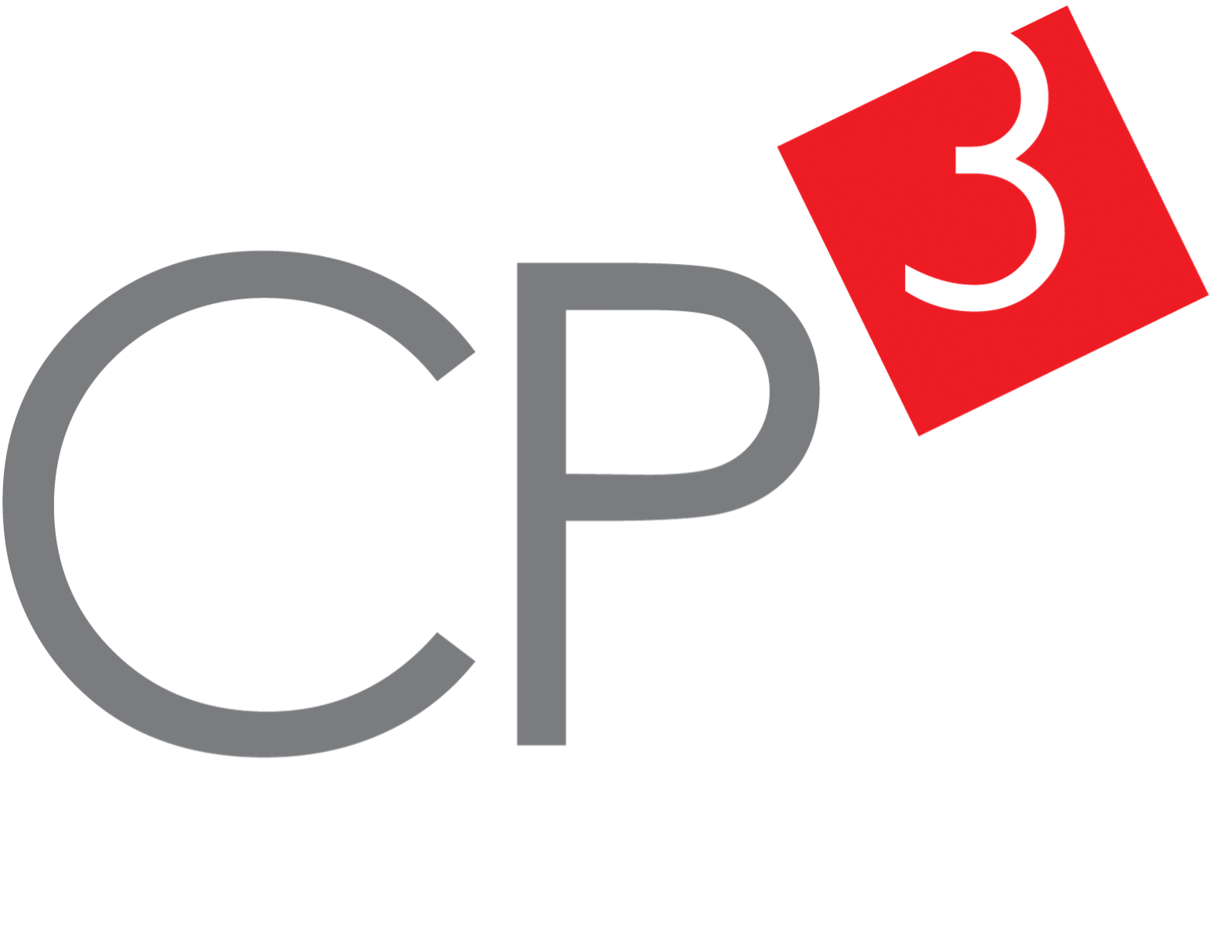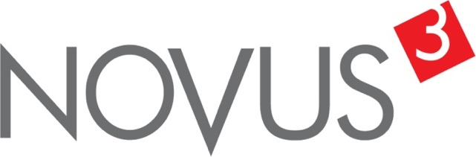

Spatial Feature Report

T: +27 12 364 2546 | E: info@novus3.co.za Postnet Suite 471, Private Bag X15,

Menlo Park, 0102**www.novus3.co.za**

engineered solutions

Disclaimer

This document contains data that was obtained from a live CP3 system at the moment the data was requested. The data is updated by users of the CP3 System and unless the system is locked for changes, this data may change on a daily basis. The reader is therefore cautioned not to place inappropriate reliance on the data unless there is certainty on the status of the data in terms of how recently it has been updated, how “clean” the data is (is there a quality control and/or verification process that was followed by the licensee of the CP3 system to ensure that data is checked and verified from time-to-time) and whether the correct baseline was queried. This report therefore provides a “snapshot in time”. Consequently, the document may be less relevant at a different time, or using a different financial baseline to query from.

At all times, all rights, title and interest in and to this material remains vested in the owner of this document and are copyrighted and protected by regulatory provisions. These materials may not be copied, reproduced, modified, published, uploaded, posted to websites or otherwise distributed in any way, without our prior written permission from the Licensee and Licensor (Nvous3 (Pty) Ltd) of the CP3 Software. The owner of this document does not grant any right to reproduce the materials. All our rights in this regard are and remain reserved.

Table of Contents

**No table of contents entries found.** (Right-click -> Update Field)

Spatial Query Report

This document was created *2022-05-05-23_01* from the **Lekwa Municipality** CP3 system.

The baseline **'2022/2023 Planning Baseline_20211214'** with description: **'New Description'** was used. The spatial feature that was selected for the purpose of this report was: **'Functional AreasCombined'**.

This is a spatial feature report for the *Lekwa Municipality.* The data contained in this report was sourced directly from the municipality's live CP3 system. The information in this report therefore reflects the data as it was on *2022-05-05* when this report was requested. Any subsequent updates to the data contained the CP3 System related to the applicable baseline from which this reports was drawn, would therefore not reflect in this report.   
  
For the *Lekwa Municipality, the following spatial features are available for the purpose of developing* 'Spatial Query Reports' (similar to this report):

* Functional AreasCombined
* Wards 2016



We hope you find this useful! Sincerely, *The Novus3 Team.*

# Introduction

The baseline that was queried for this report contains *111* projects of which a total of *6 (5.41%)* projects do not have any recorded intersection (overlap) with Functional AreasCombined. The following spatial features are available for queries using this API profile:

* Functional AreasCombined
* Wards 2016

The probable reasons for the 6 non intersecting projects reported are that:

* these projects simply do not have a location associated with them yet (most frequently the case with 'no-intersect' projects) or;
* the location that was captured for some of these projects, may have been in the wrong place (e.g. outside the boundaries of Lekwa - this is very rarely the reason).

It is important to take note of the 5.41% projects that do not intersect with Functional AreasCombined feature when appraising this report.

Figure 1.1: Intersecting vs Non-Intersecting Projects

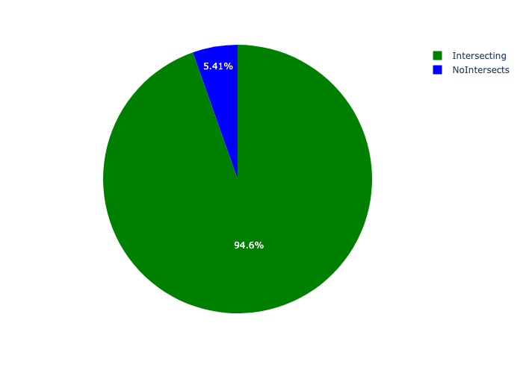

# Total Number of Projects and Total Capital Demand per Functional AreasCombined - All Years

Table 2.1 below provides a concise summary of key statistical insights regarding the number of projects that are requesting funding in each of the Functional AreasCombined.

Table 2.1: Functional AreasCombined Analysis - Number of Projects

|  |  |  |  |
| --- | --- | --- | --- |
| Description | Info (1) | Info (2) | Info (3) |
| Number of projects in all Functional AreasCombined - Overview | Total in all Functional AreasCombined: 105 projects | Average per Functional AreasCombined: 21 projects | 75th percentile of projects across all Functional AreasCombined: 24.0 projects |
| The highest number of projects | Functional AreasCombined: In Peri Urban | Number of projects in Peri Urban: 35 | Percentage of total in Peri Urban: 33.33% |
| The lowest number of projects: | Functional AreasCombined: In Urban Centre | Number of projects in Urban Centre: 9 | Percentage of total in Urban Centre: 8.57% |

Table 2.1 below provides a concise summary of key statistical insights regarding the total capital demand per Functional AreasCombined.

Table 2.1: Functional AreasCombined Analysis - Capital Demand (R)

|  |  |  |  |
| --- | --- | --- | --- |
| Description | Info (1) | Info (2) | Info (3) |
| Capital demand in all Functional AreasCombined - Overview | Total capital demand in all Functional AreasCombined: R1,249,171,790 | The average capital demand per Functional AreasCombined: R249,834,358 | The 75th percentile of capital demand for Functional AreasCombined: R164,069,778 |
| The highest capital demand | Functional AreasCombined: In Peri Urban | Capital Demand in Peri Urban: R820,235,007 | Percentage of total in Peri Urban: 65.66% |
| The lowest capital demand | Functional AreasCombined: In Urban Centre | Capital Demand in Urban Centre: R36,901,451 | Percentage of total in Urban Centre: 2.95% |

The number of projects per Functional AreasCombined and the capital demand per Functional AreasCombined needs to be looked at together for better insight. Figures 2.1 and 2.2 assist with further graphical insight into some of the numbers that are provided in Tables 2.1 and 2.2.

Figure 2.1: The single Functional AreasCombined with the highest value (Nr of Projects & Capital Demand) vs the rest

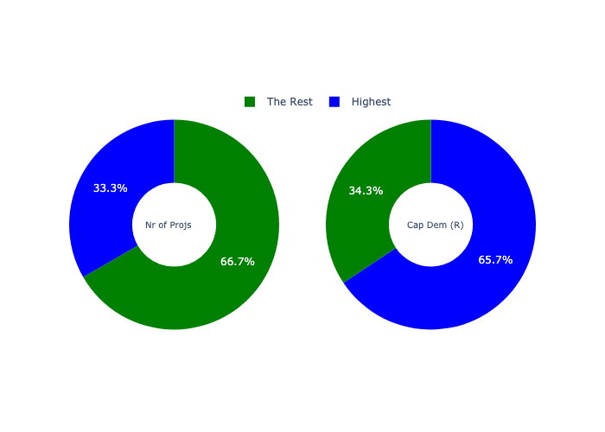

The highest number of projects in a single Functional AreasCombined is in **Peri Urban.** *That is 35 projects and this is 33.33% of the total number of projects.*The highest capital demand in a single Functional AreasCombined is in **Peri Urban.** *That is R820,235,007 and this amounts to 65.66% of the total capital demand.*

The following figures provide a bar graph representation of the number of projects per Functional AreasCombined with the colour of the bars representing the level of capital demand in each of these Functional AreasCombined.

Figure 2.2: Projects and Capital Demand per Functional AreasCombined

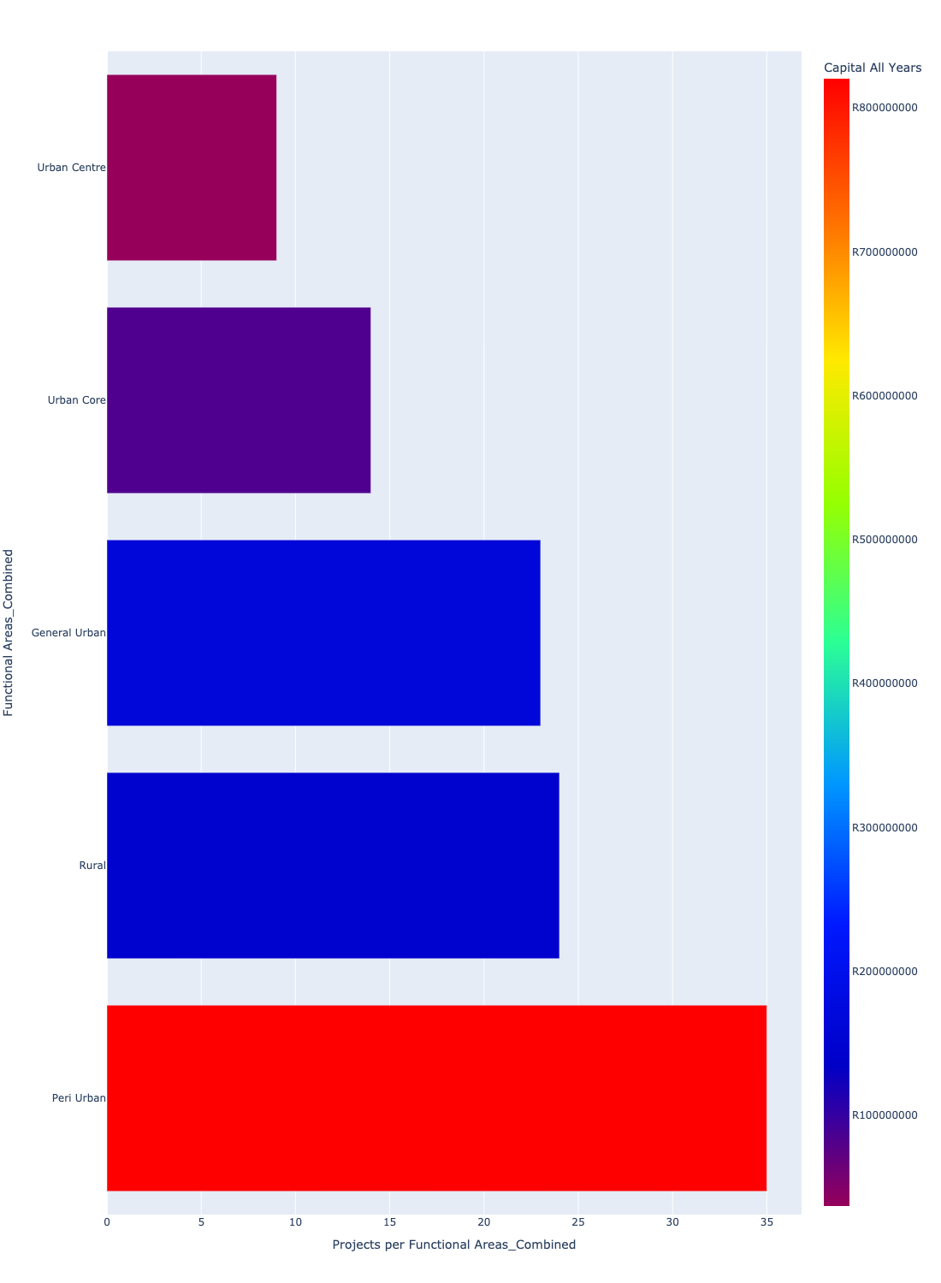

# Total Capital Demand per Functional AreasCombined - All Years

There are different funding sources from which capital is requested. For the financial baseline that was selected for this report query (2022/2023 Planning Baseline_20211214), the breakdown of capital demand for Lekwa Municipality per funding source is shown in Figure 3.1 below.

Figure 3.1: Capital Demand Per Funding Source

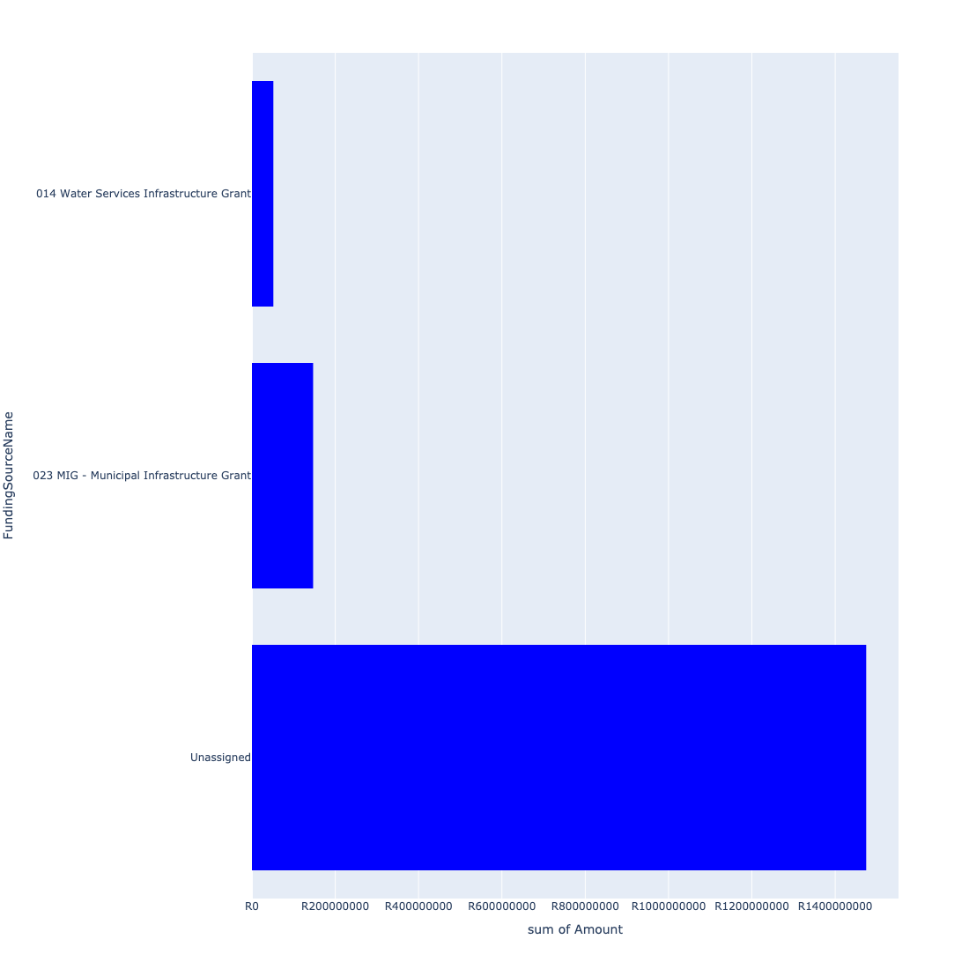

For the financial baseline that was selected for this report query (2022/2023 Planning Baseline_20211214), the breakdown of capital demand for Lekwa Municipality per department is shown in Figure 3.2 below.

Figure 3.2: Capital Demand Per Lekwa Municipality Department

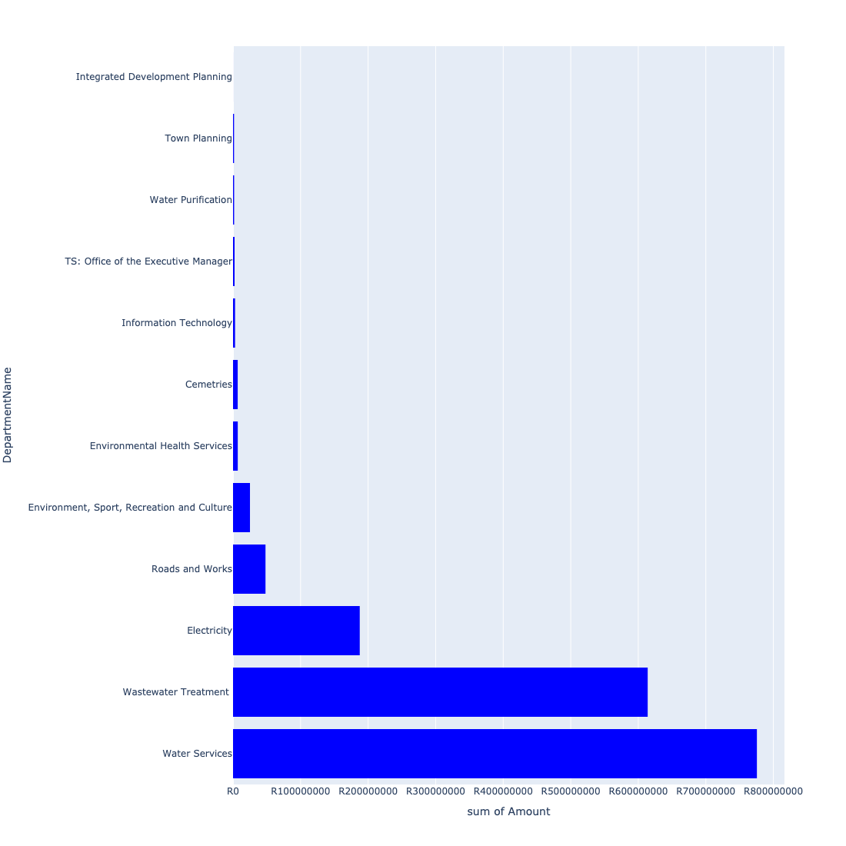

The following figures provide a histogram representation of the capital demand per Functional AreasCombined. A colour breakdown is provided of each year's sub-total that contribute towards the overall total capital demand of each Functional AreasCombined. Note that the capital demand beyond the first three years representing the Medium Term Expenditure Framework (MTREF - years 2023 and 2024) are generally more sparsely and less diligently populated, therefore less reliance should be vested on these outer years when appraising the overall capital demand. The reason for this is usually because of National Treasury's requirement for annual budget submissions spanning only over the MTREF (i.e. the next three years).

Figure 3.3: Capital Demand per Functional AreasCombined - All Years

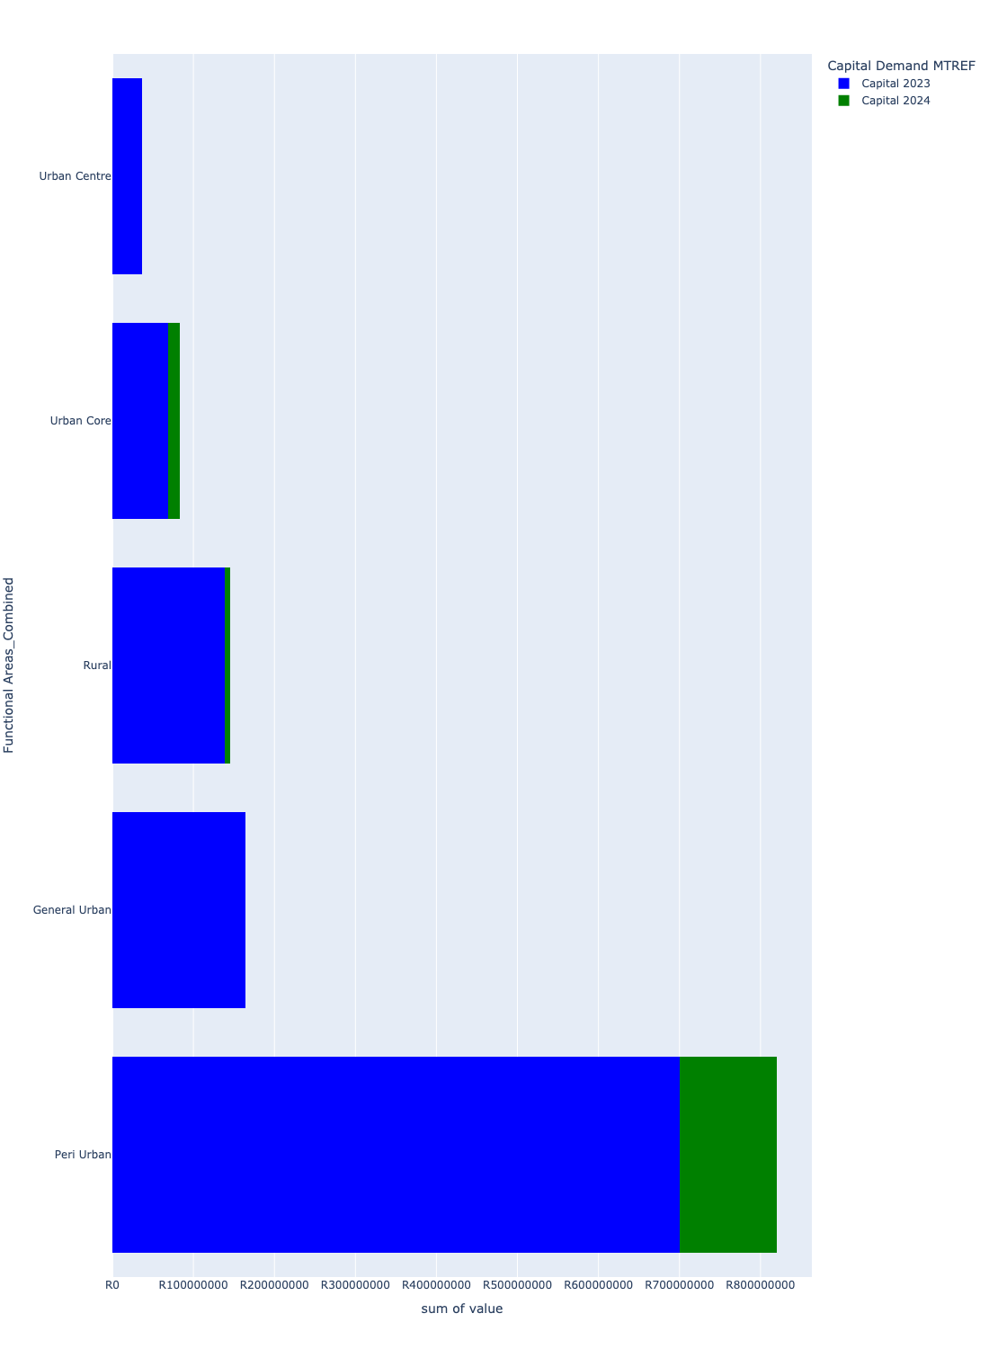

# Total Capital Demand per Functional AreasCombined - MTREF only

Table 4.1 below provides a concise summary of key statistical insights regarding the total MTREF capital demand per Functional AreasCombined.

Table 4.1: Functional AreasCombined Analysis - MTREF Capital Demand (R)

|  |  |  |  |
| --- | --- | --- | --- |
| Description | Info (1) | Info (2) | Info (3) |
| MTREF Capital demand in all Functional AreasCombined - Overview | MTREF capital demand in all Functional AreasCombined: R1,249,171,790 | The average MTREF capital demand per Functional AreasCombined: R249,834,358 | The 75th percentile of MTREF capital demand for Functional AreasCombined: R164,069,778 |
| The highest MTREF capital demand | In Functional AreasCombined: Peri Urban | MTREF capital Demand in Peri Urban: R820,235,007 | Percentage of total MRTEF capital demand in Peri Urban: 65.66% |
| The lowest MTREF capital demand | In Functional AreasCombined: Urban Centre | MTREF capital Demand in Urban Centre: R36,901,451 | Percentage of total MTREF capital demand in Urban Centre: 2.95% |

The following figures provide a histogram representation of the capital demand per Functional AreasCombined. A colour breakdown is provided of each year's sub-total that contribute towards the overall MTREF total capital demand of each Functional AreasCombined.

Figure 4.1: Capital Demand per Functional AreasCombined - MTREF Period

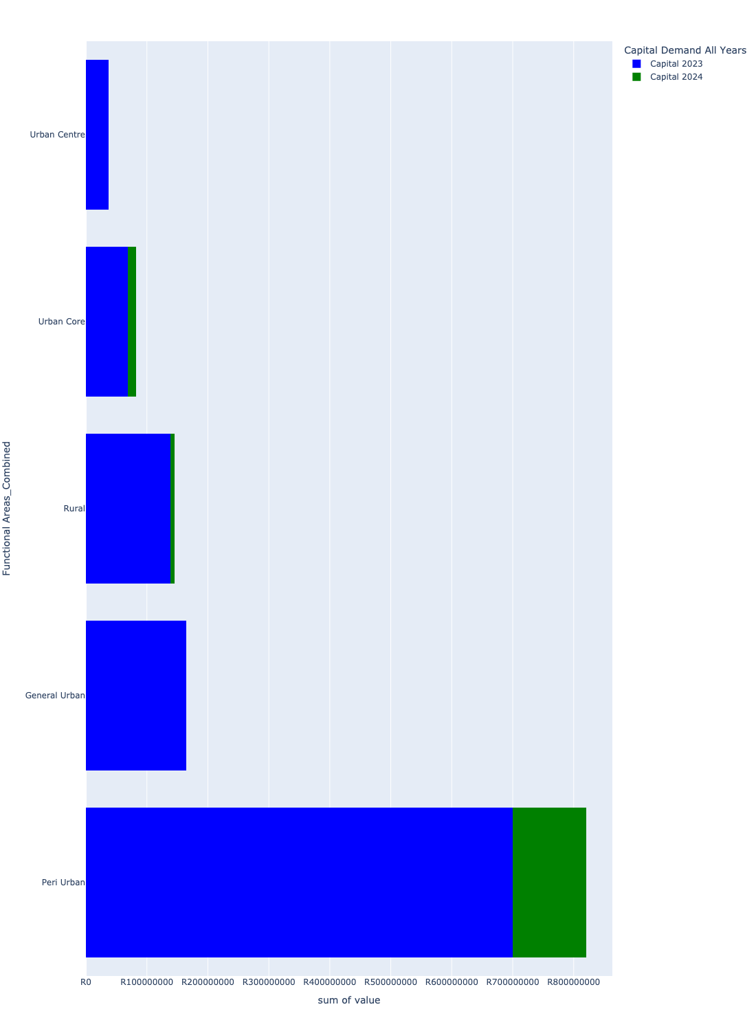

# Summary per Functional AreasCombined

## General Urban

Figure 5.1: General Urban Funding Requests

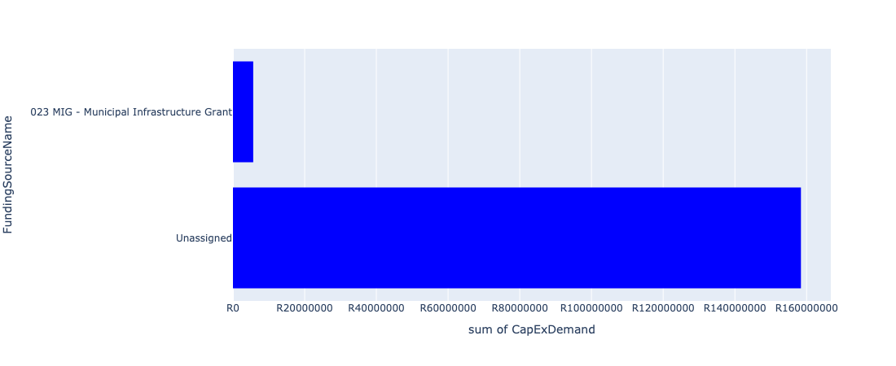

Figure 5.2: General Urban Departmental Requests

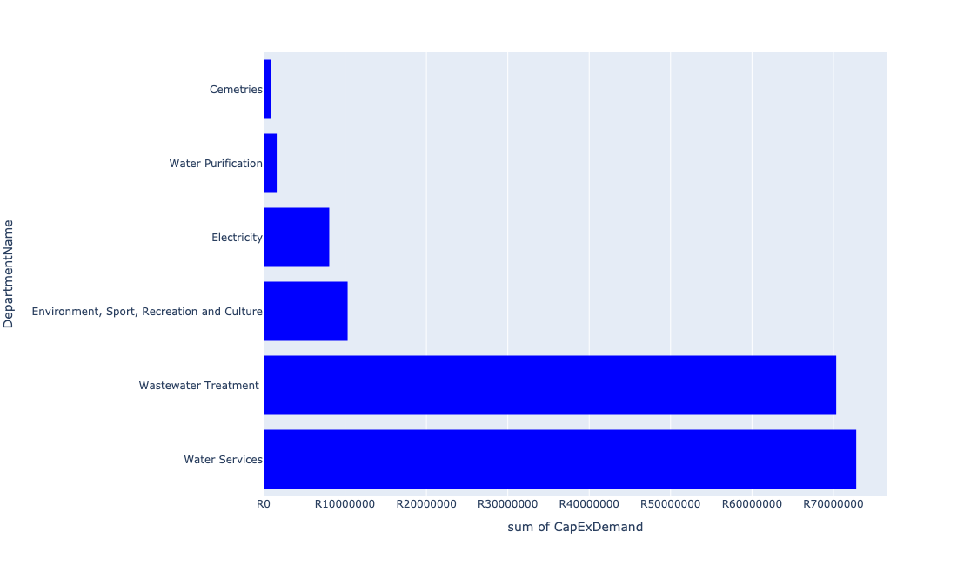

Table 5.1: Summary - General Urban

|  |  |
| --- | --- |
| Item | Description |
| Total Capital Demand for General Urban - All Years | R164,069,778 Rank: 2 (1 = Highest) |
| Total Capital Demand for General Urban - MTREF | R164,069,778 Rank: 2 (1 = Highest) |
| Financial Years in which capital requirements are listed for General Urban | 2023 |
| Financial Year with highest capital demand for General Urban | 2023 |
| General Urban intersecting feature used | Works Location |
| Total number of projects intersecting with General Urban | 23 Rank: 3 (1 = Highest) |

Table 5.2: All projects asking for budget in General Urban

|  |  |  |  |
| --- | --- | --- | --- |
| Project ID | Project Name | Department | Project Budget |
| 56 | Outdoor Facilities: Upgrade of Sports Facilities | Environment, Sport, Recreation and Culture | R9,510,900 (5.80%) Budget spread across: 2023 |
| 103 | Refurbishment and Upgrading of Morgenzon and Sivukile Bulk Water Supply System | Water Services | R5,650,000 (3.44%) Budget spread across: 2023 |
| 117 | Upgrade of Morgenzon WWTW to 5 Ml/day | Wastewater Treatment | R50,000,000 (30.47%) Budget spread across: 2023 |
| 123 | Upgrading of Standerton Water Treatment Plant to 42ML | Water Services | R15,426,257 (9.40%) Budget spread across: 2023 |
| 124 | Upgrading of SWWTP to 20ML | Water Services | R51,420,856 (31.34%) Budget spread across: 2023 |
| 185 | Consulting Engineering Services For The Provision OF Energy Efficiency Solution For High Masts; Streets | Electricity | R644,631 (0.39%) Budget spread across: 2023 |
| 191 | ELECTRICITY PROJECT 35 HOUSEHOLDS | Electricity | R6,617,529 (4.03%) Budget spread across: 2023 |
| 193 | The Supply deliver and install precast concrete palisade fencing to Morgenzon Cementry | Cemetries | R921,121 (0.56%) Budget spread across: 2023 |
| 196 | Design, Supervision Construction Monitoring - Refurbishment & Upgrade of Portions of Stan Water Treament Plant | Water Purification | R1,613,026 (0.98%) Budget spread across: 2023 |
| 202 | INSTAL CAPLE SAKHILE 14/15 | Electricity | R802,943 (0.49%) Budget spread across: 2023 |
| 203 | REFURBISHMENT SEWER ROOIKOPEN | Wastewater Treatment | R20,149,752 (12.28%) Budget spread across: 2023 |
| 204 | STORMWATER | Wastewater Treatment | R195,150 (0.12%) Budget spread across: 2023 |
| 207 | Refurbishment and upgrade of Mahala Park Soccerfield | Environment, Sport, Recreation and Culture | R810,238 (0.49%) Budget spread across: 2023 |
| 208 | Upgrade of portion of Morgenzone water scheme | Water Services | R307,376 (0.19%) Budget spread across: 2023 |

Please note that the following projects will not be shown in this table:

* Projects with no recorded intersect with Functional AreasCombined (in other words no Works Location was recorded on the system for this project)
* Projects that are not asking for any budget (requested budget fields are all '0').

## Peri Urban

Figure 5.3: Peri Urban Funding Requests

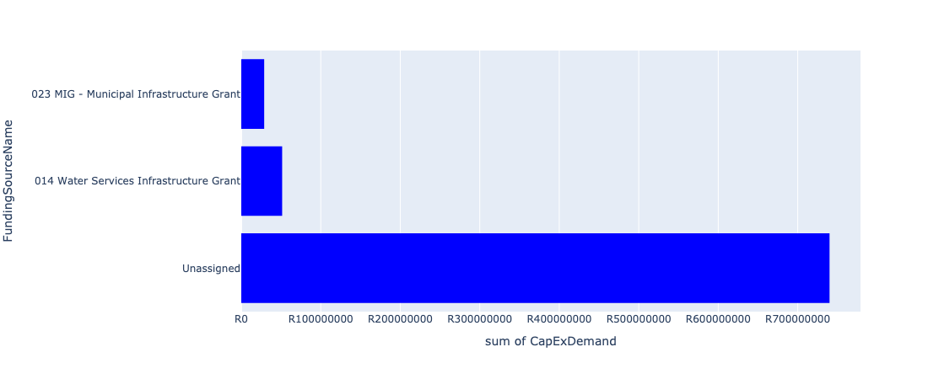

Figure 5.4: Peri Urban Departmental Requests

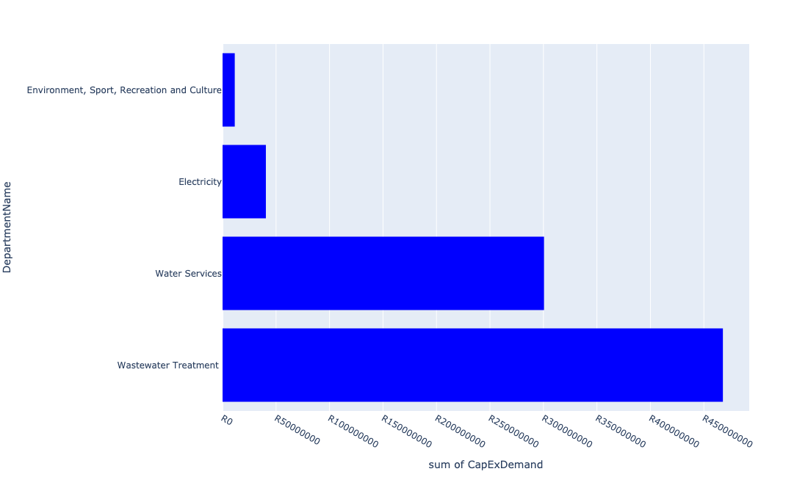

Table 5.2: Summary - Peri Urban

|  |  |
| --- | --- |
| Item | Description |
| Total Capital Demand for Peri Urban - All Years | R820,235,007 Rank: 1 (1 = Highest) |
| Total Capital Demand for Peri Urban - MTREF | R820,235,007 Rank: 1 (1 = Highest) |
| Financial Years in which capital requirements are listed for Peri Urban | 2023 and 2024 |
| Financial Year with highest capital demand for Peri Urban | 2023 |
| Peri Urban intersecting feature used | Works Location |
| Total number of projects intersecting with Peri Urban | 35 Rank: 1 (1 = Highest) |

Table 5.3: All projects asking for budget in Peri Urban

|  |  |  |  |
| --- | --- | --- | --- |
| Project ID | Project Name | Department | Project Budget |
| 123 | Upgrading of Standerton Water Treatment Plant to 42ML | Water Services | R59,573,738 (7.26%) Budget spread across: 2023 |
| 124 | Upgrading of SWWTP to 20ML | Water Services | R198,579,126 (24.21%) Budget spread across: 2023 |
| 185 | Consulting Engineering Services For The Provision OF Energy Efficiency Solution For High Masts; Streets | Electricity | R421 (0.00%) Budget spread across: 2023 |
| 207 | Refurbishment and upgrade of Mahala Park Soccerfield | Environment, Sport, Recreation and Culture | R403,557 (0.05%) Budget spread across: 2023 |
| 59 | Construction of switching station at Standerton Extension 8 and electrification of rural houses | Electricity | R40,000,000 (4.88%) Budget spread across: 2023 and 2024 |
| 69 | Maintenance and Fault Repairs for Hostels Substation | Electricity | R500,000 (0.06%) Budget spread across: 2023 |
| 80 | Boreholes:Upgrade Of Windmills and Hand Pumps | Water Services | R3,000,000 (0.37%) Budget spread across: 2023 |
| 81 | Completion and commissioning of sewer pump station No. 2 in Rooikoppen | Wastewater Treatment | R754,824 (0.09%) Budget spread across: 2023 |
| 82 | Completion of Rooikoppen 2 sewer pump station | Wastewater Treatment | R2,000,000 (0.24%) Budget spread across: 2023 |
| 83 | Construct rising main to link two pump stations under construction in Extension 8 and Link the sewer network to the existing outfall sewer | Wastewater Treatment | R19,000,000 (2.32%) Budget spread across: 2023 |
| 84 | Construction of two Sewer pump stations in Extension 8 | Wastewater Treatment | R13,000,000 (1.58%) Budget spread across: 2023 |
| 85 | Desludging or rural VIP toilets | Wastewater Treatment | R3,500,000 (0.43%) Budget spread across: 2023 and 2024 |
| 90 | Fencing of reservoirs | Water Services | R6,000,000 (0.73%) Budget spread across: 2023 and 2024 |
| 92 | Installation of elevated tank, booster pump and electrical supply in Extension 8 | Water Services | R16,000,000 (1.95%) Budget spread across: 2023 |
| 101 | Refurbishment and commissioning of sewer internal network in Extension 8 | Wastewater Treatment | R18,000,000 (2.19%) Budget spread across: 2023 |
| 104 | Refurbishment of pump stations and Coligny sewer line in Standerton and Morgenzon | Wastewater Treatment | R9,376,927 (1.14%) Budget spread across: 2023 |
| 105 | Refurbishment/Installation of boreholes in rural/farm areas | Water Services | R3,500,000 (0.43%) Budget spread across: 2023 and 2024 |
| 110 | Rooikoppen Upgrade of sewer reticulation network and pump stations | Wastewater Treatment | R50,650,000 (6.18%) Budget spread across: 2023 |
| 111 | Sewer line to address challenges affecting Lesedi school | Wastewater Treatment | R1,000,000 (0.12%) Budget spread across: 2023 |
| 118 | Upgrade of Rooikoppen Sewer | Wastewater Treatment | R320,000,000 (39.01%) Budget spread across: 2023 and 2024 |
| 119 | Upgrade of Standerton WWTW to 30 Ml/day | Wastewater Treatment | R3,423,873 (0.42%) Budget spread across: 2023 |
| 125 | Upgrading of the Standerton Bulk Water Supply System phase 2 | Water Services | R7,433,600 (0.91%) Budget spread across: 2023 |
| 139 | Sakhile: Sewer Gravity Main Upgrade | Wastewater Treatment | R1,000,000 (0.12%) Budget spread across: 2023 |
| 140 | Upgrading of the Sakhile Combined Sport Facility | Environment, Sport, Recreation and Culture | R11,000,000 (1.34%) Budget spread across: 2023 |
| 176 | Designs for Upgrade WWTW | Wastewater Treatment | R5,873,877 (0.72%) Budget spread across: 2023 |
| 187 | Design ,Supervision and construction Monitoring for the Refurbishmentand Upgrade of Bulk and Reticulation Water Infrastructure within Lekwa Local Municipality | Water Services | R657,169 (0.08%) Budget spread across: 2023 |
| 194 | Upgrade of Standerton sewer treatment plant | Wastewater Treatment | R910,406 (0.11%) Budget spread across: 2023 |
| 195 | INSTALL BULK INFRASTRUCTURE AC REPLACEMENT | Water Services | R5,798,468 (0.71%) Budget spread across: 2023 |
| 199 | RANDWATER STANDER SEWER UPGRADE | Wastewater Treatment | R19,299,021 (2.35%) Budget spread across: 2023 |

Please note that the following projects will not be shown in this table:

* Projects with no recorded intersect with Functional AreasCombined (in other words no Works Location was recorded on the system for this project)
* Projects that are not asking for any budget (requested budget fields are all '0').

## Rural

Figure 5.5: Rural Funding Requests

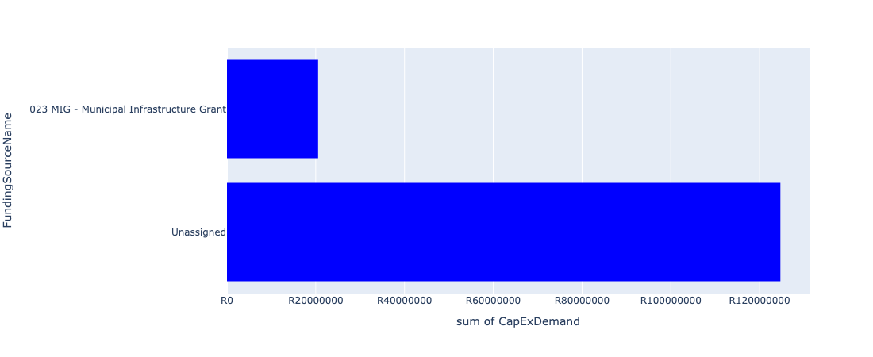

Figure 5.6: Rural Departmental Requests

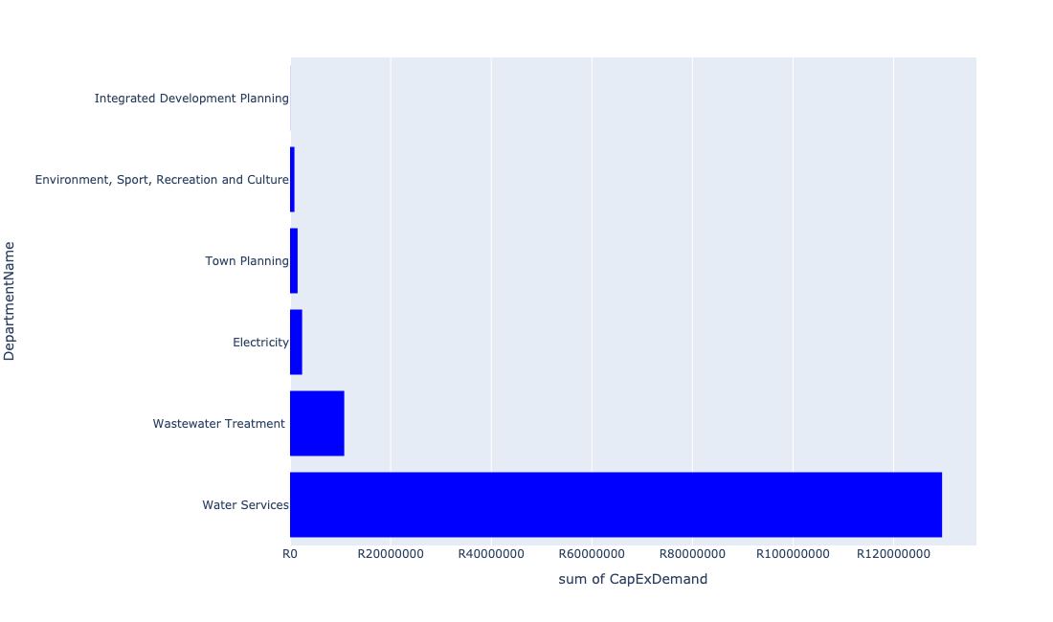

Table 5.3: Summary - Rural

|  |  |
| --- | --- |
| Item | Description |
| Total Capital Demand for Rural - All Years | R145,212,970 Rank: 3 (1 = Highest) |
| Total Capital Demand for Rural - MTREF | R145,212,970 Rank: 3 (1 = Highest) |
| Financial Years in which capital requirements are listed for Rural | 2023 and 2024 |
| Financial Year with highest capital demand for Rural | 2023 |
| Rural intersecting feature used | Works Location |
| Total number of projects intersecting with Rural | 24 Rank: 2 (1 = Highest) |

Table 5.4: All projects asking for budget in Rural

|  |  |  |  |
| --- | --- | --- | --- |
| Project ID | Project Name | Department | Project Budget |
| 208 | Upgrade of portion of Morgenzone water scheme | Water Services | R93,337 (0.06%) Budget spread across: 2023 |
| 187 | Design ,Supervision and construction Monitoring for the Refurbishmentand Upgrade of Bulk and Reticulation Water Infrastructure within Lekwa Local Municipality | Water Services | R2,849,851 (1.96%) Budget spread across: 2023 |
| 68 | Maintenance and Fault Repairs for Holmedene Substation | Electricity | R2,400,000 (1.65%) Budget spread across: 2023 |
| 116 | Toilet Facilities:Refurbishment of Rural VIP Toilets | Wastewater Treatment | R3,000,000 (2.07%) Budget spread across: 2023 |
| 121 | Upgrading of Morgenzon Water Treatment Plant to 3,9ML | Water Services | R46,000,000 (31.68%) Budget spread across: 2023 |
| 122 | Upgrading of MWWTP to 3ML | Water Services | R30,000,000 (20.66%) Budget spread across: 2023 |
| 130 | Water Treatment Works: Refurbish and upgrade Morgenson treatment works | Water Services | R8,000,000 (5.51%) Budget spread across: 2023 |
| 132 | Water Treatment Works: Upgrade standerton water supply scheme | Water Services | R14,224,800 (9.80%) Budget spread across: 2023 |
| 135 | Standerton: Construct new bulk pipeline infrastructure | Water Services | R18,999,999 (13.08%) Budget spread across: 2023 and 2024 |
| 145 | IRDP Phase 1: Planning & Services. Annual Target: 150 Sites | Integrated Development Planning | R6,544 (0.00%) Budget spread across: 2023 |
| 146 | IRDP Phase 2: Top Structure. Annual Target: 250 Units | Integrated Development Planning | R25,750 (0.02%) Budget spread across: 2023 |
| 147 | Development of Precinct Plans | Town Planning | R1,500,000 (1.03%) Budget spread across: 2023 |
| 188 | Installation of Water Services to informal settlements within Lekwa LM | Water Services | R864,991 (0.60%) Budget spread across: 2023 |
| 192 | SEWER TREATMENT | Wastewater Treatment | R7,774,489 (5.35%) Budget spread across: 2023 |
| 198 | Replacement of AC Pipes: Consultants | Water Services | R8,601,277 (5.92%) Budget spread across: 2023 |
| 200 | CRICKET FIELD | Environment, Sport, Recreation and Culture | R511,931 (0.35%) Budget spread across: 2023 |
| 205 | Refurbishment of Morgenzon Sports Facility | Environment, Sport, Recreation and Culture | R360,000 (0.25%) Budget spread across: 2023 |

Please note that the following projects will not be shown in this table:

* Projects with no recorded intersect with Functional AreasCombined (in other words no Works Location was recorded on the system for this project)
* Projects that are not asking for any budget (requested budget fields are all '0').

## Urban Centre

Figure 5.7: Urban Centre Funding Requests

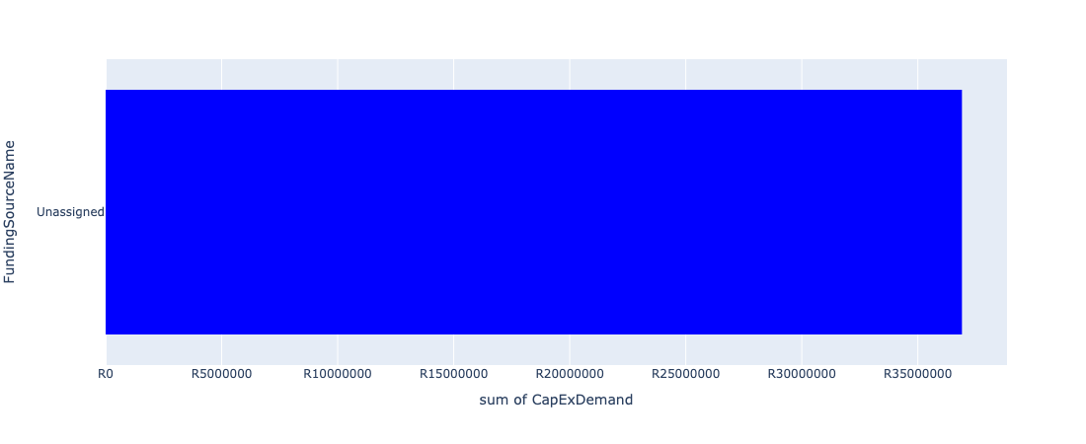

Figure 5.8: Urban Centre Departmental Requests

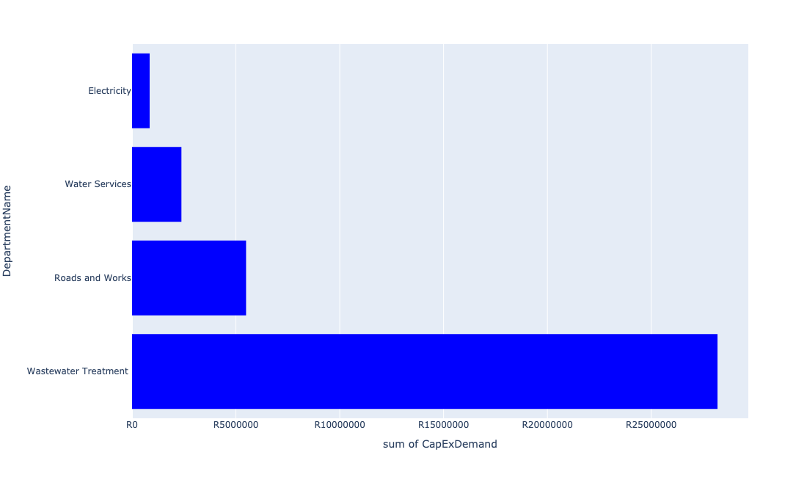

Table 5.4: Summary - Urban Centre

|  |  |
| --- | --- |
| Item | Description |
| Total Capital Demand for Urban Centre - All Years | R36,901,451 Rank: 5 (1 = Highest) |
| Total Capital Demand for Urban Centre - MTREF | R36,901,451 Rank: 5 (1 = Highest) |
| Financial Years in which capital requirements are listed for Urban Centre | 2023 |
| Financial Year with highest capital demand for Urban Centre | 2023 |
| Urban Centre intersecting feature used | Works Location |
| Total number of projects intersecting with Urban Centre | 9 Rank: 5 (1 = Highest) |

Table 5.5: All projects asking for budget in Urban Centre

|  |  |  |  |
| --- | --- | --- | --- |
| Project ID | Project Name | Department | Project Budget |
| 202 | INSTAL CAPLE SAKHILE 14/15 | Electricity | R846,786 (2.29%) Budget spread across: 2023 |
| 204 | STORMWATER | Wastewater Treatment | R202,296 (0.55%) Budget spread across: 2023 |
| 171 | Morgenzon 1 and Morgenzon 2 sewer pump stations Coligny TLC | Wastewater Treatment | R6,872,813 (18.62%) Budget spread across: 2023 |
| 172 | Construction of Kieser Pressure Tower | Water Services | R2,185,574 (5.92%) Budget spread across: 2023 |
| 184 | Resurfacing of Roads Mbonani Walter Sisulu | Roads and Works | R5,489,252 (14.88%) Budget spread across: 2023 |
| 189 | Design, Supervision Construction Monitoring - Installation of Steel Elevated Tank | Water Services | R191,590 (0.52%) Budget spread across: 2023 |
| 197 | Reconstruction of the Rooikopen Sewer Network - Refurbishment of the Rooikopen Pump Station and Construction of the Booster Pump Station within a Pumping Main (Sakhile Extension 4) | Wastewater Treatment | R20,337,018 (55.11%) Budget spread across: 2023 |
| 209 | Construction of 4.5 km line from B substation to WTW | Wastewater Treatment | R776,122 (2.10%) Budget spread across: 2023 |

Please note that the following projects will not be shown in this table:

* Projects with no recorded intersect with Functional AreasCombined (in other words no Works Location was recorded on the system for this project)
* Projects that are not asking for any budget (requested budget fields are all '0').

## Urban Core

Figure 5.9: Urban Core Funding Requests

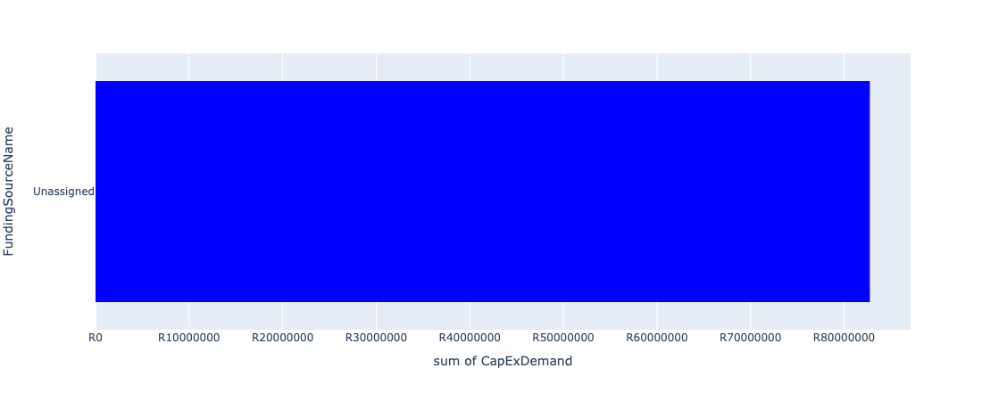

Figure 5.10: Urban Core Departmental Requests

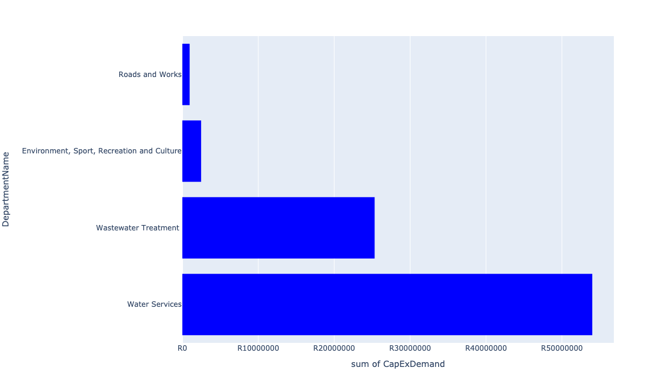

Table 5.5: Summary - Urban Core

|  |  |
| --- | --- |
| Item | Description |
| Total Capital Demand for Urban Core - All Years | R82,752,585 Rank: 4 (1 = Highest) |
| Total Capital Demand for Urban Core - MTREF | R82,752,585 Rank: 4 (1 = Highest) |
| Financial Years in which capital requirements are listed for Urban Core | 2023 and 2024 |
| Financial Year with highest capital demand for Urban Core | 2023 |
| Urban Core intersecting feature used | Works Location |
| Total number of projects intersecting with Urban Core | 14 Rank: 4 (1 = Highest) |

Table 5.6: All projects asking for budget in Urban Core

|  |  |  |  |
| --- | --- | --- | --- |
| Project ID | Project Name | Department | Project Budget |
| 91 | Improvement of Residual Pressure in Concor Supply Area | Water Services | R20,000,000 (24.17%) Budget spread across: 2023 |
| 99 | Pump Station: Muller and Johan Pump Stations | Wastewater Treatment | R4,500,000 (5.44%) Budget spread across: 2023 |
| 100 | Refurbishment an commissioning of Pressure and Level Control Valves | Water Services | R100,000 (0.12%) Budget spread across: 2023 |
| 102 | Refurbishment and upgrade of sewer pump stations and coligny sewer line | Wastewater Treatment | R20,800,000 (25.14%) Budget spread across: 2023 and 2024 |
| 126 | Upgrading of the Standerton Bulk Water Supply System phase 2 - MIG | Water Services | R24,130,099 (29.16%) Budget spread across: 2023 and 2024 |
| 171 | Morgenzon 1 and Morgenzon 2 sewer pump stations Coligny TLC | Wastewater Treatment | R27,187 (0.03%) Budget spread across: 2023 |
| 172 | Construction of Kieser Pressure Tower | Water Services | R6,342,947 (7.66%) Budget spread across: 2023 |
| 174 | Finalisation of Morg and Mahala Park Sports Facilities | Environment, Sport, Recreation and Culture | R2,471,747 (2.99%) Budget spread across: 2023 |
| 186 | Maintenace of Roads Within Lekwa Local Municipality | Roads and Works | R959,378 (1.16%) Budget spread across: 2023 |
| 190 | MEYERVILL W/WORKS: 2ND PHASE | Water Services | R3,421,226 (4.13%) Budget spread across: 2023 |

Please note that the following projects will not be shown in this table:

* Projects with no recorded intersect with Functional AreasCombined (in other words no Works Location was recorded on the system for this project)
* Projects that are not asking for any budget (requested budget fields are all '0').