



Spatial Feature Report

T: +27 12 364 2546 | E: info@novus3.co.za Postnet Suite 471, Private Bag X15,

Menlo Park, 0102**www.novus3.co.za**

engineered solutions

Disclaimer

This document contains data that was obtained from a live CP3 system at the moment the data was requested. The data is updated by users of the CP3 System and unless the system is locked for changes, this data may change on a daily basis. The reader is therefore cautioned not to place inappropriate reliance on the data unless there is certainty on the status of the data in terms of how recently it has been updated, how “clean” the data is (is there a quality control and/or verification process that was followed by the licensee of the CP3 system to ensure that data is checked and verified from time-to-time) and whether the correct baseline was queried. This report therefore provides a “snapshot in time”. Consequently, the document may be less relevant at a different time, or using a different financial baseline to query from.

At all times, all rights, title and interest in and to this material remains vested in the owner of this document and are copyrighted and protected by regulatory provisions. These materials may not be copied, reproduced, modified, published, uploaded, posted to websites or otherwise distributed in any way, without our prior written permission from the Licensee and Licensor (Nvous3 (Pty) Ltd) of the CP3 Software. The owner of this document does not grant any right to reproduce the materials. All our rights in this regard are and remain reserved.

Spatial Query Report: Midvaal Township Boundaries

This document was created *2022-04-07-18_47* from the **Midvaal Municipality** CP3 system by the following user: *'Bernard'.*

The baseline **'2021/2022 Capital Budget_20210601_Annexure A'** with description: **'Final Capital Budget approved by Council on 20210527 Data Received from Finance'** was used. The spatial feature that was selected for the purpose of this report was: **'Midvaal Township Boundaries'**.

This is a spatial feature report for the *Midvaal Municipality.* The data contained in this report was sourced directly from the municipality's live CP3 system. The information in this report therefore reflects the data as it was on the *2022-04-07* when this report was requested. Any subsequent updates to the data contained the CP3 System related to the applicable baseline from which this reports was drawn, would therefore not reflect in this report.   
  
For the *Midvaal Municipality, the following spatial features are available for the purpose of developing* 'Spatial Query Reports' (similar to this report):

* Economic Study Catalytic Nodes (5nodes)
* Midvaal 5 EDCs
* Midvaal Township Boundaries
* Wards



We hope you find this useful! Sincerely, *The Novus3 Team.*

# Introduction

The baseline that was queried for this report contains *345* projects of which a total of *14 (4.06%)* projects do not have any recorded intersection (overlap) with Midvaal Township Boundaries.The following spatial features are available for queries using this API profile:

* Economic Study Catalytic Nodes (5nodes)
* Midvaal 5 EDCs
* Midvaal Township Boundaries
* Wards

The probable reasons for the 14 non intersecting projects reported are that:

* these projects simply do not have a location associated with them yet (most frequently the case with 'no-intersect' projects) or;
* the location that was captured for some of these projects, may have been in the wrong place (e.g. outside the boundaries of Midvaal - this is very rarely the reason).

It is important to take note of the 4.06% projects that do not intersect with Midvaal Township Boundaries feature when appraising this report.

The 4.06% of non-intersecting projects is a relative low percentage and therefore not much cause of concern for this particular report.

Figure 1: Intersecting vs Non-Intersecting Projects

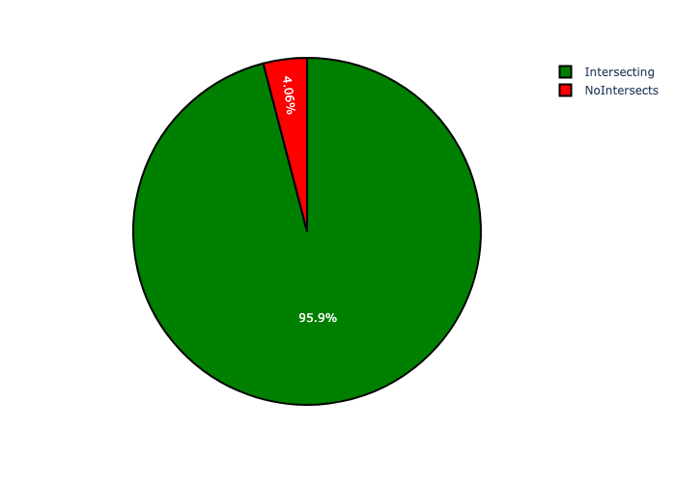

# Midvaal Township Boundaries Analysis

There is a total number of **100** *Midvaal Township Boundaries.* Each of the *Midvaal Township Boundaries* has two important perspectives namely:

* the number of projects within each geographic area and;
* the total capital demand per area.

The following information relates to the number of projects in Midvaal Township Boundaries:

* MEYERTON FARMS has the highest number of projects: 34 projects (10.27% of total number of projects);
* THE EVATON ESTATE has the lowest number of projects: 1 project (0.30% of total number of projects);
* The average number of projects per Midvaal Township Boundaries is 3.31 projects;
* The 75th percentile of projects per Midvaal Township Boundaries is 4.0 projects;
* The total number of projects in all Midvaal Township Boundaries is 331 projects;
* The 5 Midvaal Township Boundaries with the most projects have a combined total of 85 projects. This accounts for 25.68% of the total number of projects.

The following information relates to the capital demand in Midvaal Township Boundaries:

* MEYERTON FARMS has the highest capital demand: R21,812,922 (30.27% of total capital demand);
* BADFONTEIN 438-IR has the lowest capital demand: R0 (0.00% of total capital demand);
* The average capital demand per Midvaal Township Boundaries is R720,568;
* The 75th percentile of capital demand per Midvaal Township Boundaries is R5,088.
* The total capital demand in all Midvaal Township Boundaries is R72,056,841;
* The 5 Midvaal Township Boundaries with the highest capital demand have a combined total of R56,900,547. This accounts for 78.97% of the total capital demand.

Figure 2.1: Projects and Capital Demand per Midvaal Township Boundaries (1/3)

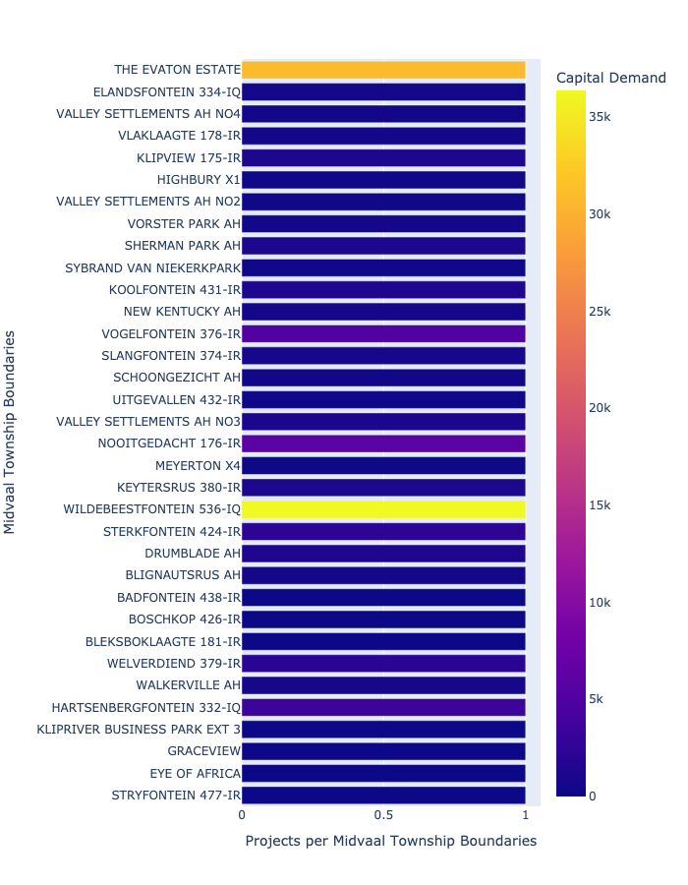

Figure 2.2: Projects and Capital Demand per Midvaal Township Boundaries (2/3)

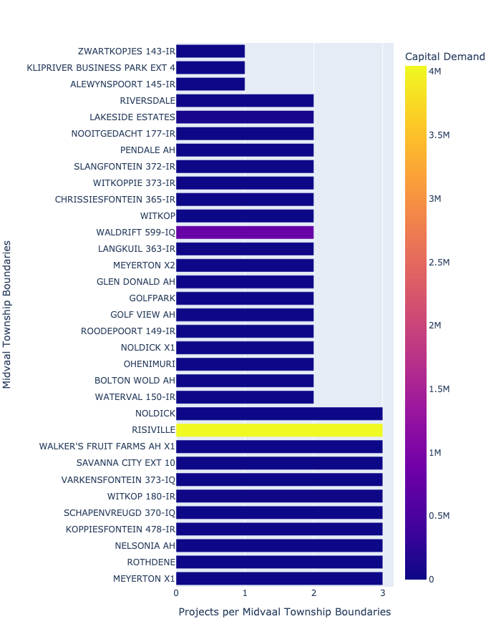

Figure 2.3: Projects and Capital Demand per Midvaal Township Boundaries (3/3)

