

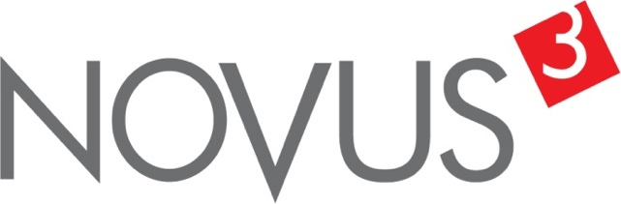

Spatial Feature Report

T: +27 12 364 2546 | E: info@novus3.co.za Postnet Suite 471, Private Bag X15,

Menlo Park, 0102**www.novus3.co.za**

engineered solutions

Disclaimer

This document contains data that was obtained from a live CP3 system at the moment the data was requested. The data is updated by users of the CP3 System and unless the system is locked for changes, this data may change on a daily basis. The reader is therefore cautioned not to place inappropriate reliance on the data unless there is certainty on the status of the data in terms of how recently it has been updated, how “clean” the data is (is there a quality control and/or verification process that was followed by the licensee of the CP3 system to ensure that data is checked and verified from time-to-time) and whether the correct baseline was queried. This report therefore provides a “snapshot in time”. Consequently, the document may be less relevant at a different time, or using a different financial baseline to query from.

At all times, all rights, title and interest in and to this material remains vested in the owner of this document and are copyrighted and protected by regulatory provisions. These materials may not be copied, reproduced, modified, published, uploaded, posted to websites or otherwise distributed in any way, without our prior written permission from the Licensee and Licensor (Nvous3 (Pty) Ltd) of the CP3 Software. The owner of this document does not grant any right to reproduce the materials. All our rights in this regard are and remain reserved.

Table of Contents

**No table of contents entries found.** (Right-click -> Update Field)

Spatial Query Report

This document was created *2022-04-29-19_52* from the **Midvaal Municipality** CP3 system.

The baseline **'2022/2023 Draft Capital Budget_20220301_Finance'** with description: **'2022/2023 Draft Capital Budget as recieved from Finance as draft Capital Budget with only MTREF Values'** was used. The spatial feature that was selected for the purpose of this report was: **'Wards'**.

This is a spatial feature report for the *Midvaal Municipality.* The data contained in this report was sourced directly from the municipality's live CP3 system. The information in this report therefore reflects the data as it was on *2022-04-29* when this report was requested. Any subsequent updates to the data contained the CP3 System related to the applicable baseline from which this reports was drawn, would therefore not reflect in this report.   
  
For the *Midvaal Municipality, the following spatial features are available for the purpose of developing* 'Spatial Query Reports' (similar to this report):

* Economic Study Catalytic Nodes (5nodes)
* Midvaal 5 EDCs
* Midvaal Township Boundaries
* Wards



We hope you find this useful! Sincerely, *The Novus3 Team.*

# Introduction

The baseline that was queried for this report contains *196* projects of which a total of *14 (7.14%)* projects do not have any recorded intersection (overlap) with Wards. The following spatial features are available for queries using this API profile:

* Economic Study Catalytic Nodes (5nodes)
* Midvaal 5 EDCs
* Midvaal Township Boundaries
* Wards

The probable reasons for the 14 non intersecting projects reported are that:

* these projects simply do not have a location associated with them yet (most frequently the case with 'no-intersect' projects) or;
* the location that was captured for some of these projects, may have been in the wrong place (e.g. outside the boundaries of Midvaal - this is very rarely the reason).

It is important to take note of the 7.14% projects that do not intersect with Wards feature when appraising this report.

Figure 1.1: Intersecting vs Non-Intersecting Projects

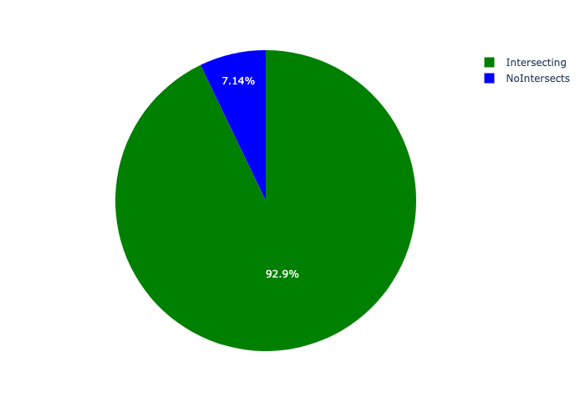

# Total Number of Projects and Total Capital Demand per Ward - All Years

Table 2.1 below provides a concise summary of key statistical insights regarding the number of projects that are requesting funding in each of the Wards.

Table 2.1: Wards Analysis - Number of Projects

|  |  |  |  |
| --- | --- | --- | --- |
| Description | Info (1) | Info (2) | Info (3) |
| Number of projects in all Wards - Overview | Total in all Wards: 182 projects | Average per Wards: 12.1 projects | 75th percentile of projects across all Wards: 19.0 projects |
| The highest number of projects | Wards: In Ward 10 | Number of projects in Ward 10: 28 | Percentage of total in Ward 10: 15.38% |
| The lowest number of projects: | Wards: In Ward 12 | Number of projects in Ward 12: 3 | Percentage of total in Ward 12: 1.65% |
| The 5 Wards that collectively have with the highest number of projects | Wards: In Ward 01, Ward 05, Ward 11, Ward 09 and Ward 10 | Number of projects in Ward 01, Ward 05, Ward 11, Ward 09 and Ward 10 together: 114 | Percentage of total in Ward 01, Ward 05, Ward 11, Ward 09 and Ward 10 together: 62.64% |

Table 2.1 below provides a concise summary of key statistical insights regarding the total capital demand per Ward.

Table 2.1: Wards Analysis - Capital Demand (R)

|  |  |  |  |
| --- | --- | --- | --- |
| Description | Info (1) | Info (2) | Info (3) |
| Capital demand in all Wards - Overview | Total capital demand in all Wards: R90,995,671 | The average capital demand per Wards: R6,066,378 | The 75th percentile of capital demand for Wards: R6,699,811 |
| The highest capital demand | Wards: In Ward 09 | Capital Demand in Ward 09: R23,508,681 | Percentage of total in Ward 09: 25.83% |
| The lowest capital demand | Wards: In Ward 12 | Capital Demand in Ward 12: R0 | Percentage of total in Ward 12: 0.00% |
| The 5 Wards that collectively have collective the highest capital demand: | Wards: In Ward 08, Ward 05, Ward 13, Ward 14 and Ward 09 | Capital Demand in Ward 08, Ward 05, Ward 13, Ward 14 and Ward 09 together: R66,130,386 | Percentage of total in Ward 08, Ward 05, Ward 13, Ward 14 and Ward 09 together: 72.67% |

The number of projects per Ward and the capital demand per Ward needs to be looked at together for better insight. Figures 2.1 and 2.2 assist with further graphical insight into some of the numbers that are provided in Tables 2.1 and 2.2.

Figure 2.1: The single Ward with the highest value (Nr of Projects & Capital Demand) vs the rest

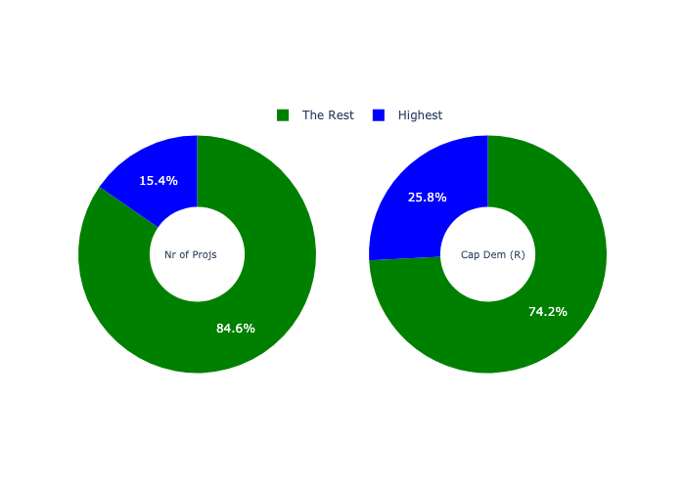

The highest number of projects in a single Ward is in **Ward 10.** *That is 28 projects and this is 15.38% of the total number of projects.*The highest capital demand in a single Ward is in **Ward 09.** *That is R23,508,681 and this amounts to 25.83% of the total capital demand.*

Figure 2.2: The 5 Wards with the highest values (Nr of Projects & Capital Demand) vs the rest

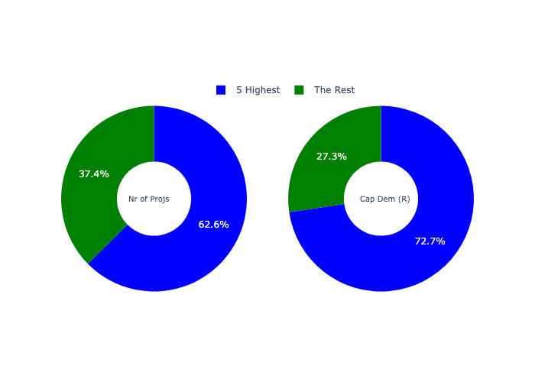

The 5 Wards that collectively have with the highest number of projects are in **Ward 01, Ward 05, Ward 11, Ward 09 and Ward 10.** *That is 114 projects and this is 62.64% of the total number of projects.*The 5 Wards that collectively have the highest capital demand are in **Ward 08, Ward 05, Ward 13, Ward 14 and Ward 09.** *That is 72.67% and this amounts to R66,130,386 of the total capital demand.*

The following figures provide a bar graph representation of the number of projects per Ward with the colour of the bars representing the level of capital demand in each of these Wards.

Figure 2.3: Projects and Capital Demand per Ward

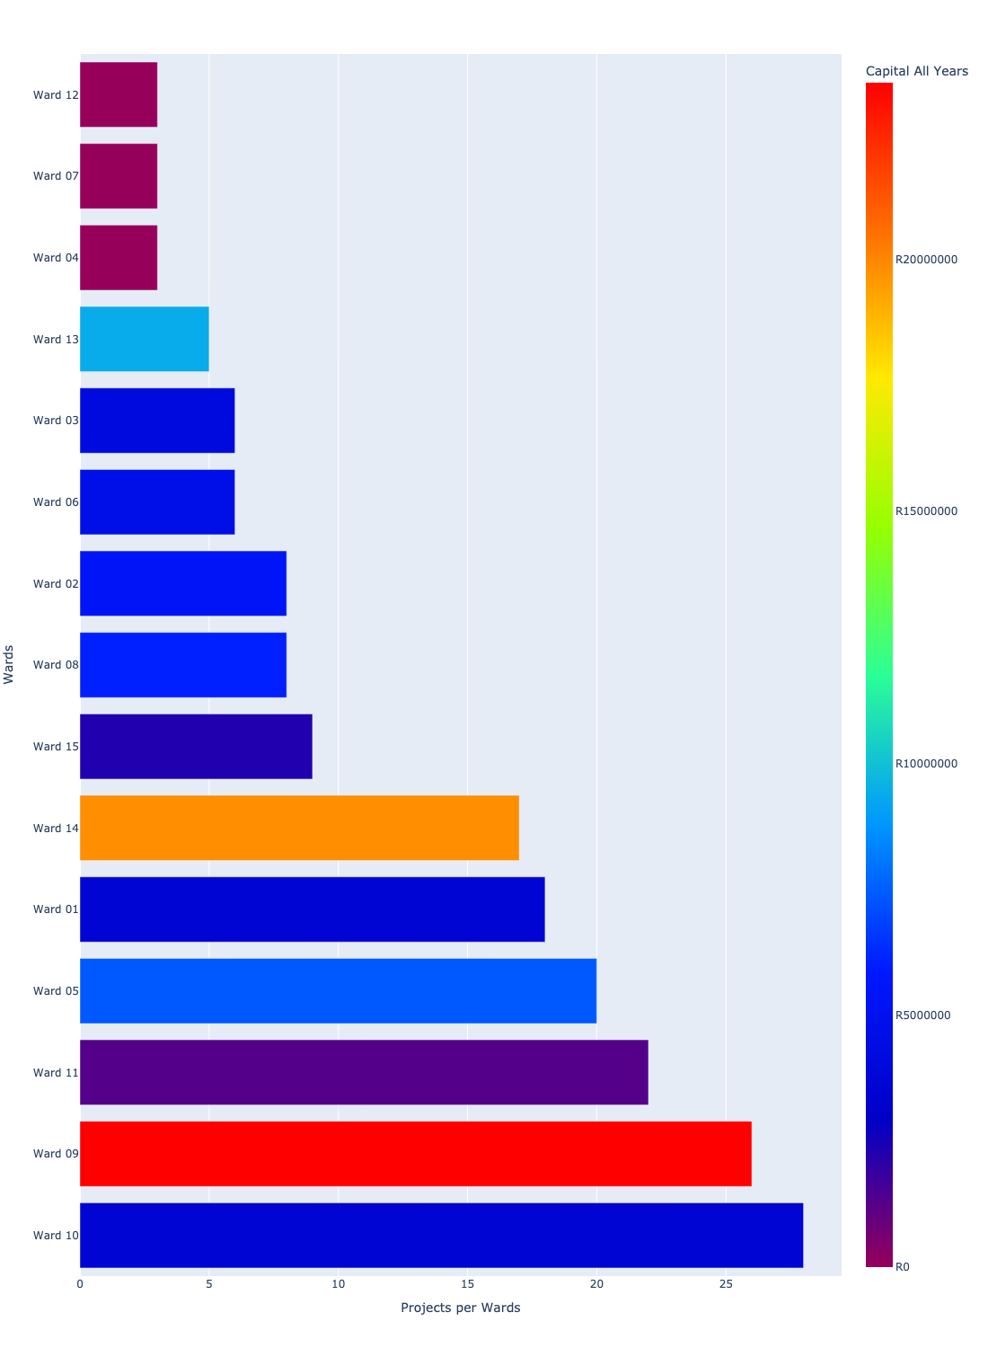

# Total Capital Demand per Ward - All Years

There are different funding sources from which capital is requested. For the financial baseline that was selected for this report query (2022/2023 Draft Capital Budget_20220301_Finance), the breakdown of capital demand for Midvaal Municipality per funding source is shown in Figure 3.1 below.

Figure 3.1: Capital Demand Per Funding Source

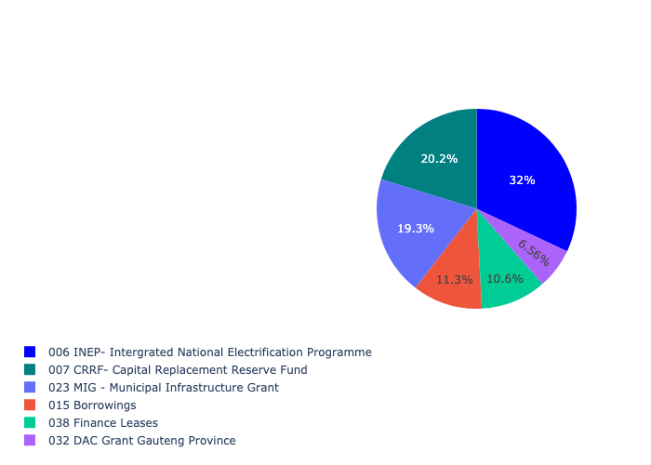

For the financial baseline that was selected for this report query (2022/2023 Draft Capital Budget_20220301_Finance), the breakdown of capital demand for Midvaal Municipality per department is shown in Figure 3.2 below.

Figure 3.2: Capital Demand Per Midvaal Municipality Department

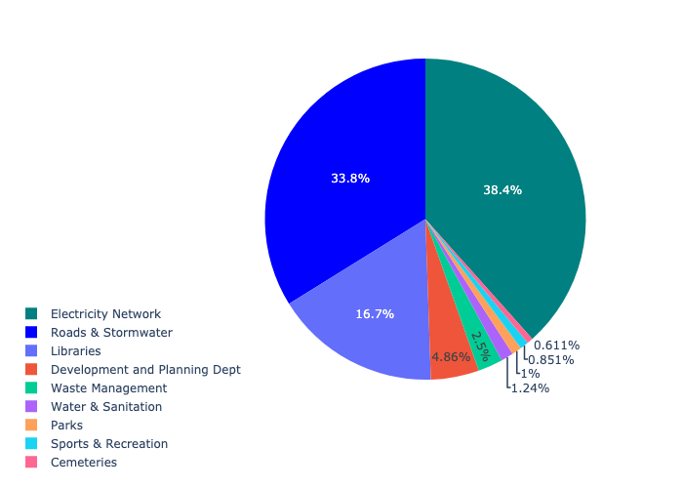

The following figures provide a histogram representation of the capital demand per Ward. A colour breakdown is provided of each year's sub-total that contribute towards the overall total capital demand of each Ward. Note that the capital demand beyond the first three years representing the Medium Term Expenditure Framework (MTREF - years 2023, 2024 and 2025) are generally more sparsely and less diligently populated, therefore less reliance should be vested on these outer years when appraising the overall capital demand. The reason for this is usually because of National Treasury's requirement for annual budget submissions spanning only over the MTREF (i.e. the next three years).

Figure 3.3: Capital Demand per Ward - All Years

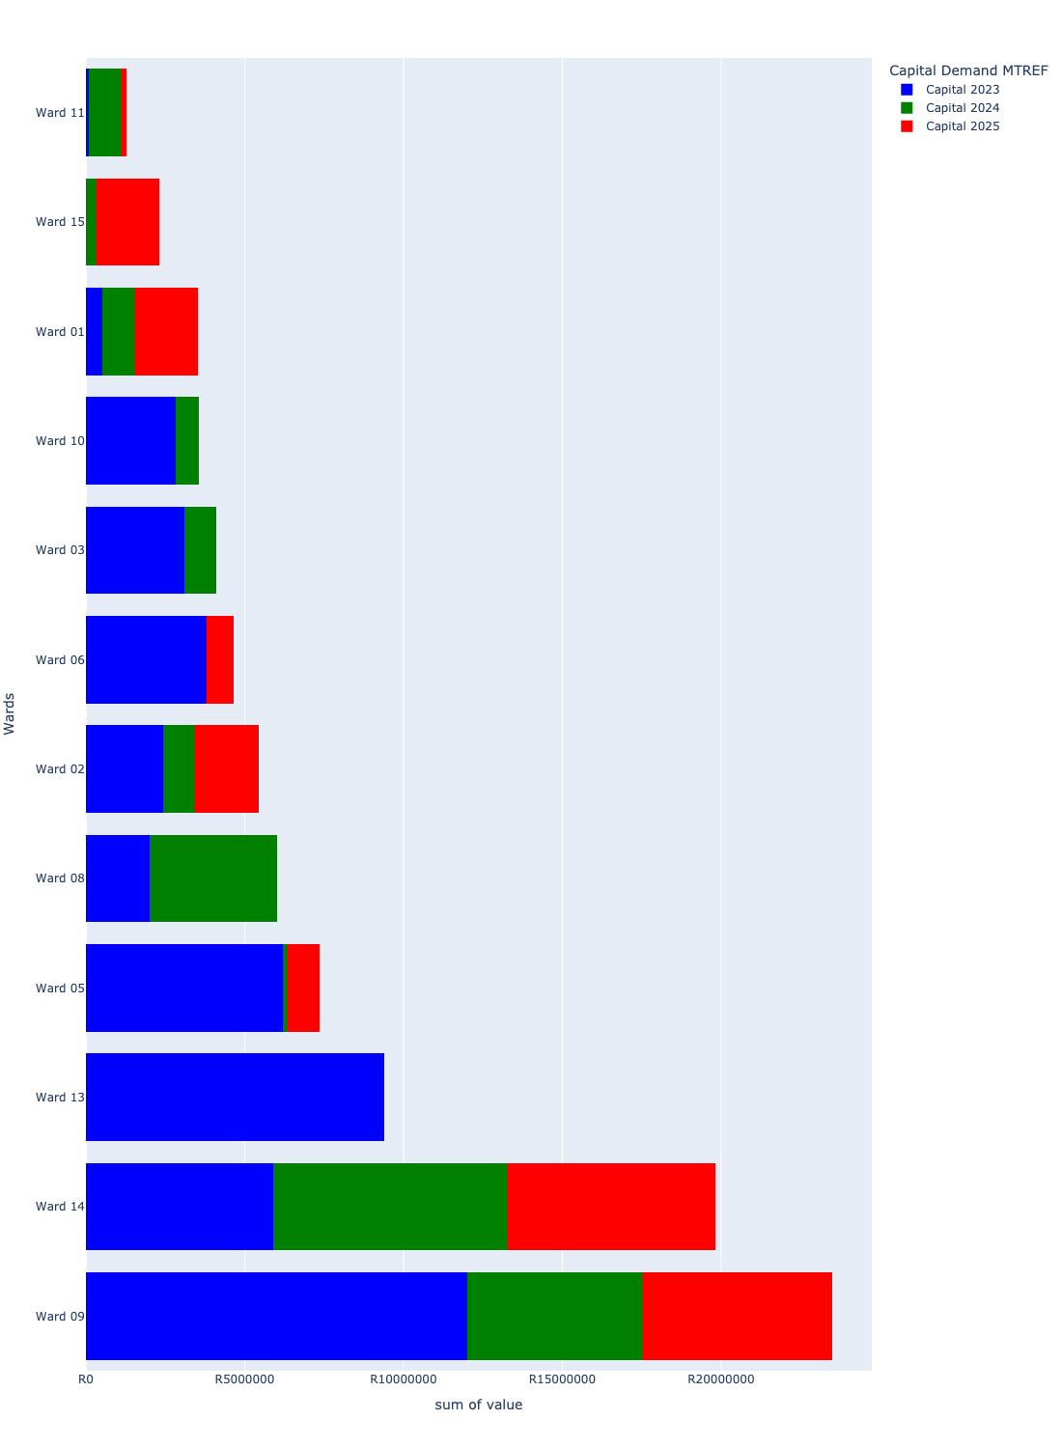

# Total Capital Demand per Ward - MTREF only

Table 4.1 below provides a concise summary of key statistical insights regarding the total MTREF capital demand per Ward.

Table 4.1: Wards Analysis - MTREF Capital Demand (R)

|  |  |  |  |
| --- | --- | --- | --- |
| Description | Info (1) | Info (2) | Info (3) |
| MTREF Capital demand in all Wards - Overview | MTREF capital demand in all Wards: R90,995,671 | The average MTREF capital demand per Ward: R6,066,378 | The 75th percentile of MTREF capital demand for Wards: R6,699,811 |
| The highest MTREF capital demand | In Ward: Ward 09 | MTREF capital Demand in Ward 09: R23,508,681 | Percentage of total MRTEF capital demand in Ward 09: 25.83% |
| The lowest MTREF capital demand | In Ward: Ward 12 | MTREF capital Demand in Ward 12: R0 | Percentage of total MTREF capital demand in Ward 12: 0.00% |

The following figures provide a histogram representation of the capital demand per Ward. A colour breakdown is provided of each year's sub-total that contribute towards the overall MTREF total capital demand of each Ward.

Figure 4.1: Capital Demand per Ward - MTREF Period

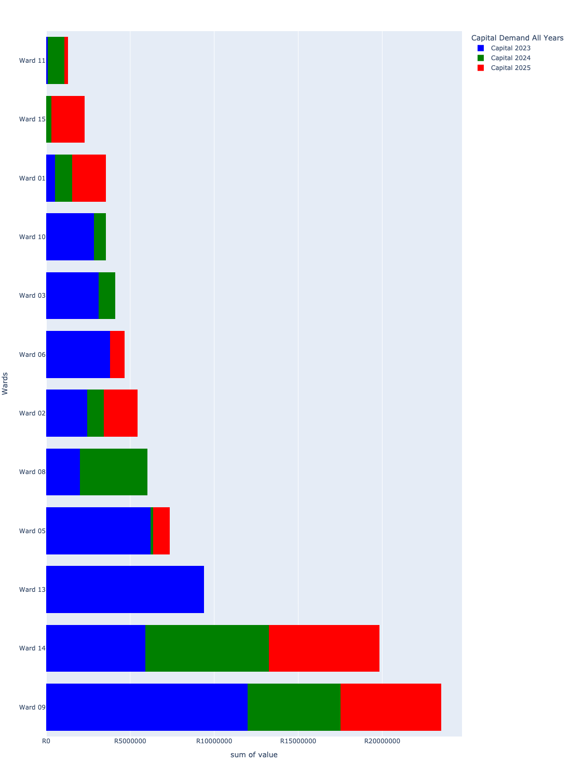

# Summary per Ward

## Ward 01

Figure 5.1: Ward 01 Funding Requests

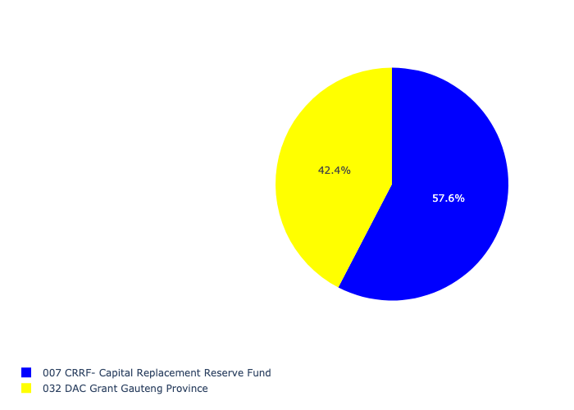

Figure 5.2: Ward 01 Departmental Requests

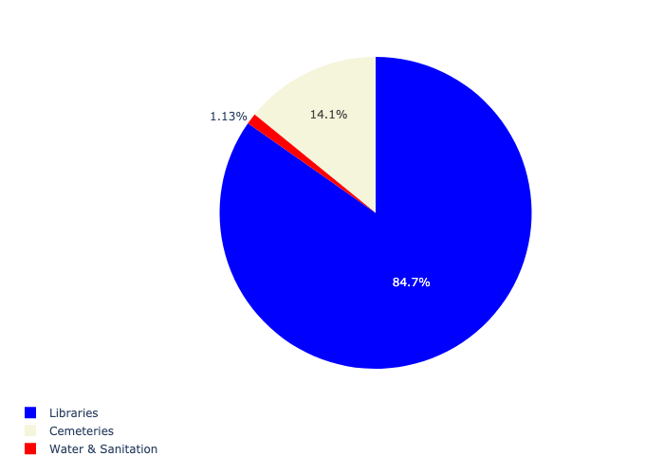

Table 5.1: Summary - Ward 01

|  |  |
| --- | --- |
| Item | Description |
| Total Capital Demand for Ward 01 - All Years | R3,540,000 Rank: 10 (1 = Highest) |
| Total Capital Demand for Ward 01 - MTREF | R3,540,000 Rank: 10 (1 = Highest) |
| Financial Years in which capital requirements are listed for Ward 01 | 2023, 2024 and 2025 |
| Financial Year with highest capital demand for Ward 01 | Capital 2025 |
| Ward 01 intersecting feature used | Works Location |
| Total number of projects intersecting with Ward 01 | 18 Rank: 5 (1 = Highest) |

## Ward 02

Figure 5.3: Ward 02 Funding Requests

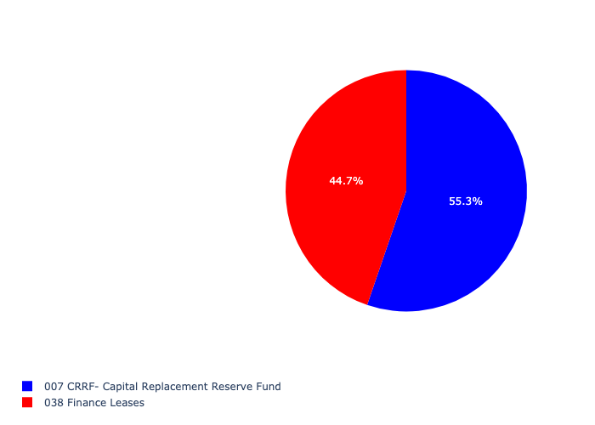

Figure 5.4: Ward 02 Departmental Requests

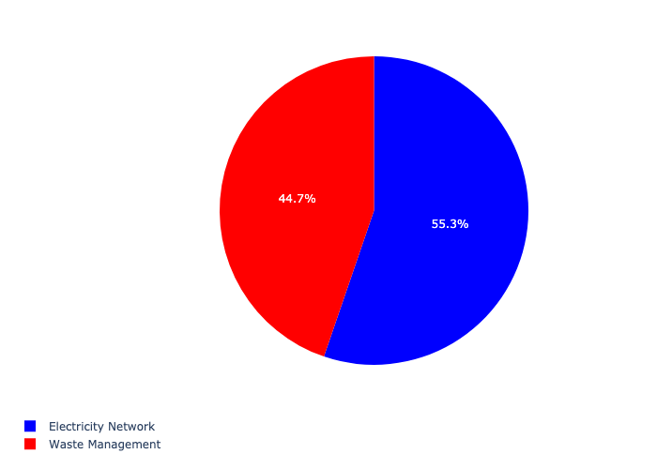

Table 5.2: Summary - Ward 02

|  |  |
| --- | --- |
| Item | Description |
| Total Capital Demand for Ward 02 - All Years | R5,429,273 Rank: 6 (1 = Highest) |
| Total Capital Demand for Ward 02 - MTREF | R5,429,273 Rank: 6 (1 = Highest) |
| Financial Years in which capital requirements are listed for Ward 02 | 2023, 2024 and 2025 |
| Financial Year with highest capital demand for Ward 02 | Capital 2023 |
| Ward 02 intersecting feature used | Works Location |
| Total number of projects intersecting with Ward 02 | 8 Rank: 8 (1 = Highest) |

## Ward 03

Figure 5.5: Ward 03 Funding Requests

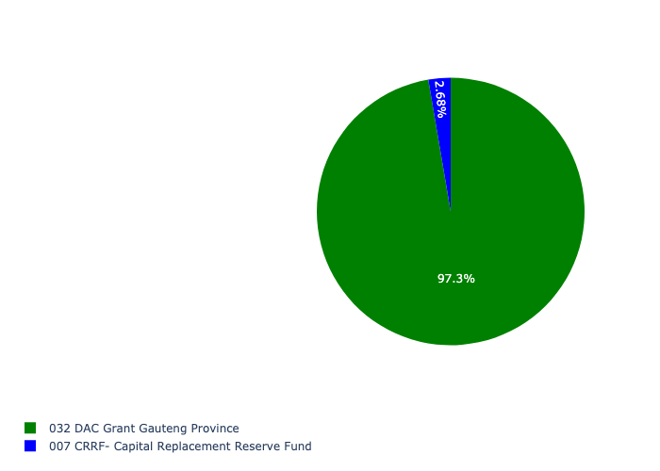

Figure 5.6: Ward 03 Departmental Requests

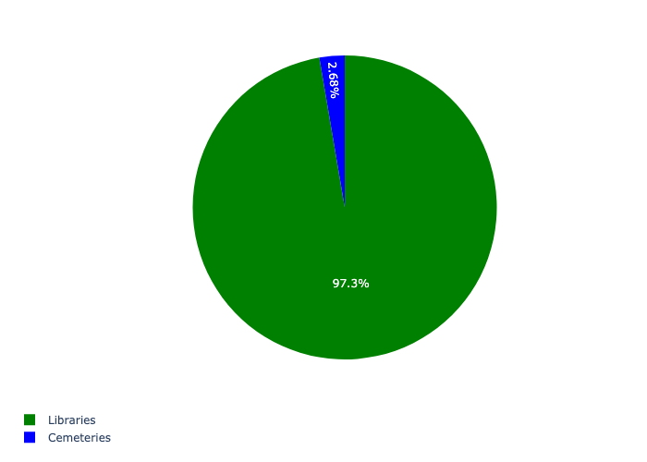

Table 5.3: Summary - Ward 03

|  |  |
| --- | --- |
| Item | Description |
| Total Capital Demand for Ward 03 - All Years | R4,110,000 Rank: 8 (1 = Highest) |
| Total Capital Demand for Ward 03 - MTREF | R4,110,000 Rank: 8 (1 = Highest) |
| Financial Years in which capital requirements are listed for Ward 03 | 2023 and 2024 |
| Financial Year with highest capital demand for Ward 03 | Capital 2023 |
| Ward 03 intersecting feature used | Works Location |
| Total number of projects intersecting with Ward 03 | 6 Rank: 10 (1 = Highest) |

## Ward 04

Figure 5.7: Ward 04 Funding Requests

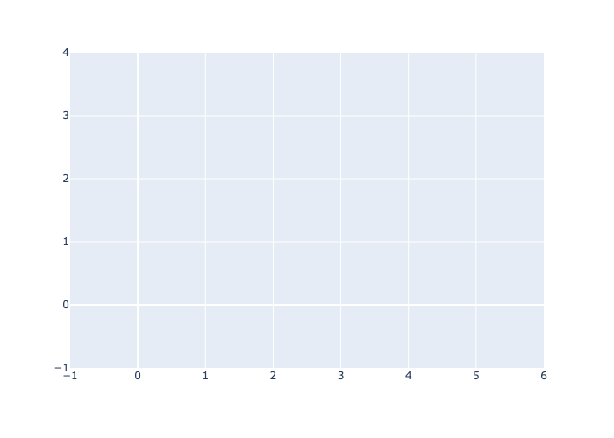

Figure 5.8: Ward 04 Departmental Requests



Table 5.4: Summary - Ward 04

|  |  |
| --- | --- |
| Item | Description |
| Total Capital Demand for Ward 04 - All Years | R0 Rank: 14 (1 = Highest) |
| Total Capital Demand for Ward 04 - MTREF | R0 Rank: 14 (1 = Highest) |
| Financial Years in which capital requirements are listed for Ward 04 |  |
| Financial Year with highest capital demand for Ward 04 | Capital 2023 |
| Ward 04 intersecting feature used | Works Location |
| Total number of projects intersecting with Ward 04 | 3 Rank: 14 (1 = Highest) |

## Ward 05

Figure 5.9: Ward 05 Funding Requests

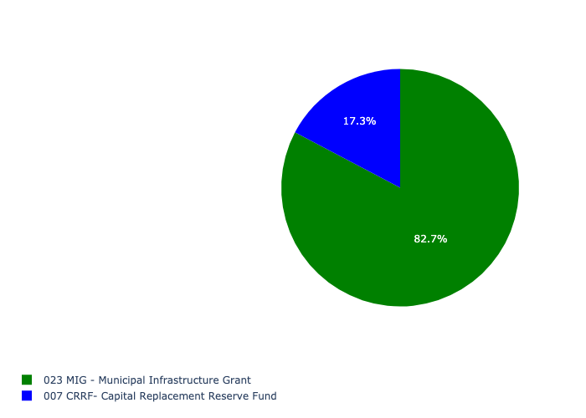

Figure 5.10: Ward 05 Departmental Requests

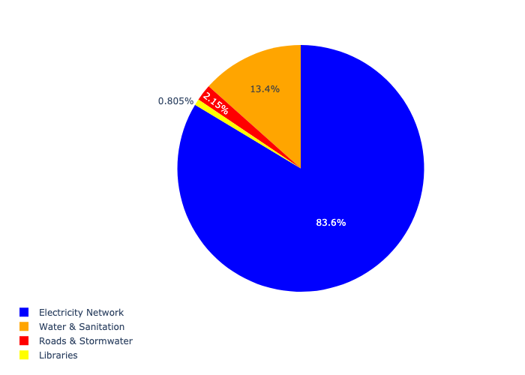

Table 5.5: Summary - Ward 05

|  |  |
| --- | --- |
| Item | Description |
| Total Capital Demand for Ward 05 - All Years | R7,367,196 Rank: 4 (1 = Highest) |
| Total Capital Demand for Ward 05 - MTREF | R7,367,196 Rank: 4 (1 = Highest) |
| Financial Years in which capital requirements are listed for Ward 05 | 2023, 2024 and 2025 |
| Financial Year with highest capital demand for Ward 05 | Capital 2023 |
| Ward 05 intersecting feature used | Works Location |
| Total number of projects intersecting with Ward 05 | 20 Rank: 4 (1 = Highest) |

## Ward 06

Figure 5.11: Ward 06 Funding Requests

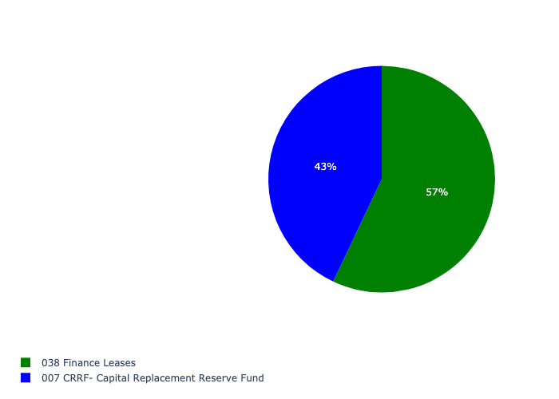

Figure 5.12: Ward 06 Departmental Requests

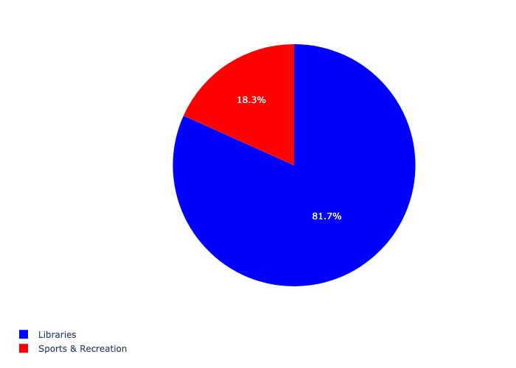

Table 5.6: Summary - Ward 06

|  |  |
| --- | --- |
| Item | Description |
| Total Capital Demand for Ward 06 - All Years | R4,655,143 Rank: 7 (1 = Highest) |
| Total Capital Demand for Ward 06 - MTREF | R4,655,143 Rank: 7 (1 = Highest) |
| Financial Years in which capital requirements are listed for Ward 06 | 2023 and 2025 |
| Financial Year with highest capital demand for Ward 06 | Capital 2023 |
| Ward 06 intersecting feature used | Works Location |
| Total number of projects intersecting with Ward 06 | 6 Rank: 10 (1 = Highest) |

## Ward 07

Figure 5.13: Ward 07 Funding Requests



Figure 5.14: Ward 07 Departmental Requests



Table 5.7: Summary - Ward 07

|  |  |
| --- | --- |
| Item | Description |
| Total Capital Demand for Ward 07 - All Years | R0 Rank: 14 (1 = Highest) |
| Total Capital Demand for Ward 07 - MTREF | R0 Rank: 14 (1 = Highest) |
| Financial Years in which capital requirements are listed for Ward 07 |  |
| Financial Year with highest capital demand for Ward 07 | Capital 2023 |
| Ward 07 intersecting feature used | Works Location |
| Total number of projects intersecting with Ward 07 | 3 Rank: 14 (1 = Highest) |

## Ward 08

Figure 5.15: Ward 08 Funding Requests

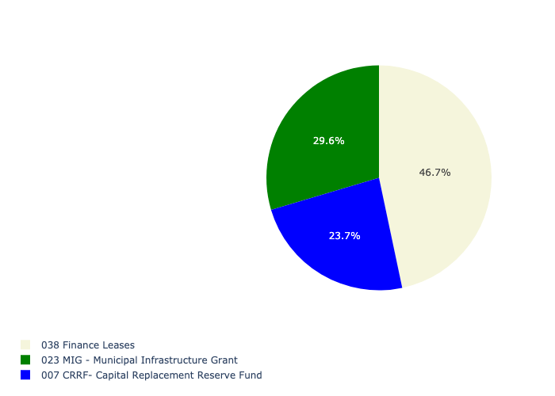

Figure 5.16: Ward 08 Departmental Requests

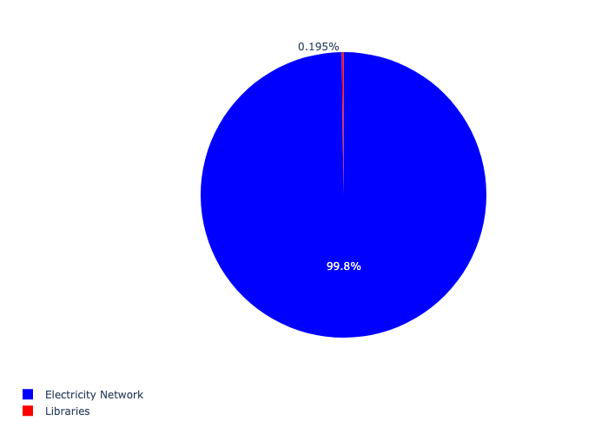

Table 5.8: Summary - Ward 08

|  |  |
| --- | --- |
| Item | Description |
| Total Capital Demand for Ward 08 - All Years | R6,032,427 Rank: 5 (1 = Highest) |
| Total Capital Demand for Ward 08 - MTREF | R6,032,427 Rank: 5 (1 = Highest) |
| Financial Years in which capital requirements are listed for Ward 08 | 2023, 2024 and 2025 |
| Financial Year with highest capital demand for Ward 08 | Capital 2024 |
| Ward 08 intersecting feature used | Works Location |
| Total number of projects intersecting with Ward 08 | 8 Rank: 8 (1 = Highest) |

## Ward 09

Figure 5.17: Ward 09 Funding Requests

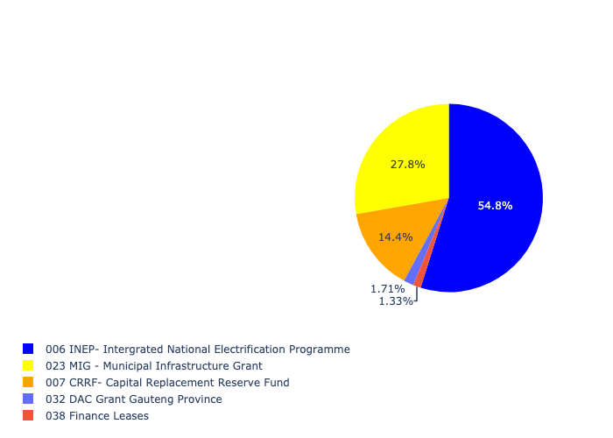

Figure 5.18: Ward 09 Departmental Requests

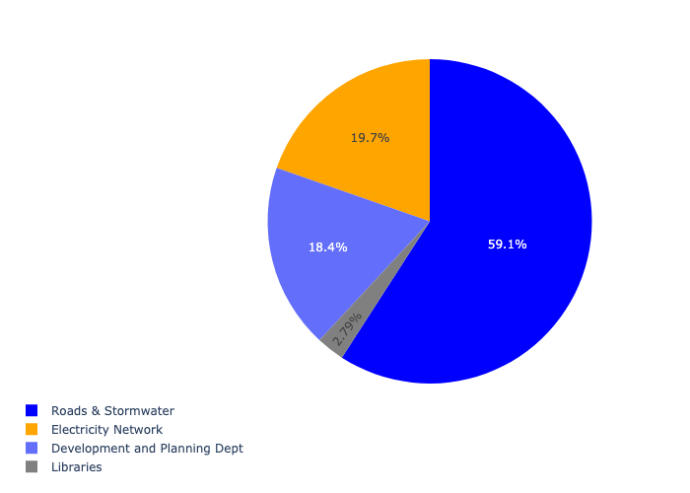

Table 5.9: Summary - Ward 09

|  |  |
| --- | --- |
| Item | Description |
| Total Capital Demand for Ward 09 - All Years | R23,508,681 Rank: 1 (1 = Highest) |
| Total Capital Demand for Ward 09 - MTREF | R23,508,681 Rank: 1 (1 = Highest) |
| Financial Years in which capital requirements are listed for Ward 09 | 2023, 2024 and 2025 |
| Financial Year with highest capital demand for Ward 09 | Capital 2023 |
| Ward 09 intersecting feature used | Works Location |
| Total number of projects intersecting with Ward 09 | 26 Rank: 2 (1 = Highest) |

## Ward 10

Figure 5.19: Ward 10 Funding Requests

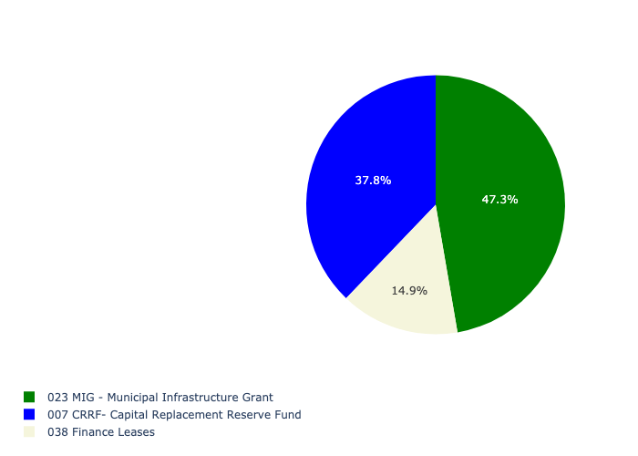

Figure 5.20: Ward 10 Departmental Requests

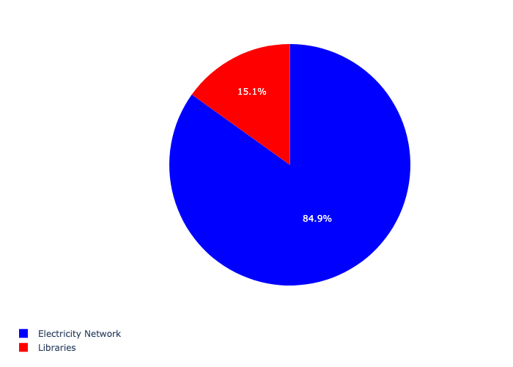

Table 5.10: Summary - Ward 10

|  |  |
| --- | --- |
| Item | Description |
| Total Capital Demand for Ward 10 - All Years | R3,546,620 Rank: 9 (1 = Highest) |
| Total Capital Demand for Ward 10 - MTREF | R3,546,620 Rank: 9 (1 = Highest) |
| Financial Years in which capital requirements are listed for Ward 10 | 2023, 2024 and 2025 |
| Financial Year with highest capital demand for Ward 10 | Capital 2023 |
| Ward 10 intersecting feature used | Works Location |
| Total number of projects intersecting with Ward 10 | 28 Rank: 1 (1 = Highest) |

## Ward 11

Figure 5.21: Ward 11 Funding Requests

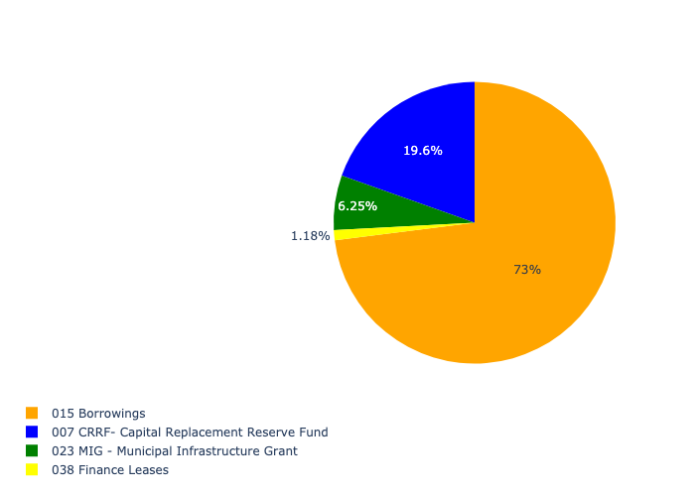

Figure 5.22: Ward 11 Departmental Requests

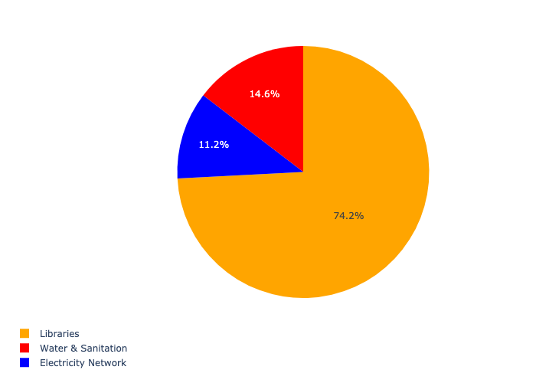

Table 5.11: Summary - Ward 11

|  |  |
| --- | --- |
| Item | Description |
| Total Capital Demand for Ward 11 - All Years | R1,284,250 Rank: 12 (1 = Highest) |
| Total Capital Demand for Ward 11 - MTREF | R1,284,250 Rank: 12 (1 = Highest) |
| Financial Years in which capital requirements are listed for Ward 11 | 2023, 2024 and 2025 |
| Financial Year with highest capital demand for Ward 11 | Capital 2024 |
| Ward 11 intersecting feature used | Works Location |
| Total number of projects intersecting with Ward 11 | 22 Rank: 3 (1 = Highest) |

## Ward 12

Figure 5.23: Ward 12 Funding Requests



Figure 5.24: Ward 12 Departmental Requests



Table 5.12: Summary - Ward 12

|  |  |
| --- | --- |
| Item | Description |
| Total Capital Demand for Ward 12 - All Years | R0 Rank: 14 (1 = Highest) |
| Total Capital Demand for Ward 12 - MTREF | R0 Rank: 14 (1 = Highest) |
| Financial Years in which capital requirements are listed for Ward 12 |  |
| Financial Year with highest capital demand for Ward 12 | Capital 2023 |
| Ward 12 intersecting feature used | Works Location |
| Total number of projects intersecting with Ward 12 | 3 Rank: 14 (1 = Highest) |

## Ward 13

Figure 5.25: Ward 13 Funding Requests

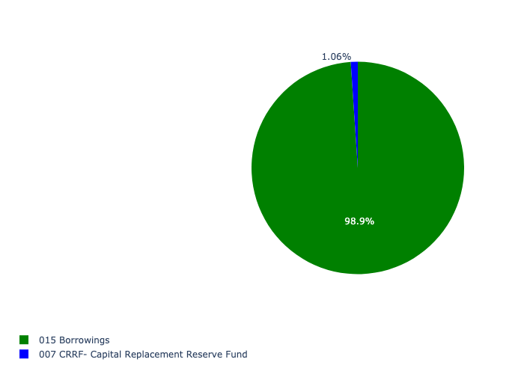

Figure 5.26: Ward 13 Departmental Requests

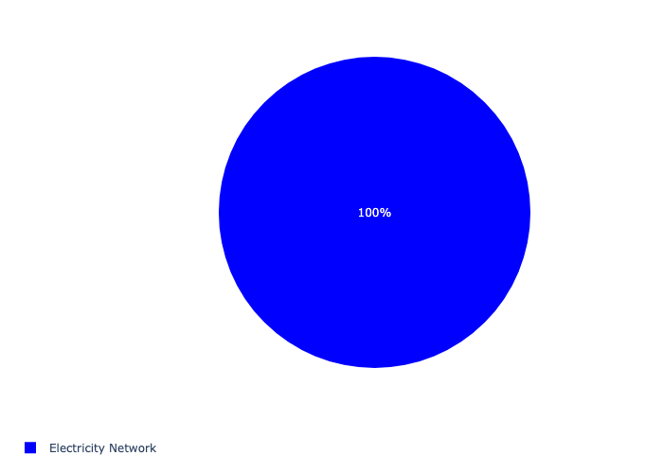

Table 5.13: Summary - Ward 13

|  |  |
| --- | --- |
| Item | Description |
| Total Capital Demand for Ward 13 - All Years | R9,400,000 Rank: 3 (1 = Highest) |
| Total Capital Demand for Ward 13 - MTREF | R9,400,000 Rank: 3 (1 = Highest) |
| Financial Years in which capital requirements are listed for Ward 13 | 2023 |
| Financial Year with highest capital demand for Ward 13 | Capital 2023 |
| Ward 13 intersecting feature used | Works Location |
| Total number of projects intersecting with Ward 13 | 5 Rank: 12 (1 = Highest) |

## Ward 14

Figure 5.27: Ward 14 Funding Requests

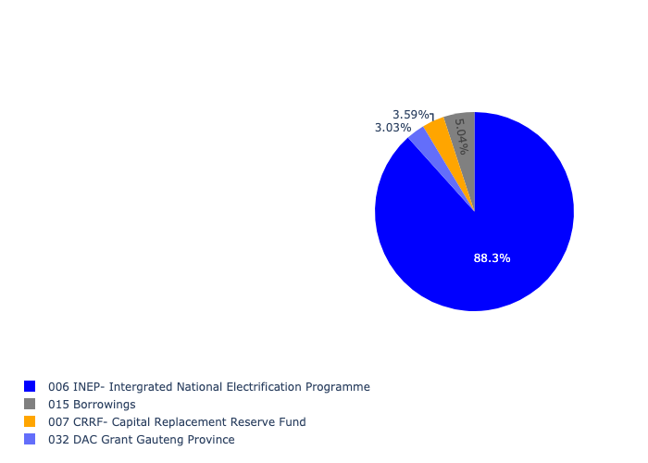

Figure 5.28: Ward 14 Departmental Requests

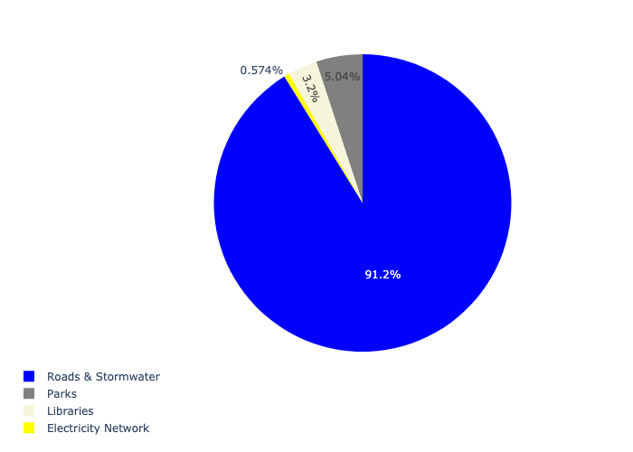

Table 5.14: Summary - Ward 14

|  |  |
| --- | --- |
| Item | Description |
| Total Capital Demand for Ward 14 - All Years | R19,822,083 Rank: 2 (1 = Highest) |
| Total Capital Demand for Ward 14 - MTREF | R19,822,083 Rank: 2 (1 = Highest) |
| Financial Years in which capital requirements are listed for Ward 14 | 2023, 2024 and 2025 |
| Financial Year with highest capital demand for Ward 14 | Capital 2024 |
| Ward 14 intersecting feature used | Works Location |
| Total number of projects intersecting with Ward 14 | 17 Rank: 6 (1 = Highest) |

## Ward 15

Figure 5.29: Ward 15 Funding Requests

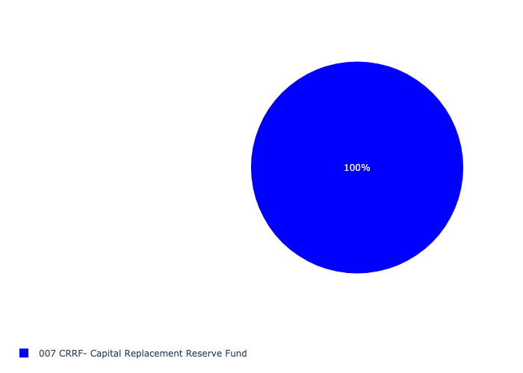

Figure 5.30: Ward 15 Departmental Requests

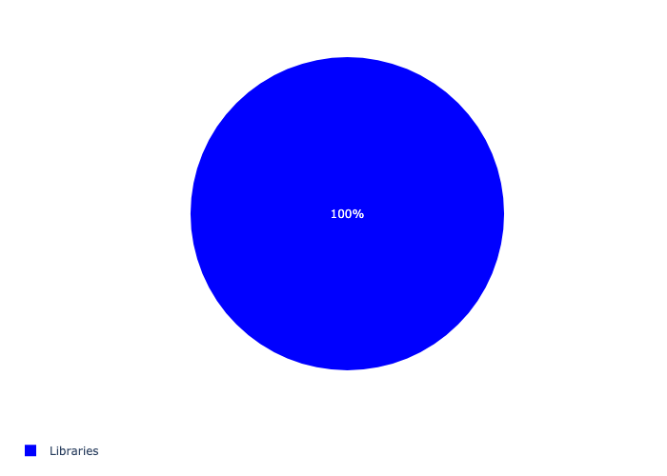

Table 5.15: Summary - Ward 15

|  |  |
| --- | --- |
| Item | Description |
| Total Capital Demand for Ward 15 - All Years | R2,300,000 Rank: 11 (1 = Highest) |
| Total Capital Demand for Ward 15 - MTREF | R2,300,000 Rank: 11 (1 = Highest) |
| Financial Years in which capital requirements are listed for Ward 15 | 2024 and 2025 |
| Financial Year with highest capital demand for Ward 15 | Capital 2025 |
| Ward 15 intersecting feature used | Works Location |
| Total number of projects intersecting with Ward 15 | 9 Rank: 7 (1 = Highest) |