



Spatial Feature Report

T: +27 12 364 2546 | E: info@novus3.co.za Postnet Suite 471, Private Bag X15,

Menlo Park, 0102**www.novus3.co.za**

engineered solutions

Disclaimer

This document contains data that was obtained from a live CP3 system at the moment the data was requested. The data is updated by users of the CP3 System and unless the system is locked for changes, this data may change on a daily basis. The reader is therefore cautioned not to place inappropriate reliance on the data unless there is certainty on the status of the data in terms of how recently it has been updated, how “clean” the data is (is there a quality control and/or verification process that was followed by the licensee of the CP3 system to ensure that data is checked and verified from time-to-time) and whether the correct baseline was queried. This report therefore provides a “snapshot in time”. Consequently, the document may be less relevant at a different time, or using a different financial baseline to query from.

At all times, all rights, title and interest in and to this material remains vested in the owner of this document and are copyrighted and protected by regulatory provisions. These materials may not be copied, reproduced, modified, published, uploaded, posted to websites or otherwise distributed in any way, without our prior written permission from the Licensee and Licensor (Nvous3 (Pty) Ltd) of the CP3 Software. The owner of this document does not grant any right to reproduce the materials. All our rights in this regard are and remain reserved.

Table of Contents

**No table of contents entries found.** (Right-click -> Update Field)

Spatial Query Report

This document was created *2022-05-06-12_10* from the **Midvaal Municipality** CP3 system.

The baseline **'2022/2023 Draft Capital Budget_20220301_Finance'** with description: **'2022/2023 Draft Capital Budget as recieved from Finance as draft Capital Budget with only MTREF Values'** was used. The spatial feature that was selected for the purpose of this report was: **'Economic Study Catalytic Nodes (5nodes)'**.

This is a spatial feature report for the *Midvaal Municipality.* The data contained in this report was sourced directly from the municipality's live CP3 system. The information in this report therefore reflects the data as it was on *2022-05-06* when this report was requested. Any subsequent updates to the data contained the CP3 System related to the applicable baseline from which this reports was drawn, would therefore not reflect in this report.   
  
For the *Midvaal Municipality, the following spatial features are available for the purpose of developing* 'Spatial Query Reports' (similar to this report):

* Economic Study Catalytic Nodes (5nodes)
* Midvaal 5 EDCs
* Wards



We hope you find this useful! Sincerely, *The Novus3 Team.*

# Introduction

The baseline that was queried for this report contains *155* projects of which a total of *131 (84.5%)* projects do not have any recorded intersection (overlap) with the 'Economic Study Catalytic Nodes (5nodes)' spatial feature that was selected for this report. The following spatial features are available for queries using this API profile:

* Economic Study Catalytic Nodes (5nodes)
* Midvaal 5 EDCs
* Wards

The probable reasons for the 131 non intersecting projects reported are that:

* these projects simply do not have a location associated with them yet (most frequently the case with 'no-intersect' projects) or;
* the location that was captured for some of these projects, may have been in the wrong place (e.g. outside the boundaries of Midvaal - this is very rarely the reason).

It is important to take note of the 84.5% projects that do not intersect with the 'Economic Study Catalytic Nodes (5nodes)' spatial feature when appraising this report.

Figure 1.1: Intersecting vs Non-Intersecting Projects

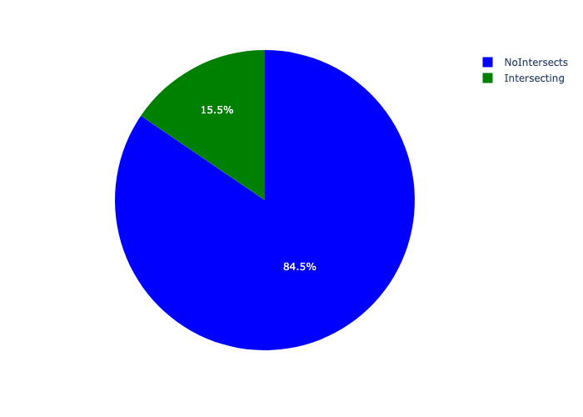

# Total Number of Projects and Total Capital Demand per node - All Years

Table 2.1 below provides a concise summary of key statistical insights regarding the number of projects that are requesting funding in each of the nodes.

Table 2.1: Economic Study Catalytic Nodes (5nodes) Analysis - Number of Projects

|  |  |  |  |
| --- | --- | --- | --- |
| Description | Info (1) | Info (2) | Info (3) |
| Number of projects in all Economic Study Catalytic Nodes (5nodes) - Overview | Total in all Economic Study Catalytic Nodes (5nodes): 24 projects | Average per Economic Study Catalytic Nodes (5nodes): 4.8 projects | 75th percentile of projects across all Economic Study Catalytic Nodes (5nodes): 6.0 projects |
| The highest number of projects | Economic Study Catalytic Nodes (5nodes): In De Deur Neighbourhood Node | Number of projects in De Deur Neighbourhood Node: 10 | Percentage of total in De Deur Neighbourhood Node: 41.67% |
| The lowest number of projects: | Economic Study Catalytic Nodes (5nodes): In Mamello EDC | Number of projects in Mamello EDC: 1 | Percentage of total in Mamello EDC: 4.17% |

Table 2.1 below provides a concise summary of key statistical insights regarding the total capital demand per node.

Table 2.1: Economic Study Catalytic Nodes (5nodes) Analysis - Capital Demand (R)

|  |  |  |  |
| --- | --- | --- | --- |
| Description | Info (1) | Info (2) | Info (3) |
| Capital demand in all Economic Study Catalytic Nodes (5nodes) - Overview | Total capital demand in all Economic Study Catalytic Nodes (5nodes): R4,496,705 | The average capital demand per Economic Study Catalytic Nodes (5nodes): R899,341 | The 75th percentile of capital demand for Economic Study Catalytic Nodes (5nodes): R676 |
| The highest capital demand | Economic Study Catalytic Nodes (5nodes): In Lakeside EDC | Capital Demand in Lakeside EDC: R4,495,953 | Percentage of total in Lakeside EDC: 99.98% |
| The lowest capital demand | Economic Study Catalytic Nodes (5nodes): In Mamello EDC | Capital Demand in Mamello EDC: R0 | Percentage of total in Mamello EDC: 0.00% |

The number of projects per node and the capital demand per node needs to be looked at together for better insight. Figures 2.1 and 2.2 assist with further graphical insight into some of the numbers that are provided in Tables 2.1 and 2.2.

Figure 2.1: The single node with the highest value (Nr of Projects & Capital Demand) vs the rest

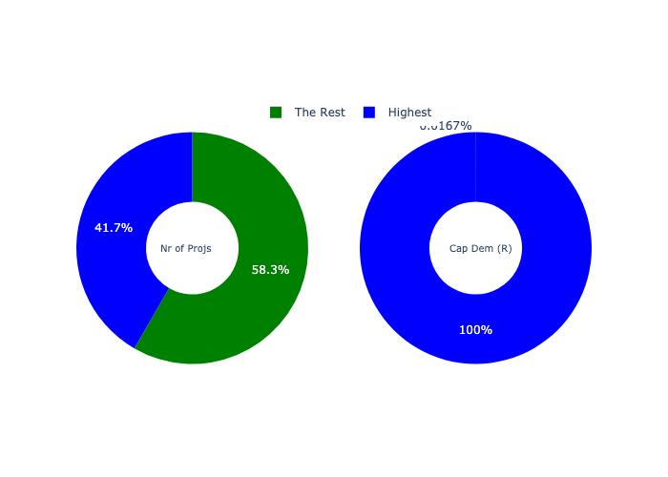

The highest number of projects in a single node is in **De Deur Neighbourhood Node.** *That is 10 projects and this is 41.67% of the total number of projects.* The highest capital demand in a single node is in **Lakeside EDC.** *That is R4,495,953 and this amounts to 99.98% of the total capital demand.*

The following figures provide a bar graph representation of the number of projects per node with the colour of the bars representing the level of capital demand in each of these nodes.

Figure 2.2: Projects and Capital Demand per node

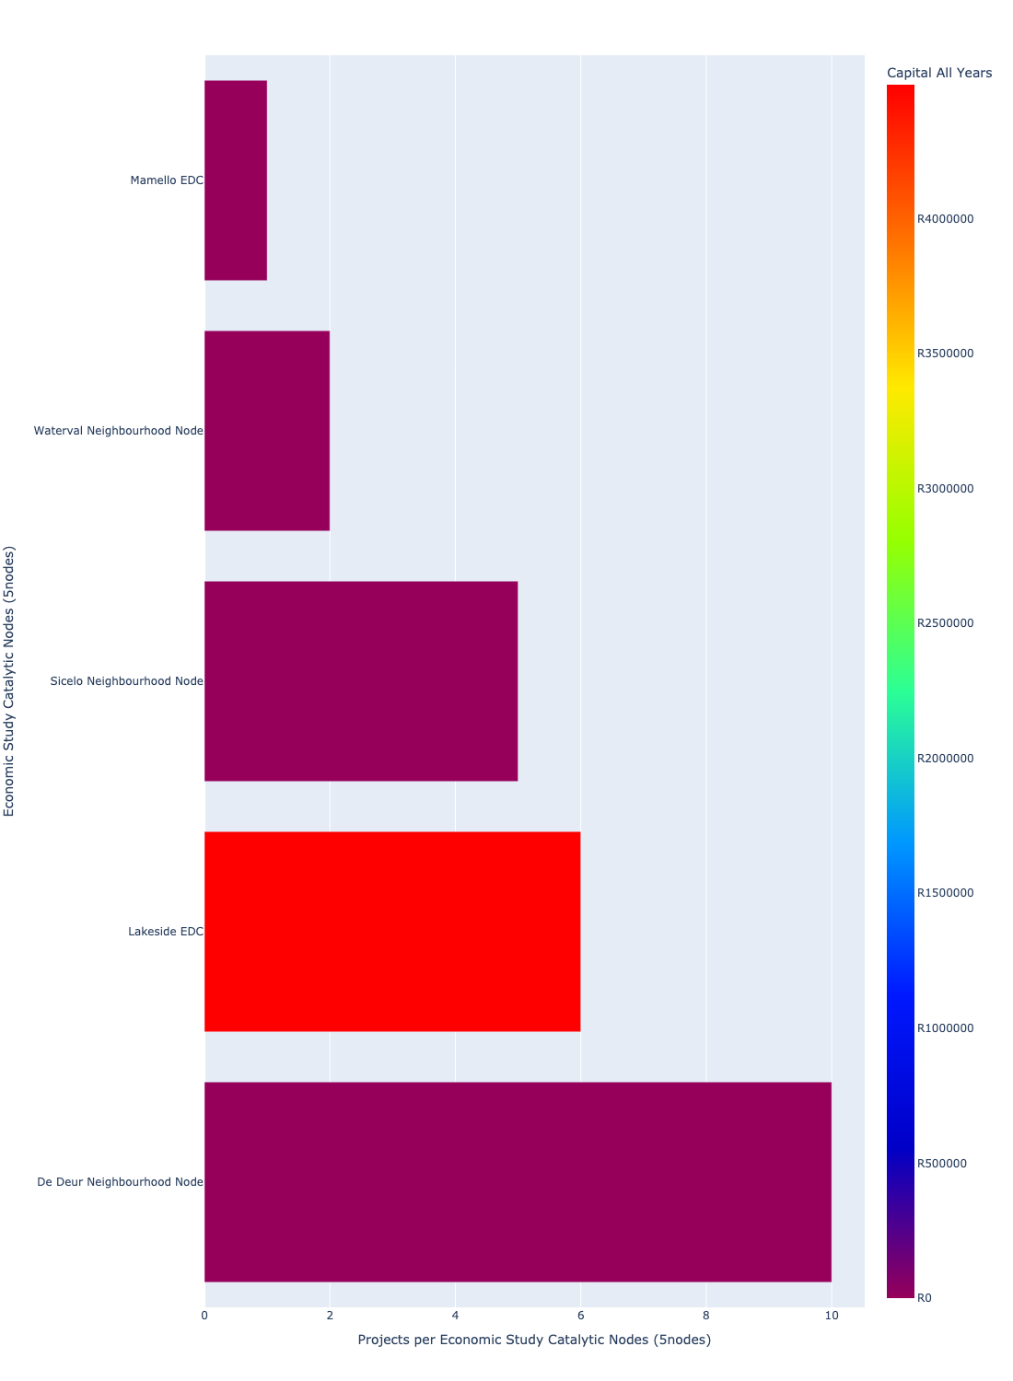

# Total Capital Demand per node - All Years

There are different funding sources from which capital is requested. For the financial baseline that was selected for this report query (2022/2023 Draft Capital Budget_20220301_Finance), the breakdown of capital demand for Midvaal Municipality per funding source is shown in Figure 3.1 below.

Figure 3.1: Capital Demand Per Funding Source

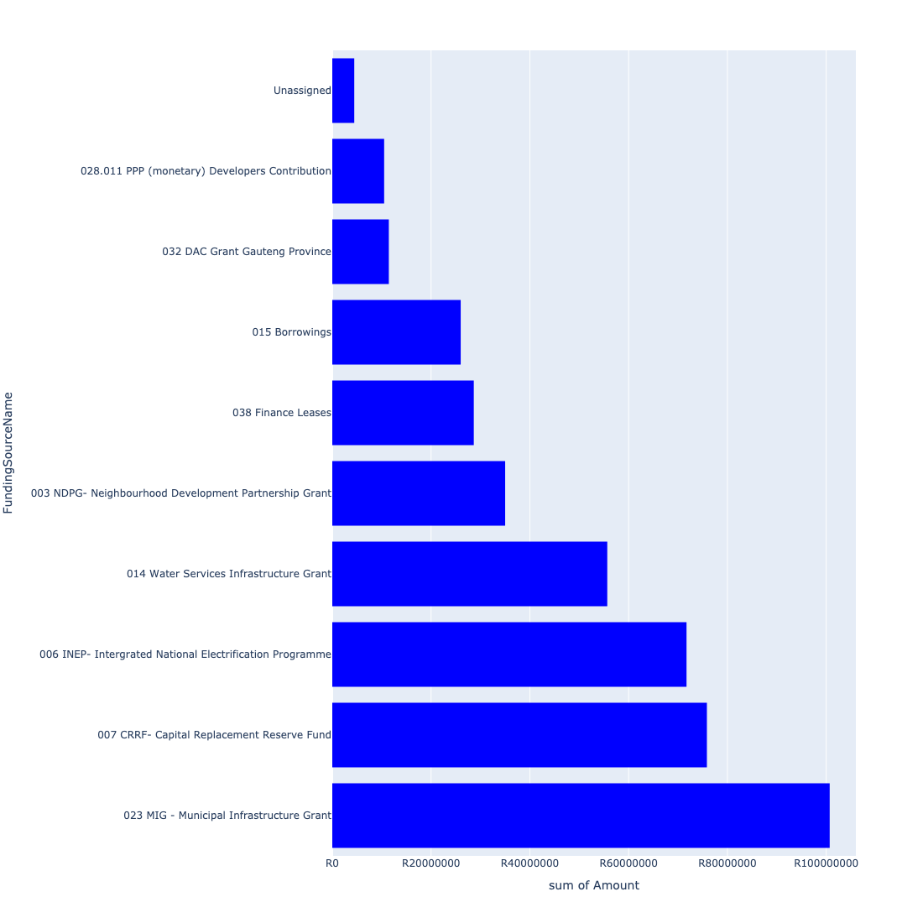

For the financial baseline that was selected for this report query (2022/2023 Draft Capital Budget_20220301_Finance), the breakdown of capital demand for Midvaal Municipality per department is shown in Figure 3.2 below.

Figure 3.2: Capital Demand Per Midvaal Municipality Department

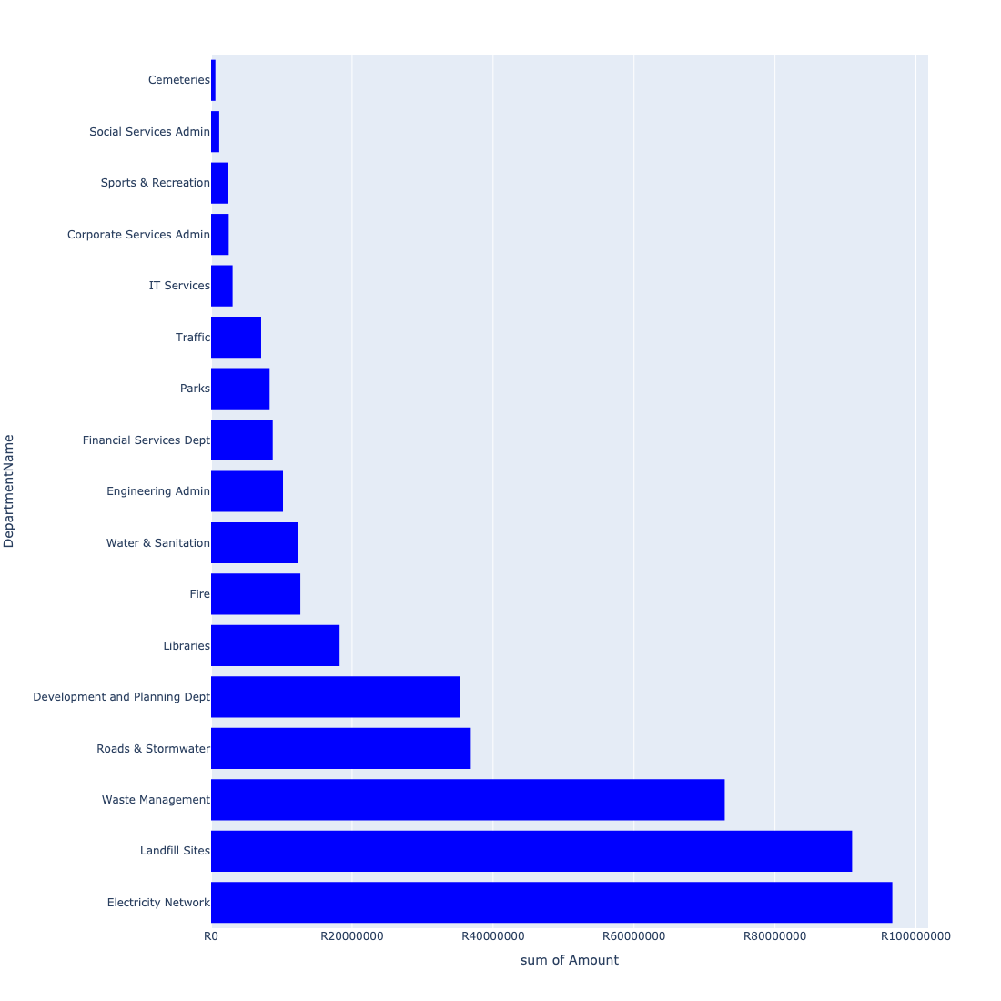

The following figures provide a histogram representation of the capital demand per node. A colour breakdown is provided of each year's sub-total that contribute towards the overall total capital demand of each node. Note that the capital demand beyond the first three years representing the Medium Term Expenditure Framework (MTREF - years 2023, 2024 and 2025) are generally more sparsely and less diligently populated, therefore less reliance should be vested on these outer years when appraising the overall capital demand. The reason for this is usually because of National Treasury's requirement for annual budget submissions spanning only over the MTREF (i.e. the next three years).

Figure 3.3: Capital Demand per node - All Years

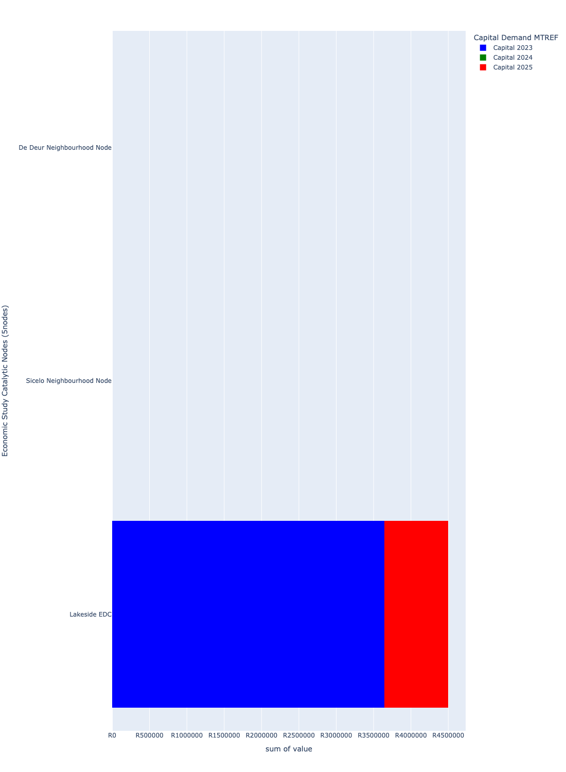

# Total Capital Demand per node - MTREF only

Table 4.1 below provides a concise summary of key statistical insights regarding the total MTREF capital demand per node.

Table 4.1: Economic Study Catalytic Nodes (5nodes) Analysis - MTREF Capital Demand (R)

|  |  |  |  |
| --- | --- | --- | --- |
| Description | Info (1) | Info (2) | Info (3) |
| MTREF Capital demand in all Economic Study Catalytic Nodes (5nodes) - Overview | MTREF capital demand in all Economic Study Catalytic Nodes (5nodes): R4,496,705 | The average MTREF capital demand per node: R899,341 | The 75th percentile of MTREF capital demand for Economic Study Catalytic Nodes (5nodes): R676 |
| The highest MTREF capital demand | In node: Lakeside EDC | MTREF capital Demand in Lakeside EDC: R4,495,953 | Percentage of total MRTEF capital demand in Lakeside EDC: 99.98% |
| The lowest MTREF capital demand | In node: Mamello EDC | MTREF capital Demand in Mamello EDC: R0 | Percentage of total MTREF capital demand in Mamello EDC: 0.00% |

The following figures provide a histogram representation of the capital demand per node. A colour breakdown is provided of each year's sub-total that contribute towards the overall MTREF total capital demand of each node.

Figure 4.1: Capital Demand per node - MTREF Period

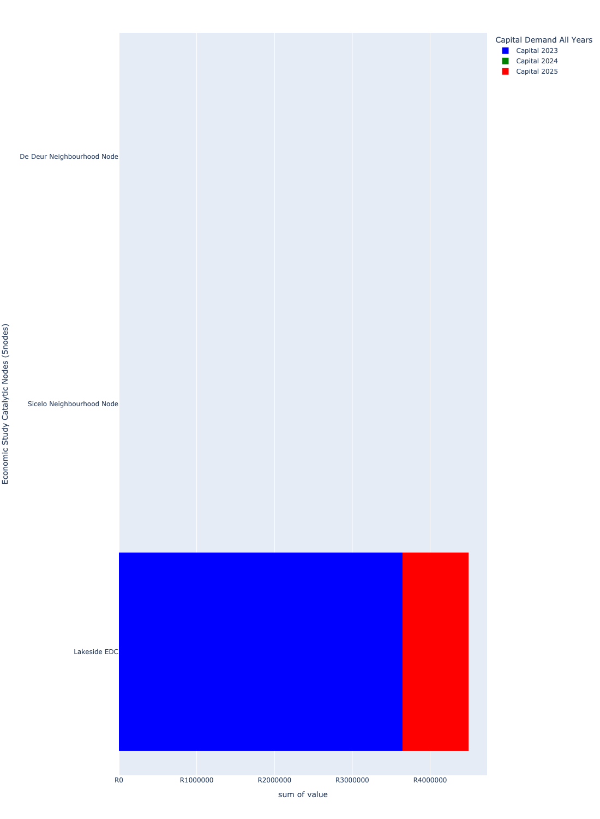

# Summary per node

## De Deur Neighbourhood Node

Figure 5.1: De Deur Neighbourhood Node Funding Requests

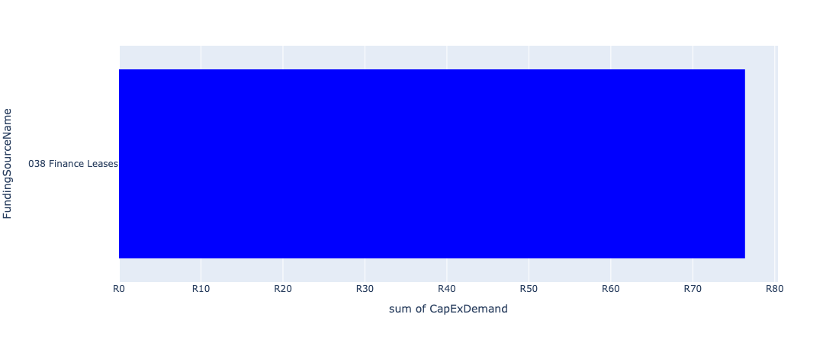

Figure 5.2: De Deur Neighbourhood Node Departmental Requests

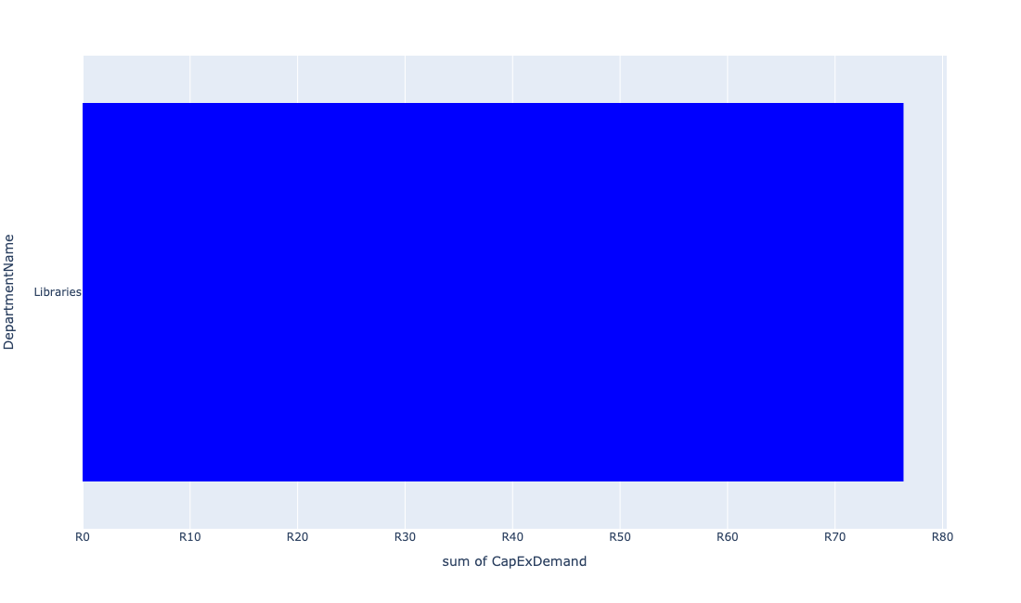

Table 5.1: Summary - De Deur Neighbourhood Node

|  |  |
| --- | --- |
| Item | Description |
| Total Capital Demand for De Deur Neighbourhood Node - All Years | R76 Rank: 3 (1 = Highest) |
| Total Capital Demand for De Deur Neighbourhood Node - MTREF | R76 Rank: 3 (1 = Highest) |
| Financial Years in which capital requirements are listed for De Deur Neighbourhood Node | 2023 |
| Financial Year with highest capital demand for De Deur Neighbourhood Node | 2023 |
| De Deur Neighbourhood Node intersecting feature used | Works Location |
| Total number of projects intersecting with De Deur Neighbourhood Node | 10 Rank: 1 (1 = Highest) |

Table 5.2: All projects asking for budget in De Deur Neighbourhood Node

|  |  |  |  |
| --- | --- | --- | --- |
| Project ID | Project Name | Department | Project Budget |
| 10811 | MOBILE TOILETS | Parks | R0.00 (0%) No budget request. |
| 10789 | Savana Roads Rehabilitation | Roads & Stormwater | R0.00 (0%) No budget request. |
| 10734 | Savana Reservoir | Water & Sanitation | R0.00 (0%) No budget request. |
| 10733 | Savana Bulk Pipeline | Water & Sanitation | R0.00 (0%) No budget request. |
| 10726 | New Library Building | Libraries | R0.00 (0%) No budget request. |
| 10918 | Furniture and Equipment | Libraries | R0.00 (0%) No budget request. |
| 10498 | Library furniture & equipment-De Deur | Libraries | R0.00 (0%) No budget request. |
| 10451 | Library Refurbishment/upgrade - De Deur | Libraries | R0.00 (0%) No budget request. |
| 10211 | PREPAID WATER METER PROJECT | Water & Sanitation | R0.00 (0%) No budget request. |
| 10049 | LAKESIDE LIBRARY BOOKS | Libraries | R76 (100.00%) Budget spread across: 2023 |

Please note that the following projects will not be shown in this table:

* Projects with no recorded intersect with Economic Study Catalytic Nodes (5nodes) (in other words no Works Location was recorded on the system for this project)

Projects that do not have any recorded budget demand on the system at the time that this report was requested, are shown in the table with zero budgets indicated.

## Lakeside EDC

Figure 5.3: Lakeside EDC Funding Requests

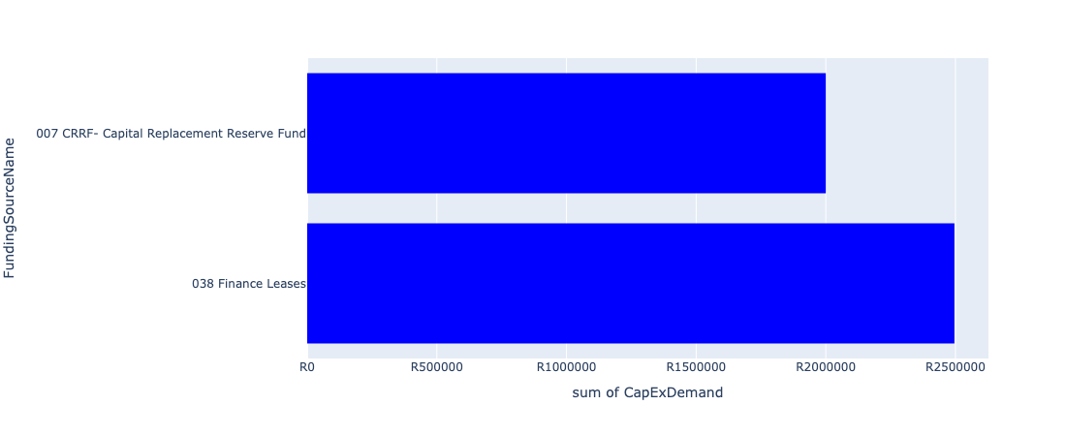

Figure 5.4: Lakeside EDC Departmental Requests

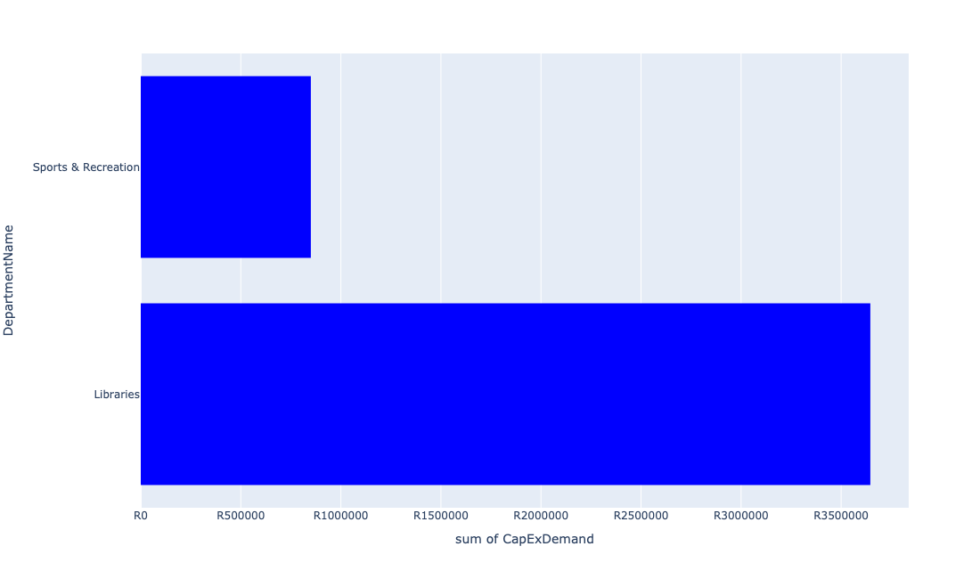

Table 5.2: Summary - Lakeside EDC

|  |  |
| --- | --- |
| Item | Description |
| Total Capital Demand for Lakeside EDC - All Years | R4,495,953 Rank: 1 (1 = Highest) |
| Total Capital Demand for Lakeside EDC - MTREF | R4,495,953 Rank: 1 (1 = Highest) |
| Financial Years in which capital requirements are listed for Lakeside EDC | 2023 and 2025 |
| Financial Year with highest capital demand for Lakeside EDC | 2023 |
| Lakeside EDC intersecting feature used | Works Location |
| Total number of projects intersecting with Lakeside EDC | 6 Rank: 2 (1 = Highest) |

Table 5.3: All projects asking for budget in Lakeside EDC

|  |  |  |  |
| --- | --- | --- | --- |
| Project ID | Project Name | Department | Project Budget |
| 10049 | LAKESIDE LIBRARY BOOKS | Libraries | R1,645,953 (36.61%) Budget spread across: 2023 |
| 10607 | Library furniture & equipment - Lakeside | Libraries | R0.00 (0%) No budget request. |
| 10494 | Ext Lakeside Lib building - Upgrading | Libraries | R2,000,000 (44.48%) Budget spread across: 2023 |
| 10208 | Installation:Domestic W/Meters (Lakeside) | Water & Sanitation | R0.00 (0%) No budget request. |
| 10186 | LAKESIDE SPORT CENTRE (MIG) | Sports & Recreation | R850,000 (18.91%) Budget spread across: 2025 |
| 10051 | Lakeside Library Children Sec Furniture | Libraries | R0.00 (0%) No budget request. |

Please note that the following projects will not be shown in this table:

* Projects with no recorded intersect with Economic Study Catalytic Nodes (5nodes) (in other words no Works Location was recorded on the system for this project)

Projects that do not have any recorded budget demand on the system at the time that this report was requested, are shown in the table with zero budgets indicated.

## Mamello EDC

Figure 5.5: Mamello EDC Funding Requests

**No projects in Mamello EDC.**

Figure 5.6: Mamello EDC Departmental Requests

**No projects in Mamello EDC.**

Table 5.3: Summary - Mamello EDC

|  |  |
| --- | --- |
| Item | Description |
| Total Capital Demand for Mamello EDC - All Years | R0 Rank: 4 (1 = Highest) |
| Total Capital Demand for Mamello EDC - MTREF | R0 Rank: 4 (1 = Highest) |
| Financial Years in which capital requirements are listed for Mamello EDC |  |
| Financial Year with highest capital demand for Mamello EDC | 2023 |
| Mamello EDC intersecting feature used | Works Location |
| Total number of projects intersecting with Mamello EDC | 1 Rank: 5 (1 = Highest) |

Table 5.4: All projects asking for budget in Mamello EDC

|  |  |  |  |
| --- | --- | --- | --- |
| Project ID | Project Name | Department | Project Budget |
| 10403 | Maintaining of the Anchovy road | Roads & Stormwater | R0.00 (0%) No budget request. |

Please note that the following projects will not be shown in this table:

* Projects with no recorded intersect with Economic Study Catalytic Nodes (5nodes) (in other words no Works Location was recorded on the system for this project)

Projects that do not have any recorded budget demand on the system at the time that this report was requested, are shown in the table with zero budgets indicated.

## Sicelo Neighbourhood Node

Figure 5.5: Sicelo Neighbourhood Node Funding Requests

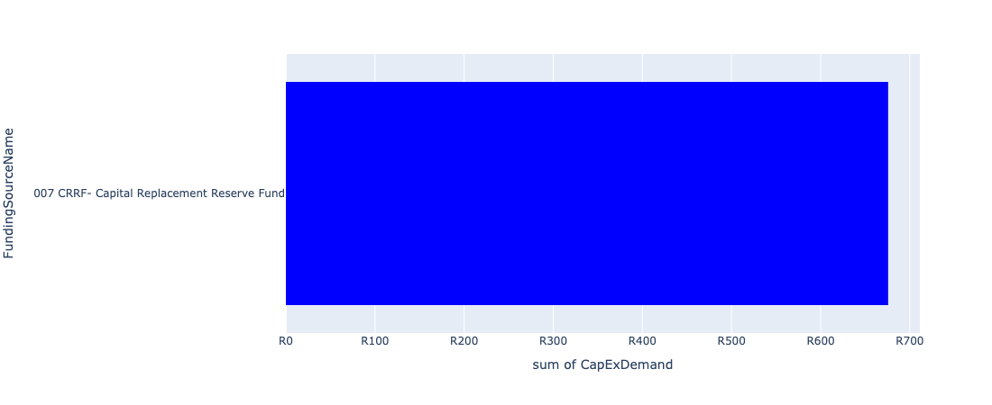

Figure 5.6: Sicelo Neighbourhood Node Departmental Requests

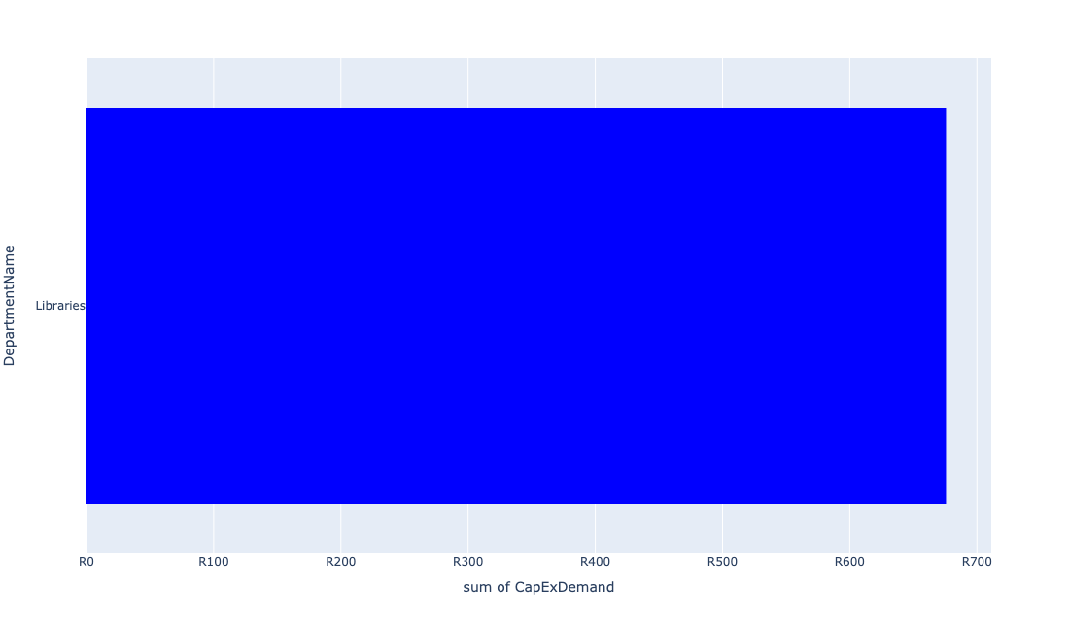

Table 5.4: Summary - Sicelo Neighbourhood Node

|  |  |
| --- | --- |
| Item | Description |
| Total Capital Demand for Sicelo Neighbourhood Node - All Years | R676 Rank: 2 (1 = Highest) |
| Total Capital Demand for Sicelo Neighbourhood Node - MTREF | R676 Rank: 2 (1 = Highest) |
| Financial Years in which capital requirements are listed for Sicelo Neighbourhood Node | 2023, 2024 and 2025 |
| Financial Year with highest capital demand for Sicelo Neighbourhood Node | 2024 |
| Sicelo Neighbourhood Node intersecting feature used | Works Location |
| Total number of projects intersecting with Sicelo Neighbourhood Node | 5 Rank: 3 (1 = Highest) |

Table 5.5: All projects asking for budget in Sicelo Neighbourhood Node

|  |  |  |  |
| --- | --- | --- | --- |
| Project ID | Project Name | Department | Project Budget |
| 10811 | MOBILE TOILETS | Parks | R0.00 (0%) No budget request. |
| 10725 | upgrade of Sicelo Library | Libraries | R0.00 (0%) No budget request. |
| 11023 | E-Resources | Libraries | R676 (100.00%) Budget spread across: 2023, 2024 and 2025 |
| 10647 | Construct Pedestrian Bridge over R 59 to link Sicelo and Meyerton CBD (UDF) | Roads & Stormwater | R0.00 (0%) No budget request. |
| 10502 | ITC hardware (Computers) - Sicelo | Libraries | R0.00 (0%) No budget request. |

Please note that the following projects will not be shown in this table:

* Projects with no recorded intersect with Economic Study Catalytic Nodes (5nodes) (in other words no Works Location was recorded on the system for this project)

Projects that do not have any recorded budget demand on the system at the time that this report was requested, are shown in the table with zero budgets indicated.

## Waterval Neighbourhood Node

Figure 5.7: Waterval Neighbourhood Node Funding Requests

**No projects in Waterval Neighbourhood Node.**

Figure 5.8: Waterval Neighbourhood Node Departmental Requests

**No projects in Waterval Neighbourhood Node.**

Table 5.5: Summary - Waterval Neighbourhood Node

|  |  |
| --- | --- |
| Item | Description |
| Total Capital Demand for Waterval Neighbourhood Node - All Years | R0 Rank: 4 (1 = Highest) |
| Total Capital Demand for Waterval Neighbourhood Node - MTREF | R0 Rank: 4 (1 = Highest) |
| Financial Years in which capital requirements are listed for Waterval Neighbourhood Node |  |
| Financial Year with highest capital demand for Waterval Neighbourhood Node | 2023 |
| Waterval Neighbourhood Node intersecting feature used | Works Location |
| Total number of projects intersecting with Waterval Neighbourhood Node | 2 Rank: 4 (1 = Highest) |

Table 5.6: All projects asking for budget in Waterval Neighbourhood Node

|  |  |  |  |
| --- | --- | --- | --- |
| Project ID | Project Name | Department | Project Budget |
| 10811 | MOBILE TOILETS | Parks | R0.00 (0%) No budget request. |
| 10732 | Graceview water reticulation | Water & Sanitation | R0.00 (0%) No budget request. |

Please note that the following projects will not be shown in this table:

* Projects with no recorded intersect with Economic Study Catalytic Nodes (5nodes) (in other words no Works Location was recorded on the system for this project)

Projects that do not have any recorded budget demand on the system at the time that this report was requested, are shown in the table with zero budgets indicated.