



Spatial Feature Report

T: +27 12 364 2546 | E: info@novus3.co.za Postnet Suite 471, Private Bag X15,

Menlo Park, 0102**www.novus3.co.za**

engineered solutions

Disclaimer

This document contains data that was obtained from a live CP3 system at the moment the data was requested. The data is updated by users of the CP3 System and unless the system is locked for changes, this data may change on a daily basis. The reader is therefore cautioned not to place inappropriate reliance on the data unless there is certainty on the status of the data in terms of how recently it has been updated, how “clean” the data is (is there a quality control and/or verification process that was followed by the licensee of the CP3 system to ensure that data is checked and verified from time-to-time) and whether the correct baseline was queried. This report therefore provides a “snapshot in time”. Consequently, the document may be less relevant at a different time, or using a different financial baseline to query from.

At all times, all rights, title and interest in and to this material remains vested in the owner of this document and are copyrighted and protected by regulatory provisions. These materials may not be copied, reproduced, modified, published, uploaded, posted to websites or otherwise distributed in any way, without our prior written permission from the Licensee and Licensor (Nvous3 (Pty) Ltd) of the CP3 Software. The owner of this document does not grant any right to reproduce the materials. All our rights in this regard are and remain reserved.

Table of Contents

**No table of contents entries found.** (Right-click -> Update Field)

Spatial Query Report

This document was created *2022-05-16-12_35* from the **Midvaal Municipality** CP3 system.

The baseline **'2022/2023 Draft Capital Budget_20220301_Finance'** with description: **'2022/2023 Draft Capital Budget as recieved from Finance as draft Capital Budget with only MTREF Values'** was used. The spatial feature that was selected for the purpose of this report was: **'Spatial Development Framework (20220428)'**.

This is a spatial feature report for the *Midvaal Municipality.* The data contained in this report was sourced directly from the municipality's live CP3 system. The information in this report therefore reflects the data as it was on *2022-05-16* when this report was requested. Any subsequent updates to the data contained the CP3 System related to the applicable baseline from which this reports was drawn, would therefore not reflect in this report.   
  
For the *Midvaal Municipality, the following spatial features are available for the purpose of developing* 'Spatial Query Reports' (similar to this report):

* Economic Study Catalytic Nodes (5nodes)
* Midvaal 5 EDCs
* Midvaal Township Boundaries
* Spatial Development Framework (20220428)
* Wards



We hope you find this useful! Sincerely, *The Novus3 Team.*

# Introduction

The baseline that was queried for this report contains *229* projects of which a total of *10 (4.37%)* projects do not have any recorded intersection (overlap) with the 'Spatial Development Framework (20220428)' spatial feature that was selected for this report. The following spatial features are available for queries using this API profile:

* Economic Study Catalytic Nodes (5nodes)
* Midvaal 5 EDCs
* Midvaal Township Boundaries
* Spatial Development Framework (20220428)
* Wards

The probable reasons for the 10 non intersecting projects reported are that:

* these projects simply do not have a location associated with them yet (most frequently the case with 'no-intersect' projects) or;
* the location that was captured for some of these projects, may have been in the wrong place (e.g. outside the boundaries of Midvaal - this is very rarely the reason).

It is important to take note of the 4.37% projects that do not intersect with the 'Spatial Development Framework (20220428)' spatial feature when appraising this report.

The 4.37% of non-intersecting projects is a relative low percentage and therefore not much cause of concern for this particular report.

Figure 1.1: Intersecting vs Non-Intersecting Projects

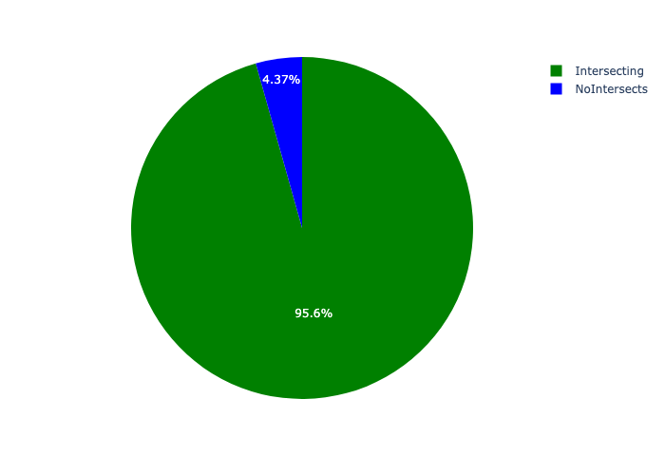

# Total Number of Projects and Total Capital Demand per Framework - All Years

Table 2.1 below provides a concise summary of key statistical insights regarding the number of projects that are requesting funding in each of the frameworks.

Table 2.1: Spatial Development Framework (20220428) Analysis - Number of Projects

|  |  |  |  |
| --- | --- | --- | --- |
| Description | Info (1) | Info (2) | Info (3) |
| Number of projects in all Spatial Development Framework (20220428) - Overview | Total in all Spatial Development Framework (20220428): 219 projects | Average per Spatial Development Framework (20220428): 36.5 projects | 75th percentile of projects across all Spatial Development Framework (20220428): 39.75 projects |
| The highest number of projects | Spatial Development Framework (20220428): In Urban Area | Number of projects in Urban Area: 92 | Percentage of total in Urban Area: 42.01% |
| The lowest number of projects: | Spatial Development Framework (20220428): In Propsed Amendments | Number of projects in Propsed Amendments: 8 | Percentage of total in Propsed Amendments: 3.65% |

Table 2.1 below provides a concise summary of key statistical insights regarding the total capital demand per framework.

Table 2.1: Spatial Development Framework (20220428) Analysis - Capital Demand (R)

|  |  |  |  |
| --- | --- | --- | --- |
| Description | Info (1) | Info (2) | Info (3) |
| Capital demand in all Spatial Development Framework (20220428) - Overview | Total capital demand in all Spatial Development Framework (20220428): R109,672,773 | The average capital demand per Spatial Development Framework (20220428): R18,278,795 | The 75th percentile of capital demand for Spatial Development Framework (20220428): R14,563,957 |
| The highest capital demand | Spatial Development Framework (20220428): In Urban Area | Capital Demand in Urban Area: R74,746,626 | Percentage of total in Urban Area: 68.15% |
| The lowest capital demand | Spatial Development Framework (20220428): In Propsed Amendments | Capital Demand in Propsed Amendments: R1,000,000 | Percentage of total in Propsed Amendments: 0.91% |

The number of projects per framework and the capital demand per framework needs to be looked at together for better insight. Figures 2.1 and 2.2 assist with further graphical insight into some of the numbers that are provided in Tables 2.1 and 2.2.

Figure 2.1: The single framework with the highest value (Nr of Projects & Capital Demand) vs the rest

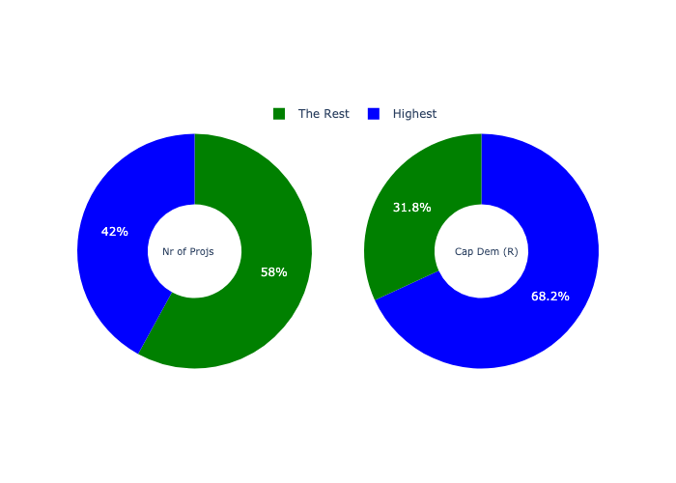

The highest number of projects in a single framework is in **Urban Area.** *That is 92 projects and this is 42.01% of the total number of projects.* The highest capital demand in a single framework is in **Urban Area.** *That is R74,746,626 and this amounts to 68.15% of the total capital demand.*

The following figures provide a bar graph representation of the number of projects per framework with the colour of the bars representing the level of capital demand in each of these frameworks.

Figure 2.2: Projects and Capital Demand per Framework

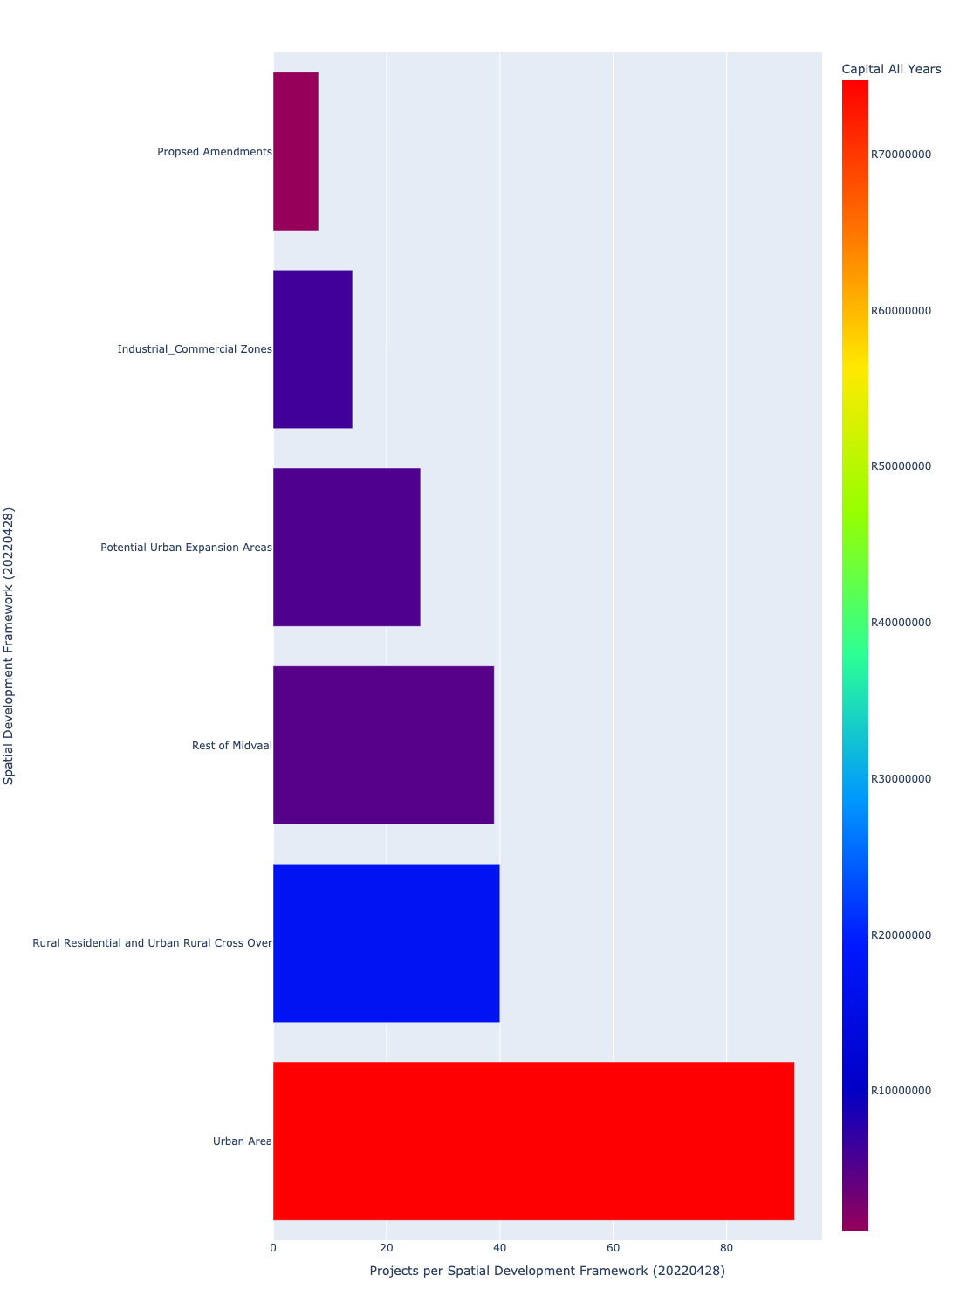

# Total Capital Demand per framework - All Years

There are different funding sources from which capital is requested. For the financial baseline that was selected for this report query (2022/2023 Draft Capital Budget_20220301_Finance), the breakdown of capital demand for Midvaal Municipality per funding source is shown in Figure 3.1 below.

Figure 3.1: Capital Demand Per Funding Source

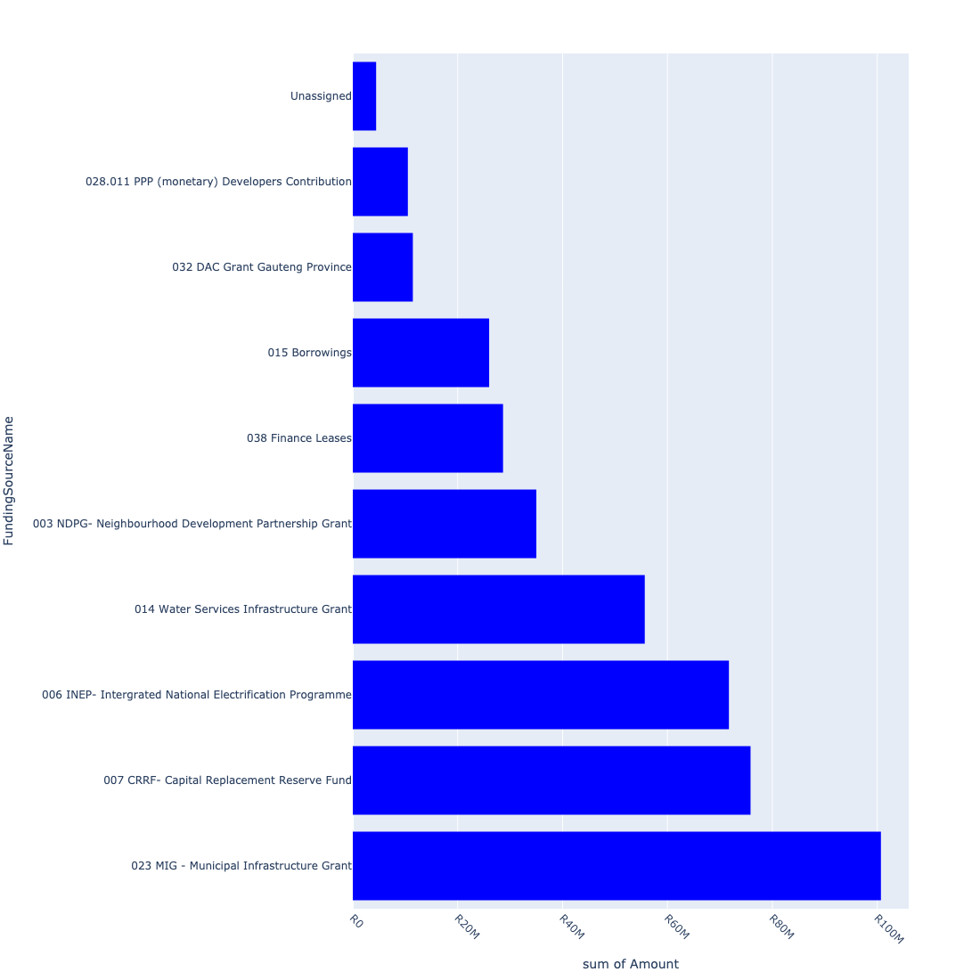

For the financial baseline that was selected for this report query (2022/2023 Draft Capital Budget_20220301_Finance), the breakdown of capital demand for Midvaal Municipality per department is shown in Figure 3.2 below.

Figure 3.2: Capital Demand Per Midvaal Municipality Department

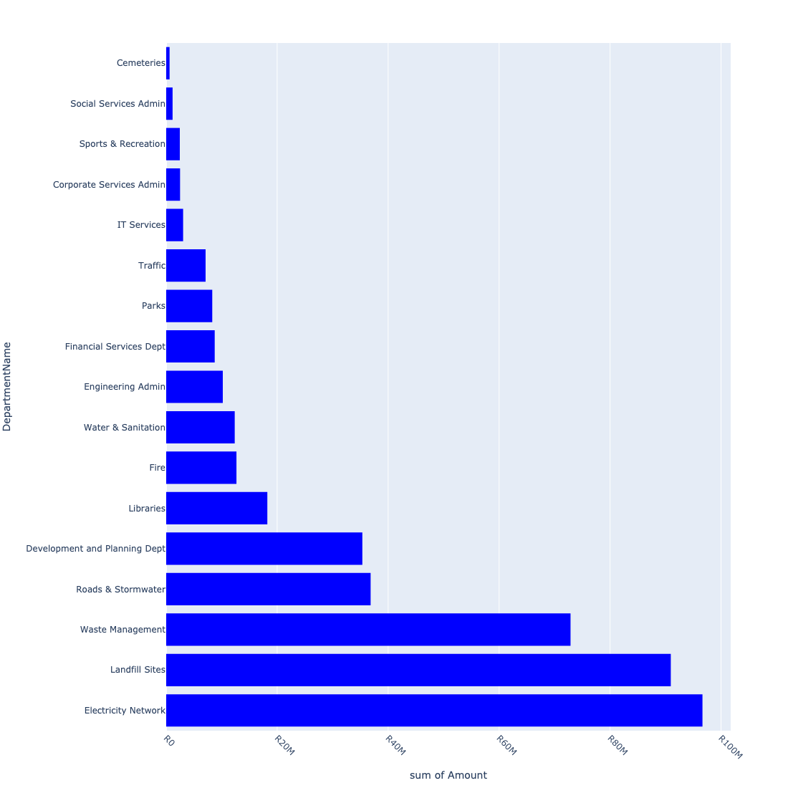

The following figures provide a histogram representation of the capital demand per framework. A colour breakdown is provided of each year's sub-total that contribute towards the overall total capital demand of each framework. Note that the capital demand beyond the first three years representing the Medium Term Expenditure Framework (MTREF - years 2023, 2024 and 2025) are generally more sparsely and less diligently populated, therefore less reliance should be vested on these outer years when appraising the overall capital demand. The reason for this is usually because of National Treasury's requirement for annual budget submissions spanning only over the MTREF (i.e. the next three years).

Figure 3.3: Capital Demand per Framework - All Years

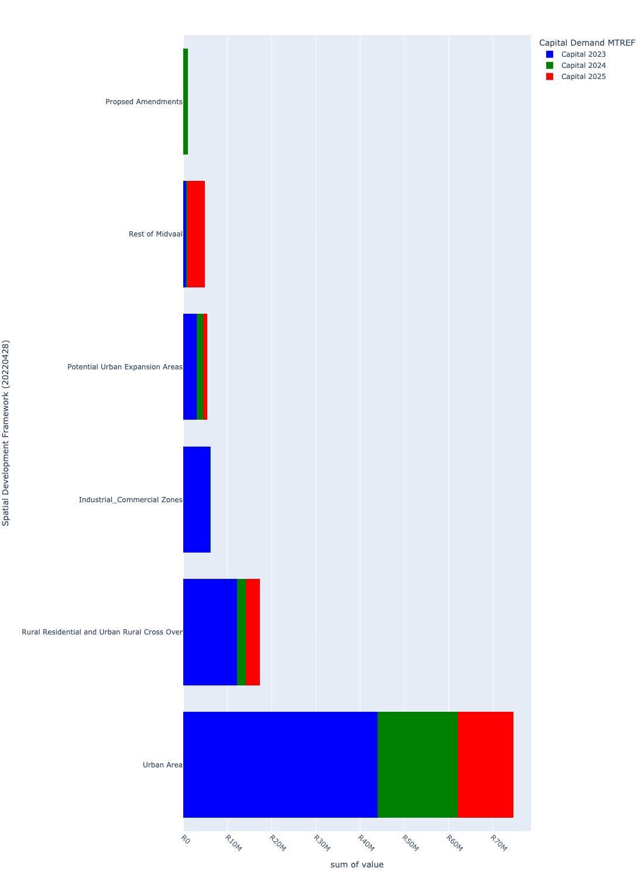

# Total Capital Demand per Framework - MTREF only

Table 4.1 below provides a concise summary of key statistical insights regarding the total MTREF capital demand per framework.

Table 4.1: Spatial Development Framework (20220428) Analysis - MTREF Capital Demand (R)

|  |  |  |  |
| --- | --- | --- | --- |
| Description | Info (1) | Info (2) | Info (3) |
| MTREF Capital demand in all Spatial Development Framework (20220428) - Overview | MTREF capital demand in all Spatial Development Framework (20220428): R109,672,773 | The average MTREF capital demand per framework: R18,278,795 | The 75th percentile of MTREF capital demand for Spatial Development Framework (20220428): R14,563,957 |
| The highest MTREF capital demand | In Framework: Urban Area | MTREF capital Demand in Urban Area: R74,746,626 | Percentage of total MRTEF capital demand in Urban Area: 68.15% |
| The lowest MTREF capital demand | In Framework: Propsed Amendments | MTREF capital Demand in Propsed Amendments: R1,000,000 | Percentage of total MTREF capital demand in Propsed Amendments: 0.91% |

The following figures provide a histogram representation of the capital demand per framework. A colour breakdown is provided of each year's sub-total that contribute towards the overall MTREF total capital demand of each framework.

Figure 4.1: Capital Demand per Framework - MTREF Period

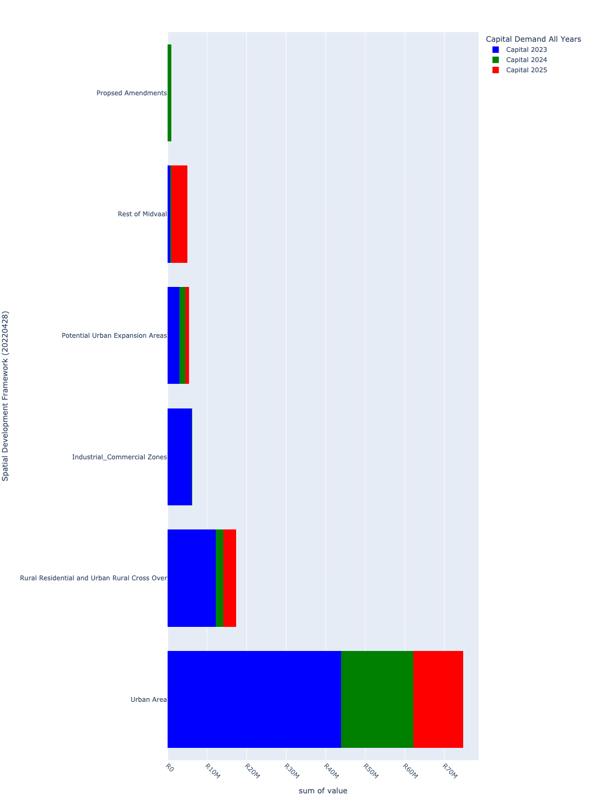

# Summary per Framework

## Industrial_Commercial Zones

Figure 5.1: Industrial_Commercial Zones Funding Requests

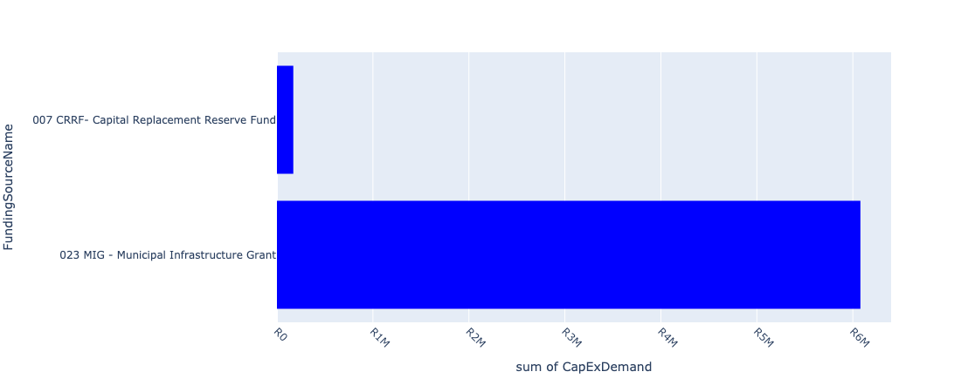

Figure 5.2: Industrial_Commercial Zones Departmental Requests

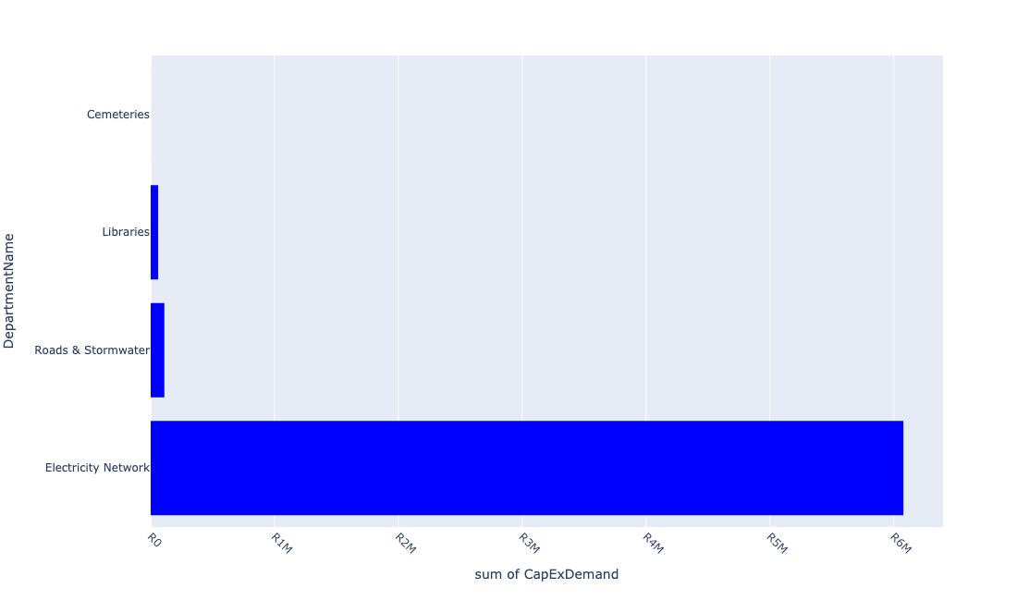

Table 5.1: Summary - Industrial_Commercial Zones

|  |  |
| --- | --- |
| Item | Description |
| Total Capital Demand for Industrial_Commercial Zones - All Years | R6,249,212 Rank: 3 (1 = Highest) |
| Total Capital Demand for Industrial_Commercial Zones - MTREF | R6,249,212 Rank: 3 (1 = Highest) |
| Financial Years in which capital requirements are listed for Industrial_Commercial Zones | 2023 and 2024 |
| Financial Year with highest capital demand for Industrial_Commercial Zones | 2023 |
| Industrial_Commercial Zones intersecting feature used | Works Location |
| Total number of projects intersecting with Industrial_Commercial Zones | 14 Rank: 5 (1 = Highest) |

Table 5.2: All projects asking for budget in Industrial_Commercial Zones

|  |  |  |  |
| --- | --- | --- | --- |
| Project ID | Project Name | Department | Project Budget |
| 10391 | Kokrus cemetery upgrade | Cemeteries | R0.00 (0%) No budget request. |
| 11010 | Rehabilitation of Meyer Street | Roads & Stormwater | R110,243 (1.76%) Budget spread across: 2024 |
| 10869 | Flatbed truck (new) | Electricity Network | R0.00 (0%) No budget request. |
| 10840 | RENEWABLE ENERGY | Electricity Network | R6,078,696 (97.27%) Budget spread across: 2023 |
| 10834 | LADDERS & BINS | Electricity Network | R0.00 (0%) No budget request. |
| 10811 | MOBILE TOILETS | Parks | R0.00 (0%) No budget request. |
| 10732 | Graceview water reticulation | Water & Sanitation | R0.00 (0%) No budget request. |
| 10483 | Pipe replacement and upgrading - Kookrus | Water & Sanitation | R0.00 (0%) No budget request. |
| 10071 | Server - Randvaal Library | Libraries | R0.00 (0%) No budget request. |
| 10070 | RANDVAAL LIBRARY BOOKS | Libraries | R0.00 (0%) No budget request. |
| 10068 | Library Furniture - Randvaal - New | Libraries | R0.00 (0%) No budget request. |
| 10043 | Extension Randvaal Library Building - Upgrading | Libraries | R60,000 (0.96%) Budget spread across: 2023 |
| 10001 | Extension of Kookrus Cemetery Fencing | Cemeteries | R273 (0.00%) Budget spread across: 2023 |
| 10323 | Replace 11 KV Overhead Line Springbok Road | Electricity Network | R0.00 (0%) No budget request. |

Please note that the following projects will not be shown in this table:

* Projects with no recorded intersect with Spatial Development Framework (20220428) (in other words no Works Location was recorded on the system for this project)

Projects that do not have any recorded budget demand on the system at the time that this report was requested, are shown in the table with zero budgets indicated.

## Potential Urban Expansion Areas

Figure 5.3: Potential Urban Expansion Areas Funding Requests

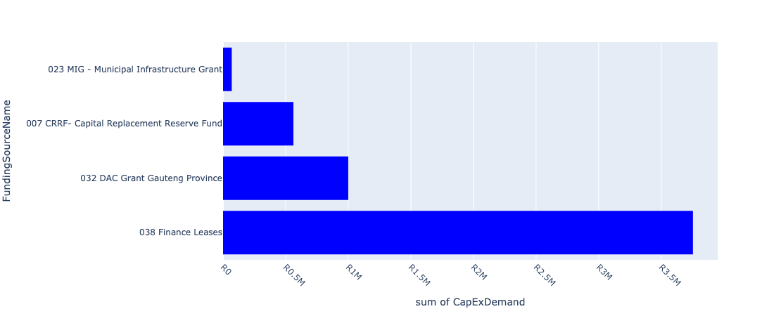

Figure 5.4: Potential Urban Expansion Areas Departmental Requests

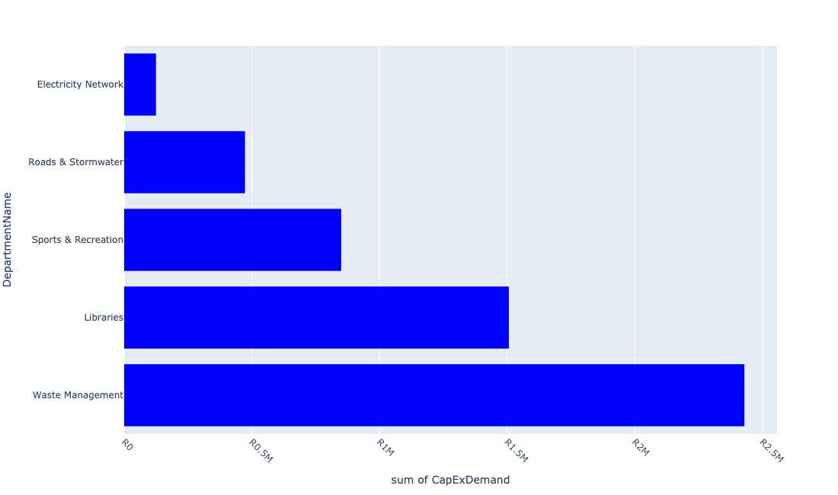

Table 5.2: Summary - Potential Urban Expansion Areas

|  |  |
| --- | --- |
| Item | Description |
| Total Capital Demand for Potential Urban Expansion Areas - All Years | R5,383,895 Rank: 4 (1 = Highest) |
| Total Capital Demand for Potential Urban Expansion Areas - MTREF | R5,383,895 Rank: 4 (1 = Highest) |
| Financial Years in which capital requirements are listed for Potential Urban Expansion Areas | 2023, 2024 and 2025 |
| Financial Year with highest capital demand for Potential Urban Expansion Areas | 2023 |
| Potential Urban Expansion Areas intersecting feature used | Works Location |
| Total number of projects intersecting with Potential Urban Expansion Areas | 26 Rank: 4 (1 = Highest) |

Table 5.3: All projects asking for budget in Potential Urban Expansion Areas

|  |  |  |  |
| --- | --- | --- | --- |
| Project ID | Project Name | Department | Project Budget |
| 10471 | Leloko Street | Roads & Stormwater | R0.00 (0%) No budget request. |
| 10470 | M. Polosong Street | Roads & Stormwater | R0.00 (0%) No budget request. |
| 10469 | Construction of Phomolong Street | Roads & Stormwater | R0.00 (0%) No budget request. |
| 10468 | Construction of N. Booi Street | Roads & Stormwater | R0.00 (0%) No budget request. |
| 10392 | Upgrading of Bronk Drive Road | Roads & Stormwater | R0.00 (0%) No budget request. |
| 11023 | E-Resources | Libraries | R33,429 (0.62%) Budget spread across: 2023, 2024 and 2025 |
| 11010 | Rehabilitation of Meyer Street | Roads & Stormwater | R473,248 (8.79%) Budget spread across: 2024 |
| 10918 | Furniture and Equipment | Libraries | R0.00 (0%) No budget request. |
| 10811 | MOBILE TOILETS | Parks | R0.00 (0%) No budget request. |
| 10789 | Savana Roads Rehabilitation | Roads & Stormwater | R0.00 (0%) No budget request. |
| 10734 | Savana Reservoir | Water & Sanitation | R0.00 (0%) No budget request. |
| 10733 | Savana Bulk Pipeline | Water & Sanitation | R0.00 (0%) No budget request. |
| 10732 | Graceview water reticulation | Water & Sanitation | R0.00 (0%) No budget request. |
| 10654 | Provide pedestrian oriented (human scale) Street lighting primarily along Station Road towards Sicelo (UDF) | Electricity Network | R124,638 (2.32%) Budget spread across: 2023 |
| 10403 | Maintaining of the Anchovy road | Roads & Stormwater | R0.00 (0%) No budget request. |
| 10482 | Valve Replacements | Water & Sanitation | R0.00 (0%) No budget request. |
| 10049 | LAKESIDE LIBRARY BOOKS | Libraries | R473,308 (8.79%) Budget spread across: 2023 |
| 10331 | Vaal Marina Upgrade of HT and LV Overheadlines | Electricity Network | R0.00 (0%) No budget request. |
| 10323 | Replace 11 KV Overhead Line Springbok Road | Electricity Network | R0.00 (0%) No budget request. |
| 10246 | Sicelo Bulk 20 MVA Sub-station | Electricity Network | R0.00 (0%) No budget request. |
| 11033 | New Library for Mamello | Libraries | R1,000,000 (18.57%) Budget spread across: 2024 |
| 10726 | New Library Building | Libraries | R0.00 (0%) No budget request. |
| 10394 | Eye Of Africa - Water Demand Management | Water & Sanitation | R0.00 (0%) No budget request. |
| 10593 | Sicelo Economic Development Centre- Upholstery | Development and Planning Dept | R0.00 (0%) No budget request. |
| 10186 | LAKESIDE SPORT CENTRE (MIG) | Sports & Recreation | R850,000 (15.79%) Budget spread across: 2025 |
| 10180 | BLACKWOOD TRANSFER STATION REFURBISHMENT | Waste Management | R2,429,273 (45.12%) Budget spread across: 2023 |

Please note that the following projects will not be shown in this table:

* Projects with no recorded intersect with Spatial Development Framework (20220428) (in other words no Works Location was recorded on the system for this project)

Projects that do not have any recorded budget demand on the system at the time that this report was requested, are shown in the table with zero budgets indicated.

## Propsed Amendments

Figure 5.5: Propsed Amendments Funding Requests

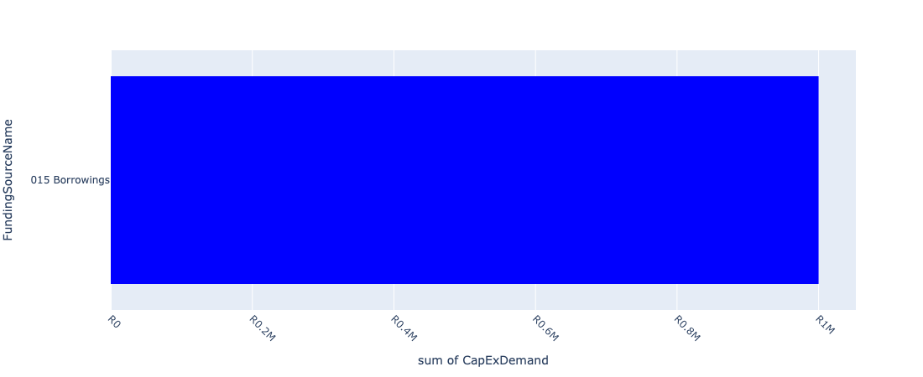

Figure 5.6: Propsed Amendments Departmental Requests

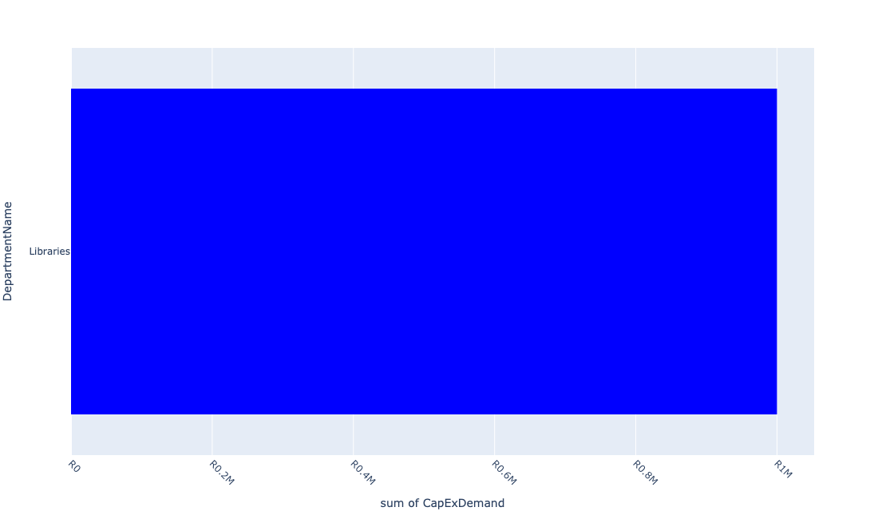

Table 5.3: Summary - Propsed Amendments

|  |  |
| --- | --- |
| Item | Description |
| Total Capital Demand for Propsed Amendments - All Years | R1,000,000 Rank: 6 (1 = Highest) |
| Total Capital Demand for Propsed Amendments - MTREF | R1,000,000 Rank: 6 (1 = Highest) |
| Financial Years in which capital requirements are listed for Propsed Amendments | 2024 |
| Financial Year with highest capital demand for Propsed Amendments | 2024 |
| Propsed Amendments intersecting feature used | Works Location |
| Total number of projects intersecting with Propsed Amendments | 8 Rank: 6 (1 = Highest) |

Table 5.4: All projects asking for budget in Propsed Amendments

|  |  |  |  |
| --- | --- | --- | --- |
| Project ID | Project Name | Department | Project Budget |
| 10918 | Furniture and Equipment | Libraries | R0.00 (0%) No budget request. |
| 10811 | MOBILE TOILETS | Parks | R0.00 (0%) No budget request. |
| 10789 | Savana Roads Rehabilitation | Roads & Stormwater | R0.00 (0%) No budget request. |
| 10734 | Savana Reservoir | Water & Sanitation | R0.00 (0%) No budget request. |
| 10733 | Savana Bulk Pipeline | Water & Sanitation | R0.00 (0%) No budget request. |
| 10498 | Library furniture & equipment-De Deur | Libraries | R0.00 (0%) No budget request. |
| 10482 | Valve Replacements | Water & Sanitation | R0.00 (0%) No budget request. |
| 10080 | DE DEUR LIBRARY BOOKS | Libraries | R1,000,000 (100.00%) Budget spread across: 2024 |

Please note that the following projects will not be shown in this table:

* Projects with no recorded intersect with Spatial Development Framework (20220428) (in other words no Works Location was recorded on the system for this project)

Projects that do not have any recorded budget demand on the system at the time that this report was requested, are shown in the table with zero budgets indicated.

## Rest of Midvaal

Figure 5.7: Rest of Midvaal Funding Requests

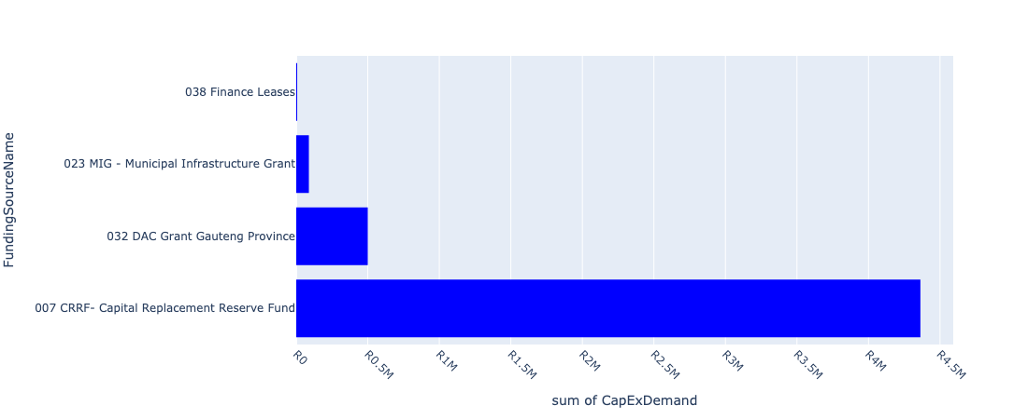

Figure 5.8: Rest of Midvaal Departmental Requests

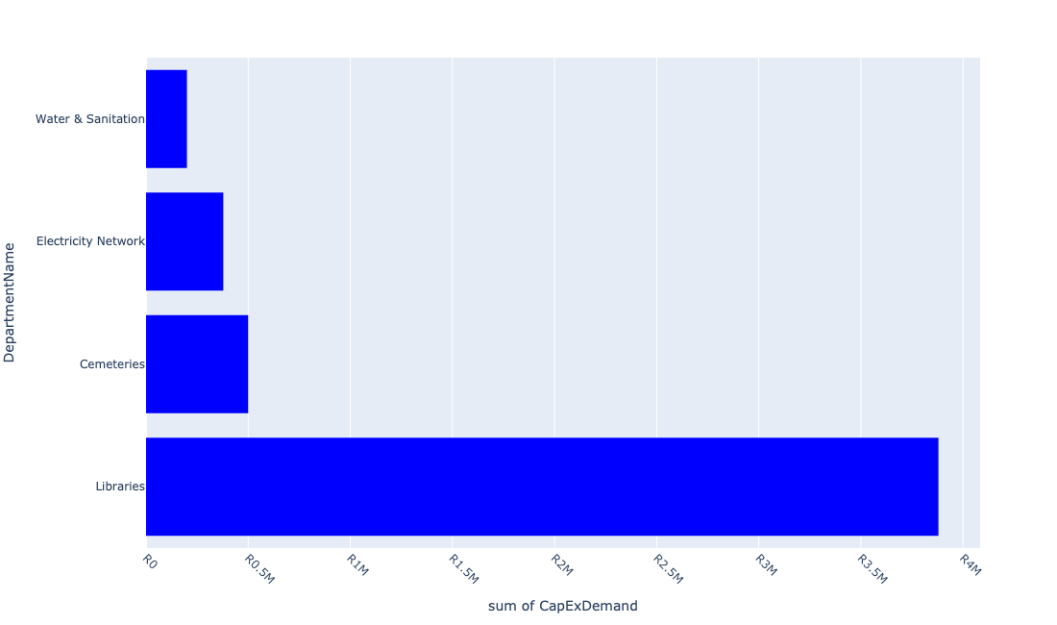

Table 5.4: Summary - Rest of Midvaal

|  |  |
| --- | --- |
| Item | Description |
| Total Capital Demand for Rest of Midvaal - All Years | R4,957,501 Rank: 5 (1 = Highest) |
| Total Capital Demand for Rest of Midvaal - MTREF | R4,957,501 Rank: 5 (1 = Highest) |
| Financial Years in which capital requirements are listed for Rest of Midvaal | 2023, 2024 and 2025 |
| Financial Year with highest capital demand for Rest of Midvaal | 2025 |
| Rest of Midvaal intersecting feature used | Works Location |
| Total number of projects intersecting with Rest of Midvaal | 39 Rank: 3 (1 = Highest) |

Table 5.5: All projects asking for budget in Rest of Midvaal

|  |  |  |  |
| --- | --- | --- | --- |
| Project ID | Project Name | Department | Project Budget |
| 10471 | Leloko Street | Roads & Stormwater | R0.00 (0%) No budget request. |
| 10470 | M. Polosong Street | Roads & Stormwater | R0.00 (0%) No budget request. |
| 10469 | Construction of Phomolong Street | Roads & Stormwater | R0.00 (0%) No budget request. |
| 10468 | Construction of N. Booi Street | Roads & Stormwater | R0.00 (0%) No budget request. |
| 10918 | Furniture and Equipment | Libraries | R0.00 (0%) No budget request. |
| 10811 | MOBILE TOILETS | Parks | R0.00 (0%) No budget request. |
| 10789 | Savana Roads Rehabilitation | Roads & Stormwater | R0.00 (0%) No budget request. |
| 10734 | Savana Reservoir | Water & Sanitation | R0.00 (0%) No budget request. |
| 10733 | Savana Bulk Pipeline | Water & Sanitation | R0.00 (0%) No budget request. |
| 10654 | Provide pedestrian oriented (human scale) Street lighting primarily along Station Road towards Sicelo (UDF) | Electricity Network | R158,371 (3.19%) Budget spread across: 2023 |
| 10403 | Maintaining of the Anchovy road | Roads & Stormwater | R0.00 (0%) No budget request. |
| 10498 | Library furniture & equipment-De Deur | Libraries | R0.00 (0%) No budget request. |
| 10482 | Valve Replacements | Water & Sanitation | R0.00 (0%) No budget request. |
| 10049 | LAKESIDE LIBRARY BOOKS | Libraries | R6,541 (0.13%) Budget spread across: 2023 |
| 10390 | Construction Windsor Circle roads in Ward 3 | Roads & Stormwater | R0.00 (0%) No budget request. |
| 10373 | Upgrade of Bantu Bonke Library | Libraries | R0.00 (0%) No budget request. |
| 10335 | Skills Development Centre | Social Services Admin | R0.00 (0%) No budget request. |
| 10329 | Upgrade HT & LT Overhead Lights - Chrissisfontein | Electricity Network | R0.00 (0%) No budget request. |
| 10327 | Bronk Lane Lighting | Electricity Network | R0.00 (0%) No budget request. |
| 10260 | Fire Engine Refurbishment | Fire | R0.00 (0%) No budget request. |
| 10231 | CABLE FEEDERS - CONSUMERS EMFULENI CONNECT | Electricity Network | R219,685 (4.43%) Budget spread across: 2024 and 2025 |
| 10216 | Relocation - Vaal Marina Ringfeed in Mamello | Water & Sanitation | R0.00 (0%) No budget request. |
| 10209 | Mamello Bulk Water (MIG) | Water & Sanitation | R0.00 (0%) No budget request. |
| 11045 | REHABILITATION VAAL MARINA LANDFILL SITE | Landfill Sites | R0.00 (0%) No budget request. |
| 11007 | Bantu Bonke Carports | Libraries | R1,000,000 (20.17%) Budget spread across: 2025 |
| 10912 | BANTU BONKE LIBRARY BOOKS | Libraries | R1,000,000 (20.17%) Budget spread across: 2025 |
| 10745 | Savanna city Sport facilities | Sports & Recreation | R0.00 (0%) No budget request. |
| 10675 | Mamello Cemetery | Cemeteries | R500,000 (10.09%) Budget spread across: 2023 |
| 10401 | Upgrading of Eaton R | Roads & Stormwater | R0.00 (0%) No budget request. |
| 10204 | Spare Pumps and Pump Replacement | Water & Sanitation | R200,000 (4.03%) Budget spread across: 2025 |
| 10202 | Servitude-Mamello Sewerage | Water & Sanitation | R0.00 (0%) No budget request. |
| 10185 | Bantu Bonke Sport Centre (MIG) | Sports & Recreation | R0.00 (0%) No budget request. |
| 10123 | Pipe Rising Main Rep(Klipriver Bus Park) | Water & Sanitation | R0.00 (0%) No budget request. |
| 10121 | Mamello Sewage Scheme Augmentation | Water & Sanitation | R0.00 (0%) No budget request. |
| 10118 | Extension to Daleside Sewer (Pump Station) | Water & Sanitation | R0.00 (0%) No budget request. |
| 10048 | Refurbishment of Library- HOK Library | Libraries | R247,115 (4.98%) Budget spread across: 2024 |
| 10046 | HENLEY ON KLIP LIBRARY BOOKS | Libraries | R1,625,788 (32.79%) Budget spread across: 2025 |
| 10045 | Carport - HOK - New | Libraries | R0.00 (0%) No budget request. |
| 10042 | Air cons - HOK - New | Libraries | R0.00 (0%) No budget request. |

Please note that the following projects will not be shown in this table:

* Projects with no recorded intersect with Spatial Development Framework (20220428) (in other words no Works Location was recorded on the system for this project)

Projects that do not have any recorded budget demand on the system at the time that this report was requested, are shown in the table with zero budgets indicated.

## Rural Residential and Urban Rural Cross Over

Figure 5.9: Rural Residential and Urban Rural Cross Over Funding Requests

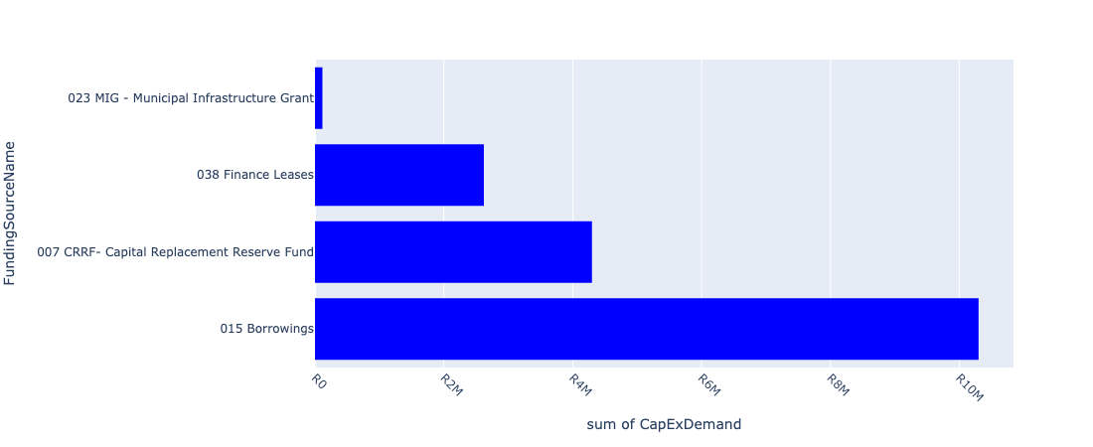

Figure 5.10: Rural Residential and Urban Rural Cross Over Departmental Requests

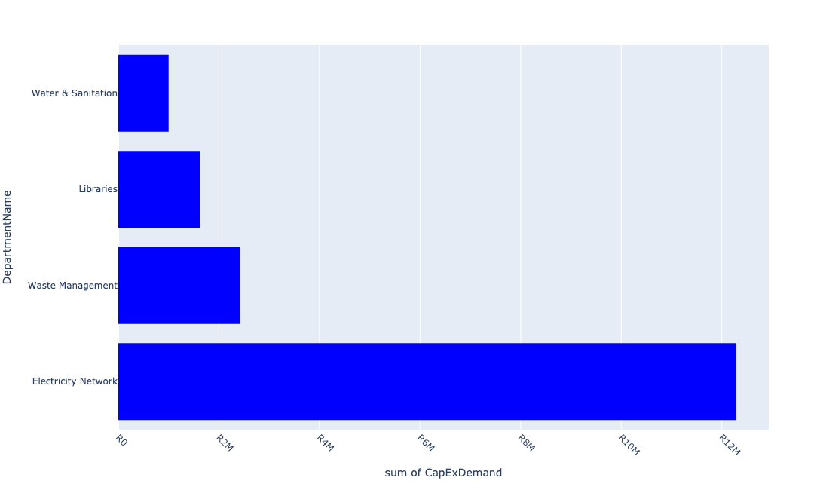

Table 5.5: Summary - Rural Residential and Urban Rural Cross Over

|  |  |
| --- | --- |
| Item | Description |
| Total Capital Demand for Rural Residential and Urban Rural Cross Over - All Years | R17,335,539 Rank: 2 (1 = Highest) |
| Total Capital Demand for Rural Residential and Urban Rural Cross Over - MTREF | R17,335,539 Rank: 2 (1 = Highest) |
| Financial Years in which capital requirements are listed for Rural Residential and Urban Rural Cross Over | 2023, 2024 and 2025 |
| Financial Year with highest capital demand for Rural Residential and Urban Rural Cross Over | 2023 |
| Rural Residential and Urban Rural Cross Over intersecting feature used | Works Location |
| Total number of projects intersecting with Rural Residential and Urban Rural Cross Over | 40 Rank: 2 (1 = Highest) |

Table 5.6: All projects asking for budget in Rural Residential and Urban Rural Cross Over

|  |  |  |  |
| --- | --- | --- | --- |
| Project ID | Project Name | Department | Project Budget |
| 10471 | Leloko Street | Roads & Stormwater | R0.00 (0%) No budget request. |
| 10470 | M. Polosong Street | Roads & Stormwater | R0.00 (0%) No budget request. |
| 10469 | Construction of Phomolong Street | Roads & Stormwater | R0.00 (0%) No budget request. |
| 10468 | Construction of N. Booi Street | Roads & Stormwater | R0.00 (0%) No budget request. |
| 10392 | Upgrading of Bronk Drive Road | Roads & Stormwater | R0.00 (0%) No budget request. |
| 10918 | Furniture and Equipment | Libraries | R0.00 (0%) No budget request. |
| 10811 | MOBILE TOILETS | Parks | R0.00 (0%) No budget request. |
| 10789 | Savana Roads Rehabilitation | Roads & Stormwater | R0.00 (0%) No budget request. |
| 10734 | Savana Reservoir | Water & Sanitation | R0.00 (0%) No budget request. |
| 10733 | Savana Bulk Pipeline | Water & Sanitation | R0.00 (0%) No budget request. |
| 10654 | Provide pedestrian oriented (human scale) Street lighting primarily along Station Road towards Sicelo (UDF) | Electricity Network | R206,765 (1.19%) Budget spread across: 2023 |
| 10451 | Library Refurbishment/upgrade - De Deur | Libraries | R0.00 (0%) No budget request. |
| 10498 | Library furniture & equipment-De Deur | Libraries | R0.00 (0%) No budget request. |
| 10482 | Valve Replacements | Water & Sanitation | R0.00 (0%) No budget request. |
| 10049 | LAKESIDE LIBRARY BOOKS | Libraries | R199,139 (1.15%) Budget spread across: 2023 |
| 10390 | Construction Windsor Circle roads in Ward 3 | Roads & Stormwater | R0.00 (0%) No budget request. |
| 10329 | Upgrade HT & LT Overhead Lights - Chrissisfontein | Electricity Network | R0.00 (0%) No budget request. |
| 10231 | CABLE FEEDERS - CONSUMERS EMFULENI CONNECT | Electricity Network | R2,780,315 (16.04%) Budget spread across: 2024 and 2025 |
| 10745 | Savanna city Sport facilities | Sports & Recreation | R0.00 (0%) No budget request. |
| 10401 | Upgrading of Eaton R | Roads & Stormwater | R0.00 (0%) No budget request. |
| 10048 | Refurbishment of Library- HOK Library | Libraries | R52,885 (0.31%) Budget spread across: 2024 |
| 10046 | HENLEY ON KLIP LIBRARY BOOKS | Libraries | R374,211 (2.16%) Budget spread across: 2025 |
| 10045 | Carport - HOK - New | Libraries | R0.00 (0%) No budget request. |
| 10042 | Air cons - HOK - New | Libraries | R0.00 (0%) No budget request. |
| 10246 | Sicelo Bulk 20 MVA Sub-station | Electricity Network | R0.00 (0%) No budget request. |
| 10593 | Sicelo Economic Development Centre- Upholstery | Development and Planning Dept | R0.00 (0%) No budget request. |
| 10180 | BLACKWOOD TRANSFER STATION REFURBISHMENT | Waste Management | R2,422,223 (13.97%) Budget spread across: 2023 |
| 10453 | Purchasing of Jojo Tanks | Water & Sanitation | R0.00 (0%) No budget request. |
| 10334 | Transfer Station: Blackwood | Electricity Network | R0.00 (0%) No budget request. |
| 10330 | Duncanville Street Light Upgrade | Electricity Network | R0.00 (0%) No budget request. |
| 10328 | Ophir Estates - Upgrade HT & LT Overhead + Street Lights | Electricity Network | R0.00 (0%) No budget request. |
| 10319 | Upgrade Overhead Lines in Chrissiesfontein | Electricity Network | R9,300,000 (53.65%) Budget spread across: 2023 |
| 10314 | Replace Rothdene LV Overhead Line to Underground | Electricity Network | R0.00 (0%) No budget request. |
| 10236 | Highmast Lights - Savanna City | Electricity Network | R0.00 (0%) No budget request. |
| 10221 | SICELO/HIGHBURY (VALLEY SETTLEMENTS) RESERVOIR | Water & Sanitation | R1,000,000 (5.77%) Budget spread across: 2025 |
| 10821 | Midvaal Agricultural Packhouse and Storage | Development and Planning Dept | R0.00 (0%) No budget request. |
| 10804 | Midvaal Entrepreneurship Hub | Development and Planning Dept | R0.00 (0%) No budget request. |
| 10393 | High Valley Settlement Reservoir and Pipeline | Water & Sanitation | R0.00 (0%) No budget request. |
| 10485 | Pipe replacement and upgrading - Valley Settlements | Water & Sanitation | R0.00 (0%) No budget request. |
| 10080 | DE DEUR LIBRARY BOOKS | Libraries | R1,000,000 (5.77%) Budget spread across: 2024 |

Please note that the following projects will not be shown in this table:

* Projects with no recorded intersect with Spatial Development Framework (20220428) (in other words no Works Location was recorded on the system for this project)

Projects that do not have any recorded budget demand on the system at the time that this report was requested, are shown in the table with zero budgets indicated.

## Urban Area

Figure 5.11: Urban Area Funding Requests

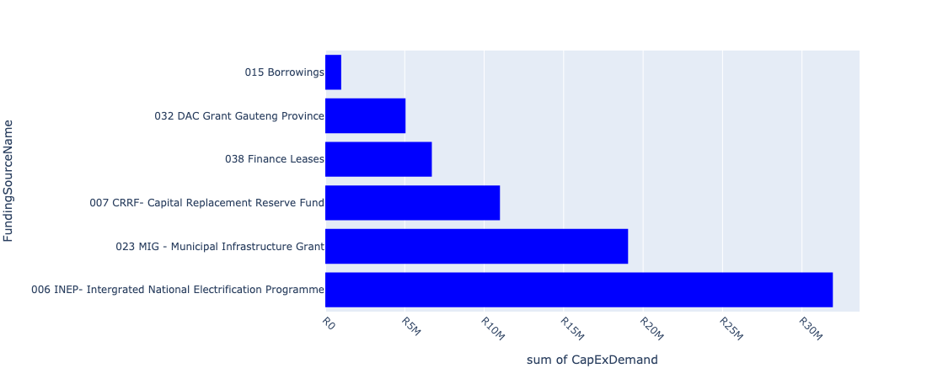

Figure 5.12: Urban Area Departmental Requests

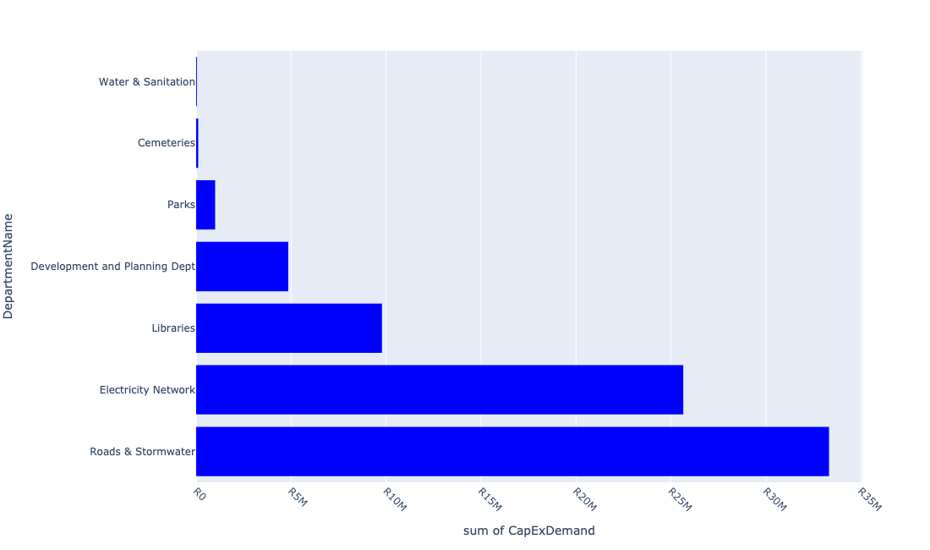

Table 5.6: Summary - Urban Area

|  |  |
| --- | --- |
| Item | Description |
| Total Capital Demand for Urban Area - All Years | R74,746,626 Rank: 1 (1 = Highest) |
| Total Capital Demand for Urban Area - MTREF | R74,746,626 Rank: 1 (1 = Highest) |
| Financial Years in which capital requirements are listed for Urban Area | 2023, 2024 and 2025 |
| Financial Year with highest capital demand for Urban Area | 2023 |
| Urban Area intersecting feature used | Works Location |
| Total number of projects intersecting with Urban Area | 92 Rank: 1 (1 = Highest) |

Table 5.7: All projects asking for budget in Urban Area

|  |  |  |  |
| --- | --- | --- | --- |
| Project ID | Project Name | Department | Project Budget |
| 10481 | Amaketa | Roads & Stormwater | R0.00 (0%) No budget request. |
| 10480 | Ntsanwisi Street | Roads & Stormwater | R0.00 (0%) No budget request. |
| 10479 | Tau Street | Roads & Stormwater | R0.00 (0%) No budget request. |
| 10478 | Chief Makana Street | Roads & Stormwater | R0.00 (0%) No budget request. |
| 10477 | Chris Hani Street | Roads & Stormwater | R0.00 (0%) No budget request. |
| 10476 | Langa Street | Roads & Stormwater | R0.00 (0%) No budget request. |
| 10475 | Mpetezeli Street | Roads & Stormwater | R0.00 (0%) No budget request. |
| 10474 | Modikeng Street | Roads & Stormwater | R0.00 (0%) No budget request. |
| 10473 | R.N. Mandela Street | Roads & Stormwater | R0.00 (0%) No budget request. |
| 10472 | Blom Street | Roads & Stormwater | R0.00 (0%) No budget request. |
| 10471 | Leloko Street | Roads & Stormwater | R0.00 (0%) No budget request. |
| 10470 | M. Polosong Street | Roads & Stormwater | R0.00 (0%) No budget request. |
| 10469 | Construction of Phomolong Street | Roads & Stormwater | R0.00 (0%) No budget request. |
| 10468 | Construction of N. Booi Street | Roads & Stormwater | R0.00 (0%) No budget request. |
| 10392 | Upgrading of Bronk Drive Road | Roads & Stormwater | R0.00 (0%) No budget request. |
| 10391 | Kokrus cemetery upgrade | Cemeteries | R0.00 (0%) No budget request. |
| 10369 | Refurbishment of Vaal Marina WaterTreatment Plant | Water & Sanitation | R40,000 (0.05%) Budget spread across: 2023 and 2024 |
| 10332 | Rissiville Ext 6 Electrification: Network Strengthening | Electricity Network | R0.00 (0%) No budget request. |
| 10325 | Festive Decorating Lights | Electricity Network | R250,000 (0.33%) Budget spread across: 2023 |
| 10322 | Ohenimuri - Upgrade of Network | Electricity Network | R0.00 (0%) No budget request. |
| 10321 | Upgrade HT & LT Overhead Lines in Ophir Estates | Electricity Network | R0.00 (0%) No budget request. |
| 10318 | Feeder Line to Riversdale | Electricity Network | R100,000 (0.13%) Budget spread across: 2023 |
| 10317 | Feeder Supply to Rothdene | Electricity Network | R0.00 (0%) No budget request. |
| 10297 | Vaal Marina Fire Station Paving | Fire | R0.00 (0%) No budget request. |
| 10294 | MEYERTON FIRE STATION SMALL GEAR | Fire | R0.00 (0%) No budget request. |
| 10248 | Sicelo Reticulation Network (ERF 78) | Electricity Network | R0.00 (0%) No budget request. |
| 10247 | Sicelo Reticulation Network (ERF 204) | Electricity Network | R4,000,000 (5.35%) Budget spread across: 2024 |
| 10244 | Risiville Sub-Ripple Injection Equip | Electricity Network | R0.00 (0%) No budget request. |
| 10211 | PREPAID WATER METER PROJECT | Water & Sanitation | R0.00 (0%) No budget request. |
| 10651 | Upgrade Diens Avenue North (service Road) – from Meyer Street to Municipal Offices | Roads & Stormwater | R0.00 (0%) No budget request. |
| 10650 | Construct Pedestrian Pavement along Diens Avenue North (service Road) – from Meyer Street to Municipal Offices (UDF) | Roads & Stormwater | R0.00 (0%) No budget request. |
| 10649 | 10028_03_Install Wi-Fi network at Public Transport facilities (Meyer Station and Taxi Rank) (UDF) | Development and Planning Dept | R0.00 (0%) No budget request. |
| 10648 | Construct Parklet areas within CBD – along Loche Street between Meyer and Galloway Street (UDF) | Roads & Stormwater | R0.00 (0%) No budget request. |
| 10647 | Construct Pedestrian Bridge over R 59 to link Sicelo and Meyerton CBD (UDF) | Roads & Stormwater | R0.00 (0%) No budget request. |
| 10646 | Construct pedestrian link and pave (asphalt) road from Sicelo to Meyerton CBD along Station Road (UDF) | Roads & Stormwater | R0.00 (0%) No budget request. |
| 10645 | 10028_01_Construct ablution facilities, seating area and public soft/hard spaces close to formalised informal trading activity (UDF) | Development and Planning Dept | R0.00 (0%) No budget request. |
| 11031 | Sidewalks in CBD Meyerton | Development and Planning Dept | R350,000 (0.47%) Budget spread across: 2025 |
| 11023 | E-Resources | Libraries | R66,857 (0.09%) Budget spread across: 2023, 2024 and 2025 |
| 11010 | Rehabilitation of Meyer Street | Roads & Stormwater | R1,026,752 (1.37%) Budget spread across: 2024 |
| 11008 | Mobile library bus | Libraries | R4,000,000 (5.35%) Budget spread across: 2023 and 2024 |
| 10918 | Furniture and Equipment | Libraries | R0.00 (0%) No budget request. |
| 10869 | Flatbed truck (new) | Electricity Network | R0.00 (0%) No budget request. |
| 10840 | RENEWABLE ENERGY | Electricity Network | R6,078,696 (8.13%) Budget spread across: 2023 |
| 10834 | LADDERS & BINS | Electricity Network | R0.00 (0%) No budget request. |
| 10811 | MOBILE TOILETS | Parks | R0.00 (0%) No budget request. |
| 10789 | Savana Roads Rehabilitation | Roads & Stormwater | R0.00 (0%) No budget request. |
| 10761 | Sicelo Sport field | Sports & Recreation | R0.00 (0%) No budget request. |
| 10734 | Savana Reservoir | Water & Sanitation | R0.00 (0%) No budget request. |
| 10733 | Savana Bulk Pipeline | Water & Sanitation | R0.00 (0%) No budget request. |
| 10732 | Graceview water reticulation | Water & Sanitation | R0.00 (0%) No budget request. |
| 10725 | upgrade of Sicelo Library | Libraries | R0.00 (0%) No budget request. |
| 10660 | Detail Design of on-street parking along Reitz Street between Meyer Street and Pierneef Boulevard (UDF) | Roads & Stormwater | R0.00 (0%) No budget request. |
| 10659 | Install traffic circles at the following intersections: Loch and Holiday (UDF) | Roads & Stormwater | R0.00 (0%) No budget request. |
| 10658 | Install traffic circles at the following intersections: Galloway and Shippard (UDF) | Roads & Stormwater | R0.00 (0%) No budget request. |
| 10657 | Install traffic circles at the following intersections: Meyer and Shippard (UDF) | Roads & Stormwater | R350,000 (0.47%) Budget spread across: 2023 |
| 10656 | Install Traffic Light at Loch and Pierneef Boulevard (UDF) | Electricity Network | R0.00 (0%) No budget request. |
| 10655 | Construct bike rack facility in Diens Avenue North across municipal offices and SPAR, Pick n Pay and Shoprite (UDF) | Development and Planning Dept | R0.00 (0%) No budget request. |
| 10654 | Provide pedestrian oriented (human scale) Street lighting primarily along Station Road towards Sicelo (UDF) | Electricity Network | R15,216,284 (20.36%) Budget spread across: 2023 |
| 10653 | Construct traffic circle and public art feature at the intersection of Holiday and Loch Street (UDF) | Roads & Stormwater | R31,943,000 (42.74%) Budget spread across: 2023, 2024 and 2025 |
| 10652 | Develop Public Open Spaces on western and eastern side of Meyer Station (UDF) | Development and Planning Dept | R0.00 (0%) No budget request. |
| 10451 | Library Refurbishment/upgrade - De Deur | Libraries | R0.00 (0%) No budget request. |
| 10447 | Development of a District Park in Meyerton | Parks | R1,000,000 (1.34%) Budget spread across: 2024 |
| 10403 | Maintaining of the Anchovy road | Roads & Stormwater | R0.00 (0%) No budget request. |
| 10402 | Construction of the pedestrian suspension bridge | Roads & Stormwater | R0.00 (0%) No budget request. |
| 10607 | Library furniture & equipment - Lakeside | Libraries | R0.00 (0%) No budget request. |
| 10601 | SICELO ELECTRIFICATION NETWORK | Electricity Network | R0.00 (0%) No budget request. |
| 10507 | 10028_02_Formalisation of Informal Trading stalls | Development and Planning Dept | R4,500,000 (6.02%) Budget spread across: 2023 |
| 10502 | ITC hardware (Computers) - Sicelo | Libraries | R0.00 (0%) No budget request. |
| 10498 | Library furniture & equipment-De Deur | Libraries | R0.00 (0%) No budget request. |
| 10495 | Ext Meyerton Lib building - Upgrading | Libraries | R250,000 (0.33%) Budget spread across: 2025 |
| 10494 | Ext Lakeside Lib building - Upgrading | Libraries | R2,000,000 (2.68%) Budget spread across: 2023 |
| 10484 | Pipe replacement and upgrading - Rothdene | Water & Sanitation | R0.00 (0%) No budget request. |
| 10483 | Pipe replacement and upgrading - Kookrus | Water & Sanitation | R0.00 (0%) No budget request. |
| 10482 | Valve Replacements | Water & Sanitation | R0.00 (0%) No budget request. |
| 10208 | Installation:Domestic W/Meters (Lakeside) | Water & Sanitation | R0.00 (0%) No budget request. |
| 10165 | SICELO ECD - PARK FENCING & JUNGLE GYM | Social Services Admin | R0.00 (0%) No budget request. |
| 10127 | Sicelo North Outfall Sewer | Water & Sanitation | R0.00 (0%) No budget request. |
| 10076 | SICELO LIBRARY BOOKS | Libraries | R0.00 (0%) No budget request. |
| 10074 | SICELO LIBRARY FURNITURE | Libraries | R1,000,000 (1.34%) Budget spread across: 2023 and 2024 |
| 10073 | Extension Sicelo Library building - Upgrading | Libraries | R0.00 (0%) No budget request. |
| 10071 | Server - Randvaal Library | Libraries | R0.00 (0%) No budget request. |
| 10070 | RANDVAAL LIBRARY BOOKS | Libraries | R0.00 (0%) No budget request. |
| 10068 | Library Furniture - Randvaal - New | Libraries | R0.00 (0%) No budget request. |
| 10065 | MEYERTON LIBRARY - RFID SECURITY SYSTEM | Libraries | R0.00 (0%) No budget request. |
| 10063 | MEYERTON LIBRARY BOOKS | Libraries | R450,000 (0.60%) Budget spread across: 2023 and 2024 |
| 10062 | MEYERTON LIBRARY FURNITURE | Libraries | R0.00 (0%) No budget request. |
| 10059 | Library Furniture - Meyerton - Shelves - New | Libraries | R0.00 (0%) No budget request. |
| 10057 | MEYERTON LIBRARY ICT HARDWARE (COMPUTORS) | Libraries | R600,000 (0.80%) Budget spread across: 2023 and 2024 |
| 10051 | Lakeside Library Children Sec Furniture | Libraries | R0.00 (0%) No budget request. |
| 10049 | LAKESIDE LIBRARY BOOKS | Libraries | R1,355,036 (1.81%) Budget spread across: 2023 |
| 10043 | Extension Randvaal Library Building - Upgrading | Libraries | R60,000 (0.08%) Budget spread across: 2023 |
| 10001 | Extension of Kookrus Cemetery Fencing | Cemeteries | R110,000 (0.15%) Budget spread across: 2023 |

Please note that the following projects will not be shown in this table:

* Projects with no recorded intersect with Spatial Development Framework (20220428) (in other words no Works Location was recorded on the system for this project)

Projects that do not have any recorded budget demand on the system at the time that this report was requested, are shown in the table with zero budgets indicated.