



Spatial Feature Report

T: +27 12 364 2546 | E: info@novus3.co.za Postnet Suite 471, Private Bag X15,

Menlo Park, 0102**www.novus3.co.za**

engineered solutions

Disclaimer

This document contains data that was obtained from a live CP3 system at the moment the data was requested. The data is updated by users of the CP3 System and unless the system is locked for changes, this data may change on a daily basis. The reader is therefore cautioned not to place inappropriate reliance on the data unless there is certainty on the status of the data in terms of how recently it has been updated, how “clean” the data is (is there a quality control and/or verification process that was followed by the licensee of the CP3 system to ensure that data is checked and verified from time-to-time) and whether the correct baseline was queried. This report therefore provides a “snapshot in time”. Consequently, the document may be less relevant at a different time, or using a different financial baseline to query from.

At all times, all rights, title and interest in and to this material remains vested in the owner of this document and are copyrighted and protected by regulatory provisions. These materials may not be copied, reproduced, modified, published, uploaded, posted to websites or otherwise distributed in any way, without our prior written permission from the Licensee and Licensor (Nvous3 (Pty) Ltd) of the CP3 Software. The owner of this document does not grant any right to reproduce the materials. All our rights in this regard are and remain reserved.

Table of Contents

**No table of contents entries found.** (Right-click -> Update Field)

Spatial Query Report

This document was created *2022-05-19-11_35* from the **Midvaal Municipality** CP3 system.

The baseline **'2022/2023 Draft Capital Budget_20220301_Finance'** with description: **'2022/2023 Draft Capital Budget as recieved from Finance as draft Capital Budget with only MTREF Values'** was used. The spatial feature that was selected for the purpose of this report was: **'Wards'**.

This is a spatial feature report for the *Midvaal Municipality.* The data contained in this report was sourced directly from the municipality's live CP3 system. The information in this report therefore reflects the data as it was on *2022-05-19* when this report was requested. Any subsequent updates to the data contained the CP3 System related to the applicable baseline from which this reports was drawn, would therefore not reflect in this report.   
  
For the *Midvaal Municipality, the following spatial features are available for the purpose of developing* 'Spatial Query Reports' (similar to this report):

* Economic Study Catalytic Nodes (5nodes)
* Midvaal 5 EDCs
* Midvaal Township Boundaries
* Spatial Development Framework (20220428)
* Wards



We hope you find this useful! Sincerely, *The Novus3 Team.*

# Introduction

The baseline that was queried for this report contains *196* projects of which a total of *14 (7.14%)* projects do not have any recorded intersection (overlap) with the 'Wards' spatial feature that was selected for this report. The following spatial features are available for queries using this API profile:

* Economic Study Catalytic Nodes (5nodes)
* Midvaal 5 EDCs
* Midvaal Township Boundaries
* Spatial Development Framework (20220428)
* Wards

The probable reasons for the 14 non intersecting projects reported are that:

* these projects simply do not have a location associated with them yet (most frequently the case with 'no-intersect' projects) or;
* the location that was captured for some of these projects, may have been in the wrong place (e.g. outside the boundaries of Midvaal - this is very rarely the reason).

It is important to take note of the 7.14% projects that do not intersect with the 'Wards' spatial feature when appraising this report.

Figure 1.1: Intersecting vs Non-Intersecting Projects

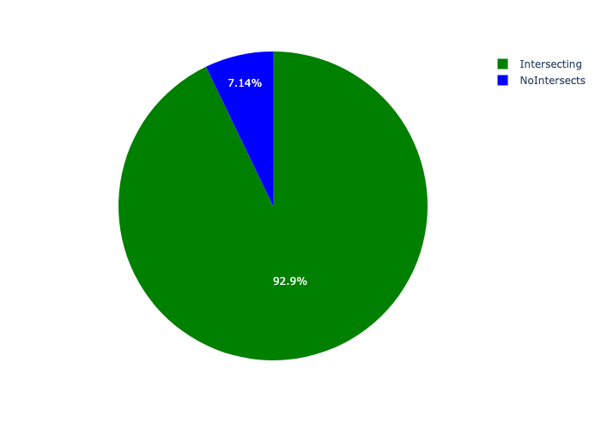

# Total Number of Projects and Total Capital Demand per Ward - All Years

Table 2.1 below provides a concise summary of key statistical insights regarding the number of projects that are requesting funding in each of the wards.

Table 2.1: Wards Analysis - Number of Projects

|  |  |  |  |
| --- | --- | --- | --- |
| Description | Info (1) | Info (2) | Info (3) |
| Number of projects in all Wards - Overview | Total in all Wards: 182 projects | Average per Wards: 12.1 projects | 75th percentile of projects across all Wards: 19.0 projects |
| The highest number of projects | Wards: In Ward 10 | Number of projects in Ward 10: 28 | Percentage of total in Ward 10: 15.38% |
| The lowest number of projects: | Wards: In Ward 04 | Number of projects in Ward 04: 3 | Percentage of total in Ward 04: 1.65% |
| The 5 wards that collectively have with the highest number of projects | Wards: In Ward 01, Ward 05, Ward 11, Ward 09 and Ward 10 | Number of projects in Ward 01, Ward 05, Ward 11, Ward 09 and Ward 10 together: 114 | Percentage of total in Ward 01, Ward 05, Ward 11, Ward 09 and Ward 10 together: 62.64% |

Table 2.1 below provides a concise summary of key statistical insights regarding the total capital demand per ward.

Table 2.1: Wards Analysis - Capital Demand (R)

|  |  |  |  |
| --- | --- | --- | --- |
| Description | Info (1) | Info (2) | Info (3) |
| Capital demand in all Wards - Overview | Total capital demand in all Wards: R99,691,323 | The average capital demand per Wards: R6,646,088 | The 75th percentile of capital demand for Wards: R8,010,379 |
| The highest capital demand | Wards: In Ward 09 | Capital Demand in Ward 09: R26,315,285 | Percentage of total in Ward 09: 26.40% |
| The lowest capital demand | Wards: In Ward 04 | Capital Demand in Ward 04: R0 | Percentage of total in Ward 04: 0.00% |
| The 5 wards that collectively have collective the highest capital demand: | Wards: In Ward 05, Ward 08, Ward 13, Ward 14 and Ward 09 | Capital Demand in Ward 05, Ward 08, Ward 13, Ward 14 and Ward 09 together: R71,558,126 | Percentage of total in Ward 05, Ward 08, Ward 13, Ward 14 and Ward 09 together: 71.78% |

The number of projects per ward and the capital demand per ward needs to be looked at together for better insight. Figures 2.1 and 2.2 assist with further graphical insight into some of the numbers that are provided in Tables 2.1 and 2.2.

Figure 2.1: The single ward with the highest value (Nr of Projects & Capital Demand) vs the rest

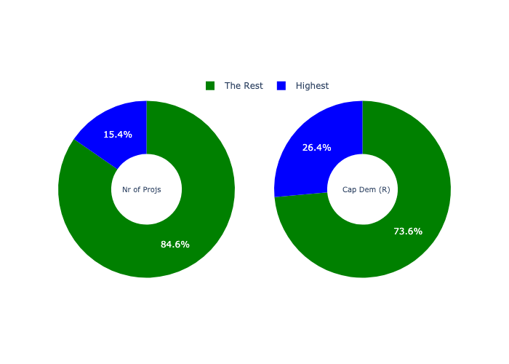

The highest number of projects in a single ward is in **Ward 10.** *That is 28 projects and this is 15.38% of the total number of projects.* The highest capital demand in a single ward is in **Ward 09.** *That is R26,315,285 and this amounts to 26.40% of the total capital demand.*

Figure 2.2: The 5 wards with the highest values (Nr of Projects & Capital Demand) vs the rest

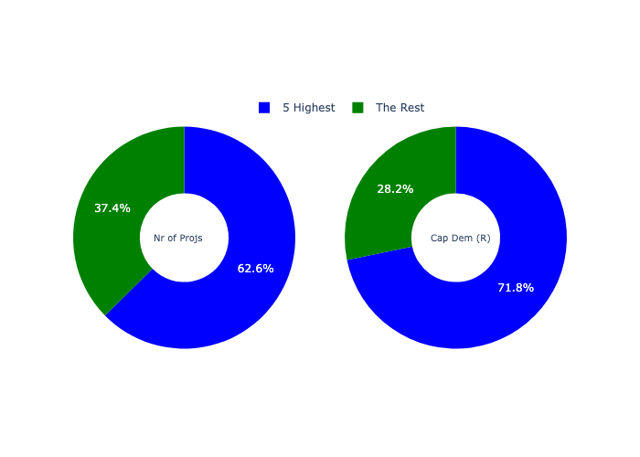

The 5 wards that collectively have with the highest number of projects are in **Ward 01, Ward 05, Ward 11, Ward 09 and Ward 10.** *That is 114 projects and this is 62.64% of the total number of projects.* The 5 wards that collectively have the highest capital demand are in **Ward 05, Ward 08, Ward 13, Ward 14 and Ward 09.** *That is 71.78% and this amounts to R71,558,126 of the total capital demand.*

The following figures provide a bar graph representation of the number of projects per ward with the colour of the bars representing the level of capital demand in each of these wards.

Figure 2.3: Projects and Capital Demand per Ward

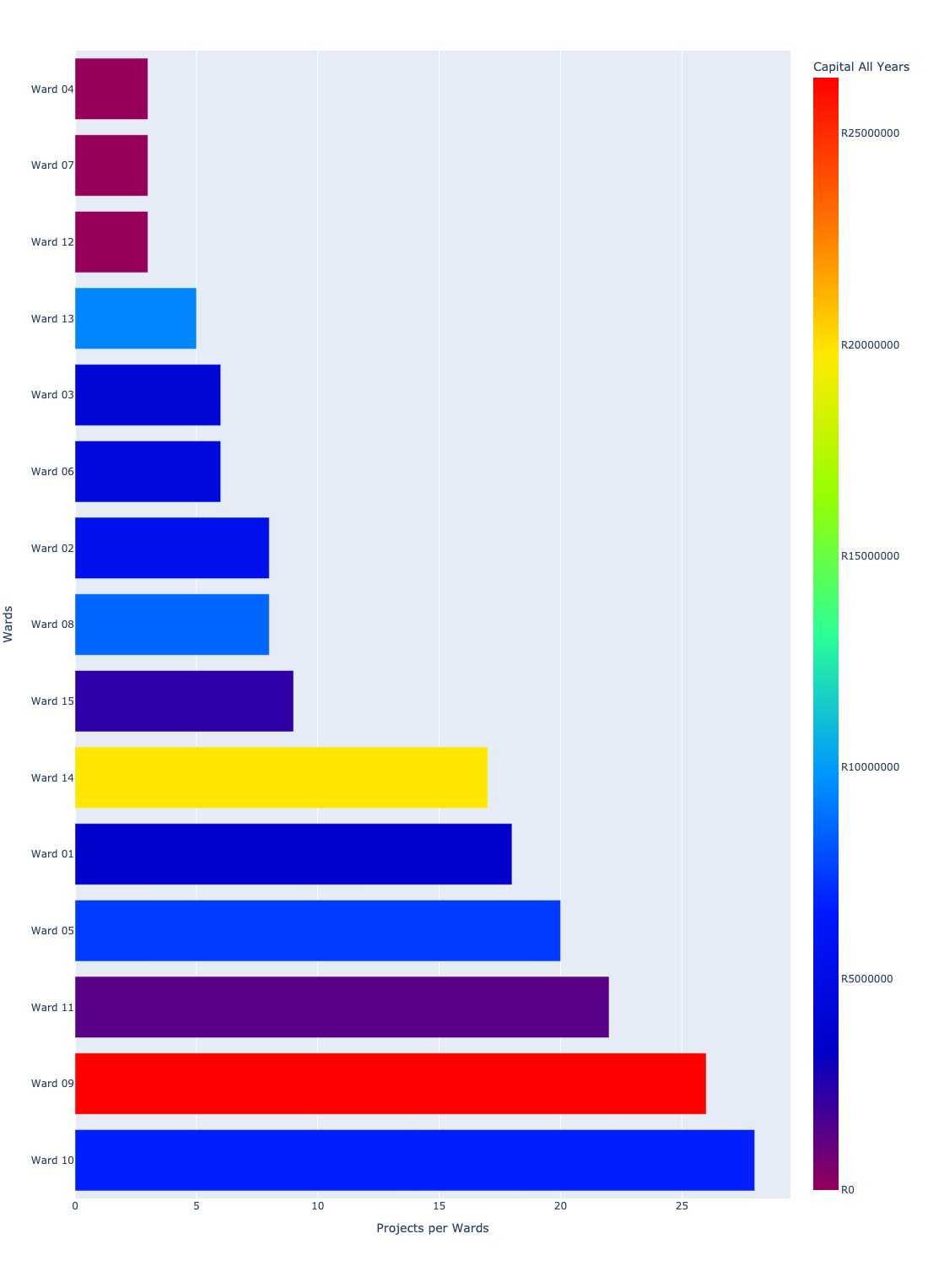

# Total Capital Demand per ward - All Years

There are different funding sources from which capital is requested. For the financial baseline that was selected for this report query (2022/2023 Draft Capital Budget_20220301_Finance), the breakdown of capital demand for Midvaal Municipality per funding source is shown in Figure 3.1 below.

Figure 3.1: Capital Demand Per Funding Source

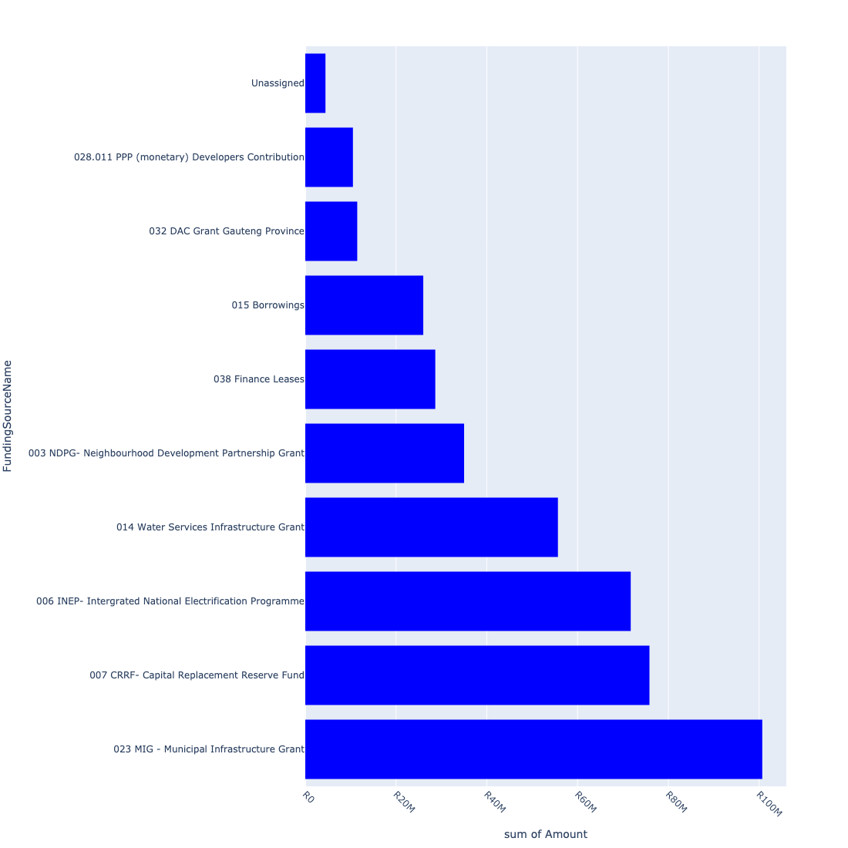

For the financial baseline that was selected for this report query (2022/2023 Draft Capital Budget_20220301_Finance), the breakdown of capital demand for Midvaal Municipality per department is shown in Figure 3.2 below.

Figure 3.2: Capital Demand Per Midvaal Municipality Department

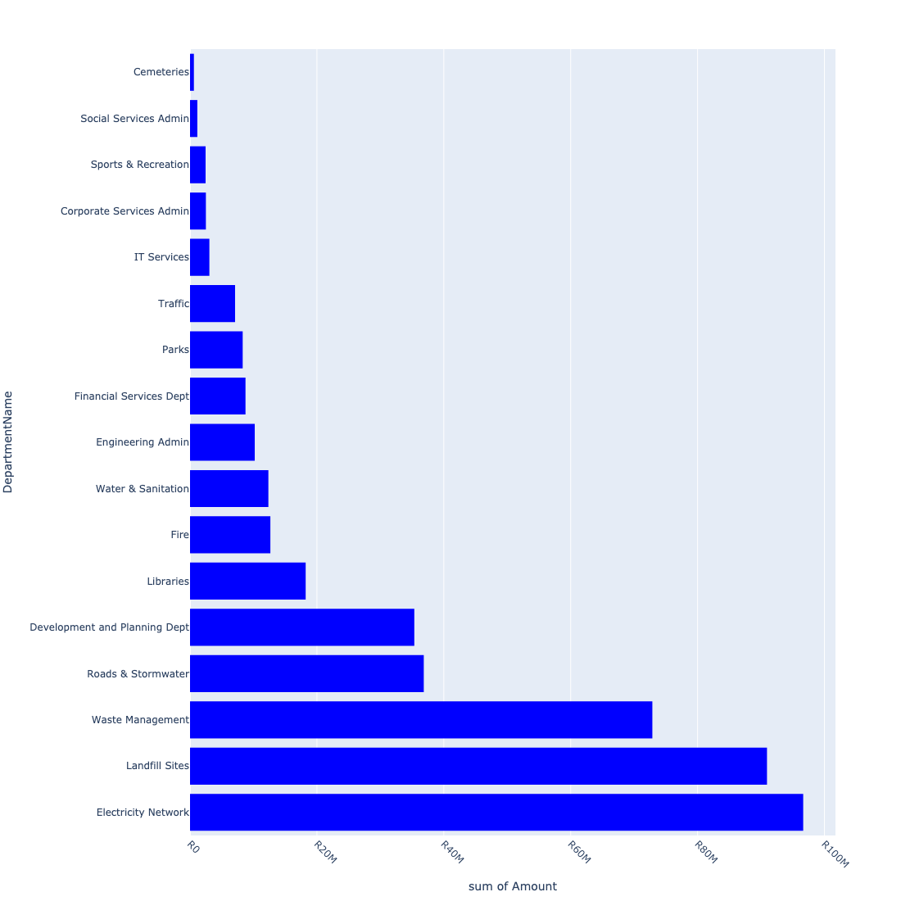

The following figures provide a histogram representation of the capital demand per ward. A colour breakdown is provided of each year's sub-total that contribute towards the overall total capital demand of each ward. Note that the capital demand beyond the first three years representing the Medium Term Expenditure Framework (MTREF - years 2023, 2024 and 2025) are generally more sparsely and less diligently populated, therefore less reliance should be vested on these outer years when appraising the overall capital demand. The reason for this is usually because of National Treasury's requirement for annual budget submissions spanning only over the MTREF (i.e. the next three years).

Figure 3.3: Capital Demand per Ward - All Years

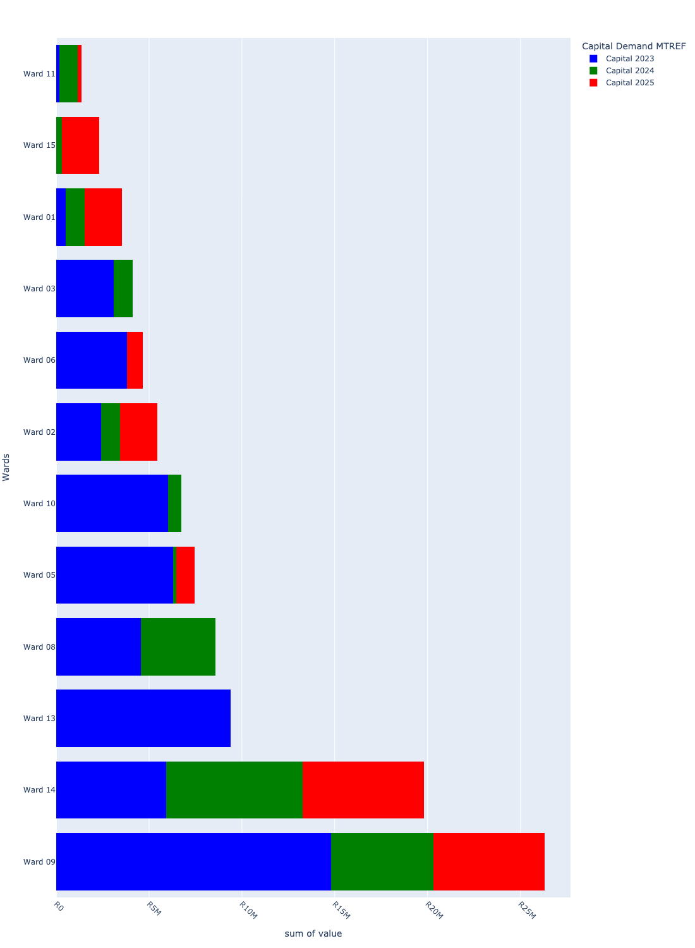

# Total Capital Demand per Ward - MTREF only

Table 4.1 below provides a concise summary of key statistical insights regarding the total MTREF capital demand per ward.

Table 4.1: Wards Analysis - MTREF Capital Demand (R)

|  |  |  |  |
| --- | --- | --- | --- |
| Description | Info (1) | Info (2) | Info (3) |
| MTREF Capital demand in all Wards - Overview | MTREF capital demand in all Wards: R99,691,323 | The average MTREF capital demand per ward: R6,646,088 | The 75th percentile of MTREF capital demand for Wards: R8,010,379 |
| The highest MTREF capital demand | In Ward: Ward 09 | MTREF capital Demand in Ward 09: R26,315,285 | Percentage of total MRTEF capital demand in Ward 09: 26.40% |
| The lowest MTREF capital demand | In Ward: Ward 04 | MTREF capital Demand in Ward 04: R0 | Percentage of total MTREF capital demand in Ward 04: 0.00% |

The following figures provide a histogram representation of the capital demand per ward. A colour breakdown is provided of each year's sub-total that contribute towards the overall MTREF total capital demand of each ward.

Figure 4.1: Capital Demand per Ward - MTREF Period

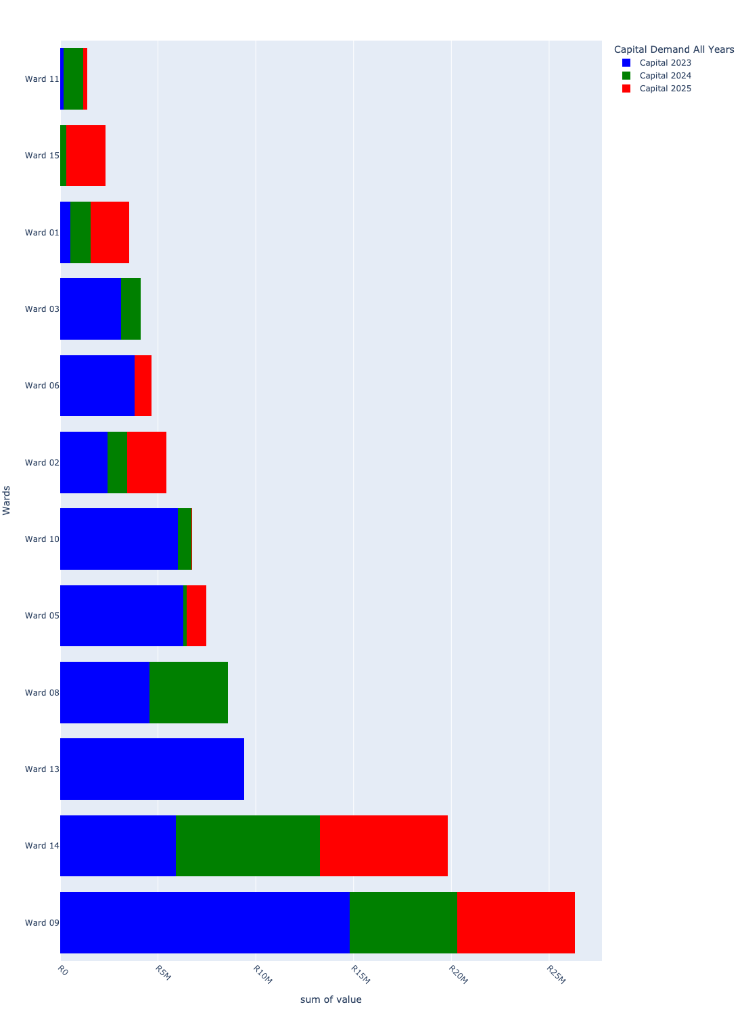

# Summary per Ward

## Ward 01

Figure 5.1: Ward 01 Funding Requests

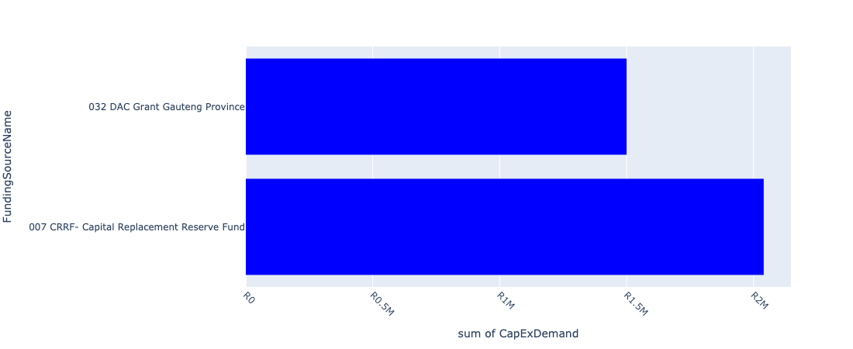

Figure 5.2: Ward 01 Departmental Requests

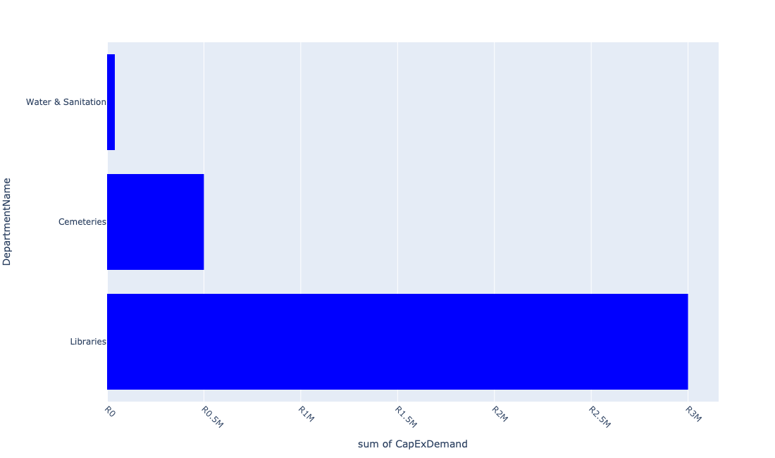

Table 5.1: Summary - Ward 01

|  |  |
| --- | --- |
| Item | Description |
| Total Capital Demand for Ward 01 - All Years | R3,540,000 Rank: 10 (1 = Highest) |
| Total Capital Demand for Ward 01 - MTREF | R3,540,000 Rank: 10 (1 = Highest) |
| Financial Years in which capital requirements are listed for Ward 01 | 2023, 2024 and 2025 |
| Financial Year with highest capital demand for Ward 01 | 2025 |
| Ward 01 intersecting feature used | Works Location |
| Total number of projects intersecting with Ward 01 | 18 Rank: 5 (1 = Highest) |

Table 5.2: All projects asking for budget in Ward 01

|  |  |  |  |
| --- | --- | --- | --- |
| Project ID | Project Name | Department | Project Budget |
| 10403 | Maintaining of the Anchovy road | Roads & Stormwater | R0.00 (0%) No budget request. |
| 10373 | Upgrade of Bantu Bonke Library | Libraries | R0.00 (0%) No budget request. |
| 10369 | Refurbishment of Vaal Marina WaterTreatment Plant | Water & Sanitation | R40,000 (1.13%) Budget spread across: 2023 and 2024 |
| 10335 | Skills Development Centre | Social Services Admin | R0.00 (0%) No budget request. |
| 10331 | Vaal Marina Upgrade of HT and LV Overheadlines | Electricity Network | R0.00 (0%) No budget request. |
| 10297 | Vaal Marina Fire Station Paving | Fire | R0.00 (0%) No budget request. |
| 10260 | Fire Engine Refurbishment | Fire | R0.00 (0%) No budget request. |
| 10216 | Relocation - Vaal Marina Ringfeed in Mamello | Water & Sanitation | R0.00 (0%) No budget request. |
| 10209 | Mamello Bulk Water (MIG) | Water & Sanitation | R0.00 (0%) No budget request. |
| 11045 | REHABILITATION VAAL MARINA LANDFILL SITE | Landfill Sites | R0.00 (0%) No budget request. |
| 11033 | New Library for Mamello | Libraries | R1,000,000 (28.25%) Budget spread across: 2024 |
| 10202 | Servitude-Mamello Sewerage | Water & Sanitation | R0.00 (0%) No budget request. |
| 10185 | Bantu Bonke Sport Centre (MIG) | Sports & Recreation | R0.00 (0%) No budget request. |
| 10121 | Mamello Sewage Scheme Augmentation | Water & Sanitation | R0.00 (0%) No budget request. |
| 10118 | Extension to Daleside Sewer (Pump Station) | Water & Sanitation | R0.00 (0%) No budget request. |
| 10675 | Mamello Cemetery | Cemeteries | R500,000 (14.12%) Budget spread across: 2023 |
| 11007 | Bantu Bonke Carports | Libraries | R1,000,000 (28.25%) Budget spread across: 2025 |
| 10912 | BANTU BONKE LIBRARY BOOKS | Libraries | R1,000,000 (28.25%) Budget spread across: 2025 |

Please note that the following projects will not be shown in this table:

* Projects with no recorded intersect with Wards (in other words no Works Location was recorded on the system for this project)

Projects that do not have any recorded budget demand on the system at the time that this report was requested, are shown in the table with zero budgets indicated.

## Ward 02

Figure 5.3: Ward 02 Funding Requests

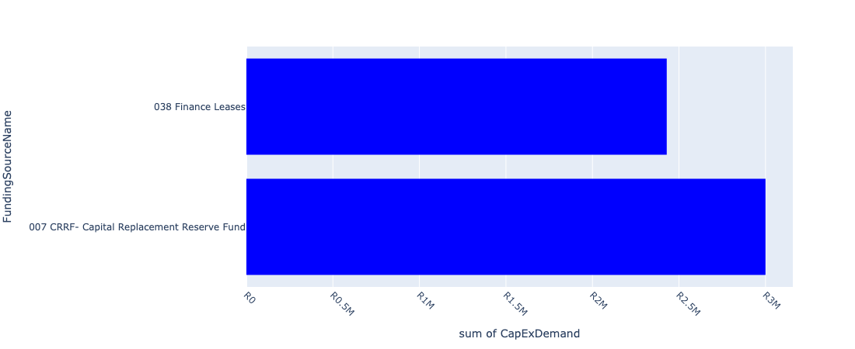

Figure 5.4: Ward 02 Departmental Requests

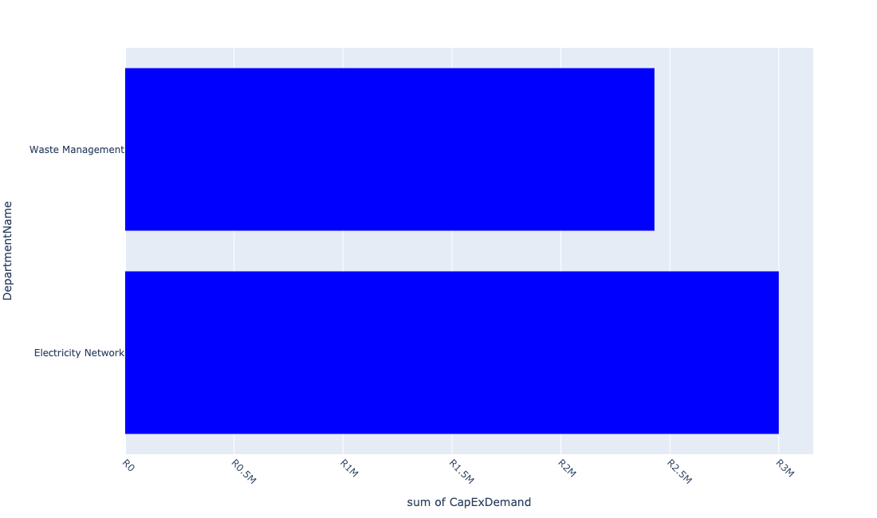

Table 5.2: Summary - Ward 02

|  |  |
| --- | --- |
| Item | Description |
| Total Capital Demand for Ward 02 - All Years | R5,429,273 Rank: 7 (1 = Highest) |
| Total Capital Demand for Ward 02 - MTREF | R5,429,273 Rank: 7 (1 = Highest) |
| Financial Years in which capital requirements are listed for Ward 02 | 2023, 2024 and 2025 |
| Financial Year with highest capital demand for Ward 02 | 2023 |
| Ward 02 intersecting feature used | Works Location |
| Total number of projects intersecting with Ward 02 | 8 Rank: 8 (1 = Highest) |

Table 5.3: All projects asking for budget in Ward 02

|  |  |  |  |
| --- | --- | --- | --- |
| Project ID | Project Name | Department | Project Budget |
| 10811 | MOBILE TOILETS | Parks | R0.00 (0%) No budget request. |
| 10392 | Upgrading of Bronk Drive Road | Roads & Stormwater | R0.00 (0%) No budget request. |
| 10334 | Transfer Station: Blackwood | Electricity Network | R0.00 (0%) No budget request. |
| 10332 | Rissiville Ext 6 Electrification: Network Strengthening | Electricity Network | R0.00 (0%) No budget request. |
| 10330 | Duncanville Street Light Upgrade | Electricity Network | R0.00 (0%) No budget request. |
| 10244 | Risiville Sub-Ripple Injection Equip | Electricity Network | R0.00 (0%) No budget request. |
| 10231 | CABLE FEEDERS - CONSUMERS EMFULENI CONNECT | Electricity Network | R3,000,000 (55.26%) Budget spread across: 2024 and 2025 |
| 10180 | BLACKWOOD TRANSFER STATION REFURBISHMENT | Waste Management | R2,429,273 (44.74%) Budget spread across: 2023 |

Please note that the following projects will not be shown in this table:

* Projects with no recorded intersect with Wards (in other words no Works Location was recorded on the system for this project)

Projects that do not have any recorded budget demand on the system at the time that this report was requested, are shown in the table with zero budgets indicated.

## Ward 03

Figure 5.5: Ward 03 Funding Requests

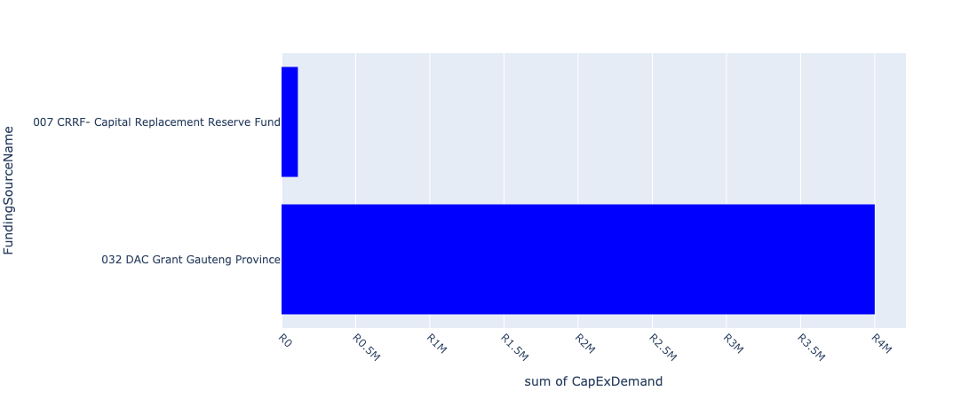

Figure 5.6: Ward 03 Departmental Requests

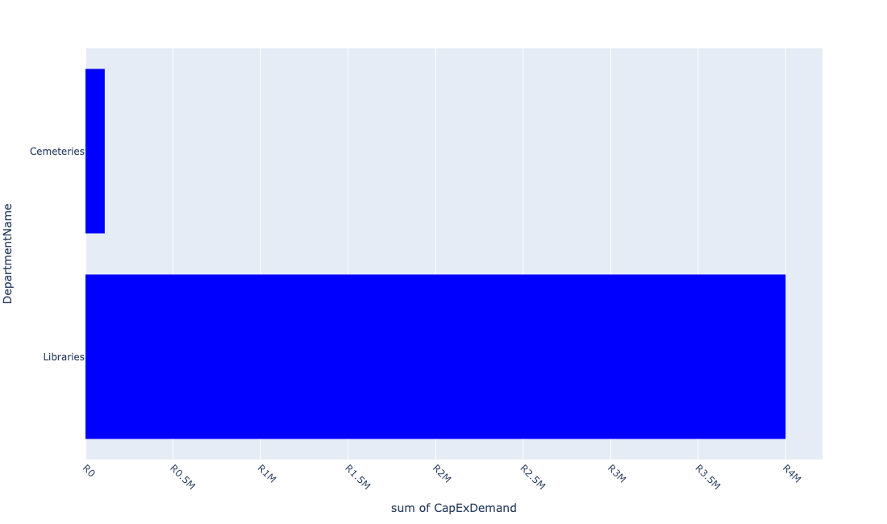

Table 5.3: Summary - Ward 03

|  |  |
| --- | --- |
| Item | Description |
| Total Capital Demand for Ward 03 - All Years | R4,110,000 Rank: 9 (1 = Highest) |
| Total Capital Demand for Ward 03 - MTREF | R4,110,000 Rank: 9 (1 = Highest) |
| Financial Years in which capital requirements are listed for Ward 03 | 2023 and 2024 |
| Financial Year with highest capital demand for Ward 03 | 2023 |
| Ward 03 intersecting feature used | Works Location |
| Total number of projects intersecting with Ward 03 | 6 Rank: 10 (1 = Highest) |

Table 5.4: All projects asking for budget in Ward 03

|  |  |  |  |
| --- | --- | --- | --- |
| Project ID | Project Name | Department | Project Budget |
| 10811 | MOBILE TOILETS | Parks | R0.00 (0%) No budget request. |
| 10391 | Kokrus cemetery upgrade | Cemeteries | R0.00 (0%) No budget request. |
| 10317 | Feeder Supply to Rothdene | Electricity Network | R0.00 (0%) No budget request. |
| 10484 | Pipe replacement and upgrading - Rothdene | Water & Sanitation | R0.00 (0%) No budget request. |
| 10001 | Extension of Kookrus Cemetery Fencing | Cemeteries | R110,000 (2.68%) Budget spread across: 2023 |
| 11008 | Mobile library bus | Libraries | R4,000,000 (97.32%) Budget spread across: 2023 and 2024 |

Please note that the following projects will not be shown in this table:

* Projects with no recorded intersect with Wards (in other words no Works Location was recorded on the system for this project)

Projects that do not have any recorded budget demand on the system at the time that this report was requested, are shown in the table with zero budgets indicated.

## Ward 04

Figure 5.7: Ward 04 Funding Requests

**No projects in Ward 04.**

Figure 5.8: Ward 04 Departmental Requests

**No projects in Ward 04.**

Table 5.4: Summary - Ward 04

|  |  |
| --- | --- |
| Item | Description |
| Total Capital Demand for Ward 04 - All Years | R0 Rank: 14 (1 = Highest) |
| Total Capital Demand for Ward 04 - MTREF | R0 Rank: 14 (1 = Highest) |
| Financial Years in which capital requirements are listed for Ward 04 |  |
| Financial Year with highest capital demand for Ward 04 | 2023 |
| Ward 04 intersecting feature used | Works Location |
| Total number of projects intersecting with Ward 04 | 3 Rank: 14 (1 = Highest) |

Table 5.5: All projects asking for budget in Ward 04

|  |  |  |  |
| --- | --- | --- | --- |
| Project ID | Project Name | Department | Project Budget |
| 10811 | MOBILE TOILETS | Parks | R0.00 (0%) No budget request. |
| 10453 | Purchasing of Jojo Tanks | Water & Sanitation | R0.00 (0%) No budget request. |
| 10401 | Upgrading of Eaton R | Roads & Stormwater | R0.00 (0%) No budget request. |

Please note that the following projects will not be shown in this table:

* Projects with no recorded intersect with Wards (in other words no Works Location was recorded on the system for this project)

Projects that do not have any recorded budget demand on the system at the time that this report was requested, are shown in the table with zero budgets indicated.

## Ward 05

Figure 5.7: Ward 05 Funding Requests

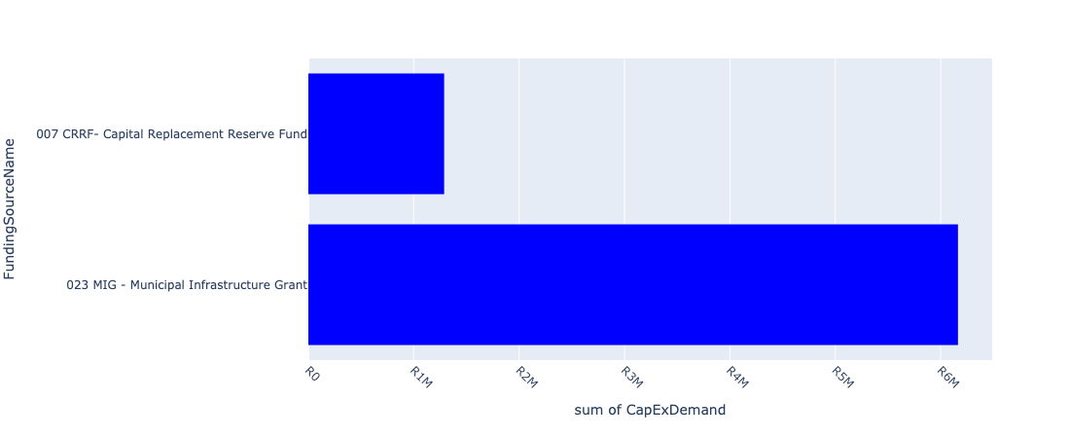

Figure 5.8: Ward 05 Departmental Requests

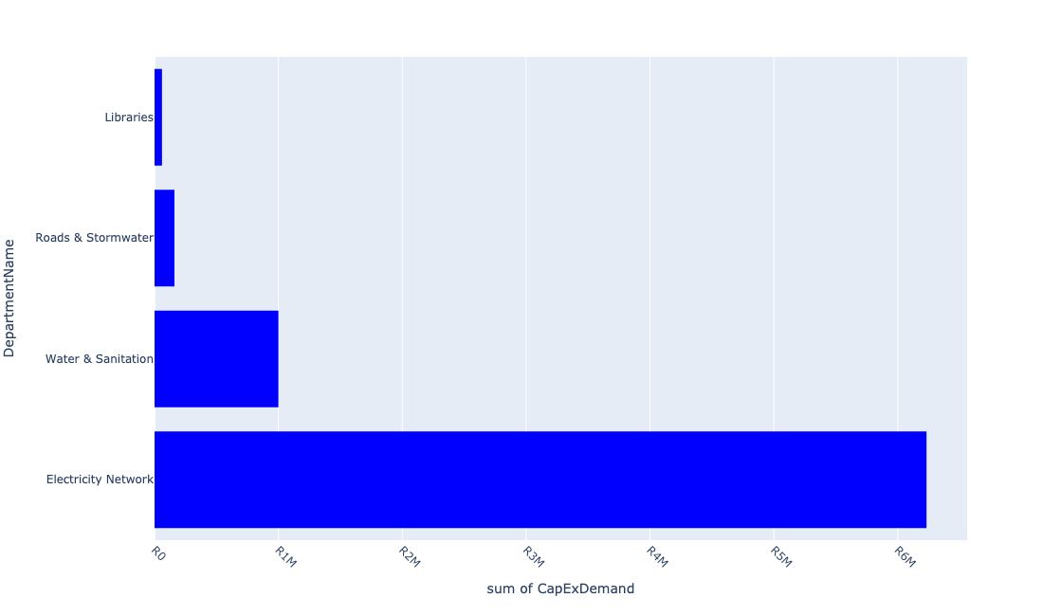

Table 5.5: Summary - Ward 05

|  |  |
| --- | --- |
| Item | Description |
| Total Capital Demand for Ward 05 - All Years | R7,452,883 Rank: 5 (1 = Highest) |
| Total Capital Demand for Ward 05 - MTREF | R7,452,883 Rank: 5 (1 = Highest) |
| Financial Years in which capital requirements are listed for Ward 05 | 2023, 2024 and 2025 |
| Financial Year with highest capital demand for Ward 05 | 2023 |
| Ward 05 intersecting feature used | Works Location |
| Total number of projects intersecting with Ward 05 | 20 Rank: 4 (1 = Highest) |

Table 5.6: All projects asking for budget in Ward 05

|  |  |  |  |
| --- | --- | --- | --- |
| Project ID | Project Name | Department | Project Budget |
| 10811 | MOBILE TOILETS | Parks | R0.00 (0%) No budget request. |
| 10654 | Provide pedestrian oriented (human scale) Street lighting primarily along Station Road towards Sicelo (UDF) | Electricity Network | R153,810 (2.06%) Budget spread across: 2023 |
| 10498 | Library furniture & equipment-De Deur | Libraries | R0.00 (0%) No budget request. |
| 10789 | Savana Roads Rehabilitation | Roads & Stormwater | R0.00 (0%) No budget request. |
| 10734 | Savana Reservoir | Water & Sanitation | R0.00 (0%) No budget request. |
| 10733 | Savana Bulk Pipeline | Water & Sanitation | R0.00 (0%) No budget request. |
| 10918 | Furniture and Equipment | Libraries | R0.00 (0%) No budget request. |
| 11010 | Rehabilitation of Meyer Street | Roads & Stormwater | R160,377 (2.15%) Budget spread across: 2024 |
| 10393 | High Valley Settlement Reservoir and Pipeline | Water & Sanitation | R0.00 (0%) No budget request. |
| 10323 | Replace 11 KV Overhead Line Springbok Road | Electricity Network | R0.00 (0%) No budget request. |
| 10246 | Sicelo Bulk 20 MVA Sub-station | Electricity Network | R0.00 (0%) No budget request. |
| 10221 | SICELO/HIGHBURY (VALLEY SETTLEMENTS) RESERVOIR | Water & Sanitation | R1,000,000 (13.42%) Budget spread across: 2025 |
| 10593 | Sicelo Economic Development Centre- Upholstery | Development and Planning Dept | R0.00 (0%) No budget request. |
| 10485 | Pipe replacement and upgrading - Valley Settlements | Water & Sanitation | R0.00 (0%) No budget request. |
| 10071 | Server - Randvaal Library | Libraries | R0.00 (0%) No budget request. |
| 10070 | RANDVAAL LIBRARY BOOKS | Libraries | R0.00 (0%) No budget request. |
| 10068 | Library Furniture - Randvaal - New | Libraries | R0.00 (0%) No budget request. |
| 10043 | Extension Randvaal Library Building - Upgrading | Libraries | R60,000 (0.81%) Budget spread across: 2023 |
| 10840 | RENEWABLE ENERGY | Electricity Network | R6,078,696 (81.56%) Budget spread across: 2023 |
| 10804 | Midvaal Entrepreneurship Hub | Development and Planning Dept | R0.00 (0%) No budget request. |

Please note that the following projects will not be shown in this table:

* Projects with no recorded intersect with Wards (in other words no Works Location was recorded on the system for this project)

Projects that do not have any recorded budget demand on the system at the time that this report was requested, are shown in the table with zero budgets indicated.

## Ward 06

Figure 5.9: Ward 06 Funding Requests

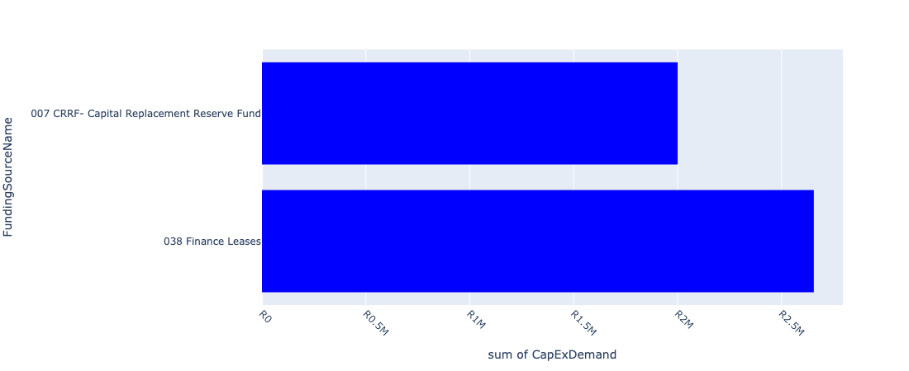

Figure 5.10: Ward 06 Departmental Requests

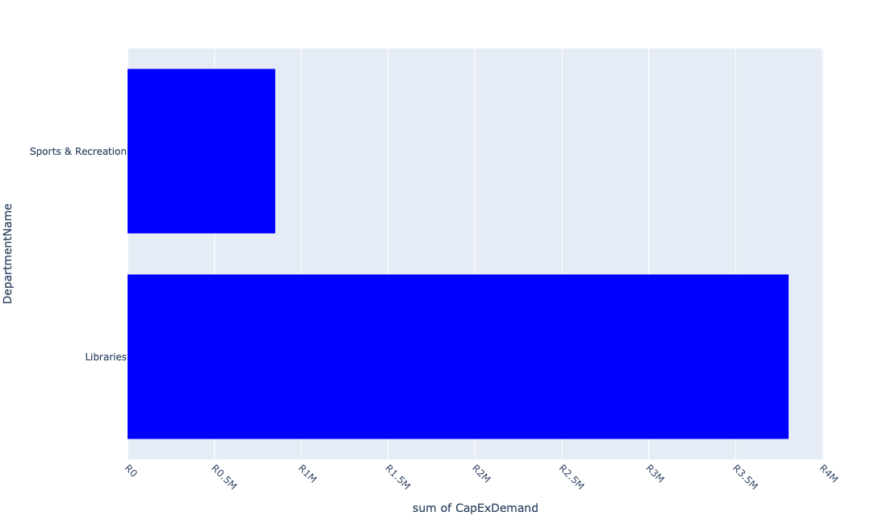

Table 5.6: Summary - Ward 06

|  |  |
| --- | --- |
| Item | Description |
| Total Capital Demand for Ward 06 - All Years | R4,655,143 Rank: 8 (1 = Highest) |
| Total Capital Demand for Ward 06 - MTREF | R4,655,143 Rank: 8 (1 = Highest) |
| Financial Years in which capital requirements are listed for Ward 06 | 2023 and 2025 |
| Financial Year with highest capital demand for Ward 06 | 2023 |
| Ward 06 intersecting feature used | Works Location |
| Total number of projects intersecting with Ward 06 | 6 Rank: 10 (1 = Highest) |

Table 5.7: All projects asking for budget in Ward 06

|  |  |  |  |
| --- | --- | --- | --- |
| Project ID | Project Name | Department | Project Budget |
| 10049 | LAKESIDE LIBRARY BOOKS | Libraries | R1,805,143 (38.78%) Budget spread across: 2023 |
| 10494 | Ext Lakeside Lib building - Upgrading | Libraries | R2,000,000 (42.96%) Budget spread across: 2023 |
| 10208 | Installation:Domestic W/Meters (Lakeside) | Water & Sanitation | R0.00 (0%) No budget request. |
| 10186 | LAKESIDE SPORT CENTRE (MIG) | Sports & Recreation | R850,000 (18.26%) Budget spread across: 2025 |
| 10051 | Lakeside Library Children Sec Furniture | Libraries | R0.00 (0%) No budget request. |
| 10607 | Library furniture & equipment - Lakeside | Libraries | R0.00 (0%) No budget request. |

Please note that the following projects will not be shown in this table:

* Projects with no recorded intersect with Wards (in other words no Works Location was recorded on the system for this project)

Projects that do not have any recorded budget demand on the system at the time that this report was requested, are shown in the table with zero budgets indicated.

## Ward 07

Figure 5.11: Ward 07 Funding Requests

**No projects in Ward 07.**

Figure 5.12: Ward 07 Departmental Requests

**No projects in Ward 07.**

Table 5.7: Summary - Ward 07

|  |  |
| --- | --- |
| Item | Description |
| Total Capital Demand for Ward 07 - All Years | R0 Rank: 14 (1 = Highest) |
| Total Capital Demand for Ward 07 - MTREF | R0 Rank: 14 (1 = Highest) |
| Financial Years in which capital requirements are listed for Ward 07 |  |
| Financial Year with highest capital demand for Ward 07 | 2023 |
| Ward 07 intersecting feature used | Works Location |
| Total number of projects intersecting with Ward 07 | 3 Rank: 14 (1 = Highest) |

Table 5.8: All projects asking for budget in Ward 07

|  |  |  |  |
| --- | --- | --- | --- |
| Project ID | Project Name | Department | Project Budget |
| 10811 | MOBILE TOILETS | Parks | R0.00 (0%) No budget request. |
| 10394 | Eye Of Africa - Water Demand Management | Water & Sanitation | R0.00 (0%) No budget request. |
| 10327 | Bronk Lane Lighting | Electricity Network | R0.00 (0%) No budget request. |

Please note that the following projects will not be shown in this table:

* Projects with no recorded intersect with Wards (in other words no Works Location was recorded on the system for this project)

Projects that do not have any recorded budget demand on the system at the time that this report was requested, are shown in the table with zero budgets indicated.

## Ward 08

Figure 5.11: Ward 08 Funding Requests

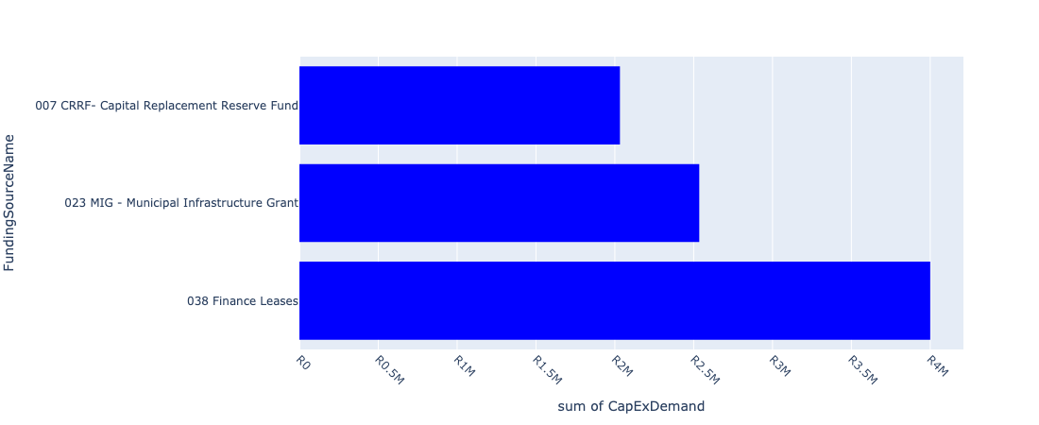

Figure 5.12: Ward 08 Departmental Requests

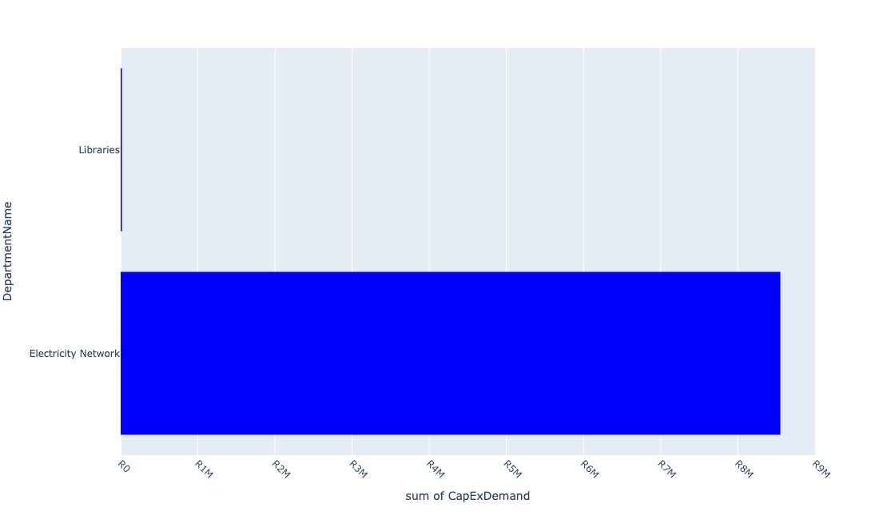

Table 5.8: Summary - Ward 08

|  |  |
| --- | --- |
| Item | Description |
| Total Capital Demand for Ward 08 - All Years | R8,567,875 Rank: 4 (1 = Highest) |
| Total Capital Demand for Ward 08 - MTREF | R8,567,875 Rank: 4 (1 = Highest) |
| Financial Years in which capital requirements are listed for Ward 08 | 2023, 2024 and 2025 |
| Financial Year with highest capital demand for Ward 08 | 2023 |
| Ward 08 intersecting feature used | Works Location |
| Total number of projects intersecting with Ward 08 | 8 Rank: 8 (1 = Highest) |

Table 5.9: All projects asking for budget in Ward 08

|  |  |  |  |
| --- | --- | --- | --- |
| Project ID | Project Name | Department | Project Budget |
| 10402 | Construction of the pedestrian suspension bridge | Roads & Stormwater | R0.00 (0%) No budget request. |
| 10811 | MOBILE TOILETS | Parks | R0.00 (0%) No budget request. |
| 10654 | Provide pedestrian oriented (human scale) Street lighting primarily along Station Road towards Sicelo (UDF) | Electricity Network | R4,551,161 (53.12%) Budget spread across: 2023 |
| 11023 | E-Resources | Libraries | R16,714 (0.20%) Budget spread across: 2023, 2024 and 2025 |
| 10646 | Construct pedestrian link and pave (asphalt) road from Sicelo to Meyerton CBD along Station Road (UDF) | Roads & Stormwater | R0.00 (0%) No budget request. |
| 10247 | Sicelo Reticulation Network (ERF 204) | Electricity Network | R4,000,000 (46.69%) Budget spread across: 2024 |
| 10127 | Sicelo North Outfall Sewer | Water & Sanitation | R0.00 (0%) No budget request. |
| 10601 | SICELO ELECTRIFICATION NETWORK | Electricity Network | R0.00 (0%) No budget request. |

Please note that the following projects will not be shown in this table:

* Projects with no recorded intersect with Wards (in other words no Works Location was recorded on the system for this project)

Projects that do not have any recorded budget demand on the system at the time that this report was requested, are shown in the table with zero budgets indicated.

## Ward 09

Figure 5.13: Ward 09 Funding Requests

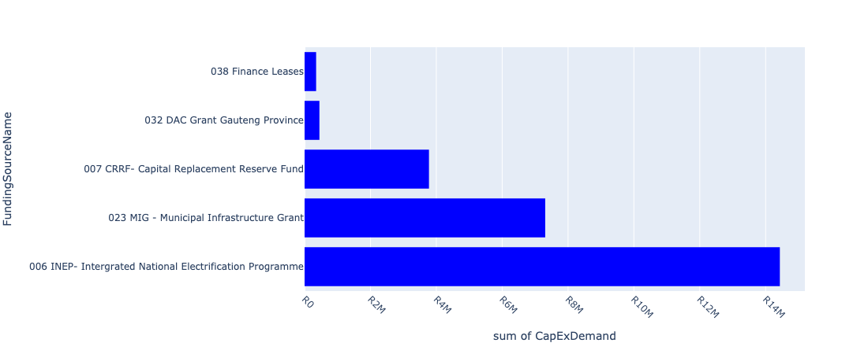

Figure 5.14: Ward 09 Departmental Requests

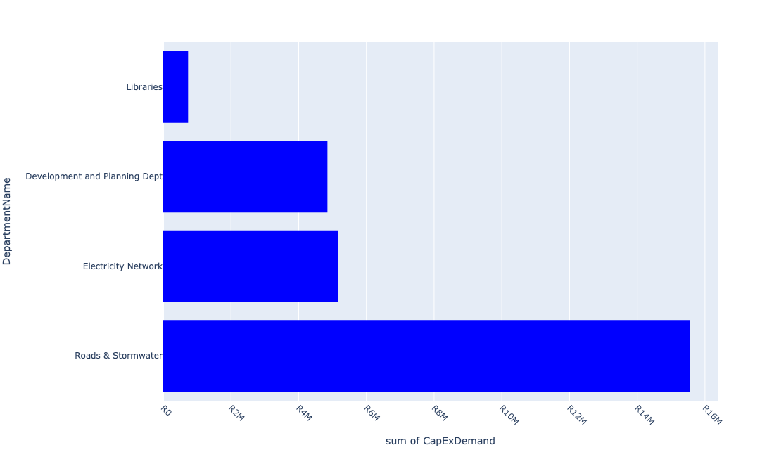

Table 5.9: Summary - Ward 09

|  |  |
| --- | --- |
| Item | Description |
| Total Capital Demand for Ward 09 - All Years | R26,315,285 Rank: 1 (1 = Highest) |
| Total Capital Demand for Ward 09 - MTREF | R26,315,285 Rank: 1 (1 = Highest) |
| Financial Years in which capital requirements are listed for Ward 09 | 2023, 2024 and 2025 |
| Financial Year with highest capital demand for Ward 09 | 2023 |
| Ward 09 intersecting feature used | Works Location |
| Total number of projects intersecting with Ward 09 | 26 Rank: 2 (1 = Highest) |

Table 5.10: All projects asking for budget in Ward 09

|  |  |  |  |
| --- | --- | --- | --- |
| Project ID | Project Name | Department | Project Budget |
| 10402 | Construction of the pedestrian suspension bridge | Roads & Stormwater | R0.00 (0%) No budget request. |
| 10811 | MOBILE TOILETS | Parks | R0.00 (0%) No budget request. |
| 10654 | Provide pedestrian oriented (human scale) Street lighting primarily along Station Road towards Sicelo (UDF) | Electricity Network | R5,037,888 (19.14%) Budget spread across: 2023 |
| 11023 | E-Resources | Libraries | R33,429 (0.13%) Budget spread across: 2023, 2024 and 2025 |
| 10647 | Construct Pedestrian Bridge over R 59 to link Sicelo and Meyerton CBD (UDF) | Roads & Stormwater | R0.00 (0%) No budget request. |
| 10646 | Construct pedestrian link and pave (asphalt) road from Sicelo to Meyerton CBD along Station Road (UDF) | Roads & Stormwater | R0.00 (0%) No budget request. |
| 10325 | Festive Decorating Lights | Electricity Network | R136,178 (0.52%) Budget spread across: 2023 |
| 10660 | Detail Design of on-street parking along Reitz Street between Meyer Street and Pierneef Boulevard (UDF) | Roads & Stormwater | R0.00 (0%) No budget request. |
| 10659 | Install traffic circles at the following intersections: Loch and Holiday (UDF) | Roads & Stormwater | R0.00 (0%) No budget request. |
| 10653 | Construct traffic circle and public art feature at the intersection of Holiday and Loch Street (UDF) | Roads & Stormwater | R14,431,712 (54.84%) Budget spread across: 2023, 2024 and 2025 |
| 11010 | Rehabilitation of Meyer Street | Roads & Stormwater | R776,079 (2.95%) Budget spread across: 2024 |
| 10321 | Upgrade HT & LT Overhead Lines in Ophir Estates | Electricity Network | R0.00 (0%) No budget request. |
| 11031 | Sidewalks in CBD Meyerton | Development and Planning Dept | R350,000 (1.33%) Budget spread across: 2025 |
| 10507 | 10028_02_Formalisation of Informal Trading stalls | Development and Planning Dept | R4,500,000 (17.10%) Budget spread across: 2023 |
| 10495 | Ext Meyerton Lib building - Upgrading | Libraries | R250,000 (0.95%) Budget spread across: 2025 |
| 10483 | Pipe replacement and upgrading - Kookrus | Water & Sanitation | R0.00 (0%) No budget request. |
| 10063 | MEYERTON LIBRARY BOOKS | Libraries | R450,000 (1.71%) Budget spread across: 2023 and 2024 |
| 10658 | Install traffic circles at the following intersections: Galloway and Shippard (UDF) | Roads & Stormwater | R0.00 (0%) No budget request. |
| 10657 | Install traffic circles at the following intersections: Meyer and Shippard (UDF) | Roads & Stormwater | R350,000 (1.33%) Budget spread across: 2023 |
| 10655 | Construct bike rack facility in Diens Avenue North across municipal offices and SPAR, Pick n Pay and Shoprite (UDF) | Development and Planning Dept | R0.00 (0%) No budget request. |
| 10652 | Develop Public Open Spaces on western and eastern side of Meyer Station (UDF) | Development and Planning Dept | R0.00 (0%) No budget request. |
| 10651 | Upgrade Diens Avenue North (service Road) – from Meyer Street to Municipal Offices | Roads & Stormwater | R0.00 (0%) No budget request. |
| 10650 | Construct Pedestrian Pavement along Diens Avenue North (service Road) – from Meyer Street to Municipal Offices (UDF) | Roads & Stormwater | R0.00 (0%) No budget request. |
| 10649 | 10028_03_Install Wi-Fi network at Public Transport facilities (Meyer Station and Taxi Rank) (UDF) | Development and Planning Dept | R0.00 (0%) No budget request. |
| 10648 | Construct Parklet areas within CBD – along Loche Street between Meyer and Galloway Street (UDF) | Roads & Stormwater | R0.00 (0%) No budget request. |
| 10645 | 10028_01_Construct ablution facilities, seating area and public soft/hard spaces close to formalised informal trading activity (UDF) | Development and Planning Dept | R0.00 (0%) No budget request. |

Please note that the following projects will not be shown in this table:

* Projects with no recorded intersect with Wards (in other words no Works Location was recorded on the system for this project)

Projects that do not have any recorded budget demand on the system at the time that this report was requested, are shown in the table with zero budgets indicated.

## Ward 10

Figure 5.15: Ward 10 Funding Requests

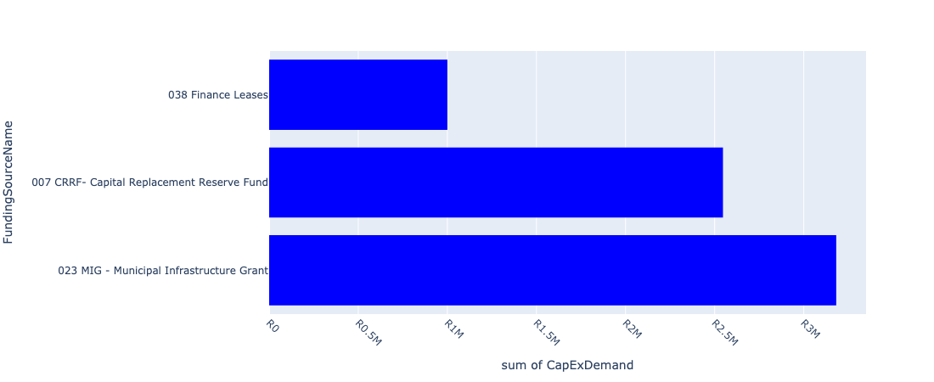

Figure 5.16: Ward 10 Departmental Requests

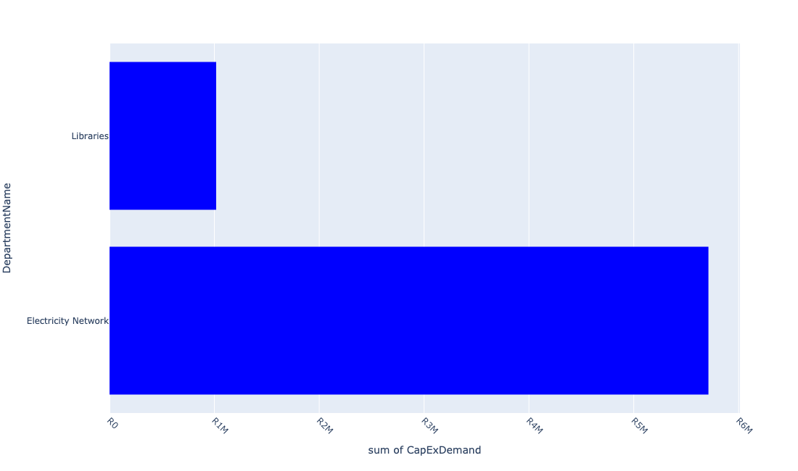

Table 5.10: Summary - Ward 10

|  |  |
| --- | --- |
| Item | Description |
| Total Capital Demand for Ward 10 - All Years | R6,728,843 Rank: 6 (1 = Highest) |
| Total Capital Demand for Ward 10 - MTREF | R6,728,843 Rank: 6 (1 = Highest) |
| Financial Years in which capital requirements are listed for Ward 10 | 2023, 2024 and 2025 |
| Financial Year with highest capital demand for Ward 10 | 2023 |
| Ward 10 intersecting feature used | Works Location |
| Total number of projects intersecting with Ward 10 | 28 Rank: 1 (1 = Highest) |

Table 5.11: All projects asking for budget in Ward 10

|  |  |  |  |
| --- | --- | --- | --- |
| Project ID | Project Name | Department | Project Budget |
| 10474 | Modikeng Street | Roads & Stormwater | R0.00 (0%) No budget request. |
| 10473 | R.N. Mandela Street | Roads & Stormwater | R0.00 (0%) No budget request. |
| 10472 | Blom Street | Roads & Stormwater | R0.00 (0%) No budget request. |
| 10471 | Leloko Street | Roads & Stormwater | R0.00 (0%) No budget request. |
| 10470 | M. Polosong Street | Roads & Stormwater | R0.00 (0%) No budget request. |
| 10469 | Construction of Phomolong Street | Roads & Stormwater | R0.00 (0%) No budget request. |
| 10468 | Construction of N. Booi Street | Roads & Stormwater | R0.00 (0%) No budget request. |
| 10402 | Construction of the pedestrian suspension bridge | Roads & Stormwater | R0.00 (0%) No budget request. |
| 10248 | Sicelo Reticulation Network (ERF 78) | Electricity Network | R0.00 (0%) No budget request. |
| 10502 | ITC hardware (Computers) - Sicelo | Libraries | R0.00 (0%) No budget request. |
| 10481 | Amaketa | Roads & Stormwater | R0.00 (0%) No budget request. |
| 10480 | Ntsanwisi Street | Roads & Stormwater | R0.00 (0%) No budget request. |
| 10479 | Tau Street | Roads & Stormwater | R0.00 (0%) No budget request. |
| 10478 | Chief Makana Street | Roads & Stormwater | R0.00 (0%) No budget request. |
| 10165 | SICELO ECD - PARK FENCING & JUNGLE GYM | Social Services Admin | R0.00 (0%) No budget request. |
| 10076 | SICELO LIBRARY BOOKS | Libraries | R0.00 (0%) No budget request. |
| 10074 | SICELO LIBRARY FURNITURE | Libraries | R1,000,000 (14.86%) Budget spread across: 2023 and 2024 |
| 10073 | Extension Sicelo Library building - Upgrading | Libraries | R0.00 (0%) No budget request. |
| 10811 | MOBILE TOILETS | Parks | R0.00 (0%) No budget request. |
| 10761 | Sicelo Sport field | Sports & Recreation | R0.00 (0%) No budget request. |
| 10725 | upgrade of Sicelo Library | Libraries | R0.00 (0%) No budget request. |
| 10654 | Provide pedestrian oriented (human scale) Street lighting primarily along Station Road towards Sicelo (UDF) | Electricity Network | R5,712,128 (84.89%) Budget spread across: 2023 |
| 11023 | E-Resources | Libraries | R16,714 (0.25%) Budget spread across: 2023, 2024 and 2025 |
| 10647 | Construct Pedestrian Bridge over R 59 to link Sicelo and Meyerton CBD (UDF) | Roads & Stormwater | R0.00 (0%) No budget request. |
| 10646 | Construct pedestrian link and pave (asphalt) road from Sicelo to Meyerton CBD along Station Road (UDF) | Roads & Stormwater | R0.00 (0%) No budget request. |
| 10477 | Chris Hani Street | Roads & Stormwater | R0.00 (0%) No budget request. |
| 10476 | Langa Street | Roads & Stormwater | R0.00 (0%) No budget request. |
| 10475 | Mpetezeli Street | Roads & Stormwater | R0.00 (0%) No budget request. |

Please note that the following projects will not be shown in this table:

* Projects with no recorded intersect with Wards (in other words no Works Location was recorded on the system for this project)

Projects that do not have any recorded budget demand on the system at the time that this report was requested, are shown in the table with zero budgets indicated.

## Ward 11

Figure 5.17: Ward 11 Funding Requests

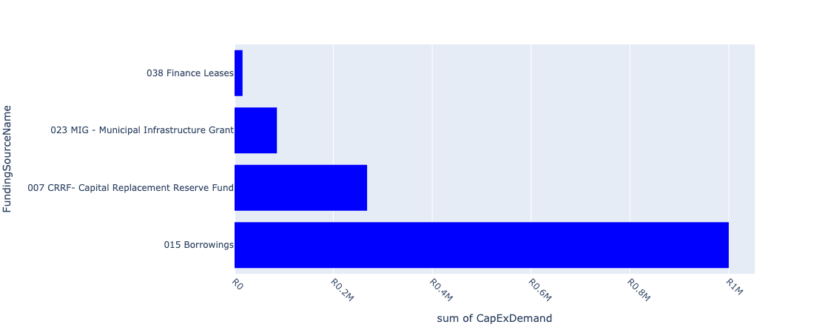

Figure 5.18: Ward 11 Departmental Requests

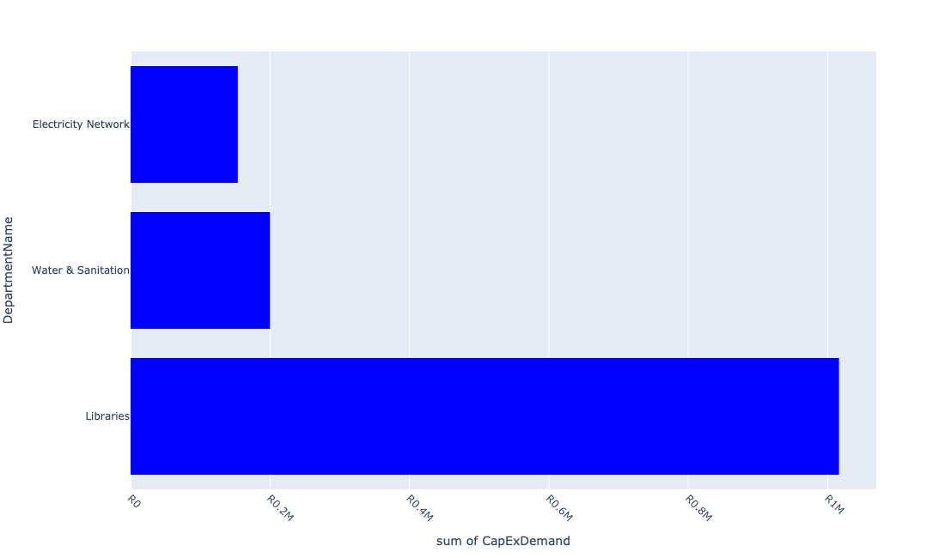

Table 5.11: Summary - Ward 11

|  |  |
| --- | --- |
| Item | Description |
| Total Capital Demand for Ward 11 - All Years | R1,369,940 Rank: 12 (1 = Highest) |
| Total Capital Demand for Ward 11 - MTREF | R1,369,940 Rank: 12 (1 = Highest) |
| Financial Years in which capital requirements are listed for Ward 11 | 2023, 2024 and 2025 |
| Financial Year with highest capital demand for Ward 11 | 2024 |
| Ward 11 intersecting feature used | Works Location |
| Total number of projects intersecting with Ward 11 | 22 Rank: 3 (1 = Highest) |

Table 5.12: All projects asking for budget in Ward 11

|  |  |  |  |
| --- | --- | --- | --- |
| Project ID | Project Name | Department | Project Budget |
| 10471 | Leloko Street | Roads & Stormwater | R0.00 (0%) No budget request. |
| 10470 | M. Polosong Street | Roads & Stormwater | R0.00 (0%) No budget request. |
| 10469 | Construction of Phomolong Street | Roads & Stormwater | R0.00 (0%) No budget request. |
| 10468 | Construction of N. Booi Street | Roads & Stormwater | R0.00 (0%) No budget request. |
| 10811 | MOBILE TOILETS | Parks | R0.00 (0%) No budget request. |
| 10654 | Provide pedestrian oriented (human scale) Street lighting primarily along Station Road towards Sicelo (UDF) | Electricity Network | R153,814 (11.23%) Budget spread across: 2023 |
| 10451 | Library Refurbishment/upgrade - De Deur | Libraries | R0.00 (0%) No budget request. |
| 10328 | Ophir Estates - Upgrade HT & LT Overhead + Street Lights | Electricity Network | R0.00 (0%) No budget request. |
| 10322 | Ohenimuri - Upgrade of Network | Electricity Network | R0.00 (0%) No budget request. |
| 10236 | Highmast Lights - Savanna City | Electricity Network | R0.00 (0%) No budget request. |
| 10211 | PREPAID WATER METER PROJECT | Water & Sanitation | R0.00 (0%) No budget request. |
| 10498 | Library furniture & equipment-De Deur | Libraries | R0.00 (0%) No budget request. |
| 10204 | Spare Pumps and Pump Replacement | Water & Sanitation | R200,000 (14.60%) Budget spread across: 2025 |
| 10080 | DE DEUR LIBRARY BOOKS | Libraries | R1,000,000 (73.00%) Budget spread across: 2024 |
| 10049 | LAKESIDE LIBRARY BOOKS | Libraries | R16,126 (1.18%) Budget spread across: 2023 |
| 10821 | Midvaal Agricultural Packhouse and Storage | Development and Planning Dept | R0.00 (0%) No budget request. |
| 10789 | Savana Roads Rehabilitation | Roads & Stormwater | R0.00 (0%) No budget request. |
| 10745 | Savanna city Sport facilities | Sports & Recreation | R0.00 (0%) No budget request. |
| 10734 | Savana Reservoir | Water & Sanitation | R0.00 (0%) No budget request. |
| 10733 | Savana Bulk Pipeline | Water & Sanitation | R0.00 (0%) No budget request. |
| 10726 | New Library Building | Libraries | R0.00 (0%) No budget request. |
| 10918 | Furniture and Equipment | Libraries | R0.00 (0%) No budget request. |

Please note that the following projects will not be shown in this table:

* Projects with no recorded intersect with Wards (in other words no Works Location was recorded on the system for this project)

Projects that do not have any recorded budget demand on the system at the time that this report was requested, are shown in the table with zero budgets indicated.

## Ward 12

Figure 5.19: Ward 12 Funding Requests

**No projects in Ward 12.**

Figure 5.20: Ward 12 Departmental Requests

**No projects in Ward 12.**

Table 5.12: Summary - Ward 12

|  |  |
| --- | --- |
| Item | Description |
| Total Capital Demand for Ward 12 - All Years | R0 Rank: 14 (1 = Highest) |
| Total Capital Demand for Ward 12 - MTREF | R0 Rank: 14 (1 = Highest) |
| Financial Years in which capital requirements are listed for Ward 12 |  |
| Financial Year with highest capital demand for Ward 12 | 2023 |
| Ward 12 intersecting feature used | Works Location |
| Total number of projects intersecting with Ward 12 | 3 Rank: 14 (1 = Highest) |

Table 5.13: All projects asking for budget in Ward 12

|  |  |  |  |
| --- | --- | --- | --- |
| Project ID | Project Name | Department | Project Budget |
| 10811 | MOBILE TOILETS | Parks | R0.00 (0%) No budget request. |
| 10123 | Pipe Rising Main Rep(Klipriver Bus Park) | Water & Sanitation | R0.00 (0%) No budget request. |
| 10732 | Graceview water reticulation | Water & Sanitation | R0.00 (0%) No budget request. |

Please note that the following projects will not be shown in this table:

* Projects with no recorded intersect with Wards (in other words no Works Location was recorded on the system for this project)

Projects that do not have any recorded budget demand on the system at the time that this report was requested, are shown in the table with zero budgets indicated.

## Ward 13

Figure 5.19: Ward 13 Funding Requests

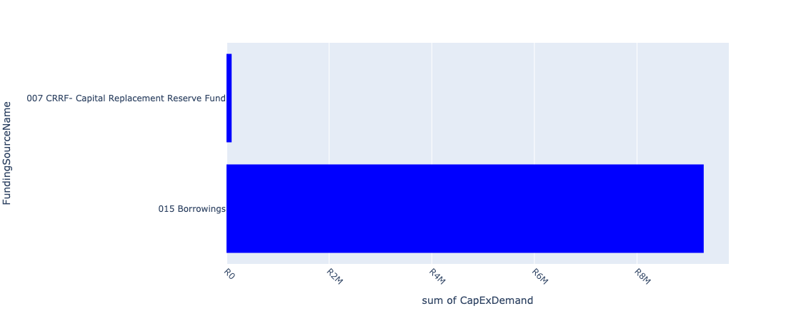

Figure 5.20: Ward 13 Departmental Requests

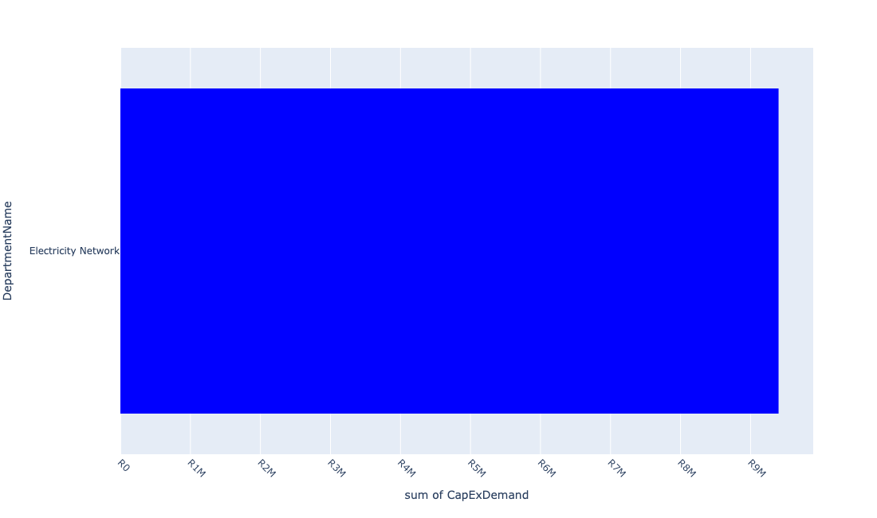

Table 5.13: Summary - Ward 13

|  |  |
| --- | --- |
| Item | Description |
| Total Capital Demand for Ward 13 - All Years | R9,400,000 Rank: 3 (1 = Highest) |
| Total Capital Demand for Ward 13 - MTREF | R9,400,000 Rank: 3 (1 = Highest) |
| Financial Years in which capital requirements are listed for Ward 13 | 2023 |
| Financial Year with highest capital demand for Ward 13 | 2023 |
| Ward 13 intersecting feature used | Works Location |
| Total number of projects intersecting with Ward 13 | 5 Rank: 12 (1 = Highest) |

Table 5.14: All projects asking for budget in Ward 13

|  |  |  |  |
| --- | --- | --- | --- |
| Project ID | Project Name | Department | Project Budget |
| 10811 | MOBILE TOILETS | Parks | R0.00 (0%) No budget request. |
| 10329 | Upgrade HT & LT Overhead Lights - Chrissisfontein | Electricity Network | R0.00 (0%) No budget request. |
| 10319 | Upgrade Overhead Lines in Chrissiesfontein | Electricity Network | R9,300,000 (98.94%) Budget spread across: 2023 |
| 10318 | Feeder Line to Riversdale | Electricity Network | R100,000 (1.06%) Budget spread across: 2023 |
| 10314 | Replace Rothdene LV Overhead Line to Underground | Electricity Network | R0.00 (0%) No budget request. |

Please note that the following projects will not be shown in this table:

* Projects with no recorded intersect with Wards (in other words no Works Location was recorded on the system for this project)

Projects that do not have any recorded budget demand on the system at the time that this report was requested, are shown in the table with zero budgets indicated.

## Ward 14

Figure 5.21: Ward 14 Funding Requests

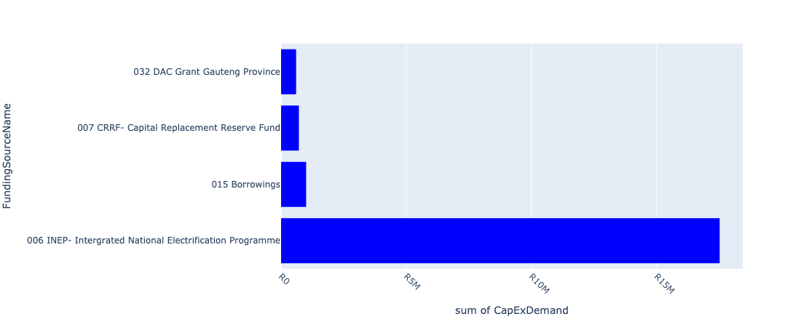

Figure 5.22: Ward 14 Departmental Requests

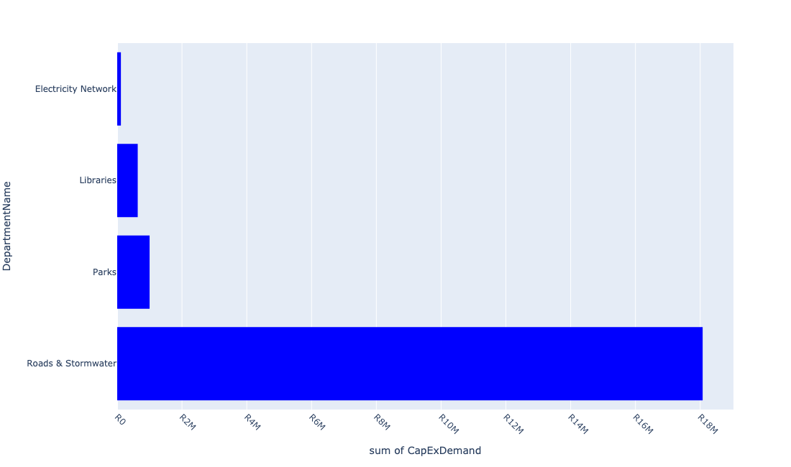

Table 5.14: Summary - Ward 14

|  |  |
| --- | --- |
| Item | Description |
| Total Capital Demand for Ward 14 - All Years | R19,822,083 Rank: 2 (1 = Highest) |
| Total Capital Demand for Ward 14 - MTREF | R19,822,083 Rank: 2 (1 = Highest) |
| Financial Years in which capital requirements are listed for Ward 14 | 2023, 2024 and 2025 |
| Financial Year with highest capital demand for Ward 14 | 2024 |
| Ward 14 intersecting feature used | Works Location |
| Total number of projects intersecting with Ward 14 | 17 Rank: 6 (1 = Highest) |

Table 5.15: All projects asking for budget in Ward 14

|  |  |  |  |
| --- | --- | --- | --- |
| Project ID | Project Name | Department | Project Budget |
| 10811 | MOBILE TOILETS | Parks | R0.00 (0%) No budget request. |
| 11023 | E-Resources | Libraries | R33,429 (0.17%) Budget spread across: 2023, 2024 and 2025 |
| 10447 | Development of a District Park in Meyerton | Parks | R1,000,000 (5.04%) Budget spread across: 2024 |
| 10325 | Festive Decorating Lights | Electricity Network | R113,822 (0.57%) Budget spread across: 2023 |
| 10294 | MEYERTON FIRE STATION SMALL GEAR | Fire | R0.00 (0%) No budget request. |
| 10482 | Valve Replacements | Water & Sanitation | R0.00 (0%) No budget request. |
| 10065 | MEYERTON LIBRARY - RFID SECURITY SYSTEM | Libraries | R0.00 (0%) No budget request. |
| 10062 | MEYERTON LIBRARY FURNITURE | Libraries | R0.00 (0%) No budget request. |
| 10059 | Library Furniture - Meyerton - Shelves - New | Libraries | R0.00 (0%) No budget request. |
| 10057 | MEYERTON LIBRARY ICT HARDWARE (COMPUTORS) | Libraries | R600,000 (3.03%) Budget spread across: 2023 and 2024 |
| 10834 | LADDERS & BINS | Electricity Network | R0.00 (0%) No budget request. |
| 10660 | Detail Design of on-street parking along Reitz Street between Meyer Street and Pierneef Boulevard (UDF) | Roads & Stormwater | R0.00 (0%) No budget request. |
| 10659 | Install traffic circles at the following intersections: Loch and Holiday (UDF) | Roads & Stormwater | R0.00 (0%) No budget request. |
| 10656 | Install Traffic Light at Loch and Pierneef Boulevard (UDF) | Electricity Network | R0.00 (0%) No budget request. |
| 10653 | Construct traffic circle and public art feature at the intersection of Holiday and Loch Street (UDF) | Roads & Stormwater | R17,511,288 (88.34%) Budget spread across: 2023, 2024 and 2025 |
| 11010 | Rehabilitation of Meyer Street | Roads & Stormwater | R563,544 (2.84%) Budget spread across: 2024 |
| 10869 | Flatbed truck (new) | Electricity Network | R0.00 (0%) No budget request. |

Please note that the following projects will not be shown in this table:

* Projects with no recorded intersect with Wards (in other words no Works Location was recorded on the system for this project)

Projects that do not have any recorded budget demand on the system at the time that this report was requested, are shown in the table with zero budgets indicated.

## Ward 15

Figure 5.23: Ward 15 Funding Requests

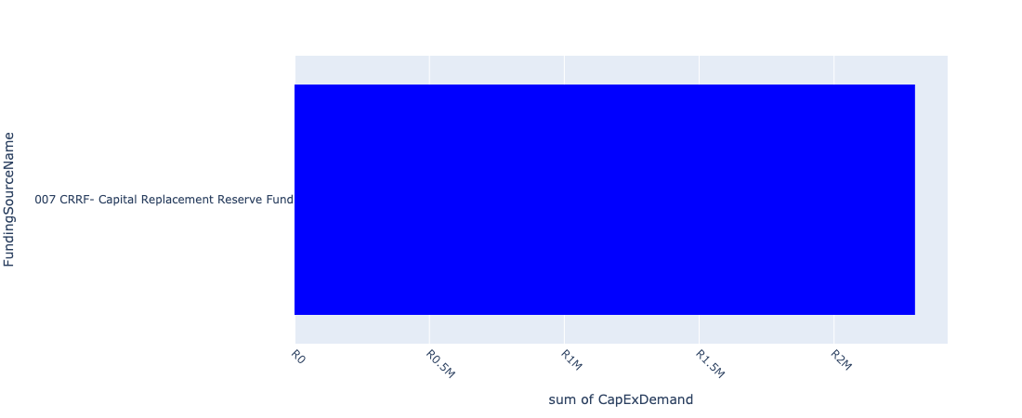

Figure 5.24: Ward 15 Departmental Requests

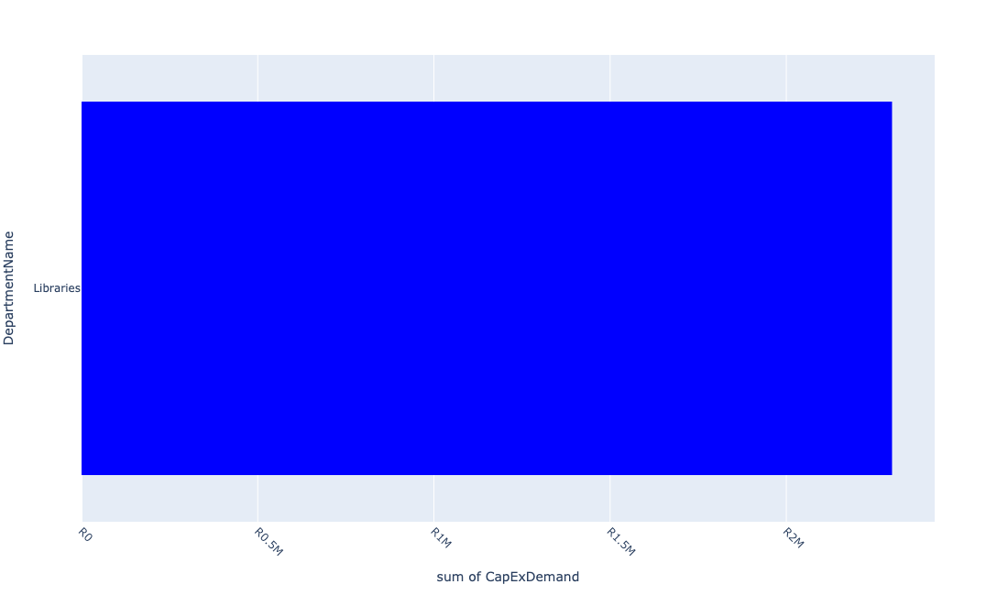

Table 5.15: Summary - Ward 15

|  |  |
| --- | --- |
| Item | Description |
| Total Capital Demand for Ward 15 - All Years | R2,300,000 Rank: 11 (1 = Highest) |
| Total Capital Demand for Ward 15 - MTREF | R2,300,000 Rank: 11 (1 = Highest) |
| Financial Years in which capital requirements are listed for Ward 15 | 2024 and 2025 |
| Financial Year with highest capital demand for Ward 15 | 2025 |
| Ward 15 intersecting feature used | Works Location |
| Total number of projects intersecting with Ward 15 | 9 Rank: 7 (1 = Highest) |

Table 5.16: All projects asking for budget in Ward 15

|  |  |  |  |
| --- | --- | --- | --- |
| Project ID | Project Name | Department | Project Budget |
| 10811 | MOBILE TOILETS | Parks | R0.00 (0%) No budget request. |
| 10401 | Upgrading of Eaton R | Roads & Stormwater | R0.00 (0%) No budget request. |
| 10482 | Valve Replacements | Water & Sanitation | R0.00 (0%) No budget request. |
| 10185 | Bantu Bonke Sport Centre (MIG) | Sports & Recreation | R0.00 (0%) No budget request. |
| 10390 | Construction Windsor Circle roads in Ward 3 | Roads & Stormwater | R0.00 (0%) No budget request. |
| 10048 | Refurbishment of Library- HOK Library | Libraries | R300,000 (13.04%) Budget spread across: 2024 |
| 10046 | HENLEY ON KLIP LIBRARY BOOKS | Libraries | R2,000,000 (86.96%) Budget spread across: 2025 |
| 10045 | Carport - HOK - New | Libraries | R0.00 (0%) No budget request. |
| 10042 | Air cons - HOK - New | Libraries | R0.00 (0%) No budget request. |

Please note that the following projects will not be shown in this table:

* Projects with no recorded intersect with Wards (in other words no Works Location was recorded on the system for this project)

Projects that do not have any recorded budget demand on the system at the time that this report was requested, are shown in the table with zero budgets indicated.