



Spatial Feature Report

T: +27 12 364 2546 | E: info@novus3.co.za Postnet Suite 471, Private Bag X15,

Menlo Park, 0102**www.novus3.co.za**

engineered solutions

Disclaimer

This document contains data that was obtained from a live CP3 system at the moment the data was requested. The data is updated by users of the CP3 System and unless the system is locked for changes, this data may change on a daily basis. The reader is therefore cautioned not to place inappropriate reliance on the data unless there is certainty on the status of the data in terms of how recently it has been updated, how “clean” the data is (is there a quality control and/or verification process that was followed by the licensee of the CP3 system to ensure that data is checked and verified from time-to-time) and whether the correct baseline was queried. This report therefore provides a “snapshot in time”. Consequently, the document may be less relevant at a different time, or using a different financial baseline to query from.

At all times, all rights, title and interest in and to this material remains vested in the owner of this document and are copyrighted and protected by regulatory provisions. These materials may not be copied, reproduced, modified, published, uploaded, posted to websites or otherwise distributed in any way, without our prior written permission from the Licensee and Licensor (Nvous3 (Pty) Ltd) of the CP3 Software. The owner of this document does not grant any right to reproduce the materials. All our rights in this regard are and remain reserved.

Table of Contents

**No table of contents entries found.** (Right-click -> Update Field)

Spatial Query Report

This document was created *2022-05-26-18_46* from the **Midvaal Municipality** CP3 system.

The baseline **'2022/2023 Draft Capital Budget_20220301_Finance'** with description: **'2022/2023 Draft Capital Budget as recieved from Finance as draft Capital Budget with only MTREF Values'** was used. The spatial feature that was selected for the purpose of this report was: **'Midvaal 5 EDCs'**.

This is a spatial feature report for the *Midvaal Municipality.* The data contained in this report was sourced directly from the municipality's live CP3 system. The information in this report therefore reflects the data as it was on *2022-05-26* when this report was requested. Any subsequent updates to the data contained the CP3 System related to the applicable baseline from which this reports was drawn, would therefore not reflect in this report.   
  
For the *Midvaal Municipality, the following spatial features are available for the purpose of developing* 'Spatial Query Reports' (similar to this report):

* Economic Study Catalytic Nodes (5nodes)
* Midvaal 5 EDCs
* Midvaal Township Boundaries
* Spatial Development Framework (20220428)
* Wards



We hope you find this useful! Sincerely, *The Novus3 Team.*

# Introduction

The baseline that was queried for this report contains *168* projects of which a total of *12 (7.14%)* projects do not have any recorded intersection (overlap) with the '5 EDCs' spatial feature that was selected for this report. The following spatial features are available for queries using this API profile:

* Economic Study Catalytic Nodes (5nodes)
* Midvaal 5 EDCs
* Midvaal Township Boundaries
* Spatial Development Framework (20220428)
* Wards

The probable reasons for the 12 non intersecting projects reported are that:

* these projects simply do not have a location associated with them yet (most frequently the case with 'no-intersect' projects) or;
* the location that was captured for some of these projects, may have been in the wrong place (e.g. outside the boundaries of Midvaal - this is very rarely the reason).

It is important to take note of the 7.14% projects that do not intersect with the '5 EDCs' spatial feature when appraising this report.

Figure 1.1: Intersecting vs Non-Intersecting Projects

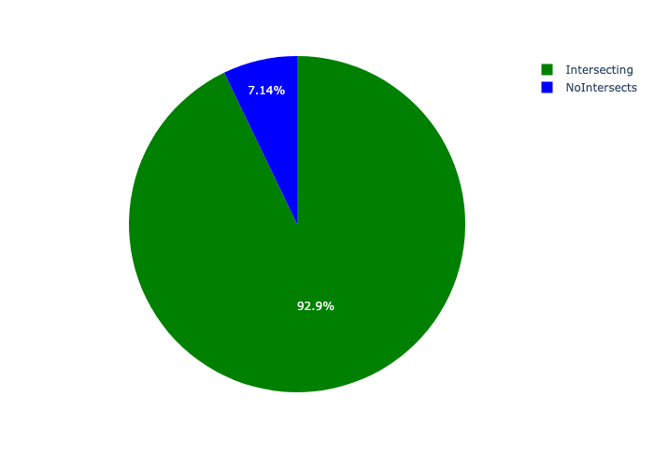

# Total Number of Projects and Total Capital Demand per 5 EDC - All Years

Table 2.1 below provides a concise summary of key statistical insights regarding the number of projects that are requesting funding in each of the 5 edcs.

Table 2.1: 5 EDCs Analysis - Number of Projects

|  |  |  |  |
| --- | --- | --- | --- |
| Description | Info (1) | Info (2) | Info (3) |
| Number of projects in all 5 EDCs - Overview | Total in all 5 EDCs: 156 projects | Average per 5 EDC: 26 projects | 75th percentile of projects across all 5 EDCs: 9.0 projects |
| The highest number of projects | 5 EDCs: In Midvaal LM | Number of projects in Midvaal LM: 128 | Percentage of total in Midvaal LM: 82.05% |
| The lowest number of projects: | 5 EDCs: In Waterval Neighbourhood Node | Number of projects in Waterval Neighbourhood Node: 2 | Percentage of total in Waterval Neighbourhood Node: 1.28% |

Table 2.1 below provides a concise summary of key statistical insights regarding the total capital demand per 5 edc.

Table 2.1: 5 EDCs Analysis - Capital Demand (R)

|  |  |  |  |
| --- | --- | --- | --- |
| Description | Info (1) | Info (2) | Info (3) |
| Capital demand in all 5 EDCs - Overview | Total capital demand in all 5 EDCs: R99,702,361 | The average capital demand per 5 EDC: R16,617,060 | The 75th percentile of capital demand for 5 EDCs: R3,759,535 |
| The highest capital demand | 5 EDCs: In Midvaal LM | Capital Demand in Midvaal LM: R94,013,319 | Percentage of total in Midvaal LM: 94.29% |
| The lowest capital demand | 5 EDCs: In Waterval Neighbourhood Node | Capital Demand in Waterval Neighbourhood Node: R0 | Percentage of total in Waterval Neighbourhood Node: 0.00% |

The number of projects per 5 edc and the capital demand per 5 edc needs to be looked at together for better insight. Figures 2.1 and 2.2 assist with further graphical insight into some of the numbers that are provided in Tables 2.1 and 2.2.

Figure 2.1: The single 5 edc with the highest value (Nr of Projects & Capital Demand) vs the rest

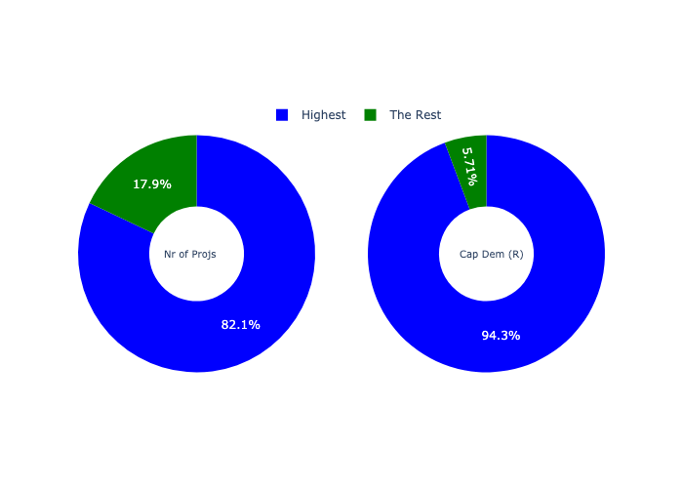

The highest number of projects in a single 5 edc is in **Midvaal LM.** *That is 128 projects and this is 82.05% of the total number of projects.* The highest capital demand in a single 5 edc is in **Midvaal LM.** *That is R94,013,319 and this amounts to 94.29% of the total capital demand.*

The following figures provide a bar graph representation of the number of projects per 5 edc with the colour of the bars representing the level of capital demand in each of these 5 edcs.

Figure 2.2: Projects and Capital Demand per 5 EDC

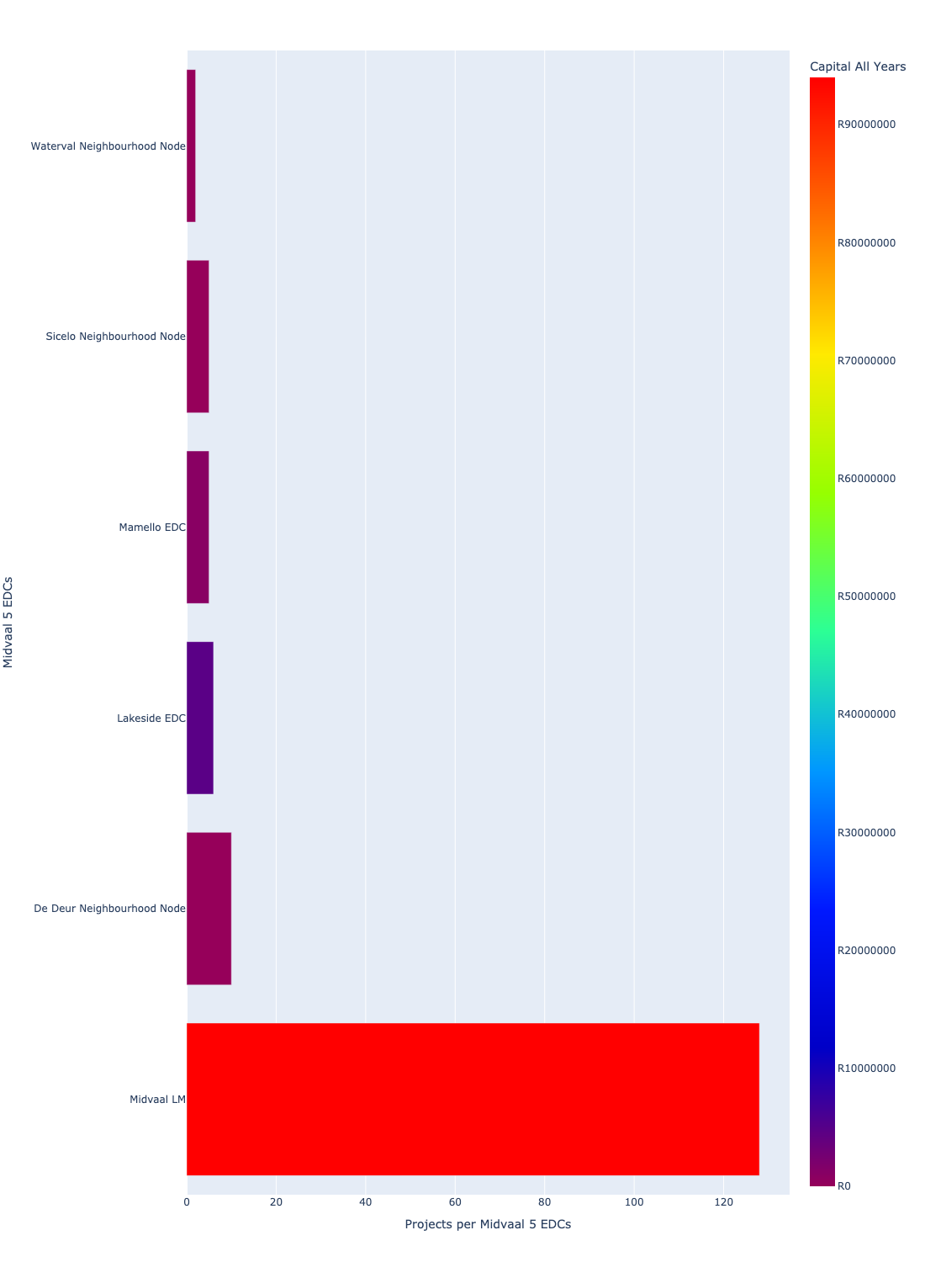

# Total Capital Demand per 5 edc - All Years

There are different funding sources from which capital is requested. For the financial baseline that was selected for this report query (2022/2023 Draft Capital Budget_20220301_Finance), the breakdown of capital demand for Midvaal Municipality per funding source is shown in Figure 3.1 below.

Figure 3.1: Capital Demand Per Funding Source

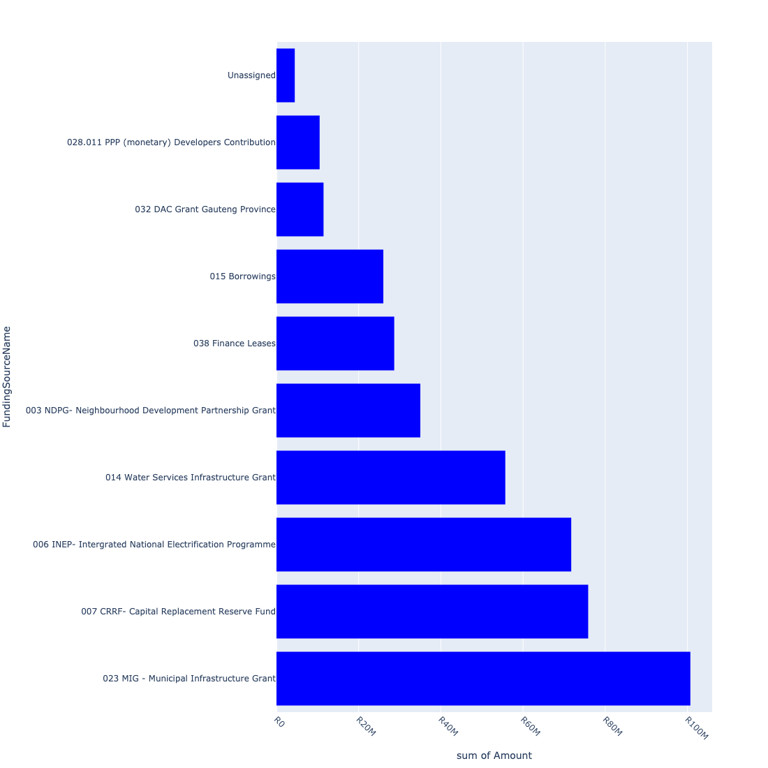

For the financial baseline that was selected for this report query (2022/2023 Draft Capital Budget_20220301_Finance), the breakdown of capital demand for Midvaal Municipality per department is shown in Figure 3.2 below.

Figure 3.2: Capital Demand Per Midvaal Municipality Department

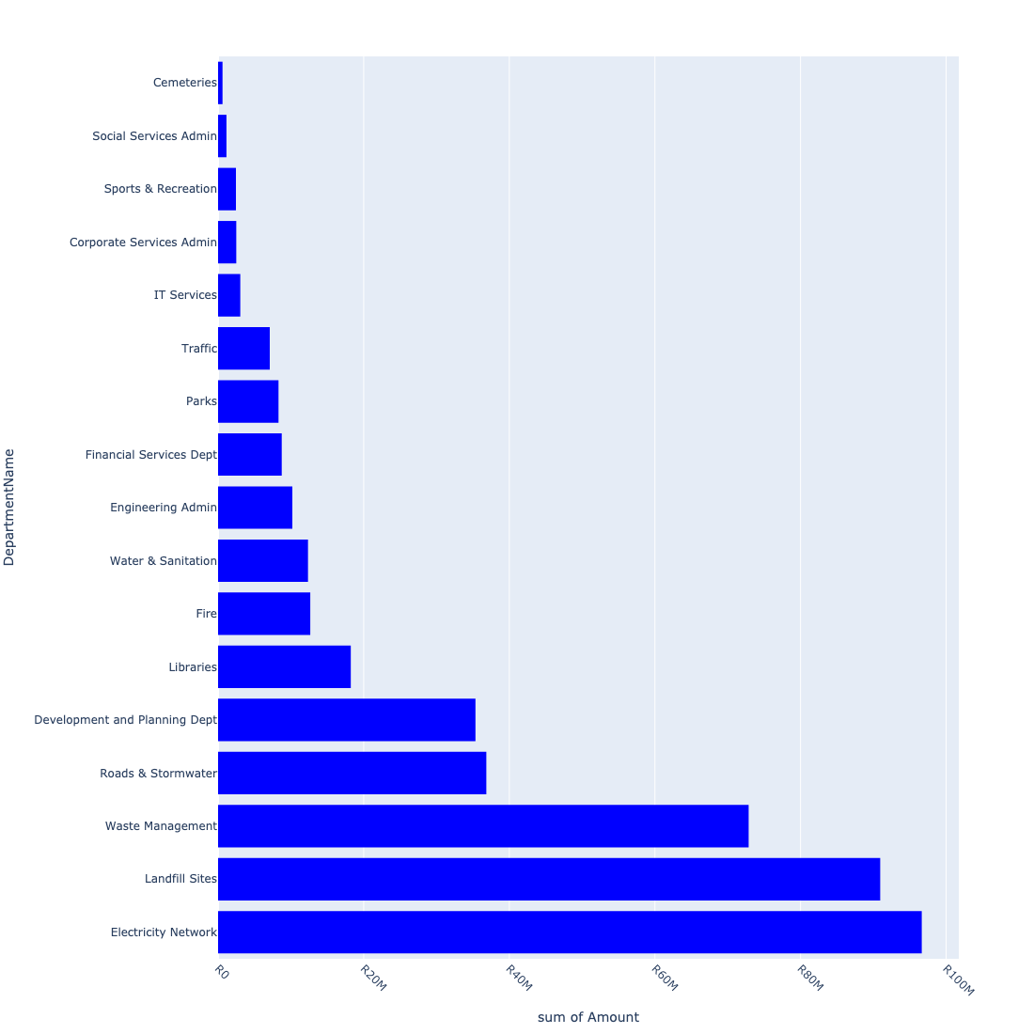

The following figures provide a histogram representation of the capital demand per 5 edc. A colour breakdown is provided of each year's sub-total that contribute towards the overall total capital demand of each 5 edc. Note that the capital demand beyond the first three years representing the Medium Term Expenditure Framework (MTREF - years 2023, 2024 and 2025) are generally more sparsely and less diligently populated, therefore less reliance should be vested on these outer years when appraising the overall capital demand. The reason for this is usually because of National Treasury's requirement for annual budget submissions spanning only over the MTREF (i.e. the next three years).

Figure 3.3: Capital Demand per 5 EDC - All Years

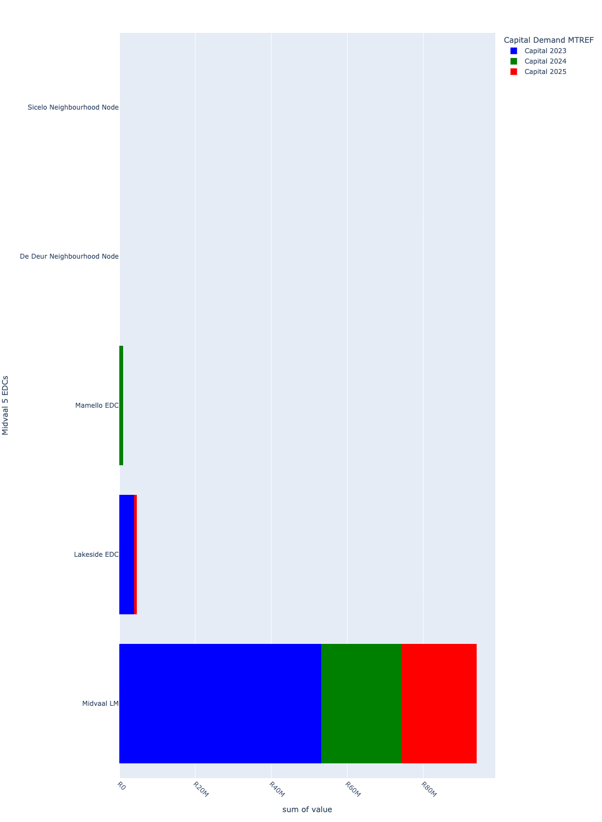

# Total Capital Demand per 5 EDC - MTREF only

Table 4.1 below provides a concise summary of key statistical insights regarding the total MTREF capital demand per 5 edc.

Table 4.1: 5 EDCs Analysis - MTREF Capital Demand (R)

|  |  |  |  |
| --- | --- | --- | --- |
| Description | Info (1) | Info (2) | Info (3) |
| MTREF Capital demand in all 5 EDCs - Overview | MTREF capital demand in all 5 EDCs: R99,702,361 | The average MTREF capital demand per 5 edc: R16,617,060 | The 75th percentile of MTREF capital demand for 5 EDCs: R3,759,535 |
| The highest MTREF capital demand | In 5 EDC: Midvaal LM | MTREF capital Demand in Midvaal LM: R94,013,319 | Percentage of total MRTEF capital demand in Midvaal LM: 94.29% |
| The lowest MTREF capital demand | In 5 EDC: Waterval Neighbourhood Node | MTREF capital Demand in Waterval Neighbourhood Node: R0 | Percentage of total MTREF capital demand in Waterval Neighbourhood Node: 0.00% |

The following figures provide a histogram representation of the capital demand per 5 edc. A colour breakdown is provided of each year's sub-total that contribute towards the overall MTREF total capital demand of each 5 edc.

Figure 4.1: Capital Demand per 5 EDC - MTREF Period

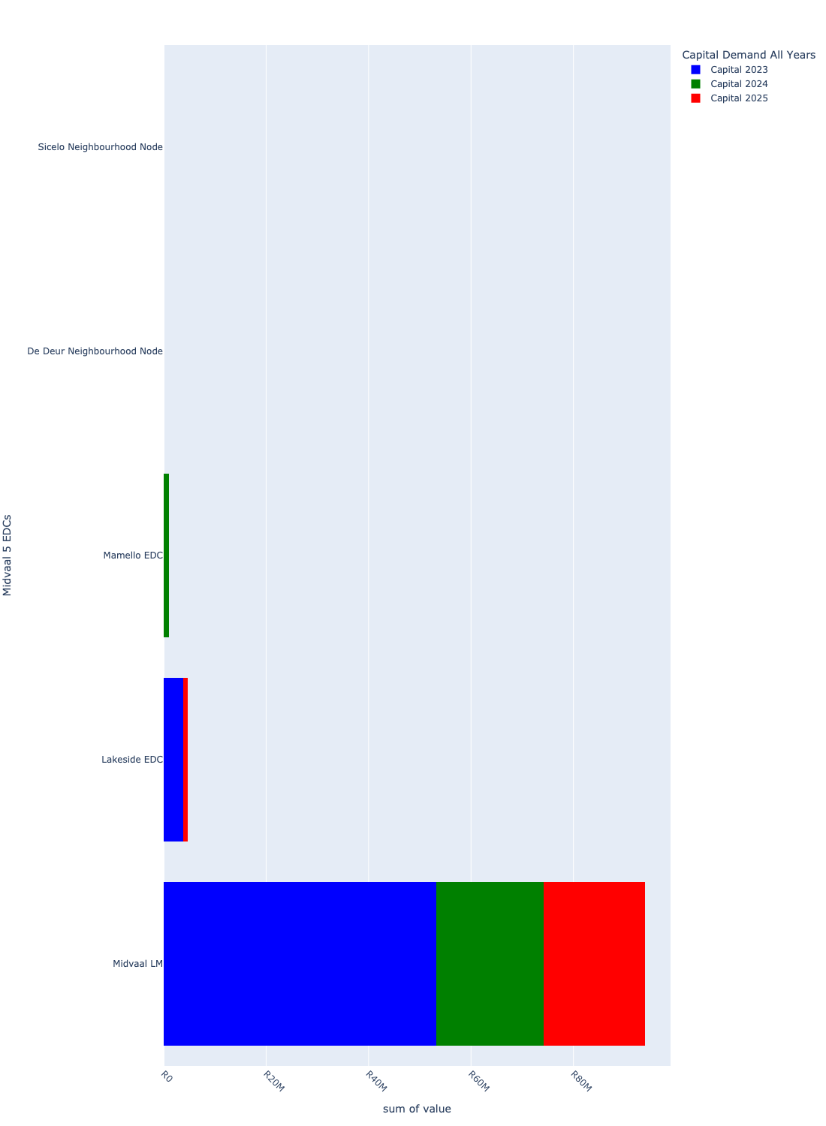

# Summary per 5 EDC

## De Deur Neighbourhood Node

Figure 5.1: De Deur Neighbourhood Node Funding Requests

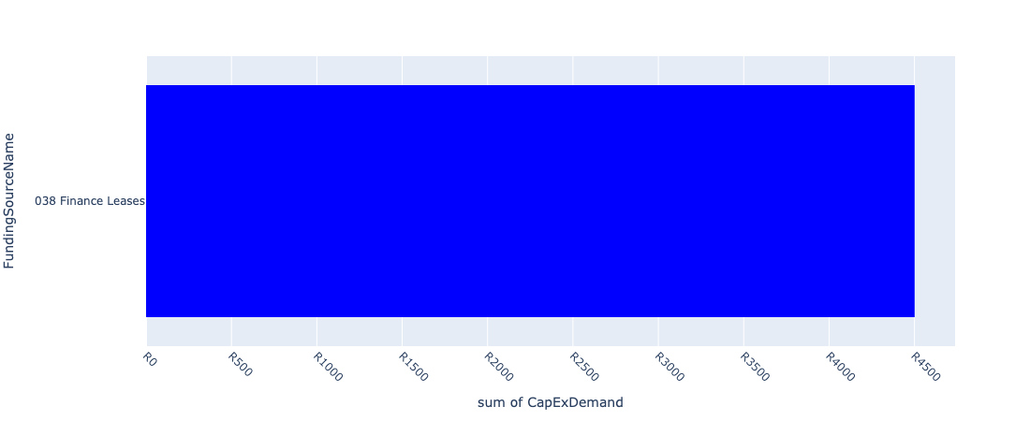

Figure 5.2: De Deur Neighbourhood Node Departmental Requests

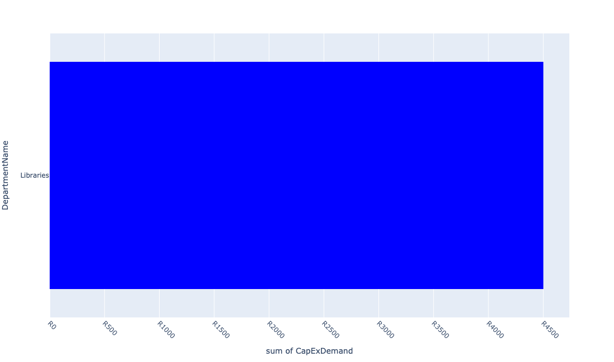

Table 5.1: Summary - De Deur Neighbourhood Node

|  |  |
| --- | --- |
| Item | Description |
| Total Capital Demand for De Deur Neighbourhood Node - All Years | R4,501 Rank: 4 (1 = Highest) |
| Total Capital Demand for De Deur Neighbourhood Node - MTREF | R4,501 Rank: 4 (1 = Highest) |
| Financial Years in which capital requirements are listed for De Deur Neighbourhood Node | 2023 |
| Financial Year with highest capital demand for De Deur Neighbourhood Node | 2023 |
| De Deur Neighbourhood Node intersecting feature used | Works Location |
| Total number of projects intersecting with De Deur Neighbourhood Node | 10 Rank: 2 (1 = Highest) |

Table 5.2: All projects asking for budget in De Deur Neighbourhood Node

|  |  |  |  |
| --- | --- | --- | --- |
| Project ID | Project Name | Department | Project Budget |
| 10498 | Library furniture & equipment-De Deur | Libraries | R0.00 (0%) No budget request. |
| 10049 | LAKESIDE LIBRARY BOOKS | Libraries | R4,501 (100.00%) Budget spread across: 2023 |
| 10918 | Furniture and Equipment | Libraries | R0.00 (0%) No budget request. |
| 10811 | MOBILE TOILETS | Parks | R0.00 (0%) No budget request. |
| 10789 | Savana Roads Rehabilitation | Roads & Stormwater | R0.00 (0%) No budget request. |
| 10734 | Savana Reservoir | Water & Sanitation | R0.00 (0%) No budget request. |
| 10733 | Savana Bulk Pipeline | Water & Sanitation | R0.00 (0%) No budget request. |
| 10451 | Library Refurbishment/upgrade - De Deur | Libraries | R0.00 (0%) No budget request. |
| 10211 | PREPAID WATER METER PROJECT | Water & Sanitation | R0.00 (0%) No budget request. |
| 10726 | New Library Building | Libraries | R0.00 (0%) No budget request. |

Please note that the following projects will not be shown in this table:

* Projects with no recorded intersect with 5 EDCs (in other words no Works Location was recorded on the system for this project)

Projects that do not have any recorded budget demand on the system at the time that this report was requested, are shown in the table with zero budgets indicated.

## Lakeside EDC

Figure 5.3: Lakeside EDC Funding Requests

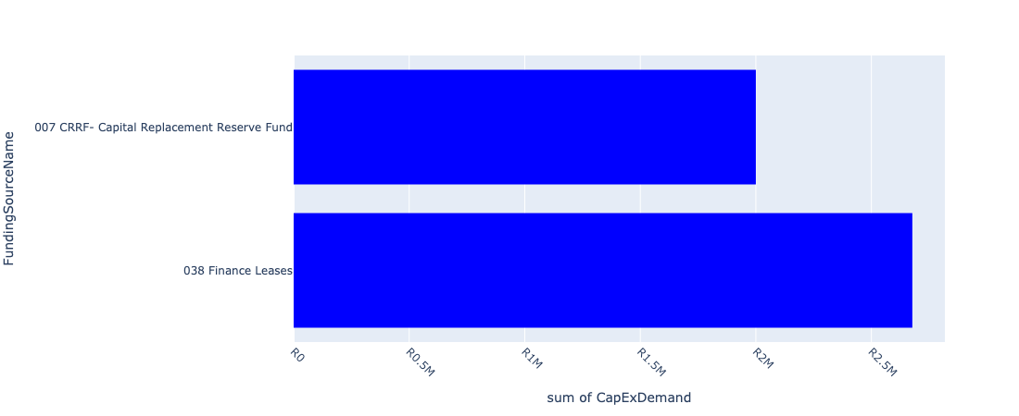

Figure 5.4: Lakeside EDC Departmental Requests

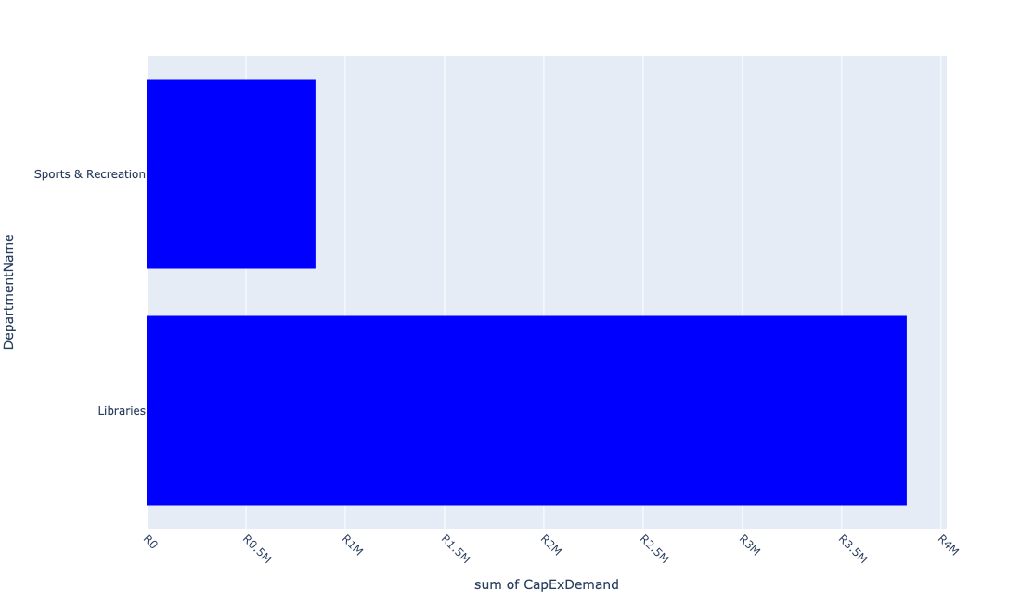

Table 5.2: Summary - Lakeside EDC

|  |  |
| --- | --- |
| Item | Description |
| Total Capital Demand for Lakeside EDC - All Years | R4,677,138 Rank: 2 (1 = Highest) |
| Total Capital Demand for Lakeside EDC - MTREF | R4,677,138 Rank: 2 (1 = Highest) |
| Financial Years in which capital requirements are listed for Lakeside EDC | 2023 and 2025 |
| Financial Year with highest capital demand for Lakeside EDC | 2023 |
| Lakeside EDC intersecting feature used | Works Location |
| Total number of projects intersecting with Lakeside EDC | 6 Rank: 3 (1 = Highest) |

Table 5.3: All projects asking for budget in Lakeside EDC

|  |  |  |  |
| --- | --- | --- | --- |
| Project ID | Project Name | Department | Project Budget |
| 10049 | LAKESIDE LIBRARY BOOKS | Libraries | R1,827,138 (39.07%) Budget spread across: 2023 |
| 10607 | Library furniture & equipment - Lakeside | Libraries | R0.00 (0%) No budget request. |
| 10494 | Ext Lakeside Lib building - Upgrading | Libraries | R2,000,000 (42.76%) Budget spread across: 2023 |
| 10208 | Installation:Domestic W/Meters (Lakeside) | Water & Sanitation | R0.00 (0%) No budget request. |
| 10186 | LAKESIDE SPORT CENTRE (MIG) | Sports & Recreation | R850,000 (18.17%) Budget spread across: 2025 |
| 10051 | Lakeside Library Children Sec Furniture | Libraries | R0.00 (0%) No budget request. |

Please note that the following projects will not be shown in this table:

* Projects with no recorded intersect with 5 EDCs (in other words no Works Location was recorded on the system for this project)

Projects that do not have any recorded budget demand on the system at the time that this report was requested, are shown in the table with zero budgets indicated.

## Mamello EDC

Figure 5.5: Mamello EDC Funding Requests

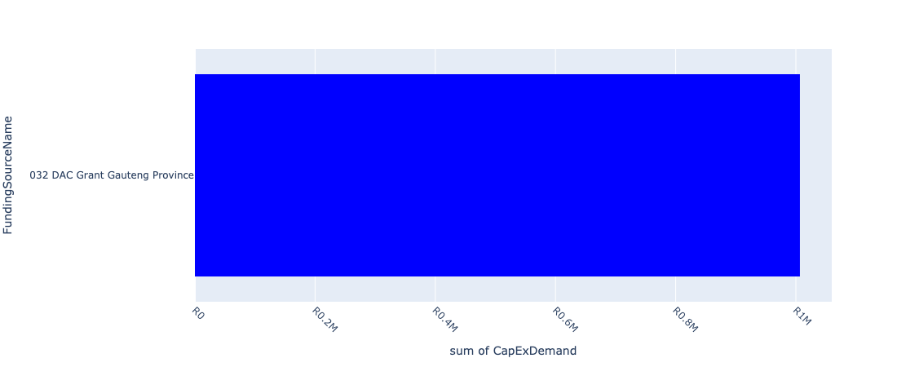

Figure 5.6: Mamello EDC Departmental Requests

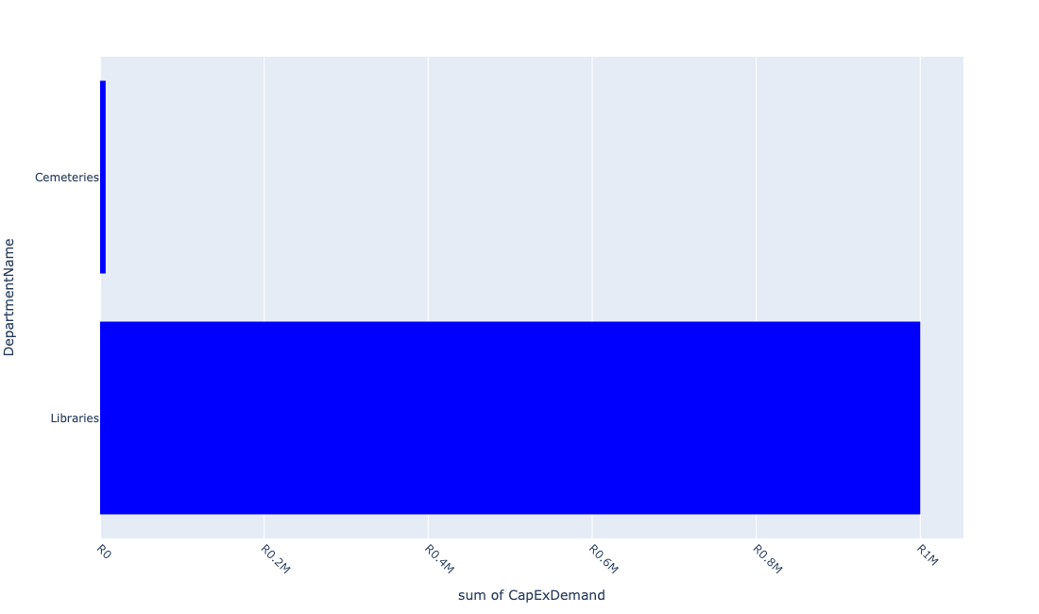

Table 5.3: Summary - Mamello EDC

|  |  |
| --- | --- |
| Item | Description |
| Total Capital Demand for Mamello EDC - All Years | R1,006,727 Rank: 3 (1 = Highest) |
| Total Capital Demand for Mamello EDC - MTREF | R1,006,727 Rank: 3 (1 = Highest) |
| Financial Years in which capital requirements are listed for Mamello EDC | 2023 and 2024 |
| Financial Year with highest capital demand for Mamello EDC | 2024 |
| Mamello EDC intersecting feature used | Works Location |
| Total number of projects intersecting with Mamello EDC | 5 Rank: 4 (1 = Highest) |

Table 5.4: All projects asking for budget in Mamello EDC

|  |  |  |  |
| --- | --- | --- | --- |
| Project ID | Project Name | Department | Project Budget |
| 10403 | Maintaining of the Anchovy road | Roads & Stormwater | R0.00 (0%) No budget request. |
| 10675 | Mamello Cemetery | Cemeteries | R6,727 (0.67%) Budget spread across: 2023 |
| 10209 | Mamello Bulk Water (MIG) | Water & Sanitation | R0.00 (0%) No budget request. |
| 10121 | Mamello Sewage Scheme Augmentation | Water & Sanitation | R0.00 (0%) No budget request. |
| 11033 | New Library for Mamello | Libraries | R1,000,000 (99.33%) Budget spread across: 2024 |

Please note that the following projects will not be shown in this table:

* Projects with no recorded intersect with 5 EDCs (in other words no Works Location was recorded on the system for this project)

Projects that do not have any recorded budget demand on the system at the time that this report was requested, are shown in the table with zero budgets indicated.

## Midvaal LM

Figure 5.7: Midvaal LM Funding Requests

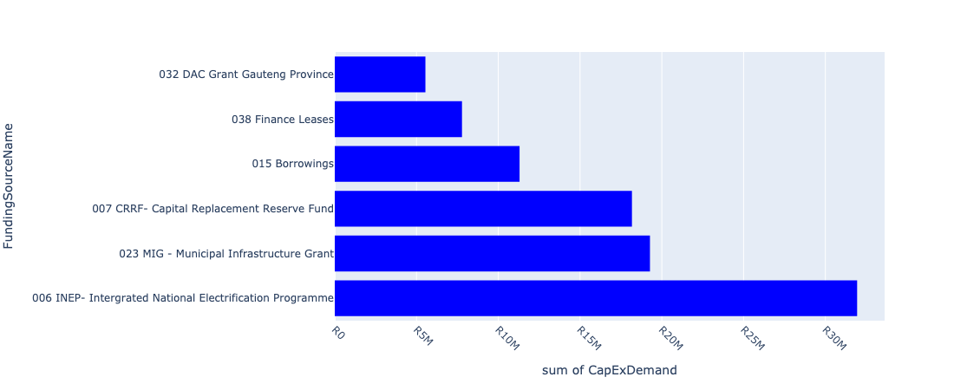

Figure 5.8: Midvaal LM Departmental Requests

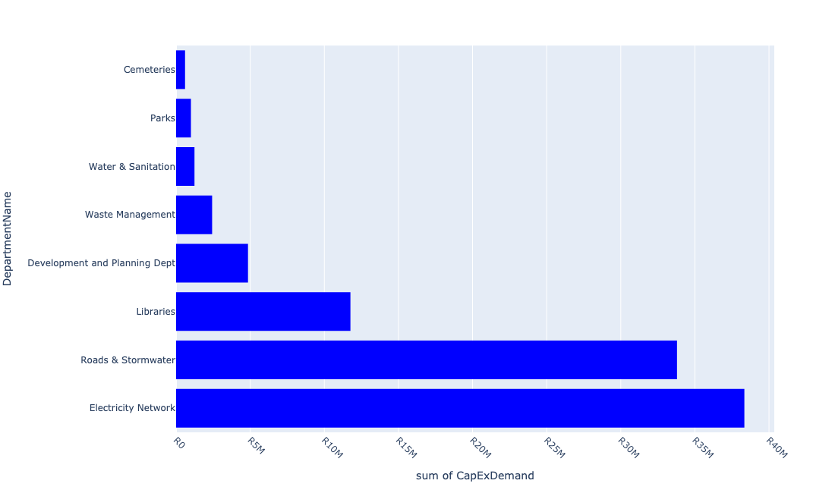

Table 5.4: Summary - Midvaal LM

|  |  |
| --- | --- |
| Item | Description |
| Total Capital Demand for Midvaal LM - All Years | R94,013,319 Rank: 1 (1 = Highest) |
| Total Capital Demand for Midvaal LM - MTREF | R94,013,319 Rank: 1 (1 = Highest) |
| Financial Years in which capital requirements are listed for Midvaal LM | 2023, 2024 and 2025 |
| Financial Year with highest capital demand for Midvaal LM | 2023 |
| Midvaal LM intersecting feature used | Works Location |
| Total number of projects intersecting with Midvaal LM | 128 Rank: 1 (1 = Highest) |

Table 5.5: All projects asking for budget in Midvaal LM

|  |  |  |  |
| --- | --- | --- | --- |
| Project ID | Project Name | Department | Project Budget |
| 10651 | Upgrade Diens Avenue North (service Road) – from Meyer Street to Municipal Offices | Roads & Stormwater | R0.00 (0%) No budget request. |
| 10650 | Construct Pedestrian Pavement along Diens Avenue North (service Road) – from Meyer Street to Municipal Offices (UDF) | Roads & Stormwater | R0.00 (0%) No budget request. |
| 10649 | 10028_03_Install Wi-Fi network at Public Transport facilities (Meyer Station and Taxi Rank) (UDF) | Development and Planning Dept | R0.00 (0%) No budget request. |
| 10648 | Construct Parklet areas within CBD – along Loche Street between Meyer and Galloway Street (UDF) | Roads & Stormwater | R0.00 (0%) No budget request. |
| 10647 | Construct Pedestrian Bridge over R 59 to link Sicelo and Meyerton CBD (UDF) | Roads & Stormwater | R0.00 (0%) No budget request. |
| 10646 | Construct pedestrian link and pave (asphalt) road from Sicelo to Meyerton CBD along Station Road (UDF) | Roads & Stormwater | R0.00 (0%) No budget request. |
| 10645 | 10028_01_Construct ablution facilities, seating area and public soft/hard spaces close to formalised informal trading activity (UDF) | Development and Planning Dept | R0.00 (0%) No budget request. |
| 10601 | SICELO ELECTRIFICATION NETWORK | Electricity Network | R0.00 (0%) No budget request. |
| 10593 | Sicelo Economic Development Centre- Upholstery | Development and Planning Dept | R0.00 (0%) No budget request. |
| 10507 | 10028_02_Formalisation of Informal Trading stalls | Development and Planning Dept | R4,500,000 (4.79%) Budget spread across: 2023 |
| 10502 | ITC hardware (Computers) - Sicelo | Libraries | R0.00 (0%) No budget request. |
| 10498 | Library furniture & equipment-De Deur | Libraries | R0.00 (0%) No budget request. |
| 10495 | Ext Meyerton Lib building - Upgrading | Libraries | R250,000 (0.27%) Budget spread across: 2025 |
| 10485 | Pipe replacement and upgrading - Valley Settlements | Water & Sanitation | R0.00 (0%) No budget request. |
| 10484 | Pipe replacement and upgrading - Rothdene | Water & Sanitation | R0.00 (0%) No budget request. |
| 10483 | Pipe replacement and upgrading - Kookrus | Water & Sanitation | R0.00 (0%) No budget request. |
| 10482 | Valve Replacements | Water & Sanitation | R0.00 (0%) No budget request. |
| 10481 | Amaketa | Roads & Stormwater | R0.00 (0%) No budget request. |
| 10480 | Ntsanwisi Street | Roads & Stormwater | R0.00 (0%) No budget request. |
| 10479 | Tau Street | Roads & Stormwater | R0.00 (0%) No budget request. |
| 10478 | Chief Makana Street | Roads & Stormwater | R0.00 (0%) No budget request. |
| 10477 | Chris Hani Street | Roads & Stormwater | R0.00 (0%) No budget request. |
| 10476 | Langa Street | Roads & Stormwater | R0.00 (0%) No budget request. |
| 10475 | Mpetezeli Street | Roads & Stormwater | R0.00 (0%) No budget request. |
| 10474 | Modikeng Street | Roads & Stormwater | R0.00 (0%) No budget request. |
| 10473 | R.N. Mandela Street | Roads & Stormwater | R0.00 (0%) No budget request. |
| 10472 | Blom Street | Roads & Stormwater | R0.00 (0%) No budget request. |
| 10471 | Leloko Street | Roads & Stormwater | R0.00 (0%) No budget request. |
| 10470 | M. Polosong Street | Roads & Stormwater | R0.00 (0%) No budget request. |
| 10469 | Construction of Phomolong Street | Roads & Stormwater | R0.00 (0%) No budget request. |
| 10468 | Construction of N. Booi Street | Roads & Stormwater | R0.00 (0%) No budget request. |
| 10453 | Purchasing of Jojo Tanks | Water & Sanitation | R0.00 (0%) No budget request. |
| 10447 | Development of a District Park in Meyerton | Parks | R1,000,000 (1.06%) Budget spread across: 2024 |
| 10403 | Maintaining of the Anchovy road | Roads & Stormwater | R0.00 (0%) No budget request. |
| 10402 | Construction of the pedestrian suspension bridge | Roads & Stormwater | R0.00 (0%) No budget request. |
| 10401 | Upgrading of Eaton R | Roads & Stormwater | R0.00 (0%) No budget request. |
| 10394 | Eye Of Africa - Water Demand Management | Water & Sanitation | R0.00 (0%) No budget request. |
| 10393 | High Valley Settlement Reservoir and Pipeline | Water & Sanitation | R0.00 (0%) No budget request. |
| 10392 | Upgrading of Bronk Drive Road | Roads & Stormwater | R0.00 (0%) No budget request. |
| 10391 | Kokrus cemetery upgrade | Cemeteries | R0.00 (0%) No budget request. |
| 10390 | Construction Windsor Circle roads in Ward 3 | Roads & Stormwater | R0.00 (0%) No budget request. |
| 10373 | Upgrade of Bantu Bonke Library | Libraries | R0.00 (0%) No budget request. |
| 10369 | Refurbishment of Vaal Marina WaterTreatment Plant | Water & Sanitation | R40,000 (0.04%) Budget spread across: 2023 and 2024 |
| 10335 | Skills Development Centre | Social Services Admin | R0.00 (0%) No budget request. |
| 10334 | Transfer Station: Blackwood | Electricity Network | R0.00 (0%) No budget request. |
| 10332 | Rissiville Ext 6 Electrification: Network Strengthening | Electricity Network | R0.00 (0%) No budget request. |
| 10331 | Vaal Marina Upgrade of HT and LV Overheadlines | Electricity Network | R0.00 (0%) No budget request. |
| 10330 | Duncanville Street Light Upgrade | Electricity Network | R0.00 (0%) No budget request. |
| 10329 | Upgrade HT & LT Overhead Lights - Chrissisfontein | Electricity Network | R0.00 (0%) No budget request. |
| 10328 | Ophir Estates - Upgrade HT & LT Overhead + Street Lights | Electricity Network | R0.00 (0%) No budget request. |
| 10327 | Bronk Lane Lighting | Electricity Network | R0.00 (0%) No budget request. |
| 10325 | Festive Decorating Lights | Electricity Network | R250,000 (0.27%) Budget spread across: 2023 |
| 10323 | Replace 11 KV Overhead Line Springbok Road | Electricity Network | R0.00 (0%) No budget request. |
| 10322 | Ohenimuri - Upgrade of Network | Electricity Network | R0.00 (0%) No budget request. |
| 10321 | Upgrade HT & LT Overhead Lines in Ophir Estates | Electricity Network | R0.00 (0%) No budget request. |
| 10319 | Upgrade Overhead Lines in Chrissiesfontein | Electricity Network | R9,300,000 (9.89%) Budget spread across: 2023 |
| 10318 | Feeder Line to Riversdale | Electricity Network | R100,000 (0.11%) Budget spread across: 2023 |
| 10317 | Feeder Supply to Rothdene | Electricity Network | R0.00 (0%) No budget request. |
| 10314 | Replace Rothdene LV Overhead Line to Underground | Electricity Network | R0.00 (0%) No budget request. |
| 10297 | Vaal Marina Fire Station Paving | Fire | R0.00 (0%) No budget request. |
| 10294 | MEYERTON FIRE STATION SMALL GEAR | Fire | R0.00 (0%) No budget request. |
| 10260 | Fire Engine Refurbishment | Fire | R0.00 (0%) No budget request. |
| 10248 | Sicelo Reticulation Network (ERF 78) | Electricity Network | R0.00 (0%) No budget request. |
| 10247 | Sicelo Reticulation Network (ERF 204) | Electricity Network | R4,000,000 (4.25%) Budget spread across: 2024 |
| 10246 | Sicelo Bulk 20 MVA Sub-station | Electricity Network | R0.00 (0%) No budget request. |
| 10244 | Risiville Sub-Ripple Injection Equip | Electricity Network | R0.00 (0%) No budget request. |
| 10236 | Highmast Lights - Savanna City | Electricity Network | R0.00 (0%) No budget request. |
| 10231 | CABLE FEEDERS - CONSUMERS EMFULENI CONNECT | Electricity Network | R3,000,000 (3.19%) Budget spread across: 2024 and 2025 |
| 10221 | SICELO/HIGHBURY (VALLEY SETTLEMENTS) RESERVOIR | Water & Sanitation | R1,000,000 (1.06%) Budget spread across: 2025 |
| 10216 | Relocation - Vaal Marina Ringfeed in Mamello | Water & Sanitation | R0.00 (0%) No budget request. |
| 10204 | Spare Pumps and Pump Replacement | Water & Sanitation | R200,000 (0.21%) Budget spread across: 2025 |
| 10202 | Servitude-Mamello Sewerage | Water & Sanitation | R0.00 (0%) No budget request. |
| 10185 | Bantu Bonke Sport Centre (MIG) | Sports & Recreation | R0.00 (0%) No budget request. |
| 10180 | BLACKWOOD TRANSFER STATION REFURBISHMENT | Waste Management | R2,429,273 (2.58%) Budget spread across: 2023 |
| 10165 | SICELO ECD - PARK FENCING & JUNGLE GYM | Social Services Admin | R0.00 (0%) No budget request. |
| 10127 | Sicelo North Outfall Sewer | Water & Sanitation | R0.00 (0%) No budget request. |
| 10123 | Pipe Rising Main Rep(Klipriver Bus Park) | Water & Sanitation | R0.00 (0%) No budget request. |
| 10118 | Extension to Daleside Sewer (Pump Station) | Water & Sanitation | R0.00 (0%) No budget request. |
| 10080 | DE DEUR LIBRARY BOOKS | Libraries | R1,000,000 (1.06%) Budget spread across: 2024 |
| 10076 | SICELO LIBRARY BOOKS | Libraries | R0.00 (0%) No budget request. |
| 10074 | SICELO LIBRARY FURNITURE | Libraries | R1,000,000 (1.06%) Budget spread across: 2023 and 2024 |
| 10073 | Extension Sicelo Library building - Upgrading | Libraries | R0.00 (0%) No budget request. |
| 10071 | Server - Randvaal Library | Libraries | R0.00 (0%) No budget request. |
| 10070 | RANDVAAL LIBRARY BOOKS | Libraries | R0.00 (0%) No budget request. |
| 10068 | Library Furniture - Randvaal - New | Libraries | R0.00 (0%) No budget request. |
| 10065 | MEYERTON LIBRARY - RFID SECURITY SYSTEM | Libraries | R0.00 (0%) No budget request. |
| 10063 | MEYERTON LIBRARY BOOKS | Libraries | R450,000 (0.48%) Budget spread across: 2023 and 2024 |
| 10062 | MEYERTON LIBRARY FURNITURE | Libraries | R0.00 (0%) No budget request. |
| 10059 | Library Furniture - Meyerton - Shelves - New | Libraries | R0.00 (0%) No budget request. |
| 10057 | MEYERTON LIBRARY ICT HARDWARE (COMPUTORS) | Libraries | R600,000 (0.64%) Budget spread across: 2023 and 2024 |
| 10049 | LAKESIDE LIBRARY BOOKS | Libraries | R666 (0.00%) Budget spread across: 2023 |
| 10048 | Refurbishment of Library- HOK Library | Libraries | R300,000 (0.32%) Budget spread across: 2024 |
| 10046 | HENLEY ON KLIP LIBRARY BOOKS | Libraries | R2,000,000 (2.13%) Budget spread across: 2025 |
| 10045 | Carport - HOK - New | Libraries | R0.00 (0%) No budget request. |
| 10043 | Extension Randvaal Library Building - Upgrading | Libraries | R60,000 (0.06%) Budget spread across: 2023 |
| 10042 | Air cons - HOK - New | Libraries | R0.00 (0%) No budget request. |
| 10001 | Extension of Kookrus Cemetery Fencing | Cemeteries | R110,000 (0.12%) Budget spread across: 2023 |
| 11045 | REHABILITATION VAAL MARINA LANDFILL SITE | Landfill Sites | R0.00 (0%) No budget request. |
| 11031 | Sidewalks in CBD Meyerton | Development and Planning Dept | R350,000 (0.37%) Budget spread across: 2025 |
| 11023 | E-Resources | Libraries | R99,610 (0.11%) Budget spread across: 2023, 2024 and 2025 |
| 11010 | Rehabilitation of Meyer Street | Roads & Stormwater | R1,500,000 (1.60%) Budget spread across: 2024 |
| 11008 | Mobile library bus | Libraries | R4,000,000 (4.25%) Budget spread across: 2023 and 2024 |
| 11007 | Bantu Bonke Carports | Libraries | R1,000,000 (1.06%) Budget spread across: 2025 |
| 10918 | Furniture and Equipment | Libraries | R0.00 (0%) No budget request. |
| 10912 | BANTU BONKE LIBRARY BOOKS | Libraries | R1,000,000 (1.06%) Budget spread across: 2025 |
| 10869 | Flatbed truck (new) | Electricity Network | R0.00 (0%) No budget request. |
| 10840 | RENEWABLE ENERGY | Electricity Network | R6,078,696 (6.47%) Budget spread across: 2023 |
| 10834 | LADDERS & BINS | Electricity Network | R0.00 (0%) No budget request. |
| 10821 | Midvaal Agricultural Packhouse and Storage | Development and Planning Dept | R0.00 (0%) No budget request. |
| 10811 | MOBILE TOILETS | Parks | R0.00 (0%) No budget request. |
| 10804 | Midvaal Entrepreneurship Hub | Development and Planning Dept | R0.00 (0%) No budget request. |
| 10789 | Savana Roads Rehabilitation | Roads & Stormwater | R0.00 (0%) No budget request. |
| 10761 | Sicelo Sport field | Sports & Recreation | R0.00 (0%) No budget request. |
| 10745 | Savanna city Sport facilities | Sports & Recreation | R0.00 (0%) No budget request. |
| 10734 | Savana Reservoir | Water & Sanitation | R0.00 (0%) No budget request. |
| 10733 | Savana Bulk Pipeline | Water & Sanitation | R0.00 (0%) No budget request. |
| 10732 | Graceview water reticulation | Water & Sanitation | R0.00 (0%) No budget request. |
| 10725 | upgrade of Sicelo Library | Libraries | R0.00 (0%) No budget request. |
| 10675 | Mamello Cemetery | Cemeteries | R493,273 (0.52%) Budget spread across: 2023 |
| 10660 | Detail Design of on-street parking along Reitz Street between Meyer Street and Pierneef Boulevard (UDF) | Roads & Stormwater | R0.00 (0%) No budget request. |
| 10659 | Install traffic circles at the following intersections: Loch and Holiday (UDF) | Roads & Stormwater | R0.00 (0%) No budget request. |
| 10658 | Install traffic circles at the following intersections: Galloway and Shippard (UDF) | Roads & Stormwater | R0.00 (0%) No budget request. |
| 10657 | Install traffic circles at the following intersections: Meyer and Shippard (UDF) | Roads & Stormwater | R350,000 (0.37%) Budget spread across: 2023 |
| 10656 | Install Traffic Light at Loch and Pierneef Boulevard (UDF) | Electricity Network | R0.00 (0%) No budget request. |
| 10655 | Construct bike rack facility in Diens Avenue North across municipal offices and SPAR, Pick n Pay and Shoprite (UDF) | Development and Planning Dept | R0.00 (0%) No budget request. |
| 10654 | Provide pedestrian oriented (human scale) Street lighting primarily along Station Road towards Sicelo (UDF) | Electricity Network | R15,608,801 (16.60%) Budget spread across: 2023 |
| 10653 | Construct traffic circle and public art feature at the intersection of Holiday and Loch Street (UDF) | Roads & Stormwater | R31,943,000 (33.98%) Budget spread across: 2023, 2024 and 2025 |
| 10652 | Develop Public Open Spaces on western and eastern side of Meyer Station (UDF) | Development and Planning Dept | R0.00 (0%) No budget request. |

Please note that the following projects will not be shown in this table:

* Projects with no recorded intersect with 5 EDCs (in other words no Works Location was recorded on the system for this project)

Projects that do not have any recorded budget demand on the system at the time that this report was requested, are shown in the table with zero budgets indicated.

## Sicelo Neighbourhood Node

Figure 5.9: Sicelo Neighbourhood Node Funding Requests

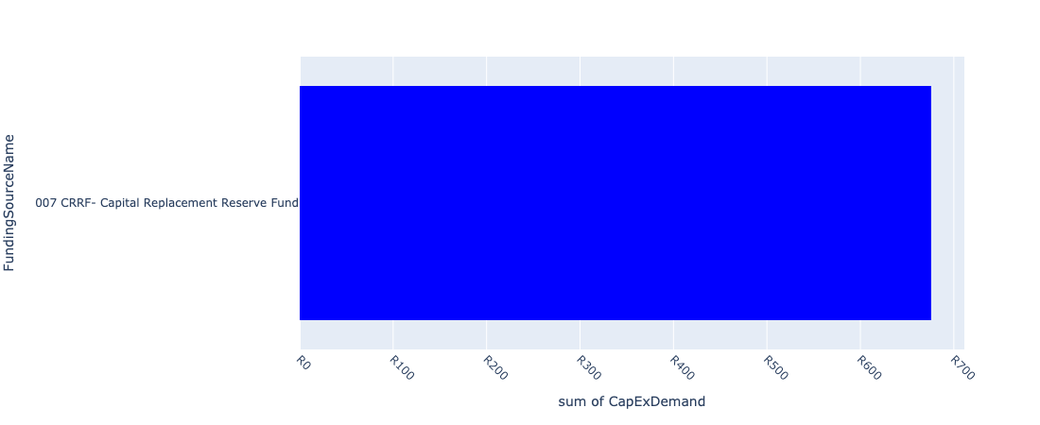

Figure 5.10: Sicelo Neighbourhood Node Departmental Requests

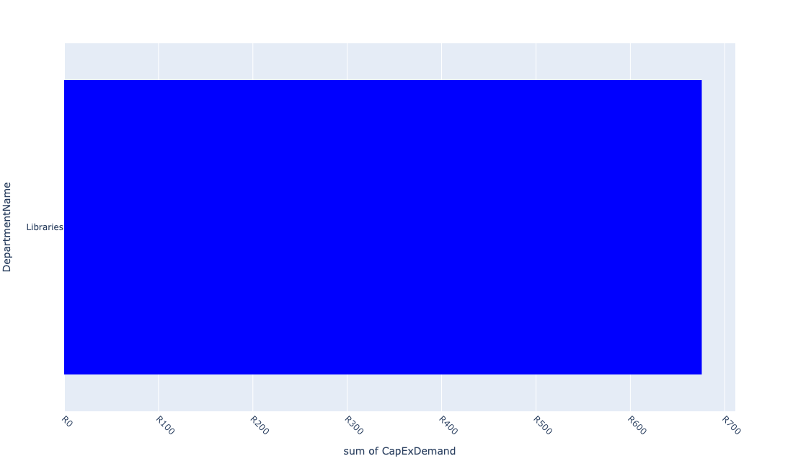

Table 5.5: Summary - Sicelo Neighbourhood Node

|  |  |
| --- | --- |
| Item | Description |
| Total Capital Demand for Sicelo Neighbourhood Node - All Years | R676 Rank: 5 (1 = Highest) |
| Total Capital Demand for Sicelo Neighbourhood Node - MTREF | R676 Rank: 5 (1 = Highest) |
| Financial Years in which capital requirements are listed for Sicelo Neighbourhood Node | 2023, 2024 and 2025 |
| Financial Year with highest capital demand for Sicelo Neighbourhood Node | 2024 |
| Sicelo Neighbourhood Node intersecting feature used | Works Location |
| Total number of projects intersecting with Sicelo Neighbourhood Node | 5 Rank: 4 (1 = Highest) |

Table 5.6: All projects asking for budget in Sicelo Neighbourhood Node

|  |  |  |  |
| --- | --- | --- | --- |
| Project ID | Project Name | Department | Project Budget |
| 10647 | Construct Pedestrian Bridge over R 59 to link Sicelo and Meyerton CBD (UDF) | Roads & Stormwater | R0.00 (0%) No budget request. |
| 10502 | ITC hardware (Computers) - Sicelo | Libraries | R0.00 (0%) No budget request. |
| 11023 | E-Resources | Libraries | R676 (100.00%) Budget spread across: 2023, 2024 and 2025 |
| 10811 | MOBILE TOILETS | Parks | R0.00 (0%) No budget request. |
| 10725 | upgrade of Sicelo Library | Libraries | R0.00 (0%) No budget request. |

Please note that the following projects will not be shown in this table:

* Projects with no recorded intersect with 5 EDCs (in other words no Works Location was recorded on the system for this project)

Projects that do not have any recorded budget demand on the system at the time that this report was requested, are shown in the table with zero budgets indicated.

## Waterval Neighbourhood Node

Figure 5.11: Waterval Neighbourhood Node Funding Requests

**No projects in Waterval Neighbourhood Node.**

Figure 5.12: Waterval Neighbourhood Node Departmental Requests

**No projects in Waterval Neighbourhood Node.**

Table 5.6: Summary - Waterval Neighbourhood Node

|  |  |
| --- | --- |
| Item | Description |
| Total Capital Demand for Waterval Neighbourhood Node - All Years | R0 Rank: 6 (1 = Highest) |
| Total Capital Demand for Waterval Neighbourhood Node - MTREF | R0 Rank: 6 (1 = Highest) |
| Financial Years in which capital requirements are listed for Waterval Neighbourhood Node |  |
| Financial Year with highest capital demand for Waterval Neighbourhood Node | 2023 |
| Waterval Neighbourhood Node intersecting feature used | Works Location |
| Total number of projects intersecting with Waterval Neighbourhood Node | 2 Rank: 6 (1 = Highest) |

Table 5.7: All projects asking for budget in Waterval Neighbourhood Node

|  |  |  |  |
| --- | --- | --- | --- |
| Project ID | Project Name | Department | Project Budget |
| 10811 | MOBILE TOILETS | Parks | R0.00 (0%) No budget request. |
| 10732 | Graceview water reticulation | Water & Sanitation | R0.00 (0%) No budget request. |

Please note that the following projects will not be shown in this table:

* Projects with no recorded intersect with 5 EDCs (in other words no Works Location was recorded on the system for this project)

Projects that do not have any recorded budget demand on the system at the time that this report was requested, are shown in the table with zero budgets indicated.