Spatial Query Report

City of Tshwane Wards

This document was created *2022-03-31-15_12* from the **City of Tshwane Metropolitan Municipality** CP3 system by the following user: *'Bernard'.*

The baseline **'2021/22 Planning + Rollover (20200901)'** with description: **'Duplicated from the 2020/21 Planning + Final Annexure A (20200625) Baseline'** was used. The spatial feature that was selected for the purpose of this report was:  
**'City of Tshwane Wards'**.

This is a spatial feature report for the *City of Tshwane Metropolitan Municipality.* The data contained in this report was sourced directly from the municipality's live CP3 system. The information in this report therefore reflects the data as it was on the *2022-03-31* when this report was requested. Any subsequent updates to the data contained the CP3 System related to the applicable baseline from which this reports was drawn, would therefore not reflect in this report.   
  
For the *City of Tshwane Metropolitan Municipality, the following spatial features are available for the purpose of developing* 'Spatial Query Reports' (similar to this report):

* City of Tshwane mSCOA Regional Segment
* City of Tshwane Regions
* City of Tshwane Wards



We hope you find this useful! Sincerely, *The Novus3 Team.*

# 1. Introduction

The baseline that was queried for this report contains *1461* projects of which a total of *55 (3.76%)* projects do not have any recorded intersection (overlap) with any of the following spatial features:

* City of Tshwane mSCOA Regional Segment
* City of Tshwane Regions
* City of Tshwane Wards

The probable reasons for the 55 non intersecting projects reported are that:

* these projects simply do not have a location associated with them yet (most frequently the case with 'no-intersect' projects) or;
* the location that was captured for some of these projects, may have been in the wrong place (e.g. outside the boundaries of Tshwane - this is very rarely the reason).

It is important to take note of the 3.76% projects that do not intersect with any spatial feature when appraising this report because a similar proportion of non-intersecting projects may be present within the specific geographic feature queried.

The 3.76% of non-intersecting projects is a relative low percentage and therefore not much cause of concern for this particular report.

Figure 1: Intersecting vs Non-Intersecting Projects

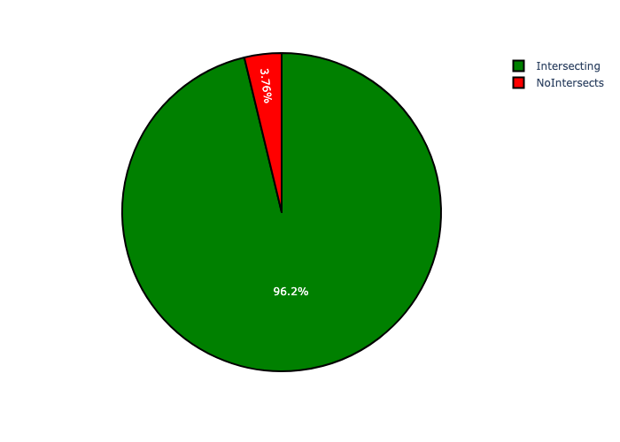

# 2. City of Tshwane Wards Analysis

There is a total number of **107** *City of Tshwane Wards.* Each of the *City of Tshwane Wards* has two important perspectives namely:

* the number of projects within each geographic area and;
* the total capital demand per area.

Figure 2: Projects and Capital Demand per City of Tshwane Wards

