



Spatial Feature Report

T: +27 12 364 2546 | E: info@novus3.co.za Postnet Suite 471, Private Bag X15,

Menlo Park, 0102**www.novus3.co.za**

engineered solutions

Disclaimer

This document contains data that was obtained from a live CP3 system at the moment the data was requested. The data is updated by users of the CP3 System and unless the system is locked for changes, this data may change on a daily basis. The reader is therefore cautioned not to place inappropriate reliance on the data unless there is certainty on the status of the data in terms of how recently it has been updated, how “clean” the data is (is there a quality control and/or verification process that was followed by the licensee of the CP3 system to ensure that data is checked and verified from time-to-time) and whether the correct baseline was queried. This report therefore provides a “snapshot in time”. Consequently, the document may be less relevant at a different time, or using a different financial baseline to query from.

At all times, all rights, title and interest in and to this material remains vested in the owner of this document and are copyrighted and protected by regulatory provisions. These materials may not be copied, reproduced, modified, published, uploaded, posted to websites or otherwise distributed in any way, without our prior written permission from the Licensee and Licensor (Nvous3 (Pty) Ltd) of the CP3 Software. The owner of this document does not grant any right to reproduce the materials. All our rights in this regard are and remain reserved.

Spatial Query Report: City of Tshwane Wards

This document was created *2022-04-04-19_40* from the **City of Tshwane Metropolitan Municipality** CP3 system by the following user: *'Bernard'.*

The baseline **'2021/22 Planning + Rollover (20200901)'** with description: **'Duplicated from the 2020/21 Planning + Final Annexure A (20200625) Baseline'** was used. The spatial feature that was selected for the purpose of this report was: **'City of Tshwane Wards'**.

This is a spatial feature report for the *City of Tshwane Metropolitan Municipality.* The data contained in this report was sourced directly from the municipality's live CP3 system. The information in this report therefore reflects the data as it was on the *2022-04-04* when this report was requested. Any subsequent updates to the data contained the CP3 System related to the applicable baseline from which this reports was drawn, would therefore not reflect in this report.   
  
For the *City of Tshwane Metropolitan Municipality, the following spatial features are available for the purpose of developing* 'Spatial Query Reports' (similar to this report):

* City of Tshwane mSCOA Regional Segment
* City of Tshwane Regions
* City of Tshwane Wards



We hope you find this useful! Sincerely, *The Novus3 Team.*

# Introduction

The baseline that was queried for this report contains *1461* projects of which a total of *55 (3.76%)* projects do not have any recorded intersection (overlap) with any of the following spatial features:

* City of Tshwane mSCOA Regional Segment
* City of Tshwane Regions
* City of Tshwane Wards

The probable reasons for the 55 non intersecting projects reported are that:

* these projects simply do not have a location associated with them yet (most frequently the case with 'no-intersect' projects) or;
* the location that was captured for some of these projects, may have been in the wrong place (e.g. outside the boundaries of Tshwane - this is very rarely the reason).

It is important to take note of the 3.76% projects that do not intersect with any spatial feature when appraising this report because a similar proportion of non-intersecting projects may be present within the specific geographic feature queried.

The 3.76% of non-intersecting projects is a relative low percentage and therefore not much cause of concern for this particular report.

Figure 1: Intersecting vs Non-Intersecting Projects

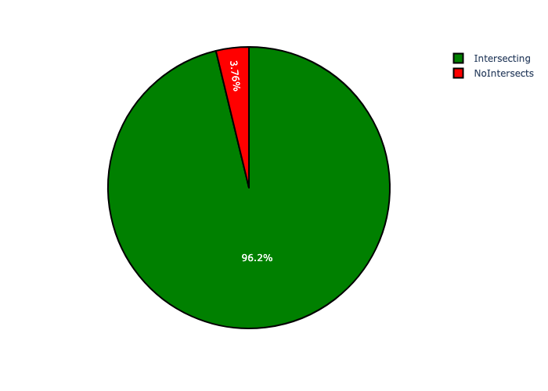

# City of Tshwane Wards Analysis

There is a total number of **107** *City of Tshwane Wards.* Each of the *City of Tshwane Wards* has two important perspectives namely:

* the number of projects within each geographic area and;
* the total capital demand per area.

The following information relates to the number of projects in City of Tshwane Wards:

* Ward 58 has the highest number of projects: 85 projects (6.05% of total number of projects);
* Ward 72 has the lowest number of projects: 1 project (0.07% of total number of projects);
* The average number of projects per City of Tshwane Wards is 13.1 projects;
* The 75th percentile of projects per City of Tshwane Wards is 16.0 projects;
* The total number of projects in all City of Tshwane Wards is 1406 projects;
* The 5 City of Tshwane Wards with the most projects have a combined total of 265 projects. This accounts for 18.85% of the total number of projects.

The following information relates to the capital demand in City of Tshwane Wards:

* Ward 100 has the highest capital demand: R844,568,697 (8.06% of total capital demand);
* Ward 72 has the lowest capital demand: R3,826 (0.00% of total capital demand);
* The average capital demand per City of Tshwane Wards is R97,892,440;
* The 75th percentile of capital demand per City of Tshwane Wards is R110,493,612.
* The total capital demand in all City of Tshwane Wards is R10,474,491,122;
* The 5 City of Tshwane Wards with the highest capital demand have a combined total of R3,181,331,830. This accounts for 30.37% of the total capital demand.

Figure 2.1: Projects and Capital Demand per City of Tshwane Wards (1/3)

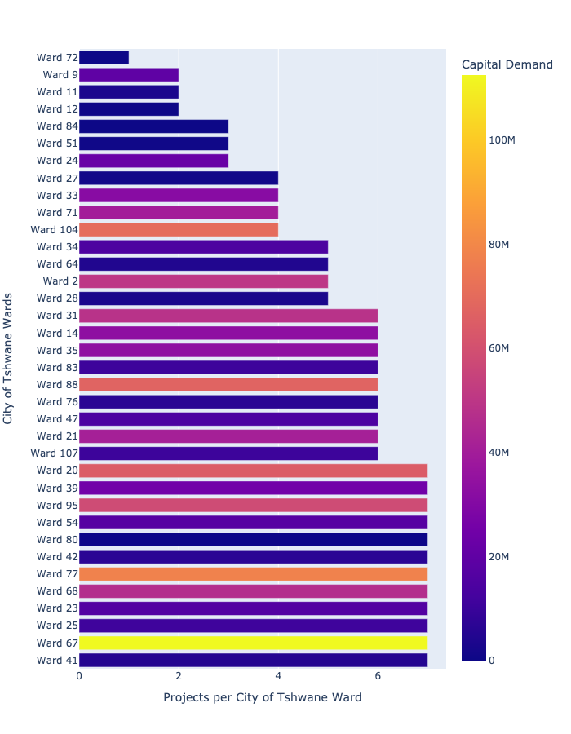

Figure 2.2: Projects and Capital Demand per City of Tshwane Wards (2/3)

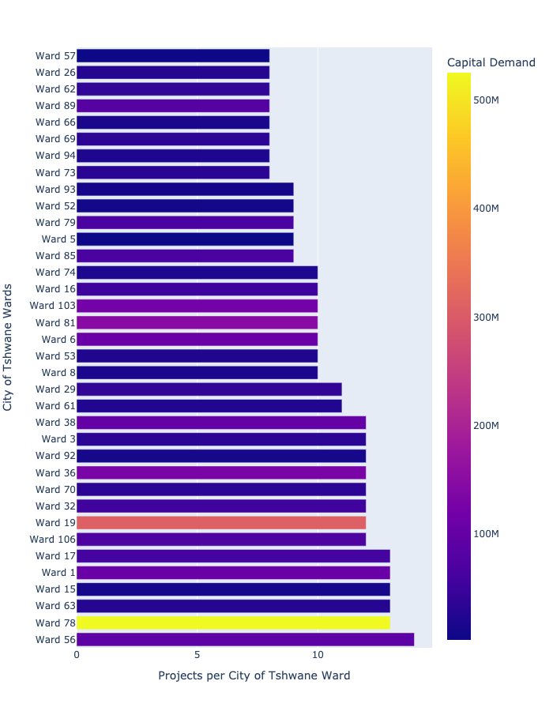

Figure 2.3: Projects and Capital Demand per City of Tshwane Wards (3/3)

