



Spatial Feature Report

T: +27 12 364 2546 | E: info@novus3.co.za Postnet Suite 471, Private Bag X15,

Menlo Park, 0102**www.novus3.co.za**

engineered solutions

Disclaimer

This document contains data that was obtained from a live CP3 system at the moment the data was requested. The data is updated by users of the CP3 System and unless the system is locked for changes, this data may change on a daily basis. The reader is therefore cautioned not to place inappropriate reliance on the data unless there is certainty on the status of the data in terms of how recently it has been updated, how “clean” the data is (is there a quality control and/or verification process that was followed by the licensee of the CP3 system to ensure that data is checked and verified from time-to-time) and whether the correct baseline was queried. This report therefore provides a “snapshot in time”. Consequently, the document may be less relevant at a different time, or using a different financial baseline to query from.

At all times, all rights, title and interest in and to this material remains vested in the owner of this document and are copyrighted and protected by regulatory provisions. These materials may not be copied, reproduced, modified, published, uploaded, posted to websites or otherwise distributed in any way, without our prior written permission from the Licensee and Licensor (Nvous3 (Pty) Ltd) of the CP3 Software. The owner of this document does not grant any right to reproduce the materials. All our rights in this regard are and remain reserved.

**No table of contents entries found.**

Spatial Query Report: City of Tshwane Wards

This document was created *2022-04-23-15_32* from the **City of Tshwane Metropolitan Municipality** CP3 system.

The baseline **'2021/22 Planning + Rollover (20200901)'** with description: **'Duplicated from the 2020/21 Planning + Final Annexure A (20200625) Baseline'** was used. The spatial feature that was selected for the purpose of this report was: **'City of Tshwane Wards'**.

This is a spatial feature report for the *City of Tshwane Metropolitan Municipality.* The data contained in this report was sourced directly from the municipality's live CP3 system. The information in this report therefore reflects the data as it was on the *2022-04-23* when this report was requested. Any subsequent updates to the data contained the CP3 System related to the applicable baseline from which this reports was drawn, would therefore not reflect in this report.   
  
For the *City of Tshwane Metropolitan Municipality, the following spatial features are available for the purpose of developing* 'Spatial Query Reports' (similar to this report):

* City of Tshwane mSCOA Regional Segment
* City of Tshwane Regions
* City of Tshwane Wards



We hope you find this useful! Sincerely, *The Novus3 Team.*

# Introduction

The baseline that was queried for this report contains *1461* projects of which a total of *55 (3.76%)* projects do not have any recorded intersection (overlap) with City of Tshwane Wards.The following spatial features are available for queries using this API profile:

* City of Tshwane mSCOA Regional Segment
* City of Tshwane Regions
* City of Tshwane Wards

The probable reasons for the 55 non intersecting projects reported are that:

* these projects simply do not have a location associated with them yet (most frequently the case with 'no-intersect' projects) or;
* the location that was captured for some of these projects, may have been in the wrong place (e.g. outside the boundaries of Tshwane - this is very rarely the reason).

It is important to take note of the 3.76% projects that do not intersect with City of Tshwane Wards feature when appraising this report.

The 3.76% of non-intersecting projects is a relative low percentage and therefore not much cause of concern for this particular report.

Figure 1: Intersecting vs Non-Intersecting Projects

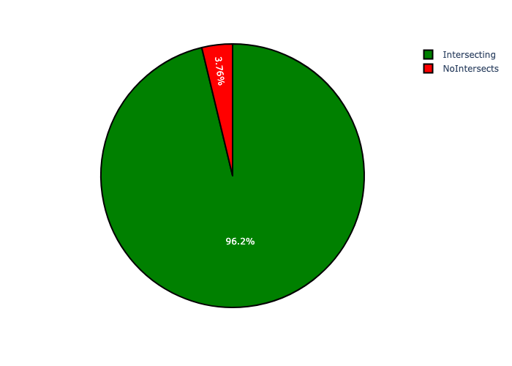

# Total Number of Projects and Total Capital Demand per City of Tshwane Ward - All Years

Table 1.1 below provides a concise summary of key statistical insights regarding the number of projects that are requesting funding in each of the City of Tshwane Wards.

Table 1.1: City of Tshwane Wards Analysis - Number of Projects

|  |  |  |  |
| --- | --- | --- | --- |
| Description | Info (1) | Info (2) | Info (3) |
| Number of projects in all City of Tshwane Wards - Overview | Total in all City of Tshwane Wards: 1406 projects | Average per City of Tshwane Wards: 13.1 projects | 75th percentile of projects across all City of Tshwane Wards: 16.0 projects |
| The highest number of projects | City of Tshwane Wards: In Ward 58 | Number of projects in Ward 58: 85 | Percentage of total in Ward 58: 6.05% |
| The lowest number of projects: | City of Tshwane Wards: In Ward 72 | Number of projects in Ward 72: 1 | Percentage of total in Ward 72: 0.07% |
| The 5 City of Tshwane Wards that collectively have with the highest number of projects | City of Tshwane Wards: In Ward 98, Ward 100, Ward 96, Ward 50 and Ward 58 | Number of projects in Ward 98, Ward 100, Ward 96, Ward 50 and Ward 58 together: 266 | Percentage of total in Ward 98, Ward 100, Ward 96, Ward 50 and Ward 58 together: 18.92% |

Table 1.2 below provides a concise summary of key statistical insights regarding the total capital demand per City of Tshwane Ward.

Table 1.2: City of Tshwane Wards Analysis - Capital Demand (R)

|  |  |  |  |
| --- | --- | --- | --- |
| Description | Info (1) | Info (2) | Info (3) |
| Capital demand in all City of Tshwane Wards - Overview | Total capital demand in all City of Tshwane Wards: R48,877,051,173 | The average capital demand per City of Tshwane Wards: R456,794,871 | The 75th percentile of capital demand for City of Tshwane Wards: R523,295,945 |
| The highest capital demand | City of Tshwane Wards: In Ward 96 | Capital Demand in Ward 96: R5,160,755,906 | Percentage of total in Ward 96: 10.56% |
| The lowest capital demand | City of Tshwane Wards: In Ward 72 | Capital Demand in Ward 72: R3,826 | Percentage of total in Ward 72: 0.00% |
| The 5 City of Tshwane Wards that collectively have collective the highest capital demand: | City of Tshwane Wards: In Ward 50, Ward 102, Ward 100, Ward 58 and Ward 96 | Capital Demand in Ward 50, Ward 102, Ward 100, Ward 58 and Ward 96 together: R14,210,793,031 | Percentage of total in Ward 50, Ward 102, Ward 100, Ward 58 and Ward 96 together: 29.07% |

The number of projects per City of Tshwane Ward and the capital demand per City of Tshwane Ward needs to be looked at together for better insight. Figures 2.1 and 2.2 assist with further graphical insight into some of the numbers that are provided in Tables 1.1 and 1.2.

Figure 2.1: The single City of Tshwane Ward with the highest value (Nr of Projects & Capital Demand) vs the rest

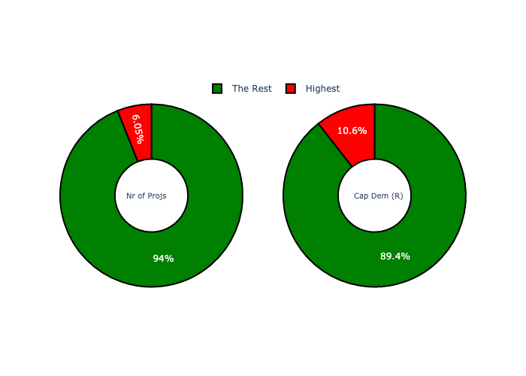

The highest number of projects in a single City of Tshwane Ward is in **Ward 58.** *That is 85 projects and this is 6.05% of the total number of projects.*The highest capital demand in a single City of Tshwane Ward is in **Ward 96.** *That is R5,160,755,906 and this amounts to 10.56% of the total capital demand.*

Figure 2.2: The 5 City of Tshwane Wards with the highest values (Nr of Projects & Capital Demand) vs the rest

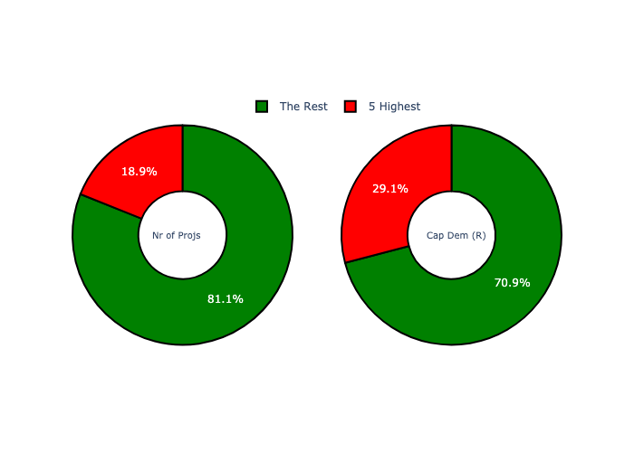

The 5 City of Tshwane Wards that collectively have with the highest number of projects are in **Ward 98, Ward 100, Ward 96, Ward 50 and Ward 58.** *That is 266 projects and this is 18.92% of the total number of projects.*The 5 City of Tshwane Wards that collectively have the highest capital demand are in **Ward 50, Ward 102, Ward 100, Ward 58 and Ward 96.** *That is 29.07% and this amounts to R14,210,793,031 of the total capital demand.*

The following figures provide a bar graph representation of the number of projects per City of Tshwane Ward with the colour of the bars representing the level of capital demand in each of these City of Tshwane Wards.

Figure 3.1: Projects and Capital Demand per City of Tshwane Ward (1/3)

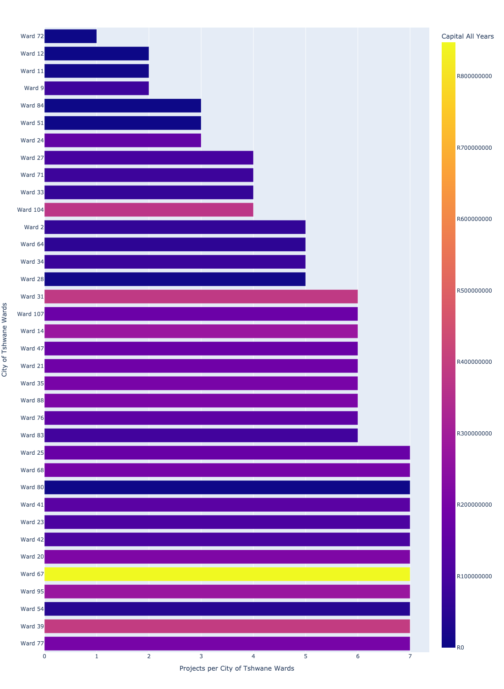

Figure 3.2: Projects and Capital Demand per City of Tshwane Ward (2/3)

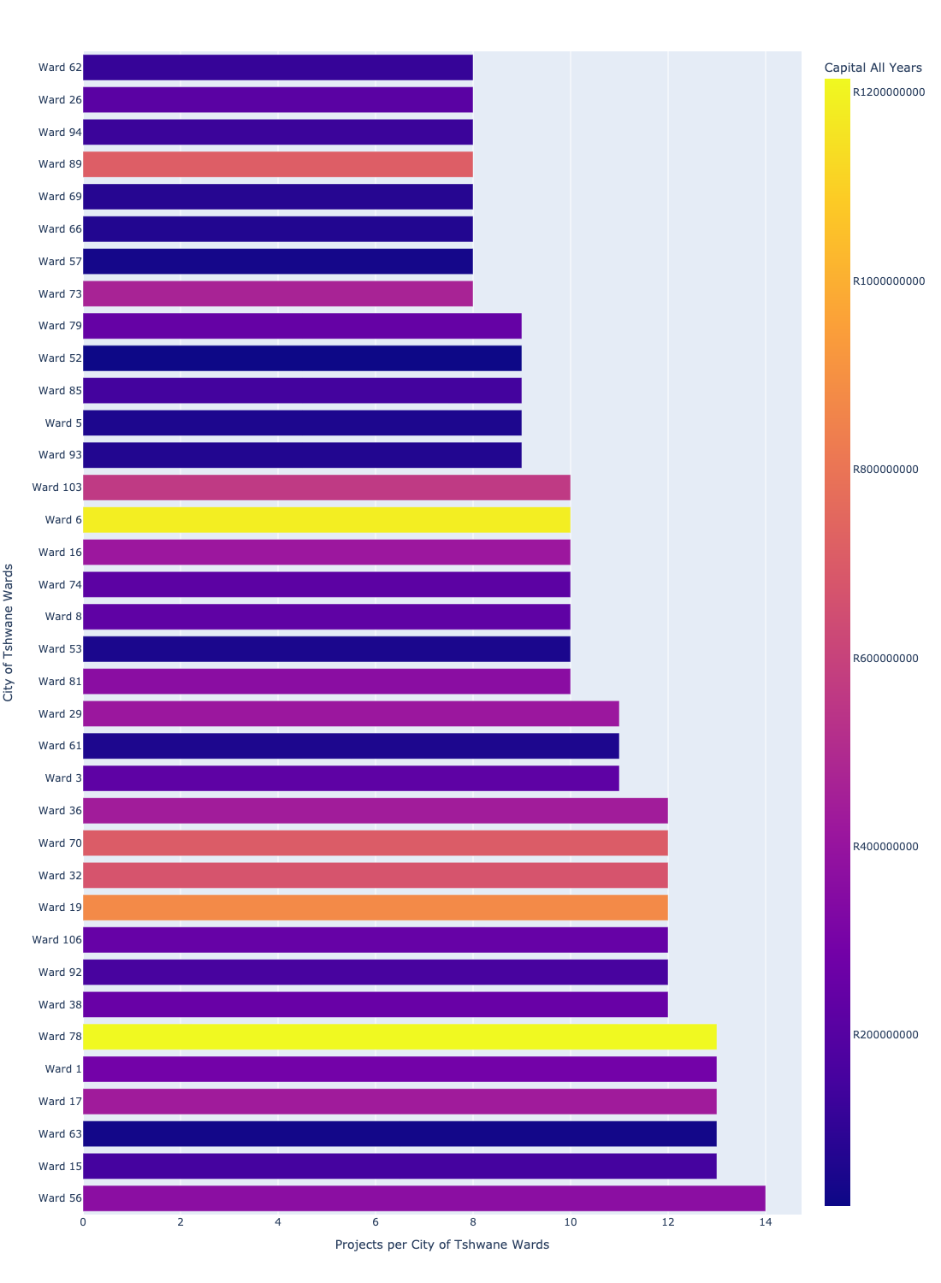

Figure 3.3: Projects and Capital Demand per City of Tshwane Ward (3/3)

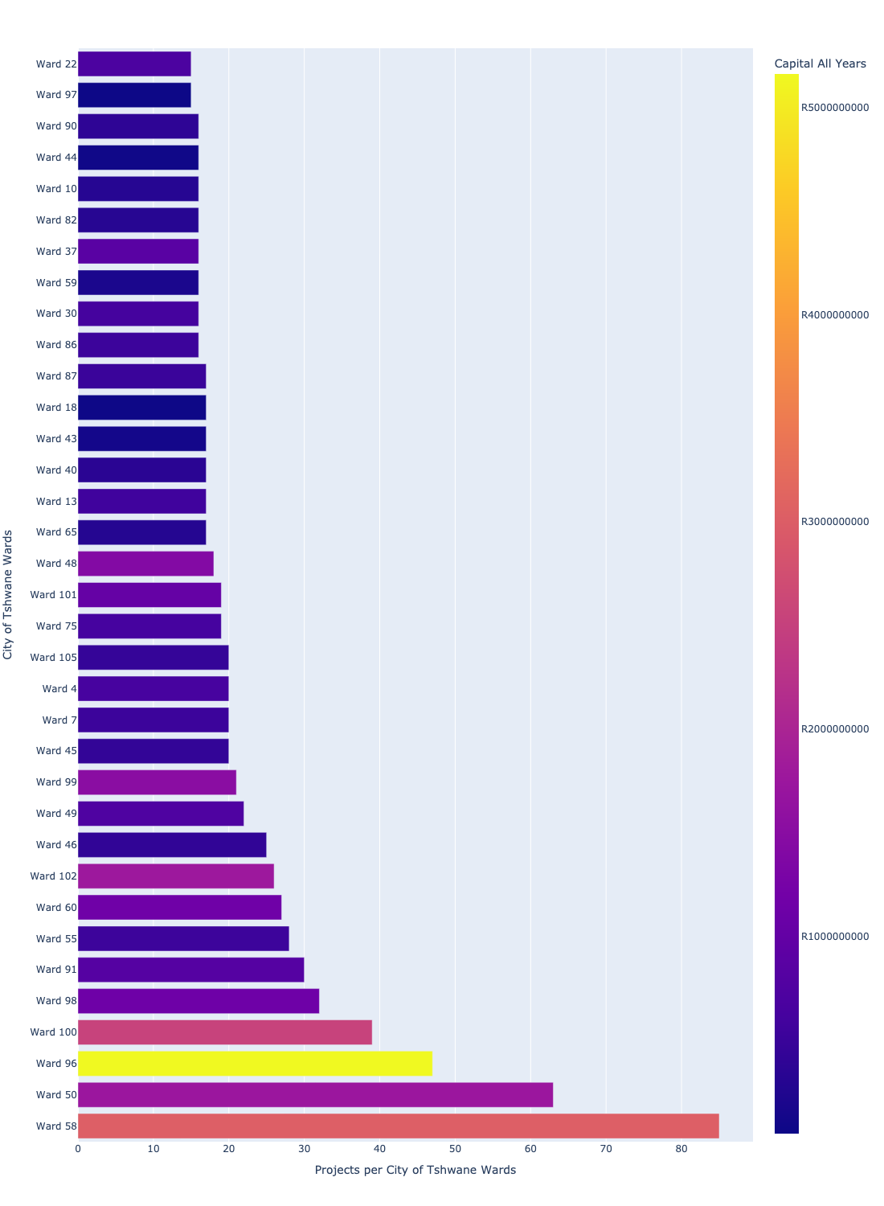

# Total Capital Demand per City of Tshwane Ward - All Years

The following figures provide a histogram representation of the capital demand per City of Tshwane Ward. A colour breakdown is provided of each year's sub-total that contribute towards the overall total capital demand of each City of Tshwane Ward. Note that the capital demand beyond the first three years representing the Medium Term Expenditure Framework (MTREF - years 2022, 2023 and 2024) are generally more sparsely and less diligently populated, therefore less reliance should be vested on these outer years when appraising the overall capital demand. The reason for this is usually because of National Treasury's requirement for annual budget submissions spanning only over the MTREF (i.e. the next three years).

Figure 4.1: Capital Demand per City of Tshwane Ward - All Years (1/3)

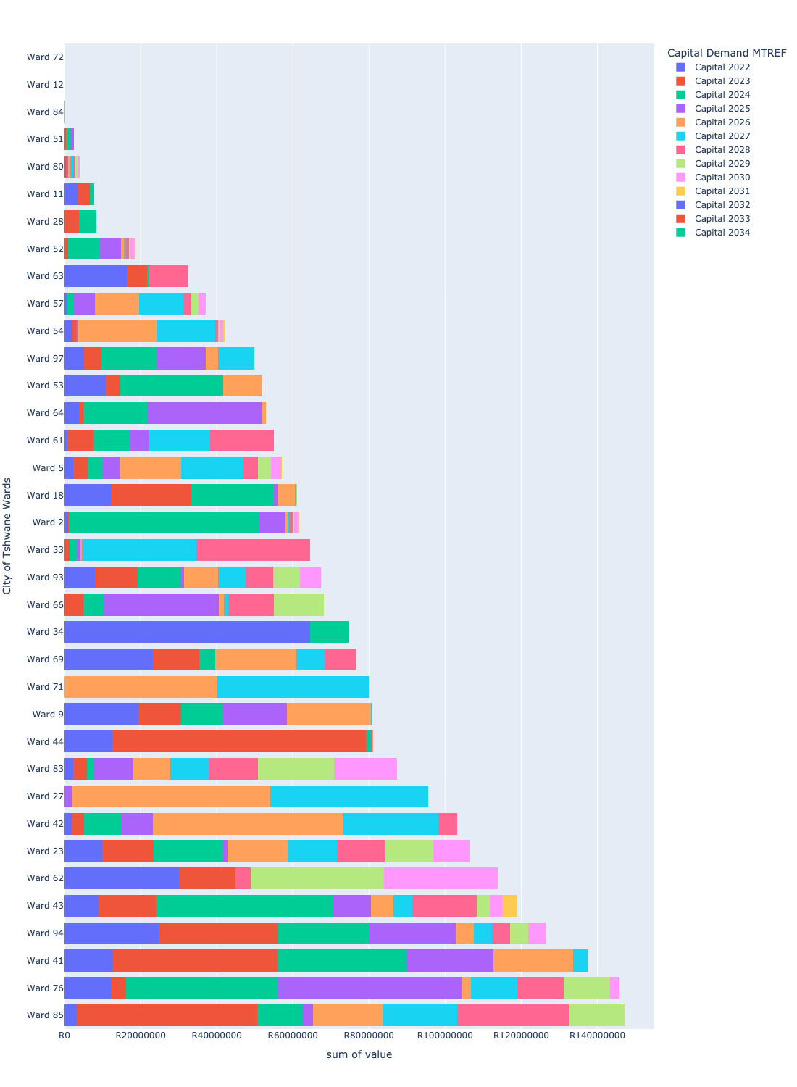

Figure 4.2: Capital Demand per City of Tshwane Ward - All Years (2/3)

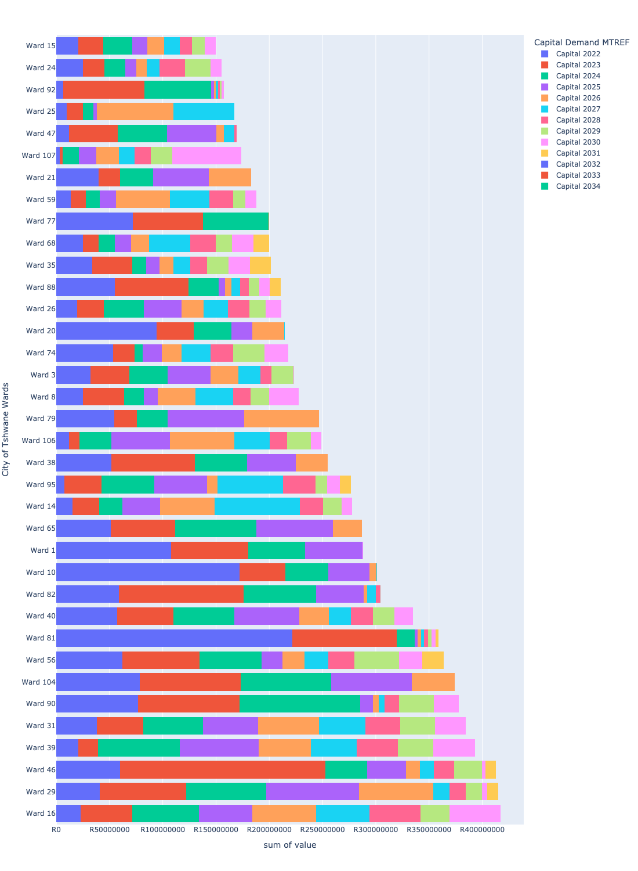

Figure 4.3: Capital Demand per City of Tshwane Ward - All Years (3/3)

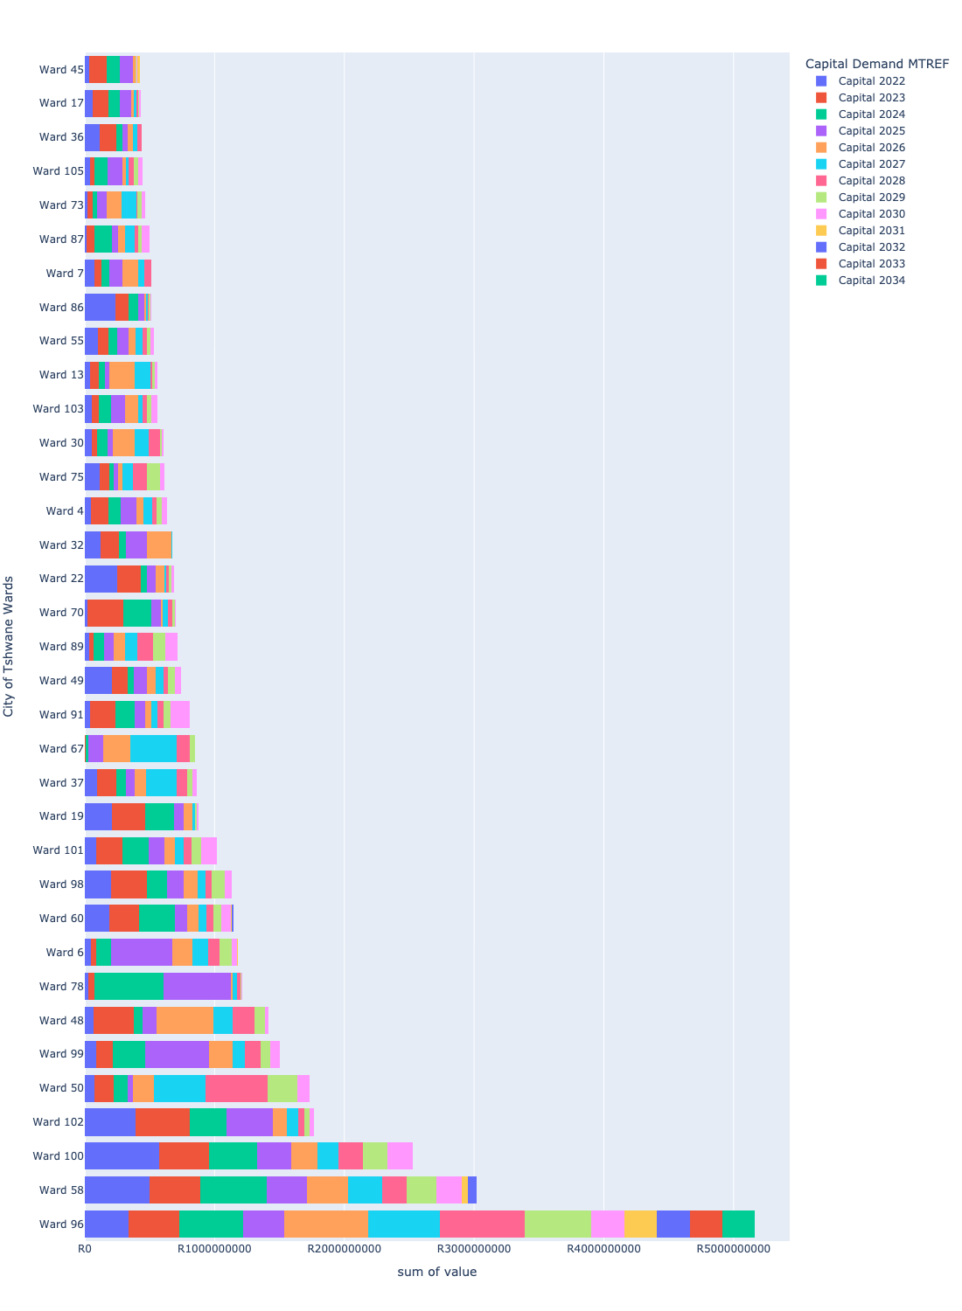

# Total Capital Demand per City of Tshwane Ward - MTREF only

Table 2 below provides a concise summary of key statistical insights regarding the total MTREF capital demand per City of Tshwane Ward.

Table 2: City of Tshwane Wards Analysis - MTREF Capital Demand (R)

|  |  |  |  |
| --- | --- | --- | --- |
| Description | Info (1) | Info (2) | Info (3) |
| MTREF Capital demand in all City of Tshwane Wards - Overview | MTREF capital demand in all City of Tshwane Wards: R21,480,882,838 | The average MTREF capital demand per City of Tshwane Ward: R200,755,914 | The 75th percentile of MTREF capital demand for City of Tshwane Wards: R256,830,440 |
| The highest MTREF capital demand | In City of Tshwane Ward: Ward 58 | MTREF capital Demand in Ward 58: R1,404,770,061 | Percentage of total MRTEF capital demand in Ward 58: 6.54% |
| The lowest MTREF capital demand | In City of Tshwane Ward: Ward 72 | MTREF capital Demand in Ward 72: R0 | Percentage of total MTREF capital demand in Ward 72: 0.00% |

The following figures provide a histogram representation of the capital demand per City of Tshwane Ward. A colour breakdown is provided of each year's sub-total that contribute towards the overall MTREF total capital demand of each City of Tshwane Ward.

Figure 5.1: Capital Demand per City of Tshwane Ward - MTREF Period (1/3)

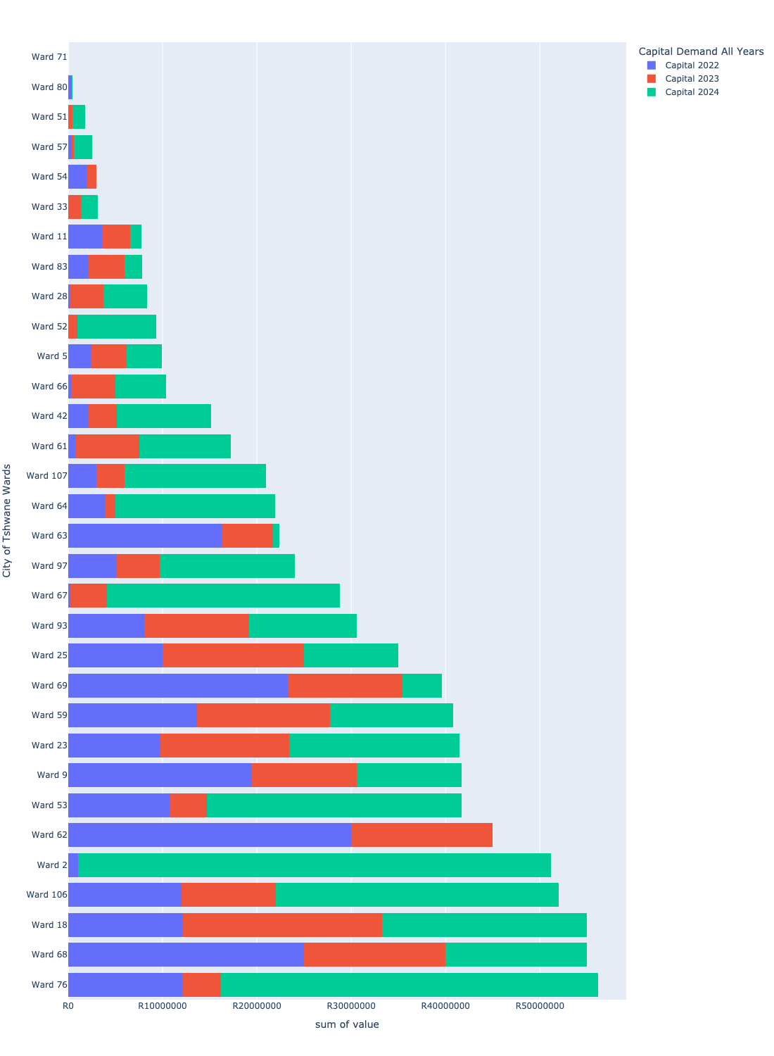

Figure 5.2: Capital Demand per City of Tshwane Ward - MTREF Period (2/3)

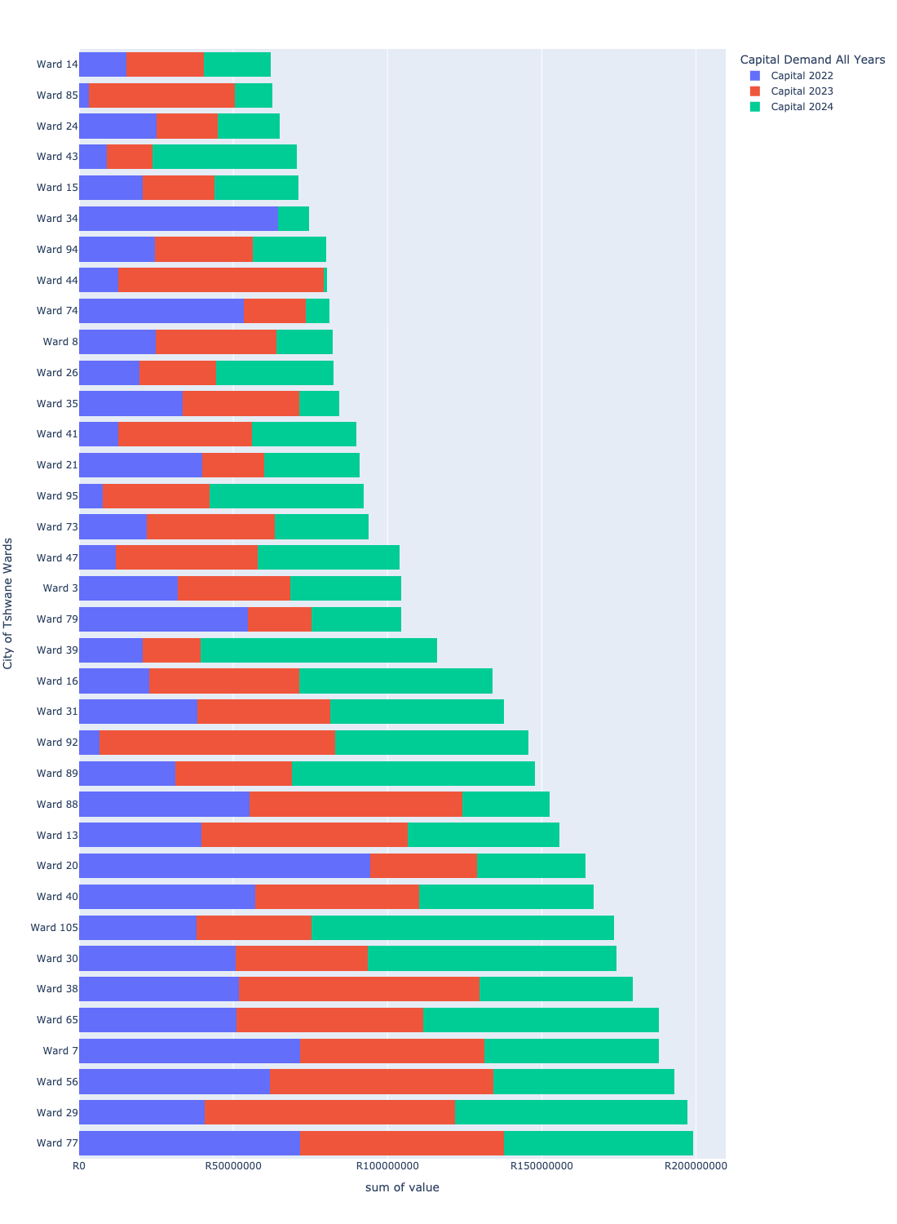

Figure 5.3: Capital Demand per City of Tshwane Ward - MTREF Period (3/3)

