

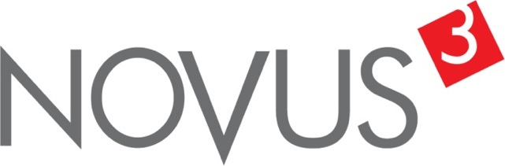

Spatial Feature Report

T: +27 12 364 2546 | E: info@novus3.co.za Postnet Suite 471, Private Bag X15,

Menlo Park, 0102**www.novus3.co.za**

engineered solutions

Disclaimer

This document contains data that was obtained from a live CP3 system at the moment the data was requested. The data is updated by users of the CP3 System and unless the system is locked for changes, this data may change on a daily basis. The reader is therefore cautioned not to place inappropriate reliance on the data unless there is certainty on the status of the data in terms of how recently it has been updated, how “clean” the data is (is there a quality control and/or verification process that was followed by the licensee of the CP3 system to ensure that data is checked and verified from time-to-time) and whether the correct baseline was queried. This report therefore provides a “snapshot in time”. Consequently, the document may be less relevant at a different time, or using a different financial baseline to query from.

At all times, all rights, title and interest in and to this material remains vested in the owner of this document and are copyrighted and protected by regulatory provisions. These materials may not be copied, reproduced, modified, published, uploaded, posted to websites or otherwise distributed in any way, without our prior written permission from the Licensee and Licensor (Nvous3 (Pty) Ltd) of the CP3 Software. The owner of this document does not grant any right to reproduce the materials. All our rights in this regard are and remain reserved.

Table of Contents

**No table of contents entries found.** (Right-click -> Update Field)

Spatial Query Report

This document was created *2022-05-02-00_02* from the **City of Tshwane Metropolitan Municipality** CP3 system.

The baseline **'2021/22 Planning + Rollover (20200901)'** with description: **'Duplicated from the 2020/21 Planning + Final Annexure A (20200625) Baseline'** was used. The spatial feature that was selected for the purpose of this report was: **'City of Tshwane Regions'**.

This is a spatial feature report for the *City of Tshwane Metropolitan Municipality.* The data contained in this report was sourced directly from the municipality's live CP3 system. The information in this report therefore reflects the data as it was on *2022-05-02* when this report was requested. Any subsequent updates to the data contained the CP3 System related to the applicable baseline from which this reports was drawn, would therefore not reflect in this report.   
  
For the *City of Tshwane Metropolitan Municipality, the following spatial features are available for the purpose of developing* 'Spatial Query Reports' (similar to this report):

* City of Tshwane mSCOA Regional Segment
* City of Tshwane Regions
* City of Tshwane Wards



We hope you find this useful! Sincerely, *The Novus3 Team.*

# Introduction

The baseline that was queried for this report contains *1020* projects of which a total of *24 (2.35%)* projects do not have any recorded intersection (overlap) with City of Tshwane Regions. The following spatial features are available for queries using this API profile:

* City of Tshwane mSCOA Regional Segment
* City of Tshwane Regions
* City of Tshwane Wards

The probable reasons for the 24 non intersecting projects reported are that:

* these projects simply do not have a location associated with them yet (most frequently the case with 'no-intersect' projects) or;
* the location that was captured for some of these projects, may have been in the wrong place (e.g. outside the boundaries of Tshwane - this is very rarely the reason).

It is important to take note of the 2.35% projects that do not intersect with City of Tshwane Regions feature when appraising this report.

The 2.35% of non-intersecting projects is a relative low percentage and therefore not much cause of concern for this particular report.

Figure 1.1: Intersecting vs Non-Intersecting Projects

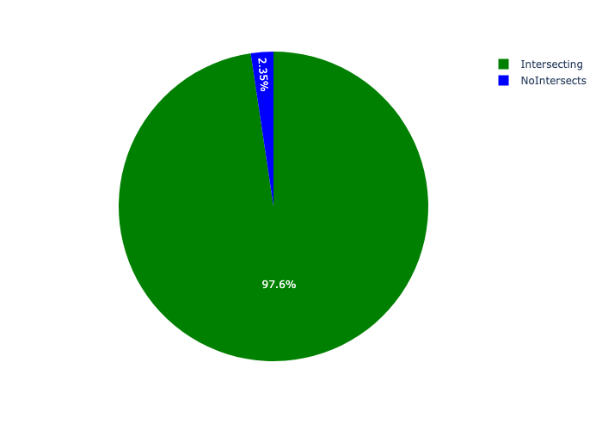

# Total Number of Projects and Total Capital Demand per City of Tshwane Region - All Years

Table 2.1 below provides a concise summary of key statistical insights regarding the number of projects that are requesting funding in each of the City of Tshwane Regions.

Table 2.1: City of Tshwane Regions Analysis - Number of Projects

|  |  |  |  |
| --- | --- | --- | --- |
| Description | Info (1) | Info (2) | Info (3) |
| Number of projects in all City of Tshwane Regions - Overview | Total in all City of Tshwane Regions: 996 projects | Average per City of Tshwane Regions: 142 projects | 75th percentile of projects across all City of Tshwane Regions: 177.0 projects |
| The highest number of projects | City of Tshwane Regions: In Region 3 | Number of projects in Region 3: 256 | Percentage of total in Region 3: 25.70% |
| The lowest number of projects: | City of Tshwane Regions: In Region 7 | Number of projects in Region 7: 48 | Percentage of total in Region 7: 4.82% |

Table 2.1 below provides a concise summary of key statistical insights regarding the total capital demand per City of Tshwane Region.

Table 2.1: City of Tshwane Regions Analysis - Capital Demand (R)

|  |  |  |  |
| --- | --- | --- | --- |
| Description | Info (1) | Info (2) | Info (3) |
| Capital demand in all City of Tshwane Regions - Overview | Total capital demand in all City of Tshwane Regions: R48,877,051,117 | The average capital demand per City of Tshwane Regions: R6,982,435,874 | The 75th percentile of capital demand for City of Tshwane Regions: R9,106,752,895 |
| The highest capital demand | City of Tshwane Regions: In Region 2 | Capital Demand in Region 2: R10,481,643,396 | Percentage of total in Region 2: 21.44% |
| The lowest capital demand | City of Tshwane Regions: In Region 7 | Capital Demand in Region 7: R3,149,916,794 | Percentage of total in Region 7: 6.44% |

The number of projects per City of Tshwane Region and the capital demand per City of Tshwane Region needs to be looked at together for better insight. Figures 2.1 and 2.2 assist with further graphical insight into some of the numbers that are provided in Tables 2.1 and 2.2.

Figure 2.1: The single City of Tshwane Region with the highest value (Nr of Projects & Capital Demand) vs the rest

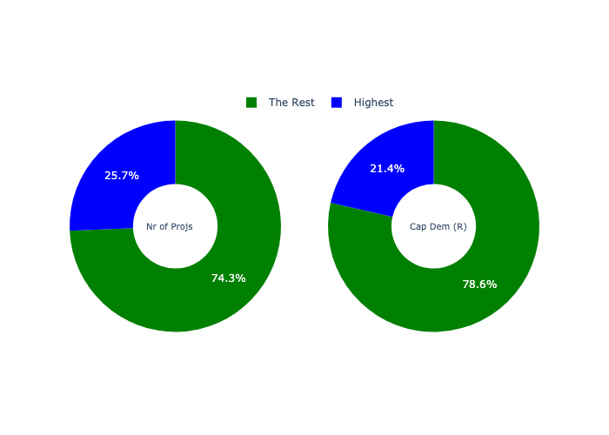

The highest number of projects in a single City of Tshwane Region is in **Region 3.** *That is 256 projects and this is 25.70% of the total number of projects.*The highest capital demand in a single City of Tshwane Region is in **Region 2.** *That is R10,481,643,396 and this amounts to 21.44% of the total capital demand.*

The following figures provide a bar graph representation of the number of projects per City of Tshwane Region with the colour of the bars representing the level of capital demand in each of these City of Tshwane Regions.

Figure 2.2: Projects and Capital Demand per City of Tshwane Region

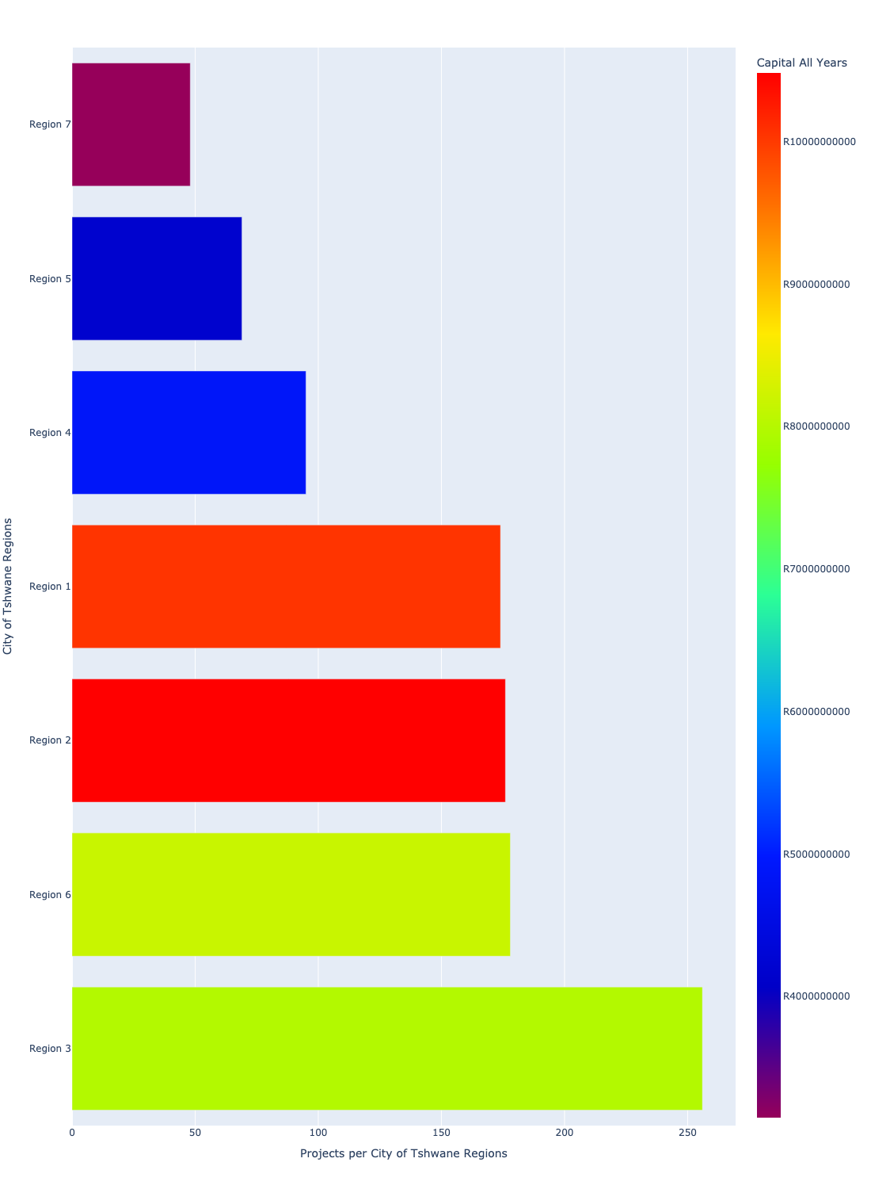

# Total Capital Demand per City of Tshwane Region - All Years

There are different funding sources from which capital is requested. For the financial baseline that was selected for this report query (2021/22 Planning + Rollover (20200901)), the breakdown of capital demand for City of Tshwane Metropolitan Municipality per funding source is shown in Figure 3.1 below.

Figure 3.1: Capital Demand Per Funding Source

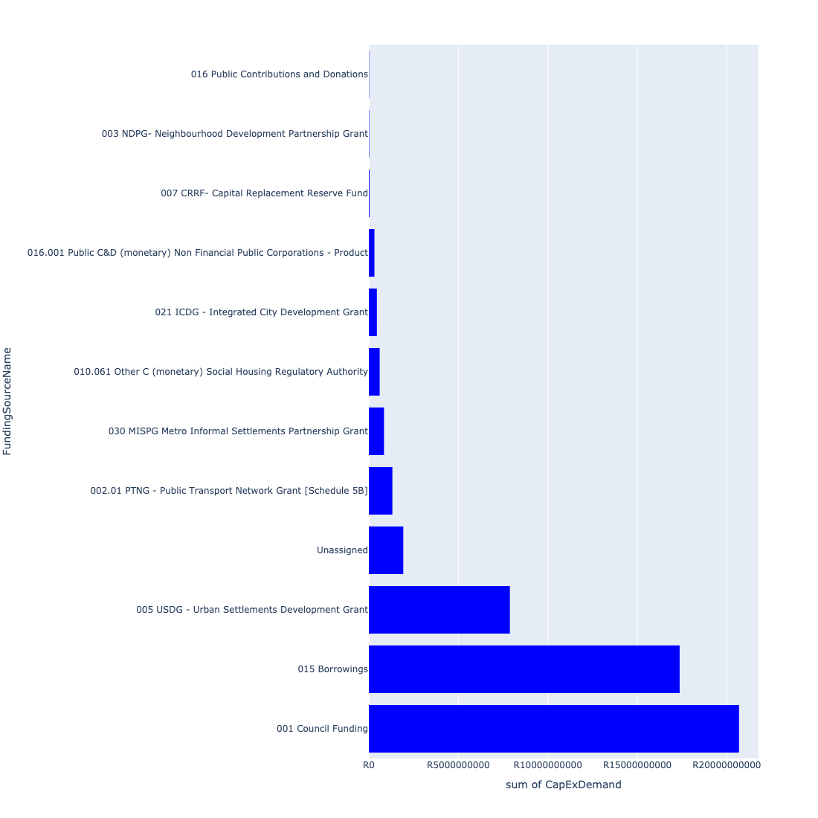

For the financial baseline that was selected for this report query (2021/22 Planning + Rollover (20200901)), the breakdown of capital demand for City of Tshwane Metropolitan Municipality per department is shown in Figure 3.2 below.

Figure 3.2: Capital Demand Per City of Tshwane Metropolitan Municipality Department

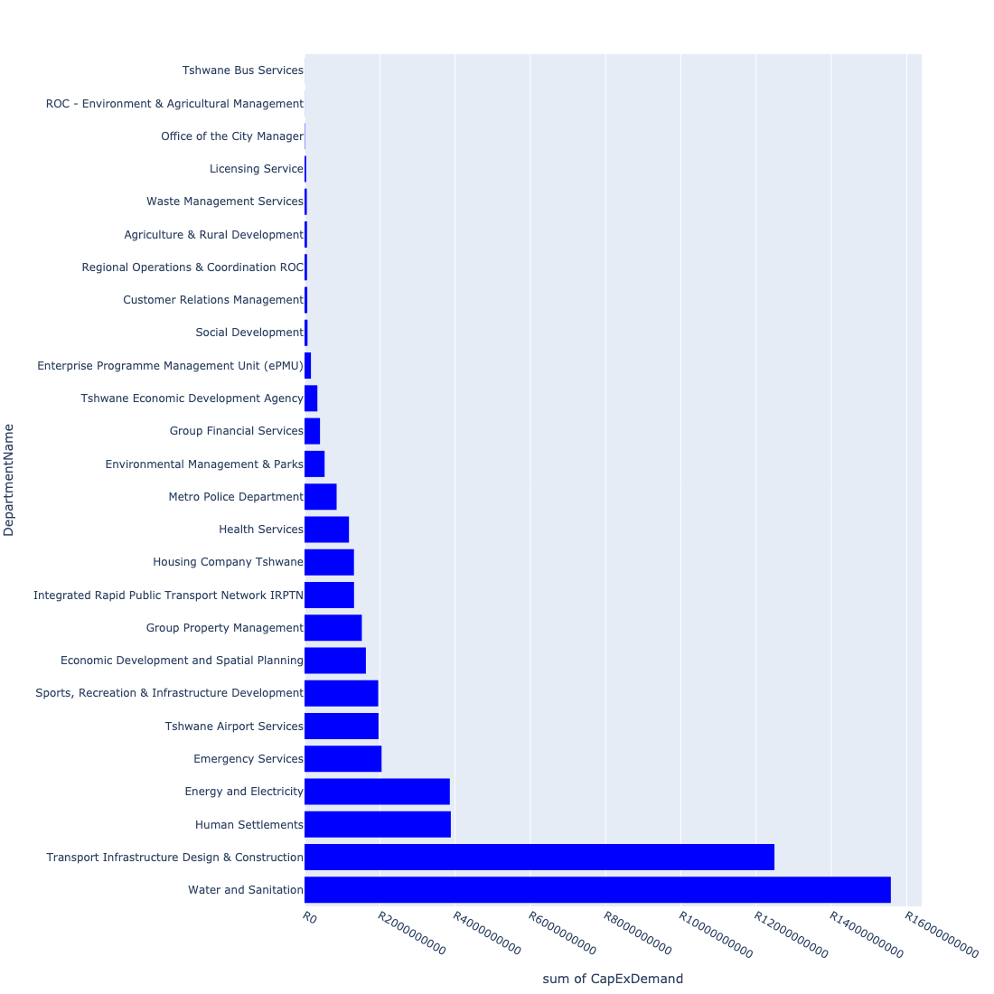

The following figures provide a histogram representation of the capital demand per City of Tshwane Region. A colour breakdown is provided of each year's sub-total that contribute towards the overall total capital demand of each City of Tshwane Region. Note that the capital demand beyond the first three years representing the Medium Term Expenditure Framework (MTREF - years 2022, 2023 and 2024) are generally more sparsely and less diligently populated, therefore less reliance should be vested on these outer years when appraising the overall capital demand. The reason for this is usually because of National Treasury's requirement for annual budget submissions spanning only over the MTREF (i.e. the next three years).

Figure 3.3: Capital Demand per City of Tshwane Region - All Years

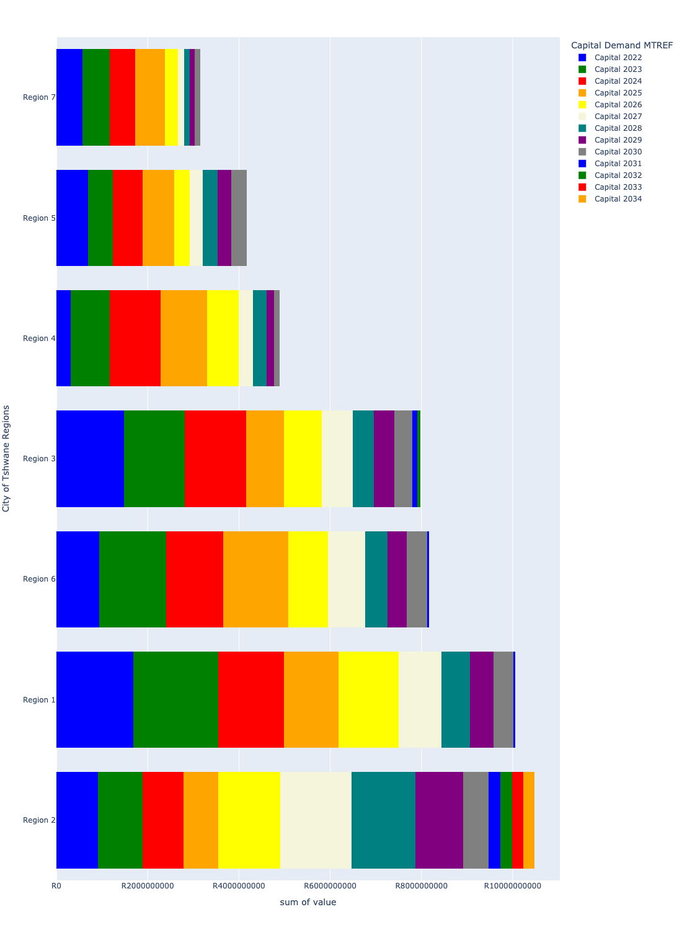

# Total Capital Demand per City of Tshwane Region - MTREF only

Table 4.1 below provides a concise summary of key statistical insights regarding the total MTREF capital demand per City of Tshwane Region.

Table 4.1: City of Tshwane Regions Analysis - MTREF Capital Demand (R)

|  |  |  |  |
| --- | --- | --- | --- |
| Description | Info (1) | Info (2) | Info (3) |
| MTREF Capital demand in all City of Tshwane Regions - Overview | MTREF capital demand in all City of Tshwane Regions: R21,480,882,801 | The average MTREF capital demand per City of Tshwane Region: R3,068,697,543 | The 75th percentile of MTREF capital demand for City of Tshwane Regions: R3,908,071,841 |
| The highest MTREF capital demand | In City of Tshwane Region: Region 1 | MTREF capital Demand in Region 1: R4,990,279,801 | Percentage of total MRTEF capital demand in Region 1: 23.23% |
| The lowest MTREF capital demand | In City of Tshwane Region: Region 7 | MTREF capital Demand in Region 7: R1,724,688,320 | Percentage of total MTREF capital demand in Region 7: 8.03% |

The following figures provide a histogram representation of the capital demand per City of Tshwane Region. A colour breakdown is provided of each year's sub-total that contribute towards the overall MTREF total capital demand of each City of Tshwane Region.

Figure 4.1: Capital Demand per City of Tshwane Region - MTREF Period

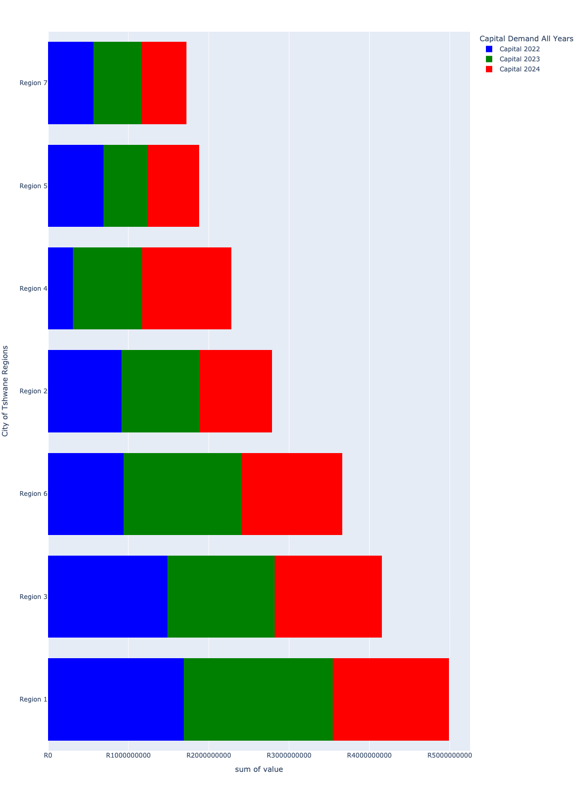

# Summary per City of Tshwane Region

## Region 1

Figure 5.1: Region 1 Funding Requests

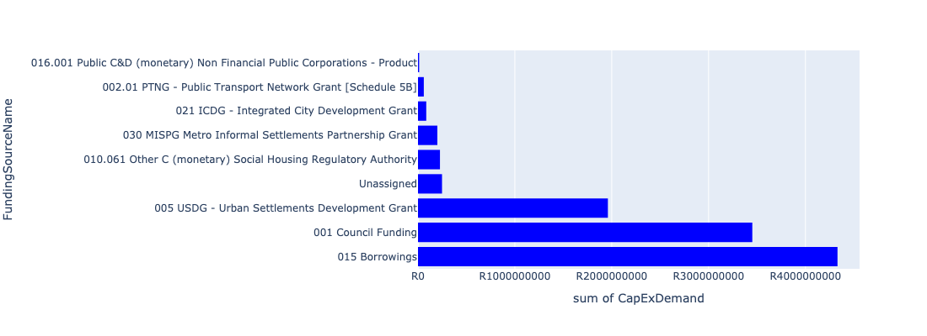

Figure 5.2: Region 1 Departmental Requests

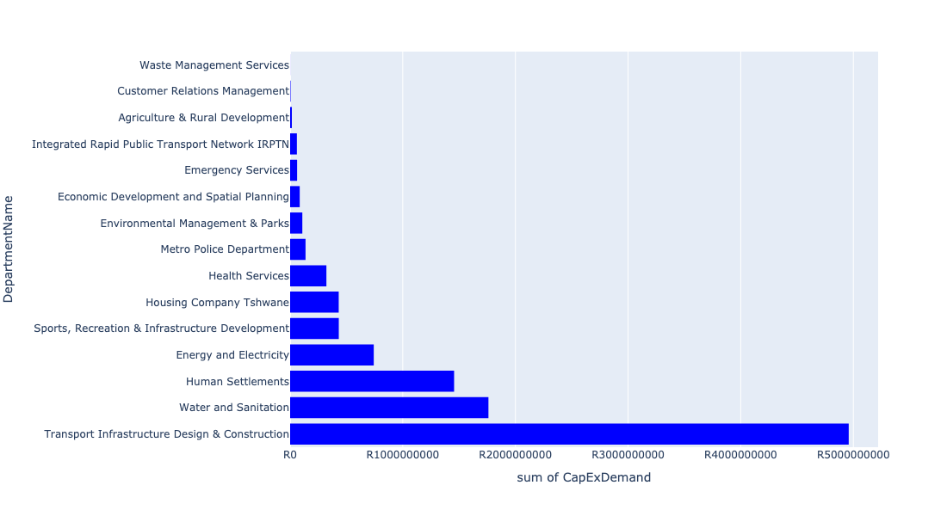

Table 5.1: Summary - Region 1

|  |  |
| --- | --- |
| Item | Description |
| Total Capital Demand for Region 1 - All Years | R10,050,172,267 Rank: 2 (1 = Highest) |
| Total Capital Demand for Region 1 - MTREF | R10,050,172,267 Rank: 1 (1 = Highest) |
| Financial Years in which capital requirements are listed for Region 1 | 2022, 2023, 2024, 2025, 2026, 2027, 2028, 2029, 2030 and 2031 |
| Financial Year with highest capital demand for Region 1 | 2023 |
| Region 1 intersecting feature used | Works Location |
| Total number of projects intersecting with Region 1 | 174 Rank: 4 (1 = Highest) |

## Region 2

Figure 5.3: Region 2 Funding Requests

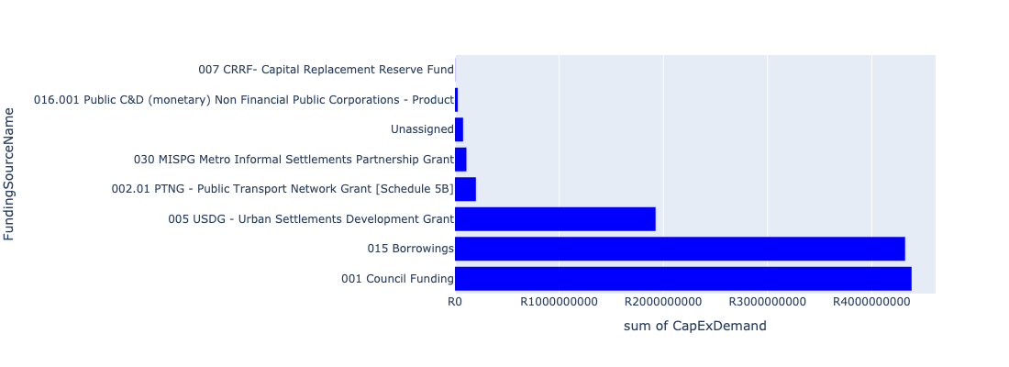

Figure 5.4: Region 2 Departmental Requests

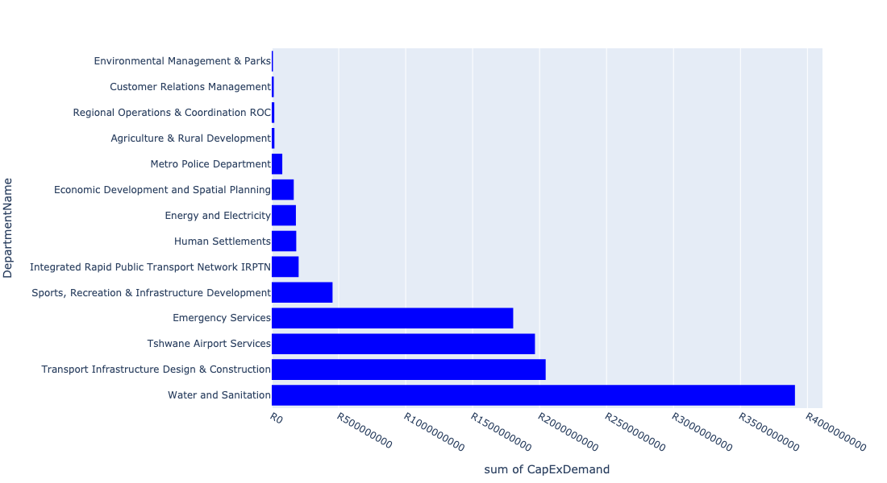

Table 5.2: Summary - Region 2

|  |  |
| --- | --- |
| Item | Description |
| Total Capital Demand for Region 2 - All Years | R10,481,643,396 Rank: 1 (1 = Highest) |
| Total Capital Demand for Region 2 - MTREF | R10,481,643,396 Rank: 4 (1 = Highest) |
| Financial Years in which capital requirements are listed for Region 2 | 2022, 2023, 2024, 2025, 2026, 2027, 2028, 2029, 2030, 2031, 2032, 2033 and 2034 |
| Financial Year with highest capital demand for Region 2 | 2027 |
| Region 2 intersecting feature used | Works Location |
| Total number of projects intersecting with Region 2 | 176 Rank: 3 (1 = Highest) |

## Region 3

Figure 5.5: Region 3 Funding Requests

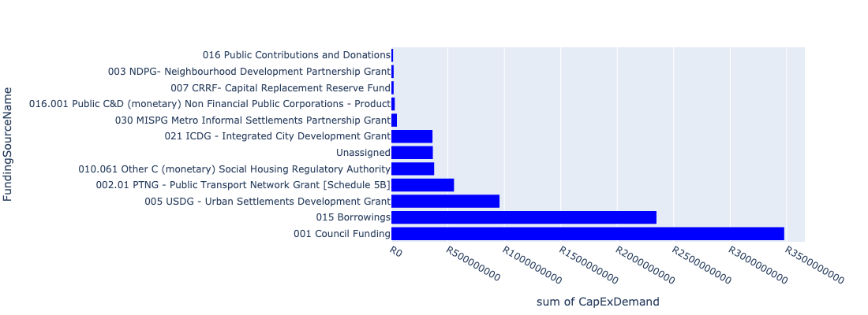

Figure 5.6: Region 3 Departmental Requests

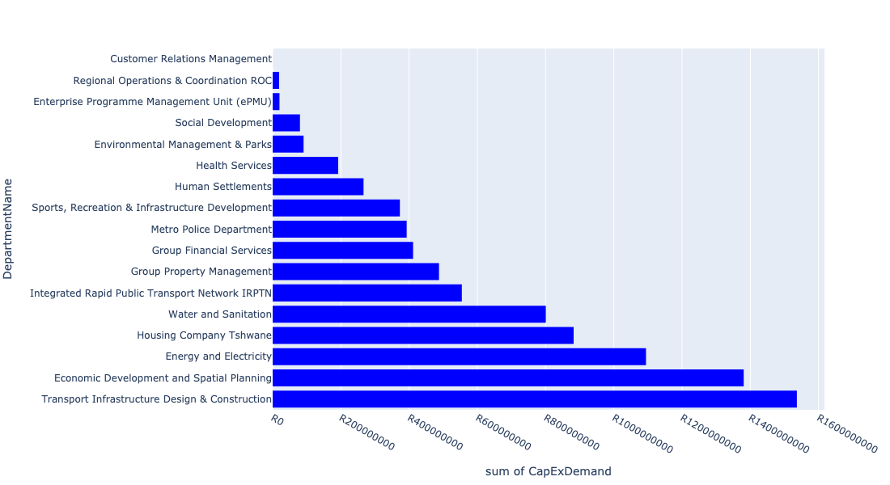

Table 5.3: Summary - Region 3

|  |  |
| --- | --- |
| Item | Description |
| Total Capital Demand for Region 3 - All Years | R7,976,146,913 Rank: 4 (1 = Highest) |
| Total Capital Demand for Region 3 - MTREF | R7,976,146,913 Rank: 2 (1 = Highest) |
| Financial Years in which capital requirements are listed for Region 3 | 2022, 2023, 2024, 2025, 2026, 2027, 2028, 2029, 2030, 2031 and 2032 |
| Financial Year with highest capital demand for Region 3 | 2022 |
| Region 3 intersecting feature used | Works Location |
| Total number of projects intersecting with Region 3 | 256 Rank: 1 (1 = Highest) |

## Region 4

Figure 5.7: Region 4 Funding Requests

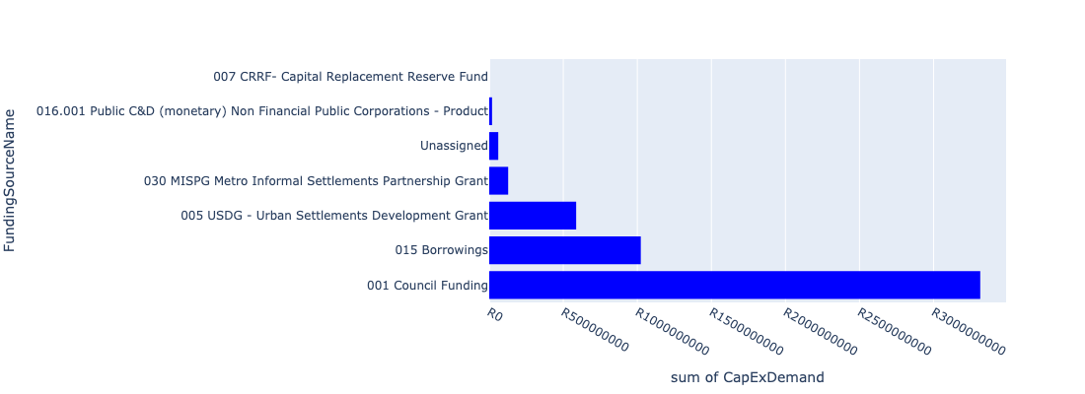

Figure 5.8: Region 4 Departmental Requests

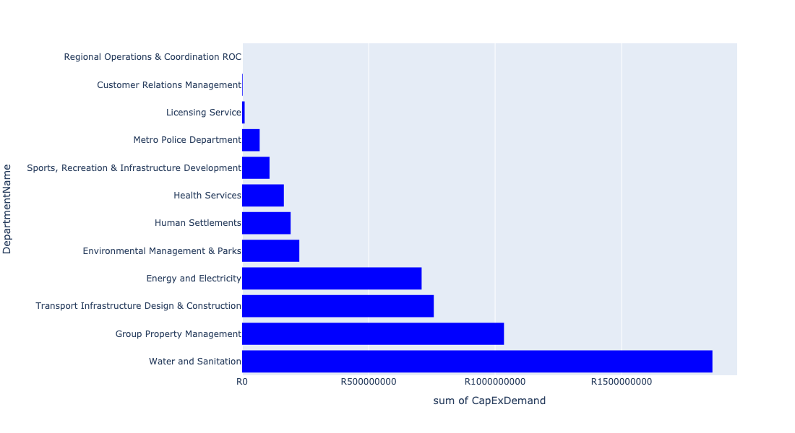

Table 5.4: Summary - Region 4

|  |  |
| --- | --- |
| Item | Description |
| Total Capital Demand for Region 4 - All Years | R4,889,735,567 Rank: 5 (1 = Highest) |
| Total Capital Demand for Region 4 - MTREF | R4,889,735,567 Rank: 5 (1 = Highest) |
| Financial Years in which capital requirements are listed for Region 4 | 2022, 2023, 2024, 2025, 2026, 2027, 2028, 2029 and 2030 |
| Financial Year with highest capital demand for Region 4 | 2024 |
| Region 4 intersecting feature used | Works Location |
| Total number of projects intersecting with Region 4 | 95 Rank: 5 (1 = Highest) |

## Region 5

Figure 5.9: Region 5 Funding Requests

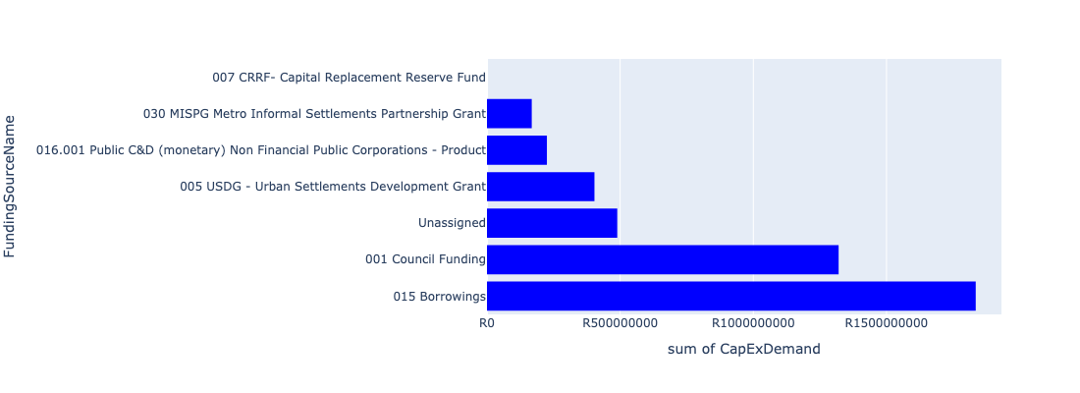

Figure 5.10: Region 5 Departmental Requests

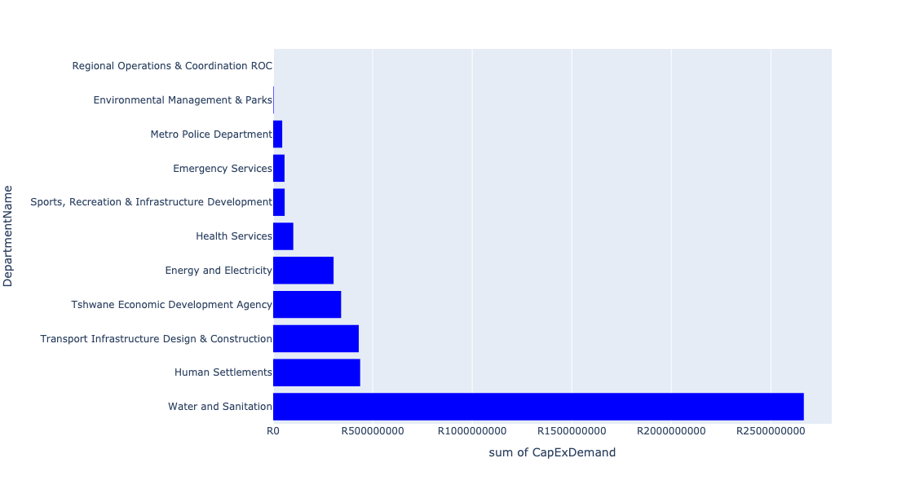

Table 5.5: Summary - Region 5

|  |  |
| --- | --- |
| Item | Description |
| Total Capital Demand for Region 5 - All Years | R4,166,102,658 Rank: 6 (1 = Highest) |
| Total Capital Demand for Region 5 - MTREF | R4,166,102,658 Rank: 6 (1 = Highest) |
| Financial Years in which capital requirements are listed for Region 5 | 2022, 2023, 2024, 2025, 2026, 2027, 2028, 2029, 2030 and 2031 |
| Financial Year with highest capital demand for Region 5 | 2025 |
| Region 5 intersecting feature used | Works Location |
| Total number of projects intersecting with Region 5 | 69 Rank: 6 (1 = Highest) |

## Region 6

Figure 5.11: Region 6 Funding Requests

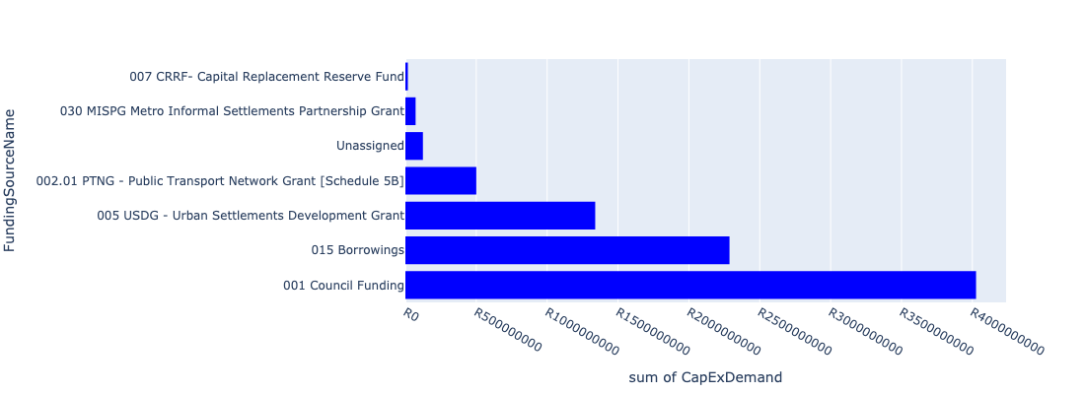

Figure 5.12: Region 6 Departmental Requests

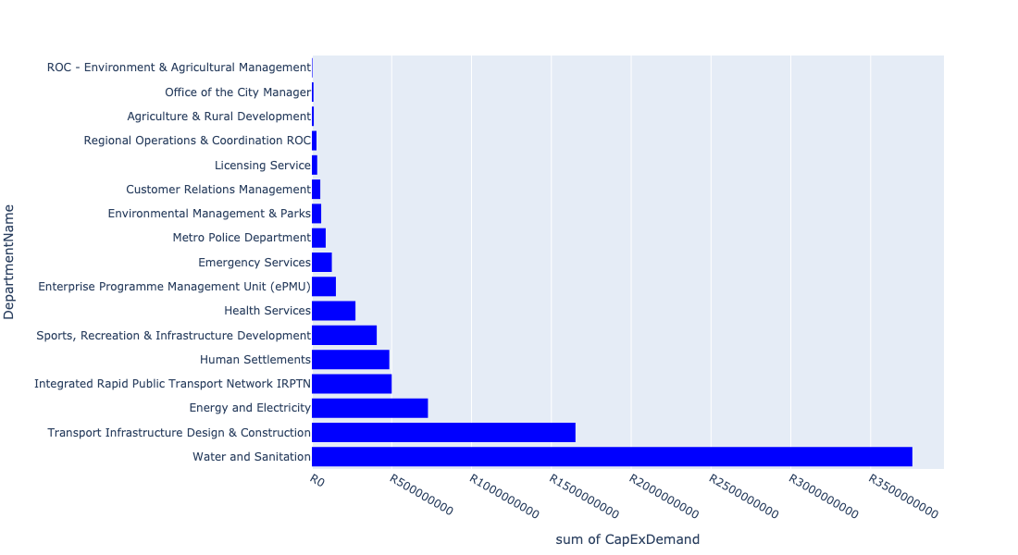

Table 5.6: Summary - Region 6

|  |  |
| --- | --- |
| Item | Description |
| Total Capital Demand for Region 6 - All Years | R8,163,333,523 Rank: 3 (1 = Highest) |
| Total Capital Demand for Region 6 - MTREF | R8,163,333,523 Rank: 3 (1 = Highest) |
| Financial Years in which capital requirements are listed for Region 6 | 2022, 2023, 2024, 2025, 2026, 2027, 2028, 2029, 2030 and 2031 |
| Financial Year with highest capital demand for Region 6 | 2023 |
| Region 6 intersecting feature used | Works Location |
| Total number of projects intersecting with Region 6 | 178 Rank: 2 (1 = Highest) |

## Region 7

Figure 5.13: Region 7 Funding Requests

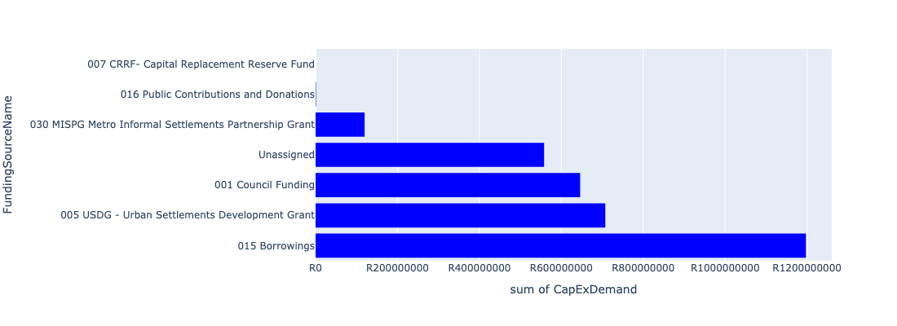

Figure 5.14: Region 7 Departmental Requests

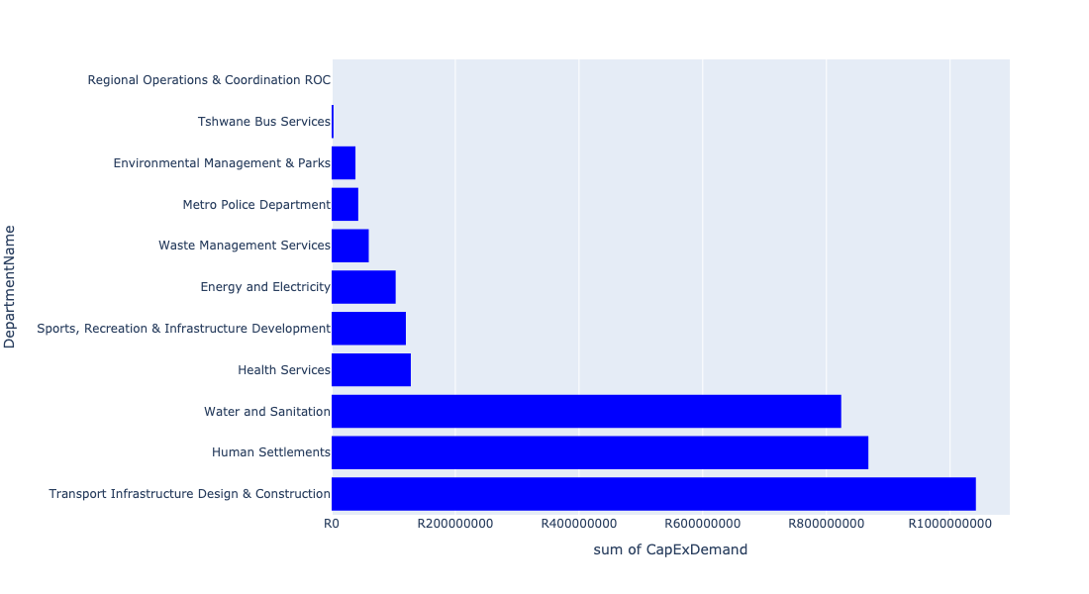

Table 5.7: Summary - Region 7

|  |  |
| --- | --- |
| Item | Description |
| Total Capital Demand for Region 7 - All Years | R3,149,916,794 Rank: 7 (1 = Highest) |
| Total Capital Demand for Region 7 - MTREF | R3,149,916,794 Rank: 7 (1 = Highest) |
| Financial Years in which capital requirements are listed for Region 7 | 2022, 2023, 2024, 2025, 2026, 2027, 2028, 2029 and 2030 |
| Financial Year with highest capital demand for Region 7 | 2025 |
| Region 7 intersecting feature used | Works Location |
| Total number of projects intersecting with Region 7 | 48 Rank: 7 (1 = Highest) |