

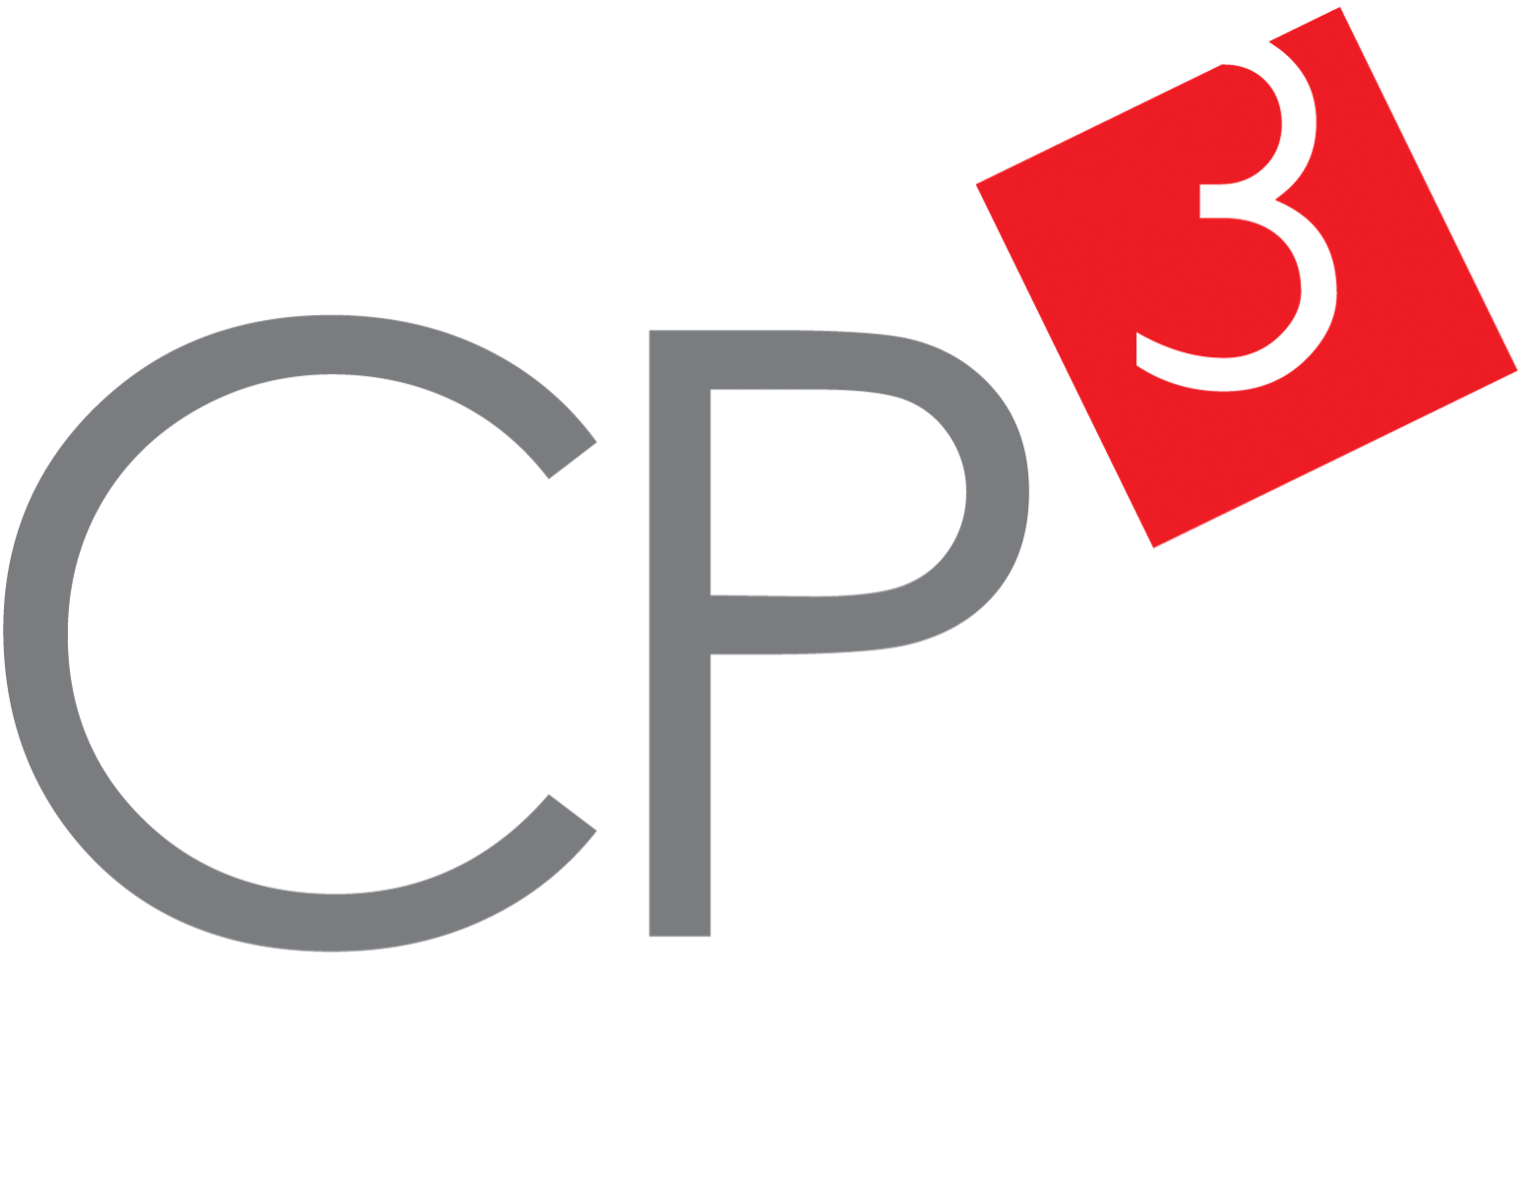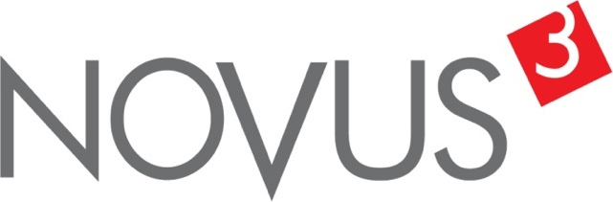

Spatial Feature Report

T: +27 12 364 2546 | E: info@novus3.co.za Postnet Suite 471, Private Bag X15,

Menlo Park, 0102**www.novus3.co.za**

engineered solutions

Disclaimer

This document contains data that was obtained from a live CP3 system at the moment the data was requested. The data is updated by users of the CP3 System and unless the system is locked for changes, this data may change on a daily basis. The reader is therefore cautioned not to place inappropriate reliance on the data unless there is certainty on the status of the data in terms of how recently it has been updated, how “clean” the data is (is there a quality control and/or verification process that was followed by the licensee of the CP3 system to ensure that data is checked and verified from time-to-time) and whether the correct baseline was queried. This report therefore provides a “snapshot in time”. Consequently, the document may be less relevant at a different time, or using a different financial baseline to query from.

At all times, all rights, title and interest in and to this material remains vested in the owner of this document and are copyrighted and protected by regulatory provisions. These materials may not be copied, reproduced, modified, published, uploaded, posted to websites or otherwise distributed in any way, without our prior written permission from the Licensee and Licensor (Nvous3 (Pty) Ltd) of the CP3 Software. The owner of this document does not grant any right to reproduce the materials. All our rights in this regard are and remain reserved.

Table of Contents

**No table of contents entries found.** (Right-click -> Update Field)

Spatial Query Report

This document was created *2022-05-06-08_02* from the **City of Tshwane Metropolitan Municipality** CP3 system.

The baseline **'2021/22 Planning + Rollover (20200901)'** with description: **'Duplicated from the 2020/21 Planning + Final Annexure A (20200625) Baseline'** was used. The spatial feature that was selected for the purpose of this report was: **'Tshwane mSCOA Regional Segment'**.

This is a spatial feature report for the *City of Tshwane Metropolitan Municipality.* The data contained in this report was sourced directly from the municipality's live CP3 system. The information in this report therefore reflects the data as it was on *2022-05-06* when this report was requested. Any subsequent updates to the data contained the CP3 System related to the applicable baseline from which this reports was drawn, would therefore not reflect in this report.   
  
For the *City of Tshwane Metropolitan Municipality, the following spatial features are available for the purpose of developing* 'Spatial Query Reports' (similar to this report):

* City of Tshwane mSCOA Regional Segment
* City of Tshwane Regions
* City of Tshwane Wards 2020
* Specialised Activity Areas
* Strategic Urban Developments (SUD)



We hope you find this useful! Sincerely, *The Novus3 Team.*

# Introduction

The baseline that was queried for this report contains *1029* projects of which a total of *27 (2.62%)* projects do not have any recorded intersection (overlap) with Tshwane mSCOA Regional Segment. The following spatial features are available for queries using this API profile:

* City of Tshwane mSCOA Regional Segment
* City of Tshwane Regions
* City of Tshwane Wards 2020
* Specialised Activity Areas
* Strategic Urban Developments (SUD)

The probable reasons for the 27 non intersecting projects reported are that:

* these projects simply do not have a location associated with them yet (most frequently the case with 'no-intersect' projects) or;
* the location that was captured for some of these projects, may have been in the wrong place (e.g. outside the boundaries of Tshwane - this is very rarely the reason).

It is important to take note of the 2.62% projects that do not intersect with Tshwane mSCOA Regional Segment feature when appraising this report.

The 2.62% of non-intersecting projects is a relative low percentage and therefore not much cause of concern for this particular report.

Figure 1.1: Intersecting vs Non-Intersecting Projects

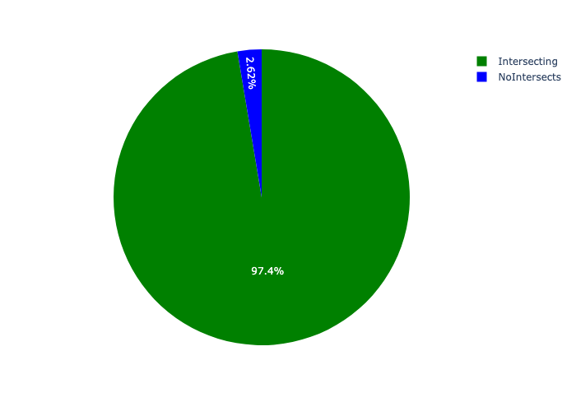

# Total Number of Projects and Total Capital Demand per Segment - All Years

Table 2.1 below provides a concise summary of key statistical insights regarding the number of projects that are requesting funding in each of the Tshwane mSCOA Regional Segment.

Table 2.1: Tshwane mSCOA Regional Segment Analysis - Number of Projects

|  |  |  |  |
| --- | --- | --- | --- |
| Description | Info (1) | Info (2) | Info (3) |
| Number of projects in all Tshwane mSCOA Regional Segment - Overview | Total in all Tshwane mSCOA Regional Segment: 1002 projects | Average per Tshwane mSCOA Regional Segment: 125 projects | 75th percentile of projects across all Tshwane mSCOA Regional Segment: 176.5 projects |
| The highest number of projects | Tshwane mSCOA Regional Segment: In Region 3B: Central Region | Number of projects in Region 3B: Central Region: 199 | Percentage of total in Region 3B: Central Region: 19.86% |
| The lowest number of projects: | Tshwane mSCOA Regional Segment: In Region 7: Kungwini | Number of projects in Region 7: Kungwini: 48 | Percentage of total in Region 7: Kungwini: 4.79% |

Table 2.1 below provides a concise summary of key statistical insights regarding the total capital demand per Segment.

Table 2.1: Tshwane mSCOA Regional Segment Analysis - Capital Demand (R)

|  |  |  |  |
| --- | --- | --- | --- |
| Description | Info (1) | Info (2) | Info (3) |
| Capital demand in all Tshwane mSCOA Regional Segment - Overview | Total capital demand in all Tshwane mSCOA Regional Segment: R51,369,859,345 | The average capital demand per Tshwane mSCOA Regional Segment: R6,421,232,418 | The 75th percentile of capital demand for Tshwane mSCOA Regional Segment: R8,917,335,567 |
| The highest capital demand | Tshwane mSCOA Regional Segment: In Region 2: Northeast | Capital Demand in Region 2: Northeast: R11,044,919,216 | Percentage of total in Region 2: Northeast: 21.50% |
| The lowest capital demand | Tshwane mSCOA Regional Segment: In Region 3A: Central Region | Capital Demand in Region 3A: Central Region: R1,635,964,481 | Percentage of total in Region 3A: Central Region: 3.18% |

The number of projects per Segment and the capital demand per Segment needs to be looked at together for better insight. Figures 2.1 and 2.2 assist with further graphical insight into some of the numbers that are provided in Tables 2.1 and 2.2.

Figure 2.1: The single Segment with the highest value (Nr of Projects & Capital Demand) vs the rest

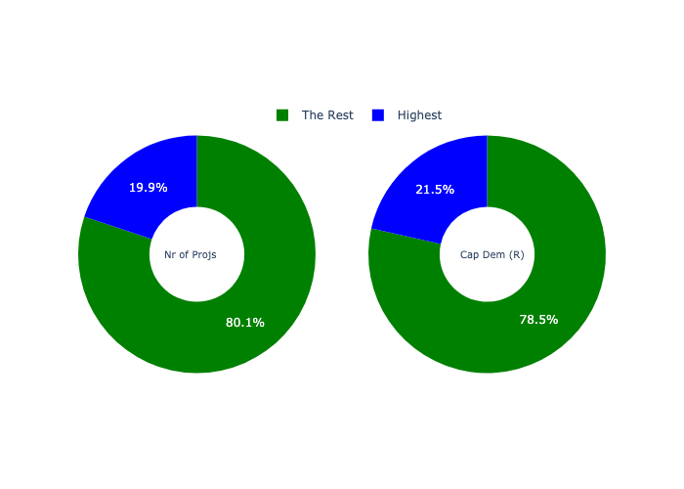

The highest number of projects in a single Segment is in **Region 3B: Central Region.** *That is 199 projects and this is 19.86% of the total number of projects.*The highest capital demand in a single Segment is in **Region 2: Northeast.** *That is R11,044,919,216 and this amounts to 21.50% of the total capital demand.*

The following figures provide a bar graph representation of the number of projects per Segment with the colour of the bars representing the level of capital demand in each of these Tshwane mSCOA Regional Segment.

Figure 2.2: Projects and Capital Demand per Segment

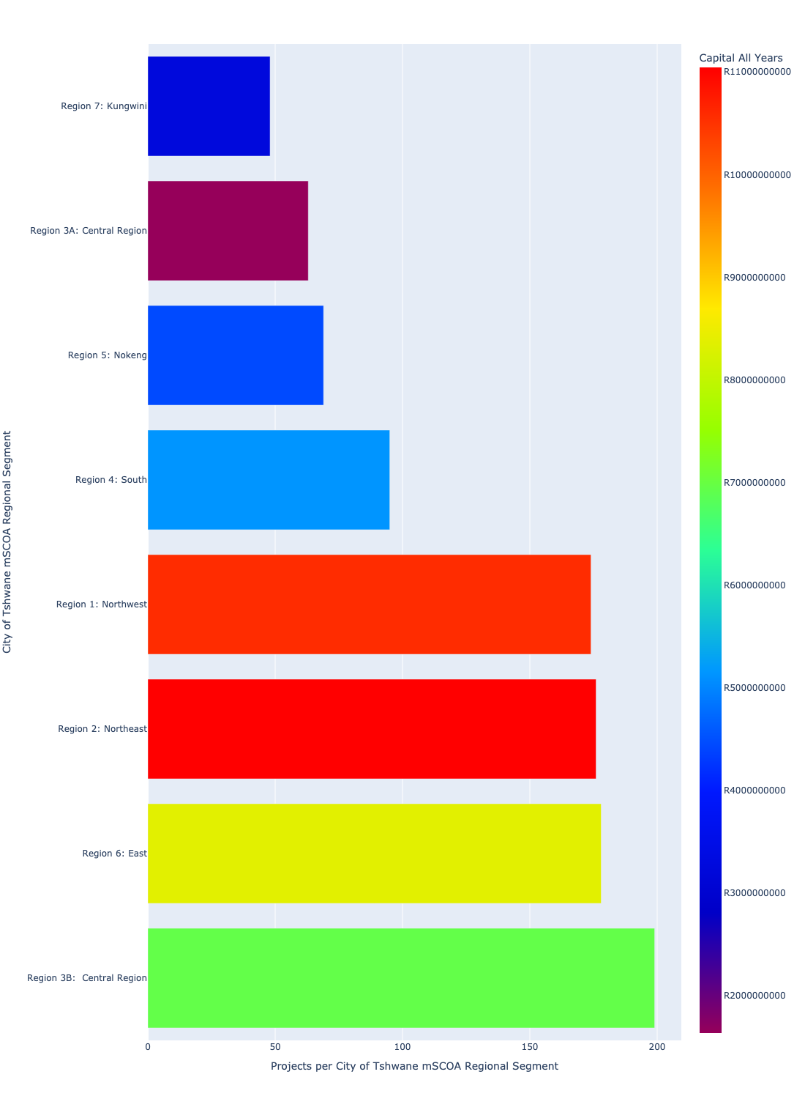

# Total Capital Demand per Segment - All Years

There are different funding sources from which capital is requested. For the financial baseline that was selected for this report query (2021/22 Planning + Rollover (20200901)), the breakdown of capital demand for City of Tshwane Metropolitan Municipality per funding source is shown in Figure 3.1 below.

Figure 3.1: Capital Demand Per Funding Source

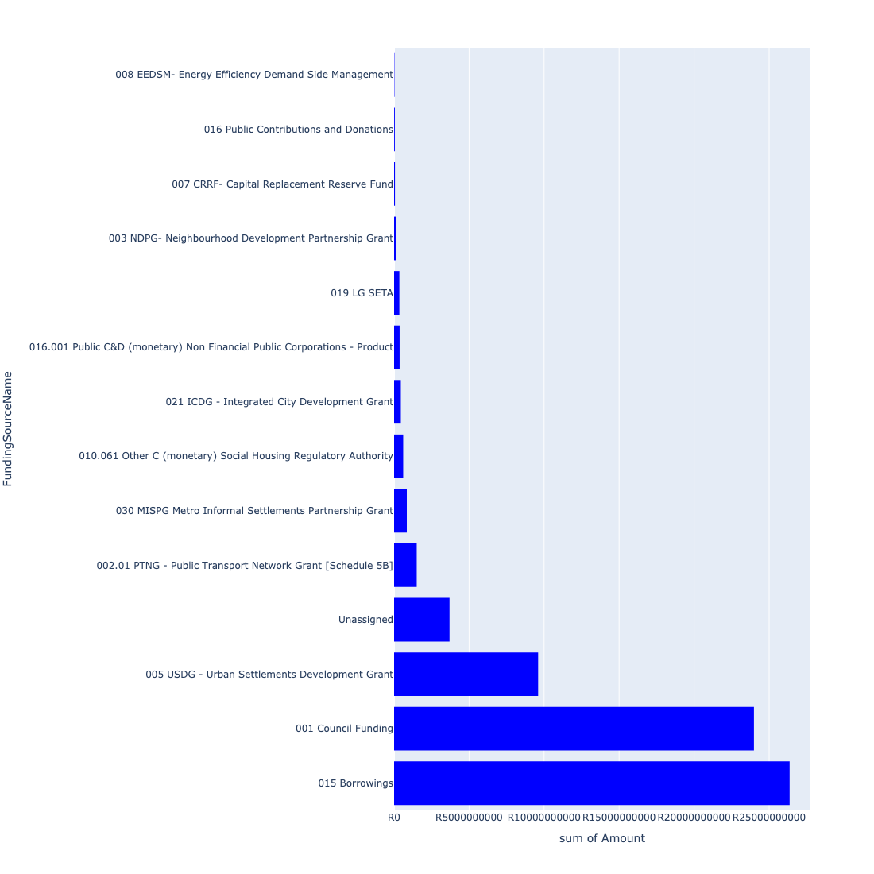

For the financial baseline that was selected for this report query (2021/22 Planning + Rollover (20200901)), the breakdown of capital demand for City of Tshwane Metropolitan Municipality per department is shown in Figure 3.2 below.

Figure 3.2: Capital Demand Per City of Tshwane Metropolitan Municipality Department

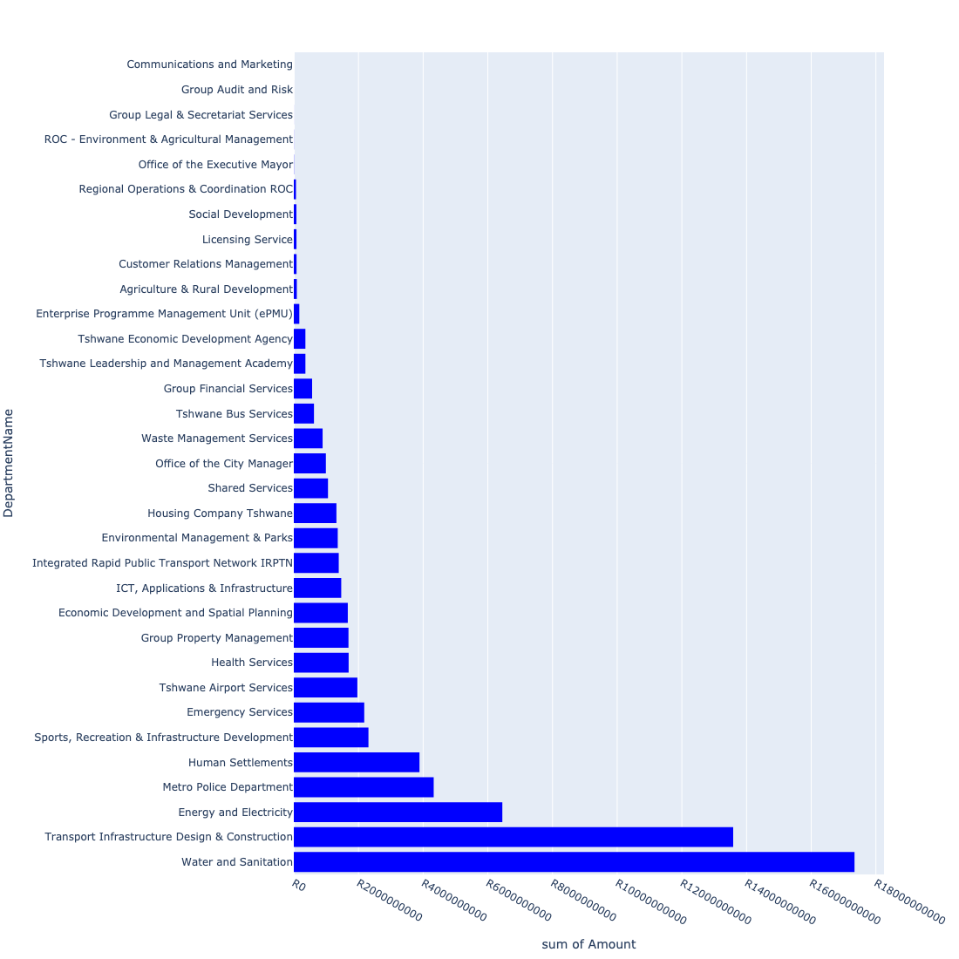

The following figures provide a histogram representation of the capital demand per Segment. A colour breakdown is provided of each year's sub-total that contribute towards the overall total capital demand of each Segment. Note that the capital demand beyond the first three years representing the Medium Term Expenditure Framework (MTREF - years 2022, 2023 and 2024) are generally more sparsely and less diligently populated, therefore less reliance should be vested on these outer years when appraising the overall capital demand. The reason for this is usually because of National Treasury's requirement for annual budget submissions spanning only over the MTREF (i.e. the next three years).

Figure 3.3: Capital Demand per Segment - All Years

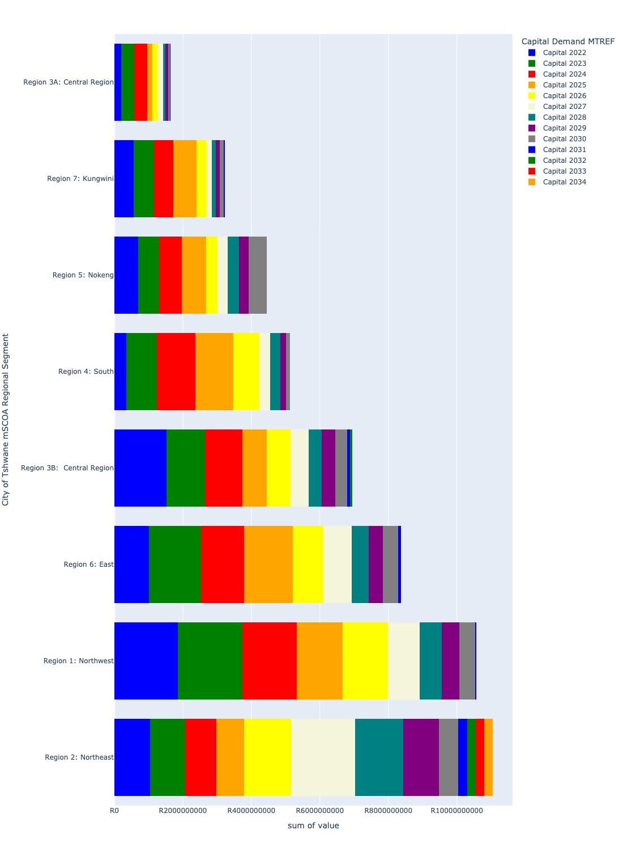

# Total Capital Demand per Segment - MTREF only

Table 4.1 below provides a concise summary of key statistical insights regarding the total MTREF capital demand per Segment.

Table 4.1: Tshwane mSCOA Regional Segment Analysis - MTREF Capital Demand (R)

|  |  |  |  |
| --- | --- | --- | --- |
| Description | Info (1) | Info (2) | Info (3) |
| MTREF Capital demand in all Tshwane mSCOA Regional Segment - Overview | MTREF capital demand in all Tshwane mSCOA Regional Segment: R22,851,950,090 | The average MTREF capital demand per Segment: R2,856,493,761 | The 75th percentile of MTREF capital demand for Tshwane mSCOA Regional Segment: R3,744,463,477 |
| The highest MTREF capital demand | In Segment: Region 1: Northwest | MTREF capital Demand in Region 1: Northwest: R5,322,465,342 | Percentage of total MRTEF capital demand in Region 1: Northwest: 23.29% |
| The lowest MTREF capital demand | In Segment: Region 3A: Central Region | MTREF capital Demand in Region 3A: Central Region: R963,607,053 | Percentage of total MTREF capital demand in Region 3A: Central Region: 4.22% |

The following figures provide a histogram representation of the capital demand per Segment. A colour breakdown is provided of each year's sub-total that contribute towards the overall MTREF total capital demand of each Segment.

Figure 4.1: Capital Demand per Segment - MTREF Period

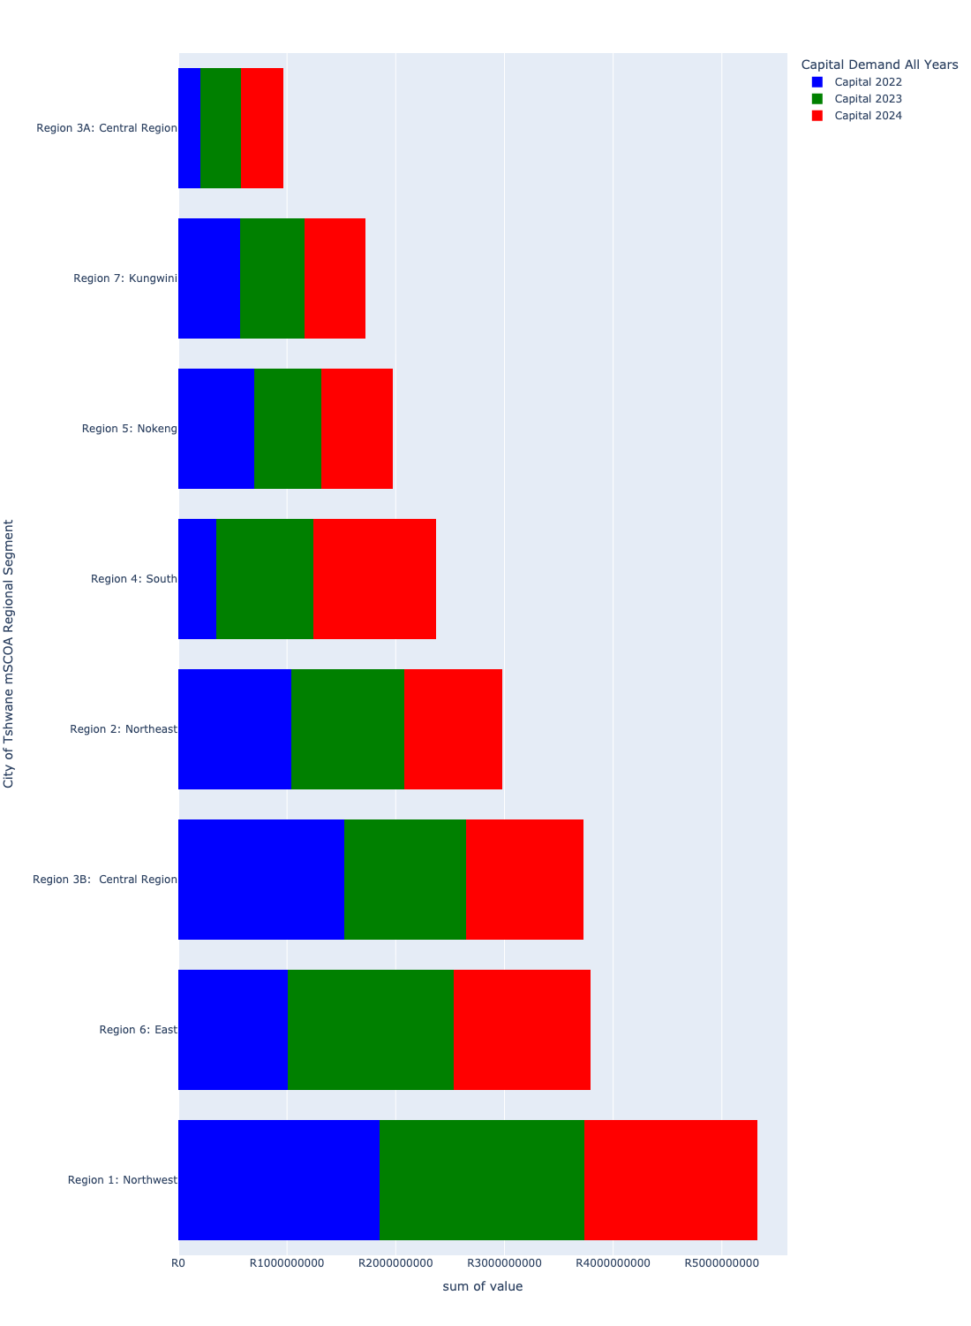

# Summary per Segment

## Region 1: Northwest

Figure 5.1: Region 1: Northwest Funding Requests

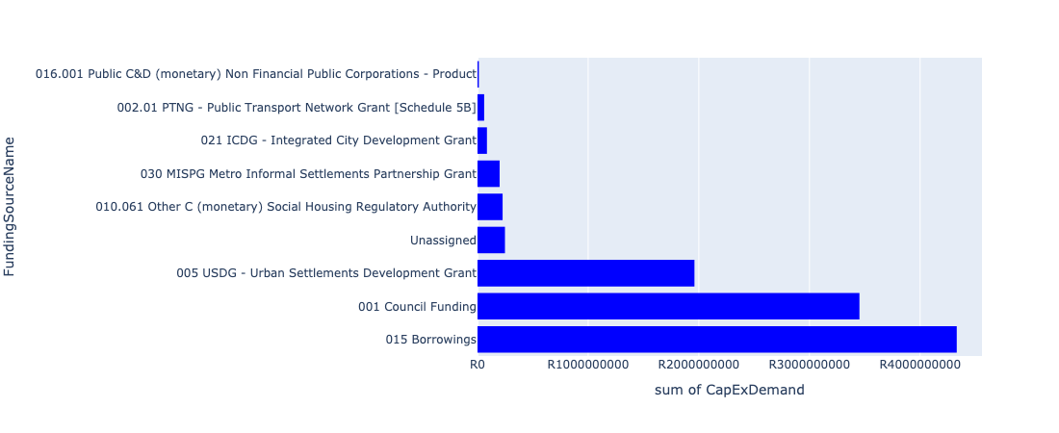

Figure 5.2: Region 1: Northwest Departmental Requests

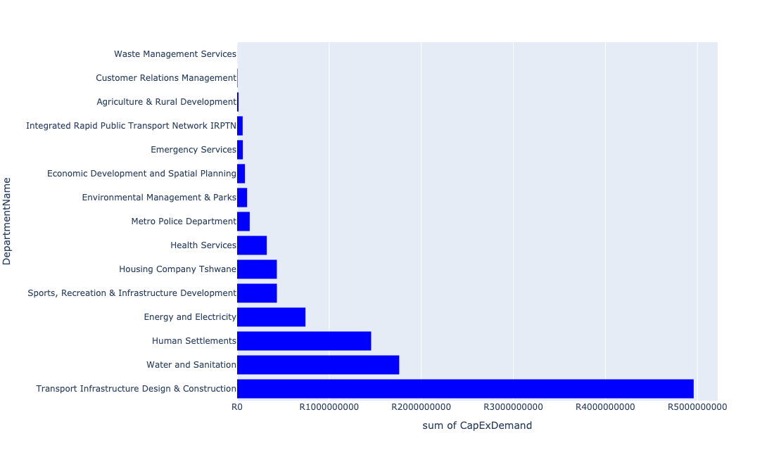

Table 5.1: Summary - Region 1: Northwest

|  |  |
| --- | --- |
| Item | Description |
| Total Capital Demand for Region 1: Northwest - All Years | R10,575,098,747 Rank: 2 (1 = Highest) |
| Total Capital Demand for Region 1: Northwest - MTREF | R5,322,465,342 Rank: 1 (1 = Highest) |
| Financial Years in which capital requirements are listed for Region 1: Northwest | 2022, 2023, 2024, 2025, 2026, 2027, 2028, 2029, 2030 and 2031 |
| Financial Year with highest capital demand for Region 1: Northwest | 2023 |
| Region 1: Northwest intersecting feature used | Works Location |
| Total number of projects intersecting with Region 1: Northwest | 174 Rank: 4 (1 = Highest) |

Table 5.2: All projects asking for budget in Region 1: Northwest

|  |  |  |  |
| --- | --- | --- | --- |
| Project ID | Project Name | Department | Project Budget |
| 712971915 | Revitalisation of the City-Development of Non-Motorised Transport Masterplan | Transport Infrastructure Design & Construction | R825,347 (0.01%) Budget spread across: 2027 |
| 712973710 | Construction of a ±900m stormwater system in Karenpark (Akasia SMP - Network 3A) 4 | Transport Infrastructure Design & Construction | R36,500,000 (0.35%) Budget spread across: 2027, 2028, 2029 and 2030 |
| 712973996 | Clarina Residential Estates (160 Units) Alternative Accommodation | Housing Company Tshwane | R12,800,000 (0.12%) Budget spread across: 2023 |
| 712974374 | (710411C1) Klipgat WWTW Phse2: Upgrading of existing infrastructure and extensions of treatment capacity to 73Ml/d | Water and Sanitation | R340,000,000 (3.22%) Budget spread across: 2023, 2024, 2025 and 2026 |
| 712974537 | (712220) Soshanguve Block FF East Area 3 | Transport Infrastructure Design & Construction | R52,000,000 (0.49%) Budget spread across: 2022, 2023, 2024 and 2025 |
| 712967836 | New Garankuwa Zone 15 Clinic | Health Services | R79,000,000 (0.75%) Budget spread across: 2022, 2023 and 2024 |
| 712967304 | (713090) Development of Soshanguve Agricultural Park | Agriculture & Rural Development | R15,500,000 (0.15%) Budget spread across: 2022, 2023, 2024 and 2025 |
| 712967596 | (710865) Construction of roads & stormwater - Thorntree View | Human Settlements | R225,000,000 (2.13%) Budget spread across: 2022, 2023 and 2024 |
| 712967398 | Mabopane EW ( Ext 2) - roads and storm water | Human Settlements | R200,000 (0.00%) Budget spread across: 2022 |
| 712973890 | (711863) Internal Roads Ga-Rankuwa Zone 5 | Transport Infrastructure Design & Construction | R170,000,000 (1.61%) Budget spread across: 2022, 2023, 2024, 2025, 2026, 2027, 2028, 2029 and 2030 |
| 712971921 | Revitalisation of the City-Internal Routes in Rosslyn and Traffic signals | Transport Infrastructure Design & Construction | R190,000,000 (1.80%) Budget spread across: 2022, 2023 and 2024 |
| 712967604 | (710865) Construction of roads & stormwater - Soshanguve South X12 | Human Settlements | R77,000,000 (0.73%) Budget spread across: 2022 and 2023 |
| 712972963 | (710863) Water provision - Garankuwa X10 - Water Connections | Human Settlements | R1,000,000 (0.01%) Budget spread across: 2022 |
| 712975147 | (71212DRTC) Dorandia, Rosslyn, Theresa Park, Clarina Outfall Sewer upgrade | Water and Sanitation | R115,500,000 (1.09%) Budget spread across: 2023, 2024, 2025, 2026 and 2027 |
| 712969551 | (712513) Soshanguve Block TT | Transport Infrastructure Design & Construction | R156,500,000 (1.48%) Budget spread across: 2022, 2023, 2024, 2025, 2026, 2027, 2028, 2029 and 2030 |
| 712969545 | (711164) Upgrading of roads and stormwater systems in Soshanguve Block W: South East | Transport Infrastructure Design & Construction | R46,000,000 (0.43%) Budget spread across: 2022, 2023, 2024, 2025, 2026 and 2027 |
| 712974357 | (712220) Upgrading of Culverts | Transport Infrastructure Design & Construction | R132,000,000 (1.25%) Budget spread across: 2023, 2024, 2025, 2026, 2027, 2028, 2029 and 2030 |
| 712972934 | (710863) Water provision - Rama City (20 ML Reservoir) | Human Settlements | R49,601,090 (0.47%) Budget spread across: 2022, 2023 and 2024 |
| 712974202 | 712974355_04_(710143) Soshanguve Block M Extension: Area 5 | Transport Infrastructure Design & Construction | R50,000,000 (0.47%) Budget spread across: 2022 and 2023 |
| 448 | (710411G) Rietgat WWTW: Sludge facility, 7Ml/day BNR re-commission, New 20Ml/day BNR Module | Water and Sanitation | R260,000,000 (2.46%) Budget spread across: 2022, 2023, 2024 and 2025 |
| 712975539 | Refurbishment of Soshanguve block KK customer care centre | Customer Relations Management | R2,000,000 (0.02%) Budget spread across: 2027 |
| 712975513 | Construction of pedestrian bridge at Toloane Nature Reserve | Environmental Management & Parks | R1,000,000 (0.01%) Budget spread across: 2028 |
| 712974494 | Construction of a ±2,9km stormwater system in Rosslyn (Rosslyn SMP - Network 6A and 6D) | Transport Infrastructure Design & Construction | R95,500,000 (0.90%) Budget spread across: 2025, 2026, 2027, 2028, 2029 and 2030 |
| 712967069 | Establishment of TMPD Training Academy | Metro Police Department | R80,279,868 (0.76%) Budget spread across: 2022, 2023 and 2024 |
| 712969084 | (712279) Soshanguve - JJ 132KV Power Line | Energy and Electricity | R54,376,991 (0.51%) Budget spread across: 2022, 2023 and 2024 |
| 712969230 | (710865) Construction of roads & stormwater - Mabopane X1 | Human Settlements | R65,387,490 (0.62%) Budget spread across: 2022 |
| 712974394 | (710863) Water provision - Winterveldt 20ML Reservoir | Human Settlements | R55,500,000 (0.52%) Budget spread across: 2022, 2023 and 2024 |
| 712974191 | Upgrading of the bridge in Longmore Road a Tributary of the sand River, The Orchards | Transport Infrastructure Design & Construction | R51,000,000 (0.48%) Budget spread across: 2026, 2027, 2028, 2029 and 2030 |
| 712967647 | (710864) Sewer provision - Rama City | Human Settlements | R14,396,442 (0.14%) Budget spread across: 2022 and 2024 |
| 712974477 | 712974355_01_(710143) Soshanguve Block M Extension: Area 2 | Transport Infrastructure Design & Construction | R50,000,000 (0.47%) Budget spread across: 2022 and 2023 |
| 712967493 | (712918) Ga-rankuwa Transport Facilities | Transport Infrastructure Design & Construction | R84,000,000 (0.79%) Budget spread across: 2022, 2023, 2024, 2025, 2026, 2027, 2028, 2029 and 2030 |
| 517 | (710609S) Shova Kalula Bicycle Project | Transport Infrastructure Design & Construction | R136,500,000 (1.29%) Budget spread across: 2022, 2023, 2024, 2025, 2026, 2027, 2029 and 2030 |
| 712975336 | Sub-Project: TMPD Station - Ga-Rankuwa | Metro Police Department | R13,000,000 (0.12%) Budget spread across: 2023 and 2024 |
| 712975075 | (712121Ro) Upgrade existing Rosslyn East outfall sewer (1/2) | Water and Sanitation | R600,000 (0.01%) Budget spread across: 2025 and 2026 |
| 712975456 | Upgrade of infrastructure of Magalies mountain | Environmental Management & Parks | R5,286,208 (0.05%) Budget spread across: 2022, 2023, 2024, 2025, 2026, 2027, 2028, 2029, 2030 and 2031 |
| 712967135 | Klip kruisfontein multi-purpose sport facility | Sports, Recreation & Infrastructure Development | R60,000,000 (0.57%) Budget spread across: 2027 and 2028 |
| 712974497 | Upgrading of internal access roads from gravel to asphalt and storm water control in Klerksoord Area | Transport Infrastructure Design & Construction | R5,000,000 (0.05%) Budget spread across: 2022, 2023 and 2024 |
| 712974603 | (712513) Soshanguve Extensions 3 and 4 | Transport Infrastructure Design & Construction | R210,000,000 (1.99%) Budget spread across: 2022, 2023, 2024, 2025, 2026, 2027, 2028, 2029 and 2030 |
| 712974360 | (712221) Upgrading of roads and stormwater: Winterveldt Area and Mabopane Area | Transport Infrastructure Design & Construction | R145,000,000 (1.37%) Budget spread across: 2022, 2023, 2024, 2025 and 2026 |
| 712975536 | Refurbishment of Bodibeng customer care centre ( Soshanguve BB) | Customer Relations Management | R2,000,000 (0.02%) Budget spread across: 2023 |
| 712969634 | (710864) Sewer reticulation - Winterveldt | Human Settlements | R65,000,000 (0.61%) Budget spread across: 2022 |
| 712975514 | Construction of Entrance gate and ablution facilities - Toloane Nature Reserve | Environmental Management & Parks | R3,000,000 (0.03%) Budget spread across: 2022 and 2023 |
| 712974163 | (711164) Upgrading of roads and stormwater systems in Soshanguve Block W: South West | Transport Infrastructure Design & Construction | R46,000,000 (0.43%) Budget spread across: 2022, 2023, 2024, 2025, 2026 and 2027 |
| 449 | (710411H) Sandspruit WWTW Phase1: Extension of Sludge Handling facility | Water and Sanitation | R32,000,000 (0.30%) Budget spread across: 2022 and 2023 |
| 712974117 | (712279) Rama City 132/11kV substation | Energy and Electricity | R90,000,000 (0.85%) Budget spread across: 2023, 2024 and 2025 |
| 712975374 | (712279) Buffel Infeed Station | Energy and Electricity | R20,000,000 (0.19%) Budget spread across: 2024 and 2025 |
| 712973731 | Extension of Karen Park Clinic | Health Services | R64,000,000 (0.61%) Budget spread across: 2025, 2026, 2027 and 2028 |
| 712974180 | (712611) Upgrading of Mabopane Block B | Transport Infrastructure Design & Construction | R170,000,000 (1.61%) Budget spread across: 2022, 2023, 2024, 2025 and 2026 |
| 712967193 | (711326) New Clinic Soshanguve South | Health Services | R67,000,000 (0.63%) Budget spread across: 2022, 2023 and 2024 |
| 712967648 | (710863) Water provision - Rama City | Human Settlements | R0 (0.00%) Budget spread across: 2022, 2023 and 2024 |
| 712975076 | (712121Ro) Upgrade existing Rosslyn outfall sewer (2/2) | Water and Sanitation | R2,600,000 (0.02%) Budget spread across: 2025, 2026 and 2027 |
| 712967745 | (712591) Planning and Design of BRT Projects | Integrated Rapid Public Transport Network IRPTN | R60,075,024 (0.57%) Budget spread across: 2022, 2023, 2024 and 2025 |
| 712974386 | (710865) Construction of roads & stormwater - Soshanguve ext19 | Human Settlements | R123,000,000 (1.16%) Budget spread across: 2022, 2023 and 2024 |
| 712967087 | (712601) Standby Quarters (Revival) | Energy and Electricity | R1,000,000 (0.01%) Budget spread across: 2022 and 2023 |
| 712967124 | (712941) Greening of Sports fields | Sports, Recreation & Infrastructure Development | R222,000,019 (2.10%) Budget spread across: 2022, 2023, 2024, 2025, 2026, 2027, 2028, 2029, 2030 and 2031 |
| 712975196 | (711863)Internal Roads Mabopane Block R (Phase 2) | Transport Infrastructure Design & Construction | R160,000,000 (1.51%) Budget spread across: 2022, 2023, 2024, 2025, 2026, 2027, 2028, 2029 and 2030 |
| 1036 | (712545) Upgrading of Buitekant Street | Transport Infrastructure Design & Construction | R220,000,000 (2.08%) Budget spread across: 2022, 2023, 2024, 2025 and 2026 |
| 712974355 | (710143) Major Stormwater Systems Klip kruisfontein | Transport Infrastructure Design & Construction | R134,000,000 (1.27%) Budget spread across: 2022, 2023, 2024, 2025, 2026, 2027, 2028, 2029 and 2030 |
| 712975465 | Providing new service and integration of minibus type transfer service in the area around Garankuwa | Transport Infrastructure Design & Construction | R74,000,000 (0.70%) Budget spread across: 2022, 2023, 2024, 2025, 2026, 2027, 2028, 2029 and 2030 |
| 712969182 | (710556) Region 1 (Public Lighting) | Energy and Electricity | R292,000,000 (2.76%) Budget spread across: 2022, 2023, 2024, 2025, 2026, 2027, 2028, 2029 and 2030 |
| 712970771 | (710864) Mabopane X11 | Human Settlements | R0 (0.00%) Budget spread across: 2022 |
| 712974177 | (712611) Upgrading of Mabopane Block A | Transport Infrastructure Design & Construction | R145,000,000 (1.37%) Budget spread across: 2022, 2023, 2024, 2025 and 2026 |
| 712973891 | (711863) Internal Roads Mabopane Block R (Phase 1) | Transport Infrastructure Design & Construction | R155,000,000 (1.47%) Budget spread across: 2022, 2023, 2024, 2025, 2026, 2027, 2028, 2029 and 2030 |
| 712974183 | (712221) Upgrading of Roads: Mabopane Block U | Transport Infrastructure Design & Construction | R140,000,000 (1.32%) Budget spread across: 2022, 2023, 2024, 2025 and 2026 |
| 712975073 | (712121Sa) Upgrade existing Sandspruit outfall sewer (1/4) | Water and Sanitation | R70,000,000 (0.66%) Budget spread across: 2023, 2024, 2025, 2026 and 2027 |
| 712974103 | (714008) Electricity Distribution Loss | Energy and Electricity | R70,000,000 (0.66%) Budget spread across: 2022 and 2024 |
| 712970708 | (713081) Construction of a new Emergency Services Station in Klip Kruisfontein | Emergency Services | R62,000,000 (0.59%) Budget spread across: 2023, 2024 and 2025 |
| 712967605 | (710865) Construction of roads & stormwater - Soshanguve South X13 | Human Settlements | R68,000,000 (0.64%) Budget spread across: 2022 and 2023 |
| 712974203 | 712974355_05_(710143) Soshanguve Block M Extension: Area 6 | Transport Infrastructure Design & Construction | R50,000,000 (0.47%) Budget spread across: 2022 and 2023 |
| 712967184 | (712983) Extension of Ga-Rankuwa Cemetery | Environmental Management & Parks | R10,300,000 (0.10%) Budget spread across: 2023, 2025 and 2026 |
| 712974160 | (711164) Upgrading of roads and stormwater systems in Soshanguve Block W: North | Transport Infrastructure Design & Construction | R46,000,000 (0.43%) Budget spread across: 2022, 2023, 2024, 2025, 2026 and 2027 |
| 712975093 | (710411Y_ NR) New Roodepoort PS | Water and Sanitation | R10,000,000 (0.09%) Budget spread across: 2023, 2024 and 2025 |
| 712974601 | (712513) Soshanguve Extension 2 | Transport Infrastructure Design & Construction | R204,000,000 (1.93%) Budget spread across: 2022, 2023, 2024, 2025, 2026, 2027, 2028, 2029 and 2030 |
| 712975006 | Security and Visitor infrastructure at Klipkruisfontein resort | Environmental Management & Parks | R22,500,000 (0.21%) Budget spread across: 2022, 2023, 2024 and 2025 |
| 712974883 | (710864) Sewer reticulation - Garankuwa X10 | Human Settlements | R1,000,000 (0.01%) Budget spread across: 2022 |
| 712974614 | Upgrading of a tributary of the Sand Spruit, Rosslyn x 17 | Transport Infrastructure Design & Construction | R19,526,828 (0.18%) Budget spread across: 2025, 2026 and 2027 |
| 712974545 | (710411C2) Klipgat WWTW Phase3: Upgrading of existing infrastructure and extensions of treatment capacity to 106 Ml/d | Water and Sanitation | R350,000,000 (3.31%) Budget spread across: 2024, 2025, 2026, 2027 and 2028 |
| 712974542 | (712220) Soshanguve Block FF East Area 4 | Transport Infrastructure Design & Construction | R55,000,000 (0.52%) Budget spread across: 2022, 2023, 2024 and 2025 |
| 712974459 | Construction of Major Stormwater Network 10A and 10B, Willem Cruywagen Street, Theresapark | Transport Infrastructure Design & Construction | R9,000,000 (0.09%) Budget spread across: 2027, 2028 and 2029 |
| 712974385 | (710865) Construction of roads & stormwater - Garankuwa | Human Settlements | R44,635,972 (0.42%) Budget spread across: 2022 and 2023 |
| 712974356 | (712220) Soshanguve Block L North | Transport Infrastructure Design & Construction | R5,000,000 (0.05%) Budget spread across: 2022 |
| 712972936 | (710864) Bulk Sewer Line - Winterveldt | Human Settlements | R35,000,000 (0.33%) Budget spread across: 2022, 2023 and 2024 |
| 712970772 | (710864) Sewer provision - Mabopane X12 | Human Settlements | R11,078,036 (0.10%) Budget spread across: 2022 |
| 712970718 | (712220) Soshanguve Block L Area 2 | Transport Infrastructure Design & Construction | R5,000,000 (0.05%) Budget spread across: 2022 |
| 712969616 | (700574) Rosslyn Urban Realm Upgrade and Multi Modal Interchange | Economic Development and Spatial Planning | R85,228,650 (0.81%) Budget spread across: 2022 and 2023 |
| 712969550 | (712513) Soshanguve Block WW | Transport Infrastructure Design & Construction | R137,500,000 (1.30%) Budget spread across: 2022, 2023, 2024, 2025, 2026, 2028, 2029 and 2030 |
| 712969544 | (711164) Upgrading of roads and stormwater systems in Soshanguve Block W: North East | Transport Infrastructure Design & Construction | R46,000,000 (0.43%) Budget spread across: 2022, 2023, 2024, 2025, 2026 and 2027 |
| 712967435 | (710865) Construction of roads & stormwater - Winterveldt | Human Settlements | R145,000,000 (1.37%) Budget spread across: 2022, 2023 and 2024 |
| 828 | (71212R) Rietgat Outfall Sewer Upgrade | Water and Sanitation | R70,000,000 (0.66%) Budget spread across: 2022, 2023, 2024, 2025 and 2026 |
| 768 | (711863) Internal Roads: Northern Areas: Mandela Village (South) | Transport Infrastructure Design & Construction | R155,000,000 (1.47%) Budget spread across: 2022, 2023, 2024, 2025, 2026, 2027, 2028, 2029 and 2030 |
| 585 | (710902) Rehabilitation Of Roads | Transport Infrastructure Design & Construction | R175,000,000 (1.65%) Budget spread across: 2022, 2023, 2024, 2025, 2026, 2027, 2028, 2029 and 2030 |
| 522 | (710657) Mabopane Station Modal Interchange | Transport Infrastructure Design & Construction | R95,000,000 (0.90%) Budget spread across: 2022, 2023, 2024, 2025, 2026, 2027, 2028, 2029 and 2030 |
| 299 | 712974355_03_(710143) Soshanguve Block M Extension: Area 4 | Transport Infrastructure Design & Construction | R75,000,000 (0.71%) Budget spread across: 2022, 2023 and 2024 |
| 712967844 | (713048) New Rosslyn Clinic | Health Services | R75,000,000 (0.71%) Budget spread across: 2022 and 2023 |
| 712967698 | (710178) Electricity for All - Region 1 | Energy and Electricity | R100,000,000 (0.95%) Budget spread across: 2022, 2023, 2024 and 2025 |
| 712967621 | (710863) Water provision - Kopanong X1 Phase 2 | Human Settlements | R31,239,481 (0.30%) Budget spread across: 2022, 2023 and 2024 |
| 712967615 | (710864) Sewer provision - Kopanong X1 Phase 2 | Human Settlements | R43,012,647 (0.41%) Budget spread across: 2022, 2023 and 2024 |
| 712975773 | (712900) Upgrading of existing Tactical Training facilities (Akasia) | Metro Police Department | R17,500,000 (0.17%) Budget spread across: 2022, 2023 and 2024 |
| 712975481 | Rehabilitation of Wetlands - Mabopane | Environmental Management & Parks | R9,000,000 (0.09%) Budget spread across: 2022, 2023 and 2024 |
| 712975332 | Sub-Project: TMPD Station - Soshanguve South | Metro Police Department | R13,000,000 (0.12%) Budget spread across: 2025 and 2026 |
| 712975143 | (712121NO) New Orchards X41 Outfall Sewer | Water and Sanitation | R9,600,000 (0.09%) Budget spread across: 2027, 2028 and 2029 |
| 712975132 | (71212SDD) Upgrade existing Soshanguve DD Outfall Sewer (2/2) | Water and Sanitation | R3,570,035 (0.03%) Budget spread across: 2023, 2024, 2025 and 2026 |
| 712975086 | (712121NTO) New The Orchards X43B Outfall Sewer | Water and Sanitation | R9,600,000 (0.09%) Budget spread across: 2027, 2028 and 2029 |
| 712974493 | Construction of major roads and stormwater networks along all roads in Klerksoord AH | Transport Infrastructure Design & Construction | R135,000,000 (1.28%) Budget spread across: 2023, 2024, 2025 and 2029 |
| 712974481 | 712974355_02_(710143) Soshanguve Block M Extension: Area 3 | Transport Infrastructure Design & Construction | R50,000,000 (0.47%) Budget spread across: 2022 and 2023 |
| 712974378 | (710863) Water Provision - Winterveldt Bulk water line | Human Settlements | R65,000,000 (0.61%) Budget spread across: 2022 and 2023 |
| 712974195 | (712279) Rosslyn Switching Station | Energy and Electricity | R60,000,000 (0.57%) Budget spread across: 2028, 2029 and 2030 |
| 712974161 | (711164) Upgrading of roads and stormwater systems in Soshanguve Block W: Central West | Transport Infrastructure Design & Construction | R46,000,000 (0.43%) Budget spread across: 2022, 2023, 2024, 2025, 2026 and 2027 |
| 712972967 | Chantelle x39 construction of 600 social housing units | Housing Company Tshwane | R418,546,410 (3.96%) Budget spread across: 2022, 2023, 2024 and 2025 |
| 712972924 | Rosslyn Development Centre | Transport Infrastructure Design & Construction | R26,000,000 (0.25%) Budget spread across: 2022, 2023, 2024, 2025 and 2026 |
| 712970760 | (710863) Water provision- Mabopane X12 | Human Settlements | R5,000,000 (0.05%) Budget spread across: 2022 |
| 712970720 | (712220) Soshanguve Block L Area 3 | Transport Infrastructure Design & Construction | R100,000,000 (0.95%) Budget spread across: 2022, 2023, 2025, 2026, 2027 and 2028 |
| 712970703 | (713044) Tshwane North Cemetery | Environmental Management & Parks | R57,200,000 (0.54%) Budget spread across: 2022, 2024 and 2025 |
| 712969549 | (712513) Soshanguve Extension 1 | Transport Infrastructure Design & Construction | R180,000,000 (1.70%) Budget spread across: 2022, 2023, 2024, 2025, 2026, 2027, 2028, 2029 and 2030 |
| 712969346 | (713041) New fork lift for Garankuwa Buy Back Centre (Recycling centre) | Waste Management Services | R600,000 (0.01%) Budget spread across: 2022 and 2023 |
| 712967437 | (710864) Winterveldt (Bulk sewer) | Human Settlements | R65,000,000 (0.61%) Budget spread across: 2022 and 2023 |
| 712967434 | (710863) Water provision - Winterveldt Water Reticulation | Human Settlements | R40,000,000 (0.38%) Budget spread across: 2022 and 2023 |
| 712967397 | Mabopane EW (Ext 2) - sewer | Human Settlements | R200,000 (0.00%) Budget spread across: 2022 |
| 712967191 | Animal Impounding Station in Tshwane Northern Areas | Health Services | R37,000,000 (0.35%) Budget spread across: 2025, 2026, 2027 and 2028 |
| 712967165 | Odi Stadium | Sports, Recreation & Infrastructure Development | R90,000,000 (0.85%) Budget spread across: 2025 and 2026 |
| 712967145 | Soshanguve cultural centre | Sports, Recreation & Infrastructure Development | R60,000,000 (0.57%) Budget spread across: 2027 and 2028 |
| 1022 | (712534) New Klipgat Reservoir | Water and Sanitation | R2,000,000 (0.02%) Budget spread across: 2022 |
| 444 | (710411C) Klipgat WWTW: Upgrading of existing infrastructure to 40Ml/d | Water and Sanitation | R195,500,000 (1.85%) Budget spread across: 2022 and 2023 |
| 295 | (710128) Concrete Canal: Sam Malema Road, Winterveldt | Transport Infrastructure Design & Construction | R14,000,000 (0.13%) Budget spread across: 2022 and 2023 |
| 712967603 | (710865) Construction of roads & stormwater - Soshanguve South X5 | Human Settlements | R17,000,000 (0.16%) Budget spread across: 2022, 2023 and 2024 |
| 712974118 | (712279) Rama City 132kV power line | Energy and Electricity | R55,000,000 (0.52%) Budget spread across: 2023, 2024 and 2025 |
| 712973889 | (711863) Internal Roads Ga-Rankuwa Zone 4 | Transport Infrastructure Design & Construction | R165,000,000 (1.56%) Budget spread across: 2022, 2023, 2024, 2025, 2026, 2027, 2028, 2029 and 2030 |
| 712969200 | (712220) Soshanguve Block L Area 4 | Transport Infrastructure Design & Construction | R102,000,000 (0.96%) Budget spread across: 2023, 2024, 2025, 2026, 2027 and 2028 |
| 712967646 | (710865) Construction of roads & stormwater - Rama City | Human Settlements | R208,332,208 (1.97%) Budget spread across: 2022, 2023 and 2024 |
| 712975712 | The paving of 4th Road (Jackie Road), north of Klip Avenue in Winterveld | Transport Infrastructure Design & Construction | R30,000,000 (0.28%) Budget spread across: 2027, 2028 and 2029 |
| 712975466 | Upgrading of Existing rank to cater for the southern west side ( road, traders, pedestrian paths linking townships, malls Infrastructure ) into interchange | Transport Infrastructure Design & Construction | R64,000,000 (0.61%) Budget spread across: 2022, 2023, 2024, 2025, 2026, 2027, 2028, 2029 and 2031 |
| 712975337 | Sub-Project: TMPD Station - Mabopane E | Metro Police Department | R13,000,000 (0.12%) Budget spread across: 2024 and 2025 |
| 712975231 | Akasia boom Station Public Transport Facility | Transport Infrastructure Design & Construction | R89,000,000 (0.84%) Budget spread across: 2022, 2023, 2024, 2025, 2026, 2027, 2028, 2029 and 2030 |
| 712975088 | (71212K) Upgrade existing Kopanong X03 Outfall Sewer (1/2) | Water and Sanitation | R12,500,000 (0.12%) Budget spread across: 2024, 2025, 2026 and 2027 |
| 712975074 | (712121Sa) Upgrade existing Sandspruit outfall sewer(4/4) | Water and Sanitation | R5,000,000 (0.05%) Budget spread across: 2023 and 2024 |
| 712974553 | Construction of The Orchards flood attenuation structure in the Kaalplaas Spruit, The Orchards | Transport Infrastructure Design & Construction | R26,000,000 (0.25%) Budget spread across: 2025, 2026 and 2027 |
| 712974547 | (710411H1) Sandspruit WWTW Phase2: 10 Ml/d Extension | Water and Sanitation | R272,000,000 (2.57%) Budget spread across: 2024, 2025, 2026, 2027, 2028 and 2029 |

Please note that the following projects will not be shown in this table:

* Projects with no recorded intersect with Tshwane mSCOA Regional Segment (in other words no Works Location was recorded on the system for this project)
* Projects that are not asking for any budget (requested budget fields are all '0').

## Region 2: Northeast

Figure 5.3: Region 2: Northeast Funding Requests

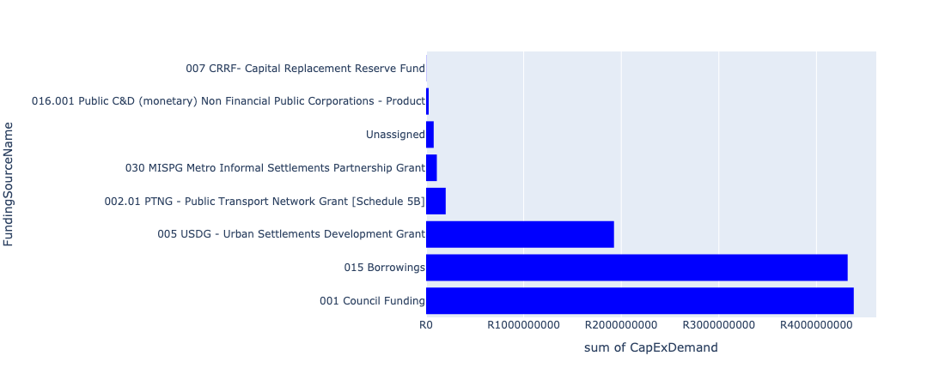

Figure 5.4: Region 2: Northeast Departmental Requests

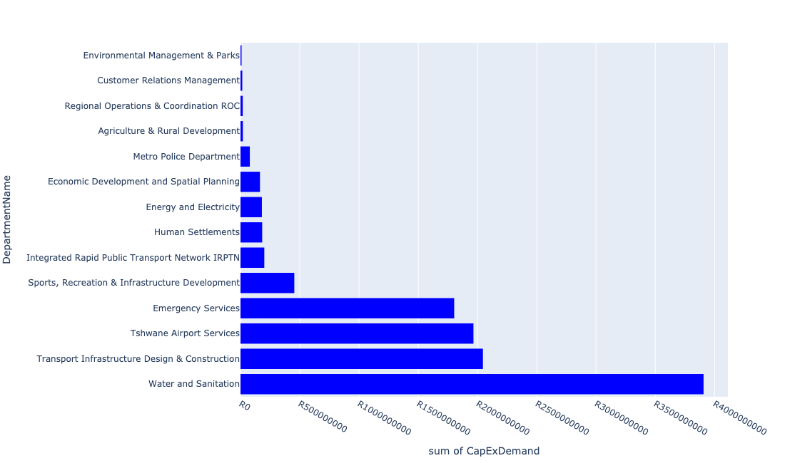

Table 5.2: Summary - Region 2: Northeast

|  |  |
| --- | --- |
| Item | Description |
| Total Capital Demand for Region 2: Northeast - All Years | R11,044,919,216 Rank: 1 (1 = Highest) |
| Total Capital Demand for Region 2: Northeast - MTREF | R2,976,991,767 Rank: 4 (1 = Highest) |
| Financial Years in which capital requirements are listed for Region 2: Northeast | 2022, 2023, 2024, 2025, 2026, 2027, 2028, 2029, 2030, 2031, 2032, 2033 and 2034 |
| Financial Year with highest capital demand for Region 2: Northeast | 2027 |
| Region 2: Northeast intersecting feature used | Works Location |
| Total number of projects intersecting with Region 2: Northeast | 176 Rank: 3 (1 = Highest) |

Table 5.3: All projects asking for budget in Region 2: Northeast

|  |  |  |  |
| --- | --- | --- | --- |
| Project ID | Project Name | Department | Project Budget |
| 712971915 | Revitalisation of the City-Development of Non-Motorised Transport Masterplan | Transport Infrastructure Design & Construction | R1,990,358 (0.02%) Budget spread across: 2027 |
| 712967069 | Establishment of TMPD Training Academy | Metro Police Department | R39,720,132 (0.36%) Budget spread across: 2022, 2023 and 2024 |
| 712969084 | (712279) Soshanguve - JJ 132KV Power Line | Energy and Electricity | R10,623,009 (0.10%) Budget spread across: 2022, 2023 and 2024 |
| 712975456 | Upgrade of infrastructure of Magalies mountain | Environmental Management & Parks | R3,486,484 (0.03%) Budget spread across: 2022, 2023, 2024, 2025, 2026, 2027, 2028, 2029, 2030 and 2031 |
| 712975536 | Refurbishment of Bodibeng customer care centre ( Soshanguve BB) | Customer Relations Management | R1,000,000 (0.01%) Budget spread across: 2023 |
| 712967745 | (712591) Planning and Design of BRT Projects | Integrated Rapid Public Transport Network IRPTN | R45,372,693 (0.41%) Budget spread across: 2022, 2023, 2024 and 2025 |
| 712967124 | (712941) Greening of Sports fields | Sports, Recreation & Infrastructure Development | R73,999,958 (0.67%) Budget spread across: 2022, 2023, 2024, 2025, 2026, 2027, 2028, 2029, 2030 and 2031 |
| 712974614 | Upgrading of a tributary of the Sand Spruit, Rosslyn x 17 | Transport Infrastructure Design & Construction | R2,473,172 (0.02%) Budget spread across: 2025, 2026 and 2027 |
| 712975132 | (71212SDD) Upgrade existing Soshanguve DD Outfall Sewer (2/2) | Water and Sanitation | R30,429,962 (0.28%) Budget spread across: 2023, 2024, 2025 and 2026 |
| 712967840 | (712534H) Replacement and upgrading of bulk pipeline: Union Building - Jumbo Rally to Schoeman Street | Water and Sanitation | R15,499,998 (0.14%) Budget spread across: 2022, 2023 and 2024 |
| 712967285 | (711335DP) Roodeplaat WTP to Montana Reservoir bulk pipe line | Water and Sanitation | R24,903,450 (0.23%) Budget spread across: 2023, 2024 and 2025 |
| 712975771 | Upgrade and replacement of the faulty booster pump | Tshwane Airport Services | R5,300,000 (0.05%) Budget spread across: 2022 and 2023 |
| 712974520 | Mashemong Major Stormwater Network 5A | Transport Infrastructure Design & Construction | R100,000,000 (0.91%) Budget spread across: 2027, 2028, 2029 and 2030 |
| 712967258 | (710878U) Refurbishment of Water networks and backlog eradication : Greater Temba: Suurman, Mashemong and Majaneng | Water and Sanitation | R42,000,000 (0.38%) Budget spread across: 2023, 2024 and 2025 |
| 712975748 | Electronic billing system for Wonderboom Airport revenue streams (aeronautical and non-aeronautical) | Tshwane Airport Services | R7,500,000 (0.07%) Budget spread across: 2022 and 2023 |
| 712969227 | (713031) Firearm safe for airport Visitors | Tshwane Airport Services | R200,000 (0.00%) Budget spread across: 2023 |
| 712974274 | (712591) Wonderboom Intermodal Facility (Hector Pieterson Station) | Integrated Rapid Public Transport Network IRPTN | R145,450,000 (1.32%) Budget spread across: 2022 |
| 65 | (713029) Additional carports and electronic parking payment equipment | Tshwane Airport Services | R3,000,000 (0.03%) Budget spread across: 2024 |
| 712974142 | (712862) Digital Valve Positioners | Energy and Electricity | R15,000,000 (0.14%) Budget spread across: 2022 |
| 574 | (710878) Sewer reticulation New Eersterust Ext 1,2,3 | Water and Sanitation | R50,000,000 (0.45%) Budget spread across: 2025, 2026 and 2027 |
| 712967252 | (710878P) Sewer reticulation New Eersterust Ext 4 to 7 | Water and Sanitation | R50,000,000 (0.45%) Budget spread across: 2025, 2026 and 2027 |
| 712974480 | RIMM: BON ACCORD QUARRY: PERIMETER FENCE | Regional Operations & Coordination ROC | R2,000,000 (0.02%) Budget spread across: 2022 |
| 73 | Construction of a parkade | Tshwane Airport Services | R83,500,000 (0.76%) Budget spread across: 2027, 2028 and 2029 |
| 961 | (712503) Flooding backlog: Network 3, Kudube Unit 11 | Transport Infrastructure Design & Construction | R101,000,000 (0.91%) Budget spread across: 2022, 2023, 2024, 2025, 2026, 2027, 2028, 2029 and 2030 |
| 712973959 | Sinoville Spinning Club add ablutions store room and Kitchen unit | Sports, Recreation & Infrastructure Development | R10,000,000 (0.09%) Budget spread across: 2029 |
| 712972920 | Golf Cart Shuttle for airport management inspection | Tshwane Airport Services | R70,000 (0.00%) Budget spread across: 2026 |
| 712974145 | (712862) Demin Plant | Energy and Electricity | R4,000,000 (0.04%) Budget spread across: 2022 |
| 62 | Main runway and taxiway upgrade and/or extension, including all security, ground lighting and related systems and services. | Tshwane Airport Services | R1,155,000,000 (10.46%) Budget spread across: 2025, 2026, 2027, 2028, 2029 and 2030 |
| 712975141 | (712121NDO3) New Doornpoort 5 Outfall Sewer (3/3) | Water and Sanitation | R3,000,000 (0.03%) Budget spread across: 2023, 2024 and 2025 |
| 712975339 | Sub-Project: TMPD Station - Suurman | Metro Police Department | R13,000,000 (0.12%) Budget spread across: 2022 and 2023 |
| 712974139 | (712862) Oxygen Analysers | Energy and Electricity | R1,000,000 (0.01%) Budget spread across: 2022 |
| 712975751 | Construction of a roof over the main terminal building | Tshwane Airport Services | R9,500,000 (0.09%) Budget spread across: 2022, 2023, 2024 and 2026 |
| 712969207 | Replacement of Tipper Truck | Tshwane Airport Services | R2,000,000 (0.02%) Budget spread across: 2022 |
| 712975768 | Scrap aircraft preservation/storage parking bay | Tshwane Airport Services | R1,000,000 (0.01%) Budget spread across: 2023 and 2024 |
| 712967146 | Hammanskraal cultural centre | Sports, Recreation & Infrastructure Development | R50,000,000 (0.45%) Budget spread across: 2027 and 2028 |
| 712975118 | (712534ND) New Doornpoort- West1 Reservoir | Water and Sanitation | R65,000,000 (0.59%) Budget spread across: 2023, 2024, 2025, 2026 and 2027 |
| 712967272 | (712534W) Babelegi Reservoir Extension | Water and Sanitation | R60,000,000 (0.54%) Budget spread across: 2022, 2023, 2024 and 2025 |
| 580 | (710878K) Sewer reticulation Kudube 5 | Water and Sanitation | R100,000,000 (0.91%) Budget spread across: 2022 and 2023 |
| 712972917 | Establishment and Renovation of Airport Maintenance Depot (compliance issue) | Tshwane Airport Services | R1,000,000 (0.01%) Budget spread across: 2022 |
| 53 | (713000) Elevator/escalator for main terminal building | Tshwane Airport Services | R500,000 (0.00%) Budget spread across: 2024 |
| 712975144 | (712121NS) New Stinkwater X03 Outfall Sewer | Water and Sanitation | R2,500,000 (0.02%) Budget spread across: 2023, 2024 and 2025 |
| 712974518 | Mashemong Major Stormwater Network 1E | Transport Infrastructure Design & Construction | R116,000,000 (1.05%) Budget spread across: 2026, 2027, 2028 and 2029 |
| 712973831 | Deon Malherbe Swimming pool Construction of a 25m indoor outdoor heated pool. | Sports, Recreation & Infrastructure Development | R20,000,000 (0.18%) Budget spread across: 2028 and 2029 |
| 712974140 | (712862) Oil Burner Spares | Energy and Electricity | R1,500,000 (0.01%) Budget spread across: 2022 |
| 712975468 | Upgrading of Existing ranking facility at Hammanskraal - Kopanong | Transport Infrastructure Design & Construction | R56,000,000 (0.51%) Budget spread across: 2022, 2023, 2024, 2025, 2026, 2027, 2028, 2029 and 2030 |
| 712969208 | (714049) Construction of rescue and fire fighting training facility as per SACARS requirements | Tshwane Airport Services | R3,000,000 (0.03%) Budget spread across: 2023 |
| 712975746 | Purchase 4x4 vehicle for the Airport Aviation Safety Officer | Tshwane Airport Services | R850,000 (0.01%) Budget spread across: 2022 |
| 712975769 | Information/advertising board at airport entrance | Tshwane Airport Services | R2,000,000 (0.02%) Budget spread across: 2022 and 2023 |
| 967 | (712507) Flooding backlog: Network 2H, Kudube Unit 7 | Transport Infrastructure Design & Construction | R106,000,000 (0.96%) Budget spread across: 2022, 2023, 2024, 2025, 2026, 2027, 2028, 2029 and 2030 |
| 712972912 | Capital Movables | Tshwane Airport Services | R4,500,000 (0.04%) Budget spread across: 2022, 2023, 2024, 2025, 2026, 2027, 2028, 2029 and 2030 |
| 712975113 | (710411IA) Temba WWTW Commission of Module 3 | Water and Sanitation | R290,000,000 (2.63%) Budget spread across: 2025, 2026, 2027 and 2028 |
| 712967247 | Construct additional helistops | Tshwane Airport Services | R12,500,000 (0.11%) Budget spread across: 2025, 2026, 2027 and 2030 |
| 712969609 | (710864) Bulk Sewer - Hammanskraal West X10 | Human Settlements | R10,000,000 (0.09%) Budget spread across: 2023 |
| 632 | (711273) Major Stormwater Drainage System Majaneng | Transport Infrastructure Design & Construction | R76,000,000 (0.69%) Budget spread across: 2022, 2025, 2026, 2027, 2028, 2029 and 2030 |
| 1342 | (712920) Rainbow Junction and Rehabilitation of the Apies River | Transport Infrastructure Design & Construction | R270,000,000 (2.44%) Budget spread across: 2022, 2023, 2024, 2025 and 2026 |
| 183 | Construction of a Specialist Emergency Services Training Academy | Emergency Services | R1,790,000,000 (16.21%) Budget spread across: 2026, 2027, 2028, 2029, 2030, 2031, 2032, 2033 and 2034 |
| 54 | (713057) Replacement and upgrade of fire hydrants and equipment | Tshwane Airport Services | R6,300,000 (0.06%) Budget spread across: 2022, 2023, 2024, 2025, 2026, 2027, 2028, 2029 and 2030 |
| 712975531 | Construction of 90 meters safety overshoot | Tshwane Airport Services | R45,000,000 (0.41%) Budget spread across: 2022, 2023 and 2024 |
| 712975139 | (712121NDO1) New Doornpoort 5 Outfall Sewer (1/3) | Water and Sanitation | R4,000,000 (0.04%) Budget spread across: 2023, 2024 and 2025 |
| 712975245 | Erf 4557 -Upgrade of Stink water Park | Environmental Management & Parks | R5,000,000 (0.05%) Budget spread across: 2022 |
| 987 | (712515) Flooding backlog: Network 2B, Ramotse | Transport Infrastructure Design & Construction | R89,000,000 (0.81%) Budget spread across: 2022, 2023, 2024, 2025, 2026, 2027, 2028, 2029 and 2030 |
| 712967685 | (712279) Soshanguve 132/11KV Substation | Energy and Electricity | R25,000,000 (0.23%) Budget spread across: 2022 |
| 712974538 | (710411D2) Rooiwal WWTW Phase 3: 50Ml/d extension | Water and Sanitation | R750,000,000 (6.79%) Budget spread across: 2024, 2025, 2026, 2027 and 2028 |
| 712967161 | Development of Stinkwater Agricultural Park | Agriculture & Rural Development | R9,500,000 (0.09%) Budget spread across: 2022, 2023, 2024 and 2025 |
| 712969228 | (714065) Runway, Taxiway and road sweeper | Tshwane Airport Services | R4,000,000 (0.04%) Budget spread across: 2022 |
| 575 | (710878) Ramotse-Marokolong waterborne sanitation | Water and Sanitation | R315,000,000 (2.85%) Budget spread across: 2022, 2023, 2025, 2026 and 2027 |
| 712967253 | (710878Q) Refurbishment of Sewer networks and backlog eradication : Greater Temba: Suurman, Mashemong and Majaneng | Water and Sanitation | R42,000,000 (0.38%) Budget spread across: 2023, 2024 and 2025 |
| 712967244 | Resurface taxiways | Tshwane Airport Services | R19,000,000 (0.17%) Budget spread across: 2022, 2023, 2028 and 2029 |
| 20 | Overkruin Library and office space | Sports, Recreation & Infrastructure Development | R40,000,000 (0.36%) Budget spread across: 2022 and 2023 |
| 68 | Airport vehicles replacement, equipment and new vehicles (i.e. slasher, tipper truck, tractors with cabins, perimeter control inspection vehicles, mini-passenger busses, truck with crane, disabled transporting vehicles, etc.) | Tshwane Airport Services | R15,000,000 (0.14%) Budget spread across: 2023, 2024, 2025, 2026, 2027, 2028, 2029 and 2030 |
| 712973888 | (711863) Internal Roads Mandela Village (North) | Transport Infrastructure Design & Construction | R140,000,000 (1.27%) Budget spread across: 2022, 2023, 2024, 2025, 2026, 2027, 2028, 2029 and 2030 |
| 712975454 | Upgrade of infrastructure at Wonderboom Nature Reserve | Environmental Management & Parks | R500,000 (0.00%) Budget spread across: 2022, 2023 and 2024 |
| 14 | New Eersterust/Stinkwater multi-purpose sport facility | Sports, Recreation & Infrastructure Development | R40,000,000 (0.36%) Budget spread across: 2027 and 2028 |
| 712973862 | Stinkwater Library to have a dedicated building | Sports, Recreation & Infrastructure Development | R40,000,000 (0.36%) Budget spread across: 2029 and 2030 |
| 712974886 | (712591) Line 1B (Wonderboom - Akasia) | Integrated Rapid Public Transport Network IRPTN | R10,000,000 (0.09%) Budget spread across: 2022 |
| 712974528 | Kudube Unit 5,7,8 and D : Flood Attenuation Structure | Transport Infrastructure Design & Construction | R42,000,000 (0.38%) Budget spread across: 2025, 2026 and 2027 |
| 712974448 | (710411D) Rooiwal WWTW Phase 2 : 80Ml/d Extensions and Extension of Sludge facility | Water and Sanitation | R1,715,000,000 (15.53%) Budget spread across: 2022, 2023, 2024, 2025, 2026, 2027, 2028 and 2029 |
| 712974393 | (710864) Sewer provision - Kudube X9 | Human Settlements | R47,000,000 (0.43%) Budget spread across: 2022 and 2023 |
| 712974382 | (710863) Water provision - Soshanguve MM | Human Settlements | R10,000,000 (0.09%) Budget spread across: 2022 |
| 712974282 | Upgrading of the Amandelboom low-level crossing in the Mimosa Spruit, Doornpoort | Transport Infrastructure Design & Construction | R21,000,000 (0.19%) Budget spread across: 2026, 2027 and 2028 |
| 712974173 | Major Stormwater Network 3B in Veronica Street, Montana | Transport Infrastructure Design & Construction | R2,500,000 (0.02%) Budget spread across: 2026 and 2027 |
| 712974167 | Upgrading of Stormwater network from Arbitus to Klippan Road, Montana Tuine | Transport Infrastructure Design & Construction | R29,800,000 (0.27%) Budget spread across: 2025, 2026 and 2027 |
| 712969350 | Hammanskraal Multi-purpose Sport Facility | Sports, Recreation & Infrastructure Development | R60,000,000 (0.54%) Budget spread across: 2026 and 2027 |
| 712967249 | CoT owned hangars and structure upgrade/replacement | Tshwane Airport Services | R43,000,000 (0.39%) Budget spread across: 2022, 2023, 2024, 2025, 2026, 2027, 2028, 2029 and 2030 |
| 712967243 | Resurface secondary runway | Tshwane Airport Services | R36,000,000 (0.33%) Budget spread across: 2022, 2023, 2029 and 2030 |
| 712967237 | Purchase ground handling equipment | Tshwane Airport Services | R7,000,000 (0.06%) Budget spread across: 2023, 2024, 2025, 2027 and 2029 |
| 712967226 | (711953) Airside/Landside: Legislative compliance and related requirements | Tshwane Airport Services | R135,000,000 (1.22%) Budget spread across: 2022, 2023, 2024, 2025, 2026, 2027, 2028, 2029 and 2030 |
| 1000 | (712520) Flooding backlog: Ramotse (Network 1A, 1C & 1F) | Transport Infrastructure Design & Construction | R75,000,000 (0.68%) Budget spread across: 2022, 2023, 2024, 2025, 2026, 2027, 2028, 2029 and 2030 |
| 963 | (712506) Flooding backlog: Networks in Matenteng and Stinkwater Area | Transport Infrastructure Design & Construction | R95,000,000 (0.86%) Budget spread across: 2022, 2023, 2024, 2025 and 2026 |
| 631 | (711268) Montana Spruit: Channel Improvements | Transport Infrastructure Design & Construction | R112,000,000 (1.01%) Budget spread across: 2022, 2023, 2024, 2025, 2026, 2027, 2028, 2029 and 2030 |
| 625 | (711264) Major S/ Water Drainage System: Matenteng | Transport Infrastructure Design & Construction | R12,700,000 (0.11%) Budget spread across: 2023 and 2024 |
| 622 | (711262) Magriet Monamodi Stormwater System | Transport Infrastructure Design & Construction | R104,000,000 (0.94%) Budget spread across: 2022, 2023, 2024, 2025, 2026, 2027, 2028, 2029 and 2030 |
| 582 | (710878N) Sewer reticulation Stinkwater Ext 2 to 8 | Water and Sanitation | R85,000,000 (0.77%) Budget spread across: 2023, 2024, 2025 and 2027 |
| 508 | (710597M) Mateteng Main Transport Route, Stinkwater | Transport Infrastructure Design & Construction | R55,000,000 (0.50%) Budget spread across: 2022, 2023, 2024 and 2025 |
| 445 | (710411D) Rooiwal WWTW Phase 1: Upgrading of Existing Infrastructure | Water and Sanitation | R138,000,000 (1.25%) Budget spread across: 2022 and 2023 |
| 67 | Construction of a new control tower | Tshwane Airport Services | R55,000,000 (0.50%) Budget spread across: 2026, 2027 and 2028 |
| 64 | Upgrade of Alpha apron | Tshwane Airport Services | R38,500,000 (0.35%) Budget spread across: 2026, 2027 and 2028 |
| 58 | (714059) Construction of labour change room and related facilities | Tshwane Airport Services | R2,000,000 (0.02%) Budget spread across: 2022 and 2023 |
| 712973947 | Refurbishment of New Eersterust customer care centre | Customer Relations Management | R8,000,000 (0.07%) Budget spread across: 2026 |
| 712973855 | Rooiwal Community Centre and Swimming pool Upgrade of facilities, Security and Access control | Sports, Recreation & Infrastructure Development | R20,000,000 (0.18%) Budget spread across: 2027 and 2028 |
| 712969221 | Upgrade and fully equipping of airport medical clinic | Tshwane Airport Services | R5,150,000 (0.05%) Budget spread across: 2023, 2024, 2027 and 2029 |
| 712969218 | Airport minibus | Tshwane Airport Services | R2,500,000 (0.02%) Budget spread across: 2022 and 2024 |
| 712975490 | Steve Bikoville Library | Sports, Recreation & Infrastructure Development | R40,000,000 (0.36%) Budget spread across: 2029 and 2030 |
| 712975338 | Sub-Project: TMPD Station - Annlin West | Metro Police Department | R13,000,000 (0.12%) Budget spread across: 2023 and 2024 |
| 712975092 | (710411Y_NT) New Temba PS and Rising mains (Phase 2/2) | Water and Sanitation | R48,000,000 (0.43%) Budget spread across: 2028, 2029 and 2030 |
| 712974390 | (710864) Sewer reticulation - Soshanguve MM | Human Settlements | R6,000,000 (0.05%) Budget spread across: 2022 |
| 712974347 | (714039) RIMM: Bon Accord | Regional Operations & Coordination ROC | R17,000,000 (0.15%) Budget spread across: 2022 |
| 712974172 | Flooding backlog: Kudube Unit 3 | Transport Infrastructure Design & Construction | R42,000,000 (0.38%) Budget spread across: 2027, 2028 and 2029 |
| 712973846 | Temba Stadium: Roof over the Main and side Pavilions with floodlights at main field (912 Unit D, Temba) | Sports, Recreation & Infrastructure Development | R20,000,000 (0.18%) Budget spread across: 2029 |
| 712972933 | (710863) Water provision - Hammanskraal West X10 (Bulk water line) | Human Settlements | R20,000,000 (0.18%) Budget spread across: 2022 |
| 712970903 | (710864) Sewer provision - New Eersterust X8 (Tswaing) (Pump Stations ) | Human Settlements | R40,000,000 (0.36%) Budget spread across: 2022, 2023 and 2024 |
| 712969641 | (713054) Construction of a separate entrance for General Aviation passengers | Tshwane Airport Services | R21,000,000 (0.19%) Budget spread across: 2023 and 2024 |
| 712969612 | (710863) Water provision - Hammanskraal West X10 (15ML Reservoir) | Human Settlements | R50,000,000 (0.45%) Budget spread across: 2022 and 2023 |
| 712967331 | (712977) Business Process Outsourcing (BPO) Park Construction | Economic Development and Spatial Planning | R164,300,000 (1.49%) Budget spread across: 2022 and 2023 |
| 712967248 | Construct of Golf Taxiway 2nd phase | Tshwane Airport Services | R45,000,000 (0.41%) Budget spread across: 2027, 2028 and 2029 |
| 712967245 | (712884) Upgrade and replacement of all runway and taxiway lights, Threshold light, Papi lights, apron lights, security and lighting system | Tshwane Airport Services | R43,000,000 (0.39%) Budget spread across: 2022, 2023 and 2024 |
| 712967242 | Resurface main runway | Tshwane Airport Services | R22,000,000 (0.20%) Budget spread across: 2022 and 2028 |
| 712967231 | Construction of Holding Bays | Tshwane Airport Services | R14,500,000 (0.13%) Budget spread across: 2027, 2028 and 2029 |
| 712967139 | (712911) New Eersterust library | Sports, Recreation & Infrastructure Development | R40,000,000 (0.36%) Budget spread across: 2023 and 2024 |
| 712967085 | (714009) New Electricity Depot Region 2 | Energy and Electricity | R6,000,000 (0.05%) Budget spread across: 2022 |
| 712967042 | Development of Rooiwal Agricultural Park | Agriculture & Rural Development | R10,500,000 (0.10%) Budget spread across: 2022, 2023, 2024 and 2025 |
| 1005 | (712523) Flooding backlog: Network 3A, Kudube Unit 9 | Transport Infrastructure Design & Construction | R101,000,000 (0.91%) Budget spread across: 2022, 2023, 2024, 2025, 2026, 2027, 2028, 2029 and 2030 |
| 988 | (712516) Flooding backlog: Network 2D, New Eersterust x 2 | Transport Infrastructure Design & Construction | R96,000,000 (0.87%) Budget spread across: 2022, 2023, 2024, 2025, 2026, 2027, 2028, 2029 and 2030 |
| 962 | (712504) Flooding backlog: Network 2F, Kudube Unit 6 | Transport Infrastructure Design & Construction | R91,000,000 (0.82%) Budget spread across: 2022, 2023, 2024, 2025, 2026, 2027, 2028, 2029 and 2030 |
| 876 | (712219) Flooding Backlogs: Stinkwater & New Eersterust Area | Transport Infrastructure Design & Construction | R108,000,000 (0.98%) Budget spread across: 2022, 2023, 2024, 2025, 2026, 2027, 2028, 2029 and 2030 |
| 450 | (710411I) Temba and Babelegi WWTW upgrade of existing infrastructure | Water and Sanitation | R50,000,000 (0.45%) Budget spread across: 2022 and 2023 |
| 178 | (713083) Urban Regeneration of Wonderboom Emergency Services Station | Emergency Services | R13,000,000 (0.12%) Budget spread across: 2022 |
| 69 | Construction of offices, maintenance depot, boardroom, training facilities and conference facility on Airport Property | Tshwane Airport Services | R23,000,000 (0.21%) Budget spread across: 2027, 2028, 2029 and 2030 |
| 66 | Provision of additional water, sewage, service road and taxiways, stormwater, security systems, electricity for airport expansion | Tshwane Airport Services | R43,000,000 (0.39%) Budget spread across: 2022, 2023, 2024, 2025, 2026, 2027, 2028, 2029 and 2030 |
| 63 | Completion of Bravo apron | Tshwane Airport Services | R30,000,000 (0.27%) Budget spread across: 2025 and 2026 |
| 712974141 | (712862) LED Digital Display | Energy and Electricity | R2,700,000 (0.02%) Budget spread across: 2022 |
| 712973963 | Refurbishment of Hammanskraal customer care centre | Customer Relations Management | R6,000,000 (0.05%) Budget spread across: 2024 |
| 712969223 | 1 Tonner LDV for maintenance | Tshwane Airport Services | R500,000 (0.00%) Budget spread across: 2022 |
| 712969217 | (714064) Tractors with slashers | Tshwane Airport Services | R7,300,000 (0.07%) Budget spread across: 2022, 2023 and 2030 |
| 712969209 | (714016) Development of a Joint Operating Centre | Tshwane Airport Services | R4,500,000 (0.04%) Budget spread across: 2022, 2023 and 2024 |
| 712969197 | (710556) Region 2 (Public Lighting) | Energy and Electricity | R58,500,000 (0.53%) Budget spread across: 2022, 2023, 2024, 2025, 2026, 2027, 2028, 2029 and 2030 |
| 712967846 | (710178) Electricity for All - Region 2 | Energy and Electricity | R56,000,000 (0.51%) Budget spread across: 2024 and 2025 |
| 712975532 | Upgrade/replacement of emergency generator | Tshwane Airport Services | R6,800,000 (0.06%) Budget spread across: 2022, 2024 and 2025 |
| 712975340 | Sub-Project: TMPD Station - Tswaing | Metro Police Department | R13,000,000 (0.12%) Budget spread across: 2025 and 2026 |
| 712975140 | (712121NDO2) New Doornpoort 5 Outfall Sewer (2/3) | Water and Sanitation | R24,000,000 (0.22%) Budget spread across: 2023, 2024 and 2025 |
| 712975085 | (712121NS1) New Suurman 1 Outfall Sewer (1/2) | Water and Sanitation | R2,500,000 (0.02%) Budget spread across: 2023 and 2024 |

Please note that the following projects will not be shown in this table:

* Projects with no recorded intersect with Tshwane mSCOA Regional Segment (in other words no Works Location was recorded on the system for this project)
* Projects that are not asking for any budget (requested budget fields are all '0').

## Region 3A: Central Region

Figure 5.5: Region 3A: Central Region Funding Requests

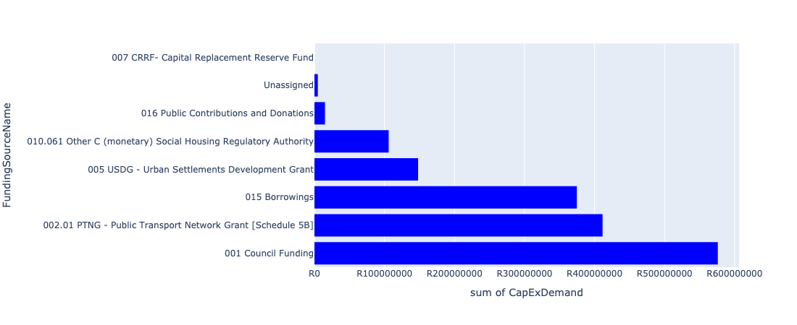

Figure 5.6: Region 3A: Central Region Departmental Requests

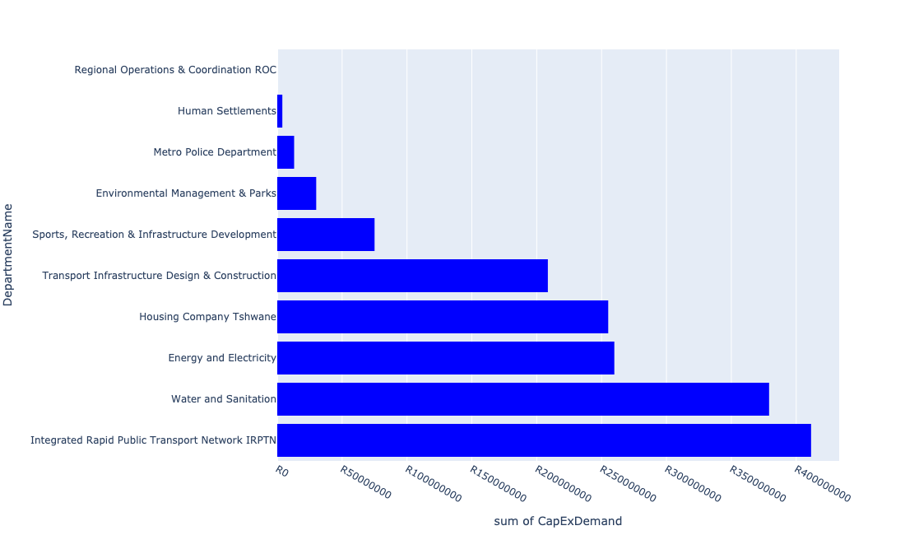

Table 5.3: Summary - Region 3A: Central Region

|  |  |
| --- | --- |
| Item | Description |
| Total Capital Demand for Region 3A: Central Region - All Years | R1,635,964,481 Rank: 8 (1 = Highest) |
| Total Capital Demand for Region 3A: Central Region - MTREF | R963,607,053 Rank: 8 (1 = Highest) |
| Financial Years in which capital requirements are listed for Region 3A: Central Region | 2022, 2023, 2024, 2025, 2026, 2027, 2028, 2029, 2030 and 2031 |
| Financial Year with highest capital demand for Region 3A: Central Region | 2024 |
| Region 3A: Central Region intersecting feature used | Works Location |
| Total number of projects intersecting with Region 3A: Central Region | 63 Rank: 7 (1 = Highest) |

Table 5.4: All projects asking for budget in Region 3A: Central Region

|  |  |  |  |
| --- | --- | --- | --- |
| Project ID | Project Name | Department | Project Budget |
| 712971915 | Revitalisation of the City-Development of Non-Motorised Transport Masterplan | Transport Infrastructure Design & Construction | R256,673 (0.02%) Budget spread across: 2027 |
| 712970748 | R6 Machinery and Equipment to ensure basic infrastructure reliability | Regional Operations & Coordination ROC | R0 (0.00%) Budget spread across: 2022 and 2023 |
| 712975456 | Upgrade of infrastructure of Magalies mountain | Environmental Management & Parks | R7,512,568 (0.46%) Budget spread across: 2022, 2023, 2024, 2025, 2026, 2027, 2028, 2029, 2030 and 2031 |
| 712975019 | Decongestion of the inner city- Provisioning of New off street holding facilities within the inner city – CBD as per the 04 identified sites | Transport Infrastructure Design & Construction | R28,388,742 (1.74%) Budget spread across: 2022, 2023, 2024, 2025, 2026, 2027, 2028, 2029 and 2030 |
| 712967744 | (712591) Design, Supply, Installation, Commissioning and Operational Support Of Advanced Public Transport Management System (APTMS) | Integrated Rapid Public Transport Network IRPTN | R7,940,287 (0.49%) Budget spread across: 2022 |
| 712967731 | (712591) Line 2B: Atterbury Rd (btw Lynnwood Rd to Lois Avenue) | Integrated Rapid Public Transport Network IRPTN | R152,990,840 (9.35%) Budget spread across: 2022, 2023, 2024 and 2025 |
| 712967133 | (712736) Fencing off Nature areas City Wide (Ecological Sensitive Purposes) | Environmental Management & Parks | R2,000,000 (0.12%) Budget spread across: 2022 and 2023 |
| 712974522 | Upgrading of Solomon Mahlangu Drive | Transport Infrastructure Design & Construction | R35,926,363 (2.20%) Budget spread across: 2022 |
| 712969046 | (712591) NMT Line 2B (Hatfield to Menlyn) | Integrated Rapid Public Transport Network IRPTN | R9,436,227 (0.58%) Budget spread across: 2022 |
| 712967743 | (712591) The Design, Supply, Installation, Operation and Maintenance of an automated fare Collection (AFC) System | Integrated Rapid Public Transport Network IRPTN | R42,090,667 (2.57%) Budget spread across: 2022, 2023, 2024 and 2025 |
| 712975324 | Furniture and equipment for visitor facilities at Groenkloof Nature Reserve | Environmental Management & Parks | R2,000,000 (0.12%) Budget spread across: 2028 |
| 712967730 | (712591) Line 2B: Lynnwood Rd (btw University Rd to Atterbury) | Integrated Rapid Public Transport Network IRPTN | R199,000,000 (12.16%) Budget spread across: 2022, 2023 and 2024 |
| 712974188 | Hillcrest swimming pool upgrade to international standard facility | Sports, Recreation & Infrastructure Development | R40,000,000 (2.45%) Budget spread across: 2028 and 2029 |
| 712975516 | Construction of Entrance gates - Klapperkop | Environmental Management & Parks | R3,000,000 (0.18%) Budget spread across: 2022, 2023 and 2024 |
| 712975410 | Sub-Project: TMPD Station - Ashlea Garden | Metro Police Department | R13,000,000 (0.79%) Budget spread across: 2022 and 2023 |
| 712975442 | Upgrade of infrastructure at DLS Nature Reserve | Environmental Management & Parks | R54,051 (0.00%) Budget spread across: 2022 and 2023 |
| 712974377 | (710863) Water provision - Bridgeway Communial Stand pipes | Human Settlements | R3,913,092 (0.24%) Budget spread across: 2022 |
| 712973994 | Silwerkroon SSE (121 Units) | Housing Company Tshwane | R12,702,022 (0.78%) Budget spread across: 2024 |
| 712975491 | Rehabilitation of Wetlands - Colbyn Wetland | Environmental Management & Parks | R1,500,000 (0.09%) Budget spread across: 2022, 2023, 2024, 2025 and 2026 |
| 712975345 | (712279) Elland Switching Station | Energy and Electricity | R55,000,000 (3.36%) Budget spread across: 2023, 2024 and 2025 |
| 712967840 | (712534H) Replacement and upgrading of bulk pipeline: Union Building - Jumbo Rally to Schoeman Street | Water and Sanitation | R15,500,002 (0.95%) Budget spread across: 2022, 2023 and 2024 |
| 712975494 | Construction of Litter Traps at Austin Roberts Nature Reserve | Environmental Management & Parks | R3,000,000 (0.18%) Budget spread across: 2022, 2023, 2024, 2025 and 2026 |
| 712973991 | Oosmoot (Villeria) SSE (60 Units) | Housing Company Tshwane | R6,058,398 (0.37%) Budget spread across: 2024 |
| 712975122 | (712534Mo) Mooiwater Reservoir (Phase 2) | Water and Sanitation | R31,000,000 (1.89%) Budget spread across: 2026, 2027 and 2028 |
| 712967488 | (710671) East Lynne bus and taxi facilities | Transport Infrastructure Design & Construction | R100,000,000 (6.11%) Budget spread across: 2022, 2023, 2024, 2025, 2026, 2027, 2028, 2029 and 2030 |
| 712975099 | (711335WK) Waterkloof 2 feeder main | Water and Sanitation | R19,500,000 (1.19%) Budget spread across: 2023, 2024 and 2025 |
| 712975030 | (712534) Rietfontein Res (Phase1) | Water and Sanitation | R34,000,000 (2.08%) Budget spread across: 2023, 2024 and 2026 |
| 712974217 | Sunnyside Boundary Fence | Housing Company Tshwane | R650,000 (0.04%) Budget spread across: 2024 |
| 712975448 | Upgrade of infrastructure of Voortrekker Monument Nature Reserve | Environmental Management & Parks | R2,000,000 (0.12%) Budget spread across: 2022 and 2023 |
| 712974164 | Major Stormwater network 4G along Boundary Road, Hatfield | Transport Infrastructure Design & Construction | R17,000,000 (1.04%) Budget spread across: 2026, 2027 and 2028 |
| 485 | (710484) Secondary Substations | Energy and Electricity | R204,800,000 (12.52%) Budget spread across: 2022, 2023, 2024, 2025, 2026, 2027, 2028, 2029, 2030 and 2031 |
| 18 | (713070) New Mayville Library | Sports, Recreation & Infrastructure Development | R35,000,000 (2.14%) Budget spread across: 2026 and 2027 |
| 712975573 | Stalshoogte | Housing Company Tshwane | R20,000,000 (1.22%) Budget spread across: 2022 and 2023 |
| 712975146 | (71212Arc) Upgrade existing Arcadia X8 Outfall Sewer | Water and Sanitation | R3,600,000 (0.22%) Budget spread across: 2023, 2024 and 2025 |
| 712974198 | Sunnyside: Construction of 264 Social Housing Units | Housing Company Tshwane | R215,690,817 (13.18%) Budget spread across: 2022, 2023 and 2024 |
| 712967294 | (711335) Cathodic protection to all Steel pipes (City wide) | Water and Sanitation | R108,000,000 (6.60%) Budget spread across: 2022, 2023, 2024, 2025, 2026, 2027, 2028, 2029 and 2030 |
| 712975526 | Upgrade of Roads in Groenkloof Nature reserve | Environmental Management & Parks | R3,953,754 (0.24%) Budget spread across: 2022, 2023, 2024, 2025, 2026, 2027, 2028 and 2029 |
| 712975523 | Upgrade of Visitors Facilities - Groenkloof Nature Reserve | Environmental Management & Parks | R3,999,979 (0.24%) Budget spread across: 2022, 2023, 2024, 2025, 2026 and 2027 |
| 712975512 | Upgrade of worker ablution facilities - Groenkloof Nature Reserve | Environmental Management & Parks | R1,000,000 (0.06%) Budget spread across: 2022 |
| 712975120 | (712534) New Additional Waverly LL Reservoir | Water and Sanitation | R11,000,000 (0.67%) Budget spread across: 2023, 2024 and 2025 |
| 712975097 | (711335Mck) Replace feeder mains to Muckleneuck Reservoir with new route from Klapperkop | Water and Sanitation | R75,000,000 (4.58%) Budget spread across: 2025, 2026, 2027 and 2028 |
| 712975094 | (710411Y_C) Upgrading of Carina Street Pump station | Water and Sanitation | R81,500,000 (4.98%) Budget spread across: 2025, 2026, 2027 and 2028 |
| 712974816 | Upgrading of Justice Mahomed Drive between Dely/Brooklyn Road and Jan Shoba Street | Transport Infrastructure Design & Construction | R27,000,000 (1.65%) Budget spread across: 2022 and 2023 |

Please note that the following projects will not be shown in this table:

* Projects with no recorded intersect with Tshwane mSCOA Regional Segment (in other words no Works Location was recorded on the system for this project)
* Projects that are not asking for any budget (requested budget fields are all '0').

## Region 3B: Central Region

Figure 5.7: Region 3B: Central Region Funding Requests

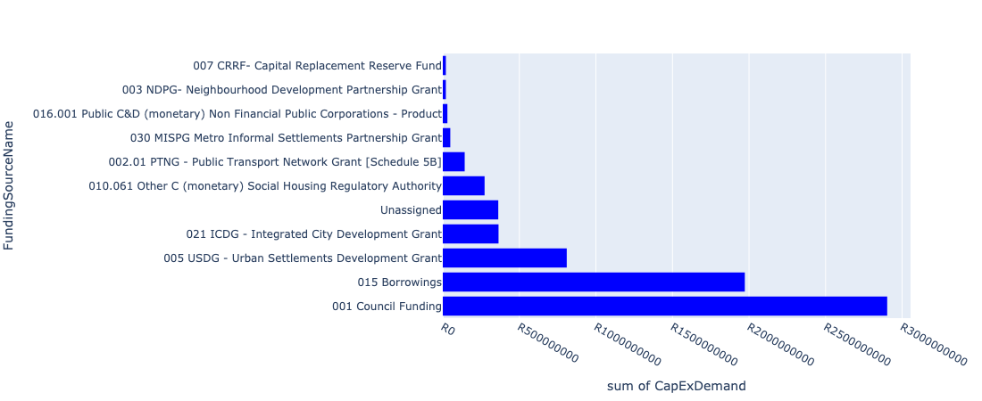

Figure 5.8: Region 3B: Central Region Departmental Requests

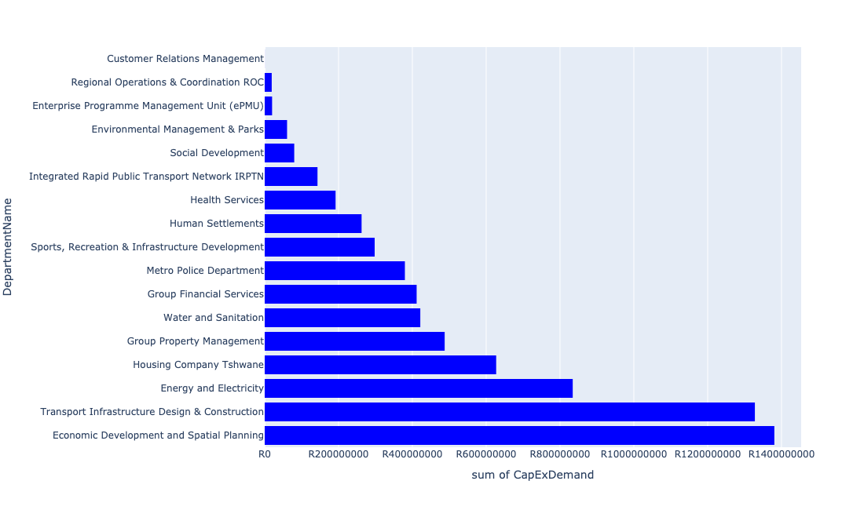

Table 5.4: Summary - Region 3B: Central Region

|  |  |
| --- | --- |
| Item | Description |
| Total Capital Demand for Region 3B: Central Region - All Years | R6,945,498,143 Rank: 4 (1 = Highest) |
| Total Capital Demand for Region 3B: Central Region - MTREF | R3,730,004,885 Rank: 3 (1 = Highest) |
| Financial Years in which capital requirements are listed for Region 3B: Central Region | 2022, 2023, 2024, 2025, 2026, 2027, 2028, 2029, 2030, 2031 and 2032 |
| Financial Year with highest capital demand for Region 3B: Central Region | 2022 |
| Region 3B: Central Region intersecting feature used | Works Location |
| Total number of projects intersecting with Region 3B: Central Region | 199 Rank: 1 (1 = Highest) |

Table 5.5: All projects asking for budget in Region 3B: Central Region

|  |  |  |  |
| --- | --- | --- | --- |
| Project ID | Project Name | Department | Project Budget |
| 712971915 | Revitalisation of the City-Development of Non-Motorised Transport Masterplan | Transport Infrastructure Design & Construction | R557,320 (0.01%) Budget spread across: 2027 |
| 712975456 | Upgrade of infrastructure of Magalies mountain | Environmental Management & Parks | R3,414,990 (0.05%) Budget spread across: 2022, 2023, 2024, 2025, 2026, 2027, 2028, 2029, 2030 and 2031 |
| 712967745 | (712591) Planning and Design of BRT Projects | Integrated Rapid Public Transport Network IRPTN | R42,552,283 (0.61%) Budget spread across: 2022, 2023, 2024 and 2025 |
| 712970762 | (710863) Water reticulation - Andeon X37 | Human Settlements | R0 (0.00%) Budget spread across: 2022 |
| 712970768 | (710864) Sewer reticulation - Andeon X37 | Human Settlements | R0 (0.00%) Budget spread across: 2022 and 2023 |
| 712974065 | (712279) Ifafi 88/11kV Substation | Energy and Electricity | R80,000,000 (1.15%) Budget spread across: 2024, 2025 and 2026 |
| 712973856 | (714029) RIMM: Belle Ombre: Concrete Plant | Regional Operations & Coordination ROC | R1,500,000 (0.02%) Budget spread across: 2022 |
| 712967089 | (712915) Upgrading of Caledonian Stadium (Inner City Park) | Sports, Recreation & Infrastructure Development | R112,886,200 (1.63%) Budget spread across: 2022 and 2023 |
| 712974096 | 712972939_04_Replacement of oils cables (City Centre) ( Electricity Distribution Loss) | Energy and Electricity | R36,000,000 (0.52%) Budget spread across: 2022, 2023, 2024 and 2025 |
| 712975556 | Refurbishment of Pretoria City Hall | Group Property Management | R50,000,000 (0.72%) Budget spread across: 2022 and 2023 |
| 1004 | (712522) Collector Road Backlogs: Atteridgeville | Transport Infrastructure Design & Construction | R170,000,000 (2.45%) Budget spread across: 2025, 2026, 2027 and 2028 |
| 712971918 | Revitalisation of the City-Upgrade of Pretoria Station Taxi Rank- Dairy Mall Taxi Rank | Transport Infrastructure Design & Construction | R236,000,000 (3.40%) Budget spread across: 2022, 2023, 2024, 2025, 2026, 2027, 2028, 2029 and 2030 |
| 712975525 | Upgrading and extension of cold storage Facilities | Economic Development and Spatial Planning | R444,160,000 (6.39%) Budget spread across: 2022, 2023, 2024, 2025, 2026, 2027, 2028, 2029, 2030, 2031 and 2032 |
| 391 | (710276) Upgrading And Extension Of Market Facilities | Economic Development and Spatial Planning | R228,700,000 (3.29%) Budget spread across: 2022, 2023, 2024 and 2025 |
| 712975453 | Upgrading of Dr Savage tranking facility and holding facility | Transport Infrastructure Design & Construction | R182,000,000 (2.62%) Budget spread across: 2022, 2023, 2024, 2025, 2026, 2027, 2028, 2029 and 2030 |
| 712969694 | (712762) Capital Moveables | Water and Sanitation | R9,000,000 (0.13%) Budget spread across: 2022, 2023, 2024, 2025, 2026, 2027, 2028, 2029 and 2030 |
| 1124 | (712751) Capital Funded from Operating (City Planning & Development) | Economic Development and Spatial Planning | R5,500,000 (0.08%) Budget spread across: 2022, 2023, 2024, 2025, 2026, 2027, 2028, 2029 and 2030 |
| 460 | Reparation To & Resurfacing Of Roads (Fresh Produce Market) | Economic Development and Spatial Planning | R17,500,000 (0.25%) Budget spread across: 2022, 2023, 2024 and 2025 |
| 712975533 | The Upgrading of Malie Street in Andeon and Booysens | Transport Infrastructure Design & Construction | R22,000,000 (0.32%) Budget spread across: 2025, 2026 and 2027 |
| 712975390 | (712279) Tunnel 132/11kV Substation | Energy and Electricity | R75,000,000 (1.08%) Budget spread across: 2025, 2026 and 2027 |
| 712967075 | Establishment of a TMPD Command and Communication Centre (C3) | Metro Police Department | R313,000,000 (4.51%) Budget spread across: 2022, 2023, 2024 and 2025 |
| 712974208 | (712872) Network Control Centre Reconfiguration | Energy and Electricity | R15,000,000 (0.22%) Budget spread across: 2022 |
| 712973993 | Capital Park SSE (69 Units) | Housing Company Tshwane | R6,852,942 (0.10%) Budget spread across: 2024 |
| 712974540 | Construction of major storm water Network 2A in the vicinity of Motheberebe Street, AtteridgevilleProject | Transport Infrastructure Design & Construction | R1,690,082 (0.02%) Budget spread across: 2025 and 2026 |
| 22 | Mountain View Library | Sports, Recreation & Infrastructure Development | R30,000,000 (0.43%) Budget spread across: 2026 and 2027 |
| 712975413 | Sub-Project: TMPD Station - Kwaggasrand / Atteridgeville | Metro Police Department | R420,888 (0.01%) Budget spread across: 2023 |
| 712975479 | Upgrade elevator Christiaan De Wet administration building | Group Property Management | R1,200,000 (0.02%) Budget spread across: 2024 |
| 712972966 | Townlands Project - Construction of 1,200 social housing units | Housing Company Tshwane | R267,180,300 (3.85%) Budget spread across: 2022, 2023 and 2024 |
| 712975293 | Upgrade elevator Old Council Chamber | Group Property Management | R1,400,000 (0.02%) Budget spread across: 2027 |
| 712975150 | (71212WS)Witkoppies Spruit Bulk Sewer | Water and Sanitation | R45,000,000 (0.65%) Budget spread across: 2023, 2024, 2026 and 2027 |
| 712967862 | (711335L) Louwlardia to Samrand Bulk Pipeline | Water and Sanitation | R50,000,000 (0.72%) Budget spread across: 2023, 2024, 2025 and 2026 |
| 712970767 | (710864) Sewer reticulation - Booysens X4 | Human Settlements | R5,000,000 (0.07%) Budget spread across: 2022 |
| 712974354 | (712591) Belle Ombre - Phase 2 (Overflow car park, Electric Fencing etc) | Integrated Rapid Public Transport Network IRPTN | R1,000,000 (0.01%) Budget spread across: 2022 |
| 712972931 | (710863) Booysens X4 (30ML Reservoir) | Human Settlements | R60,000,000 (0.86%) Budget spread across: 2022, 2023 and 2024 |
| 712975244 | Upgrade of Jubilee Park Sunnyside | Environmental Management & Parks | R6,000,000 (0.09%) Budget spread across: 2022 |
| 712970745 | (713093) Upgrade HB Philips Building | Group Property Management | R150,000,000 (2.16%) Budget spread across: 2022 |
| 712973925 | Saulsville Library | Sports, Recreation & Infrastructure Development | R10,000,000 (0.14%) Budget spread across: 2028 |
| 712972958 | (712827) Specialised Vehicles | Economic Development and Spatial Planning | R24,700,000 (0.36%) Budget spread across: 2022, 2023, 2024, 2025, 2026, 2027, 2029, 2030, 2031 and 2032 |
| 712972946 | (712591) Wonderboom Intermodal Facility (Building Works) | Integrated Rapid Public Transport Network IRPTN | R70,000,000 (1.01%) Budget spread across: 2022 |
| 712975520 | Upgrading of ripening center | Economic Development and Spatial Planning | R60,500,000 (0.87%) Budget spread across: 2022, 2023, 2024, 2025, 2026, 2027, 2028, 2029, 2030, 2031 and 2032 |
| 17 | (713068) Lotus Gardens Library | Sports, Recreation & Infrastructure Development | R35,000,000 (0.50%) Budget spread across: 2025 and 2026 |
| 712975019 | Decongestion of the inner city- Provisioning of New off street holding facilities within the inner city – CBD as per the 04 identified sites | Transport Infrastructure Design & Construction | R36,611,258 (0.53%) Budget spread across: 2022, 2023, 2024, 2025, 2026, 2027, 2028, 2029 and 2030 |
| 712974478 | RIMM: BELLE OMBRE: BIOMETRICAL TIME AND ATTENDANCE SYSTEM | Regional Operations & Coordination ROC | R1,000,000 (0.01%) Budget spread across: 2022 |
| 712969692 | (712926) Capital Moveables | Regional Operations & Coordination ROC | R12,500,000 (0.18%) Budget spread across: 2022, 2023, 2024, 2025 and 2026 |
| 712975408 | Upgrading of market Halls roofs | Economic Development and Spatial Planning | R78,900,000 (1.14%) Budget spread across: 2022, 2023, 2024, 2025, 2026, 2027, 2028, 2029, 2030, 2031 and 2032 |
| 712967602 | (710865) Construction of roads & stormwater - Fort West X5 | Human Settlements | R67,000,000 (0.96%) Budget spread across: 2022, 2023 and 2024 |
| 712975474 | Upgrade elevators Pretoria City Hall | Group Property Management | R5,000,000 (0.07%) Budget spread across: 2023 |
| 712973728 | (713044) Laudium Cemetery | Environmental Management & Parks | R328,271 (0.00%) Budget spread across: 2022 and 2023 |
| 712975033 | (712121NA2) New Atteridgeville P3 Outfall Sewer (2/3) | Water and Sanitation | R8,500,000 (0.12%) Budget spread across: 2023, 2024 and 2025 |
| 712973957 | Timberlands Construction Of 607 Social Housing Units | Housing Company Tshwane | R315,714,838 (4.55%) Budget spread across: 2022, 2023 and 2024 |
| 712975348 | (712279) Saulsville 132/11kV Substation | Energy and Electricity | R80,000,000 (1.15%) Budget spread across: 2025, 2026 and 2027 |
| 712975133 | (712121NSW1) New Swartspruit (A) Outfall Sewer (1/2) | Water and Sanitation | R10,500,000 (0.15%) Budget spread across: 2028, 2029 and 2030 |
| 712974352 | (712591) Line 3: CBD to Atteridgeville - Section 1 (CBD - Pretoria West) | Integrated Rapid Public Transport Network IRPTN | R8,000,000 (0.12%) Budget spread across: 2022 |
| 712975797 | Acquisition Old-Mercedes Benz Building | Group Property Management | R120,888,656 (1.74%) Budget spread across: 2022, 2023, 2024, 2025, 2026, 2027, 2028, 2029, 2030 and 2031 |
| 712967167 | (712260) Lotus Gardens multi-purpose sport facility | Sports, Recreation & Infrastructure Development | R40,000,000 (0.58%) Budget spread across: 2025 and 2026 |
| 712967144 | (711442) Upgrading of museums/historical buildings | Sports, Recreation & Infrastructure Development | R20 (0.00%) Budget spread across: 2025 |
| 712973851 | (714030 RIMM: Belle Ombre: Concrete Plant: Pneumatic Cylinders | Regional Operations & Coordination ROC | R1,000,000 (0.01%) Budget spread across: 2022 |
| 712975517 | Installation of high mast lights | Economic Development and Spatial Planning | R10,650,000 (0.15%) Budget spread across: 2022, 2023, 2024, 2025, 2026, 2027, 2028, 2029, 2030, 2031 and 2032 |
| 712971919 | Revitalisation of the City-Taxi Holding areas within the Pretoria CBD | Transport Infrastructure Design & Construction | R276,000,000 (3.97%) Budget spread across: 2022, 2023, 2024, 2025, 2026, 2027, 2028, 2029 and 2030 |
| 712975571 | Construction/Refurbishment of Atteridgeville Electrical Depot | Group Property Management | R45,000,000 (0.65%) Budget spread across: 2022 and 2023 |
| 712975007 | Security and visitor infrastructure upgrades at GaMothakga Recreational Resort | Environmental Management & Parks | R27,000,000 (0.39%) Budget spread across: 2022, 2023 and 2024 |
| 712967127 | (713040) Furniture and Equipment for offices, overnight accommodation and facilities within resorts | Environmental Management & Parks | R1,350,000 (0.02%) Budget spread across: 2022 and 2024 |
| 712967121 | (712878) Upgrading of Pilditch Stadium - cycle track | Sports, Recreation & Infrastructure Development | R15,000,000 (0.22%) Budget spread across: 2026 |
| 712969048 | (712591) Pretoria Station | Integrated Rapid Public Transport Network IRPTN | R0 (0.00%) Budget spread across: 2022 |
| 712969042 | (712591) Capital Park Railway Bridges (Line 1A - WP6) | Integrated Rapid Public Transport Network IRPTN | R1,000,000 (0.01%) Budget spread across: 2022 |
| 712967276 | (712534SL) Salvokop Reservoir | Water and Sanitation | R60,000,000 (0.86%) Budget spread across: 2023, 2024, 2025 and 2026 |
| 712975385 | Upgrading and extension of Access control office on the eastern gate | Economic Development and Spatial Planning | R20,300,000 (0.29%) Budget spread across: 2022, 2023, 2024, 2025, 2026, 2027, 2028, 2029, 2030, 2031 and 2032 |
| 712975142 | (712121NA3) New Atteridgeville P3 Outfall Sewer (3/3) | Water and Sanitation | R5,500,000 (0.08%) Budget spread across: 2023, 2024 and 2025 |
| 712975003 | Security and visitor infrastructure Upgrades for Kwaggaspruit Resort | Environmental Management & Parks | R15,000,000 (0.22%) Budget spread across: 2022, 2023 and 2024 |
| 712974934 | (712533) Tsosoloso Programme - Upgrading of roads in Saulsville | Enterprise Programme Management Unit (ePMU) | R20,000,000 (0.29%) Budget spread across: 2022 and 2023 |
| 712974840 | (714046) Salvokop Reservoir – Conduit Hydropower Plant | Water and Sanitation | R14,000,000 (0.20%) Budget spread across: 2022, 2023 and 2024 |
| 712974602 | Upgrading of the Steenhoven Spruit near Asiatic Bazaar, Pretoria west | Transport Infrastructure Design & Construction | R45,000,000 (0.65%) Budget spread across: 2026, 2027, 2028, 2029 and 2030 |
| 712974551 | (711706) Network Control System Extension | Energy and Electricity | R50,000,000 (0.72%) Budget spread across: 2022 and 2023 |
| 712974539 | Construction of major storm water Network 8 throughout Atteridgeville x 7 | Transport Infrastructure Design & Construction | R19,000,000 (0.27%) Budget spread across: 2026, 2027 and 2028 |
| 712974479 | RIMM: BELLE OMBRE: SOIL & ASPHALT LAB REFURBISHMENT | Regional Operations & Coordination ROC | R1,000,000 (0.01%) Budget spread across: 2022 |
| 712974353 | (712591) Line 3: CBD to Atteridgeville - Section 2 (Pretoria West - Atteridgeville) | Integrated Rapid Public Transport Network IRPTN | R7,000,000 (0.10%) Budget spread across: 2022 |
| 712972951 | (712826) Upgrade of infrastructure at Booysens Nursery | Environmental Management & Parks | R7,500,000 (0.11%) Budget spread across: 2022, 2023 and 2026 |
| 712970712 | (713084) Lalela Monument | Economic Development and Spatial Planning | R24,000,000 (0.35%) Budget spread across: 2022 and 2023 |
| 712969610 | (710863) Bulk water pipeline - Booysens X4 | Human Settlements | R35,000,000 (0.50%) Budget spread across: 2022, 2023 and 2024 |
| 712967498 | (712591) BRT Rationalization Infrastructure (Mixed Traffic Operations) | Integrated Rapid Public Transport Network IRPTN | R8,000,000 (0.12%) Budget spread across: 2022 |
| 712967094 | (713008) Construction of the Centralised Engineering Support centre Services. | Energy and Electricity | R200,000,000 (2.88%) Budget spread across: 2022, 2023, 2024 and 2025 |
| 712967091 | (713010) Infrastructure Fault Reporting and Dispatch (New) | Energy and Electricity | R200,000 (0.00%) Budget spread across: 2022 and 2023 |
| 1286 | (712868) Upgrading of the market trading system | Economic Development and Spatial Planning | R106,100,000 (1.53%) Budget spread across: 2022, 2023, 2025, 2026, 2027, 2028, 2029, 2031 and 2032 |
| 1080 | (712681) Multipurpose Development Centre next to Phomolong Clinic | Social Development | R80,000,000 (1.15%) Budget spread across: 2026 and 2027 |
| 712973990 | Danville SSE (105 Units) | Housing Company Tshwane | R20,856,780 (0.30%) Budget spread across: 2023 |
| 712973921 | Mbolekwa Synthetic Soccer pitch | Sports, Recreation & Infrastructure Development | R5,000,000 (0.07%) Budget spread across: 2029 |
| 712969192 | (710556) Region 3 (Public Lighting) | Energy and Electricity | R181,500,000 (2.61%) Budget spread across: 2022, 2023, 2024, 2025, 2026, 2027, 2028, 2029 and 2030 |
| 712967744 | (712591) Design, Supply, Installation, Commissioning and Operational Support Of Advanced Public Transport Management System (APTMS) | Integrated Rapid Public Transport Network IRPTN | R5,484,174 (0.08%) Budget spread across: 2022 |
| 712967629 | (710863) Bulk Reservoir - Fort West X4&5 | Human Settlements | R50,000,000 (0.72%) Budget spread across: 2022, 2023 and 2024 |
| 712967609 | (710864) Sewer provision - Fort West X4 | Human Settlements | R7,000,000 (0.10%) Budget spread across: 2022 |
| 712975796 | (714071) Acquisition and refurbishment of Midtown Building | Group Property Management | R82,890,700 (1.19%) Budget spread across: 2022, 2023, 2024, 2025, 2026, 2027, 2028, 2029, 2030 and 2031 |
| 712975590 | Refurbishment of Mamelodi customer care centre | Customer Relations Management | R166,667 (0.00%) Budget spread across: 2025 |
| 712975527 | Design ,Supply and install market surveillance system | Economic Development and Spatial Planning | R4,700,000 (0.07%) Budget spread across: 2022, 2023, 2024, 2025, 2026, 2027, 2028, 2029, 2030, 2031 and 2032 |
| 712975510 | Upgrading of perforated roller doors at Tshwane market | Economic Development and Spatial Planning | R2,990,000 (0.04%) Budget spread across: 2022, 2023, 2024, 2025, 2026, 2027, 2028, 2029, 2030, 2031 and 2032 |
| 712975438 | Creative Arts Spaces (Region 3) | Sports, Recreation & Infrastructure Development | R10,000,000 (0.14%) Budget spread across: 2025 |
| 712975292 | Upgrading of Dairy Mall to one stop intermodal facility ( Rail,Bus,Taxi) | Transport Infrastructure Design & Construction | R110,000,000 (1.58%) Budget spread across: 2022, 2023, 2024, 2025, 2026, 2027, 2028, 2029 and 2030 |
| 712975289 | Upgrade elevator metro police HQ | Group Property Management | R1,400,000 (0.02%) Budget spread across: 2025 |
| 712975278 | 712967311_01 Upgrade dock levellers at Tshwane Fresh Produce Market Banana Ripening plant | Group Property Management | R1,650,000 (0.02%) Budget spread across: 2022 |
| 712975229 | Saulsville Public Transport Facility | Transport Infrastructure Design & Construction | R19,099 (0.00%) Budget spread across: 2022, 2023, 2024, 2025, 2026, 2027, 2028, 2029 and 2030 |
| 712975072 | (712121NA1) New Atteridgeville P3 Outfall Sewer (1/3) | Water and Sanitation | R5,500,000 (0.08%) Budget spread across: 2023, 2024 and 2025 |
| 712974536 | (712872) Electricity Building Extension | Energy and Electricity | R20,000,000 (0.29%) Budget spread across: 2022 |
| 712974181 | Provisioning of new taxi ranking facility at Marabastad  Bazaar | Transport Infrastructure Design & Construction | R79,000,000 (1.14%) Budget spread across: 2022, 2023, 2024, 2025, 2026, 2027, 2028, 2029 and 2030 |
| 712973703 | Extension of Saulsville Clinic | Health Services | R64,000,000 (0.92%) Budget spread across: 2028, 2029 and 2030 |
| 712970763 | (710863) Water reticulation - Booysens X4 | Human Settlements | R3,000,000 (0.04%) Budget spread across: 2022 |
| 712969687 | (713063) Turnaround of Municipal Water Service - Reduction of Water losses | Group Financial Services | R411,592,208 (5.93%) Budget spread across: 2022, 2023, 2024, 2026 and 2027 |
| 712969601 | (712591) Atteridgeville Taxi Interchange | Integrated Rapid Public Transport Network IRPTN | R0 (0.00%) Budget spread across: 2022 |
| 712969243 | (713023) Inner City Regeneration: Civic and Northern Gateway Precincts | Economic Development and Spatial Planning | R200,000,000 (2.88%) Budget spread across: 2022, 2023, 2024, 2025, 2026, 2027, 2028, 2029 and 2030 |
| 712967345 | (711712) Development of Saulsville hostels | Human Settlements | R29,440,467 (0.42%) Budget spread across: 2022, 2023 and 2024 |
| 712967142 | Saulsville arena | Sports, Recreation & Infrastructure Development | R15,000,000 (0.22%) Budget spread across: 2027 |
| 1028 | (712534) Relining/upgrading reservoirs | Water and Sanitation | R190,000,000 (2.74%) Budget spread across: 2022, 2023, 2024, 2025, 2026, 2027, 2028, 2029 and 2030 |
| 968 | (712511) Flooding backlog: Atteridgeville | Transport Infrastructure Design & Construction | R150,000,000 (2.16%) Budget spread across: 2022, 2023, 2024, 2025, 2026, 2027, 2028, 2029 and 2030 |
| 15 | Capital Theatre (Feasibility Study) | Sports, Recreation & Infrastructure Development | R10,000,000 (0.14%) Budget spread across: 2025 |
| 712974129 | (712500) Postal Franking Machine | Metro Police Department | R350,000 (0.01%) Budget spread across: 2022 |
| 712973995 | Claremont 50 (BeterWag) SSE - 50 Units | Housing Company Tshwane | R6,000,000 (0.09%) Budget spread across: 2022 |
| 712973992 | Eloff Gebou (95 Units) Affordable rental | Housing Company Tshwane | R10,450,000 (0.15%) Budget spread across: 2023 and 2024 |
| 712973975 | Replacement of FF Ribeiro Clinic | Health Services | R64,000,000 (0.92%) Budget spread across: 2024, 2025 and 2026 |
| 712973923 | Upgrading of Makhaza Sport Facility | Sports, Recreation & Infrastructure Development | R15,000,000 (0.22%) Budget spread across: 2031 |
| 712973869 | RIMM: BELLE OMBRE DEPOT: Upgrade Security fence | Regional Operations & Coordination ROC | R2,000,000 (0.03%) Budget spread across: 2022 |
| 712967835 | New Folang Clinic | Health Services | R64,000,000 (0.92%) Budget spread across: 2022, 2023 and 2024 |
| 712967812 | (712900) Upgrading of Departmental Armory & Ammunition Depot | Metro Police Department | R11,000,000 (0.16%) Budget spread across: 2022, 2023 and 2024 |
| 712967697 | (710178) Electricity for All - Region 3 | Energy and Electricity | R96,750,000 (1.39%) Budget spread across: 2022, 2023, 2024 and 2025 |
| 712967626 | (710863) Water provision - Fort West X4 | Human Settlements | R6,000,000 (0.09%) Budget spread across: 2022 |
| 712975578 | Refurbishment of the Old Fire Station | Group Property Management | R20,000,000 (0.29%) Budget spread across: 2023 |
| 712975443 | Supply and installation of generators for Tshwane Market | Economic Development and Spatial Planning | R11,900,000 (0.17%) Budget spread across: 2022, 2023, 2024, 2025, 2026, 2027, 2028, 2029, 2030, 2031 and 2032 |
| 712975409 | Sub-Project: TMPD Station - Lady Selbourne/Suiderberg | Metro Police Department | R13,000,000 (0.19%) Budget spread across: 2024 and 2025 |
| 712975406 | Sub-Project: TMPD Station - CBD (Madiba Street 1) | Metro Police Department | R42,000,000 (0.60%) Budget spread across: 2022, 2023 and 2024 |
| 712975251 | 712967311_02 Upgrade passenger elevators at Blesbok and Bosbok flats | Group Property Management | R4,000,000 (0.06%) Budget spread across: 2022 |
| 712975197 | Upgrade elevator PE5905 Sammy Marks Library | Group Property Management | R1,400,000 (0.02%) Budget spread across: 2022 |
| 712975134 | (712121NSW2) New Swartspruit (A) Outfall Sewer (2/2) | Water and Sanitation | R22,000,000 (0.32%) Budget spread across: 2028 and 2029 |
| 712975077 | (712121NK) New Kwaggasrand flow diversion and Outfall Sewer | Water and Sanitation | R1,500,000 (0.02%) Budget spread across: 2023 and 2024 |
| 712975048 | Upgrade elevators Pretoria West power station | Group Property Management | R2,700,000 (0.04%) Budget spread across: 2022 |
| 712974825 | (713023) Inner City Regeneration - CBD areas | Economic Development and Spatial Planning | R140,000,000 (2.02%) Budget spread across: 2022, 2023, 2024, 2025, 2026, 2027, 2028 and 2029 |

Please note that the following projects will not be shown in this table:

* Projects with no recorded intersect with Tshwane mSCOA Regional Segment (in other words no Works Location was recorded on the system for this project)
* Projects that are not asking for any budget (requested budget fields are all '0').

## Region 4: South

Figure 5.9: Region 4: South Funding Requests

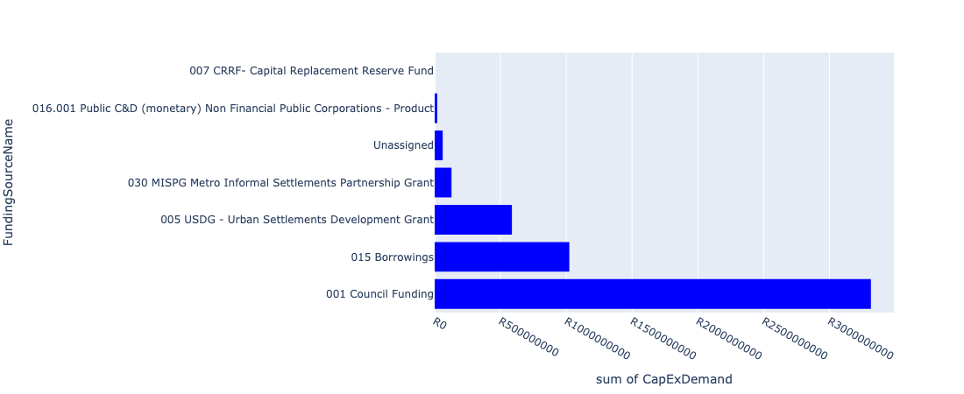

Figure 5.10: Region 4: South Departmental Requests

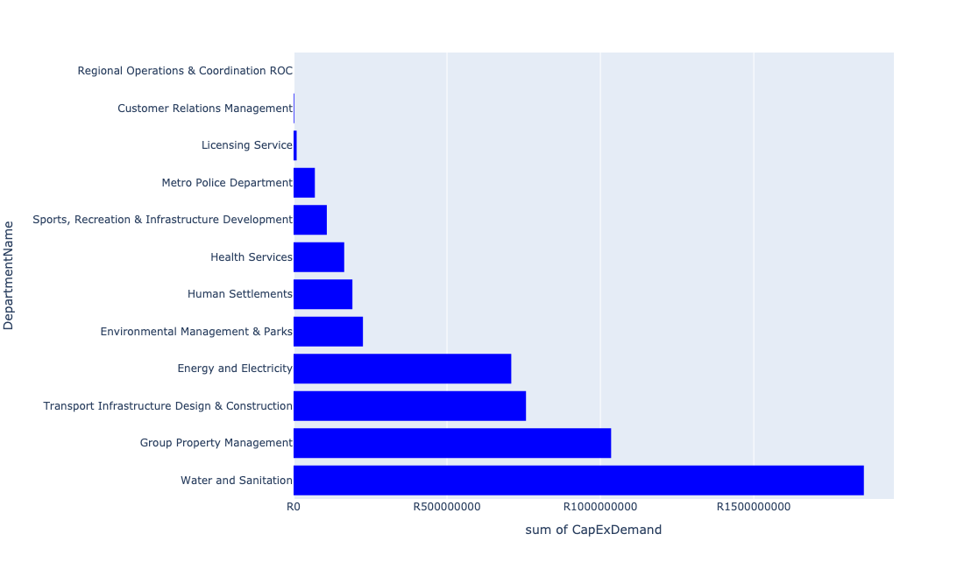

Table 5.5: Summary - Region 4: South

|  |  |
| --- | --- |
| Item | Description |
| Total Capital Demand for Region 4: South - All Years | R5,133,424,534 Rank: 5 (1 = Highest) |
| Total Capital Demand for Region 4: South - MTREF | R2,370,916,822 Rank: 5 (1 = Highest) |
| Financial Years in which capital requirements are listed for Region 4: South | 2022, 2023, 2024, 2025, 2026, 2027, 2028, 2029 and 2030 |
| Financial Year with highest capital demand for Region 4: South | 2024 |
| Region 4: South intersecting feature used | Works Location |
| Total number of projects intersecting with Region 4: South | 95 Rank: 5 (1 = Highest) |

Table 5.6: All projects asking for budget in Region 4: South

|  |  |  |  |
| --- | --- | --- | --- |
| Project ID | Project Name | Department | Project Budget |
| 712971915 | Revitalisation of the City-Development of Non-Motorised Transport Masterplan | Transport Infrastructure Design & Construction | R803,291 (0.02%) Budget spread across: 2027 |
| 712970748 | R6 Machinery and Equipment to ensure basic infrastructure reliability | Regional Operations & Coordination ROC | R0 (0.00%) Budget spread across: 2022 and 2023 |
| 712974540 | Construction of major storm water Network 2A in the vicinity of Motheberebe Street, AtteridgevilleProject | Transport Infrastructure Design & Construction | R2,309,918 (0.04%) Budget spread across: 2025 and 2026 |
| 712975413 | Sub-Project: TMPD Station - Kwaggasrand / Atteridgeville | Metro Police Department | R12,579,112 (0.25%) Budget spread across: 2023 |
| 712973728 | (713044) Laudium Cemetery | Environmental Management & Parks | R4,671,729 (0.09%) Budget spread across: 2022 and 2023 |
| 712975229 | Saulsville Public Transport Facility | Transport Infrastructure Design & Construction | R109,980,897 (2.14%) Budget spread across: 2022, 2023, 2024, 2025, 2026, 2027, 2028, 2029 and 2030 |
| 712975233 | Development of Rietvlei conference Facility and Office park | Environmental Management & Parks | R149,447,383 (2.91%) Budget spread across: 2022, 2023, 2024 and 2025 |
| 712974522 | Upgrading of Solomon Mahlangu Drive | Transport Infrastructure Design & Construction | R3,162,239 (0.06%) Budget spread across: 2022 |
| 712975442 | Upgrade of infrastructure at DLS Nature Reserve | Environmental Management & Parks | R1,945,949 (0.04%) Budget spread across: 2022 and 2023 |
| 712975526 | Upgrade of Roads in Groenkloof Nature reserve | Environmental Management & Parks | R46,246 (0.00%) Budget spread across: 2022, 2023, 2024, 2025, 2026, 2027, 2028 and 2029 |
| 712975523 | Upgrade of Visitors Facilities - Groenkloof Nature Reserve | Environmental Management & Parks | R21 (0.00%) Budget spread across: 2022, 2023, 2024, 2025, 2026 and 2027 |
| 712967166 | (711432) Olievenhoutbosch multi-purpose sport facility | Sports, Recreation & Infrastructure Development | R40,000,000 (0.78%) Budget spread across: 2025 and 2026 |
| 712975084 | (712121H) Upgrade existing Hennops River (B) Outfall Sewer (2/4) | Water and Sanitation | R800,000 (0.02%) Budget spread across: 2028 and 2029 |
| 712967195 | New Clinic Mooiplaas | Health Services | R64,000,000 (1.25%) Budget spread across: 2024, 2025 and 2026 |
| 712967490 | (712368) Upgrading of facility ( Shelters and bus terminals ) at Centurion CBD | Transport Infrastructure Design & Construction | R103,000,000 (2.01%) Budget spread across: 2022, 2023, 2024, 2025, 2026, 2027, 2028, 2029 and 2030 |
| 712967696 | (710178) Electricity for All - Region 4 | Energy and Electricity | R94,500,000 (1.84%) Budget spread across: 2022, 2023, 2024 and 2025 |
| 712967690 | (712279) Monavoni 132/11KV Substation | Energy and Electricity | R60,000,000 (1.17%) Budget spread across: 2022, 2023 and 2024 |
| 712975170 | Construction of stormwater relief networks to alleviate flooding from the regional low-point discharging unto the township, Erasmia | Transport Infrastructure Design & Construction | R2,100,000 (0.04%) Budget spread across: 2027 and 2028 |
| 712975078 | (712121NH1) New Hennops River (Sunderland Ridge) Outfall Sewer (1/6) | Water and Sanitation | R16,500,000 (0.32%) Budget spread across: 2026, 2027 and 2028 |
| 712967169 | New Electricity Depot -Region 4 (New) | Energy and Electricity | R114,000,000 (2.22%) Budget spread across: 2022, 2023 and 2024 |
| 712969196 | (710556) Region 4 (Public Lighting) | Energy and Electricity | R96,000,000 (1.87%) Budget spread across: 2024, 2025, 2026, 2027, 2028, 2029 and 2030 |
| 712974159 | Major Stormwater Network 6C, along Gropius Avenue, Die Hoewes | Transport Infrastructure Design & Construction | R2,000,000 (0.04%) Budget spread across: 2026 and 2027 |
| 712975087 | (71212PvR) Upgrade existing Pierre van Ryneveld Outfall Sewer | Water and Sanitation | R7,500,000 (0.15%) Budget spread across: 2023, 2024 and 2025 |
| 826 | (712121E) Rietspruit outfall sewer upgrade | Water and Sanitation | R25,000,000 (0.49%) Budget spread across: 2023 and 2024 |
| 712975081 | (712121NH4) New Hennops River (Sunderland Ridge) Outfall Sewer (4/6) | Water and Sanitation | R26,500,000 (0.52%) Budget spread across: 2026, 2027, 2028 and 2029 |
| 712974523 | Upgrading of Rooihuiskraal Road | Transport Infrastructure Design & Construction | R27,000,000 (0.53%) Budget spread across: 2022, 2023 and 2024 |
| 712974534 | (710411A4) Sunderland Ridge WWTW: land aquisition of new adjacent site | Water and Sanitation | R155,000,000 (3.02%) Budget spread across: 2023 |
| 712967627 | (710863) Water provision - Olievenhoutbosch X60 | Human Settlements | R8,000,000 (0.16%) Budget spread across: 2022 |
| 712973701 | Eldoraigne Clinic Dispensaries | Health Services | R34,000,000 (0.66%) Budget spread across: 2022 and 2023 |
| 16 | New Valhalla Library | Sports, Recreation & Infrastructure Development | R25,000,000 (0.49%) Budget spread across: 2028 and 2029 |
| 712973727 | 713044 Construction of internal roads and guard house at Centurion Cemetery | Environmental Management & Parks | R10,000,000 (0.19%) Budget spread across: 2022 |
| 712975450 | Upgrade of infrastructure development at Luton Valley Nature Area | Environmental Management & Parks | R2,500,000 (0.05%) Budget spread across: 2026 |
| 712967278 | (712534PR) Pretorius rand reservoir | Water and Sanitation | R85,000,000 (1.66%) Budget spread across: 2023, 2024, 2025, 2026 and 2027 |
| 712975493 | Rehabilitation of Wetlands - The Reeds | Environmental Management & Parks | R1,500,000 (0.03%) Budget spread across: 2022, 2023, 2024, 2025 and 2026 |
| 643 | (711325) Olievenhoutbosch Activity Spine | Transport Infrastructure Design & Construction | R180,000,000 (3.51%) Budget spread across: 2023, 2024, 2025 and 2026 |
| 712975082 | (712121NH5) New Hennops River (Sunderland Ridge) Outfall Sewer (5/6) | Water and Sanitation | R18,500,000 (0.36%) Budget spread across: 2027, 2028 and 2029 |
| 712975228 | Olivienhoutbosch Public Transport Facility (Provisioning of new taxi ranking facility at Olivienhoutbosch ) | Transport Infrastructure Design & Construction | R94,000,000 (1.83%) Budget spread across: 2022, 2023, 2024, 2025, 2026, 2027, 2028, 2029 and 2030 |
| 712974535 | (710411A5) Sunderland Ridge WWTW Phase 3: 25 Ml/d Extension on new adjacent site | Water and Sanitation | R693,000,000 (13.50%) Budget spread across: 2023, 2024, 2025, 2026, 2027 and 2028 |
| 712969022 | Extension of Rooihuiskraal Clinic to accommodate growing patient numbers | Health Services | R67,000,000 (1.31%) Budget spread across: 2024, 2025 and 2026 |
| 712975259 | Development of of Monte kneen Park | Environmental Management & Parks | R2,000,000 (0.04%) Budget spread across: 2023 |
| 712975414 | Olievenhoutbosch Cultural Centre | Sports, Recreation & Infrastructure Development | R13,333,334 (0.26%) Budget spread across: 2027 |
| 712974200 | Refurbishment of Olievenhoutbosch customer care walk in centre | Customer Relations Management | R2,000,000 (0.04%) Budget spread across: 2022 |
| 712975402 | Sub-Project: TMPD Station: Raslouw AH | Metro Police Department | R13,000,000 (0.25%) Budget spread across: 2024 and 2025 |
| 712975580 | Centurion Customer Centre - Masterplan | Group Property Management | R1,035,000,000 (20.16%) Budget spread across: 2022, 2023, 2024 and 2025 |
| 712975096 | (710411Y_EP) Additional Pump for Elardus Park (Large) booster PS | Water and Sanitation | R11,500,000 (0.22%) Budget spread across: 2025, 2026 and 2027 |
| 712975417 | Sub-Project: TMPD Station - Irene | Metro Police Department | R13,000,000 (0.25%) Budget spread across: 2022 and 2023 |
| 712975256 | Erf 5426 -Upgrade of Olievenhoutbosch Park | Environmental Management & Parks | R5,000,000 (0.10%) Budget spread across: 2022 |
| 712975070 | 713044 Extension of Centurion Cemetery | Environmental Management & Parks | R6,200,000 (0.12%) Budget spread across: 2023 and 2025 |
| 712975079 | (712121NH2) New Hennops River (Sunderland Ridge) Outfall Sewer (2/6) | Water and Sanitation | R19,500,000 (0.38%) Budget spread across: 2026, 2027 and 2028 |
| 712974552 | Construction of major storm water Networks 1A and 1C in the vicinity of Mahwane Street, Atteridgeville | Transport Infrastructure Design & Construction | R6,000,000 (0.12%) Budget spread across: 2025 and 2026 |
| 712975029 | (710411Sc) Schurveberg WWTW: New 25 Ml/day BNR Module | Water and Sanitation | R55,000,000 (1.07%) Budget spread across: 2029 and 2030 |
| 712967492 | Wierda Park Transport Facilities | Transport Infrastructure Design & Construction | R75,000,000 (1.46%) Budget spread across: 2022, 2023, 2024, 2025, 2026, 2027, 2028, 2029 and 2030 |
| 712967277 | (712534L) Louwlardia Reservoir/ Heritage Reservoir | Water and Sanitation | R45,000,000 (0.88%) Budget spread across: 2023, 2024 and 2025 |
| 712967120 | (713089) Rehabilitation of wetlands | Environmental Management & Parks | R6,000,000 (0.12%) Budget spread across: 2022 and 2023 |
| 439 | (710411A) Sunderland Ridge WWTW Phase1: Upgrade of existing infrastructure | Water and Sanitation | R60,000,000 (1.17%) Budget spread across: 2022 and 2023 |
| 21 | Erasmia Library | Sports, Recreation & Infrastructure Development | R30,000,000 (0.58%) Budget spread across: 2027 and 2028 |
| 712967598 | (710865) Construction of roads & stormwater - Olievenhoutbosch X60 | Human Settlements | R179,838,974 (3.50%) Budget spread across: 2022, 2023 and 2024 |
| 712967684 | (712279) Eldoraigne 132/11kv Substation | Energy and Electricity | R20,000,000 (0.39%) Budget spread across: 2026 |
| 712975458 | Upgrade infrastructure at Bishop Bird Sanctuary | Environmental Management & Parks | R1,500,000 (0.03%) Budget spread across: 2028 |
| 712975392 | (712279) Heritage Hill to Kentron T 132kV Power Line | Energy and Electricity | R25,000,000 (0.49%) Budget spread across: 2023 and 2024 |
| 712975169 | Construction of stormwater relief networks to alleviate flooding pertaining to Fourth Avenue and surrounding areas in Laudium | Transport Infrastructure Design & Construction | R900,000 (0.02%) Budget spread across: 2026 and 2027 |
| 712975149 | (71212Doo)Doornkloof Bulk Sewer Extension | Water and Sanitation | R18,500,000 (0.36%) Budget spread across: 2023, 2024 and 2025 |
| 712975135 | (712121PT) New Peach Tree 1 Outfall Sewer | Water and Sanitation | R3,500,000 (0.07%) Budget spread across: 2028 and 2029 |
| 712975083 | (712121NH6) New Hennops River (Sunderland Ridge) Outfall Sewer (6/6) | Water and Sanitation | R106,500,000 (2.07%) Budget spread across: 2027, 2028, 2029 and 2030 |
| 712975080 | (712121NH3) New Hennops River (Sunderland Ridge) Outfall Sewer (3/6) | Water and Sanitation | R31,500,000 (0.61%) Budget spread across: 2026, 2027, 2028 and 2029 |
| 712974533 | (710411A3) Sunderland Ridge WWTW Phase 2: 20 Ml/d Extension project using alternative technologies on existing site | Water and Sanitation | R480,000,000 (9.35%) Budget spread across: 2022, 2023, 2024 and 2025 |
| 712974524 | Upgrading of Lenchen Avenue | Transport Infrastructure Design & Construction | R49,000,000 (0.95%) Budget spread across: 2022, 2023 and 2024 |
| 712974158 | Upgrading of major stormwater Network 3A along Rabie Street, Lyttleton | Transport Infrastructure Design & Construction | R25,300,000 (0.49%) Budget spread across: 2025, 2026 and 2027 |
| 712969077 | (712279) Kentron 132/11kV Substation | Energy and Electricity | R75,000,000 (1.46%) Budget spread across: 2022 and 2023 |
| 712967614 | (710864) Sewer provision Olievenhoutbosch X60 | Human Settlements | R3,905,440 (0.08%) Budget spread across: 2022 |
| 712975772 | (712900) Upgrading of existing Practical Training facilities (Centurion) | Metro Police Department | R30,800,000 (0.60%) Budget spread across: 2022, 2023 and 2024 |
| 712975529 | Upgrade of Rooihuiskraal - Reptile park | Environmental Management & Parks | R1,000,000 (0.02%) Budget spread across: 2022, 2023, 2024, 2025, 2026, 2027 and 2028 |
| 712975483 | Rehabilitation of Wetlands - Technopark | Environmental Management & Parks | R1,500,000 (0.03%) Budget spread across: 2022, 2023, 2024 and 2025 |
| 712975349 | (712279) Heritage Hill Substation | Energy and Electricity | R175,000,000 (3.41%) Budget spread across: 2024, 2025 and 2026 |
| 712975346 | (712279) Centurion Switching Station | Energy and Electricity | R50,000,000 (0.97%) Budget spread across: 2025 and 2026 |
| 712975171 | Upgrading of Hendrik Verwoerd Drive between John Vorster Drive and Rooihuiskraal Road in Centurion | Transport Infrastructure Design & Construction | R65,000,000 (1.27%) Budget spread across: 2026, 2027 and 2028 |
| 712975168 | Construction of major and minor stormwater drainage networks in Olievenhoutbosch X21 and X37. | Transport Infrastructure Design & Construction | R12,000,000 (0.23%) Budget spread across: 2028 and 2029 |
| 712975008 | Upgrades security and building infrastructure at Zwartkops Resort | Environmental Management & Parks | R32,000,000 (0.62%) Budget spread across: 2022, 2023 and 2024 |
| 712974819 | 713044 Olievenhoutbosch Cemetery | Environmental Management & Parks | R800,000 (0.02%) Budget spread across: 2022 |
| 712974567 | Installation of security at licensing centres | Licensing Service | R10,000,000 (0.19%) Budget spread across: 2022 |

Please note that the following projects will not be shown in this table:

* Projects with no recorded intersect with Tshwane mSCOA Regional Segment (in other words no Works Location was recorded on the system for this project)
* Projects that are not asking for any budget (requested budget fields are all '0').

## Region 5: Nokeng

Figure 5.11: Region 5: Nokeng Funding Requests

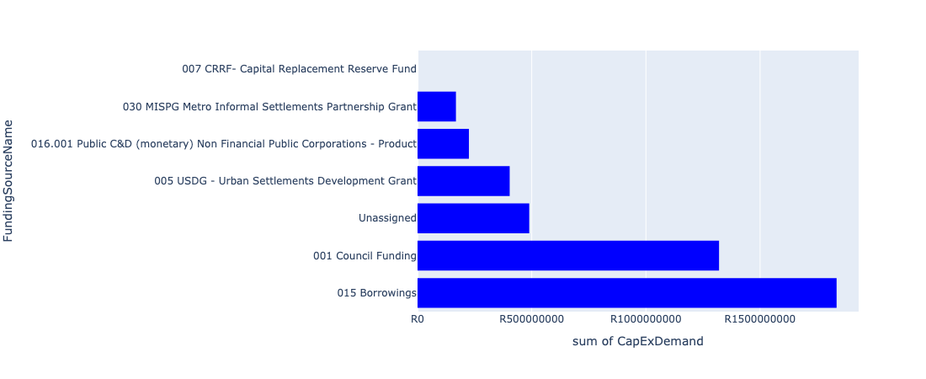

Figure 5.12: Region 5: Nokeng Departmental Requests

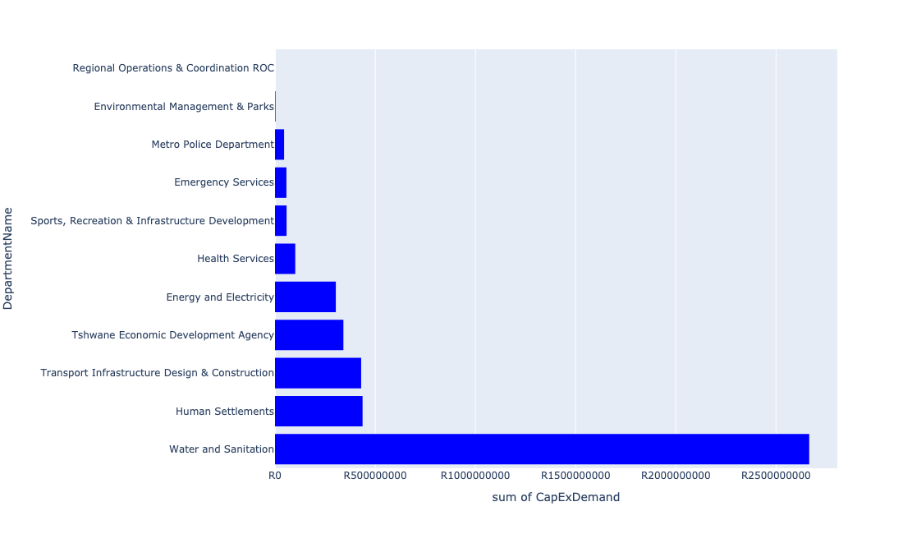

Table 5.6: Summary - Region 5: Nokeng

|  |  |
| --- | --- |
| Item | Description |
| Total Capital Demand for Region 5: Nokeng - All Years | R4,440,789,590 Rank: 6 (1 = Highest) |
| Total Capital Demand for Region 5: Nokeng - MTREF | R1,975,436,649 Rank: 6 (1 = Highest) |
| Financial Years in which capital requirements are listed for Region 5: Nokeng | 2022, 2023, 2024, 2025, 2026, 2027, 2028, 2029, 2030 and 2031 |
| Financial Year with highest capital demand for Region 5: Nokeng | 2025 |
| Region 5: Nokeng intersecting feature used | Works Location |
| Total number of projects intersecting with Region 5: Nokeng | 69 Rank: 6 (1 = Highest) |

Table 5.7: All projects asking for budget in Region 5: Nokeng

|  |  |  |  |
| --- | --- | --- | --- |
| Project ID | Project Name | Department | Project Budget |
| 712971915 | Revitalisation of the City-Development of Non-Motorised Transport Masterplan | Transport Infrastructure Design & Construction | R1,725,911 (0.04%) Budget spread across: 2027 |
| 712970748 | R6 Machinery and Equipment to ensure basic infrastructure reliability | Regional Operations & Coordination ROC | R0 (0.00%) Budget spread across: 2022 and 2023 |
| 712975456 | Upgrade of infrastructure of Magalies mountain | Environmental Management & Parks | R299,750 (0.01%) Budget spread across: 2022, 2023, 2024, 2025, 2026, 2027, 2028, 2029, 2030 and 2031 |
| 712967295 | (711335ML) Mamelodi R5 feeder main relocation | Water and Sanitation | R1,061,545 (0.02%) Budget spread across: 2023, 2024, 2025 and 2026 |
| 712969439 | (712121D) Moreletaspruit: Outfall sewer | Water and Sanitation | R17,878,273 (0.40%) Budget spread across: 2022, 2023, 2024, 2025 and 2026 |
| 992 | (712518) Flooding backlog: Drainage canals along Hans Strydom Dr, Mamelodi x 4 and 5 | Transport Infrastructure Design & Construction | R2,733,288 (0.06%) Budget spread across: 2022, 2023 and 2024 |
| 712975437 | Sub-Project: TMPD Station - Mamelodi (Extension 10) | Metro Police Department | R2,371,272 (0.05%) Budget spread across: 2022, 2023 and 2024 |
| 712975391 | (712279) Mamelodi II 132/11kV Substation | Energy and Electricity | R24,850 (0.00%) Budget spread across: 2026 |
| 712969619 | (713044) Hatherley Cemetery | Environmental Management & Parks | R2,314,286 (0.05%) Budget spread across: 2022, 2023 and 2025 |
| 712974192 | Provisioning of New ranking facility at Eersterus Taxi rank | Transport Infrastructure Design & Construction | R83,405,884 (1.88%) Budget spread across: 2022, 2024, 2025, 2026, 2027, 2028, 2029 and 2030 |
| 712972960 | (710864) Sewer reticulation - Refilwe X7 | Human Settlements | R20,500,000 (0.46%) Budget spread across: 2022 and 2023 |
| 712974380 | (710863) Water provision - Refilwe ext 10 | Human Settlements | R30,235,473 (0.68%) Budget spread across: 2022, 2023 and 2024 |
| 440 | (710411B) Zeekoegat WWTW Phase 1: Upgrading of existing infrastructure (mechanical) | Water and Sanitation | R62,000,000 (1.40%) Budget spread across: 2022, 2023, 2024 and 2025 |
| 179 | Construction of New Emergency Services Station in Derdepoort | Emergency Services | R57,000,000 (1.28%) Budget spread across: 2028, 2029 and 2030 |
| 712970776 | (710864) Sewer provision - Pienaarspoort X20 | Human Settlements | R66,800,000 (1.50%) Budget spread across: 2022, 2023 and 2024 |
| 1456 | (712945) Upgrading of roads and stormwater systems in Rayton | Transport Infrastructure Design & Construction | R55,000,000 (1.24%) Budget spread across: 2022, 2023 and 2024 |
| 712973744 | (711921H) Upgrading of Sable Hills Portable WTP | Water and Sanitation | R6,000,000 (0.14%) Budget spread across: 2023 and 2024 |
| 712967178 | (712916) Upgrade Refilwe Stadium | Sports, Recreation & Infrastructure Development | R47,700,000 (1.07%) Budget spread across: 2022 and 2023 |
| 712969571 | (712946) Upgrading of roads and stormwater systems in Cullinan - Phase 1 | Transport Infrastructure Design & Construction | R75,000,000 (1.69%) Budget spread across: 2022, 2023, 2025 and 2026 |
| 712974546 | (710411B1) Zeekoegat WWTW: Phase2: De-bottlenecking & tertiary treatment | Water and Sanitation | R363,000,000 (8.17%) Budget spread across: 2023, 2024, 2025 and 2028 |
| 712975445 | Creative Hub and Incubation (Region 5), Ward 100 Refilwe Community Hall. | Sports, Recreation & Infrastructure Development | R10,000,000 (0.23%) Budget spread across: 2026 |
| 712975145 | (712121NHS) New Hammanskraal South Outfall Sewer (2/2) | Water and Sanitation | R7,000,000 (0.16%) Budget spread across: 2028, 2029 and 2030 |
| 712969125 | (710178) Electricity for All - Region 5 | Energy and Electricity | R75,400,000 (1.70%) Budget spread across: 2022, 2023, 2024 and 2025 |
| 712974383 | (710864) Sewer reticulation - Pienaarspoort | Human Settlements | R66,800,000 (1.50%) Budget spread across: 2022 and 2023 |
| 712975032 | (712121FZ) Future Zeekoegat bulk Outfall sewer (2/6) | Water and Sanitation | R22,500,000 (0.51%) Budget spread across: 2025, 2026 and 2027 |
| 712972962 | (710863) Water provision - Refilwe X7 | Human Settlements | R22,714,802 (0.51%) Budget spread across: 2022, 2023 and 2024 |
| 712969238 | (713051) Health Posts | Health Services | R37,000,000 (0.83%) Budget spread across: 2024, 2025 and 2026 |
| 712967289 | (711335OR) New Kameelfontein Down feeder Main pipeline (Bulk supply from the existing Baviaanspoort Reservoir to the east and north areas of Roodeplaat Dam) | Water and Sanitation | R35,000,000 (0.79%) Budget spread across: 2022, 2023 and 2024 |
| 453 | (710411R) New Lewzene Waste Water Treatment Works (10Ml/d) | Water and Sanitation | R55,000,000 (1.24%) Budget spread across: 2023, 2024 and 2025 |
| 267 | (710026) Replacement Of Worn-Out Water Network Pipes | Water and Sanitation | R1,443,000,000 (32.49%) Budget spread across: 2022, 2023, 2024, 2025, 2026, 2027, 2028, 2029 and 2030 |
| 239 | (710022) Township Water and Sanitation Services Development: Tshwane Contributions (City Wide) | Water and Sanitation | R525,000,000 (11.82%) Budget spread across: 2022, 2023, 2024, 2025, 2026, 2027, 2028, 2029 and 2030 |
| 712967595 | (710865) Construction of roads & stormwater - Refilwe Manor X9 | Human Settlements | R130,000,000 (2.93%) Budget spread across: 2022, 2023 and 2024 |
| 712974053 | (710868) Expropriation of servitude at Pienaarspoort X21 | Human Settlements | R10,000,000 (0.23%) Budget spread across: 2022 |
| 712974041 | Tshwane Agro-Processing Hub | Tshwane Economic Development Agency | R341,306,806 (7.69%) Budget spread across: 2022 |
| 712973981 | Extension of East Lynne Clinic | Health Services | R64,000,000 (1.44%) Budget spread across: 2025, 2026 and 2027 |
| 712969195 | (710556) Region 5 (Public Lighting) | Energy and Electricity | R68,000,000 (1.53%) Budget spread across: 2023, 2024, 2025, 2026, 2027, 2028, 2029 and 2030 |
| 712975418 | Establishment of Metro Police Office - Region 5 | Metro Police Department | R43,000,000 (0.97%) Budget spread across: 2022, 2023 and 2024 |
| 712975341 | (712279) Refilwe 132/11kV Substation | Energy and Electricity | R100,000,000 (2.25%) Budget spread across: 2023 and 2024 |
| 712974384 | (710864) Sewer reticulation - Refilwe X10 | Human Settlements | R38,700,900 (0.87%) Budget spread across: 2022, 2023 and 2024 |
| 712974381 | (710863) Water provision - Pienaarspoort Extension 20 | Human Settlements | R46,200,000 (1.04%) Budget spread across: 2022 and 2023 |
| 712969598 | (710863) Refilwe Manor 10ml reservoir | Human Settlements | R5,000,000 (0.11%) Budget spread across: 2022 |
| 712969561 | (712944) Upgrading of roads and stormwater systems in Refilwe | Transport Infrastructure Design & Construction | R135,000,000 (3.04%) Budget spread across: 2022, 2023, 2024, 2025, 2026, 2027, 2028, 2029 and 2030 |
| 712967285 | (711335DP) Roodeplaat WTP to Montana Reservoir bulk pipe line | Water and Sanitation | R30,096,550 (0.68%) Budget spread across: 2023, 2024 and 2025 |
| 441 | (710411L) Cullinan/ Refilwe WWTW: Effluent Pump Station, pipeline and 2 Ml/d extension | Water and Sanitation | R65,500,000 (1.47%) Budget spread across: 2023, 2024, 2025 and 2026 |
| 315 | (710164) 11kV Panel Extension In Substations | Energy and Electricity | R60,000,000 (1.35%) Budget spread across: 2022, 2023 and 2024 |
| 298 | (710129M) Major Stormwater System, Mamelodi X 8 | Transport Infrastructure Design & Construction | R77,020,000 (1.73%) Budget spread across: 2022, 2023, 2024, 2025, 2026, 2027, 2028, 2029 and 2030 |
| 712975031 | (712121FR) Future Rayton Bulk Outfall Sewer | Water and Sanitation | R32,500,000 (0.73%) Budget spread across: 2023, 2024, 2025 and 2026 |

Please note that the following projects will not be shown in this table:

* Projects with no recorded intersect with Tshwane mSCOA Regional Segment (in other words no Works Location was recorded on the system for this project)
* Projects that are not asking for any budget (requested budget fields are all '0').

## Region 6: East

Figure 5.13: Region 6: East Funding Requests

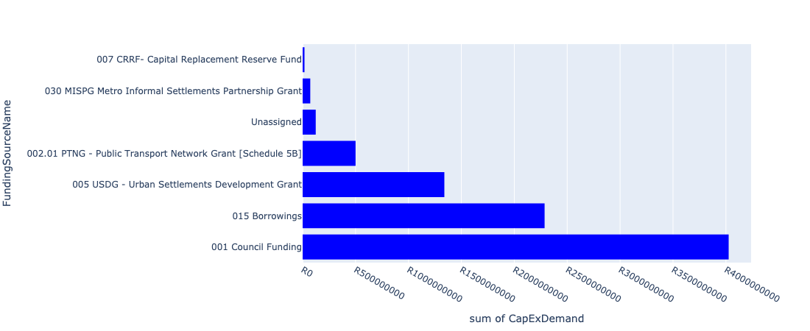

Figure 5.14: Region 6: East Departmental Requests

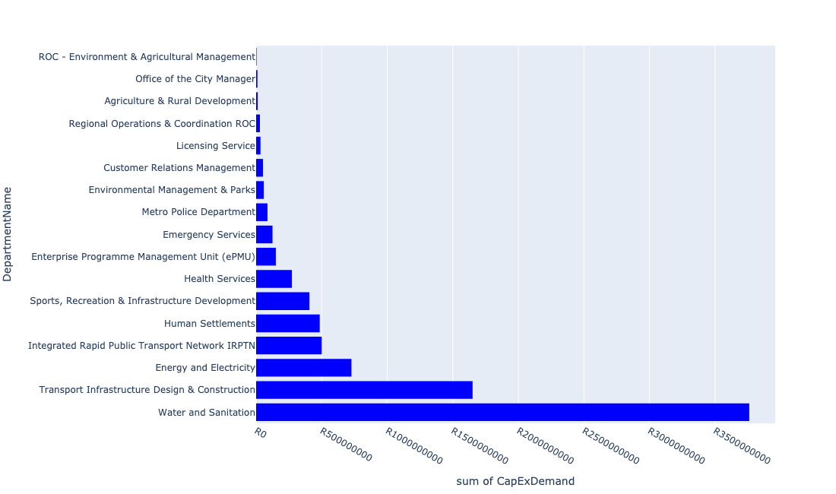

Table 5.7: Summary - Region 6: East

|  |  |
| --- | --- |
| Item | Description |
| Total Capital Demand for Region 6: East - All Years | R8,364,747,840 Rank: 3 (1 = Highest) |
| Total Capital Demand for Region 6: East - MTREF | R3,787,839,251 Rank: 2 (1 = Highest) |
| Financial Years in which capital requirements are listed for Region 6: East | 2022, 2023, 2024, 2025, 2026, 2027, 2028, 2029, 2030 and 2031 |
| Financial Year with highest capital demand for Region 6: East | 2023 |
| Region 6: East intersecting feature used | Works Location |
| Total number of projects intersecting with Region 6: East | 178 Rank: 2 (1 = Highest) |

Table 5.8: All projects asking for budget in Region 6: East

|  |  |  |  |
| --- | --- | --- | --- |
| Project ID | Project Name | Department | Project Budget |
| 712971915 | Revitalisation of the City-Development of Non-Motorised Transport Masterplan | Transport Infrastructure Design & Construction | R954,794 (0.01%) Budget spread across: 2027 |
| 712970748 | R6 Machinery and Equipment to ensure basic infrastructure reliability | Regional Operations & Coordination ROC | R2,400,000 (0.03%) Budget spread across: 2022 and 2023 |
| 712967124 | (712941) Greening of Sports fields | Sports, Recreation & Infrastructure Development | R74,000,023 (0.88%) Budget spread across: 2022, 2023, 2024, 2025, 2026, 2027, 2028, 2029, 2030 and 2031 |
| 712967127 | (713040) Furniture and Equipment for offices, overnight accommodation and facilities within resorts | Environmental Management & Parks | R1,350,000 (0.02%) Budget spread across: 2022 and 2024 |
| 712967744 | (712591) Design, Supply, Installation, Commissioning and Operational Support Of Advanced Public Transport Management System (APTMS) | Integrated Rapid Public Transport Network IRPTN | R1,375,539 (0.02%) Budget spread across: 2022 |
| 712975590 | Refurbishment of Mamelodi customer care centre | Customer Relations Management | R333,333 (0.00%) Budget spread across: 2025 |
| 712969047 | (712591) Denneboom Intermodal facility | Integrated Rapid Public Transport Network IRPTN | R40,000,000 (0.48%) Budget spread across: 2022 |
| 712975347 | (712279) Mamelodi Switching Station | Energy and Electricity | R70,000,000 (0.84%) Budget spread across: 2023, 2024 and 2025 |
| 712967951 | Waste Management Block Office Block | ROC - Environment & Agricultural Management | R3,400,000 (0.04%) Budget spread across: 2022 |
| 712975230 | Provisioning of new taxi holding facility for the Wingate area. | Transport Infrastructure Design & Construction | R95,000,000 (1.14%) Budget spread across: 2022, 2023, 2024, 2025, 2026, 2027, 2028, 2029 and 2030 |
| 712975098 | (711335Gar) Replace and upgrade Garsfontein bulk pipe in Lynwood road | Water and Sanitation | R8,000,000 (0.10%) Budget spread across: 2026, 2027 and 2028 |
| 712967295 | (711335ML) Mamelodi R5 feeder main relocation | Water and Sanitation | R48,938,455 (0.59%) Budget spread across: 2023, 2024, 2025 and 2026 |
| 712975121 | (712534Do) Donkerhoek LL Res (Phase 2) | Water and Sanitation | R55,000,000 (0.66%) Budget spread across: 2029 and 2030 |
| 712974929 | (710864) Sewer provision - Nellmapius Willows Mega Project | Human Settlements | R50,000,000 (0.60%) Budget spread across: 2022, 2023 and 2024 |
| 712969053 | (712591) Denneboom Depot | Integrated Rapid Public Transport Network IRPTN | R70,000,000 (0.84%) Budget spread across: 2022 and 2023 |
| 712975233 | Development of Rietvlei conference Facility and Office park | Environmental Management & Parks | R552,617 (0.01%) Budget spread across: 2022, 2023, 2024 and 2025 |
| 712969439 | (712121D) Moreletaspruit: Outfall sewer | Water and Sanitation | R60,121,727 (0.72%) Budget spread across: 2022, 2023, 2024, 2025 and 2026 |
| 712973830 | Build additional study hall at Glenstantia Library | Sports, Recreation & Infrastructure Development | R15,000,000 (0.18%) Budget spread across: 2029 |
| 712967733 | (712591) BRT Line 2C-January Masilela (btw Atterbury & Lynnwood Rd) | Integrated Rapid Public Transport Network IRPTN | R90,000,000 (1.08%) Budget spread across: 2022 and 2023 |
| 712967192 | (713049) New Clinic Lusaka | Health Services | R46,000,000 (0.55%) Budget spread across: 2022 and 2023 |
| 712975304 | Upgrade of Security and visitor infrastructure in Moretele resort | Environmental Management & Parks | R3,500,000 (0.04%) Budget spread across: 2022 and 2023 |
| 712975519 | Upgrade of Lion Camp at Rietvlei Nature Reserve | Environmental Management & Parks | R300,000 (0.00%) Budget spread across: 2022 |
| 712973836 | R6 Installation of Electric and Security Fencing at Regional Facilities / Depots | Regional Operations & Coordination ROC | R10,000,000 (0.12%) Budget spread across: 2022 and 2023 |
| 712975018 | Provisioning of new taxi holding facility for the Menlyn area | Transport Infrastructure Design & Construction | R74,000,000 (0.88%) Budget spread across: 2022, 2023, 2024, 2025, 2026, 2027, 2028, 2029 and 2031 |
| 712967793 | (713052) Construction of Emergency Services Station Mamelodi 1 | Emergency Services | R1,000,000 (0.01%) Budget spread across: 2022 |
| 712975101 | (711335GL) Extension of existing pipe to Zwartkoppies Reservoir +Res (Phase 1) | Water and Sanitation | R36,000,000 (0.43%) Budget spread across: 2023, 2024, 2025 and 2026 |
| 712975473 | Provisioning of new taxi ranking facility at Erasmus | Transport Infrastructure Design & Construction | R64,000,000 (0.77%) Budget spread across: 2022, 2023, 2024, 2025, 2026, 2027, 2028, 2029 and 2030 |
| 712969548 | (712223) Mamelodi Extension 2: Area 2 | Transport Infrastructure Design & Construction | R25,000,000 (0.30%) Budget spread across: 2022 and 2023 |
| 712974168 | Upgrading of Major Stormwater Drainage System in Lipizzaner Road, Tijger Valley | Transport Infrastructure Design & Construction | R8,000,000 (0.10%) Budget spread across: 2025, 2026 and 2027 |
| 992 | (712518) Flooding backlog: Drainage canals along Hans Strydom Dr, Mamelodi x 4 and 5 | Transport Infrastructure Design & Construction | R25,266,712 (0.30%) Budget spread across: 2022, 2023 and 2024 |
| 712975138 | (712121NAB2) New Arbeidsgenot 1 (Northern) Outfall Sewer (2/2) | Water and Sanitation | R18,000,000 (0.22%) Budget spread across: 2027, 2028, 2029 and 2030 |
| 712974901 | Mamelodi Hostels (TRUS) | Human Settlements | R61,000,000 (0.73%) Budget spread across: 2022 |
| 712975542 | Construction of Pretorius park customer care centre | Customer Relations Management | R15,000,000 (0.18%) Budget spread across: 2030 |
| 712975095 | (710411Y_O) Olympus booster Pump station and pipework | Water and Sanitation | R12,000,000 (0.14%) Budget spread across: 2025 and 2026 |
| 712974846 | (714048) Tshwane Automotive SEZ Phase 1 Bulk Infrastructure Roll out | Enterprise Programme Management Unit (ePMU) | R150,489,324 (1.80%) Budget spread across: 2022 |
| 712974541 | (710411F1) Baviaanspoort WWTW Phase 2: 20Ml/d extension using alternative technologies, new sludge infrastructure & tertiary treatment | Water and Sanitation | R1,030,000,000 (12.31%) Budget spread across: 2022, 2023, 2024, 2025, 2026, 2027, 2028 and 2029 |
| 712967141 | (714011) Lusaka Library | Sports, Recreation & Infrastructure Development | R27,413,800 (0.33%) Budget spread across: 2022 and 2023 |
| 712967734 | (712591) BRT Line 2C-Lynnwood Rd (btw January Masilela & Simon Vermooten) | Integrated Rapid Public Transport Network IRPTN | R90,000,000 (1.08%) Budget spread across: 2022 and 2023 |
| 712970774 | (710864) Mamelodi X11 | Human Settlements | R15,000,000 (0.18%) Budget spread across: 2022 |
| 712967147 | (711439) Solomon Mahlangu freedom square | Sports, Recreation & Infrastructure Development | R60,000,000 (0.72%) Budget spread across: 2025 and 2026 |
| 712974927 | (710863) Water Provision - Nellmapius Willows Mega Project | Human Settlements | R40,320,169 (0.48%) Budget spread across: 2022, 2023 and 2024 |
| 712975119 | (712534) New 20ML La-Montagne Reservoir | Water and Sanitation | R79,000,000 (0.94%) Budget spread across: 2023, 2024, 2025, 2026 and 2027 |
| 712967293 | (711335GL) Replace feeder main from Garsfontein to Parkmore HL Reservoir | Water and Sanitation | R50,000,000 (0.60%) Budget spread across: 2023, 2024, 2025 and 2026 |
| 712967794 | Construction of New Emergency Services Station Shere / The Willows | Emergency Services | R62,000,000 (0.74%) Budget spread across: 2025, 2026 and 2027 |
| 712969194 | (710556) Region 6 (Public Lighting) | Energy and Electricity | R192,500,000 (2.30%) Budget spread across: 2022, 2023, 2024, 2025, 2026, 2027, 2028, 2029 and 2030 |
| 712973702 | Nellmapius Clinic Dispensaries | Health Services | R27,000,000 (0.32%) Budget spread across: 2024, 2025 and 2026 |
| 712974884 | (712591) Menlyn Taxi Interchange (Dallas) | Integrated Rapid Public Transport Network IRPTN | R68,925,200 (0.82%) Budget spread across: 2022 |
| 712974392 | (710864) Sewer reticulation - Mamelodi X6 erf 34041 (Phomolong) | Human Settlements | R35,481,502 (0.42%) Budget spread across: 2022, 2023 and 2024 |
| 712974343 | (711921R) Rietvlei Water Purification Plant Refurbishment | Water and Sanitation | R50,000,000 (0.60%) Budget spread across: 2022, 2023 and 2024 |
| 712975090 | (710411Y_R) Rietvlei PS and Rising system | Water and Sanitation | R31,000,000 (0.37%) Budget spread across: 2027, 2028 and 2029 |
| 712974549 | (712121G) Zwavelpoort Outfall Sewer Pipeline – Phase1 | Water and Sanitation | R160,000,000 (1.91%) Budget spread across: 2022, 2023, 2024, 2025 and 2026 |
| 712975388 | (712279) TASEZ 132/11kV Substation | Energy and Electricity | R53,000,000 (0.63%) Budget spread across: 2023, 2025 and 2026 |
| 246 | (710023) Lengthening Of Network & Supply Pipelines | Water and Sanitation | R273,500,000 (3.27%) Budget spread across: 2022, 2023, 2024, 2025, 2026, 2027, 2028, 2029 and 2030 |
| 712975437 | Sub-Project: TMPD Station - Mamelodi (Extension 10) | Metro Police Department | R40,628,728 (0.49%) Budget spread across: 2022, 2023 and 2024 |
| 712967765 | (712970) Mamelodi Ext 11 water (Bulk and reticulation) and sanitation services | Water and Sanitation | R153,000,000 (1.83%) Budget spread across: 2022, 2023, 2024, 2025 and 2026 |
| 712967831 | (713069) Lusaka multi-purpose sport facility | Sports, Recreation & Infrastructure Development | R50,000,000 (0.60%) Budget spread across: 2022 and 2023 |
| 712967731 | (712591) Line 2B: Atterbury Rd (btw Lynnwood Rd to Lois Avenue) | Integrated Rapid Public Transport Network IRPTN | R44,540,093 (0.53%) Budget spread across: 2022, 2023, 2024 and 2025 |
| 712967645 | New Silverton Clinic | Health Services | R42,000,000 (0.50%) Budget spread across: 2022, 2023 and 2024 |
| 712973845 | R6 Regional Building Electrical Equipment / Aircon, Fire detection/systems installation (energy efficient) | Regional Operations & Coordination ROC | R4,000,000 (0.05%) Budget spread across: 2022 and 2023 |
| 712974283 | Spruit channel improvements and rehabilitation of the Tweefontein Spruit in Boardwalk Meander | Transport Infrastructure Design & Construction | R7,000,000 (0.08%) Budget spread across: 2026 and 2027 |
| 712973842 | (714028) R6 Security Cameras / Alarms Systems at Regional Facilities | Regional Operations & Coordination ROC | R5,000,000 (0.06%) Budget spread across: 2022 and 2023 |
| 712969099 | 712969116_05_(712970) Kameeldrift 174 & 175 - Bulk Supply Pipeline to 1000 Housing Units - Water Provision | Water and Sanitation | R64,000,000 (0.77%) Budget spread across: 2022, 2023, 2024 and 2025 |
| 712967625 | (710863) Water provision - Garsfontein | Human Settlements | R0 (0.00%) Budget spread across: 2022 and 2023 |
| 712967133 | (712736) Fencing off Nature areas City Wide (Ecological Sensitive Purposes) | Environmental Management & Parks | R2,000,000 (0.02%) Budget spread across: 2022 and 2023 |
| 712969546 | (712223) Mamelodi Extension 5: Area 1 | Transport Infrastructure Design & Construction | R170,000,000 (2.03%) Budget spread across: 2023, 2024, 2025, 2026, 2027, 2028, 2029 and 2030 |
| 712974887 | (712591) Line 2B Stations | Integrated Rapid Public Transport Network IRPTN | R14,000,000 (0.17%) Budget spread across: 2022 and 2023 |
| 712975391 | (712279) Mamelodi II 132/11kV Substation | Energy and Electricity | R19,975,150 (0.24%) Budget spread across: 2026 |
| 712974897 | Nellmapius Ext 26 (Covid-19) Acquisition of Land | Human Settlements | R10,000,000 (0.12%) Budget spread across: 2022 |
| 712974525 | Upgrading of Lynnwood Road | Transport Infrastructure Design & Construction | R42,000,000 (0.50%) Budget spread across: 2023 and 2024 |
| 712974522 | Upgrading of Solomon Mahlangu Drive | Transport Infrastructure Design & Construction | R3,411,399 (0.04%) Budget spread across: 2022 |
| 712974468 | Enlargement of bridges and spruit channel improvements of the Zwavelpoort Spruit, Zwavelkloof Estate | Transport Infrastructure Design & Construction | R51,200,000 (0.61%) Budget spread across: 2025, 2026 and 2027 |
| 712974187 | Providing new Inter modal Public Transport Facility at Green View (including access to the facility) | Transport Infrastructure Design & Construction | R100,000,000 (1.20%) Budget spread across: 2022, 2023, 2024, 2025, 2026, 2027, 2028, 2029 and 2030 |
| 712973721 | Upgrade of Nelson Mandela Park Tsamaya avenue | Agriculture & Rural Development | R3,000,000 (0.04%) Budget spread across: 2022 |
| 712971920 | Revitalisation of the City-Doubling of Petroleum Street | Transport Infrastructure Design & Construction | R31,000,000 (0.37%) Budget spread across: 2023 and 2024 |
| 712970801 | (712970) Mahube Valley Ext 15 - Water Provision | Water and Sanitation | R133,500,000 (1.60%) Budget spread across: 2022, 2023, 2024, 2025 and 2026 |
| 712970764 | (710863) Water Provision - Mamelodi X6 erf 34041 (Phomolong) | Human Settlements | R29,166,470 (0.35%) Budget spread across: 2022, 2023 and 2024 |
| 712969619 | (713044) Hatherley Cemetery | Environmental Management & Parks | R5,785,714 (0.07%) Budget spread across: 2022, 2023 and 2025 |
| 712969547 | (712223) Mamelodi Extension 4: Area 1 | Transport Infrastructure Design & Construction | R135,000,000 (1.61%) Budget spread across: 2022, 2023, 2024, 2025, 2026, 2027, 2028 and 2030 |
| 712967269 | (712534) New Parkmore LL Reservoir and HL Reservoir | Water and Sanitation | R65,000,000 (0.78%) Budget spread across: 2022 and 2023 |
| 1026 | (712534D) Mooikloof Reservoir and Bulk pipeline | Water and Sanitation | R75,000,000 (0.90%) Budget spread across: 2022, 2023, 2024 and 2025 |
| 1003 | (712521) Collector Road Backlogs: Mamelodi | Transport Infrastructure Design & Construction | R1,700,000 (0.02%) Budget spread across: 2022, 2023, 2024 and 2025 |
| 891 | (712223) Mamelodi Extension 2: Area 3 | Transport Infrastructure Design & Construction | R128,000,000 (1.53%) Budget spread across: 2023, 2024, 2025, 2026, 2027, 2028, 2029 and 2030 |
| 712974153 | (712279) Wildebees 400/132kV, 315MVA Infeed station | Energy and Electricity | R165,000,000 (1.97%) Budget spread across: 2022, 2023 and 2024 |
| 712974087 | (712121SL) Silver Lakes outfall sewer upgrade | Water and Sanitation | R66,000,000 (0.79%) Budget spread across: 2022, 2023, 2024, 2025 and 2026 |
| 712973984 | Replacement of Mamelodi West Clinic | Health Services | R94,000,000 (1.12%) Budget spread across: 2022, 2029, 2030 and 2031 |
| 712973941 | (714026) Revamp of Nellmapius customer care centre | Customer Relations Management | R7,000,000 (0.08%) Budget spread across: 2022 and 2023 |
| 712969046 | (712591) NMT Line 2B (Hatfield to Menlyn) | Integrated Rapid Public Transport Network IRPTN | R563,773 (0.01%) Budget spread across: 2022 |
| 712967967 | R6 Installation of bio metrics systems at SRAC and Parks Offices | Regional Operations & Coordination ROC | R6,700,000 (0.08%) Budget spread across: 2022 |
| 712967701 | (710178) Electricity for All - Region 6 | Energy and Electricity | R81,600,000 (0.98%) Budget spread across: 2022, 2023, 2024 and 2025 |
| 712967641 | (711713) Development of Mamelodi hostels | Human Settlements | R75,000,000 (0.90%) Budget spread across: 2022 and 2023 |
| 712975779 | (710865) Construction of roads & stormwater at Pretorius Park X20 | Human Settlements | R84,092,455 (1.01%) Budget spread across: 2022 and 2023 |
| 712975767 | (712900) Upgrading of existing Academic Training facilities (Mamelodi) | Metro Police Department | R20,000,000 (0.24%) Budget spread across: 2022, 2023 and 2024 |
| 712975541 | construction of Garsfontein customer care centre | Customer Relations Management | R20,000,000 (0.24%) Budget spread across: 2031 |
| 712975455 | Upgrade infrastructure at Moreletakloof Nature Reserve | Environmental Management & Parks | R3,000,000 (0.04%) Budget spread across: 2023 and 2024 |
| 712975435 | Sub-Project: TMPD Station - Nellmapius (Extension 3) | Metro Police Department | R13,000,000 (0.16%) Budget spread across: 2023 and 2024 |
| 712975378 | Upgrading of Waltloo Testing Centre | Licensing Service | R26,000,000 (0.31%) Budget spread across: 2022, 2023, 2024, 2028 and 2031 |
| 712975103 | Upgrade of infrastructure at Rietvlei Nature Reserve | Environmental Management & Parks | R28,200,000 (0.34%) Budget spread across: 2022, 2023, 2024, 2025, 2026, 2027, 2028 and 2029 |
| 712975100 | (711335Co) Feeder main replacement Constantia Reservoir | Water and Sanitation | R19,500,000 (0.23%) Budget spread across: 2028, 2029 and 2030 |
| 712975089 | (710411Rit) 35 Ml/day Portion of Proposed Rietvlei WWTW | Water and Sanitation | R105,000,000 (1.26%) Budget spread across: 2029 and 2030 |
| 712975066 | Upgrade of PTA East Cemetery | Environmental Management & Parks | R3,200,000 (0.04%) Budget spread across: 2025 and 2026 |
| 712974544 | (710411F2) Baviaanspoort WWTW Phase3: 40Ml/d extension project on new site with link outfall sewer | Water and Sanitation | R660,000,000 (7.89%) Budget spread across: 2024, 2025, 2026, 2027, 2028 and 2029 |
| 712974192 | Provisioning of New ranking facility at Eersterus Taxi rank | Transport Infrastructure Design & Construction | R16,594,116 (0.20%) Budget spread across: 2022, 2024, 2025, 2026, 2027, 2028, 2029 and 2030 |
| 712973743 | (711921Ro) Roodeplaat WTP: Refurbishment and Upgrade of existing plant | Water and Sanitation | R312,000,000 (3.73%) Budget spread across: 2023, 2024, 2025, 2026 and 2027 |
| 712970780 | (710863) Mamelodi X11 | Human Settlements | R0 (0.00%) Budget spread across: 2022 |
| 712970769 | (710864) Sewer provision - Pretorius Park | Human Settlements | R30,000,000 (0.36%) Budget spread across: 2022, 2023 and 2024 |
| 712967494 | (712921) Nellmapius Transport Facilities | Transport Infrastructure Design & Construction | R94,000,000 (1.12%) Budget spread across: 2022, 2023, 2024, 2025, 2026, 2027, 2028, 2029 and 2030 |
| 712967271 | (712534U) Grootfontein Water Reservoir, tower and pipework | Water and Sanitation | R56,000,000 (0.67%) Budget spread across: 2022, 2023 and 2024 |
| 712967168 | (710692) Upgrading of HM Pitje Stadium | Sports, Recreation & Infrastructure Development | R180,000,000 (2.15%) Budget spread across: 2025, 2026 and 2027 |
| 712967162 | Development of Kleinzonderhout Agricultural Park | Agriculture & Rural Development | R9,000,000 (0.11%) Budget spread across: 2022 and 2023 |
| 1472 | (712956) Upgrading of Garsfontein road | Transport Infrastructure Design & Construction | R281,900,000 (3.37%) Budget spread across: 2022, 2023, 2024, 2025 and 2026 |
| 1074 | (712612) Upgrading of Sibande Street, Mamelodi | Transport Infrastructure Design & Construction | R147,000,000 (1.76%) Budget spread across: 2022, 2023, 2024, 2025, 2026, 2027, 2028, 2029 and 2030 |
| 619 | (711213) Stormwater Drainage Mahube Valley | Transport Infrastructure Design & Construction | R150,000,000 (1.79%) Budget spread across: 2022, 2023, 2024, 2025, 2026, 2027, 2028, 2029 and 2030 |
| 712974121 | (712279) Wildebees - Elland 132kV Power line | Energy and Electricity | R100,000,000 (1.20%) Budget spread across: 2023 and 2024 |
| 712974109 | (710864) Sewer provision - Nellmapius X22 -stand 12223 & 12224 | Human Settlements | R23,000,000 (0.27%) Budget spread across: 2022 and 2023 |
| 712969057 | (712533) (VPUU) Mamelodi East Multi-purpose (Indoor Sports) Centre | Office of the City Manager | R10,000,000 (0.12%) Budget spread across: 2022 |
| 712967795 | Construction of New Emergency Services Station Rietvlei | Emergency Services | R62,000,000 (0.74%) Budget spread across: 2028, 2029 and 2030 |
| 712967766 | 712969116_17_(712970T) Mamelodi Ext 11 - Sewerage network line | Water and Sanitation | R63,000,000 (0.75%) Budget spread across: 2023, 2024 and 2025 |
| 712967743 | (712591) The Design, Supply, Installation, Operation and Maintenance of an automated fare Collection (AFC) System | Integrated Rapid Public Transport Network IRPTN | R11,709,333 (0.14%) Budget spread across: 2022, 2023, 2024 and 2025 |
| 712975592 | Refurbishment of Eersterust customer care centre | Customer Relations Management | R300,000 (0.00%) Budget spread across: 2025 |
| 712975546 | Construction of new Alaska and Stoffel Park customer care centre | Customer Relations Management | R10,000,000 (0.12%) Budget spread across: 2027 |
| 712975440 | Sub-Project: TMPD Station - Pretorius Park | Metro Police Department | R13,000,000 (0.16%) Budget spread across: 2024 and 2025 |
| 712975386 | (712279) Wapadrand 132/11kV Substation | Energy and Electricity | R45,000,000 (0.54%) Budget spread across: 2028 and 2029 |
| 712975334 | RIMM: STELLENBERG QUARRY: PERIMETER FENCE | Regional Operations & Coordination ROC | R1,000,000 (0.01%) Budget spread across: 2022 |
| 712975148 | (71212MOK) Mooikloof Bulk Outfall and connection to Moreleta system | Water and Sanitation | R71,500,000 (0.85%) Budget spread across: 2023, 2024, 2025 and 2026 |
| 712975137 | (712121NAB1) New Arbeidsgenot 1 (Northern) Outfall Sewer (1/2) | Water and Sanitation | R6,000,000 (0.07%) Budget spread across: 2028, 2029 and 2030 |
| 712975114 | Phahameng Clinic 2nd phase | Health Services | R64,000,000 (0.77%) Budget spread across: 2022, 2023 and 2024 |
| 712975005 | Upgrade of infrastructure at Rietvlei Angling area | Environmental Management & Parks | R10,500,000 (0.13%) Budget spread across: 2022 and 2023 |
| 712974928 | (710863) Water provision - Pretorius Park | Human Settlements | R32,000,000 (0.38%) Budget spread across: 2022, 2023 and 2024 |
| 712974888 | (712591) Line 2C Stations | Integrated Rapid Public Transport Network IRPTN | R26,000,000 (0.31%) Budget spread across: 2022 and 2023 |
| 712974885 | (712591) Menlyn Taxi Interchange (Gobie) | Integrated Rapid Public Transport Network IRPTN | R43,075,415 (0.51%) Budget spread across: 2022 and 2023 |
| 712974564 | Upgrading of pits and VTS at Licensing centres | Licensing Service | R7,282,000 (0.09%) Budget spread across: 2022, 2024 and 2025 |

Please note that the following projects will not be shown in this table:

* Projects with no recorded intersect with Tshwane mSCOA Regional Segment (in other words no Works Location was recorded on the system for this project)
* Projects that are not asking for any budget (requested budget fields are all '0').

## Region 7: Kungwini

Figure 5.15: Region 7: Kungwini Funding Requests

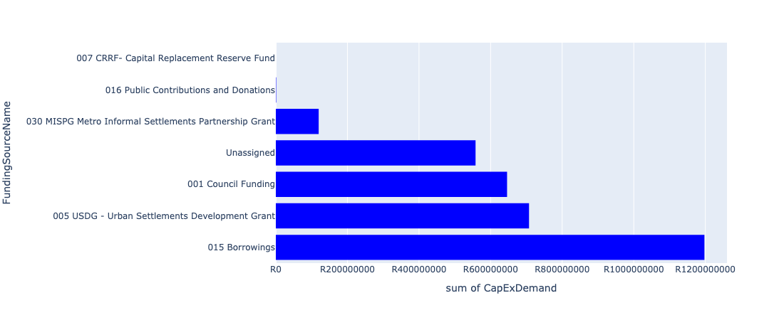

Figure 5.16: Region 7: Kungwini Departmental Requests

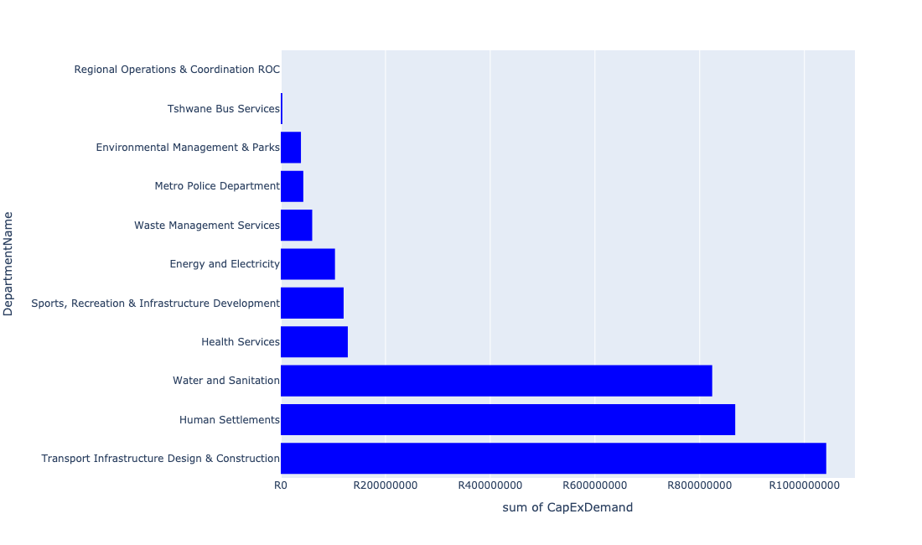

Table 5.8: Summary - Region 7: Kungwini

|  |  |
| --- | --- |
| Item | Description |
| Total Capital Demand for Region 7: Kungwini - All Years | R3,229,416,794 Rank: 7 (1 = Highest) |
| Total Capital Demand for Region 7: Kungwini - MTREF | R1,724,688,320 Rank: 7 (1 = Highest) |
| Financial Years in which capital requirements are listed for Region 7: Kungwini | 2022, 2023, 2024, 2025, 2026, 2027, 2028, 2029, 2030 and 2031 |
| Financial Year with highest capital demand for Region 7: Kungwini | 2025 |
| Region 7: Kungwini intersecting feature used | Works Location |
| Total number of projects intersecting with Region 7: Kungwini | 48 Rank: 8 (1 = Highest) |

Table 5.9: All projects asking for budget in Region 7: Kungwini

|  |  |  |  |
| --- | --- | --- | --- |
| Project ID | Project Name | Department | Project Budget |
| 712967270 | (711921E) Bronkhorstbaai: Refurbishment and upgrade of Water Purification Plant | Water and Sanitation | R91,000,000 (2.82%) Budget spread across: 2022 and 2023 |
| 712967634 | (710863) Water provision - Zithobeni Heights X13 | Human Settlements | R100,000,000 (3.10%) Budget spread across: 2022 and 2023 |
| 1307 | (712893) Upgrading of Road from gravel to tar in Zithobeni Ward 102 | Transport Infrastructure Design & Construction | R185,000,000 (5.73%) Budget spread across: 2022, 2023, 2024, 2025, 2026, 2027, 2028, 2029 and 2030 |
| 712975004 | Security and visitor infrastructure Upgrade at Die Draai Resort Region 7 | Environmental Management & Parks | R2,000,000 (0.06%) Budget spread across: 2022 |
| 712975482 | Rehabilitation of Wetlands - Bronkhorstspruit Town Wetland | Environmental Management & Parks | R1,500,000 (0.05%) Budget spread across: 2022, 2023, 2024 and 2025 |
| 712975439 | Creative Hub and Incubator ( Region 7) | Sports, Recreation & Infrastructure Development | R10,000,000 (0.31%) Budget spread across: 2027 |
| 712970842 | (712894) Upgrading of Road from gravel to tar in Ekangala (Ward 103 and 104) | Transport Infrastructure Design & Construction | R370,000,000 (11.46%) Budget spread across: 2022, 2023, 2024, 2025, 2026, 2027, 2028, 2029 and 2030 |
| 712975227 | Bronkhorstspruit Public Transport Facility (Investigate an ideal location and provide for a new taxi rank at Bronkhorstspruit) | Transport Infrastructure Design & Construction | R99,000,000 (3.07%) Budget spread across: 2022, 2023, 2024, 2025, 2026, 2027, 2028, 2029 and 2030 |
| 712967138 | Ekangala community library | Sports, Recreation & Infrastructure Development | R30,000,000 (0.93%) Budget spread across: 2024 and 2025 |
| 712967633 | (710863) Zithobeni X8&9 - Bulk water main line | Human Settlements | R50,000,000 (1.55%) Budget spread across: 2022, 2023 and 2024 |
| 712971915 | Revitalisation of the City-Development of Non-Motorised Transport Masterplan | Transport Infrastructure Design & Construction | R660,713 (0.02%) Budget spread across: 2027 |
| 712969193 | (710556) Region 7 (Public Lighting) | Energy and Electricity | R31,500,000 (0.98%) Budget spread across: 2022, 2023, 2024, 2025, 2027, 2028, 2029 and 2030 |
| 82 | (714000) Bus Depot at Ekangala | Tshwane Bus Services | R3,000,000 (0.09%) Budget spread across: 2022, 2023, 2024, 2025 and 2026 |
| 712970845 | (712895) Upgrading of Road from gravel to tar in Ekangala Ward 105 | Transport Infrastructure Design & Construction | R125,000,000 (3.87%) Budget spread across: 2022, 2023, 2025, 2026, 2028, 2029 and 2030 |
| 712972938 | (710864) Sewer provision - Zithobeni Heights : Bulk Sewer | Human Settlements | R5,000,000 (0.15%) Budget spread across: 2022 |
| 452 | (710411E) Godrich WWTW: New 10 Ml/day BNR | Water and Sanitation | R284,000,000 (8.79%) Budget spread across: 2023, 2024, 2025 and 2027 |
| 712970748 | R6 Machinery and Equipment to ensure basic infrastructure reliability | Regional Operations & Coordination ROC | R0 (0.00%) Budget spread across: 2022 and 2023 |
| 661 | (711335) Bulk feeder main pipeline from Bronkhorstspruit WTP to Ekandustria Reservoir | Water and Sanitation | R75,000,000 (2.32%) Budget spread across: 2022, 2023, 2024 and 2025 |
| 712967837 | Upgrading of Rethabiseng Clinic | Health Services | R64,000,000 (1.98%) Budget spread across: 2029, 2030 and 2031 |
| 578 | (710878) Ekangala Block A - F sewer reticulation and toilets | Water and Sanitation | R313,900,000 (9.72%) Budget spread across: 2022, 2023, 2024, 2025 and 2026 |
| 712974797 | Zithobeni 8 pump station | Human Settlements | R800,000 (0.02%) Budget spread across: 2022 |
| 712974345 | (710411K) Ekangala WWTW: Upgrade of existing infrastructure | Water and Sanitation | R50,000,000 (1.55%) Budget spread across: 2022 and 2023 |
| 712967177 | (712883) Upgrading of Zithobeni Sport Stadium | Sports, Recreation & Infrastructure Development | R20,000,000 (0.62%) Budget spread across: 2023 |
| 712967174 | New Bronkhorstspruit Clinic | Health Services | R64,000,000 (1.98%) Budget spread across: 2024, 2025 and 2026 |
| 7 | Establishment of Metro Police Office - Region 7 | Metro Police Department | R43,000,000 (1.33%) Budget spread across: 2023, 2024 and 2025 |
| 712967601 | (710865) Construction of roads & stormwater - Zithobeni X8&9 | Human Settlements | R302,320,646 (9.36%) Budget spread across: 2022, 2023, 2024, 2025 and 2026 |
| 712969075 | (712279) Bronkhorstspruit 132/11kv substation | Energy and Electricity | R15,000,000 (0.46%) Budget spread across: 2022 |
| 712967850 | (711921F) Bronkhorstspruit Water Purification Plant Refurbishment | Water and Sanitation | R10,000,000 (0.31%) Budget spread across: 2022 |
| 712967635 | (710863) Water provision - Zithobeni Heights Phase 1 | Human Settlements | R15,000,000 (0.46%) Budget spread across: 2022 and 2023 |
| 712967618 | (710864) Sewer provision - Zithobeni X8 | Human Settlements | R7,145,436 (0.22%) Budget spread across: 2022 |
| 712975232 | Development of Visitor and security infrastructure at Bronkhorstspruit dam angling area | Environmental Management & Parks | R34,999,999 (1.08%) Budget spread across: 2022, 2023, 2024 and 2025 |
| 712974527 | Upgrading of road from gravel to tar in Rethabiseng | Transport Infrastructure Design & Construction | R67,000,000 (2.07%) Budget spread across: 2022, 2023, 2024, 2025, 2026, 2027, 2028, 2029 and 2030 |
| 712970852 | (712947) Improvement of dirt road leading to Clover hill club, Bronkhorstspruit dam | Transport Infrastructure Design & Construction | R195,000,000 (6.04%) Budget spread across: 2022, 2023, 2024, 2025, 2026, 2027, 2028, 2029 and 2030 |
| 712969618 | (713043) Development of waste transfer stations | Waste Management Services | R60,000,000 (1.86%) Budget spread across: 2022, 2023, 2024 and 2025 |
| 712967136 | (712917) Upgrade Ekangala stadium | Sports, Recreation & Infrastructure Development | R60,000,000 (1.86%) Budget spread across: 2023 and 2024 |
| 712967600 | (710865) Construction of roads & stormwater - Zithobeni Heights | Human Settlements | R377,590,000 (11.69%) Budget spread across: 2022, 2023 and 2024 |
| 712969123 | (710178) Electricity for All - Region 7 | Energy and Electricity | R57,000,000 (1.77%) Budget spread across: 2024 and 2025 |
| 712967623 | (710863) Water provision - Zithobeni X8 | Human Settlements | R10,000,000 (0.31%) Budget spread across: 2022 and 2023 |

Please note that the following projects will not be shown in this table:

* Projects with no recorded intersect with Tshwane mSCOA Regional Segment (in other words no Works Location was recorded on the system for this project)
* Projects that are not asking for any budget (requested budget fields are all '0').