

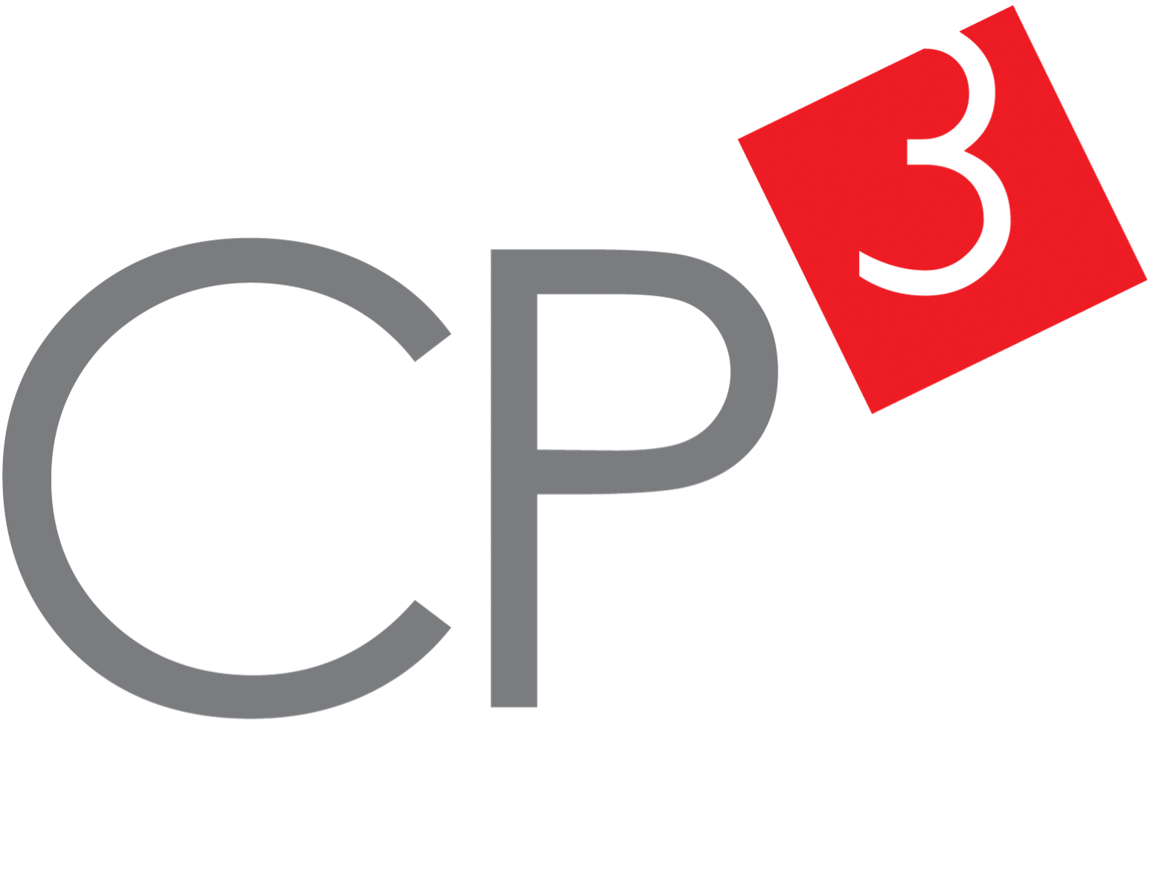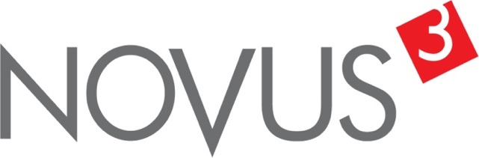

Spatial Feature Report

T: +27 12 364 2546 | E: info@novus3.co.za Postnet Suite 471, Private Bag X15,

Menlo Park, 0102**www.novus3.co.za**

engineered solutions

Disclaimer

This document contains data that was obtained from a live CP3 system at the moment the data was requested. The data is updated by users of the CP3 System and unless the system is locked for changes, this data may change on a daily basis. The reader is therefore cautioned not to place inappropriate reliance on the data unless there is certainty on the status of the data in terms of how recently it has been updated, how “clean” the data is (is there a quality control and/or verification process that was followed by the licensee of the CP3 system to ensure that data is checked and verified from time-to-time) and whether the correct baseline was queried. This report therefore provides a “snapshot in time”. Consequently, the document may be less relevant at a different time, or using a different financial baseline to query from.

At all times, all rights, title and interest in and to this material remains vested in the owner of this document and are copyrighted and protected by regulatory provisions. These materials may not be copied, reproduced, modified, published, uploaded, posted to websites or otherwise distributed in any way, without our prior written permission from the Licensee and Licensor (Nvous3 (Pty) Ltd) of the CP3 Software. The owner of this document does not grant any right to reproduce the materials. All our rights in this regard are and remain reserved.

Table of Contents

**No table of contents entries found.** (Right-click -> Update Field)

Spatial Query Report

This document was created *2022-05-11-19_29* from the **City of Tshwane Metropolitan Municipality** CP3 system.

The baseline **'2021/22 Planning + Rollover (20200901)'** with description: **'Duplicated from the 2020/21 Planning + Final Annexure A (20200625) Baseline'** was used. The spatial feature that was selected for the purpose of this report was: **'City of Tshwane Regions'**.

This is a spatial feature report for the *City of Tshwane Metropolitan Municipality.* The data contained in this report was sourced directly from the municipality's live CP3 system. The information in this report therefore reflects the data as it was on *2022-05-11* when this report was requested. Any subsequent updates to the data contained the CP3 System related to the applicable baseline from which this reports was drawn, would therefore not reflect in this report.   
  
For the *City of Tshwane Metropolitan Municipality, the following spatial features are available for the purpose of developing* 'Spatial Query Reports' (similar to this report):

* City of Tshwane mSCOA Regional Segment
* City of Tshwane Regions
* City of Tshwane Wards 2020
* Industrial Estates
* Specialised Activity Areas
* Strategic Urban Developments (SUD)



We hope you find this useful! Sincerely, *The Novus3 Team.*

# Introduction

The baseline that was queried for this report contains *1019* projects of which a total of *22 (2.16%)* projects do not have any recorded intersection (overlap) with the 'Regions' spatial feature that was selected for this report. The following spatial features are available for queries using this API profile:

* City of Tshwane mSCOA Regional Segment
* City of Tshwane Regions
* City of Tshwane Wards 2020
* Industrial Estates
* Specialised Activity Areas
* Strategic Urban Developments (SUD)

The probable reasons for the 22 non intersecting projects reported are that:

* these projects simply do not have a location associated with them yet (most frequently the case with 'no-intersect' projects) or;
* the location that was captured for some of these projects, may have been in the wrong place (e.g. outside the boundaries of Tshwane - this is very rarely the reason).

It is important to take note of the 2.16% projects that do not intersect with the 'Regions' spatial feature when appraising this report.

The 2.16% of non-intersecting projects is a relative low percentage and therefore not much cause of concern for this particular report.

Figure 1.1: Intersecting vs Non-Intersecting Projects

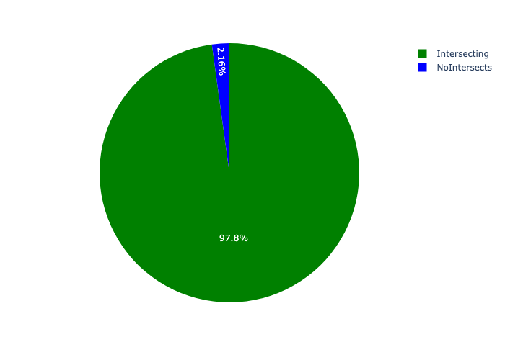

# Total Number of Projects and Total Capital Demand per Region - All Years

Table 2.1 below provides a concise summary of key statistical insights regarding the number of projects that are requesting funding in each of the regions.

Table 2.1: Regions Analysis - Number of Projects

|  |  |  |  |
| --- | --- | --- | --- |
| Description | Info (1) | Info (2) | Info (3) |
| Number of projects in all Regions - Overview | Total in all Regions: 997 projects | Average per Regions: 142 projects | 75th percentile of projects across all Regions: 177.5 projects |
| The highest number of projects | Regions: In Region 3 | Number of projects in Region 3: 256 | Percentage of total in Region 3: 25.68% |
| The lowest number of projects: | Regions: In Region 7 | Number of projects in Region 7: 48 | Percentage of total in Region 7: 4.81% |

Table 2.1 below provides a concise summary of key statistical insights regarding the total capital demand per region.

Table 2.1: Regions Analysis - Capital Demand (R)

|  |  |  |  |
| --- | --- | --- | --- |
| Description | Info (1) | Info (2) | Info (3) |
| Capital demand in all Regions - Overview | Total capital demand in all Regions: R51,369,859,346 | The average capital demand per Regions: R7,338,551,335 | The 75th percentile of capital demand for Regions: R9,587,232,002 |
| The highest capital demand | Regions: In Region 2 | Capital Demand in Region 2: R11,025,795,771 | Percentage of total in Region 2: 21.46% |
| The lowest capital demand | Regions: In Region 7 | Capital Demand in Region 7: R3,229,416,794 | Percentage of total in Region 7: 6.29% |

The number of projects per region and the capital demand per region needs to be looked at together for better insight. Figures 2.1 and 2.2 assist with further graphical insight into some of the numbers that are provided in Tables 2.1 and 2.2.

Figure 2.1: The single region with the highest value (Nr of Projects & Capital Demand) vs the rest

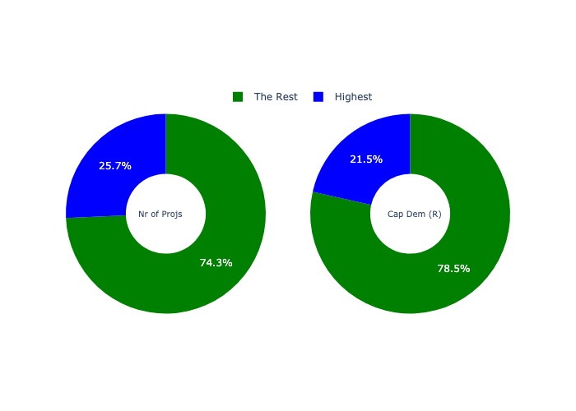

The highest number of projects in a single region is in **Region 3.** *That is 256 projects and this is 25.68% of the total number of projects.* The highest capital demand in a single region is in **Region 2.** *That is R11,025,795,771 and this amounts to 21.46% of the total capital demand.*

The following figures provide a bar graph representation of the number of projects per region with the colour of the bars representing the level of capital demand in each of these regions.

Figure 2.2: Projects and Capital Demand per Region

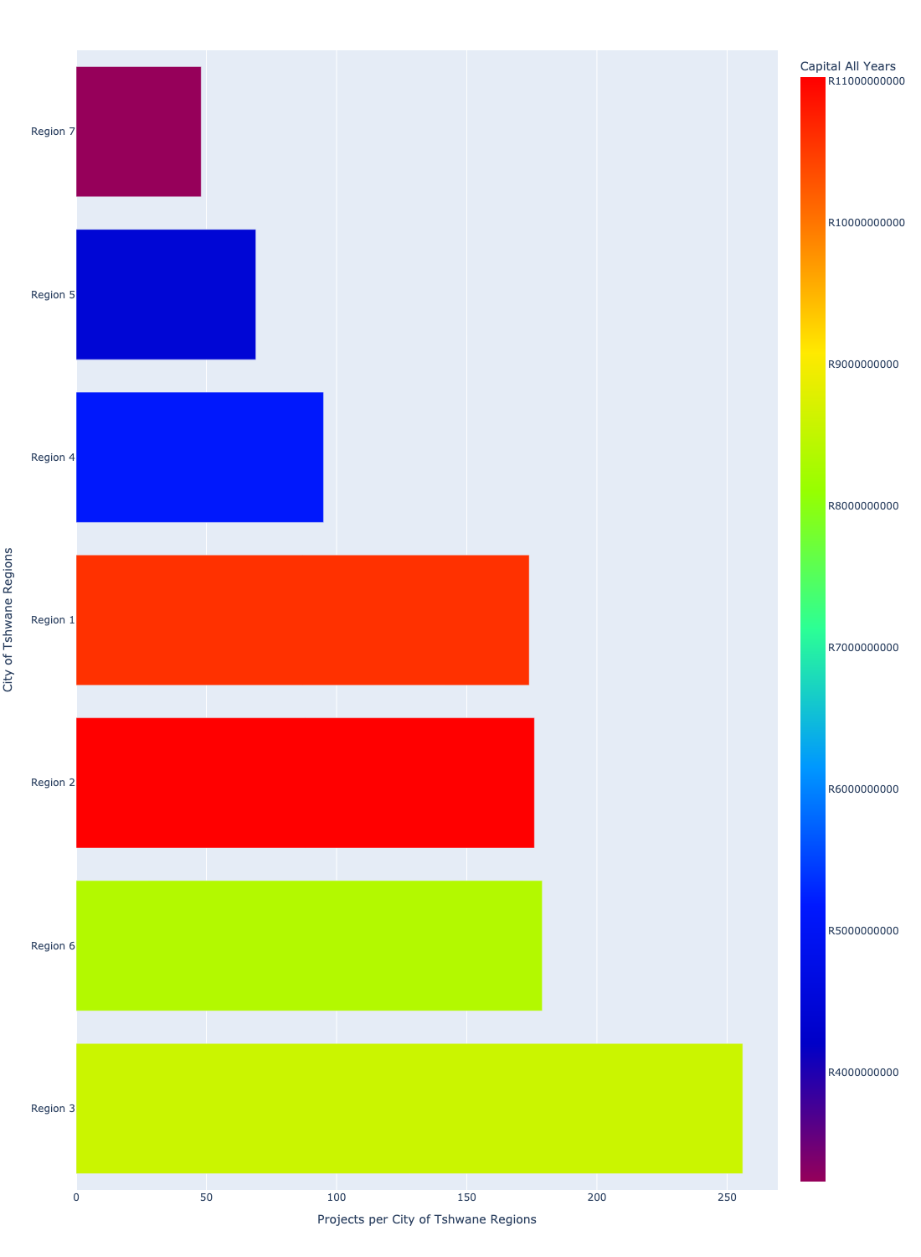

# Total Capital Demand per region - All Years

There are different funding sources from which capital is requested. For the financial baseline that was selected for this report query (2021/22 Planning + Rollover (20200901)), the breakdown of capital demand for City of Tshwane Metropolitan Municipality per funding source is shown in Figure 3.1 below.

Figure 3.1: Capital Demand Per Funding Source

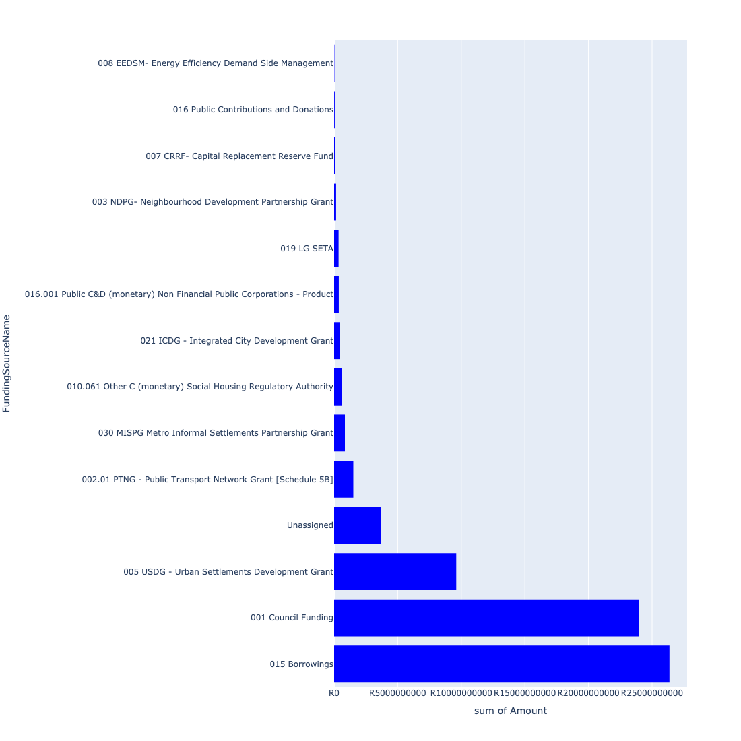

For the financial baseline that was selected for this report query (2021/22 Planning + Rollover (20200901)), the breakdown of capital demand for City of Tshwane Metropolitan Municipality per department is shown in Figure 3.2 below.

Figure 3.2: Capital Demand Per City of Tshwane Metropolitan Municipality Department

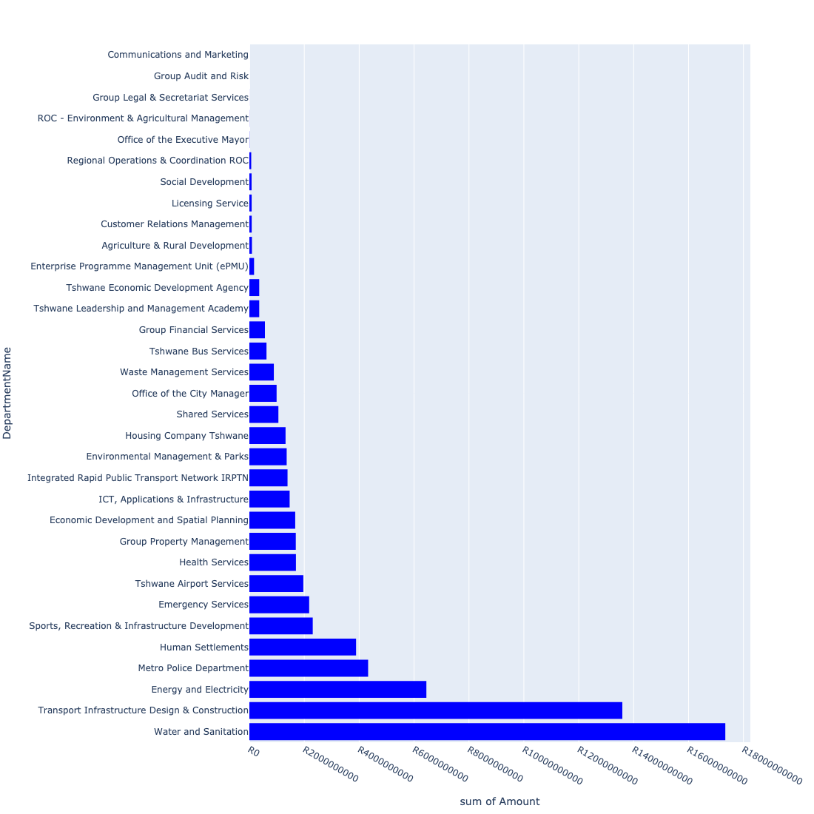

The following figures provide a histogram representation of the capital demand per region. A colour breakdown is provided of each year's sub-total that contribute towards the overall total capital demand of each region. Note that the capital demand beyond the first three years representing the Medium Term Expenditure Framework (MTREF - years 2022, 2023 and 2024) are generally more sparsely and less diligently populated, therefore less reliance should be vested on these outer years when appraising the overall capital demand. The reason for this is usually because of National Treasury's requirement for annual budget submissions spanning only over the MTREF (i.e. the next three years).

Figure 3.3: Capital Demand per Region - All Years

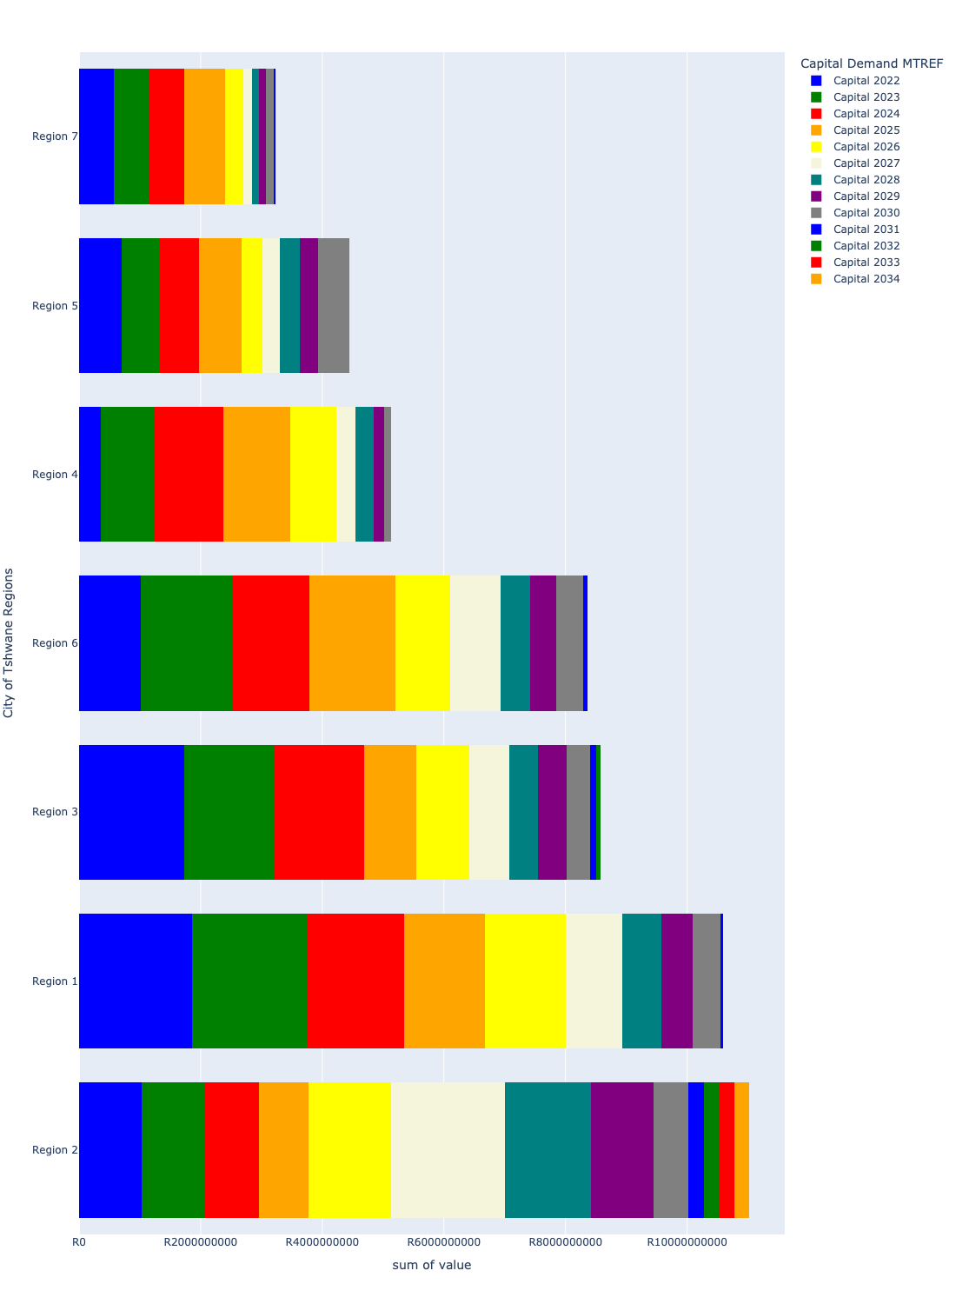

# Total Capital Demand per Region - MTREF only

Table 4.1 below provides a concise summary of key statistical insights regarding the total MTREF capital demand per region.

Table 4.1: Regions Analysis - MTREF Capital Demand (R)

|  |  |  |  |
| --- | --- | --- | --- |
| Description | Info (1) | Info (2) | Info (3) |
| MTREF Capital demand in all Regions - Overview | MTREF capital demand in all Regions: R22,851,950,091 | The average MTREF capital demand per region: R3,264,564,299 | The 75th percentile of MTREF capital demand for Regions: R4,239,124,565 |
| The highest MTREF capital demand | In Region: Region 1 | MTREF capital Demand in Region 1: R5,339,907,006 | Percentage of total MRTEF capital demand in Region 1: 23.37% |
| The lowest MTREF capital demand | In Region: Region 7 | MTREF capital Demand in Region 7: R1,724,688,320 | Percentage of total MTREF capital demand in Region 7: 7.55% |

The following figures provide a histogram representation of the capital demand per region. A colour breakdown is provided of each year's sub-total that contribute towards the overall MTREF total capital demand of each region.

Figure 4.1: Capital Demand per Region - MTREF Period

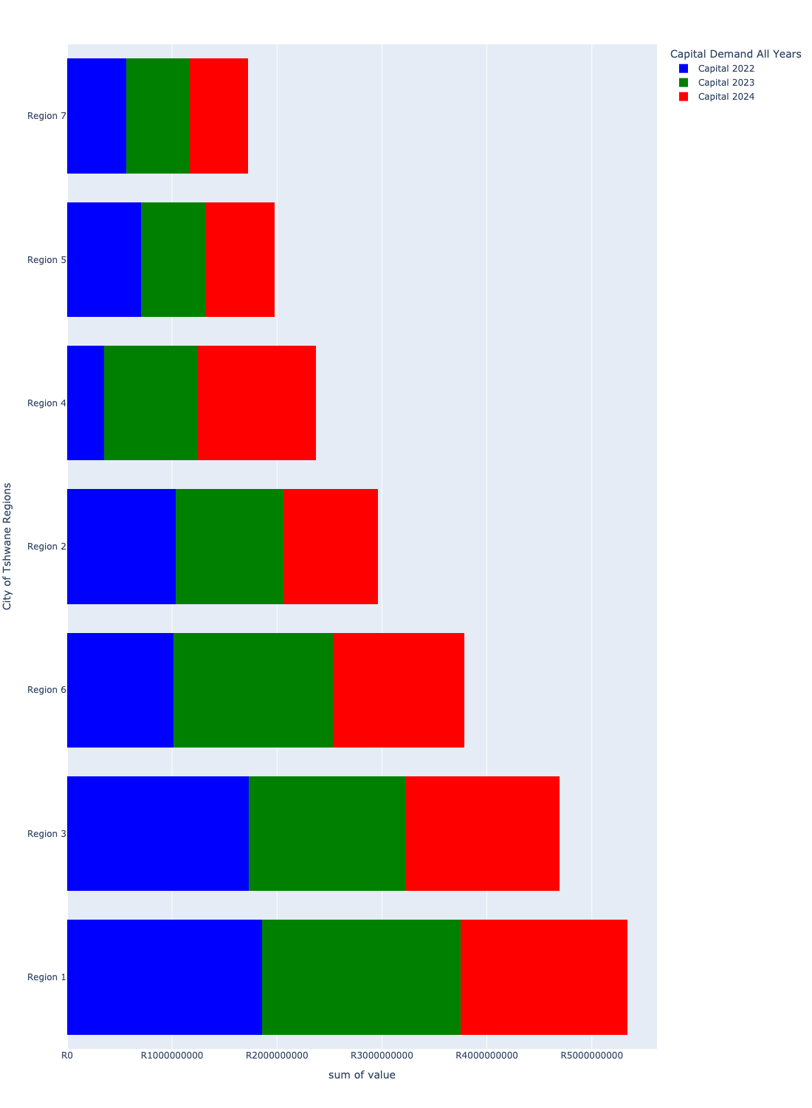

# Summary per Region

## Region 1

Figure 5.1: Region 1 Funding Requests

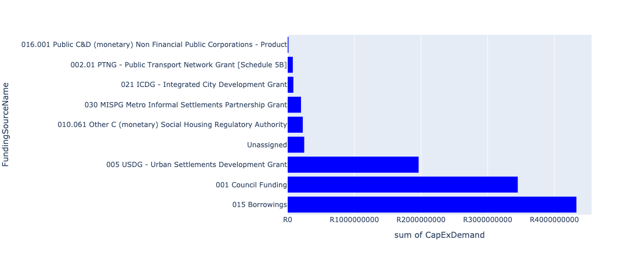

Figure 5.2: Region 1 Departmental Requests

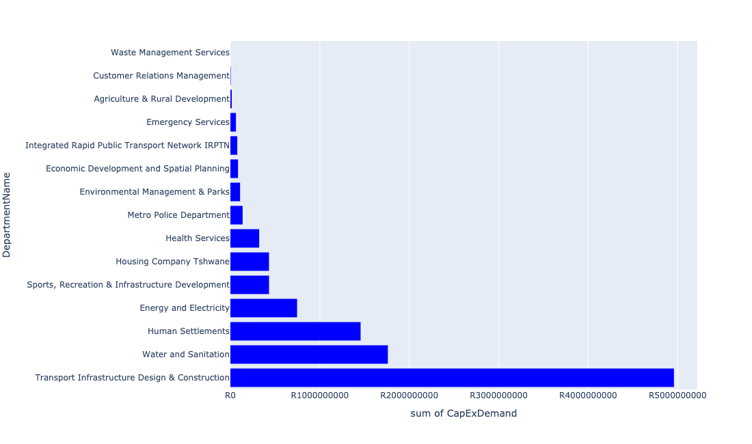

Table 5.1: Summary - Region 1

|  |  |
| --- | --- |
| Item | Description |
| Total Capital Demand for Region 1 - All Years | R10,595,292,566 Rank: 2 (1 = Highest) |
| Total Capital Demand for Region 1 - MTREF | R5,339,907,006 Rank: 1 (1 = Highest) |
| Financial Years in which capital requirements are listed for Region 1 | 2022, 2023, 2024, 2025, 2026, 2027, 2028, 2029, 2030 and 2031 |
| Financial Year with highest capital demand for Region 1 | 2023 |
| Region 1 intersecting feature used | Works Location |
| Total number of projects intersecting with Region 1 | 174 Rank: 4 (1 = Highest) |

Table 5.2: All projects asking for budget in Region 1

|  |  |  |  |
| --- | --- | --- | --- |
| Project ID | Project Name | Department | Project Budget |
| 712971915 | Revitalisation of the City-Development of Non-Motorised Transport Masterplan | Transport Infrastructure Design & Construction | R825,347 (0.01%) Budget spread across: 2027 |
| 712967124 | (712941) Greening of Sports fields | Sports, Recreation & Infrastructure Development | R222,000,019 (2.10%) Budget spread across: 2022, 2023, 2024, 2025, 2026, 2027, 2028, 2029, 2030 and 2031 |
| 712969043 | (712591) RJ to Akasia - Complementary | Integrated Rapid Public Transport Network IRPTN | R0.00 (0%) No budget request. |
| 712975132 | (71212SDD) Upgrade existing Soshanguve DD Outfall Sewer (2/2) | Water and Sanitation | R3,570,035 (0.03%) Budget spread across: 2023, 2024, 2025 and 2026 |
| 712974614 | Upgrading of a tributary of the Sand Spruit, Rosslyn x 17 | Transport Infrastructure Design & Construction | R19,526,828 (0.18%) Budget spread across: 2025, 2026 and 2027 |
| 712967718 | (712591) Construction of Line 1A: CBD to Rainbow Junction Section 1A-4B (Rainbow Junction Bypass road) | Integrated Rapid Public Transport Network IRPTN | R0.00 (0%) No budget request. |
| 712976097 | Upgrading of Kaalplaas Spruit through Rosslyn and Soshanguve South | Transport Infrastructure Design & Construction | R0.00 (0%) No budget request. |
| 712967069 | Establishment of TMPD Training Academy | Metro Police Department | R80,279,868 (0.76%) Budget spread across: 2022, 2023 and 2024 |
| 712969084 | (712279) Soshanguve - JJ 132KV Power Line | Energy and Electricity | R57,599,185 (0.54%) Budget spread across: 2022, 2023 and 2024 |
| 712975456 | Upgrade of infrastructure of Magalies mountain | Environmental Management & Parks | R5,286,208 (0.05%) Budget spread across: 2022, 2023, 2024, 2025, 2026, 2027, 2028, 2029, 2030 and 2031 |
| 712969044 | (712591) RJ to Kopanong - Complementary | Integrated Rapid Public Transport Network IRPTN | R0.00 (0%) No budget request. |
| 712975536 | Refurbishment of Bodibeng customer care centre ( Soshanguve BB) | Customer Relations Management | R2,000,000 (0.02%) Budget spread across: 2023 |
| 712967745 | (712591) Planning and Design of BRT Projects | Integrated Rapid Public Transport Network IRPTN | R77,046,650 (0.73%) Budget spread across: 2022, 2023, 2024 and 2025 |
| 768 | (711863) Internal Roads: Northern Areas: Mandela Village (South) | Transport Infrastructure Design & Construction | R155,000,000 (1.46%) Budget spread across: 2022, 2023, 2024, 2025, 2026, 2027, 2028, 2029 and 2030 |
| 712973710 | Construction of a ±900m stormwater system in Karenpark (Akasia SMP - Network 3A) 4 | Transport Infrastructure Design & Construction | R36,500,000 (0.34%) Budget spread across: 2027, 2028, 2029 and 2030 |
| 1022 | (712534) New Klipgat Reservoir | Water and Sanitation | R2,000,000 (0.02%) Budget spread across: 2022 |
| 712974195 | (712279) Rosslyn Switching Station | Energy and Electricity | R60,000,000 (0.57%) Budget spread across: 2028, 2029 and 2030 |
| 712969614 | (710865) Construction of roads & stormwater - Soshanguve South X24 | Human Settlements | R0.00 (0%) No budget request. |
| 712969607 | (710864) Sewer reticulation - Gatsebe | Human Settlements | R0.00 (0%) No budget request. |
| 712969611 | (710863) Water reticulation -Gatsebe | Human Settlements | R0.00 (0%) No budget request. |
| 712974161 | (711164) Upgrading of roads and stormwater systems in Soshanguve Block W: Central West | Transport Infrastructure Design & Construction | R46,000,000 (0.43%) Budget spread across: 2022, 2023, 2024, 2025, 2026 and 2027 |
| 712974493 | Construction of major roads and stormwater networks along all roads in Klerksoord AH | Transport Infrastructure Design & Construction | R135,000,000 (1.27%) Budget spread across: 2023, 2024, 2025 and 2029 |
| 712975466 | Upgrading of Existing rank to cater for the southern west side ( road, traders, pedestrian paths linking townships, malls Infrastructure ) into interchange | Transport Infrastructure Design & Construction | R64,000,000 (0.60%) Budget spread across: 2022, 2023, 2024, 2025, 2026, 2027, 2028, 2029 and 2031 |
| 712975274 | Development of SAB Park R/44 | Environmental Management & Parks | R0.00 (0%) No budget request. |
| 712975088 | (71212K) Upgrade existing Kopanong X03 Outfall Sewer (1/2) | Water and Sanitation | R12,500,000 (0.12%) Budget spread across: 2024, 2025, 2026 and 2027 |
| 712969346 | (713041) New fork lift for Garankuwa Buy Back Centre (Recycling centre) | Waste Management Services | R600,000 (0.01%) Budget spread across: 2022 and 2023 |
| 712967191 | Animal Impounding Station in Tshwane Northern Areas | Health Services | R37,000,000 (0.35%) Budget spread across: 2025, 2026, 2027 and 2028 |
| 712970703 | (713044) Tshwane North Cemetery | Environmental Management & Parks | R57,200,000 (0.54%) Budget spread across: 2022, 2024 and 2025 |
| 712967646 | (710865) Construction of roads & stormwater - Rama City | Human Settlements | R208,332,208 (1.97%) Budget spread across: 2022, 2023 and 2024 |
| 712967145 | Soshanguve cultural centre | Sports, Recreation & Infrastructure Development | R60,000,000 (0.57%) Budget spread across: 2027 and 2028 |
| 712975712 | The paving of 4th Road (Jackie Road), north of Klip Avenue in Winterveld | Transport Infrastructure Design & Construction | R30,000,000 (0.28%) Budget spread across: 2027, 2028 and 2029 |
| 712974378 | (710863) Water Provision - Winterveldt Bulk water line | Human Settlements | R65,000,000 (0.61%) Budget spread across: 2022 and 2023 |
| 712975074 | (712121Sa) Upgrade existing Sandspruit outfall sewer(4/4) | Water and Sanitation | R5,000,000 (0.05%) Budget spread across: 2023 and 2024 |
| 712974361 | (712221) Upgrading of roads and stormwater: Mabopane Block U Ext 1 | Transport Infrastructure Design & Construction | R0.00 (0%) No budget request. |
| 712969051 | (712591) Kopanong Interchange | Integrated Rapid Public Transport Network IRPTN | R0.00 (0%) No budget request. |
| 712970760 | (710863) Water provision- Mabopane X12 | Human Settlements | R5,000,000 (0.05%) Budget spread across: 2022 |
| 712974175 | Refurbishment Soshanguve F walk in centre old buildings | Group Property Management | R0.00 (0%) No budget request. |
| 712969549 | (712513) Soshanguve Extension 1 | Transport Infrastructure Design & Construction | R180,000,000 (1.70%) Budget spread across: 2022, 2023, 2024, 2025, 2026, 2027, 2028, 2029 and 2030 |
| 712967434 | (710863) Water provision - Winterveldt Water Reticulation | Human Settlements | R40,000,000 (0.38%) Budget spread across: 2022 and 2023 |
| 712972967 | Chantelle x39 construction of 600 social housing units | Housing Company Tshwane | R418,546,410 (3.95%) Budget spread across: 2022, 2023, 2024 and 2025 |
| 712976076 | UPGRADE HVAC SYSTEM MABOPANE TMPD REG 1 ADMIN BUILDING | Group Property Management | R0.00 (0%) No budget request. |
| 712974118 | (712279) Rama City 132kV power line | Energy and Electricity | R55,000,000 (0.52%) Budget spread across: 2023, 2024 and 2025 |
| 712969200 | (712220) Soshanguve Block L Area 4 | Transport Infrastructure Design & Construction | R102,000,000 (0.96%) Budget spread across: 2023, 2024, 2025, 2026, 2027 and 2028 |
| 712974547 | (710411H1) Sandspruit WWTW Phase2: 10 Ml/d Extension | Water and Sanitation | R272,000,000 (2.57%) Budget spread across: 2024, 2025, 2026, 2027, 2028 and 2029 |
| 712972924 | Rosslyn Development Centre | Transport Infrastructure Design & Construction | R26,000,000 (0.25%) Budget spread across: 2022, 2023, 2024, 2025 and 2026 |
| 712975337 | Sub-Project: TMPD Station - Mabopane E | Metro Police Department | R13,000,000 (0.12%) Budget spread across: 2024 and 2025 |
| 295 | (710128) Concrete Canal: Sam Malema Road, Winterveldt | Transport Infrastructure Design & Construction | R14,000,000 (0.13%) Budget spread across: 2022 and 2023 |
| 712974553 | Construction of The Orchards flood attenuation structure in the Kaalplaas Spruit, The Orchards | Transport Infrastructure Design & Construction | R26,000,000 (0.25%) Budget spread across: 2025, 2026 and 2027 |
| 444 | (710411C) Klipgat WWTW: Upgrading of existing infrastructure to 40Ml/d | Water and Sanitation | R195,500,000 (1.85%) Budget spread across: 2022 and 2023 |
| 712967165 | Odi Stadium | Sports, Recreation & Infrastructure Development | R90,000,000 (0.85%) Budget spread across: 2025 and 2026 |
| 712975231 | Akasia boom Station Public Transport Facility | Transport Infrastructure Design & Construction | R89,000,000 (0.84%) Budget spread across: 2022, 2023, 2024, 2025, 2026, 2027, 2028, 2029 and 2030 |
| 712967597 | (710865) Mabopane EW | Human Settlements | R0.00 (0%) No budget request. |
| 712976110 | Upgrade of the infrastructure at Klipkruisfontein Resort | Environmental Management & Parks | R0.00 (0%) No budget request. |
| 712976104 | Acquiring of security protection and monitoring systems_Region 1 | Customer Relations Management | R0.00 (0%) No budget request. |
| 712967397 | Mabopane EW (Ext 2) - sewer | Human Settlements | R200,000 (0.00%) Budget spread across: 2022 |
| 712973889 | (711863) Internal Roads Ga-Rankuwa Zone 4 | Transport Infrastructure Design & Construction | R165,000,000 (1.56%) Budget spread across: 2022, 2023, 2024, 2025, 2026, 2027, 2028, 2029 and 2030 |
| 712974078 | Klerksoord X32 | Human Settlements | R0.00 (0%) No budget request. |
| 712974481 | 712974355_02_(710143) Soshanguve Block M Extension: Area 3 | Transport Infrastructure Design & Construction | R50,000,000 (0.47%) Budget spread across: 2022 and 2023 |
| 712967603 | (710865) Construction of roads & stormwater - Soshanguve South X5 | Human Settlements | R17,000,000 (0.16%) Budget spread across: 2022, 2023 and 2024 |
| 712967437 | (710864) Winterveldt (Bulk sewer) | Human Settlements | R65,000,000 (0.61%) Budget spread across: 2022 and 2023 |
| 712974052 | Rietgat | Human Settlements | R0.00 (0%) No budget request. |
| 712970720 | (712220) Soshanguve Block L Area 3 | Transport Infrastructure Design & Construction | R100,000,000 (0.94%) Budget spread across: 2022, 2023, 2025, 2026, 2027 and 2028 |
| 712976179 | (710163) Refurbishment of Rosslyn Sub Station | Energy and Electricity | R0.00 (0%) No budget request. |
| 712976082 | Refurbishment of Soshanguve F Customer care centre | Customer Relations Management | R0.00 (0%) No budget request. |
| 522 | (710657) Mabopane Station Modal Interchange | Transport Infrastructure Design & Construction | R95,000,000 (0.90%) Budget spread across: 2022, 2023, 2024, 2025, 2026, 2027, 2028, 2029 and 2030 |
| 712975086 | (712121NTO) New The Orchards X43B Outfall Sewer | Water and Sanitation | R9,600,000 (0.09%) Budget spread across: 2027, 2028 and 2029 |
| 712967615 | (710864) Sewer provision - Kopanong X1 Phase 2 | Human Settlements | R43,012,647 (0.41%) Budget spread across: 2022, 2023 and 2024 |
| 712975773 | (712900) Upgrading of existing Tactical Training facilities (Akasia) | Metro Police Department | R17,500,000 (0.17%) Budget spread across: 2022, 2023 and 2024 |
| 712970772 | (710864) Sewer provision - Mabopane X12 | Human Settlements | R11,078,036 (0.10%) Budget spread across: 2022 |
| 712974459 | Construction of Major Stormwater Network 10A and 10B, Willem Cruywagen Street, Theresapark | Transport Infrastructure Design & Construction | R9,000,000 (0.08%) Budget spread across: 2027, 2028 and 2029 |
| 712967698 | (710178) Electricity for All - Region 1 | Energy and Electricity | R100,000,000 (0.94%) Budget spread across: 2022, 2023, 2024 and 2025 |
| 712975006 | Security and Visitor infrastructure at Klipkruisfontein resort | Environmental Management & Parks | R22,500,000 (0.21%) Budget spread across: 2022, 2023, 2024 and 2025 |
| 712976188 | Kapanong New Library | Sports, Recreation & Infrastructure Development | R0.00 (0%) No budget request. |
| 712974545 | (710411C2) Klipgat WWTW Phase3: Upgrading of existing infrastructure and extensions of treatment capacity to 106 Ml/d | Water and Sanitation | R350,000,000 (3.30%) Budget spread across: 2024, 2025, 2026, 2027 and 2028 |
| 712972936 | (710864) Bulk Sewer Line - Winterveldt | Human Settlements | R35,000,000 (0.33%) Budget spread across: 2022, 2023 and 2024 |
| 712967612 | (710864) Sewer provision - Mabopane X1 | Human Settlements | R0.00 (0%) No budget request. |
| 585 | (710902) Rehabilitation Of Roads | Transport Infrastructure Design & Construction | R175,000,000 (1.65%) Budget spread across: 2022, 2023, 2024, 2025, 2026, 2027, 2028, 2029 and 2030 |
| 299 | 712974355_03_(710143) Soshanguve Block M Extension: Area 4 | Transport Infrastructure Design & Construction | R75,000,000 (0.71%) Budget spread across: 2022, 2023 and 2024 |
| 712975143 | (712121NO) New Orchards X41 Outfall Sewer | Water and Sanitation | R9,600,000 (0.09%) Budget spread across: 2027, 2028 and 2029 |
| 828 | (71212R) Rietgat Outfall Sewer Upgrade | Water and Sanitation | R70,000,000 (0.66%) Budget spread across: 2022, 2023, 2024, 2025 and 2026 |
| 712974542 | (712220) Soshanguve Block FF East Area 4 | Transport Infrastructure Design & Construction | R55,000,000 (0.52%) Budget spread across: 2022, 2023, 2024 and 2025 |
| 712969616 | (700574) Rosslyn Urban Realm Upgrade and Multi Modal Interchange | Economic Development and Spatial Planning | R85,228,650 (0.80%) Budget spread across: 2022 and 2023 |
| 712967844 | (713048) New Rosslyn Clinic | Health Services | R75,000,000 (0.71%) Budget spread across: 2022 and 2023 |
| 712974385 | (710865) Construction of roads & stormwater - Garankuwa | Human Settlements | R44,635,972 (0.42%) Budget spread across: 2022 and 2023 |
| 712974127 | Ga-Rankuwa Zone 15 (Industrial) | Human Settlements | R0.00 (0%) No budget request. |
| 712967435 | (710865) Construction of roads & stormwater - Winterveldt | Human Settlements | R145,000,000 (1.37%) Budget spread across: 2022, 2023 and 2024 |
| 712975332 | Sub-Project: TMPD Station - Soshanguve South | Metro Police Department | R13,000,000 (0.12%) Budget spread across: 2025 and 2026 |
| 712969550 | (712513) Soshanguve Block WW | Transport Infrastructure Design & Construction | R137,500,000 (1.30%) Budget spread across: 2022, 2023, 2024, 2025, 2026, 2028, 2029 and 2030 |
| 712974883 | (710864) Sewer reticulation - Garankuwa X10 | Human Settlements | R1,000,000 (0.01%) Budget spread across: 2022 |
| 712967621 | (710863) Water provision - Kopanong X1 Phase 2 | Human Settlements | R31,239,481 (0.29%) Budget spread across: 2022, 2023 and 2024 |
| 712969544 | (711164) Upgrading of roads and stormwater systems in Soshanguve Block W: North East | Transport Infrastructure Design & Construction | R46,000,000 (0.43%) Budget spread across: 2022, 2023, 2024, 2025, 2026 and 2027 |
| 712975481 | Rehabilitation of Wetlands - Mabopane | Environmental Management & Parks | R9,000,000 (0.08%) Budget spread across: 2022, 2023 and 2024 |
| 712970718 | (712220) Soshanguve Block L Area 2 | Transport Infrastructure Design & Construction | R5,000,000 (0.05%) Budget spread across: 2022 |
| 712974356 | (712220) Soshanguve Block L North | Transport Infrastructure Design & Construction | R5,000,000 (0.05%) Budget spread across: 2022 |
| 712973996 | Clarina Residential Estates (160 Units) Alternative Accommodation | Housing Company Tshwane | R12,800,000 (0.12%) Budget spread across: 2023 |
| 712974374 | (710411C1) Klipgat WWTW Phse2: Upgrading of existing infrastructure and extensions of treatment capacity to 73Ml/d | Water and Sanitation | R340,000,000 (3.21%) Budget spread across: 2023, 2024, 2025 and 2026 |
| 712974537 | (712220) Soshanguve Block FF East Area 3 | Transport Infrastructure Design & Construction | R52,000,000 (0.49%) Budget spread across: 2022, 2023, 2024 and 2025 |
| 712976349 | (711863) Internal Roads Ga-Rankuwa View | Transport Infrastructure Design & Construction | R0.00 (0%) No budget request. |
| 712967836 | New Garankuwa Zone 15 Clinic | Health Services | R79,000,000 (0.75%) Budget spread across: 2022, 2023 and 2024 |
| 712967304 | (713090) Development of Soshanguve Agricultural Park | Agriculture & Rural Development | R15,500,000 (0.15%) Budget spread across: 2022, 2023, 2024 and 2025 |
| 712967596 | (710865) Construction of roads & stormwater - Thorntree View | Human Settlements | R225,000,000 (2.12%) Budget spread across: 2022, 2023 and 2024 |
| 712967398 | Mabopane EW ( Ext 2) - roads and storm water | Human Settlements | R200,000 (0.00%) Budget spread across: 2022 |
| 712973890 | (711863) Internal Roads Ga-Rankuwa Zone 5 | Transport Infrastructure Design & Construction | R170,000,000 (1.60%) Budget spread across: 2022, 2023, 2024, 2025, 2026, 2027, 2028, 2029 and 2030 |
| 712971921 | Revitalisation of the City-Internal Routes in Rosslyn and Traffic signals | Transport Infrastructure Design & Construction | R190,000,000 (1.79%) Budget spread across: 2022, 2023 and 2024 |
| 712967604 | (710865) Construction of roads & stormwater - Soshanguve South X12 | Human Settlements | R77,000,000 (0.73%) Budget spread across: 2022 and 2023 |
| 712972963 | (710863) Water provision - Garankuwa X10 | Human Settlements | R1,000,000 (0.01%) Budget spread across: 2022 |
| 712975147 | (71212DRTC) Dorandia, Rosslyn, Theresa Park, Clarina Outfall Sewer upgrade | Water and Sanitation | R115,500,000 (1.09%) Budget spread across: 2023, 2024, 2025, 2026 and 2027 |
| 712976186 | Upgrade Ga-Rankuwa Stadium | Sports, Recreation & Infrastructure Development | R0.00 (0%) No budget request. |
| 712969551 | (712513) Soshanguve Block TT | Transport Infrastructure Design & Construction | R156,500,000 (1.48%) Budget spread across: 2022, 2023, 2024, 2025, 2026, 2027, 2028, 2029 and 2030 |
| 712969545 | (711164) Upgrading of roads and stormwater systems in Soshanguve Block W: South East | Transport Infrastructure Design & Construction | R46,000,000 (0.43%) Budget spread across: 2022, 2023, 2024, 2025, 2026 and 2027 |
| 712972934 | (710863) Water provision - Rama City (20 ML Reservoir) | Human Settlements | R49,601,090 (0.47%) Budget spread across: 2022, 2023 and 2024 |
| 712974357 | (712220) Upgrading of Culverts | Transport Infrastructure Design & Construction | R132,000,000 (1.25%) Budget spread across: 2023, 2024, 2025, 2026, 2027, 2028, 2029 and 2030 |
| 712974202 | 712974355_04_(710143) Soshanguve Block M Extension: Area 5 | Transport Infrastructure Design & Construction | R50,000,000 (0.47%) Budget spread across: 2022 and 2023 |
| 448 | (710411G) Rietgat WWTW: Sludge facility, 7Ml/day BNR re-commission, New 20Ml/day BNR Module | Water and Sanitation | R260,000,000 (2.45%) Budget spread across: 2022, 2023, 2024 and 2025 |
| 712975539 | Refurbishment of Soshanguve block KK customer care centre | Customer Relations Management | R2,000,000 (0.02%) Budget spread across: 2027 |
| 712975513 | Construction of pedestrian bridge at Toloane Nature Reserve | Environmental Management & Parks | R1,000,000 (0.01%) Budget spread across: 2028 |
| 712974494 | Construction of a ±2,9km stormwater system in Rosslyn (Rosslyn SMP - Network 6A and 6D) | Transport Infrastructure Design & Construction | R95,500,000 (0.90%) Budget spread across: 2025, 2026, 2027, 2028, 2029 and 2030 |
| 712969230 | (710865) Construction of roads & stormwater - Mabopane X1 | Human Settlements | R65,387,490 (0.62%) Budget spread across: 2022 |
| 712974394 | (710863) Water provision - Winterveldt 20ML Reservoir | Human Settlements | R55,500,000 (0.52%) Budget spread across: 2022, 2023 and 2024 |
| 712974191 | Upgrading of the bridge in Longmore Road a Tributary of the sand River, The Orchards | Transport Infrastructure Design & Construction | R51,000,000 (0.48%) Budget spread across: 2026, 2027, 2028, 2029 and 2030 |
| 712967647 | (710864) Sewer provision - Rama City | Human Settlements | R14,396,442 (0.14%) Budget spread across: 2022 and 2024 |
| 712974477 | 712974355_01_(710143) Soshanguve Block M Extension: Area 2 | Transport Infrastructure Design & Construction | R50,000,000 (0.47%) Budget spread across: 2022 and 2023 |
| 712967493 | (712918) Ga-rankuwa Transport Facilities | Transport Infrastructure Design & Construction | R84,000,000 (0.79%) Budget spread across: 2022, 2023, 2024, 2025, 2026, 2027, 2028, 2029 and 2030 |
| 712976054 | Upgrading of ablution blocks - Rosslyn Watloo Centurion | Tshwane Leadership and Management Academy | R0.00 (0%) No budget request. |
| 517 | (710609S) Shova Kalula Bicycle Project | Transport Infrastructure Design & Construction | R136,500,000 (1.29%) Budget spread across: 2022, 2023, 2024, 2025, 2026, 2027, 2029 and 2030 |
| 712975336 | Sub-Project: TMPD Station - Ga-Rankuwa | Metro Police Department | R13,000,000 (0.12%) Budget spread across: 2023 and 2024 |
| 712969050 | (712591) Akasia Interchange | Integrated Rapid Public Transport Network IRPTN | R0.00 (0%) No budget request. |
| 712975075 | (712121Ro) Upgrade existing Rosslyn East outfall sewer (1/2) | Water and Sanitation | R600,000 (0.01%) Budget spread across: 2025 and 2026 |
| 712967135 | Klip kruisfontein multi-purpose sport facility | Sports, Recreation & Infrastructure Development | R60,000,000 (0.57%) Budget spread across: 2027 and 2028 |
| 712974497 | Upgrading of internal access roads from gravel to asphalt and storm water control in Klerksoord Area | Transport Infrastructure Design & Construction | R5,000,000 (0.05%) Budget spread across: 2022, 2023 and 2024 |
| 712974360 | (712221) Upgrading of roads and stormwater: Winterveldt Area and Mabopane Area | Transport Infrastructure Design & Construction | R145,000,000 (1.37%) Budget spread across: 2022, 2023, 2024, 2025 and 2026 |
| 712974603 | (712513) Soshanguve Extensions 3 and 4 | Transport Infrastructure Design & Construction | R210,000,000 (1.98%) Budget spread across: 2022, 2023, 2024, 2025, 2026, 2027, 2028, 2029 and 2030 |
| 712969634 | (710864) Sewer reticulation - Winterveldt | Human Settlements | R65,000,000 (0.61%) Budget spread across: 2022 |
| 712975514 | Construction of Entrance gate and ablution facilities - Toloane Nature Reserve | Environmental Management & Parks | R3,000,000 (0.03%) Budget spread across: 2022 and 2023 |
| 712974163 | (711164) Upgrading of roads and stormwater systems in Soshanguve Block W: South West | Transport Infrastructure Design & Construction | R46,000,000 (0.43%) Budget spread across: 2022, 2023, 2024, 2025, 2026 and 2027 |
| 712974827 | Development Landfill site (Rosslyn) | Waste Management Services | R0.00 (0%) No budget request. |
| 449 | (710411H) Sandspruit WWTW Phase1: Extension of Sludge Handling facility | Water and Sanitation | R32,000,000 (0.30%) Budget spread across: 2022 and 2023 |
| 712974117 | (712279) Rama City 132/11kV substation | Energy and Electricity | R90,000,000 (0.85%) Budget spread across: 2023, 2024 and 2025 |
| 712975374 | (712279) Buffel Infeed Station | Energy and Electricity | R20,000,000 (0.19%) Budget spread across: 2024 and 2025 |
| 712973731 | Extension of Karen Park Clinic | Health Services | R64,000,000 (0.60%) Budget spread across: 2025, 2026, 2027 and 2028 |
| 712974180 | (712611) Upgrading of Mabopane Block B | Transport Infrastructure Design & Construction | R170,000,000 (1.60%) Budget spread across: 2022, 2023, 2024, 2025 and 2026 |
| 712967193 | (711326) New Clinic Soshanguve South | Health Services | R67,000,000 (0.63%) Budget spread across: 2022, 2023 and 2024 |
| 712967648 | (710863) Water provision - Rama City | Human Settlements | R0 (0.00%) Budget spread across: 2022, 2023 and 2024 |
| 712974040 | Replace Package Plants in akasia Hall | Group Property Management | R0.00 (0%) No budget request. |
| 712967396 | Mabopane EW (Ext 2) - water | Human Settlements | R0.00 (0%) No budget request. |
| 712974126 | Soshanguve T - stand 1266 | Human Settlements | R0.00 (0%) No budget request. |
| 712975076 | (712121Ro) Upgrade existing Rosslyn outfall sewer (2/2) | Water and Sanitation | R2,600,000 (0.02%) Budget spread across: 2025, 2026 and 2027 |
| 712974386 | (710865) Construction of roads & stormwater - Soshanguve ext19 | Human Settlements | R123,000,000 (1.16%) Budget spread across: 2022, 2023 and 2024 |
| 712967087 | (712601) Standby Quarters (Revival) | Energy and Electricity | R1,000,000 (0.01%) Budget spread across: 2022 and 2023 |
| 712967622 | (710863) Water provision - Mabopane X1 | Human Settlements | R0.00 (0%) No budget request. |
| 712975196 | (711863)Internal Roads Mabopane Block R (Phase 2) | Transport Infrastructure Design & Construction | R160,000,000 (1.51%) Budget spread across: 2022, 2023, 2024, 2025, 2026, 2027, 2028, 2029 and 2030 |
| 1036 | (712545) Upgrading of Buitekant Street | Transport Infrastructure Design & Construction | R220,000,000 (2.08%) Budget spread across: 2022, 2023, 2024, 2025 and 2026 |
| 712967914 | Provision of employees safety parking & storm water drainage - Rosslyn Depot | Transport Infrastructure Design & Construction | R0.00 (0%) No budget request. |
| 712969388 | Construction of New Emergency Services Station Garankuwa | Emergency Services | R0.00 (0%) No budget request. |
| 712974355 | (710143) Major Stormwater Systems Klip kruisfontein | Transport Infrastructure Design & Construction | R134,000,000 (1.26%) Budget spread across: 2022, 2023, 2024, 2025, 2026, 2027, 2028, 2029 and 2030 |
| 712969182 | (710556) Region 1 (Public Lighting) | Energy and Electricity | R292,000,000 (2.76%) Budget spread across: 2022, 2023, 2024, 2025, 2026, 2027, 2028, 2029 and 2030 |
| 712975465 | Providing new service and integration of minibus type transfer service in the area around Garankuwa | Transport Infrastructure Design & Construction | R74,000,000 (0.70%) Budget spread across: 2022, 2023, 2024, 2025, 2026, 2027, 2028, 2029 and 2030 |
| 712970771 | (710864) Mabopane X11 | Human Settlements | R0 (0.00%) Budget spread across: 2022 |
| 712974177 | (712611) Upgrading of Mabopane Block A | Transport Infrastructure Design & Construction | R145,000,000 (1.37%) Budget spread across: 2022, 2023, 2024, 2025 and 2026 |
| 712973891 | (711863) Internal Roads Mabopane Block R (Phase 1) | Transport Infrastructure Design & Construction | R155,000,000 (1.46%) Budget spread across: 2022, 2023, 2024, 2025, 2026, 2027, 2028, 2029 and 2030 |
| 712974183 | (712221) Upgrading of Roads: Mabopane Block U | Transport Infrastructure Design & Construction | R140,000,000 (1.32%) Budget spread across: 2022, 2023, 2024, 2025 and 2026 |
| 712975073 | (712121Sa) Upgrade existing Sandspruit outfall sewer (1/4) | Water and Sanitation | R70,000,000 (0.66%) Budget spread across: 2023, 2024, 2025, 2026 and 2027 |
| 180 | Construction of New Emergency Services Station in Amandasig | Emergency Services | R0.00 (0%) No budget request. |
| 712974103 | (714008) Electricity Distribution Loss | Energy and Electricity | R70,000,000 (0.66%) Budget spread across: 2022 and 2024 |
| 712970708 | (713081) Construction of a new Emergency Services Station in Klip Kruisfontein | Emergency Services | R62,000,000 (0.59%) Budget spread across: 2023, 2024 and 2025 |
| 712967605 | (710865) Construction of roads & stormwater - Soshanguve South X13 | Human Settlements | R68,000,000 (0.64%) Budget spread across: 2022 and 2023 |
| 712976187 | Ga-Rankuwa new swimming pool | Sports, Recreation & Infrastructure Development | R0.00 (0%) No budget request. |
| 712974203 | 712974355_05_(710143) Soshanguve Block M Extension: Area 6 | Transport Infrastructure Design & Construction | R50,000,000 (0.47%) Budget spread across: 2022 and 2023 |
| 712967362 | Winterveldt X3 | Human Settlements | R0.00 (0%) No budget request. |
| 712967184 | (712983) Extension of Ga-Rankuwa Cemetery | Environmental Management & Parks | R10,300,000 (0.10%) Budget spread across: 2023, 2025 and 2026 |
| 712974844 | Acquisition of Land for Landfill site (Rosslyn) | Waste Management Services | R0.00 (0%) No budget request. |
| 712974160 | (711164) Upgrading of roads and stormwater systems in Soshanguve Block W: North | Transport Infrastructure Design & Construction | R46,000,000 (0.43%) Budget spread across: 2022, 2023, 2024, 2025, 2026 and 2027 |
| 712974601 | (712513) Soshanguve Extension 2 | Transport Infrastructure Design & Construction | R204,000,000 (1.93%) Budget spread across: 2022, 2023, 2024, 2025, 2026, 2027, 2028, 2029 and 2030 |
| 712975093 | (710411Y_ NR) New Roodepoort PS | Water and Sanitation | R10,000,000 (0.09%) Budget spread across: 2023, 2024 and 2025 |

Please note that the following projects will not be shown in this table:

* Projects with no recorded intersect with Regions (in other words no Works Location was recorded on the system for this project)

Projects that do not have any recorded budget demand on the system at the time that this report was requested, are shown in the table with zero budgets indicated.

## Region 2

Figure 5.3: Region 2 Funding Requests

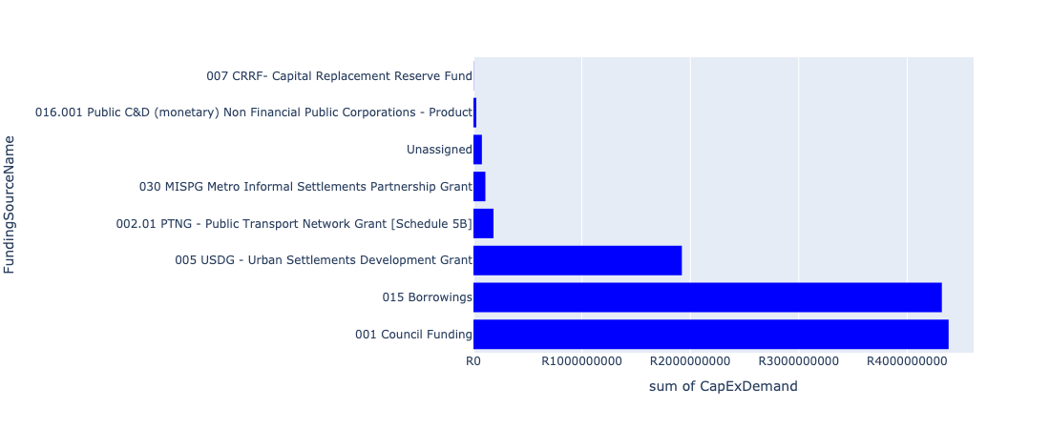

Figure 5.4: Region 2 Departmental Requests

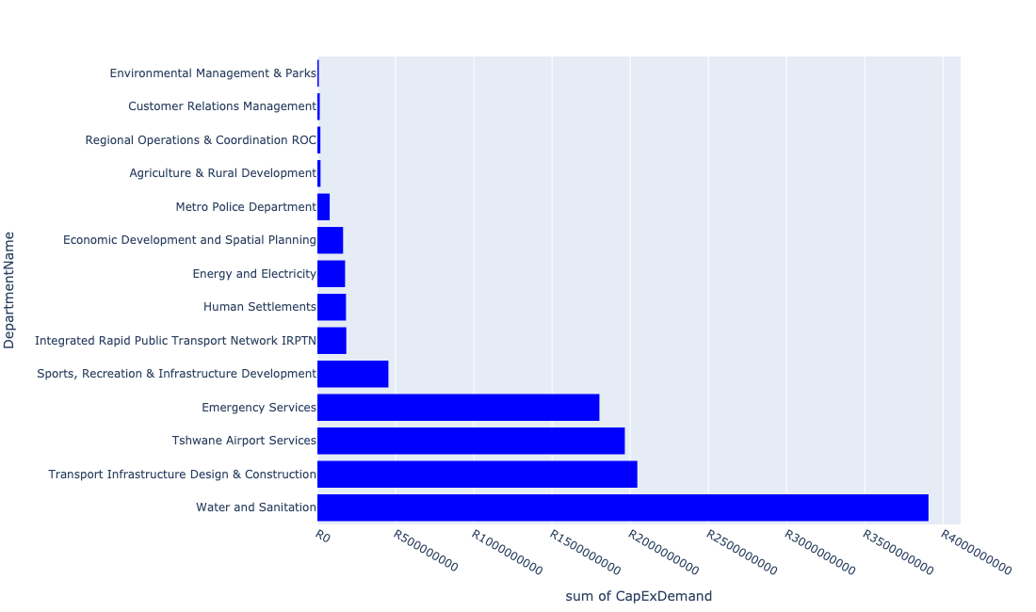

Table 5.2: Summary - Region 2

|  |  |
| --- | --- |
| Item | Description |
| Total Capital Demand for Region 2 - All Years | R11,025,795,771 Rank: 1 (1 = Highest) |
| Total Capital Demand for Region 2 - MTREF | R2,960,446,902 Rank: 4 (1 = Highest) |
| Financial Years in which capital requirements are listed for Region 2 | 2022, 2023, 2024, 2025, 2026, 2027, 2028, 2029, 2030, 2031, 2032, 2033 and 2034 |
| Financial Year with highest capital demand for Region 2 | 2027 |
| Region 2 intersecting feature used | Works Location |
| Total number of projects intersecting with Region 2 | 176 Rank: 3 (1 = Highest) |

Table 5.3: All projects asking for budget in Region 2

|  |  |  |  |
| --- | --- | --- | --- |
| Project ID | Project Name | Department | Project Budget |
| 712971915 | Revitalisation of the City-Development of Non-Motorised Transport Masterplan | Transport Infrastructure Design & Construction | R1,990,358 (0.02%) Budget spread across: 2027 |
| 712967124 | (712941) Greening of Sports fields | Sports, Recreation & Infrastructure Development | R73,999,958 (0.67%) Budget spread across: 2022, 2023, 2024, 2025, 2026, 2027, 2028, 2029, 2030 and 2031 |
| 712969045 | (712591) Denneboom to RJ - QBS | Integrated Rapid Public Transport Network IRPTN | R0.00 (0%) No budget request. |
| 450 | (710411I) Temba and Babelegi WWTW upgrade of existing infrastructure | Water and Sanitation | R50,000,000 (0.45%) Budget spread across: 2022 and 2023 |
| 712967594 | (710865) Construction of roads & stormwater - Kudube X9 | Human Settlements | R0.00 (0%) No budget request. |
| 712972947 | (712591) Wonderboom Taxi Holding Facility (Temp Turn around facility) | Integrated Rapid Public Transport Network IRPTN | R0.00 (0%) No budget request. |
| 712967331 | (712977) Business Process Outsourcing (BPO) Park Construction | Economic Development and Spatial Planning | R164,300,000 (1.49%) Budget spread across: 2022 and 2023 |
| 69 | Construction of offices, maintenance depot, boardroom, training facilities and conference facility on Airport Property | Tshwane Airport Services | R23,000,000 (0.21%) Budget spread across: 2027, 2028, 2029 and 2030 |
| 712974347 | (714039) RIMM: Bon Accord | Regional Operations & Coordination ROC | R17,000,000 (0.15%) Budget spread across: 2022 |
| 712967285 | (711335DP) Roodeplaat WTP to Montana Reservoir bulk pipe line | Water and Sanitation | R24,903,450 (0.23%) Budget spread across: 2023, 2024 and 2025 |
| 712967139 | (712911) New Eersterust library | Sports, Recreation & Infrastructure Development | R40,000,000 (0.36%) Budget spread across: 2023 and 2024 |
| 712973846 | Temba Stadium: Roof over the Main and side Pavilions with floodlights at main field (912 Unit D, Temba) | Sports, Recreation & Infrastructure Development | R20,000,000 (0.18%) Budget spread across: 2029 |
| 712969223 | 1 Tonner LDV for maintenance | Tshwane Airport Services | R500,000 (0.00%) Budget spread across: 2022 |
| 712967245 | (712884) Upgrade and replacement of all runway and taxiway lights, Threshold light, Papi lights, apron lights, security and lighting system | Tshwane Airport Services | R43,000,000 (0.39%) Budget spread across: 2022, 2023 and 2024 |
| 712969217 | (714064) Tractors with slashers | Tshwane Airport Services | R7,300,000 (0.07%) Budget spread across: 2022, 2023 and 2030 |
| 712967248 | Construct of Golf Taxiway 2nd phase | Tshwane Airport Services | R45,000,000 (0.41%) Budget spread across: 2027, 2028 and 2029 |
| 712969641 | (713054) Construction of a separate entrance for General Aviation passengers | Tshwane Airport Services | R21,000,000 (0.19%) Budget spread across: 2023 and 2024 |
| 712970903 | (710864) Sewer provision - New Eersterust X8 (Tswaing) (Pump Stations ) | Human Settlements | R40,000,000 (0.36%) Budget spread across: 2022, 2023 and 2024 |
| 712967085 | (714009) New Electricity Depot Region 2 | Energy and Electricity | R6,000,000 (0.05%) Budget spread across: 2022 |
| 712973726 | Deon Malherbe Swimming pool - Construction of security infrastructure and systems | ROC - Community & Social Development Services | R0.00 (0%) No budget request. |
| 712974390 | (710864) Sewer reticulation - Soshanguve MM | Human Settlements | R6,000,000 (0.05%) Budget spread across: 2022 |
| 712974796 | Hammanskraal water reticulation | Human Settlements | R0.00 (0%) No budget request. |
| 712975778 | Modification of the Airport Management Offices | Tshwane Airport Services | R0.00 (0%) No budget request. |
| 712969043 | (712591) RJ to Akasia - Complementary | Integrated Rapid Public Transport Network IRPTN | R0.00 (0%) No budget request. |
| 712973963 | Refurbishment of Hammanskraal customer care centre | Customer Relations Management | R6,000,000 (0.05%) Budget spread across: 2024 |
| 712974066 | Tribal Authorities | Human Settlements | R0.00 (0%) No budget request. |
| 712975085 | (712121NS1) New Suurman 1 Outfall Sewer (1/2) | Water and Sanitation | R2,500,000 (0.02%) Budget spread across: 2023 and 2024 |
| 712967042 | Development of Rooiwal Agricultural Park | Agriculture & Rural Development | R10,500,000 (0.10%) Budget spread across: 2022, 2023, 2024 and 2025 |
| 876 | (712219) Flooding Backlogs: Stinkwater & New Eersterust Area | Transport Infrastructure Design & Construction | R108,000,000 (0.98%) Budget spread across: 2022, 2023, 2024, 2025, 2026, 2027, 2028, 2029 and 2030 |
| 712967242 | Resurface main runway | Tshwane Airport Services | R22,000,000 (0.20%) Budget spread across: 2022 and 2028 |
| 66 | Provision of additional water, sewage, service road and taxiways, stormwater, security systems, electricity for airport expansion | Tshwane Airport Services | R43,000,000 (0.39%) Budget spread across: 2022, 2023, 2024, 2025, 2026, 2027, 2028, 2029 and 2030 |
| 712969209 | (714016) Development of a Joint Operating Centre | Tshwane Airport Services | R4,500,000 (0.04%) Budget spread across: 2022, 2023 and 2024 |
| 712974141 | (712862) LED Digital Display | Energy and Electricity | R2,700,000 (0.02%) Budget spread across: 2022 |
| 712967846 | (710178) Electricity for All - Region 2 | Energy and Electricity | R56,000,000 (0.51%) Budget spread across: 2024 and 2025 |
| 1005 | (712523) Flooding backlog: Network 3A, Kudube Unit 9 | Transport Infrastructure Design & Construction | R101,000,000 (0.92%) Budget spread across: 2022, 2023, 2024, 2025, 2026, 2027, 2028, 2029 and 2030 |
| 712969612 | (710863) Water provision - Hammanskraal West X10 (15ML Reservoir) | Human Settlements | R50,000,000 (0.45%) Budget spread across: 2022 and 2023 |
| 962 | (712504) Flooding backlog: Network 2F, Kudube Unit 6 | Transport Infrastructure Design & Construction | R91,000,000 (0.83%) Budget spread across: 2022, 2023, 2024, 2025, 2026, 2027, 2028, 2029 and 2030 |
| 178 | (713083) Urban Regeneration of Wonderboom Emergency Services Station | Emergency Services | R13,000,000 (0.12%) Budget spread across: 2022 |
| 63 | Completion of Bravo apron | Tshwane Airport Services | R30,000,000 (0.27%) Budget spread across: 2025 and 2026 |
| 712974172 | Flooding backlog: Kudube Unit 3 | Transport Infrastructure Design & Construction | R42,000,000 (0.38%) Budget spread across: 2027, 2028 and 2029 |
| 712970906 | Wonderboom Intermodal Facility-Permanent Phase 1 | Integrated Rapid Public Transport Network IRPTN | R0.00 (0%) No budget request. |
| 712972933 | (710863) Water provision - Hammanskraal West X10 (Bulk water line) | Human Settlements | R20,000,000 (0.18%) Budget spread across: 2022 |
| 712975140 | (712121NDO2) New Doornpoort 5 Outfall Sewer (2/3) | Water and Sanitation | R24,000,000 (0.22%) Budget spread across: 2023, 2024 and 2025 |
| 712975532 | Upgrade/replacement of emergency generator | Tshwane Airport Services | R6,800,000 (0.06%) Budget spread across: 2022, 2024 and 2025 |
| 712969197 | (710556) Region 2 (Public Lighting) | Energy and Electricity | R58,500,000 (0.53%) Budget spread across: 2022, 2023, 2024, 2025, 2026, 2027, 2028, 2029 and 2030 |
| 712967231 | Construction of Holding Bays | Tshwane Airport Services | R14,500,000 (0.13%) Budget spread across: 2027, 2028 and 2029 |
| 988 | (712516) Flooding backlog: Network 2D, New Eersterust x 2 | Transport Infrastructure Design & Construction | R96,000,000 (0.87%) Budget spread across: 2022, 2023, 2024, 2025, 2026, 2027, 2028, 2029 and 2030 |
| 712975340 | Sub-Project: TMPD Station - Tswaing | Metro Police Department | R13,000,000 (0.12%) Budget spread across: 2025 and 2026 |
| 712974113 | Kudube Unit 14 (Stellenbosch) | Human Settlements | R0.00 (0%) No budget request. |
| 712976105 | Acquiring of security protection and monitoring systems_Region 2 | Customer Relations Management | R0.00 (0%) No budget request. |
| 712969350 | Hammanskraal Multi-purpose Sport Facility | Sports, Recreation & Infrastructure Development | R60,000,000 (0.54%) Budget spread across: 2026 and 2027 |
| 1000 | (712520) Flooding backlog: Ramotse (Network 1A, 1C & 1F) | Transport Infrastructure Design & Construction | R75,000,000 (0.68%) Budget spread across: 2022, 2023, 2024, 2025, 2026, 2027, 2028, 2029 and 2030 |
| 712969398 | (712977) Business Process Outsourcing (BPO) Park - IT | Economic Development and Spatial Planning | R0.00 (0%) No budget request. |
| 712975132 | (71212SDD) Upgrade existing Soshanguve DD Outfall Sewer (2/2) | Water and Sanitation | R30,429,962 (0.28%) Budget spread across: 2023, 2024, 2025 and 2026 |
| 712974614 | Upgrading of a tributary of the Sand Spruit, Rosslyn x 17 | Transport Infrastructure Design & Construction | R2,473,172 (0.02%) Budget spread across: 2025, 2026 and 2027 |
| 712974393 | (710864) Sewer provision - Kudube X9 | Human Settlements | R47,000,000 (0.43%) Budget spread across: 2022 and 2023 |
| 712967237 | Purchase ground handling equipment | Tshwane Airport Services | R7,000,000 (0.06%) Budget spread across: 2023, 2024, 2025, 2027 and 2029 |
| 67 | Construction of a new control tower | Tshwane Airport Services | R55,000,000 (0.50%) Budget spread across: 2026, 2027 and 2028 |
| 712969221 | Upgrade and fully equipping of airport medical clinic | Tshwane Airport Services | R5,150,000 (0.05%) Budget spread across: 2023, 2024, 2027 and 2029 |
| 712969212 | (714058) Upgrade of NDB | Tshwane Airport Services | R0.00 (0%) No budget request. |
| 622 | (711262) Magriet Monamodi Stormwater System | Transport Infrastructure Design & Construction | R104,000,000 (0.94%) Budget spread across: 2022, 2023, 2024, 2025, 2026, 2027, 2028, 2029 and 2030 |
| 712967243 | Resurface secondary runway | Tshwane Airport Services | R36,000,000 (0.33%) Budget spread across: 2022, 2023, 2029 and 2030 |
| 963 | (712506) Flooding backlog: Networks in Matenteng and Stinkwater Area | Transport Infrastructure Design & Construction | R95,000,000 (0.86%) Budget spread across: 2022, 2023, 2024, 2025 and 2026 |
| 712974382 | (710863) Water provision - Soshanguve MM | Human Settlements | R10,000,000 (0.09%) Budget spread across: 2022 |
| 712974528 | Kudube Unit 5,7,8 and D : Flood Attenuation Structure | Transport Infrastructure Design & Construction | R42,000,000 (0.38%) Budget spread across: 2025, 2026 and 2027 |
| 712974282 | Upgrading of the Amandelboom low-level crossing in the Mimosa Spruit, Doornpoort | Transport Infrastructure Design & Construction | R21,000,000 (0.19%) Budget spread across: 2026, 2027 and 2028 |
| 712974173 | Major Stormwater Network 3B in Veronica Street, Montana | Transport Infrastructure Design & Construction | R2,500,000 (0.02%) Budget spread across: 2026 and 2027 |
| 58 | (714059) Construction of labour change room and related facilities | Tshwane Airport Services | R2,000,000 (0.02%) Budget spread across: 2022 and 2023 |
| 64 | Upgrade of Alpha apron | Tshwane Airport Services | R38,500,000 (0.35%) Budget spread across: 2026, 2027 and 2028 |
| 712974886 | (712591) Line 1B (Wonderboom - Akasia) | Integrated Rapid Public Transport Network IRPTN | R10,000,000 (0.09%) Budget spread across: 2022 |
| 712967632 | (710863) Water provision - Soutpan (phase 2) | Human Settlements | R0.00 (0%) No budget request. |
| 712969055 | (712591) Rainbow Junction Depot | Integrated Rapid Public Transport Network IRPTN | R0.00 (0%) No budget request. |
| 712972922 | (714005) Wonderboom Airport: Budget Placeholder_2019/20 | Tshwane Airport Services | R0.00 (0%) No budget request. |
| 712975092 | (710411Y_NT) New Temba PS and Rising mains (Phase 2/2) | Water and Sanitation | R48,000,000 (0.44%) Budget spread across: 2028, 2029 and 2030 |
| 712974167 | Upgrading of Stormwater network from Arbitus to Klippan Road, Montana Tuine | Transport Infrastructure Design & Construction | R29,800,000 (0.27%) Budget spread across: 2025, 2026 and 2027 |
| 712967718 | (712591) Construction of Line 1A: CBD to Rainbow Junction Section 1A-4B (Rainbow Junction Bypass road) | Integrated Rapid Public Transport Network IRPTN | R0.00 (0%) No budget request. |
| 712967226 | (711953) Airside/Landside: Legislative compliance and related requirements | Tshwane Airport Services | R135,000,000 (1.22%) Budget spread across: 2022, 2023, 2024, 2025, 2026, 2027, 2028, 2029 and 2030 |
| 712975490 | Steve Bikoville Library | Sports, Recreation & Infrastructure Development | R40,000,000 (0.36%) Budget spread across: 2029 and 2030 |
| 712973947 | Refurbishment of New Eersterust customer care centre | Customer Relations Management | R8,000,000 (0.07%) Budget spread across: 2026 |
| 70 | Aircraft washing and aircraft paint stripping bay to meet environmental legislative requirements | Tshwane Airport Services | R0.00 (0%) No budget request. |
| 712974448 | (710411D) Rooiwal WWTW Phase 2 : 80Ml/d Extensions and Extension of Sludge facility | Water and Sanitation | R1,715,000,000 (15.55%) Budget spread across: 2022, 2023, 2024, 2025, 2026, 2027, 2028 and 2029 |
| 712973855 | Rooiwal Community Centre and Swimming pool Upgrade of facilities, Security and Access control | Sports, Recreation & Infrastructure Development | R20,000,000 (0.18%) Budget spread across: 2027 and 2028 |
| 712973838 | Park play equipment to be replaced in Region 2 Sport and Recreation facilities | ROC - Community & Social Development Services | R0.00 (0%) No budget request. |
| 712969218 | Airport minibus | Tshwane Airport Services | R2,500,000 (0.02%) Budget spread across: 2022 and 2024 |
| 712967249 | CoT owned hangars and structure upgrade/replacement | Tshwane Airport Services | R43,000,000 (0.39%) Budget spread across: 2022, 2023, 2024, 2025, 2026, 2027, 2028, 2029 and 2030 |
| 582 | (710878N) Sewer reticulation Stinkwater Ext 2 to 8 | Water and Sanitation | R85,000,000 (0.77%) Budget spread across: 2023, 2024, 2025 and 2027 |
| 712969052 | (712591) Kolonnade SC Taxi interchange | Integrated Rapid Public Transport Network IRPTN | R0.00 (0%) No budget request. |
| 631 | (711268) Montana Spruit: Channel Improvements | Transport Infrastructure Design & Construction | R112,000,000 (1.02%) Budget spread across: 2022, 2023, 2024, 2025, 2026, 2027, 2028, 2029 and 2030 |
| 625 | (711264) Major S/ Water Drainage System: Matenteng | Transport Infrastructure Design & Construction | R12,700,000 (0.12%) Budget spread across: 2023 and 2024 |
| 508 | (710597M) Mateteng Main Transport Route, Stinkwater | Transport Infrastructure Design & Construction | R55,000,000 (0.50%) Budget spread across: 2022, 2023, 2024 and 2025 |
| 445 | (710411D) Rooiwal WWTW Phase 1: Upgrading of Existing Infrastructure | Water and Sanitation | R138,000,000 (1.25%) Budget spread across: 2022 and 2023 |
| 712975338 | Sub-Project: TMPD Station - Annlin West | Metro Police Department | R13,000,000 (0.12%) Budget spread across: 2023 and 2024 |
| 712975771 | Upgrade and replacement of the faulty booster pump | Tshwane Airport Services | R5,300,000 (0.05%) Budget spread across: 2022 and 2023 |
| 712974520 | Mashemong Major Stormwater Network 5A | Transport Infrastructure Design & Construction | R100,000,000 (0.91%) Budget spread across: 2027, 2028, 2029 and 2030 |
| 712975748 | Electronic billing system for Wonderboom Airport revenue streams (aeronautical and non-aeronautical) | Tshwane Airport Services | R7,500,000 (0.07%) Budget spread across: 2022 and 2023 |
| 712967258 | (710878U) Refurbishment of Water networks and backlog eradication : Greater Temba: Suurman, Mashemong and Majaneng | Water and Sanitation | R42,000,000 (0.38%) Budget spread across: 2023, 2024 and 2025 |
| 712969227 | (713031) Firearm safe for airport Visitors | Tshwane Airport Services | R200,000 (0.00%) Budget spread across: 2023 |
| 712974274 | (712591) Wonderboom Intermodal Facility (Hector Pieterson Station) | Integrated Rapid Public Transport Network IRPTN | R145,450,000 (1.32%) Budget spread across: 2022 |
| 65 | (713029) Additional carports and electronic parking payment equipment | Tshwane Airport Services | R3,000,000 (0.03%) Budget spread across: 2024 |
| 712974334 | (714009) New Electricity Depot for Wonderboom | Energy and Electricity | R0.00 (0%) No budget request. |
| 712974142 | (712862) Digital Valve Positioners | Energy and Electricity | R15,000,000 (0.14%) Budget spread across: 2022 |
| 574 | (710878) Sewer reticulation New Eersterust Ext 1,2,3 | Water and Sanitation | R50,000,000 (0.45%) Budget spread across: 2025, 2026 and 2027 |
| 712976097 | Upgrading of Kaalplaas Spruit through Rosslyn and Soshanguve South | Transport Infrastructure Design & Construction | R0.00 (0%) No budget request. |
| 712967252 | (710878P) Sewer reticulation New Eersterust Ext 4 to 7 | Water and Sanitation | R50,000,000 (0.45%) Budget spread across: 2025, 2026 and 2027 |
| 73 | Construction of a parkade | Tshwane Airport Services | R83,500,000 (0.76%) Budget spread across: 2027, 2028 and 2029 |
| 712974480 | RIMM: BON ACCORD QUARRY: PERIMETER FENCE | Regional Operations & Coordination ROC | R2,000,000 (0.02%) Budget spread across: 2022 |
| 961 | (712503) Flooding backlog: Network 3, Kudube Unit 11 | Transport Infrastructure Design & Construction | R101,000,000 (0.92%) Budget spread across: 2022, 2023, 2024, 2025, 2026, 2027, 2028, 2029 and 2030 |
| 712973959 | Sinoville Spinning Club add ablutions store room and Kitchen unit | Sports, Recreation & Infrastructure Development | R10,000,000 (0.09%) Budget spread across: 2029 |
| 712972920 | Golf Cart Shuttle for airport management inspection | Tshwane Airport Services | R70,000 (0.00%) Budget spread across: 2026 |
| 712974145 | (712862) Demin Plant | Energy and Electricity | R4,000,000 (0.04%) Budget spread across: 2022 |
| 712969402 | (712977) Business Process Outsourcing (BPO) Park - Furniture | Economic Development and Spatial Planning | R0.00 (0%) No budget request. |
| 62 | Main runway and taxiway upgrade and/or extension, including all security, ground lighting and related systems and services. | Tshwane Airport Services | R1,155,000,000 (10.48%) Budget spread across: 2025, 2026, 2027, 2028, 2029 and 2030 |
| 712975141 | (712121NDO3) New Doornpoort 5 Outfall Sewer (3/3) | Water and Sanitation | R3,000,000 (0.03%) Budget spread across: 2023, 2024 and 2025 |
| 712975339 | Sub-Project: TMPD Station - Suurman | Metro Police Department | R13,000,000 (0.12%) Budget spread across: 2022 and 2023 |
| 712967069 | Establishment of TMPD Training Academy | Metro Police Department | R39,720,132 (0.36%) Budget spread across: 2022, 2023 and 2024 |
| 712974139 | (712862) Oxygen Analysers | Energy and Electricity | R1,000,000 (0.01%) Budget spread across: 2022 |
| 712975751 | Construction of a roof over the main terminal building | Tshwane Airport Services | R9,500,000 (0.09%) Budget spread across: 2022, 2023, 2024 and 2026 |
| 712969084 | (712279) Soshanguve - JJ 132KV Power Line | Energy and Electricity | R7,400,815 (0.07%) Budget spread across: 2022, 2023 and 2024 |
| 712969207 | Replacement of Tipper Truck | Tshwane Airport Services | R2,000,000 (0.02%) Budget spread across: 2022 |
| 712975768 | Scrap aircraft preservation/storage parking bay | Tshwane Airport Services | R1,000,000 (0.01%) Budget spread across: 2023 and 2024 |
| 712967146 | Hammanskraal cultural centre | Sports, Recreation & Infrastructure Development | R50,000,000 (0.45%) Budget spread across: 2027 and 2028 |
| 712975118 | (712534ND) New Doornpoort- West1 Reservoir | Water and Sanitation | R65,000,000 (0.59%) Budget spread across: 2023, 2024, 2025, 2026 and 2027 |
| 712967272 | (712534W) Babelegi Reservoir Extension | Water and Sanitation | R60,000,000 (0.54%) Budget spread across: 2022, 2023, 2024 and 2025 |
| 712975456 | Upgrade of infrastructure of Magalies mountain | Environmental Management & Parks | R3,486,484 (0.03%) Budget spread across: 2022, 2023, 2024, 2025, 2026, 2027, 2028, 2029, 2030 and 2031 |
| 580 | (710878K) Sewer reticulation Kudube 5 | Water and Sanitation | R100,000,000 (0.91%) Budget spread across: 2022 and 2023 |
| 712972917 | Establishment and Renovation of Airport Maintenance Depot (compliance issue) | Tshwane Airport Services | R1,000,000 (0.01%) Budget spread across: 2022 |
| 712975828 | (710163) Refurbishment of Pyramid Sub Station | Energy and Electricity | R0.00 (0%) No budget request. |
| 53 | (713000) Elevator/escalator for main terminal building | Tshwane Airport Services | R500,000 (0.00%) Budget spread across: 2024 |
| 712974119 | Hammanskraal 112JR - PTN 9 & 10 | Human Settlements | R0.00 (0%) No budget request. |
| 712975144 | (712121NS) New Stinkwater X03 Outfall Sewer | Water and Sanitation | R2,500,000 (0.02%) Budget spread across: 2023, 2024 and 2025 |
| 712969044 | (712591) RJ to Kopanong - Complementary | Integrated Rapid Public Transport Network IRPTN | R0.00 (0%) No budget request. |
| 712975536 | Refurbishment of Bodibeng customer care centre ( Soshanguve BB) | Customer Relations Management | R1,000,000 (0.01%) Budget spread across: 2023 |
| 712974518 | Mashemong Major Stormwater Network 1E | Transport Infrastructure Design & Construction | R116,000,000 (1.05%) Budget spread across: 2026, 2027, 2028 and 2029 |
| 712973831 | Deon Malherbe Swimming pool Construction of a 25m indoor outdoor heated pool. | Sports, Recreation & Infrastructure Development | R20,000,000 (0.18%) Budget spread across: 2028 and 2029 |
| 712974140 | (712862) Oil Burner Spares | Energy and Electricity | R1,500,000 (0.01%) Budget spread across: 2022 |
| 712975468 | Upgrading of Existing ranking facility at Hammanskraal - Kopanong | Transport Infrastructure Design & Construction | R56,000,000 (0.51%) Budget spread across: 2022, 2023, 2024, 2025, 2026, 2027, 2028, 2029 and 2030 |
| 712969208 | (714049) Construction of rescue and fire fighting training facility as per SACARS requirements | Tshwane Airport Services | R3,000,000 (0.03%) Budget spread across: 2023 |
| 712975746 | Purchase 4x4 vehicle for the Airport Aviation Safety Officer | Tshwane Airport Services | R850,000 (0.01%) Budget spread across: 2022 |
| 712975769 | Information/advertising board at airport entrance | Tshwane Airport Services | R2,000,000 (0.02%) Budget spread across: 2022 and 2023 |
| 967 | (712507) Flooding backlog: Network 2H, Kudube Unit 7 | Transport Infrastructure Design & Construction | R106,000,000 (0.96%) Budget spread across: 2022, 2023, 2024, 2025, 2026, 2027, 2028, 2029 and 2030 |
| 712972912 | Capital Movables | Tshwane Airport Services | R4,500,000 (0.04%) Budget spread across: 2022, 2023, 2024, 2025, 2026, 2027, 2028, 2029 and 2030 |
| 712975113 | (710411IA) Temba WWTW Commission of Module 3 | Water and Sanitation | R290,000,000 (2.63%) Budget spread across: 2025, 2026, 2027 and 2028 |
| 712967247 | Construct additional helistops | Tshwane Airport Services | R12,500,000 (0.11%) Budget spread across: 2025, 2026, 2027 and 2030 |
| 712967840 | (712534H) Replacement and upgrading of bulk pipeline: Union Building - Jumbo Rally to Schoeman Street | Water and Sanitation | R15,499,998 (0.14%) Budget spread across: 2022, 2023 and 2024 |
| 712969609 | (710864) Bulk Sewer - Hammanskraal West X10 | Human Settlements | R10,000,000 (0.09%) Budget spread across: 2023 |
| 712967745 | (712591) Planning and Design of BRT Projects | Integrated Rapid Public Transport Network IRPTN | R29,471,440 (0.27%) Budget spread across: 2022, 2023, 2024 and 2025 |
| 632 | (711273) Major Stormwater Drainage System Majaneng | Transport Infrastructure Design & Construction | R76,000,000 (0.69%) Budget spread across: 2022, 2025, 2026, 2027, 2028, 2029 and 2030 |
| 183 | Construction of a Specialist Emergency Services Training Academy | Emergency Services | R1,790,000,000 (16.23%) Budget spread across: 2026, 2027, 2028, 2029, 2030, 2031, 2032, 2033 and 2034 |
| 1342 | (712920) Rainbow Junction and Rehabilitation of the Apies River | Transport Infrastructure Design & Construction | R270,000,000 (2.45%) Budget spread across: 2022, 2023, 2024, 2025 and 2026 |
| 712967728 | (712591) Wonderboom Intermodal Facility (Civil & Bulk Earthworks) | Integrated Rapid Public Transport Network IRPTN | R0.00 (0%) No budget request. |
| 54 | (713057) Replacement and upgrade of fire hydrants and equipment | Tshwane Airport Services | R6,300,000 (0.06%) Budget spread across: 2022, 2023, 2024, 2025, 2026, 2027, 2028, 2029 and 2030 |
| 712975531 | Construction of 90 meters safety overshoot | Tshwane Airport Services | R45,000,000 (0.41%) Budget spread across: 2022, 2023 and 2024 |
| 712975139 | (712121NDO1) New Doornpoort 5 Outfall Sewer (1/3) | Water and Sanitation | R4,000,000 (0.04%) Budget spread across: 2023, 2024 and 2025 |
| 712975245 | Erf 4557 -Upgrade of Stink water Park | Environmental Management & Parks | R5,000,000 (0.05%) Budget spread across: 2022 |
| 712976121 | (712533) Temba & Hammanskraal West Walkways | Enterprise Programme Management Unit (ePMU) | R0.00 (0%) No budget request. |
| 987 | (712515) Flooding backlog: Network 2B, Ramotse | Transport Infrastructure Design & Construction | R89,000,000 (0.81%) Budget spread across: 2022, 2023, 2024, 2025, 2026, 2027, 2028, 2029 and 2030 |
| 712967685 | (712279) Soshanguve 132/11KV Substation | Energy and Electricity | R25,000,000 (0.23%) Budget spread across: 2022 |
| 712974538 | (710411D2) Rooiwal WWTW Phase 3: 50Ml/d extension | Water and Sanitation | R750,000,000 (6.80%) Budget spread across: 2024, 2025, 2026, 2027 and 2028 |
| 712967161 | Development of Stinkwater Agricultural Park | Agriculture & Rural Development | R9,500,000 (0.09%) Budget spread across: 2022, 2023, 2024 and 2025 |
| 712969228 | (714065) Runway, Taxiway and road sweeper | Tshwane Airport Services | R4,000,000 (0.04%) Budget spread across: 2022 |
| 712974037 | Proposed Hammanskraal West X4 | Human Settlements | R0.00 (0%) No budget request. |
| 575 | (710878) Ramotse-Marokolong waterborne sanitation | Water and Sanitation | R315,000,000 (2.86%) Budget spread across: 2022, 2023, 2025, 2026 and 2027 |
| 20 | Overkruin Library and office space | Sports, Recreation & Infrastructure Development | R40,000,000 (0.36%) Budget spread across: 2022 and 2023 |
| 712967253 | (710878Q) Refurbishment of Sewer networks and backlog eradication : Greater Temba: Suurman, Mashemong and Majaneng | Water and Sanitation | R42,000,000 (0.38%) Budget spread across: 2023, 2024 and 2025 |
| 712967244 | Resurface taxiways | Tshwane Airport Services | R19,000,000 (0.17%) Budget spread across: 2022, 2023, 2028 and 2029 |
| 68 | Airport vehicles replacement, equipment and new vehicles (i.e. slasher, tipper truck, tractors with cabins, perimeter control inspection vehicles, mini-passenger busses, truck with crane, disabled transporting vehicles, etc.) | Tshwane Airport Services | R15,000,000 (0.14%) Budget spread across: 2023, 2024, 2025, 2026, 2027, 2028, 2029 and 2030 |
| 712974083 | Stinkwater X10 | Human Settlements | R0.00 (0%) No budget request. |
| 74 | Sealing the roof of the main terminal building and resolve stormwater problems inside the building to prevent structural damages | Tshwane Airport Services | R0.00 (0%) No budget request. |
| 712973888 | (711863) Internal Roads Mandela Village (North) | Transport Infrastructure Design & Construction | R140,000,000 (1.27%) Budget spread across: 2022, 2023, 2024, 2025, 2026, 2027, 2028, 2029 and 2030 |
| 712975454 | Upgrade of infrastructure at Wonderboom Nature Reserve | Environmental Management & Parks | R500,000 (0.00%) Budget spread across: 2022, 2023 and 2024 |
| 712976069 | Construction of Electrical Trade Workshops across regions | Tshwane Leadership and Management Academy | R0.00 (0%) No budget request. |
| 712974123 | Subdivision of Soshanguve MM - stand 25 & 426 | Human Settlements | R0.00 (0%) No budget request. |
| 712973725 | (713044) Acquisition of Servitude ( Zandkop) | Environmental Management & Parks | R0.00 (0%) No budget request. |
| 14 | New Eersterust/Stinkwater multi-purpose sport facility | Sports, Recreation & Infrastructure Development | R40,000,000 (0.36%) Budget spread across: 2027 and 2028 |
| 712967611 | (710864) Sewer provision - Soutpan (phase 2) | Human Settlements | R0.00 (0%) No budget request. |
| 712973862 | Stinkwater Library to have a dedicated building | Sports, Recreation & Infrastructure Development | R40,000,000 (0.36%) Budget spread across: 2029 and 2030 |

Please note that the following projects will not be shown in this table:

* Projects with no recorded intersect with Regions (in other words no Works Location was recorded on the system for this project)

Projects that do not have any recorded budget demand on the system at the time that this report was requested, are shown in the table with zero budgets indicated.

## Region 3

Figure 5.5: Region 3 Funding Requests

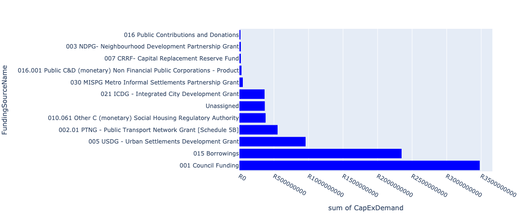

Figure 5.6: Region 3 Departmental Requests

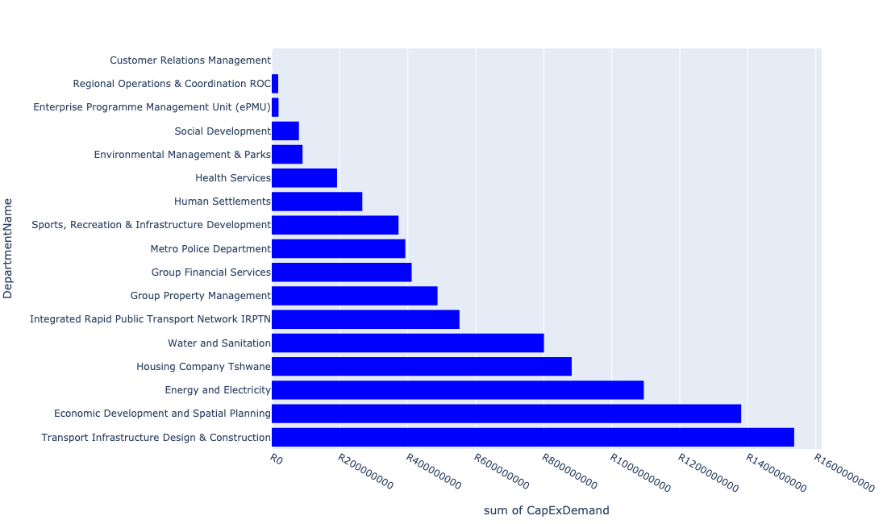

Table 5.3: Summary - Region 3

|  |  |
| --- | --- |
| Item | Description |
| Total Capital Demand for Region 3 - All Years | R8,579,171,438 Rank: 3 (1 = Highest) |
| Total Capital Demand for Region 3 - MTREF | R4,691,749,407 Rank: 2 (1 = Highest) |
| Financial Years in which capital requirements are listed for Region 3 | 2022, 2023, 2024, 2025, 2026, 2027, 2028, 2029, 2030, 2031 and 2032 |
| Financial Year with highest capital demand for Region 3 | 2022 |
| Region 3 intersecting feature used | Works Location |
| Total number of projects intersecting with Region 3 | 256 Rank: 1 (1 = Highest) |

Table 5.4: All projects asking for budget in Region 3

|  |  |  |  |
| --- | --- | --- | --- |
| Project ID | Project Name | Department | Project Budget |
| 712969216 | (712591)Taxi Industry Compensation | Integrated Rapid Public Transport Network IRPTN | R0.00 (0%) No budget request. |
| 712967743 | (712591) The Design, Supply, Installation, Operation and Maintenance of an automated fare Collection (AFC) System | Integrated Rapid Public Transport Network IRPTN | R41,792,985 (0.49%) Budget spread across: 2022, 2023, 2024 and 2025 |
| 712974522 | Upgrading of Solomon Mahlangu Drive | Transport Infrastructure Design & Construction | R35,926,363 (0.42%) Budget spread across: 2022 |
| 712967744 | (712591) Design, Supply, Installation, Commissioning and Operational Support Of Advanced Public Transport Management System (APTMS) | Integrated Rapid Public Transport Network IRPTN | R13,424,461 (0.16%) Budget spread across: 2022 |
| 712975590 | Refurbishment of Mamelodi customer care centre | Customer Relations Management | R166,667 (0.00%) Budget spread across: 2025 |
| 712969046 | (712591) NMT Line 2B (Hatfield to Menlyn) | Integrated Rapid Public Transport Network IRPTN | R9,282,750 (0.11%) Budget spread across: 2022 |
| 712968961 | Upgrade of MV and LV in Waterkloof | ROC - Utility Services | R0.00 (0%) No budget request. |
| 712971915 | Revitalisation of the City-Development of Non-Motorised Transport Masterplan | Transport Infrastructure Design & Construction | R813,993 (0.01%) Budget spread across: 2027 |
| 712969045 | (712591) Denneboom to RJ - QBS | Integrated Rapid Public Transport Network IRPTN | R0.00 (0%) No budget request. |
| 712970748 | R6 Machinery and Equipment to ensure basic infrastructure reliability | Regional Operations & Coordination ROC | R0 (0.00%) Budget spread across: 2022 and 2023 |
| 712967731 | (712591) Line 2B: Atterbury Rd (btw Lynnwood Rd to Lois Avenue) | Integrated Rapid Public Transport Network IRPTN | R152,221,186 (1.77%) Budget spread across: 2022, 2023, 2024 and 2025 |
| 712967133 | (712736) Fencing off Nature areas City Wide (Ecological Sensitive Purposes) | Environmental Management & Parks | R2,000,000 (0.02%) Budget spread across: 2022 and 2023 |
| 712967127 | (713040) Furniture and Equipment for offices, overnight accommodation and facilities within resorts | Environmental Management & Parks | R1,350,000 (0.02%) Budget spread across: 2022 and 2024 |
| 712975456 | Upgrade of infrastructure of Magalies mountain | Environmental Management & Parks | R10,927,558 (0.13%) Budget spread across: 2022, 2023, 2024, 2025, 2026, 2027, 2028, 2029, 2030 and 2031 |
| 712967840 | (712534H) Replacement and upgrading of bulk pipeline: Union Building - Jumbo Rally to Schoeman Street | Water and Sanitation | R15,500,002 (0.18%) Budget spread across: 2022, 2023 and 2024 |
| 712967745 | (712591) Planning and Design of BRT Projects | Integrated Rapid Public Transport Network IRPTN | R41,481,910 (0.48%) Budget spread across: 2022, 2023, 2024 and 2025 |
| 712969509 | (713085) Marabastad Informal Traders Formalisation | Economic Development and Spatial Planning | R0.00 (0%) No budget request. |
| 712969686 | (710865) Timberland | Human Settlements | R0.00 (0%) No budget request. |
| 712974934 | (712533) Tsosoloso Programme - Upgrading of roads in Saulsville | Enterprise Programme Management Unit (ePMU) | R20,000,000 (0.23%) Budget spread across: 2022 and 2023 |
| 712970762 | (710863) Water reticulation - Andeon X37 | Human Settlements | R0 (0.00%) Budget spread across: 2022 |
| 712970768 | (710864) Sewer reticulation - Andeon X37 | Human Settlements | R0 (0.00%) Budget spread across: 2022 and 2023 |
| 712974798 | (710868) Acquisition of land | Human Settlements | R0.00 (0%) No budget request. |
| 712974825 | (713023) Inner City Regeneration - CBD areas | Economic Development and Spatial Planning | R140,000,000 (1.63%) Budget spread across: 2022, 2023, 2024, 2025, 2026, 2027, 2028 and 2029 |
| 712973923 | Upgrading of Makhaza Sport Facility | Sports, Recreation & Infrastructure Development | R15,000,000 (0.17%) Budget spread across: 2031 |
| 712975251 | 712967311_02 Upgrade passenger elevators at Blesbok and Bosbok flats | Group Property Management | R4,000,000 (0.05%) Budget spread across: 2022 |
| 712975134 | (712121NSW2) New Swartspruit (A) Outfall Sewer (2/2) | Water and Sanitation | R22,000,000 (0.26%) Budget spread across: 2028 and 2029 |
| 712975443 | Supply and installation of generators for Tshwane Market | Economic Development and Spatial Planning | R11,900,000 (0.14%) Budget spread across: 2022, 2023, 2024, 2025, 2026, 2027, 2028, 2029, 2030, 2031 and 2032 |
| 712973975 | Replacement of FF Ribeiro Clinic | Health Services | R64,000,000 (0.75%) Budget spread across: 2024, 2025 and 2026 |
| 712969352 | (713091) Upgrade of existing Studios located at Premos | Communications and Marketing | R0.00 (0%) No budget request. |
| 712967337 | Kruger Park | Human Settlements | R0.00 (0%) No budget request. |
| 712969601 | (712591) Atteridgeville Taxi Interchange | Integrated Rapid Public Transport Network IRPTN | R0 (0.00%) Budget spread across: 2022 |
| 712969615 | (710864) Bulk Sewer -Booysens X4 | Human Settlements | R0.00 (0%) No budget request. |
| 712973992 | Eloff Gebou (95 Units) Affordable rental | Housing Company Tshwane | R10,450,000 (0.12%) Budget spread across: 2023 and 2024 |
| 712973986 | HOUSING BOTHONGO PLAZA: Supply of First Aid Box | ROC - Human Settlements | R0.00 (0%) No budget request. |
| 712973940 | Swimming Pool ,Gert Van Schalkwyk Pool:Renovate Ablution Facility ,Re-tile the Swimming Pool | ROC - Community & Social Development Services | R0.00 (0%) No budget request. |
| 712975512 | Upgrade of worker ablution facilities - Groenkloof Nature Reserve | Environmental Management & Parks | R1,000,000 (0.01%) Budget spread across: 2022 |
| 712973983 | Housing beneficiary and administration :Supply of First Aid Box and Servicing of Fire Extinguishers. | ROC - Human Settlements | R0.00 (0%) No budget request. |
| 712975406 | Sub-Project: TMPD Station - CBD (Madiba Street 1) | Metro Police Department | R42,000,000 (0.49%) Budget spread across: 2022, 2023 and 2024 |
| 712967626 | (710863) Water provision - Fort West X4 | Human Settlements | R6,000,000 (0.07%) Budget spread across: 2022 |
| 712976119 | (712533) Masopha Sports Facility Upgrade | Sports, Recreation & Infrastructure Development | R0.00 (0%) No budget request. |
| 712974816 | Upgrading of Justice Mahomed Drive between Dely/Brooklyn Road and Jan Shoba Street | Transport Infrastructure Design & Construction | R27,000,000 (0.31%) Budget spread across: 2022 and 2023 |
| 15 | Capital Theatre (Feasibility Study) | Sports, Recreation & Infrastructure Development | R10,000,000 (0.12%) Budget spread across: 2025 |
| 712974169 | Torch-on concrete slabs at TLMA campus all roof tops | Group Property Management | R0.00 (0%) No budget request. |
| 712974198 | Sunnyside: Construction of 264 Social Housing Units | Housing Company Tshwane | R215,690,817 (2.51%) Budget spread across: 2022, 2023 and 2024 |
| 712975523 | Upgrade of Visitors Facilities - Groenkloof Nature Reserve | Environmental Management & Parks | R3,999,979 (0.05%) Budget spread across: 2022, 2023, 2024, 2025, 2026 and 2027 |
| 712975578 | Refurbishment of the Old Fire Station | Group Property Management | R20,000,000 (0.23%) Budget spread across: 2023 |
| 712973906 | Dorp Park :Upgrade and replace all Gym Equipment in the park keeps on braking and can't be fixed anymore. | ROC - Community & Social Development Services | R0.00 (0%) No budget request. |
| 712973763 | Magnolia Dell Decorative Park | ROC - Community & Social Development Services | R0.00 (0%) No budget request. |
| 712967812 | (712900) Upgrading of Departmental Armory & Ammunition Depot | Metro Police Department | R11,000,000 (0.13%) Budget spread across: 2022, 2023 and 2024 |
| 712976431 | (710276) Upgrading And Extension Of Market Facilities | Economic Development and Spatial Planning | R0.00 (0%) No budget request. |
| 712973869 | RIMM: BELLE OMBRE DEPOT: Upgrade Security fence | Regional Operations & Coordination ROC | R2,000,000 (0.02%) Budget spread across: 2022 |
| 712973857 | 1090_02_Building lights retrofit at Fortsig Electricity Depot | Energy and Electricity | R0.00 (0%) No budget request. |
| 712967477 | Centralised furniture and equipment - CRR | Group Financial Services | R0.00 (0%) No budget request. |
| 1028 | (712534) Relining/upgrading reservoirs | Water and Sanitation | R190,000,000 (2.21%) Budget spread across: 2022, 2023, 2024, 2025, 2026, 2027, 2028, 2029 and 2030 |
| 712969243 | (713023) Inner City Regeneration: Civic and Northern Gateway Precincts | Economic Development and Spatial Planning | R200,000,000 (2.33%) Budget spread across: 2022, 2023, 2024, 2025, 2026, 2027, 2028, 2029 and 2030 |
| 712975094 | (710411Y_C) Upgrading of Carina Street Pump station | Water and Sanitation | R81,500,000 (0.95%) Budget spread across: 2025, 2026, 2027 and 2028 |
| 712973995 | Claremont 50 (BeterWag) SSE - 50 Units | Housing Company Tshwane | R6,000,000 (0.07%) Budget spread across: 2022 |
| 712967142 | Saulsville arena | Sports, Recreation & Infrastructure Development | R15,000,000 (0.17%) Budget spread across: 2027 |
| 712967334 | Lady Selborne | Human Settlements | R0.00 (0%) No budget request. |
| 712973926 | Hillcrest Swimming Pool:Replace current heaters with heat pumps | ROC - Community & Social Development Services | R0.00 (0%) No budget request. |
| 712967835 | New Folang Clinic | Health Services | R64,000,000 (0.75%) Budget spread across: 2022, 2023 and 2024 |
| 712973740 | (712591) Pretoria Intermodal Facility | Integrated Rapid Public Transport Network IRPTN | R0.00 (0%) No budget request. |
| 968 | (712511) Flooding backlog: Atteridgeville | Transport Infrastructure Design & Construction | R150,000,000 (1.75%) Budget spread across: 2022, 2023, 2024, 2025, 2026, 2027, 2028, 2029 and 2030 |
| 712974536 | (712872) Electricity Building Extension | Energy and Electricity | R20,000,000 (0.23%) Budget spread across: 2022 |
| 712974129 | (712500) Postal Franking Machine | Metro Police Department | R350,000 (0.00%) Budget spread across: 2022 |
| 712973932 | Waverley Community library | Sports, Recreation & Infrastructure Development | R0.00 (0%) No budget request. |
| 712975409 | Sub-Project: TMPD Station - Lady Selbourne/Suiderberg | Metro Police Department | R13,000,000 (0.15%) Budget spread across: 2024 and 2025 |
| 712976150 | Refurbishment of Atteridgeville Customer care centre | Customer Relations Management | R0.00 (0%) No budget request. |
| 712967345 | (711712) Development of Saulsville hostels | Human Settlements | R29,440,467 (0.34%) Budget spread across: 2022, 2023 and 2024 |
| 712973886 | Urban Management: Installation of bollards. | ROC - Community & Social Development Services | R0.00 (0%) No budget request. |
| 712974181 | Provisioning of new taxi ranking facility at Marabastad  Bazaar | Transport Infrastructure Design & Construction | R79,000,000 (0.92%) Budget spread across: 2022, 2023, 2024, 2025, 2026, 2027, 2028, 2029 and 2030 |
| 712975120 | (712534) New Additional Waverly LL Reservoir | Water and Sanitation | R11,000,000 (0.13%) Budget spread across: 2023, 2024 and 2025 |
| 712975097 | (711335Mck) Replace feeder mains to Muckleneuck Reservoir with new route from Klapperkop | Water and Sanitation | R75,000,000 (0.87%) Budget spread across: 2025, 2026, 2027 and 2028 |
| 712967697 | (710178) Electricity for All - Region 3 | Energy and Electricity | R96,750,000 (1.13%) Budget spread across: 2022, 2023, 2024 and 2025 |
| 712967294 | (711335) Cathodic protection to all Steel pipes (City wide) | Water and Sanitation | R108,000,000 (1.26%) Budget spread across: 2022, 2023, 2024, 2025, 2026, 2027, 2028, 2029 and 2030 |
| 712975077 | (712121NK) New Kwaggasrand flow diversion and Outfall Sewer | Water and Sanitation | R1,500,000 (0.02%) Budget spread across: 2023 and 2024 |
| 712976067 | Replacement of old Market advertising boards | Economic Development and Spatial Planning | R0.00 (0%) No budget request. |
| 712976044 | Upgrade of the infrastructure at Joos Becker Caravan Park | Environmental Management & Parks | R0.00 (0%) No budget request. |
| 712973703 | Extension of Saulsville Clinic | Health Services | R64,000,000 (0.75%) Budget spread across: 2028, 2029 and 2030 |
| 712975526 | Upgrade of Roads in Groenkloof Nature reserve | Environmental Management & Parks | R3,953,754 (0.05%) Budget spread across: 2022, 2023, 2024, 2025, 2026, 2027, 2028 and 2029 |
| 712970763 | (710863) Water reticulation - Booysens X4 | Human Settlements | R3,000,000 (0.03%) Budget spread across: 2022 |
| 712975197 | Upgrade elevator PE5905 Sammy Marks Library | Group Property Management | R1,400,000 (0.02%) Budget spread across: 2022 |
| 712976073 | UPGRADE HVAC SYSTEM OLD RAADSAAL | Group Property Management | R0.00 (0%) No budget request. |
| 712969687 | (713063) Turnaround of Municipal Water Service - Reduction of Water losses | Group Financial Services | R411,592,208 (4.80%) Budget spread across: 2022, 2023, 2024, 2026 and 2027 |
| 712975048 | Upgrade elevators Pretoria West power station | Group Property Management | R2,700,000 (0.03%) Budget spread across: 2022 |
| 712973766 | Venning Park Decorative Park | ROC - Community & Social Development Services | R0.00 (0%) No budget request. |
| 712967498 | (712591) BRT Rationalization Infrastructure (Mixed Traffic Operations) | Integrated Rapid Public Transport Network IRPTN | R8,000,000 (0.09%) Budget spread across: 2022 |
| 712967091 | (713010) Infrastructure Fault Reporting and Dispatch (New) | Energy and Electricity | R200,000 (0.00%) Budget spread across: 2022 and 2023 |
| 712973921 | Mbolekwa Synthetic Soccer pitch | Sports, Recreation & Infrastructure Development | R5,000,000 (0.06%) Budget spread across: 2029 |
| 712974539 | Construction of major storm water Network 8 throughout Atteridgeville x 7 | Transport Infrastructure Design & Construction | R19,000,000 (0.22%) Budget spread across: 2026, 2027 and 2028 |
| 712975796 | (714071) Acquisition and refurbishment of Midtown Building | Group Property Management | R82,890,700 (0.97%) Budget spread across: 2022, 2023, 2024, 2025, 2026, 2027, 2028, 2029, 2030 and 2031 |
| 712975278 | 712967311_01 Upgrade dock levellers at Tshwane Fresh Produce Market Banana Ripening plant | Group Property Management | R1,650,000 (0.02%) Budget spread across: 2022 |
| 712973990 | Danville SSE (105 Units) | Housing Company Tshwane | R20,856,780 (0.24%) Budget spread across: 2023 |
| 712976111 | (712533) Ga Mothaga Resort Upgrade | Enterprise Programme Management Unit (ePMU) | R0.00 (0%) No budget request. |
| 712975510 | Upgrading of perforated roller doors at Tshwane market | Economic Development and Spatial Planning | R2,990,000 (0.03%) Budget spread across: 2022, 2023, 2024, 2025, 2026, 2027, 2028, 2029, 2030, 2031 and 2032 |
| 712973887 | Urban Management : Installation of playing Equipment. | ROC - Community & Social Development Services | R0.00 (0%) No budget request. |
| 712973938 | Swimming Pool Region 3:Atteridgeville Pool,Re-tile the Swimming pool and Renovate Ablution facility. | ROC - Community & Social Development Services | R0.00 (0%) No budget request. |
| 485 | (710484) Secondary Substations | Energy and Electricity | R204,800,000 (2.39%) Budget spread across: 2022, 2023, 2024, 2025, 2026, 2027, 2028, 2029, 2030 and 2031 |
| 712975527 | Design ,Supply and install market surveillance system | Economic Development and Spatial Planning | R4,700,000 (0.05%) Budget spread across: 2022, 2023, 2024, 2025, 2026, 2027, 2028, 2029, 2030, 2031 and 2032 |
| 628 | (711265) Hartebeest Spruit: Canal Upgrading | Transport Infrastructure Design & Construction | R0.00 (0%) No budget request. |
| 712974353 | (712591) Line 3: CBD to Atteridgeville - Section 2 (Pretoria West - Atteridgeville) | Integrated Rapid Public Transport Network IRPTN | R7,000,000 (0.08%) Budget spread across: 2022 |
| 712974551 | (711706) Network Control System Extension | Energy and Electricity | R50,000,000 (0.58%) Budget spread across: 2022 and 2023 |
| 712973961 | BELLE OMBRE ROADS DEPOT:Repair of Security Lighting. | ROC - Roads & Transport | R0.00 (0%) No budget request. |
| 712975292 | Upgrading of Dairy Mall to one stop intermodal facility ( Rail,Bus,Taxi) | Transport Infrastructure Design & Construction | R110,000,000 (1.28%) Budget spread across: 2022, 2023, 2024, 2025, 2026, 2027, 2028, 2029 and 2030 |
| 712969192 | (710556) Region 3 (Public Lighting) | Energy and Electricity | R181,500,000 (2.12%) Budget spread across: 2022, 2023, 2024, 2025, 2026, 2027, 2028, 2029 and 2030 |
| 712974602 | Upgrading of the Steenhoven Spruit near Asiatic Bazaar, Pretoria west | Transport Infrastructure Design & Construction | R45,000,000 (0.52%) Budget spread across: 2026, 2027, 2028, 2029 and 2030 |
| 712967094 | (713008) Construction of the Centralised Engineering Support centre Services. | Energy and Electricity | R200,000,000 (2.33%) Budget spread across: 2022, 2023, 2024 and 2025 |
| 712972951 | (712826) Upgrade of infrastructure at Booysens Nursery | Environmental Management & Parks | R7,500,000 (0.09%) Budget spread across: 2022, 2023 and 2026 |
| 712973970 | SAULSVILLE HOSTEL: Upgrading of Saulsville Office Block,Roof,Ceiling and Air Cons. | ROC - Human Settlements | R0.00 (0%) No budget request. |
| 712975870 | Supply and installation of Public lights Tshwane Market | Economic Development and Spatial Planning | R0.00 (0%) No budget request. |
| 712975229 | Saulsville Public Transport Facility | Transport Infrastructure Design & Construction | R19,099 (0.00%) Budget spread across: 2022, 2023, 2024, 2025, 2026, 2027, 2028, 2029 and 2030 |
| 18 | (713070) New Mayville Library | Sports, Recreation & Infrastructure Development | R35,000,000 (0.41%) Budget spread across: 2026 and 2027 |
| 712973978 | BELLE OMBRE HOSTEL: PLUMBING THE KITCHEN PIPES. | ROC - Human Settlements | R0.00 (0%) No budget request. |
| 712975072 | (712121NA1) New Atteridgeville P3 Outfall Sewer (1/3) | Water and Sanitation | R5,500,000 (0.06%) Budget spread across: 2023, 2024 and 2025 |
| 712976102 | Guard House Belle Ombre Clinic | Tshwane Leadership and Management Academy | R0.00 (0%) No budget request. |
| 712974479 | RIMM: BELLE OMBRE: SOIL & ASPHALT LAB REFURBISHMENT | Regional Operations & Coordination ROC | R1,000,000 (0.01%) Budget spread across: 2022 |
| 712969610 | (710863) Bulk water pipeline - Booysens X4 | Human Settlements | R35,000,000 (0.41%) Budget spread across: 2022, 2023 and 2024 |
| 712975003 | Security and visitor infrastructure Upgrades for Kwaggaspruit Resort | Environmental Management & Parks | R15,000,000 (0.17%) Budget spread across: 2022, 2023 and 2024 |
| 712975146 | (71212Arc) Upgrade existing Arcadia X8 Outfall Sewer | Water and Sanitation | R3,600,000 (0.04%) Budget spread across: 2023, 2024 and 2025 |
| 1080 | (712681) Multipurpose Development Centre next to Phomolong Clinic | Social Development | R80,000,000 (0.93%) Budget spread across: 2026 and 2027 |
| 712970712 | (713084) Lalela Monument | Economic Development and Spatial Planning | R24,000,000 (0.28%) Budget spread across: 2022 and 2023 |
| 712967721 | (712591) Implementation of Church Square Landscaping - Phase 2 | Integrated Rapid Public Transport Network IRPTN | R0.00 (0%) No budget request. |
| 712974840 | (714046) Salvokop Reservoir – Conduit Hydropower Plant | Water and Sanitation | R14,000,000 (0.16%) Budget spread across: 2022, 2023 and 2024 |
| 712967629 | (710863) Bulk Reservoir - Fort West X4&5 | Human Settlements | R50,000,000 (0.58%) Budget spread across: 2022, 2023 and 2024 |
| 712974050 | Tshwane Bio-energy Facility | Tshwane Economic Development Agency | R0.00 (0%) No budget request. |
| 712972968 | Sunnyside detail design, bulk infrastructure and internal reticulation | Housing Company Tshwane | R0.00 (0%) No budget request. |
| 712975573 | Stalshoogte | Housing Company Tshwane | R20,000,000 (0.23%) Budget spread across: 2022 and 2023 |
| 712967609 | (710864) Sewer provision - Fort West X4 | Human Settlements | R7,000,000 (0.08%) Budget spread across: 2022 |
| 712973872 | Korfball Park | Sports, Recreation & Infrastructure Development | R0.00 (0%) No budget request. |
| 1286 | (712868) Upgrading of the market trading system | Economic Development and Spatial Planning | R106,100,000 (1.24%) Budget spread across: 2022, 2023, 2025, 2026, 2027, 2028, 2029, 2031 and 2032 |
| 712974164 | Major Stormwater network 4G along Boundary Road, Hatfield | Transport Infrastructure Design & Construction | R17,000,000 (0.20%) Budget spread across: 2026, 2027 and 2028 |
| 712975830 | (710163) Refurbishment Of Kwagga Infeed Substation | Energy and Electricity | R0.00 (0%) No budget request. |
| 712975289 | Upgrade elevator metro police HQ | Group Property Management | R1,400,000 (0.02%) Budget spread across: 2025 |
| 712975438 | Creative Arts Spaces (Region 3) | Sports, Recreation & Infrastructure Development | R10,000,000 (0.12%) Budget spread across: 2025 |
| 712975324 | Furniture and equipment for visitor facilities at Groenkloof Nature Reserve | Environmental Management & Parks | R2,000,000 (0.02%) Budget spread across: 2028 |
| 712974065 | (712279) Ifafi 88/11kV Substation | Energy and Electricity | R80,000,000 (0.93%) Budget spread across: 2024, 2025 and 2026 |
| 712973856 | (714029) RIMM: Belle Ombre: Concrete Plant | Regional Operations & Coordination ROC | R1,500,000 (0.02%) Budget spread across: 2022 |
| 712973756 | 1090_03_Building lights retrofit at Tshwane Food Market | Energy and Electricity | R0.00 (0%) No budget request. |
| 712973973 | SAULSVILLE HOSTEL ACCESS CONTROL: Pedestrian revolving gate,Replace Main Gate and Replace Heavy Trucks Gate | ROC - Human Settlements | R0.00 (0%) No budget request. |
| 712967730 | (712591) Line 2B: Lynnwood Rd (btw University Rd to Atterbury) | Integrated Rapid Public Transport Network IRPTN | R199,000,000 (2.32%) Budget spread across: 2022, 2023 and 2024 |
| 712976063 | Upgrading of new electrical reticulation System | Economic Development and Spatial Planning | R0.00 (0%) No budget request. |
| 712967089 | (712915) Upgrading of Caledonian Stadium (Inner City Park) | Sports, Recreation & Infrastructure Development | R112,886,200 (1.32%) Budget spread across: 2022 and 2023 |
| 712974096 | 712972939_04_Replacement of oils cables (City Centre) ( Electricity Distribution Loss) | Energy and Electricity | R36,000,000 (0.42%) Budget spread across: 2022, 2023, 2024 and 2025 |
| 712975994 | Design and construction of new entry and exits for Tshwane market | Economic Development and Spatial Planning | R0.00 (0%) No budget request. |
| 1004 | (712522) Collector Road Backlogs: Atteridgeville | Transport Infrastructure Design & Construction | R170,000,000 (1.98%) Budget spread across: 2025, 2026, 2027 and 2028 |
| 712975556 | Refurbishment of Pretoria City Hall | Group Property Management | R50,000,000 (0.58%) Budget spread across: 2022 and 2023 |
| 712974188 | Hillcrest swimming pool upgrade to international standard facility | Sports, Recreation & Infrastructure Development | R40,000,000 (0.47%) Budget spread across: 2028 and 2029 |
| 712975516 | Construction of Entrance gates - Klapperkop | Environmental Management & Parks | R3,000,000 (0.03%) Budget spread across: 2022, 2023 and 2024 |
| 712976103 | Construction of Major Stormwater Network 8V in Atteridgeville | Transport Infrastructure Design & Construction | R0.00 (0%) No budget request. |
| 712971918 | Revitalisation of the City-Upgrade of Pretoria Station Taxi Rank- Dairy Mall Taxi Rank | Transport Infrastructure Design & Construction | R236,000,000 (2.75%) Budget spread across: 2022, 2023, 2024, 2025, 2026, 2027, 2028, 2029 and 2030 |
| 712975410 | Sub-Project: TMPD Station - Ashlea Garden | Metro Police Department | R13,000,000 (0.15%) Budget spread across: 2022 and 2023 |
| 712974036 | Atteridgeville X46 | Human Settlements | R0.00 (0%) No budget request. |
| 712976003 | UPGRADE HVAC PLANT SAMMY MARKS SQUARE | Group Property Management | R0.00 (0%) No budget request. |
| 712976094 | (712868)Acquisition of IT software for Fresh Produce Market | Economic Development and Spatial Planning | R0.00 (0%) No budget request. |
| 712975525 | Upgrading and extension of cold storage Facilities | Economic Development and Spatial Planning | R444,160,000 (5.18%) Budget spread across: 2022, 2023, 2024, 2025, 2026, 2027, 2028, 2029, 2030, 2031 and 2032 |
| 391 | (710276) Upgrading And Extension Of Market Facilities | Economic Development and Spatial Planning | R228,700,000 (2.67%) Budget spread across: 2022, 2023, 2024 and 2025 |
| 712975453 | Upgrading of Dr Savage tranking facility and holding facility | Transport Infrastructure Design & Construction | R182,000,000 (2.12%) Budget spread across: 2022, 2023, 2024, 2025, 2026, 2027, 2028, 2029 and 2030 |
| 712969694 | (712762) Capital Moveables | Water and Sanitation | R9,000,000 (0.10%) Budget spread across: 2022, 2023, 2024, 2025, 2026, 2027, 2028, 2029 and 2030 |
| 1124 | (712751) Capital Funded from Operating (City Planning & Development) | Economic Development and Spatial Planning | R5,500,000 (0.06%) Budget spread across: 2022, 2023, 2024, 2025, 2026, 2027, 2028, 2029 and 2030 |
| 460 | Reparation To & Resurfacing Of Roads (Fresh Produce Market) | Economic Development and Spatial Planning | R17,500,000 (0.20%) Budget spread across: 2022, 2023, 2024 and 2025 |
| 712976066 | (712147) New Vlakplaats Pump station | Water and Sanitation | R0.00 (0%) No budget request. |
| 712967063 | (712988) Informal Trade Market(Inner City) | Economic Development and Spatial Planning | R0.00 (0%) No budget request. |
| 712976074 | Upgrading of Management Building and associated works(IT offices into Market Development offices and water proofing) | Economic Development and Spatial Planning | R0.00 (0%) No budget request. |
| 712973916 | Solomon Park: Planting of concrete bollards. | ROC - Community & Social Development Services | R0.00 (0%) No budget request. |
| 712975533 | The Upgrading of Malie Street in Andeon and Booysens | Transport Infrastructure Design & Construction | R22,000,000 (0.26%) Budget spread across: 2025, 2026 and 2027 |
| 712975390 | (712279) Tunnel 132/11kV Substation | Energy and Electricity | R75,000,000 (0.87%) Budget spread across: 2025, 2026 and 2027 |
| 712967075 | Establishment of a TMPD Command and Communication Centre (C3) | Metro Police Department | R313,000,000 (3.65%) Budget spread across: 2022, 2023, 2024 and 2025 |
| 712974208 | (712872) Network Control Centre Reconfiguration | Energy and Electricity | R15,000,000 (0.17%) Budget spread across: 2022 |
| 712975442 | Upgrade of infrastructure at DLS Nature Reserve | Environmental Management & Parks | R54,051 (0.00%) Budget spread across: 2022 and 2023 |
| 712974068 | Proposed Andeon X37 | Human Settlements | R0.00 (0%) No budget request. |
| 712973993 | Capital Park SSE (69 Units) | Housing Company Tshwane | R6,852,942 (0.08%) Budget spread across: 2024 |
| 712973976 | BELLE OMBRE HOSTEL: Upgrading of the Hostel Buildings | ROC - Human Settlements | R0.00 (0%) No budget request. |
| 712974540 | Construction of major storm water Network 2A in the vicinity of Motheberebe Street, AtteridgevilleProject | Transport Infrastructure Design & Construction | R1,690,082 (0.02%) Budget spread across: 2025 and 2026 |
| 712976100 | Upgrading and channelization of the Modder spruit next to Kenneth Street, Andeon AH | Transport Infrastructure Design & Construction | R0.00 (0%) No budget request. |
| 712969176 | Scada HMI (Capital Park) | Energy and Electricity | R0.00 (0%) No budget request. |
| 657 | (711335) Heights Iscor Feeder | Water and Sanitation | R0.00 (0%) No budget request. |
| 712973939 | Swimming Pool Region 3 :Les Marais Pool,:Renovate Ablution Facility ,Re-tile Swimming pool | ROC - Community & Social Development Services | R0.00 (0%) No budget request. |
| 22 | Mountain View Library | Sports, Recreation & Infrastructure Development | R30,000,000 (0.35%) Budget spread across: 2026 and 2027 |
| 712974377 | (710863) Water provision - Bridgeway Communial Stand pipes | Human Settlements | R3,913,092 (0.05%) Budget spread across: 2022 |
| 712975413 | Sub-Project: TMPD Station - Kwaggasrand / Atteridgeville | Metro Police Department | R420,888 (0.00%) Budget spread across: 2023 |
| 712975479 | Upgrade elevator Christiaan De Wet administration building | Group Property Management | R1,200,000 (0.01%) Budget spread across: 2024 |
| 712973982 | Housing ,Saulsville Hostel First Aid Box contents supply, Servicing of Fire Extinguishers,Repairing of Falling Ceiling and Building Roof Repair. | ROC - Human Settlements | R0.00 (0%) No budget request. |
| 712972966 | Townlands Project - Construction of 1,200 social housing units | Housing Company Tshwane | R267,180,300 (3.11%) Budget spread across: 2022, 2023 and 2024 |
| 712976432 | (710276) Upgrading And Extension Of Market Facilities | Economic Development and Spatial Planning | R0.00 (0%) No budget request. |
| 712975293 | Upgrade elevator Old Council Chamber | Group Property Management | R1,400,000 (0.02%) Budget spread across: 2027 |
| 712975150 | (71212WS)Witkoppies Spruit Bulk Sewer | Water and Sanitation | R45,000,000 (0.52%) Budget spread across: 2023, 2024, 2026 and 2027 |
| 712973919 | Villieria Bowling | Sports, Recreation & Infrastructure Development | R0.00 (0%) No budget request. |
| 712972931 | (710863) Booysens X4 (30ML Reservoir) | Human Settlements | R60,000,000 (0.70%) Budget spread across: 2022, 2023 and 2024 |
| 712970767 | (710864) Sewer reticulation - Booysens X4 | Human Settlements | R5,000,000 (0.06%) Budget spread across: 2022 |
| 712974354 | (712591) Belle Ombre - Phase 2 (Overflow car park, Electric Fencing etc) | Integrated Rapid Public Transport Network IRPTN | R1,000,000 (0.01%) Budget spread across: 2022 |
| 712967862 | (711335L) Louwlardia to Samrand Bulk Pipeline | Water and Sanitation | R50,000,000 (0.58%) Budget spread across: 2023, 2024, 2025 and 2026 |
| 712975244 | Upgrade of Jubilee Park Sunnyside | Environmental Management & Parks | R6,000,000 (0.07%) Budget spread across: 2022 |
| 712973913 | Suiderberg Park.:Replace broken fence with concrete bollards and Repair irrigation system. | ROC - Community & Social Development Services | R0.00 (0%) No budget request. |
| 712975491 | Rehabilitation of Wetlands - Colbyn Wetland | Environmental Management & Parks | R1,500,000 (0.02%) Budget spread across: 2022, 2023, 2024, 2025 and 2026 |
| 712973994 | Silwerkroon SSE (121 Units) | Housing Company Tshwane | R12,702,022 (0.15%) Budget spread across: 2024 |
| 712970745 | (713093) Upgrade HB Philips Building | Group Property Management | R150,000,000 (1.75%) Budget spread across: 2022 |
| 712975345 | (712279) Elland Switching Station | Energy and Electricity | R55,000,000 (0.64%) Budget spread across: 2023, 2024 and 2025 |
| 712973925 | Saulsville Library | Sports, Recreation & Infrastructure Development | R10,000,000 (0.12%) Budget spread across: 2028 |
| 712972946 | (712591) Wonderboom Intermodal Facility (Building Works) | Integrated Rapid Public Transport Network IRPTN | R70,000,000 (0.82%) Budget spread across: 2022 |
| 712972958 | (712827) Specialised Vehicles | Economic Development and Spatial Planning | R24,700,000 (0.29%) Budget spread across: 2022, 2023, 2024, 2025, 2026, 2027, 2029, 2030, 2031 and 2032 |
| 712975520 | Upgrading of ripening center | Economic Development and Spatial Planning | R60,500,000 (0.71%) Budget spread across: 2022, 2023, 2024, 2025, 2026, 2027, 2028, 2029, 2030, 2031 and 2032 |
| 17 | (713068) Lotus Gardens Library | Sports, Recreation & Infrastructure Development | R35,000,000 (0.41%) Budget spread across: 2025 and 2026 |
| 712973931 | SUNNY SIDE POOL:Bullet proof window in front of Cashiers office;Replace Filter Bags inside filters and Renovate ablution facilities and RE-Tile the swimming pool. | ROC - Community & Social Development Services | R0.00 (0%) No budget request. |
| 712976055 | Construction of Brick Laying Workshop | Tshwane Leadership and Management Academy | R0.00 (0%) No budget request. |
| 712973739 | (712591) Line 1A (Nana Sita - Pretoria Station) | Integrated Rapid Public Transport Network IRPTN | R0.00 (0%) No budget request. |
| 712975019 | Decongestion of the inner city- Provisioning of New off street holding facilities within the inner city – CBD as per the 04 identified sites | Transport Infrastructure Design & Construction | R65,000,000 (0.76%) Budget spread across: 2022, 2023, 2024, 2025, 2026, 2027, 2028, 2029 and 2030 |
| 712974478 | RIMM: BELLE OMBRE: BIOMETRICAL TIME AND ATTENDANCE SYSTEM | Regional Operations & Coordination ROC | R1,000,000 (0.01%) Budget spread across: 2022 |
| 712969692 | (712926) Capital Moveables | Regional Operations & Coordination ROC | R12,500,000 (0.15%) Budget spread across: 2022, 2023, 2024, 2025 and 2026 |
| 712975408 | Upgrading of market Halls roofs | Economic Development and Spatial Planning | R78,900,000 (0.92%) Budget spread across: 2022, 2023, 2024, 2025, 2026, 2027, 2028, 2029, 2030, 2031 and 2032 |
| 712976072 | Suppy,Install of pre-paid meters electricity and water for market tenants and Marabastad stalls | Economic Development and Spatial Planning | R0.00 (0%) No budget request. |
| 712968953 | Upgrading of LV Overhead lines - Lynnwood; Menlo Park | ROC - Utility Services | R0.00 (0%) No budget request. |
| 712967602 | (710865) Construction of roads & stormwater - Fort West X5 | Human Settlements | R67,000,000 (0.78%) Budget spread across: 2022, 2023 and 2024 |
| 712973728 | (713044) Laudium Cemetery | Environmental Management & Parks | R328,271 (0.00%) Budget spread across: 2022 and 2023 |
| 712975474 | Upgrade elevators Pretoria City Hall | Group Property Management | R5,000,000 (0.06%) Budget spread across: 2023 |
| 712975033 | (712121NA2) New Atteridgeville P3 Outfall Sewer (2/3) | Water and Sanitation | R8,500,000 (0.10%) Budget spread across: 2023, 2024 and 2025 |
| 712967871 | (712591)Refurbishment and Upgrading of TBS Depots | Integrated Rapid Public Transport Network IRPTN | R0.00 (0%) No budget request. |
| 712973908 | Rangers Football Club | Sports, Recreation & Infrastructure Development | R0.00 (0%) No budget request. |
| 712975494 | Construction of Litter Traps at Austin Roberts Nature Reserve | Environmental Management & Parks | R3,000,000 (0.03%) Budget spread across: 2022, 2023, 2024, 2025 and 2026 |
| 712973957 | Timberlands Construction Of 607 Social Housing Units | Housing Company Tshwane | R315,714,838 (3.68%) Budget spread across: 2022, 2023 and 2024 |
| 712975797 | Acquisition Old-Mercedes Benz Building | Group Property Management | R120,888,656 (1.41%) Budget spread across: 2022, 2023, 2024, 2025, 2026, 2027, 2028, 2029, 2030 and 2031 |
| 712975133 | (712121NSW1) New Swartspruit (A) Outfall Sewer (1/2) | Water and Sanitation | R10,500,000 (0.12%) Budget spread across: 2028, 2029 and 2030 |
| 712975348 | (712279) Saulsville 132/11kV Substation | Energy and Electricity | R80,000,000 (0.93%) Budget spread across: 2025, 2026 and 2027 |
| 712974352 | (712591) Line 3: CBD to Atteridgeville - Section 1 (CBD - Pretoria West) | Integrated Rapid Public Transport Network IRPTN | R8,000,000 (0.09%) Budget spread across: 2022 |
| 712976081 | (712868)Acquisition of IT hardware for Fresh Produce Market | Economic Development and Spatial Planning | R0.00 (0%) No budget request. |
| 712967167 | (712260) Lotus Gardens multi-purpose sport facility | Sports, Recreation & Infrastructure Development | R40,000,000 (0.47%) Budget spread across: 2025 and 2026 |
| 712976058 | Construction of Carpentry Workshop | Tshwane Leadership and Management Academy | R0.00 (0%) No budget request. |
| 712967144 | (711442) Upgrading of museums/historical buildings | Sports, Recreation & Infrastructure Development | R20 (0.00%) Budget spread across: 2025 |
| 712973759 | 1090_01_Building light retrofit at Villieria Training Centre | Energy and Electricity | R0.00 (0%) No budget request. |
| 712973874 | 1090_05_Streetlight retrofit project in Pretoria CBD | Energy and Electricity | R0.00 (0%) No budget request. |
| 712975866 | Townlands Project - Construction social housing units - Phase 2 | Housing Company Tshwane | R0.00 (0%) No budget request. |
| 712973974 | SAULSVILLE HOSTEL : Upgrade Ablution,Sewerage System in Hostels. | ROC - Human Settlements | R0.00 (0%) No budget request. |
| 712973851 | (714030 RIMM: Belle Ombre: Concrete Plant: Pneumatic Cylinders | Regional Operations & Coordination ROC | R1,000,000 (0.01%) Budget spread across: 2022 |
| 712976112 | Upgrade of the infrastructure at Ga-Mothakga Resort | Environmental Management & Parks | R0.00 (0%) No budget request. |
| 712973991 | Oosmoot (Villeria) SSE (60 Units) | Housing Company Tshwane | R6,058,398 (0.07%) Budget spread across: 2024 |
| 712973980 | BELLE OMBRE HOSTELS : FIXING OF LIGHTS AND PARKING BAYS. | ROC - Human Settlements | R0.00 (0%) No budget request. |
| 712975517 | Installation of high mast lights | Economic Development and Spatial Planning | R10,650,000 (0.12%) Budget spread across: 2022, 2023, 2024, 2025, 2026, 2027, 2028, 2029, 2030, 2031 and 2032 |
| 712973934 | Atteridgeville Library | Sports, Recreation & Infrastructure Development | R0.00 (0%) No budget request. |
| 712971919 | Revitalisation of the City-Taxi Holding areas within the Pretoria CBD | Transport Infrastructure Design & Construction | R276,000,000 (3.22%) Budget spread across: 2022, 2023, 2024, 2025, 2026, 2027, 2028, 2029 and 2030 |
| 712975122 | (712534Mo) Mooiwater Reservoir (Phase 2) | Water and Sanitation | R31,000,000 (0.36%) Budget spread across: 2026, 2027 and 2028 |
| 712967488 | (710671) East Lynne bus and taxi facilities | Transport Infrastructure Design & Construction | R100,000,000 (1.17%) Budget spread across: 2022, 2023, 2024, 2025, 2026, 2027, 2028, 2029 and 2030 |
| 712975099 | (711335WK) Waterkloof 2 feeder main | Water and Sanitation | R19,500,000 (0.23%) Budget spread across: 2023, 2024 and 2025 |
| 712976095 | Construction of a new bridge in Flowers Street across the Apies River, Capital Park | Transport Infrastructure Design & Construction | R0.00 (0%) No budget request. |
| 712975030 | (712534) Rietfontein Res (Phase1) | Water and Sanitation | R34,000,000 (0.40%) Budget spread across: 2023, 2024 and 2026 |
| 712967725 | (712591) Belle Ombre CNG Bus Depot: Building Works | Integrated Rapid Public Transport Network IRPTN | R0.00 (0%) No budget request. |
| 712974217 | Sunnyside Boundary Fence | Housing Company Tshwane | R650,000 (0.01%) Budget spread across: 2024 |
| 712974074 | Atteridgeville X19 | Human Settlements | R0.00 (0%) No budget request. |
| 712975571 | Construction/Refurbishment of Atteridgeville Electrical Depot | Group Property Management | R45,000,000 (0.52%) Budget spread across: 2022 and 2023 |
| 712975007 | Security and visitor infrastructure upgrades at GaMothakga Recreational Resort | Environmental Management & Parks | R27,000,000 (0.31%) Budget spread across: 2022, 2023 and 2024 |
| 712975448 | Upgrade of infrastructure of Voortrekker Monument Nature Reserve | Environmental Management & Parks | R2,000,000 (0.02%) Budget spread across: 2022 and 2023 |
| 712974154 | Proposed Andeon X36 | Human Settlements | R0.00 (0%) No budget request. |
| 712967121 | (712878) Upgrading of Pilditch Stadium - cycle track | Sports, Recreation & Infrastructure Development | R15,000,000 (0.17%) Budget spread across: 2026 |
| 712969048 | (712591) Pretoria Station | Integrated Rapid Public Transport Network IRPTN | R0 (0.00%) Budget spread across: 2022 |
| 712969042 | (712591) Capital Park Railway Bridges (Line 1A - WP6) | Integrated Rapid Public Transport Network IRPTN | R1,000,000 (0.01%) Budget spread across: 2022 |
| 712967276 | (712534SL) Salvokop Reservoir | Water and Sanitation | R60,000,000 (0.70%) Budget spread across: 2023, 2024, 2025 and 2026 |
| 712975385 | Upgrading and extension of Access control office on the eastern gate | Economic Development and Spatial Planning | R20,300,000 (0.24%) Budget spread across: 2022, 2023, 2024, 2025, 2026, 2027, 2028, 2029, 2030, 2031 and 2032 |
| 712975142 | (712121NA3) New Atteridgeville P3 Outfall Sewer (3/3) | Water and Sanitation | R5,500,000 (0.06%) Budget spread across: 2023, 2024 and 2025 |

Please note that the following projects will not be shown in this table:

* Projects with no recorded intersect with Regions (in other words no Works Location was recorded on the system for this project)

Projects that do not have any recorded budget demand on the system at the time that this report was requested, are shown in the table with zero budgets indicated.

## Region 4

Figure 5.7: Region 4 Funding Requests

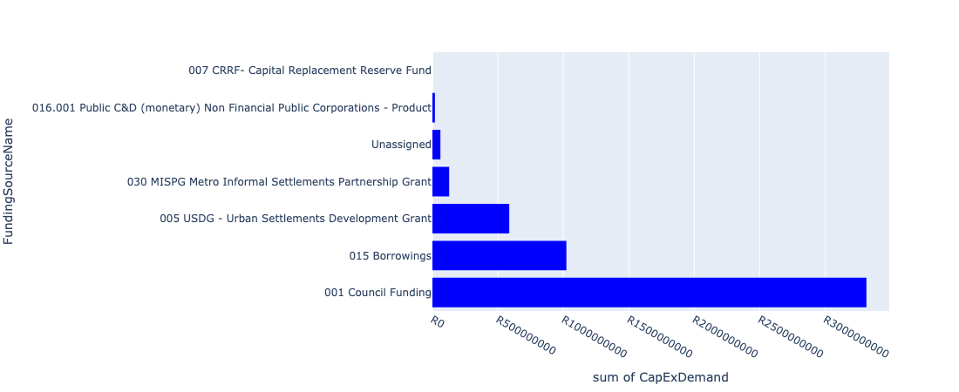

Figure 5.8: Region 4 Departmental Requests

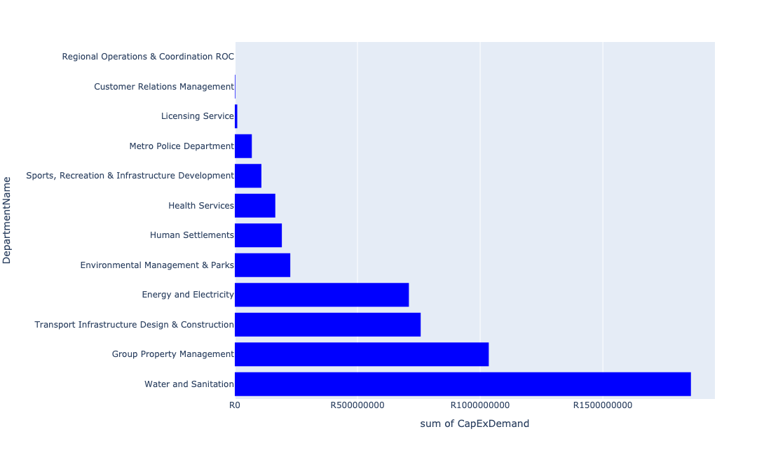

Table 5.4: Summary - Region 4

|  |  |
| --- | --- |
| Item | Description |
| Total Capital Demand for Region 4 - All Years | R5,133,424,534 Rank: 5 (1 = Highest) |
| Total Capital Demand for Region 4 - MTREF | R2,370,916,822 Rank: 5 (1 = Highest) |
| Financial Years in which capital requirements are listed for Region 4 | 2022, 2023, 2024, 2025, 2026, 2027, 2028, 2029 and 2030 |
| Financial Year with highest capital demand for Region 4 | 2024 |
| Region 4 intersecting feature used | Works Location |
| Total number of projects intersecting with Region 4 | 95 Rank: 5 (1 = Highest) |

Table 5.5: All projects asking for budget in Region 4

|  |  |  |  |
| --- | --- | --- | --- |
| Project ID | Project Name | Department | Project Budget |
| 712974522 | Upgrading of Solomon Mahlangu Drive | Transport Infrastructure Design & Construction | R3,162,239 (0.06%) Budget spread across: 2022 |
| 712975233 | Development of Rietvlei conference Facility and Office park | Environmental Management & Parks | R149,447,383 (2.91%) Budget spread across: 2022, 2023, 2024 and 2025 |
| 712971915 | Revitalisation of the City-Development of Non-Motorised Transport Masterplan | Transport Infrastructure Design & Construction | R803,291 (0.02%) Budget spread across: 2027 |
| 712970748 | R6 Machinery and Equipment to ensure basic infrastructure reliability | Regional Operations & Coordination ROC | R0 (0.00%) Budget spread across: 2022 and 2023 |
| 712975523 | Upgrade of Visitors Facilities - Groenkloof Nature Reserve | Environmental Management & Parks | R21 (0.00%) Budget spread across: 2022, 2023, 2024, 2025, 2026 and 2027 |
| 712975526 | Upgrade of Roads in Groenkloof Nature reserve | Environmental Management & Parks | R46,246 (0.00%) Budget spread across: 2022, 2023, 2024, 2025, 2026, 2027, 2028 and 2029 |
| 712975229 | Saulsville Public Transport Facility | Transport Infrastructure Design & Construction | R109,980,897 (2.14%) Budget spread across: 2022, 2023, 2024, 2025, 2026, 2027, 2028, 2029 and 2030 |
| 712975442 | Upgrade of infrastructure at DLS Nature Reserve | Environmental Management & Parks | R1,945,949 (0.04%) Budget spread across: 2022 and 2023 |
| 712974540 | Construction of major storm water Network 2A in the vicinity of Motheberebe Street, AtteridgevilleProject | Transport Infrastructure Design & Construction | R2,309,918 (0.04%) Budget spread across: 2025 and 2026 |
| 712975413 | Sub-Project: TMPD Station - Kwaggasrand / Atteridgeville | Metro Police Department | R12,579,112 (0.25%) Budget spread across: 2023 |
| 712973728 | (713044) Laudium Cemetery | Environmental Management & Parks | R4,671,729 (0.09%) Budget spread across: 2022 and 2023 |
| 712967463 | (712533) Construction of Roads and Walkways in Olievenhoutbosch ( Council Funding ) | Transport Infrastructure Design & Construction | R0.00 (0%) No budget request. |
| 712967684 | (712279) Eldoraigne 132/11kv Substation | Energy and Electricity | R20,000,000 (0.39%) Budget spread across: 2026 |
| 1025 | (712534) Doornkloof Reservoir | Water and Sanitation | R0.00 (0%) No budget request. |
| 712976107 | Upgrading of the Bridge in West Avenue across the Hennops River, Centurion CBD | Transport Infrastructure Design & Construction | R0.00 (0%) No budget request. |
| 712975349 | (712279) Heritage Hill Substation | Energy and Electricity | R175,000,000 (3.41%) Budget spread across: 2024, 2025 and 2026 |
| 712974819 | 713044 Olievenhoutbosch Cemetery | Environmental Management & Parks | R800,000 (0.02%) Budget spread across: 2022 |
| 712974524 | Upgrading of Lenchen Avenue | Transport Infrastructure Design & Construction | R49,000,000 (0.95%) Budget spread across: 2022, 2023 and 2024 |
| 712974533 | (710411A3) Sunderland Ridge WWTW Phase 2: 20 Ml/d Extension project using alternative technologies on existing site | Water and Sanitation | R480,000,000 (9.35%) Budget spread across: 2022, 2023, 2024 and 2025 |
| 712975008 | Upgrades security and building infrastructure at Zwartkops Resort | Environmental Management & Parks | R32,000,000 (0.62%) Budget spread across: 2022, 2023 and 2024 |
| 712975529 | Upgrade of Rooihuiskraal - Reptile park | Environmental Management & Parks | R1,000,000 (0.02%) Budget spread across: 2022, 2023, 2024, 2025, 2026, 2027 and 2028 |
| 712974453 | Construction of a New Emergency Services Station in Rooihuiskraal | Emergency Services | R0.00 (0%) No budget request. |
| 712967614 | (710864) Sewer provision Olievenhoutbosch X60 | Human Settlements | R3,905,440 (0.08%) Budget spread across: 2022 |
| 712975346 | (712279) Centurion Switching Station | Energy and Electricity | R50,000,000 (0.97%) Budget spread across: 2025 and 2026 |
| 712969063 | Management of River Pollution - Demolishing Centurion Dam Wall, protection of Bridge and provision of water to the Centurion Lake Ponds | ROC - Environment & Agricultural Management | R0.00 (0%) No budget request. |
| 712971911 | (710863) Olievenhoutbosch X60 Bulk Water | Human Settlements | R0.00 (0%) No budget request. |
| 712974567 | Installation of security at licensing centres | Licensing Service | R10,000,000 (0.19%) Budget spread across: 2022 |
| 712975772 | (712900) Upgrading of existing Practical Training facilities (Centurion) | Metro Police Department | R30,800,000 (0.60%) Budget spread across: 2022, 2023 and 2024 |
| 712975171 | Upgrading of Hendrik Verwoerd Drive between John Vorster Drive and Rooihuiskraal Road in Centurion | Transport Infrastructure Design & Construction | R65,000,000 (1.27%) Budget spread across: 2026, 2027 and 2028 |
| 712975168 | Construction of major and minor stormwater drainage networks in Olievenhoutbosch X21 and X37. | Transport Infrastructure Design & Construction | R12,000,000 (0.23%) Budget spread across: 2028 and 2029 |
| 712969077 | (712279) Kentron 132/11kV Substation | Energy and Electricity | R75,000,000 (1.46%) Budget spread across: 2022 and 2023 |
| 712976167 | Centurion Lake Rehabilitation | Regional Operations & Coordination ROC | R0.00 (0%) No budget request. |
| 712976116 | Upgrade of infrastructure at Rooihuiskraal Resort | Environmental Management & Parks | R0.00 (0%) No budget request. |
| 712975483 | Rehabilitation of Wetlands - Technopark | Environmental Management & Parks | R1,500,000 (0.03%) Budget spread across: 2022, 2023, 2024 and 2025 |
| 712974158 | Upgrading of major stormwater Network 3A along Rabie Street, Lyttleton | Transport Infrastructure Design & Construction | R25,300,000 (0.49%) Budget spread across: 2025, 2026 and 2027 |
| 712967120 | (713089) Rehabilitation of wetlands | Environmental Management & Parks | R6,000,000 (0.12%) Budget spread across: 2022 and 2023 |
| 712967598 | (710865) Construction of roads & stormwater - Olievenhoutbosch X60 | Human Settlements | R179,838,974 (3.50%) Budget spread across: 2022, 2023 and 2024 |
| 712975080 | (712121NH3) New Hennops River (Sunderland Ridge) Outfall Sewer (3/6) | Water and Sanitation | R31,500,000 (0.61%) Budget spread across: 2026, 2027, 2028 and 2029 |
| 712967492 | Wierda Park Transport Facilities | Transport Infrastructure Design & Construction | R75,000,000 (1.46%) Budget spread across: 2022, 2023, 2024, 2025, 2026, 2027, 2028, 2029 and 2030 |
| 712975458 | Upgrade infrastructure at Bishop Bird Sanctuary | Environmental Management & Parks | R1,500,000 (0.03%) Budget spread across: 2028 |
| 21 | Erasmia Library | Sports, Recreation & Infrastructure Development | R30,000,000 (0.58%) Budget spread across: 2027 and 2028 |
| 712975029 | (710411Sc) Schurveberg WWTW: New 25 Ml/day BNR Module | Water and Sanitation | R55,000,000 (1.07%) Budget spread across: 2029 and 2030 |
| 712967277 | (712534L) Louwlardia Reservoir/ Heritage Reservoir | Water and Sanitation | R45,000,000 (0.88%) Budget spread across: 2023, 2024 and 2025 |
| 712975149 | (71212Doo)Doornkloof Bulk Sewer Extension | Water and Sanitation | R18,500,000 (0.36%) Budget spread across: 2023, 2024 and 2025 |
| 712975392 | (712279) Heritage Hill to Kentron T 132kV Power Line | Energy and Electricity | R25,000,000 (0.49%) Budget spread across: 2023 and 2024 |
| 712975135 | (712121PT) New Peach Tree 1 Outfall Sewer | Water and Sanitation | R3,500,000 (0.07%) Budget spread across: 2028 and 2029 |
| 712975083 | (712121NH6) New Hennops River (Sunderland Ridge) Outfall Sewer (6/6) | Water and Sanitation | R106,500,000 (2.07%) Budget spread across: 2027, 2028, 2029 and 2030 |
| 439 | (710411A) Sunderland Ridge WWTW Phase1: Upgrade of existing infrastructure | Water and Sanitation | R60,000,000 (1.17%) Budget spread across: 2022 and 2023 |
| 712975169 | Construction of stormwater relief networks to alleviate flooding pertaining to Fourth Avenue and surrounding areas in Laudium | Transport Infrastructure Design & Construction | R900,000 (0.02%) Budget spread across: 2026 and 2027 |
| 712967166 | (711432) Olievenhoutbosch multi-purpose sport facility | Sports, Recreation & Infrastructure Development | R40,000,000 (0.78%) Budget spread across: 2025 and 2026 |
| 712975084 | (712121H) Upgrade existing Hennops River (B) Outfall Sewer (2/4) | Water and Sanitation | R800,000 (0.02%) Budget spread across: 2028 and 2029 |
| 712967195 | New Clinic Mooiplaas | Health Services | R64,000,000 (1.25%) Budget spread across: 2024, 2025 and 2026 |
| 712967490 | (712368) Upgrading of facility ( Shelters and bus terminals ) at Centurion CBD | Transport Infrastructure Design & Construction | R103,000,000 (2.01%) Budget spread across: 2022, 2023, 2024, 2025, 2026, 2027, 2028, 2029 and 2030 |
| 712967696 | (710178) Electricity for All - Region 4 | Energy and Electricity | R94,500,000 (1.84%) Budget spread across: 2022, 2023, 2024 and 2025 |
| 712967690 | (712279) Monavoni 132/11KV Substation | Energy and Electricity | R60,000,000 (1.17%) Budget spread across: 2022, 2023 and 2024 |
| 712975170 | Construction of stormwater relief networks to alleviate flooding from the regional low-point discharging unto the township, Erasmia | Transport Infrastructure Design & Construction | R2,100,000 (0.04%) Budget spread across: 2027 and 2028 |
| 712976329 | (711335) Refurbishment Of Laudium Bulk Pipeline | Water and Sanitation | R0.00 (0%) No budget request. |
| 712975078 | (712121NH1) New Hennops River (Sunderland Ridge) Outfall Sewer (1/6) | Water and Sanitation | R16,500,000 (0.32%) Budget spread across: 2026, 2027 and 2028 |
| 712967169 | New Electricity Depot -Region 4 (New) | Energy and Electricity | R114,000,000 (2.22%) Budget spread across: 2022, 2023 and 2024 |
| 712969196 | (710556) Region 4 (Public Lighting) | Energy and Electricity | R96,000,000 (1.87%) Budget spread across: 2024, 2025, 2026, 2027, 2028, 2029 and 2030 |
| 712974159 | Major Stormwater Network 6C, along Gropius Avenue, Die Hoewes | Transport Infrastructure Design & Construction | R2,000,000 (0.04%) Budget spread across: 2026 and 2027 |
| 712976106 | Upgrading of Bridges in Lenchen Road-South and Lenchen Road-North across the Hennops River, Centurion CBD | Transport Infrastructure Design & Construction | R0.00 (0%) No budget request. |
| 712975087 | (71212PvR) Upgrade existing Pierre van Ryneveld Outfall Sewer | Water and Sanitation | R7,500,000 (0.15%) Budget spread across: 2023, 2024 and 2025 |
| 826 | (712121E) Rietspruit outfall sewer upgrade | Water and Sanitation | R25,000,000 (0.49%) Budget spread across: 2023 and 2024 |
| 712975081 | (712121NH4) New Hennops River (Sunderland Ridge) Outfall Sewer (4/6) | Water and Sanitation | R26,500,000 (0.52%) Budget spread across: 2026, 2027, 2028 and 2029 |
| 712974523 | Upgrading of Rooihuiskraal Road | Transport Infrastructure Design & Construction | R27,000,000 (0.53%) Budget spread across: 2022, 2023 and 2024 |
| 712976146 | Acquiring of security protection and monitoring systems_Region 4 | Customer Relations Management | R0.00 (0%) No budget request. |
| 712974534 | (710411A4) Sunderland Ridge WWTW: land aquisition of new adjacent site | Water and Sanitation | R155,000,000 (3.02%) Budget spread across: 2023 |
| 712967627 | (710863) Water provision - Olievenhoutbosch X60 | Human Settlements | R8,000,000 (0.16%) Budget spread across: 2022 |
| 712976120 | (712533) Creation of Walkways in Olievenhoutbosch Traders Market | Enterprise Programme Management Unit (ePMU) | R0.00 (0%) No budget request. |
| 16 | New Valhalla Library | Sports, Recreation & Infrastructure Development | R25,000,000 (0.49%) Budget spread across: 2028 and 2029 |
| 712973701 | Eldoraigne Clinic Dispensaries | Health Services | R34,000,000 (0.66%) Budget spread across: 2022 and 2023 |
| 712973727 | 713044 Construction of internal roads and guard house at Centurion Cemetery | Environmental Management & Parks | R10,000,000 (0.19%) Budget spread across: 2022 |
| 712975450 | Upgrade of infrastructure development at Luton Valley Nature Area | Environmental Management & Parks | R2,500,000 (0.05%) Budget spread across: 2026 |
| 712967278 | (712534PR) Pretorius rand reservoir | Water and Sanitation | R85,000,000 (1.66%) Budget spread across: 2023, 2024, 2025, 2026 and 2027 |
| 712975493 | Rehabilitation of Wetlands - The Reeds | Environmental Management & Parks | R1,500,000 (0.03%) Budget spread across: 2022, 2023, 2024, 2025 and 2026 |
| 643 | (711325) Olievenhoutbosch Activity Spine | Transport Infrastructure Design & Construction | R180,000,000 (3.51%) Budget spread across: 2023, 2024, 2025 and 2026 |
| 712975082 | (712121NH5) New Hennops River (Sunderland Ridge) Outfall Sewer (5/6) | Water and Sanitation | R18,500,000 (0.36%) Budget spread across: 2027, 2028 and 2029 |
| 712975228 | Olivienhoutbosch Public Transport Facility (Provisioning of new taxi ranking facility at Olivienhoutbosch ) | Transport Infrastructure Design & Construction | R94,000,000 (1.83%) Budget spread across: 2022, 2023, 2024, 2025, 2026, 2027, 2028, 2029 and 2030 |
| 712974535 | (710411A5) Sunderland Ridge WWTW Phase 3: 25 Ml/d Extension on new adjacent site | Water and Sanitation | R693,000,000 (13.50%) Budget spread across: 2023, 2024, 2025, 2026, 2027 and 2028 |
| 712969022 | Extension of Rooihuiskraal Clinic to accommodate growing patient numbers | Health Services | R67,000,000 (1.31%) Budget spread across: 2024, 2025 and 2026 |
| 712975259 | Development of of Monte kneen Park | Environmental Management & Parks | R2,000,000 (0.04%) Budget spread across: 2023 |
| 712975414 | Olievenhoutbosch Cultural Centre | Sports, Recreation & Infrastructure Development | R13,333,334 (0.26%) Budget spread across: 2027 |
| 712976101 | Upgrading of three bridges across the Hennops River, Centurion CBD | Transport Infrastructure Design & Construction | R0.00 (0%) No budget request. |
| 712974200 | Refurbishment of Olievenhoutbosch customer care walk in centre | Customer Relations Management | R2,000,000 (0.04%) Budget spread across: 2022 |
| 712975402 | Sub-Project: TMPD Station: Raslouw AH | Metro Police Department | R13,000,000 (0.25%) Budget spread across: 2024 and 2025 |
| 712975580 | Centurion Customer Centre - Masterplan | Group Property Management | R1,035,000,000 (20.16%) Budget spread across: 2022, 2023, 2024 and 2025 |
| 712975096 | (710411Y_EP) Additional Pump for Elardus Park (Large) booster PS | Water and Sanitation | R11,500,000 (0.22%) Budget spread across: 2025, 2026 and 2027 |
| 712975417 | Sub-Project: TMPD Station - Irene | Metro Police Department | R13,000,000 (0.25%) Budget spread across: 2022 and 2023 |
| 712975256 | Erf 5426 -Upgrade of Olievenhoutbosch Park | Environmental Management & Parks | R5,000,000 (0.10%) Budget spread across: 2022 |
| 712975070 | 713044 Extension of Centurion Cemetery | Environmental Management & Parks | R6,200,000 (0.12%) Budget spread across: 2023 and 2025 |
| 712975079 | (712121NH2) New Hennops River (Sunderland Ridge) Outfall Sewer (2/6) | Water and Sanitation | R19,500,000 (0.38%) Budget spread across: 2026, 2027 and 2028 |
| 712974452 | Construction of a New Emergency Services Station in Laudium | Emergency Services | R0.00 (0%) No budget request. |
| 712976181 | (711335NL)New Laudium Reservoir construction | Water and Sanitation | R0.00 (0%) No budget request. |
| 712974552 | Construction of major storm water Networks 1A and 1C in the vicinity of Mahwane Street, Atteridgeville | Transport Infrastructure Design & Construction | R6,000,000 (0.12%) Budget spread across: 2025 and 2026 |

Please note that the following projects will not be shown in this table:

* Projects with no recorded intersect with Regions (in other words no Works Location was recorded on the system for this project)

Projects that do not have any recorded budget demand on the system at the time that this report was requested, are shown in the table with zero budgets indicated.

## Region 5

Figure 5.9: Region 5 Funding Requests

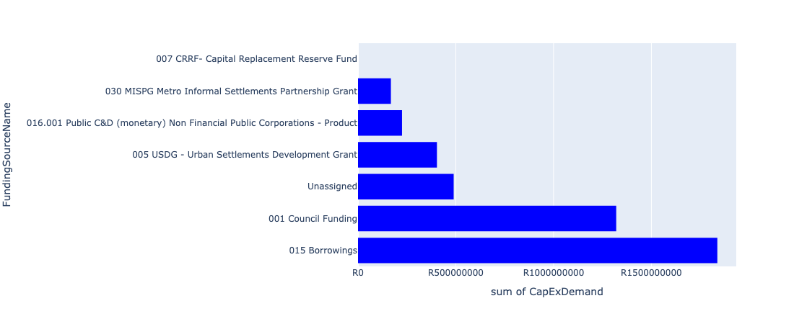

Figure 5.10: Region 5 Departmental Requests

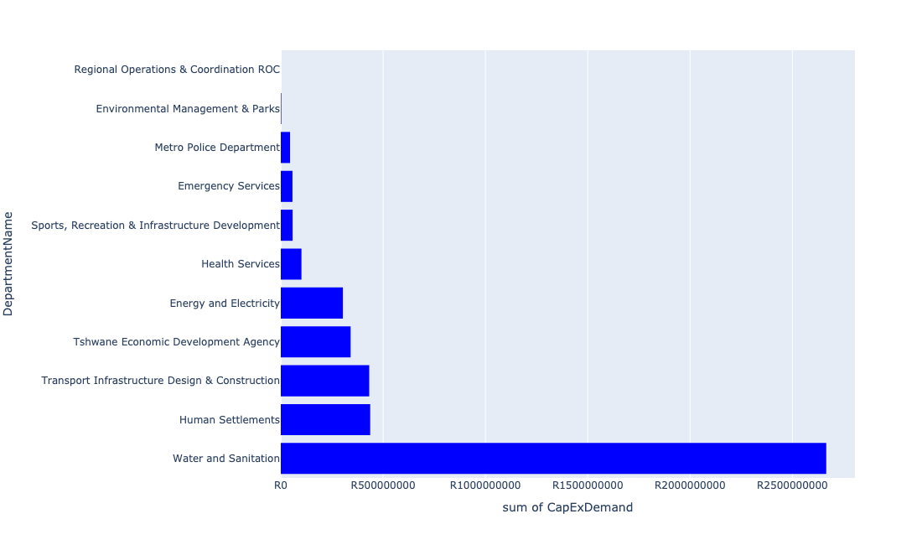

Table 5.5: Summary - Region 5

|  |  |
| --- | --- |
| Item | Description |
| Total Capital Demand for Region 5 - All Years | R4,443,094,852 Rank: 6 (1 = Highest) |
| Total Capital Demand for Region 5 - MTREF | R1,977,741,911 Rank: 6 (1 = Highest) |
| Financial Years in which capital requirements are listed for Region 5 | 2022, 2023, 2024, 2025, 2026, 2027, 2028, 2029, 2030 and 2031 |
| Financial Year with highest capital demand for Region 5 | 2025 |
| Region 5 intersecting feature used | Works Location |
| Total number of projects intersecting with Region 5 | 69 Rank: 6 (1 = Highest) |

Table 5.6: All projects asking for budget in Region 5

|  |  |  |  |
| --- | --- | --- | --- |
| Project ID | Project Name | Department | Project Budget |
| 712969177 | (711213S) Mahube Valley Extension 15 | Energy and Electricity | R0.00 (0%) No budget request. |
| 712974192 | Provisioning of New ranking facility at Eersterus Taxi rank | Transport Infrastructure Design & Construction | R83,405,884 (1.88%) Budget spread across: 2022, 2024, 2025, 2026, 2027, 2028, 2029 and 2030 |
| 712974086 | Proposed Mahube Valley X15 | Human Settlements | R0.00 (0%) No budget request. |
| 712969619 | (713044) Hatherley Cemetery | Environmental Management & Parks | R2,314,286 (0.05%) Budget spread across: 2022, 2023 and 2025 |
| 712974104 | Proposed Mamelodi Ext 11 | Human Settlements | R0.00 (0%) No budget request. |
| 712967295 | (711335ML) Mamelodi R5 feeder main relocation | Water and Sanitation | R1,061,545 (0.02%) Budget spread across: 2023, 2024, 2025 and 2026 |
| 712969439 | (712121D) Moreletaspruit: Outfall sewer | Water and Sanitation | R17,878,273 (0.40%) Budget spread across: 2022, 2023, 2024, 2025 and 2026 |
| 712971915 | Revitalisation of the City-Development of Non-Motorised Transport Masterplan | Transport Infrastructure Design & Construction | R1,725,911 (0.04%) Budget spread across: 2027 |
| 992 | (712518) Flooding backlog: Drainage canals along Hans Strydom Dr, Mamelodi x 4 and 5 | Transport Infrastructure Design & Construction | R5,038,550 (0.11%) Budget spread across: 2022, 2023 and 2024 |
| 712969045 | (712591) Denneboom to RJ - QBS | Integrated Rapid Public Transport Network IRPTN | R0.00 (0%) No budget request. |
| 712975437 | Sub-Project: TMPD Station - Mamelodi (Extension 10) | Metro Police Department | R2,371,272 (0.05%) Budget spread across: 2022, 2023 and 2024 |
| 712970748 | R6 Machinery and Equipment to ensure basic infrastructure reliability | Regional Operations & Coordination ROC | R0 (0.00%) Budget spread across: 2022 and 2023 |
| 712976144 | Acquiring of security protection and monitoring systems_Region 3 | Customer Relations Management | R0.00 (0%) No budget request. |
| 712975391 | (712279) Mamelodi II 132/11kV Substation | Energy and Electricity | R24,850 (0.00%) Budget spread across: 2026 |
| 712967285 | (711335DP) Roodeplaat WTP to Montana Reservoir bulk pipe line | Water and Sanitation | R30,096,550 (0.68%) Budget spread across: 2023, 2024 and 2025 |
| 712975456 | Upgrade of infrastructure of Magalies mountain | Environmental Management & Parks | R299,750 (0.01%) Budget spread across: 2022, 2023, 2024, 2025, 2026, 2027, 2028, 2029, 2030 and 2031 |
| 712969631 | (710864) Refilwe Manor Sewer pump station | Human Settlements | R0.00 (0%) No budget request. |
| 712974384 | (710864) Sewer reticulation - Refilwe X10 | Human Settlements | R38,700,900 (0.87%) Budget spread across: 2022, 2023 and 2024 |
| 712976147 | Acquiring of security protection and monitoring systems_Region 5 | Customer Relations Management | R0.00 (0%) No budget request. |
| 315 | (710164) 11kV Panel Extension In Substations | Energy and Electricity | R60,000,000 (1.35%) Budget spread across: 2022, 2023 and 2024 |
| 712969561 | (712944) Upgrading of roads and stormwater systems in Refilwe | Transport Infrastructure Design & Construction | R135,000,000 (3.04%) Budget spread across: 2022, 2023, 2024, 2025, 2026, 2027, 2028, 2029 and 2030 |
| 712975031 | (712121FR) Future Rayton Bulk Outfall Sewer | Water and Sanitation | R32,500,000 (0.73%) Budget spread across: 2023, 2024, 2025 and 2026 |
| 712969598 | (710863) Refilwe Manor 10ml reservoir | Human Settlements | R5,000,000 (0.11%) Budget spread across: 2022 |
| 712974496 | 1090_03_Zeekoegat WWTP CHP construction | Energy and Electricity | R0.00 (0%) No budget request. |
| 712974381 | (710863) Water provision - Pienaarspoort Extension 20 | Human Settlements | R46,200,000 (1.04%) Budget spread across: 2022 and 2023 |
| 441 | (710411L) Cullinan/ Refilwe WWTW: Effluent Pump Station, pipeline and 2 Ml/d extension | Water and Sanitation | R65,500,000 (1.47%) Budget spread across: 2023, 2024, 2025 and 2026 |
| 712974015 | Roodeplaat Community Library | Sports, Recreation & Infrastructure Development | R0.00 (0%) No budget request. |
| 298 | (710129M) Major Stormwater System, Mamelodi X 8 | Transport Infrastructure Design & Construction | R77,020,000 (1.73%) Budget spread across: 2022, 2023, 2024, 2025, 2026, 2027, 2028, 2029 and 2030 |
| 712975418 | Establishment of Metro Police Office - Region 5 | Metro Police Department | R43,000,000 (0.97%) Budget spread across: 2022, 2023 and 2024 |
| 712976437 | (710026) Replacement Of Worn-Out Water Network Pipes | Water and Sanitation | R0.00 (0%) No budget request. |
| 712973998 | Upgrading of a building into Operational Depot | ROC - Utility Services | R0.00 (0%) No budget request. |
| 453 | (710411R) New Lewzene Waste Water Treatment Works (10Ml/d) | Water and Sanitation | R55,000,000 (1.24%) Budget spread across: 2023, 2024 and 2025 |
| 712974084 | Proposed Pienaarspoort X20 township | Human Settlements | R0.00 (0%) No budget request. |
| 267 | (710026) Replacement Of Worn-Out Water Network Pipes | Water and Sanitation | R1,443,000,000 (32.48%) Budget spread across: 2022, 2023, 2024, 2025, 2026, 2027, 2028, 2029 and 2030 |
| 712967289 | (711335OR) New Kameelfontein Down feeder Main pipeline (Bulk supply from the existing Baviaanspoort Reservoir to the east and north areas of Roodeplaat Dam) | Water and Sanitation | R35,000,000 (0.79%) Budget spread across: 2022, 2023 and 2024 |
| 712974053 | (710868) Expropriation of servitude at Pienaarspoort X21 | Human Settlements | R10,000,000 (0.23%) Budget spread across: 2022 |
| 712973981 | Extension of East Lynne Clinic | Health Services | R64,000,000 (1.44%) Budget spread across: 2025, 2026 and 2027 |
| 712975341 | (712279) Refilwe 132/11kV Substation | Energy and Electricity | R100,000,000 (2.25%) Budget spread across: 2023 and 2024 |
| 239 | (710022) Township Water and Sanitation Services Development: Tshwane Contributions (City Wide) | Water and Sanitation | R525,000,000 (11.82%) Budget spread across: 2022, 2023, 2024, 2025, 2026, 2027, 2028, 2029 and 2030 |
| 712974041 | Tshwane Agro-Processing Hub | Tshwane Economic Development Agency | R341,306,806 (7.68%) Budget spread across: 2022 |
| 1089 | (712684) Refurbishment of Rayton Clinic | Health Services | R0.00 (0%) No budget request. |
| 712974116 | Leeuwfontein 299JR - PTN 126 & 127 | Human Settlements | R0.00 (0%) No budget request. |
| 712976440 | (710026) Replacement Of Worn-Out Water Network Pipes | Water and Sanitation | R0.00 (0%) No budget request. |
| 712967595 | (710865) Construction of roads & stormwater - Refilwe Manor X9 | Human Settlements | R130,000,000 (2.93%) Budget spread across: 2022, 2023 and 2024 |
| 712972962 | (710863) Water provision - Refilwe X7 | Human Settlements | R22,714,802 (0.51%) Budget spread across: 2022, 2023 and 2024 |
| 712975032 | (712121FZ) Future Zeekoegat bulk Outfall sewer (2/6) | Water and Sanitation | R22,500,000 (0.51%) Budget spread across: 2025, 2026 and 2027 |
| 712969195 | (710556) Region 5 (Public Lighting) | Energy and Electricity | R68,000,000 (1.53%) Budget spread across: 2023, 2024, 2025, 2026, 2027, 2028, 2029 and 2030 |
| 712969238 | (713051) Health Posts | Health Services | R37,000,000 (0.83%) Budget spread across: 2024, 2025 and 2026 |
| 712973864 | 1090_06_Zeekoegat waste water treatment plant biogas co-generation | Energy and Electricity | R0.00 (0%) No budget request. |
| 712972960 | (710864) Sewer reticulation - Refilwe X7 | Human Settlements | R20,500,000 (0.46%) Budget spread across: 2022 and 2023 |
| 712974380 | (710863) Water provision - Refilwe ext 10 | Human Settlements | R30,235,473 (0.68%) Budget spread across: 2022, 2023 and 2024 |
| 440 | (710411B) Zeekoegat WWTW Phase 1: Upgrading of existing infrastructure (mechanical) | Water and Sanitation | R62,000,000 (1.40%) Budget spread across: 2022, 2023, 2024 and 2025 |
| 179 | Construction of New Emergency Services Station in Derdepoort | Emergency Services | R57,000,000 (1.28%) Budget spread across: 2028, 2029 and 2030 |
| 712970776 | (710864) Sewer provision - Pienaarspoort X20 | Human Settlements | R66,800,000 (1.50%) Budget spread across: 2022, 2023 and 2024 |
| 712974016 | Refilwe Community Library | Sports, Recreation & Infrastructure Development | R0.00 (0%) No budget request. |
| 185 | Construction of a New Emergency Services Station in Cullinan | Emergency Services | R0.00 (0%) No budget request. |
| 1456 | (712945) Upgrading of roads and stormwater systems in Rayton | Transport Infrastructure Design & Construction | R55,000,000 (1.24%) Budget spread across: 2022, 2023 and 2024 |
| 712973744 | (711921H) Upgrading of Sable Hills Portable WTP | Water and Sanitation | R6,000,000 (0.14%) Budget spread across: 2023 and 2024 |
| 712974085 | Proposed Pienaarspoort X21 township | Human Settlements | R0.00 (0%) No budget request. |
| 712967178 | (712916) Upgrade Refilwe Stadium | Sports, Recreation & Infrastructure Development | R47,700,000 (1.07%) Budget spread across: 2022 and 2023 |
| 712969571 | (712946) Upgrading of roads and stormwater systems in Cullinan - Phase 1 | Transport Infrastructure Design & Construction | R75,000,000 (1.69%) Budget spread across: 2022, 2023, 2025 and 2026 |
| 712974546 | (710411B1) Zeekoegat WWTW: Phase2: De-bottlenecking & tertiary treatment | Water and Sanitation | R363,000,000 (8.17%) Budget spread across: 2023, 2024, 2025 and 2028 |
| 712975445 | Creative Hub and Incubation (Region 5), Ward 100 Refilwe Community Hall. | Sports, Recreation & Infrastructure Development | R10,000,000 (0.23%) Budget spread across: 2026 |
| 712970791 | (712971) Cullinan Marketing and Trading Stalls | Economic Development and Spatial Planning | R0.00 (0%) No budget request. |
| 712975145 | (712121NHS) New Hammanskraal South Outfall Sewer (2/2) | Water and Sanitation | R7,000,000 (0.16%) Budget spread across: 2028, 2029 and 2030 |
| 712969125 | (710178) Electricity for All - Region 5 | Energy and Electricity | R75,400,000 (1.70%) Budget spread across: 2022, 2023, 2024 and 2025 |
| 712976436 | (710026) Replacement Of Worn-Out Water Network Pipes | Water and Sanitation | R0.00 (0%) No budget request. |
| 712970834 | (714022) Upgrading of Rayton Licensing Offices | Licensing Service | R0.00 (0%) No budget request. |
| 712974383 | (710864) Sewer reticulation - Pienaarspoort | Human Settlements | R66,800,000 (1.50%) Budget spread across: 2022 and 2023 |

Please note that the following projects will not be shown in this table:

* Projects with no recorded intersect with Regions (in other words no Works Location was recorded on the system for this project)

Projects that do not have any recorded budget demand on the system at the time that this report was requested, are shown in the table with zero budgets indicated.

## Region 6

Figure 5.11: Region 6 Funding Requests

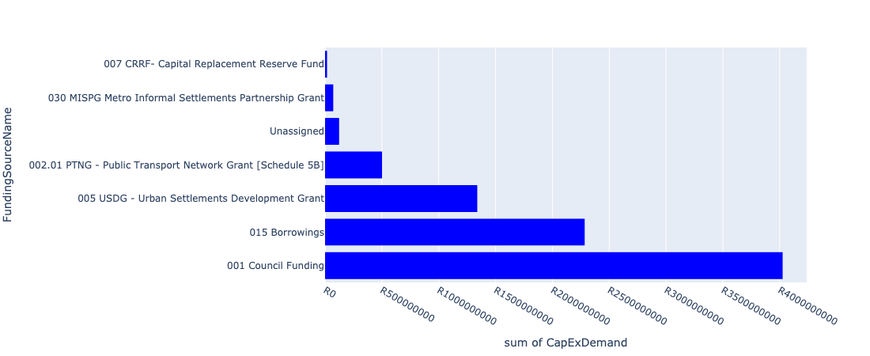

Figure 5.12: Region 6 Departmental Requests

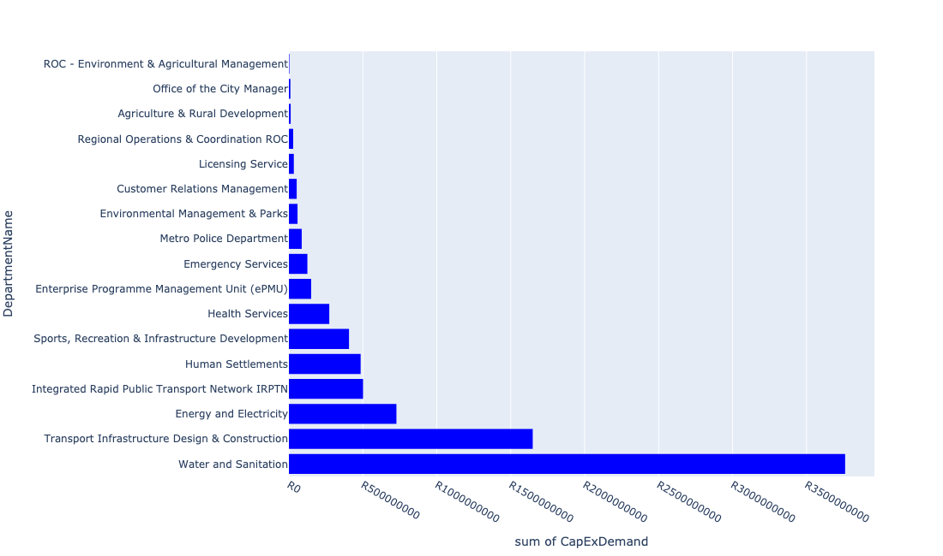

Table 5.6: Summary - Region 6

|  |  |
| --- | --- |
| Item | Description |
| Total Capital Demand for Region 6 - All Years | R8,363,663,392 Rank: 4 (1 = Highest) |
| Total Capital Demand for Region 6 - MTREF | R3,786,499,722 Rank: 3 (1 = Highest) |
| Financial Years in which capital requirements are listed for Region 6 | 2022, 2023, 2024, 2025, 2026, 2027, 2028, 2029, 2030 and 2031 |
| Financial Year with highest capital demand for Region 6 | 2023 |
| Region 6 intersecting feature used | Works Location |
| Total number of projects intersecting with Region 6 | 179 Rank: 2 (1 = Highest) |

Table 5.7: All projects asking for budget in Region 6

|  |  |  |  |
| --- | --- | --- | --- |
| Project ID | Project Name | Department | Project Budget |
| 712973721 | Upgrade of Nelson Mandela Park Tsamaya avenue | Agriculture & Rural Development | R3,000,000 (0.04%) Budget spread across: 2022 |
| 712969628 | (712533) Tsosoloso Programme - Mamelodi West walkways | Transport Infrastructure Design & Construction | R0.00 (0%) No budget request. |
| 712969047 | (712591) Denneboom Intermodal facility | Integrated Rapid Public Transport Network IRPTN | R40,000,000 (0.48%) Budget spread across: 2022 |
| 712969216 | (712591)Taxi Industry Compensation | Integrated Rapid Public Transport Network IRPTN | R0.00 (0%) No budget request. |
| 712974121 | (712279) Wildebees - Elland 132kV Power line | Energy and Electricity | R100,000,000 (1.20%) Budget spread across: 2023 and 2024 |
| 712974387 | (712591) Line 2B: Atterbury Remaining Scope WP3 | Integrated Rapid Public Transport Network IRPTN | R0.00 (0%) No budget request. |
| 712974564 | Upgrading of pits and VTS at Licensing centres | Licensing Service | R7,282,000 (0.09%) Budget spread across: 2022, 2024 and 2025 |
| 712967972 | R6 Biometrics and access system at Mini Mun | Regional Operations & Coordination ROC | R0.00 (0%) No budget request. |
| 1472 | (712956) Upgrading of Garsfontein road | Transport Infrastructure Design & Construction | R281,900,000 (3.37%) Budget spread across: 2022, 2023, 2024, 2025 and 2026 |
| 712967162 | Development of Kleinzonderhout Agricultural Park | Agriculture & Rural Development | R9,000,000 (0.11%) Budget spread across: 2022 and 2023 |
| 712967168 | (710692) Upgrading of HM Pitje Stadium | Sports, Recreation & Infrastructure Development | R180,000,000 (2.15%) Budget spread across: 2025, 2026 and 2027 |
| 712967732 | (712591) Line 2B: Atterbury Rd (btw Lois Avenue Rd to January Masilela Rd) | Integrated Rapid Public Transport Network IRPTN | R0.00 (0%) No budget request. |
| 712969177 | (711213S) Mahube Valley Extension 15 | Energy and Electricity | R0.00 (0%) No budget request. |
| 712974192 | Provisioning of New ranking facility at Eersterus Taxi rank | Transport Infrastructure Design & Construction | R16,594,116 (0.20%) Budget spread across: 2022, 2024, 2025, 2026, 2027, 2028, 2029 and 2030 |
| 712967494 | (712921) Nellmapius Transport Facilities | Transport Infrastructure Design & Construction | R94,000,000 (1.12%) Budget spread across: 2022, 2023, 2024, 2025, 2026, 2027, 2028, 2029 and 2030 |
| 712973743 | (711921Ro) Roodeplaat WTP: Refurbishment and Upgrade of existing plant | Water and Sanitation | R312,000,000 (3.73%) Budget spread across: 2023, 2024, 2025, 2026 and 2027 |
| 712974086 | Proposed Mahube Valley X15 | Human Settlements | R0.00 (0%) No budget request. |
| 712967271 | (712534U) Grootfontein Water Reservoir, tower and pipework | Water and Sanitation | R56,000,000 (0.67%) Budget spread across: 2022, 2023 and 2024 |
| 712974888 | (712591) Line 2C Stations | Integrated Rapid Public Transport Network IRPTN | R26,000,000 (0.31%) Budget spread across: 2022 and 2023 |
| 712970780 | (710863) Mamelodi X11 | Human Settlements | R0 (0.00%) Budget spread across: 2022 |
| 712975592 | Refurbishment of Eersterust customer care centre | Customer Relations Management | R300,000 (0.00%) Budget spread across: 2025 |
| 712975137 | (712121NAB1) New Arbeidsgenot 1 (Northern) Outfall Sewer (1/2) | Water and Sanitation | R6,000,000 (0.07%) Budget spread across: 2028, 2029 and 2030 |
| 712975386 | (712279) Wapadrand 132/11kV Substation | Energy and Electricity | R45,000,000 (0.54%) Budget spread across: 2028 and 2029 |
| 712970769 | (710864) Sewer provision - Pretorius Park | Human Settlements | R30,000,000 (0.36%) Budget spread across: 2022, 2023 and 2024 |
| 712974544 | (710411F2) Baviaanspoort WWTW Phase3: 40Ml/d extension project on new site with link outfall sewer | Water and Sanitation | R660,000,000 (7.89%) Budget spread across: 2024, 2025, 2026, 2027, 2028 and 2029 |
| 712967952 | R6 Ablution and shower facilities at Petroleum Depot | Regional Operations & Coordination ROC | R0.00 (0%) No budget request. |
| 712969057 | (712533) (VPUU) Mamelodi East Multi-purpose (Indoor Sports) Centre | Office of the City Manager | R10,000,000 (0.12%) Budget spread across: 2022 |
| 712975114 | Phahameng Clinic 2nd phase | Health Services | R64,000,000 (0.77%) Budget spread across: 2022, 2023 and 2024 |
| 712974928 | (710863) Water provision - Pretorius Park | Human Settlements | R32,000,000 (0.38%) Budget spread across: 2022, 2023 and 2024 |
| 712967743 | (712591) The Design, Supply, Installation, Operation and Maintenance of an automated fare Collection (AFC) System | Integrated Rapid Public Transport Network IRPTN | R12,007,015 (0.14%) Budget spread across: 2022, 2023, 2024 and 2025 |
| 619 | (711213) Stormwater Drainage Mahube Valley | Transport Infrastructure Design & Construction | R150,000,000 (1.79%) Budget spread across: 2022, 2023, 2024, 2025, 2026, 2027, 2028, 2029 and 2030 |
| 712973843 | R6 Pret Park Parks Depot Upgrades | Regional Operations & Coordination ROC | R0.00 (0%) No budget request. |
| 712967795 | Construction of New Emergency Services Station Rietvlei | Emergency Services | R62,000,000 (0.74%) Budget spread across: 2028, 2029 and 2030 |
| 712975334 | RIMM: STELLENBERG QUARRY: PERIMETER FENCE | Regional Operations & Coordination ROC | R1,000,000 (0.01%) Budget spread across: 2022 |
| 712975005 | Upgrade of infrastructure at Rietvlei Angling area | Environmental Management & Parks | R10,500,000 (0.13%) Budget spread across: 2022 and 2023 |
| 712975546 | Construction of new Alaska and Stoffel Park customer care centre | Customer Relations Management | R10,000,000 (0.12%) Budget spread across: 2027 |
| 712969054 | (712591) Pretorius Park Depot | Integrated Rapid Public Transport Network IRPTN | R0.00 (0%) No budget request. |
| 712974885 | (712591) Menlyn Taxi Interchange (Gobie) | Integrated Rapid Public Transport Network IRPTN | R43,075,415 (0.52%) Budget spread across: 2022 and 2023 |
| 1074 | (712612) Upgrading of Sibande Street, Mamelodi | Transport Infrastructure Design & Construction | R147,000,000 (1.76%) Budget spread across: 2022, 2023, 2024, 2025, 2026, 2027, 2028, 2029 and 2030 |
| 712975148 | (71212MOK) Mooikloof Bulk Outfall and connection to Moreleta system | Water and Sanitation | R71,500,000 (0.85%) Budget spread across: 2023, 2024, 2025 and 2026 |
| 447 | (710411F) Baviaanspoort WWTW Phase1: Upgrading of existing infrastructure | Water and Sanitation | R0.00 (0%) No budget request. |
| 712975440 | Sub-Project: TMPD Station - Pretorius Park | Metro Police Department | R13,000,000 (0.16%) Budget spread across: 2024 and 2025 |
| 712974109 | (710864) Sewer provision - Nellmapius X22 -stand 12223 & 12224 | Human Settlements | R23,000,000 (0.27%) Budget spread across: 2022 and 2023 |
| 712967766 | 712969116_17_(712970T) Mamelodi Ext 11 - Sewerage network line | Water and Sanitation | R63,000,000 (0.75%) Budget spread across: 2023, 2024 and 2025 |
| 712974468 | Enlargement of bridges and spruit channel improvements of the Zwavelpoort Spruit, Zwavelkloof Estate | Transport Infrastructure Design & Construction | R51,200,000 (0.61%) Budget spread across: 2025, 2026 and 2027 |
| 712969058 | (712533) (VPUU) Construction of Skills Centre Mamelodi East | Transport Infrastructure Design & Construction | R0.00 (0%) No budget request. |
| 712973835 | R6 Upgrading of Cemetery Entrances and security | Regional Operations & Coordination ROC | R0.00 (0%) No budget request. |
| 712975767 | (712900) Upgrading of existing Academic Training facilities (Mamelodi) | Metro Police Department | R20,000,000 (0.24%) Budget spread across: 2022, 2023 and 2024 |
| 712972948 | (712591) Menlyn Pedestrian Overpass | Integrated Rapid Public Transport Network IRPTN | R0.00 (0%) No budget request. |
| 712974522 | Upgrading of Solomon Mahlangu Drive | Transport Infrastructure Design & Construction | R3,411,399 (0.04%) Budget spread across: 2022 |
| 712973844 | R6 Construction of access Roads at Regional Facilities | Regional Operations & Coordination ROC | R0.00 (0%) No budget request. |
| 712967744 | (712591) Design, Supply, Installation, Commissioning and Operational Support Of Advanced Public Transport Management System (APTMS) | Integrated Rapid Public Transport Network IRPTN | R1,375,539 (0.02%) Budget spread across: 2022 |
| 712969619 | (713044) Hatherley Cemetery | Environmental Management & Parks | R5,785,714 (0.07%) Budget spread across: 2022, 2023 and 2025 |
| 712975455 | Upgrade infrastructure at Moreletakloof Nature Reserve | Environmental Management & Parks | R3,000,000 (0.04%) Budget spread across: 2023 and 2024 |
| 891 | (712223) Mamelodi Extension 2: Area 3 | Transport Infrastructure Design & Construction | R128,000,000 (1.53%) Budget spread across: 2023, 2024, 2025, 2026, 2027, 2028, 2029 and 2030 |
| 712969049 | (712591) Menlyn Park and Ride | Integrated Rapid Public Transport Network IRPTN | R0.00 (0%) No budget request. |
| 712975100 | (711335Co) Feeder main replacement Constantia Reservoir | Water and Sanitation | R19,500,000 (0.23%) Budget spread across: 2028, 2029 and 2030 |
| 712974104 | Proposed Mamelodi Ext 11 | Human Settlements | R0.00 (0%) No budget request. |
| 712970801 | (712970) Mahube Valley Ext 15 - Water Provision | Water and Sanitation | R133,500,000 (1.60%) Budget spread across: 2022, 2023, 2024, 2025 and 2026 |
| 712969547 | (712223) Mamelodi Extension 4: Area 1 | Transport Infrastructure Design & Construction | R135,000,000 (1.61%) Budget spread across: 2022, 2023, 2024, 2025, 2026, 2027, 2028 and 2030 |
| 712975378 | Upgrading of Waltloo Testing Centre | Licensing Service | R26,000,000 (0.31%) Budget spread across: 2022, 2023, 2024, 2028 and 2031 |
| 712970764 | (710863) Water Provision - Mamelodi X6 erf 34041 (Phomolong) | Human Settlements | R29,166,470 (0.35%) Budget spread across: 2022, 2023 and 2024 |
| 1026 | (712534D) Mooikloof Reservoir and Bulk pipeline | Water and Sanitation | R75,000,000 (0.90%) Budget spread across: 2022, 2023, 2024 and 2025 |
| 712975590 | Refurbishment of Mamelodi customer care centre | Customer Relations Management | R333,333 (0.00%) Budget spread across: 2025 |
| 712967953 | R6 Ablution toilets facilities at Heatherly Cemetery | Regional Operations & Coordination ROC | R0.00 (0%) No budget request. |
| 712975435 | Sub-Project: TMPD Station - Nellmapius (Extension 3) | Metro Police Department | R13,000,000 (0.16%) Budget spread across: 2023 and 2024 |
| 712975876 | (710863) Water reticulation - Portion 1 of erf 14582 Mamelodi (Elephants Community) | Human Settlements | R0.00 (0%) No budget request. |
| 712975541 | construction of Garsfontein customer care centre | Customer Relations Management | R20,000,000 (0.24%) Budget spread across: 2031 |
| 712967967 | R6 Installation of bio metrics systems at SRAC and Parks Offices | Regional Operations & Coordination ROC | R6,700,000 (0.08%) Budget spread across: 2022 |
| 712974153 | (712279) Wildebees 400/132kV, 315MVA Infeed station | Energy and Electricity | R165,000,000 (1.97%) Budget spread across: 2022, 2023 and 2024 |
| 712967269 | (712534) New Parkmore LL Reservoir and HL Reservoir | Water and Sanitation | R65,000,000 (0.78%) Budget spread across: 2022 and 2023 |
| 712967735 | (712591) BRT Line 2C - Watloo Rd (btw Simon Vermooten & Denneboom Station) | Integrated Rapid Public Transport Network IRPTN | R0.00 (0%) No budget request. |
| 712976108 | Construction of major stormwater Network in Mamelodi x6 | Transport Infrastructure Design & Construction | R0.00 (0%) No budget request. |
| 712973878 | R6 OHS Required Upgrades to Pretorius Park Electricity Depot | Regional Operations & Coordination ROC | R0.00 (0%) No budget request. |
| 712973941 | (714026) Revamp of Nellmapius customer care centre | Customer Relations Management | R7,000,000 (0.08%) Budget spread across: 2022 and 2023 |
| 712976148 | Acquiring of security protection and monitoring systems_Region 6 | Customer Relations Management | R0.00 (0%) No budget request. |
| 1003 | (712521) Collector Road Backlogs: Mamelodi | Transport Infrastructure Design & Construction | R1,700,000 (0.02%) Budget spread across: 2022, 2023, 2024 and 2025 |
| 712974087 | (712121SL) Silver Lakes outfall sewer upgrade | Water and Sanitation | R66,000,000 (0.79%) Budget spread across: 2022, 2023, 2024, 2025 and 2026 |
| 712975066 | Upgrade of PTA East Cemetery | Environmental Management & Parks | R3,200,000 (0.04%) Budget spread across: 2025 and 2026 |
| 712974525 | Upgrading of Lynnwood Road | Transport Infrastructure Design & Construction | R42,000,000 (0.50%) Budget spread across: 2023 and 2024 |
| 712974187 | Providing new Inter modal Public Transport Facility at Green View (including access to the facility) | Transport Infrastructure Design & Construction | R100,000,000 (1.20%) Budget spread across: 2022, 2023, 2024, 2025, 2026, 2027, 2028, 2029 and 2030 |
| 712967641 | (711713) Development of Mamelodi hostels | Human Settlements | R75,000,000 (0.90%) Budget spread across: 2022 and 2023 |
| 712971920 | Revitalisation of the City-Doubling of Petroleum Street | Transport Infrastructure Design & Construction | R31,000,000 (0.37%) Budget spread across: 2023 and 2024 |
| 712973984 | Replacement of Mamelodi West Clinic | Health Services | R94,000,000 (1.12%) Budget spread across: 2022, 2029, 2030 and 2031 |
| 712967701 | (710178) Electricity for All - Region 6 | Energy and Electricity | R81,600,000 (0.98%) Budget spread across: 2022, 2023, 2024 and 2025 |
| 712975779 | (710865) Construction of roads & stormwater at Pretorius Park X20 | Human Settlements | R84,092,455 (1.01%) Budget spread across: 2022 and 2023 |
| 712975103 | Upgrade of infrastructure at Rietvlei Nature Reserve | Environmental Management & Parks | R28,200,000 (0.34%) Budget spread across: 2022, 2023, 2024, 2025, 2026, 2027, 2028 and 2029 |
| 712967466 | (712533) (VPUU) Mamelodi East Walkways | Transport Infrastructure Design & Construction | R0.00 (0%) No budget request. |
| 712967956 | R6 Generator for server room at Waltloo Depot | Regional Operations & Coordination ROC | R0.00 (0%) No budget request. |
| 712975089 | (710411Rit) 35 Ml/day Portion of Proposed Rietvlei WWTW | Water and Sanitation | R105,000,000 (1.26%) Budget spread across: 2029 and 2030 |
| 712969046 | (712591) NMT Line 2B (Hatfield to Menlyn) | Integrated Rapid Public Transport Network IRPTN | R717,250 (0.01%) Budget spread across: 2022 |
| 712974897 | Nellmapius Ext 26 (Covid-19) Acquisition of Land | Human Settlements | R10,000,000 (0.12%) Budget spread across: 2022 |
| 712975347 | (712279) Mamelodi Switching Station | Energy and Electricity | R70,000,000 (0.84%) Budget spread across: 2023, 2024 and 2025 |
| 712967951 | Waste Management Block Office Block | ROC - Environment & Agricultural Management | R3,400,000 (0.04%) Budget spread across: 2022 |
| 712975230 | Provisioning of new taxi holding facility for the Wingate area. | Transport Infrastructure Design & Construction | R95,000,000 (1.14%) Budget spread across: 2022, 2023, 2024, 2025, 2026, 2027, 2028, 2029 and 2030 |
| 712975098 | (711335Gar) Replace and upgrade Garsfontein bulk pipe in Lynwood road | Water and Sanitation | R8,000,000 (0.10%) Budget spread across: 2026, 2027 and 2028 |
| 712967295 | (711335ML) Mamelodi R5 feeder main relocation | Water and Sanitation | R48,938,455 (0.59%) Budget spread across: 2023, 2024, 2025 and 2026 |
| 712975121 | (712534Do) Donkerhoek LL Res (Phase 2) | Water and Sanitation | R55,000,000 (0.66%) Budget spread across: 2029 and 2030 |
| 712974929 | (710864) Sewer provision - Nellmapius Willows Mega Project | Human Settlements | R50,000,000 (0.60%) Budget spread across: 2022, 2023 and 2024 |
| 712976043 | Upgrade of infrastructure at Faerie Glen Nature Reserve | Environmental Management & Parks | R0.00 (0%) No budget request. |
| 712969053 | (712591) Denneboom Depot | Integrated Rapid Public Transport Network IRPTN | R70,000,000 (0.84%) Budget spread across: 2022 and 2023 |
| 712974108 | Mamelodi X6 stand 34041 | Human Settlements | R0.00 (0%) No budget request. |
| 712975233 | Development of Rietvlei conference Facility and Office park | Environmental Management & Parks | R552,617 (0.01%) Budget spread across: 2022, 2023, 2024 and 2025 |
| 712969439 | (712121D) Moreletaspruit: Outfall sewer | Water and Sanitation | R60,121,727 (0.72%) Budget spread across: 2022, 2023, 2024, 2025 and 2026 |
| 712967687 | (712279) Hatherley 132/11KV substation | Energy and Electricity | R0.00 (0%) No budget request. |
| 712973830 | Build additional study hall at Glenstantia Library | Sports, Recreation & Infrastructure Development | R15,000,000 (0.18%) Budget spread across: 2029 |
| 712967733 | (712591) BRT Line 2C-January Masilela (btw Atterbury & Lynnwood Rd) | Integrated Rapid Public Transport Network IRPTN | R90,000,000 (1.08%) Budget spread across: 2022 and 2023 |
| 712967192 | (713049) New Clinic Lusaka | Health Services | R46,000,000 (0.55%) Budget spread across: 2022 and 2023 |
| 712975304 | Upgrade of Security and visitor infrastructure in Moretele resort | Environmental Management & Parks | R3,500,000 (0.04%) Budget spread across: 2022 and 2023 |
| 712975519 | Upgrade of Lion Camp at Rietvlei Nature Reserve | Environmental Management & Parks | R300,000 (0.00%) Budget spread across: 2022 |
| 712973836 | R6 Installation of Electric and Security Fencing at Regional Facilities / Depots | Regional Operations & Coordination ROC | R10,000,000 (0.12%) Budget spread across: 2022 and 2023 |
| 712968961 | Upgrade of MV and LV in Waterkloof | ROC - Utility Services | R0.00 (0%) No budget request. |
| 712971915 | Revitalisation of the City-Development of Non-Motorised Transport Masterplan | Transport Infrastructure Design & Construction | R954,794 (0.01%) Budget spread across: 2027 |
| 712975018 | Provisioning of new taxi holding facility for the Menlyn area | Transport Infrastructure Design & Construction | R74,000,000 (0.88%) Budget spread across: 2022, 2023, 2024, 2025, 2026, 2027, 2028, 2029 and 2031 |
| 712967793 | (713052) Construction of Emergency Services Station Mamelodi 1 | Emergency Services | R1,000,000 (0.01%) Budget spread across: 2022 |
| 712969522 | (712533) (VPUU) Mamelodi East Recreational Park | Office of the City Manager | R0.00 (0%) No budget request. |
| 712975101 | (711335GL) Extension of existing pipe to Zwartkoppies Reservoir +Res (Phase 1) | Water and Sanitation | R36,000,000 (0.43%) Budget spread across: 2023, 2024, 2025 and 2026 |
| 712975473 | Provisioning of new taxi ranking facility at Erasmus | Transport Infrastructure Design & Construction | R64,000,000 (0.77%) Budget spread across: 2022, 2023, 2024, 2025, 2026, 2027, 2028, 2029 and 2030 |
| 712969548 | (712223) Mamelodi Extension 2: Area 2 | Transport Infrastructure Design & Construction | R25,000,000 (0.30%) Budget spread across: 2022 and 2023 |
| 712974168 | Upgrading of Major Stormwater Drainage System in Lipizzaner Road, Tijger Valley | Transport Infrastructure Design & Construction | R8,000,000 (0.10%) Budget spread across: 2025, 2026 and 2027 |
| 992 | (712518) Flooding backlog: Drainage canals along Hans Strydom Dr, Mamelodi x 4 and 5 | Transport Infrastructure Design & Construction | R22,961,450 (0.27%) Budget spread across: 2022, 2023 and 2024 |
| 712975138 | (712121NAB2) New Arbeidsgenot 1 (Northern) Outfall Sewer (2/2) | Water and Sanitation | R18,000,000 (0.22%) Budget spread across: 2027, 2028, 2029 and 2030 |
| 712974901 | Mamelodi Hostels (TRUS) | Human Settlements | R61,000,000 (0.73%) Budget spread across: 2022 |
| 712975542 | Construction of Pretorius park customer care centre | Customer Relations Management | R15,000,000 (0.18%) Budget spread across: 2030 |
| 712975095 | (710411Y_O) Olympus booster Pump station and pipework | Water and Sanitation | R12,000,000 (0.14%) Budget spread across: 2025 and 2026 |
| 712974846 | (714048) Tshwane Automotive SEZ Phase 1 Bulk Infrastructure Roll out | Enterprise Programme Management Unit (ePMU) | R150,489,324 (1.80%) Budget spread across: 2022 |
| 712975877 | (710864) Sewer reticulation - Portion 1 of erf 14582 Mamelodi (Elephants Community) | Human Settlements | R0.00 (0%) No budget request. |
| 712974541 | (710411F1) Baviaanspoort WWTW Phase 2: 20Ml/d extension using alternative technologies, new sludge infrastructure & tertiary treatment | Water and Sanitation | R1,030,000,000 (12.32%) Budget spread across: 2022, 2023, 2024, 2025, 2026, 2027, 2028 and 2029 |
| 712974209 | Refurbishment of Stanza Bopape customer care centre | Customer Relations Management | R0.00 (0%) No budget request. |
| 712973877 | R6 Construction of Carports at Regional Libraries | Regional Operations & Coordination ROC | R0.00 (0%) No budget request. |
| 712967141 | (714011) Lusaka Library | Sports, Recreation & Infrastructure Development | R27,413,800 (0.33%) Budget spread across: 2022 and 2023 |
| 712967734 | (712591) BRT Line 2C-Lynnwood Rd (btw January Masilela & Simon Vermooten) | Integrated Rapid Public Transport Network IRPTN | R90,000,000 (1.08%) Budget spread across: 2022 and 2023 |
| 712970774 | (710864) Mamelodi X11 | Human Settlements | R15,000,000 (0.18%) Budget spread across: 2022 |
| 712974071 | Pretorius Park X40 | Human Settlements | R0.00 (0%) No budget request. |
| 712967147 | (711439) Solomon Mahlangu freedom square | Sports, Recreation & Infrastructure Development | R60,000,000 (0.72%) Budget spread across: 2025 and 2026 |
| 712974927 | (710863) Water Provision - Nellmapius Willows Mega Project | Human Settlements | R40,320,169 (0.48%) Budget spread across: 2022, 2023 and 2024 |
| 712969603 | Mahube Valley Interchange | Integrated Rapid Public Transport Network IRPTN | R0.00 (0%) No budget request. |
| 712975119 | (712534) New 20ML La-Montagne Reservoir | Water and Sanitation | R79,000,000 (0.94%) Budget spread across: 2023, 2024, 2025, 2026 and 2027 |
| 712967293 | (711335GL) Replace feeder main from Garsfontein to Parkmore HL Reservoir | Water and Sanitation | R50,000,000 (0.60%) Budget spread across: 2023, 2024, 2025 and 2026 |
| 910 | (712278) Phahameng Clinic Dispensaries | Health Services | R0.00 (0%) No budget request. |
| 712976450 | (711921Ro) Roodeplaat WTP Extension by 30Ml/d | Water and Sanitation | R0.00 (0%) No budget request. |
| 712967794 | Construction of New Emergency Services Station Shere / The Willows | Emergency Services | R62,000,000 (0.74%) Budget spread across: 2025, 2026 and 2027 |
| 712969194 | (710556) Region 6 (Public Lighting) | Energy and Electricity | R192,500,000 (2.30%) Budget spread across: 2022, 2023, 2024, 2025, 2026, 2027, 2028, 2029 and 2030 |
| 712973702 | Nellmapius Clinic Dispensaries | Health Services | R27,000,000 (0.32%) Budget spread across: 2024, 2025 and 2026 |
| 712967608 | (710864) Sewer provision - Garsfontein | Human Settlements | R0.00 (0%) No budget request. |
| 712974884 | (712591) Menlyn Taxi Interchange (Dallas) | Integrated Rapid Public Transport Network IRPTN | R68,925,200 (0.82%) Budget spread across: 2022 |
| 712974392 | (710864) Sewer reticulation - Mamelodi X6 erf 34041 (Phomolong) | Human Settlements | R35,481,502 (0.42%) Budget spread across: 2022, 2023 and 2024 |
| 712974343 | (711921R) Rietvlei Water Purification Plant Refurbishment | Water and Sanitation | R50,000,000 (0.60%) Budget spread across: 2022, 2023 and 2024 |
| 712967124 | (712941) Greening of Sports fields | Sports, Recreation & Infrastructure Development | R74,000,023 (0.88%) Budget spread across: 2022, 2023, 2024, 2025, 2026, 2027, 2028, 2029, 2030 and 2031 |
| 712969045 | (712591) Denneboom to RJ - QBS | Integrated Rapid Public Transport Network IRPTN | R0.00 (0%) No budget request. |
| 712967957 | R6 Fencing at Region 6 Cemeteries | Regional Operations & Coordination ROC | R0.00 (0%) No budget request. |
| 712975090 | (710411Y_R) Rietvlei PS and Rising system | Water and Sanitation | R31,000,000 (0.37%) Budget spread across: 2027, 2028 and 2029 |
| 712972932 | (710864) Sewer provision - Garsfontein - Bulk | Human Settlements | R0.00 (0%) No budget request. |
| 712974549 | (712121G) Zwavelpoort Outfall Sewer Pipeline – Phase1 | Water and Sanitation | R160,000,000 (1.91%) Budget spread across: 2022, 2023, 2024, 2025 and 2026 |
| 712975437 | Sub-Project: TMPD Station - Mamelodi (Extension 10) | Metro Police Department | R40,628,728 (0.49%) Budget spread across: 2022, 2023 and 2024 |
| 246 | (710023) Lengthening Of Network & Supply Pipelines | Water and Sanitation | R273,500,000 (3.27%) Budget spread across: 2022, 2023, 2024, 2025, 2026, 2027, 2028, 2029 and 2030 |
| 712967765 | (712970) Mamelodi Ext 11 water (Bulk and reticulation) and sanitation services | Water and Sanitation | R153,000,000 (1.83%) Budget spread across: 2022, 2023, 2024, 2025 and 2026 |
| 712975388 | (712279) TASEZ 132/11kV Substation | Energy and Electricity | R53,000,000 (0.63%) Budget spread across: 2023, 2025 and 2026 |
| 712974114 | Proposed Potion 25 & 26 of Pienaarspoort | Human Settlements | R0.00 (0%) No budget request. |
| 712970748 | R6 Machinery and Equipment to ensure basic infrastructure reliability | Regional Operations & Coordination ROC | R2,400,000 (0.03%) Budget spread across: 2022 and 2023 |
| 712967831 | (713069) Lusaka multi-purpose sport facility | Sports, Recreation & Infrastructure Development | R50,000,000 (0.60%) Budget spread across: 2022 and 2023 |
| 712967731 | (712591) Line 2B: Atterbury Rd (btw Lynnwood Rd to Lois Avenue) | Integrated Rapid Public Transport Network IRPTN | R45,309,747 (0.54%) Budget spread across: 2022, 2023, 2024 and 2025 |
| 712969397 | (712591) Menlyn Taxi Interchange | Integrated Rapid Public Transport Network IRPTN | R0.00 (0%) No budget request. |
| 712967645 | New Silverton Clinic | Health Services | R42,000,000 (0.50%) Budget spread across: 2022, 2023 and 2024 |
| 712973845 | R6 Regional Building Electrical Equipment / Aircon, Fire detection/systems installation (energy efficient) | Regional Operations & Coordination ROC | R4,000,000 (0.05%) Budget spread across: 2022 and 2023 |
| 712974283 | Spruit channel improvements and rehabilitation of the Tweefontein Spruit in Boardwalk Meander | Transport Infrastructure Design & Construction | R7,000,000 (0.08%) Budget spread across: 2026 and 2027 |
| 712973842 | (714028) R6 Security Cameras / Alarms Systems at Regional Facilities | Regional Operations & Coordination ROC | R5,000,000 (0.06%) Budget spread across: 2022 and 2023 |
| 712976144 | Acquiring of security protection and monitoring systems_Region 3 | Customer Relations Management | R0.00 (0%) No budget request. |
| 712969099 | 712969116_05_(712970) Kameeldrift 174 & 175 - Bulk Supply Pipeline to 1000 Housing Units - Water Provision | Water and Sanitation | R64,000,000 (0.77%) Budget spread across: 2022, 2023, 2024 and 2025 |
| 712969546 | (712223) Mamelodi Extension 5: Area 1 | Transport Infrastructure Design & Construction | R170,000,000 (2.03%) Budget spread across: 2023, 2024, 2025, 2026, 2027, 2028, 2029 and 2030 |
| 712967625 | (710863) Water provision - Garsfontein | Human Settlements | R0 (0.00%) Budget spread across: 2022 and 2023 |
| 712967133 | (712736) Fencing off Nature areas City Wide (Ecological Sensitive Purposes) | Environmental Management & Parks | R2,000,000 (0.02%) Budget spread across: 2022 and 2023 |
| 712974930 | Mamelodi flood victims TRU's | Human Settlements | R0.00 (0%) No budget request. |
| 712974887 | (712591) Line 2B Stations | Integrated Rapid Public Transport Network IRPTN | R14,000,000 (0.17%) Budget spread across: 2022 and 2023 |
| 712969056 | (712533) (VPUU) Mamelodi East Violence Prevention through Urban Upgrade community centre | Office of the City Manager | R0.00 (0%) No budget request. |
| 712967954 | Generators for Main Customer centres | Regional Operations & Coordination ROC | R0.00 (0%) No budget request. |
| 712967127 | (713040) Furniture and Equipment for offices, overnight accommodation and facilities within resorts | Environmental Management & Parks | R1,350,000 (0.02%) Budget spread across: 2022 and 2024 |
| 712975391 | (712279) Mamelodi II 132/11kV Substation | Energy and Electricity | R19,975,150 (0.24%) Budget spread across: 2026 |
| 712975832 | (710163) Refurbishment of Mooikloof Substation | Energy and Electricity | R0.00 (0%) No budget request. |

Please note that the following projects will not be shown in this table:

* Projects with no recorded intersect with Regions (in other words no Works Location was recorded on the system for this project)

Projects that do not have any recorded budget demand on the system at the time that this report was requested, are shown in the table with zero budgets indicated.

## Region 7

Figure 5.13: Region 7 Funding Requests

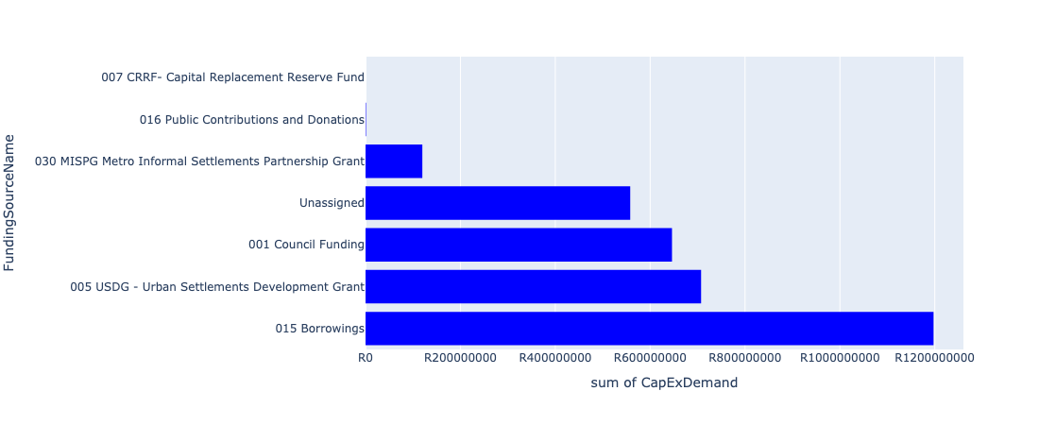

Figure 5.14: Region 7 Departmental Requests

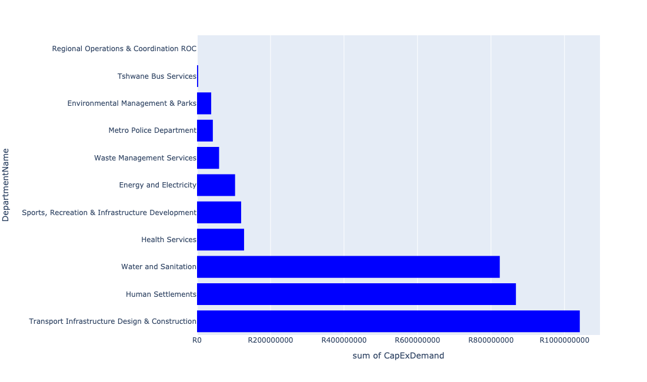

Table 5.7: Summary - Region 7

|  |  |
| --- | --- |
| Item | Description |
| Total Capital Demand for Region 7 - All Years | R3,229,416,794 Rank: 7 (1 = Highest) |
| Total Capital Demand for Region 7 - MTREF | R1,724,688,320 Rank: 7 (1 = Highest) |
| Financial Years in which capital requirements are listed for Region 7 | 2022, 2023, 2024, 2025, 2026, 2027, 2028, 2029, 2030 and 2031 |
| Financial Year with highest capital demand for Region 7 | 2025 |
| Region 7 intersecting feature used | Works Location |
| Total number of projects intersecting with Region 7 | 48 Rank: 7 (1 = Highest) |

Table 5.8: All projects asking for budget in Region 7

|  |  |  |  |
| --- | --- | --- | --- |
| Project ID | Project Name | Department | Project Budget |
| 712971915 | Revitalisation of the City-Development of Non-Motorised Transport Masterplan | Transport Infrastructure Design & Construction | R660,713 (0.02%) Budget spread across: 2027 |
| 712970748 | R6 Machinery and Equipment to ensure basic infrastructure reliability | Regional Operations & Coordination ROC | R0 (0.00%) Budget spread across: 2022 and 2023 |
| 712967177 | (712883) Upgrading of Zithobeni Sport Stadium | Sports, Recreation & Infrastructure Development | R20,000,000 (0.62%) Budget spread across: 2023 |
| 712967270 | (711921E) Bronkhorstbaai: Refurbishment and upgrade of Water Purification Plant | Water and Sanitation | R91,000,000 (2.82%) Budget spread across: 2022 and 2023 |
| 712967348 | (710865) Construction of roads & stormwater - Zithobeni Hostel | Human Settlements | R0.00 (0%) No budget request. |
| 712967634 | (710863) Water provision - Zithobeni Heights X13 | Human Settlements | R100,000,000 (3.10%) Budget spread across: 2022 and 2023 |
| 712967600 | (710865) Construction of roads & stormwater - Zithobeni Heights | Human Settlements | R377,590,000 (11.69%) Budget spread across: 2022, 2023 and 2024 |
| 712969123 | (710178) Electricity for All - Region 7 | Energy and Electricity | R57,000,000 (1.77%) Budget spread across: 2024 and 2025 |
| 712974075 | Zithobeni Heights X13 | Human Settlements | R0.00 (0%) No budget request. |
| 712970852 | (712947) Improvement of dirt road leading to Clover hill club, Bronkhorstspruit dam | Transport Infrastructure Design & Construction | R195,000,000 (6.04%) Budget spread across: 2022, 2023, 2024, 2025, 2026, 2027, 2028, 2029 and 2030 |
| 712967136 | (712917) Upgrade Ekangala stadium | Sports, Recreation & Infrastructure Development | R60,000,000 (1.86%) Budget spread across: 2023 and 2024 |
| 712975792 | (714069) Upgrading of Bronkhorstspruit Library- roof structure | Sports, Recreation & Infrastructure Development | R0.00 (0%) No budget request. |
| 712974527 | Upgrading of road from gravel to tar in Rethabiseng | Transport Infrastructure Design & Construction | R67,000,000 (2.07%) Budget spread across: 2022, 2023, 2024, 2025, 2026, 2027, 2028, 2029 and 2030 |
| 712970792 | (712902) Bronkhorstspruit Informal Traders Market | Economic Development and Spatial Planning | R0.00 (0%) No budget request. |
| 712969618 | (713043) Development of waste transfer stations | Waste Management Services | R60,000,000 (1.86%) Budget spread across: 2022, 2023, 2024 and 2025 |
| 712967623 | (710863) Water provision - Zithobeni X8 | Human Settlements | R10,000,000 (0.31%) Budget spread across: 2022 and 2023 |
| 712975232 | Development of Visitor and security infrastructure at Bronkhorstspruit dam angling area | Environmental Management & Parks | R34,999,999 (1.08%) Budget spread across: 2022, 2023, 2024 and 2025 |
| 712975272 | Erf 4113 Zithobeni Park | Environmental Management & Parks | R0.00 (0%) No budget request. |
| 712974345 | (710411K) Ekangala WWTW: Upgrade of existing infrastructure | Water and Sanitation | R50,000,000 (1.55%) Budget spread across: 2022 and 2023 |
| 7 | Establishment of Metro Police Office - Region 7 | Metro Police Department | R43,000,000 (1.33%) Budget spread across: 2023, 2024 and 2025 |
| 712967618 | (710864) Sewer provision - Zithobeni X8 | Human Settlements | R7,145,436 (0.22%) Budget spread across: 2022 |
| 712967850 | (711921F) Bronkhorstspruit Water Purification Plant Refurbishment | Water and Sanitation | R10,000,000 (0.31%) Budget spread across: 2022 |
| 712967635 | (710863) Water provision - Zithobeni Heights Phase 1 | Human Settlements | R15,000,000 (0.46%) Budget spread across: 2022 and 2023 |
| 712969075 | (712279) Bronkhorstspruit 132/11kv substation | Energy and Electricity | R15,000,000 (0.46%) Budget spread across: 2022 |
| 712967601 | (710865) Construction of roads & stormwater - Zithobeni X8&9 | Human Settlements | R302,320,646 (9.36%) Budget spread across: 2022, 2023, 2024, 2025 and 2026 |
| 712976114 | Provisioning of new taxi holding facility for Ekangala area | Transport Infrastructure Design & Construction | R0.00 (0%) No budget request. |
| 712968983 | Zithobeni Satellite Substation Yard | ROC - Utility Services | R0.00 (0%) No budget request. |
| 712967174 | New Bronkhorstspruit Clinic | Health Services | R64,000,000 (1.98%) Budget spread across: 2024, 2025 and 2026 |
| 712974797 | Zithobeni 8 pump station | Human Settlements | R800,000 (0.02%) Budget spread across: 2022 |
| 712968995 | Switching & Testing Equipment (2) | ROC - Utility Services | R0.00 (0%) No budget request. |
| 1307 | (712893) Upgrading of Road from gravel to tar in Zithobeni Ward 102 | Transport Infrastructure Design & Construction | R185,000,000 (5.73%) Budget spread across: 2022, 2023, 2024, 2025, 2026, 2027, 2028, 2029 and 2030 |
| 712976149 | Acquiring of security protection and monitoring systems_Region 7 | Customer Relations Management | R0.00 (0%) No budget request. |
| 712975004 | Security and visitor infrastructure Upgrade at Die Draai Resort Region 7 | Environmental Management & Parks | R2,000,000 (0.06%) Budget spread across: 2022 |
| 712975482 | Rehabilitation of Wetlands - Bronkhorstspruit Town Wetland | Environmental Management & Parks | R1,500,000 (0.05%) Budget spread across: 2022, 2023, 2024 and 2025 |
| 712975439 | Creative Hub and Incubator ( Region 7) | Sports, Recreation & Infrastructure Development | R10,000,000 (0.31%) Budget spread across: 2027 |
| 712970842 | (712894) Upgrading of Road from gravel to tar in Ekangala (Ward 103 and 104) | Transport Infrastructure Design & Construction | R370,000,000 (11.46%) Budget spread across: 2022, 2023, 2024, 2025, 2026, 2027, 2028, 2029 and 2030 |
| 712975227 | Bronkhorstspruit Public Transport Facility (Investigate an ideal location and provide for a new taxi rank at Bronkhorstspruit) | Transport Infrastructure Design & Construction | R99,000,000 (3.07%) Budget spread across: 2022, 2023, 2024, 2025, 2026, 2027, 2028, 2029 and 2030 |
| 712967138 | Ekangala community library | Sports, Recreation & Infrastructure Development | R30,000,000 (0.93%) Budget spread across: 2024 and 2025 |
| 712967633 | (710863) Zithobeni X8&9 - Bulk water main line | Human Settlements | R50,000,000 (1.55%) Budget spread across: 2022, 2023 and 2024 |
| 712976189 | Upgrade Sokulumi sports ground | Sports, Recreation & Infrastructure Development | R0.00 (0%) No budget request. |
| 712969193 | (710556) Region 7 (Public Lighting) | Energy and Electricity | R31,500,000 (0.98%) Budget spread across: 2022, 2023, 2024, 2025, 2027, 2028, 2029 and 2030 |
| 82 | (714000) Bus Depot at Ekangala | Tshwane Bus Services | R3,000,000 (0.09%) Budget spread across: 2022, 2023, 2024, 2025 and 2026 |
| 712970845 | (712895) Upgrading of Road from gravel to tar in Ekangala Ward 105 | Transport Infrastructure Design & Construction | R125,000,000 (3.87%) Budget spread across: 2022, 2023, 2025, 2026, 2028, 2029 and 2030 |
| 712972938 | (710864) Sewer provision - Zithobeni Heights : Bulk Sewer | Human Settlements | R5,000,000 (0.15%) Budget spread across: 2022 |
| 452 | (710411E) Godrich WWTW: New 10 Ml/day BNR | Water and Sanitation | R284,000,000 (8.79%) Budget spread across: 2023, 2024, 2025 and 2027 |
| 661 | (711335) Bulk feeder main pipeline from Bronkhorstspruit WTP to Ekandustria Reservoir | Water and Sanitation | R75,000,000 (2.32%) Budget spread across: 2022, 2023, 2024 and 2025 |
| 712967837 | Upgrading of Rethabiseng Clinic | Health Services | R64,000,000 (1.98%) Budget spread across: 2029, 2030 and 2031 |
| 578 | (710878) Ekangala Block A - F sewer reticulation and toilets | Water and Sanitation | R313,900,000 (9.72%) Budget spread across: 2022, 2023, 2024, 2025 and 2026 |

Please note that the following projects will not be shown in this table:

* Projects with no recorded intersect with Regions (in other words no Works Location was recorded on the system for this project)

Projects that do not have any recorded budget demand on the system at the time that this report was requested, are shown in the table with zero budgets indicated.