1. Lihat skema LIBRARY berikut ini:

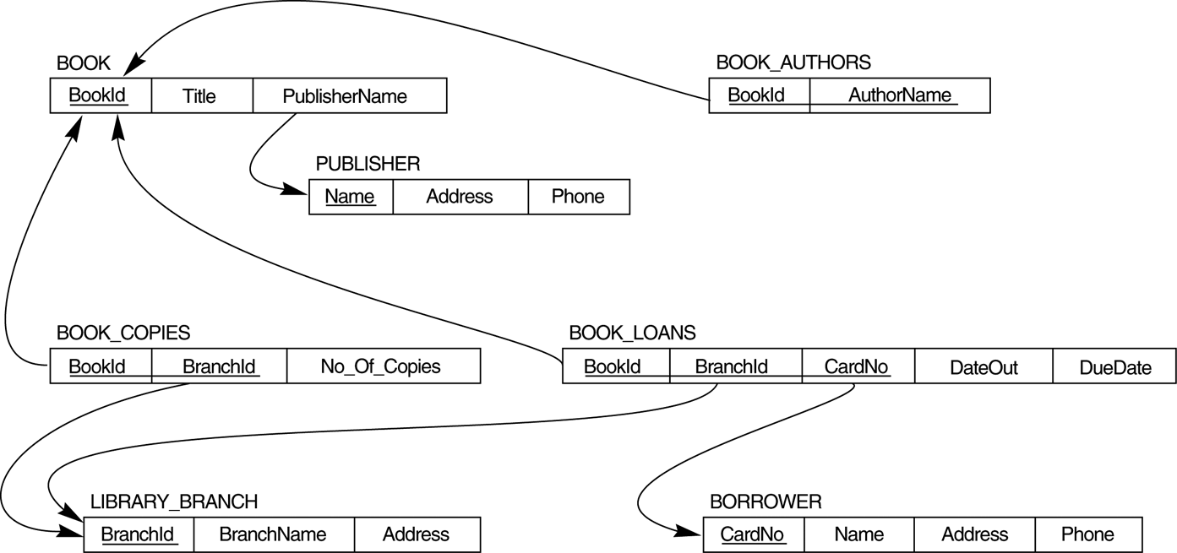

1. Tuliskan pernyataan DDL dari SQL untuk mendeklarasikan skema basis data LIBRARY di atas (lengkap dengan domain dan constraint -nya)
2. Tuliskan query SQL untuk masing-masing query berikut:
   1. How many copies of the book titled The Lost Tribe are owned by the library branch whose name is "Sharpstown"?
   2. How many copies of the book titled The Lost Tribe are owned by each library branch?
   3. Retrieve the names of all borrowers who do not have any books checked out.
   4. For each book that is loaned out from the "Sharpstown" branch and whose DueDate is today, retrieve the book title, the borrower's name, and the borrower's address.
   5. For each library branch, retrieve the branch name and the total number of books loaned out from that branch.
   6. Retrieve the names, addresses, and number of books checked out for all borrowers who have more than five books checked out.
   7. For each book authored (or co-authored) by "Stephen King", retrieve the title and the number of copies owned by the library branch whose name is "Central".