**NIM :**

**NAMA :**

**MATA KULIAH : Pemrograman Framework**

**JADWAL : Rabu/10.00/Q.1.1**

**Laporan Latihan OOP di PHP**

**Percobaan STEP 2: Create a PHP class**

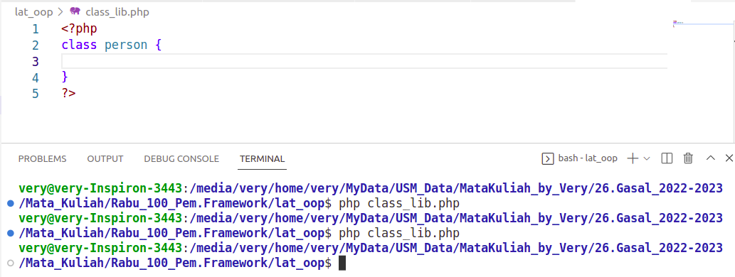

**STEP 3: Add data to your class**

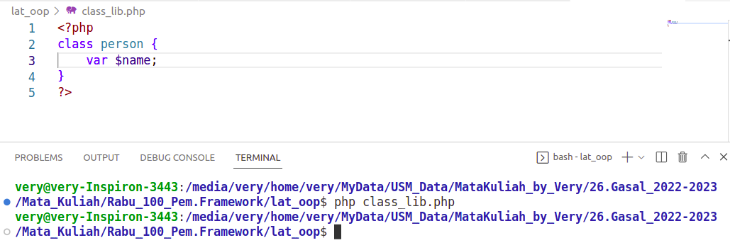

dst...