Establishment of a temperature-based immigration model to predict the flight onset of *Cacopsylla melanoneura* and *C. picta*, vectors of apple proliferation disease, in South Tyrol, Italy

Authors: Bernd Panassiti1,*, Nicolas Sander2, Valerio Mazzoni3, Stefanie Fischnaller1, Martin Parth1, Manuel Messner1, Katrin Janik1, Florian Hartig4

1 Laimburg Research Centre, Auer, Italy

2 Biometry and Environmental System Analysis, Faculty of Environment and Natural

Resources, University of Freiburg, Germany

3 IASMA, Fondazione E. Mach, Via E. Mach 1, 38010, San Michele all’Adige (TN), Italy

4 University of Regensburg, Theoretical Ecology, Universitätsstraße 31, D-93053 Regensburg, Germany

* email corresponding author: bernd.panassiti@gmail.com

Key-words: Apple proliferation, crop protection, pest management, phytoplasma, population dynamics, psyllid, temperature sum model

## Abstract

The activity of insects is mostly temperature driven. Therefore, temperature-based models, predicting the first flight onset of pest insects in crop fields, are useful tools in crop protection. Here, we apply such a temperature-based model on the psyllids *Cacopsylla melanoneura* and *C. picta* (Hemiptera - Psyllidae) in South Tyrol (Northern Italy). Both psyllids are considered the main vectors of apple proliferation, an economically important phytoplasma disease. We found that the flight onset differs between vectors and between the different South Tyrol regions. Depending on temperature and region, the first adults of *C. melanoneura* and *C. picta* remigrants are predicted to be presented in the orchard between January and mid of March.

In conclusion, we found that flight onset differs between years and regions of South Tyrol. Provided further validation, the presented temperature-based immigration model can be used as a tool to predict of first vector appearance in the apple orchards in South Tyrol.

## Zusammenfassung:

## Introduction

Insects are ectothermic and thus dependent on warm air temperatures for activity (Mellanby, 1939). Moreover, studies have shown that for light trapping of flying insects, warmer temperatures increase catches due to increased flight activity (McGeachie, 1989; Jonason et al., 2014). Therefore, temperature-based models present useful tools to predict the flight onset of pest insects, i.e. the first encounter of adults of a pest insect in a crop field. In crop protection, these models have been successfully applied to support pest management strategies. A prominent example is the web-tool ‘Vitimeteo’ (www.vitimeteo.de, last accessed 16.01.2016, Bleyer et al. 2014) which contains a module called “VM Schwarzholz”. This module predicts the flight onset of the planthopper *Hyalesthes obsoletus*, vector of the grapevine phytoplasma disease ‘bois noir’. These temperature-based models often rely on temperature sums to derive regional thresholds, as it is the case for *H. obsoletus* (Maixner and Langer 2006).

Apple proliferation (AP) is a phytoplasma disease causing severe economic damage in European apple production areas (Kunze 1989). AP is vectored by two psyllid species, *Cacopsylla melanoneura* (Förster) and *C. picta* (Förster) (Hemiptera - Psyllidae) (Frisinghelli et al. 2000, Jarausch et al. 2003, Tedeschi et al. 2002).

Recently, *C. picta* was found to transovarially transmit the AP phytoplasma to its offspring, and is hence considered the more effective AP vector (Mittelberger et al. 2016).

The life cycle of both vectors is summarized by Jarausch and Jarausch (2010). In brief, *C. melanoneura* is univoltine and hibernates in adult stage on overwintering plants, mostly conifers (Lal 1934, Novak and Achtziger 1995, Ossiannilsson 1992). In South Tyrol, the coniferous forests are mainly restricted to the valley’s hillsides. Early in the year, *C. melanoneura* adults (so called “remigrants”) migrate to their host plants for oviposition. Being oligophagous, the species uses different Rosaceae species as host plants such as hawthorn (*Crataegus* spp.) and *Malus* spp. The new generation (“remigrants”) leave for the overwintering sites in mid summer.

*C. picta* is also univoltine but feeds monophagously on *Malus* spp.. *C. picta* presence in the orchard is timely delayed compared to *C. melanoneura*. *C. picta* re-migrates into the apple orchard in March/ Abril and the new generation emigrates to the overwintering sites in late summer.

The aim of the study was to apply a temperature-based immigration analysis for both AP vectors for all apple growing regions in South Tyrol.

## Study site

The study area was carried out throughout all apple growing regions in South Tyrol, Northern Italy. The study area comprises six apple growing regions: Bozen, Burggrafenamt, Eisacktal, Salten-Schlern, Überetsch-Unterland and Vinschgau. Located in the southern side of the Alps, the landscape is formed by valleys at elevations as low as 200 m a.s.l. and high mountain peaks reaching 3000 m a.s.l.. The elevations of the surveyed orchards ranged between 200 m a.s.l. elevation in the valleys and up to 1000 m a.s.l. in the adjacent hill sides. The annual mean temperature in the apple growing area is about 15°C.

## Material and methods

### Psyllid vector sampling

Monitoring data on both AP vectors, *C. melanoneura* and *C. picta*, were provided by both the “Laimburg Research Centre” (Katrin Janik 2016) and the South Tyrol advisory council “Südtiroler Beratungsring”. 178 orchards were surveyed one to four times between 2013 and 2016. Psyllid vectors were collected using yellow sticky traps and the “beating tray”-method (Horton 1999, Muther and Vogt 2003). Depending on orchard size, between 20 and 200 apple trees were randomly selected for vector sampling. Species identification followed the keys by Ossiannilsson (1992).

### Weather data

Daily minimum, mean and maximum air temperature were derived from weather stations provided by the Hydrographic Office of the Autonomous Province Bozen (<http://www.provinz.bz.it/wetter/home.asp>, downloaded October 2016). The regional distribution of the weather stations was as follows: 1 Bozen, 7 Burggrafenamt, 8 Eisacktal, 5 Salten-Schlern, 4 Überetsch-Unterland, 4 Vinschgau.

### Regional temperature-based immigration analysis

Following the methods outlined in Tedeschi et al. (2012), we applied a temperature-based immigration analysis (TempIA) for both AP psyllid vectors for each of the apple growing regions in South Tyrol. The TempIA is based on two indices, a temperature threshold as well as an immigration index. Psyllid immigration is triggered by either having the immigration index become positive or having the hourly temperature exceeding a threshold defined as the average of maximum hourly temperatures in the week before the first psyllid occurrence in each year (T7th).

The TempIA calculation was as follows:

1. Average 10 minute weather data from weather stations to 1 hour temperatures (**Thourly**)
2. Combine beating and yellow trap data for *C. melanoneura* & *C. picta* for both generations (parental (P) & filial (F1))
3. Calculate date of first captured presence per subregion and species (**a0**)
4. Take the mean of all weather stations’ average hourly data within the same subregion

(**Thourlyregion**)

1. Calculate the max. temperature (**T0max**) within 7 days preceding date of first presence (a0), from

Thourlyregion

1. Min. of T0max over all years for the same subregion gives subregional **T7th**
2. Hourly immigration index (**Ii**) for each region.

The immigration index (Ii) is based on the following equation:

|  |  |
| --- | --- |
| Ii = [(T7n T7th) + ddn] | (1.1) |

where Ii = Immigration index; T7n = Mean temperature in the 7 days before observation; T7th = Highest hourly temperature in the 7 days before observation; and ddn = Number of hours in 7 days before observation with temperatures > T7th.

The R-code for the calculation of the temperature thresholds and immigration indices are provided in Appendix A.

## Results

The regions “Burggrafenamt” and “Eisacktal” have T7th values close to Trentino’s 9.5°C with 9.79°C in Burggrafenamt and 9.68°C in Eisacktal. The regions “Salten-Schlern” and “Vinschgau” deviate from this value, with 7.99°C and 10.47°C respectively. “Bozen” and “Überetsch-Unterland” simply do not have enough data points to create a reliable temperature threshold value and were only included for completeness (see Figures 1 and 2). There is significant variation between years in regards to when the thresholds are exceeded. The immigration starting dates range from early January up to the middle of March.

*C. picta*, being the rarer of the two species, has very few positive data points making such an analysis highly unreliable. Yet, for the two regions with some available presence data, the T7th values are higher than for *C. melanoneura* due to later start of orchard immigration of *C. picta* (Fig. 3 and 4).

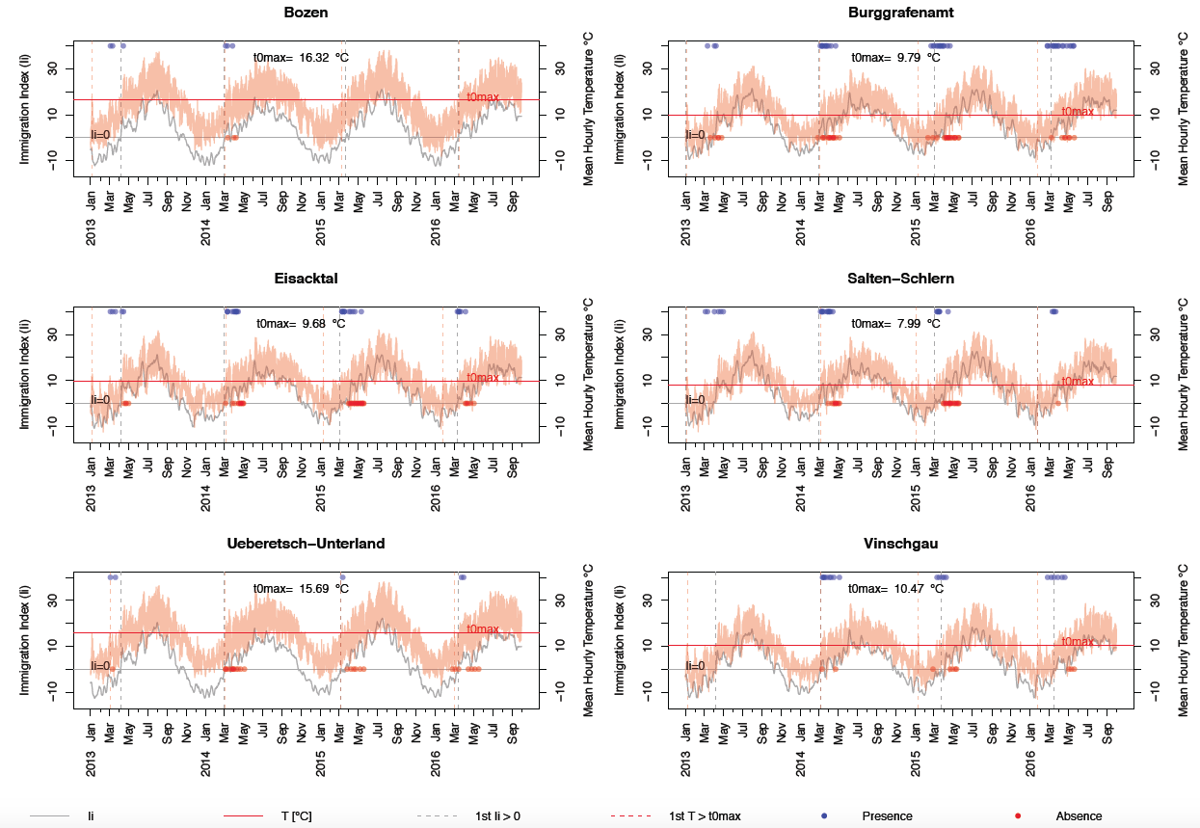

Figure 1. Immigration index and threshold for *Cacopsylla melanoneura* remigrants by region.

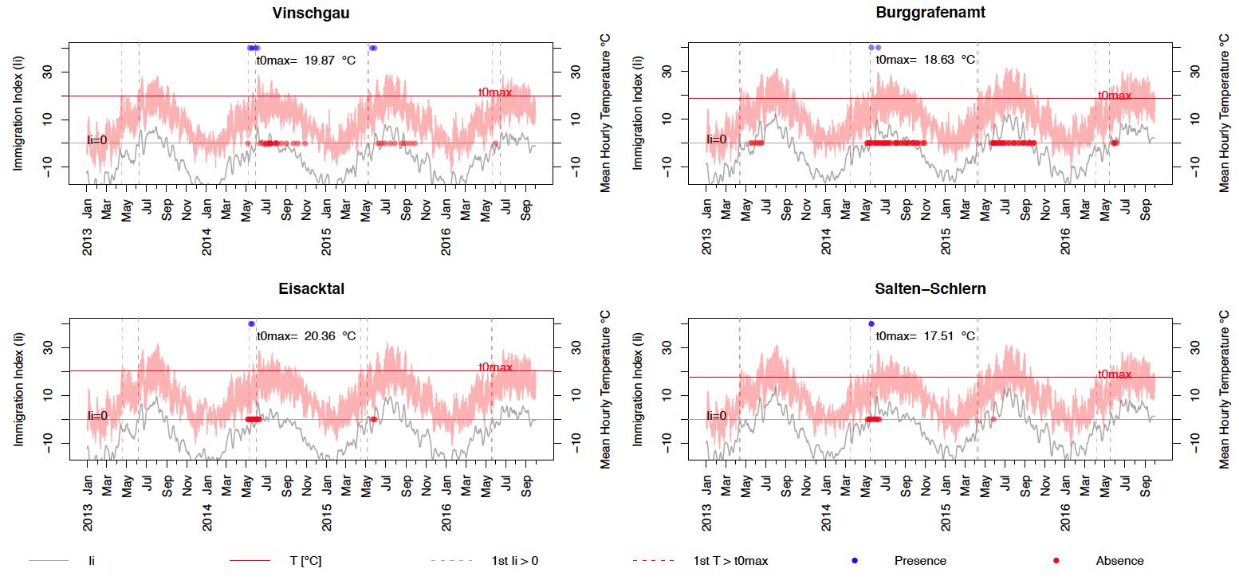

Figure 2. Immigration index and threshold for *Cacopsylla melanoneura* emigrants by region.

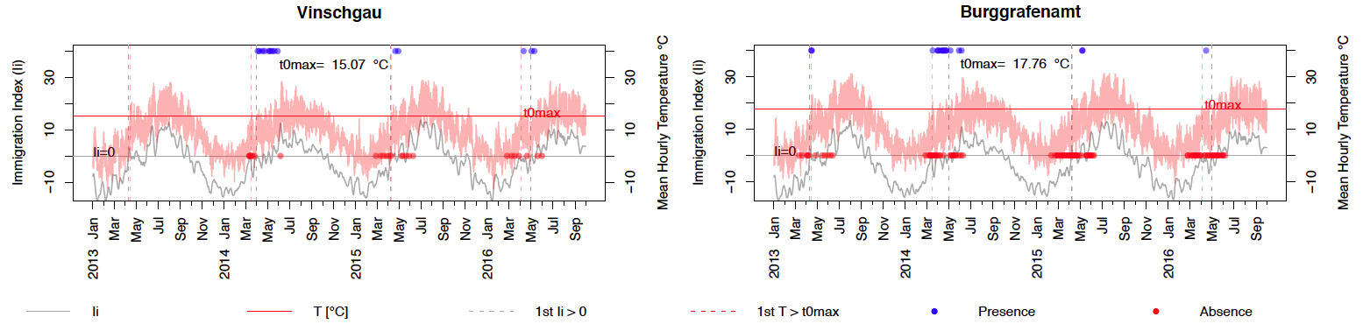

Figure 3. Immigration index and threshold for *C. picta* remigrants by region.

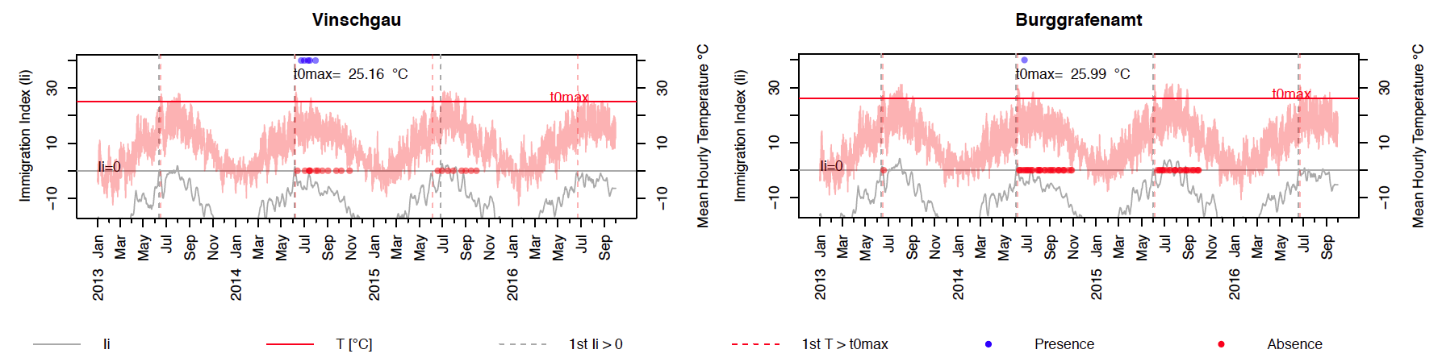

Figure 4. Immigration index and threshold for *C. picta* emigrants by region.

## Discussion

To predict the flight onset of the two AP vectors, *C. melanoneura* and *C. picta*, in South Tyrol/ Northern Italy, we applied the temperature-based immigration analysis developed by Tedeschi et al. (2012). Its goal is to determine an absolute temperature threshold and index, which represent the temperature trigger for vector re-migration into the apple orchards. For one, this allowed us to potentially define a temperature immigration threshold for each of the region, which is not covered by a statistical model and can be further compared to other studies. The second reason is one of practicality, in that such temperature threshold analyses, if deemed accurate enough, are very easy to provide to farmers for management decisions at the beginning of the migration season when pest control is of critical importance.

### Immigration-thresholds for *C. melanoneura*

The analysis for the regions with a sufficient amount of *C. melanoneura* observations (Burggrafenamt, Eisacktal, Salten-Schlern, Vinschgau) shows differences in their estimated temperature thresholds, ranging from 7.99°C to 10.47°C. Tedeschi et al. (2012) calculated the T7th for Trentino to be around 9.5°C, which lies in the middle of our calculated threshold range, confirming their plausibility. The found threshold differences either suggests that the migration behavior of *C. melanoneura* is not solely triggered by temperature or hints at the existence of regional subpopulations that immigrate at different times. As shown in Figure 1, the immigration start (either when Ii > 0 or the hourly temperature exceeds T7th) varies extremely between the years. For 2013 and 2015, the analysis indicates immigration to start as early as the beginning of January, whereas for 2014, it does not begin until early March. Unfortunately, the other apple growing regions simply did not have enough years with data or lack *C. melanoneura* absences before the first annual capture, and therefore prevent reliable conclusions about their temperature thresholds.

### Immigration-thresholds for *C. picta*

*C. picta* captures were low or absent across all apple growing regions in South Tyrol. For regions with some data on *C. picta*, the preliminary threshold estimates do indicate that *C. picta* begins orchard immigration at higher temperatures than *C. melanoneura*. This matches our expectations from the migratory patterns as well as previous studies, which show that *C. picta*’s immigration starts at a later date with consequently higher ambient temperatures than *C. melanoneura* (Mattedi et al. 2008).

### Conclusions

We established a temperature-based immigration analysis for the AP vectors *C. melanoneura* and *C. picta* in South Tyrol, Italy. The analysis indicated that the flight onset is species and region specific. Additional data and validation is necessary, in order to make regionally customized thresholds, and the different immigration starting dates they reflect, reliable enough for adapting management choices.

## Appendix

Appendix A: R-code for the temperature immigration analysis.

<https://github.com/berndpanassiti/Temperature-based_immigration_analysis/blob/master/r-code/TempIA.md>

## References

Bleyer G., Kassemeyer H.-H., Breuer M., Krause R., Augenstein B., Viret O., Dubuis P.-H., Fabre A.-L., Bloesch B., Kehrli P., Siegfried W., Naef A., Hill G. K., Mattedi L. and Varner M. (2014). Presentation of the VitiMeteo forecasting system - current state at the 10th anniversary of the system. - IOBC WPRS BULLETIN 105, 113-123.

Frisinghelli C., Delaiti L., Grando M. S., Forti D. and Vindimian M. E. (2000). *Cacopsylla costalis* (Flor 1861), as a vector of apple proliferation in Trentino. - Journal of Phytopathology 148, 425–431.

Horton D. R. (1999). Monitoring of pear psylla for pest management decisions and research. - Integrated Pest Management Reviews 4, 1-20.

Jarausch B. and Jarausch W. (2010). Psyllid vectors and their control. In: P. G. Weintraub and P. Jones (Eds.), Phytoplasmas genomes, plant hosts, and vectors (pp. 250-271). Cambridge, USA: CABI North American Office.

Jarausch B., Schwind N., Jarausch W., Krczal G., Dickler E. and Seemüller E. (2003). First report of *Cacopsylla picta* as a vector of apple proliferation phytoplasma in Germany. - Plant Disease 87.

Katrin Janik S. F., Christine Kerschbamer. (2016). Suche nach weiteren Überträgern des Apfeltriebsuchterregers. - Obst- und Weinbau 4.

Kunze L. (1989). Apple proliferation. In: P. R. Fridlund (Ed.), Virus and viruslike diseases of pome fruits and simulating noninfectious disorders (pp. 99-113). Washington: Cooperative Extension College of Agriculture and Home Economics, Washington State University, Pullmann.

Lal K. B. (1934). The biology of Scottish Psyllidae. - Transactions of the Royal Entomological Society of London 82, 363-385.

Maixner M. and Langer M. (2006). Prediction of the flight of *Hyalesthes obsoletus*, vector of stolbur phytoplasma, using temperature sums. - IOBC/WPRS Bulletin 29, 161-166.

Mattedi L., Forno F., Cainelli C., Grando M. S. and Jarausch W. (2008). Research on ‘*Candidatus* Phytoplasma’ mali transmission by insect vectors in Trentino. - Acta Horticulturae 781, 369–374.

Mittelberger C., Obkircher L., Oettl S., Oppedisano T., Pedrazzoli F., Panassiti B., Kerschbamer C., Anfora G. and Janik K. (2016). The insect vector *Cacopsylla picta* vertically transmits the bacterium ‘*Candidatus* Phytoplasma mali’ to its progeny. - Plant Pathology *in press*, n/a-n/a.

Muther J. and Vogt H. (2003). Sampling methods in orchard trials: A comparison between beating and inventory sampling. - IOBC WPRS BULLETIN 26, 67-72.

Novak H. and Achtziger R. (1995). Influence of heteropteran predators (Het., Anthocoridae, Miridae) on larval populations of hawthorn psyllids (Hom., Psyllidae). - Journal of Applied Entomology 119, 479-486.

Ossiannilsson F. (1992). The Psylloidea (Homoptera) of Fennoscandia and Demark. Leiden; New York: E.J. Brill.

Tedeschi R., Baldessari M., Mazzoni V., Trona F. and Angeli G. (2012). Population dynamics of *Cacopsylla melanoneura* (Hemiptera: Psyllidae) in northeast Italy and its role in the apple proliferation epidemiology in apple orchards. - Journal of Economic Entomology 105, 322–328.

Tedeschi R., Bosco D. and Alma A. (2002). Population dynamics of *Cacopsylla melanoneura* (Homoptera: Psyllidae), a vector of apple proliferation phytoplasma in northwestern Italy. - Journal of Economic Entomology 95, 544-551.