A cortical model for reversal learning without a reward prediction error but Hebbian learning and serotonin controlling its plasticity

Introduction
Theoretical models of reversal learning usually use the dopaminergic reward prediction error generated in the sub-cortical structures. However, it has long been argued (Rolls, 2008) that the reward related behavioural flexibility is rather cortical than sub-cortical and not dopamine driven.

Methods
A computer simulated rat has to find food at one of two landmarks and then after successful learning the food is moved to the other landmark. Instead of a reward prediction error, learning of the stimulus/reward associations is Hebbian LTP by feeding the primary reward postsynaptically into the orbitofrontal cortex (OFC) while place and landmark information is its pre-synaptic activity. LTD is triggered when the primary reward is not driving the OFC causing less and slower changing postsynaptic activity. The same plasticity rule is used downstream in the mPFC selecting the actions (see Panel B). Serotonin acts as an accelerator for both LTP and LTD. Experiments were run for a control scenario, for one with less serotonin and one with a simulated application of serotonin reuptake inhibitors.

Approach for statistical analysis
Every experiment ran 30 times and during reversal the relative reward was calculated which is the number of successful food retrievals against any attempts to go to either landmark. A t-test was applied at p = 0.05.

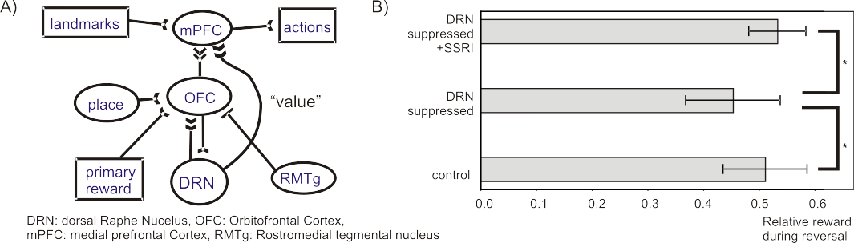
Results and conclusions
We show that Hebbian learning is able to model reversal learning (Panel B, control) and that serotonin acts as an accelerator of flexibility. Reduced serotonin increases the number of non-rewarding actions during reversal (Panel B, DRN suppressed). SSRIs can help to overcome this deficiency (Panel C, DRN suppressed + SSRI) but we'd predict that any drug boosting plasticity will have this effect. Crucial is that as shown in our previous study (Porr et al 2019) this boosts the average rewards which in turn influences motivation & mood.

Rolls, E. T., Grabenhorst, F (2008) The orbitofrontal cortex and beyond: From affect to decision-making. Progress in Neurobiology.

Porr, B & Miller, A & Trew, A (2019) An investigation into serotonergic and environmental interventions against depression in a simulated delayed reward paradigm. Adaptive Behaviour.

