Summary

G_Cloete

2025-03-27

data <- data.frame(x1 = c(1,2,3),  
 x2 = c(5,6,7),  
 x3 = c(9,10,11))  
  
A <- cbind(data)  
  
B = matrix(c(11,12,13,14,15,16,17,18,19), nrow = 3)  
B

## [,1] [,2] [,3]  
## [1,] 11 14 17  
## [2,] 12 15 18  
## [3,] 13 16 19

det(B)

## [1] 0

library(MASS)  
ginv(B)

## [,1] [,2] [,3]  
## [1,] -1.4722222 -5.555556e-02 1.3611111  
## [2,] -0.1666667 2.628106e-16 0.1666667  
## [3,] 1.1388889 5.555556e-02 -1.0277778

z = c(1:3, NA)  
z

## [1] 1 2 3 NA

sample(1:10, 5, replace = FALSE)

## [1] 8 7 3 2 5

#if you want to transform a data frame into a matrix use as.matrix() function.

#More matrices

diag_matrix <- diag(1:3)  
diag_matrix

## [,1] [,2] [,3]  
## [1,] 1 0 0  
## [2,] 0 2 0  
## [3,] 0 0 3

identity_matrix <- diag(3)  
identity_matrix

## [,1] [,2] [,3]  
## [1,] 1 0 0  
## [2,] 0 1 0  
## [3,] 0 0 1

m <- array(c(3.7,4.2, 2.01, 4.77, 9.8, 3.6, 1.5, 2.7, 8.7), dim = c(3,3))  
det_m <- det(m)  
det_m

## [1] 124.222

inverse_m <- solve(m)  
inverse_m

## [,1] [,2] [,3]  
## [1,] 0.60810489 -0.29060072 -0.01465924  
## [2,] -0.25046290 0.23486180 -0.02970489  
## [3,] -0.03685338 -0.03004541 0.13062100

eigen_m <- eigen(m)  
eigen_m

## eigen() decomposition  
## $values  
## [1] 14.400768 6.464950 1.334282  
##   
## $vectors  
## [,1] [,2] [,3]  
## [1,] -0.3970154 -0.2366891 -0.89941892  
## [2,] -0.7063542 -0.4136537 0.43588517  
## [3,] -0.5860397 0.8791296 0.03239948

data <- iris  
head(data)

## Sepal.Length Sepal.Width Petal.Length Petal.Width Species  
## 1 5.1 3.5 1.4 0.2 setosa  
## 2 4.9 3.0 1.4 0.2 setosa  
## 3 4.7 3.2 1.3 0.2 setosa  
## 4 4.6 3.1 1.5 0.2 setosa  
## 5 5.0 3.6 1.4 0.2 setosa  
## 6 5.4 3.9 1.7 0.4 setosa

str(data)

## 'data.frame': 150 obs. of 5 variables:  
## $ Sepal.Length: num 5.1 4.9 4.7 4.6 5 5.4 4.6 5 4.4 4.9 ...  
## $ Sepal.Width : num 3.5 3 3.2 3.1 3.6 3.9 3.4 3.4 2.9 3.1 ...  
## $ Petal.Length: num 1.4 1.4 1.3 1.5 1.4 1.7 1.4 1.5 1.4 1.5 ...  
## $ Petal.Width : num 0.2 0.2 0.2 0.2 0.2 0.4 0.3 0.2 0.2 0.1 ...  
## $ Species : Factor w/ 3 levels "setosa","versicolor",..: 1 1 1 1 1 1 1 1 1 1 ...

data$Species

## [1] setosa setosa setosa setosa setosa setosa   
## [7] setosa setosa setosa setosa setosa setosa   
## [13] setosa setosa setosa setosa setosa setosa   
## [19] setosa setosa setosa setosa setosa setosa   
## [25] setosa setosa setosa setosa setosa setosa   
## [31] setosa setosa setosa setosa setosa setosa   
## [37] setosa setosa setosa setosa setosa setosa   
## [43] setosa setosa setosa setosa setosa setosa   
## [49] setosa setosa versicolor versicolor versicolor versicolor  
## [55] versicolor versicolor versicolor versicolor versicolor versicolor  
## [61] versicolor versicolor versicolor versicolor versicolor versicolor  
## [67] versicolor versicolor versicolor versicolor versicolor versicolor  
## [73] versicolor versicolor versicolor versicolor versicolor versicolor  
## [79] versicolor versicolor versicolor versicolor versicolor versicolor  
## [85] versicolor versicolor versicolor versicolor versicolor versicolor  
## [91] versicolor versicolor versicolor versicolor versicolor versicolor  
## [97] versicolor versicolor versicolor versicolor virginica virginica   
## [103] virginica virginica virginica virginica virginica virginica   
## [109] virginica virginica virginica virginica virginica virginica   
## [115] virginica virginica virginica virginica virginica virginica   
## [121] virginica virginica virginica virginica virginica virginica   
## [127] virginica virginica virginica virginica virginica virginica   
## [133] virginica virginica virginica virginica virginica virginica   
## [139] virginica virginica virginica virginica virginica virginica   
## [145] virginica virginica virginica virginica virginica virginica   
## Levels: setosa versicolor virginica

min(data$Sepal.Length)

## [1] 4.3

max(data$Sepal.Length)

## [1] 7.9

mean(data$Sepal.Length)

## [1] 5.843333

var(data$Sepal.Length)

## [1] 0.6856935

median(data$Sepal.Length)

## [1] 5.8

quantile(data$Sepal.Length, 0.3)

## 30%   
## 5.27

summary(data)

## Sepal.Length Sepal.Width Petal.Length Petal.Width   
## Min. :4.300 Min. :2.000 Min. :1.000 Min. :0.100   
## 1st Qu.:5.100 1st Qu.:2.800 1st Qu.:1.600 1st Qu.:0.300   
## Median :5.800 Median :3.000 Median :4.350 Median :1.300   
## Mean :5.843 Mean :3.057 Mean :3.758 Mean :1.199   
## 3rd Qu.:6.400 3rd Qu.:3.300 3rd Qu.:5.100 3rd Qu.:1.800   
## Max. :7.900 Max. :4.400 Max. :6.900 Max. :2.500   
## Species   
## setosa :50   
## versicolor:50   
## virginica :50   
##   
##   
##

#Probability distributions

#binomial distribution P(X=1), Bin(25,0.005)  
  
dbinom(1,25,0.005)

## [1] 0.1108317

#Loops

#if-else statements  
  
x = 9  
if (x>5) {  
 if(x %% 2 == 0) {  
 print("x is greater than 5 and even")  
} else {  
 print("x is greater than 5 and odd")  
}  
} else {  
 print("x is less than or equal to 5")  
}

## [1] "x is greater than 5 and odd"

# For loop  
for (i in 1:5) {  
 print(i)  
   
}

## [1] 1  
## [1] 2  
## [1] 3  
## [1] 4  
## [1] 5

n <- 5  
total <- 0  
  
for (i in 1:n) {  
 total <- total + i  
}  
print(total)

## [1] 15

start <- 2  
end <- 10  
step <- 2  
total <- 0  
  
for (i in seq(start, end, step)) {  
 print(i)  
 total <- total + i  
}

## [1] 2  
## [1] 4  
## [1] 6  
## [1] 8  
## [1] 10

print(total)

## [1] 30

##while loop  
  
n <- 5  
factorial <- 1  
i <- 1  
  
while (i <=n) {  
 factorial = factorial * i  
 i <- i+1  
}  
  
print(factorial)

## [1] 120

#ex 2  
i = 1  
  
while(i <= 20) {  
 if (i %% 2 == 0) {  
 print(i)  
 }  
 i = i+1  
}

## [1] 2  
## [1] 4  
## [1] 6  
## [1] 8  
## [1] 10  
## [1] 12  
## [1] 14  
## [1] 16  
## [1] 18  
## [1] 20

#ex 3  
numbers <- rpois(100,1)  
  
sum <- 0  
i <- 1  
  
while(sum < 50 && i <= length(numbers)) {  
 sum <- sum + numbers[i]  
 i = 1+ i  
}  
sum

## [1] 50

#Repeat loops  
  
repeat {  
 x <- sample(1:10, 1)  
   
 if (x>7) {  
 break  
 }  
}  
x

## [1] 8

num_occurences <- 10000  
occurence_count <- 0  
repeat{  
 if (runif(1) < 0.001) {  
 occurence_count <- occurence_count + 1  
 if (occurence_count >= num_occurences) {  
 break  
 }  
 }  
}  
  
est_prob <- occurence_count / num_occurences  
  
cat("Estimated probability:", est_prob, "\n")

## Estimated probability: 1

##fancy example  
  
library(ggplot2)  
library(hrbrthemes)  
  
set.seed(123)  
samples <- matrix(rnorm(100*5), ncol =5)  
  
sample_means <- apply(samples,1,mean)  
  
df <- data.frame(sample_means)  
  
ggplot(df, aes(x=1:nrow(df), y = sample_means)) +  
 geom_line(linetype = "dashed", color ="red") +  
 xlab("Sample number")+  
 ylab("Sample Mean") +  
 ggtitle(" Line plot of 100 samples from standard normal distribution")+  
 theme_classic()

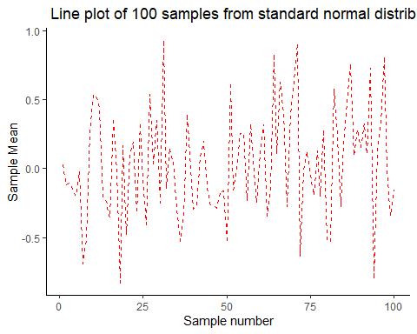 #Data visualization

data(airquality)  
  
head(airquality, 20)

## Ozone Solar.R Wind Temp Month Day  
## 1 41 190 7.4 67 5 1  
## 2 36 118 8.0 72 5 2  
## 3 12 149 12.6 74 5 3  
## 4 18 313 11.5 62 5 4  
## 5 NA NA 14.3 56 5 5  
## 6 28 NA 14.9 66 5 6  
## 7 23 299 8.6 65 5 7  
## 8 19 99 13.8 59 5 8  
## 9 8 19 20.1 61 5 9  
## 10 NA 194 8.6 69 5 10  
## 11 7 NA 6.9 74 5 11  
## 12 16 256 9.7 69 5 12  
## 13 11 290 9.2 66 5 13  
## 14 14 274 10.9 68 5 14  
## 15 18 65 13.2 58 5 15  
## 16 14 334 11.5 64 5 16  
## 17 34 307 12.0 66 5 17  
## 18 6 78 18.4 57 5 18  
## 19 30 322 11.5 68 5 19  
## 20 11 44 9.7 62 5 20

summary(airquality)

## Ozone Solar.R Wind Temp   
## Min. : 1.00 Min. : 7.0 Min. : 1.700 Min. :56.00   
## 1st Qu.: 18.00 1st Qu.:115.8 1st Qu.: 7.400 1st Qu.:72.00   
## Median : 31.50 Median :205.0 Median : 9.700 Median :79.00   
## Mean : 42.13 Mean :185.9 Mean : 9.958 Mean :77.88   
## 3rd Qu.: 63.25 3rd Qu.:258.8 3rd Qu.:11.500 3rd Qu.:85.00   
## Max. :168.00 Max. :334.0 Max. :20.700 Max. :97.00   
## NA's :37 NA's :7   
## Month Day   
## Min. :5.000 Min. : 1.0   
## 1st Qu.:6.000 1st Qu.: 8.0   
## Median :7.000 Median :16.0   
## Mean :6.993 Mean :15.8   
## 3rd Qu.:8.000 3rd Qu.:23.0   
## Max. :9.000 Max. :31.0   
##

data.ozone = airquality$Ozone  
data.temp = airquality$Temp  
data.wind = airquality$Wind  
  
is.na(data.ozone)

## [1] FALSE FALSE FALSE FALSE TRUE FALSE FALSE FALSE FALSE TRUE FALSE FALSE  
## [13] FALSE FALSE FALSE FALSE FALSE FALSE FALSE FALSE FALSE FALSE FALSE FALSE  
## [25] TRUE TRUE TRUE FALSE FALSE FALSE FALSE TRUE TRUE TRUE TRUE TRUE  
## [37] TRUE FALSE TRUE FALSE FALSE TRUE TRUE FALSE TRUE TRUE FALSE FALSE  
## [49] FALSE FALSE FALSE TRUE TRUE TRUE TRUE TRUE TRUE TRUE TRUE TRUE  
## [61] TRUE FALSE FALSE FALSE TRUE FALSE FALSE FALSE FALSE FALSE FALSE TRUE  
## [73] FALSE FALSE TRUE FALSE FALSE FALSE FALSE FALSE FALSE FALSE TRUE TRUE  
## [85] FALSE FALSE FALSE FALSE FALSE FALSE FALSE FALSE FALSE FALSE FALSE FALSE  
## [97] FALSE FALSE FALSE FALSE FALSE TRUE TRUE FALSE FALSE FALSE TRUE FALSE  
## [109] FALSE FALSE FALSE FALSE FALSE FALSE TRUE FALSE FALSE FALSE TRUE FALSE  
## [121] FALSE FALSE FALSE FALSE FALSE FALSE FALSE FALSE FALSE FALSE FALSE FALSE  
## [133] FALSE FALSE FALSE FALSE FALSE FALSE FALSE FALSE FALSE FALSE FALSE FALSE  
## [145] FALSE FALSE FALSE FALSE FALSE TRUE FALSE FALSE FALSE

is.na(data.wind)

## [1] FALSE FALSE FALSE FALSE FALSE FALSE FALSE FALSE FALSE FALSE FALSE FALSE  
## [13] FALSE FALSE FALSE FALSE FALSE FALSE FALSE FALSE FALSE FALSE FALSE FALSE  
## [25] FALSE FALSE FALSE FALSE FALSE FALSE FALSE FALSE FALSE FALSE FALSE FALSE  
## [37] FALSE FALSE FALSE FALSE FALSE FALSE FALSE FALSE FALSE FALSE FALSE FALSE  
## [49] FALSE FALSE FALSE FALSE FALSE FALSE FALSE FALSE FALSE FALSE FALSE FALSE  
## [61] FALSE FALSE FALSE FALSE FALSE FALSE FALSE FALSE FALSE FALSE FALSE FALSE  
## [73] FALSE FALSE FALSE FALSE FALSE FALSE FALSE FALSE FALSE FALSE FALSE FALSE  
## [85] FALSE FALSE FALSE FALSE FALSE FALSE FALSE FALSE FALSE FALSE FALSE FALSE  
## [97] FALSE FALSE FALSE FALSE FALSE FALSE FALSE FALSE FALSE FALSE FALSE FALSE  
## [109] FALSE FALSE FALSE FALSE FALSE FALSE FALSE FALSE FALSE FALSE FALSE FALSE  
## [121] FALSE FALSE FALSE FALSE FALSE FALSE FALSE FALSE FALSE FALSE FALSE FALSE  
## [133] FALSE FALSE FALSE FALSE FALSE FALSE FALSE FALSE FALSE FALSE FALSE FALSE  
## [145] FALSE FALSE FALSE FALSE FALSE FALSE FALSE FALSE FALSE

is.na(data.temp)

## [1] FALSE FALSE FALSE FALSE FALSE FALSE FALSE FALSE FALSE FALSE FALSE FALSE  
## [13] FALSE FALSE FALSE FALSE FALSE FALSE FALSE FALSE FALSE FALSE FALSE FALSE  
## [25] FALSE FALSE FALSE FALSE FALSE FALSE FALSE FALSE FALSE FALSE FALSE FALSE  
## [37] FALSE FALSE FALSE FALSE FALSE FALSE FALSE FALSE FALSE FALSE FALSE FALSE  
## [49] FALSE FALSE FALSE FALSE FALSE FALSE FALSE FALSE FALSE FALSE FALSE FALSE  
## [61] FALSE FALSE FALSE FALSE FALSE FALSE FALSE FALSE FALSE FALSE FALSE FALSE  
## [73] FALSE FALSE FALSE FALSE FALSE FALSE FALSE FALSE FALSE FALSE FALSE FALSE  
## [85] FALSE FALSE FALSE FALSE FALSE FALSE FALSE FALSE FALSE FALSE FALSE FALSE  
## [97] FALSE FALSE FALSE FALSE FALSE FALSE FALSE FALSE FALSE FALSE FALSE FALSE  
## [109] FALSE FALSE FALSE FALSE FALSE FALSE FALSE FALSE FALSE FALSE FALSE FALSE  
## [121] FALSE FALSE FALSE FALSE FALSE FALSE FALSE FALSE FALSE FALSE FALSE FALSE  
## [133] FALSE FALSE FALSE FALSE FALSE FALSE FALSE FALSE FALSE FALSE FALSE FALSE  
## [145] FALSE FALSE FALSE FALSE FALSE FALSE FALSE FALSE FALSE

data.ozone = data.ozone[!is.na(data.ozone)]  
data.wind = data.wind[!is.na(data.wind)]  
data.temp = data.temp[!is.na(data.temp)]  
  
ggplot(airquality, aes(x = Ozone, y = Temp)) + geom_point()

## Warning: Removed 37 rows containing missing values or values outside the scale range  
## (`geom_point()`).

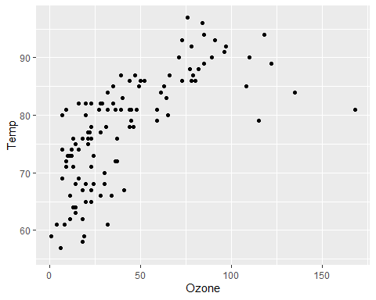

ggplot(airquality, aes(x = Wind, y = Temp)) + geom_line(color = "blue") + geom_point(shape = 21, color = "black", fill = "red", size =6)

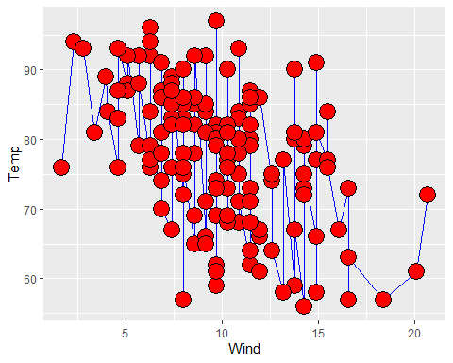

ggplot(airquality, aes(x = Temp, y = Wind)) + geom_smooth()

## `geom_smooth()` using method = 'loess' and formula = 'y ~ x'

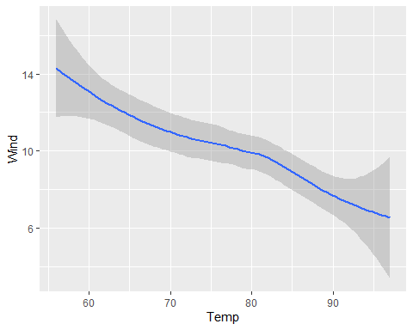

library(tidyverse)

## ── Attaching core tidyverse packages ──────────────────────── tidyverse 2.0.0 ──  
## ✔ dplyr 1.1.4 ✔ readr 2.1.5  
## ✔ forcats 1.0.0 ✔ stringr 1.5.1  
## ✔ lubridate 1.9.4 ✔ tibble 3.2.1  
## ✔ purrr 1.0.4 ✔ tidyr 1.3.1  
## ── Conflicts ────────────────────────────────────────── tidyverse_conflicts() ──  
## ✖ dplyr::filter() masks stats::filter()  
## ✖ dplyr::lag() masks stats::lag()  
## ✖ dplyr::select() masks MASS::select()  
## ℹ Use the conflicted package (<http://conflicted.r-lib.org/>) to force all conflicts to become errors

str(mtcars)

## 'data.frame': 32 obs. of 11 variables:  
## $ mpg : num 21 21 22.8 21.4 18.7 18.1 14.3 24.4 22.8 19.2 ...  
## $ cyl : num 6 6 4 6 8 6 8 4 4 6 ...  
## $ disp: num 160 160 108 258 360 ...  
## $ hp : num 110 110 93 110 175 105 245 62 95 123 ...  
## $ drat: num 3.9 3.9 3.85 3.08 3.15 2.76 3.21 3.69 3.92 3.92 ...  
## $ wt : num 2.62 2.88 2.32 3.21 3.44 ...  
## $ qsec: num 16.5 17 18.6 19.4 17 ...  
## $ vs : num 0 0 1 1 0 1 0 1 1 1 ...  
## $ am : num 1 1 1 0 0 0 0 0 0 0 ...  
## $ gear: num 4 4 4 3 3 3 3 4 4 4 ...  
## $ carb: num 4 4 1 1 2 1 4 2 2 4 ...

data = as.data.frame(mtcars)  
  
rownames_to_column(mtcars, var = "carName")

## carName mpg cyl disp hp drat wt qsec vs am gear carb  
## 1 Mazda RX4 21.0 6 160.0 110 3.90 2.620 16.46 0 1 4 4  
## 2 Mazda RX4 Wag 21.0 6 160.0 110 3.90 2.875 17.02 0 1 4 4  
## 3 Datsun 710 22.8 4 108.0 93 3.85 2.320 18.61 1 1 4 1  
## 4 Hornet 4 Drive 21.4 6 258.0 110 3.08 3.215 19.44 1 0 3 1  
## 5 Hornet Sportabout 18.7 8 360.0 175 3.15 3.440 17.02 0 0 3 2  
## 6 Valiant 18.1 6 225.0 105 2.76 3.460 20.22 1 0 3 1  
## 7 Duster 360 14.3 8 360.0 245 3.21 3.570 15.84 0 0 3 4  
## 8 Merc 240D 24.4 4 146.7 62 3.69 3.190 20.00 1 0 4 2  
## 9 Merc 230 22.8 4 140.8 95 3.92 3.150 22.90 1 0 4 2  
## 10 Merc 280 19.2 6 167.6 123 3.92 3.440 18.30 1 0 4 4  
## 11 Merc 280C 17.8 6 167.6 123 3.92 3.440 18.90 1 0 4 4  
## 12 Merc 450SE 16.4 8 275.8 180 3.07 4.070 17.40 0 0 3 3  
## 13 Merc 450SL 17.3 8 275.8 180 3.07 3.730 17.60 0 0 3 3  
## 14 Merc 450SLC 15.2 8 275.8 180 3.07 3.780 18.00 0 0 3 3  
## 15 Cadillac Fleetwood 10.4 8 472.0 205 2.93 5.250 17.98 0 0 3 4  
## 16 Lincoln Continental 10.4 8 460.0 215 3.00 5.424 17.82 0 0 3 4  
## 17 Chrysler Imperial 14.7 8 440.0 230 3.23 5.345 17.42 0 0 3 4  
## 18 Fiat 128 32.4 4 78.7 66 4.08 2.200 19.47 1 1 4 1  
## 19 Honda Civic 30.4 4 75.7 52 4.93 1.615 18.52 1 1 4 2  
## 20 Toyota Corolla 33.9 4 71.1 65 4.22 1.835 19.90 1 1 4 1  
## 21 Toyota Corona 21.5 4 120.1 97 3.70 2.465 20.01 1 0 3 1  
## 22 Dodge Challenger 15.5 8 318.0 150 2.76 3.520 16.87 0 0 3 2  
## 23 AMC Javelin 15.2 8 304.0 150 3.15 3.435 17.30 0 0 3 2  
## 24 Camaro Z28 13.3 8 350.0 245 3.73 3.840 15.41 0 0 3 4  
## 25 Pontiac Firebird 19.2 8 400.0 175 3.08 3.845 17.05 0 0 3 2  
## 26 Fiat X1-9 27.3 4 79.0 66 4.08 1.935 18.90 1 1 4 1  
## 27 Porsche 914-2 26.0 4 120.3 91 4.43 2.140 16.70 0 1 5 2  
## 28 Lotus Europa 30.4 4 95.1 113 3.77 1.513 16.90 1 1 5 2  
## 29 Ford Pantera L 15.8 8 351.0 264 4.22 3.170 14.50 0 1 5 4  
## 30 Ferrari Dino 19.7 6 145.0 175 3.62 2.770 15.50 0 1 5 6  
## 31 Maserati Bora 15.0 8 301.0 335 3.54 3.570 14.60 0 1 5 8  
## 32 Volvo 142E 21.4 4 121.0 109 4.11 2.780 18.60 1 1 4 2

ggplot(data, aes(x=wt, y = mpg)) +  
 geom_point() +  
 geom_label(  
 data = data%>%filter(mpg>20 & wt>3), aes(label="carName")  
 )

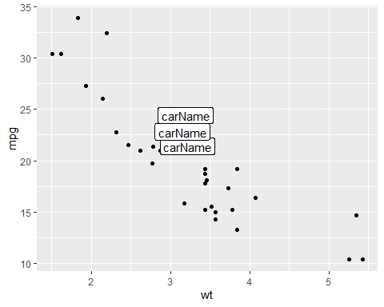

# create data  
xValue = c(1:10)  
yValue = cumsum(rnorm(10))  
data = data.frame(xValue, yValue)  
  
p = ggplot(data, aes(x = xValue, y = yValue)) +  
 geom_line()  
  
library(babynames)  
library(dplyr)  
str(babynames)

## tibble [1,924,665 × 5] (S3: tbl_df/tbl/data.frame)  
## $ year: num [1:1924665] 1880 1880 1880 1880 1880 1880 1880 1880 1880 1880 ...  
## $ sex : chr [1:1924665] "F" "F" "F" "F" ...  
## $ name: chr [1:1924665] "Mary" "Anna" "Emma" "Elizabeth" ...  
## $ n : int [1:1924665] 7065 2604 2003 1939 1746 1578 1472 1414 1320 1288 ...  
## $ prop: num [1:1924665] 0.0724 0.0267 0.0205 0.0199 0.0179 ...

don = babynames %>%  
 filter(name%in% c("Ashley", "Patricia", "Helen")) %>%  
 filter(sex=="F")  
  
ggplot(don, aes(x = year, y = n, group = name, color = name)) +  
 geom_line()

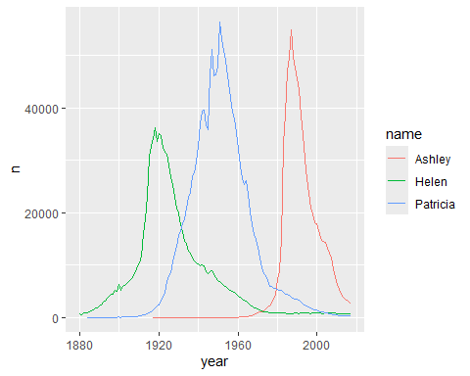 #boxplots

library(tidyverse)  
data(AirPassengers)  
data = data.frame(AirPassengers)  
  
ggplot(data, aes(x = "", y = AirPassengers)) +  
 geom_boxplot(fill = "lightblue") +  
 labs(title = "Boxplot of AirPassengers Dataset", x ="", y ="Number of Passangers")

## Don't know how to automatically pick scale for object of type <ts>. Defaulting  
## to continuous.

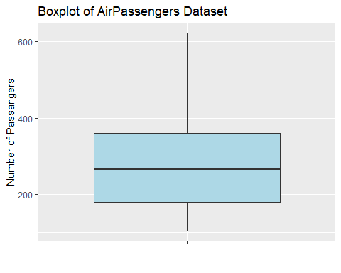 #Histograms

library(ggplot2)  
data(mpg)  
  
ggplot(mpg, aes(x = hwy)) +  
 geom_histogram(fill="blue", color = "white") +  
 geom_density() +  
 ggtitle("Highway MPG Distribution") +  
 labs(x = "Highway MPG", y = "Frequency")

## `stat_bin()` using `bins = 30`. Pick better value with `binwidth`.

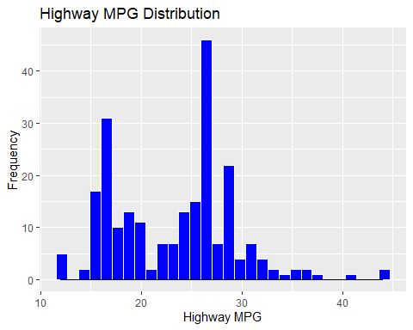 #Linecharts

#library(tidyverse)  
#data(economics)  
#head(economics)  
  
#ggplot(economics, aes(x = date, y = pce)) +  
# geom_line()  
  
#chart = ggplot(economics, aes(x = date, y = unemploy)) +  
# geom_line(color = "red", size = 1.5) +  
# labs(title = "U.S Unemployment Rate over Time", x = "Year", y = "Unemployment rate")  
  
#chart <- chart + scale_x_date(date_labels = "%Y", date_breaks = "5 years")

## R Markdown

This is an R Markdown document. Markdown is a simple formatting syntax for authoring HTML, PDF, and MS Word documents. For more details on using R Markdown see <http://rmarkdown.rstudio.com>.

When you click the **Knit** button a document will be generated that includes both content as well as the output of any embedded R code chunks within the document. You can embed an R code chunk like this:

summary(cars)

## speed dist   
## Min. : 4.0 Min. : 2.00   
## 1st Qu.:12.0 1st Qu.: 26.00   
## Median :15.0 Median : 36.00   
## Mean :15.4 Mean : 42.98   
## 3rd Qu.:19.0 3rd Qu.: 56.00   
## Max. :25.0 Max. :120.00

## Including Plots

You can also embed plots, for example:

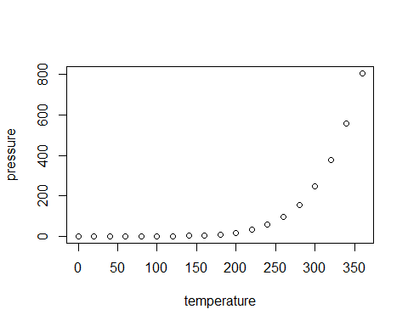

Note that the echo = FALSE parameter was added to the code chunk to prevent printing of the R code that generated the plot.