Homework 3 example: The effect of swear word use on pain tolerance

Bernhard Angele

16/10/2014

### Results

In order to evaluate the effect of swear word usage on pain tolerance, we performed a one-way between-subjects ANOVA with time until hand withdrawal as the dependent variable and swear word usage (quiet vs. neutral word vs. swear word) as the independent variable. Table 1 and Figure 1 show the condition means.

*Table 1. Means, sample sizes (N), standard deviations (SD), and standard errors (SE) for the swear word usage conditions.*

|  |  |  |  |  |
| --- | --- | --- | --- | --- |
| Condition | N | Mean | SD | SE |
| Neutral Word | 20 | 45 | 6.9 | 1.5 |
| Quiet | 20 | 46 | 5.7 | 1.3 |
| Swear Word | 20 | 60 | 7.3 | 1.6 |

*Figure 1. Condition means. Error bars denote 95% confidence intervals.*

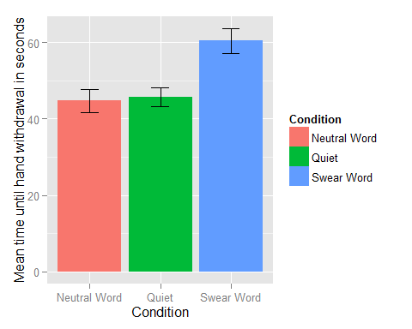

The ANOVA showed that overall, there was a significant effect of the swear condition, *F*(2, 57) = 34.74, $η^{2}$ = 0.55, *p* < .01. There was no evidence for unequality of variances from Levene's test (*p* > .05). Also, the Shapiro-Wilk test revealed no deviations from normality in the residuals (*p* > .05).

Post-hoc comparisons performed using Holm-Bonferroni corrected *t*-tests showed that the quiet condition (mean time until hand withdrawal: 45.75 s) and the neutral word condition (mean: 44.7 s) were significantly different from the swear word condition (mean: 60.45 s; quiet vs. swear word: *p* < .01; neutral vs. swear word: *p* < .01), but the neutral word condition did not differ significantly from the quiet condition (*p* > .05).

### Summary

Based on the results of our analyses, we can conclude that repeating swear words seemed to increase participants' pain tolerance compared to repeating neutral words or remaining quiet. Repeating neutral words did not seem to increase participants' pain tolerance compared to remaining quiet. It seems that using swear words in painful situations may be an effective strategy.