Homework 3

Your name here

Your date here

# Assignment

Here is another data set stolen from Andy Johnson. This one is about the relationship between alcohol and driving performance. Participants received either a drink with actual alcohol, a placebo drink that they thought contained alcohol, but actually didn't, or no drink at all. Run the ANOVA and perform the appropriate assumption checks. Report the results as shown in the file Homework3_template.Rmd. I've already started you off with opening the file below and adding a subject column -- you just have to make sure the working directory is correct.

In order to evaluate the effect of apparent alcohol content on driving skill, we performed a one-way between-subjects ANOVA with driving skill as the dependent variable and apparent alcohol content (alcohol vs. alcohol placebo vs. no drink control) as the independent variable. Table 1 and Figure 1 show the condition means.

*Table 1. Means, sample sizes (N), standard deviations (SD), and standard errors (SE) for the swear word usage conditions.*

|  |  |  |  |  |
| --- | --- | --- | --- | --- |
| Condition | N | Mean | SD | SE |
| Alcohol | 20 | 35.05 | 7.163 | 1.602 |
| Alcohol Placebo | 20 | 37.70 | 6.791 | 1.518 |
| No drink control | 20 | 54.90 | 7.398 | 1.654 |

*Figure 1. Condition means. Error bars denote 95% confidence intervals.*

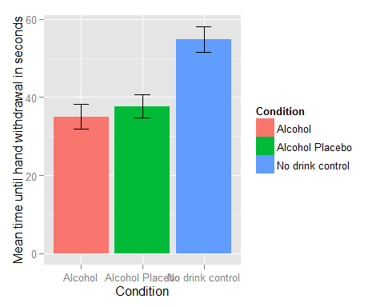

The ANOVA showed that overall, there was a significant effect of the swear condition, *F*(2, 57) = 45.8009, $η^{2}$ = 0.6164, *p* < .01. There was no evidence for unequality of variances from Levene's test (*p* > .05). Also, the Shapiro-Wilk test revealed no deviations from normality in the residuals (*p* > .05).

Post-hoc comparisons performed using Holm-Bonferroni corrected *t*-tests showed that the alcohol placebo condition (mean time until hand withdrawal: s) and the alcohol condition (mean: 35.05 s) were significantly different from the no drink control condition (mean: 54.9 s; placebo vs. no drink control: *p* < .01; no drink control vs. alcohol: *p* < .01), but the alcohol placebo condition did not differ significantly from the alcohol condition (*p* > .05).

### Summary

Based on the results of our analyses, we can conclude that repeating swear words seemed to increase participants' drive tolerance compared to repeating neutral words or remaining quiet. Repeating neutral words did not seem to increase participants' drive tolerance compared to remaining quiet. It seems that using swear words in driveful situations may be an effective strategy.