Homework 5 example: The effect of swear word use on pain tolerance

Bernhard Angele

30/10/2014

### Results

## Warning: Implementation of ANCOVA in this version of ez is experimental and not yet fully validated. Also, note that ANCOVA is intended purely as a tool to increase statistical power; ANCOVA can not eliminate confounds in the data. Specifically, covariates should: (1) be uncorrelated with other predictors and (2) should have effects on the DV that are independent of other predictors. Failure to meet these conditions may dramatically increase the rate of false-positives.  
## Warning: Covariate"Aggression" is numeric and will therefore be fit to a linear effect.

In order to evaluate the effect of swear word usage on pain tolerance and to take into account the current aggression levels of each participant, we performed an ANCOVA with time until hand withdrawal as the dependent variable, swear word usage (quiet vs. neutral word vs. swear word) as the independent variable, and state aggression (mean = 101.47, sd = 37.32). Table 1 and Figure 1 show the raw condition means.

*Table 1. Means, sample sizes (N), standard deviations (SD), and standard errors (SE) for the swear word usage conditions.*

|  |  |  |  |  |
| --- | --- | --- | --- | --- |
| Condition | N | Mean | SD | SE |
| Neutral Word | 20 | 45 | 6.9 | 1.5 |
| Quiet | 20 | 46 | 5.7 | 1.3 |
| Swear Word | 20 | 60 | 7.3 | 1.6 |

*Figure 1. Condition means. Error bars denote Fisher's LSD.*

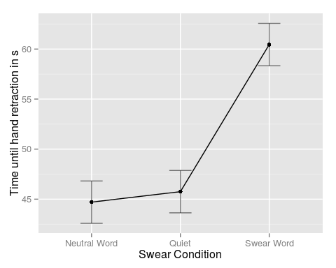

The ANOVA showed that overall, there was a significant effect of the swear condition, *F*(2, 56) = 45.22, $η_{P}^{2}$ = 0.62, *p* < .01. The covariate, state aggression, was significantly related to time submerged in the cold water, *F*(2, 56) = 18.25, $η_{P}^{2}$ = 0.25, *p* < .01. There was no evidence for unequality of variances from Levene's test (*p* > .05). Also, the Shapiro-Wilk test revealed no deviations from normality in the residuals (*p* > .05). There was no evidence for an interaction between swear condition and the covariate, *F*(2, 54) = 0.3, *p* > .05).

Planned contrasts showed that participants repeating a swear word (mean time until hand withdrawal: 60.45 s) held their hands in the cold water for significantly longer than participants in the quiet condition (mean time until hand withdrawal: 45.75; *b* = 14.7, SE = 1.85, *t* = 7.94, *p* < .01). The times until hand withdrawal for those participants who were repeating neutral words (mean time until hand withdrawal: 44.7 s) did not differ significantly from those in the quiet condition (*b* = -1.04, SE = 1.85, *t* = -0.56, *p* > .05)).

### Summary

Based on the results of our analyses, we can conclude that repeating swear words seemed to increase participants' pain tolerance compared to repeating neutral words or remaining quiet. Repeating neutral words did not seem to increase participants' pain tolerance compared to remaining quiet. It seems that using swear words in painful situations may be an effective strategy. Currently aggressive participants also tended to leave their hands in the water for longer time periods, but there was no evidence that state aggression affected the swear condition.