Erosion
The term erosion covers many naturally occurring phenomena. With that in mind, I will focus on 2 specific phenomena: thermal and hydraulic erosion.

Thermal erosion
Thermal erosion simulates material breaking loose and sliding down slopes to pile up at the bottom.

How does it work?
A percentage of the material at the top of a slope whose inclination is above a threshold value – the talus angle T – will be moved down the slope until the inclination reaches T.

A simplified example of thermal erosion:
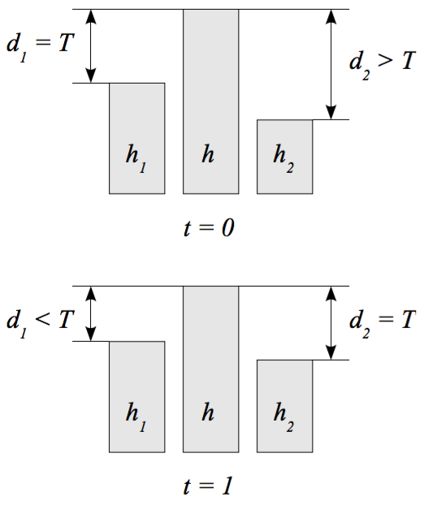
d₂ is greater than the talus angle T so material is moved from h to h₂ until d₂ equals T.

This of course is only a simplified example and for real world purposes an extended model for modified Von Neumann neighbourhoods is proposed.
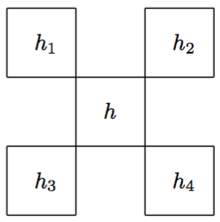

d_{max} is the greatest of the d_{i}
d_{total} is the sum of the d_{i} greater than T
A reasonable value for c should be somewhere around 0.5 but not higher to prevent oscillation
An example value for T would be 4/N.
N being the dimension of the heightmap (e.g. for a 512x512 heightmap, T would be 512)

Hydraulic erosion
Hydraulic erosion simulates changes to terrain caused by flowing water dissolving material, transporting it and depositing it elsewhere.

How does it work?
Similar to the material distribution in thermal erosion, water is being distributed to the neighbour cells instead and the distribution seeks to level out any height differences of the total altitude
a = h + w (h being the cell height, w being the water level height) so that a = a_{i} for each neighbourhood whose total height is less than that of the currently examined cell.

A simplified example of hydraulic erosion:
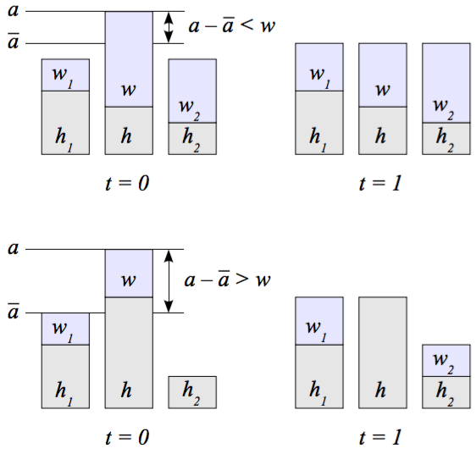
Two cases for water distribution in hydraulic erosion. In the first case, only a fraction of the water w is moved to level out the total height, while in the case all available water is distributed to the neighbours without reaching level.

The algorithm can be split up into four independent steps:
- Appearance of new water.
- Water eroding the underlying terrain and capturing the dissolved material.
- Transportation of water and sediment.
- Evaporation of water and deposition of sediment.

Apart from the height map, hydraulic erosion also maintains a water map and a sediment map for keeping track of the flow of water and dissolved material.

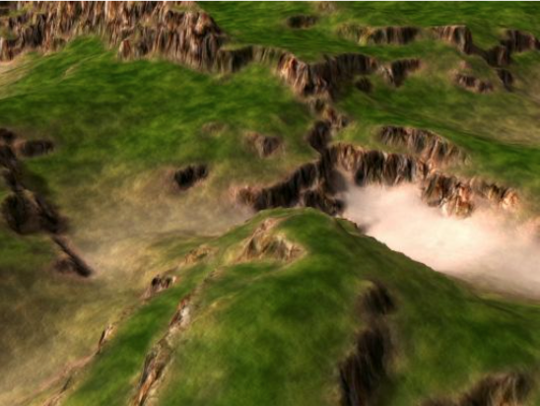
Optimizations
The algorithms proposed above are originally based on Ken Musgrave et. al. “The Synthesis and Rendering of Eroded Fractal Terrains” (1989). Jacob Olsen proposed several modifications which result in a more optimized version of the 2 proposed erosion algorithms. In his paper “Realtime Procedural Terrain Generation” he describes them as being fast (~2 seconds to generate a 512x512 eroded heightmap) but yet physically-realistic.

References
Jacob Olsen's “Realtime Procedural Terrain Generation” (2004)
Musgrave et. al. “The Synthesis and Rendering of Eroded Fractal Terrains” (1989)

