Proposal: Finger-tracking using touchless input devices

# Goal

Goal of this project is the evaluation of finger-tracking capabilities for touchless input devices. Primarily, the Leap Motion will be investigated. Research and evaluation of additional devices will also be performed (e.g. Kinect).

# http://www.real3dtutorials.com/images/img00045.jpgIdeas

To evaluate the finger-tracking capabilities of a device, a *bounding volume hierarchy* of a human hand is reconstructed from the device input data. Each finger contains three bounding volumes, one for each bone, in addition to two bounding volumes for the thumb. Fingers and thumb are attached on a bigger bounding volume for the palm/wrist. (<https://www.youtube.com/watch?v=1LHBlY9go7M>)

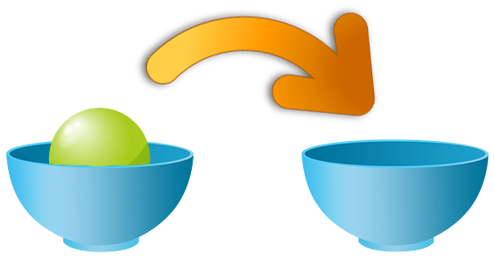Then, the bounding volumes of the reconstructed hand are loaded into a real-time physic simulation environment. In this environment the hand fully interacts with other entities (also bounding volumes). The user can move his hand freely and interact with objects in a very natural way – by touching and grabbing objects. (<https://www.youtube.com/watch?v=sAcTshfZCU8>)

A simple scenario will be the task to move a ball from one bowl to another bowl. Depending on the complexity of the scenario various tasks can be performed, like grabbing and moving things or opening doors. Even more complex tasks like playing a game of Jenga or solving a Rubik’s Cube are possible. (<https://www.youtube.com/watch?feature=player_detailpage&v=uo3QrcZlr_E#t=87>)

Depending on the accuracy of the device, and the user’s skills to a certain degree, the easiness of the task will be evaluated. With this evaluation data the suitability of a device in regard to its finger-tracking capability can be measured.

# Expected Results

The results of this project will be performed in several stages:

* First, a short survey about possible devices to evaluate is created.
* Based on the devices, a framework will be developed for generating the bounding volume hierarchy of the hand. This stage includes some basic visualization for the bounding volumes.
* In the third stage, the bounding volumes from the hand are loaded into a physics simulation environment. This include a simple scenario where the user has to grab and move an object.
* After the simple scenario, more advanced scenarios with more complex interactions and more sophisticated physics constraints will be created (e.g. solving a Rubik’s Cube).
* Based on the evaluation data from the scenarios, a conclusion about the capability and suitability for finger-tracking with touchless input devices is drawn.