# Intro

First, we decided that our application should be scalable upon a big number of clients. Therefore we first thought a lot about possible network topologies. A fully-connected graph would be easy to implement, but does not scale as well as a topology where each participant only knows a small subset of the infrastructure. We also decided against a pure UDP-broadcast solution because of the possible package loss, although UDP broadcasts and multicasts are predestinated for reaching a broad audience. Our decision fell on a spanning tree topology where packages are routed and flooded efficiently. This topology can be built simply, but is harder to maintain than fully connected graphs or connectionless topologies. Especially handling dead peers (disconnect, network failure) is tedious in spanning trees. Therefore, a fully connected infrastructure has also been implemented for comparison. The used network implementation is defined by the settings of the dependency injection framework.

Our second implementation decision regarded network technology and was based on the uncertainty whether an existing communication framework could realize our desired network topology or not. We considered using well-established technologies such as WCF, Remoting, App Spaces as presented in the lecture as well as the frameworks listed on the exercise sheet. However, we felt that all of these require some kind of distinguished super/server node. We therefore decided to not use any existing framework and rely on basic sockets for the time being. Although this decision might seem odd, as handling raw sockets is typically more fragile and harder than higher level communication frameworks, it turned out that the main difficulty was maintaining the network topology which is independent of network technology.

Concerning the data structure of the document, we decided not to partition the document into smaller pieces (e.g. per line or sentence) or represent it by a higher level structure. Therefore our text document is a simple string (-builder). Text changes, which are sent in the network, only contain the position in the text and the change itself. A change can include a string which will be inserted on a specified position, or a number of characters which should be deleted at a specified position. Furthermore, profiling sessions showed that operations on the document text data structure (string builder) are insignificant as the vast majority of runtime is consumed by the custom renderers of the UI as well as packet serialization inside the network stack.

# Architecture

Since we were not sure which network-framework would fit our need best, we designed our architecture with a flexible network layer. Therefore we specified a network layer which defined only interfaces and common network logic. On top of the network logic the document-layer defines the business logic for managing the document, the curser positions of the clients, etc. Finally, the editor-layer, which uses the WPF, displays the document text, and handles user input.

The following sections contains a more detailed description of each layer.

## Editor-Layer

The Editor only contains a single window (MainWindowView) and its corresponding ViewModel. Within the ViewModel everything we display in the GUI is stored. Changes made by the GUI are reflected to the view model, which are then forwarded to the document-layer. Some logic and some states of the ViewModel are introduced because not all changes are forwarded directly into the document. For instance, changes from the network which triggers updates in the ViewModel also causes the Gui to send change events. Events that are trigger by processing changes from the network are not forwarded into the network again to spare the network.

For preventing typing within the range of a “foreign cursor” we introduced a ranges where editing is not allowed. This ranges are displayed with different colors based on the clients IP and port. When the own cursor is moved into a forbidden region, the textbox is locked and editing is only possible when manually position the cursor into an allowed region. Additionally, editing on the first and after the last index of text is always possible.

The HighlightTextBox, derives from a normal WPF-Text box and overrides the Rendering procedure to visualize the color ranges. Two new Dependency Properties, the HighlightRanges and the CaretIndex, are added which are bound to the MainWindowViewModel.

## Document-Layer

The document layer specifies a document-interface for connecting to a document, submit text changes, and events for text- and cursor changes. Changes to the document caused by the UI (Editor layer) are converted into network packets and given to the network layer. Incoming packets from the network layer are integrated into the document’s state and usually trigger events which update the UI. The document layer therefore serves the purpose of a business logic and the data model by interpreting incoming packets and UI events as well as perform operations on the document data itself.

The document layer is also responsible for “merging” concurrent changes into the document. We started with an implementation of a simple merging strategy which merges the changes based on their arrival sequence. Tests with this merging strategy showed that, even when hammering onto the keyboards with two clients on two clients, there were no merging conflicts. Within the same LAN the latency is small enough, that no complex merging strategy was required. Still, we thought about implementing a vector clock for detecting possible merging conflicts, but we did not implement it because the simple merging worked fine.

## Network-Layer(s)

### Network interface

The stack of network layers is responsible for managing connections between participants (called peers) of the same document. The network layer is itself structured into several further layers to achieve a clean software architecture. The very top layer contains the technology independent C# interface INetwork which does not specify the underlying connection technology (e.g. TCP, UDP, WCF, etc.). This interface which is injected into the document layer and offers the following four interactions:

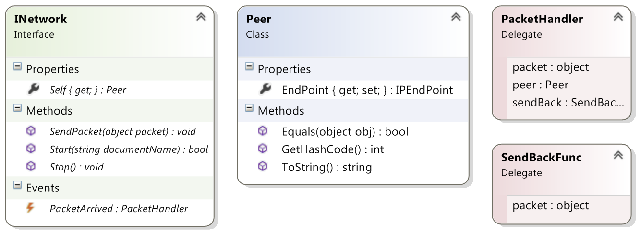

* Start(): Initializes the network layer and triggers construction of the network topology. This method requires the document name which is used as an identifier on the network to find peers of the same document. The return value of Start() indicates whether a peer could be found (true) or the current application instance is the first peer for the given document name.
* Stop(): Shuts the network down. Disconnects from all peers of the network topology. After a call to this method no further packages can be sent or are received.
* SendPacket(): Sends a packet into the network. Although packets are themselves classes and all packet types used by the document layer are defined, this method accepts any object. The object passed to SendPacket() is serialized into a binary representation which is then transmitted to all (or one) peers of the network. Generally (apart from forwarding and custom packets) the network layer does not interpret the objects passed to this interface.
* PacketArrived: Event which is raised whenever a packet arrives from the network. This packet can again be any object. In addition to the packet data (object) an instance of Peer is delivered, which serves as a unique descriptor of a peer on the network. The provided sendBack delegate enables higher layers to directly respond to an individual peer as opposed to the SendPacket() method which does not allow the specification of a target.
* Self: Retrievable property holding an instance of Peer which describes the own node/peer on the network. This property is mostly used by the network layer itself to identify the current instance to other peers on the network.

On the highest network layer several kinds of (business logic) packets are available to describe changes to the document and the environment:

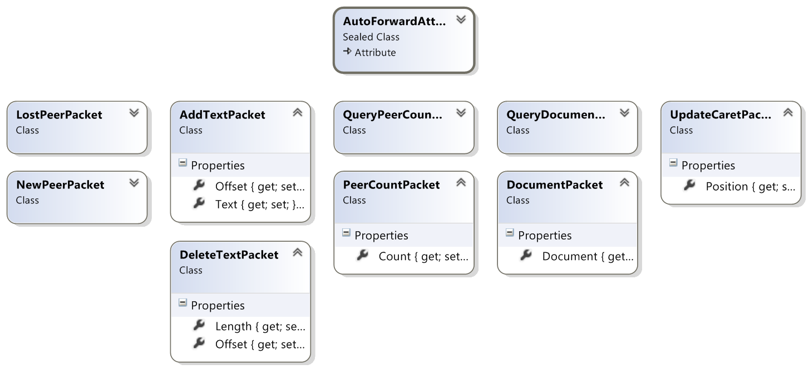

* NewPeerPacket/LostPeerPacket to inform other peers on the network that a peer has been added to the network or connection has been lost,
* The AddTextPacket/DeleteTextPacket for document text changes,
* *QueryPeerCount*/*PeerCountPacket* for querying the current number of participants on the network for the set document name,
* *QueryDocumentPacket*/*DocumentPacket* for querying and receiving the whole document text and
* UpdateCaretPacket for updating the caret position.

The optional attribute AutoForward can be declared on any packet and specifies that the packet should be forwarded to all peers of the network or only to a certain destination. Packets names in italic do not have the AutoForward attribute and are typically used to query information from a single peer.

### TCP network commons

## Network.Tcp.SpanningTree-Layer

TODO

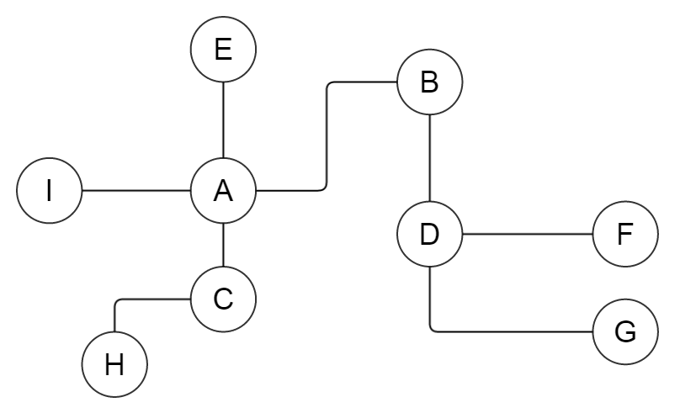

## Network.Tcp.CompleteGraph-Layer

TODO

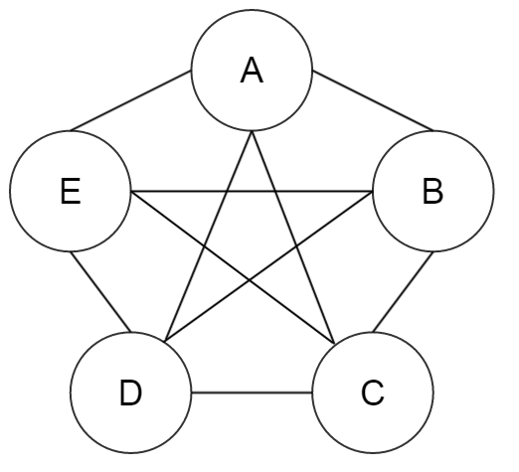

# Network Algorithms

The algorithms and concepts described in the following sections refers to our TCP-SpanningTree-Layer implementation.

## Topology

When connecting to the network, a client connects to a single “parent” client. This way, the clients form a spanning tree as each client connects to another one except the first client. Packages forwarded into the network are not able to be forwarded infinitely because of the lack of cycles in the topology. Because we have n-1 connections established between n clients, it is not possible to form a cycle.

## Connect to Network

When connecting to a network, the client sends a broadcast, looking for other clients with the same document. TODO which client connects to which client?

## Send Packages

## Connection Loss

# Concurrency mechanisms

The network and logic are not actively using any concurrency mechanisms, as we never experienced concurrency issues. This might come from the fact that most actions are forwarded and reflected to the view model in the GUI and the WPF-bindings schedules changes and events correctly into the GUI-thread. However, as each network link has its own receiver thread, multiple threads may run through the network layer as well as network events can be raised concurrently from different threads. As a consequence a few locks are required (e.g. when accessing the TCP listener, the collection of network links or the document string).

# Difficulties and Known Bugs

The management of connections, especially the repair mechanism turned out to be very difficult to implement.

We started developing the client as a pure network-application and therefore never expected to run multiple client on the same machine. Because we initially used the IP-address and a well-known port for our application, the changeover to a different identifier and a flexible port was rather troublesome. The current implementation supports multiple peers on the same machine but on the cost of implications on the network layer. For example the TCP listener’s port is found by try and error and also has to be communicated to other peers. Furthermore, an opened TCP listener has to be kept open for the application’s lifetime. Otherwise the same port could be chosen by another instance running on the same machine and peers would no longer be uniquely identified by the IP and port of their TCP listener.

# Performance

Our main performance issue emerges not from network or synchronization overhead. Instead it turned out that our custom Textbox, which highlights the locked regions near other editors’ cursors, is very inefficient. The rendering procedure takes quite long and we weren’t able to fix it.

Although, network traffic and overhead cannot be neglected. Packages only contains small changes to the document, a lot of small packages are sent into the network. Collecting changes over some time and sending one big package with all gathered information could reduce some overhead.

Zusätzlich zur Implementierung soll ein etwa 3-4 seitiger Bericht geschrieben werden, der zumindest folgendes beschreibt:

• Beschreiben Sie Ihre Implementierung. Welche Entscheidungen wurden getroffen und warum?

• Wie sieht ihre Lösung in Bezug auf Concurrency, Zugriffskoordination und Synchronisierung aus? Warum haben Sie sich für die gewählten Lösungsansätze entschieden? Welche verschiedenen Ansätze haben Sie ausprobiert und mit welchem Ergebnis?

• Für welches Kommunikationsframework haben Sie sich entschieden und warum?

• Wie viele gleichzeitige User schafft Ihre Lösung? Welche Probleme/Performanceeinbußen haben Sie dabei beobachtet?

• Auf welche Schwierigkeiten sind Sie gestoßen?

• Wieviel Zeit haben Sie wofür gebraucht?