Datasets and Exploratory Analysis
We use two complementary public datasets. CRADLEBench (Byun et al., 2025) provides real, clinician-annotated crisis labels over help-seeking posts, while DeepSuiMind (Li et al., 2025) provides synthetic dialogues that isolate implicit suicidal ideation. Our exploratory analysis examines label structure, class imbalance, text length, and data quality across both.
CRADLEBench. 8,259 help-seeking posts (train 7,239 / dev 420 / test 600) in a multi-label task tagging each post with <crisis_type>_<temporal> or no_crisis; it is the first crisis benchmark to add temporal (ongoing/past) labels. Labels are strongly imbalanced (Figure 1): no_crisis dominates (2,500 occurrences), followed by self-harm (1,715), passive (1,171) and active (909) suicide ideation, domestic violence (921), rape (800), sexual harassment (692), and child abuse/endangerment (311); most posts carry one label but up to four. The temporal skew is clinically informative — 4,262 ongoing vs. 2,257 past overall, with self-harm and suicide ideation mostly ongoing but rape and child abuse mostly past — making temporal state a first-class modelling target. Self-harm and suicide ideation co-occur most often. The raw labels required normalizing 245 malformed entries (e.g. 'No crisis', 'suicideideation(passive)'), cutting the vocabulary from 22 to 15 tags.
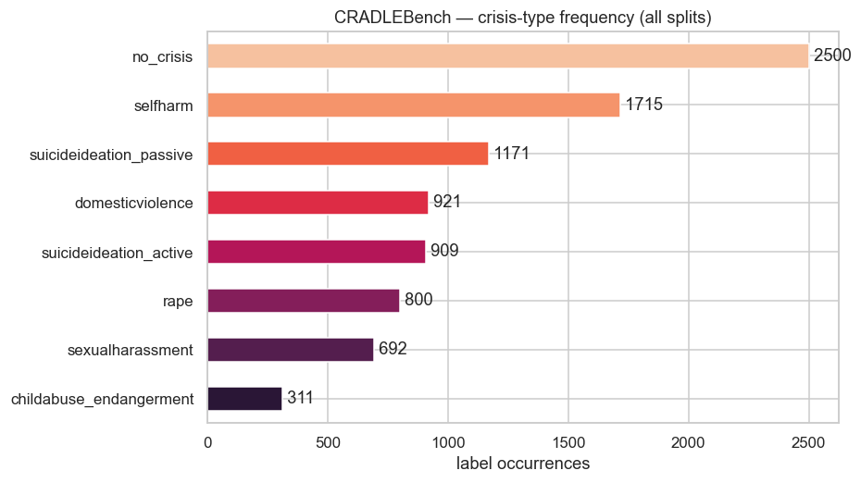
Figure 1: CRADLEBench crisis-type frequency (all splits, normalized labels).
DeepSuiMind. Fully synthetic: 1,605 narratives (median 306 words; no missing values or duplicates), each tagged with a Scenario (11 situations, led by Depression and Loneliness), a Negative Core Belief (~11 cognitive distortions, led by Emotional Reasoning), and a D/S-IAT Intention Category. After fixing hyphen/space spelling variants (268 rows), Intention resolves to three balanced classes: Death-Me (537), Death-Not-Me (534), and Life-Not-Me (534).
Comparison and implications. The datasets differ in unit, label scheme, and provenance (Table 1): CRADLEBench is real, multi-label, and shorter/variable in length; DeepSuiMind is synthetic, categorical, and length-bounded. The real-vs-synthetic domain gap and the class imbalance directly shape our preprocessing, imbalanced-data optimization, and evaluation design.
 | CRADLEBench | DeepSuiMind
Rows | 8,259 | 1,605
Unit | help-seeking post | synthetic narrative
Task | multi-label crisis + temporal | categorical (scenario/belief/intent)
Median words | 143 | 306
Provenance | real, clinician-annotated | fully synthetic
Table 1: Summary comparison of the two datasets.
References: Byun et al. (2025), CRADLE Bench, arXiv:2510.23845. Li et al. (2025), Can LLMs Identify Implicit Suicidal Ideation?, Findings of EMNLP 2025, arXiv:2502.17899.

