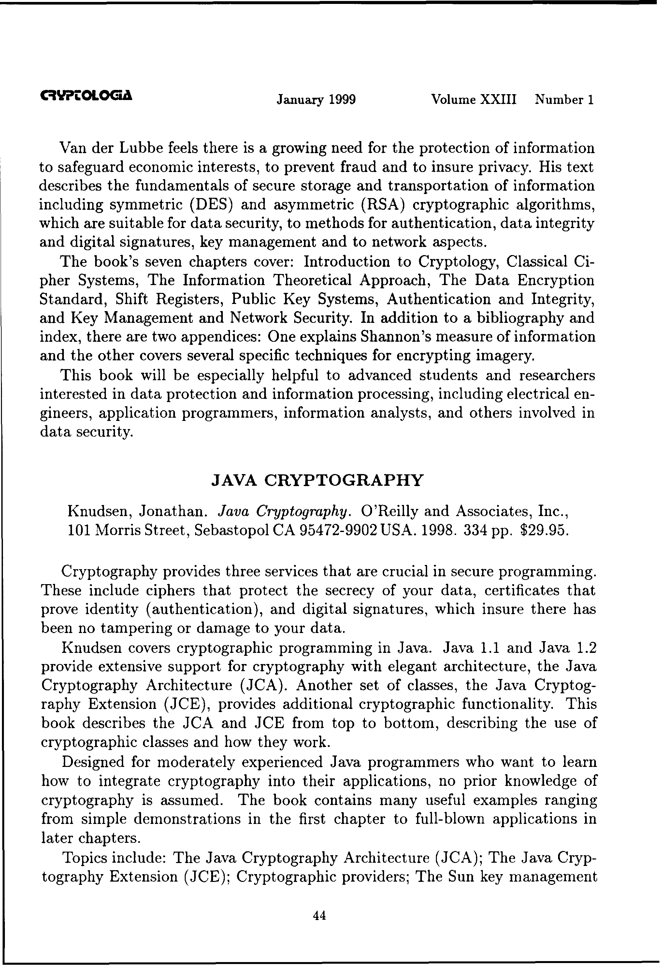**Java cryptography**

Kruh, Louis

*Cryptologia;* Jan 1999; 23, 1; Science Database

pg. 44

