**Exercise 4-1 Modify a web page**

1. Start IDE and open the ch04_ex1_survey project in ex_starts dir

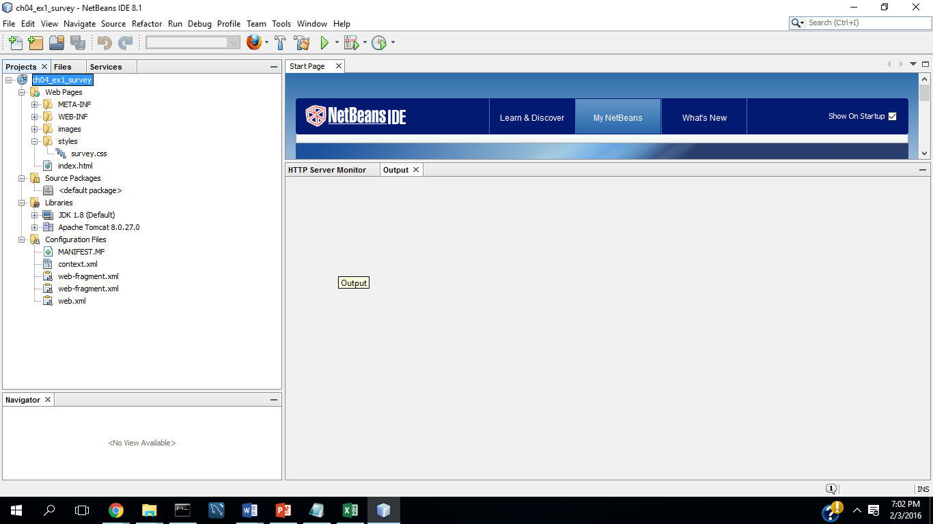

1. Open the index.html page and review its html

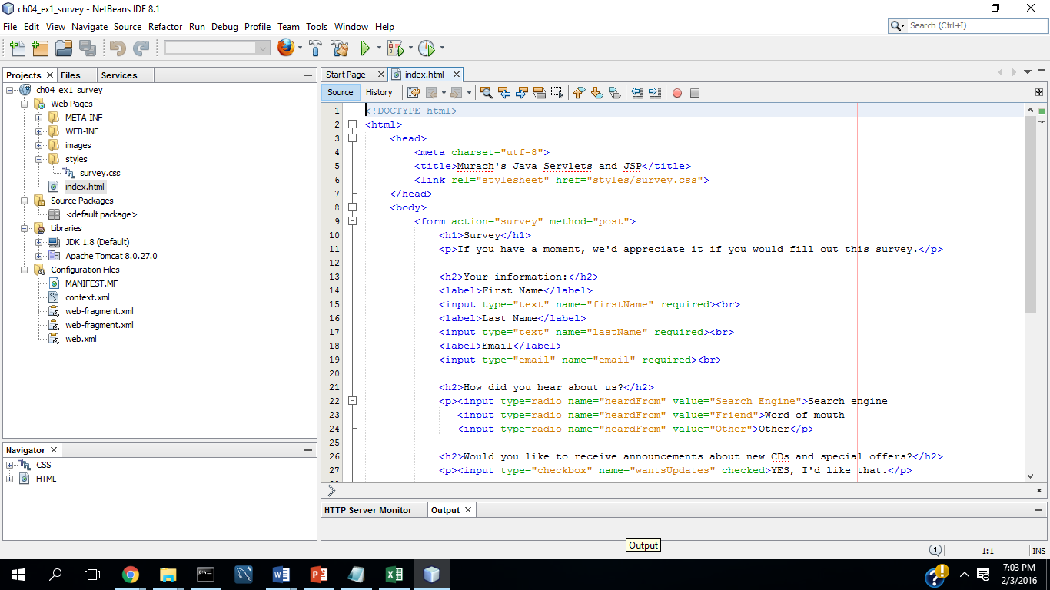

1. Open the survey.css in the styles subdirectory and review its CSS

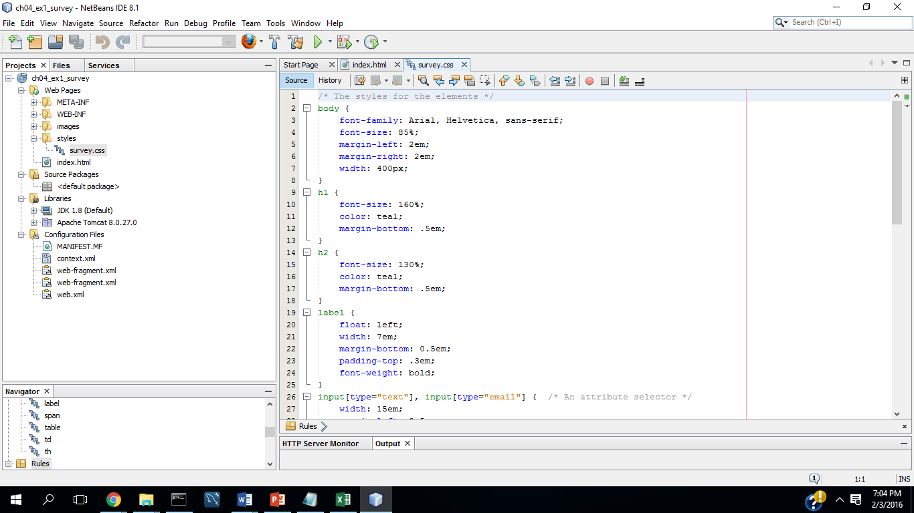

**Test the page:**

1. Run the project. This should display the web page in your browser. In the browser’s address bar, the URL for the page should use the Tomcat server.

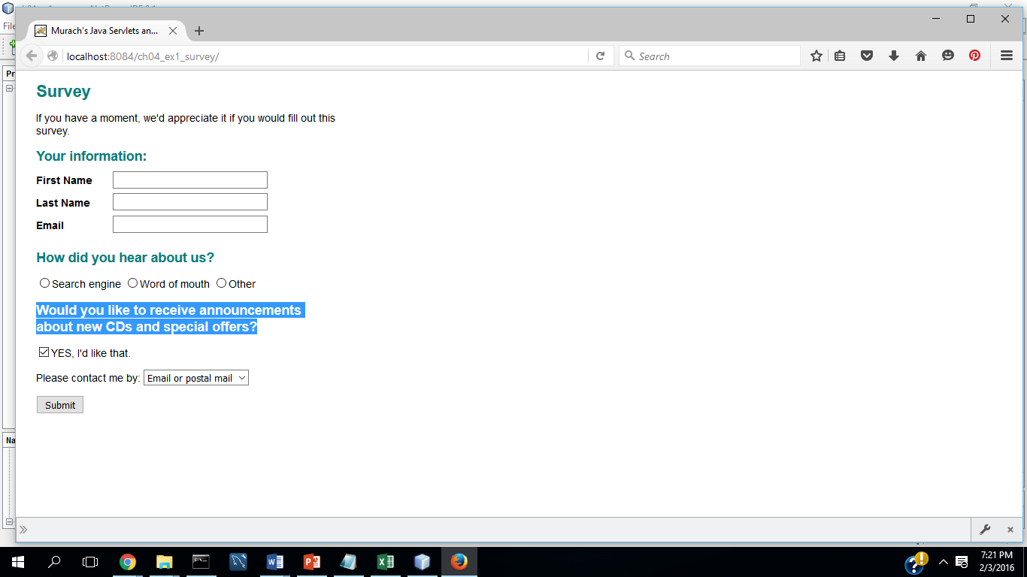

1. Open the Windows Explorer and double-click on the index-html file that’s in the ch04survey/web folder to display the page in your web browser. This time, the URL for the page will use the file system, not the Tomcat Server.

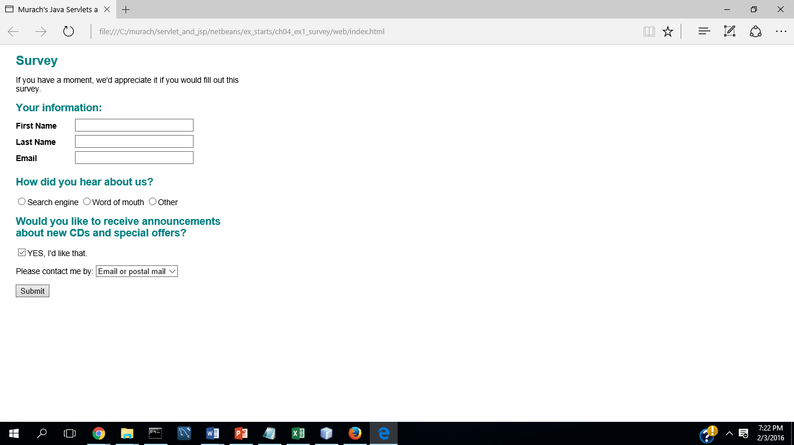

1. Run the project again. When Tomcat displays your page click the Submit button. Since you didn’t enter the required fields, this should cause the browser to display an error.

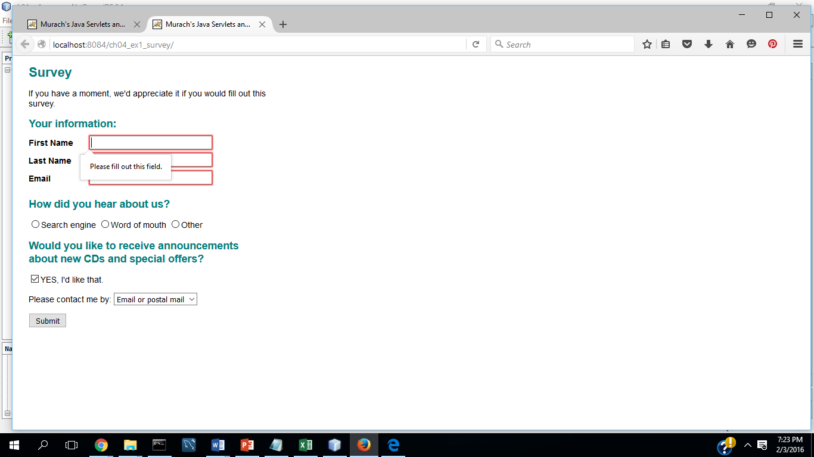

1. Fill out all required fields and click the submit button again. This should request this URL:  
   <http://localhost:8080/ch04_ex1_survey/survey>

For now, this will display an error that indicates that no resource exists at this URL. In the next chapter you will learn to map a servlet to this URL

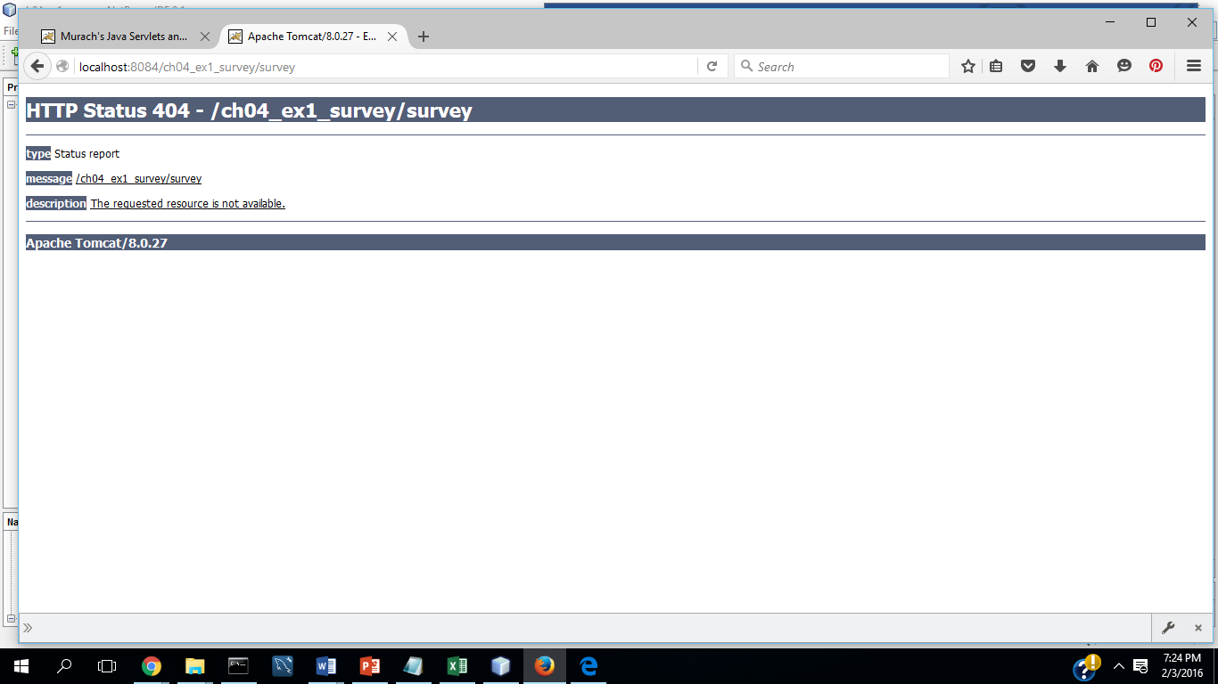

Modify the page

1. Edit the survey.html page so it displays the image for the Murach’s logo at the top of the page. This image should be in the images directory of your webapp

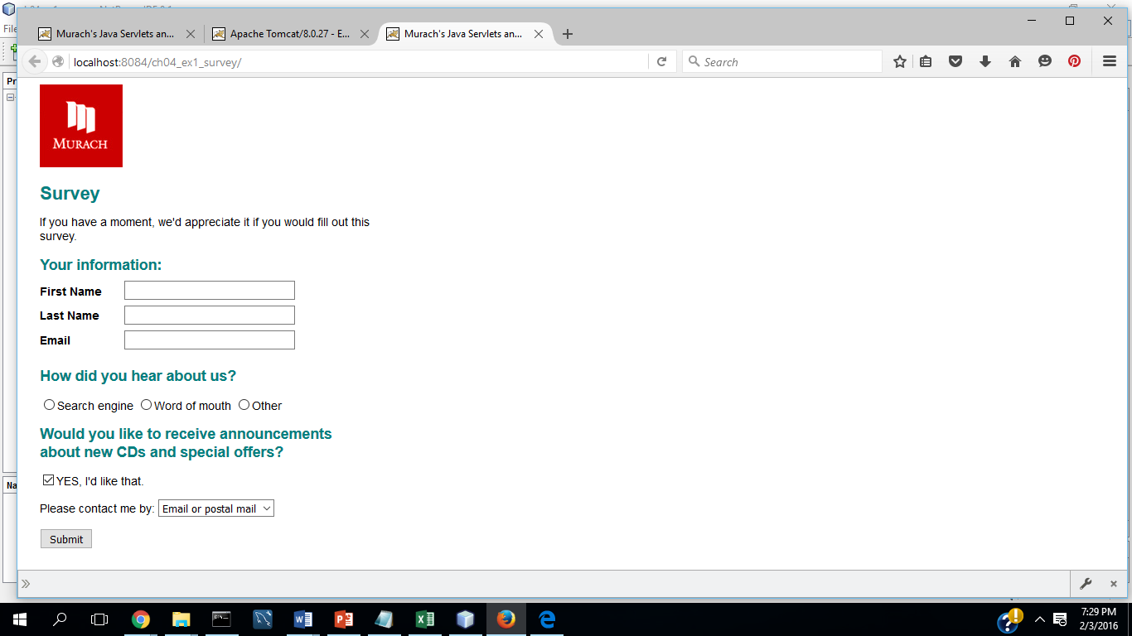

1. After the label and text box that let the user enter an email address, add another label and text box that let the user enter a dob. This should be optional, not required.

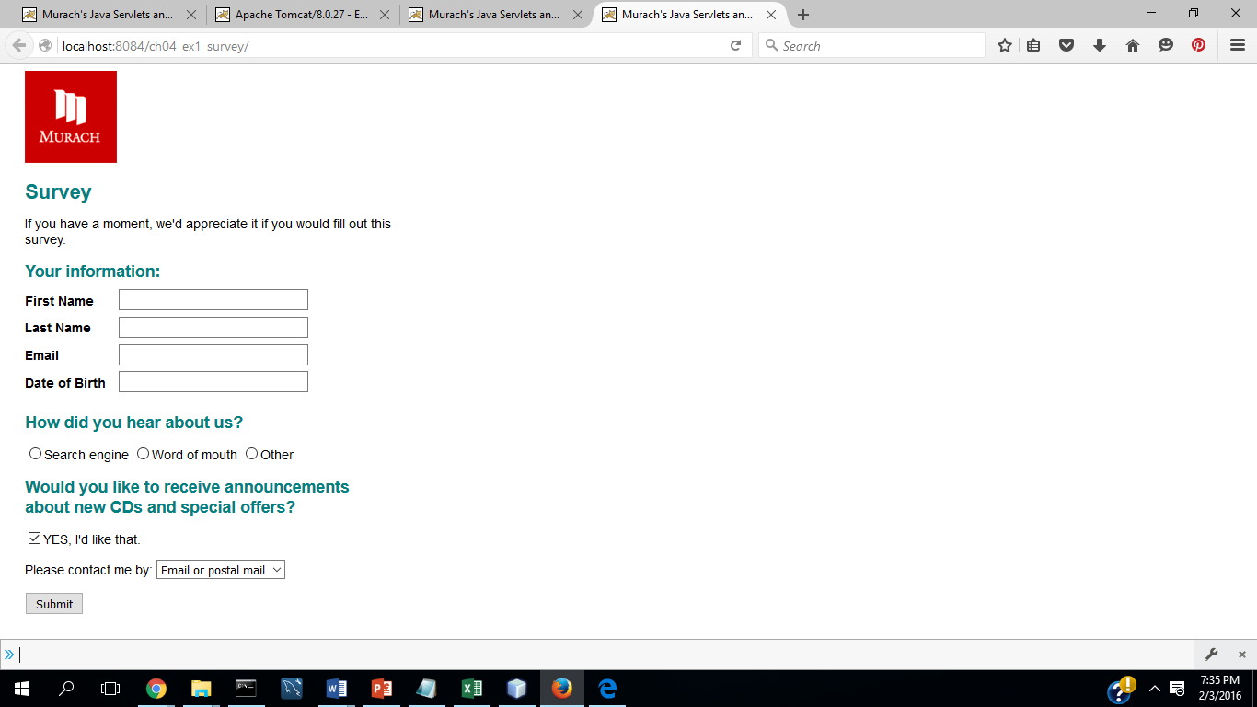

1. Turn the Search engine button on as the default button for the group of radio buttons.

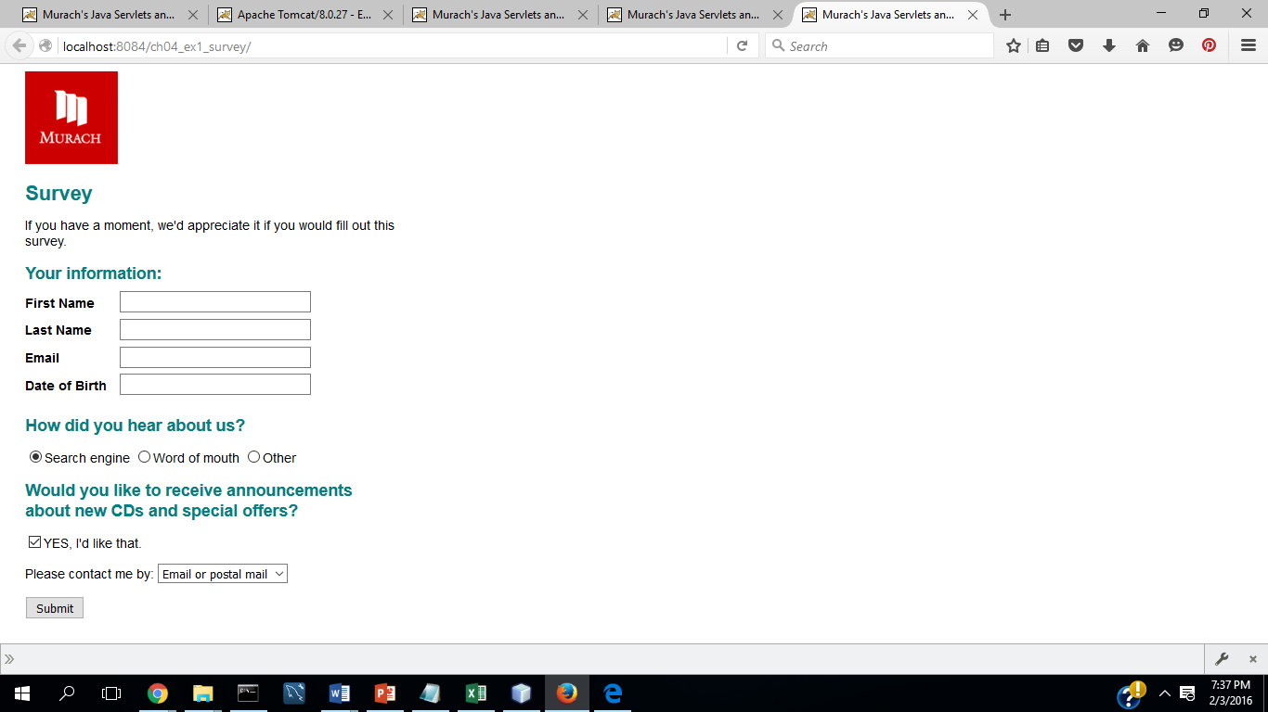

1. Add a social Media radio button before the other radio button

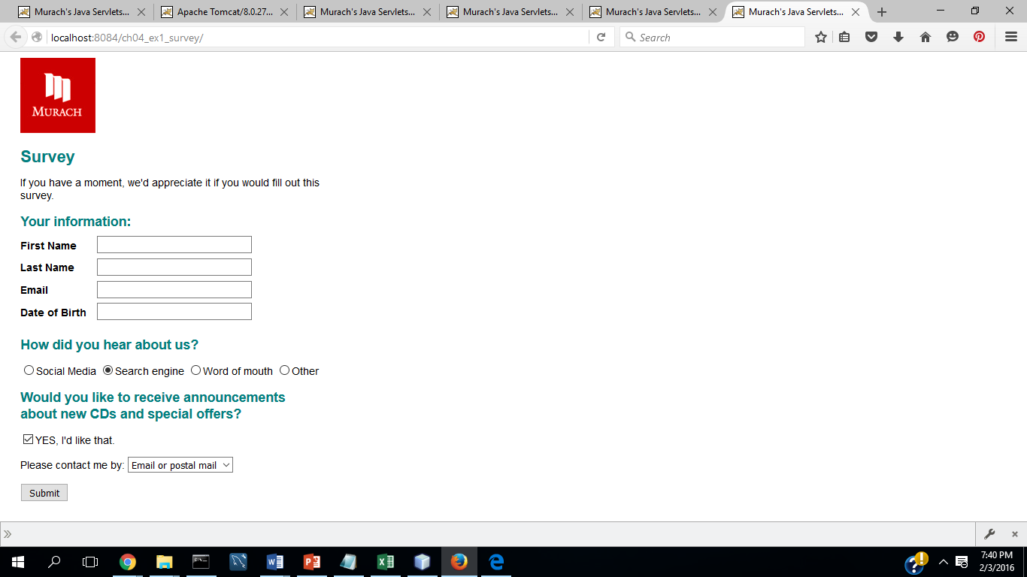

1. After the check box, add another check box with a name of emailOK and text that says, “YES, please send me email announcements.” Then modify both check boxes so that neither one is checked by default

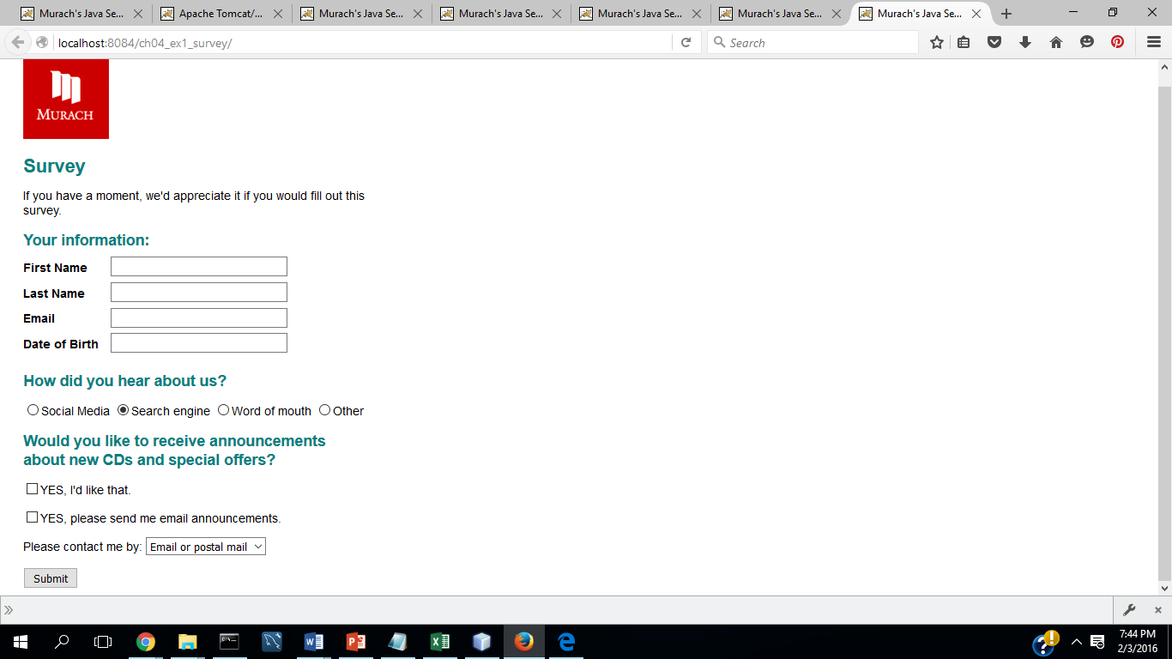

1. When you’ve got everything working right, close the project.

