Bernice Templeman

CIS 5740/ Spring 2016

Program 4-1

Program 4-1: Product Maintenance

For this project, you’ll create a series of pages that allow you to add, update, or delete a product that’s available to the application. (*Prerequisites: chapters 1-9*)

Program 4 (Part 1) Chapters 1-9

**(a) Input/Output - Screen shots showing input/output for each part.**

**TC1: Add a product**

**1.) Start Application**

**The index page:**

* When the application starts, it displays the Index page. This page contains a link that leads to the Products page that can be used to add, update, or delete products.

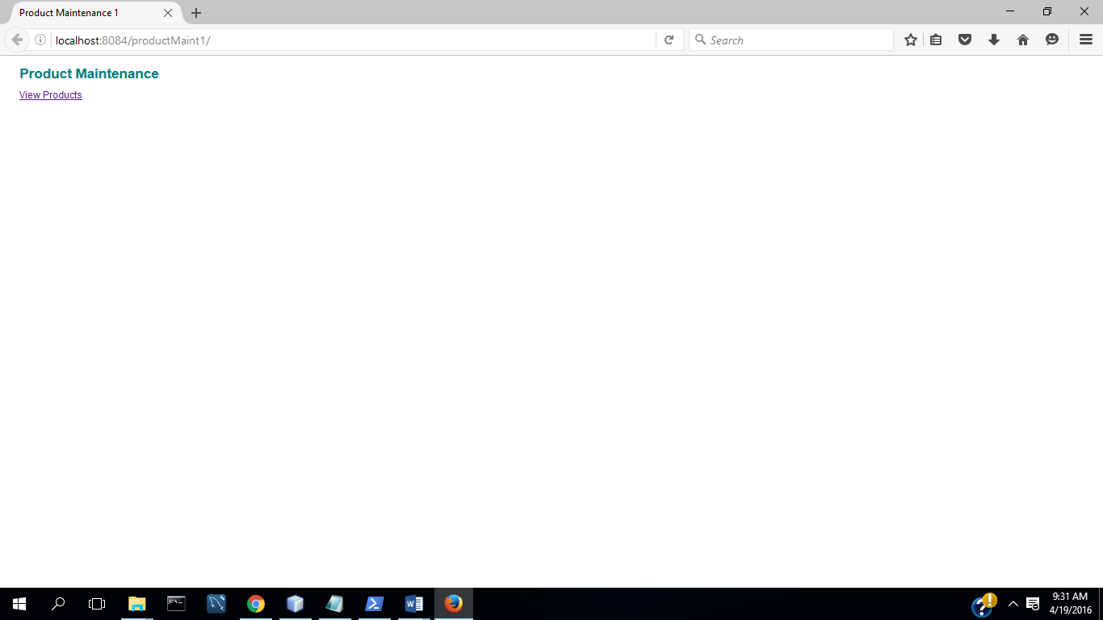

**2.) Select View Products**

**The Products Page:**

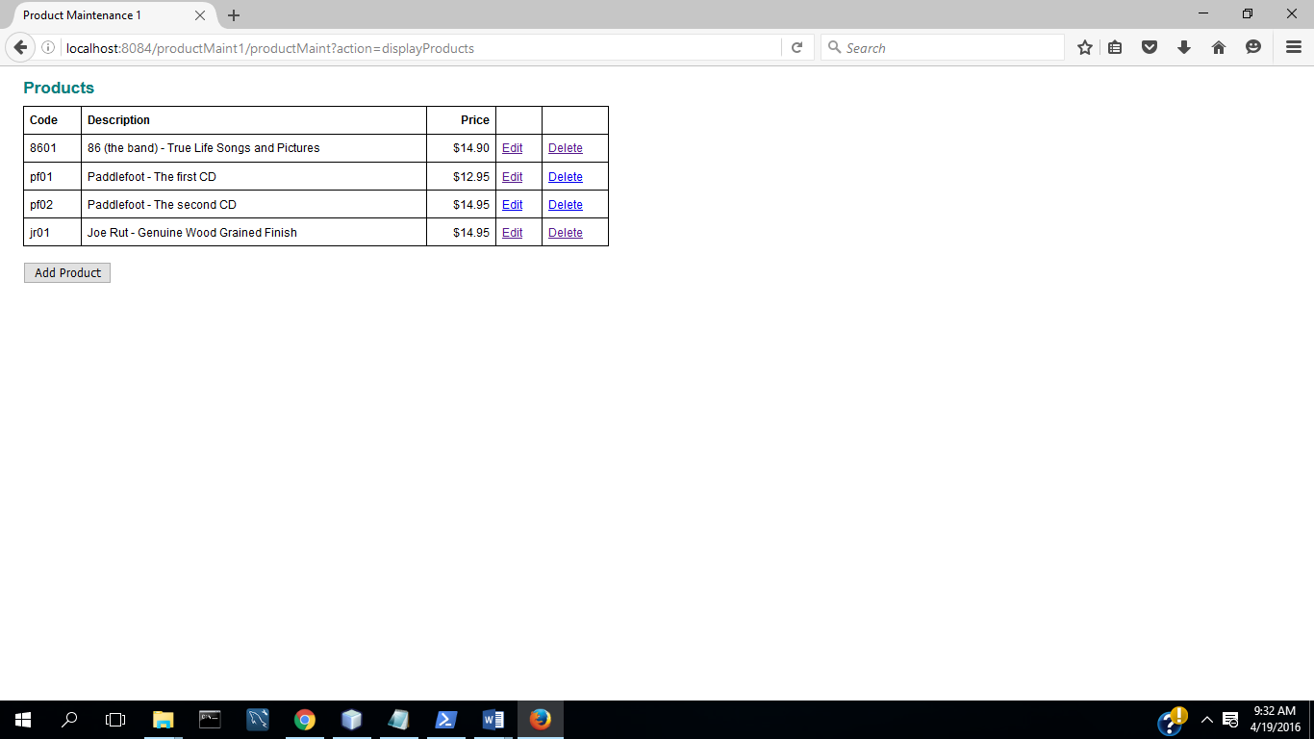

**3.) Select Add Product**

**The Product Page:**

* To add a new product, the user selects the Add Product button. This displays the Product page with all text fields empty. 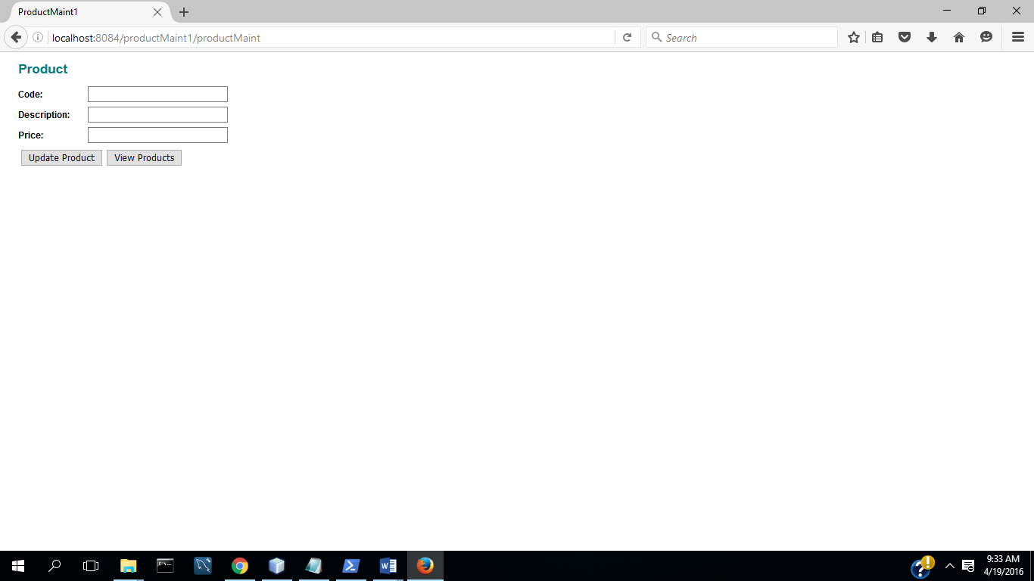

**(4) Complete fields with valid data**

* Then, the user can fill in the text fields and click on the Update Product button to add the product.

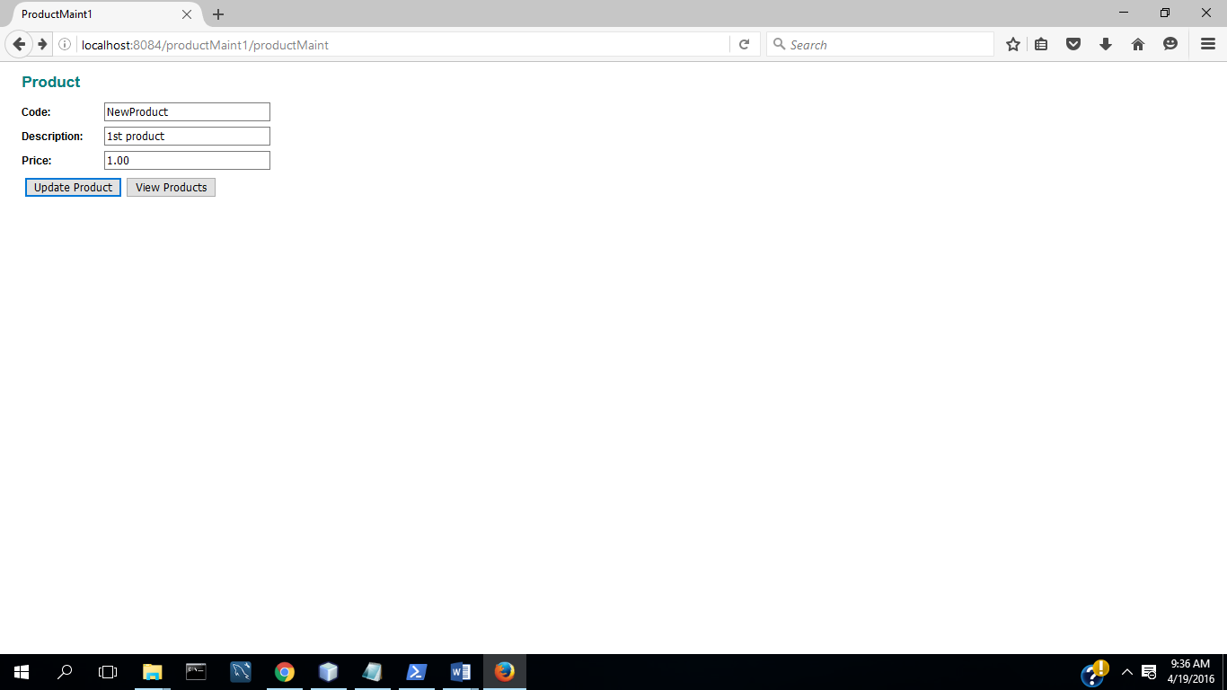

**(5) Select Update ( Commit Transaction & Update Inventory)**

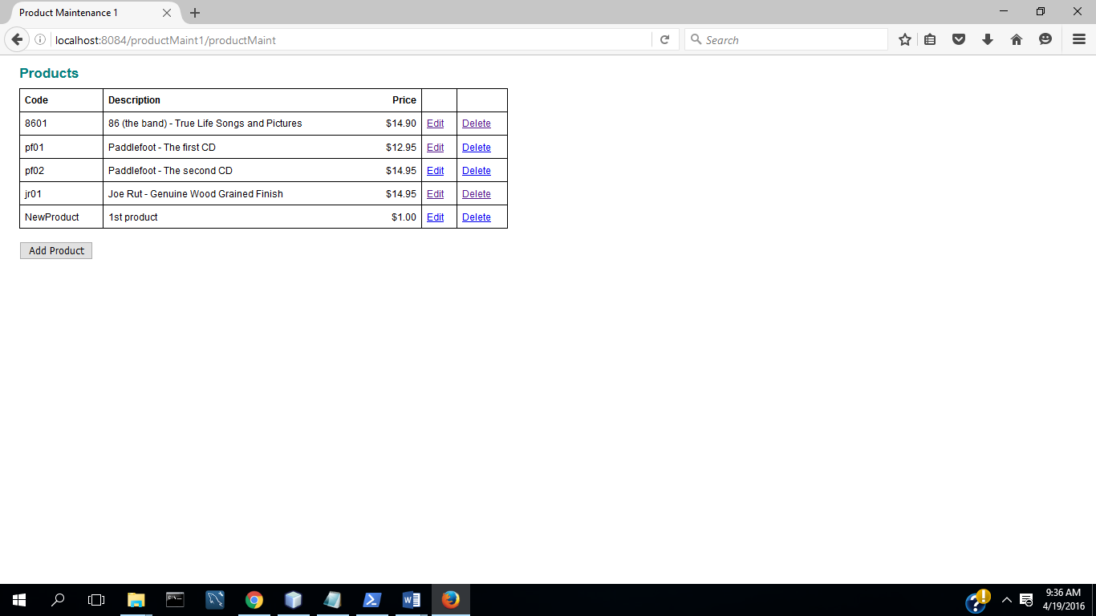

**TC2: Update a Product**

**(1) Select Edit Product**

* To edit an existing product, the user selects the Edit link for the product. This displays the Product page with all existing data for the product displayed.

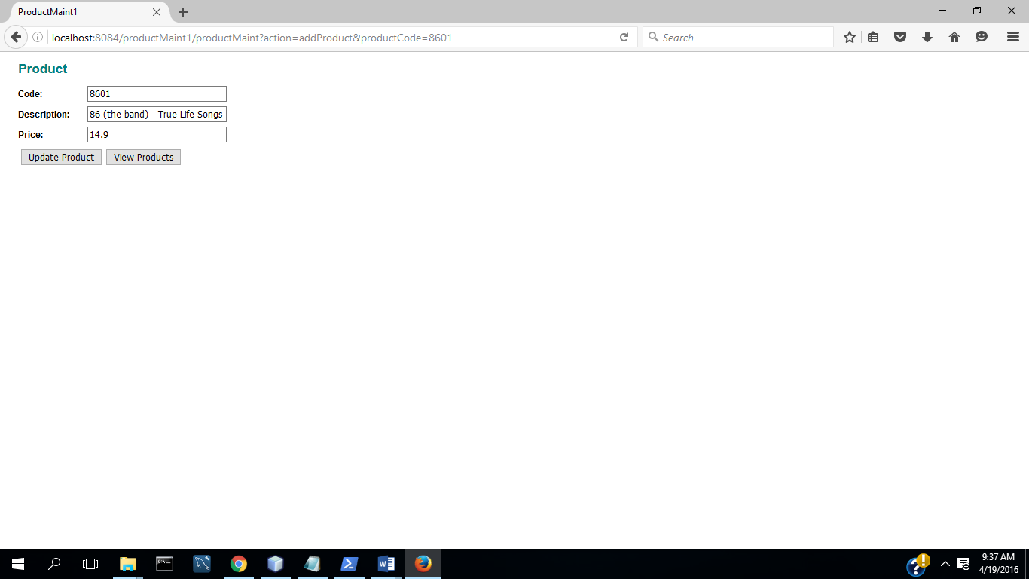

**(2) Change description and price**

* Then, the user can edit any entries and click on the Update Product button to update the data for the existing product.

(3) Select Update( Commit Transaction &Update Inventory)

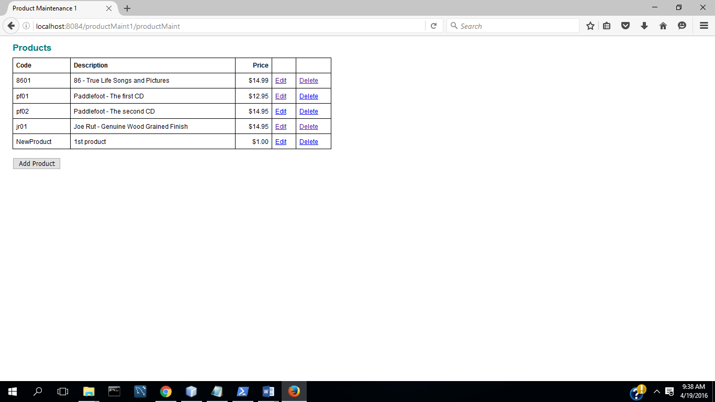

**TC3: Delete a Product**

1. Select Delete Product

The Confirm Delete Page:

* To delete a product, the user selects the Delete link for the product. This displays the Confirm Delete page. Then, if the user confirms the deletion by selecting the Yes button, the product is deleted and the Products page is displayed to reflect the new data. If the user selects the No button, the Products page is displayed.

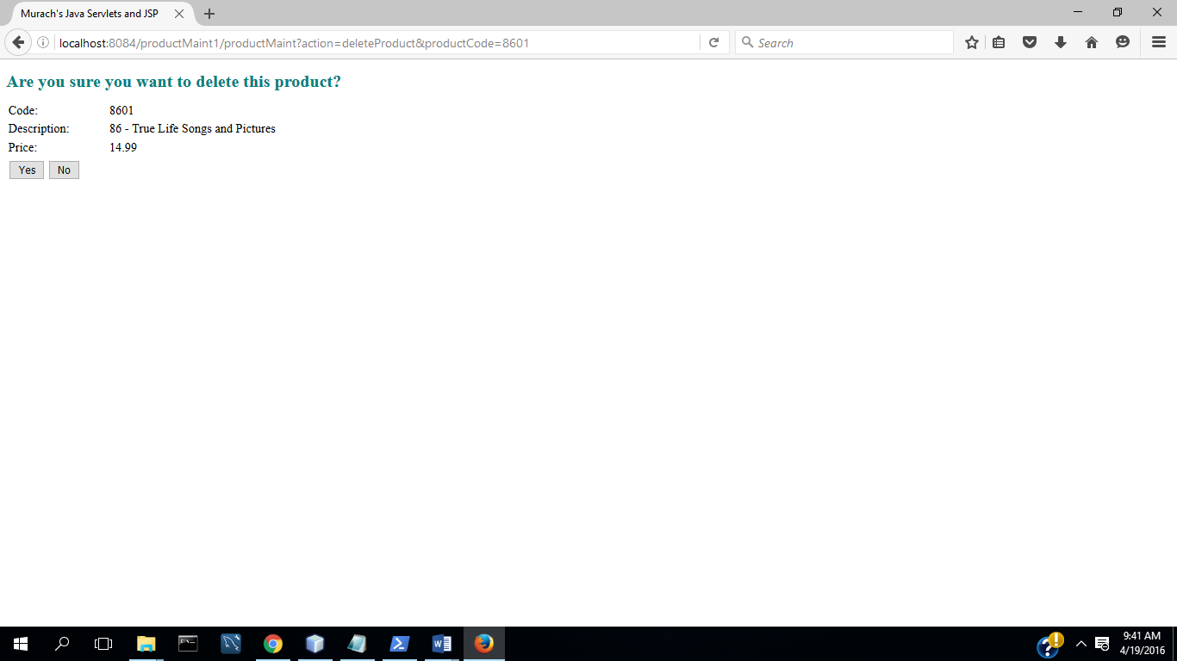

2. Select No

Delete Product: No Selected:

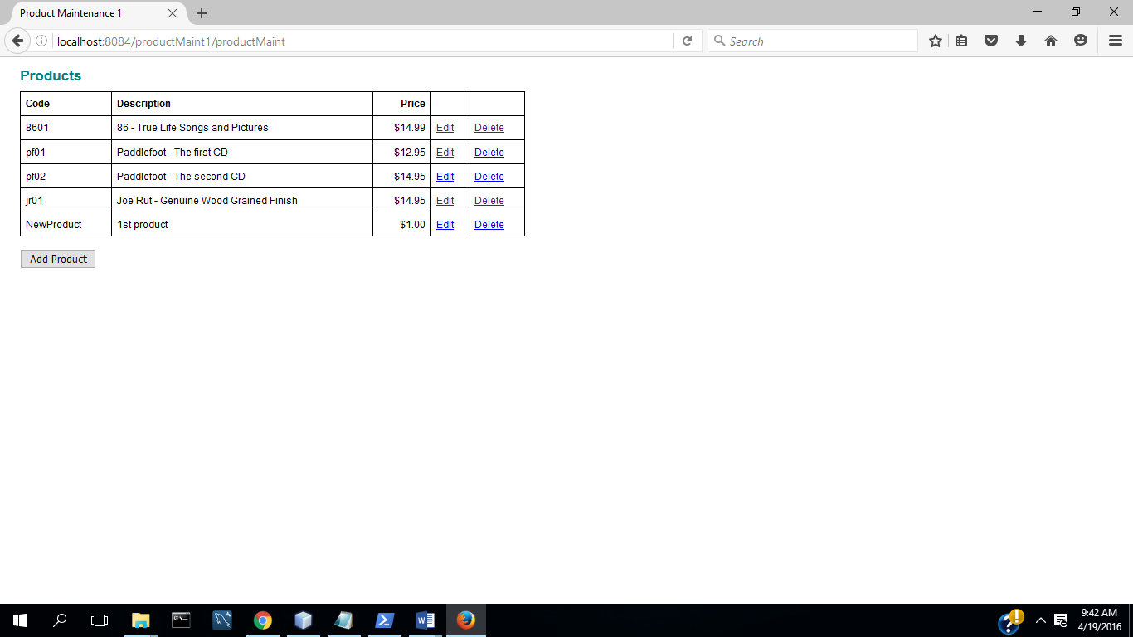

3. Select Delete Product

4. Select Yes (Commit Transaction &Update Inventory)

Delete Product: Yes Selected:

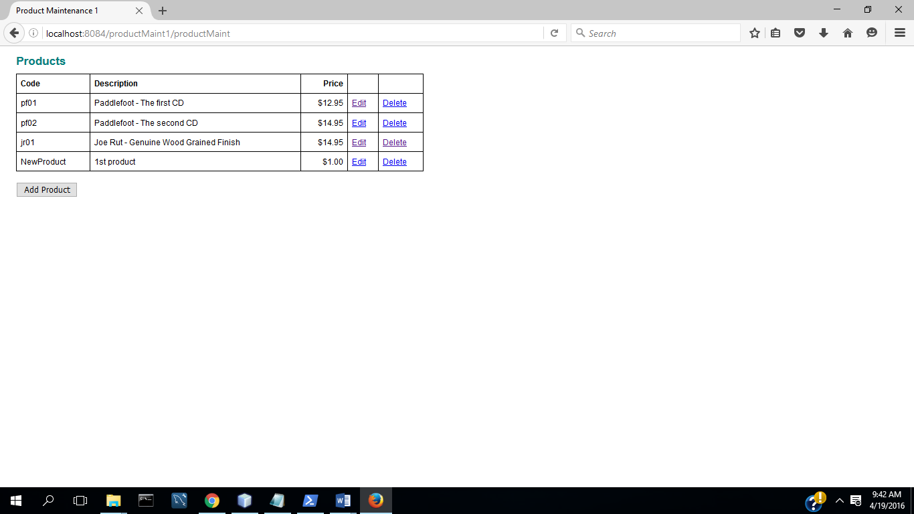

**(b) All program code for each part.**

**All code is in the zipped NetBeans project directory**

* Use a Product class like the one shown later in this document to store the product data.
* Use a ProductIO class like the one shown later in this document to read and write the product data to a text file named products.txt in the WEB-INF directory.
* Use a text file like the products.txt file shown later in this document as a starting point for the products that are available to the application.
* Use server-side validation to validate all user entries.

In particular, make sure the user enters a code, description, and price for each product.

In addition, make sure the product’s price is a valid double value.

**Server-Side Validation:**

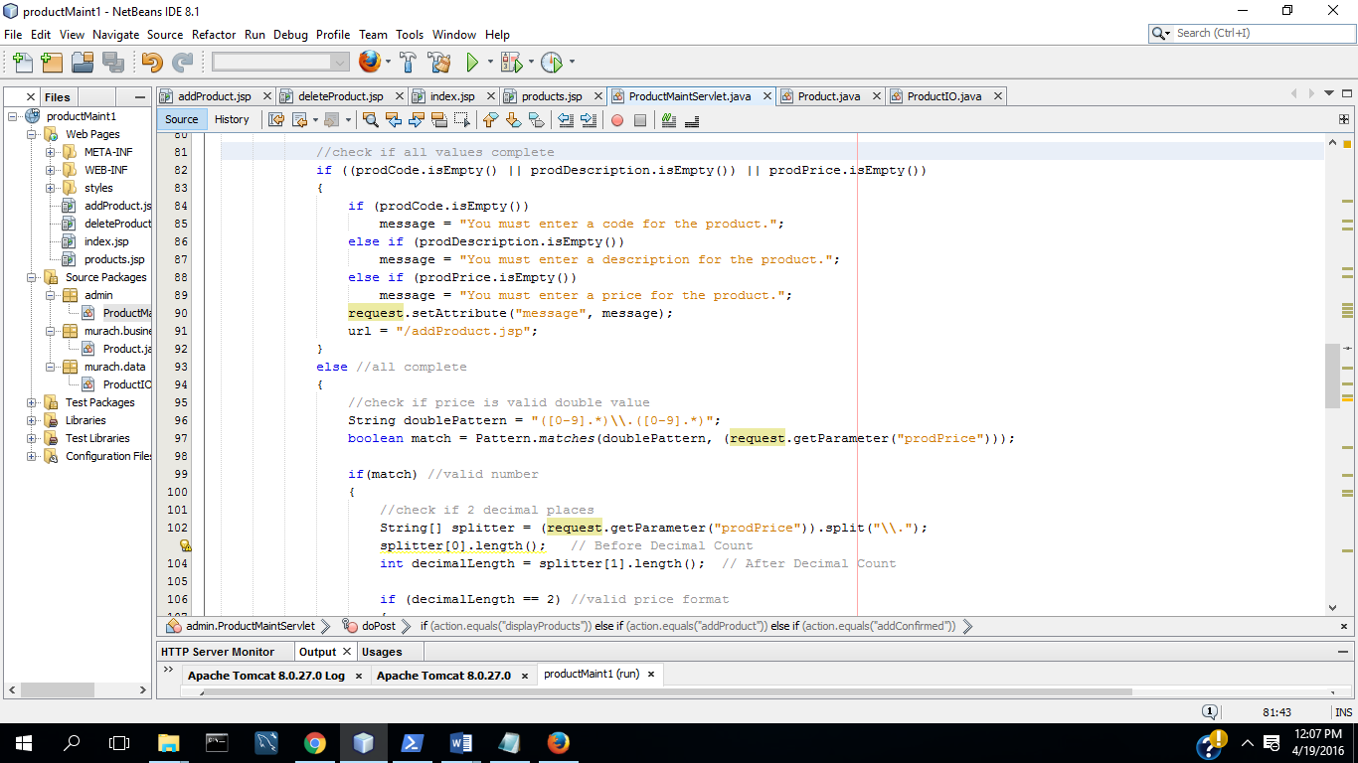

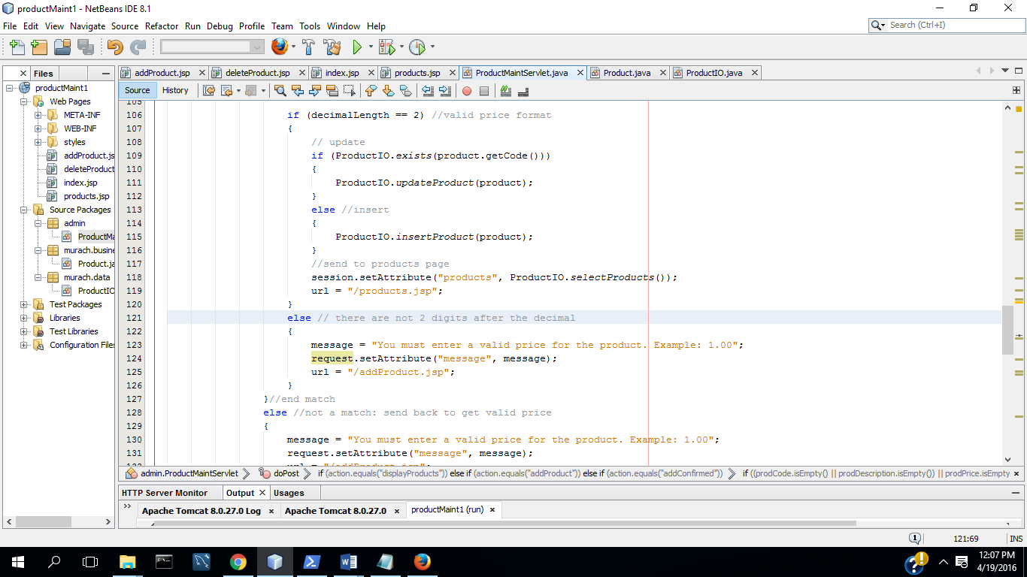

**TC4:**

**Make sure code, description and price are entered:**

1. **Start App:**

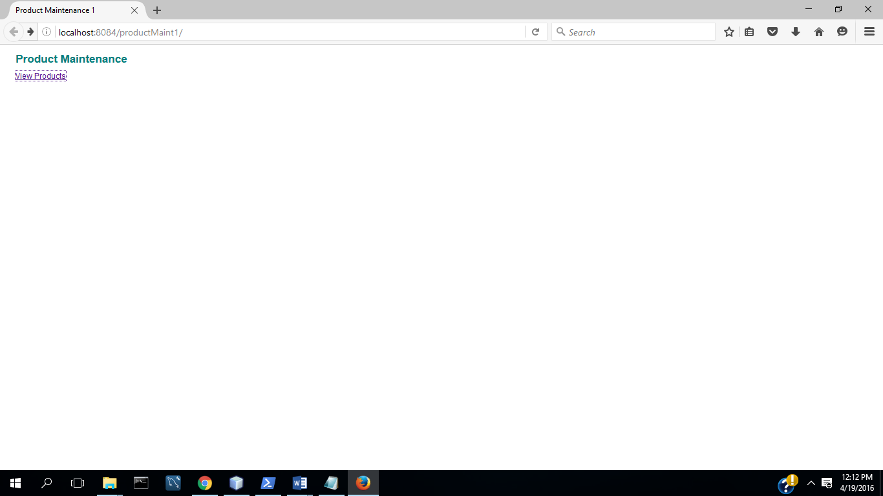

1. **Select View Product:**

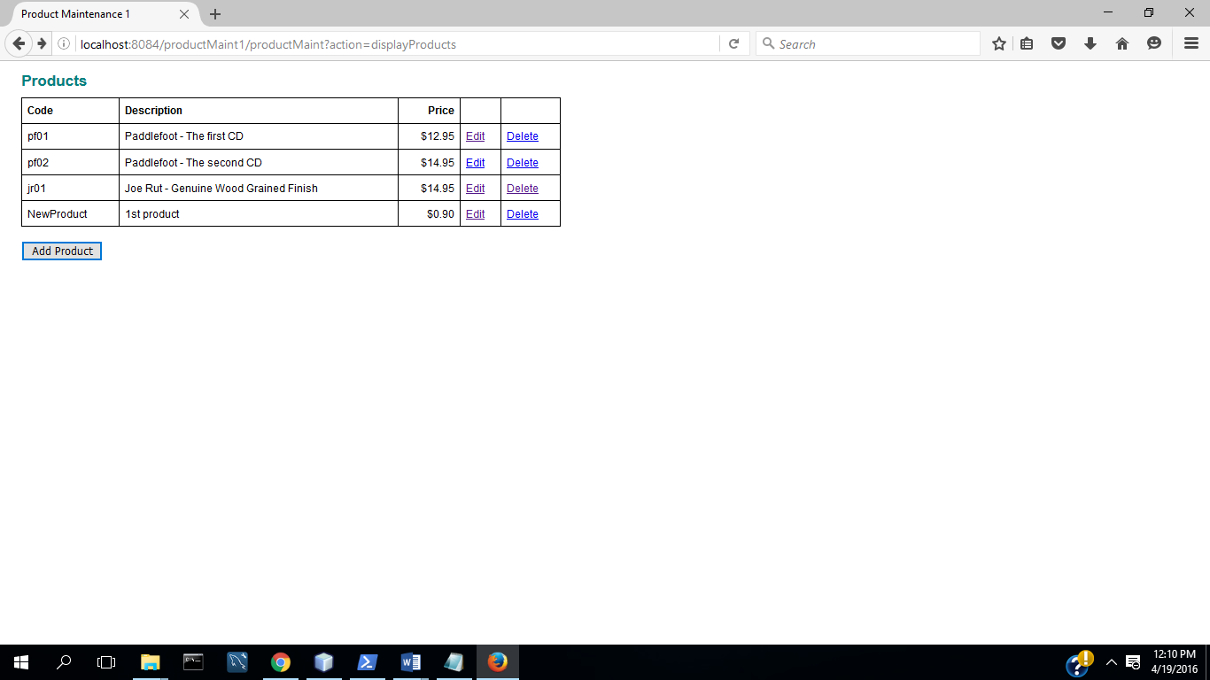

1. **Select Add Product:**

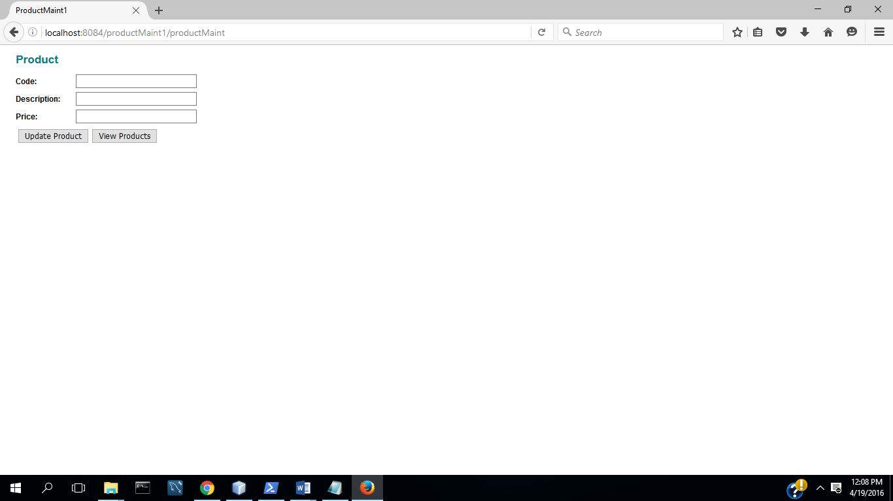

1. Select Update product:

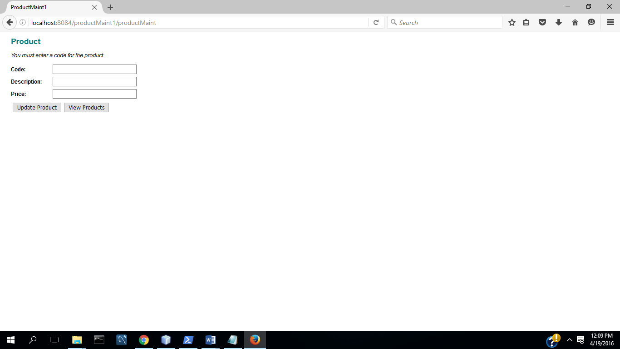

(5) Enter Code

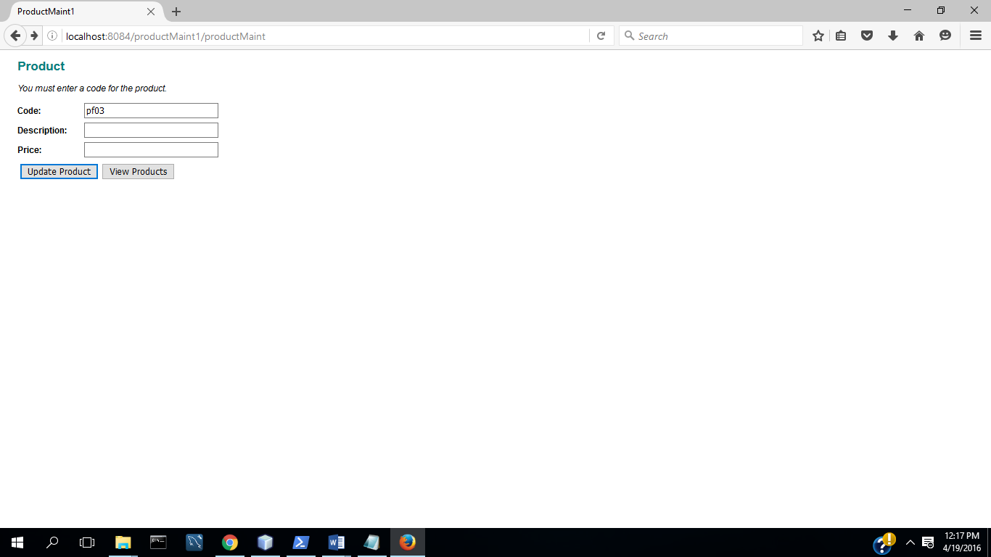

(6) Select Update

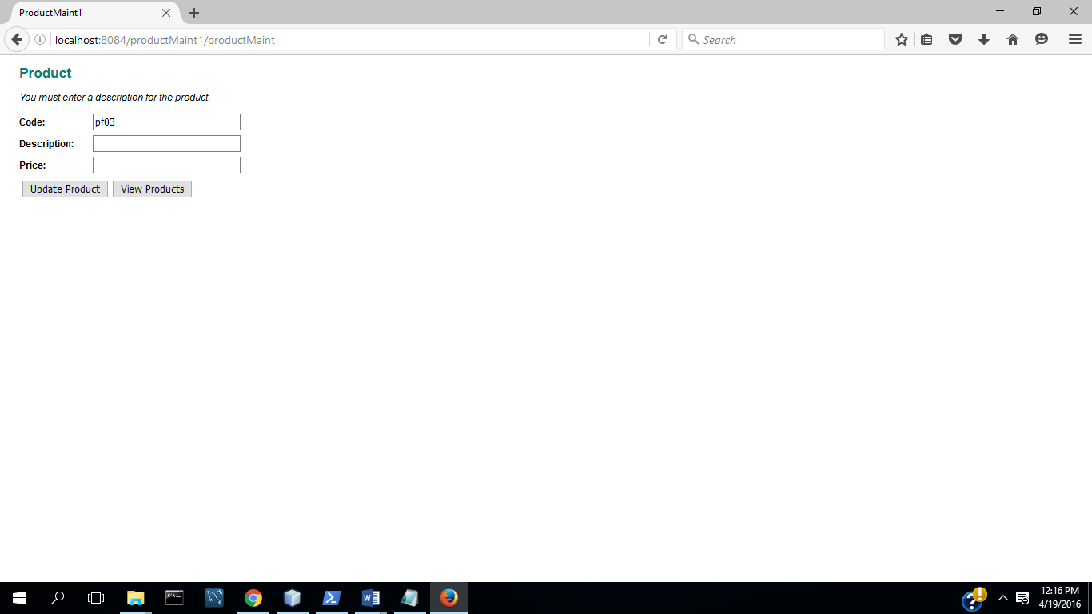

(7) Enter Description

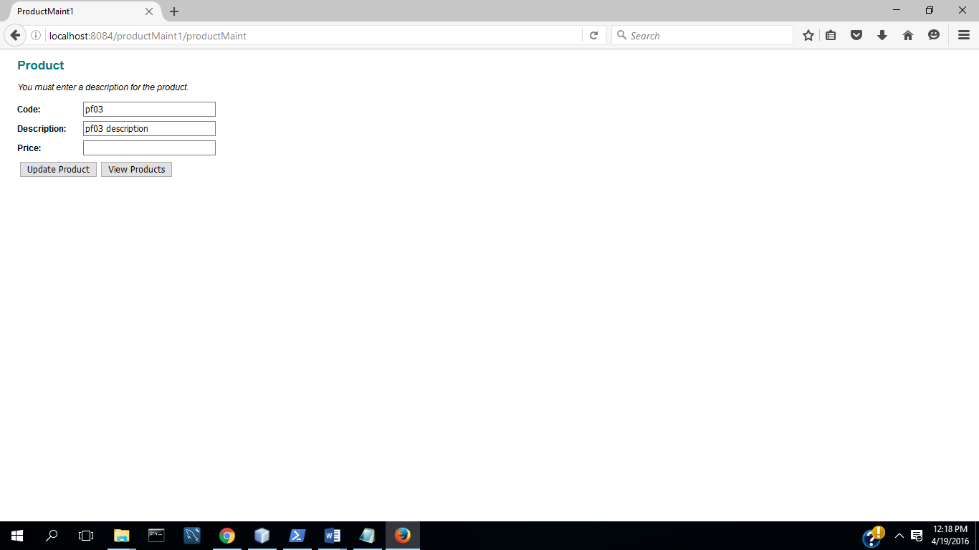

(8) Select Update

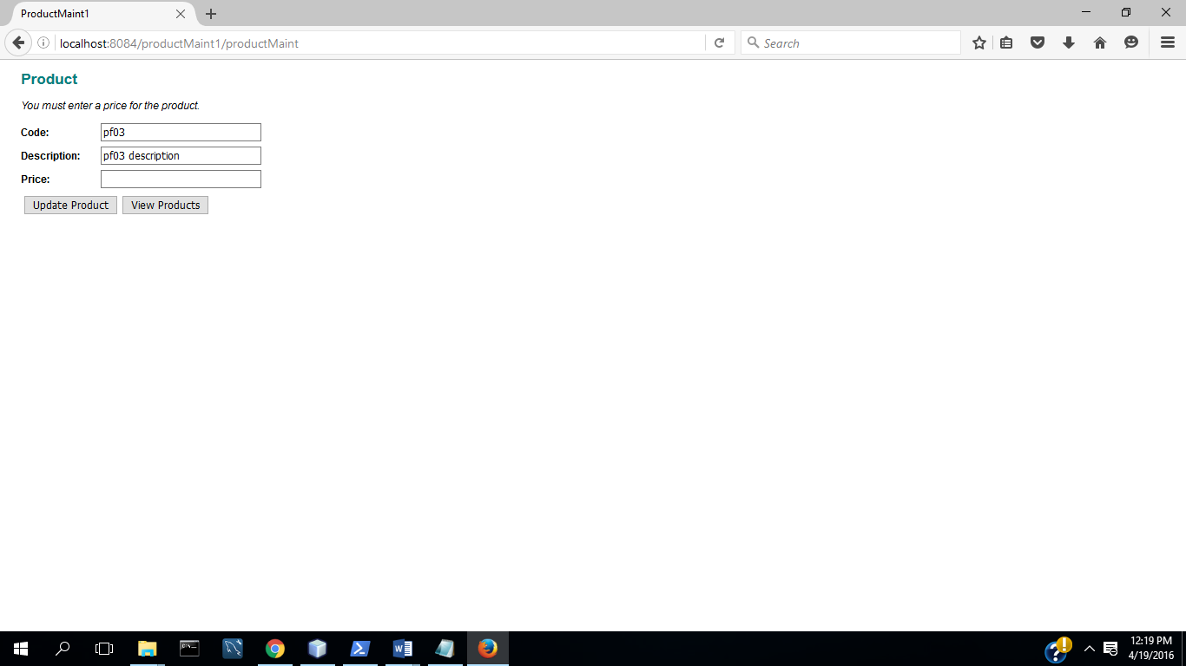

(9) Enter Valid Price

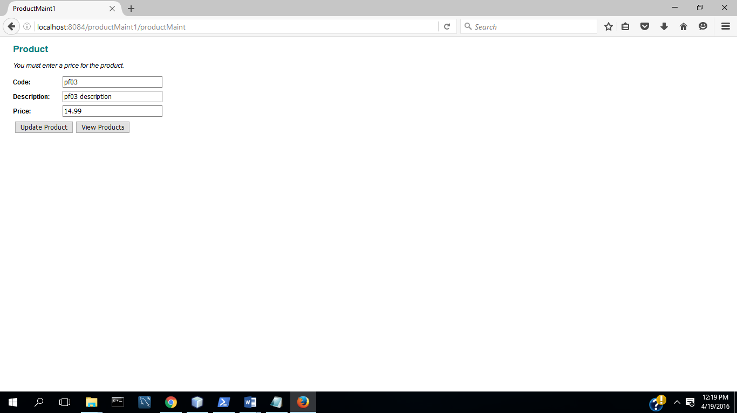

(10) Select Update

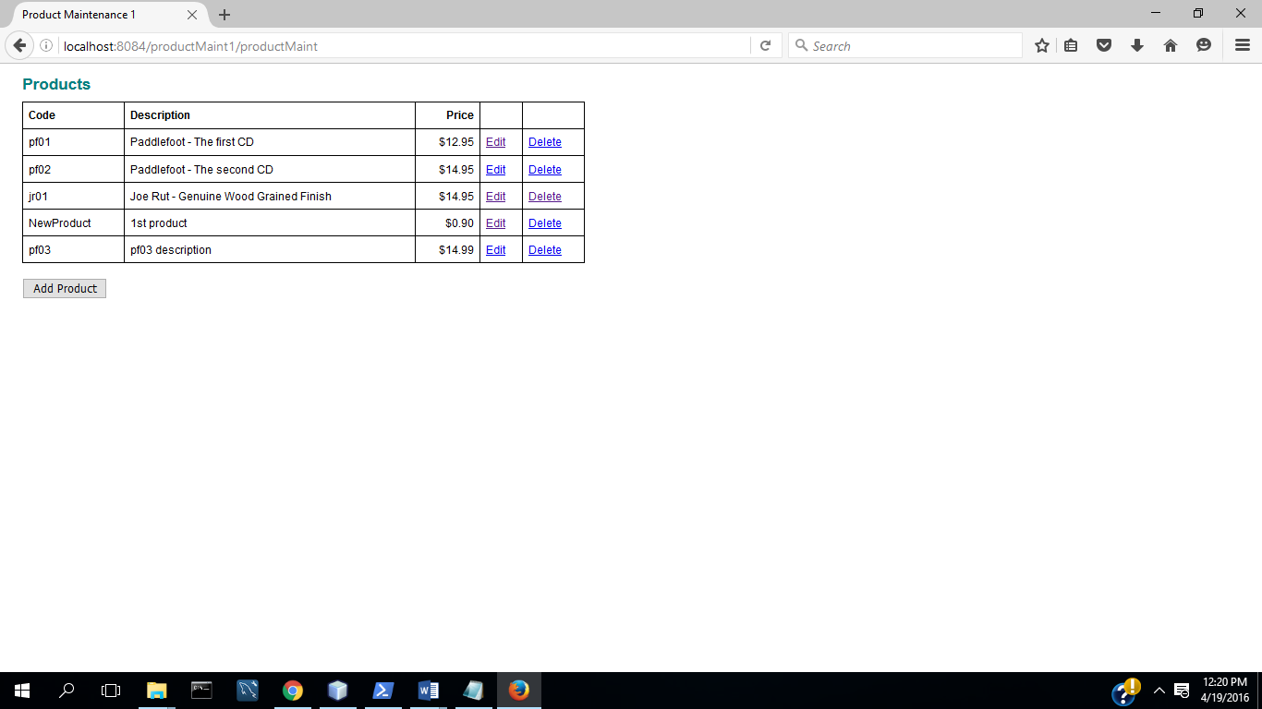

**TC5: Input Validation: Valid Price**

(1) Start App

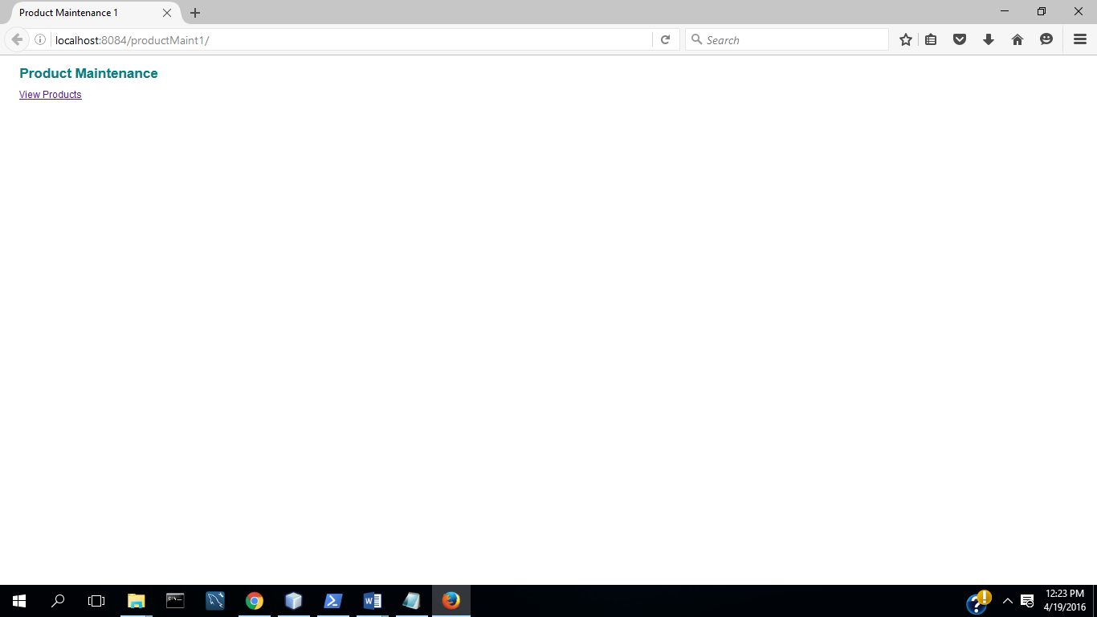

(1) Select View Products

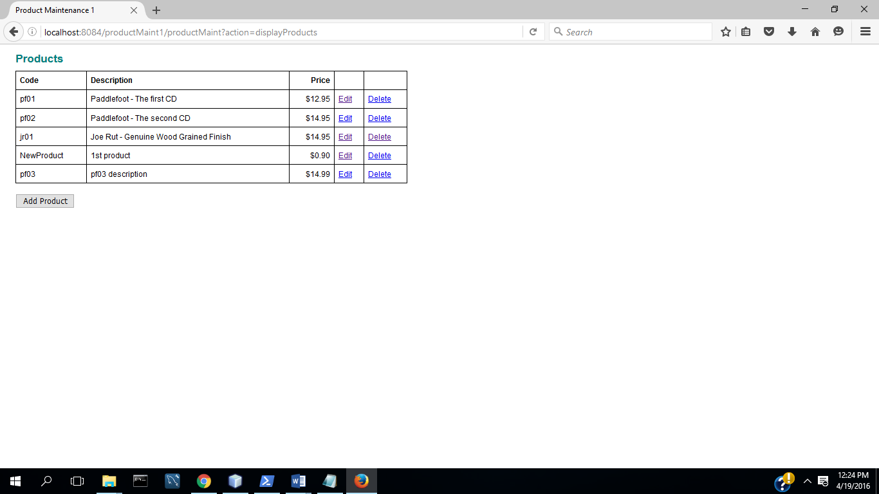

(2) Select Add Product

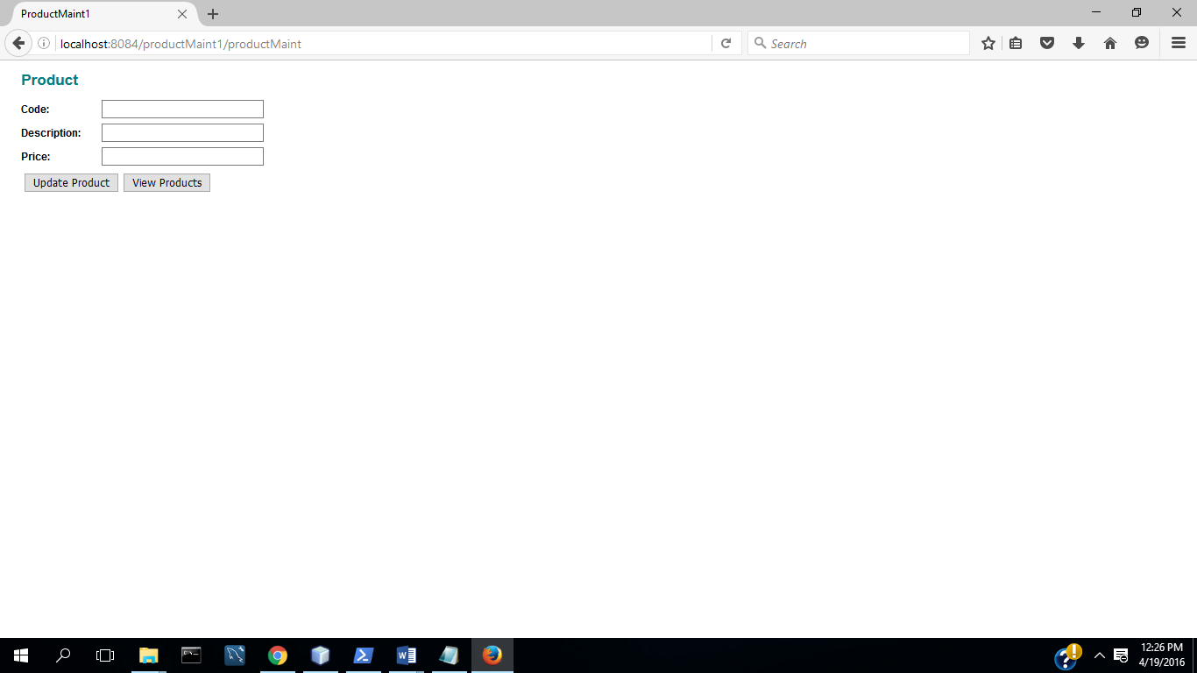

(3) Enter code, description, and invalid price

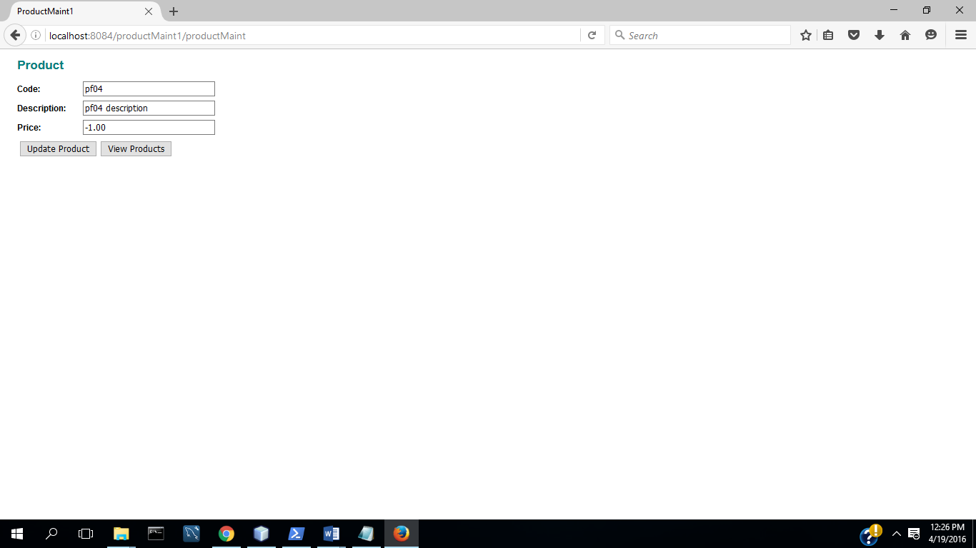

(4) Select update

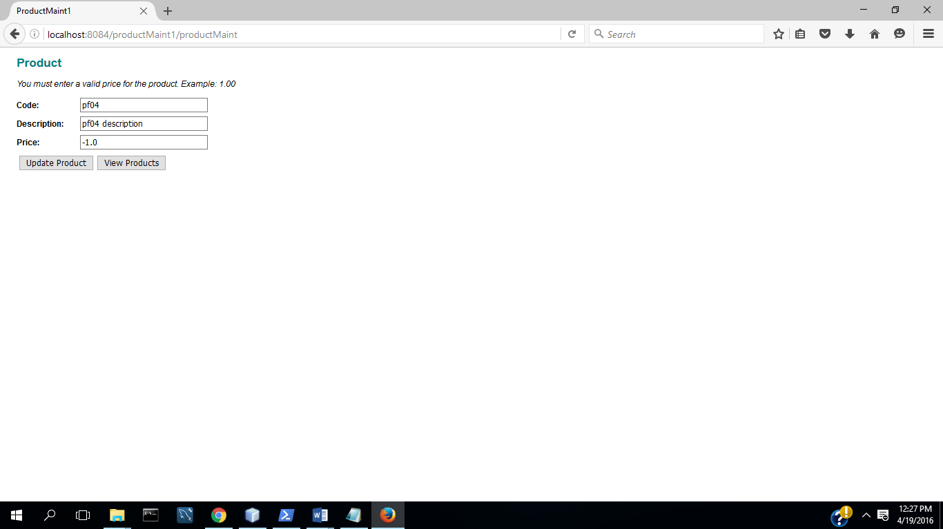

(5) Enter valid price

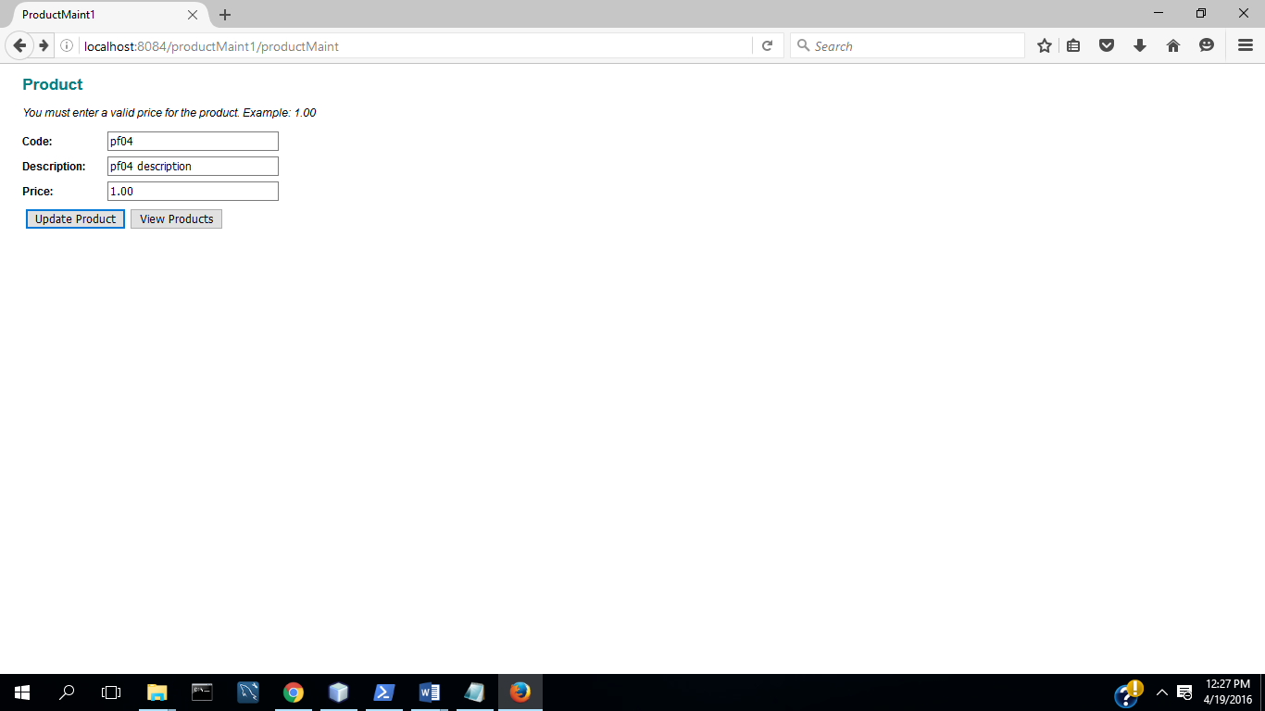

(6) Select Update

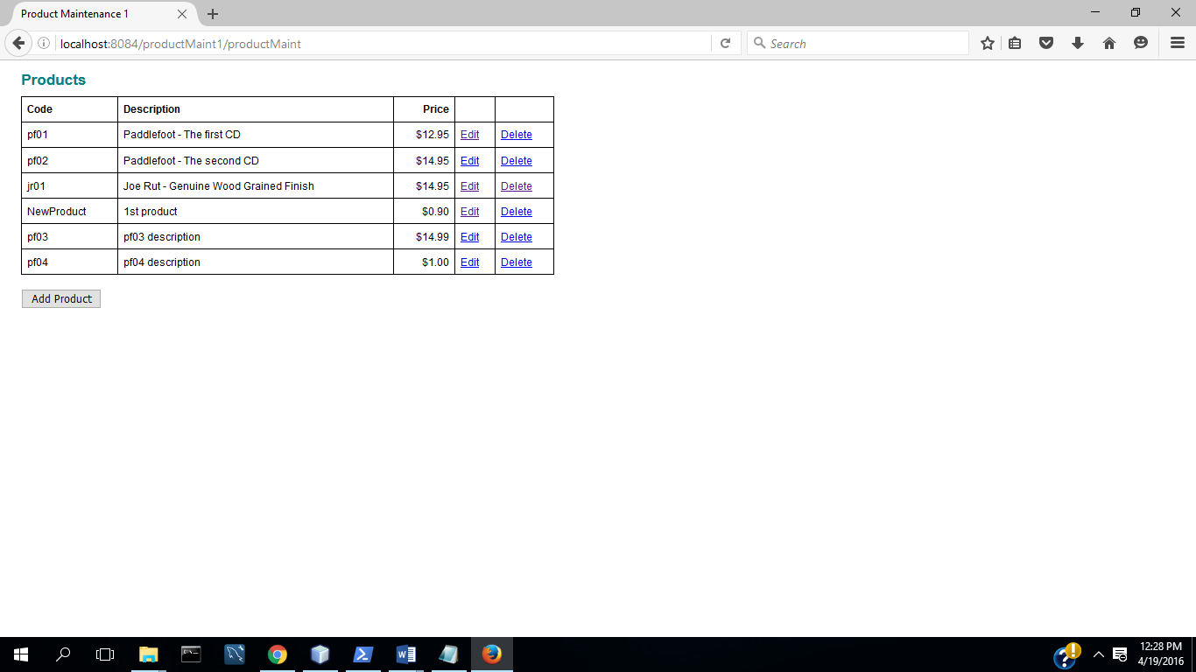

**(d) Test procedure/plan and implementation. What did you do to the test the program fully.**

**TC1: Add a Product**

(1) Start Application

(2) Select View Products

(3) Select Add Product

(4) Complete fields with valid data

(5) Select Update( Commit Transaction & Update Inventory)

**TC2: Update a Product**

(1) Select Edit Product

(2) Change description and price

(2) Select Update( Commit Transaction &Update Inventory)

**TC3: Delete a Product**

1. Select Delete Product
2. Select No
3. Select Delete Product

(4) Select Yes (Commit Transaction &Update Inventory)

**TC4: Input Validation : All Fields Complete**

(1) Start App

(2) Select View Products

(3) Select Add Product

(4) Select Update

(5) Enter Code

(6) Select Update

(7) Enter Description

(8) Select Update

(9) Enter Valid Price

(10) Select Update

**TC5: Input Validation: Valid Price**

(1) Start App

(1) Select View Products

(2) Select Add Product

(3) Enter code, description, and invalid price

(4) Select update

(5) Enter valid price

(6) Select Update

**(e) Overall Block diagram showing high level design**

Product Data

ProductIO

Product

Maintenance

Products