Bernice Templeman

CIS 5740/ Spring 2016

Program 4-2

Program 4-2: Product Maintenance with custom tag validation

For this project, you’ll enhance the application described in project 1 by adding a custom tag to validate user entries. (*Prerequisites: chapters 1-10*)

The Product page with custom tags for validation

Specifications

* Use a custom tag to mark empty fields that are required on the Product page with an asterisk.

Program 4 (Part 2) Chapters 1-10

(a) Input/Output - Screen shots showing input/output for each part.

**TC1: Add a Product**

(1) Start Application

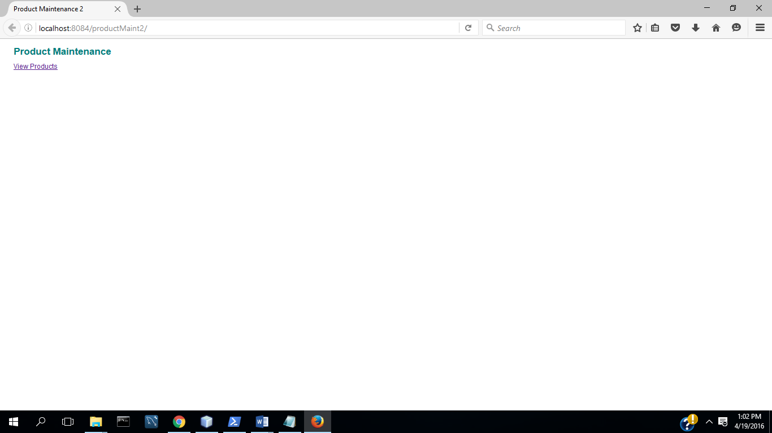

(2) Select View Products

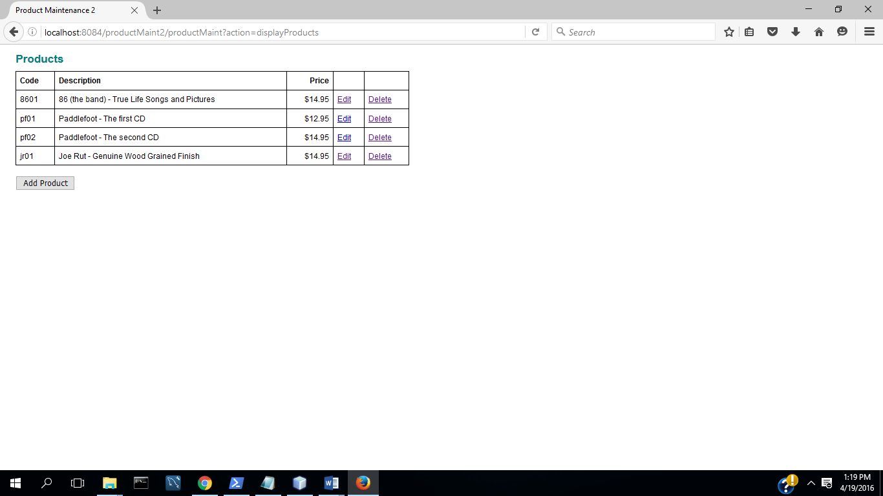

(3) Select Add Product

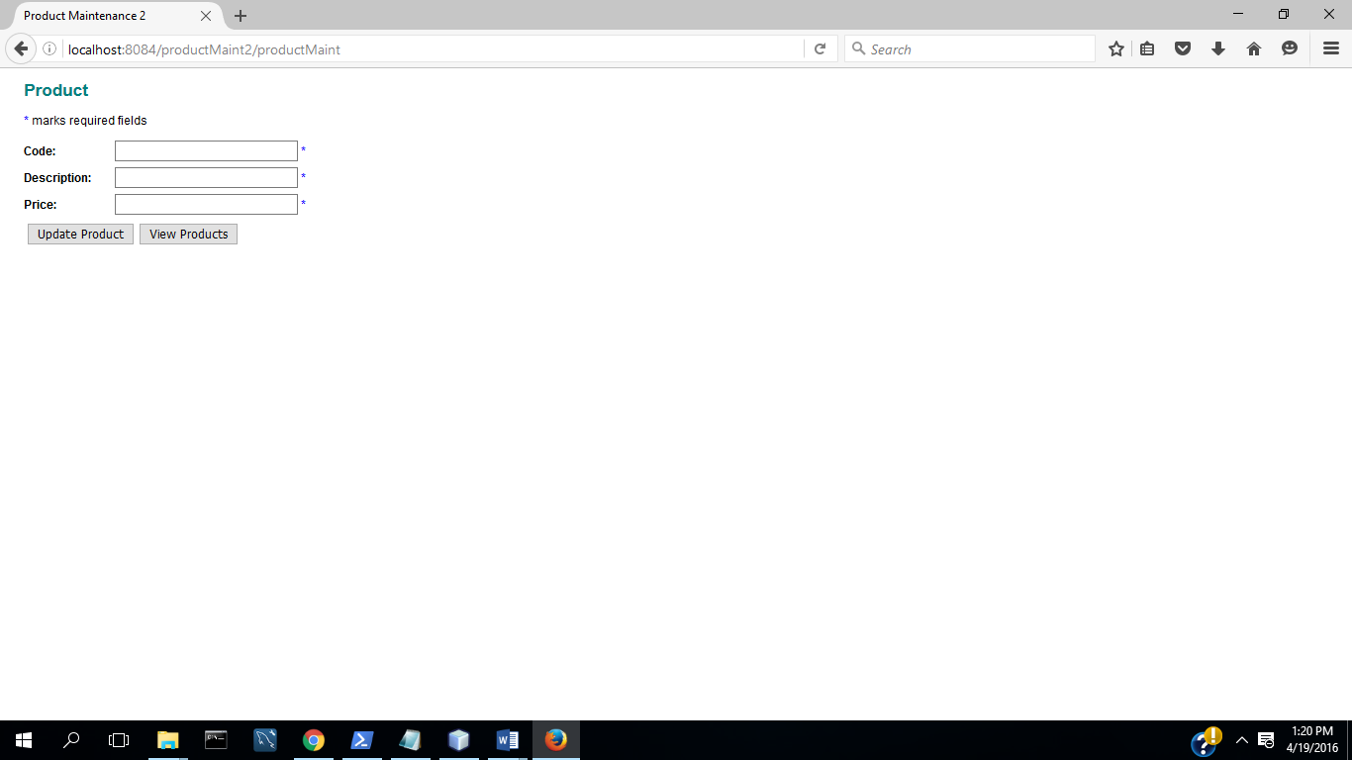

(4) Complete fields with valid data

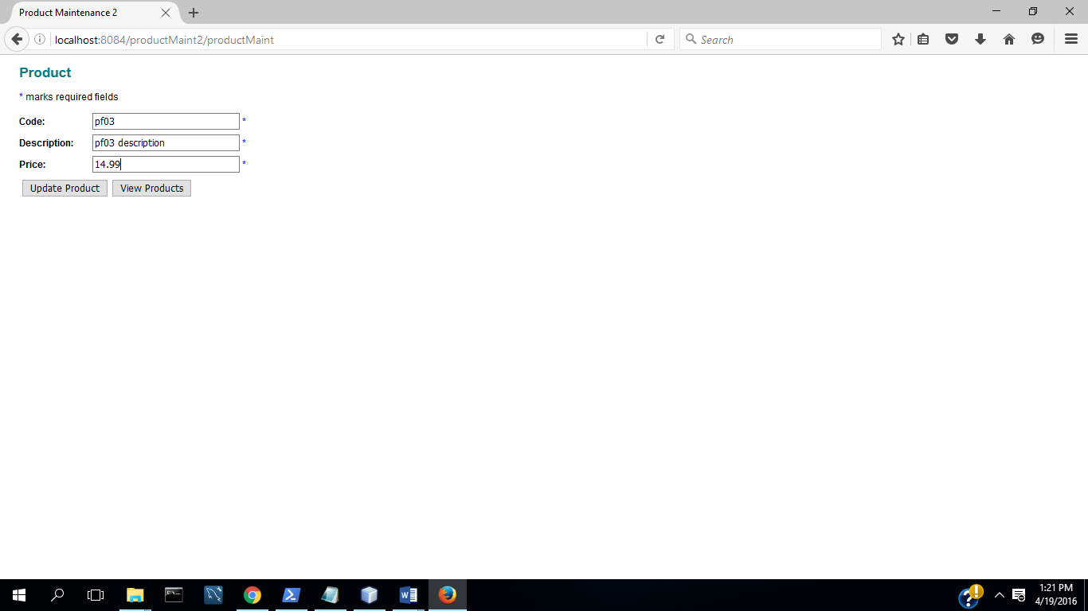

(5) Select Update( Commit Transaction & Update Inventory)

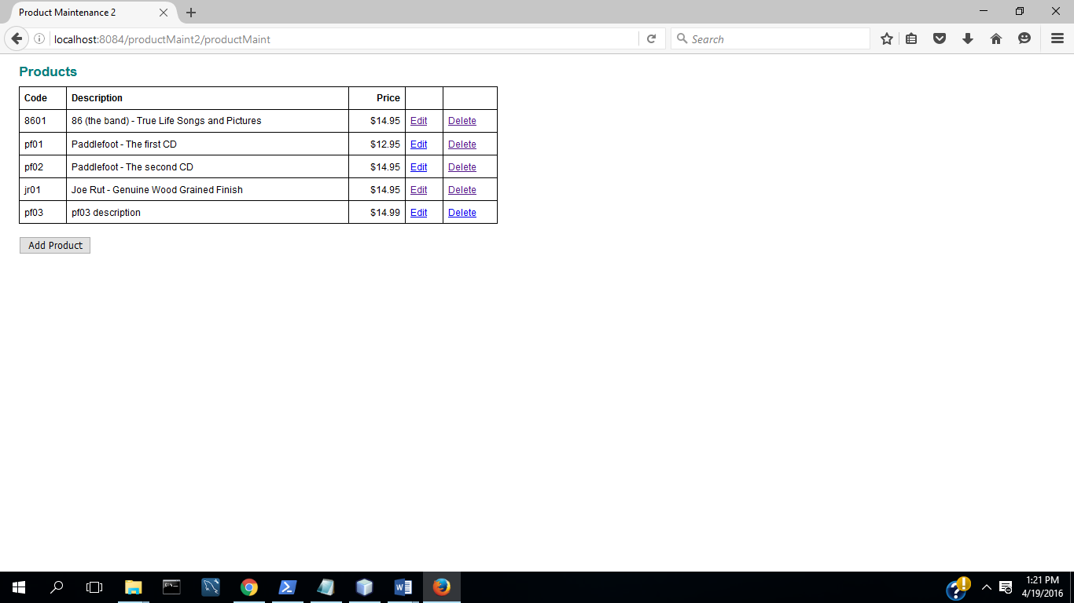

**TC2: Update a Product**

(1) Select Edit Product

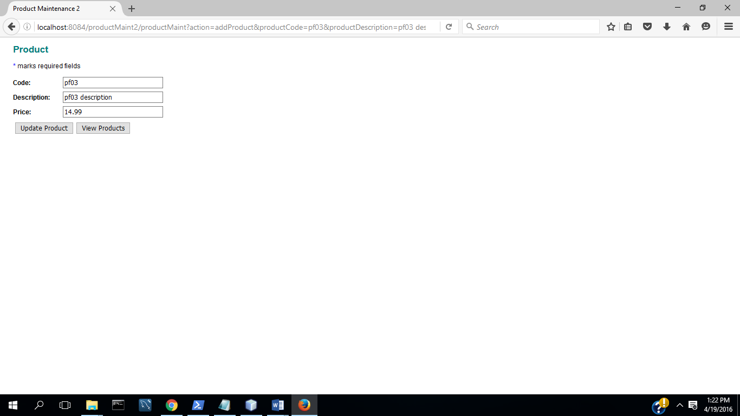

(2) Change description and price

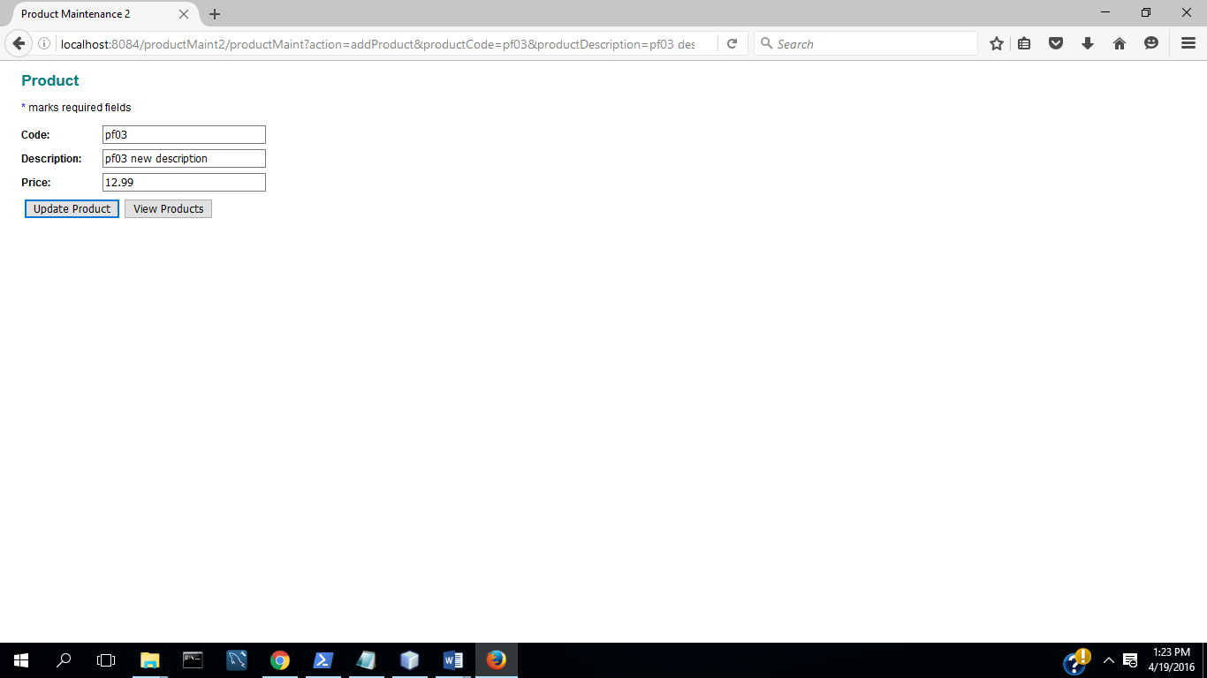

(2) Select Update( Commit Transaction &Update Inventory)

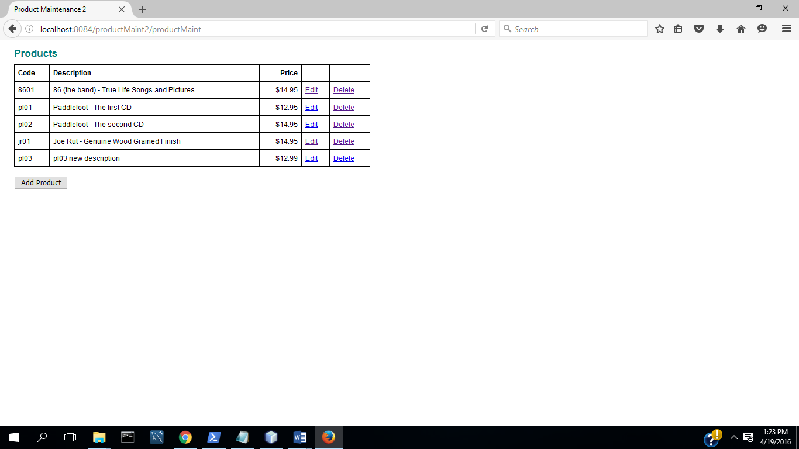

**TC3: Input Validation : All Fields Complete**

(1) Start App

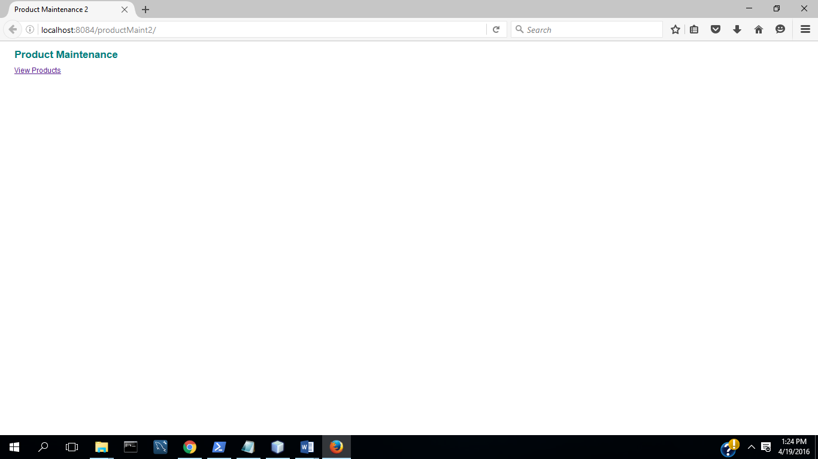

(2) Select View Products

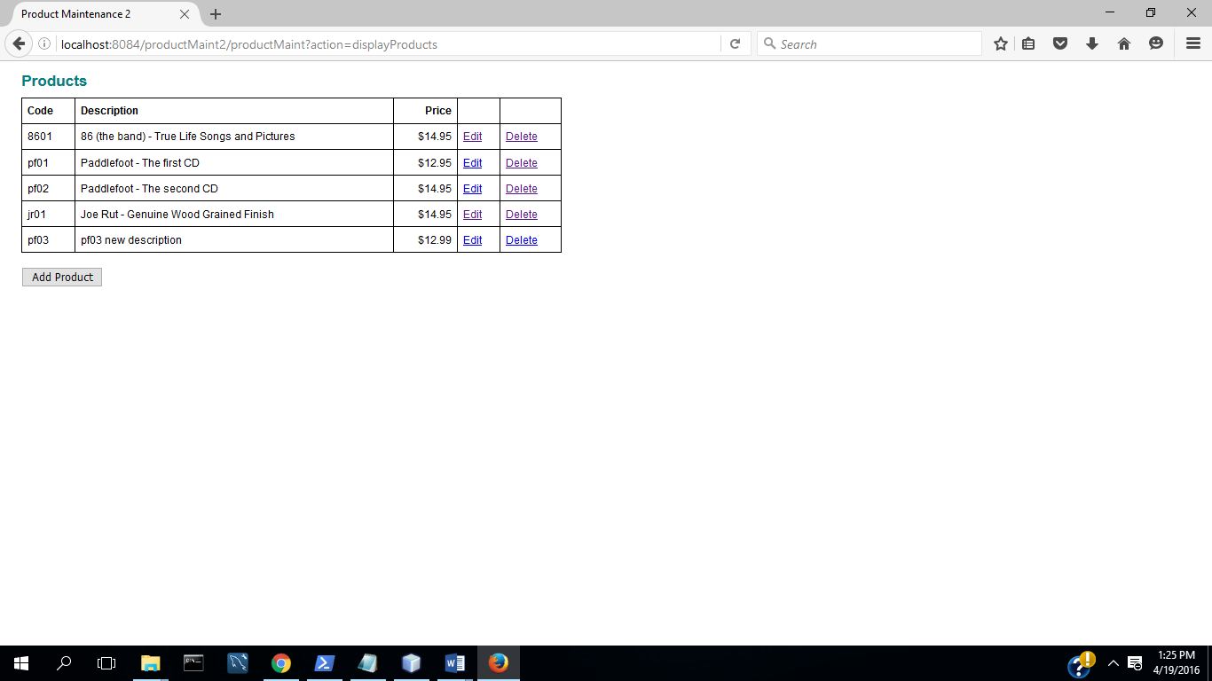

(3) Select Add Product

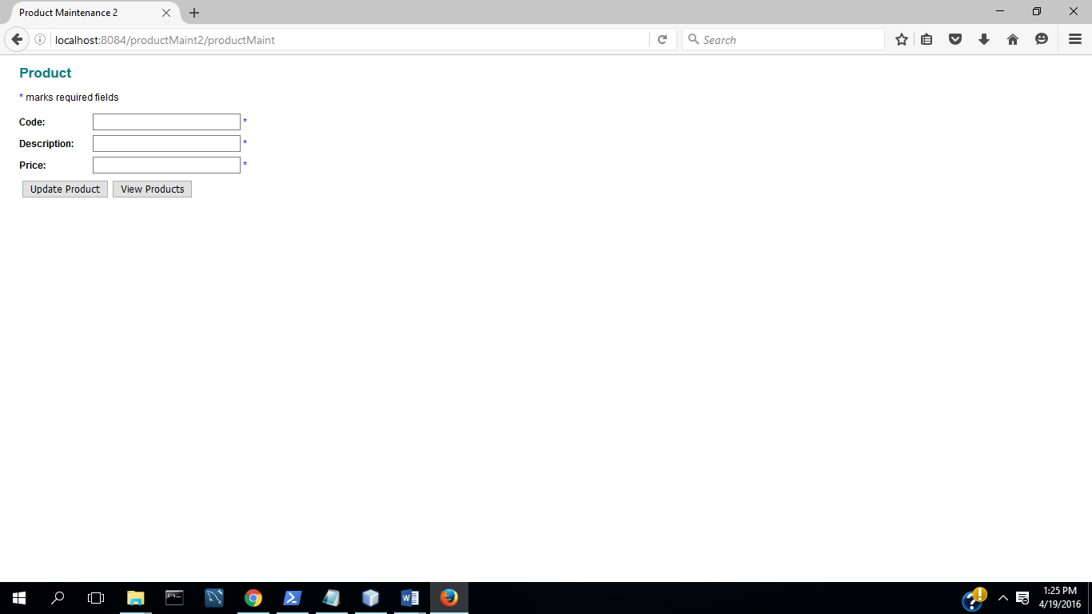

(4) Select Update

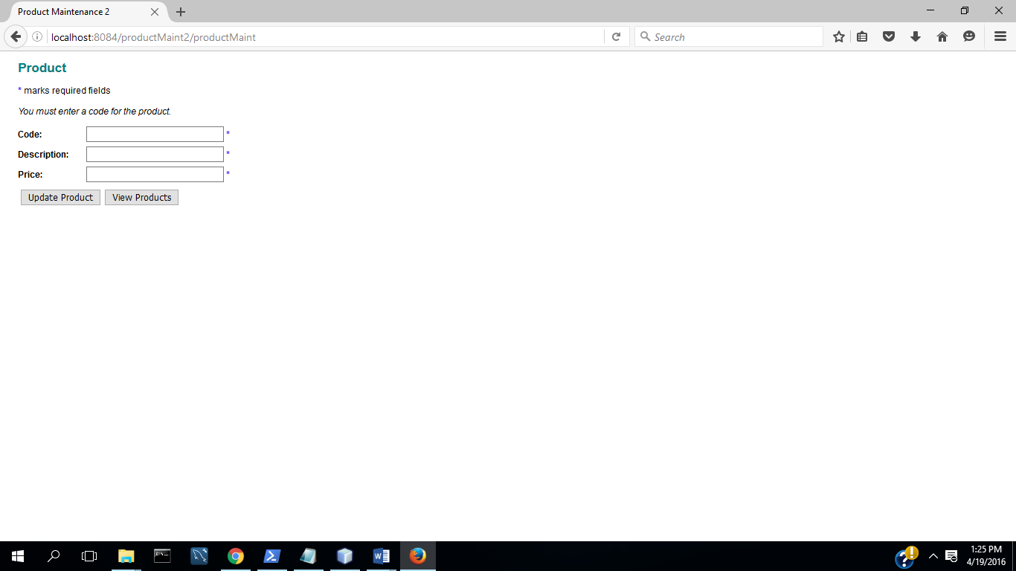

(5) Enter Code

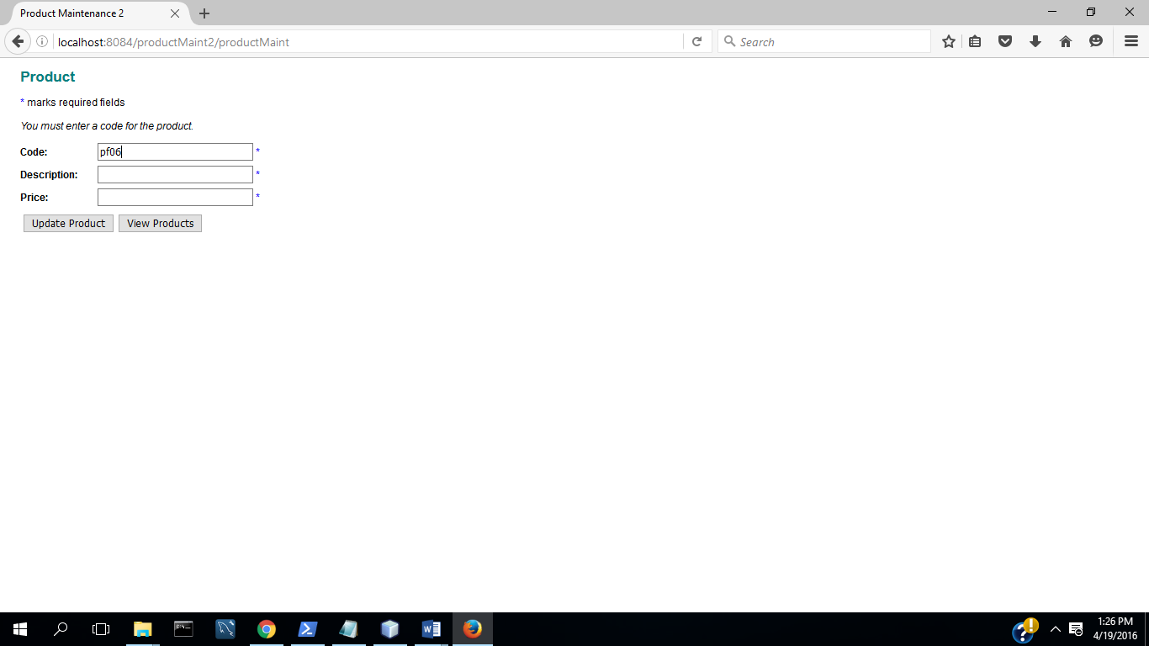

(6) Select Update

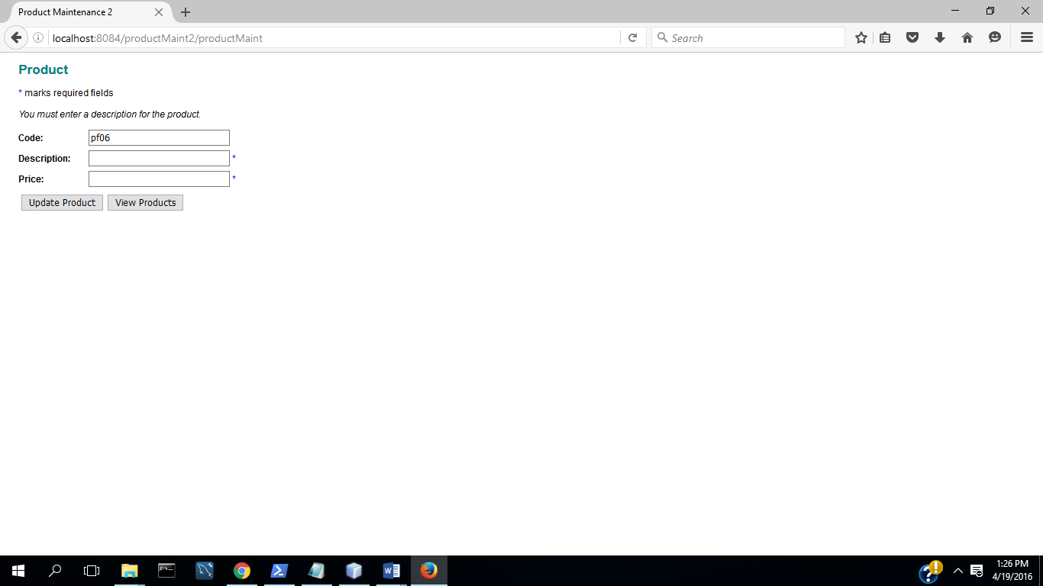

(7) Enter Description

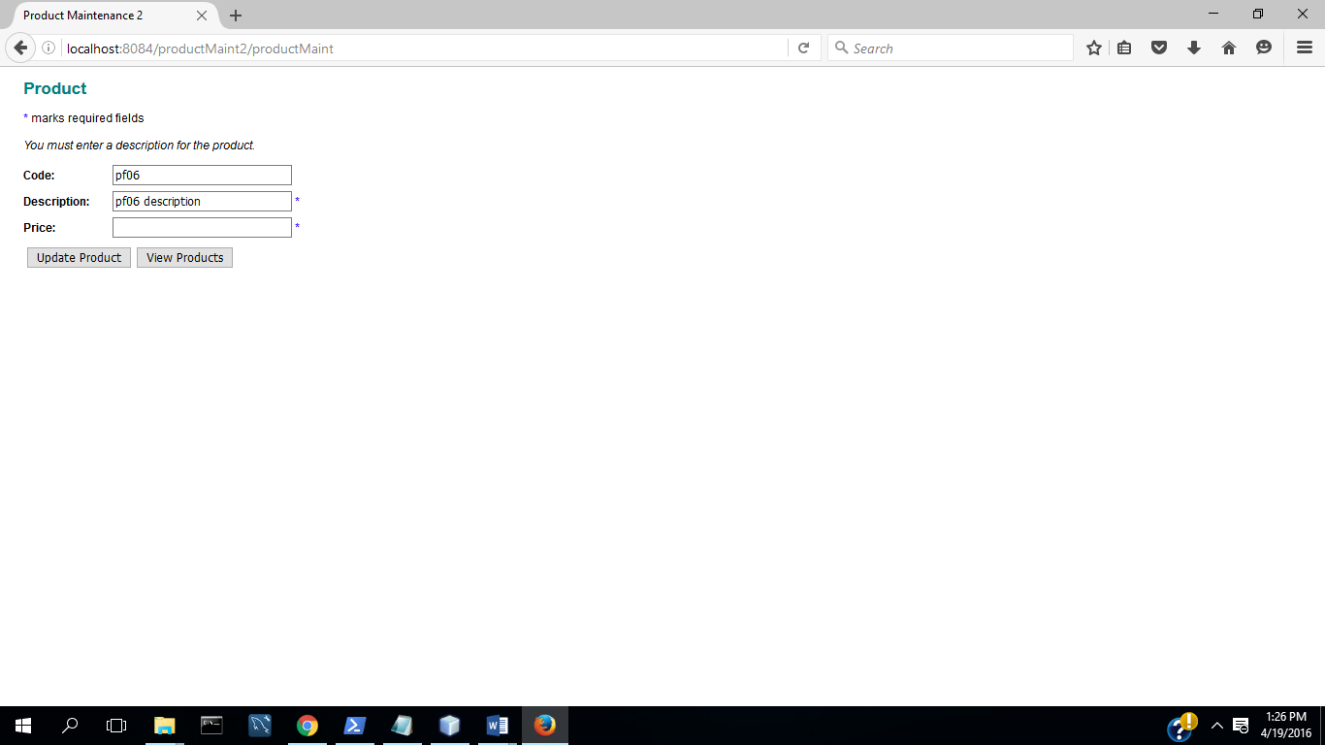

(8) Select Update

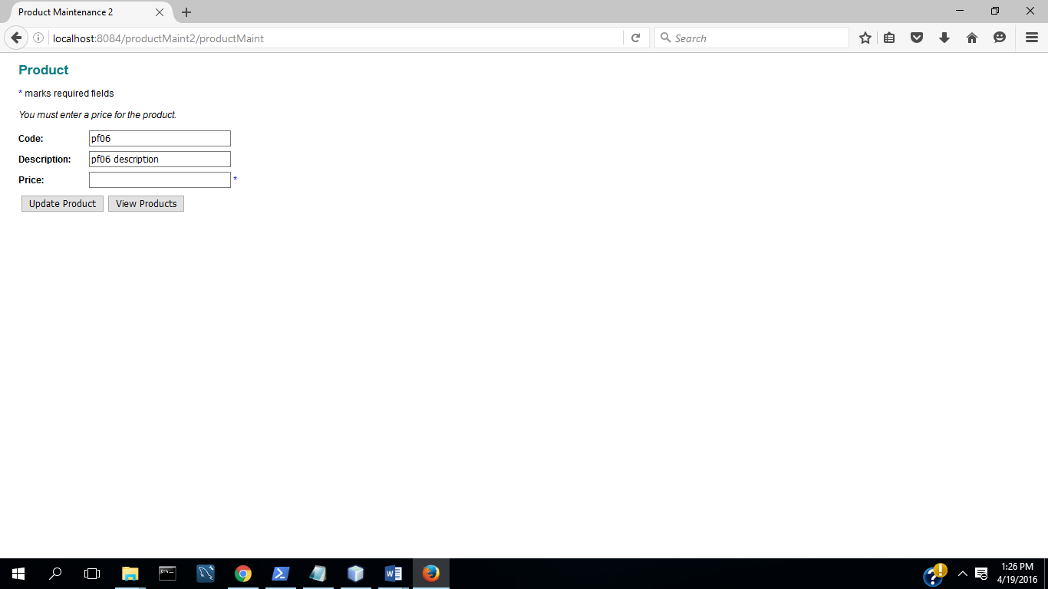

(9) Enter Valid Price

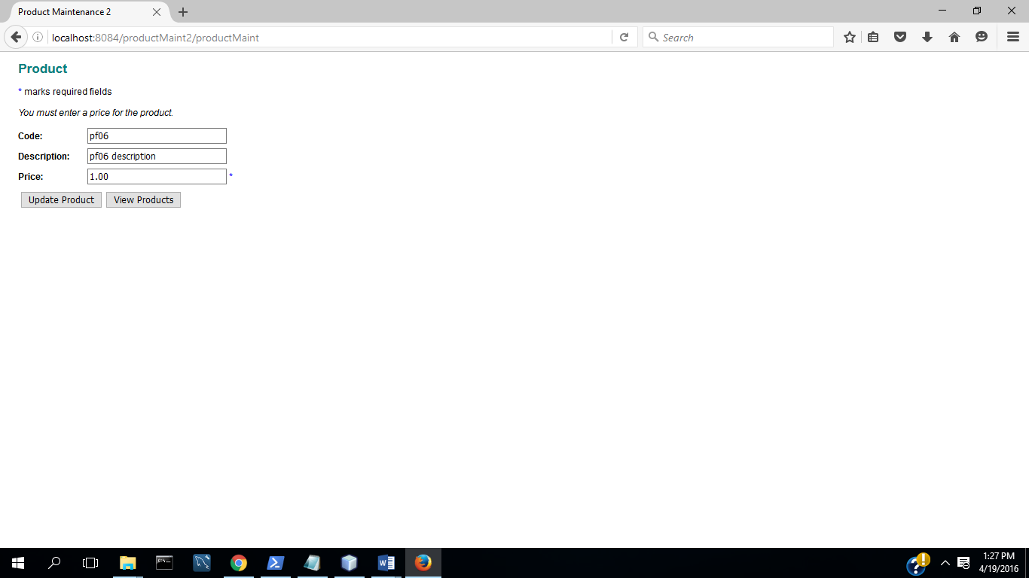

(10) Select Update

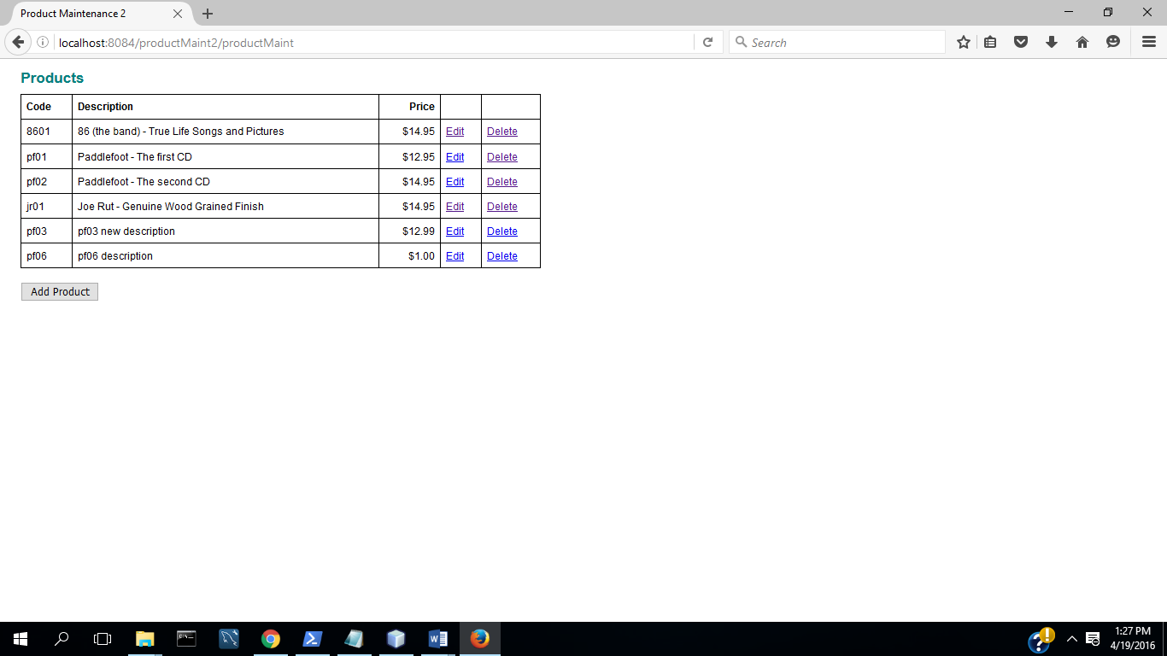

**TC4: Input Validation: Valid Price**

(1) Start App

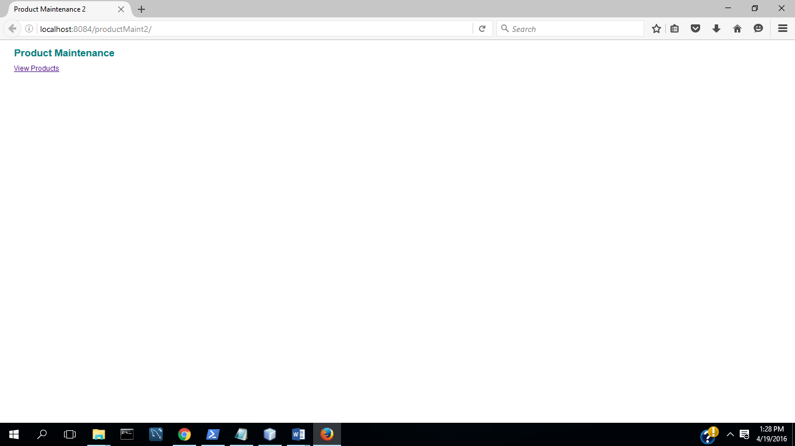

(1) Select View Products

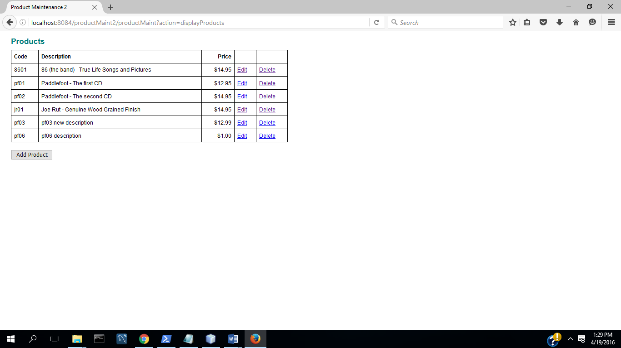

(2) Select Add Product

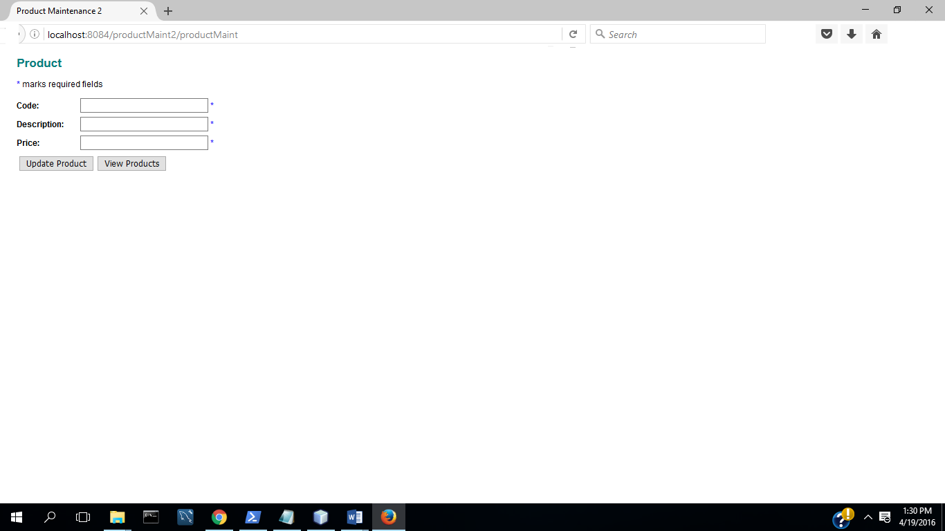

(3) Enter code, description, and invalid price

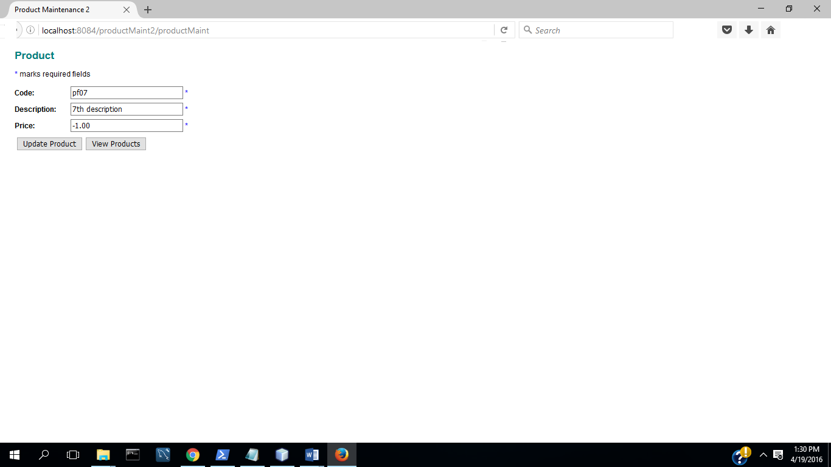

(4) Select update

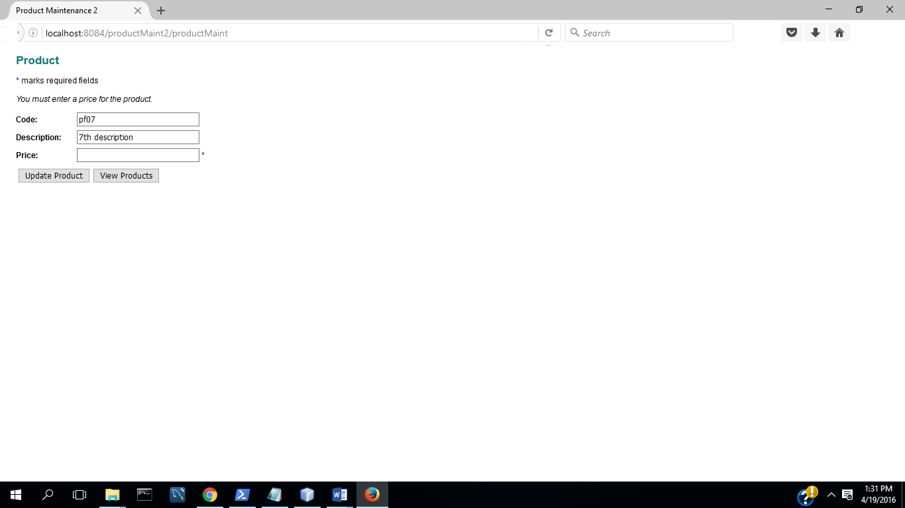

(5) Enter valid price

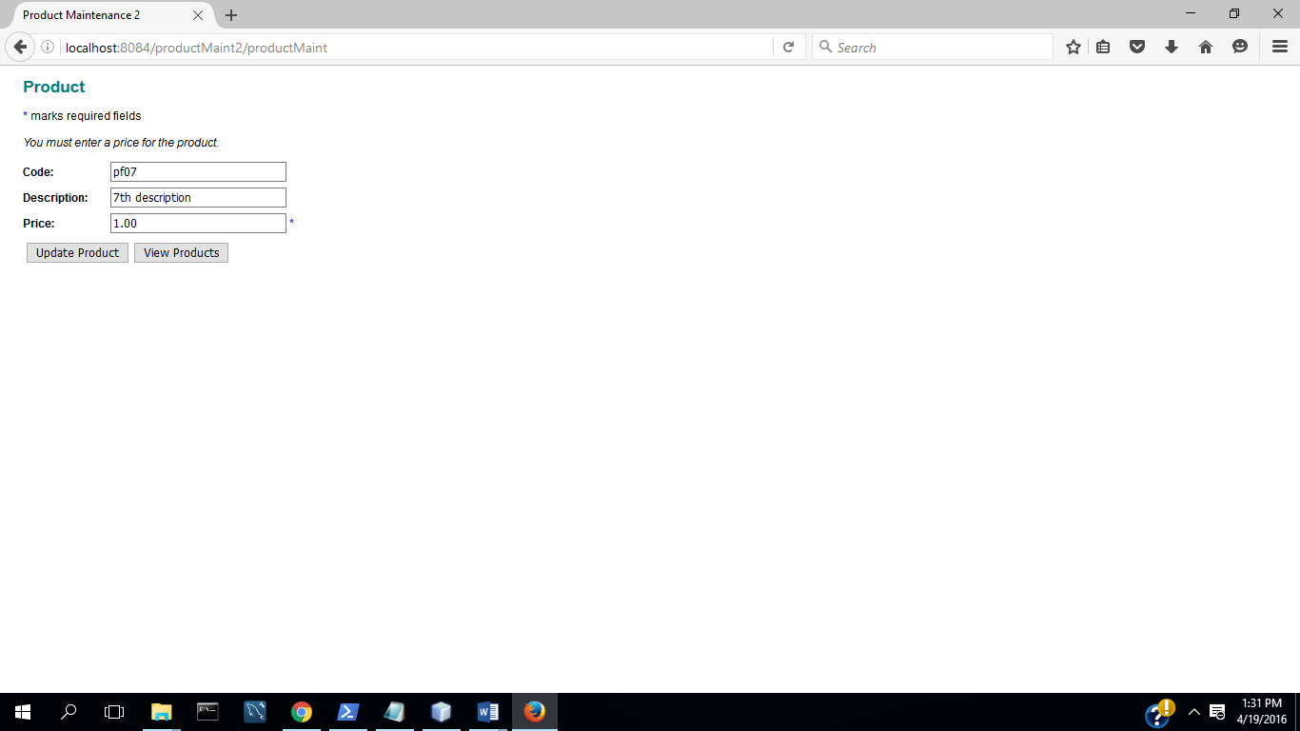

(6) Select Update

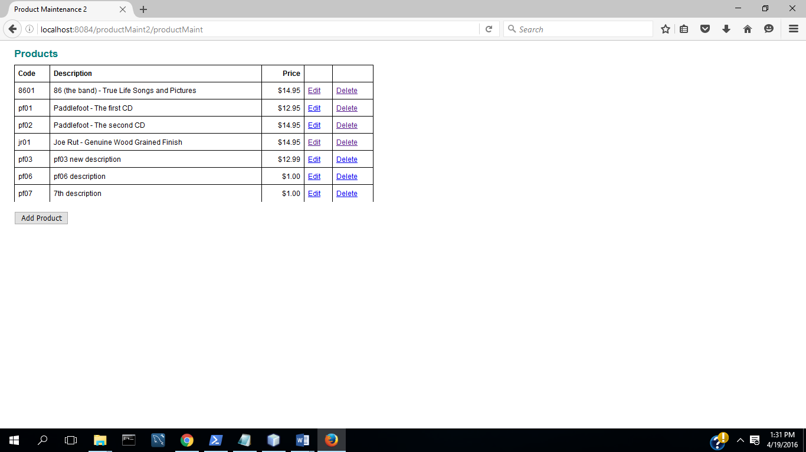

Product Maint in Chrome:

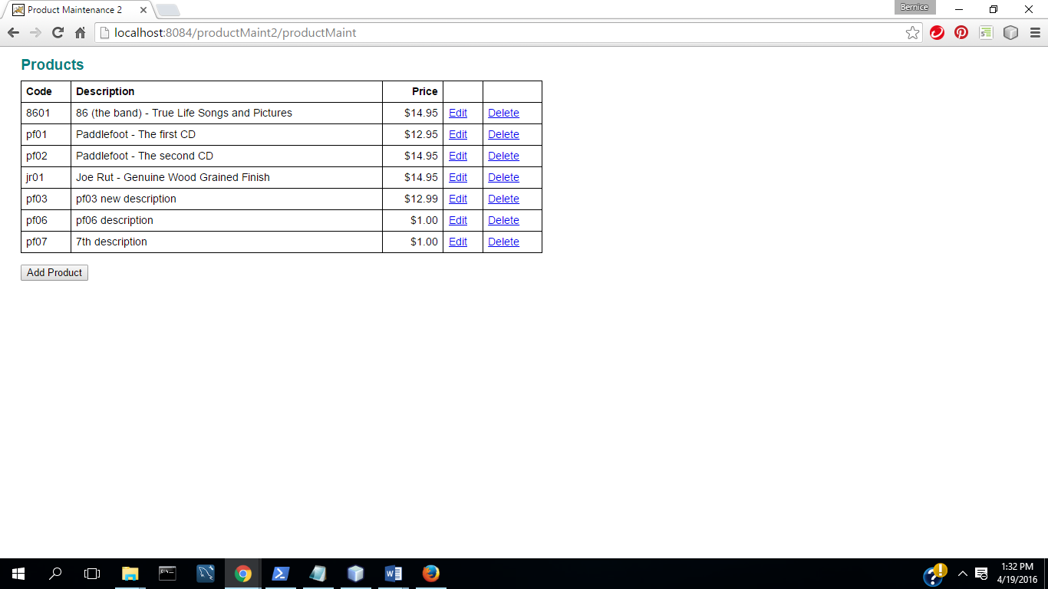

(b) All program code for each part.

In zipped NetBeans project directory.

(d) Test procedure/plan and implementation. What did you do to the test the program fully.

**TC1: Add a Product**

(1) Start Application

(2) Select View Products

(3) Select Add Product

(4) Complete fields with valid data

(5) Select Update( Commit Transaction & Update Inventory)

**TC2: Update a Product**

(1) Select Edit Product

(2) Change description and price

(2) Select Update( Commit Transaction &Update Inventory)

**TC3: Input Validation : All Fields Complete**

(1) Start App

(2) Select View Products

(3) Select Add Product

(4) Select Update

(5) Enter Code

(6) Select Update

(7) Enter Description

(8) Select Update

(9) Enter Valid Price

(10) Select Update

**TC4: Input Validation: Valid Price**

(1) Start App

(1) Select View Products

(2) Select Add Product

(3) Enter code, description, and invalid price

(4) Select update

(5) Enter valid price

(6) Select Update

(e) Overall Block diagram showing high level design